Abstract:
Most polymers are non-biodegradable because they came from petrochemical materials so they cause several environmental problems when they are discarded in dumpsites or landfills in addition to air pollution if they are incinerated or high energy consumption as a result of recycling therefore, Thermoplastic Starch polymer (TPS) is one of biodegradable polymers, used in medicine, packaging, agriculture, fertilizer and chemical storage bags and become one of the most common natural polymers. Its production and characterization are the objective of this project to replace the synthesis polymers.
TPS was prepared from starch with HCl and plasticized by glycerol. In order to improve poor tensile properties of the TPS, dichloromethane (DCM) were added into the starch to remove gluten that cause rehydration of TPS. Samples were analyzed for mechanical and thermal properties. The results showed that the increase in percentage of glycerin cause a decrease in tensile strength and Young’s modulus. Moreover, water absorption of the TPS samples was clearly reduced by removing gluten. In addition, Films with gluten were more crystalline and had higher tensile strength and rigidity, but lower elongation capacity. The modulus of elasticity, maximum stress, and % El at break values of the TPS for the best sample were 56.35, 1.6 MPa and 23.8% respectively for sample of 2.5% glycerin, and 6% of HCl.

Contents:

List of figures…………………………………………………………………………..…….2
List of Tables…………………………………………………………..….….………...……3
1.Introduction …….……………………………….……………………..………...………..4
2.Polymers………………………………………………………….……………....…….…..8
2.1.Classifications of Polymer…………………………..…………..……………...……..9
2.1.2. Polymer Structure………….……………………………………………….…...….11
2.1.5.Thermal Behavior……………………………………………….……..………..…..12
2.1.6.Polymer Morphology………………………………………….…..………….....….14
3.Biodegradation………………………………………………………….………….…….16
3.1.Mechanical of biodegradation………………….……………………...……...….….17
3.2.Applications of biodegradable plastic……………………...………………..…..….18
3.3.Types of biodegradable plastic………………………….…………………….….….19
3.4.Testing method………………………………………………………………….…….20
3.5.Sources of biodegradable plastic…………………..……………...……...………….21
4.Starch…………………………………………..............................................................….22
4.1.Properties of starch……………………………….………..…………………....……..25
4.1.1. Physical properties of starch………………………………..…..………….…..…..25
4.2.Blending of starch-based materials…………………………………………..…........26
5.Polymerization of Starch………………….……………………………..…...………..….27
6.ExperimentalWork………………………………………………………...…..…….….30
7.Results and Discussion……..…………..…………………………….…...…..…..…….36
7.1.Mechanical properties of the TPS………………………….………..……...………..37
7.2.Thermal analysis……………………………….………..…………………..………....38
7.3.The Effect of Glycerin Percentage on Mechanical Properties……………...……..39
7.4.Gluten Removal……………………………….………..…………………….....……..40
7.5.Water Loss………………………………….………..……………………….....….…..40
7.6. Melt Flow Index ………………………….………..…………………...…..…….…..41
7.7. Comparison between Our Works and the Others Works ………………….….…..41
8.Conclusion………………………………………..….……...………………….…….…...43
References………………………………………..….…………………………..….….…...45

List of Figures:

Figure (2.1): Classifications of Polymer ………………………………………………..………..…….….….10
Figure (2.2): Linear, branched and cross-linked polymers …………………………….……..….…11
Figure (2.3): Polymer based on types of Monomer. ……………………………………………..….….13
Figure (3.1): Classification of the main biodegradable polymers…………………..……………19
Figure (4.1): Starch (amylose)(A) and cellulose(B) ……………………………………………...…....24
Figure (5.1): The Steps of Starch Polymerization ………………………………………….…………....29
Figure (7) : Samples that achieved from 1,2 and 3 trials, (B) samples that achieved from last trial……………………………………………………………………………………………………………...…...34
Figure (7.2.1): DSC curve of TPS/3.8% glycerin with gluten …………………….……….…....38
Figure (7.2.2): DSC curve of TPS/3.8% glycerin without gluten ……..………….…………...38
Figure (7.3) :relationship between the percentage of glycerin and mechanical properties …………………………………………………………………………………………………….….….……..…....39

List of Tables:

Table (3.1): Schematic overview on tests for biodegradable plastics……………….……...20
Table (4.1): Amylose and amylopectin contents………………………………………….…….…....23
Table (4.2): Properties of different types of starch………………………………….………….......26
Table (6): Previous experiments with different parameters……………….……..….…….….…32
Table (7.1): Mechanical properties of starch and fibers composites….………………..….…37
Table (7.2): DSC results with mechanical properties …………………..……………………….…39
Table (7.4): The Effect of Gluten Presence on the Mechanical Properties …….…………40
Table (7.5): The Water Loss in TPS Sample after Certain Days …………………………...…40
Table (7.6): The Melt Flow Index for TPS Samples ………………………………………….....…41

Chapter 1
Introduction

1. Introduction:
- In recent years, the environmental pollution from consumed polymers has become serious, particularly from packaging materials and off-set plastic bags and cups. The growing interest in the environmental impact of discarded plastics has led to research on the development of plastics that degrade more rapidly in the environment, leading to a complete mineralization or bio-assimilation of plastics. Biopolymer consists of naturally occurring polymers that are found in living organisms. The use of biopolymers will have a less harmful effect on our environment compared to the use of fossil fuel based commodity plastics. Starch is one of the most studied and promising raw materials for the production of biodegradable plastics; it is a natural renewable carbohydrate polymer obtained from a great variety of crops. Starch is a low-cost material compared to most synthetic plastics, and it is readily available. Starch has been investigated widely for the potential manufacture of products such as water-soluble pouches for detergents and insecticides, flushable liners and bags, and medical delivery systems and devices. Starch consists primarily of branched and linear chains of glucose molecules, namely amylopectin and amylose, respectively. Amylose is essentially a linear molecule with a few branches, whereas amylopectin is a highly branched molecule. A preponderance of amylose in starches gives stronger films.[Piyada ,Waranyou , &Thawien , 2013, p. 439-449].

Thermoplastic starch (TPS) has attracted much attention due to its thermoplastic-like process ability with temperature and shear, though the structures being disrupted are more complex than those of synthetic thermoplastics. However, TPS is no different to any other polymer with respect to linear and branched structures, molar mass, glass transition temperature, plasticizer modification, crystallinity and melting temperature.
[Danupol , Bhalang , & Ratchada, 2013, p. 241– 248].

The TPS film was prepared by making polymerization of starch polymers in water with addition to glycerol as plasticizer agent and HCL to improve the chain growth of TPS. The mixture was heated and mixed at the same time until reaching gelatinization point at temperature 85 °C and for 5 minutes . Then the heated mixture was casted into flat, leveled, non stick mold and dried by using oven at 80°C for 2 hours. The dried casted mold was cooled to ambient temperature before cutting it into small pieces. The sample with thickness 2mm was compressed using homemade thermo-press mold at temperature 140 °C to test if it was thermoplastic polymer or not. Then different tests were applied into samples to measure the mechanical and thermal properties. The mechanical tests were done to measure modules of elasticity, tensile strength and elongation at break. While the thermal tests were measured the melt flow index and crystillanity.
After making different samples of TPS with different percentage of Glycerin and acid to find the best recipe. The best TPS recipe was resulted in low percentage of glycerin and by using starch-gluten removed. the TPS sample was resulted had a very good properties like modules of elasticity etc .. these results were better than results of other people work in same field.

Chapter 2
Polymers

.Polymers2

The word polymer is derived from classical Greek polymeaning “many” and meres meaning “parts.” Thus a polymer is a large molecule (macromolecule) built up by the repetition of small chemical units, [Ahluwalia & Kidwai , 2008 , p.219] , [Robert , 2000 , P. 544] .
Polymers are substances whose molecules have high molar masses and are composed of a large number of repeating units,[ Ahluwalia & Kidwai , 2008 , p.219].Any molecule that can be converted to apolymer by combining with other molecules of the same or different type, the unit called the repeating unit. Structure of the repeating unit is not exactly the same as that of themonomer even though both possess identical atoms occupying similar relative positions. The residue from the monomer employed in the preparation of a polymer is referred to as the structural unit, [Robert , 2000 , P. 544]. Polymers are formed by chemical reactions called polymerization, which means that a successive series of reactions occurs as the repeating units are linked together. In which a large number of monomers are joined sequentially, forming a chain. In many polymers, only one monomer is used. In others, two or three different monomers may be combined, [Robert , 2000 , P. 544] , [Shakhashiri , 2008 , p. 1] .

2.1Classificationof Polymers

Polymers can be classified in many different ways. The most obvious classification is based on the origin of the polymer, i.e., natural vs. synthetic. Other classifications are based on the polymer structure, polymerization mechanism, preparative techniques, or thermal behavior as shown in Figure (2.1).
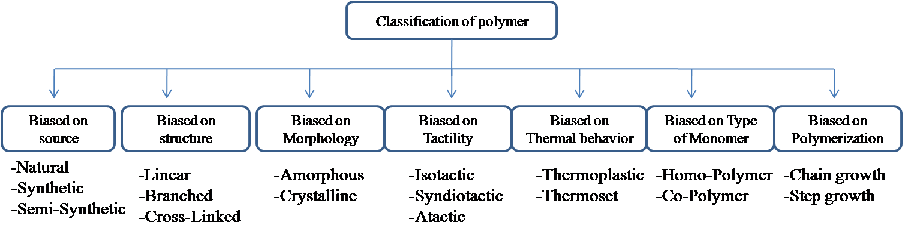
Figure (2.1): Classifications of Polymer.

2.1.1Natural& Synthetic Polymer

Polymers may either be naturally occurring or purely synthetic.
Natural Polymer: All the conversion processes occurring in our body (e.g., generation of energy from our food intake) are due to the presence of enzymes. Life itself may cease if there is a deficiency of these enzymes. Enzymes, nucleic acids, and proteins are polymers of biological origin. Their structures, which are normally very complex, were not understood until very recently. Starch a staple food in most cultures cellulose, and natural rubber, [Robert , 2000 , P. 544]. Polymer molecules that are found in nature called natural polymer, among naturally occurring polymers are proteins, starches, cellulose, quartz, natural rubber, and carbohydrates. Some of these natural polymers include DNA and RNA. These are critical in genes and life processes, [Ahluwalia & Kidwai , 2008 , p.219].

Synthetic Polymer: Synthetic or manmade polymers are produced commercially on a very large scale and have a wide range of properties and uses, like nylons, polyethylene and polystyrene, in general synthetic polymers commonly called plastic.
The raw materials for these polymers are obtained from petroleum, a limited, non-renewable resource, [Ahluwalia & Kidwai , 2008 , p.219].

2.1.2PolymerStructure

A polymer is formed when a very large number of monomers are made to link up by covalent bonds under appropriate conditions. Certainly even if the conditions are “right” not molecules possess the ability to form polymers, [Robert , 2000 , P. 544].

The structural units resulting from the reaction of monomers may in principle be linked together in any conceivable pattern.Bifunctional structural units can enter into two and only two linkages with other structural units. This means that the sequence of linkages between bifunctional units is necessarily linear. The resulting polymer is said to be linear, [Robert , 2000 , P. 544];VanderWaals bonding between chains are founded like polyethylene and nylonm,[ Glaser , Granthil , & Mathieu , 2004 , P. 34].
However, the reaction between polyfunctional molecules results in structural units that may be linked so as to form nonlinear structures. In some cases the side growth of each polymer chain may be terminated before the chain has a chance to link up with another chain. The resulting polymer molecules are said to be branched,[Robert , 2000 , P. 544].In other cases, growing polymer chainsbecome chemically linked to each other, resulting in across-linkedsystem, [Robert , 2000 , P. 544].As shown in Figure (2.2).

Figure (2.2): Linear, branched and cross-linked polymers,[Robert , 2000 , P. 544].

2.1.3 Telicit

Atoms are linked together in the same order, but can have different spatial arrangement this called Stereoisomerism, can classified as the following:

- Isotactic configuration: all side groups R areonthe same side of the chain.
- Syndiotactic configuration: side groups Ralternate sides of the chain.
- Atactic configuration: random orientations ofgroups R along the chain,[ Glaser , Granthil , & Mathieu , 2004 , P. 34].

2.1.4 Polymer based on type of Monomer

Polymers may be either Homopolymers or Copolymers depending on the composition.
Homopolymer:This polymer contains a single type of repeat unit like Polystyrene.
Copolymer:These polymer made up of two different monomers like Styrene butadiene SBS, [Ahluwalia & Kidwai , 2008 , p.219]. If the polymer composed of different mers at least two different types of mers these called Copolymers, can differ in the way the mers are arranged as shown in Figure (2.3):
- Random copolymer: The repeating units are arranged randomly on the chain molecule. It we represent the repeating units by A and B, and then the random copolymer might have the structure shown below.
- Alternating copolymer: There is an ordered (alternating) arrangement of the two repeating units along the polymer chain.
- Block copolymer: The chain consists of relatively long sequences (blocks) of each repeating unit chemically bound together.
- Graft copolymer: Sequences of onemonomer (repeating unit) are “grafted” onto a backbone of another monomer type, [Robert , 2000 , P. 544] , [Glaser , Granthil , & Mathieu , 2004 , P. 34].

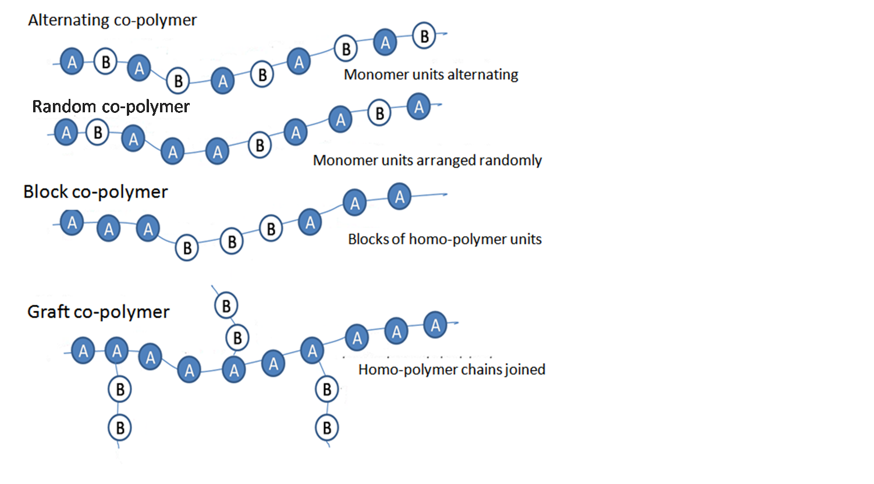
Figure (2.3): Polymer based on types of Monomer.

2.1.5 Thermal Behavior

For engineering purposes, the most useful classification of polymers is based on their thermal (thermo mechanical) response. Under this scheme, polymers are classified as thermoplastics or thermo sets. As the name suggests, thermoplastic polymers soften and flow under the action of heat and pressure. Upon cooling, the polymer hardens and assumes the shape of the mold (container). Thermoplastics, when compounded with appropriate ingredients, can usually withstand several of these heating and cooling cycles without suffering any structural breakdown. This behavior is similar to that of candle wax. Examples of thermoplastic polymers are polyethylene, polystyrene, and nylon, [Robert , 2000 , P. 544] , [Ahluwalia & Kidwai , 2008 , p.219].

The basic structural difference between thermoplastics and thermosets is that thermoplastic polymers are composed mainly of linear and branched molecules, whereas thermosets are made up of cross-linked systems. Recall from our previous discussion that linear and branched polymers consist of molecules that are not chemically tied together. It is therefore possible for individual chains to slide past one
another. For cross-linked systems, however, chains are linked chemically; consequently, chains will not flow freely even under the application of heat and pressure, [Robert , 2000 , P. 544].

2.1.6Polymer Morphology

Morphology for polymers means the study of physical form, arrangement and structure of the molecules of a material, [Ahluwalia & Kidwai , 2008 , p.219] ,[Shawbury , 2005 , p. 556].Polymers in the solid state may be amorphous or crystalline. Polymers are different; they can be amorphous totally lacking positional order on the molecular scale or semi crystalline containing both crystalline and amorphous regions in the same sample,[Shawbury. et al,2005 , p. 556].When polymers are cooled from the molten state or concentrated from the solution, molecules are often attracted to each other and tend to aggregate as closely as possible into a solid with the least possible potential energy,[Robert , 2000 , P. 544].
For some polymers, in the process of forming a solid, individual chains are folded and packed regularly in an orderly fashion. The resulting solid is a crystalline polymer with a long-range, three-dimensional, ordered arrangement. However, since the polymer chains are very long, it is impossible for the chains to fit intoa perfect arrangement equivalent to that observed in low-molecular-weight materials,[Robert , 2000 , P. 544].Some polymers specially Polyolefin, a highly crystalline material. Although single crystals of some polymers such as polyethylene can be grown under laboratory conditions, no bulk polymer is completely crystalline. In the case of semi-crystalline polymers, regular crystalline units are linked by un-oriented random conformation chains that constitute amorphous region, [Ahluwalia & Kidwai , 2008 , p.219].

An important example of commercial polymer with low crystanillity is polyvinyl chlorides (P.V.C). Many other polymers such as atactic PS (Polystyrene) and PMAA (Polymethyl methacrylate) are totally amorphous. In all these cases, morphology aspects such as the presence of crystalline structure have a significant influence on the thermal, physical and mechanical properties of the polymer, [Ahluwalia & Kidwai , 2008 , p.219].

Degree of crystallinity is determined by:
- Rate of cooling during solidification: time is necessary for chains to move and align into a crystal structure.
- Mer complexity: crystallization less likely in complex structures, simple polymers, such as polyethylene, crystallize relatively easily.
- Chain configuration: linear polymers crystallize relatively easily, branches inhibit crystallization, network polymers almost completely amorphous, cross linked polymers can be both crystalline and amorphous.
- Isomerism: isotactic, syndiotacticpolymers crystallize relatively easily - geometrical regularity allows chains to fit together, atactic difficult to crystallize.
- Copolymerism: easier to crystallize if mer arrangements are more regular - alternating, block can crystallize more easily as compared to random and graft.
More crystallinity: higher density, more strength, higher resistance to dissolution and softening by heating, [Glaser , Granthil , & Mathieu , 2004 , P. 34].

The main different between the natural and synthetic polymers, that polymer with natural rescores can breack down easly by microorganisms so natural polymers can Characterized as bidegredable polymers.

Chapter 3
Biodegradation

3. Biodegradation

Biodegradation is a chemical degradation of materials by the action of microorganism such as bacteria, [Leja&Lewandowicz. ,2009, p. 1]. also the Biodegradation can be defined as capable of undergoing decomposition into carbon dioxide, methane, water and inorganic compounds, or biomass in which the predominant mechanism is the enzymatic action of microorganisms, that can be measured by standardized tests, in a specified period of time, reflecting available disposal condition,[Shwin Kumar. et al, 2011, p. 3] ,[Ashwin Kumar. A. et al, 2011 , p. 3]. Biodegradable material are beginning to be accepted in many countries due to the conventional of the synthetic plastic have many problems such as Pollution of water, air and soil, also the growing problem of waste resulting in the shortage of landfill availability and need for the environmentally responsible useofresources,[Berkesch, 2005, p1].

3.1Mechanism of biodegradation
Two key steps occur in the microbial polymer degradation process: first, a de-polymerization or chain cleavage step, and second, mineralization. The first step normally occurs outside the organism. The microorganisms must first excrete extracellular enzymes which de-polymerize the polymers outside the cells due to the size of the polymer chain and the insoluble nature of many of the polymers. As a consequence, if the molar mass of the polymers can be sufficiently reduced to generate water–soluble intermediates, these can be transported into the microorganisms and fed into the appropriate metabolic pathway(s). As a result, the end product of these metabolic processes includes water and carbon dioxide together with new biomass. The extracellular enzymes are too large to penetrate deeply into the polymer material and so act only on the polymer surface. Consequently, the biodegradation of plastics is usually a surface erosion process, [Shawbury , 2005 , p. 556],[Welzel , Belal , & muller , 2002 , p. 574].

The biodegradation process can be divided into (1) aerobic and (2) anaerobicdegradation:

Aerobic biodegradation:
POLYMER+ O2 CO2 + H2O + biomass+ residue(s)…………..(1)
Anaerobic biodegradation:
POLYMER CH4 + H2O + biomass+ residue(s)…………..(2)
If oxygen is present, aerobic biodegradation occurs and carbon dioxide is produced. If there is no oxygen, an anaerobic degradation occurs and methane is produced instead of carbon dioxide. When conversion of biodegradable materials or biomass to gases (like carbon dioxide, methane, and nitrogen compounds), water, salts, minerals and residual biomass occurs, this process is called mineralization. Mineralization is complete when all the biodegradable materials or biomass are consumed and all the carbon is converted to carbon dioxide, [Leja&Lewandowicz. ,2009, p. 1].

Biodegradable materials have the proven capability to decompose in the most common environment where the material is disposed, within one year, through natural biological processes into non-toxic carbonaceous soil, water or carbon dioxide, [Leja&Lewandowicz. ,2009, p. 1]. The chemical structure (responsible for functional group stability, reactivity, swelling behavior, also the hydrophilic/hydrophobic character of polymers) is the most important factor affecting the biodegradability of polymeric materials. Other important factors are inter alia, physical and physico-mechanical properties, e.g., molecular weight, porosity, elasticity and morphology (crystalline, amorphous), [Yan&Texter, 2013 , p.1653].

3.2Applications for biodegradable polymers

Applications for biopolymers have introduced include medicine, packaging, agriculture. Fertilizer and chemical storage bags which are biodegradable are also applications that material scientists have examined. From an agricultural standpoint, biopolymers which are compostable are important, as they may supplement the current nutrient cycle in the soils where the remnants are added, [Shwin Kumar, 2011, p. 3].

3.3Types of degradable plastics

The major category of biodegradable polymers consists of those with hydrolysable linkages along the polymer chain backbone: polyamides, polyanhydrides, poly (amide-enamine) s, and polyphosphazene. Outside of natural fibers like wool and silk, polysaccharides such as starch are the most prevalent naturally biodegradable polymers in commercial use as shown in Figure (8), that shows classification of the main biodegradable polymers, [Shawbury , 2005 , p. 556].

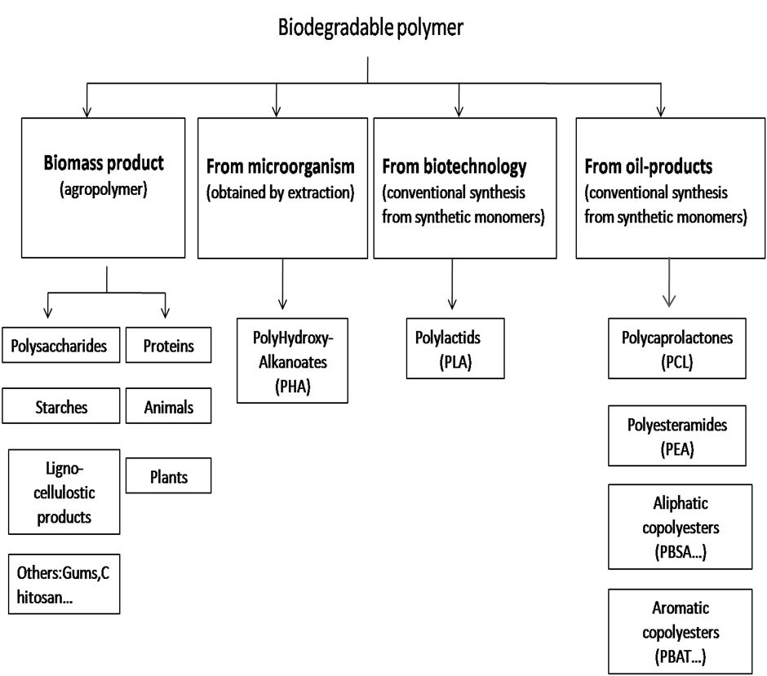

Figure (3.1): Classification of the main biodegradable polymers, [Averous, 2004].

3.4Testing methods

There are many methods for testing biodegradation, such as burying plastics in soil, placing it in a lake or river, or performing a full-scale composting with the biodegradable plastic as shown in Table (1), there are several serious disadvantages associated with these types of test, one problem is that environmental conditions such as temperature, pH, or humidity cannot be well controlled and secondly, the analytical opportunities to monitor the degradation process are limited. In most cases it is only possible to evaluate visible changes on the polymer specimen, or perhaps to determine disintegration by measuring weight loss. The latter approach is problematic if the material breaks into small fragments that must be quantitatively recovered from the soil, compost or water. The analysis of residues and intermediates is complicated by the complex and undefined environment. Since the pure physical disintegration of a plastic is not regarded as biodegradation in the sense of most definitions, these tests alone can never distinguish whether a material is biodegradable or not.

Table (3.1): Schematic overview on tests for biodegradable plastics

laboratory – tests |  | simulation-tests | field - tests
Enzyme-test:  enzymes | clear-zone test:  individual- cultures | laboratory reactor:  water  soil  compost  material from landfill | in nature:  water  soil  compost  landfill
synthetic environment  defined conditions |  | complex environment  defined conditions | complex environment  variable conditions

As an alternative to field tests, various simulation tests in the laboratory have been used to measure the biodegradation of plastics. Here, the degradation might take place in compost, soil or sea water placed in a controlled reactor in a laboratory. Although the environmental conditions are still very close to the field-test situation, the external parameters (temperature, pH, humidity, etc.) can be controlled and adjusted and the analytical tools available are better than for field tests (e.g. for analysis of residues and intermediates, determination of CO2 evolution or O2 consumption), [Welzel, Belal , & muller , 2002 , p. 574].

The most biodegradation tests are the laboratory tests, where defined media are used (in most cases synthetic media) and which are inoculated with either a mixed microbial population (e.g., from waste water) or individual microbial strains which may have been especially screened for a particular polymer. In such tests, which may be optimized for the activity of the particular microorganisms used, polymers often exhibit a much higher degradation rate than it would be observed under natural conditions. This can be regarded as an advantage when studying the basic mechanisms of polymer biodegradation, but on the other hand in laboratory tests it is only possible to derive limited conclusions on the absolute degradation rate of plastics in a natural environment. However, for many systematic investigations these tests are widely used, [Welzel , Belal , & muller , 2002 , p. 574].

3.5Sources of biodegradable plastic
There are many different sources and materials of biodegradable plastic that containing hydrolysable linkages such as protein, cellulose, bacteria, but the most source that generally susceptible to biodegradation by the hydrolytic enzymes of microorganisms, also the product tends to degrade slightly faster is starch,[Berkesch, 2005, p. 1].

Chapter 4
Starch

4. Starch:
Starch is a highly hydrophilic macromolecule. Starch has two major components: amylose and amylopectin. These polymers are very different structurally, amylose being linear and amylopectin highly branched - each structure playing a critical role in the ultimate functionality of the native starch and its derivatives. The amylose/amylopectin ratios of starches as shown in Table (4.2), can be genetically manipulated and offer a significant opportunity for the researcher with certain crops. Viscosity, shear resistance, gelatinization, textures, solubility,tackiness, gel stability, cold swelling and retrogradation are all functions of their amylose/amylopectin ratio ,[Morton Satin , 2007 , p. 1].
- Amylose :-molecular size ~ 5. 10⁵ g mol⁻¹

- Amylopectin: -molecular size ~ 10⁸ g mol⁻¹,[Murphy& Mitchell , 2009 , p. 1-750].

Table (4.1):Amylose / amylopectin contents ,[Murphy& Mitchell , 2009 , p. 1-750].
Starch Source | % amylose | Amylopectin
Maize | 26 | 76
Wheat | 25 | 75
Potato | 24 | 76
Tapioca | 17 | 83
Rice | 17 | 83
Waxy maize | <1 | <99
High amylose | 50/75 | 50/25

Starch consists of two kinds of glucose. The simple kind is called amylose, and it make up about 20% of starch. It is basically a chain of glucose units linked by α – 1, 4 – glycosidic bonds. During digestion, the oxygen bridges are hydrolyzed and the glucose units are broken up. 80% of starch is a water insoluble fraction called amylopectin, which is a branched chain polysaccharide with again α – 1,4 – glycosidic bonds as shown in Figure (4.1). At approximately every 25 glucose units, a branching of glucose units, exists. Upon treatment with acid or under the influence of enzymes, the components of starch are hydrolyzed progressively to dextrins (mixture of low melting polysaccharides, made up of 3 – 8 glucose units), maltose and finally D-glucose, [Xiao. C , Zhan. Xu, 2009 , p. 366–375].
Starch obtained by animals from plants is stored in the animal body in the form of glycogen. Digestive processes in both plants and animals convert starch to glucose. Starch is one of the major nutrients in the human diet. Its presence in foods and other substances can be detected by the blue-black color produced when iodine solution is added to a sample of the material to be tested, [Xiao. C , Zhan. Xu, 2009 , p. 366–375].
A
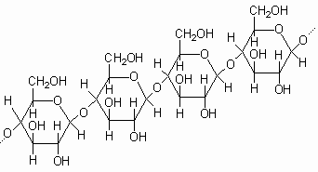
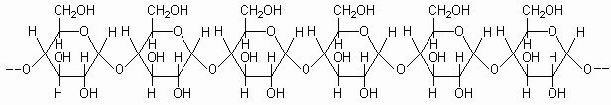A
β – 1, 4 – glycosidic bond
B
Figure (4.1): Starch (amylose) (A) and cellulose (B)
The production of starch polymers begins with the extraction of starch. Taking as an example corn: starch is extracted from the kernel by wet milling. The kernel is first softened by steeping it in a dilute acid solution, then ground coarsely to split the kernel and remove the oil-containing germ. Finer milling separates the fibre from the endosperm which is then centrifuged to separate the less dense protein from the more dense starch.
The starch slurry is then washed in a centrifuge, dewatered and dried. Either prior or subsequent to the drying step, the starch may be processed in a number of ways to improve its properties, [Xiao. C , Zhan. Xu, 2009 , p. 366–375].

4.1Propertiesof Starch
- Starch, an omnipresent bio-material, is one of the most abundant and inexpensive polysaccharide sourceswhich have the unique characteristic of biodegradabilityeasily dissolved in water, [Leja & Lewandowicz, 2009 , p.255-266].
- Starch is a highly hydrophilic macromolecule. It is oftenused as the degradable additive in the preparation ofbiodegradable polyethylene film, [Leja & Lewandowicz, 2009 , p.255-266].
- Starch is unique among carbohydrates because it occurs naturally as discrete granules. This is because the short branched amylopectin chains are able to form helical structureswhichcrystallize, [Bastioli ,2005 , p. 3-566].
- No sweet taste, [Bastioli ,2005 , p. 3-566].
- Insoluble in water. When mixed with water and heated, starch granules absorb water, thicken liquid and form gel, [Bastioli ,2005 , p. 3-566].

4.1.1Physical properties of starch

Such as paste- viscosity, stability, texture and interaction with other components in complex systems are likely directly determined by the molecular constitution of the polymer. The molecular size, unit chain length distribution, branching pattern and the degree of phosphate substitution have in different studies been demonstrated to exert some important effects on the physical properties of the starch. High amylose contents restrict swelling and increase gel formation and subsequent irreversible retrogradation.Amylopectin chain length structure and molecular mass as well as amylose branch pattern and molecular mass distribution also influence physical properties of the starch as shown in Table (4.1),[Bastioli , 2005 , p. 3-566].

Table [4.2]: Properties of different types of starch: ,[Murphy& Mitchell , 2009 , p. 1-750].
Freeze / thaw stability | Resistance to shear | Stability to retrograde | Gel Texture | Solution Clarity | Gel Temp °C | Granule Size µ | Starch Source
Poor | Fair | Poor | Short | Opaque | 62 – 74 | 10 – 20 | Maize
Poor | Fair | Poor | Short | Opaque | 52 – 64 | A 25 –35  B 2 - 5 | Wheat
Poor | Fair | Poor | Short | Opaque | 61 – 78 | 3 – 8 | Rice
Poor | Poor | Fair | Very cohesive | Clear | 56 – 69 | 15 – 100 | Potato
Poor | Poor | Fair | Soft | Clear | 60 – 72 | 20 – 60 | Tapioca
Poor | Poor | Fair | Soft | Clear | 52 – 64 | 15 – 25 | Sago
Fair | Poor | Good | Cohesive | Clear | 63 - 72 | 6 – 30 | Waxy Maize

Blending of starch-based materials4.2
Blending is one of the most common techniques of polymer technology to produce materials with physical properties that are different from those of the pure components. Blending may yield to: (i) materials with a favorable set of desired properties without having to synthesize completely new materials; or(ii) materials with improved specific properties (e.g., impact strength or moisture resistance) ,[Edwin Habeych , 2009, p.1-152].

Chapter 5
Polymerization of Starch

5. Polymerization of Starch
Polymerization is the process in which monomer units are linked by chemical reaction to form long chains. These long chains set polymers apart from other chemical species and give them their unique characteristic properties. The polymer chains can be linear, branched, or cross linked. Thermoplastic material is a polymer that can be softened or melted under the application of heat and pressure and becomes hard solid when being cooled, [Sriroth & Sangseethong, 2009, p. 1-4]. Naturally, starch is not a real thermoplastic. The molecules in starch granule possess high intermolecular association leading to strong crystalline structure. As a result, its melting temperature is higher than its decomposition temperature; and the degradation would take place before crystal melting. However, with the aid of an additive called plasticizer, higher temperature (nearly 80 °C) and shearing, the crystalline structure of the starch granules can be destroyed, and the starch granules can be melted at a much lower temperature which will result in a continuous phase in the form of a viscous melt. So to obtain a thermoplastic starch it is necessary that the starch maintains its semi-crystal granular structure and it behaves in a way similar to that of a melted thermoplastic, [Vilpoux & Avérous , 2003 , p. 499-529].
The water added to the formula plays two roles: it is an agent that breaks the structure of the native granule, breaking the bonds of hydrogen chains. Although water has a very good plasticizing effect on starch, it is not suitable as a plasticizer for the production of TPS due to its high volatility. As shown in Figure (5.1). The TPS would become more brittle as the material losses water over time. The use of other plasticizers (for example glycerol) results in a rubbery material,with better properties than virgin starch in various applications.
The elongation of break of the thermoplastic starchis significantly improved by plasticization with glycol, glycerol, and hexyleneglycol. The plasticized starch properties may be tuned by changing thetemperature of processing, water content, and the properties and amount ofplasticizers. For instance, the thermal properties of glycerol‐plasticized starch are afunction of water content. At intermediate water levels, phaseseparation may still occur and as water has a plasticizing power, the material behavior changes according to the relative humidity of the air, [Azwa, Yousif, & Manalo , 2013 , p. 424–442]. Although thermoplasticization seems to be a promising method, TPSsynthesized from polyol and sugar plasticizers have the tendency to re‐crystallize(retrogradation) after being stored for a period of time, which results inembrittlement. Another issue is the poor water resistance and low strength, whichstill limits their use.The plasticizers are also usually hydrophilic and can bewashed out by water. Solutions to improve the properties of TPS are blending,or coating with hydrophobic polymer TPS can be used as the main component of the plastic matrix because it can be melted and fabricated into any desirable shape by the application of heat and mechanical energy. However, TPS has two main drawbacks: namely its water sensitivity and its poor mechanical properties. Most research activities on this area have been concentrated on the ways to overcome these limitations. The most common approaches to improve TPS properties are by modifying starch structure via chemical reaction and blending of TPS with other synthetic polymers.

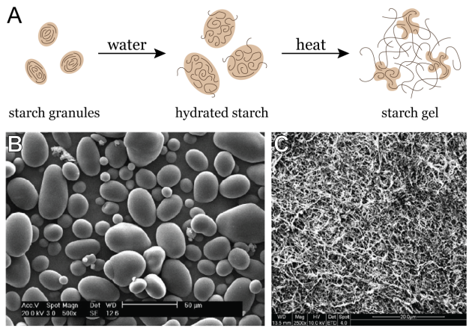
Figure (5.1): The Steps of Starch Polymerization, [Azwa, Yousif, & Manalo, 2013, p. 424–442].

Chapter 6
Experimental Work

6. Several trials were carried out to produce TPS sample through preparing and using raw material by special procedure.
6.1 Raw materials
- Starch (Corn starch)
- Water.
- (HCL) as acid.
- Plasticizer (Glycerin).
All above material were supplied from local market.
6.2 Experimental Procedure for our samples:
1) Initially the gluten was removed from starch by dichloromethane (excess amount of DCM was added into starch then filtration the starch from DCM)
2) Starch was put in beaker.
3) Then water was added to the starch and mixing by the glass rod.
4) Then HCL was added.
5) Glycerin was introduced to the mixture in different percentages.
6) Mixing all raw materials to be homogenous.
7) The mixtures were placed on heater and mixed until the mixture becomes viscous and semitransparent.
8) Before the mixture was reached to boiling point, it was poured into the mold.
9) The samples were placed in the oven for 2 hours at a temperature of approximately 80-100 ◦C.
10) After preparing TPS films they were pressed by thermo-press mold at 130◦C to insure that the film was thermo plastic.
- This procedure was done by using different parameters with different percentage of raw materials as shown in Table (6).

From first trial, the resulted plastic wasn't easily dried because large amount of water was used. In second one, the amount of acid and glycerin wrer increased; the resulted plastic had a good flexibility but wasn't completely dried as shown in Figure (7.1)(A). In third trial the concentration of Citric acid and the resulted plastic was as the same one obtained in second one. In these three trials when the solution was poured on mold, the thickness of mixture was high . When half amount of glycerin was used in forth trial, the resulted plastic had low flexibility and can be broken. In fifth trail no glycerin was added to solution and the resulted plastic was brittle and can be easily broken. Propylene glycol was used instead of glycerin; the resulted plastic had same characteristics of plastic with glycerin but with lower flexibility. In seventh trial low amount of water was used, the mixture was difficult to control during preparation. HCl was used instead of citric acid in eighth trial with different tow concentrations but the resulted plastic from both concentrations had the same characteristics , the resulted plastic became transparent but without becoming viscous. The resulted plastic in all of these trials didn't re-conformed thermally, but the samples were succeed from trial one to trial ninth just success after drying, but under thermo press mold the samples were failed.
After working these experiments the parameters were adjusted as shown from trial 11 to trial 13.
The last three trials were good and successful samples, HCl was used with fixed concentration of 0.1%. The resulted plastic was thin film that can be re-conformed thermally by thermo press mold as shown in Figure (7.1)(B).
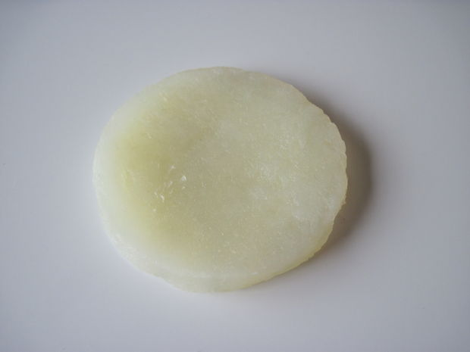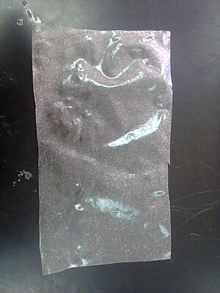
(B)
(A)
Figure (7): (A) Samples that achieved from 1,2 and 3 trials, (B) samples that achieved from last trial.

Testing:
Testing was done for samples of TPS with produced different parameters to know the mechanical properties by tensile test, and thermal properties by Differential scanning calorimeter and Melt flow index.
- Tensile test: The tensile strength, modulus of elasticity and percent elongation of films were determined using Sinowon testing machine ST series, model No:ST-500 at room temperature and at constant speed 4 mm/min.

- Differential scanning calorimeter (DSC): used to measure thermal transitions of TPS films and nanocomposite films. The test was performed with Perkin Elmer (Jade DSC) equipment, fitted with a nitrogen-based cooling system. The samples were weighed in aluminum pans and hermetically sealed; an empty pan was used as reference. From DSC the melting point and percentage of crystalinity can be obtained. . All measurements were performed in the range 25 to 200 ◦C at a heating rate 10 ◦C/min.

- Melt flow index: used to measure the melt mass flow rate, melt volume flow rate, and melt density by extrusion of thermoplastics through an orifice at a prescribed temperature and load. This test was done by compressing 6g from each sample by a weight about 5 Kg and melting it at temperature about 190 °C for 10 minutes.

Chapter 7
Results and Discussion

The samples shown in Table (7) were the most successful samples of (TPS), they will be tested mechanically and thermally.

Table (7): Successful samples with different parameters.
Plasticizer  glycerin | Acid (HCL) | water | Starch | parameters
percentage | percentage | percentage | percentage | # of sample
5% | 6% | 75% | 14% Without gluten | 1
3.5% | 6% | 76.5% | 14% Without gluten | 2
3.5% | 6% | 76.5% | 14%With gluten | 3
2.5% | 6% | 77.5% | 14% Without gluten | 4

7.1. Mechanical properties of the TPS:

Table (7.1) : Mechanical properties of starch and fibers composites.
 | % of glycerin | Amount of glycerin(ml) | presence of gluten | Modulus of elasticity (MPa) | Maximum stress(MPa) | Strain at break(%)
1 | 2.6 | 10 | no | 56.35 | 1.606098 | 23.8 %
2 | 3.8 | 15 | no | 40.88 | 1.510003 | 10.63 %
3 | 3.8 | 15 | yes | 48.7 | 1.579550 | 9.42%
4 | 5 | 20 | no | 13.7 | 0.384811 | 7.97 %

Table (7.1) shows the tensile properties of the TPS films. Tensile properties such as modulus of elasticity, max Stress and elongation at break (%El) these values have been evaluated from the experimental stress–strain curves obtained for all prepared films. The same percent of glycerin was used for two samples one of them with gluten and the other one without, it was obvious that the modulus was lower when the gluten was removed for the sample 3.8% of plasticizer (Glycerin). However, the %El increased also when the hygroscopic mechanism was removed.

7.2. Thermal analysis:

Results from Differential Scanning Calorimeter (DSC):

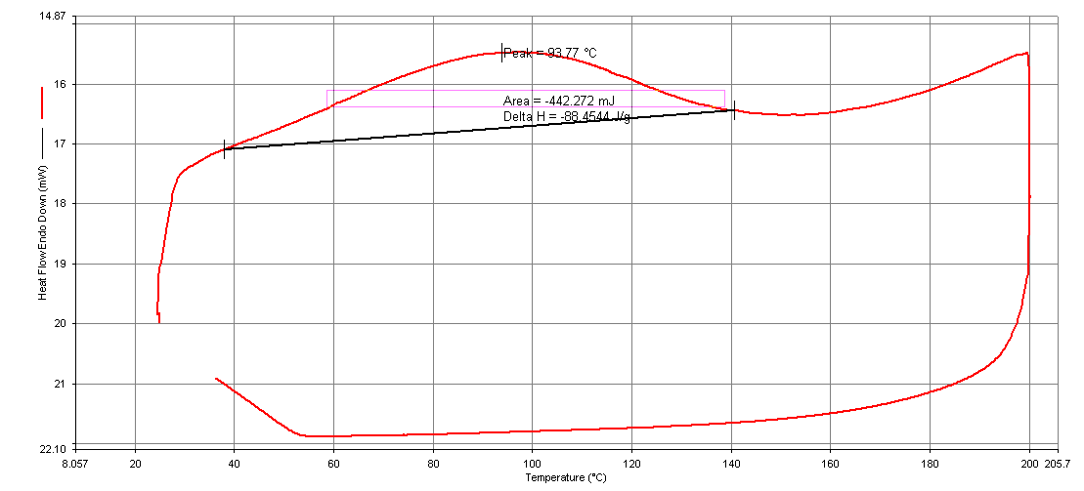
Figure (7.2.1): DSC curve of TPS/3.8% glycerin with gluten.

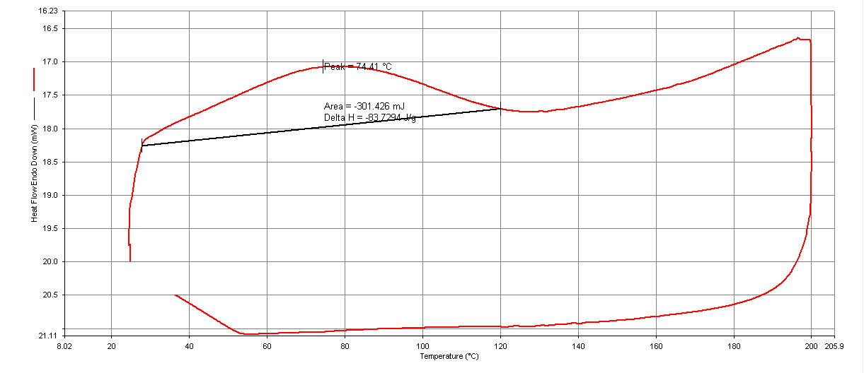
Figure (7.2.2): DSC curve of TPS/3.8% glycerin without gluten.

The values of melting point and heat of fusion were taken from Figures (7.2). The calculations were done to calculate the percentage of crystallinity by taking ratio between heat of fusion of TPS samples and reference. The heat of fusion of reference (∆H˚m) was 128.8 J/g. It was noticed from previous calculations that there is a proportional relationship between percent of crystallinity and mechanical properties of TPS (modulus of elasticity). As shown in Table (7.2).

Table (7.2): DSC results with mechanical properties.

TPS sample | presence of gluten | % of glycerin | M.p | % of cristallinity | Modulus of elasticity (MPa) | Maximum stress(MPa)
1 | Yes | 3.8 | 93.77 | 68.7 % | 48.7 | 1.606098
2 | No | 3.8 | 74.41 | 65 % | 40.88 | 1.510003

7.3. The Effect of Glycerin Percentage on Mechanical Properties:

Figure (7.3): relationship between the percentage of glycerin and mechanical properties.

The percentage of glycerin affects the mechanical properties of TPS such as modulus of elasticity, maximum stress and %El they decreased with increasing the percentage of glycerin. To get the TPS with good mechanical properties the percentage of glycerin must be low, but not lower than 2.6% of glycerin to obtain the flexibility as shown from Figure (7.3).
The highest effect of percentage of glycerin was on the maximum stress it was noticed that at 2.6% glycerin the highest value of maximum stress was obtained which was 1.6 MPa. For modules of elasticity there was nearly a linear inverse relationship and the best value of modulus of elasticity was in 2.6 % glycerin. Percentage of glycerin has lowest effect on strain comparing with the other properties.

7.4. Gluten Removal:

By removing gluten from starch the resulted TPS had a suitable mechanical properties and higher water resistance, without loss of their characteristics of biodegradability.
Table (7.4): The Effect of Gluten Presence on the Mechanical Properties.

TPS sample | presence of gluten | % of glycerin | Melting  Point | % of cristallinity | Modulus of elasticity (MPa) | Maximum stress(MPa)
1 | Yes | 3.8 | 93.77 | 68.7 % | 48.7 | 1.606098
2 | No | 3.8 | 74.41 | 65 % | 40.88 | 1.510003

Table (7.4) shows that the tensile strength decreased, elongation increased and milting point were decreased also crystallinity was decreased when gluten was removed from the sample. The difference between these two samples was related to the immiscibility of gluten in water.

7.5. Water Loss:
Table (7.5): The Water Loss in TPS Sample after Certain Days
Time (Days) | % Loss
7 | 32.5
14 | 6.7
21 | 5.9

The origin sample weight was 1.35g. When this sample was soaked in water there was a loss in water content of sample, in the first seven days the water loss percent was at high value about 32.5%. This loss decreased to reach after 21 days a weight percent of TPS sample about 5.9%.

7.6. Melt Flow Index
The results were as shown in Table (7.6):
Table (7.6): The Melt Flow Index for TPS Samples
Sample | percentage of Glycerin | Presence of Gluten | Melt Flow Index. 5Kg / 190 °C  (g/10 min)
1 | 3.8% | Yes | 22.7
2 | 3.8% | No | 27.13
3 | 5% | No | 31.16

The results were obtained from this test shows that the Melt Flow Index increased with increasing the percentage of glycerin which means a decrease in molecular weight of samples.

7.7. Comparison between Our Works and the Others Works
The results were obtained to determine the mechanical properties of TPS samples were better than the results of the other specialists in the same field.
The resulted TPS sample with good mechanical properties was obtained by using 2.6 % of glycerin and starch-gluten removed. The mechanical properties were 56.35 MPa for Young Modules, 1.6 MPa for tensile strength and elongation about 23.6%.
research about Natural fiber-reinforced thermoplastic starch composites obtained by melt processing showed that the resulted mechanical properties TPS were 10 MPa for young modules,1.3 MPa for tensile strength and elongation about 20%,[Gironès, López, Carvalho, Curvelo and Vilaseca, 2012, P. 858–863]. Other research form Brazil about the properties of thermoplastic starch showed that the resulted f tensile strength were 0.6 MPa which is smaller than the value of tensile strength in our project,[Campos, Marconcini, Martins-Franchetti and Mattoso, 2012. P. 1948-1955]. Also the research nn State University of Londrina, Brazil about the mechanical properties of starch-based films showed the value of modules of elasticity which is 21 MPa was lower than our result, [Carmen, Müller, Joao, Laurindo and Fabio, 2009, P. 293–299] .
The difference between our work and the others work came from different reasons such as procedure that was considered to prepare the samples, in our TPS project the percentages of raw materials were carefully controlled especially the percentage of glycerin to be lower than the percentage used in other's work. Our TPS sample had 2.6% as glycerin percent while the percentage of glycerin that used in the other's studies was 5%. So according to high amount of glycerin the resulted TPS of the other's research was brittle. While in comparison with our work used the resulted TPS has a very good mechanical properties like modules of elasticity and tensile strength. Moreover, The removal of gluten increased the elongation of resulted TPS.

Chapter 8
Conclusion

8. Conclusion:

The main results were observed and noticed from this project:
- TPS was prepared by mixing starch and water with addition to a plasticizer like glycerin and Hydrochloric acid.
- The mechanical analysis showed that the percent of glycerin related inversely with the mechanical properties of resulted TPS.
- At low percent of glycerin and used starch contained gluten, the resulted TPS had a very good mechanical properties and so more crystalline structure.
- When the gluten was removed from the starch, the resulted TPS had less possibility to absorb water.
- The thermal analysis showed that there is a proportional relationship between percent of crystallinity and mechanical properties of TPS.

References
- Ashwin. K, Karthick. K, and Arumugam. P, 2011. Biochemistry and Bioinformatics. Biodegradable Polymers and Its Applications. Vol.1, p. 3

- Averous. S, 2004, Classification of biodegradable polymers. Barazil, p. 33-101.

- Bastioli .C , (2005) , Rapra technology limited , 1sted , Shawbury, Shrewsbury, Shropshire , SY4 4NR , United Kingdom, p. 3-566.

- Berkesch.S , 2005 , Biodegradable Polymers: A Rebirth of Plastic , 1sted, Michigan State University , Michigan State, p.1.

- Müller. CMO , Laurindo. JB , Yamashita F , 2009, Carbohydrate Polymers. Effect of cellulose fibers on the crystallinity and mechanical properties of starch-based films at different relative humidity values, 1sted, p. 293–299.

- Danupol. K , Bhalang. S, Ratchada. T, and Kamol. L, 2013, Carbohydrate Polymers. Changes in physicochemical properties of waxy corn starches at different stages of harvesting, 1sted, p. 241– 248.

- Xiao. C , Zhan. Xu , (2009) , Starch-based completely biodegradable polymer materials.eXPRESS Polymer Letters. Vol.3, p. 366–375.

- Edwin. A, Habeych. N , (2009) , Development of starch-based materials, 1sted , Wageningen University, p. 1-152.

- Yan. F, Texter. J. 2013.Progress in Polymer Science. Bio-based plastics and bionanocomposites , 1sted , Current status and future opportunities , p.1653.

- John. M, Thomas. S, 2008, Biofibres and biocomposites. CarbohydrPolym, p. 64.

- Sriroth. K, Sangseethong. K, (2009), Starch: An Important Component of the Paper Making Process. Thai Tapioca Starch Association, p. 1-4.

- Welzel. K, Belal. E, and Müller. RJ. (2002). Einsatz von Nanopartikeln zur schnellen Evaluierung der biologischen Abbaubarke it von Polyestern. Chemie Ingenieur Technik p. 574.

- Leja. K, Lewandowicz. G, 2009, Polish J. of Environ. Stud. Polymer Biodegradation and BiodegradablePolymers, 19(2), p.255-266

- Morton. S, 2007. Functional Properties of Starches, FAO Agricultural and Food Engineering Technologies Service. 1sted, p.1-9

- Murphy. P, Mitchell. J, (2009) Starch in Handbook of Hydrocolloids edited and Phillips G.O and Williams P.A,Woodhead Publishers, p. 1-750.

- Savadekar. N, Mhaske. S, 2012. Carbohydrate Polymers. Synthesis of nano cellulose fibers and effect on thermoplastics starch based films, p. 146– 151.

- Vilpoux. O, Avérous. L, (2003), Latin American Starchy Tubers, technology, use and potentialities. Vol.3, Chapter 18. p. 499-529.

- Glaser. P, Granthil. C, Mathieu. D , and Mercier. P, 2004 . Introduction to Materials Science.Chapter 15, Polymer Structures. Vol.1, p. 34.

- Piyada. K, Waranyou. S, and Thawien. W, (2013), International Food Research Journal. Mechanical, thermal and structural properties of rice starch films reinforced with rice starch nanocrystals, p. 439-449.

- Robert. O, 2000. Polymer science and technology. Florida 33431, p. 544.

- Shakhashiri. A , 2008. Chemical Of The Week, scifun organization, p. 1.

.
- Shawbury. S, 2005. Handbook of Biodegradable Polymers. CatiaBastioli.. Rapra Technology Limited, p. 556.

- Shwin. K, 2011. Biodegradable Polymers and Its applications.Bioscience.Biochemistry and Bioinformatics.Vol.1, No. 3.

- Ahluwalia. VK, Kidwai. M. 2008. Polymer science, 1st ed, p. 219.

- Azwa. ZN, Yousif BF, Manalo. AC, and Karunasena. W, 2013. Materials and Design.A review on the degradability of polymeric composites based on natural fibres. p. 424–442.

