

An-Najah National University
Faculty of Engineering and Information Technology
Chemical Engineering Department

Design Of Absorption Tower
Graduation Project (2)

Submitted by:
Ala'a Naser
Noor Al-Awad
Sana Al-Nouri
Sherin Takrori

Supervisor:
Dr.Husni Odeh

Presented in partial fulfillment of the requirements for
Bachelor degree in Chemical Engineering

May 2015

‏2015

إلهي لا يطيب الليل الٌا بطاعتك ,,, ولا يطيب النهار الٌا بشكرك
ولا تطيب اللحظات الٌا بذكرك ,,, ولا تطيب الآخرة الٌا بعفوك
ولا تطيب الجنة الٌا برؤيتك ,,, سبحــانك جلٌ جلالك

إلى من بلٌغ الرسالة وأدى الأمانة ونصح الأمة الى نبي الرحمة ونور العالمين سيدنا محمد صلٌى الله عليه وسلٌم" "

إلى من كلله الله بالهيبة والوقار , الى من علٌم وعلٌمني العطاء ولا زال بدون انتظار , إلى الذي تبسم يوم ميلادي إلى الذي سار من أجلي في غربتي
إلى من أحمل أسمه بكل افتخار , يا من يرتعش قلبي لذكرك
إليك يا من وهبت عمرك لأجلنا أهدي لك نجاحي
"والدي الحبــيب"

الماس الذي لا ينكسر , نبع العطاء الذي زرع الأخلاق بداخلي وعلمتني طرق الارتقاء , الى من تعجز الكلمات عن وصفها وتسكن أمواج البحر لسماع صوتها
"والدتي الحبــيبة"

إلى الدم الذي يسير في عروقي ومن يسرهم فرحي , إلى الأزهار التي ترعرعت معي في بستان الأسرة إلى شموع قلبي إلى الذين أعشقهم بلا حدود
"أخوتي و صديقاتي"

إلى قناديل الجامعة وزينتها , أساتذتي الأفاضل
إلى دكتورنا الفاضل
"حسني عودة"

Contents
Chapter 1 1
Introduction[1] 1
1-1 Type of separation process : 1
1-2 Flow regimes on trays : 3
1-3 Hydrodynamic measurements: 6
1-4 Mass transfer : 7
1-5 operating line derivation: 7
1-6 Graphical determination of the number of trays: 9
1-7 Overall Mass Transfer Coefficients and Driving Forces: 10
Chapter 2 12
2-1 Constraints : 12
2-2 Standards / Codes : 14
2-2-1 Choice of plates or packing : 14
2-2-2 Plate spacing : 15
2-2-3 Estimation of interfacial area : 15
Chapter Three 18
3-1 The clear liquid height on a plate : 18
3-2 Influence of weeping on mass transfer rate of different plate: 22
Chapter Four 23
Methodology : 23
4-1 Part (A): Construction of tray column which have the following parts: 23
4-1-1 Sieve tray columns 23
4-1-2 Calculation of Geometrical Parameters of Sieve Trays: 23
4-1-3 Design of the downcomer : 26
4-1-4 Diameter of the column : 27
4-1-5 Design of stand: 29
4-2 Part (B): Experimental work 30
4-2-1 Hydrodynamic measurements of packed column: 30
4-2-2 Chemical absorption 31
Chapter Five 32
Results and Analysis: 32
Chapter Six 35
Discussion: 35
Chapter Seven 39
Conclusion and Recommendation: 39
Chapter Eight 41
References: 41

Abstract
Many Palestinian industrial activities release undesirable odors such as vapors produced from coffee beans toasters and chicken by-products processing Aziza Company. These activities need very expensive industrial absorption towers to control the emitted odors. This project is a local industrial attempt to tackle such industrial odor problems.
The absorption towers are entirely similar to distillation towers. The differences are in construction materials. PVC is used as a construction material of our absorption tower while the transparent poly acrylate is used for construction internal mass transfer perforated grids. Each grid has about 30 holes of 3mm hole diameter. The perforation has been made by computerized CNC machine. It has five gas absorption units with 13cm internal diameter. A stainless steel liquid pump with proper liquid/ gas flow meters installed. The absorption tower is mobile to allow transportation to any working place to carry out experiments.
The hydrodynamic experiments on this system show that it has a wide working regime with low-pressure loss. The used liquid flow rates are up to 500 L/h while the permitted polluted airflow rates are up to 8000L/h.
The absorption tower has one transparent gas absorption unit for teaching purposes to allow the students to follow up the foam structure inside this unit. The foam structure is responsible for the performance of the gas absorption unit because it generates the interfacial area between gas and liquid. There are specific formulae to calculate the interfacial area and give the ground to compare between different absorption towers.
One molar NaOH aqueous solution with 1% CO2 gas is taken as a basic reaction for calculation the interfacial area. This tower exhibits promising interfacial area of about 100-150 m²/m³ It is worth to say that the import value of such system is about
25 ,000 US dollars. The total cost of this absorption tower that has been constructed by our group has not exceeded $4000.
The processing capacity of the absorption towers are increased with diameter of the tower. In general, five absorption units are enough for such gas absorption processes.

Chapter 1

Introduction[1]

Many chemical process materials and biological substances present as mixtures of different components in the gas, liquid, or solid phase . Sometimes these differences cause undesirable odors in food and chemical factories so we are looking for a solution to remove such odors. In order to do so , we have to separate or remove one or more of the components from their original mixture that must be contacted with another phase. The two phases are brought into more or less intimate contact with each other so that a solute or solutes can diffuse from one to the other. The two-phase pair can be gas-liquid, liquid-solid, liquid-liquid, or liquid-solid phases. During the contact of the two phases , the components of the original mixture redistribute themselves between the two phases. The phases are then separated by simple physical methods by choosing the proper condition and phases. One phase is enriched with one component while the other is depleted in one or more components.

Type of separation process :

- Absorption: when the two contacting phases are a gas and a liquid, the unit operation is called absorption. A solute A or several solutes are absorbed from the gas phase into a liquid phase in absorption. This process involves molecular and turbulent diffusion or mass transfer of solute A through a stagnant no diffusing gas B into a stagnant liquid C. The reverse of absorption is called stripping or desorption, and the same theories and basic principles hold. When the gas is a pure air and the liquid is a pure water, the process is called humidification. Dehumidification involves removal of water vapor from air.
- Distillation: in the distillation process, a volatile vapor phase and a liquid phase that vaporizes are involved.
- Liquid-liquid extraction: when the two phases are liquids, where a solute or solutes are removed from one liquid phase to another liquid phase, the process is called liquid-liquid extraction.
- Leaching: if a fluid is being used to extract a solute from a solid, the process is called leaching. Sometimes this process is also called extraction.

- Membrane processing: separation of molecules by the use of membrane is a relatively new unit operation and is becoming more important. The relatively thin, solid membrane controls the rate of movement of molecules between two phases. It is used to remove salts from water, purify gases, in food processing , and so on.
- Crystallization: solute components soluble in a solution can be removed from the solution by adjusting the condition, such as temperature or concentration, so that the solubility of one or more solute components is exceeded and they crystallize out as a solid phase.
- Adsorption : in this process one or more components of a liquid or gas stream are adsorbed on the surface or in the pores of a solid adsorbent and a separation is obtained.

The project will focus on description of the main components of absorption column, the geometrical and operational parameters of Absorption column need to be investigated as well.
The components of tray column are, down-comers ,weirs, flanges, trays holding structures, pressure measuring system, ventilators, valves and pumps.
The geometrical parameters are determination the sizes of these elements, height of column and it’s diameter.
The operational parameters are the rates of gas and liquid pass through the column and the resulting of pressure drop through the column .

Absorption towers are applied at different industries such as pharmaceutical, food, petrochemicals and so on .
Our absorption pilot plant unit serve educational purposes.
The trays can be changed, and another trays with different geometrical parameters can be installed on their places.

We assure that the absorption columns will be economically developed and environmentally preserved in the field of chemical and food companies , the absorption columns are not manufactured in Palestine and imported at high cost, while the cost of production of this product locally is slightly low.

- What are the flow regime types ?
- What is the mass transfer ?
- How can we design tray absorption column?

1-2 Flow regimes on trays :

Three main flow regimes exist on industrial absorption trays:
- Froth regime (or mixed regime; (Fig. 1-a): This is the most common operating regime in distillation practice. Each perforation bubbles vigorously. The bubbles circulate rapidly through the liquid, are of non uniform sizes and shapes, and travel at varying velocities. The froth surface is mobile and not level, and is generally covered by droplets. Bubbles are formed at the tray perforations and are swept away by the froth.
As gas load increases in the froth regime, jetting begins to replace bubbling in some holes. The fraction of holes that is jetting increases with gas velocity. When jetting becomes the dominant mechanism, the dispersion changes from froth to spray.

- Emulsion regime (Fig. 1-b): At high liquid loads and relatively low gas loads, the high-velocity liquid bends the swarms of gas bubbles leaving the orifices, and tears them off, so most of the gas becomes emulsified as small bubbles within the liquid. The mixture behaves as a uniform two-phase fluid. In industrial practice, the emulsion regime is the most common in high-pressure and high-liquid-rate operation.

- Spray regime or drop regime,( Fig. 1-c): At high gas velocities and low liquid loads, the liquid pool on the tray floor is shallow and easily atomized by the high-velocity gas. The dispersion becomes a turbulent cloud of liquid droplets of various sizes that reside at high elevations above the tray and follow free trajectories. Some droplets are entrained to the tray above, while others fall back into the liquid pools and become reatomized . In contrast to the liquid-continuous froth and emulsion regimes, the phases are reversed in the spray regime: here the gas is the continuous phase, while the liquid is the dispersed phase
The spray regime frequently occurs where gas velocities are high and liquid loads are low (e.g., vacuum and rectifying sections at low liquid loads).

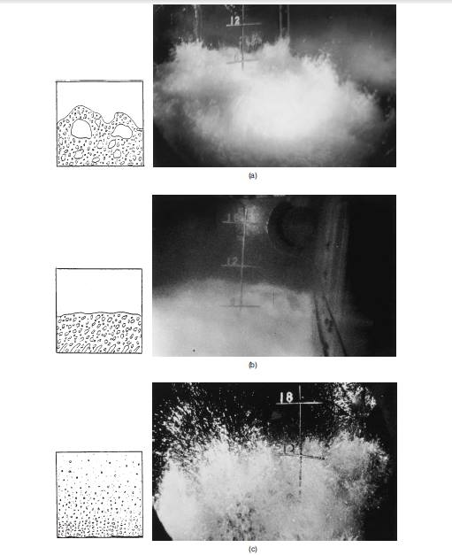
Figure(1) distillation flow regime (a) Froth (b) Emulsion (c) Spray

The next figure (2) demonstrates the sieve tray in operation. It is seen clearly the different component of any column such as down comer, weir the cross flow of liquid and the form of foam structure on the tray.
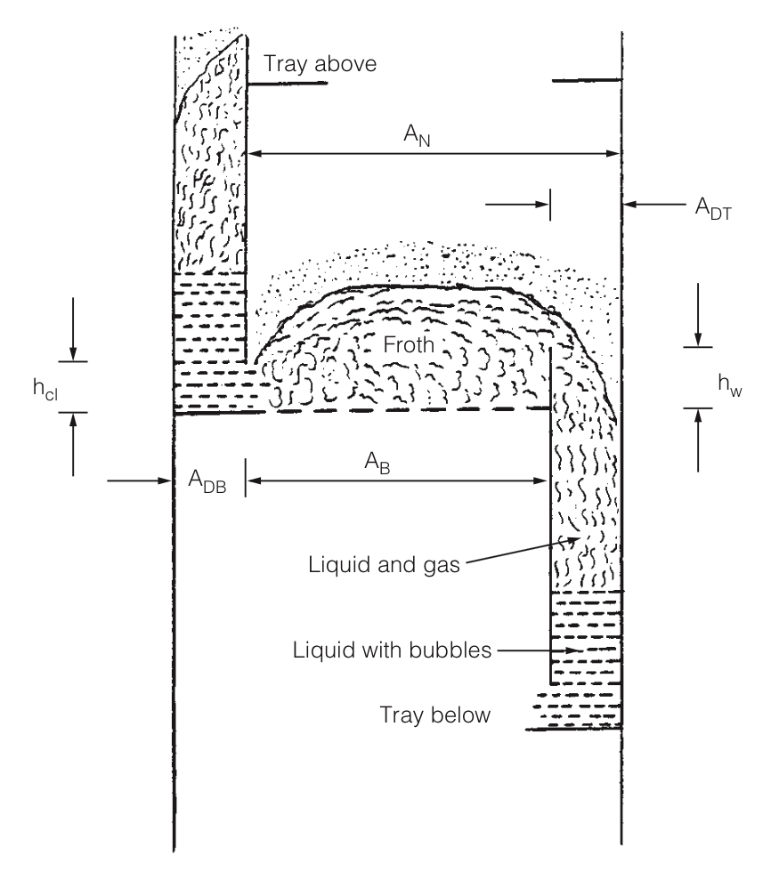
Figure(2) Schematic of a tray operating in the regime

Bubbling Area AB (also called active area)
The total tower cross-sectional area minus the sum of down comer top area A_{DT}, down comer seal area A_{DB}, and any other non perforated areas on the tray. The bubbling area represents the area available for vapor flow just above the tray floor. See figure (3)
Hole area Ah: The total area of the perforations on the tray. The hole area is the smallest area available for vapor passage on a sieve tray.
Slot area AS : The total (for all open valves) vertical curtain area through which vapor passes in a horizontal direction as it leaves the valves. It is a function of the narrowest opening of each valve and the number of valves that are open. The slot area is normally the smallest area available for vapor flow on a valve tray.
Open slot area ASO: The slot area when all valves are open.
Fractional hole area Af: The ratio of hole area to bubbling area (sieve trays) or slot area to bubbling area (valve trays).

1-3 Hydrodynamic measurements:

The hydrodynamic measurements are carried out on any tray column to previously determine the working domain of the column n. These experiments use inert phases such as water/air media. The aim of hydrodynamic measurements is to measure the pressure drop (ΔP, Pa) on tray column under different gas/liquid flow conditions.
It is worth to start the experimental work by increasing air flow rate at constant liquid flow rates. The liquid flow rates (L) start from L=0 l/min and increased to any liquid flow rate. The experimental limitations are the tray weeping at very low air velocity (v m/s), the other limitation is the flooding of tray where the pressure drop increases continuously and the tray holds the liquid on it. This phenomenon occurs at high liquid flow rates and high air velocities.

The obtained pressure drop curves versus gas /liquid flow rates are known as characteristic curves of the column.
The tray column constructors aim to have low-pressure drop and wider working regime.

1-4 Mass transfer :

Mass transfer is important in many areas in science and engineering. Mass transfer occurs when a component in a mixture migrates in the same phase or from phase to phase because of a difference in concentration between two points. Many familiar phenomena involve mass transfer. Many purification processes involve mass transfer for example removal of SO₂ and odors from flue gas is done by absorption in a basic liquid solution. There is the “driving force” from the surface of polluted air to the liquid.
Many chemical process materials and biological substances occur as mixtures of different components in the gas, liquid, or solid phase. In order to separate or remove one or more of the component from its original mixture, it must be contacted with another phase.
The two phases are brought into more or less intimate contact with each other so that a solute or solutes can diffuse from one to another. The two phase pair can be gas-liquid, gas-solid, liquid-liquid. During the contact of the two phases components of the original mixture redistribute themselves between the two phases. The phases are then separated by simple physical methods. By choosing the proper conditions and phases, one phase is enriched while the other depleted in one or more components.
Absorption is a mass transfer process in which a vapor solute A in a gas mixture is absorbed by means of a liquid in which the solute is more or less soluble. The gas mixture consists mainly of an inert gas and the solute. The liquid also is primarily immiscible in the gas phase its vaporization into the gas phase is relatively slight.

1-5 operating line derivation:

What is the operating line? This is graphical construction presents any solute concentration in gas and liquid at any point in the column. While the equilibrium curve, show any solute concentration in gas and liquid at any point in the column if they are at equilibrium. The differences between the equilibrium values and actual values give the theoretical stages.
So, the derivation and plotting of both operation line and equilibrium curve are very important. The A plate (tray) absorption tower has the same process flow diagram as the counter current multiple stage process as shown in a vertical tray tower below in Figure (3). .
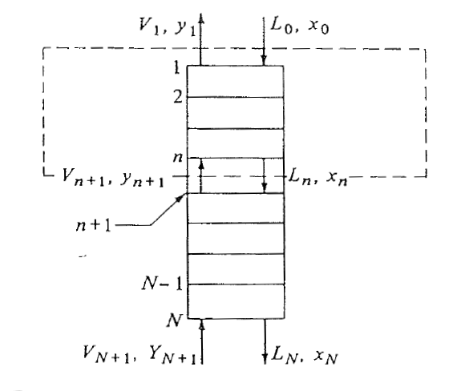
Figure(3) Material balance in an absorption tray tower

In the case of solute A diffusing through stagnant gas B and then into stagnant fluid, as in the absorption of acetone (A) from air (B) by water, the mole of inert or stagnant air and inert water remain constant throughout the entire tower. If the rates $ν'$kg mol inert air/s and L’ kg mol inert solvent water/s or in kg mol inert /s.$m^{2}$ units
( ${Ib mol inert}/{h.{ft}^{2}})$, an overall material balance on component A in above Figure is:
L’$\left(\frac{x_{0}}{{1-x}_{0}}\right)$+$ν'\left(\frac{y_{N+1}}{1-y_{N+1}}\right)$= L’$\left(\frac{x_{N}}{{1-x}_{N}}\right)$+$ν'\left(\frac{y_{1}}{1-y_{1}}\right)$ …………………………. (1)
A balanced around the dashed line box gives:
L’$\left(\frac{x_{0}}{{1-x}_{0}}\right)$+$ν'\left(\frac{y_{n+1}}{1-y_{n+1}}\right)$= L’$\left(\frac{x_{n}}{{1-x}_{n}}\right)$+$ν'\left(\frac{y_{1}}{1-y_{1}}\right)$ …………………………. (2)
Where x is mole fraction A in the liquid, y the mole fraction of A in the gas,$l_{n}$ the total mole liquid/s, and$v_{n+1}$ the total moles gas/s. The total flows/s of liquid and of gas vary throughout the tower.

Equation (2) is the material balance or operating line for the absorption tower. Equation (2) relates the concentration$y_{n+1}$ in the gas stream with$x_{n}$ in the liquid stream passing it. The terms $ν^{'},$ L’, $x_{0}$ and $y_{1}$are constant and usually known or can be determined.

1-6 Graphical determination of the number of trays:

A plot of the operating line equation (2) as y versus x will give a curved line. If x and y are very dilute, the denominators 1-x and 1-y will be close to 1, and the line will be approximately straight, with a slope$≅{l'}/{v'}$.The number of theoretical trays are determined by simply stepping off the number of trays as done in Fig (4) for a countercurrent multiple stage process.

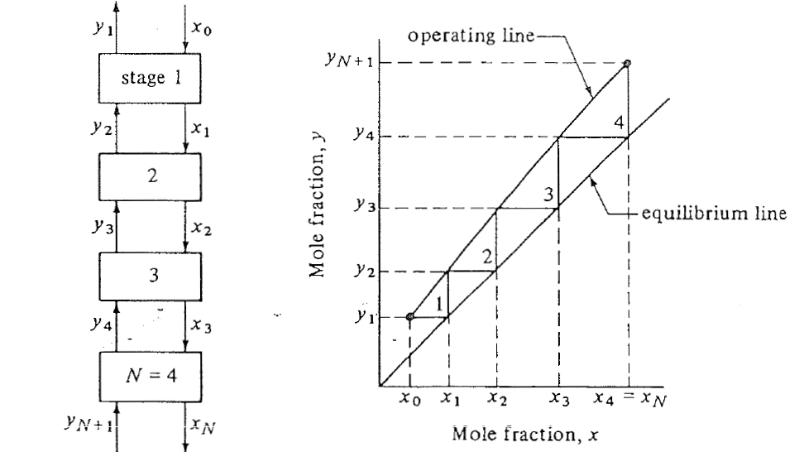
Figure( 4): Number of stages in countercurrent multiple stage contact process

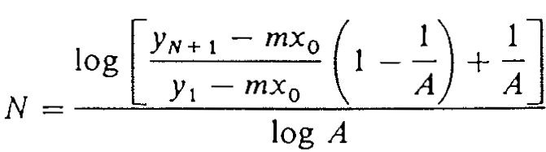
For gas absorption, the number of theoretical trays is calculated by the next formulae. The formulae is applied for low solute concentration.
(3)………….
(.
)(3

A is absorption factor and gives the ratio of the slopes of operating and equilibrium curves.

1-7 Overall Mass Transfer Coefficients and Driving Forces:

Film or single-phase mass transfer coefficient${k'}_{y }$and ${k'}_{x}$ or $k_{y }$or $k_{x}$ are often difficult to measure experimentally. As a result, overall mass transfer coefficient$K_{y}^{'}$and $K_{x}^{'}$are measured based on the gas phase or liquid phase.
The overall mass transfer $K_{y}^{'}$ is defined as:
$N_{A }=K_{y}^{' }(y_{AG }- y_{A}^{*}$ …………………………(4)
Where $K_{y}^{' }$ is based on the overall gas phase driving force in ${Kg mol}/{s.m^{2}}.mol frac$ and $y_{A}^{*}$ is the value that would be in equilibrium with $x_{AL}$, Also, $K_{x}^{'}$ is defined as:
$N_{A }=K_{x}^{' }(x_{A}^{*}- x_{AL}$) …………………………. ( 5)
Where$K_{x}^{'}$is based on the overall liquid phase driving force in ${Kg mol}/{s.m^{2}}.mol frac$ and $x_{A}^{*}$ is the value that would be in equilibrium with$y_{AG }$.
Equimolar counter diffusion ${and}/{or }$diffusion in dilute diffusion:
$N_{A }=k(y_{AG }- y_{Ai}$)$=k_{x}^{' }(x_{A}^{*}- x_{AL}$) …………………………. (6)
Where $y_{Ai}$ is the mole fraction on interphase which impossible to measure directly.
After proper treatment of the equations you may find

When A solute is very soluble in the liquid phase, small.
$\frac{1}{K_{y}^{' }}≅\frac{1}{k_{y}^{'}}$ …………………………. (7)
And the major resistance is in the gas phase, or the “gas phase is controlling
Similarly, the solute A is very insoluble in the liquid, $then$
$\frac{1}{K_{x}^{' }}≅\frac{1}{k_{x}^{'}}$ …………………………. (8)
The “liquid phase is controlling” and ${ x }_{Ai}≅x_{A}^{*}$. This is valid for Systems such as absorption of oxygen or ${CO}_{2}$ from air by water are .

Chapter 2

2-1 Constraints :

The design pass through many difficulties. The Palestinian plastic company promised to find a proper cylindrical tube with a proper diameter, thickness, material and valves. The cylindrical tube was not totally cylindrical, it was ellipsoid. It caused problems in fitting. Another difficulty is to prepare trays with required symmetrical holes, which finally prepared by CNC machine.
We brought the cartoon stimulant with us to company to explain what we need exactly. After long discussion with company men , they promised us to build the column. After many trials the promised solution was expensive and not feasible, this solution based on using stainless steel flanges.
Finally, we found out that the different tube sections and trays can be fixed by:
1 - metallic corset
2 - using industrial adhesive
After using the metallic corset we observed intensive leakage of liquid solution from the absorption tower. We have found an alternative solution by using acrylic flanges with 3.3mm width that installed by screws and silicon adhesive.

The placing of trays between tubes was the best solution. To lathe the tube (engrave) and then to place the trays in engraved was site. See Fig. (5,6).
To see what is happening through the column , a glass column (transparent tube ) is used to allow us observing different foam structures in the column.

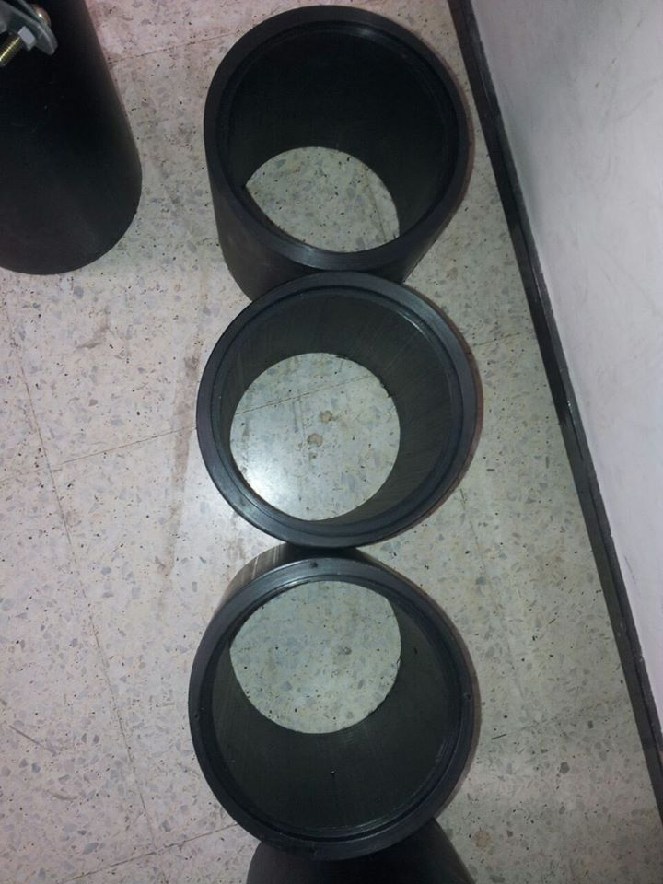

Figure (5)

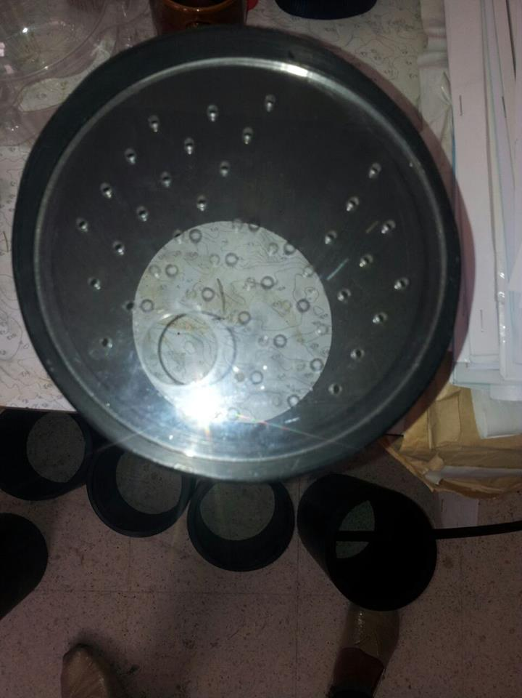

Figure(6)

2-2 Standards / Codes :

2-2-1 Choice of plates or packing :

The choice between a plate or packed column for a particular application can only be made with complete assurance by costing each design. However, this will not always be worthwhile, or necessary, and the choice can usually be made, on the basis of experience by considering main advantages and disadvantages of each type; which are listed below:
1. Plate columns can be designed to handle a wider range of liquid and gas flow-rates
than packed columns.

2. Packed columns are not suitable for very low liquid rates.

3. The efficiency of a plate can be predicted with more certainty than the equivalent
term for packing (HETP or HTU).

4. Plate columns can be designed with more assurance than packed columns. There
is always some doubt that good liquid distribution can be maintained throughout
a packed column under all operating conditions, particularly in large columns.
5. It is easier to make provision for cooling in a plate column; coils can be installed
on the plates.

6. It is easier to make provision for the withdrawal of side-streams from plate columns.

7. If the liquid causes fouling, or contains solids, it is easier to make provision for
cleaning in a plate column; many ways can be installed on the plates. With small diameter columns it may be cheaper to use packing and replace the packing when
it becomes fouled.

8. For corrosive liquids a packed column will usually be cheaper than the equivalent
plate column.

9. The liquid hold-up is appreciably lower in a packed column than a plate column.
This can be important when the inventory of toxic or flammable liquids needs to
be kept as small as possible for safety reasons.

10. Packed columns are more suitable for handling foaming systems.

11. The pressure drop per equilibrium stage (HETP) can be lower for packing than
plates; and packing should be considered for vacuum columns.

12. Packing should always be considered for small diameter columns, say less than
0.6 m, where plates would be difficult to install, and expensive.

2-2-2 Plate spacing :

The overall height of the column will depend on the plate spacing. Plate spacings from 0.15 m (6 in.) to 1 m (36 in.) are normally used. The plate spacing is chosen according to the column diameter and operating conditions. Close spacing is used with small-diameter columns, and where head room is restricted; as it will be when a column is installed in a building. For columns above 1 m diameter, plate spacings of 0.3 to 0.6 m will normally be used, and 0.5 m (18 in.) can be taken as an initial estimate. This would be revised, as necessary, when the detailed plate design is made. A larger spacing will be needed between certain plates to accommodate feed and sides treams arrangements, and for manways.

2-2-3 Estimation of interfacial area :

The interfacial area between gas and liquid phase is important indicator to mass flow. The development of internal constructions of tray and packed columns are aimed to improve the foam structure or in another word to increase the interfacial area between gas and liquids. The best column construction that gives higher interfacial area.
Husni [2] has built wetted wall absorber with known geometrical area, the obtained data on this model was in agree with other authors Pohoreczki and Moniuk [3]
The brut to chemical reaction used for interfacial area determination is :
2NaOH + = Na₂CO₃ + H₂O
When the concentration of CO2 is 1% and NaOH is 4wt% the reaction is pseudo first order reaction, the absorption rate is proportional to mass transfer area, thus, the interfacial area is measured and calculated as shown in the following:
a= Φ/ φ …………………………(9)
where:
a : mass transfer area m²
Φ : mass transfer flow: mole/s
Φ : mass flux mole/m².s

The mass flux Φ was determined experimentally and is given by the following formula
Φ = ( 0.274+ 0.016t) .10-6 Pco₂. (C_{OH}-)^{-0.5} …………………………. (10)
Where
t: temperature, °C
Pco₂ partial pressure of CO₂
C_{OH} is concentration of NaOH

Φ=L (ΔC)_{Na2CO3} …………………………. (11)
Where
L : liquid flow rate
(ΔC)_{Na2CO3} : the amount of carbonate formation.

So, it is possible to go ahead with the above formula to calculate interfacial area.
The modern equations for estimation the mass transfer area on trays are based on direct measurements of geometrical and operating parameters of column. Therefore, the interfacial area equations are given as a function of column operating parameters, geometrical parameters and hydrodynamic measured data.
Zuiderweg , Chen and Husni have given different formula to calculate the interfacial on tray. Husni gives the next formulae in his post doctorate work.
Foaming regime:
a_{f}=1330 fa^{0.20}.hw^{0.15}Ψ^{0.07} ………………………. (12)
Transitional regime:
a_{f}=2790 fa^{0.07}.hw^{0.32}Ψ^{0.18} …………………………. (13)

Where:
Ψ=(Lw (ρ_{L})^{0.5})/Fa, ………………………….(14)
Ψ is dimensionless number gives the ratio of liquid to gas flow.

The above formula are valid to sieve trays, so it can be used in this project calculation to compare the obtained value interfacial area with other columns.

Chapter Three

Literature Review :
Many other researcher have investigated the characters of the tray under different work [4] condition, they focus on different tray parameters such as clear liquid height on a plate, weeping of trays and pressure drop of column .

3-1 The clear liquid height on a plate :

The clear liquid height on a plate and the quality and structure of the two phase foaming play an important role in the hydrodynamics and mass transfer of a plate column.The quantity of liquid on the plate is expressed in terms of the clear liquid height ,its value is given by the sum of the pressure drop across the foam and the dynamic effect due to gas flow [5]:
${h_{l}}_{=}\left(∆p_{f+d_{G}}\right)/\left(ρ_{l}g\right)$ …………………………. (15)
Where
$d_{G={w_{G}}/{A.\left(v_{h-}v_{a}\right)}}$ …………………………. (16)
The structure of the foam, that is the hydrodynamic regime on the plate, changes with increasing gas and liquid loadings.
In the past thirty years, many researchers have investigated the hydrodynamics of sieve plates. For quite a long time, however, it was supposed that the operating range of a plate can be hydro dynamically considered as a single regime. With improved methods of a measurement, it became obvious that, e.g. from the measurements of the hydrodynamic parameters in the froth regime, no deductions can be made relating to the spray regime.${Shkov et al}^{}. , {de Goederen}^{ }$ and ${Lockett}^{}$[6] have already distinguished between two different hydrodynamic regimes: at small velocities of gas cellular foaming develops on the plate, with the liquid as continuous phase and gas the dispersed phase-this is the froth regime. At high velocities, the gas blows up the foam and a spray layer forms with the gas as continuous phase and the liquid as disperse phase–this is the spray regime.
y..${Locket}^{},{Miyahara et al}^{ }and {Chen et al}^{}$[7].offer equations for calculating the transition between the froth and spray regime.
According to recent investigations, there is qualitatively different third regime between froth and spray regimes, this is mixed${regime}^{}$.Dhulesia[8].
In 1985 ${Chen}^{}$[9], on the basis of ${Dhulesia's}^{}$ [10] idea, evaluated data published in the literature measured by using the light transmission technique. He found that the froth-mixed-spray regimes are sharply differentiated on the sieve plate. At the boundary of froth and mixed regimes on sieve plate:
At boundary of mixed and spray regimes:
$\frac{h_{l}}{d_{°}}=3.79v_{h }\sqrt{ρ_{G/ρ_{L}}}$ ………………………….(17)
The equations of Chen are valid for the ranges:
$v=0.4-2.8\frac{m}{s}; Lw=\left(1.4-16.4\right)×{10}^{-3}\frac{m^{3}}{ms};$ ………………………….(18)
$w=(25-75)×{10}^{-3}m$ ………………………….(19)

It is worth mentioning that${Zuiderweg et al}^{}.$distinguished four different regimes on the sieve plate :besides those earlier mentioned they found a free bubbling regime near the boundary of weeping.
Correlation for calculating the clear liquid height on sieve plates were already published around the ${eighties}^{} .$However, only one part or these correlations relates the specific foam structures.
In his summary work${ Zuiderweg}^{}[11]$ underlines that the traditional equations containing weir height, Francis$,$ formula, and relative froth density as parameters, are applicable to calculate the clear liquid height on a sieve plates in the froth and spray regimes together.
The measurements of Hofhius and the data published in equation . ${Dhuleesia}^{}$ shows that the correlation developed by Zuiderweg for the froth and spray regime does not define the clear liquid height in all of the three foaming regimes.
Colwell [ 14] collected a large number of data from literature on measurements made on substances having different physico-chemical properties . He complements the pressure drop across foam layer ($∆p_{f}$)with the dynamic effect due to gas flow ($d_{G}$)and correlate the sum for the froth regime. In his 1987 article, ${Chen}^{}$[12] shows that Colwell marked out the froth regime wrongly and his equations therefore is not applicable. However, his measured data collection is valuable.
In 1984,${Dhulesia}^{}$published a correlation for calculating the clear liquid height in the froth regime of a sieve plate. In his equation, he uses his own data measured on a column of cross section1.2m$×$0.63m using an air-water system,as well as data from ${Brambilla}^{}$ and ${Lockett}^{}$. In his equation, he uses the flow ratio group proposed by Fair and ${Zuiderweg}^{}$[13] .His equation is only valid for a plate with 10% free cross section.
${Haq}^{}$[14] measured the effect of liquid density,viscosity and surface tension on hydrodynamic parameters of a big hole sieve plate. He measured in the range:
$ρ_{l}=800-1500\frac{kg}{m^{3}}; μ_{l}=0.6-910 mPas;σ=22$…………………(20)
His most important conclusion was that the clear liquid height is completely independent of all the three parameters in the above intervals. That is, measuring$h_{l}$ with an air-water system, for instance, the results are unanimously valid for other system. Measured data (pressure drop across foam, foam height) are found in another article published by ${Haq}^{}$ .

Mahiout and ${Vogelpohl}^{}$[15] measured the hydrodynamic parameters on sieve plates of different geometrical shapes using a liquid of high viscosity. Their conclusions are consistant with those of ${Haq}^{}$, the clear liquid height is independent of the viscosity.

SYMBOLS USED:
A cross-section of empty column,$m^{2}$
$d_{°}$ hole diameter, m
$d_{G}$ dynamic effect due to gas flow, N/$m^{2}$
G gravity constant, m/$s^{2}$
$h_{l }$ clear liquid height, m
$l_{w}$ liquid load related to unit weir length, $m^{3}$
$∆p_{f}$ pressure drop across the foam on plate,N/$m^{2}$
$v$ velocity of gas in the empty column, m/s
$v_{a}$ velocity of gas in the active cross section of plate,m/s
$v_{h}$ velocity of gas in the hole, m/s
$w$ weir height, m
$w_{G}$ mass flow rate of gas, kg/s
$μ_{l}$ viscosity of liquid, kg/(ms)
$ρ_{G}$ gas density, kg/$m^{3}$
$ρ_{l}$ liquid density, kg/$m^{3}$
$σ$ surface tension of liquid, N/m

3-2 Influence of weeping on mass transfer rate of different plate:

The expansion of the operative domain of plates by extending their lower limit towards the weeping regime is an important task and results in a remarkable money saving in the design of chemical plants. Therefore , it is necessary to know how much the weeping affects on the mass transfer of plates.
Many authors have reported their opinions on this matter. Prince[16] supposed that when a plate operates satisfactorily hydrodynamically, it should have a reasonable efficiency, so he advised operation well above the minimum load conditions. Several authors agreed with his opinion, although this position appears more an assumption than a result of effective investigations of tray behavior in the weeping regime.
Kagayama [17] measured the distillation efficiency using a wide range of liquid loads. Their data do not show an excessive variation of efficiency even in the presence of weeping. Having measured the column efficiency of a sieve plate column with the air humidification method,they also found that at a high weeping ratio, the column efficiency remains relatively constant. That point of view agreed with the data reported by Umholtz and Van Winkle[18] who have shown that the values of efficiency are still satisfactory where there is strong weeping. Zhou et al[19] have carried out experiments in sieve plate columns and measured the (oxygen desorption) efficiency with an air/water system. The weeping point was determined on the basis of a comprehensive treatment of the actual effect on the weeping rate as a measure of the efficiency and the relationship between the vapor velocity and the relative weeping rate. They found that a 15% reduction in efficiency occurs at the lower operating limit. Banik established a greater reduction in tray efficiency is obtained, if the weeping is localized mainly near the inlet weir, as is often the case on large trays.
The purpose of this work was to investigate the mass transfer behavior of different industrial type plates in the weeping regime, which is defined as a domain between dump point (gas velocity corresponding to the beginning of the liquid flow over the weir) and the weeping point (gas velocity corresponding to liquid flow only over the weir).

Chapter Four

Methodology :

4-1 Part (A): Construction of tray column which have the following parts:

For better understanding we started to construct a cartoon model, this cartoon model is helpful to recognize all elements and component accessories that are needed for installation the sieve tray absorption column.

4-1-1 Sieve tray columns
Sieve tray columns contain mainly different components that need design and installation. The main components of tray are cylindrical tubes that hold the trays and provide spacing between them. The other components are: sieve trays, down comers, weirs, pressure measuring system, flow meters, pump and air compressor.
The space between trays is taken 20cm, which agrees with literature. The heart of sieve tray column is a sieve tray, which need sophisticated work.

4-1-2 Calculation of Geometrical Parameters of Sieve Trays:
The sieve tray column have 5 sieve trays which is poly acre late acid (glass fiber), where the similar geometrical calculation of sieve trays on industrial data are shown in table (1) where f_{a} is (4.5 – 15%)

D_{in}=130mm
A= D²$\frac{ π}{4}$ = (126)²$\frac{3.14}{4}$ =12468.98 mm² = .0124m²
Weir area = (40)²$\frac{3.14}{4}$ = 1256 mm² = .001256 m²
Inlet of down comer = (25)²$\frac{3.14}{4}$ = 490.6 mm² = .0005 m²
Number of perforation = 42
Perforation area = (3)²$\frac{3.14}{4}$ × 42 = 296.7 mm² = .000297 m²
f = $\frac{.000297}{.0124}$ = .0239 = 2.4%
f_{a} = $\frac{.000297}{.0124-.0005-.001256 }$ = .0279 = 2.8
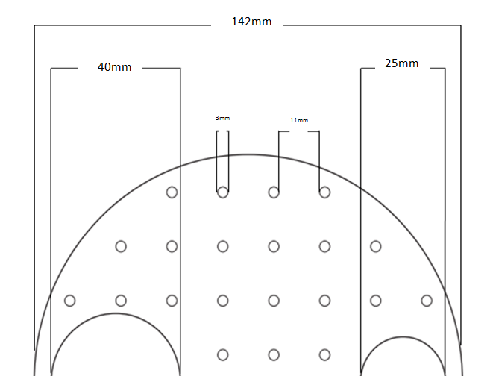
126 mm
Figure (7): Design of sieve tray

Table (1) Geometrical parameters of sieve trays
Tray number | Fa  % | F  % | T  mm | d₀  mm | h_{w}  mm
1 | 4.5 | 3.6 | 18 | 4.3 | 25
2 | 4.5 | 3.6 | 19 | 4.3 | 50
3 | 9.5 | 7.6 | 14.5 | 4.9 | 25
4 | 9.5 | 7.6 | 14.5 | 4.9 | 50
5 | 14.4 | 11.5 | 14.5 | 6.0 | 25
6 | 14.4 | 11.5 | 14.5 | 6.0 | 50

Where:
fa: area of perforation + down comers area) per area of plate
f: area of perforation per area of plate
t: distance between holes
d₀: hole diameter
h_{w}: weir highest

This design of our trays was achieved by using the CNC machine in faculty of art, first the machine prepared cartoon tray sample, then the machine repeated the work by running computer program . The CNC machine and its products are shown in Fig.(8, 9,10 ) The material of tray is acrylic material with 4.3mm width.
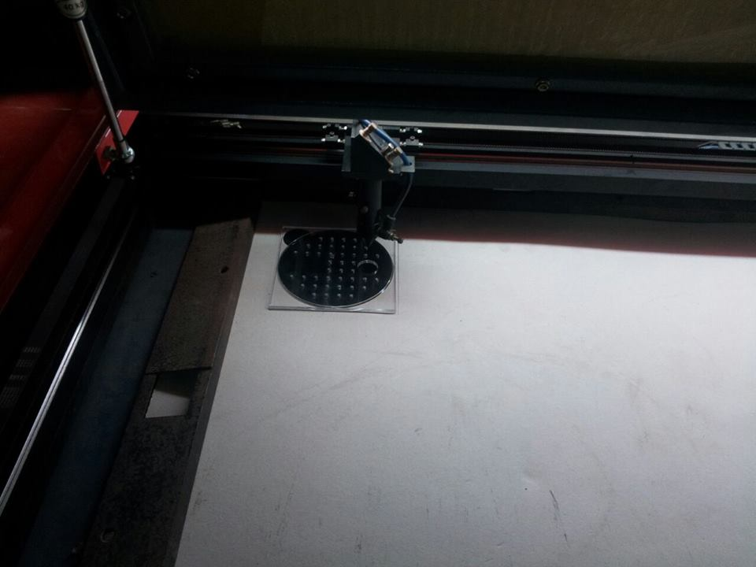
Figure (8)

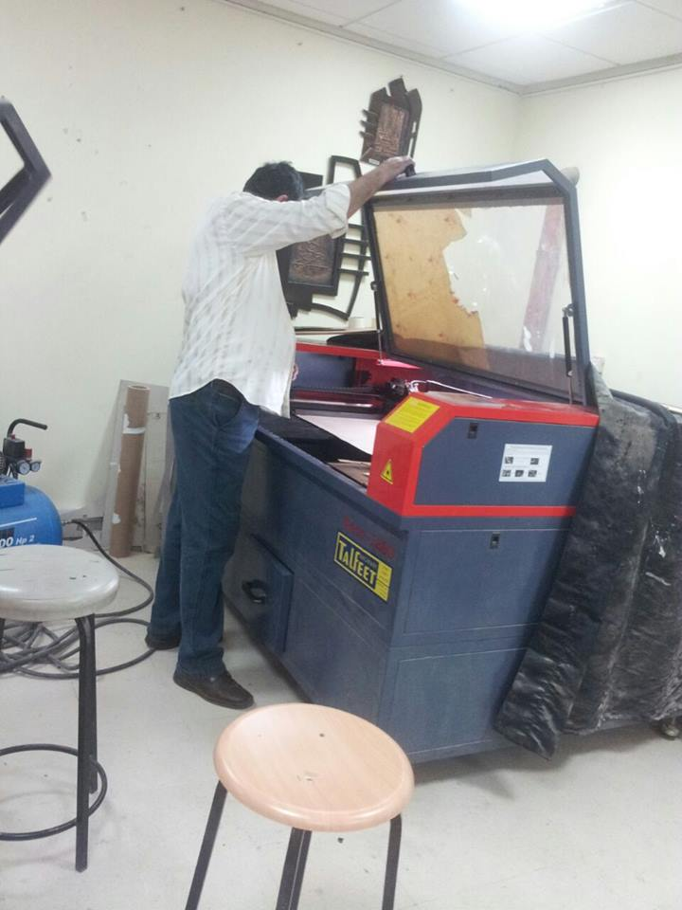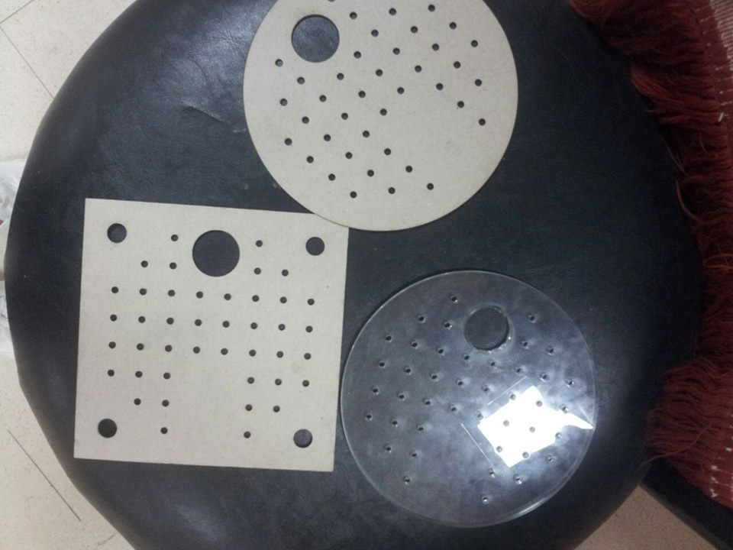
Figure (9) Figure (10)

4-1-3 Design of the downcomer :

The down comer is a tube for conveying liquid between up to lower tray. Air must not pass through it.

The down comer is shown in Figure (11).

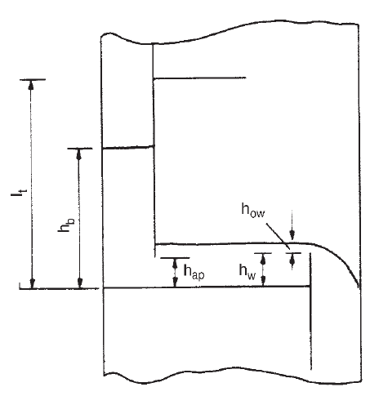
Figure (11): Downcomer

4-1-4 Diameter of the column :
For selection of diameter of column we were governed by the available tube sizes and sheets for manufacturing the trays. The column diameter that found to meet all of the requirement is about 130 mm as internal diameter and 150 mm as external diameter. The tube obtained from Palestinians plastic company is consisted of 6 pieces for holding trays, each of 200 mm height. More details is seen on tube sections and trays are shown in the Table (2) and Figure (12).

Table (2) Details about the column components, tray spacing tubes and their positions.
Number of tray spacing tube | Holding trays | Material | Dimension (mm)
4 | Tray holes | PVC  (Poly Vinyl Chloride) | 200
1 | Tray holes | Glass | 200
1 | Upper/ no trays | PVC  (Poly Vinyl Chloride) | 400
1 | Bottom/ no trays | PVC  (Poly Vinyl Chloride) | 600

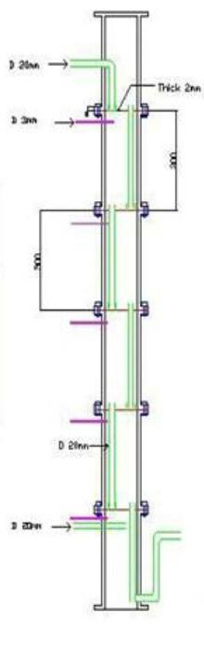
Figure (12): Design of absorber column

4-1-5 Design of stand:

The metallic stand or / ironic structure / that holds the absorber with all accessories.
It contains 4 wheels (D 10cm), and 1mm thickness sheet 70*120 cm at the area above the wheels, painted with blue color .

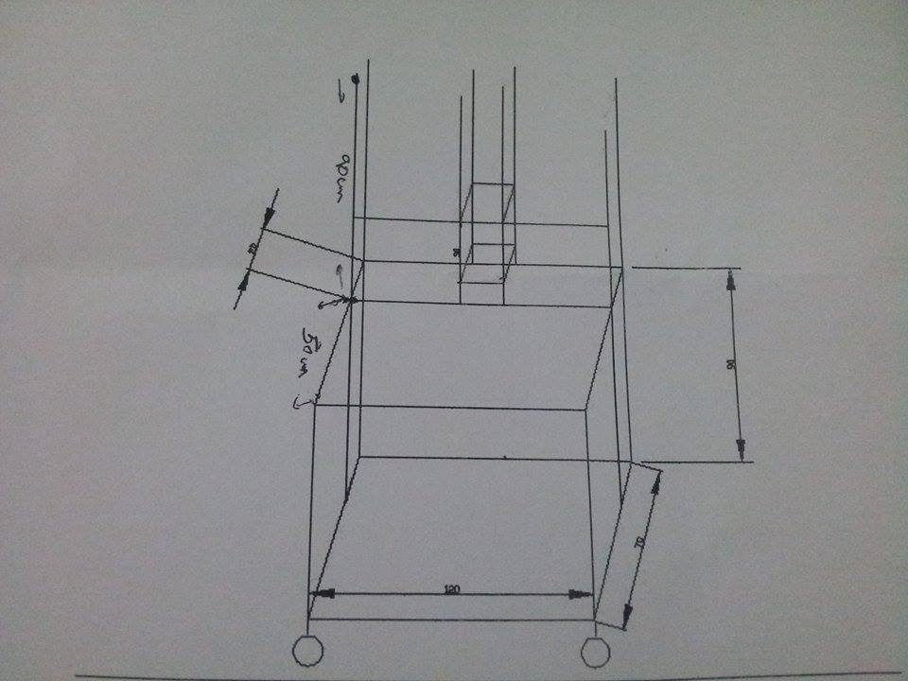
Figure 13 : Design of stand

4-2 Part (B): Experimental work

4-2-1 Hydrodynamic measurements of packed column:

- The water reservoir tank is filled to three quarters full with tap water. The valves on the system are set in the way that make the differential pressures in the top and bottom sections of the column are indicated on the water manometers.

- The water pump is switched on and is set to give a flow rate of different values down the column.

- After 3 seconds the compressor is switched on

- The air pressure differential is measured across the wet column as a function of the air flow rate.

- The air pressure differential measurement is repeated at different flow rate values.

- The height of liquid and foam length was taken.

4-2-2 Chemical absorption

- The liquid pump was started and adjusts the flow of caustic soda through the column.

- The compressor was started and adjusted to give a proper air flow
- Samples were taken
- Every sample had 200ml volume; it was taken from inlet and outlet places on column..
- A drop of phenolphthalein were added to the solution, and titration was made until the pink color just disappears with standard hydrochloric acid, the volume of HCl which was consumed is the volume which was needed to neutralize all hydroxide and convert carbonate to bicarbonate (T1).

- Then drops of methyl orange were added to the flask and titration was continued with HCl until the end point was found, the volume of HCl which was consumed is the volume which was needed to neutralize all of bicarbonate (T2).

Chapter Five

Results and Analysis:

Table(3) The liquid flow rates = 0 L/h
W (L/m) | P (mmHg) | Hl | P(pa) | Foam high
20 | 0.5 | 0 | 29.4 | 0
40 | 0.5 | 0 | 34.3 | 0
60 | 3 | 0 | 44.1 | 0
80 | 3 | 0 | 44.1 | 0
100 | 3 | 0 | 44.1 | 0

Table(4) The liquid flow rates = 50 L/h
W (L/m) | P (mmHg) | Hl | P(pa) | Foam high
20 | 9 | 4 | 88.2 | 5
40 | 8.5 | 3 | 83.3 | 5
60 | 8.8 | 3.5 | 86.24 | 5
80 | 9.2 | 3 | 90.16 | 5
100 | 9.5 | 1 | 93.1 | 6
120 | 11 | 1 | 107.8 | 7

Table(5) The liquid flow rates = 100 L/h
W (L/m) | P (mmHg) | hl | P(pa) | Foam high
20 | 9.5 | 4 | 93.1 | 4.5
40 | 9.5 | 4.5 | 93.1 | 5
60 | 0.9 | 4.5 | 97.02 | 6
80 | 0.9 | 4.5 | 97.02 | 6
100 | 11.5 | 3 | 112.7 | 6.5
120 | 13.5 | 3 | 118.58 | 7

Table(6) The liquid flow rates = 150 L/h
W (L/m) | P (mmHg) | hl | P(pa) | Foam high
20 | 9.5 | 4 | 93.1 | 4.5
40 | 9.9 | 4 | 97.02 | 5.5
60 | 10.5 | 4.5 | 102.9 | 7
80 | 11.5 | 5 | 112.7 | 8
100 | 12.2 | 4 | 119.56 | 8
120 | 12.5 | 3 | 122.5 | 8.5
140 | 13.7 | 2 | 134.26 | 8
160 | 13.8 | 1 | 135.24 | 8

Table(7) The liquid flow rates = 200 L/h
W (L/m) | P (mmHg) | hl | P(pa) | Foam high
20 | 10.1 | 4.5 | 98.98 | 5.5
40 | 11.5 | 5 | 112.7 | 7
60 | 12.5 | 5 | 121.52 | 8
80 | 12.6 | 5 | 123.48 | 8.5
100 | 13.9 | 4.5 | 136.22 | 9
120 | 15.1 | 4 | 147.98 | 10.5
140 | 12.5 | 4 | 122.5 | 10.5
160 | 13 | 4 | 127.4 | 10.5

Table(8) The liquid flow rates = 250 L/h
W (L/m) | P (mmHg) | hl | P(pa) | Foam high
20 | 10.5 | 4.5 | 102.9 | 6.5
40 | 12 | 5 | 117.6 | 8
60 | 14.5 | 8 | 142.1 | 13
80 | 16.5 | 10 | 161.7 | 14

Table (9) determination of interfacial area at v=.5m/s
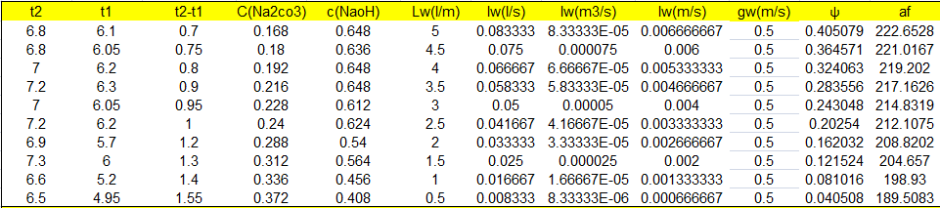

Table (10) determination of interfacial area at v=.133m/s
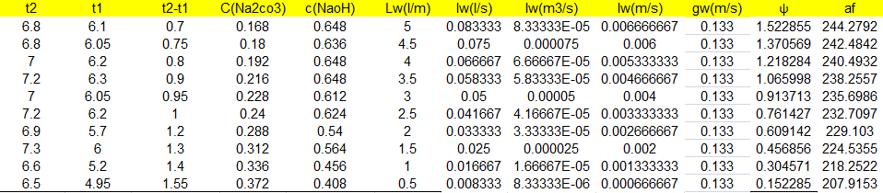

Chapter Six

Discussion:

The final goal of this project is to design and install pilot plant absorption column . The column consists of five sieve trays, .the construction of sieve trays are achieved by:
CNC machine at art collage laboratory, the geometrical parameter of the column are presented in Table (1).
The column is installed perfectly in accordance with declared geometrical and operational conditions.

Indeed, the delay of financial support caused many difficulties in provision the different column components in time.
The column still need air compressor and it’s gas flow meters.

After overcoming all leakage problems. The hydrodynamic measurements are started using air/water system, The results are presented in Figure (15) below. The area in L vs v is domain work or working regime.
This is helpful to determine the limitation of work on the column.
It is worth to say that air velocity or superficial velocity is calculated on the bases of column diameter, but is suggested to be given also through the holes of the column.
The working regime is presented again on the basis of air velocity on holes as shown in Figure (16).

The measured parameters are clear liquid height (h_{l}) which expresses the amount of liquid on tray where the air goes through and produce interfacial areas between the air/water phases. The foam and the pressure loss on tray are measured, The pressure loss on trays are not increase exponentially with the increase of gas velocity as in the case of packed bed. The pressure drop experimental results are presented on Figure (17).

The foam height is a good indicator for interfacial area, The interfacial area increases with foam height in foam regime. The foam height is quite different from spray height produced at height gas velocities.

To measure numerically the interfacial area there are lot of modern formulae provided by different authors. In this project formulae of Husni Odeh are used,
The formula gives interfacial area (a_{f}) as a function of geometrical and operational parameters (fa, hw, Lw, V) .
The calculated interfacial area by Husni formula are presented with the data of different authors using their own formulae. Our calculated data are fit with other authers such as Poherecki.

The different formulae have different bases to establish them, such as light dispersion. Husni formulae are based on measurement on wetted absorber with known interfacial area.
In the case of using Husni formulae derived from wetted wall absorber for determination of interfacial. It is found that the obtained results are about 70% of those obtained by formulae based on geometrical and operational parameter.

The explanation of this big deviation is because of very small holes used in our sieve trays (3mm), while Husni formulae is based on sieve trays having holes bigger than five mm-es.

Figure (14 (Our working regime in trays

Figure)15( Working regime in holes

Figure (16) The pressure drop (ΔP, Pa) on tray column under different gas/liquid flow conditions

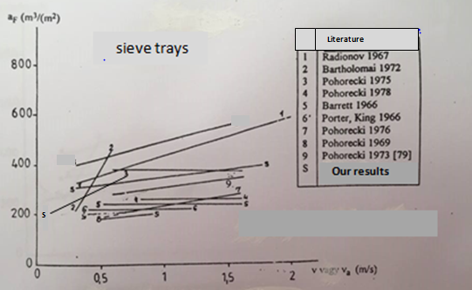

Figure (17) Interfacial area [Pohorecki]

Chapter Seven

Conclusion and Recommendation:

The benefit of hydrodynamic measurement of tray column experiment is to know the range of air flow rate for any other liquid which depends on the type of the liquid used itself. Hydrodynamic measurement is a characteristic of any column by using air and water flow rate to produce working regime.
Mass transfer efficiency in absorption depends on thermodynamic efficiency and hydrodynamic behavior. Thermodynamic efficiency is dependent on the system kinetics while hydrodynamic is study of fluid flow behavior. The focus of our project is the hydrodynamic measurement in tray column, which affect entrainment, the design of tray and column . Such results can be improved by ultimately increasing the operatability and capacity while reducing capital costs. The onset of entrainment is one of operating limits that determines the design of the column and thus impacts on capital cost.
There are some sources of error that affect the calculation such as; water entered to the tube for passing air through it. There also was an error in reading the pressure difference especially when flooding occurred, since the level in manometer is not constant.

For chemical absorption experiment which was conducted under unsteady state regime. Thus, the values of carbon dioxide concentrations in caustic soda can be predicted if the initial NaOH concentrations is given , volume of NaOH and flow rate. This naturally leads to formation of Na₂CO₃ . The model has not yet been tested to verify the CO₂ outlet concentration in the air stream.
• The solvent is recycled without regeneration.
• The absorption process is counter current.
• There is negligible heat effect in the column, thus; the column operates with
constant temperature.
• The absorbent is of dilute concentration.
• The NaOH concentration is depleted on reacting with CO₂ at a certain time( t ).

Factors influencing the CO₂ absorption are :
- Temperature.
- Pressure, gas phase partial pressure.
- Types and concentrations of solvents .
- Characteristics of experimental rigs such as stirring speed and contact surface area.

Chapter Eight

References:

- Christle J. G. (1993), University of Minnesota, "Transport Processes and Unit Operation", Third Edition,Printice-Hall Intrn. , Inc.
- Husni Odeh, Post doctoratal thesis, 1995, Budapest (Hungarian language).
- Pohorecki ,R. ; Moniuk,W.:Chem.Eng.J.38(1);27-35, (1989).
- Sinnott R. K. ,(1983)," Chemical Engineering Design " , FOURTH EDITION ,British.
- Fan.A.G., Sawistowski, H., 1969, Distillation, I Chem E Symp Series No 32, 1:8.
- Lockett, M.J., 1981, Trans I Chem E, 59: 26.
- Miyahara, T., Takahasi, T, 1984, J Chem Eng Japan, 17(2):211.
- Dhulesia, H., 1983, Chem Eng Res Des, 61:329.
- Chen, J.J.J.,1985, Chem Eng Res Des, 63:206.
- Dhulesia , H,.1984,Chem Eng Res Des,62:321.
- Zuiderweg, F.J.,Hofhuis,P.A.M.,Kuzniar,J.,1984, Chem Eng Res Des,62:39.
- Chen, J.J.J.,1987, Ind Eng Chem Res, 26:638 .
- Zuiderweg,F.J.,1982 Chem Eng Sci,37(10):1441.
- Haq ,M.A.,1982,Hydrocarbon Processing ,117.
- Mahiout, S.,Vogelpohl,A.,1985,Ger Chem Eng,8:152.
- Prince, R. G. H., 1960, Proc Int Symp Distillation (IChemE, London) 177.
- Kagayama, O., 1966, Chem Eng (Japan) , 30: 629.
- Umholtz, C. L. and Van Winkle, M., 1957, Ind Eng Chem, 49:226.
- Zhou, Y. G., Shi, J. F., Wang, X. M. and Ye, Y.H., 1980, Inst Chem Eng, 20(4): 642.

