6 Design of Shear wall

6.1 Introduction:
Two types of walls are used in the project, shear wall and masonry walls. Masonry walls considered as non structural element which can be damaged during strong earthquakes.
Shear walls are structural walls in a frame building, they posses necessary stiffness needed to reduce the relative inter-story distributions caused by seismic –induced motion.
Their additional function is to reduce the possibility of damage of nonstructural elements.
Shear walls acts as a cantilever beams. They may be affected by the shear force or by over turning moment under the following condition.
If h/L > 2, the over turning moment is more critical than shear force.
If h/L ≤ 2,
Where:
-h: is the height of shear wall.
-L: the width of shear wall.

6.2 Design Limitation on Shear wall:
Shear walls may be divided into two parts "Web and Boundary zones ".Reinforcing of web or none reinforcing is depending on the lateral and axial loads at shear walls .Boundary zones will be treated as columns.
The web of shear walls will be reinforced with ratio (𝜌min=0.25%) in the two direction "vertical and horizontal", and this ratio is for a steel strength 4200 kg/cm².

6.3 Shear strength of the walls:
Shear strength of walls =Vu=фVn
If Vu>A_{vc}√𝒇_{c}, two layers of steel reinforcement is required.
σ=Mc/I
Where:
*σ: the stress at shear wall
*I: moment of inertia of shear wall section.
*c: the diine of neutral axis
*M: the overturning moment.

6.4 Design wall

6.4.A Block A
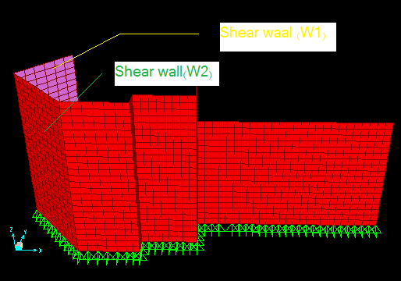
fig (6-1) shear wall of Block A

Design of wall1 (W1):
𝒒₁=-208 ton /m² 𝒒₂=5 ton/m²
L= 4.92m h=9m.

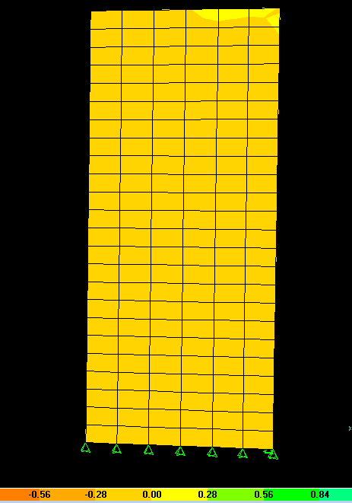
Fig (6-2) S22 diagram for Sh W1
(𝒒₁/c)= (𝒒₂/c-L)
(5/4.92-c)= (20.8/c)
c=4.8 m
I= (1/12) (0.3) (4.92)³=2.98 m⁴
M=q*I/c
=208*2.98/4.8 =129 ton.m
$$ρ=0.85\frac{f_{c}}{f_{y}}\left(1-\sqrt{\left(1-\frac{{2.35M}_{u}}{{∅bd}^{2}f_{c}}\right)}\right)$$
𝜌=.85*240/4200(1-√ (1-2.35*129*10⁵/.9*492²*30*240)
=.0005< 𝜌min.

As= 𝜌min*b*h.
=0.0025*30*492
=36.9 cm²
As(19ф16)1ф16@25 cm c/c
h/L=9/4.92 =1.83<2 shear is critical
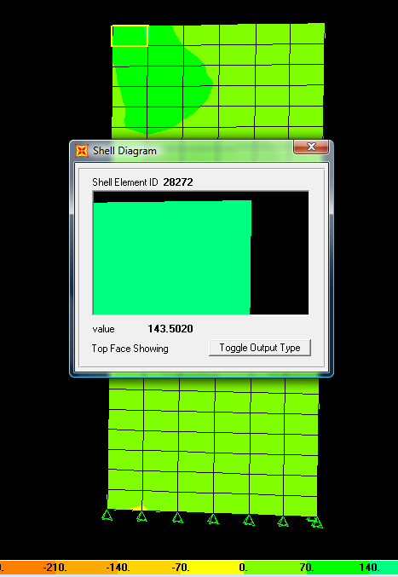
Fig (6-3 ) S12 diagram for W1
From SAP:
S12=143.5 ton
Vu=143.5*0.3*4.8=206.64 ton
Vn=Vu/ ф
=206.64/0.75 =275.5 ton
Use two layer of steel because Vu>2A_{v}√ 𝒇_{c}
𝓥_{c}=0.53√ 𝒇_{c}΄* b_{w}*d
Ф Vc=0.75*.035*√240*30*492*10⁻³
=90.9
Vs=Vn- Ф Vc=275.5- 96.9=184.6 ton
Av/S=Vs/( ℱy*L)
Av/S=0.089
Use Ф10 Av=1.57 cm²
S=1.57/0.089 =17.64 cm
1 Ф10@15 cm c/c

Design of wall2 (W2):
𝒒₁=-140 ton /m² 𝒒₂=-91 ton/m²
L= 6.36m h=9m.
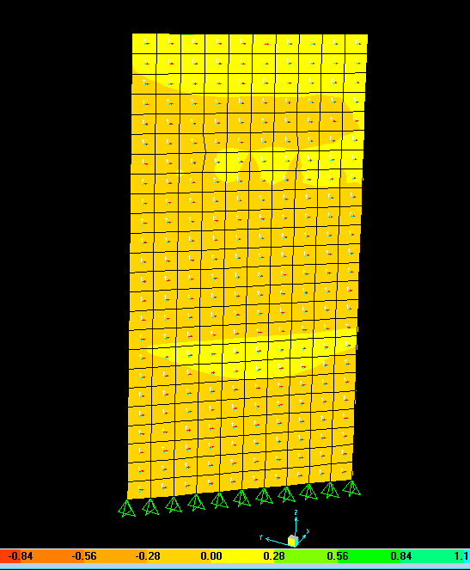
Fig ( 6-4) S22diagram for Sh W2
(𝒒₁/c)= (𝒒₂/c-L)
c=6.36+11.8=18.16 m
I=(1/12)(0.3)(6.36)³=6.43 m⁴
M=q*I/c
=140*6.43/18.16 =49.57 ton.m
$$ρ=0.85\frac{f_{c}}{f_{y}}\left(1-\sqrt{\left(1-\frac{{2.35M}_{u}}{{∅bd}^{2}f_{c}}\right)}\right)$$
𝜌=.85*240/4200(1-√ (1-2.35*49.57*10⁵/0.9*636²*30*240)
=1.07*10⁻⁴< 𝜌min.
As= 𝜌min*b*h.
=0.0025*30*636
=47.7 cm²
As(24ф16)1ф16@25 cm c/c

h/L=9/6.36 =1.4<2 shear is critical
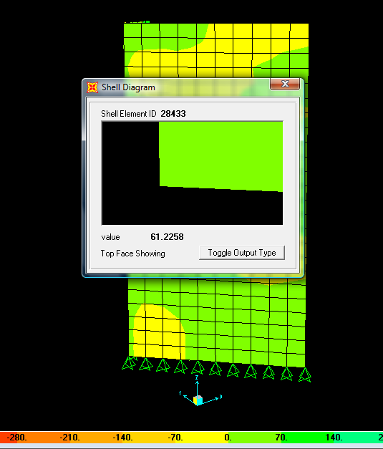
Fig (6-5 ) S12 diagram for W2
From SAP:
S12=61.23 ton
Vu=61.23*0.3*18.16=333.6 ton
Vn=Vu/ ф
=333.6/0.75 =444.8 ton
Use two layer of steel because Vu>2Av√ 𝒇_{c}
𝓥_{c}=0.53√ 𝒇_{c}΄* b_{w}*d
Ф Vc=0.75*.035*√240*30*636*10⁻³
=117.5
Vs =Vn- Ф Vc=444.8- 117.5=327.3 ton

Av/S=Vs/( ℱy*L)
=327.3*10³/4200*636
Av/S=0.123
Use Ф10 Av=1.57 cm²
S=1.57/0.123 =12.76 cm
1 Ф10@10 cm c/c
Design of pool wall as Shear wall:
𝒒₁=-212 ton /m² 𝒒₂=-100 ton/m²
h=3m.
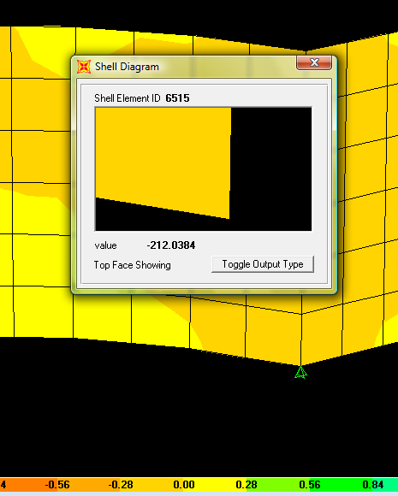
Fig( 6-6)S22diagram for wall pool (𝒒₁)
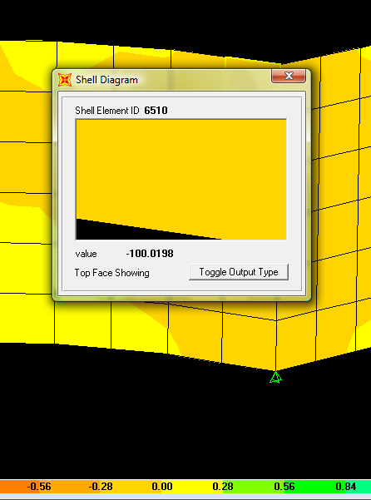
Fig ( 6-7) S22diagram for wall pool (𝒒₂)
(𝒒₁/c) = (𝒒₂/c-L)
c=3+2.68=5.68 m
I= (1/12) (0.25) (3)³=0.5625 m⁴
M=q*I/c
=212*0.5625/5.68 =21 ton.m
$$ρ=0.85\frac{f_{c}}{f_{y}}\left(1-\sqrt{\left(1-\frac{{2.35M}_{u}}{{∅bd}^{2}f_{c}}\right)}\right)$$
𝜌=.85*240/4200(1-√ (1-2.35*21*10⁵/0.9*300²*25*240)
𝜌 < 𝜌min
As= 𝜌min*b*h.
=0.0025*25*300
=18.75 cm²
A_{S} (10ф16)1ф16@30 cm c/c
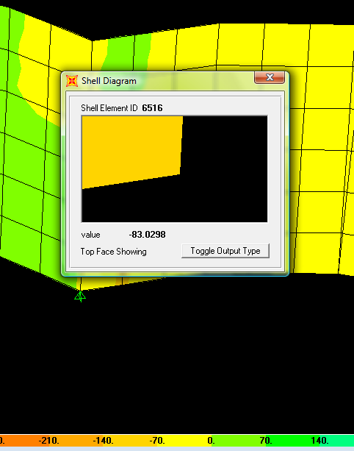
Fig (6-8 ) S12 diagram for wall pool
From SAP:
S12=83 ton
Vu=83*0.25*3=62.25 ton
Vn=Vu/ ф
=62.25/0.75 =83 ton
𝓥_{c}=0.53√ 𝒇_{c}΄* b_{w}*d
Ф Vc=0.75*.035*√240*30*100*10⁻³
=18.47
Vs=Vn- Ф Vc=83- 18.47=64.53 ton
Av/S=Vs/( ℱy*L)
=64.53*10³/4200*300
Av/S=0.051
Use Ф10 Av=1.57 cm²
S=1.57/0.051 =31 cm
1 Ф10@25 cm c/c
6.4.B Block B:
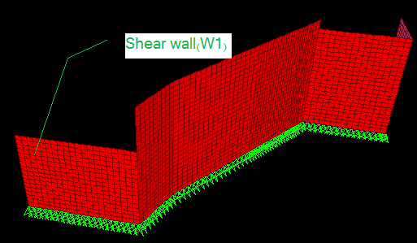
fig (6-9) shear wall of Block B
Design of wall 1 (W1):
𝒒₁=-200 ton /m² 𝒒₂=-26 ton/m²
L= 10.6m h=8.5m.
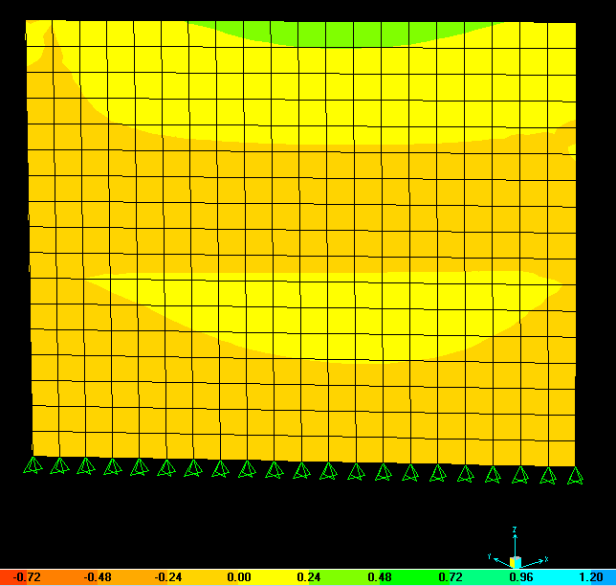
Fig ( 6-10) S22diagram for Sh W1

(𝒒₁/c)= (𝒒₂/c-L)
26/c=200/10.6+c
c=12.2 m
I= (1/12) (0.3) (10.6)³=29.78 m⁴
M=q*I/c
=200*29.78/12.2 =488 ton.m
$$ρ=0.85\frac{f_{c}}{f_{y}}\left(1-\sqrt{\left(1-\frac{{2.35M}_{u}}{{∅bd}^{2}f_{c}}\right)}\right)$$
𝜌=.85*240/4200(1-√ (1-2.35*488*10⁵/0.9*1220²*30*240)
=.0004< 𝜌min.

As= 𝜌min*b*h.
=0.0025*30*1060
=79.5 cm²
As(40ф16)1ф16@26 cm c/c
h/L=8.5/10.6 =0.8<2 shear is critical
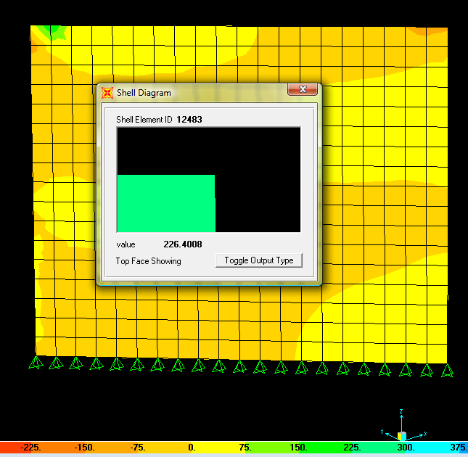
Fig (6-11 ) S12 diagram for W1
From SAP:
S12=226.4 ton
Vu=226.4*0.3*12.2=333.6 ton
Vn=Vu/ ф
=828.6/0.75 =1105 ton
Use two layer of steel because Vu>2Av√ 𝒇_{c}
𝓥_{c}=0.53√ 𝒇_{c}΄* b_{w}*d
Ф Vc=0.75*.035*√240*30*1060*10⁻³
=196
Vs=Vn- Ф Vc=1105- 196=909 ton
Av/S=Vs/( ℱy*L)
=909*10³/4200*1060
Av/S=0.2
Use Ф10 Av=1.57 cm²
S=1.57/0.2=7.85 cm
1 Ф10@10 cm c/c

