

An-Najah
National
University

Faculty Of Engineering

Computer Engineering Department

Graduation Project 1
Masaar
Author:
- Jehad Abu Raad
- Osaid Jabaji

Supervisor:
Dr. Anas Toma

Presented in partial fulfillment of requirements of bachelor’s degree in computer engineering.
February 2024

Acknowledgement

We want to convey our honest thankfulness and appreciation to Allah, the Almighty, for giving us the information, power, and endurance to complete this project. Additionally, we want to thank Dr. Anas Toma, our supervisor, for his advice and assistance with the creation of this Masar app. We also want to express our thanks to the Graduation Projects Committee for giving us the opportunity to work on this project. We are pleased to have contributed to the creation of a tool that will help travelers, explorers, and tour lovers. It has been an invaluable learning opportunity. Because there is always potential for improvement, we acknowledge that this tour app is not ideal. But we are hoping it will turn out to be a great asset for the travelers, explorers and improve the health and happiness of its patrons.
We are grateful to our families and friends for their love, encouragement, and patience during the long hours spent working on this project.

Disclaimer

This report was written by Jehad Abu Raad and Osaid Jabaji at the Computer Engineering Department, Faculty of Engineering, An-Najah National University. It has not been altered or corrected, other than editorial corrections, because of assessment and it may contain language as well as content errors. The views expressed in it together with any outcomes and recommendations are solely those of the student(s). An-Najah National University accepts no responsibility or liability for the consequences of this report being used for a purpose other than the purpose for which it was commissioned.

Contents

- Acknowledgement 1
- Disclaimer 2
- Abstract 1
- Introduction 2
  - Background and Motivation 2
  - Problem 3
  - objectives 3
  - Scope of the Project 3
  - Importance 4
  - Report Organization 5
- Constraints, Standards, and Earlier coursework 6
  - Constraints and Limitations 6
  - Standards 6
    - Provider pattern 6
  - Earlier coursework 7
- LITERATURE REVIEW 7
- Methodology 8
  - Tools, Methods, and Programming Languages 8
    - Client Side 9
    - Server Side 11
    - Integrated Development Environments (IDEs) 12
    - Testing of the Server and API 13
    - Data Visualization 13
  - Database Design 13
  - System Features and Implementation 15
    - Login and Registration feature 15
    - Home Screen Content and features 17
    - Profile page 21
    - Registered Trips Page 24
    - View All Tours Page 25
    - View Page for All Tourism Companies 26
    - Create A New Trip Page 27
    - A Page to See All the Trips You Have Created 28
    - A Page to See All Users Registered for A Trip You Created 29
    - Edit Information Page for A Trip You Created 30
    - Search for A Tour Using its Name or Part of it 31
    - Side Bar 33
    - Chat System 34
    - Notification system 35
    - Starting a Solo Tour 37

- Result and Discussion: 40
- Conclusion and recommendations 41
  - Conclusion 41
  - Recommendations 41
  - Future work 42
- References 43

List of figures
- Provider pattern Figure explanation 6
- Applying Agile mode 7
- From 2009 through 2022, Flutter’s explosive rise in popularity………………...
and the features that make it so advantageous for developers 10
- client server architecture 11
- MongoDB with NodeJS server 13
- login screen. 15
- Sign Up 1 screen. 16
- Sign Up 2 screen 17
- main page for normal 1 screen 18
- main page for normal 2 screen 19
- main page for normal 3 screen 20
- main page for company 1 screen 21
- main page for company 2 screen 22
- profile page screen 22
- update password screen 23
- profile page view by normal user screen 23
- Registered Trips Page screen 24
- All Tours Page screen 25
- full company list screen 26
- Create Tour screen. 27
- . 28
- Tours created by you page screen 29
- participants list in my tour screen. 29
- edit tour screen. 30
- search screen 31
- when searching for tours with letter a screen. 32
- side bar screen 33
- contact's list screen 33
- message sent by company to user screen. 34
- notification list for normal screen 35
- notification list for company screen 36
- starting a solo tour screen. 37
- showing locations on map for sabastya tour screen. 37
- Show information about the tour 1 screen. 38
- Show information about the tour 2 screen. 39

Abstract

Our project is a website and mobile application that specializes in walking and hiking events and publishing it to the users who can book their tickets and get full information about their journey. This project is mainly used as an app that hosts different number of hiking companies who can post and publish their events on the website for the users to register and book their place in the event, while also containing a list of guides that specialize in directing the movement route of the journey, who can be hired by the hiking companies, or can host their own hiking events since they have to needed knowledge to guide
their own events, the app also contains a rating and comment section to help users choose their favorite hiking spots and companies. We got our inspiration for this project from our love of hiking and having a hard time knowing and
choosing our desired hiking event, while also knowing if the hosts of the event are trusted or not, so we decided to create our own application to gather all hiking lovers together and making it easier for them to navigate and pick their option. Similar applications have been done before in different worldwide countries and got quite common and famous among hikers and attracted a good number of newcomers who always had that small interest in hiking but found it hard and tedious to look through social media for a trustworthy and engaging event. But surprisingly, such application was never created in Palestine, even though hiking is a pretty famous hobby here, so we thought it would be our honor to be the first to create a hiking related app and drive the wheel
of creating and upgrading similar apps in our beloved country.
Our aim with our application to spread our love for hiking in our beloved country and make it a more popular hobby that relieves people’s stress and hopefully spread positivity and lead to a better atmosphere
among people. We’ll hopefully add a lot of useful features through the development process of the project, features that
will make it even more user-friendly and effective.

Introduction

Background and Motivation
The West Bank, a land rich in history and cultural significance, presents a unique landscape both geographically and socio-politically. With its varied terrain, encompassing mountains, valleys, and historical sites, the region offers a wealth of opportunities for internal tourism, hiking, and camping. However, the potential for local tourism in the West Bank is often underutilized due to a variety of factors including limited awareness of available destinations, logistical challenges, and a lack of centralized platforms to facilitate these activities.
In recent years, there has been a growing interest in exploring the natural beauty and historical heritage within the West Bank. Locals and domestic tourists are increasingly seeking opportunities for outdoor activities such as hiking, camping, and exploring historical trails. Despite this interest, there has been a notable absence of a dedicated platform to cater to these specific needs. Most existing tourism apps and services focus on international travel, overlooking the rich experiences available locally. This gap presents an opportunity to develop a solution tailored to the needs of domestic tourists and adventure enthusiasts within the region.
"Masaar" is conceived as a response to this gap in the market. The application aims to empower locals and visitors in the West Bank to discover and participate in internal tourism activities easily and efficiently. By offering a one-stop platform for registering and participating in local tourism activities, Masaar seeks to streamline the process of planning and engaging in such experiences. The app not only facilitates the discovery of hidden gems in terms of trails and sites but also provides essential tools such as a notification system, chat for community engagement, and maps integration for easy navigation.
Beyond serving as a practical tool for adventure planning, Masaar holds the potential to significantly impact the local economy and cultural preservation. By encouraging internal tourism, it can contribute to a more sustainable tourism model that benefits local communities and preserves the cultural and historical integrity of the region. The app aims to foster a deeper appreciation among locals and visitors for the West Bank's unique heritage, while also providing a boost to local businesses and services that cater to tourists.
The development of Masaar is motivated by the need to provide a tailored solution for internal tourism in the West Bank, a region with untapped potential for local travel and adventure. By addressing the specific needs of this market, Masaar seeks to become an integral part of how people in the West Bank explore, appreciate, and interact with their rich natural and cultural landscape.

Problem

In the heart of the West Bank, a region brimming with cultural and historical richness, lies untapped potential for internal tourism. Despite the area's natural beauty and historical significance, residents and domestic tourists often find themselves at a loss when seeking to explore these local treasures. The core issue is the fragmented and scarce information about tourism spots, trails, and camping sites. This lack of centralized and reliable information poses a significant barrier to discovering and planning visits to these destinations. Further complicating matters is the challenging terrain and varying infrastructure across the West Bank, which can make navigation and trip planning daunting tasks.

Safety concerns also loom large, with the absence of real-time updates or a community platform leaving tourists without essential guidance or a means to share experiences and advice.

Moreover, the rich cultural and natural resources of the region remain underutilized, leading to missed opportunities for economic and cultural enrichment. The absence of an integrated service platform that combines information dissemination with practical trip planning tools is keenly felt, leaving a gap in the market for an all-encompassing solution to these challenges.

objectives

The creation of "Masaar" is driven by the ambition to transform the landscape of internal tourism in the West Bank. The app aims to centralize and simplify access to information about local tourist destinations, trails, and camping sites, thereby opening up a world of exploration for both locals and tourists. In navigating the West Bank's diverse geography, "Masaar" seeks to offer advanced mapping and direction features, making trip planning and execution a seamless experience. A key objective is to enhance the safety and communication aspects of tourism; by providing real-time updates and creating a platform for users to connect and share insights, "Masaar" intends to foster a sense of community and shared adventure. At its core, the app is about promoting the cultural and natural heritage of the West Bank, encouraging exploration, and appreciation of this unique region. Ultimately, "Masaar" is envisioned as a one-stop solution, a comprehensive tool that caters to every aspect of local tourism, from the initial spark of interest to the completion of a memorable trip.

Scope of the Project

"Masaar" is an ambitious project with a broad scope, primarily focused on the West Bank but with the potential to expand to other regions in the future. It is designed to cater to a diverse group of users, from locals seeking new adventures in their backyard to tourists wanting to explore the region's hidden gems. The app's features are comprehensive, encompassing user registration, detailed trip planning, integrated maps, real-time notifications, and a community chat platform. From a technological standpoint, "Masaar" leverages modern technologies for app development, ensuring a user-friendly interface and robust data management. Moreover, the project is not just about technology; it's about building partnerships and collaborations. This includes working closely with local businesses, tourism boards, and cultural organizations to provide the most authentic and enriching experience to its users. In essence, the scope of "Masaar" extends beyond being just an app; it's about nurturing a community, supporting local economies, and showcasing the cultural wealth of the West Bank.

Importance

- Cultural Connectivity and Preservation: "Masaar" plays a crucial role in connecting people with the rich cultural heritage and historical sites of the West Bank. By promoting awareness and accessibility to these locations, the app aids in the preservation and appreciation of the region's cultural legacy.
- Economic Growth and Local Business Support: The app is poised to significantly boost the local economy. By increasing internal tourism, it creates demand for local services and products, thereby supporting small businesses and generating new employment opportunities.
- Community Building and Social Interaction: "Masaar" encourages community building by providing a platform for locals and tourists to share experiences, plan activities together, and exchange cultural insights, fostering a sense of unity and social interaction.
- Environmental Awareness and Sustainable Tourism: The app highlights the importance of sustainable tourism practices, promoting environmental awareness among tourists. This is crucial for the conservation of natural sites and for maintaining the ecological balance of the region.
- Enhanced Accessibility and Convenience: By providing comprehensive information, easy navigation, and efficient planning tools, "Masaar" makes exploring the West Bank more accessible and convenient, encouraging more people to engage in internal tourism.
- Safety and Security: With features like real-time notifications and a community chat platform, "Masaar" enhances the safety and security of tourists. This is especially important in areas with challenging terrain or where immediate updates on conditions are crucial.
- Innovative Use of Technology: The project showcases the innovative use of technology in addressing regional tourism challenges. It sets a precedent for how tech solutions can be tailored to meet specific cultural and geographical needs.
- Educational Value: "Masaar" offers significant educational value by providing users with information about the historical, cultural, and natural significance of different sites, enriching their travel experience and broadening their knowledge.
- Promotion of Health and Wellness: By encouraging activities like hiking and camping, the app promotes physical health and wellness. Engaging with nature and participating in outdoor activities have been shown to have positive effects on mental health as well.
- Global Recognition of Local Sites: Finally, "Masaar" has the potential to bring global recognition to the West Bank's tourism sites, highlighting them as must-visit destinations for a wider international audience in the future.

Report Organization
The report is structured into seven distinct phases, starting with an introduction, and then proceeding to a section on constraints, standards, and codes. Following that, we go into previous coursework suitable to the project and highlight the key challenges. A literature review chapter and a methodology chapter will outline the project’s developmental stages, including the tools and technologies used. Our results and discussion section will detail the obstacles we get over and the successes we achieved. Lastly, we will provide recommendations and future development goals in the conclusion chapter.

Constraints, Standards, and Earlier coursework

Constraints and Limitations
- Time Limit for Developing Masaar app: The time frame for developing the Masaar app was constrained by various factors, including the current war conditions in Palestine in general and handling other projects. In addition, since this was our first experience developing apps using Flutter and Dart programming languages, it required a significant amount of time to ramp up at the beginning of the development cycle, which was limited to just four months.
- fixed budget for development and implementation: certain features were not included in the app due to the associated costs for implementing them, these limitations were taken into consideration throughout the development process to ensure that the project was completed within the set budget and time frame.
- platform constraints: we test and build our project on Android devices due to the lack of resources for IOS Devices.
- One of the biggest constraints was trying to create an Arabic application on an English platform, causing some text problems and spending time on figuring out the appropriate text format to display each message or text label.

Standards

Provider pattern
In our system, we utilized the Provider pattern, which allowed us to structure the project into distinct, manageable layers, enhancing the clarity and flow of work processes. These layers are organized as follows:

Provider Layer: This is the state management core of our application. It is responsible for managing and granting access to the application's state across various other layers.

Presentation Layer: This layer is the face of our application, encompassing the user interface. Its primary role is to observe changes in the application's state and update the user interface elements to reflect these changes.

Data Layer: Serving as the application's data backbone, this layer includes sources such as APIs, databases, or other data providers. Its key function is to interact with the Provider Layer for data retrieval and updates, ensuring a smooth data flow within the application.

Services Layer: This layer is pivotal to the application's business logic. It acts as a bridge, facilitating effective communication and coordination between the Data Layer and the Presentation Layer, thereby ensuring a cohesive and seamless user experience.

This structured approach, with clearly defined layers, not only simplifies development and maintenance but also enhances the overall efficiency and scalability of the application.

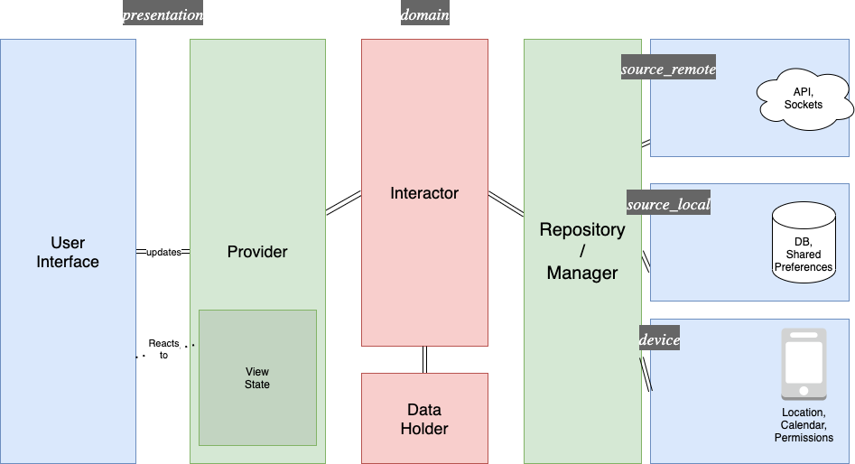
Figure 1: Provider pattern Figure explanation

Earlier coursework
The foundational knowledge gained from our Computer Engineering courses was instrumental in the development of this app. Core concepts from Web Programming and Object-Oriented Programming, which were integral parts of our academic curriculum, served as the cornerstone for this project. To further enhance our expertise, we proactively pursued additional learning opportunities through online courses focused on Node.js, MongoDB, Flutter, and Socket IO. This supplementary education played a crucial role in the effective implementation and development of our app, enriching our practical skills and technical proficiency.

LITERATURE REVIEW

When we chose the idea for our graduation projection, we took into consideration that our country lacks applications of this type, applications that supports and encourages going out and discovering the nature, which was our motive when we saw that most of the countries around the world have enormous number of apps that does exactly that, so we decided to be the firsts to start this motive of developing mobile apps for hiking tours.

The review underscores the effectiveness and popularity of mobile applications in enhancing the experience of internal tourism and outdoor activities globally. However, it also points out a significant gap in the market for such apps in the West Bank, Palestine. This absence indicates a potential area for development, where an app like "Masaar" could not only fulfill a market need but also contribute to the promotion and accessibility of local tourism within the region.

Methodology
Based on the research and literature review conducted on domestic tourism applications, it can be concluded that Masaar is a great idea and a step towards enhancing the popularity of trips and itineraries in the West Bank. This chapter discusses research methodology, including data collection, analysis, and processing. It also covers the tools, methods and systems used in developing Masaar and the results obtained.

Tools, Methods, and Programming Languages
In the creation of the Masaar app, we employed an array of tools, methodologies, and programming languages to ensure a robust and user-friendly application. Flutter and Dart were chosen for front-end development, enabling us to craft a contemporary and user-friendly interface. For the back-end, we opted for Node.js and Express.js, which were instrumental in developing a RESTful API that efficiently manages the app's data and logic. Additionally, MongoDB was utilized to design a database schema that effectively stores and organizes the application's data.

Client Side
- Design: The design process for the client side of the "Masaar" app commenced with the initial idea selection, followed by thorough research to develop a creative and innovative design concept tailored to the app. Our commitment to this project stemmed from a desire to enhance the experience of internal tourism, particularly in the unique context of the West Bank. We chose to forego pre-designed UI templates, instead of investing significant effort in crafting a distinct user interface (UI) for "Masaar." This bespoke UI design was developed in-house, grounded in extensive research that considered user needs and industry best practices. Our approach enabled us to create a custom, intuitive, and visually appealing design that aligns seamlessly with the application's theme and branding. The color scheme was selected with care to enrich the user experience and instill a sense of comfort and ease during app usage. We maintained simplicity and ease of use in the design of the application and website interfaces, ensuring user-friendliness. Additionally, we integrated contemporary design elements to keep the application modern and aligned with current industry trends.
- Framework: For the client-side development of "Masaar," we opted to utilize Google's cross-platform UI framework. Flutter, a renowned open-source mobile application development framework backed by Google, uses the Dart programming language. Its wide array of features, such as hot-reload, widget-centric development approach, and platform-specific widgets, significantly enhance the development process. Flutter enables the creation of iOS and Android mobile apps from a single codebase, effectively rendering its own components. This feature eliminates the necessity for traditional native programming for these platforms, resulting in substantial savings in both time and effort for cross-platform app development. We selected Flutter for "Masaar" due to its proven reliability, swift performance, and versatile cross-platform capabilities. The framework has gained increasing popularity, supported by Google, and enriched by the community's ongoing contributions. As of January 2024, Flutter boasts over 300 million downloads globally and offers developers a vast ecosystem with more than 120,000 Flutter packages, underscoring its widespread acceptance and utility in app development.

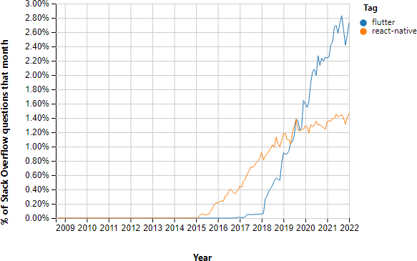

Figure 3: From 2009 through 2022, Flutter’s explosive rise in popularity and the features that make it so advantageous for developers.

- Programming Languages: For client-side development in Flutter, we employed Dart, an object-oriented programming language developed by Google. Dart shares similarities with languages like C++, Java, and JavaScript, being a compiled, type-safe language with scripting capabilities that are reminiscent of Python and JavaScript. Our existing proficiency with these languages from our university studies made Dart relatively easy to learn and use. Despite its relative novelty, Dart is equipped with an extensive range of libraries that streamline and accelerate the scripting process. Its popularity has been rapidly growing, making it a promising choice for modern app development.
- Website Development: The website for "Masaar" was developed using the same client-side technology as the mobile application, leveraging Flutter's cross-platform UI framework. This strategy ensures a consistent design and functionality across all platforms, resulting in a cohesive user experience. Flutter's efficiency in rendering high-performance web applications using the same codebase as mobile apps presents a considerable advantage. It reduces the time and effort required for development while maintaining high standards of code maintainability and performance.

Server Side

Server-Side Architecture: For our "Masaar" system, we adopted a client-server architecture, enabling various clients like the website and mobile app to interact with the same API. Our servers are specifically designed to support a RESTful API, facilitating efficient and seamless communication between the client interfaces and the server.

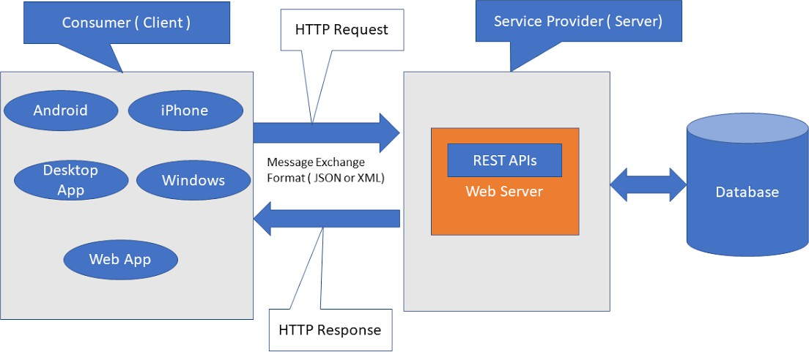
Figure 4: client server architecture

Server-Side Framework Usage: In developing the server-side environment, we chose to utilize Node.js in conjunction with the Express.js framework. This combination is highly effective for crafting server-side applications. Node.js was selected for its array of features that perfectly align with our project requirements, including its ease of learning, comprehensive documentation, scalability, and high performance. Express.js, known for its status as a leading back-end development framework in the Node ecosystem, contributes to the robustness of our server framework. The synergy of Node and Express has endowed our application with a dependable and high-performing server-side infrastructure.

    - Integrated Development Environments (IDEs)

For the development of the REST API in our "Masaar" project, Visual Studio Code was our chosen Integrated Development Environment (IDE). As a free, open-source, cross-platform code editor, Visual Studio Code stands out for its extensive range of powerful extensions. These extensions allowed us to tailor the IDE to our specific development needs. We found Visual Studio Code to be highly efficient and user-friendly, particularly suitable for constructing complex applications. Its advanced capabilities like IntelliSense, debugging, and code navigation greatly assisted us in writing clean, efficient, and error-free JavaScript code. Additionally, its integrated support for Git streamlined our code repository management and facilitated smooth collaboration within our team.
For the development of both Android and iOS platforms, we needed an IDE that could efficiently handle both. We chose Android Studio for this purpose, as it provided us with the tools to develop, debug, and test for both platforms within a single environment. However, we encountered challenges in testing functionalities separately for Android and iOS. Since Android Studio is primarily optimized for Android app development, testing iOS applications was not feasible on our PCs due to the requirement of a Mac device for such tasks.

Testing of the Server and API

The reliability of the server and API is vital for the seamless operation of the "Masaar" project. To ensure this, we employed both Postman and Thunder Client for our testing processes. Postman is a widely utilized tool in the developer community, known for its effectiveness in API testing. It enabled us to automate many testing aspects, saving considerable time and effort. This tool proved invaluable in simulating various request-response scenarios, testing edge cases, and validating the functionality and performance of our API.
In conjunction with Postman, we used Thunder Client, a lightweight extension for Visual Studio Code. This extension provided the convenience of testing and debugging APIs directly within our coding environment. The combination of Postman and Thunder Client allowed for comprehensive and efficient testing of our server and API, ensuring robust performance and reliability of the "Masaar" app.

Data Visualization
In the "Masaar" app, data visualization plays a crucial role in both backend management and enhancing user experience. Leveraging MongoDB as our database, we have implemented several strategies for visualizing the data from our seven key tables: users, tours, ratings, notifications, joined tours, comments, and chats.

Database
Data Structure and Visualization Strategy:

MongoDB's Flexible Schema: MongoDB's schema-less nature allowed us to tailor our data structures to the specific needs of each table. This flexibility is especially useful for tables like 'comments' and 'chats', where data can be highly variable in structure.

Aggregation and Reporting: We use MongoDB's aggregation framework to compile and analyze data, especially for the 'ratings' and 'joining tours' tables. This helps in generating insights such as popular tours, user engagement statistics, and overall app usage trends.

Real-Time Data Visualization: For features like notifications and chats, real-time data visualization is crucial. MongoDB aids in this by efficiently handling real-time data, allowing for instant updates and dynamic visual feedback in the app interface.

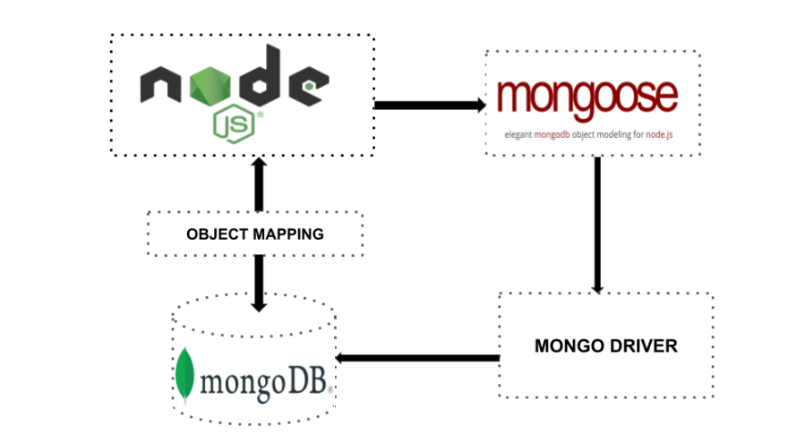

Figure 5: MongoDB with NodeJS server

Tools for Visualization:
Integration with Visualization Tools: We integrate MongoDB with visualization tools and libraries to create intuitive and interactive visual representations of our data. These visualizations aid in understanding user behaviors, tracking app performance, and making data-driven decisions for future updates.

Visualization in User Interface:
Enhancing User Experience: On the client side, data visualizations are implemented to enhance user experience. For example, visual representations of tour ratings and user participation statistics help users make informed decisions.
Interactive Elements: Interactive elements, such as maps for tours and graphical representations of user engagement, are incorporated, making the app more engaging and informative.

Challenges and Solutions:
Handling Large Datasets: As our user base grows, handling larger datasets efficiently becomes crucial. We optimize our MongoDB queries and use indexing strategies to maintain quick data access and visualization responsiveness.
Data Privacy and Security: While visualizing user data, we ensure strict adherence to data privacy and security standards, anonymizing sensitive data where necessary.

The strategic use of MongoDB for data visualization in "Masaar" has not only streamlined backend data management but also significantly enhanced the front-end user experience. By effectively visualizing complex datasets, we provide valuable insights to our users and admins, driving informed decision-making and continuous improvement of the app.

System Features and Implementation

7.3.1 Login and Registration feature
This is the first page in the application, where the user must enter his email and password, and he can click on the “Create a new account” box if he does not have an account. On the registration page, he is asked to enter his full name, email, phone number, age (or company age), and gender. He is also asked to specify the type of account he wants to create, where he can create a regular user account or a company account.

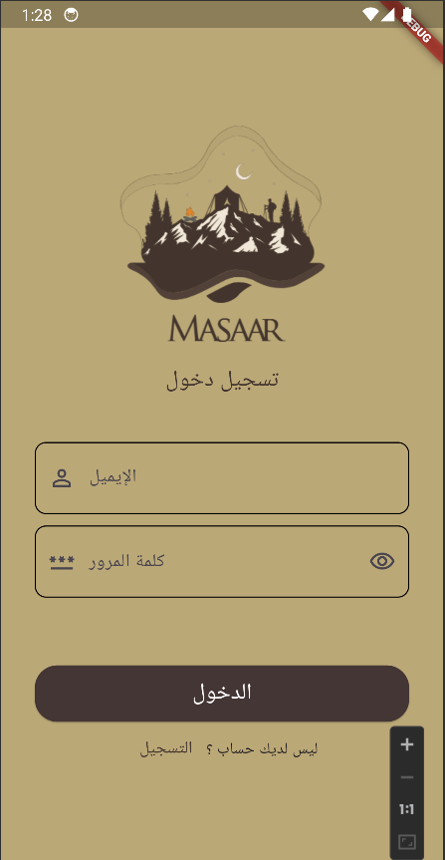
Figure 6: login screen

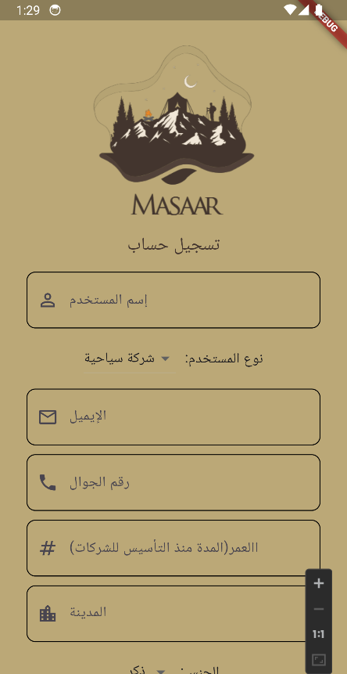
Figure 7: Sign Up 1 screen.

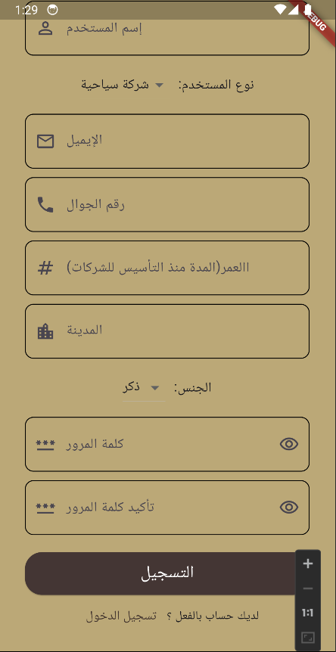
Figure 8: Sign Up 2 screen.

7.3.2 Home Page

The information displayed on the home page varies depending on the type of account that is logged in, whether it is a regular user account or a tourism company account.

On the home page, if the user who has logged in is a regular user, a variety of shortcuts are displayed, such as a list of the most famous trips, a list of trips that this user has registered for, or the most famous tourist routes, in addition to the List icon, which when pressed shows some shortcuts.

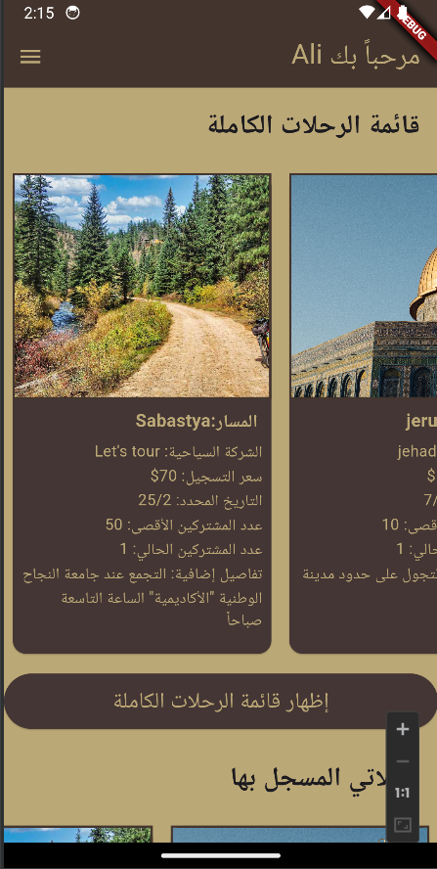
Figure 9: main page for normal 1 screen

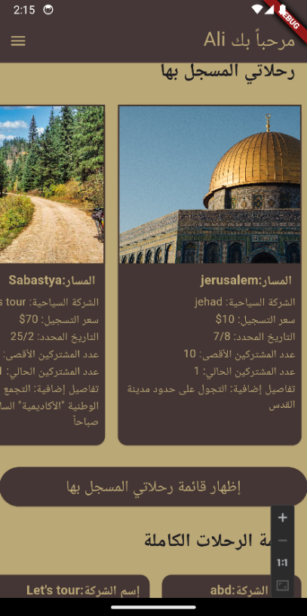
Figure 10: main page for normal 2 screen

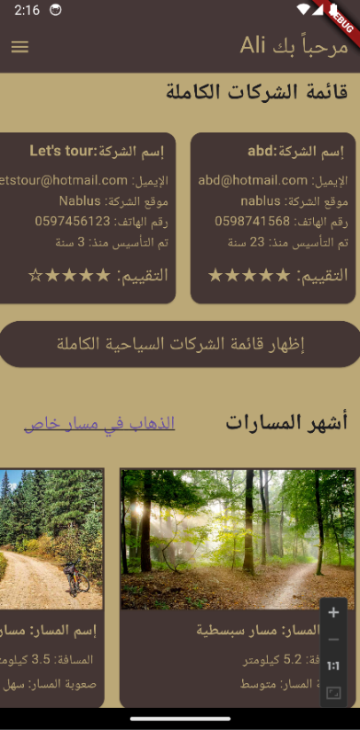
Figure 11: main page for normal 3 screen

On the home page, if the user who has logged in is a tourism company account type, some shortcuts will appear to him, such as some of the trips that this company has created and a list of the most famous tourist trips based on the users’ actions, in addition to the list icon, which when clicked pops up a group of Abbreviations.

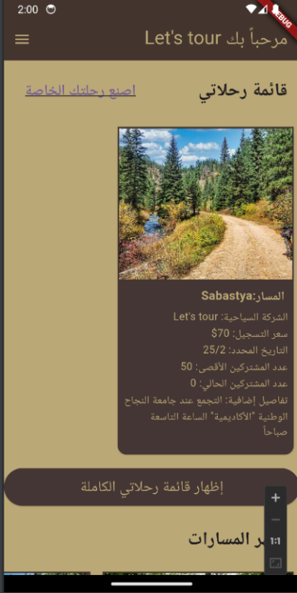
Figure 12: main page for company 1 screen

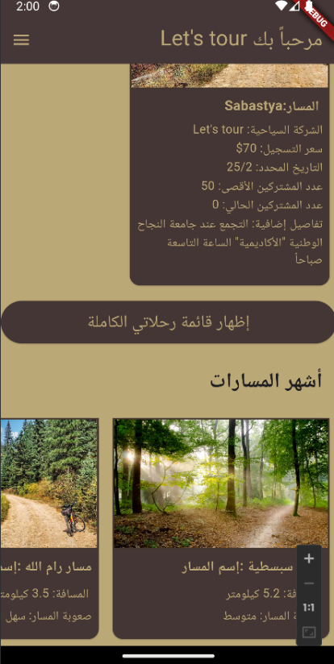
Figure 13: main page for company 2 screen

7.3.3 Profile page
The information displayed on the profile page varies depending on the type of account that is logged in, whether it is a regular user account or a tourism company account.
On the profile page, when the user himself logs into his profile, his personal information is shown to him, and there is an option to modify the information or update the password.

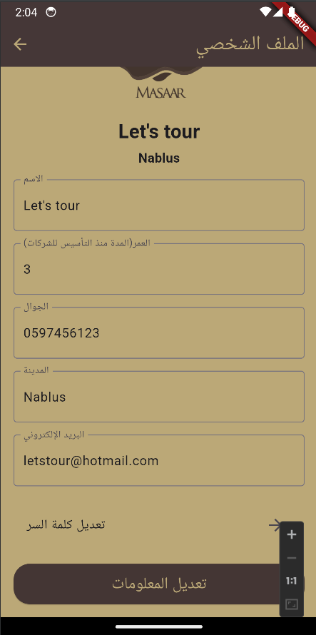
Figure 14: profile page screen

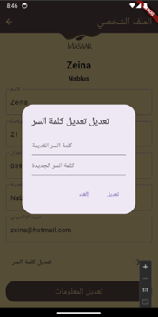
Figure 15: update password screen

When a regular user accesses a company’s profile, the company’s information and details appear to him and he can rate the company out of five stars.

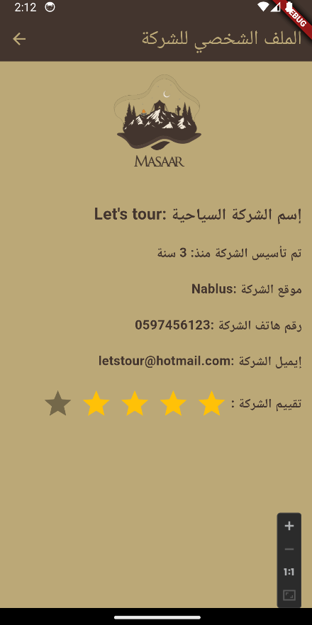
Figure 16: profile page view by normal user screen

7.3.4 Registered Trips Page
This is the list of tours that the normal user has registered for.
From here, he can cancel the registration for a trip.

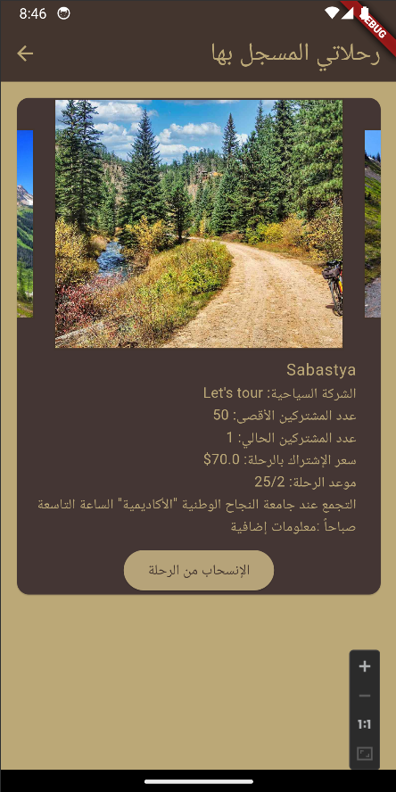
Figure 17: Registered Trips Page screen

7.3. 5 View All Tours Page

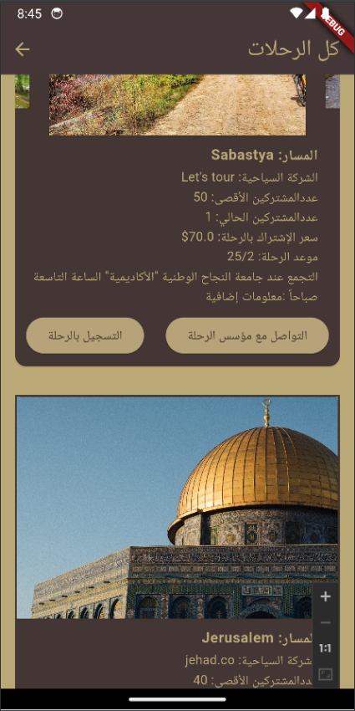
Figure 18: All Tours Page screen

7.3.6 View Page for All Tourism Companies

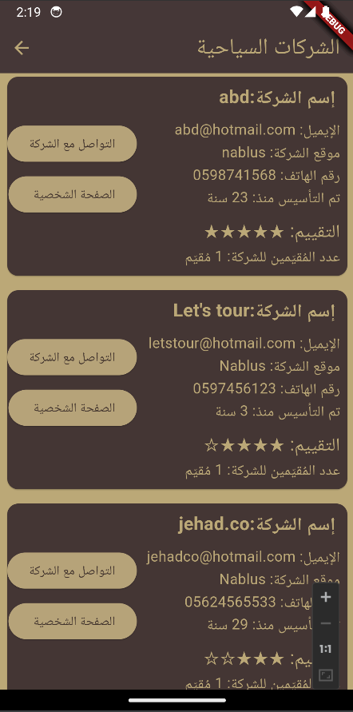
Figure 19: full company list screen

7.3.7 Create A New Trip Page

If the logged in user is a tourism company account type, he can create a new trip and is asked to add the maximum number of participants in the trip, the cost of the trip, the destination and date of the trip, in addition to a field for adding details such as the meeting place or the start date of the trip and other things. This is what must be taken into consideration before going on the trip, in addition to adding pictures of the trip location.

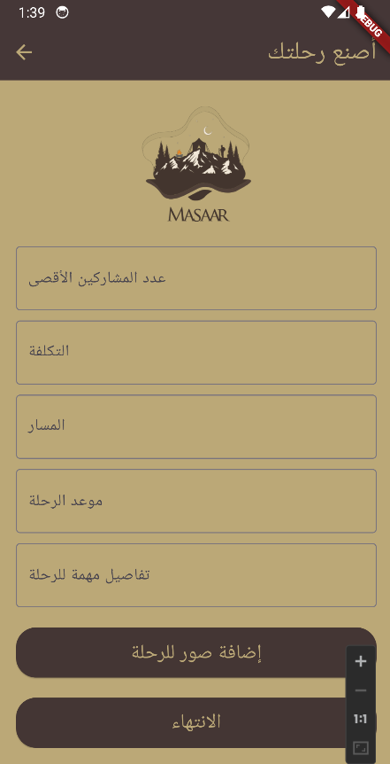
Figure 20: Create Tour screen.

7.3.8 A Page to See All the Trips You Have Created
If the user has a tourism company account, from here he can see all the trips he has created, and several options appear with each trip, such as deleting the trip, modifying the trip information, or showing the users participating in this trip.
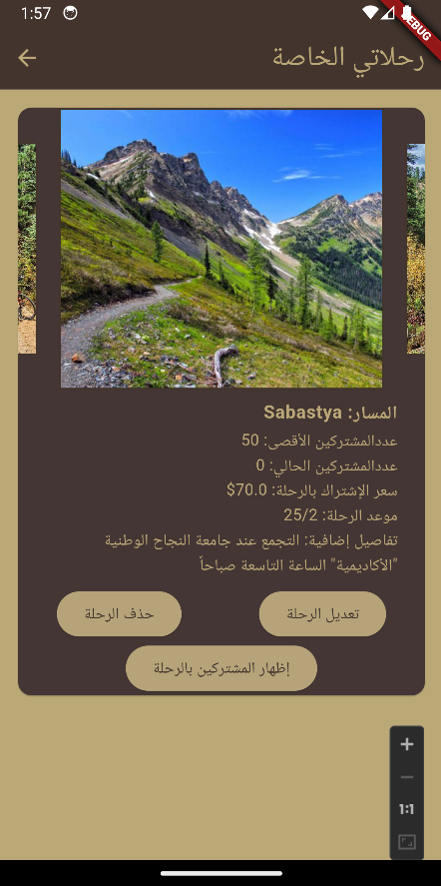
Figure 22: Tours created by you page screen.

7.3.9 A Page to See All Users Registered for A Trip You Created
When you view the list of those registered for a trip that you created, all information appears with each user and the possibility of deleting him from the trip.

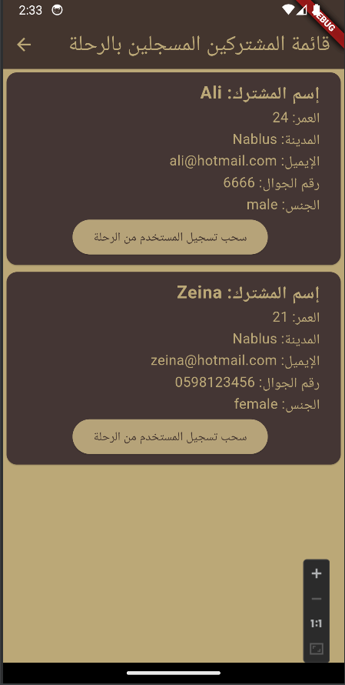
Figure 23: participants list in my tour screen.

7.3.10 Edit Information Page for A Trip You Created
From here, anyone who created a trip can modify the information for this trip, such as its date, cost, or other matters.
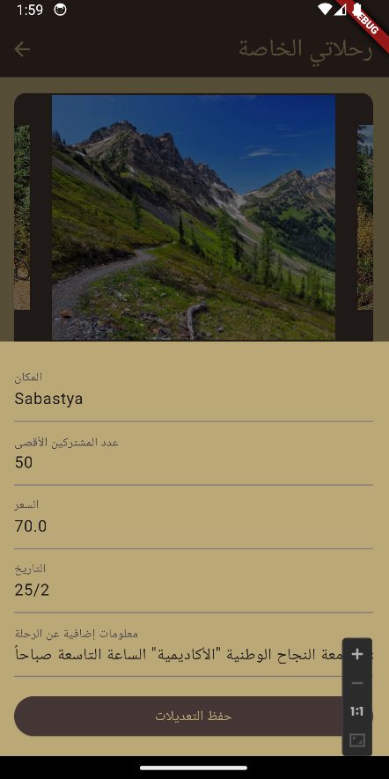
Figure 24: edit tour screen.

7.3.11 Search for A Tour Using its Name or Part of it

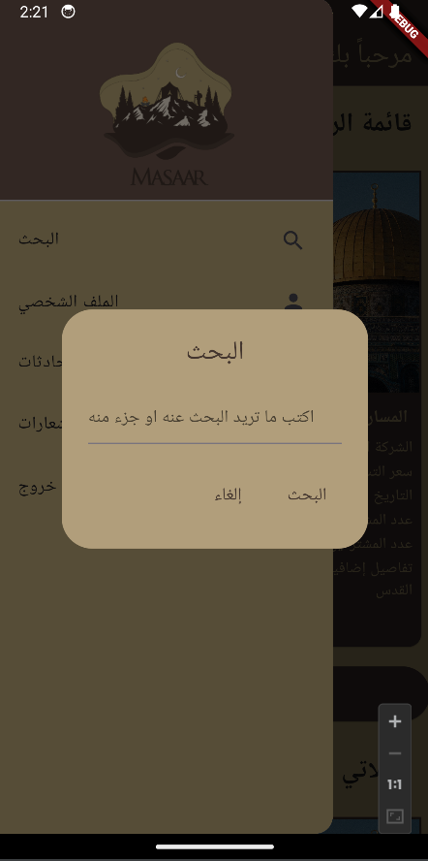
Figure 25: search screen

This is the search result when searching for the letter a .
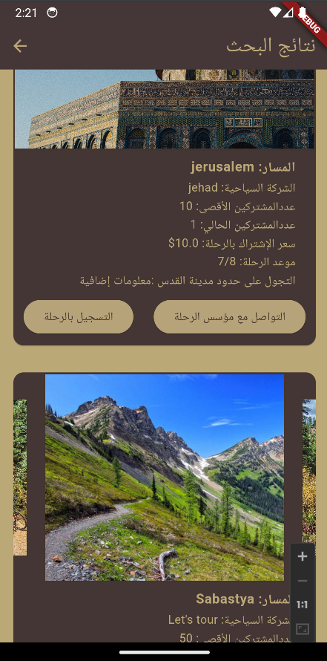
Figure 26: when searched for tours with letter a screen.

7.3.12 Side Bar
From here, the user can access his profile, messages, or notifications, or he can log out.

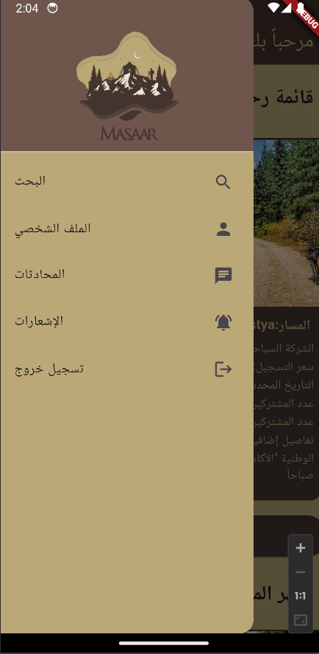
Figure 27: side bar screen

7.3.13 Chat System
The chat system provides a means of communication between the regular user and the tourism company if one of them needs to inquire about information that is not available in the personal file or the tour details.

Here we display the pages of chat and the people who were contacted.

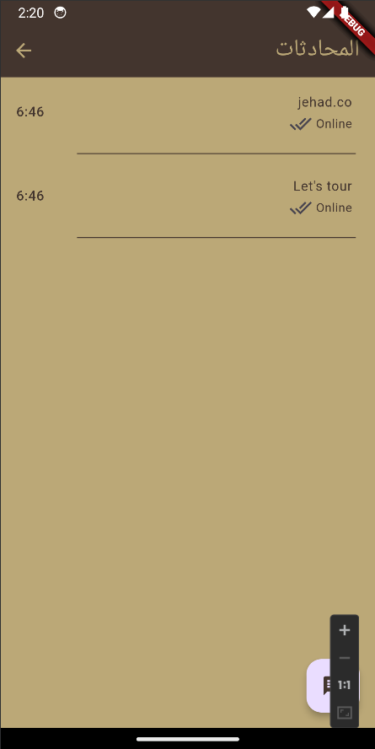
Figure 28: contact's list screen

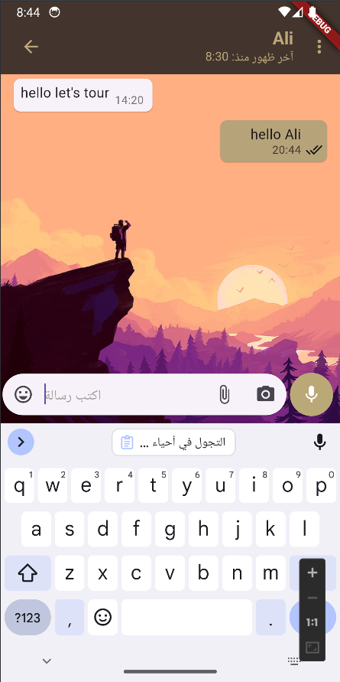
Figure 29: message sent by company to user screen.

7.3.14 Notification system
Notifications are sent to the regular user or to the company’s account in five cases:
1: The company deleted the tour.
2: The company deleted one of the participants in the tour.
3: The company updated the tour information.
4: One of the users has registered for a tour.
5: One of the users has unregistered from the tour.
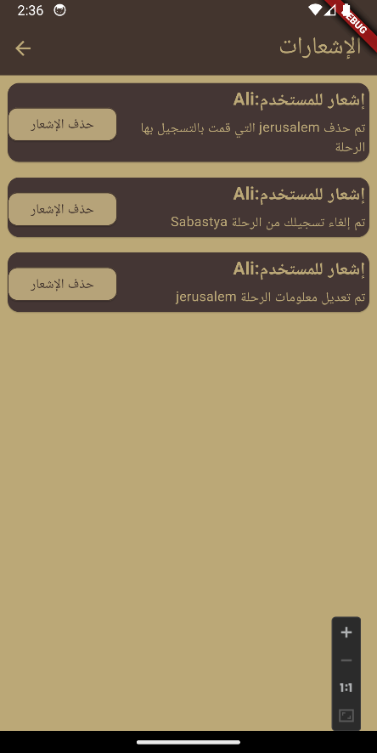
Figure 30: notification list for normal screen

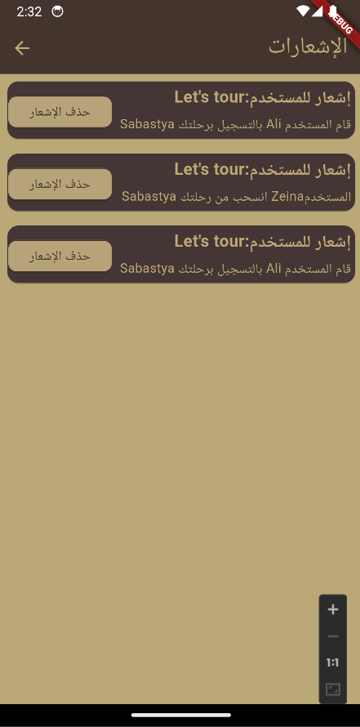
Figure 31: notification list for company screen

7.3.15 Starting a Solo Tour
From here, the user can go on his journey, enter the city and the trip, and then a map will be shown to him to help him reach the beginning of the route. Then the user will click on “Next,” and a picture of the location he is in will appear to him, and an explanation of this location, and the application will continue. To tell him where to go until he reaches the next leg of the trip, and so on until the trip ends.

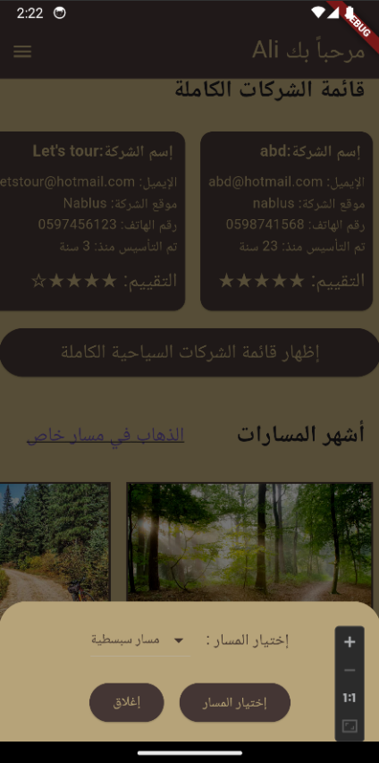
Figure 32: starting a solo tour screen.

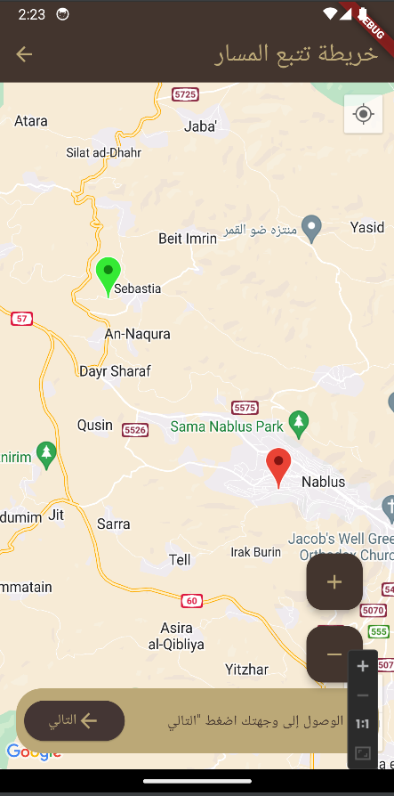
Figure 33: showing locations on map for Sabastya tour screen.

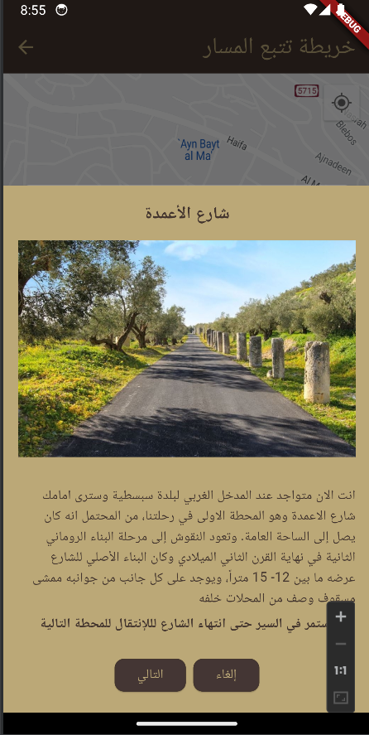
Figure 34: Show information about the tour 1 screen.

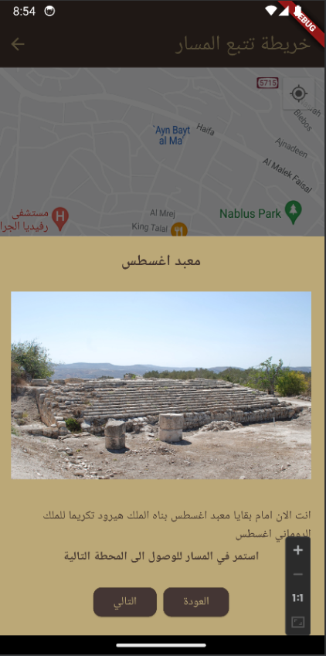
Figure 35: Show information about the tour 2 screen.

Result and Discussion
The development of the "Masaar" app has been a journey marked by significant insights and positive expectations. Aimed at enhancing internal tourism experiences in the West Bank, the app is meticulously designed with an intuitive user interface and a suite of comprehensive functionalities. It is poised to address the unique challenges of navigating and communicating within the region, simplifying the discovery and engagement in local tourism activities.
Throughout the development process, we have engaged in extensive testing and iterative feedback cycles. These steps have been crucial in shaping the app’s functionalities, revealing its usability and effectiveness, particularly in terms of real-time features and comprehensive tour information. This phase has also highlighted areas for improvement and additional features, reflecting the dynamic nature of user needs and preferences.
Our backend, powered by MongoDB, has been tailored to meet the expected demands of the app. It is designed to handle diverse data sets efficiently, such as user profiles, tour details, and real-time interactions, promising swift response times and high reliability. This robust backend structure is anticipated to be fundamental in ensuring a seamless user experience.
Reflecting on our initial objectives, "Masaar" aims to make a significant contribution to making internal tourism more accessible and enjoyable in the West Bank. The app is expected to encourage exploration of lesser-known destinations and to enhance engagement in regional tourism activities, potentially boosting the local economy and promoting cultural heritage.
The development path of "Masaar" has not been without challenges. Technical hurdles, particularly in integrating real-time communication features and ensuring consistent performance across devices, have provided valuable learning experiences. These challenges have emphasized the importance of adaptability and resilience in the app development landscape.

Conclusion and recommendations

  - Conclusion

As the development of the "Masaar" app nears completion, we reflect on a journey that has been both challenging and rewarding. Our goal was to create an innovative application that enhances the internal tourism experience in the West Bank, making it easier for users to discover and engage in local tourism activities. Throughout this process, we have successfully implemented a user-friendly interface, integrated real-time communication features, and developed a robust backend using MongoDB.

The anticipated impact of "Masaar" on the West Bank’s tourism landscape is significant. By facilitating easier access to tourism information and providing a platform for users to share experiences, the app is expected to boost local tourism, support the economy, and promote the region's rich cultural heritage. This project has not only been about developing an application but also about contributing to the community and the local tourism industry.

9.2 Recommendations

Considering the development and anticipated launch of the "Masaar" app, several key recommendations emerge for its ongoing success and evolution. Firstly, maintaining a strong focus on user engagement and feedback post-launch is essential. This will not only aid in refining the app’s features based on actual user experiences but also ensure that it continuously aligns with user needs and preferences. As the user base expands, it will be critical to regularly assess and upgrade the app’s infrastructure to manage scalability and performance effectively, ensuring that "Masaar" remains efficient and reliable even as demand grows.

Implementing a robust marketing strategy will be crucial in enhancing the app's visibility and expanding its user community. This could include leveraging social media platforms, collaborating with local tourism authorities, and engaging in community-oriented events.

Furthermore, the app's feature set should not remain static. Based on evolving technological trends and user feedback, the integration of advanced features like augmented reality and personalized recommendations could significantly enhance user experience and engagement. Ensuring the highest standards of data privacy and security is paramount; regular security assessments and adherence to privacy regulations will be essential in safeguarding user data and maintaining user trust. Additionally, the app should be continuously evaluated for cultural sensitivity and inclusiveness, ensuring that it caters to a diverse user base with multi-language support and content that resonates across different cultural backgrounds. Lastly, as "Masaar" promotes tourism, incorporating features that encourage sustainable and environmentally friendly tourism practices can contribute positively to the region’s ecological sustainability and community welfare.

These recommendations, if effectively implemented, will not only bolster the app's functionality and user base but also reinforce its role as a transformative tool in the West Bank's tourism landscape.

9.3 Future work

In envisioning the future trajectory of the "Masaar" app, our team is dedicated to exploring a range of enhancements and expansions that promise to elevate the platform's capabilities and user experience. A significant focus will be on the development of advanced personalization features, utilizing sophisticated algorithms to tailor tour and activity recommendations to individual user preferences and past behavior. Augmented Reality (AR) integration is another exciting prospect, offering an immersive layer of digital interactivity to the exploration of historical sites and landscapes. Recognizing the diversity of our user base, expanding the language options within the app is a key objective, aimed at broadening accessibility and inclusivity.

We also see immense value in strengthening community engagement features, such as forums or social networking within the app, to encourage users to connect, share experiences, and possibly coordinate joint activities. In response to the growing importance of sustainability, we plan to introduce features that endorse eco-friendly tourism practices and highlight sustainable local businesses. Enhanced data analytics will underpin these developments, providing deeper insights into user behavior and preferences to inform our ongoing optimization and innovation efforts.

10 References

[1] F. Doglio, Pro REST API Development with Node. js. Apress, 2015.
[2] D. Slepnev, “State management approaches in flutter,” 2020.
[3] R. Payne and R. Payne, “Using firebase with flutter,” Beginning App
Development with Flutter: Create Cross-Platform Mobile Apps, pp. 255–
285, 2019.
[4] A. Mardan, Express. js Guide: The Comprehensive Book on Express. js.
Azat Mardan, 2014.
[5] N. Delic, “Basics of clean code— Flutter project [UI Part].”
https://nihad-delic91.medium.com/basics-of-clean-code-flutter-project-uipart-b7fa93c31775, feb 2 2021.
[6] “How to Use the Provider Pattern in Flutter.”
https://www.freecodecamp.org/news/provider-pattern-in-flutter/, jun
12 2020.
[7] “Mysql: Mysql Documentation.” https://dev.mysql.com/doc/.
[8] “Index | Node.js v20.2.0 Documentation.” https://nodejs.org/api/.
[9] “Socket.io Documentation.” https://socket.io/docs/v4/.
[10] “Flutter documentation.” https://docs.flutter.dev/.

