
An Najah National University

Faculty of Engineering
Electrical Engineering Department

Indoor Cell Planning For An Najah Educational National Hospital

Graduation Project


Submitted To
Dr. Allam Mousa

Prepared By
Haitham Fahed
Mohammed Donbok


In Corporation with
Contents

Figures IV
Tables V
Acknowledgement VI
Abstract VII
Chapter 1: Introduction 1
Chapter 2: Indoor Components Design 2
2.1 Radio Base Stations 2
2.2 Cables 5
2.2.1 Coaxial Cable 5
2.2.2 Fiber Optics Cable 6
2.3 Splitters 6
2.4 Antenna 7
2.4.1 Omni-directional antenna 8
2.4.2 Directional antenna 9
Chapter 3: Before Design 10
3.1 Problems description 10
3.2 Signal strength inside the hospital before implementing the system 11
Chapter 4: Project Design 16
4.1 Passive or Active DAS? 16
4.2 Capacity Dimensioning 16
4.3 Radio Base Station (RBS) 18
4.4 Antenna Locations 18
4.4.1 The ‘Corridor Effect’ 19
4.4.2 Antenna Location inside the Hospital 20
4.5 RF Indoor Link Calculations 26
4.5.1 Link Budget 26
4.5.2 Free space path loss 31
4.6 The design by using software. 41
4.6.1 Link budget results 41
4.6.2 Path loss results 43
Chapter 5: Conclusion 49
References 50
Appendices 51
Appendix-A : Radio Base Station 2308 (RBS 2308) Catalogue 51
Appendix-B : Coaxial Cable ( LDF4-50A) Catalogue 53
Appendix-C : Splitters Catalogue 58
Appendix-D : Omni Directional Antenna Catalogue 59
Appendix-E : Directional Antenna Catalogue 60
Appendix-F : Erlang B table, 1-50 channels, 0.07-40% grade of service 61
Appendix - G : Cable Routing inside hospital 63

Figures

Figure 1 : Ericson Front view of RBS 2202 2
Figure 2 : Capacity Vs cell range related to each other 4
Figure 3 : Ericsson RBS types 5
Figure 4 : Different types of splitters. 6
Figure 5 : Power distribution of a typical 1:2 splitter 7
Figure 6 : RX Level Distribution in Ground Floor 11
Figure 7 : RX Level Distribution in Basement One 12
Figure 8 : RX Level Distribution in Basement Two 12
Figure 9 : RX Level Distribution in Basement Three 12
Figure 10 : RX Level Distribution in Basement Four 13
Figure 11 : RX Level Distribution in Basement Five 13
Figure 12 : Signal strength inside Basement One 14
Figure 13 : Signal strength inside Basement Two 15
Figure 14 : Antennas location in Ground Floor 20
Figure 15 : Antennas location in Basement One 21
Figure 16 : Antennas location in Basement Two 22
Figure 17 : Antennas location in Basement Three 23
Figure 18 : Antennas location in Basement Four 24
Figure 19 : Antennas location in Basement Five 25
Figure 20 : Distributed Antenna Design (DAS Design) 30
Figure 21 : Attenuation Measures Vs Materials 31
Figure 22 : Points inside Ground Floor 35
Figure 23 : Points inside Basement One 36
Figure 24 : Points inside Basement Two 37
Figure 25 : Points inside Basement Three 38
Figure 26 : Points inside Basement Four 39
Figure 27 : Points inside Basement Five 40
Figure 28 : iBwave link budget report for antenna number 115 41
Figure 29 : iBwave link budget report for antenna number 54 42
Figure 30 : Prediction area at Basement Two 43
Figure 31 : Prediction area at Ground Floor 44
Figure 32 : Prediction area at Basement One 45
Figure 33 : Prediction area at Basement Three 46
Figure 34 : Prediction area at Basement Four 47
Figure 35 : Prediction area at Basement Five 48
Figure 36 Cable Routing inside GF 63
Figure 37 Cable routing inside B1 64
Figure 38 Cable routing inside B2 65
Figure 39 Cable routing inside B3 66
Figure 40 Cable routing inside B4 67
Figure 41 Cable routing inside B5 68

Tables

Table 1: Differences between antenna systems 8
Table 2 : Receiving level 19
Table 3 : Building ‘A’ link Budget 27
Table 4 : Building 'C' Link Budget 27
Table 5 : Building 'B' Link Budget 28
Table 6 : Lifts Link Budget 29
Table 7 : Building ‘A’ path loss 32
Table 8 : Building ‘B’ path loss 33
Table 9 : Building ‘C’ path loss 34

Acknowledgement

We would like to dedicate our deep thanks and appreciation to our university and our supervisor Dr. Allam Mousa for his generous efforts in helping us completing this work and continuing theory with practice. Dr.Allam is one of the people in this industry we respect the most, for his dedicated work and contribution to so many fields in the industry of telecommunication.
We would also like to thank Jawwal team led by Dr.Khaled Hijji, Eng.Akram Barkeh for their support. We would also like to thank Eng.Karem Al Hosani, Eng.Ahmad Abed, and Eng.Abeer Imteer for their help in fascinating the access to the IBwave software. They also helped us by reviewing the project's documents.
Last, but not least, lots of thanks to our families and friends for their support, encouragement and for letting us spend so many late nights, early mornings and weekends on this project. Without them, this project would not have been possible.
Even though we have spent many hours on this project, checking and double-checking everything, there might be some errors. If so, we will make sure to correct them.

Haitham M. Fahed
Mohammed A. Donbok

Abstract

This project aims to develop a solution to the expected shortage of cellular communication services inside An Najah university hospital. This proposed system will serve hundreds of the hospital visitors, workers and residences. At one stage data will be collected based on a predesigned method then, this data will be interpreted. This problem will be stated and examined using certain mathematical tools and a proper engineering approach. Both capacity and coverage problems will be addresses.
The system components will be studied and analyzed and the engineering aspects will be applied to design an integrated solution to a critical problem which faces the local society. During this project we will be able to strengthen our team work and communication skills, we will be able to cooperate among ourselves as well as with partners inside and outside the university. This project will result in designing a solution for the shortage of cellular communication services inside the university hospital.

Keywords: RBS, Antenna, splitter, indoor, link-budget, RF-Planner, path loss ,iBwave …etc.

Chapter 1: Introduction

This chapter gives an overview of what was achieved in the Introduction of Graduation Project the past semester. This part of the project digs deep in the main core of the project which is Indoor Cell Planning for An-Najah Educational National Hospital.
According to the scope of the project, GSM network components are: cell sizing, frequency reuse interference and more. Moreover, for any planner engineer, it’s essential to consider many factors affecting the design such as coverage, traffic within the network, capacity and revenue are all important factors that should be considered. On the other hand, some of challenges that depend on the business itself as many challenges are related to the technical part.
Chapter two focuses on the components that are used or may be used in indoor projects. The very first components are the RBS and what are the differences between them which lead to choosing a suitable one for the site. The Second one is cabling. The splitter and the calculations related to its port is the third component. The final one is antenna types.
Chapter three explains the current problems statement present in the site “AN Najah Hospital” before doing the indoor system which they are the cause of doing this project.
For a planner engineer, RF-Design is an essential thing that should be considered. Chapter four stresses on the related disciplines within the project. Additionally, coverage area that is needed and traffic related to the Erlang calculation are included too. The link budget which is a main field to get the power calculation results and how much power is transmitted by antenna is also calculated by hand through mathematical equations approach.
To wrap up, this project developed a solution to the expected shortage of cellular communication services inside An-Najah Educational National Hospital. This proposed system will serve hundreds of the hospital visitors, workers and residences. The problem will be stated and examined using certain mathematical tools and a proper engineering approach.

Chapter 2: Indoor Components Design

This chapter includes the components needed for the plan site which are mostly used for indoor design and it is important to any planning engineer. These components contain radio base station (RBS), feeders, antenna and splitters. They are used in different ways according to design and project that are needed.

2.1 Radio Base Stations

A Radio Base Station (RBS) is a data communications station which is geographically fixed and which is typically made up of equipments handle with connecting mobile terminals to a digital network by sending and receiving signals and converting between radio frequency (RF) waves and audio signals. The digital network enables the base station (BS) to communicate with a mobile switching center (MSC) within the wireless network. The mobile switching center sets up and connects calls between the mobile terminal and/or the fixed wireless terminal and a remote device. RBS is also referred to as base transceiver station (BTS) or simply, the base station.
These are RBS parts in general shown in Figure 1:
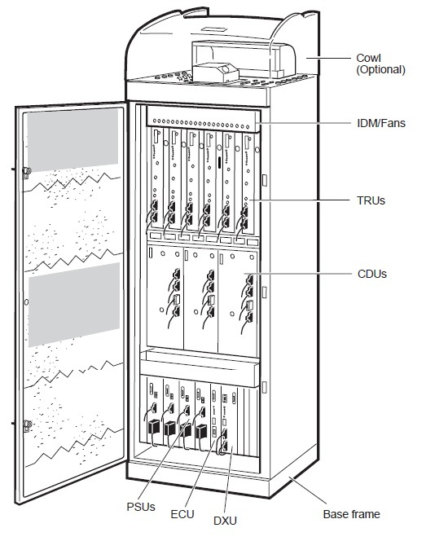

Figure 1 : Ericson Front view of RBS 2202
- TRU: Transceiver Unit

The Transceiver Unit (TRU) is a transmitter/receiver and signal processing unit which transmits and receives the radio frequency signals that are passed to and from the mobile station. There are different versions of TRU depending on the frequency band.
One TRU can serve eight full rate duplex channels or 16 half rate channels. The TRU has one transmit antenna terminal and two receive terminals.
The TRU supports diversity reception. Diversity is used to improve the receiver performance. It is achieved by having two independent receiver paths. The signals are combined in the signal processing in the Digital Block.

- CDU: Combiner & Distribution Unit.
The Combining and Distribution Unit (CDU) is the interface between Transceivers (TRUs) and the antenna system. The CDU allows several TRUs to share antennas.

- DXU: Distribution Switch Unit.
The Distribution Switch Unit (DXU) is the central control unit of the RBS. There is one DXU per RBS. In multi-cabinet configurations the DXU is located in the Master Cabinet only. The DXU establish connection with the BSC and cross connect individual time slots to certain transceivers.
- PSU: Power Supply Unit.
The Power Supply Unit (PSU) rectifies the incoming AC power to the regulated DC voltage required.

- ECU: Energy Control Unit
The Energy Control Unit (ECU) controls and supervises the power equipment (PSU, BFU, battery, AC Connection Unit) and climate equipment (fans, heater, cooler and heat exchanger). The ECU observes alarm signals from power and climate system. The purpose of the ECU is to protect equipment within the RBS from conditions that could reduce lifetime and reliability. The ECU protects the equipment during power failure conditions and cold-start up.

Commercial types of radio base station:
There are many companies such as Ericsson Company and Motorola Company manufacture several types of RBSs which differs in the output power and the maximum number of TRUs that can be supported. Figure 2 shows the types of RBSs and the capacity Vs cell range related to each one in relevant to all Ericsson types’ .Figure 3 shows most important specification for most Ericson types.
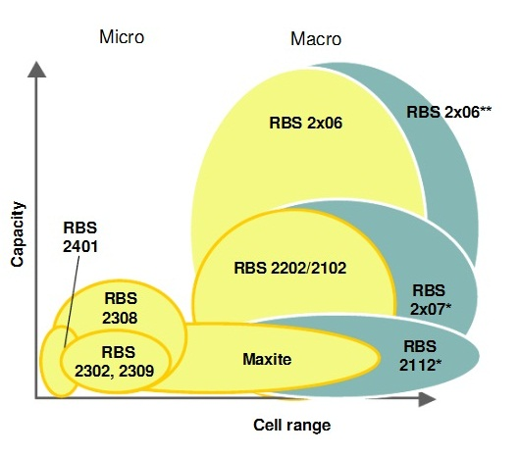
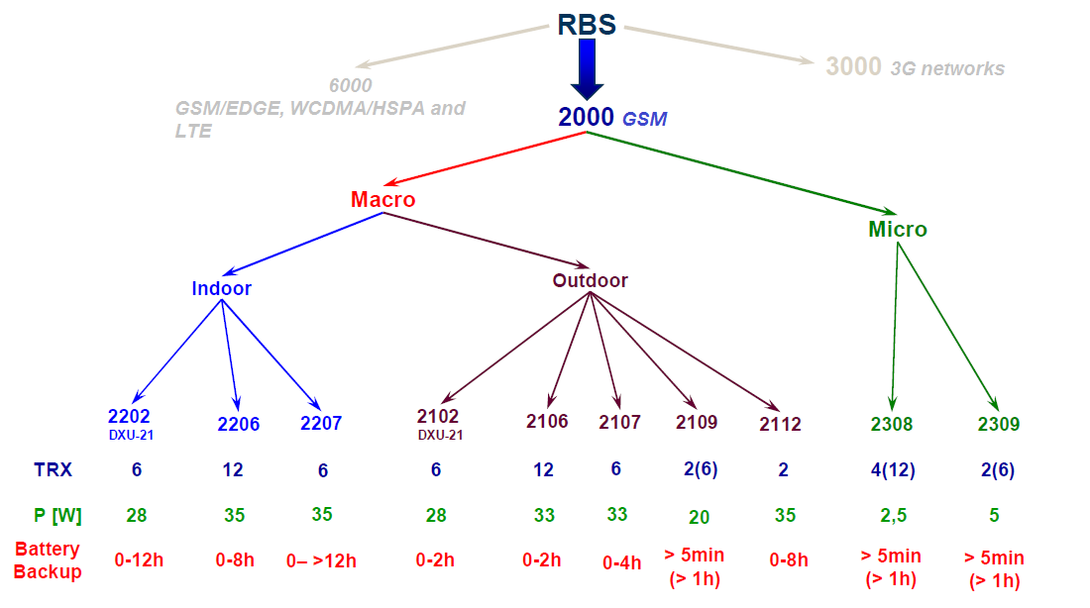
Figure 2 : Capacity Vs cell range related to each other
Figure 3 : Ericsson RBS types

2.2 Cables

The following section summarizes the cable types of an indoor system, two types of systems can be used, the first one is passive distributed antenna system which uses coaxial cables and components do power losses, and the second one is active distributed antenna system which uses fiber cables and components approximately don’t make power losses in compare to passive one.

2.2.1 Coaxial Cable

Coaxial Cable is mainly used as a transmission line for radio frequency signals such as the indoor system to be designed in some system. Its application includes connecting radio transmitters and receivers with their antennas, computer networks connection and distributing cable television. 'One of the advantages of coaxial cable -over other types of radio transmission line- is that in an ideal coaxial cable, the electromagnetic field carrying the signal exists only in the space between the inner and outer conductors'1. Moreover, coaxial cable also provides protection of the signal from external electromagnetic interference.

Coaxial cables usually come with different types that may be used in various installations that depend on each case. In this project, as a result of the usage of the passive DAS method, “LDF4-50a” cable diameters of 1/2in and loss feeder approximately equals to 7dB/100m were selected to be used. Appendix-B contains the specifications of this cable.

2.2.2 Fiber Optics Cable

'There are different solutions based on fiber-optics that can be used for indoor systems. The main purpose is to overcome losses in long coaxial feeder cable. One disadvantage of using fiber-optical network is that each antenna terminal need local power supply and alarm handling.'²

2.3 Splitters

The design of this project depends on the passive components in DAS which commonly use splitters and power dividers. They divide the signal that comes from cables to multiple distributed ports that is distributed through antennas. The illustration Figure 4 shows the types of splitters that split the line into two or more lines, and vice versa. It is notable here that termination of all ports on the splitter is essential, thus, ports should not be left opened.
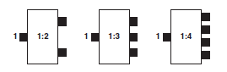
Figure 4 : Different types of splitters.

The following equation is used to calculate the loss through the splitter:
$$splitter loss=10\log\left( no.of ports \right)+ insertion loss$$
- Insertion loss is the loss that is produced by splitter-typically equal 0.1 db.

Example
For (1:2) splitter -as shown in Figure 5, the attenuation will be:
$$10 log(2) + 0.1 dB=3.11 dB$$
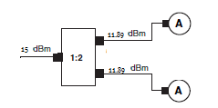
Figure 5 : Power distribution of a typical 1:2 splitter
This is an example of the splitter calculation, if the input power of (1:2) splitter was $15 dBm$ on port 1, the output power on ports $2$-$3$ will be $15-3.11= 11.89$ dBm.
In this project, 1:2, 1:3 and 1:4 splitters have been used; Appendix-C shows the catalogues for these types.

2.4 Antenna

Antennas are a very important component of communication systems. By definition, an antenna is a device used to transform an RF signal, traveling on a conductor, into an electromagnetic wave in free space. Antennas demonstrate a property known as reciprocity, which means that an antenna will maintain the same characteristics regardless if it is transmitting or receiving. Most antennas are resonant devices, which operate efficiently over a relatively narrow frequency band. An antenna must be tuned to the same frequency band of the radio system to which it is connected; otherwise the reception and the transmission will be impaired. When a signal is fed into an antenna, the antenna will emit radiation distributed in space in a certain way. A graphical representation of the relative distribution of the radiated power in space is called a radiation pattern.

The antenna configurations for indoor installations may be categorized into two types:
- Distributed antennas using a coaxial feeder network.
- Distributed antennas using a fiber-optical feeder network.

Table 1 explains the differences between the aforementioned types of antenna:

Table 1: Differences between antenna systems
Antenna System | Comments
Distributed antennas (Coax) | Low Cost  Flexible Design  Robust and well proven technique
Distributed antennas (Fiber) | +Low attenuation  +Easy installation  -Expensive  -Limited design flexibility

According to radiation pattern, there are several types of antenna devices that are suitable for indoor applications. The most commonly used types are the directional and the Omni-directional antenna.

2.4.1 Omni-directional antenna

The Omni-directional antenna radiates or receives equally well in all directions. It is also called the "non-directional" antenna because it does not favor any particular direction. The catalogue of this antenna type is listed in Appendix-D.

2.4.2 Directional antenna

A directional antenna or beam antenna is an antenna which radiates greater power in one or more directions allowing for increased performance on transmit and receive and reduced interference from unwanted source, in this project, directional antennas have been used above the lifts so that the power will concentrate in the shafts of the lifts. The catalogue of this antenna type is listed in Appendix-E.

Chapter 3: Before Design

Before starting the design process, a survey should be done to measure the signal strength inside all over the building to determine if the problem could be solved from the macro layer around the building. It is possible to get enough signal strength from the outside macro layer by increase the transmitted power, but it could make an interference problem. Capacity could be a problem too, because the macro layers may not have extra empty recourses to serve the building, so you need the indoor solution.
This step is important not only to measure the signal strength; it is in need to take a look on the shafts, corridors and walls.

3.1 Problems description

In An Najah Educational National Hospital case, a survey had been done and checked if there is a problem and these problems have been found
- Drop calls (poor quality): Call that is terminated unexpectedly as a result of technical reasons, including presence in a dead zone or interference from cells using the same frequency.

- Call setup failure: Call setup procedure failed due to a number of technical reasons like weak coverage.
These problems are due to
- Weak signal strength which refers to the magnitude of the electric field at a reference point that is a significant distance from the transmitting antenna. Al Najah Educational National Hospital area has a very poor reception although there is a site approximately near to the hospital but the coverage signal cannot reach the hospital itself because of the topography of the region.

- Low Carrier to Interference (C/I): Ratio (C/I), is the quotient between the average received modulated carrier power C and the average received co-channel interference power I. Interference usually refers to the interaction of waves, either because they come from the same source or because they have the same or nearly the same frequency.

- Rapid attenuation of the signal strength because of the construction materials used in the building. Large buildings such as warehouses, hospitals and factories often have no usable signal further than a few meters from the outside walls.

3.2 Signal strength inside the hospital before implementing the system

These results obtained by doing a walk test as described in the introduction to graduation project last semester as shown in the Figure 6-Figure 11 for each floor inside the building. This figures show the range if received Signal Vs number of points having this range inside every floor. The range of $>-75 dbm$ could be consider as an acceptable range.
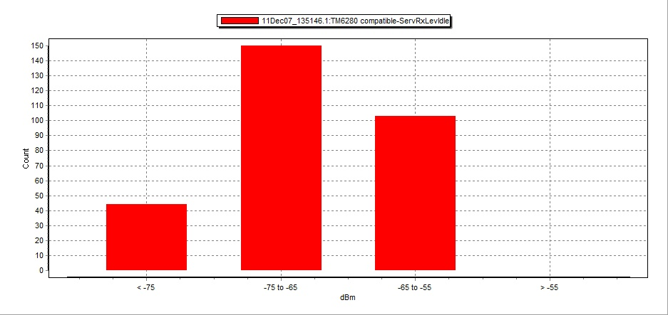
Figure 6 : RX Level Distribution in Ground Floor
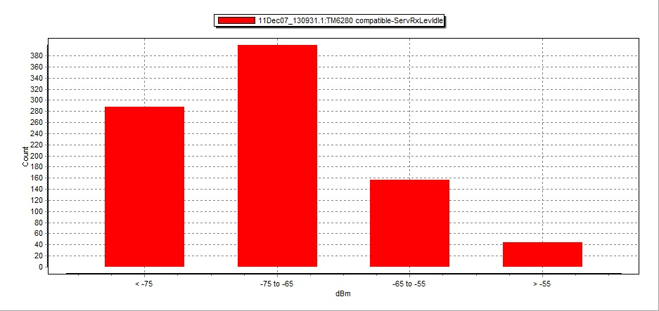
Figure 7 : RX Level Distribution in Basement One
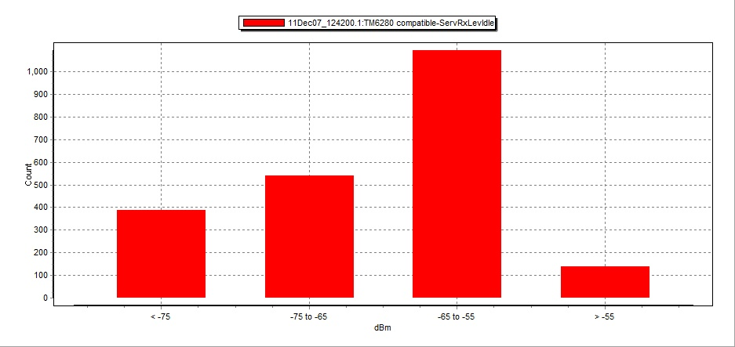
Figure 8 : RX Level Distribution in Basement Two
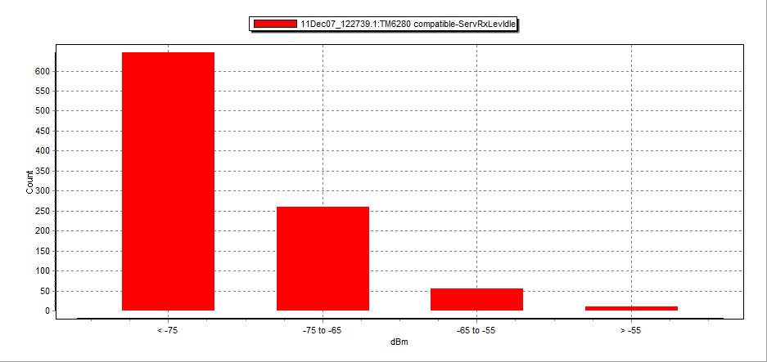
Figure 9 : RX Level Distribution in Basement Three
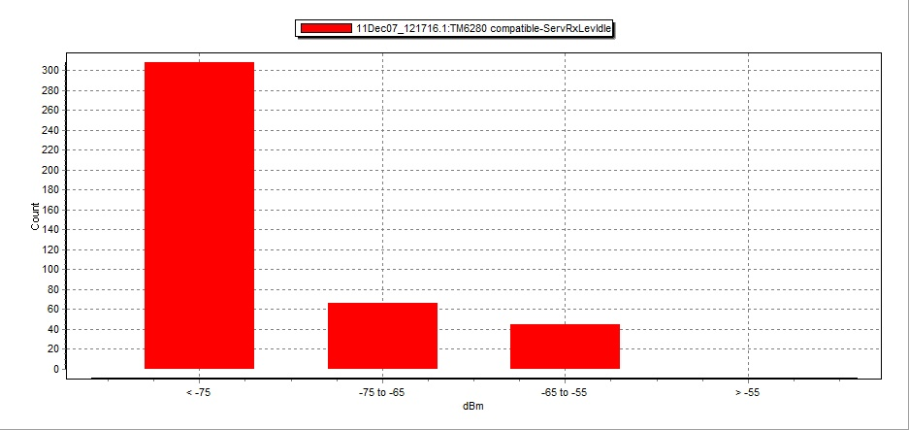
Figure 10 : RX Level Distribution in Basement Four
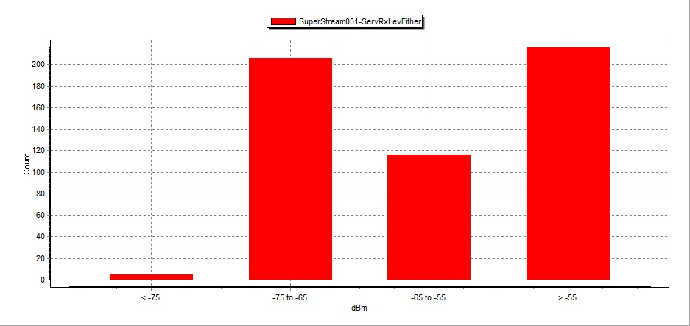
Figure 11 : RX Level Distribution in Basement Five

Another way to represent the signal strength inside the hospital in this stage can be shown in Figures 12 and 13.

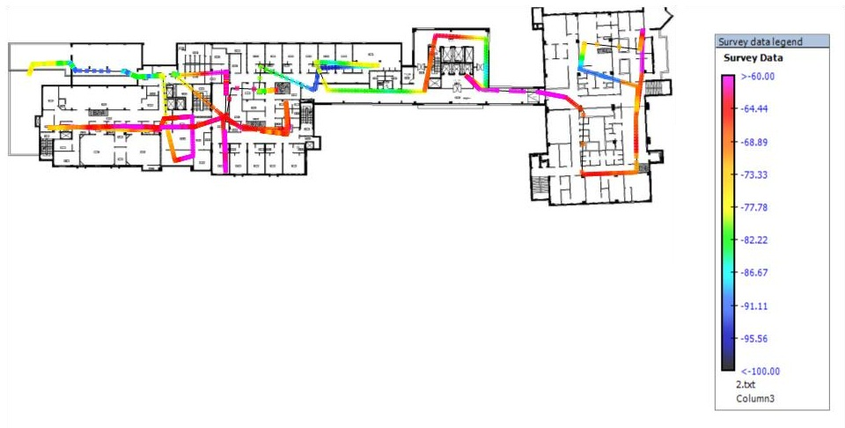
Figure 12 : Signal strength inside Basement One
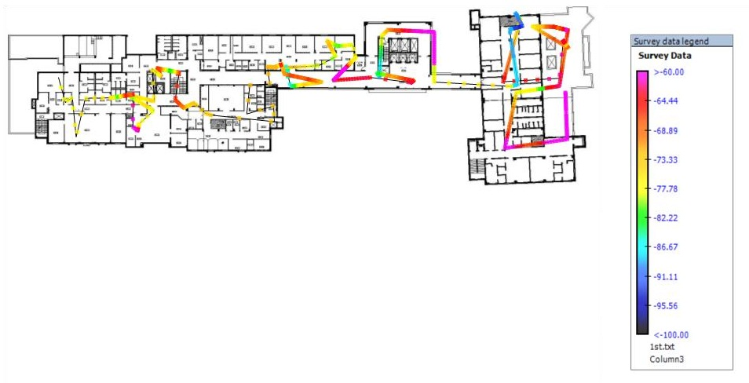
Figure 13 : Signal strength inside Basement Two

Chapter 4: Project Design

At this stage of the project, designing the indoor system will take place. The design process has been done by hand then software used to ensure that the values are accurate.
This chapter will also includes calculations related to indoor Rf-link budget after using cables, power splitters, antennas and other components. This step would assess the power received at the antenna and as a result the coverage, quality too.

4.1 Passive or Active DAS?
Two system types can be used for indoor solution as mentioned before, Active DAS or Passive DAS. In this project Passive DAS has been used for these reasons:

- It is straightforward to design.
- Components from different manufacturers are compatible.
- Components are available.
- It can be installed in harsh environment.
- No high data rate needed.

4.2 Capacity Dimensioning

This step aims to calculate the number of served subscribers and the number of TRUs required installing in the RBS:
- Number of subscribers:
According to the information from the hospital administration, there are 108 beds, if we suppose that in the peak time there are 108 patients, 108 followers, 108 staff members, 108 trainees and 300 visitors, so the summation equals 732, but the administration of the hospital estimated the number of people inside the hospital at the peak time will be 900 person. So, for more reliability 900 subscribers have been considered as peak time traffic for this project design.

- Type of subscribers:
Telecommunication Companies divide the subscribers into these types
- Extreme Users.
- Heavy Users.
- Normal Users.
- Privet Users.

Every type has an air time value measured in (mE) indicates to how many minute calls the subscriber do in one hour. In this project a Normal Users type has been assumed.
Every communication company chose the air time value according to the statistics they have from they own live network, for example Jawwal uses (22 mE) for Normal Type but Ericsson recommends to use (25 mE) which equals 1.5 minute calls in one hour for Normal Type, so for more reliability Ericsson recommendation will be used for this project.

- Grade Of Service ( GOS)-Call Blocking-:
Block rate means how many calls will be rejected according to lake of channels. This value determines by the operator, Jawwal uses $2\%$ GOS so this value used for this project.

- Number of channels and TRUs needed.
The number of channels can be calculated after calculate the value of total load in Erlang unit and then use the Erlang B-Table with GOS from Appendix-F ; this value can be calculated from this equation
$$Total load = number of subscribers X load per user$$
$$Total load = 900X0.025$$
$$Total load = 22.5 (E)$$

According to Erlang B-Table with $2\%$ GOS, $32$ channels are needed.
Every TRUs can carry 8 channels so $32/8 =4$ TRUs.
The system uses $3$ channels for control so 32$– 3 = 29$ traffic channels.

4.3 Radio Base Station (RBS)

Ericsson Company (which is the RBS supplier for Jawwal Company) manufacturing several types of RBSs with different characteristics as mentioned in section 2-1 .
As what have been determined in the capacity dimensioning section, 4 TRUs are needed, after studying all types, RBS 2308 micro site fit the requirements with $34 dbm$ output power and $-108 dBm$ sensitivity value. All the specifications for this RBS are in Appendix-A.
It is required to put the RBS somewhere in the middle of the building to get the minimum feeder distance to the antenna. For this project the RBS has been decided to be put on the roof of the building in the middle, the location of the RBS shown in Basement1 plan as shown in Figure 15.

4.4 Antenna Locations

This process starts by bring the plans of the building and signs the areas according to RX-Levels that should have reached in these areas- The levels are shown in Table 2 .
Selecting the correct coverage design level for the indoor design is crucial, for the performance of the indoor system, the data throughput performance and the leakage from the building. It must be also realized that the design levels come at a cost, and this has a direct impact on the business case. The higher the coverage level, the higher the cost of the system, obviously due to the need for more antennas and equipment for the indoor system, more equipment, more installation work and maintenance costs.

Table 2 : Receiving level
RX-Levels
Deep Indoor | -47 dBm to -64dBm
Indoor | -65 dBm to -74dBm
Incar | -75 dBm to -84dBm
Outdoor | -85 dBm to -94dBm
Bad Service | -95 dBm to -110dBm

After signs Corridors, reception, waiting rooms and staff rooms have Deep Indoor RX-Level, the antennas distributed inside them, if the room is square then the antenna will be in the center because it is Omni directional one, if it is corridors then the antenna should be in the start, middle, and the end of it. About the lifts, the antenna should be in the most upper side or in the most down side the shaft of the lifts and the antennas should be directional one.
The antennas should be placed so that the maximum footprint is obtained for each antenna. The antenna locations have to be adapted to the reality of the building, taking into account the installation limitations of the individual antenna placements, cable routes and antenna overlaps.

4.4.1 The ‘Corridor Effect’

‘One effect of placing antennas inside a building that is very important to know and utilize is the ‘corridor effect’. This is the distribution of coverage when placing an antenna in one of the most typical locations, the corridor.
This antenna location will give you several advantages:
- Typically there will be easy installation access to cable conduits in the corridors of the building, which will save implementation costs.
- Corridors are often ‘static’ when buildings are being refurbished, so the antennas are left in place with no impact of service degradation caused by refurbishment of the internal structure of the building.
- The users of the building are less concerned about radiation when they do not have antennas installed in the ceiling above their office desk.
- You can use the corridor to distribute the signal from the antenna, there is typically line-of-sight throughout the corridor, and this is what is known as the ‘corridor effect’ ³.

4.4.2 Antenna Location inside the Hospital

These Figures show the Distributed Antenna System (DAS) inside the hospital.
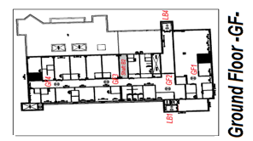
Figure 14 : Antennas location in Ground Floor
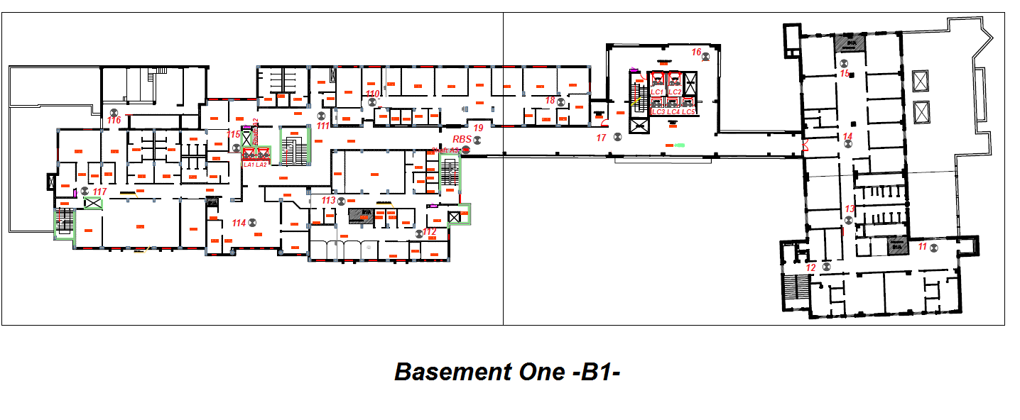
Figure 15 : Antennas location in Basement One
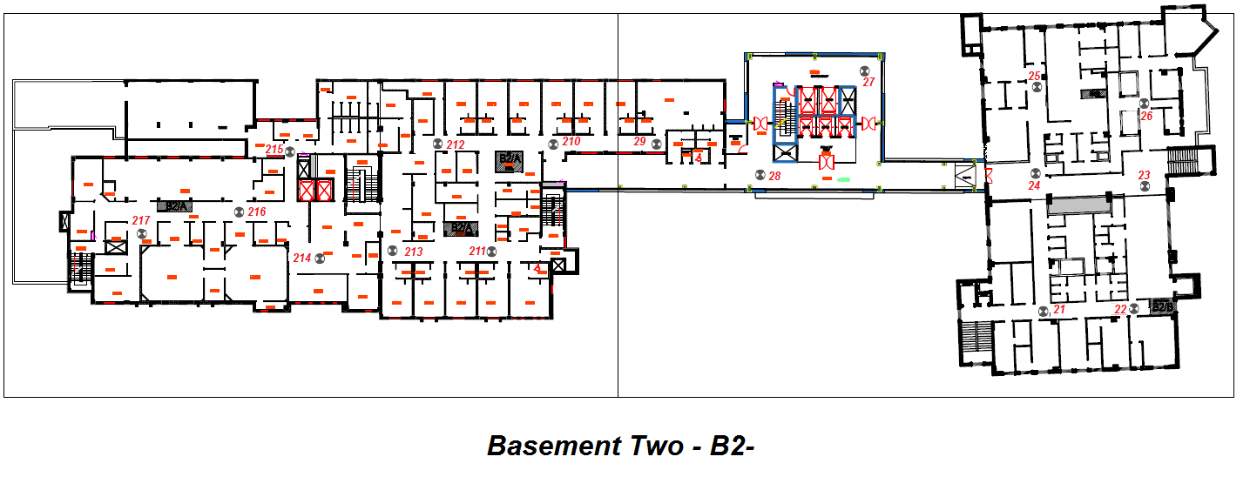
Figure 16 : Antennas location in Basement Two
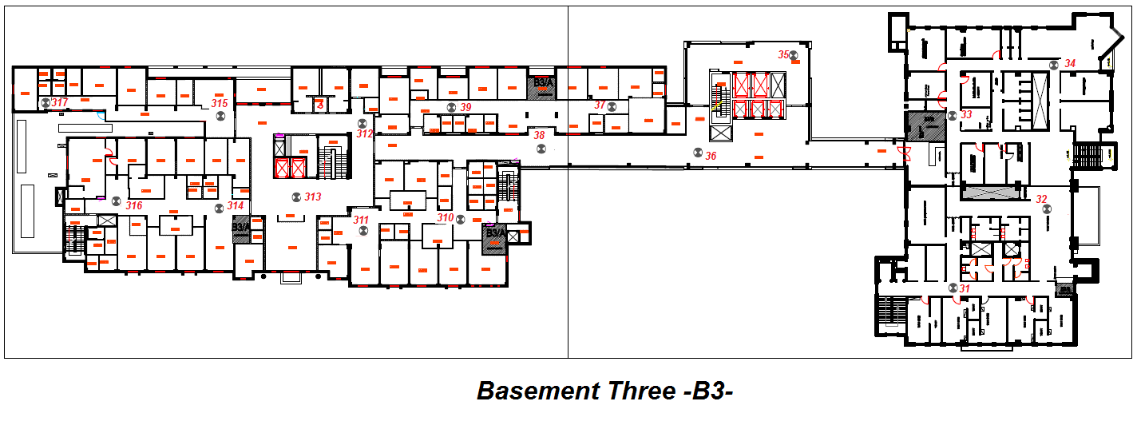
Figure 17 : Antennas location in Basement Three
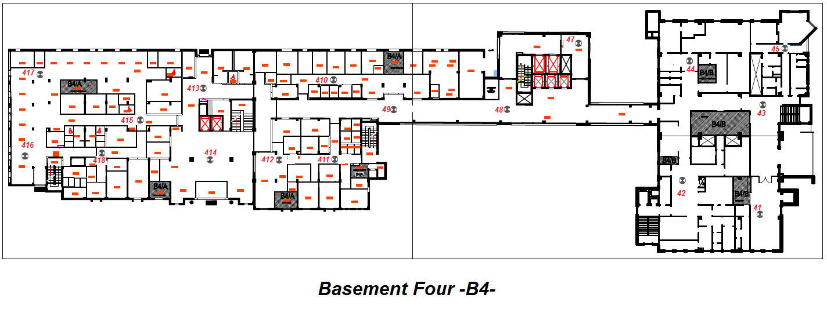
Figure 18 : Antennas location in Basement Four
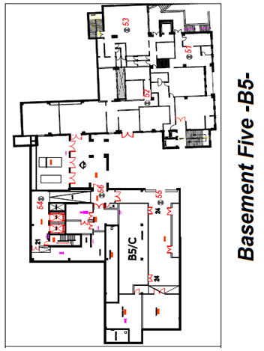
Figure 19 : Antennas location in Basement Five

4.5 RF Indoor Link Calculations

4.5.1 Link Budget

The link budget (LB) is the fundamental calculation for planning of any RF link between a transmitter (Tx) and a receiver (Rx). In two-way calculations we actually have two LB calculations, one for the Down Link and one for the Up Link.
We can calculate the power come out antenna according to this equation:
$TXpower\left(dBm\right)=Power out from RBS-Cable loss-splitter loss+ antenna gain$
$$RBS output power = 34 dbm$$
$$Cable loss (db)= 0.07db/m$$
$$Splitter loss \left(db\right)= 10\log\left(number of ports\right)+ 0.1$$
$Antenna gain = 0 db, 2dbi$

The specifications for the components which used are attached in the appendix.
A range of $±5 dbm$ between any antennas in the system is maintained except the antenna covering the lift sides. It might be with a greater value than any antenna to compensate the losses in the path of the shaft (path loss) and the body of the lift.
The next sub-section 4.5.1.1 showing the design and the link budget according to the value shown above and the antenna places.
Note: in the column named cable length there are 3 sub columns, the first one from left is the distance between RBS and the top of the shaft, second one is between the top of the shaft and the start of the floor inside the building and third one is between the start of the floor to the antenna.

4.5.1.1 Link Budget Tables

Table 3 : Building ‘A’ link Budget
 | Antenna # | RBS Output (dbm) | cable length (M) |  |  | 2 Port Splitter | 3 Port Splitter | 4 Port Splitter | TX Power (dbm)
B1 | 111 | 34 | 40 | 5 | 14 | 2 | 2 | 1 | 7.79
 | 114 | 34 | 40 | 5 | 21 | 2 | 2 | 1 | 7.3
 | 116 | 34 | 40 | 5 | 28 | 2 | 2 | 1 | 6.81
 | 115 | 34 | 40 | 5 | 7 | 2 | 2 | 1 | 8.28
 | 117 | 34 | 40 | 5 | 34 | 2 | 2 | 1 | 6.39
 | 110 | 34 | 40 | 5 | 28 | 2 | 2 | 1 | 6.81
B2 | 216 | 34 | 40 | 10 | 17 | 1 | 2 | 1 | 10.34
 | 217 | 34 | 40 | 10 | 31 | 1 | 2 | 1 | 9.36
 | 215 | 34 | 40 | 10 | 4 | 1 | 2 | 1 | 11.25
 | 214 | 34 | 40 | 10 | 36 | 1 | 2 | 1 | 9.01
 | 213 | 34 | 40 | 10 | 28 | 1 | 2 | 1 | 9.57
 | 211 | 34 | 40 | 10 | 40 | 1 | 2 | 1 | 8.73
B3 | 312 | 34 | 40 | 15 | 14 | 3 | 1 | 1 | 8.85
 | 313 | 34 | 40 | 15 | 18 | 3 | 1 | 1 | 8.57
 | 314 | 34 | 40 | 15 | 17 | 3 | 1 | 1 | 8.64
 | 315 | 34 | 40 | 15 | 11 | 3 | 1 | 1 | 9.06
 | 316 | 34 | 40 | 15 | 31 | 3 | 1 | 1 | 7.66
 | 317 | 34 | 40 | 15 | 34 | 3 | 1 | 1 | 7.45
B4 | 413 | 34 | 40 | 20 | 3 | 3 | 1 | 1 | 9.27
 | 414 | 34 | 40 | 20 | 26 | 3 | 1 | 1 | 7.66
 | 415 | 34 | 40 | 20 | 20 | 3 | 1 | 1 | 8.08
 | 416 | 34 | 40 | 20 | 40 | 3 | 1 | 1 | 6.68
 | 417 | 34 | 40 | 20 | 40 | 3 | 1 | 1 | 6.68
 | 418 | 34 | 40 | 20 | 51 | 3 | 1 | 1 | 5.91

Table 4 : Building 'C' Link Budget
 | Antenna # | RBS Output (dbm) | cable length (M) |  |  | 2 Port Splitter | 3 Port Splitter | 4 Port Splitter | TX Power (dbm)
B1 | 16 | 33 | 1 | 5 | 48 | 1 | 1 | 2 | 9
 | 17 | 33 | 1 | 5 | 22 | 1 | 1 | 2 | 10.82
 | 18 | 33 | 1 | 5 | 20 | 1 | 1 | 2 | 10.96
 | 19 | 33 | 1 | 5 | 3 | 1 | 1 | 2 | 12.15
 | 112 | 33 | 1 | 5 | 20 | 1 | 1 | 2 | 10.96
 | 113 | 33 | 1 | 5 | 34 | 1 | 1 | 2 | 9.98
B2 | 212 | 33 | 1 | 10 | 23 | 1 | 1 | 2 | 10.4
 | 210 | 33 | 1 | 10 | 6 | 1 | 1 | 2 | 11.59
 | 29 | 33 | 1 | 10 | 17 | 1 | 1 | 2 | 10.82
 | 28 | 33 | 1 | 10 | 26 | 2 | 0 | 2 | 11.95
 | 27 | 33 | 1 | 10 | 54 | 2 | 0 | 2 | 9.99
B3 | 35 | 33 | 1 | 15 | 56 | 1 | 1 | 2 | 7.74
 | 36 | 33 | 1 | 15 | 28 | 1 | 1 | 2 | 9.7
 | 37 | 33 | 1 | 15 | 26 | 1 | 1 | 2 | 9.84
 | 38 | 33 | 1 | 15 | 25 | 1 | 0 | 3 | 8.66
 | 39 | 33 | 1 | 15 | 26 | 1 | 0 | 3 | 8.59
 | 310 | 33 | 1 | 15 | 14 | 1 | 0 | 3 | 9.43
 | 311 | 33 | 1 | 15 | 28 | 1 | 0 | 3 | 8.45
B4 | 47 | 33 | 1 | 20 | 59 | 1 | 1 | 2 | 7.18
 | 48 | 33 | 1 | 20 | 31 | 1 | 1 | 2 | 9.14
 | 49 | 33 | 1 | 20 | 11 | 1 | 1 | 2 | 10.54
 | 410 | 33 | 1 | 20 | 17 | 1 | 1 | 2 | 10.12
 | 411 | 33 | 1 | 20 | 17 | 1 | 1 | 2 | 10.12
 | 412 | 33 | 1 | 20 | 34 | 1 | 1 | 2 | 8.93

Table 5 : Building 'B' Link Budget
 | Antenna # | RBS Output (dbm) | cable length (M) |  |  | 2 Port Splitter | 3 Port Splitter | 4 Port Splitter | TX Power (dbm)
GF | G1 | 34 | 55 | 9 | 23 | 0 | 2 | 2 | 5.93
 | G2 | 34 | 55 | 9 | 15 | 0 | 2 | 2 | 6.49
 | G3 | 34 | 55 | 9 | 9 | 0 | 2 | 2 | 6.91
 | G4 | 34 | 55 | 9 | 21 | 0 | 2 | 2 | 6.07
B1 | 11 | 34 | 63 | 10 | 35 | 1 | 2 | 1 | 7.47
 | 12 | 34 | 63 | 10 | 18 | 1 | 2 | 1 | 8.66
 | 13 | 34 | 63 | 10 | 9 | 0 | 3 | 1 | 7.53
 | 14 | 34 | 63 | 10 | 9 | 0 | 3 | 1 | 7.53
 | 15 | 34 | 63 | 10 | 20 | 0 | 3 | 1 | 6.76
B2 | 21 | 34 | 63 | 15 | 19 | 1 | 2 | 1 | 8.24
 | 22 | 34 | 63 | 15 | 22 | 1 | 2 | 1 | 8.03
 | 23 | 34 | 63 | 15 | 14 | 1 | 2 | 1 | 8.59
 | 24 | 34 | 63 | 15 | 11 | 1 | 2 | 1 | 8.8
 | 25 | 34 | 63 | 15 | 23 | 1 | 2 | 1 | 7.96
 | 26 | 34 | 63 | 15 | 23 | 1 | 2 | 1 | 7.96
B3 | 31 | 34 | 63 | 20 | 22 | 1 | 1 | 2 | 6.43
 | 32 | 34 | 63 | 20 | 11 | 1 | 1 | 2 | 7.2
 | 33 | 34 | 63 | 20 | 20 | 1 | 1 | 2 | 6.57
 | 34 | 34 | 63 | 20 | 34 | 1 | 1 | 2 | 5.59
B4 | 41 | 34 | 63 | 25 | 37 | 1 | 2 | 1 | 6.28
 | 42 | 34 | 63 | 25 | 31 | 1 | 2 | 1 | 6.7
 | 43 | 34 | 63 | 25 | 15 | 1 | 2 | 1 | 7.82
 | 44 | 34 | 63 | 25 | 23 | 2 | 1 | 1 | 9.02
 | 45 | 34 | 63 | 25 | 37 | 2 | 1 | 1 | 8.04
B5 | 51 | 34 | 63 | 30 | 35 | 1 | 2 | 1 | 6.07
 | 52 | 34 | 63 | 30 | 19 | 1 | 2 | 1 | 7.19
 | 53 | 34 | 63 | 30 | 21 | 1 | 2 | 1 | 7.05
 | 54 | 34 | 63 | 30 | 43 | 1 | 2 | 1 | 5.51
 | 55 | 34 | 63 | 30 | 41 | 1 | 2 | 1 | 5.65
 | 56 | 34 | 63 | 30 | 31 | 1 | 2 | 1 | 6.35

Table 6 : Lifts Link Budget
Antenna # | RBS Output (dbm) | cable length (M) |  |  | 2 Port Splitter | 3 Port Splitter | 4 Port Splitter | TX Power (dbm)
LA1 | 34 | 34 |  | 1 | 1 | 2 | 1 | 19.43
La2 | 34 | 34 |  | 1 | 1 | 2 | 1 | 19.43
LC1 | 34 | 40 |  | 1 | 0 | 3 | 1 | 17.25
LC2 | 34 | 40 |  | 1 | 0 | 3 | 1 | 17.25
LC3 | 34 | 41 |  | 1 | 0 | 3 | 1 | 17.18
LC4 | 34 | 42 |  | 1 | 1 | 2 | 1 | 18.87
LC5 | 34 | 43 |  | 1 | 1 | 2 | 1 | 18.8
LB1 | 34 | 63 | 25 | 1 | 2 | 1 | 1 | 17.41
LB4 | 34 | 63 | 24 | 1 | 2 | 1 | 1 | 17.48

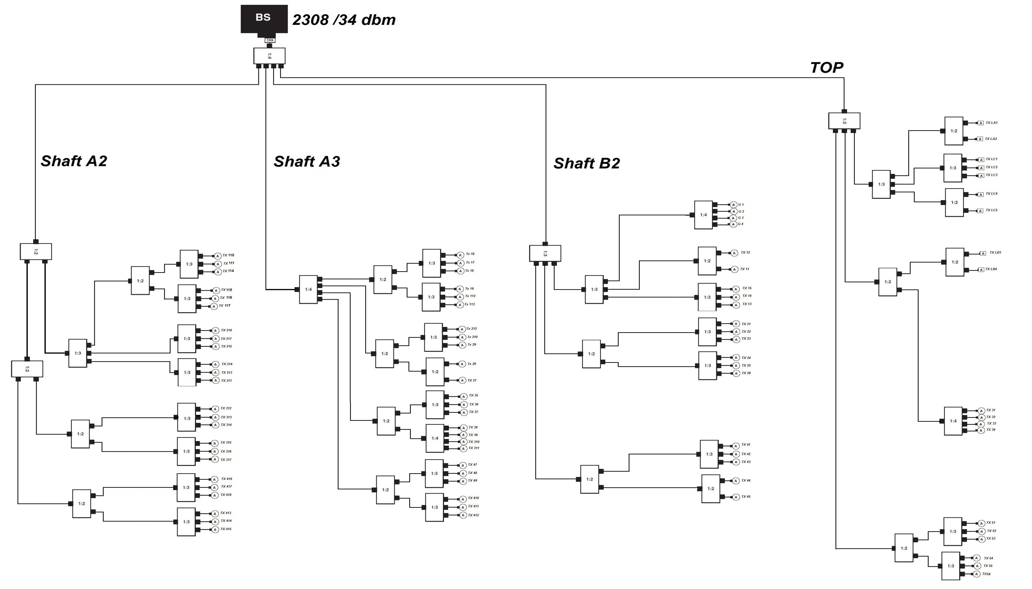
Figure 20 : Distributed Antenna Design (DAS Design)

4.5.2 Free space path loss

'A major component in the LB is the path loss between the Tx and Rx antenna. This loss depends on the distance between the Tx and Rx antenna, and the environment that the RF signal has to pass. Free space loss is a physical constant. This simple RF formula is valid when in line-of-sight indoors. The free space loss does not take into account any additional clutter loss or reflections, hence the name'³.

Path loss calculations depend on many elements, first of all the distance between the Tx and Rx. In addition, losses depend also on the route of the signal across the walls and the frequency as shown in Figure 21⁽⁶⁾.

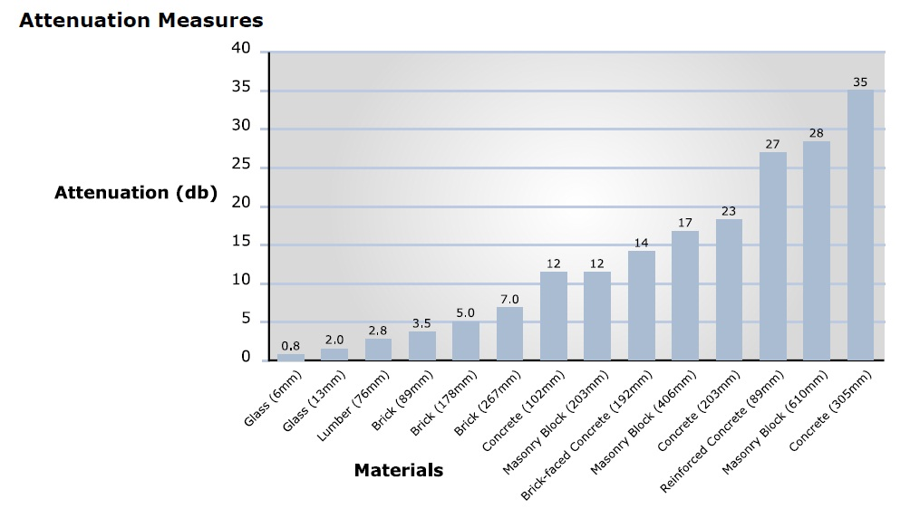
Figure 21 : Attenuation Measures Vs Materials
This formula shows how to calculate the free space path loss

$$FSPL\left(dB\right)=20\log_{10}{(d)}+ 20 \log_{10}\left(f\right)+32.45$$

$$FSPL: Free Space Path Loss in (dB)$$
$$d: distance in ( km)$$
$$f: frequency in ( MHz)$$

After this introduction about the free space path loss, a calculations of received power inside the hospital can be done .Several points have been taken inside every floor and calculated the power received at these points as shown below.
Figures from 22 – 27 show the location of sample points determined to calculate the received power around them. Tables 7, 8 and 9 in this section relate to the calculations of the power loss from the antenna to the sample point.

Table 7 : Building ‘A’ path loss
 | Point  # | Tx Power(dBm) | EIRP(dBm) | Distance(m) | Wall | Loss in wall(dB) | RX-Power(dBm)
B1 | p111 | 7.79 | 9.79 | 9 | 2 | 6.4 | -47.79027485
 | p112 | 7.3 | 9.3 | 9 | 1 | 3.2 | -45.08027485
 | p113 | 6.81 | 8.81 | 17 | 3 | 9.6 | -57.49440309
 | p114 | 8.28 | 10.28 | 11.5 | 2 | 6.4 | -49.42938147
 | p115 | 6.39 | 8.39 | 6.4 | 2 | 6.4 | -46.22902414
 | p116 | 6.81 | 8.81 | 6.4 | 3 | 9.6 | -49.00902414
B2 | p216 | 10.34 | 12.34 | 5.65 | 2 | 6.4 | -41.19639362
 | p217 | 9.36 | 11.36 | 10.2 | 2 | 6.4 | -47.3074281
 | p215 | 11.25 | 13.25 | 6.4 | 2 | 6.4 | -41.36902414
 | p214 | 9.01 | 11.01 | 6.8 | 1 | 3.2 | -40.93560291
 | p213 | 9.57 | 11.57 | 8.5 | 2 | 6.4 | -45.51380318
 | p211 | 8.73 | 10.73 | 9 | 2 | 6.4 | -46.85027485
B3 | p312 | 8.85 | 10.85 | 10 | 3 | 9.6 | -50.84542466
 | p313 | 8.57 | 10.57 | 11.6 | 0 | 0 | -42.81458445
 | p314 | 8.64 | 10.64 | 8.9 | 1 | 3.2 | -43.64322479
 | p315 | 9.06 | 11.06 | 8.4 | 1 | 3.2 | -42.72101038
 | p316 | 7.66 | 9.66 | 8.4 | 2 | 6.4 | -47.32101038
 | p317 | 7.45 | 9.45 | 6.4 | 2 | 6.4 | -45.16902414
B4 | p413 | 9.27 | 11.27 | 11.7 | 3 | 9.6 | -51.7891419
 | p414 | 7.66 | 9.66 | 11.75 | 0 | 0 | -43.83618199
 | p415 | 8.08 | 10.08 | 8.5 | 3 | 9.6 | -50.20380318
 | p416 | 6.68 | 8.68 | 6.9 | 0 | 0 | -40.19240648
 | p417 | 6.68 | 8.68 | 6.9 | 2 | 6.4 | -46.59240648
 | p418 | 5.91 | 7.91 | 11.2 | 4 | 12.8 | -57.96978511

Table 8 : Building ‘B’ path loss
 | Point  # | Tx Power(dBm) | EIRP(dBm) | Distance(m) | Wall | Loss in wall(dB) | RX-Power(dBm)
B1 | p16 | 9.07 | 11.07 | 11.5 | 0 | 0 | -42.23938
 | p17 | 10.89 | 12.89 | 11.5 | 0 | 0 | -40.41938
 | p18 | 11.03 | 13.03 | 9 | 1 | 3.2 | -41.35027
 | p19 | 12.22 | 14.22 | 11.5 | 1 | 3.2 | -42.28938
 | p112 | 11.03 | 13.03 | 6.4 | 1 | 3.2 | -38.38902
 | p113 | 10.05 | 12.05 | 9 | 3 | 9.6 | -48.73027
B2 | p212 | 10.47 | 12.47 | 9.6 | 4 | 12.8 | -52.07085
 | p210 | 11.66 | 13.66 | 11.3 | 1 | 3.2 | -42.69699
 | p29 | 10.89 | 12.89 | 8.5 | 1 | 3.2 | -40.9938
 | p28 | 12.02 | 14.02 | 12.2 | 0 | 0 | -39.80262
 | p27 | 10.06 | 12.06 | 11.7 | 0 | 0 | -41.39914
B3 | p35 | 7.81 | 9.81 | 9.4 | 0 | 0 | -41.74798
 | p36 | 9.77 | 11.77 | 7.4 | 1 | 3.2 | -40.91006
 | p37 | 9.91 | 11.91 | 9 | 2 | 6.4 | -45.67027
 | p38 | 8.73 | 10.73 | 7.4 | 2 | 6.4 | -45.15006
 | p39 | 8.66 | 10.66 | 8.4 | 2 | 6.4 | -46.32101
 | p310 | 9.5 | 11.5 | 9.4 | 1 | 3.2 | -43.25798
 | p311 | 8.52 | 10.52 | 10 | 1 | 3.2 | -44.77542
B4 | p47 | 7.25 | 9.25 | 9.5 | 0 | 0 | -42.3999
 | p48 | 9.21 | 11.21 | 8 | 1 | 3.2 | -42.14722
 | p49 | 10.61 | 12.61 | 11.75 | 2 | 6.4 | -47.28618
 | p410 | 10.19 | 12.19 | 6.8 | 2 | 6.4 | -42.9556
 | p411 | 10.19 | 12.19 | 11.75 | 3 | 9.6 | -50.90618
 | p412 | 9 | 11 | 6.4 | 2 | 6.4 | -43.61902

Table 9 : Building ‘C’ path loss
 | Point  # | Tx Power(dBm) | EIRP(dBm) | Distance(m) | Wall | Loss in wall(dB) | RX-Power(dBm)
GF | pG1 | 5.93 | 7.93 | 9.8 | 2 | 6.4 | -50.3899462
 | pG2 | 6.49 | 8.49 | 14.4 | 5 | 16 | -62.7726745
 | pG3 | 6.91 | 8.91 | 9.3 | 2 | 6.4 | -48.9550836
 | pG4 | 6.07 | 8.07 | 9.97 | 3 | 9.6 | -53.5993278
B1 | p11 | 7.47 | 9.47 | 10.4 | 3 | 9.6 | -52.5660914
 | p12 | 8.66 | 10.66 | 9 | 0 | 0 | -40.5202748
 | p13 | 7.53 | 9.53 | 9 | 2 | 6.4 | -48.0502748
 | p14 | 7.53 | 9.53 | 9 | 1 | 3.2 | -44.8502748
 | p15 | 6.76 | 8.76 | 9 | 1 | 3.2 | -45.6202748
B2 | p21 | 8.24 | 10.24 | 9 | 3 | 9.6 | -50.5402748
 | p22 | 8.03 | 10.03 | 9 | 0 | 0 | -41.1502748
 | p23 | 8.59 | 10.59 | 8.45 | 2 | 6.4 | -46.4425588
 | p24 | 8.8 | 10.8 | 7.41 | 1 | 3.2 | -41.8917888
 | p25 | 7.96 | 9.96 | 9.5 | 1 | 3.2 | -44.8898968
 | p26 | 7.96 | 9.96 | 11.7 | 3 | 9.6 | -53.0991419
B3 | p31 | 6.43 | 8.43 | 10 | 2 | 6.4 | -50.0654247
 | p32 | 7.2 | 9.2 | 9 | 2 | 6.4 | -48.3802748
 | p33 | 6.57 | 8.57 | 16 | 3 | 9.6 | -57.2078243
 | p34 | 5.59 | 7.59 | 11 | 2 | 6.4 | -51.7332784
B4 | p41 | 6.28 | 8.28 | 10.1 | 3 | 9.6 | -53.5018521
 | p42 | 6.7 | 8.7 | 12.8 | 2 | 6.4 | -51.9396241
 | p43 | 7.82 | 9.82 | 10.2 | 1 | 3.2 | -45.6474281
 | p44 | 9.02 | 11.02 | 9 | 3 | 9.6 | -49.7602748
 | p45 | 8.04 | 10.04 | 6.8 | 1 | 3.2 | -41.9056029
B5 | p51 | 6.07 | 8.07 | 11.5 | 2 | 6.4 | -51.6393815
 | p52 | 7.19 | 9.19 | 12.2 | 3 | 9.6 | -54.2326213
 | p53 | 7.05 | 9.05 | 11.2 | 2 | 6.4 | -50.4297851
 | p54 | 5.51 | 7.51 | 14.5 | 2 | 6.4 | -54.2127847
 | p55 | 5.65 | 7.65 | 18.6 | 2 | 6.4 | -56.2356835
 | p56 | 6.38 | 8.38 | 14.7 | 2 | 6.4 | -53.4617714

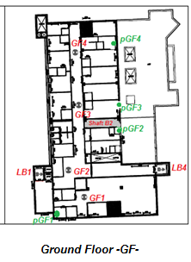
According to our path loss calculation, this Figures show the points which calculation related to

Figure 22 : Points inside Ground Floor

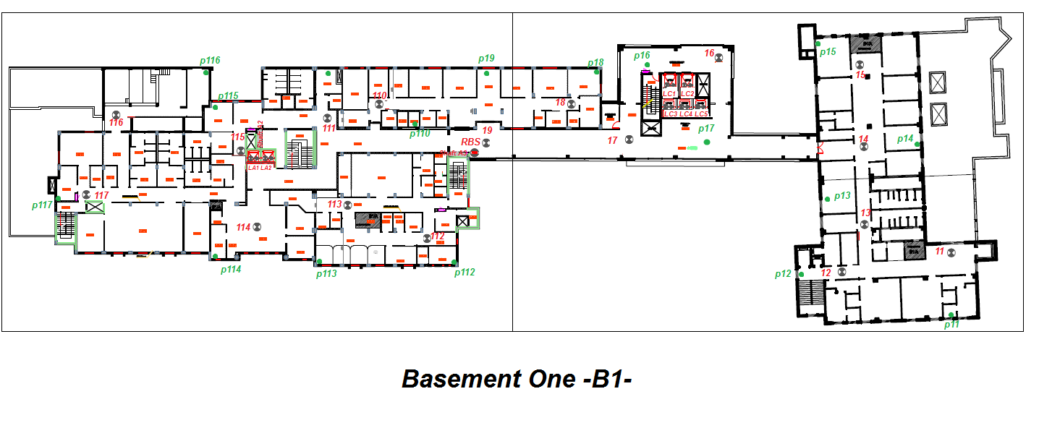
Figure 23 : Points inside Basement One
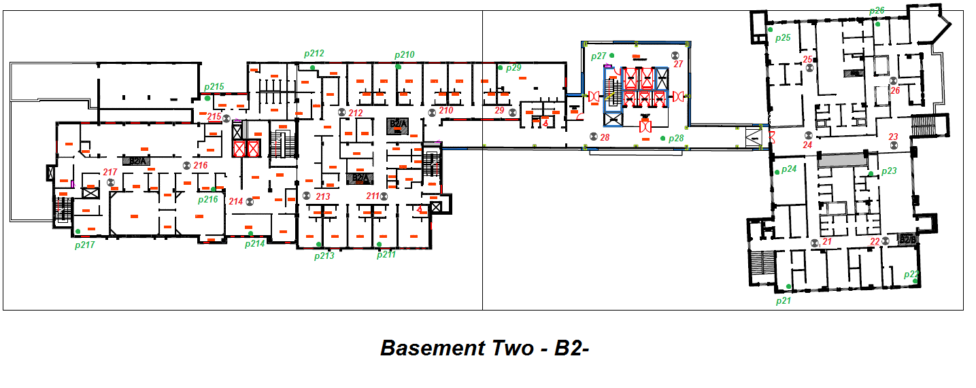
Figure 24 : Points inside Basement Two
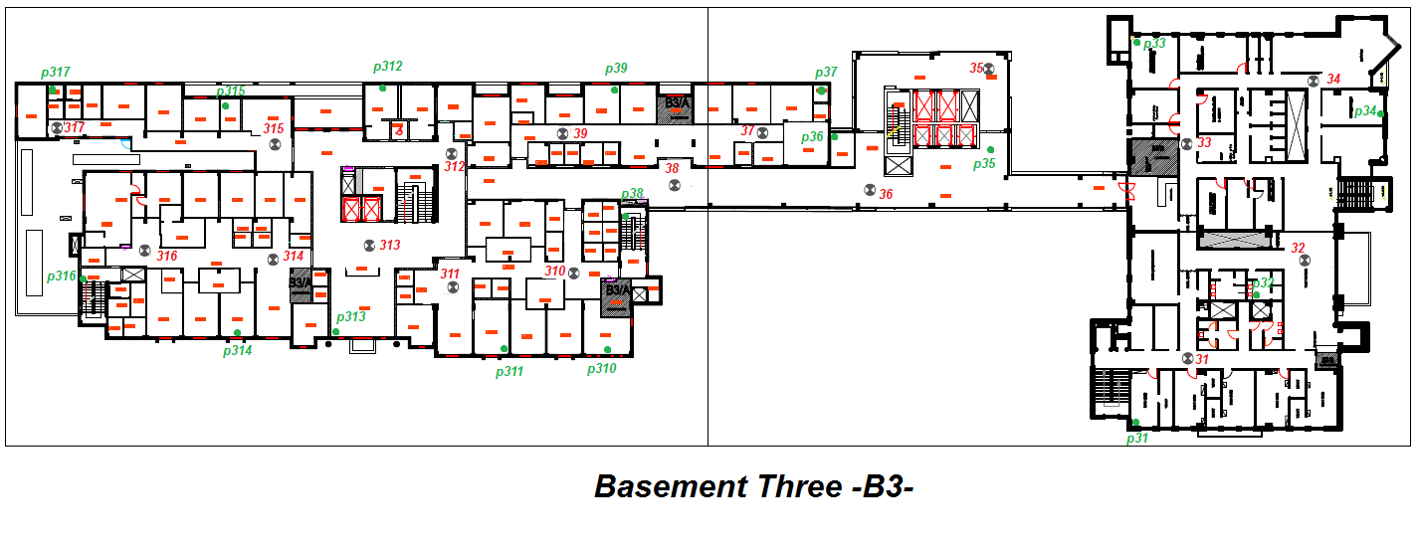
Figure 25 : Points inside Basement Three
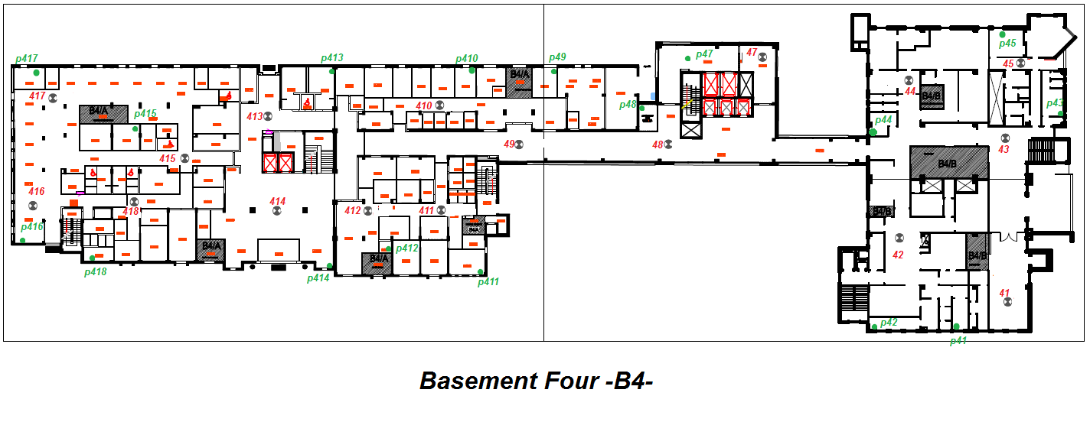
Figure 26 : Points inside Basement Four
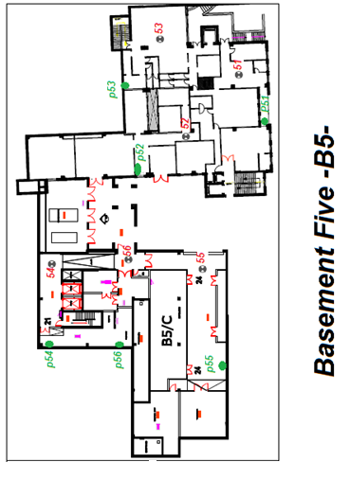
Figure 27 : Points inside Basement Five

4.6 The design by using software.

To make sure that hand calculations are accurate, a program called iBwave has been used, and this program cannot be used by normal users or students because it is not free. Jawwal Company helped by providing an access to this software.
After the design has been entered to the program, results for link budget and path loss achieved and the attached CD will show full results.

4.6.1 Link budget results

The program create a link budget report calculation for every antennas used in the design. Two samples will be elaborate and compare with hand calculations results. "All iBwave link budget reports are included in the attached CD".

- Sample one
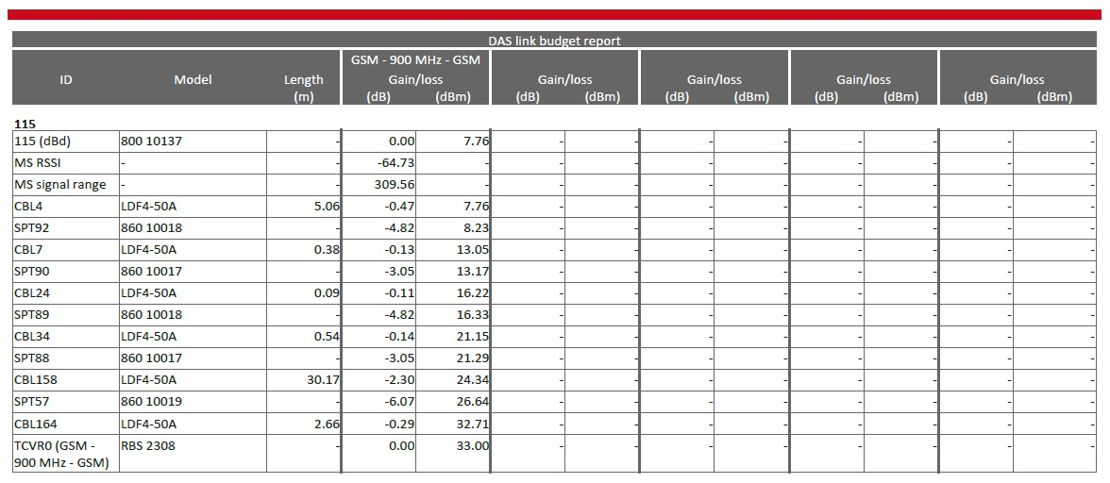
Antenna number 115 which is in the basement one floor in building “A” has a received power from RBS equals to $8.82 dBm$ by our link budget calculations, iBwave report for this antenna shown in Figure 28.
Figure 28 : iBwave link budget report for antenna number 115
So as the report shows that the power received from the RBS to the antenna is equal to $7.76 dBm$. The difference between hand calculation and iBwave calculation equals to $1.06 dB$.
- Sample two
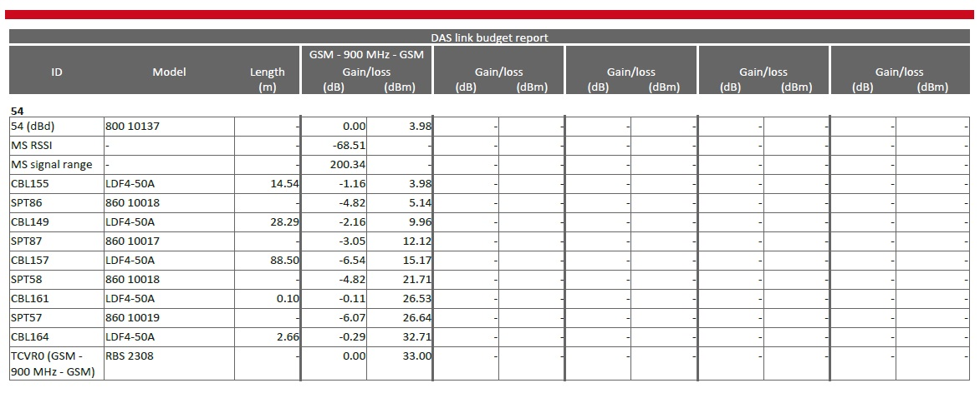
Antenna number 54 which is in the basement five floor in building “C” has a received power from RBS equals to $5.51 dBm$ by our link budget calculations, iBwave report for this antenna shown in Figure 29.
Figure 29 : iBwave link budget report for antenna number 54
So as the report shows that the power received from the RBS to the antenna is equal to $3.98 dBm$. The difference between hand calculation and iBwave calculation equals to $1.53 dB$.
These differences are because of three reasons, the first one because of the minimum cable length that the IBwave use which is 0.09 m between any two device by default, but in hand design, assumed that it can connect any two device directly like an output port of a splitter to an input port without using a cable between them so the minimum length of cables in hand design equals to zero. The second depends on the accuracy of measuring the distance between the RBS and the Antenna which affects the cable length. The final reason which is the most significant one comes from that the iBwave software used 33dBm as an output power from 2308 RBS but in hand design, 34 dBm output power from the RBS used, as Ericson Company defined it in its catalogue.

4.6.2 Path loss results

In this section, comparing the calculation of path loss and the software results will take place to improve what did we do. The program creates a prediction area covered by every antenna that radiates power in the design. "All iBwave prediction plans are included in the attached CD".

As mentioned in Table 2 in this chapter, an indoor prediction legend in software will be used and the prediction area related to this table will be defined.
- Sample one
The Rx-power from Antenna number 212 at point p212 in the hand calculation nearly equals to $-52.07 dBm$. It can be noticed that IBwave prediction value from the antenna to this point at range $-51 to -54 dBm$ which is approximately equals to the hand calculations, Figure (24).Figure (31), shows the prediction area from iBwave compared with hand calculation.

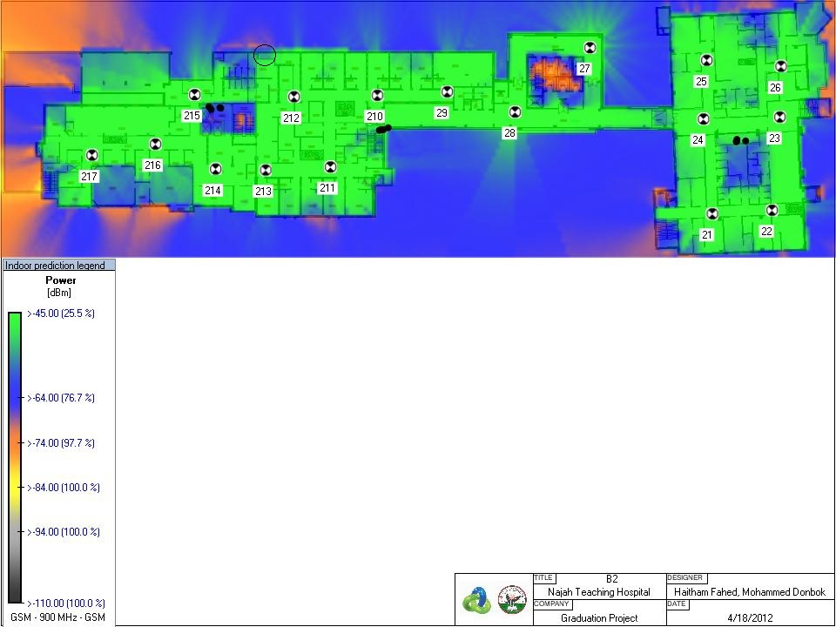
Figure 30 : Prediction area at Basement Two
- Sample two
Another sample that assures the closeness of the hand calculations to the accurate software results of point$pGF2$. As example of path loss calculation, it is found that in this point the Rx-power is$-62.77 dBm$, Figure (22). When getting back to the approximate software prediction in between of range of $-60 to -63 dBm$, Figure (31).
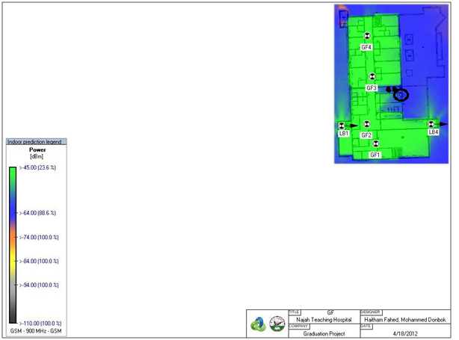
Figure 31 : Prediction area at Ground Floor

- Sample three
Another sample that improves the hand calculations to the accurate software results of point$p113$. As anther example of path loss calculation, the Rx-power in this point is$-57.49 dBm$, as shown in Figure (23). Going back to the values of the iBwave Results, it is almost near the hand one and approximate range in between -56 to -58, Figure (32).

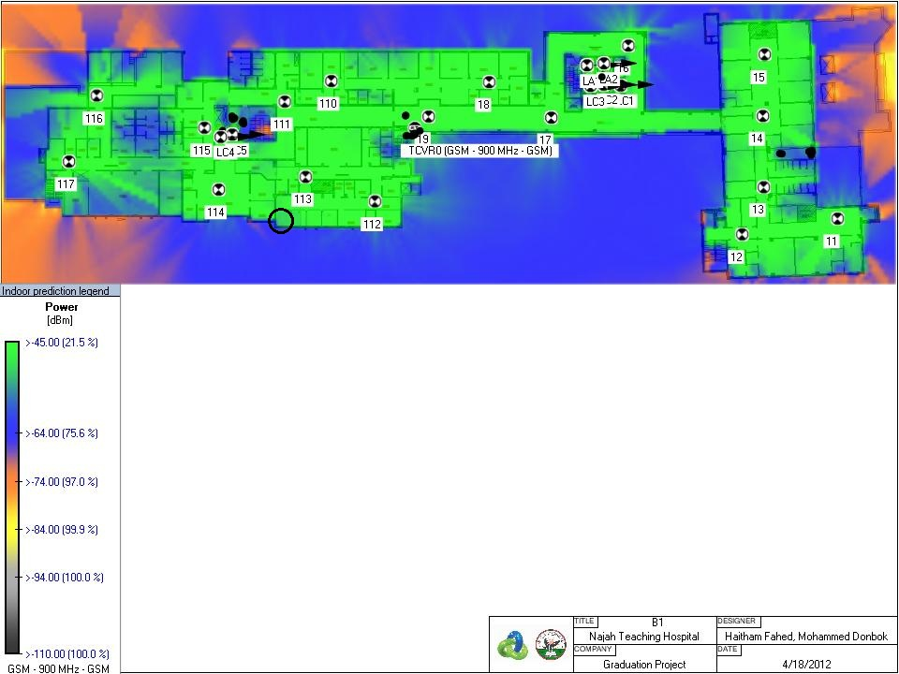
Figure 32 : Prediction area at Basement One

- Sample four
Point from Antenna 34 at point p34 which is in the basement three has a received power approximately equals $-52 dBm$which is nearly close to hand calculation one and equal $-51.73 dBm$ by link budget calculations, this can be shown in Figure 33 .

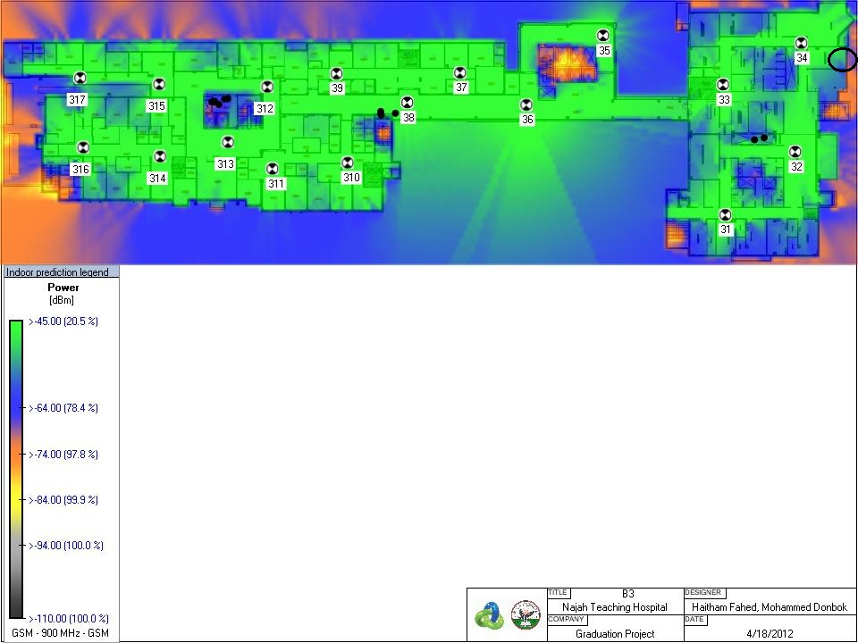
Figure 33 : Prediction area at Basement Three

- Sample five
Last, but not least, another sample in another place in this project that increase the truth of the simple program that can calculate the path loss in any point of the building. Points p411 at basement four improved what did said in compare with hand calculation and software one , at this point the received power equals -$50.90 dBm$ by using the Table 8 and the software reading is approximately -51 dBm as shown in Figure 34.

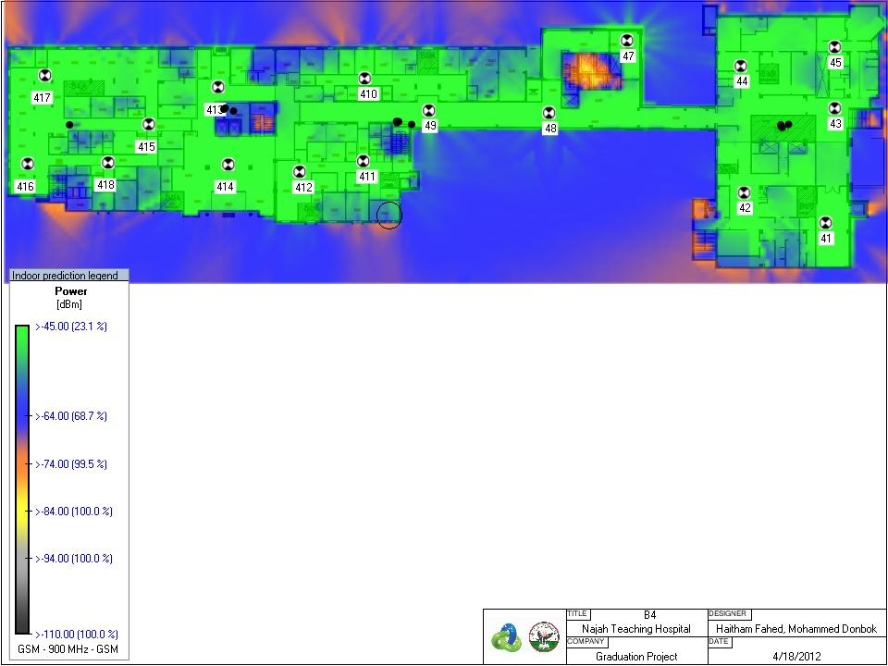
Figure 34 : Prediction area at Basement Four

- Sample six
The final sample that took at basement five in point p51 from Figure 27. Figure 35 showing this point at the predication area that got from iBwave report . In compare of the link budget that calculated in previous section in Table 9 finding the received power in this point is nearly $-51.64 dBm$ , getting back to the software calculation the approximate received power is nearly between $-49 and -52 dBm$ .
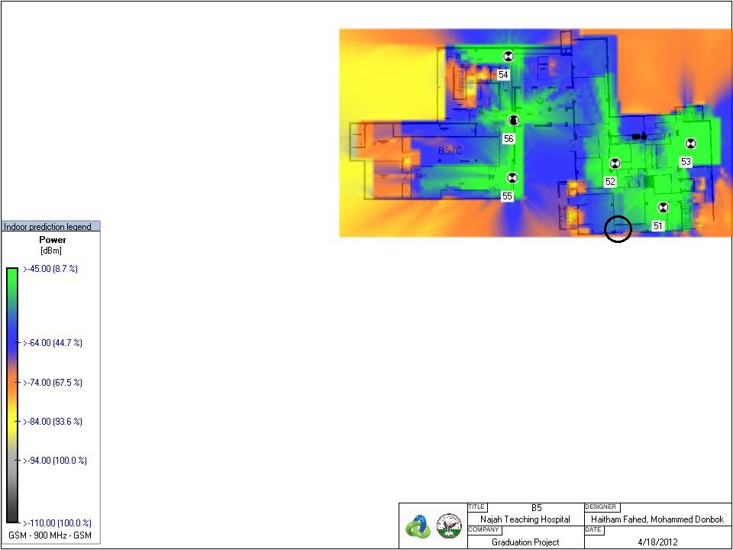
Figure 35 : Prediction area at Basement Five

It can be noticed from the previous samples that the hand calculation nearly matches the software results. From this point, one can infer that the procedure followed in the design is relatively accurate. To conclude, calculation of the path loss everywhere inside any building can be done at any point.

Chapter 5: Conclusion

This project discussed the problems existing in An Najah Educational National Hospital which are poor quality calls, drop calls and call setup failure. These problems are because of weak signal strength and Low Carrier to Interference.
Many approaches have been studied after taking into account the needs to solve these problems. The main target that should be achieved in all scenarios is good signal strength all over the hospital so that the quality will be increased.
An Indoor Passive Distributed Antenna System was chosen to be designed for this project because of many reasons like it is straight forwarding design, it can be installed in harsh environment and no high data rate needed.
The design process includes capacity dimensioning, choosing the components, deciding the target coverage level and distributing the antennas inside all over the building including cables paths.
Link budget calculations which deal with the power that sent from the RBS to the antenna have been done, this power affects by the cables long and the way of splitting, these calculations done by using mathematical equations. Another type of calculations called path loss calculations have been done too, this type deals with the losses in power that just come out the antenna until reach the receiver, these losses are because of space losses and attenuation on the signal due to construction materials such as walls.
The full solution of the problems was governed through the design process and this solution had been done manually using mathematical equations and simple programs. Moreover, it will guarantee deep indoor and indoor signal strength inside all over the hospital. In addition, sufficient capacity, optimum usage of power, low interference and very good isolation from an outside macro layers are guaranteed too.
To make sure that the hand calculations are matched, many samples taken and compared with the results which had been got from professional software, it was clear that the results matched so the hand design can be considered as a reliable one and generalized the steps of design in any further project so that a full design can be obtained without using a very high expensive software.

References

- http://en.wikipedia.org/wiki/Coaxial_cable
- http://www.scribd.com/knah098/d/47065064-Indoor-Planning
- Indoor Radio Planning A Practical Guide for GSM, DCS, UMTS and HSPA
- Component Kathrain Catalogues. http://kathrein.de/en/mcs/index.htm
- http://www.ericsson.com
- http://www.avalanwireless.com
- http://www.scribd.com/word/removal/19442658
- http://www.rfparts.com/heliax_LDF450A.html

Appendices

Appendix-A : Radio Base Station 2308 (RBS 2308) Catalogue⁵
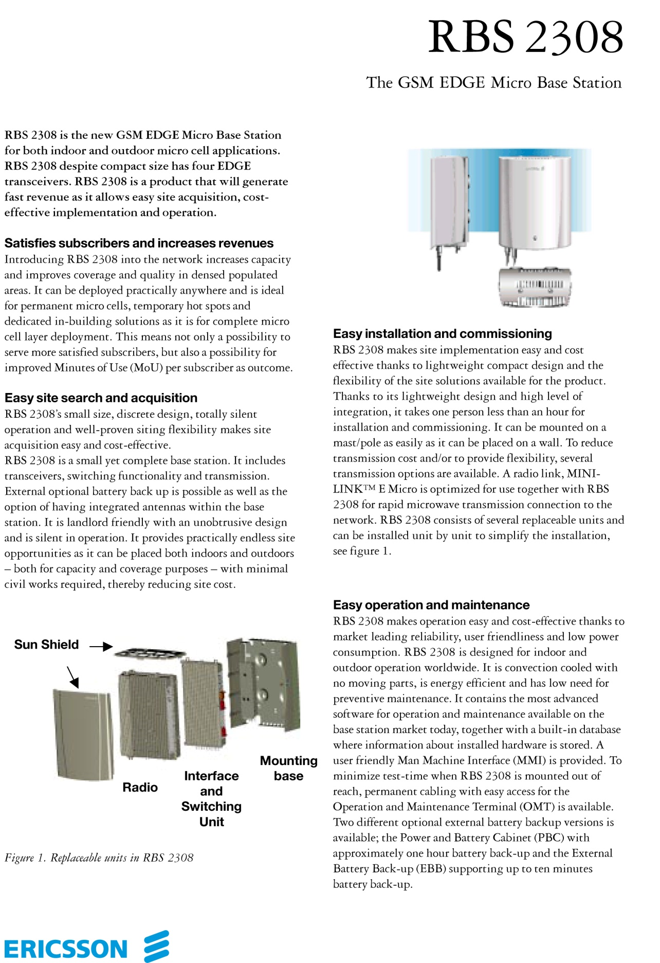
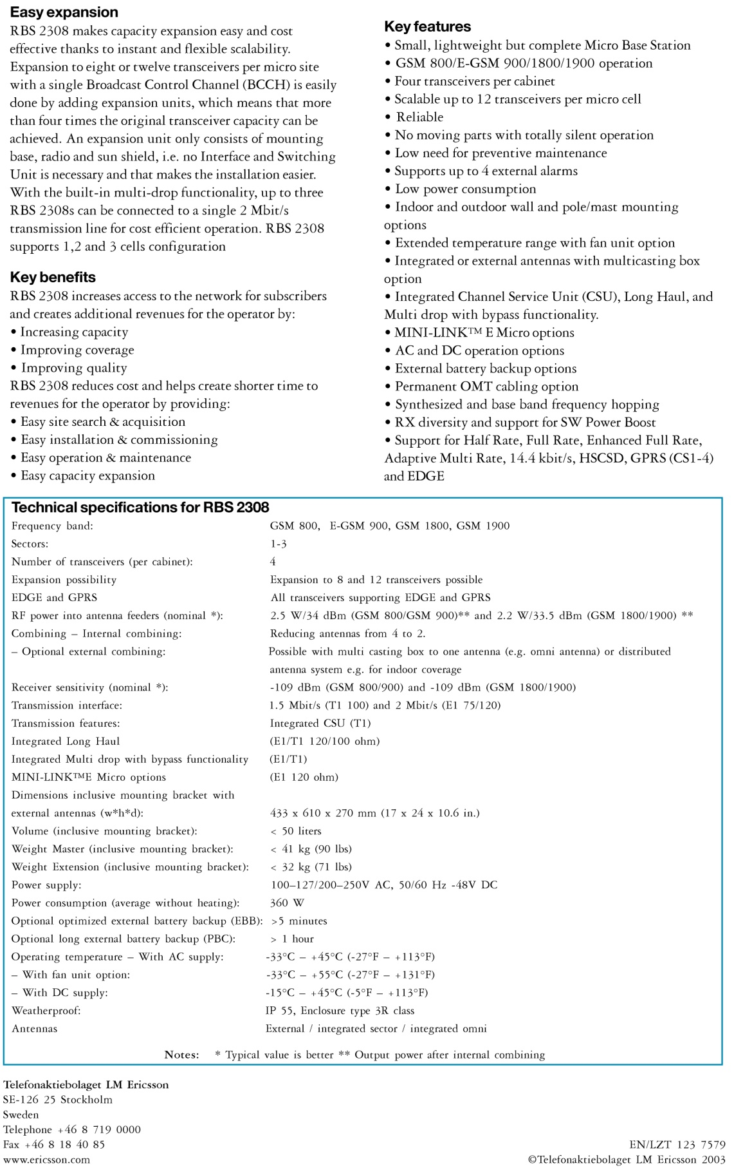

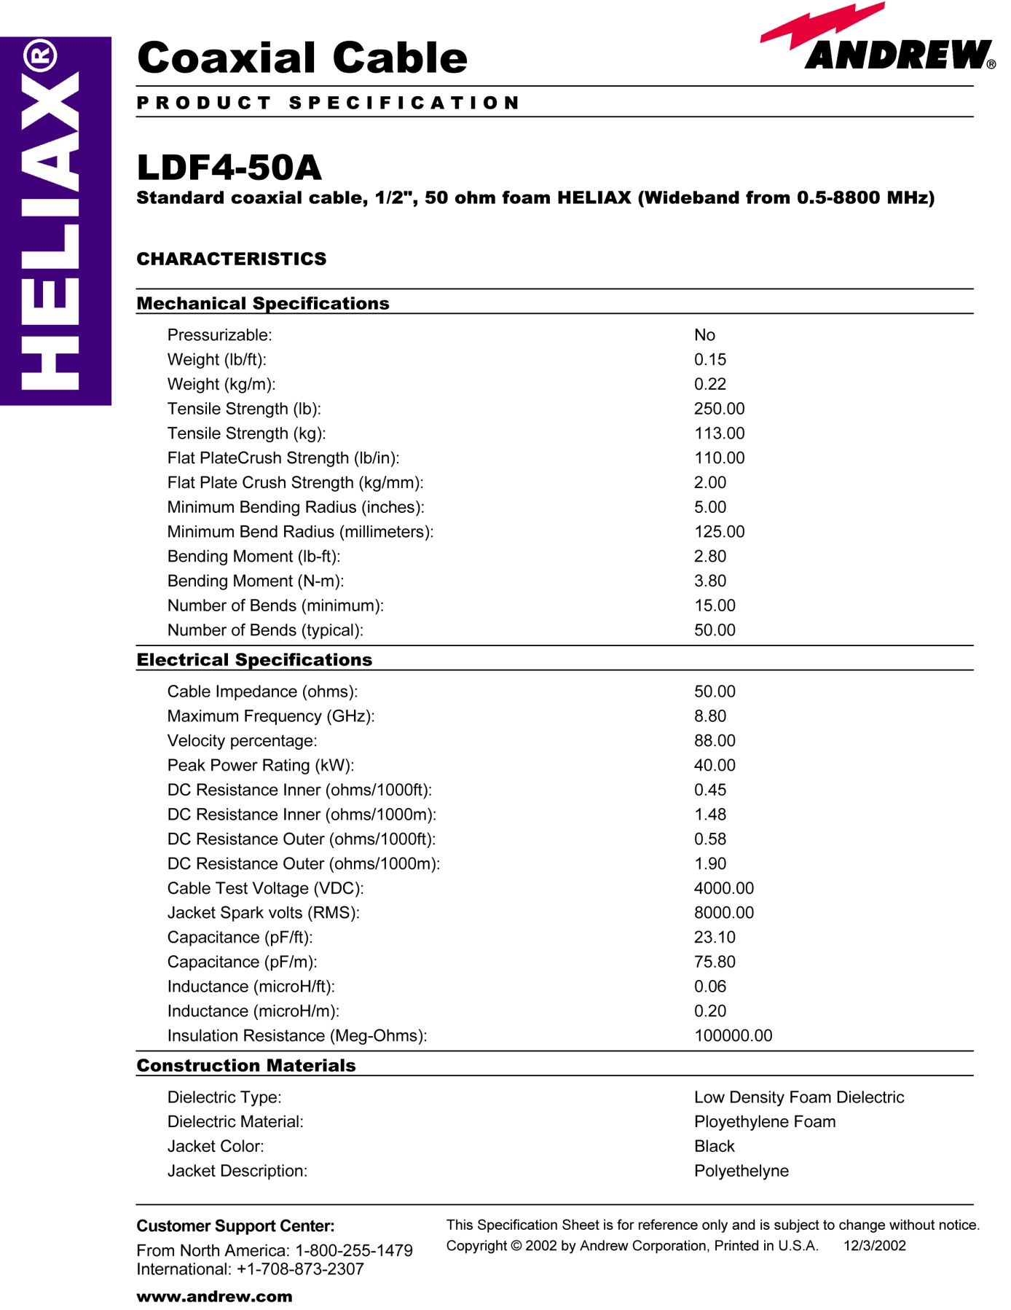
Appendix-B : Coaxial Cable ( LDF4-50A) Catalogue ⁸
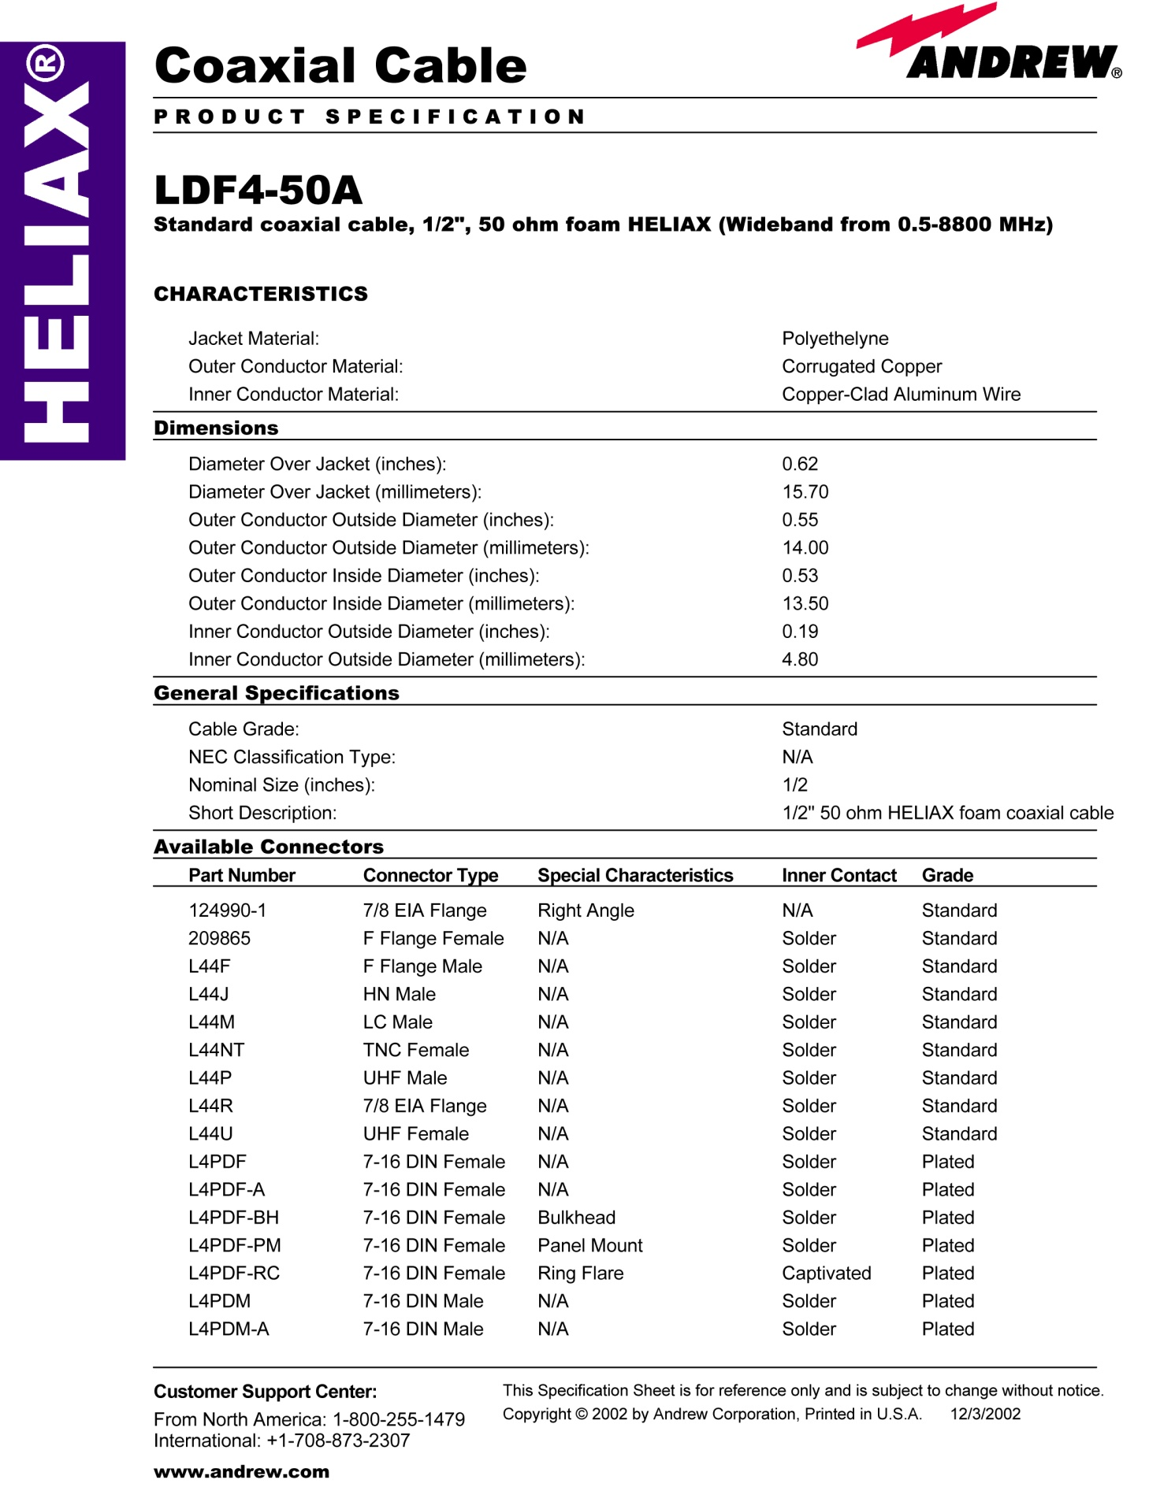
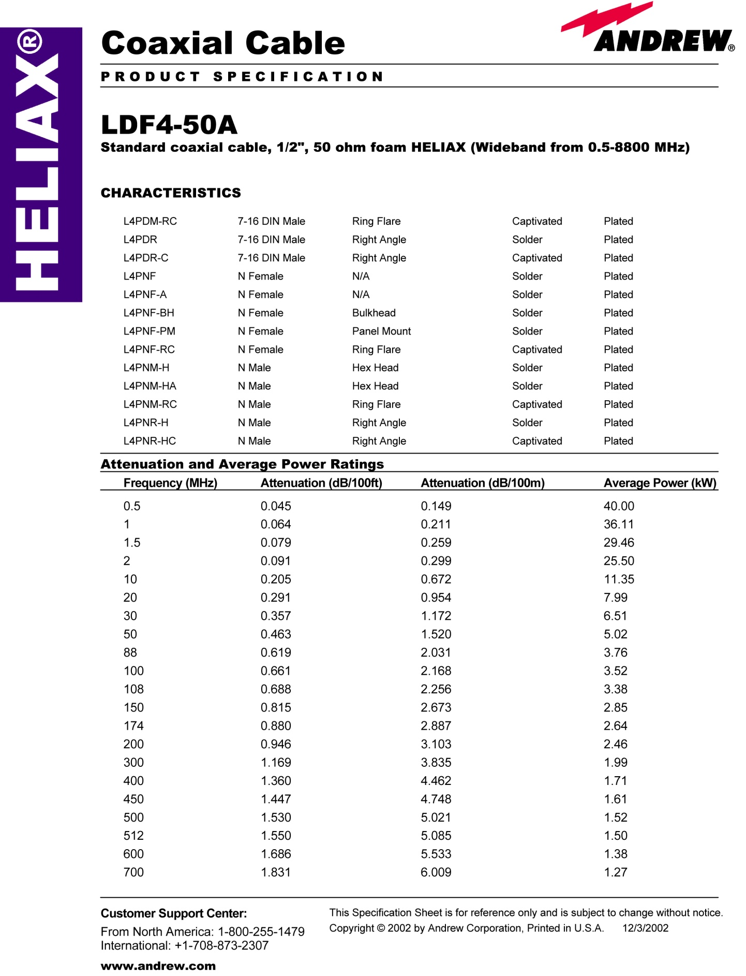
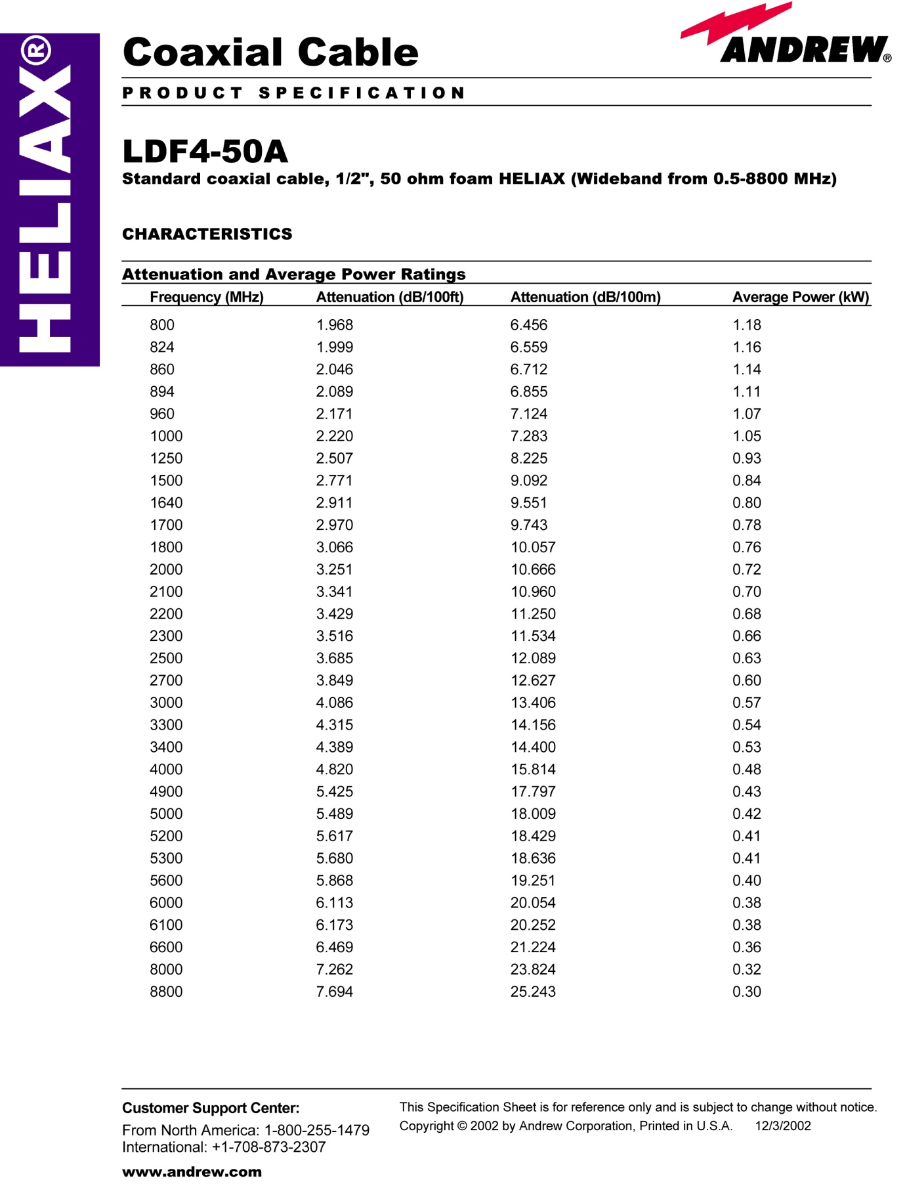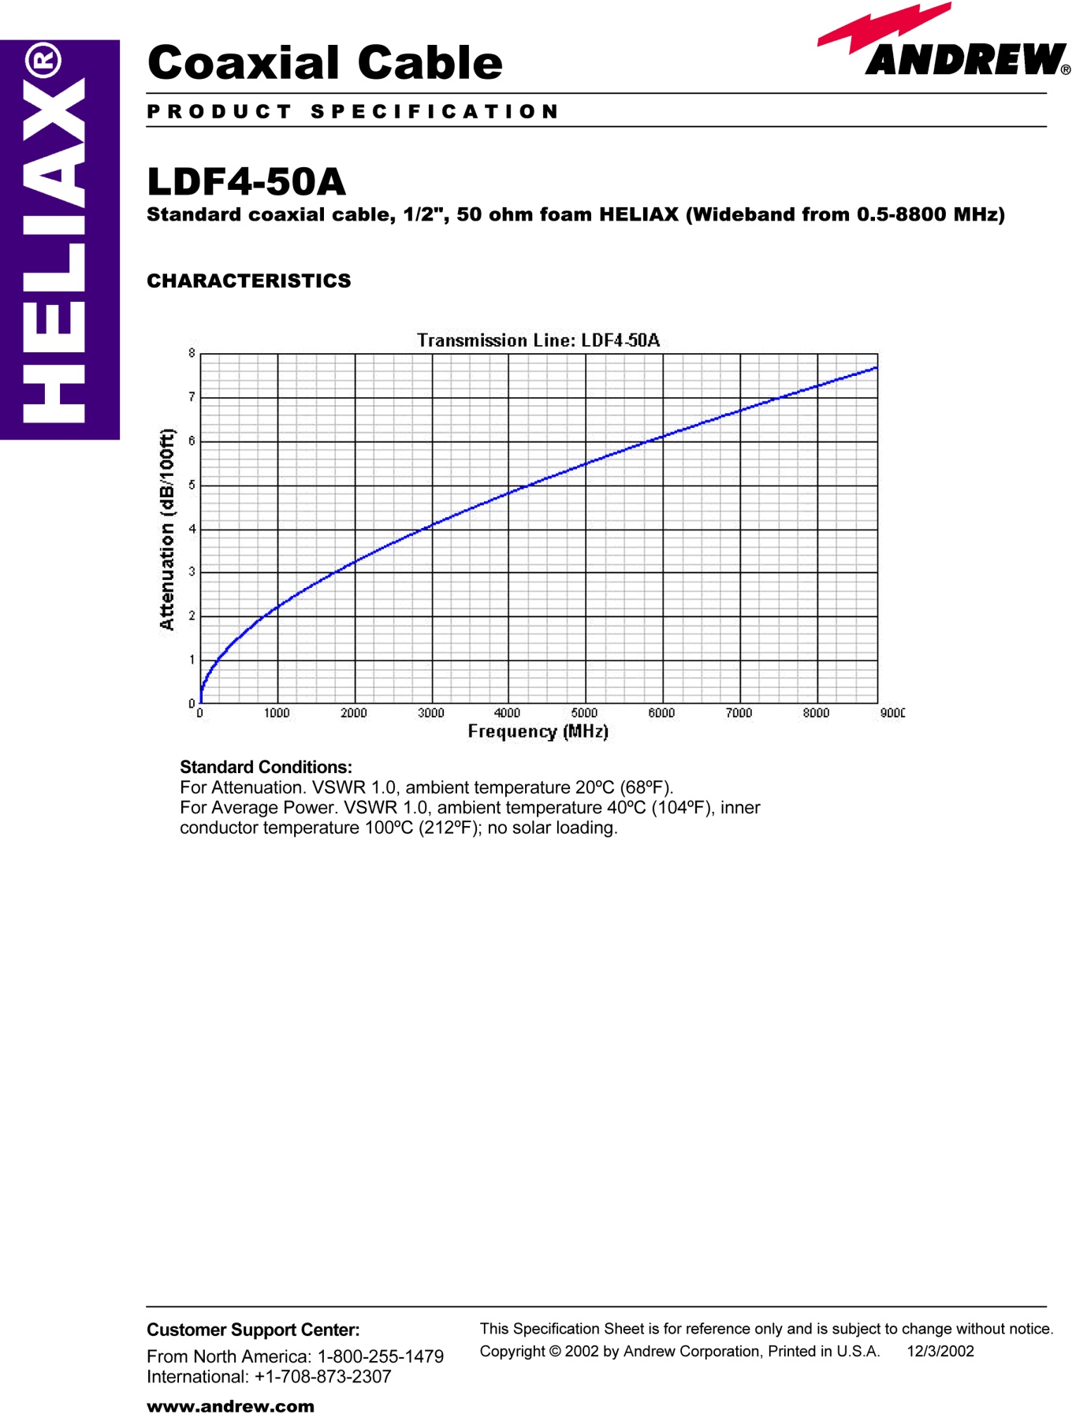

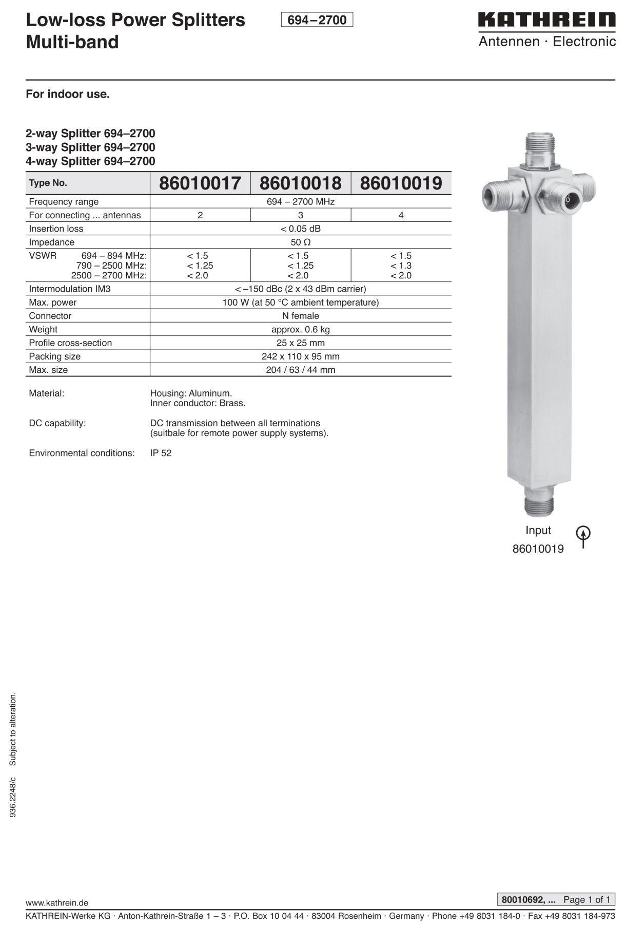
Appendix-C : Splitters Catalogue ⁴

Appendix-D : Omni Directional Antenna Catalogue ⁴
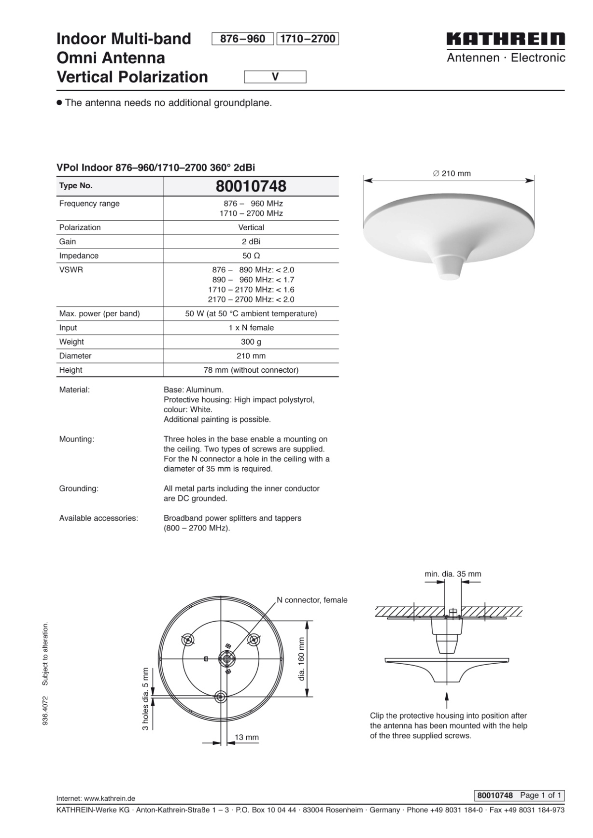

Appendix-E : Directional Antenna Catalogue⁴
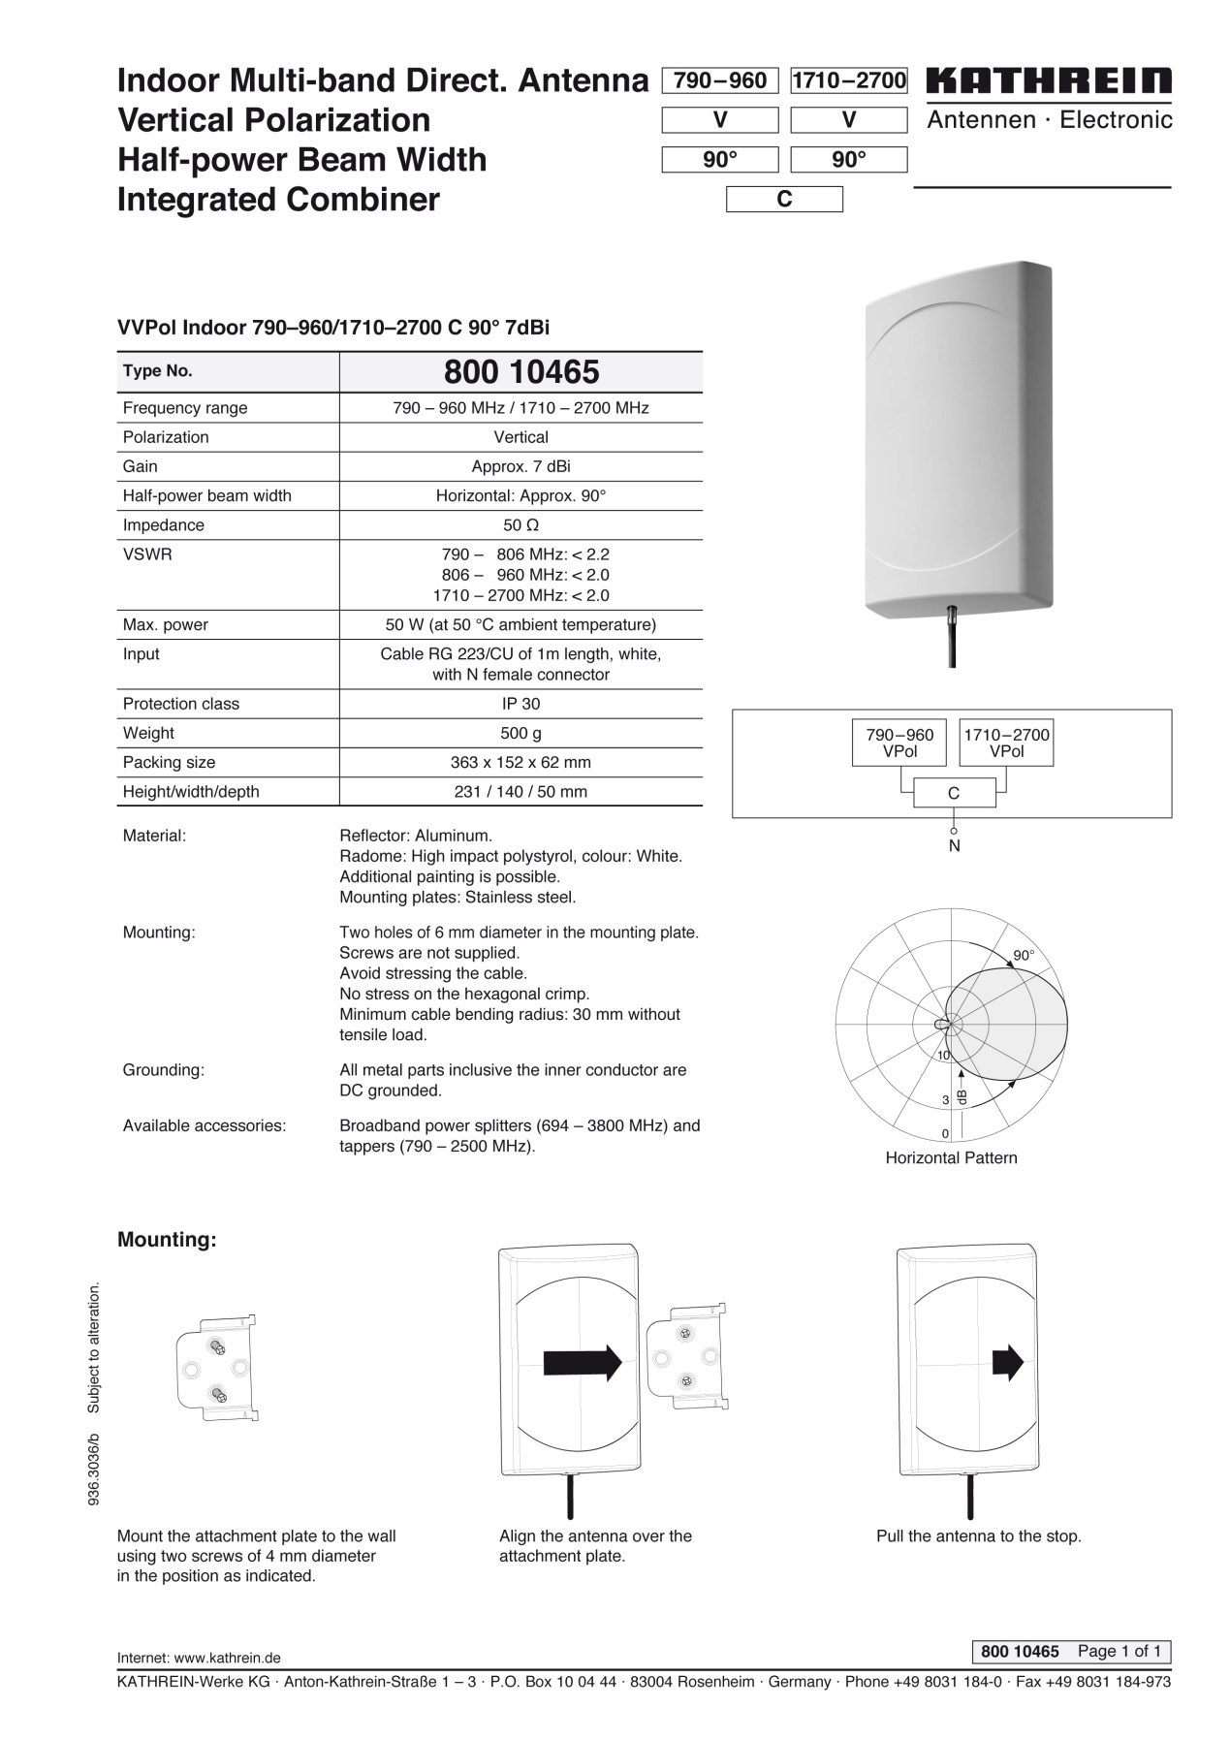

Appendix-F : Erlang B table, 1-50 channels, 0.07-40% grade of service ³

n | Blocking (GOS) |  |  |  |  |  |  |  |  |  | n
 | 0.007 | 0.008 | 0.009 | 0.01 | 0.02 | 0.03 | 0.05 | 0.1 | 0.2 | 0.4
1 | .00705 | .00806 | .00908 | .01010 | .02041 | .03093 | .05263 | .11111 | .25000 | .66667 | 1
2 | .12600 | .13532 | .14416 | .15259 | .22347 | .28155 | .38132 | .59543 | 1.0000 | 2.0000 | 2
3 | .39664 | .41757 | .43711 | .45549 | .60221 | .71513 | .89940 | 1.2708 | 1.9299 | 3.4798 | 3
4 | .77729 | .81029 | .84085 | .86942 | 1.0923 | 1.2589 | 1.5246 | 2.0454 | 2.9452 | 5.0210 | 4
5 | 1.2362 | 1.2810 | 1.3223 | 1.3608 | 1.6571 | 1.8752 | 2.2185 | 2.8811 | 4.0104 | 6.5955 | 5
6 | 1.7531 | 1.8093 | 1.8610 | 1.9090 | 2.2759 | 2.5431 | 2.9603 | 3.7584 | 5.1086 | 8.1907 | 6
7 | 2.3149 | 2.3820 | 2.4437 | 2.5009 | 2.9354 | 3.2497 | 3.7378 | 4.6662 | 6.2302 | 9.7998 | 7
8 | 2.9125 | 2.9902 | 3.0615 | 3.1276 | 3.6271 | 3.9865 | 4.5430 | 5.5971 | 7.3692 | 11.419 | 8
9 | 3.5395 | 3.6274 | 3.7080 | 3.7825 | 4.3447 | 4.7479 | 5.3702 | 6.5464 | 8.5217 | 13.045 | 9
10 | 4.1911 | 4.2889 | 4.3784 | 4.4612 | 5.0840 | 5.5294 | 6.2157 | 7.5106 | 9.6850 | 14.677 | 10
11 | 4.8637 | 4.9709 | 5.0691 | 5.1599 | 5.8415 | 6.3280 | 7.0764 | 8.4871 | 10.857 | 16.314 | 11
12 | 5.5543 | 5.6708 | 5.7774 | 5.8760 | 6.6147 | 7.1410 | 7.9501 | 9.4740 | 12.036 | 17.954 | 12
13 | 6.2607 | 6.3863 | 6.5011 | 6.6072 | 7.4015 | 7.9667 | 8.8349 | 10.470 | 13.222 | 19.598 | 13
14 | 6.9811 | 7.1155 | 7.2382 | 7.3517 | 8.2003 | 8.8035 | 9.7295 | 11.473 | 14.413 | 21.243 | 14
15 | 7.7139 | 7.8568 | 7.9874 | 8.1080 | 9.0096 | 9.6500 | 10.633 | 12.484 | 15.608 | 22.891 | 15
16 | 8.4579 | 8.6092 | 8.7474 | 8.8750 | 9.8284 | 10.505 | 11.544 | 13.500 | 16.807 | 24.541 | 16
17 | 9.2119 | 9.3714 | 9.5171 | 9.6516 | 10.656 | 11.368 | 12.461 | 14.522 | 18.010 | 26.192 | 17
18 | 9.9751 | 10.143 | 10.296 | 10.437 | 11.491 | 12.238 | 13.385 | 15.548 | 19.216 | 27.844 | 18
19 | 10.747 | 10.922 | 11.082 | 11.230 | 12.333 | 13.115 | 14.315 | 16.579 | 20.424 | 29.498 | 19
20 | 11.526 | 11.709 | 11.876 | 12.031 | 13.182 | 13.997 | 15.249 | 17.613 | 21.635 | 31.152 | 20
21 | 12.312 | 12.503 | 12.677 | 12.838 | 14.036 | 14.885 | 16.189 | 18.651 | 22.848 | 32.808 | 21
22 | 13.105 | 13.303 | 13.484 | 13.651 | 14.896 | 15.778 | 17.132 | 19.692 | 24.064 | 34.464 | 22
23 | 13.904 | 14.110 | 14.297 | 14.470 | 15.761 | 16.675 | 18.080 | 20.737 | 25.281 | 36.121 | 23
24 | 14.709 | 14.922 | 15.116 | 15.295 | 16.631 | 17.577 | 19.031 | 21.784 | 26.499 | 37.779 | 24
25 | 15.519 | 15.739 | 15.939 | 16.125 | 17.505 | 18.483 | 19.985 | 22.833 | 27.720 | 39.437 | 25
26 | 16.334 | 16.561 | 16.768 | 16.959 | 18.383 | 19.392 | 20.943 | 23.885 | 28.941 | 41.096 | 26
27 | 17.153 | 17.387 | 17.601 | 17.797 | 19.265 | 20.305 | 21.904 | 24.939 | 30.164 | 42.755 | 27
28 | 17.977 | 18.218 | 18.438 | 18.640 | 20.150 | 21.221 | 22.867 | 25.995 | 31.388 | 44.414 | 28
29 | 18.805 | 19.053 | 19.279 | 19.487 | 21.039 | 22.140 | 23.833 | 27.053 | 32.614 | 46.074 | 29
30 | 19.637 | 19.891 | 20.123 | 20.337 | 21.932 | 23.062 | 24.802 | 28.113 | 33.840 | 47.735 | 30
31 | 20.473 | 20.734 | 20.972 | 21.191 | 22.827 | 23.987 | 25.773 | 29.174 | 35.067 | 49.395 | 31
32 | 21.312 | 21.580 | 21.823 | 22.048 | 23.725 | 24.914 | 26.746 | 30.237 | 36.295 | 51.056 | 32
33 | 22.155 | 22.429 | 22.678 | 22.909 | 24.626 | 25.844 | 27.721 | 31.301 | 37.524 | 52.718 | 33
34 | 23.001 | 23.281 | 23.536 | 23.772 | 25.529 | 26.776 | 28.698 | 32.367 | 38.754 | 54.379 | 34
35 | 23.849 | 24.136 | 24.397 | 24.638 | 26.435 | 27.711 | 29.677 | 33.434 | 39.985 | 56.041 | 35
36 | 24.701 | 24.994 | 25.261 | 25.507 | 27.343 | 28.647 | 30.657 | 34.503 | 41.216 | 57.703 | 36
37 | 25.556 | 25.854 | 26.127 | 26.378 | 28.254 | 29.585 | 31.640 | 35.572 | 42.448 | 59.365 | 37
38 | 26.413 | 26.718 | 26.996 | 27.252 | 29.166 | 30.526 | 32.624 | 36.643 | 43.680 | 61.028 | 38
39 | 27.272 | 27.583 | 27.867 | 28.129 | 30.081 | 31.468 | 33.609 | 37.715 | 44.913 | 62.690 | 39
40 | 28.134 | 28.451 | 28.741 | 29.007 | 30.997 | 32.412 | 34.596 | 38.787 | 46.147 | 64.353 | 40
41 | 28.999 | 29.322 | 29.616 | 29.888 | 31.916 | 33.357 | 35.584 | 39.861 | 47.381 | 66.016 | 41
42 | 29.866 | 30.194 | 30.494 | 30.771 | 32.836 | 34.305 | 36.574 | 40.936 | 48.616 | 67.679 | 42
43 | 30.734 | 31.069 | 31.374 | 31.656 | 33.758 | 35.253 | 37.565 | 42.011 | 49.851 | 69.342 | 43
44 | 31.605 | 31.946 | 32.256 | 32.543 | 34.682 | 36.203 | 38.557 | 43.088 | 51.086 | 71.006 | 44
45 | 32.478 | 32.824 | 33.140 | 33.432 | 35.607 | 37.155 | 39.550 | 44.165 | 52.322 | 72.669 | 45
46 | 33.353 | 33.705 | 34.026 | 34.322 | 36.534 | 38.108 | 40.545 | 45.243 | 53.559 | 74.333 | 46
47 | 34.230 | 34.587 | 34.913 | 35.215 | 37.462 | 39.062 | 41.540 | 46.322 | 54.796 | 75.997 | 47
48 | 35.108 | 35.471 | 35.803 | 36.109 | 38.392 | 40.018 | 42.537 | 47.401 | 56.033 | 77.660 | 48
49 | 35.988 | 36.357 | 36.694 | 37.004 | 39.323 | 40.975 | 43.534 | 48.481 | 57.270 | 79.324 | 49
50 | 36.870 | 37.245 | 37.586 | 37.901 | 40.255 | 41.933 | 44.533 | 49.562 | 58.508 | 80.988 | 50
 | 0.007 | 0.008 | 0.009 | 0.01 | 0.02 | 0.03 | 0.05 | 0.1 | 0.2 | 0.4
n | Blocking (GOS) |  |  |  |  |  |  |  |  |  | n

Appendix - G : Cable Routing inside hospital
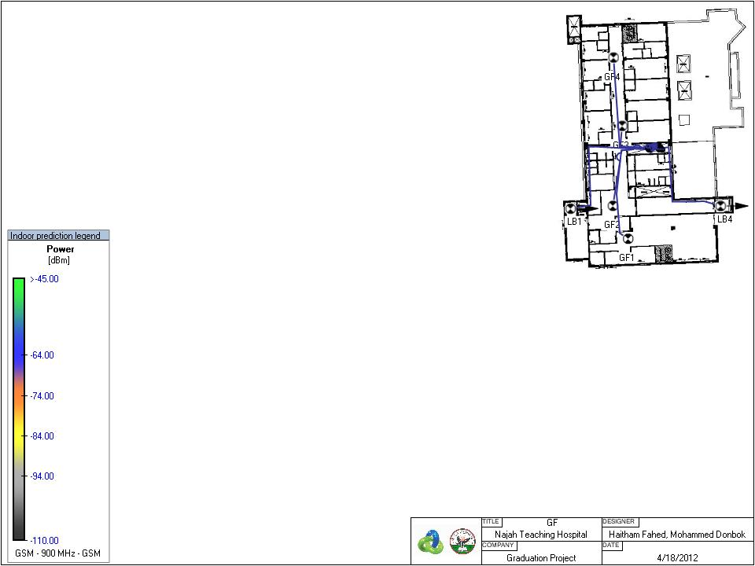
Figure 36 Cable Routing inside GF
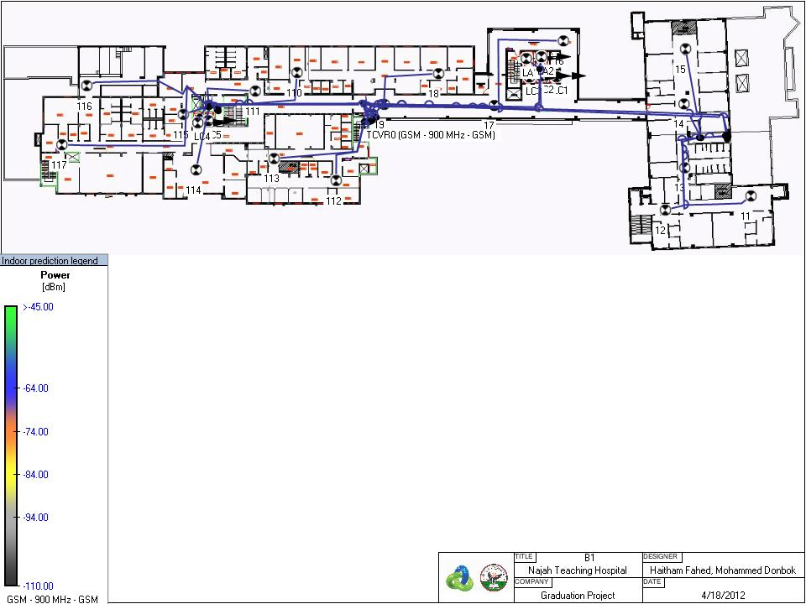
Figure 37 Cable routing inside B1
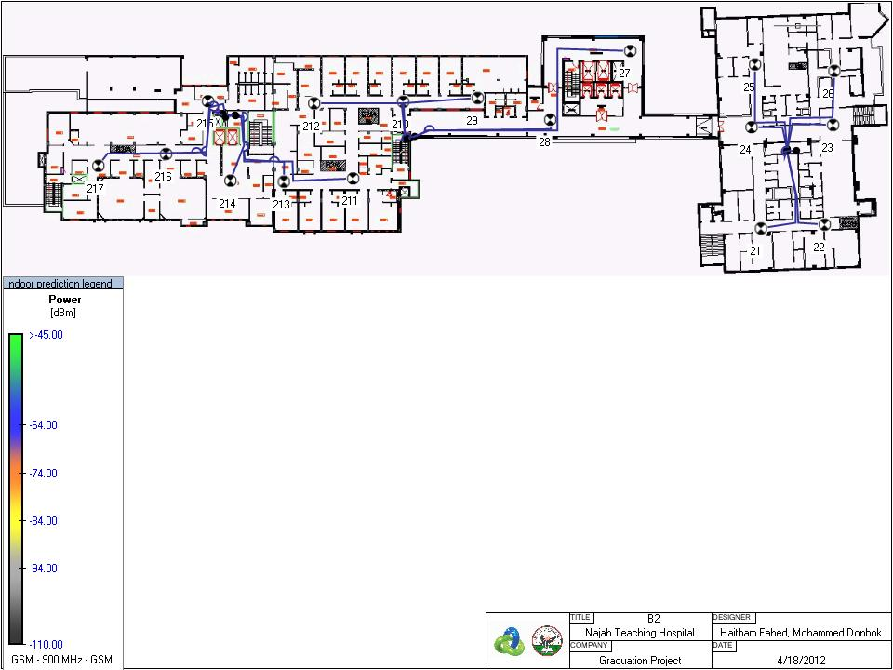
Figure 38 Cable routing inside B2

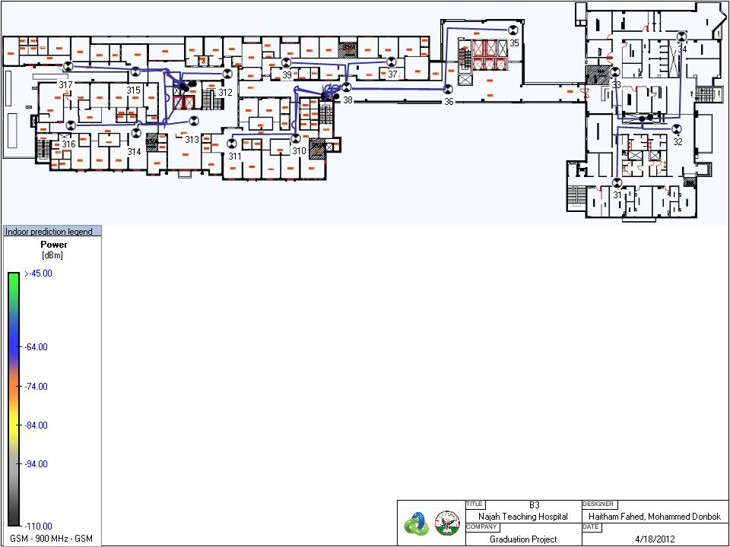
Figure 39 Cable routing inside B3
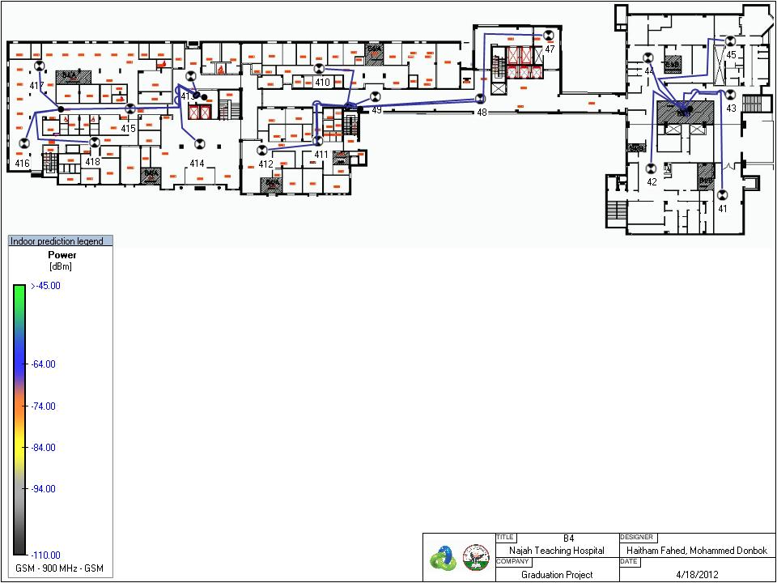
Figure 40 Cable routing inside B4
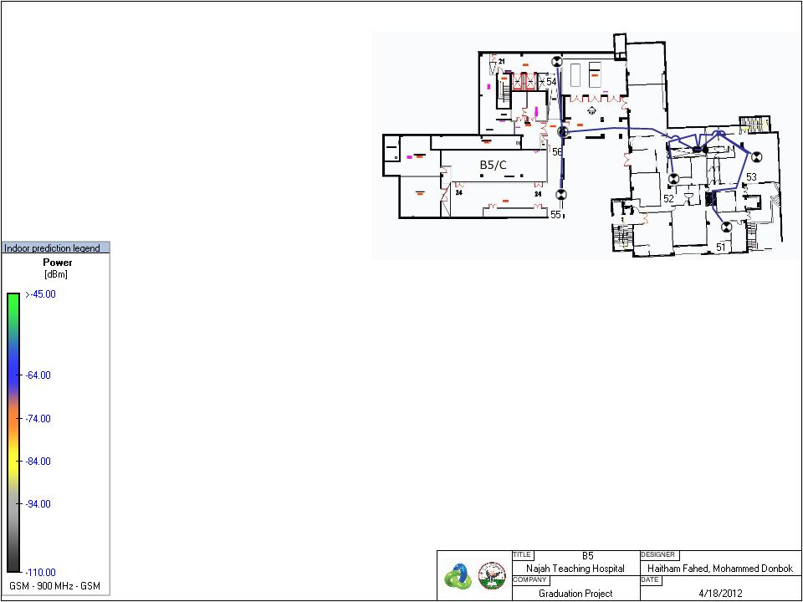
Figure 41 Cable routing inside B5

