

An-Najah National University
Faculty of Graduate Studies

IMPACT OF ELECTRICAL VEHICLES CHARGING ON THE MAXIMUM DEMAND OF THE POWER GRID AND THE POLICES FOLLOWED TO CONFRONT IT

By
Talal Amjad Talal Dweikat

Supervisor
Prof. Kamel Saleh

This Thesis is Submitted in Partial Fulfillment of the Requirements for the Degree of Master of program name, Faculty of Graduate Studies, An-Najah National University, Nablus - Palestine.
2025

IMPACT OF ELECTRICAL VEHICLES CHARGING ON THE MAXIMUM DEMAND OF THE POWER GRID AND THE POLICES FOLLOWED TO CONFRONT IT

By
Talal Amjad Talal Dweikat

This Thesis was Defended Successfully on 00/00/2025 and approved by
Prof. Kamel Saleh  Supervisor | Signature
Dr.  External Examiner | Signature
Dr.  Internal Examiner | Signature

Dedication
The researcher may dedicate his work to relatives, friends and family members.

Acknowledgements
The Researcher may thank people, institutions and different parties who helped him in accomplishing his work.

Declaration

I, the undersigned, declare that I submitted the thesis entitled:

IMPACT OF ELECTRICAL VEHICLES CHARGING ON THE MAXIMUM DEMAND OF THE POWER GRID AND THE POLICES FOLLOWED TO CONFRONT IT

I declare that the work provided in this thesis, unless otherwise referenced, is the researcher’s own work, and has not been submitted elsewhere for any other degree or qualification.

Talal Amjad Talal Dweikat | Student's Name:
 | Signature:
00/00/2025 | Date:

List of Contents
Dedication III
Acknowledgements IV
Declaration V
List of Contents VI
List of Tables VIII
List of Figures IX
List of Appendices X
Abstract XI
Chapter One: Introduction and Literature Review 1
1.1 Introduction 1
1.2 Literature review 2
1.2.1 Over view about the electric vehicle 2
1.2.1.1 Hybrid vehicles 2
1.2.1.2 Plug-in hybrid vehicles 2
1.2 Main components of electric vehicles 3
1.2.1.3 Electric motor 5
1.2.1.4 On board charger 7
1.2.1.5 How are electric vehicles charged? 8
1.2.2 electric peak demand 9
1.2.2.1 Why is peak demand important 10
1.2.2.2 Grid Reliability and Stability 10
1.2.2.3 Infrastructure and Capacity Planning 10
1.2.2.4 Cost Efficiency 10
1.2.2.5 Environmental Impact 11
1.2.2.6 Pricing and Consumer Incentives 11
1.2.2.7 Demand Response and Flexibility 11
1.2.3 How dose peak demand impact the grid 12
1.2.4 Importance of Peak Shaving 12
1.2.5 The Role of EV Charging and V2G in Power System Support and Energy Storage………….. 14
1.2.6 Methodes of v2g 15
1.2.7 Management of v2g system 16
1.2.8 Advantages of v2g 17
1.2.9 Disadvantage of v2g 18
1.2.10 Challenges of v2g system…………………..……………………………………18
Chapter Tow: Methodology 19
2.1 Questionnaire 20
2.1.1 Through the previous results, the following will be studied: 23
2.1.2 results of questionnaire 26
2.3 Questionnaire’s Summary 29
2.4 Daily load curve 29
2.4.1 types of daily load curve 33
2.5 Etab Network test 46
2.6 Summary of methodology 49
Chapter Three: Results and Recommendations 51
3.1 Results 51
3.2 Recommendations 53
3.3 Future work 56
References 58
Appendices 64
الملخص ‌ب

List of Tables
Table 1: The loads were distributed in this case as follows in the table 34
Table 2: The loads of electric vehicles were distributed 3 years ago as follows in the table: 35
Table 3: The loads of electric vehicles were distributed 2 years ago as follows in the table: 36
Table 4: The loads of electric vehicles were distributed 1 year ago as follows in the table 37
Table 5: The following table shows the total loads of electric vehicles with the grid loads in the three cases 38
Table 6: The loads were distributed in this case as follows in the table 40
Table 7: The loads of electric vehicles were distributed 3 years ago as follows in the table 41
Table 8: The loads of electric vehicles were distributed 2 years ago as follows in the table 42
Table 9: The loads of electric vehicles were distributed 1 year ago as follows in the table: 43
Table 10: The following table shows the total loads of electric vehicles with the grid loads in the three cases 44

List of Figures
Figure 1: Levels of ev charging 9
Figure 2: Matlab code used to create the daily load curve of EV charging pattern 32
Figure 3: Load Befor (EV) 34
Figure 4: Total Daily Load Curve 38
Figure 5: load before EV 40
Figure 6: Load of EV 1 year ago -two peak demand curve 43
Figure 7: Total daily load curve 45
Figure 8: E-tab Network 47

List of Appendices
Appendix A: Main component of eV 64
Appendix b: Types of ev battery 65
Appendix c: The time at which charging begins 66
Appendix D: Table shows example of data entry for matlab code 67
Appendix E: EV chargers daily load curve 3 years ago 1 peak daily load curve 68
Appendix F: Ev chargers daily load curve 2 years ago 1 peak daily load curve 69
Appendix G: Ev chargers daily load curve 1 year ago 1 peak daily load curve 70
Appendix H: Ev chargers daily load curve 3 year ago 2- peak daily load curve 71
Appendix I: Ev chargers daily load curve 2 year ago 2- peak daily load curve 72
Appendix J: Comparison between the daily load curve and the number of vehicles on the charger in case reducing the charger capacity 73
Appendix K: Figures 74
Appendix L: Tables shows the changes in voltages, LF, THD 86

IMPACT OF ELECTRICAL VEHICLES CHARGING ON THE MAXIMUM DEMAND OF THE POWER GRID AND THE POLICES FOLLOWED TO CONFRONT IT
By
Talal Amjad Talal Dweikat
Supervisor
Prof. Kamel Saleh

Abstract
With the increasing number of electric vehicles and increased government adoption, challenges are mounting for electrical grids around the world. One of the most significant challenges is the rising demand for electrical grids and its impact on the maximum load, especially during peak hours. This research investigates the impact of the widespread deployment of electric vehicles on the grid's daily load curve, and the strategies that can be used to mitigate the stress on the grid.
The user behavior of electric vehicles and their charging methods were studied through a questionnaire. The results obtained from the analysis of user data enable the identification of several important elements in this study. Data such as the prevalence of electric vehicles, the capacity of the chargers used, the average battery capacity available in the market, and the behavior of the electric charger user during usage times are all elements that help in studying the impact of the increase in electric vehicles and providing appropriate recommendations for each network separately. Using the results obtained from the user behavior study and drawing a daily load curve for new loads, it is possible to identify areas of high loads and how they are distributed across the network spatially and temporally. Determining the daily load curve for vehicle charging is the key point in providing recommendations for the use of network management strategies.
To address these challenges, this study examines demand-side management (DSM) strategies such as demand response, load shifting, smart grid, and smart charging. Implementing DSM strategies enables the grid to handle increased electrical loads while maintaining network stability and quality. The study includes specific recommendations for increasing grid reliability and addressing the challenges of increased loads, including the integration of storage systems into the grid, the use of mechanisms such as V2G, and smart charging policies for electric vehicles. These strategies improve electricity service while reducing network stress and decreasing network development costs. Future work will focus on the use of more accurate methods for collecting user information, promoting the use of smart chargers connected to the electricity grid and its operators, and enhancing the policies used in this area.
Keyword: Electric Vehicles (EV); Peak Demand; V2G; Consumer Behavior.

Chapter One

Introduction and Literature Review

Introduction
With the global shift towards the clean energy systems, the use of internal combustion engines is reduced to reduce emissions, and to preserve the environment. This led to an increasing number of Electrical Vehicles (EVs) in the global markets, and hence, an increase in the growth of the electrical loads.
EVs companies compete to provide the best service to users and reduce the obstacles that affect electric cars. The most important of which are the charging process of the cars in terms of the time required for it, the efficiency of the charging process, and the maximum distance it can travel before recharging it.
This thesis aims to study the increase in electrical loads caused by charging EVs on a large scale by consumers and its impact on the electrical system. The thesis will focus on the charging process including the size and capacity of the EV battery and its affects the time and the amount of electrical power required. Moreover, the thesis will study deeply various vehicles chargers and effect of charger capacity on the electrical power demand.
Studying the pattern of electrical energy consumption enables us to reach a close and stable shape for the electrical load curve throughout the year, know the growth rate of natural loads, and conduct the necessary studies to develop the energy sector accordingly. One of the elements of this study is studying the pattern of new electrical loads resulting from the use of electric vehicle chargers and knowing their behavior. Using them during the time of day, this helps predict the form of new loads, their growth rate, and the extent of their impact on peak energy demand, because high electrical loads greatly affect decision-making regarding the size of electricity generation, modifying the infrastructure, and taking new measures to maintain system reliability and system efficiency.

Literature review

Over view about the electric vehicle
With the general development of transportation systems and the world's need to reduce emissions, the transportation sector has been developed to produce as little emissions as possible. One of the practical steps towards this was the beginning of the development of electric vehicles of all kinds, as electric vehicles are divided into three main types. (Ajanovic, 2015)

Hybrid vehicles
Hybrid vehicles are designed to reduce emissions and improve the quality factor in fuel consumption in vehicles. The hybrid vehicle consists of an internal combustion engine, an electric motor, a built-in battery, and a special battery charging system using the energy wasted in the vehicles, such as the engine brake system, where the system charges the vehicle's battery using the energy wasted in braking the vehicle. One of the advantages of this system is that the vehicle is not charged from the available chargers, but rather depends on charging the battery from the vehicle itself. It reduces fuel consumption in vehicles to help reduce emissions and consumption by operating the electric motor in the vehicle and turning off the petrol engine or operating them together. (Abd El et al., 2022; Ajanovic, 2015)

Plug-in hybrid vehicles
These are vehicles similar to the hybrid system, but with the ability to charge the vehicle battery using available vehicle chargers to provide the vehicle with the necessary energy. The size of the electrical system in plug-in hybrid vehicles is usually larger than in hybrid vehicles, as larger batteries can be used than in hybrids. Plug-in vehicles are more complex than hybrid vehicles, but they have more advantages than them, such as a longer range for electric driving, the ability to charge the battery using chargers, and greater savings in emissions. (Abd El et al., 2022; Ajanovic, 2015)

1.2.1.3 Full electric vehicles:
Full electric vehicles are the latest in emission-saving and environmentally friendly transportation systems. An electric vehicle consists of several main components, mainly an electric motor, a battery, a control system to control the motors, and a battery charging mechanism. The driving force of the vehicle is the electric motor and the only source of energy is the battery. From this, it can be distinguished from the previous two types of electric vehicles by the absence of an internal combustion engine in the vehicle. (Abd El et al., 2022; Ajanovic, 2015)

Main components of electric vehicles
The electric vehicle consists of several components like regular vehicles, but it is distinguished by the presence of different electrical components. The related electrical components will be mentioned. (Abd El et al. A.-K. , 2022)
      - Electric battery
The battery is the primary source of energy in electric vehicles, unlike traditional vehicles that use internal combustion engines to drive the vehicle, where electric motors and batteries are used as a power source. The electric battery plays a fundamental role in the performance, efficiency and distance traveled by the vehicle (Ajanovic, 2015). There are several types of electric batteries, which differ in cost, lifespan, capacity versus size and the technology used to develop these types. The most important of these types are: (Abd El et al. A.-K. , 2022)
- Lithium-ion batteries.
Lithium-ion (Li-ion) batteries are common storage devices employed on contemporary electric vehicles (EVs) primarily due to their high energy density—typically ranging from 150 to 250 Wh/kg—being feasible in achieving extended driving ranges (Rachapudi et al., 2022). The batteries also exhibit satisfactory cycle life between 1,000 and 3,000 charge-discharge cycles based on their particular chemistry and operational conditions.
Depending on the charging level and battery management system (BMS) efficiency, Li-ion batteries can be charged relatively quickly, typically taking one to four hours. Additionally, they have a low self-discharge rate (roughly 2–5% monthly), require less maintenance, and are more environmentally friendly than older battery technologies because they don't contain heavy metals like lead or cadmium. However, in order to guarantee stable operation, integrated thermal management systems are required because their performance is sensitive to extreme temperatures. Long-term, Li-ion batteries are the most cost-effective option due to their efficiency, durability, and consistent performance, despite their higher initial cost. (Abd El et al., 2022)
- Nickel batteries.
Lithium-ion and lead-acid batteries can be balanced with nickel-metal hydride (NiMH) batteries. They outperform lead-acid batteries with energy densities between 60 and 120 Wh/kg, but they are still less effective and heavier than lithium-ion batteries. (Abd El et al., 2022)
The Toyota Prius and other early hybrid electric vehicles (HEVs) made NiMH batteries famous. Because of their mechanical strength and comparatively long cycle life (usually 500–1,000 cycles), NiMH batteries are still utilized in hybrid systems. However, they are prone to the memory effect, which can lower their usable capacity if not adequately controlled, and they have a high self-discharge rate, frequently surpassing 20% per month. In some operating conditions, NiMH batteries are safer than lithium-ion batteries because they have better thermal stability and are less likely to experience thermal runaway. Nevertheless, handling and recycling must be done carefully due to the presence of toxic nickel. (Zhao et al., 2022)
- Lead acid batteries.
One of the earliest types of rechargeable energy storage used in electric mobility is lead-acid batteries, which were particularly prevalent in early electric scooters, golf carts, and low-speed EVs. Their affordability and resistance to overcharging are what define them. Their low energy density (30–50 Wh/kg), which causes significant weight and a short vehicle range, is one of their main disadvantages. (Abd El et al., 2022)
Lead-acid batteries also need frequent maintenance, like electrolyte replenishment, to maintain performance because of their short cycle life (roughly 300 to 500 cycles). Their poor cold-temperature performance and comparatively high self-discharge rate further limit their use in contemporary EVs. Environmentally speaking, the presence of toxic lead calls for strict recycling and disposal practices. While they may still be used in low-cost, short-range use cases, lead-acid batteries are now regarded as outdated for widespread EV applications. (Abd El et al., 2022)
Comparative Analysis
With their high energy density, long cycle life, low maintenance needs, and comparatively low environmental impact, lithium-ion battery systems stand out among the evaluated battery technologies and have established themselves as the industry standard for contemporary EV applications. In some hybrid configurations, nickel-metal hydride batteries are still a good option, but lithium-ion batteries are gradually replacing them. Though historically significant and reasonably priced, lead-acid batteries are mostly out of use in modern EV designs because of their subpar performance and environmental issues.
A number of factors, such as the application type, financial limitations, intended vehicle range, accessibility to charging infrastructure, and environmental concerns, influence the best battery technology for an electric vehicle. While NiMH may continue to play specialized roles in hybrid or industrial electric vehicles, lithium-ion technology significantly enhances high-performance and long-range EVs. Making educated decisions about EV development, energy policy, grid integration, and sustainable mobility planning requires a thorough grasp of the trade-offs between battery chemistries.

Electric motor
The electric motor is one of the latest developments that have helped transform the transportation sector to become more stable and more advanced. Electric motors are more efficient than internal combustion engines, instant torque, and reduced emissions (Un-Noor et al., 2017). The electric motor uses energy from the batteries in the vehicle and converts electrical energy into mechanical energy to move the vehicle. There are several types of electric motors, which differ in their mechanism of operation, size, and efficiency, as many types have been used and these types are. (Un-Noor et al., 2017)
- Permanent Magnet Synchronous Motor (PMSM): PMSMs are very highly developed electrical machines capable of functioning efficiently over a broad speed range without any mechanical gear set utilization. This gearless property also contributes to their enhanced efficiency and smaller footprint. Such characteristics make them very appropriate for in-wheel electric vehicle (EV) applications, where they can deliver high torque even at slow rotation speeds. Non-rotor bearing use can also be attained for outer rotor configurations of PMSMs. However, there is an immense caveat noted through their utilization for high-speed in-wheel applications, where there can be strong iron losses potentially giving rise to system instability (Magnussen, 2004). For achieving high-energy density, Neodymium-Iron-Boron (NdFeB) permanent magnets are also typically employed. Due to their sinusoidal nature of their air-gap flux linkages, these motors can be operated using sinusoidal voltage excitation and vector control methods (Parag Jose & Meikandasivam, 2016). PMSMs are also today used most commonly as a form of a motor used by battery electric vehicles (BEVs), and more than 26 commercial vehicles feature this technology itself (Grunditz & Thiringer, 2016) .
- Induction Motor Induction motors have also found their use on earlier versions of EVs, such as GM EV1 (Rajashekara, 2013), and contemporary cars like Tesla vehicles (https://www.tesla.com/support/model-s-specifications, 2017). Of various forms of commutator less electric drive configurations, IMs represent technologically most advanced ones (Camacho et al.). With vector control as an embraced principle, IM performance can be optimized such that its demanding requirements can be attained for EV propulsion purposes. For instance, vector-controlled IM configurations can be optimized for minimum losses on various load working conditions, as can be extracted from (Yamada et al., 1996). With field-oriented control (FOC), IMs can emulate separate excitation behavior for DC motors by uncoupling torque and field control and can also offer flux weakening techniques for increasing speed ranges of operation above base speed for any motor. Well-designed IMs with FOC can attain three to five times their base speed with constant delivered power outputs (Boglietti et al., 1993). Contemporary EVs typically incorporate three-phase AC induction motors with copper and four poles on their rotors.
- Switched Reluctance Motor (SRM): Switched Reluctance Motors, or doubly salient machines because their rotor and stator poles are saliency due to their shape, are a family of unipolar current-driven synchronous motors powered by an inverter. Mechanically simple and robust motors and generators, SRMs enjoy their mechanical simplicity and robustness through their low cost of manufacture, their very high rotation speeds, their broad range for constant power, and their very good power density and safety through nonpermanent magnets. Because their fault tolerance makes them further suitable for EV usage. Some drawbacks also accompany SRMs: their high acoustic noise because of their torque ripple, their moderate compared-to PM-based machines and induction machines efficiency rate, and their larger and heavier machine compared-to PM-based machines. Further because SRMs are simple mechanical devices and because their design and their electromagnetic behavior are difficult because of phenomena such as slot-based fringing effects and magnetic saturation (Parag Jose & Meikandasivam, 2016); (Rajashekara, 2013); (Gao et al., 2005); (Parag Jose & Meikandasivam, 2016). Because historically such drawbacks prevented them from being prolonged compared-to PM and induction machines because their development was slowed down. Recent advances because rare-earth magnets cost increases turned back from them toward SRMs. Interestingly enough, there was an excellent SRM invented by Nidec Corporation in 2012 and has excellent performance such as interior permanent magnet machines with much-less cost. Improving further torque ripple and acoustic noise is ongoing research. One very promising configuration is a double-stator SRM configuration: such machines have reduced inertia and acoustic noise factors and improved speed range and torque density compared-to standard SRMs (Abbasian et al., 2010); (Cameron et al., 2002). To further optimize their behavior and their usage, finite element methods (FEM) can be used and can suppress global losses (Chan et al., 1996), and newer advanced control methods such as fuzzy sliding mode methods can be used and can suppress their nonlinearity and chattering usage due to their duty cycle usage. (Zhan et al., 2002)
- Brushless DC Motor (BLDC): Known for efficiency and reliability, frequently used in light EVs and e-bikes. (Un-Noor et al., 2017)

On board charger
It is the component responsible for converting the alternating current electrical energy coming from the electrical grid into direct current DC to charge the batteries of the electric vehicle. The onboard charger allows the electric vehicle to be charged from small home chargers or from charging stations and various charging infrastructures, as it controls the vehicle's charging speed and efficiency and ensures charging safety in various conditions. (Inamdar et al., 2019)

How are electric vehicles charged?
With the spread of electric vehicles, the spread of vehicle chargers has become parallel to the spread of vehicles, as the two most important elements in the electric transport system are batteries and chargers. The challenges that have emerged with the increasing growth of electric vehicles are to provide an appropriate infrastructure to provide the electrical energy needed to charge vehicles. (Khaligh & D'Antonio, 2019). The function of the electric charger is generally to transfer and convert energy from the electrical grid to vehicles in an appropriate manner by recharging the electric batteries in them. The types of electric chargers vary in terms of design, power output, charging speed and technology used in them to make chargers suitable for all types of vehicles. (Khaligh & D'Antonio, 2019); (Inamdar et al., 2019)
Vehicle chargers are classified into several types, which are
1- Level 1 Chargers: These chargers use a standard 120V AC household outlet and provide the slowest charging speed. Typically, they deliver 5 miles of range per hour of charging. Level 1 chargers are often used for overnight charging at home, as they do not require special installation and can be plugged into any standard outlet. (https://www.tesla.com/support/model-s-specifications, 2017); (Acharige et al., 2023)
2- Level 2 Chargers: Level 2 chargers require a 240V outlet, similar to those used for large appliances like electric dryers. These chargers provide a significant improvement in charging speed, typically offering 20-60 miles of range per hour. They are commonly installed in homes, workplaces, and public charging stations. The higher power output of Level 2 chargers makes them a popular choice for regular daily charging. (https://www.tesla.com/support/model-s-specifications, 2017); (Acharige et al., 2023)
3- DC Fast Chargers (Level 3): DC Fast Chargers are the fastest charging option available, providing direct current (DC) power to the vehicle's battery, bypassing the need for the vehicle's onboard charger to convert AC to DC. These chargers can deliver 60-100 miles of a in just 20 minutes, depending on the vehicle's battery size and the charger's power output. DC Fast Chargers are typically found at commercial charging stations, particularly along highways and in urban areas, where quick turnaround times are essential. . (https://www.tesla.com/support/model-s-specifications, 2017); (Acharige et al., 2023)
Figure 1
Levels of ev charging
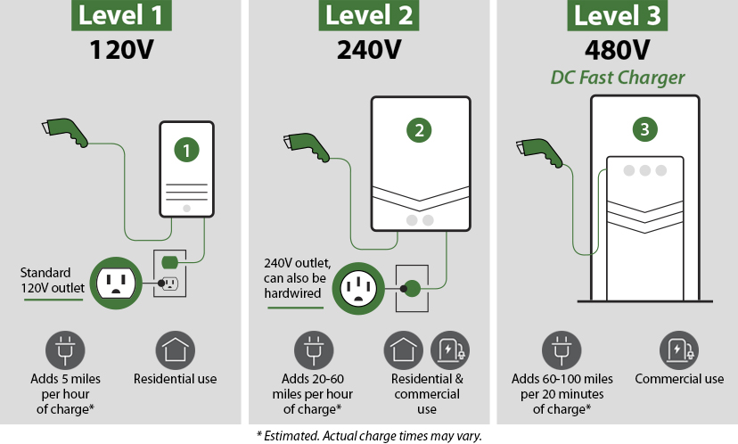

electric peak demand
Peak demand is defined as the maximum power load that the electrical grid receives at a given moment of the day or a given period of the day, and is usually considered a peak demand if it exceeds a period of 15 minutes to an hour. It is necessary to differentiate between electrical power requirements, as they are divided into two sections: energy, which focuses on the amount of energy you consume during a given period, and demand, which focuses on the amount of energy you consume during a given moment. Energy is the amount of kwh you consume during a given period, and demand is the amount of kw you consume during a given moment. (Enertiv)
They can be differentiated by the daily load curve, where energy is the area under the daily load curve, which means the amount of energy consumed during the day, and the demand is any point on the curve at any moment of the day. The peak demand is the highest point reached by the daily load curve. (Enertiv)
The peak demand is usually reached at times when facilities and individuals use electrical energy together at the same time, as the demand is raised on the network. The most important electrical loads are air conditioning loads, especially at times when temperatures are high, as most air conditioning units are operated and a large amount of energy is consumed, which raises the maximum load on the grid.

Why is peak demand important
There are many researches and methods around the world to study the peak demand and the mechanism of predicting the amount of energy needed in each period of the year and for several years to come, and it can reach up to 10 years to come, by analyzing the electrical network loads and studying the behavior of energy consumers, as energy consumption habits do not change quickly, so it is possible to study the growth rates of electrical loads and predict the upcoming loads on the network. The importance of studying the peak demand and predicting the forecast loads lies in several important factors that have a major impact on the electrical network. Including.

Grid Reliability and Stability
Peak load management and monitoring of the maximum load of the electrical network is essential to prevent overloading of the network, which can lead to power outages or power shortages in large areas of the network. When the network operates at a value close to the maximum load of the network, it is close to its maximum capacity and may lead to a filler in the network. As the management of electrical loads helps ensure that the network meets its needs while maintaining the reliability of the system. (Peak Demand: What Is It And Why Does It Matter? Energy Sage)

Infrastructure and Capacity Planning
The peak demand of the electrical grid determines the maximum capacity that utility can support. Knowing the peak demand of the grid over the study period of electrical power systems affects investment in the section of generation and transmission in particular. Planning based on the peak demand of energy in the electrical network helps utilities avoid over- or under-development of infrastructure in the areas of generation and transmission and improve costs. (Peak Demand: What Is It And Why Does It Matter? Energy Sage)

Cost Efficiency
The energy generated during peak load times of the grid usually comes from “peak demand plants”, which are characterized by their high cost, low efficiency, low sustainability and high operating costs. Reducing the peak load of the electricity grid leads to reducing the use of these plants, which leads to stabilization of energy prices. (Peak Demand: What Is It And Why Does It Matter? Energy Sage)

Environmental Impact
Peak demand leads to increased use of fossil fuel power plants which emit more greenhouse gases and pollutants. By reducing peak demand, the use of these plants is reduced, which leads to reduced emissions and increased sustainability. (Peak Demand: What Is It And Why Does It Matter? Energy Sage)

Pricing and Consumer Incentives
Many utility companies use time-of-use or demand-charge pricing systems during peak demand times. This encourages consumers to stay away from these times to reduce usage bills, which in turn reduces demand for energy during peak times and reduces peak demand. (Peak Demand: What Is It And Why Does It Matter? Energy Sage)

Demand Response and Flexibility
Many utilities use demand response systems to encourage consumers to reduce consumption during peak times and maximum load. These mechanisms help deal with increased demand for electrical energy without the need to increase energy sources. (Peak Demand: What Is It And Why Does It Matter? Energy Sage)
The importance of studying the peak demand lies in knowing the amount of electrical energy production needed over the study period and knowing the number of energy units needed to secure the network’s needs for electrical energy in order to ensure that there is no failure in the network and that the quality of power reaches its best levels and studying the loads to reach the lowest peak that can be reached using the mechanisms followed for this to reduce the cost and not to purchase new generating units to operate the network for a few hours a year.

How dose peak demand impact the grid
One of the common effects on the electrical grid due to the high peak demand is Grid Reliability and Risk of Outages, as the lower the peak demand, the more reliable the electrical grid becomes and the quality of the capacity improves, as when the grid has a high load and is close to the upper limit of the generating stations, fears of failure and failure in the electrical grid increase, leading to an interruption of electrical service and an increase in faults on the components of the electrical grid, which increases operating and maintenance costs. Another important factor is that increasing the peak demand requires an increase in the energy infrastructure and its costs, as it requires an increase in the number of power generators and the development and modernization of the components of the electrical system in terms of transmission and distribution, according to the requirements of the grid.

Importance of Peak Shaving
Because customers expect a consistently available supply all year long, power outages are the biggest worry in the electric utility sector. According to (Mehta & Mehta, 2005), this ready supply is the "reliability" of a power system in terms of delivering sufficient output to consumers. Discussions concerning the effects of power outages on customers have been sparked by a number of studies. Generally speaking, distribution systems have expanded haphazardly, leading to significant technical and financial losses as well as subpar power quality. The absence of effective operational planning tools is another factor contributing to rising system losses (Biancardi et al., 2021). Improving power systems' dependability is a workable way to lessen significant power outages. Electrical energy storage was costly and ineffective at the beginning of the 1980s. However, a sizable market for energy storage systems has recently emerged due to improvements in microgrid utilization, making them technically and financially feasible. Rahimi et al, (2013)These advancements demonstrate the extent to which ESS are progressing and are anticipated to do so in other regions of the world. Based on power system reliability, the literature has identified a number of factors that encourage the adoption of energy storage systems. The most important aspect is that scientists are eager to minimize disruptions in order to alleviate the world's energy demand. The implementation of energy storage systems, postponing transmission line expansion, and incorporating free and environmentally friendly renewable energy sources are also anticipated to result in a notable decrease in net operating costs. These factors have been the subject of numerous studies. Research in this area is still lacking, though, as evidenced by the worldwide interest in adopting energy storage systems and the discovery of additional, as yet untapped, renewable resource sources.
Peak shaving is important. The significance of peak load shaving Because peak load only happens sporadically and for a small portion of the day, it is a sensitive factor for the grids. A traditional method that includes capacity addition is frequently employed to supply the peak load. However, since the utilities must maintain the generation capacity that will only be used for a few hours per day, this approach is not economically viable and is inefficient in terms of the generators' usage (Mishra & Palanisamy, 2018). Additionally, it has a number of drawbacks, including high fuel consumption and carbon dioxide (CO2) emissions, higher maintenance and transportation expenses, and quicker equipment deterioration. Peak load shaving is therefore a better strategy to get around these drawbacks of the capacity addition approach. It is crucial to distinguish between the effects and advantages of peak shaving for market participants, including power producers, transmission and distribution (T & D) grid operators, electricity traders, and electricity consumers, since many nations (such as EU member states) have already fully unbundled the power market (Meeus et al., 2005). Nonetheless, there are three general categories into which the advantages of peak shaving can be divided. Carbon Emission Reduction; Grid Operator Benefits; End-User Benefits. Grid operator advantages the ensuing subsections describe a number of aspects that can be greatly enhanced by making use of the system's peak load shaving.
Quality of power Maintaining a balance between the production and demand of electricity is one of the major ongoing challenges that the utilities face (Parag Jose & Meikandasivam, 2016). The grid system may experience issues like instability, voltage fluctuations, and complete blackouts if the generating system is unable to precisely match the demand for electricity (Bruch et al., 2011). These issues may manifest as low power quality and strain on the generating equipment. Various peak load shaving strategies have been suggested by earlier studies to address the generation-demand imbalance. These methods concentrate especially on developing an effective demand profile, which will enhance the quality of the power.
Effective use of energy A helpful method for gauging a plant's variability in consumption is the load factor. It establishes how effectively electricity is being used. A low load factor indicates a highly variable load. A high load factor is necessary for the plant to be economically viable. According to the load factor equation, low energy costs are the result of a high load factor. Therefore, in order to lower energy costs and make the plant economically viable, load factor improvement is required. Peak electrical load must be decreased in order to increase the load factor. Efficiency of the system the supply current must be greatly increased in order to reduce the peak load. However, because current is nonlinearly related to power loss, increasing the supply current will result in a decrease in system efficiency.
In order to increase system efficiency, the supply current must be decreased by lowering peak demand because power loss is proportional to the square of the current (Kalkhambkar et al., 2016). Lowering expenses The utility typically lacks a storage system. As a result, the amount of electricity produced should not exceed the amount needed. If not, the cost of producing electricity will rise per unit due to the wasted energy. Peak shaving is therefore emerging to precisely balance supply and demand. The cost of producing energy will go down as a result. Generally speaking, though, a power grid is built to be able to handle the highest anticipated demand during peak hours. It is not economically viable to design a system with a capacity significantly higher than what is required because peaks only occur infrequently. Peak shaving will also improve system efficiency, which will save grid operators money on maintenance and fuel. Additionally, peak shaving will guarantee that the transmission and distribution (T & D) system is used efficiently. This will prolong the life of T & D systems equipment and postpone system upgrades (Yan et al., 2014). As a result, the grid operator will benefit from lower capital costs. Additionally, peak shaving will reduce transmission and distribution system losses, which will further reduce costs. Peak shaving is therefore necessary to guarantee the greatest possible financial gain for utility. Peak shaving's financial advantages are explained in. (Cartes et al., 2007)

The Role of EV Charging and V2G in Power System Support and Energy Storage
With the rapid development and spread of electric vehicles, the advancement of electric vehicle chargers, and governments' encouragement of electric vehicles to keep pace with advances in transportation and reduce carbon emissions, several problems have emerged related to the significant increase in electric vehicles, including increased electrical loads and the burden on electrical grids to power these vehicles by charging batteries. Increased loads during peak times are among the biggest problems facing electrical grids, as they impact all components of the electrical system in terms of increased production, increased transformer capacity, improved network infrastructure, and ultimately, the network's ability to supply new loads without electrical system failure.
One of the new developments to deal with the increase in loads is V2G technology. This technology means that the electrical energy is two-way, from the grid to the vehicle and vice versa. The electric vehicle can export energy from its own battery to the grid at specific times.

Methodes of v2g
- unidirectional v2g
This type of charging is based on a technology where electrical energy is directed in only one direction from the electrical grid to the loads, electric vehicles. This type is called smart charging, as the electric chargers in this type are connected to the grid, where information supply systems can be used between the grid and the electric chargers. Systems such as demand response and time of use tariff can be applied in this system, where information is exchanged between the grid and the electric charger to reduce loads during peak times and help the grid. One of the disadvantages of this system is that it cannot transfer energy from the electric vehicle battery to the grid or directly to the home. (Shariff et al., 2019)
- Bidirectional V2G (Full V2G)
This system is similar to the previous one, but it is distinguished by the fact that the flow of electrical energy is in two directions: from the electrical grid to the electrical chargers to charge the batteries and from the batteries to the electrical grid. Smart electrical load management systems can also be applied to this system, but in addition, the grid can take electrical energy from the batteries to it during peak times, as the batteries of the electric vehicles participating in this system can form a battery storage system for the grid to be used during peak times to shave the electrical loads during peak times to maintain the stability of the electrical system. (Sami et al., 2019)
- Vehicle-to-Home (V2H)
This system participates in smart electrical load management systems, including demand side management, as it works like the previous system, but does not transfer electrical energy towards the electrical grid, but rather towards the house to which the electric charger is connected. This system, as before, helps in managing electrical loads, as it allows the user to use batteries for consumption during times of high tariff prices or when the electrical power is cut off as a backup power source. (Sami et al., 2019)

Management of v2g system
Managing a V2G system is one of the most important factors that help keep the electrical system safe and stable. This process requires coordination of information between users and the network, as the charging and discharging information of electric vehicle batteries must match the network requirements and the electric vehicle owner's usage.
One of the most important components of a V2G system is the central control system, which primarily collects information and connects electric vehicles to the grid. It collects information on battery capacity, charge percentage, vehicle usage times, the ability to connect the vehicle to the grid during times of high load, when it can be recharged, and the grid's power requirements (Battistelli et al., 2012). All of this information can help the system decide when to charge the battery and when to discharge it. The other part of v2g management is real-time monitoring and scheduling which It helps in transferring electrical energy at the right time, as vehicle batteries can be discharged during times when the grid demand is high and recharged during times when the demand is low or electricity tariffs are low, with alternative energy systems in the grid to boost electrical capacity. All these details can help in implementing the system well. The presence of an information transfer system and good standards is sufficient to achieve the system elements. A standard such as ISO 15118 enables vehicles and charging stations to exchange information with the network about the network status, the battery charge percentage in the system, and the network status in general. (Mendes et al., 2016)
One of the most important elements of the system is the behavior of the electric vehicle user. This system allows the electric vehicle owner to determine their own charging preferences, such as when they want the vehicle to be fully charged, whether they want to share energy with the grid, and the possibility of financial returns for participants in the system. The existence of elements of a successful system must be accompanied by support from governments or energy institutions. These institutions can provide policies for the use of this system, which benefits the electricity grid, users, and society as a whole. (Battistelli et al., 2012)

Advantages of v2g
- Peak network support
The most important benefit of the V2G system is supporting the network during times when the network is in high demand . This system helps reduce stress on the network by supplying it with the amount of energy that suits the network’s condition to achieve stability. (Shariff et al., 2019)
- Improved integration of renewable energy
The system helps, by communicating with the components of the electrical system, to enhance the role of renewable energy systems and the mechanism of their use in increasing the stability of the network, as the network, alternative energy systems, and the battery system are linked together in smart networks to obtain the best position for the electrical network. (El Chehaly et al., 2009)
- Reduced electricity costs for EV owners
Participants in this system can reduce their electric vehicle charging bill through incentives provided by electricity-based utilities by returning electricity to the grid during peak times and charging the vehicle again during off-demand times. This is a use of time-of-use tariff programs. (El Chehaly et al., 2009)
- Decreased need for additional power plants
One of the most important benefits of the V2G system is reducing the need for new electricity generation units, as the maximum load on the electricity grid usually occurs in most networks at short times, which forces the networks to invest in new generation stations to meet the shortage in electrical capacity and prevent network failure. Electric vehicle batteries are considered a battery storage system for the network that can be used during peak demand times. (El Chehaly et al., 2009)

- Support for emergency power supply
In the event of a loss of electrical power from the grid, the presence of the vehicle battery in the V2H system, which means the vehicle to the home, as the electric vehicle battery can return power to the home using the same mechanism as a backup power source. (El Chehaly et al., 2009)

Disadvantage of v2g
- Battery degradation
One of the characteristics of electric batteries is that they have a limited number of charging and discharging times before their efficiency and capacity change. Participating in these programs helps reduce the battery's lifespan, which may lead to its replacement earlier and increase the cost to consumers.
- Higher initial cost
The impact of the high cost on chargers that support the V2G feature and the limited number of vehicles that support this feature is evident.
- Potential user inconvenience
Subscribing to V2G programs may restrict users' freedom to use electric vehicles at certain times, as they may be forced to use the vehicle at times when power is being discharged to the grid, which may cause inconvenience to users.

Challenges of v2g system
There are many challenges to this type of system, including: Need for reliable bi-directional charging infrastructure, difficulty in aggregating EVs and predicting their availability for grid services and variability in user behavior makes demand forecasting more complex.

Chapter Tow

Methodology
This chapter focuses on the methods and methodologies used in studying the impact of charging electric vehicles on the maximum load of the network and on the electrical network in general, as the results emerging from this chapter will contribute to helping researchers establish foundations and methodologies for dealing with electric vehicles in global markets, as the study will study the impact of charging vehicles on most parts of the electrical network, the most important of which is the maximum load of the network, as through the results, utilities governments will develop ways to confront this impact in a thoughtful manner based on the data provided for each network separately.
The study mechanism is based first on taking a sample of electric vehicle owners in a specific area according to the study location and distributing a questionnaire containing several questions, where the purpose of each question is to obtain specific information that benefits the study. The questionnaire provides information about the behavior of electric vehicle users and the charging mechanism followed for their vehicles and charging behavior. The results of the questionnaire, according to equations and laws, will give us the percentage of electric vehicle owners and their growth rate over the given period. Based on information from transportation institutions, we can obtain the growth rate of electric vehicle owners and develop an equation to calculate it. Among the results that we will obtain from the questionnaire is the mechanism of charging behavior of consumers for electric vehicles, where we can know the charging hours and the expected amount of electrical power consumed and its growth rate based on the given results. The questionnaire will be analyzed and the results will be used in the study and its questions will be generalized to other cases in the electrical networks following the study to experiment with them and achieve a high accuracy rate in the conclusions, as the results will have a major role in the final chapters.
After taking the results from the previous file, the study network will be taken and the load flow programs will be used to see the general status of the network before entering the new loads on it and to give general comments on the network performance and provide general recommendations for it before entering the new loads. After taking the previous results, the given network will be changed based on the new loads. They will be entered based on the percentages obtained from the questionnaire on the load flow programs and the changes that occurred in the network will be seen, as the information will be entered gradually as it appeared in the questionnaire in order to follow up on the changes over the study period, which is usually five years.
After reading the results we obtained from the load flow programs, they will be used in the analysis programs, where the Etab program will be used to study the variables on the network on the parts of the electrical system, where the effect of the changes on the peak demand will be studied in terms of increase or decrease.
It will be studied whether the old daily load curve has been changed and the shape in which it was changed and comments will be given on the network performance. The effect of the new loads on the peak demand, the required demand quantity, the maximum capacity and the shape of the daily load curve will be studied in accordance with the power quality slandered. The system components will be judged in terms of developing its infrastructure or using different mechanisms to regulate electrical loads.
More than one scenario will be proposed on the selected networks for the experiment and different scenarios will be presented from the questionnaire to be evaluated on several factors and to provide a general system for judging the impact of charging electric vehicles on the electrical networks because each network has an individual case of specifications. The impact on the transformers will also be studied in terms of load factors, their infrastructure and the amount of harmonics on them before and after the loads and examined based on the ieee standards of the THD scale for the network in order to reach the best decision regarding the transformers.

2.1 Questionnaire
Questionnaires are one of the common ways to obtain sufficient information to reach results with greater accuracy in the forecasting process. They have several benefits, including: (Marshall, 2005)
- Collect basic information: Where information is collected directly from its source, which increases its accuracy, as you can set questions that suit the required information and the result of each question. (Marshall, 2005)
- Easy access: It’s spread to the required category has become easy, especially with electronic questionnaires. (Marshall, 2005)
- Analysis of results: The results obtained from the questionnaire can be analyzed using specialized programs such as SPSS for the purposes of scientific studies. (Marshall, 2005)
In this study, a questionnaire was used that was distributed to electric vehicle owners within a specific community and according to the study criteria. The questionnaire’s mission is summarized in:
- Knowing the distance traveled by the electric vehicle user: Knowing the distance traveled by the vehicle during a specific period, such as each week, is useful in knowing the rate of electrical energy consumption of vehicles, as the number of times the vehicle is charged each week can be estimated based on additional information added to the questions, such as the type of vehicle and the size of its battery (Helmbrecht et al., 2014). Knowing this information helps in estimating the amount of energy needed for each vehicle in proportion to its use during a specific period.
- Knowing the number of times the vehicle has been charged: Users were asked about the number of times they charged their electric vehicle in a certain period based on how they use it. This enables us to estimate the vehicle charging times and the number of vehicles that will be charged in one day. (Helmbrecht et al., 2014) (Schey et al., 2012)
- Electric vehicle charging hours: Questions were asked to try to reach the vehicle charging hours during the day for users, as the user's answer to these questions enables the researcher to know the times of use of the electric charger during the day, which enables the study of new loads on the daily load curve, as the result of the previous questions enables us to know the number of vehicles that will be charged in one day, what time of day they will be placed on the charger, and the number of hours that the vehicle will spend on the charger. Through this information, the daily load curve is drawn for charging vehicles on a specific network, its effect is studied, and variables are added based on the required data. (Wu et al., 2015)
- Find out the size of the vehicle's electric battery: Knowing the size of the electric battery is done by asking the vehicle owners about the size or type of the vehicle accurately, as knowing the size enables the researcher to know the amount of energy needed to charge the vehicles per day, and through it, it is possible to know the size of the increase in electrical loads on the network in a specific period. (Wu et al., 2015)
- Knowing the capacity of the electric charger: By knowing the size of the electric charger used, we can know the amount of increase in the electric loads and the maximum electric load on the electric transformers and on the network. For example, using an electric charger with a capacity of up to 50 kilowatts means that the network consumes 50 kilowatts/hour for each charging process, and this number in total shows the extent of the increase in the maximum load on the network. By knowing the size of the electric charger used, we can know the amount of increase in the electric loads and the maximum electric load on the electric transformers and on the network. For example, using an electric charger with a capacity of up to 50 kilowatts means that the network consumes 50 kilowatts/hour for each charging process, and this number in total shows the extent of the increase in the maximum load on the network. (Pan et al., 2020)
- Knowing the user's behavior in charging the vehicle: The user charging behavior was studied through questions about the timing and reasons for charging the vehicle, including whether the user charges the car periodically at the same time of day every day, or when the vehicle’s charge level reaches half each time, or when it is completely empty (Helmbrecht et al., 2014). These questions and others enable the researcher to know when to charge the vehicle, the time it will take on the charger, and the days and hours that the vehicle is placed on the charger.
- Find out where to charge your electric vehicle: The benefit of knowing the location of the vehicle charging, whether at home, work, or vehicle charging stations, helps to know the location of chargers distributed on the network and the extent of their use in parts of the network, as knowing this matter enables the researcher to know the percentage of chargers and their size in residential areas, workplaces, and charging stations. This helps in studying the effect of increased loads on the transformers of that area and studying the load flow and the status of the electrical network from increased loads. (Al-Hamadi et al., 2005)
The above can be summarized by the use of the questionnaire in this study through knowing the size of the study sample and using probability laws to obtain a high percentage of accuracy of the results, as the results were distributed to know the number of vehicle chargers, their average capacity, their location in the network, the number of hours of operation, the times of use during the entire day, and the intensity of use. This helped in drawing a daily load curve specific to the use of the electric vehicle charger.
The result of the daily load curve enables us to know the maximum load of the network and compare it with the old maximum load of the network, and to know the amount of new energy needed for the electrical network to supply the loads, and to know the times of day when the loads are concentrated.

2.1.1 Through the previous results, the following will be studied:
- Daily Load Curve: The results will provide the shape of the new loads based on the variable ratios.
- Natural electrical load growth rate: The rate of growth of natural loads in the network is known over the period of study and development of electrical networks, which usually lasts 5-10 years, as electrical networks are built on this rate, which is the prediction of the rate of growth of electrical loads. (Kütt et al., 2013)
- Electric vehicle growth rate: Including the growth rate of electrical loads resulting from charging electric vehicles. The increase in the growth rate of electric vehicles affects previous studies for developing networks, as previous studies were conducted without the presence of electric vehicle charging loads as basic loads. As the increase in the percentage of electric vehicles on the network means a significant increase in loads, studies must be changed. (Schey et al., 2012)
- The new Daily Load Curve: Knowing the shape of the new daily load curve helps in making appropriate decisions for each network separately in terms of power quality issues. As we can have several scenarios for the network, including:
- The daily load curve over the study period previously contained one point for the maximum network load and maintaining this point but increasing it.
- The daily load curve over the study period previously contained one point of maximum network load and now contains two or more points of maximum network load.
- The daily load curve during the study period previously contained more than one maximum network load point and an increase was found in these points.
These scenarios represent cases that can be found in the study and each problem can be solved differently as each one of them can affect differently the parts of the network such as transformers, circuit breakers, infrastructure and the maximum capacity that the network obtains by generalizing it to the rest of the parts of the network.
- Knowing the new load ratios for electrical loads on transformers and the amount of new harmonics that will be added to the transformers Kütt et al, (2013) Knowing these ratios enables researchers to estimate the size and type of new electrical transformers and the mechanism for reducing harmonics coming from nonlinear loads such as chargers.
The results of the questionnaire were analyzed using the SPSS program and all the information obtained through it was entered. The questions were as follows:
- Get age categories: One of the requirements for submitting questionnaires is to obtain age groups. Information can be obtained that is useful inside studies, including knowing the percentage of preference of some age groups for a certain type of electric chargers or battery size, or whether age affects vehicle charging behavior. Through this, the study can be further customized and more accurate results can be obtained in future work.
- Place of residence: It is important in terms of allocating the electrical network that will be studied, Where the following information can be determined:
- Knowing the load shape of this network: The network will be determined by identifying the study city, taking its network and drawing its daily load curve. By drawing it, the mechanisms that are compatible with this network can be determined.
- Knowing basic network information: Average Demand, Max Demand and Max Capacity.
3. Electric vehicle purchase time : Knowing the time of vehicle purchase helps us to know the time when electric vehicles began to spread on the network and the rate of their spread each year compared to the previous year. Through this information, we can predict the rate of increase in electric vehicles on the network for the next five years.
4. Type of electric vehicle: Knowing the type of electric vehicle is useful in knowing the capacity of the electric battery accurately, as vehicle owners may answer the question of battery capacity with poor accuracy due to lack of sufficient knowledge or lack of interest in this matter, unlike the full name of the vehicle.
5. Battery capacity: The answer to the battery capacity of the electric vehicle is useful in the equations for calculating the amount of energy needed to charge the vehicle and the number of hours needed for each case using the data in the equations.
6. Approximate distance traveled per day: The answer to the approximate distance traveled per day is useful in the equations for calculating the amount of energy needed to charge the vehicle and the number of hours needed for each case using the data in the equations.
7. Primary use of electric vehicle: For the purposes of the survey standards, the results can be used to know the growth rate of electric vehicles more accurately through the results.
8. Electric vehicle charging station : Knowing where to charge an electric vehicle is useful in knowing where electric chargers are concentrated in the network and estimating the amount of electrical capacity in these areas, as charging areas have been distributed into 3 sections: home, workplace, and charging stations.
9. The capacity of the electric charger used to charge the vehicle: The answer to the capacity of the charger used is useful in the equations for calculating the amount of energy needed to charge the vehicle and the number of hours needed for each case using the data in the equations.
10.vehicle charging time: The answer to the vehicle charging time is useful in the equations for calculating the amount of energy needed to charge the vehicle and the number of hours needed for each case using the data in the equations.
11. Number of hours of vehicle charging: The answer to the number of hours of charging the vehicle is useful in the equations for calculating the amount of energy needed to charge the vehicle and the number of hours needed for each case using the data in the equations.
12. Set charging start time: The answer to determining the start time of charging is useful in the equations for calculating the amount of energy needed to charge the vehicle and the number of hours needed for each case using the data in the equations.
13. Waiting for the battery to be empty: It is useful in knowing the usage pattern of electric vehicle owners to charge the vehicle and increasing accuracy by adding these percentages to the equations for calculating the amount of consumption.
14. The distance the vehicle travels on a single charge: It helps to increase the accuracy of consumption calculation equations.

2.1.2 results of questionnaire
After analyzing the questionnaire, the following results were obtained, along with comments on all results and how to use them:
- Age groups
The age groups were divided into several sections, which are:
1- From the age of 18-25 and its percentage was 18.9%
2- From the age of 26-35 and its percentage was 16%
3- From the age of 36-45 and its percentage was 37.4%
4- From the age of 46+ and its percentage was 27.8%
Through these ratios and results, we can increase the percentage of expected electric vehicles in the coming years based on the percentages of age groups in society compared to the percentages obtained from the questionnaire.
- Place of residence
The questionnaire sample was taken in Amman.
The questionnaire sample is taken in the city of the network on which the impact of vehicles is to be studied.
- Electric vehicle ownership time
The results are distributed into the following categories:
1- From one day to a year and its percentage was 38.8%
2- From one to two years and its percentage was 33.8%
3-From two to three years and its percentage was 27.4%
The data on electric vehicle ownership indicates the annual increase in electric vehicles on the grid, with the annual increase in vehicles ranging between 15-20%.
- Vehicle type:
The prevalence of vehicle types will vary from one region to another, but knowing the type of vehicle accurately enables us to know the size of its battery more accurately, as the accuracy of the information helps increase the accuracy of the desired results from the survey.
- Battery capacity
The battery capacity in electric vehicles ranges from 27 kilowatts to more than 100 kilowatts, with the percentage of battery capacity in the sample distributed as follows:
1- 24 KWH battery and its percentage was 1.4%
2- 32 KWH battery and its percentage was 3.2%
3- 47 KWH battery and its percentage was 9.3%
4-64 KWH battery and its percentage was 33.5%
5- 77 KWH battery and its percentage was 16.8%
6- 86 KWH battery and its percentage was 14.2%
7- 92 KWH battery and its percentage was 10.3%
8- 100 KWH battery and its percentage was 11.4%
The battery capacity ratios in the survey refer to the numbers previously found, as knowing the battery capacity, the time at which the vehicle starts charging, and the distance traveled by the vehicle allows us to know the approximate number of hours the vehicle will spend on the electric charger more accurately.
- Use of electric vehicles
The mechanism for using electric vehicles is divided into three axes:
1- Going to work and daily use was 56.2%
2- The vehicle was used for work and its percentage was28.8%
3- Traveling by vehicle for long distances its percentage was14.9%
The results of electric vehicle use indicate the distribution of vehicle use in society. This helps in studying the user’s behavior in the process of charging the vehicle. An example of its use in traveling long distances can be given, as the vehicle is charged at charging stations with high electrical capacity.
- The capacity of the charger used
The capacity of the chargers in the sample ranged from 4 kWh to 350 kWh and was distributed as follows:
- 4KWH and its percentage was 15.7%
- 7KWH and its percentage was 25.3%
- 11 KWH and its percentage was 18.9%
- 22KWH and its percentage was 10%
- 50KWH and its percentage was 12.1%
- 120KWH and its percentage was 3.9%
- 150KWH and its percentage was 7.5%
- 200KWH and its percentage was 5.3%
- 350KWH and its percentage was 1.4%
From the previous results, the percentage of presence of each size of vehicle chargers in the electrical network appears, as it is possible to know the amount of electrical energy consumption from this category of vehicle chargers on the network at every hour of the day based on the results of the questionnaire.
- When to charge an electric vehicle
The percentage of electric vehicle charging times throughout the week was distributed as follows:
- Who charges the vehicle every day and its percentage was 79%
- who charges the vehicle 2-3 times in the week and its percentage was 13%
- who charges the vehicle 1 time in the week and its percentage was 8%
Knowing this information helps us develop an equation to calculate the expected amount of energy consumption and draw the daily load curve for charging electric vehicles by knowing all the necessary elements, including the number of vehicles being charged, the capacity of the charger used, the battery capacity, and the time of day the vehicle is placed on the charger.
- Vehicle charging time of day (the time at which charging begins)
The percentage of charging times was distributed as follows in appendix C
- Number of vehicle charging hours

2.3 Questionnaire’s Summary
Questionnaires are a common method for obtaining targeted information using statistical and probability equations. A questionnaire was used in this thesis to obtain sufficient information to study the pattern of electric vehicle owners’ use of electric chargers in all its details. Questionnaire questions may differ based on the desired results, the accuracy of the results, and the specifics of each community. (Marshall, 2005)
Another objective of analyzing this questionnaire is to obtain the daily load curve of electric vehicle charging separate from the daily load curve of the electrical grid. The objective of obtaining this information is to study the pattern of increase and growth of electrical loads and the mechanism of their distribution on the grid in a way that enables the researcher to analyze these networks based on the data and the possibility of commenting on the results and giving suggestions and policies that must be followed to ensure maintaining the stability of the electrical grid and maintaining electrical standards in the operation of the networks.
The ratios resulting from this survey were used in the equations for calculating the demand at each hour of the day. These ratios can be used and modified to study the different scenarios that may occur during the study period to study the impact of charging electric vehicles on the grid.

2.4 Daily load curve
The daily load curve is one of the most important elements of this study, as predicting the amount of electrical loads and their arrangement is one of the most important factors that contribute to the stability of the electrical system and has many advantages, including:
- Grid reliability and stability
By accurately predicting electrical loads, we maintain system stability, balance loads, reduce the risk of power outages, and maintain network voltage and frequency.
- Optimal power generation planning
The ability to schedule power generation stations appropriately to achieve the highest energy generation efficiency, which enables us to reduce the use of expensive power units during peak times and reduce costs. (Viral & Khatod, 2012)
- Better integration of renewable energy
Load forecasting helps improve the integration of renewable energy sources into the electrical grid, as it becomes possible to manage these sources in the electrical grid and make them compatible with the demand for loads. (Dhakouani et al., 2019)
- Improved demand response strategies
By knowing the peak and off -demand load times in the electrical grid we can use strategies like time of use tariff to encourage shifting load programs to shift the loads from peak times. (Pinson & Madsen, 2014)
- Cost Savings for Utilities and Consumers
Reducing the need for expensive infrastructure by using existing resources as efficiently as possible, and reducing customers bills through demand side management. (Palensky & Dietrich, 2011)
- Enhanced EV Charging Management
Predicts the impact of EV charging on peak demand, avoiding grid overload.
Helps utilities design smart charging strategies.
The previous results obtained from the survey were used to draw the daily load curve for electric vehicle charging using the following information:
- Percentage of vehicles charged each day
Where we can know the worst scenario for charging vehicles. The results indicate that electric vehicle owners fall into three categories: charging every day, charging 2-3 times a week, and charging once a week. The worst-case scenario is when the highest percentage of vehicles charge on the same day. This information can provide multiple versions of the daily load curve for vehicle charging by increasing the percentage of vehicles charged during the day.
- Electric vehicle charger capacity
The results of the vehicle charger capacity ratios were taken and placed in a table to show the amount of energy needed to charge the vehicles.

- Number of charging hours and charging start time.
Using the above information, a table can be created to detail the proportions needed to draw the daily load curve for vehicles as follows in appendix D
From the following table, a special equation can be created to find the number of vehicles charged in each hour of the day and the amount of energy needed in each hour of the day. The MATLAB program was used to write the code for drawing the daily load curve for vehicles.

Figure 2
Matlab code used to create the daily load curve of EV charging pattern
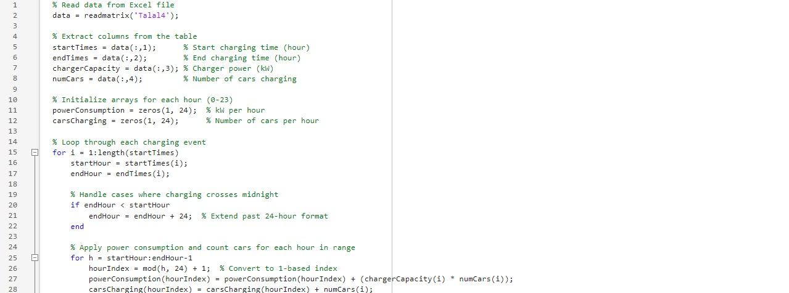

In this study, the impact of adding new loads, especially electric vehicles, on the electricity grid was analyzed using Test Network. This network contains 30 bus systems and has the highest electrical capacity of 20 MW, supplying electricity to a neighborhood with a population of 7,000. This area contains 1,700 electric vehicles. The real spread of electric vehicles began 3 years ago, when the percentage of electric vehicles reached 7% of the total number of vehicles, which is approximately 120 vehicles. Based on the results obtained, it was shown that there is a 20% increase in the number of vehicles each year compared to the number in the previous year. With the successive increase in the number of electric vehicles, this led to successive increases in the electrical loads and peak demand in general.
To study the impact of this increase in vehicle demand, three load scenarios were considered for the network. Based on a study of user behavior, the electrical loads resulting from electric vehicle charging were plotted. The loads generated by electric vehicles were added to the network loads, and the resulting increase was compared each year. The network loads were changed three times to observe the impact of vehicle charging on multiple loads.
By incorporating the growing EV charging demand into the network’s daily load curve, we aim to determine how charging behaviors contribute to peak demand fluctuations and explore potential mitigation strategies such as load shifting, smart charging techniques, and demand response programs. This research provides insights into the long-term planning and management of power distribution systems as EV penetration continues to rise. Understanding these effects is crucial for grid operators and policymakers to ensure grid reliability, optimize infrastructure investment, and develop strategies to integrate EV charging efficiently into the existing power network.

2.4.1 types of daily load curve
- Single peak -load curve
Single Peak Demand Load: This type of load represents a usage behavior where the electrical load gradually increases until it reaches its peak value and then gradually decreases again (Kabeyi & Olanrewaju). This type of load is common in residential areas where the peak is usually in the evening resulting from household activities such as cooking, lighting, and the use of electrical appliances. Managing this type of load is important to achieve electrical system stability. In this type of load, demand response, demand side management, and time of use tariff strategies can be used to help distribute the loads. (Yang et al., 2013)

Table 1
The loads were distributed in this case as follows in the table
Time of the day | Load(MWH)
0:00 | 2.035
1:00 | 1.826
2:00 | 1.63
3:00 | 1.52
4:00 | 1.213
5:00 | 1.8
6:00 | 2.569
7:00 | 3.00
8:00 | 3.84
9:00 | 4.596
10:00 | 5
11:00 | 5.362
12:00 | 5.59
13:00 | 5.59
14:00 | 5.687
15:00 | 5.8
16:00 | 5.54
17:00 | 5.1
18:00 | 4
19:00 | 3.56
20:00 | 3
21:00 | 2.54
22:00 | 2.23
23:00 | 2

Figure 3
Load Befor (EV)
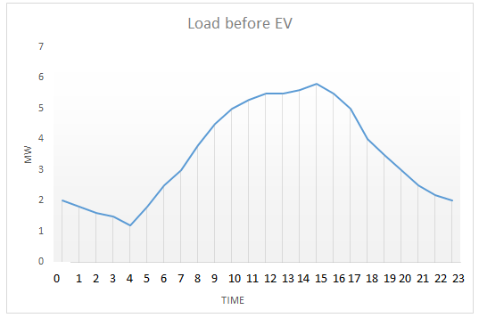
Table 2
The loads of electric vehicles were distributed 3 years ago as follows in the table:
Time of the day | Load(MWH) | Num of EV on chargers
0:00 | 0.8785 | 69
1:00 | 0.964 | 66
2:00 | 0.856 | 54
3:00 | 0.7155 | 41
4:00 | 0.225 | 29
5:00 | 0.195 | 24
6:00 | 0.195 | 24
7:00 | 0.118 | 14
8:00 | 0.022 | 1
9:00 | 0.022 | 1
10:00 | 0.322 | 16
11:00 | 0.17 | 15
12:00 | 0.117 | 15
13:00 | 0.17 | 15
14:00 | 2.293 | 14
15:00 | 2.255 | 30
16:00 | 1.366 | 29
17:00 | 0.87 | 37
18:00 | 0.4489 | 36
19:00 | 0.442 | 39
20:00 | 0.295 | 34
21:00 | 0.446 | 49
22:00 | 0.93 | 22
23:00 | 0.875 | 69

Figure shows the load of electric vehicles 3 years ago Appendix E

Table 3
The loads of electric vehicles were distributed 2 years ago as follows in the table:
Time of the day | Load(MWH) | Num of EV on chargers
0:00 | 1.9 | 150
1:00 | 2.056 | 143
2:00 | 1.884 | 119
3:00 | 1.57 | 91
4:00 | 0.498 | 64
5:00 | 0.429 | 54
6:00 | 0.429 | 54
7:00 | 0.26 | 31
8:00 | 0.048 | 3
9:00 | 0.048 | 3
10:00 | 0.71 | 37
11:00 | 0.374 | 34
12:00 | 0.378 | 34
13:00 | 0.374 | 34
14:00 | 5.054 | 60
15:00 | 4.961 | 66
16:00 | 3.005 | 60
17:00 | 1.9125 | 81
18:00 | 0.987 | 79
19:00 | 0.972 | 86
20:00 | 0.65 | 75
21:00 | 0.9811 | 108
22:00 | 2.07 | 155
23:00 | 1.9 | 150

Figure shows the load of electric vehicles 2 years ago Appendix F

Table 4
The loads of electric vehicles were distributed 1 year ago as follows in the table
Time of the day | Load(MWH) | Num of EV on chargers
0:00 | 4.1 | 327
1:00 | 4.4 | 313
2:00 | 4.04 | 257
3:00 | 3.385 | 195
4:00 | 11.025 | 137
5:00 | 0.921 | 116
6:00 | 0.921 | 116
7:00 | 0.559 | 68
8:00 | 0.108 | 8
9:00 | 0.104 | 8
10:00 | 11.525 | 80
11:00 | 0.804 | 74
12:00 | 0.804 | 74
13:00 | 0.804 | 74
14:00 | 10.837 | 130
15:00 | 10.6 | 142
16:00 | 6.45 | 140
17:00 | 4.114 | 175
18:00 | 2.12 | 171
19:00 | 2.08 | 185
20:00 | 11.378 | 161
21:00 | 2.125 | 233
22:00 | 4.36 | 335
23:00 | 4.41 | 323

Figure shows the load of electric vehicles 1 year ago Appendix G

Table 5
The following table shows the total loads of electric vehicles with the grid loads in the three cases
Time of the day | Grid Load (MWH) before EV | Grid load (MWH) 3years ago | Grid load (MWH) 2years ago | Grid load (MWH) years ago
0:00 | 2.035 | 2.8785 | 3.9 | 6.1
1:00 | 1.826 | 2.784 | 3.87 | 6.22
2:00 | 1.63 | 2.456 | 3.484 | 5.64
3:00 | 1.52 | 2.2155 | 3.07 | 4.88
4:00 | 1.213 | 1.425 | 1.695 | 2.225
5:00 | 1.8 | 1.995 | 2.229 | 2.721
6:00 | 2.569 | 2.695 | 2.929 | 3.421
7:00 | 3.00 | 3.118 | 3.26 | 3.559
8:00 | 3.84 | 3.822 | 3.848 | 3.908
9:00 | 4.596 | 4.522 | 4.548 | 4.604
10:00 | 5 | 5.322 | 5.71 | 6.525
11:00 | 5.362 | 5.47 | 5.674 | 6.104
12:00 | 5.59 | 5.67 | 5.874 | 6.304
13:00 | 5.59 | 5.67 | 5.874 | 6.304
14:00 | 5.687 | 7.893 | 10.654 | 16.437
15:00 | 5.8 | 8.055 | 10.761 | 16.4
16:00 | 5.54 | 6.866 | 8.505 | 11.95
17:00 | 5.1 | 5.87 | 6.9155 | 9.114
18:00 | 4 | 4.4489 | 4.987 | 6.12
19:00 | 3.56 | 3.942 | 4.472 | 5.58
20:00 | 3 | 3.295 | 3.65 | 4.378
21:00 | 2.54 | 2.946 | 3.481 | 4.625
22:00 | 2.23 | 3.13 | 4.27 | 6.56
23:00 | 2 | 2.875 | 3.9 | 6.14

Figure 4
Total Daily Load Curve
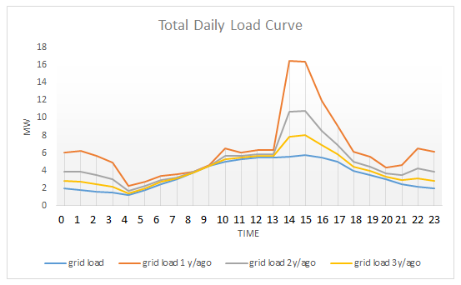
From the previous results in the tables, it becomes clear to us in this case that the peak demand of electric vehicles intersects with the peak demand of the network, as from the shape of the loads we see that the loads have increased in general on the entire network and no other peak has occurred in the network as the system has maintained one peak demand.
We also see significant increases in electrical loads during peak hours due to electric vehicle charging. By studying consumer behavior, we see that vehicle charging loads increase in the evening when people return home, as user behavior indicates that they charge their vehicles daily upon returning from work or other activities.
In this case, we see that the electrical loads have been close to the maximum capacity of the electrical grid. We also see that the increased loads at other times approach the maximum capacity of the electrical grid, increasing the pressure on the network. The new load pattern, while maintaining the same general pattern, helps us implement new strategies to protect the grid from failure and stabilize the system before making recommendations to expand the infrastructure for generating, transmitting, and distributing electricity in this network.
- Two- peak load curve
This type of load represents the presence of two peak demand periods during the day in the electrical grid. Such loads usually occur in urban areas, with the first period occurring in the morning when people start their day, and the second period occurring in the evening when people return home (Kabeyi & Olanrewaju). This type of load occurs in areas that combine residential and commercial use. This type of load increases the pressure on the grid and requires improvements in power distribution mechanisms such as load shifting or battery storage systems.

Table 6
The loads were distributed in this case as follows in the table
Time of the day | Load(MWH)
0:00 | 1.5
1:00 | 1.2
2:00 | 1
3:00 | 0.85
4:00 | 0.512
5:00 | 1
6:00 | 2.5
7:00 | 4
8:00 | 5.5
9:00 | 6
10:00 | 5.8
11:00 | 5.2
12:00 | 5.0125
13:00 | 4.239
14:00 | 4.7852
15:00 | 4
16:00 | 4.23
17:00 | 3.9023
18:00 | 5.23
19:00 | 6.2
20:00 | 7.012
21:00 | 6
22:00 | 4.5
23:00 | 3

Figure 5
load before EV
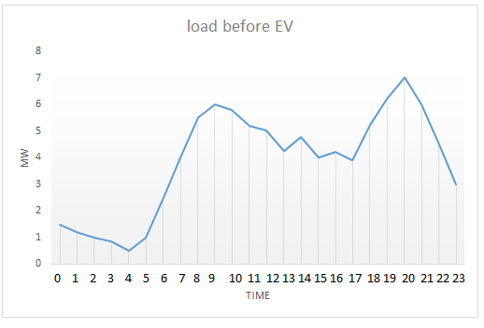
Table 7
The loads of electric vehicles were distributed 3 years ago as follows in the table
Time of the day | Load(MWH) | Num of EV on chargers
0:00 | 0.8785 | 69
1:00 | 0.964 | 66
2:00 | 0.856 | 54
3:00 | 0.7155 | 41
4:00 | 0.225 | 29
5:00 | 0.195 | 24
6:00 | 0.195 | 24
7:00 | 0.118 | 14
8:00 | 0.022 | 1
9:00 | 0.022 | 1
10:00 | 0.322 | 16
11:00 | 0.17 | 15
12:00 | 0.117 | 15
13:00 | 0.17 | 15
14:00 | 2.293 | 14
15:00 | 2.255 | 30
16:00 | 1.366 | 29
17:00 | 0.87 | 37
18:00 | 0.4489 | 36
19:00 | 0.442 | 39
20:00 | 0.295 | 34
21:00 | 0.446 | 49
22:00 | 0.93 | 22
23:00 | 0.875 | 69

Figure shows the load of electric vehicles 3 years ago 2-peak demand load in Appendix H

Table 8
The loads of electric vehicles were distributed 2 years ago as follows in the table
Time of the day | Load(MWH) | Num of EV on chargers
0:00 | 1.9 | 150
1:00 | 2.056 | 143
2:00 | 1.884 | 119
3:00 | 1.57 | 91
4:00 | 0.498 | 64
5:00 | 0.429 | 54
6:00 | 0.429 | 54
7:00 | 0.26 | 31
8:00 | 0.048 | 3
9:00 | 0.048 | 3
10:00 | 0.71 | 37
11:00 | 0.374 | 34
12:00 | 0.378 | 34
13:00 | 0.374 | 34
14:00 | 5.054 | 60
15:00 | 4.961 | 66
16:00 | 3.005 | 60
17:00 | 1.9125 | 81
18:00 | 0.987 | 79
19:00 | 0.972 | 86
20:00 | 0.65 | 75
21:00 | 0.9811 | 108
22:00 | 2.07 | 155
23:00 | 1.9 | 150

Figure shows the load of electric vehicles 3 years ago 2-peak demand load in Appendix I

Table 9
The loads of electric vehicles were distributed 1 year ago as follows in the table:
Time of the day | Load(MWH) | Num of EV on chargers
0:00 | 4.1 | 327
1:00 | 4.4 | 313
2:00 | 4.04 | 257
3:00 | 3.385 | 195
4:00 | 11.025 | 137
5:00 | 0.921 | 116
6:00 | 0.921 | 116
7:00 | 0.559 | 68
8:00 | 0.108 | 8
9:00 | 0.104 | 8
10:00 | 11.525 | 80
11:00 | 0.804 | 74
12:00 | 0.804 | 74
13:00 | 0.804 | 74
14:00 | 10.837 | 130
15:00 | 10.6 | 142
16:00 | 6.45 | 140
17:00 | 4.114 | 175
18:00 | 2.12 | 171
19:00 | 2.08 | 185
20:00 | 11.378 | 161
21:00 | 2.125 | 233
22:00 | 4.36 | 335
23:00 | 4.41 | 323

Figure 6
Load of EV 1 year ago -two peak demand curve
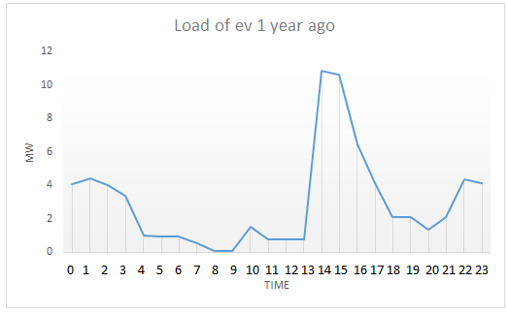
Table 10
The following table shows the total loads of electric vehicles with the grid loads in the three cases
Time of the day | Grid Load (MWH) before EV | Grid load (MWH) 3years ago | Grid load (MWH) 2years ago | Grid load (MWH) years ago
0:00 | 1.5 | 2.3785 | 3.4 | 5.6
1:00 | 1.2 | 2.164 | 3.25 | 5.6
2:00 | 1 | 1.856 | 2.884 | 5.04
3:00 | 0.85 | 1.5655 | 2.42 | 4.23
4:00 | 0.512 | 0.737 | 1.007 | 1.537
5:00 | 1 | 1.195 | 1.429 | 1.921
6:00 | 2.5 | 2.695 | 2.929 | 3.421
7:00 | 4 | 4.118 | 4.26 | 4.559
8:00 | 5.5 | 5.522 | 5.548 | 5.608
9:00 | 6 | 6.022 | 6.048 | 6.104
10:00 | 5.8 | 6.122 | 6.51 | 7.325
11:00 | 5.2 | 5.37 | 5.574 | 6.004
12:00 | 5.0125 | 5.1825 | 5.3865 | 5.8165
13:00 | 4.239 | 4.409 | 4.613 | 5.043
14:00 | 4.7852 | 7.0782 | 9.8392 | 15.6222
15:00 | 4 | 6.255 | 8.961 | 14.6
16:00 | 4.23 | 5.596 | 7.235 | 10.68
17:00 | 3.9023 | 4.7723 | 5.8178 | 8.0163
18:00 | 5.23 | 5.6789 | 6.217 | 7.35
19:00 | 6.2 | 6.642 | 7.172 | 8.28
20:00 | 7.012 | 7.307 | 7.662 | 8.39
21:00 | 6 | 6.446 | 6.981 | 8.125
22:00 | 4.5 | 5.43 | 6.57 | 8.86
23:00 | 3 | 3.875 | 4.9 | 7.14

Figure 7
Total daily load curve
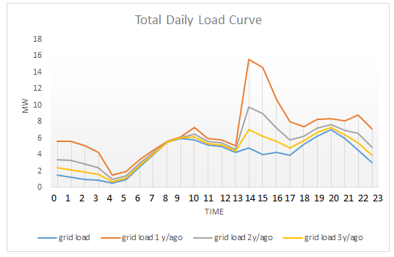
In this case, we notice the presence of two peak demands in the network before the electric vehicle loads enter. After adding the electric vehicle loads to the network, we notice an increase in the loads across the network and a slight increase in the peak demand value. Also, a new peak demand appears in the network. The appearance of a peak demand in the network increases the stress on the electrical network and reduces the opportunity to use load distribution strategies within the network, as the network has reached levels that make it difficult to use mechanisms such as demand response and load shifting. In such cases, the recommendation to increase and develop the infrastructure increases to prevent failure in the electrical system to meet the network's needs.
2.4.2 Reducing the capacity of vehicle chargers during peak times
In this case, we tested replacing the capacity of the vehicle chargers during peak times in the last case, where the vehicle chargers were replaced from high-capacity chargers to low-capacity chargers, while changing the number of charger operating hours, in order to see the resulting change in the peak demand:
After changing the peak load capacity of electric chargers, we got the new daily load curve for electric vehicles. We notice from the new load shape that the peak demand of electric vehicles has decreased and no longer coincides with the peak demand of electric vehicles. The change in the capacity of electric chargers and its reduction increased the time the vehicle spends on the charger, which led to an increase in loads at different times of the day. This change led to a reduction in the peak demand of the network without changing the facts of the electrical network, but it changed the behavior of the electric vehicle user. Through the following tables, you can see the difference between the daily load curve of the previous case and the daily load curve, as the size of the electric chargers was reduced . appendix J
The research results can be summarized in the behavior of electric vehicle charger users and the daily load curve of the networks. There are several factors that can affect the electrical loads and the impact of charging electric vehicles. The capacity of electric chargers falls under the category of consumer behavior, as the consumer can decide the capacity of the charger used from several factors, including charging speed, the availability of high-capacity chargers, the way the vehicle is used, and the need to charge the vehicle quickly.

2.5 Etab Network test
An electrical network was reviewed to conduct a study on the effect of vehicle charging on the maximum demand of the network, in order to arrive at recommendations for electrical networks in general, based on fundamentals that are taken into consideration with the differences in the electrical network and the consumer's usage pattern of electric vehicles, as mentioned in detail in the previous chapters.
A Redel Network electrical network with a max capacity of 20 MW and 21 buses was selected, and an experiment was conducted to add vehicle loads during the network's peak hours. In the first case, the peak demand for vehicle charging coincided with the network's peak hours, which increased the loads during the peak hours. This enables us to see the effects of this increase and comment on these cases and how recommendations can be made for each network separately.
The first case is that the network does not contain electric vehicle chargers. These are the network details.

Figure 8
E-tab Network
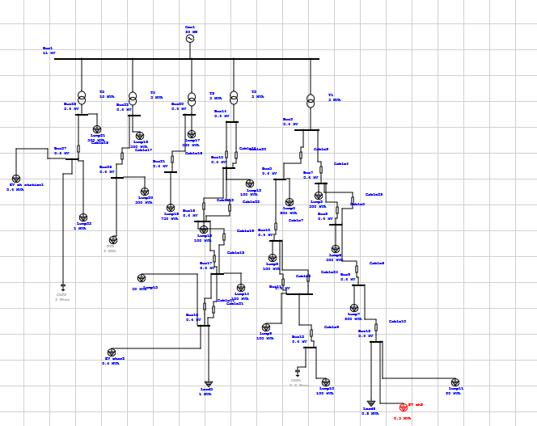
In the tables in appendix A we see all the facts about the network through the reports of the ETAB program for each case, as the tables contain the values ​​of the voltages for each busbar, the load factor on the electrical transformers in the network, the resulting losses in the network and their total, the total harmonic distortion for each busbar and the harmonics of the voltage and current and the effect of the increase on each of them. The tables also contain the results of the power factor at each point and the changes that occurred in each case on each of the previous elements.
As in the previous chapter, the impact of vehicle charging on the electrical grid was studied over the past three years, with the first case of the grid being 3 years ago. When adding vehicle loads to the network in the first year, electric vehicle loads were added to the following buses: 13, 18, 27. The loads were added in the form of a non-linear load current source harmonic option to see the results of increasing this type of load.
All data about the voltages, load factor, p.f , harmonics are listed in appendix K
The previous tables show the effect of changing the variables mentioned, voltage, transformer load factor and total harmonic distortion, on the buses to which vehicle loads were added. The results show the changes from one year to the next with the increase in the number of electric vehicles and their usage pattern.
- The effect of changing the voltage values
The ability of an electrical system to provide stable voltage, frequency, and waveform values ​​is a fundamental component of power quality. Maintaining the best stable voltage values ​​based on power quality standards such as the ETRIPLE E1547 standard to maintain voltage between 95-105% and protect it from over and under voltages is required to keep the system stable. The effects of over and undervoltages directly affect the operation and performance of electrical devices. One of the most important reasons for the decrease in voltage in the electrical system is the increase in electrical loads during peak times, as shown by the results in the previous table. With the increase in electrical loads resulting from the addition of electric vehicle loads, the voltages decreased to low values ​​that require direct intervention to adjust these values ​​through several mechanisms, such as adjusting the values ​​of the electrical cables feeding the loads and adjusting the tap changer of the transformers to obtain stable voltage values. If the network is unable to return the voltages to the appropriate values, this requires giving general recommendations to the network to reach an appropriate mechanism before starting to develop the network.
- Change in total harmonic distortion
The basic definition of total harmonic distortion (THD) is a measure of the distortion in the shape of an electrical signal. It measures how much voltage and current deviate from the original signal shape (sinusoidal signal) caused by high-frequency devices. Signal distortion occurs in electrical signals from nonlinear loads such as VFDs, UPSs, power supplies, LED lighting, and electric vehicle chargers. High total harmonic distortion can lead to overheating in transformers and electric motors, reducing efficiency. Total harmonic distortion can be reduced by using filters on the network such as active filters, passive filters, using transformers with higher harmonic tolerance factors (K-factor), in addition to load management to reduce the accumulation of high electrical loads at the same time.
- Change in transformers load factor
The load factor of electrical vehicles affects the load factor of electrical transformers. From the previous table, we can see that the load factor of transformers that have been loaded with electrical vehicle loads has increased. Most studies confirm that the best efficiency can be obtained from transformers when their load factor is between 70-80% of the transformer's maximum capacity. There are several factors that affect the selection of the transformer type and its capacity to achieve the highest efficiency and best power quality.
From the above, we can see that there are several variables that go into determining the components of the electrical system and the impact of charging electric vehicles. The type of electrical network, its efficiency, and the development of its infrastructure all influence recommendations for increasing electrical loads. Voltage drops resulting from increased electrical loads in general, and electric vehicles in particular, can be addressed in several ways depending on the electrical system, including increasing the transformer tap changer and adding a capacitor bank before making recommendations for infrastructure development. Load management can also be used to monitor all variables in the network, such as harmonics, voltages, load factors, loss, and the capacity of electrical system components, to arrive at the best recommendations for increasing loads. This ensures that the service reaches the consumer with the highest power quality and system stability.

2.6 Summary of methodology
In this chapter, we study the impact of charging electric vehicles on the grid using the mechanisms described in the chapter. By understanding the behavior of electric vehicle users and their charging methods through a questionnaire, detailing their answers, and accurately utilizing the information obtained, we can arrive at accurate results regarding the electrical loads resulting from vehicle charging. Information such as daily distance traveled, number of times the vehicle is charged, and battery capacity can provide more accurate results for determining the actual number of hours the vehicle will spend on the charger each time. By adding more details to the query, the accuracy of the results can be increased. Through the questionnaire and its answers, a relationship was reached that shows the amount of energy needed to charge vehicles per hour and the number of vehicles placed on the charger per hour, where a daily load curve was drawn for charging electric vehicles. Using the daily load curve obtained from the questionnaire data analysis, a network was selected as a sample for the study. Each network has specific data such as its maximum electricity generation capacity, its specific daily load curve, the number of electric vehicles in the neighborhood, and their growth rate. The electrical load growth rate can be incorporated into the study to increase the accuracy of network recommendations to address increased load. Several scenarios for electrical grid loads were tested while maintaining the same vehicle charging behavior to compare cases and study the impact of vehicle charging on different electrical load patterns and summarize the results based on them.

Chapter Three

Results and Recommendations

3.1 Results
This thesis examines the impact of electric vehicle charging on the electricity grid, and on peak demand in particular. The widespread popularity of electric vehicles and governments' goal of reducing emissions has led to an increase in electric vehicles in global markets. With the rapid increase in electric vehicles and the increasing development of their battery systems and electric chargers, the challenges facing the electrical grid have increased. The increased electrical capacity that electric vehicle chargers can deliver leads to increased loads on the electrical grid. With the increasing electrical loads resulting from electric vehicle charging, it has become necessary to develop policies and mechanisms to regulate electrical grids, maintain the stability of the electrical system, and prevent service interruptions.
The effect of vehicle charging can be obtained through several results that change with the change in the network and its details, as each network has a special condition that differs from any other network.
The results of the study change based on several details:
The results of the test network and the data of voltages load factor and THD in appendix L
- Consumer behavior : consumer behavior is one of the most important elements of this study, as knowing the behavior of the user of the electric vehicle charger enables us to collect sufficient information to know all the important details in the process of charging vehicles, including the number of times the vehicle is charged, the battery capacity, the capacity of the chargers deployed, the time the vehicle starts charging, and the number of hours it spends charging[54]. All of this information is important in knowing the loads of electric vehicles and the possibility of studying their impact on the electrical networks.
Consumer behavior varies based on several factors including :
1- The nature of the community’s work: Residential communities usually charge vehicles at home at a specific time every day at the same hour, due to the fixed time of return from work or departure. (Luo et al., 2015)
2- Encouraging electric vehicles: Countries that encourage users to switch to electric vehicles have a higher penetration rate, which increases the diversity of vehicle owners’ behavior in charging their vehicles. (Barkenbus, 2020)
3- Fuel price: In countries where fuel prices are high and electricity tariffs are low, the prevalence of vehicles is higher than in other countries, which changes the behavior of vehicle users. For example, in these societies, taxis are electric vehicles due to the lower cost of charging vehicles compared to the price of fuel. (Vega-Perkins et al., 2023)
Among the results obtained in this thesis is that there is a percentage of vehicle owners who use their vehicles for work, such as transportation or long-distance travel, and this percentage uses high-capacity vehicle chargers such as 120 kilowatts per hour, with the aim of reducing the time spent charging the vehicle based on the nature of their work requirements. Although this percentage is much lower than the percentage of home chargers, it coincided with the peak time in the network and created a peak demand and increased it significantly compared to many numbers of vehicles that charge using chargers with a lower capacity.
The increasing development in the capacity of electric chargers may increase the pressure on the electrical grids and require the management of available resources to meet the demand for electrical energy. As we noted from the previous table, a small number of vehicles are charged using high-capacity chargers, causing a high peak demand that exceeds the maximum limit of the grid. This problem can be solved using several strategies that will be mentioned in detail.
- The network's daily load curve : The effect of charging electric vehicles on the electricity grid can be obtained based on the following:
Determine the electrical network and the community in which the study will be conducted, as the facts related to the network differ from one network to another, the most important of which is the daily load curve, which provides us with all the information about this network. The presence of multiple daily curves alters the results of the study as the behavior of the community changes. For example, residential and commercial communities typically have a fluctuating load pattern and contain one or two peak demands. Charging electric vehicles will increase the pressure on the grid during most of the day and increase the variability of the electrical grid. In industrial communities, where the load pattern is constant throughout the day, charging vehicles increases the pressure on the grid but does not increase the fluctuation of the grid.
From the above, we see that the peak demand in the network coincides with the peak demand for charging electric vehicles, as a result of the presence of vehicle charging loads using high-capacity charging stations, which has affected the state of the electrical network and made it exceed the maximum limit of the electrical capacity that the network can provide. Reaching more than the maximum limit causes necessary intervention in regulating the energy sector to achieve a stable system and avoid power outages. In another case, when the vehicle's peak demand was not synchronized with the electrical grid, there was no need for direct intervention on the grid, with increased pressure on it, but the system remained somewhat stable.
The above indicates that the change in electrical loads from one network to another alters the decision regarding the policies and management of electrical loads resulting from electric vehicle charging.
Things that affect peak demand:
1. Electric vehicle penetration rate
2. Electric charger user behavior
3. Grid facts

3.2 Recommendations
The increase in electrical loads worldwide is due to many factors, including urbanization, increasing urbanization and rural-urban migration, increased industrial development, population growth, and the spread of modern technology. Particularly noteworthy is the shift in transportation to the electric sector and other factors that have increased tension on the electrical grid. As societies evolve and reliance on electricity increases, the need for more stable and efficient energy sources has become urgent. This increase poses numerous challenges to the electrical grid's components, including peak demand management, maintaining grid stability, and the need for further infrastructure development. Conventional power plants can handle the increase in electrical loads by increasing production and generating units, but the grid needs innovative solutions to cope with the increase, such as smart grids, integrating renewable systems, storage systems, and demand-side management.
There are many techniques that can be used to increase energy demand management, including:
1- Demand Response Program
A change in a user's electricity usage pattern, different from what is usual due to changes in electricity tariffs over time, can be defined as demand response. This method allows the end consumer to be part of the electricity load management process by shifting or reducing consumption during peak times in response to financial reasons. This method is used by operators to create a balance between supply and demand [57]. There are many types of demand response, including:
1- Incentive-Based Demand Response
Users participating in demand response programs receive financial incentives for reducing loads during peak times.
2- Time-Based Demand Response
Participants in demand response programs of this type determine their loads based on variable tariff programs such as:
1-Time of Use Tariff: Electricity tariffs fluctuate throughout the day based on electrical loads.
2-Critical Peak Pricing: The highest electricity tariff throughout the day occurs during peak demand times.
Demand Response programs have many benefits, including grid reliability, as the results provided by the program help reduce pressure on the network during peak times, reduce the risk of power outages, reduce costs, as the Demand Response helps consumers reduce their bills, and reduce the network's need to increase infrastructure in all elements of the electrical system, as the program enables energy providers to manage all network resources more efficiently. (Vardakas et al., 2014) (Palensky & Dietrich, 2011)
2- Smart Grid Implementations:
Smart grids can be defined as advanced networks that use modern systems, automation, and communication systems to improve the efficiency, stability, and sustainability of the electrical system. They integrate renewable energy systems such as PV and wind turbines to increase the ability to control the electrical grid.
Smart grid components include the electrical grid, modern communication systems, smart meters, integration with renewable energy systems, demand response, and load management. These components work together to increase communication between components of the electrical system via the communications network. The addition of smart meters connected to the grid provides real-time data consumption of electrical loads, which can be analyzed by the service provider to achieve optimal management of the electrical grid. The presence of real-time data enables demand response programs to operate much more efficiently than traditional methods. (Judge et al., 2022)
3- Load Shifting and Peak Demand Management
With the increase in electrical loads and the reliance on modern technology in daily life, the need for energy management techniques increases to maintain system stability and reduce costs. Among these mechanisms are load shifting and peak-demand management. They rely on shifting electrical loads from peak-demand periods to off-demand periods to reduce pressure on the network during peak-demand periods and prevent power outages. They also manage loads during peak-demand periods to reduce them as much as possible. (Sinha & De, 2016)
4- Energy Storage System
With the recent development of battery charging systems and their direct connection to renewable energy systems such as solar systems and wind turbines, batteries have become a key player in increasing system stability, increasing reliance on renewable systems, and ensuring uninterrupted electricity service. (Shariff et al., 2019)
The availability of complete information about the electrical grid and the increasing reliance on smart grids helps in managing energy sources and loads, as it is possible to rely on charging batteries from renewable energy sources and from off-demand times on the electrical grid to reuse them during peak system hours to mitigate the resulting effects. This system has many benefits, including helping in system stability, increasing the integration of renewable energy systems, backup power, and peak demand management. (Judge et al., 2022) (Mitali et al., 2022)
5- v2g
The term V2G refers to the interconnection of energy and information between networks and electric vehicles, which can be expressed as bidirectional charging according to the direction of electrical energy flow. V2G technology enables electric vehicle batteries to store energy instead of just being used as energy storage for the electrical grid. The system enables the electric vehicle charger to flow electrical energy from the vehicle into the electrical grid and also charge the vehicles themselves. This system helps demand side management systems by increasing the size of the battery storage system without the need to invest in secondary batteries for the system. It also helps in demand response systems by reducing energy consumption during peak times. Consumers can participate in reducing the peak demand by connecting their vehicles to the grid and using them as storage systems, pumping energy back into the grid, thus helping to reduce peak loads.

3.3 Future work
With the widespread adoption of electric vehicles globally, the challenges and opportunities associated with the integration of electric vehicle loads into the electrical grid have increased. This thesis analyzes the impact of electric vehicle charging on the peak load of the grid and the electrical grid as a whole. This thesis was limited to specific grid realities, such as a uniform behavior pattern of electric vehicle users and a uniform load profile. Future research is necessary to develop the methodology used in this thesis, explore advanced technologies such as V2G, and evaluate the political and economic aspects of real-time grid connectivity to assess the true impact. (Shariff et al., 2019)
Many topics could be explored in the future related to this study, including:
- Technical Extensions
An important area for future research development is the model for studying the charging patterns of electric vehicle users. Smart meters can be used to collect and store data, enabling researchers to analyze it according to the study's objectives. The presence of smart meters allows for a higher degree of accuracy in results and enables us to monitor changes in the network and the charging patterns used in real time.
One of the things that can be added to this future research is the addition of the behavior of electric batteries during charging and discharging, which would enable the study of the impact of technology such as V2G on a broader and larger scale, and provide recommendations regarding similar programs in finding solutions to the increase in loads during peak times.
- Load Scenarios and Geographical Diversity
Seasonal and daily variations in electrical loads should be considered in future studies to obtain more accurate results consistent with electrical grids. The shift in loads between summer and winter due to higher cooling and heating loads and increased natural load demand makes this a research requirement. Understanding these variables, along with increased electricity demand from vehicle charging, will improve the accuracy of electrical load planning and forecasting.
- Economic and Regulatory Perspectives
Beyond technical aspects, future research should also address the economic implications of large-scale EV integration. For instance, cost-benefit analyses comparing grid upgrades versus smart charging infrastructure could guide investment decisions. Additionally, studies should examine how different tariff designs influence user behavior and grid performance.

References

Abbasian et al., M. (2010). Double-stator switched reluctance machines (DSSRM): Fundamentals and magnetic force analysis. IEEE Transactions on energy conversion, 25(3), 589-597.
Abd El et al., A.-K. (2022). Electric vehicles: a review of their components and technologies. International Journal of Power Electronics and Drive Systems (IJPEDS), 13(4), 2041-2061.
Abd El et al., A.-K. (2022, Dec ). Electric vehicles: a review of their components and technologies. International Journal of Power Electronics and Drive Systems (IJPEDS), 1;13(4):2041-61.
Acharige et al., S. O. (2023). Review of electric vehicle charging technologies, standards, architectures, and converter configurations. IEEE access, 11, 41218-41255.
Ajanovic, A. (2015). The future of electric vehicles: prospects and impediments. Wiley Interdisciplinary Reviews. Energy and Environment, 4(6), 521-536.
Al-Hamadi et al., H. (2005). Long-term/mid-term electric load forecasting based on short-term correlation and annual growth. Electric power systems research, 74(3), 353-361.
Barkenbus, J. (2020). Prospects for electric vehicles. Sustainability, 12(14), 5813.
Battistelli et al., C. (2012). Optimal energy management of small electric energy systems including V2G facilities and renewable energy sources. Electric Power Systems Research, 92, 50-59.
Battistelli et al., C. (2012). Optimal energy management of small electric energy systems including V2G facilities and renewable energy sources. Electric Power Systems Research, 92, 50-59.
Biancardi et al., A. (2021). A framework to evaluate how European Transmission System Operators approach innovation. Energy Policy, 158, 112555.
Boglietti et al., A. (1993). A new design criteria for spindles induction motors controlled by field oriented technique. Electric Machines & Power Systems, 21(2), 171-182.
Bruch et al., M. M. (2011, November). Weymann, M., & Schmid, G. Power blackout risks. In CRO forum, p. 28.
Camacho et al., O. M.-P. (n.d.). & Mihet-Popa, L. (2017). Electrical vehicle batteries testing in a distribution network using sustainable energy. IEEE Transactions on Smart Grid, 1033-1042.
Cameron et al., D. (2002). The origin and reduction of acoustic noise in doubly salient variable-reluctance motors. IEEE Transactions on industry applications, 28(6), 1250-1255.
Cartes et al., D. &. (2007, June). Novel integrated energy systems and control methods with economic analysis for integrated community based energy systems. In 2007 IEEE power engineering society general meeting, pp 1-6.
Chan et al., C. (1996). A high-performance switched reluctance drive for P-star EV project. In Proceedings of 13th Electric Vehicle Symposium. Japan Electric Vehicle Assn.
Dhakouani et al., A. (2019). Impacts of energy efficiency policies on the integration of renewable energy. Energy Policy, 133, 110922.
El Chehaly et al., M. (2009, October). Advantages and applications of vehicle to grid mode of operation in plug-in hybrid electric vehicles.
El Chehaly et al., M. (2009, October). Advantages and applications of vehicle to grid mode of operation in plug-in hybrid electric vehicles.
Enertiv. (n.d.).
Gao et al., Y. (2005, June). Hybrid electric vehicle: Overview and state of the art. In Proceedings of the IEEE International Symposium on Industrial Electronics. ISIE , Vol. 1, pp. 307-316.
Gotham et al., D. R. (2009). & Ruangpattana, S A load factor based mean–variance analysis for fuel diversification. Energy Economics, 31(2), 249-256.
Grunditz, E., & Thiringer, T. (2016). Performance analysis of current BEVs based on a comprehensive review of specifications. IEEE Transactions on Transportation Electrification, 2(3), 270-289.
Helmbrecht et al., M.-M. &. (2014). How electric vehicles affect driving behavioral patterns. IEEE Intelligent Transportation Systems Magazine, 6(3), 22-32.
https://www.tesla.com/support/model-s-specifications. (2017). (M. S. Specifications, Producer) Retrieved May 8, 2017, from Tesla: https://www.tesla.com/support/model-s-specifications
Inamdar et al., S. (2019, June). Literature review of 3.3 kW on board charger topologies. In 2019 3rd . international conference on electronics, communication and aerospace technology (ICECA), pp. 276-281.
Judge et al., M. (2022). Overview of smart grid implementation: Frameworks, impact, performance and challenges. Journal of Energy Storage, 49, 104056.
Kabeyi, M., & Olanrewaju, O. (n.d.). The Load Curve and Load Duration Curves in Generation Planning.
Kalkhambkar et al., V. (2016). Energy loss minimization through peak shaving using energy storage. Perspectives in Science, 8, 162-165.
Khaligh, A., & D'Antonio, M. (2019). Global trends in high-power on-board chargers for electric vehicles. IEEE Transactions on Vehicular Technology, 68(4), 3306-3324.
Kütt et al., L. S. (2013, May). A review of the harmonic and unbalance effects in electrical distribution networks due to EV charging. In 2013 12th International Conference on Environment and Electrical Engineering, pp 556-561.
Luo et al., C. H. (2015, May). A consumer behavior based approach to multi-stage EV charging station placement. In 2015 IEEE 81st Vehicular Technology Conference (VTC Spring), pp. 1-6.
Magnussen, F. (2004). On design and analysis of synchronous permanent magnet for field—Weakening operation. Doctoral dissertation, KTH Royal Institute of Technology.
Marshall, G. (2005). The purpose, design and administration of a questionnaire for data collection. Radiography, 11(2), 131-136.
Meeus et al., L. (2005). Development of the internal electricity market in Europe. The Electricity Journal, 18(6), 25-35.
Mehta, V., & Mehta, R. (2005). Principles of Power System: Including Generation, Transmission, Distribution, Switchgear and Protection. BE/B. Tech., AMIE and Other Engineering Examinations.
Mendes et al., P. R.-R. (2016). Energy management of an experimental microgrid coupled to a V2G system. Journal of Power Sources, 327, 702-713.
Mishra, S., & Palanisamy, P. (2018, September). Efficient power flow management and peak shaving in a microgrid-PV system. In 2018 IEEE Energy Conversion Congress and Exposition (ECCE), pp. 3792-3798.
Mitali et al., J. (2022). Energy storage systems: A review. Energy Storage and Saving, 1(3), 166-216.
Palensky, P., & Dietrich, D. (2011). Demand side management: Demand response, intelligent energy systems, and smart loads. IEEE transactions on industrial informatics, 7(3), 381-388.
Pan et al., L. (2020). A location model for electric vehicle (EV) public charging stations based on drivers’ existing activities. Sustainable cities and society, 59, 102192.
Parag Jose, C., & Meikandasivam, S. (2016). A review on the trends and developments in hybrid electric vehicles. Innovative Design and Development Practices in Aerospace and Automotive Engineering. I-DAD, 22-24, 211-229.
Parag Jose, C., & Meikandasivam, S. (2016). A review on the trends and developments in hybrid electric vehicles. Innovative Design and Development Practices in Aerospace and Automotive Engineering. I-DAD, February 22-24, 2016, 211-229.
Peak Demand: What Is It And Why Does It Matter? Energy Sage. (n.d.).
Pinson, P., & Madsen, H. (2014). Benefits and challenges of electrical demand response: A critical review. Renewable and Sustainable Energy Reviews, 39, 686-699.
Rahimi et al., A. (2013, September). A simple and effective approach for peak load shaving using Battery Storage Systems. In 2013 North American Power Symposium (NAPS), pp. 1-5.
Rajashekara, K. (2013). Present status and future trends in electric vehicle propulsion technologies. IEEE journal of emerging and selected topics in power electronics, 1(1), 3-10.
Sami et al., I. &. (2019, February). A bidirectional interactive electric vehicles operation modes: Vehicle-to-grid (V2G) and grid-to-vehicle (G2V) variations within smart grid. In 2019 international conference on engineering and emerging technologies (ICEET), pp. 1-6.
Schey et al., S. (2012). A first look at the impact of electric vehicle charging on the electric grid in the EV project. Idaho National Lab.(INL), Idaho Falls, ID (United States), No. INL/CON-11-22696.
Shariff et al., S. (2019, October). A state of the art review of electric vehicle to grid (V2G) technology. In IOP Conference Series: Materials Science and Engineering, Vol. 561, No. 1, p. 012103.
Shariff et al., S. (2019, October). A state of the art review of electric vehicle to grid (V2G) technology. In IOP Conference Series: Materials Science and Engineering, Vol. 561, No. 1, p. 012103.
Sinha, A., & De, M. (2016, July). Load shifting technique for reduction of peak generation capacity requirement in smart grid. In 2016 IEEE 1st International Conference on Power Electronics, Intelligent Control and Energy Systems (ICPEICES), pp. 1-5.
Un-Noor et al., F.-P. &. (2017). Mollah, M. N., & Hossain, E A comprehensive study of key electric vehicle (EV) components, technologies, challenges, impacts, and future direction of development. Energies, 10(8), 1217.
Vardakas et al., J. (2014, Jul ). A survey on demand response programs in smart grids: Pricing methods and optimization algorithms. IEEE Communications Surveys & Tutorials, 22;17(1):152-78.
Vega-Perkins et al., J. (2023). Mapping electric vehicle impacts: greenhouse gas emissions, fuel costs, and energy justice in the United States. Environmental Research Letters, 18(1), 014027.
Viral, R., & Khatod, D. (2012). Optimal planning of distributed generation systems in distribution system: A review. Renewable and sustainable energy Reviews, 16(7), 5146-5165.
Wu et al., X. (2015). Electric vehicles’ energy consumption measurement and estimation. Transportation Research Part D: Transport and Environment, 34, 52-67.
Yamada et al., K. K. (1996, October). An efficiency maximizing induction motor drive system for transmissionless electric vehicle. In Proceedings of the 13th International Electric Vehicle Symposium, Osaka, Japan, pp 13-16.
Yan et al., X. (2014). Techno-economic and social analysis of energy storage for commercial buildings. Energy conversion and management, 78, 125-136.
Yang et al., L. (2013). Electricity time-of-use tariff with consumer behavior consideration. International Journal of Production Economics, 146(2), 402-410.
Zhan et al., Y. (2002). A novel sliding-mode observer for indirect position sensing of switched reluctance motor drives. IEEE Transactions on Industrial Electronics, 46(2), 390-397.
Zhao et al., G. (2022). Connecting battery technologies for electric vehicles from battery materials to management. Iscience, 25(2).
https://www.cenhud.com/en/my-energy/electric-vehicles/how-to-charge/

Appendices
Appendix A
Main component of eV
Fig 1
Main component of eV
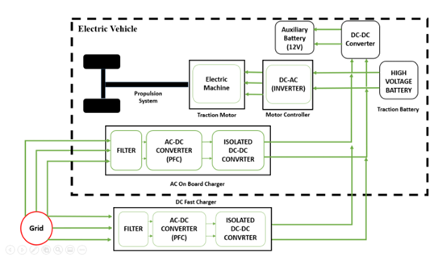

Appendix b
Types of ev battery
Figure 2
Types of ev battery
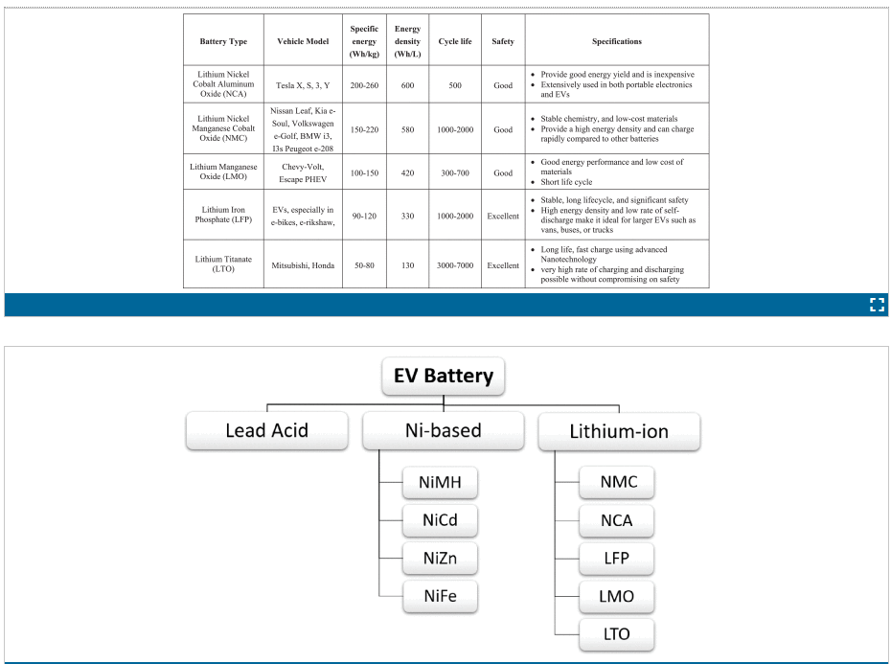

Appendix c
The time at which charging begins
Time of the day | percentage
0:00 | 1%
1:00 | 0
2:00 | 0
3:00 | 0
4:00 | 0
5:00 | 0
6:00 | 0
7:00 | 0
8:00 | 0.7%
9:00 | 0%
10:00 | 13.5
11:00 | 0%
12:00 | 0%
13:00 | 2.1%
14:00 | 10.7%
15:00 | 8.9%
16:00 | 12.1%
17:00 | 10.3%
18:00 | 5.3%
19:00 | 3.9%
20:00 | 0.7%
21:00 | 12.8%
22:00 | 18.9%
23:00 | 0%

Appendix D
Table shows example of data entry for matlab code
Charging start time | Charger capacity (KWH) | Number of charging hours | Percentage of vehicles placed on the charger | Number of vehicles
0:00 | 7 | 5 | 10% | 12
0:00 | 11 | 3 | 2% | 1
0:00 | 50 | 2 | 5% | 3

Appendix E
EV chargers daily load curve 3 years ago 1 peak daily load curve
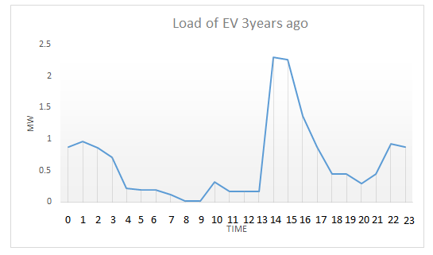

Appendix F
Ev chargers daily load curve 2 years ago 1 peak daily load curve
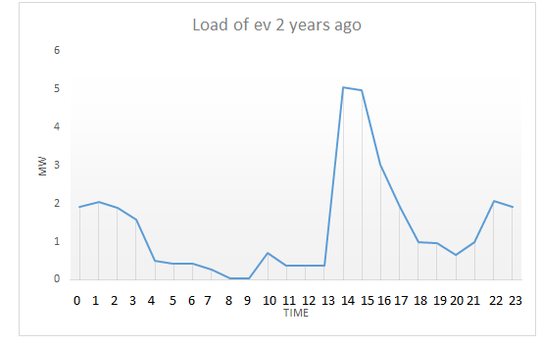

Appendix G
Ev chargers daily load curve 1 year ago 1 peak daily load curve
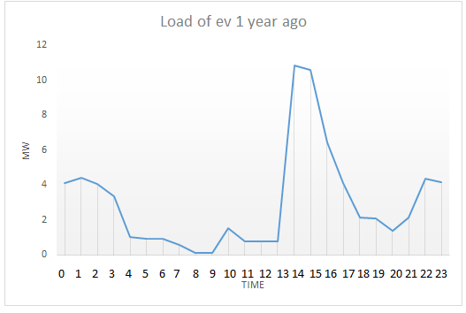

Appendix H
Ev chargers daily load curve 3 year ago 2- peak daily load curve
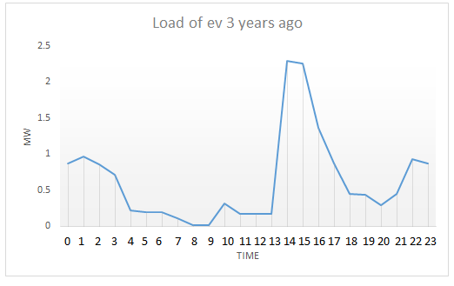

Appendix I
Ev chargers daily load curve 2 year ago 2- peak daily load curve
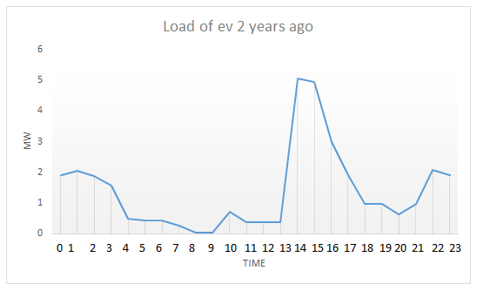

Appendix J
Comparison between the daily load curve and the number of vehicles on the charger in case reducing the charger capacity
The loads of electric vehicles were distributed 1 year ago as follows in the table:
Time of the day | Load (MWH) reduced capacity | Load (MWH) | Num of EV on chargers (reduced capacity) | Num of EV on chargers
0:00 | 4.5 | 4.1 | 369 | 327
1:00 | 4.442 | 4.4 | 313 | 313
2:00 | 4.07 | 4.04 | 257 | 257
3:00 | 3.3 | 3.385 | 195 | 195
4:00 | 1.063 | 1.025 | 137 | 137
5:00 | 0.92 | 0.921 | 116 | 116
6:00 | 092 | 0.921 | 116 | 116
7:00 | 0.559 | 0.559 | 68 | 68
8:00 | 0.108 | 0.108 | 8 | 8
9:00 | 0.108 | 0.104 | 8 | 8
10:00 | 0.934 | 1.525 | 75 | 80
11:00 | 0.934 | 0.804 | 81 | 74
12:00 | 0.934 | 0.804 | 81 | 74
13:00 | 0.934 | 0.804 | 81 | 74
14:00 | 2.27 | 10.837 | 136 | 130
15:00 | 3.12 | 10.6 | 186 | 142
16:00 | 3.28 | 6.45 | 200 | 140
17:00 | 4.26 | 4.114 | 257 | 175
18:00 | 4.12 | 2.12 | 279 | 171
19:00 | 4.094 | 2.08 | 293 | 185
20:00 | 2.94 | 1.378 | 225 | 161
21:00 | 3.65 | 2.125 | 297 | 233
22:00 | 5.94 | 4.36 | 399 | 335
23:00 | 5.68 | 4.41 | 387 | 323

Daily load curve and number of EV’s on chargers before changing the charger’s capacity
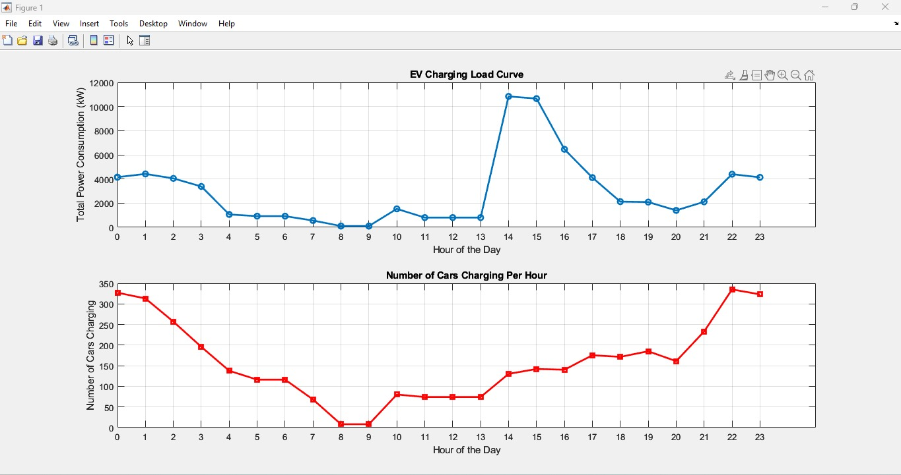
Daily load curve and number of EV’s on chargers after changing the charger’s capacity
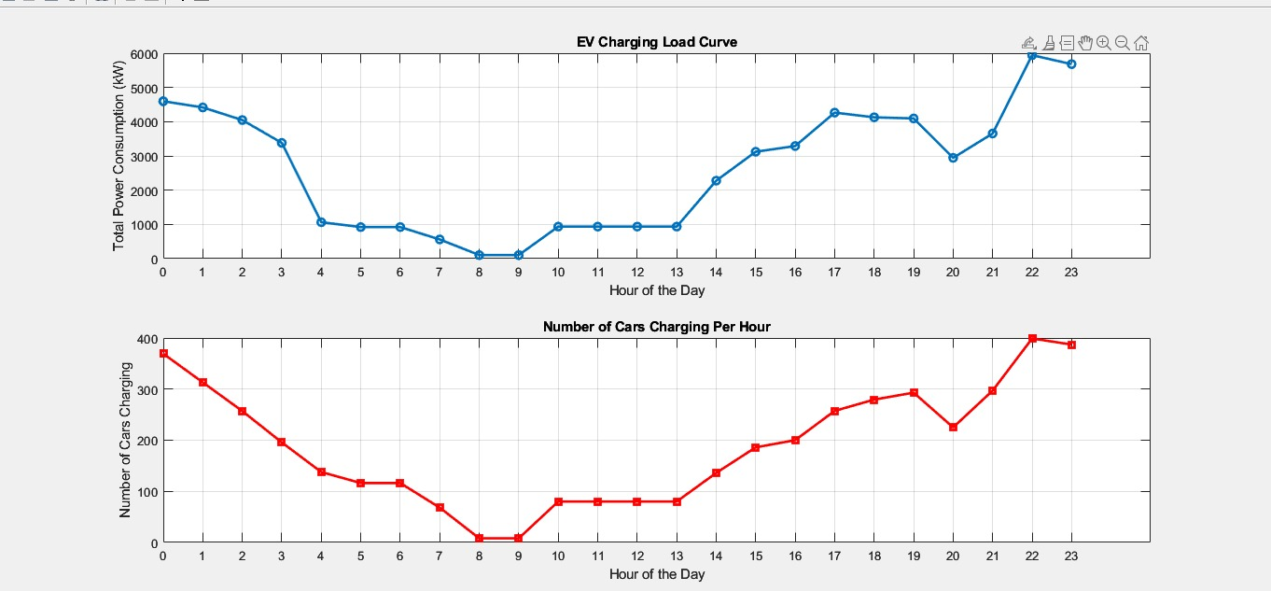

Appendix K
Figures
Network without EV loads
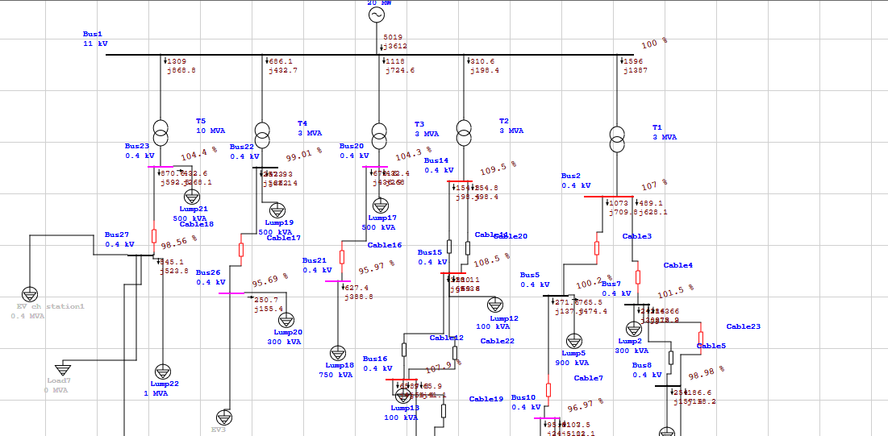
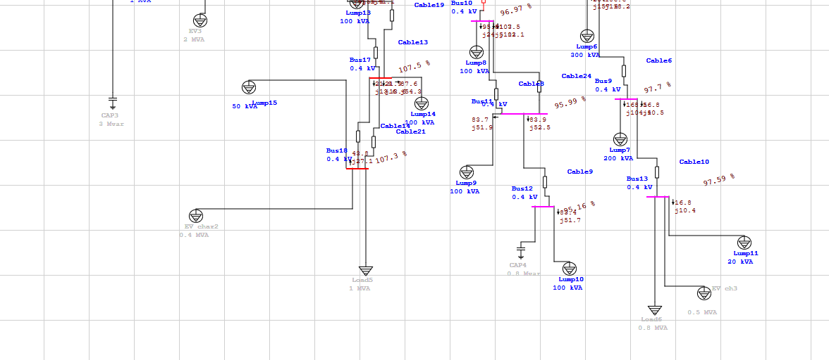

Network 3 years ago
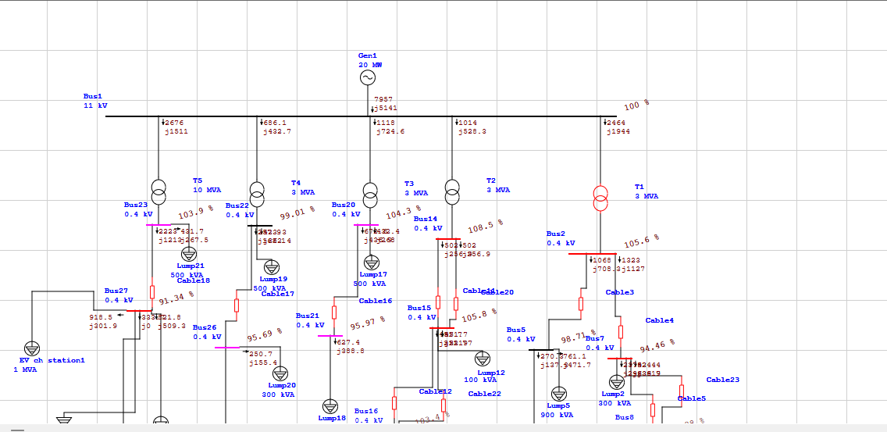
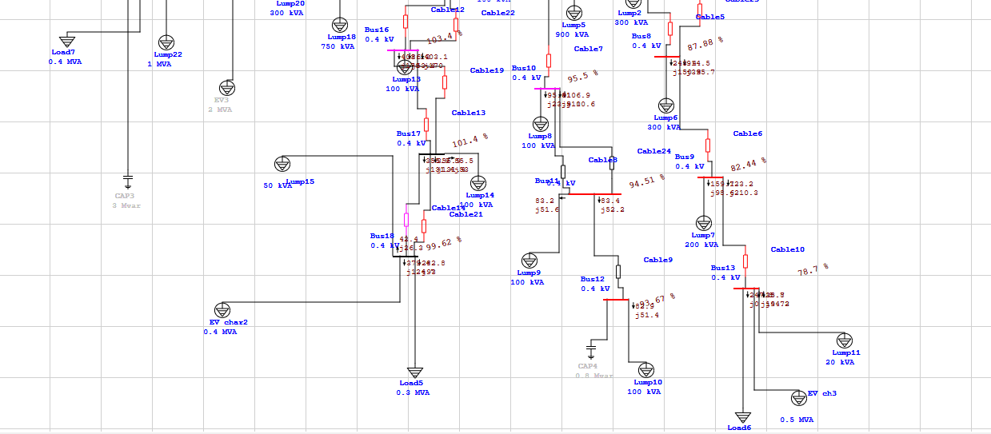

Network 2years ago
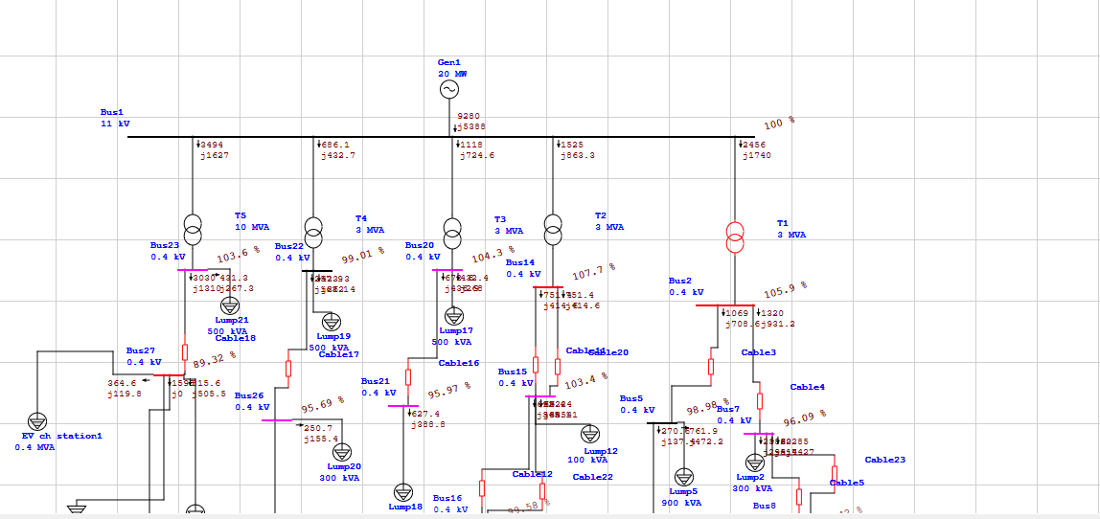
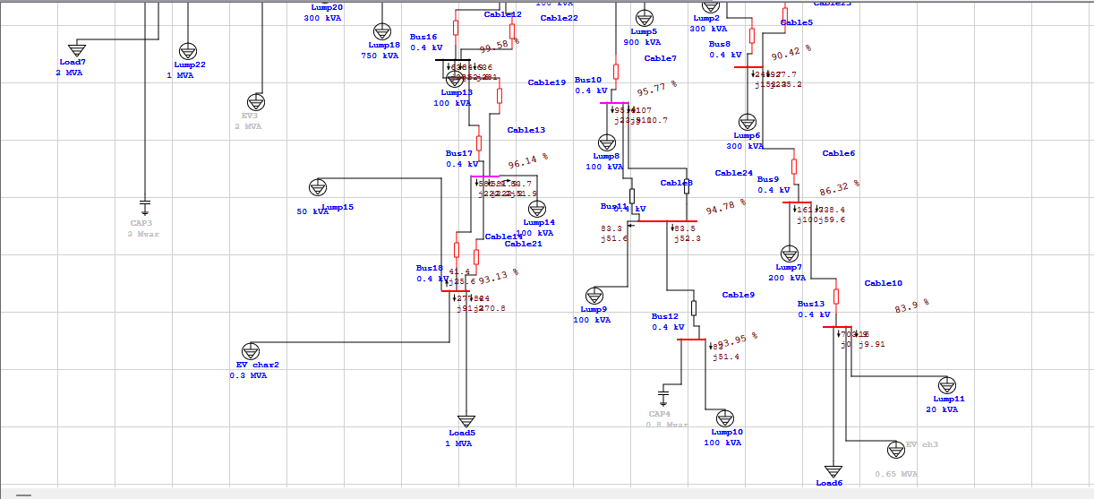

Network year ago
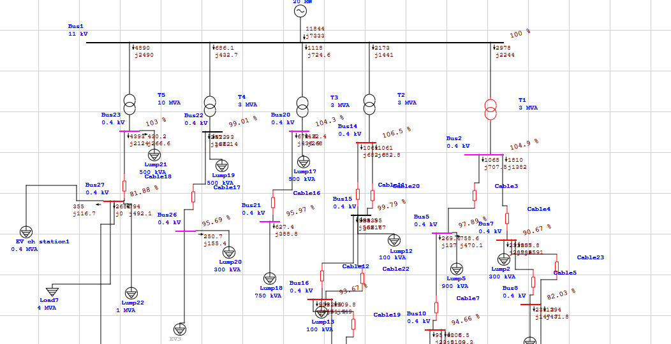
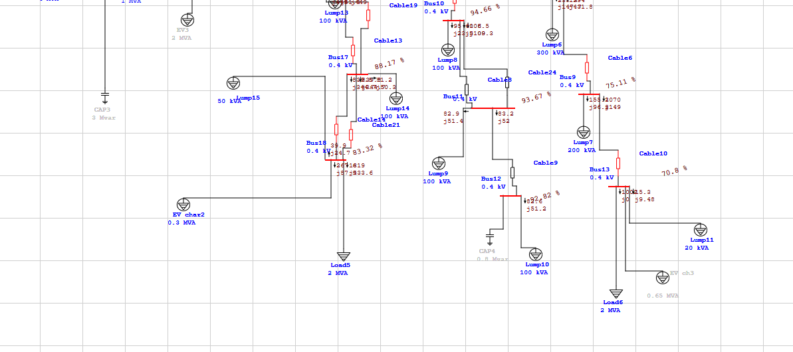

Network data without EV’s load
Busses and transformers data
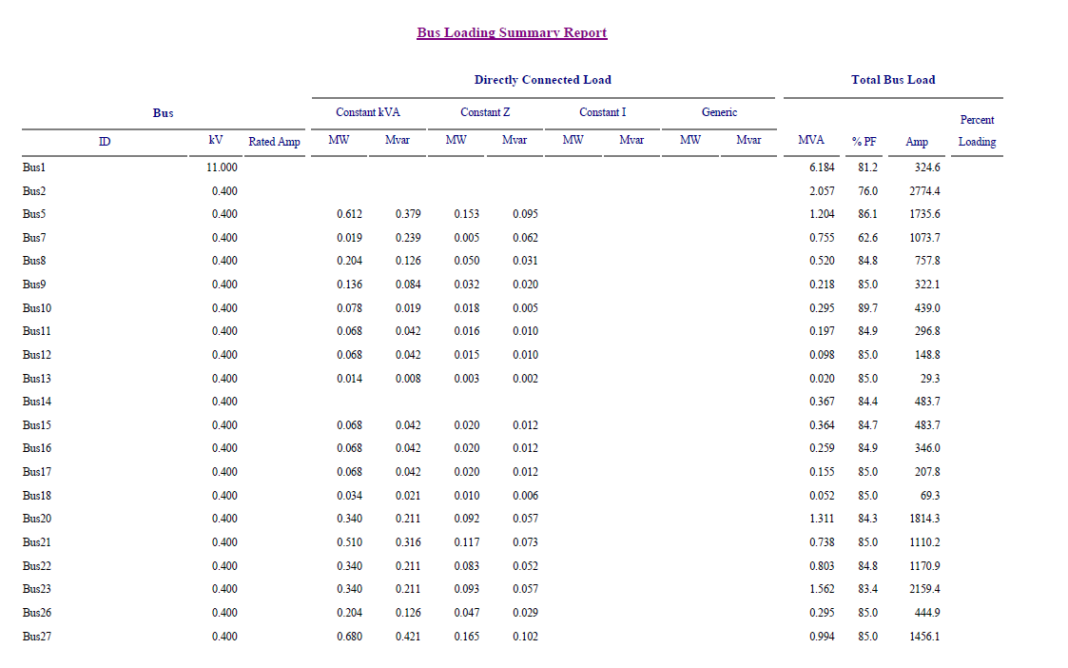
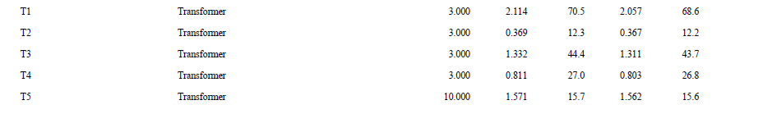

Harmonics buses data
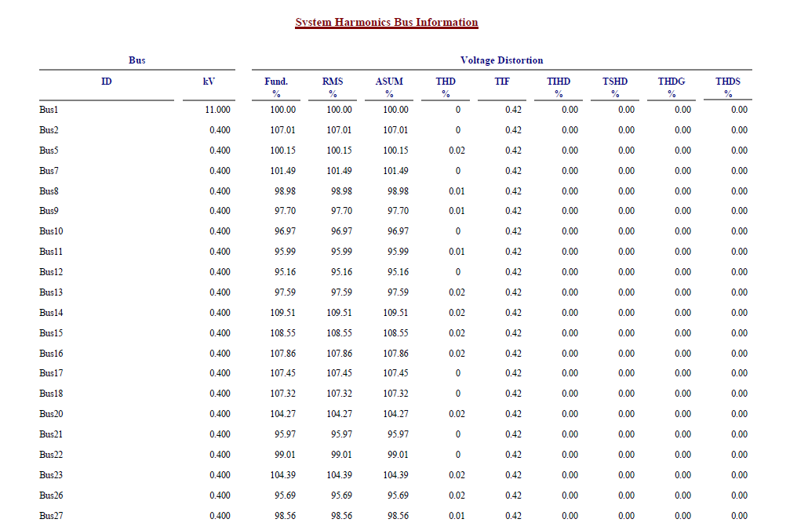

Network data 3years ago
Busses and transformers data
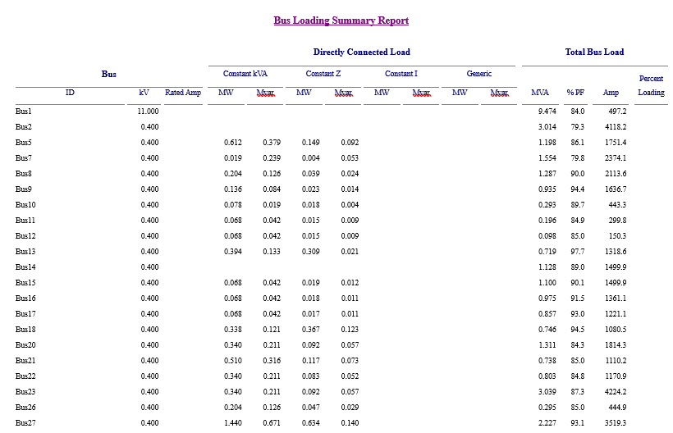


Harmonics buses data
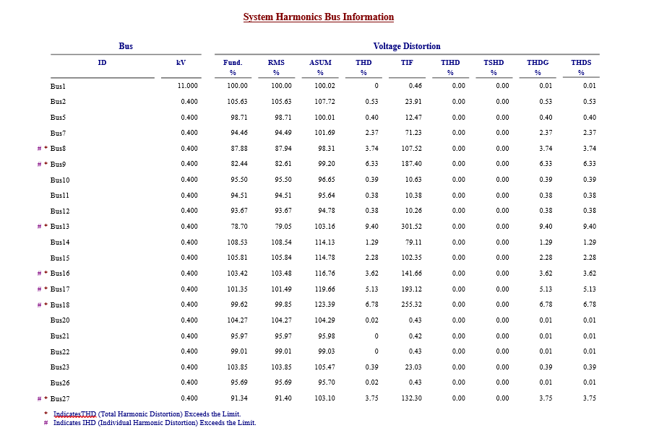

Network data 2years ago
Busses and transformers data
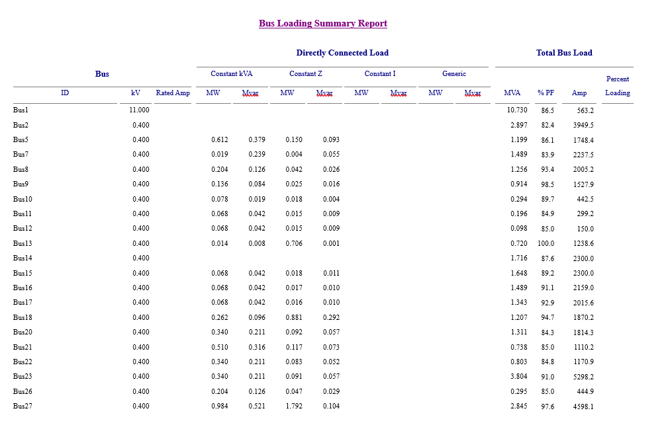
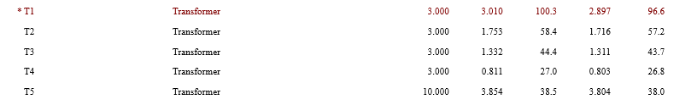

Harmonics buses data
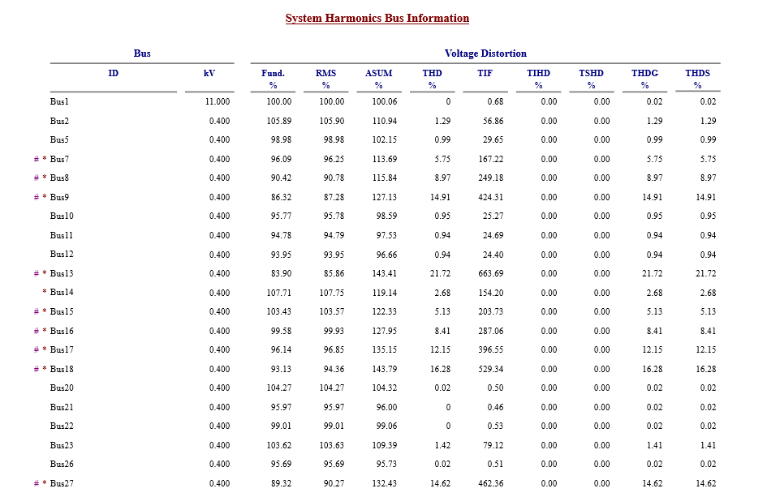

Network data years ago
Busses and transformers data
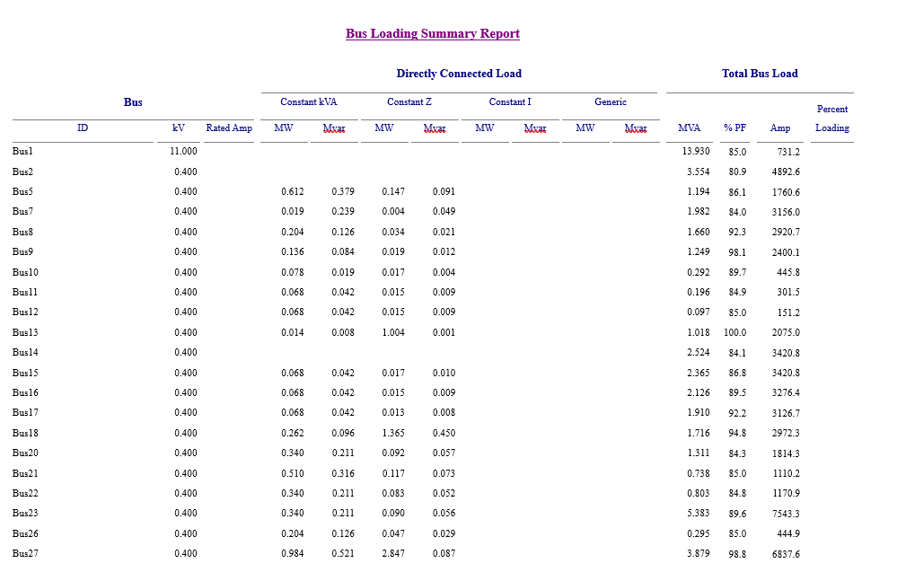
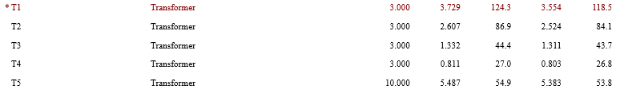

Harmonics buses data
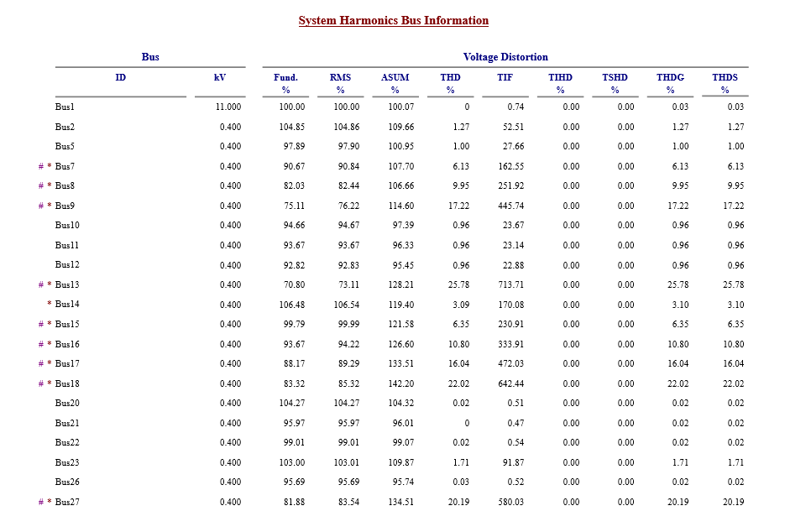

Appendix L
Tables shows the changes in voltages, LF, THD
Bus number | Voltage percent befor ev | Voltage percent from3 years | Voltage percent from 2 years | Voltage from one year
8 | 98.98 | 87.9 | 90.4 | 82
9 | 97.7 | 82.4 | 86.3 | 75.1
13 | 97.59 | 78.7 | 83.9 | 70.8
16 | 107.9 | 103.4 | 98.6 | 93.7
17 | 107.5 | 101.6 | 97.3 | 88.2
18 | 107.3 | 96.2 | 93.1 | 83.3
Voltage percentage according to the year after adding EV’s loads
Bus number | %THD before | %THD 3 years ago | %THD 2 years ago | %THD 1 year ago
8 | 0.01 | 3.74 | 8.97 | 9.95
9 | 0.01 | 6.33 | 14.91 | 17.22
13 | 0.02 | 9.40 | 21.72 | 25.78
16 | 0.02 | 3.62 | 8.41 | 10.8
17 | 0 | 5.13 | 12.15 | 16.04
18 | 0 | 6.78 | 16.28 | 22.02
Total Harmonic Distortion according to the year after adding EV’s loads
Transformer # | %Load factor before EV | %Load factor 3 years ago | %Load factor 2 years ago | %Load factor 1 year ago
1 | 68.8 | 100.5 | 96.6 | 118.5
2 | 12.2 | 37.6 | 57.2 | 84.1
3 | 43.7 | 43.7 | 43.7 | 43.7
4 | 26.8 | 26.8 | 26.8 | 26.8
5 | 15.6 | 30.4 | 38.01 | 53.8
Transformer’s load factor according to the year after adding EV’s loads


جــــامعــــــــة النجاح الوطنية
كليـــــة الدراســــــــات العليــــــا

اثر شحن المركبات الكهربائية على اقصى حمل للشبكة الكهربائية والسياسات المتبعة لمواجهتها

إِعداد
طلال أمجد طلال دويكات

إشراف
أ.د. كامل صالح

قدمت هذه الرسالة استكمالا لمتطلبات الحصول على درجة الماجستير في هندسة القوى الكهربائية، من كلية الدراسات العليا، في جامعة النجاح الوطنية، نابلس- فلسطين.
2025
اثر شحن المركبات الكهربائية على اقصى حمل للشبكة الكهربائية
والسياسات المتبعة لمواجهتها
إِعداد
طلال أمجد طلال دويكات
إشراف
أ.د. كامل صالح

الملخص
مع تزايد أعداد المركبات الكهربائية واعتماد الحكومات المتزايد لها، تتزايد التحديات التي تواجه شبكات الكهرباء حول العالم. وتُعد زيادة الطلب على شبكات الكهرباء وتأثيرها على الأحمال القصوى، خصوصًا خلال ساعات الذروة، من أبرز هذه التحديات. يبحث هذا البحث في أثر الانتشار الواسع للمركبات الكهربائية على منحنى الحمل اليومي للشبكة، والاستراتيجيات التي يمكن استخدامها للتخفيف من الضغط الواقع على الشبكة.
تمت دراسة سلوك مستخدمي المركبات الكهربائية وطرق شحنها من خلال استبيان. وأتاحت النتائج المستخلصة من تحليل بيانات المستخدمين وتحديد عدة عناصر مهمة في هذه الدراسة. إذ تُعد بيانات مثل انتشار المركبات الكهربائية، وسعات أجهزة الشحن المستخدمة، ومتوسط سعات البطاريات المتاحة في السوق، وسلوك مستخدم الشاحن الكهربائي أثناء أوقات الاستخدام، كلها عناصر تساعد في دراسة أثر تزايد أعداد المركبات الكهربائية وتقديم التوصيات المناسبة لكل شبكة على حدة. ومن خلال الاستفادة من نتائج دراسة سلوك المستخدم ورسم منحنى الحمل اليومي للأحمال الجديدة، يصبح من الممكن تحديد مناطق الأحمال المرتفعة وكيفية توزيعها على الشبكة مكانيًا وزمانيًا. ويُعد تحديد منحنى الحمل اليومي لشحن المركبات نقطة محورية في تقديم التوصيات المتعلقة باستخدام استراتيجيات إدارة الشبكة.
لمعالجة هذه التحديات، تتناول هذه الدراسة استراتيجيات إدارة الطلب على جانب المستهلك (DSM) مثل الاستجابة للطلب، وتحويل الأحمال، والشبكات الذكية، والشحن الذكي. إذ يُمكن من خلال تنفيذ استراتيجيات إدارة الطلب تمكين الشبكة من استيعاب الأحمال الكهربائية المتزايدة مع الحفاظ على استقرار الشبكة وجودة الخدمة. وتتضمن الدراسة توصيات محددة لزيادة موثوقية الشبكة ومعالجة تحديات الأحمال المتزايدة، بما في ذلك دمج أنظمة التخزين في الشبكة، واستخدام آليات مثل تقنيةV2G ، وسياسات الشحن الذكي للمركبات الكهربائية. وتعمل هذه الاستراتيجيات على تحسين خدمة الكهرباء مع تقليل الضغط على الشبكة وخفض تكاليف تطويرها. وسيتركز العمل المستقبلي على استخدام أساليب أدق لجمع معلومات المستخدمين، وتعزيز استخدام أجهزة الشحن الذكية المرتبطة بشبكة الكهرباء ومشغليها، وتحسين السياسات المطبقة في هذا المجال.
الكلمات المفتاحية: المركبات الكهربائية (EV)، الطلب الأقصى، V2G، سلوك المستهلك.

