

AL-NAJAH NATIONAL UNIVERSITY
FACULTY OF ENGINEERING
DEPARTMENT OF ELECTRICAL AND MECHATRONICS EMGINEERING
AXELO CNC ROBOT
Graduation Project Submitted In Partial Fulfillment Of The Requirements For The Degree Of B.Sc. In Electrical Engineering.

Supervisor: Student:
Dr. Samer Mayaleh Afnan Shhaddeh 11422527
Diana Khozondar 11524484
Shima HajAhmed 11524021
Tareq Abu Khader 11526211
Moath Abu Karsh 11525891
Acknowledgment
In the name of Allah, the Most Gracious and the Most Merciful Alhamdulillah, all praises to Allah for the strengths and His blessing in completing this project, we would like to express our gratitude for everyone who helped us during the graduation project (Axelo CNC ROBOT), starting with endless thanks for our supervisor

Dr. Samer Mayaleh

Who didn’t keep any effort in encouraging us to do a great job, providing our group with valuable information and advices to be better each time. Thanks for the continuous support and kind communication, which had a great effect regarding to feel interesting about what we are working on. Thanks is also extended to all the people who helped, supported and encouraged us to successfully finish the graduation project-1 whether they were in the university or in the community life. In addition, we would like to express our appreciation toward our families who gave us continuous support to reach our goal.
Abstract
CNC machine are machines used for cutting & grooving different type of material like (wood, aluminum, Alucobond, etc.).
Axelo is an advanced type of CNC machine modified as robot which can move freely not fixed in one space like any other CNC machine, Axelo is a robot which can cut & groove any material sheets, can be moved to any work place since it has a small and not so heavy weight in counteract to any other CNC machine, it has a reasonable price which can be affordable for the costumer.
Axelo’s specifications can be summarized in several things, portability which means that it can be used in any place by anyone who works in the field, it has high efficiency, good quality, speed and less time to finish work. Manufactured parts are made identical with the highest level of accuracy. Design and specifications are programmed into computer which means minimal errors during production and no unnecessary waste.
Axelo has a 220 volt cable which is used to power the robot, its total current is about 10 Ampere.
Axelo principle of work is that the robot will take the drawing (sketch) desired that will be installed to Estlcam that will choose the feed speed. The use of the cutting tool depend on whether it’s cutting or grooving, and then the G-code will be transferred to the robot microprocessor and with that Axelo can control the wheels movement in desired directions that G-code has commanded and also control the tool rotational speed and height above the working sheet if the robot is cutting or grooving, with also to make sure it’s moving in the right track, so Axelo will be able to do the job as it intended.

Table of Contents
List of Figure ..................................................................................................................................06
List of Tables .................................................................................................................................07 CHAPTER 1.....................................................................................................................................08 INTRODUCTION .............................................................................................................................08
1.1 Chapter by chapter overview...................................................................................................09 CHAPTER 2.....................................................................................................................................10 Computer Numerical Control machine (CNC)................................................................................10
2.1Introduction............................................................................................................................11
2.2 CNC cutting with router tool..................................................................................................12
2.2.1 Cutting tool………………………………….………………………………………………………………………………13
2.2.2 Cutting parameters ..........................................................................................................15
2.3 CNC programmomg...............................................................................................................16
2.3.1 CAD/CAM system.............................................................................................................17
2.3.2CNC program............…………..............................................................................................18
2.3.3 Positioning reference point system..................................................................................18
2.3.4 Point-to-Point or Continuous Path CNC programming....................................................19
2.3.5Programming format.........................................................................................................20
2.3.6 Codes …………………...........................................................................................................20
CHAPTER 3………………………………………………………………………………………………………………………………..23
Mechanical and Electrical Components Design ……………………………………………………………………….23
3.1 Introduction.........................................................................................................................24
3.2 Mechanical design................................................................................................................24
3.3 Omni wheels.........................................................................................................................25
3.4 Base frame...........................................................................................................................26
3.5 Slider mechanism.................................................................................................................26
3.5.1 Power screw....................................................................................................................27
3.5.2 Ball screw.........................................................................................................................28
3.6 Shaft coupling ......................................................................................................................29
3.7 Electrical components..........................................................................................................30
3.7.1 Actuators.........................................................................................................................30
3.7.2 Spindle ............................................................................................................................32
3.7.3 Drives...............................................................................................................................34
3.7.3 Power supply ..................................................................................................................35
3.7.3 Variable frequency driver ...............................................................................................36
3.8 Selection ………………………………………………………………………………………………………………………….37
CHAPTER 4.....................................................................................................................................45 Control system...............................................................................................................................45
4.1 Introduction.........................................................................................................................46
4.2 Open and close loop system................................................................................................46
4.2.1Open loop system.............................................................................................................47
4.2.2Close loop system.............................................................................................................47
4.3 PID controller.......................................................................................................................50
4.3.1 Loop tuning......................................................................................................................51
4.3.2 Feed forward...................................................................................................................51
4.4 Mapping................................................................................................................................52
4.4.1 Introduction.....................................................................................................................52
4.4.2 Mapping algorthim.........................................................................................................53
4.5 Modeling..............................................................................................................................54
4.5.1 Introduction....................................................................................................................54
4.5.2 Kinematics......................................................................................................................55
4.5.3 Dynamic..........................................................................................................................57
4.5.4 Base inertia.....................................................................................................................58
4.5.4 Friction force..................................................................................................................61
4.6 Control algorthim..............................................................................................................61
4.7 Controller.............................................................................................................................63
4.7.1 Arduino mega ................................................................................................................63
4.7.2 Arduino nano..................................................................................................................67
4.8 Positioning system ..............................................................................................................70
4.8.1 Encoder …………………………………………………………………………………………………………………….70
4.8.4 RS485 module ……………………………………………………………………………………………………………72
4.9 software……..........................................................................................................................74
4.9.1 Tablet .............................................................................................................................75
4.10 Modeling and simulation of stepper motors .....................................................................76
4.10.1 Stepper motor modeling..............................................................................................76
4.10.2 Close loop position control, PID controller …...............................................................78
4.10.3 Simulink model.............................................................................................................80
4.11 Code ……………………………………………………………………………………………………………………………..82
Chapter 5 Expected shape of Axelo ………….……………………………………………………………..……………….88
5.1 introduction………………………………………………………………………………………………………………….89
CHAPTER 6 ...................................................................................................................................90
Non technical................................................................................................................................ 91
6.1 Cost analysis ………............................................................................................................ 92
6.2 Ethics and environment ...................................................................................................92
CHAPTER 7.................................................................................................................................... 93 CONCLUSION................................................................................................................................. 93
7.1 General conclusion......................................................................................................... 93
References…………………………………………………………………………………………………………………………….. 94

List of Figures
Figure (2.1) Rotary tool ……………………………………………………………………………………………… 12
Figure (2.2) Flat End mill cutting tool ………………………………………………………………………… 14
Figure (2.3) Flat ball and V-grooving end mill …………………………………………………………….. 14
Figure (2.4) main formula of cutting parameters ……………………………………………………….. 16
Figure (2.5) CAD/CAM system ……………………………………………………………………………………. 17
Figure (2.6) Point to point position ………………………………………………………………………….…. 19
Figure (2.7) continues path position ……………………………………………………………………………20
Figure (3.1) Mechanical design of Axelo CNC robot ………………………………………………….… 25
Figure (3.2.1) Omni wheel design ……………………………………………………………………………… 26
Figure (3.2.2) Omni wheel dimension ……………………………………………………………………….. 27
Figure (3.3) Slider with screw …………………………………………………………………………………….. 28
Figure (3.4) Power screw and how it work ……………………………………………………………….… 29
Figure (3.5) Ball screw ……………………………………………………………………………………………….. 30
Figure (3.6) shaft coupling …………………………………………………………………………………………. 31
Figure (3.7.1) stepper motor design …………………………………………………………………………… 32
Figure (3.7.2) Stepper motor dimension …………………………………………………………………….. 32
Figure (3.8) spindle …………………………………………………………………………………………………….. 33
Figure (3.9) Generalized structure ……………………………………………………………………………… 35
Figure (3.10.1): Stepper motor driver ………………………………………………………………….………36
Figure (3.10.2): Power supply 220V to 12V …………….……………………………………………..…… 37 Figure (3.10.3) variable frequency driver…………………………………………………………………... 38 Figure (4.1) Input output relation ………………………………………………………………………………. 40 Figure (4.2) Open loop system……………………………………………………………………………………. 40 Figure (4.3) close loop system………………………………………………………………………..…………… 40 Figure (4.4) Open loop system …………………………………………………………………………………... 40 Figure (4.5) Close loop system …………………………………………………………………………………… 41 Figure (4.6) Feedback with disturbance ……………………………………………………………………… 42 Figure (4.7) inner and outer feedback loop ………………………………………………………………… 43 Figure (4.8) Multi variable control system ………………………………………………………………….. 44 Figure (4.9) Feed forward feed control structure ……………………………………………………….. 46 Figure (4.10) Calculation L1, L2, L3 …………………………………………………………………………….. 48 Figure (4.11) Translation motion of the robot ……………………………………………………………. 50 Figure (4.12): Dynamics module of robot ……………………………………………………………………57 Figure (4.13) Arduino mega……..……………………………………………………………………………….. 59 Figure (4.14) Arduino mega pins …………………………………………………………………..…………… 61 Figure (4.15) Arduino nano ……………………………………………………………………………………….. 62 Figure (4.16) Arduino nano pins …………………………………………………………………………………. 64 Figure (4.17): wire encoder …………………………………………………………………………………………70
Figure (4.18): encoder structure ………………………………………………………………………………….71
Figure (4.19): incremental encoder output signal …………………………………………………….....72
Figure (4.20): RS485 module ………………………………………………………………………………………73 Figure (4.21): table that uses windows ………………………………………………………………………. 75 Figure (4.22) Schematic view of a stepper motor ……………………………………………………….. 76 Figure (4.23) Equivalent circuit of hybrid motor ………………………………………………………... 77 Figure (4.24) Mechanical sib-system of the hybrid stepper motor …………………………….. 78 Figure (4.25) Block diagram of decoupled stepper motor ………………………………………….. 79 Figure (4.26) Close loop control system…………………………..…………………………………………. 80 Figure (4.27) Speed loop controller …………………………………………………………………………… 80 Figure (4.28) Electrical sub-system for motor ………………………………………………………………81 Figure (4.29.1) Unit step input driven to system ……………………………………………………….. 81 Figure (4.29.2) Response after compensating ……………………………………………………………. 82 Figure (5.1): Axelo shape using solid …………………………………………………………………………. 91 Figure (5.2): Axelo shape without outer cover …………………………………………………………… 91

List of table
Table (2.1) CNC code ………………………………………………………………………………………………….. 22
Table (2.2) G & M, non-model commands …………………………………………………………………. 22
Table (3.1) Technical data of stepper motor ………………………………………………………………. 33
Table (4.1) Arduino Mega specification ……………………………………………………………….…….. 68
Table (4.2) Arduino Nano specification ……………………….…….………………………………………. 72
Table (5.1) second semester cost ………………………………………………………………………………. 92
Table (5.2) first semester cost ……………………………………………………………………………………. 92

Chapter (1) Introduction
Since the industrial revolution begun; the world turned to replace the most human power with machines to make it easier, fast achievements, produce large quantity of products, over the years humans had been improving the machines qualities reducing there sizes, enlarging products amount in very short time.
One of most important innovation is computer numerically controlled (CNC) which is a machine used for material cutting, grooving, milling, turning. Which is one of the most widely used manufacturing processes to produce the final shape of products, and its technology continuous to advance in parallel with development in material, computers, sensors, and actuators._{[3]}
Despite the continuous development in CNC machine over the years there was no actual improvement in size of the machine which has remand respectively large which means it needs its own work space, because of this matter the idea of Axelo CNC robot has been found to solve the need for special work place.
Axelo CNC robot, is a modified CNC which combine both CNC and mobile robot characteristics, it has CNC capability to cut and groove material with mobile robot ability to move freely in open areas. Axelo was designed with 4 degree of freedom with the aim to accomplish the given commands to meet the tightest tolerance, and producing the most accurate, precise products. Like any CNC machine Axelo uses Estlcam software so, instructions can be transferred to G-code to the microcontroller this microcontroller will also receive data from encoder as a result the robot will function according to the desired mapped envelop.
Axelo has many advantages, it can be used in any place by anyone who works in the field, it has high efficiency, good quality, speed and less time to finish work. Axelo which is fed from 220 volts cable is designed so it can move freely in all 360 degrees reaching every possible dimension, manufactured parts are made identical with the highest level of accuracy. Design and specifications are programmed into computer which means minimal errors during production and no unnecessary waste.
1.1 Chapter by chapter over view

Chapter 2 is an introduction to the CNC machines, how they used to shape materials, their types and how to program a CNC machine.
Chapter 3 talks about the mechanical and electrical design of Axelo, how the robot parts has been selected, and their calculations.
Chapter 4 is about control systems, the PID compensating, the mapping algorithm that used based on forces affected on the system parts, the kinetic and dynamic modeling for Axelo, then the Arduino microcontrollers used, after that the beacons types used to transfer the signal from the references points and code from computer. On the last part of the chapter, the Simulink and modeling of the robot has been explained.
Chapter 5 is about the final shape of Axelo robot.
Chapter 6 is about nontechnical issues and the list of costs for the robot’s components.
Chapter 7 is the conclusion of what has been selected and the some further look for what could be done for future work.

Chapter 2

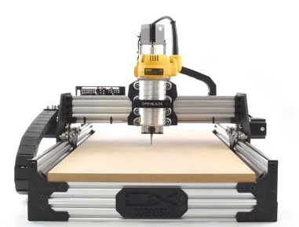

Computer numerically machine
(CNC)

2.1 introduction to CNC machine:
At the beginning, the industry was dependent on the artisans and professionals in the world to use the manual method to produce the final form of their products, but in last decades modern automation systems appeared widely, which gave another choice more accurate and easier to produce with a lower cost and less waste time, one of these modern machines is Computer-numerical control (CNC).

CNC machine defined as an automated control of machining tools (drills, boring tools, lathes) by means of a computer to transforms a piece of material (metal, plastic, wood, ceramic, or composite) according to instructions from a computer programmed to precise specifications.

Working with sheet metal Alucabond (it's a composite panel consisting of two aluminum cover sheets and a plastic core) which is used today spread in several areas of special construction requires the CNC machine of a special type and CNC with router tool is a very suitable and effective one to make cut off and V-groves.

Basically, CNC machine works by write motor commands for the machine to execute them in line by line. This command line is called the G-Code. the movement of the cutting tool and the rotation speed of the cutting tool and secondary orders such as changing the cutting tool and turning on and off cooling, suction and inhibition will all be present in this program.

The program will give successive orders to all motors, controls and machine accessories to perform the operations ordered by the designer. Command writing makes it easy to perform complex operations.

2.2 CNC cutting with router tool:
Cutting operations in CNC machines can be done in a several of ways. One of the most widely used methods is the use of a rotary tool that has more than one cutting edge so that the machine can cut the plates rotational and transitional at the same time see figure (2.1). There are several things that depend on the process of cutting or slitting the most important type of tool Used and the appropriate rotational speed and of course the properties of the material used. _{[1]}

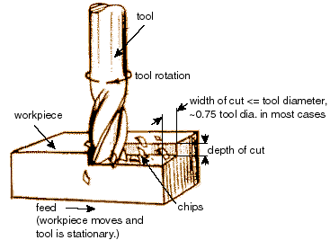

Figure (2.1): Rotary tool

The cutting tool must have the ability to withstand the force exerted on it -radial force and tangential force which acts on the cutting tool during the cutting process.

Also cutting a V-groves in sheet metal allowed to bend foamboard at the groves and make a perfect right angle and that is an ideal for creating inexpensive object box.

2.2.1: cutting tool

A cutting tool or cutter is any tool that is used to remove material from the work piece by means of shear deformation. Cutting may be accomplished by single-point or multipoint tools. Single-point tools are used in turning, shaping, planning and similar operations, and remove material by means of one cutting edge. Milling and drilling tools are often multipoint tools.

Cutting tool materials must be harder than the material which is to be cut, and the tool must be able to withstand the heat generated in the metal-cutting process. Also, the tool must have a specific geometry, angle of the cutting face is also important, as is the flute width, number of flutes or teeth and margin, all of these factors must be optimized, plus the speeds and feeds at which the tool is run.

End mill cutter is a cutting tool used in industrial applications. It is distinguished from the drill bit in its application, geometry, and manufacture, while a drill bit can only cut in the axial directional, milling bit can generally cut in all directions. End mill cutter come in a variety of shapes, the most common are flat end mills. See figure (2.2)

Flat end mill has many advantages. Their straight profiles and consistent diameters ensure that milled traces are of a consistent width. Flat end mills are also great at clearing large areas of material, and large flat end mills can remove material very quickly.

Flat end mills do have downsides, however smaller tools, particularly 1/64" and smaller, are fragile and can be easy to snap. To avoid breakage, they require slower feeds and speeds, multiple passes.

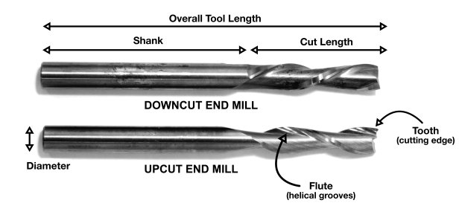
Figure (2.2): flat end mill cutting tool
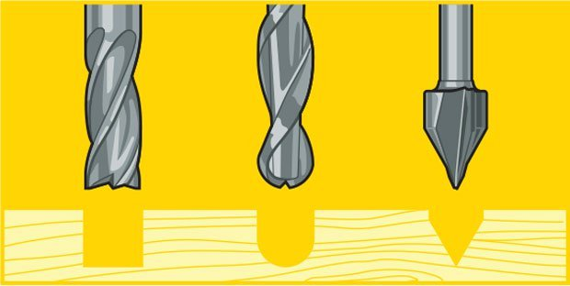
There is another shape of end mill cutter which can be used in grooving process such as ball end mill and V-groves. See figure (2.3)
Figure (2.3): flat, ball and V-groves end mil

While the number, direction and type of flutes that a cutting tool has can vary widely, the most common flute numbers for general milling operations are two (better space for chip ejection) and four (better surface finish). Up-cut, down-cut and compression cut determine the way the chips (cut material) are ejected and the smoothness of the surface.

As the number of cutting edges increases, your feed rate should increase to prevent burning and premature tool dulling. More flutes reduce chip load and improves surface finish if feed rate remains the same.

End mills cutting tool offers High Speed Steel and standard carbide materials
- High Speed Steel (HSS) End Mill Material: HSS end mills are designed for a variety milling and cutting operations on most materials, including steel, at an economical price.

- Standard Carbide End Mill Material: Harder than HSS, standard carbide end mills are designed for general milling operations on all materials.

2.2.3 Cutting parameters
The speed and motion of the cutting tool is specified through several parameters. These parameters are selected for each operation based upon the work piece material, tool material, tool size and more…

- Cutting feed - The distance that the cutting tool or work piece advances during one revolution of the spindle and tool, in some operations the tool feeds into the work piece and in others the work piece feeds into the tool.
- Cutting speed - The speed of the work piece surface relative to the edge of the cutting tool during a cut.
- Spindle speed - The rotational speed of the spindle and tool in revolutions per minute (RPM). The spindle speed is equal to the cutting speed divided by the circumference of the tool.
- Feed rate - The speed of the cutting tool's movement relative to the workpiece as the tool makes a cut and is the product of the cutting feed and the spindle speed (RPM).

The main formula of cutting parameters in CNC machine, as shown in figure (2.4)
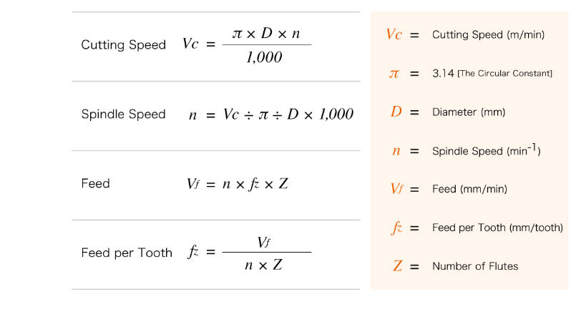
Figure (2.4): Main formula of cutting parameters

Material Removal Rate (MRR), otherwise known as Metal Removal Rate, is the measurement for how much material is removed from a part in a given period of time.
MRR=RDOC x ADOC x Feed Rate
Where ADOC is axial depth of cut, RDOC is radial depth of cut. _{[2]}

2.3 CNC programming
CNC programming software creates program codes and instructions used to run a machine tool controlled by a computer. Each unique part requires its own CNC program.

When starting out with CNC, the first thing to do is creating some sort of model, drawing, or representation of the part or object to be machined. Most of the time this is a function of a CAD/CAM systems so they will generate g-code (machine commands). _{[3]} See figure (2.5)

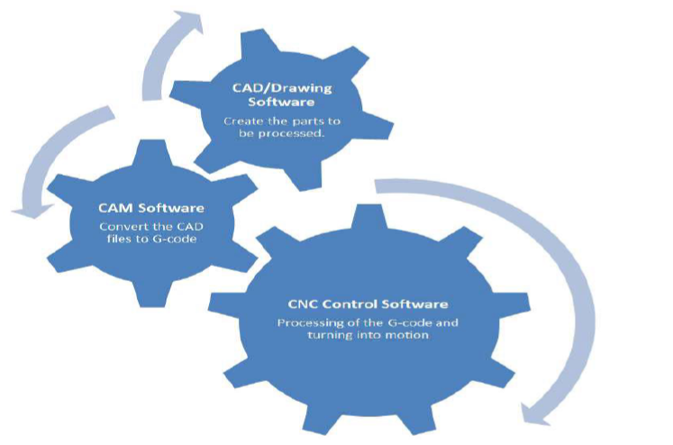

Figure (2.5): CAD/CAM system

2.3.1 CAD/CAM system
Computer-aided design (CAD) involves creating computer models defined by geometrical parameters. These models typically appear on a computer monitor as a three-dimensional representation of a part or a system of parts, which can be readily altered by changing relevant parameters. CAD systems enable designers to view objects under a wide variety of representations and to test these objects by simulating real-world conditions.

CAD software includes algorithms for projecting the 3-D models on to the 2-D device coordinate systems and vice versa. CAD systems include several primitive drawing functions, including lines, polygons, circles and arcs, rectangles, and other simple shapes.
Computer-aided manufacturing (CAM) is the process in which a 3D model is translated into the machine tool paths necessary to create that model. To create the tool paths, it is necessary to know what kind of machine will be doing the work and what type of machining tool bits are available. It is also necessary to know what kind of stock material will be used, as parameters for feed rates and spindle speeds must be specified. The tool paths are generated in a series of operations, which may involve automatic changing of the tooling bit if the CNC machine is capable of this. The end result is typically output as G-code, which can then be fed into a CNC machine, which does the rest of the work. Depending on the complexity of the CNC machine.

2.3.2 CNC program
CNC Controller is the program that processes the G-code file from the CAM program, and controls the motors and the mill to shape the object from the stock and tells the motors on the mill exactly how they should move in order to cut your part. Some larger mills have integrated computers or controllers that have this software built in. For most small to-mid machine.
2.3.3 Positioning reference point Systems
Two types of programming modes, the incremental system and the absolute system, are used for CNC. Both systems have applications in CNC programming, and no system is either right or wrong all the time. Most controls on machine tools today are capable of handling either incremental or absolute programming, Absolute program locations are always given from a single fixed zero or origin point, where the Incremental program locations are always given as the distance and direction from the immediately preceding point.

2.3.4 Point-to-Point or Continuous Path CNC programming
Falls into two distinct categories the difference between the two categories was once very distinct. However, most control units are able to handle both point-to point and continuous path machining. A knowledge of both programming methods is necessary to understand what applications each has in CNC.
Point-to-point positioning is used when it is necessary to accurately locate the spindle, or the work piece mounted on the machine table, at one or more specific Locations to perform such operations as drilling, reaming, boring, tapping, and punching. See figure (2.6)
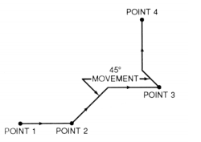

Figure (2.6): Point to point position

Contouring, or continuous path machining, involves work such as that produced on a lathe or milling machine, where the cutting tool is in contact with the work piece as it travels from one programmed point to the next. Continuous path positioning is the ability to control motions on two or more machine axes simultaneously to keep a constant cutter-work piece relationship. See figure (2.7)

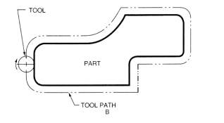

Figure (2.7): Continuous path position
The method by which contouring machine tools move from one programmed point to the next is called interpolation. This ability to merge individual axis points into a predefined tool path is built into most of today’s MCUs. There are five methods of interpolation: linear, circular, helical, parabolic, and cubic.

2.3.5 Programming Format
Word address is the most common programming format used for CNC programming systems. This format contains a large number of different codes (preparatory and miscellaneous) these codes, which conform to EIA (Electronic Industries Association) standards, are in a logical sequence called a block of information. Each block should contain enough information to perform one machining operation. _{[4]}

2.3.6 Codes
The most common codes used when programming CNC machines tools are G-codes (preparatory functions), and M codes (miscellaneous functions). See table (2.1). Other codes such as F, S, D, and T are used for machine functions such as feed, speed, cutter diameter offset, tool number, etc. G-codes are sometimes called cycle codes because they refer to some action occurring on the X, Y, and/or Z axis of a machine tool.
In order to achieve these particular kinds of movement, Numerical Control uses a block as its basic unit. When printed it resembles a line of text. Each block carries one or more words each consisting of a letter followed by a number that assigns value to the function. A block of input is limited to a maximum of 256 characters.

There are two types of G-Codes, modal and non-modal. Modal commands remain in effect, in multiple blocks until they are changed by another command from the same group; whereas, non-modal commands are only in effect for the block in which they are stated.

M or miscellaneous codes are used to either turn ON or OFF different functions which control certain machine tool operations as show.

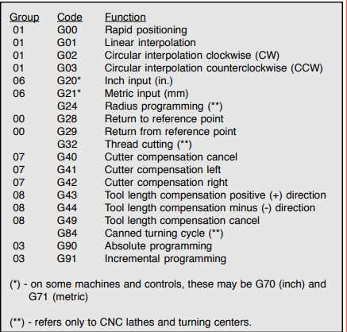
Table (2.1): CNC code
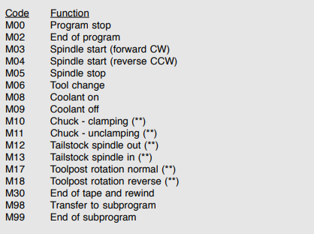
Table (2.2): G & M codes, non-model commands

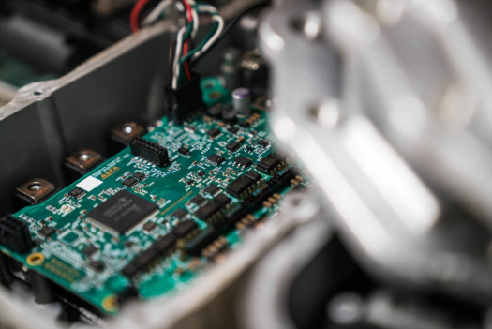
Chapter 3

Mechanical and Electrical Components
Design

3.1 introduction
A CNC Robot machine "AXELO" is built from a mechanical body, electrical and electronics components and also control system , the machine structure is very important to how movement can be preform which effects on the design ability to be more balanced and rigid where the proper mechanical design construction gives high stiffness which leading to high accuracy in the execution of operations, on the other side the right electrical components add more capability to control the body motion Whether it was through the control of the speed, torque, and displacement.
3.2 Mechanical design
The mechanical design of CNC robot machine includes various parts and components, start from the Omni wheels that will move the entire body and the load will be on them , then the base of the machine which is connect with wheels and all other components are mounted to it , next part is slider with stand and its role to hold the drill and taking charge of its z-axis motion , the last is some combinations of bearings units ,rods ,lead screw ,shaft coupling and all of these have different uses whether transitions of motion or to support parts together. See figure (3.1)
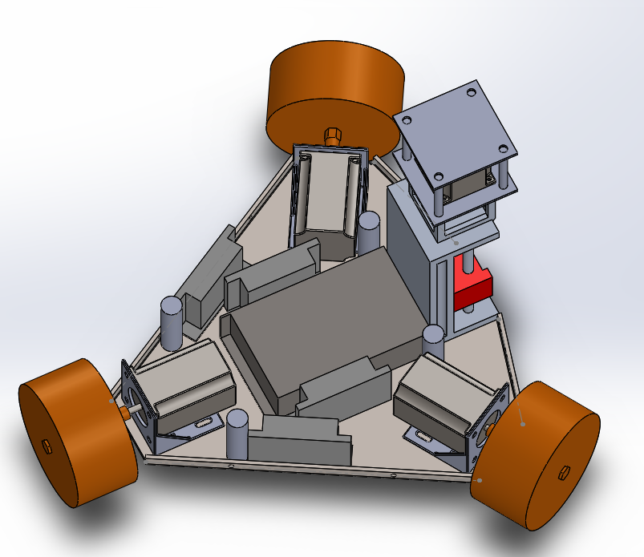

Figure (3.1): mechanical design of CNC robot "AXELO"

3.3 Omni wheels
Omni wheels are a unique wheel as they can roll freely in two directions with three controllable degree of freedom forward/ backward, rotates and also move side way which gives the robot more efficient in reaching its given goal with no friction, omni wheel design that has a number of small passive rollers mounted on the periphery of a normal wheel. The shafts of the rollers are perpendicular to that of the wheel is driven in a normal fashion, while the rollers allow for a free motion in the perpendicular direction. _{[5]}
See figure (3.2.1)
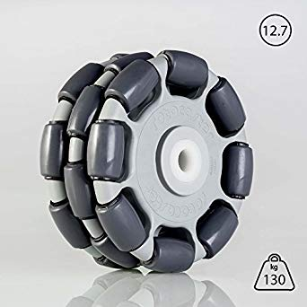
Figure (3.2.1): omni wheels design

After studying the case of Axelo and putting the maximum weight of it 25 Kg, the most suitable wheels were ROTACASTER R3-125mm-85A-19hexa bore- omnidirectional. See figure (3.2.2)

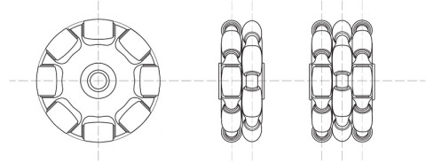
Figure (3.2.2): omni wheels dimension
3.4 Base Frame
Base frame is the structure that holds the whole parts and support them with each other's its can be made various material but preferred to be metal with high strength and stiffness such as aluminum or steel. Determining the shape and the layout of is necessary to give freer move to the tool cutting and also the body, teardrop shape is very appropriate for that where the tool cutting is at a point far from the wheels.

3.5 Slider Mechanism
A slider-mechanism is a set of mechanical parts arranged to move the circular motion to a straight motion or vice versa.
There are several ways to build it, by roller, cams and gears ,piston or, screw which is the best way to give a very suitable precision for surface cutting and any precise operations ,this mechanism consist usually these parts, first is screw which move rational motion and usually connect with motors ,second parts nuts, its mechanical part with teeth rotates with screw and convert the circular motion to linear one , slider is flat plates connect with other side of motion and also there is a stand base which holds these parts . See figure (3.3)

It has many applications in machines such as CNC machine and its accuracy depend on screw that used in mechanism.
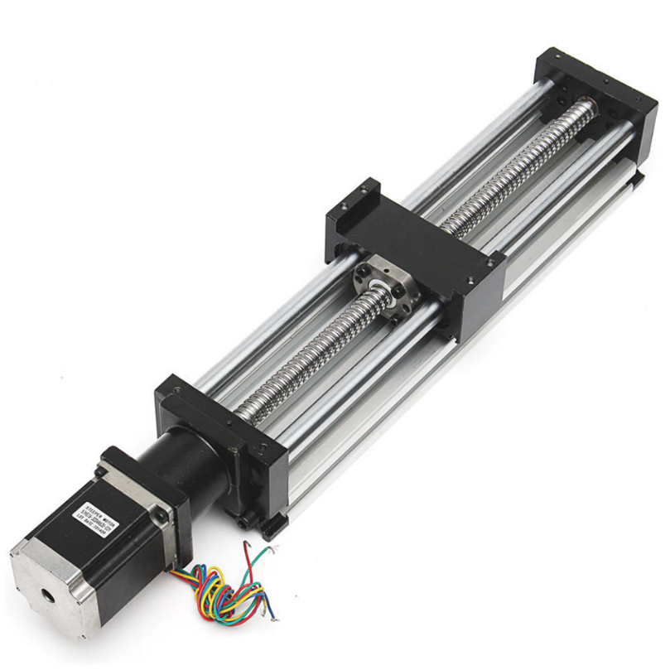
Figure (3.3): slider with screw mechanism

3.5.1 Power screw
A power screw is a drive used in machinery to convert a rotary motion into a linear motion for power transmission. and the design of the power screw may be such that the screw or the nut is held at rest and the other member rotates as it moves axially or the screw or the nut rotates but does not move axially , Power screw normally uses square threads but ACME or Buttress threads may also be used its designed for smooth and noiseless transmission of power with an ability to carry heavy load, Other applications of power screws is lead screws the most used thread is the ACME its form has a 29° thread angle with a thread height half of the pitch , the crest and root are flat. This shape is easier to machine (faster cutting, longer tool life) than is a square thread. See figures (3.4)
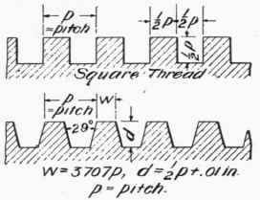
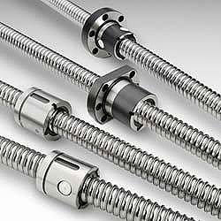
Lead screws Square & ACME threads

Figure (3.4): Power screw & how it work

3.5.2 Ball screw
A ball screw is not all alike its Differences in design, quality, materials, manufacturing, and application support are all factors that affect the performance and extend the life of your ball screw, Low friction in ball screws yields high mechanical efficiency compared to alternatives where typical ball screw may be 90 percent efficient, its 25 percent efficiency of an Acme lead screw of equal size.
Lack of sliding friction between the nut and screw lends itself to extended lifespan of the screw assembly, reducing downtime for maintenance and parts replacement, while also decreasing demand for lubrication. This combined with their overall performance benefits and reduced power requirements. _{[6]} See figure (3.5)
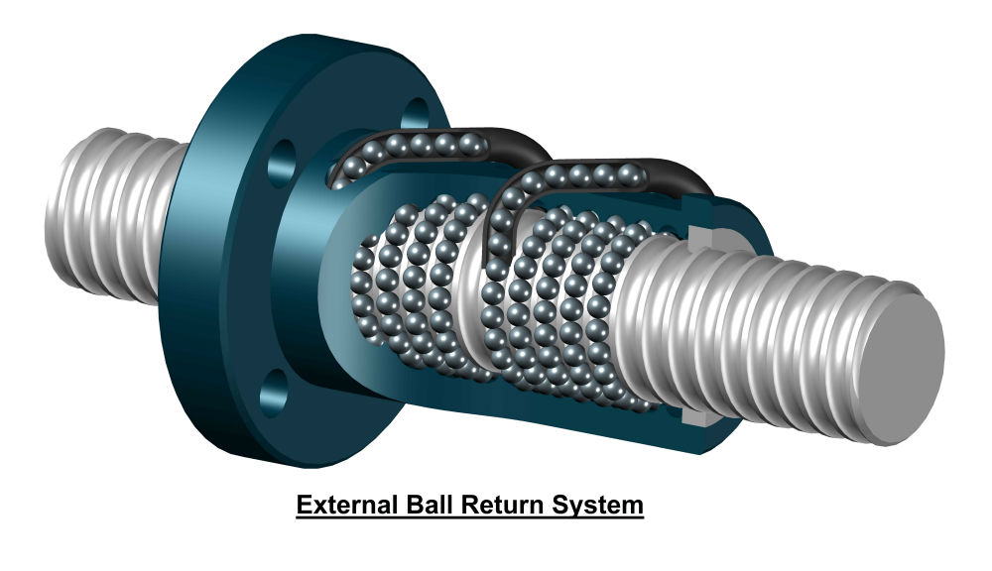
Figure (3.5): Ball screw

3.6 Shaft couplings
Shaft couplings are actually the mechanical device that connects or couples the two-drive element or shaft together for transmitting the power from one end to another. See figure (3.6)
Couplings do not allow any shaft interruption during operation. Anyway, with the torque limiting couplings can disconnect when the limit of the torque is exceeded.
Shaft couplings are used in machinery for several purposes, the most common of which are the following.
- To provide for the connection of shafts of units that are manufactured separately such as a motor and generator and to provide for disconnection for repairs or alternations.
- To provide for misalignment of the shafts or to introduce mechanical flexibility.
- To reduce the transmission of shock loads from one shaft to another.
- To introduce protection against overloads.
- To alter the vibration characteristics of rotating units.
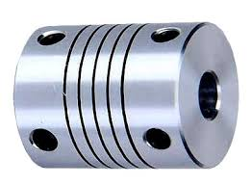

Figure (3.6): shaft coupling

3.7 Electrical components
3.7.1 Actuators
1-Stepper motors
Stepper motors are DC motors that move in discrete steps. They have multiple coils that are organized in groups called "phases". By energizing each phase in sequence, the motor will rotate, one step at a time. With a computer controlled stepping very precise positioning and speed control can be achieved. See figure (3.7) Stepper motors has been chosen for this project because these features:
1. Positioning: Since steppers move in precise repeatable steps, they excel in applications requiring precise positioning such as CNC.
2. Speed Control: Precise increments of movement also allow for excellent control of rotational speed for process automation and robotics.
3. Low Speed Torque: Normal DC motors don't have very much torque at low speeds. A Stepper motor has maximum torque at low speeds, so they are a good choice for applications requiring low speed with high precision. _{[7]}
Based on mapping design, weight, and the shape of Axelo, the base stepper motors were selected as NEMA 23 ST5909L1008-A:
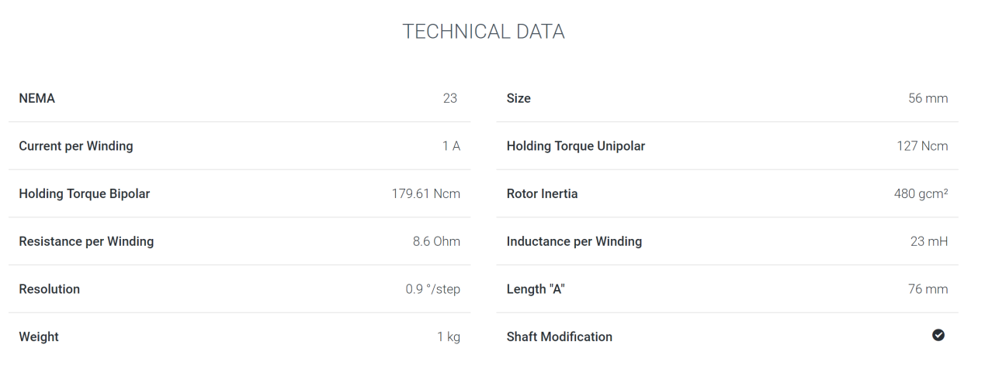
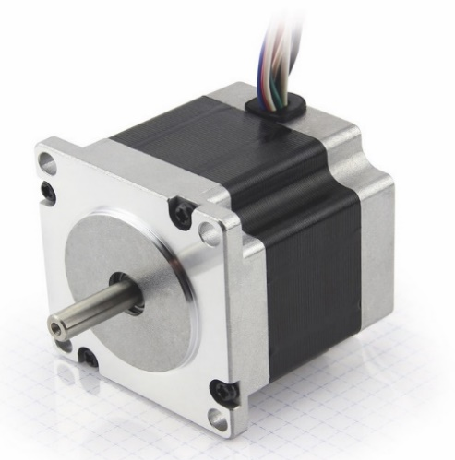

Figure (3.7.1): stepper motor
dimentions: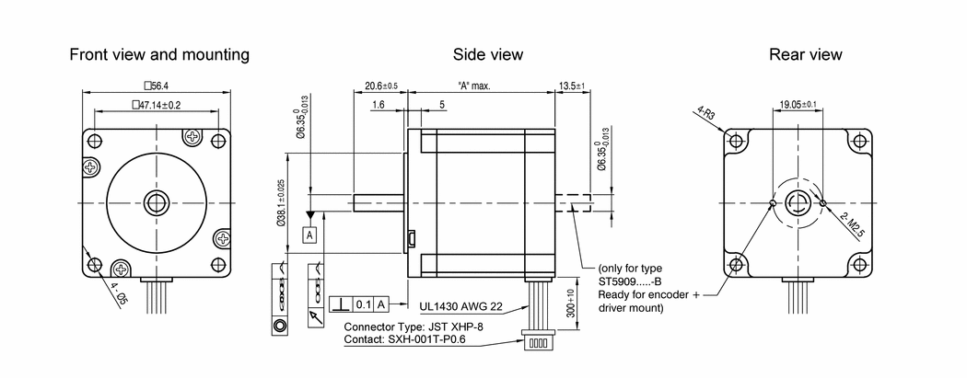
figure (3.7.2): Stepper motor dimenstion
The specifications of the stepper motor holding the power screw were: the maximum holding torque is 0.65 and step size resolution of 0.9°, so the selected motor was NEMA 23 ST5909X2508-A
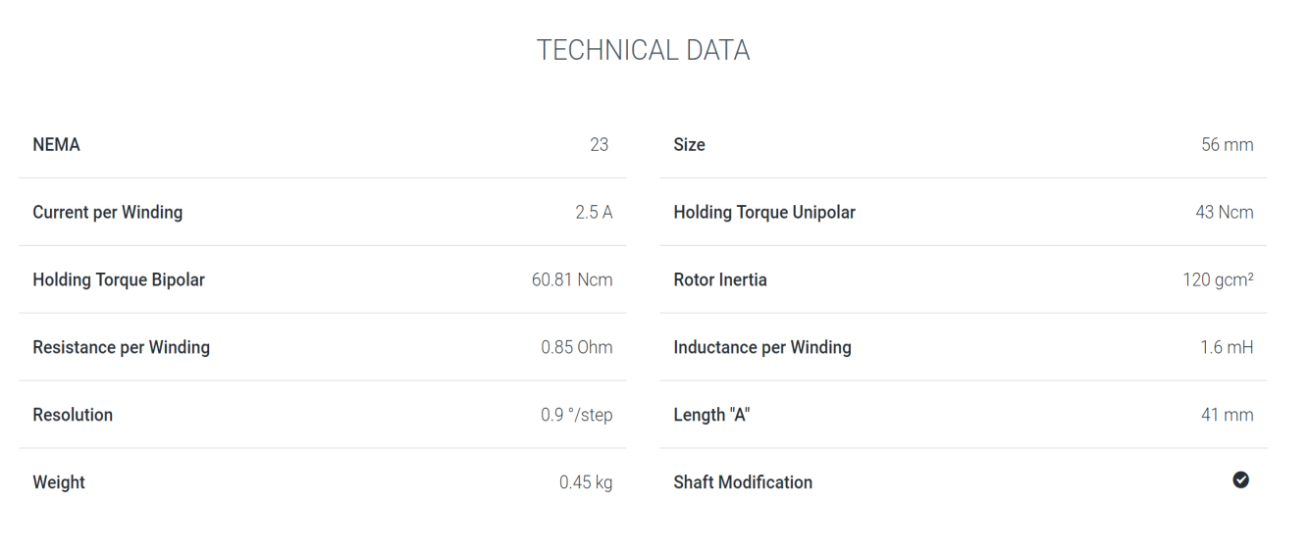
Table (3.1): Technical data of stepper motor

3.7.2 Spindle
A spindle motor is a small, high-precision, high-reliability electric motor that is used to rotate the shaft, or spindle as shown in Figure (3.8), on which the platters are mounted in a hard disk drive (HDD).
A platter is a thin, high-precision aluminum or glass disk that is coated on both sides with a high precision magnetic material and which is used in a HDD to store data. Modern HDDs typically contain multiple platters, all of which are mounted on a single shaft, in order to maximize the data storage surface in a given volume of space.
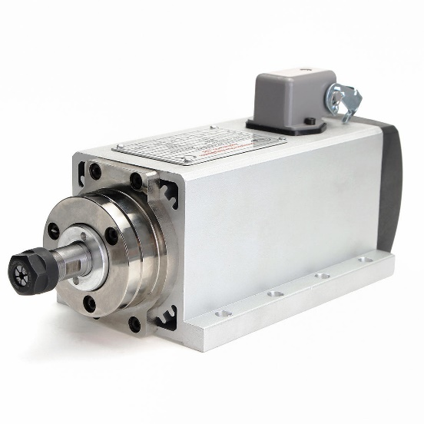

Figure (3.8): air cooled spindle
All HDD spindle motors are configured for direct driving of the platters. That is, the rotating shaft of the motor and shaft on which the platters are mounted is a single, integral unit. This is in contrast to most electric motors, which use gears or belts to transfer and modify their output.
Most HDD spindle motors spin the platters at a constant rate ranging from 160000 to 30000 RPM. The precision of the rotational speed is maintained through the use of feedback loop circuitry. Among the other important characteristics of spindle motors are small size, low power consumption, high reliability (including the ability to run for thousands of hours and tolerate thousands of start and stop cycles without failure), minimal wobbling and vibration (due to the tight tolerances of the platters and magnetic heads), low heat output and minimal noise output. Minimizing the wobbling and vibration makes it possible to reduce track spacing on the platters, thereby increasing HDD data storage capacity. A track is any of the concentric circles on the magnetic coating on a platter over which one magnetic head passes while the head is stationary but the disk is spinning. A critical component for reducing the wobbling of the shaft along with vibration and noise is the bearings. Spindle motors have long used ball bearings, which consist of small metal balls that are housed in a metal ring structure around the spindle motor shaft. However, in the past few years there has been a transition to fluid dynamic bearings, in which the metal balls are replaced by a high viscosity oil, thereby eliminating the metal-to-metal contact. The advantages include a further reduction in noise, longer life expectancy and lower cost. Other ways in which spindle motor performance has been improved and size and cost have been reduced in recent years include the use of more powerful permanent magnetic materials, higher precision machining techniques and improved electronic control circuits.

3.7.3 Drivers
Electric drive is an electromechanical system (mechatronic system) intended to set into motion technological equipment. It consists of an electric motor (motors), a transfer mechanism, an electrical energy converter, and a control system. The control system consists of a microcontroller with data connection interfaces, data channels (data network), sensors and actuators.

A generalized structure of the electric drive is shown in Figure (3.9)
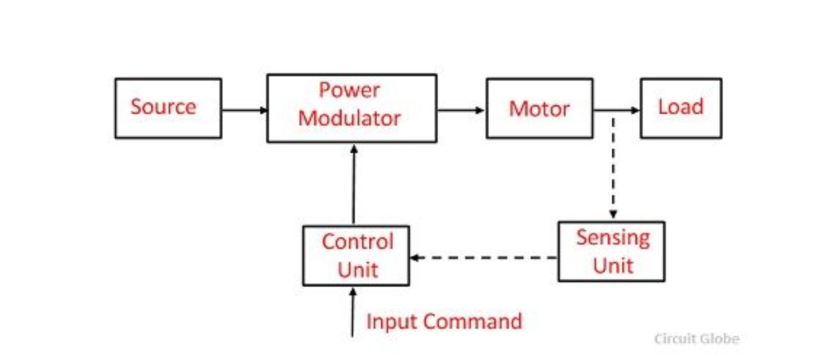
Figure (3.9): Generalized structure

The driver used to control the motors is TB6600 arduino Stepper Motor Driver is an easy-to-use professional stepper motor driver, which could control a two-phase stepping motor. It is compatible with Arduino and other microcontrollers that can output a 5V digital pulse signal. TB6600 arduino stepper motor driver has a wide range power input, 9~42VDC power supply. And it is able to output 4A peak current, which is enough for the most of stepper motors. The stepper driver supports speed and direction control. You can set its micro step and output current with 6 DIP switch. There are 7 kinds of micro steps (1, 2 / A, 2 / B, 4, 8, 16, 32) and 8 kinds of current control (0.5A, 1A, 1.5A, 2A, 2.5A, 2.8A, 3.0A, 3.5A) in all. And all signal terminals adopt high-speed optocoupler isolation, enhancing its anti-high-frequency interference ability. As a professional device, it is able to drive 57, 42-type two-phase, four-phase, hybrid stepper motor.
Features:
- upport 8 kinds of current control
- Support 7 kinds of micro steps adjustable
- The interface adopts high-speed optocoupler isolation
- Automatic semi-flow to reduce heat
- Large area heat sink
- Anti-high-frequency interference ability
- Input anti-reverse protection
- Overheat, over current and short circuit protection.[8]
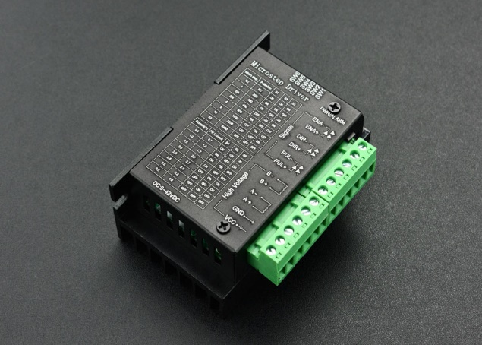

Figure (3.10.1): Stepper motor drive

3.7.4 Power supply
What is a power supply it’s an electrical device that supply electrical power to the load it can is used to convert electrical power from one form to another for example, converting AC voltage to DC voltage like it is used in this project, power supply is used to convert 220-230 V AC to 24V DC in order to supply the motors with the sufficient voltage for them to operate efficiently. As you can see in the figure (3.10.2) below is the power supply that is used.

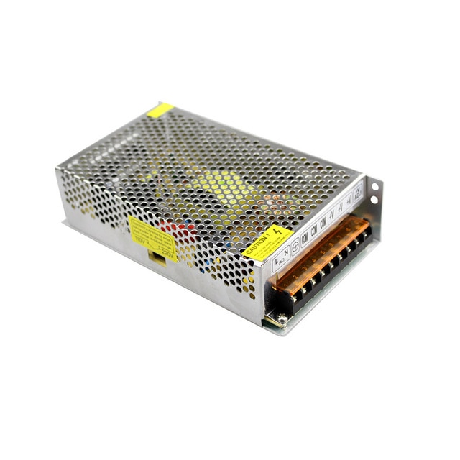

Figure (3.10.2): power supply 220V to 12V

3.7.5 Variable frequency drive
In order to control the spindle that is used in this system variable frequency drive (VFD) is used, which is a type of motor controller that drives an electric motor by varying the frequency and voltage supplied to the electric motor. Other names for a VFD are variable speed drive, adjustable speed drive, adjustable frequency drive, AC drive, micro drive, and inverter.

Frequency (or hertz) is directly related to the motor’s speed (RPMs). In other words, the faster the frequency, the faster the RPMs go. If an application does not require an electric motor to run at full speed, the VFD can be used to ramp down the frequency and voltage to meet the requirements of the electric motor’s load. As the application’s motor speed requirements change, the VFD can simply turn up or down the motor speed to meet the speed requirement.[9]

The VFD that is used has 1.5Kw power with 220V input. As you can see below in figure (3.10.3).

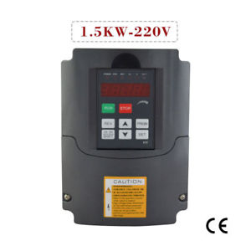

Figure (3.10.3): Variable frequency driver
3.8 Selection
1-Stepper motor needed specification
- Omni-Wheels motors
Evaluating the maximum effect of cutting or grooving operation on robot
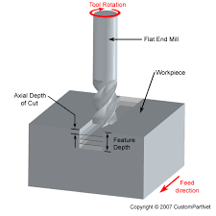

Figure (3.11): The face milling parameters
Face milling parameters:
- Cutting time (t)
$t=\frac{(L+2 Lc)}{V}$ where L: length of cutting
- Horizontal extent of cutter’s first contact with the work part (L_{c})
$Lc=\frac{(D)}{2}$, D: cutter diameter
- L_{c}= 10 =5 mm
- $t=\frac{(1000+2*5)}{600}$ = 1.675 min
- Surface speed of cutter (V)
V = D*N, N: Rotational speed of milling cutter
- V = 15000 mm/min
- Material removable rate (MRR)
MRR = W*D*v , W: width of the cutter
v: feed speed for tool or work piece
- MRR = 56400
- Power (P) in (Watt)
P = MRR *U
U: specific energy (specific energy for aluminum =1.1)
- P = 56400*1.1 = 62040 watt
- Torque (T) in (N.m or Ib.ft)
$Τ=\frac{(P)}{ω}$, ω: rotational speed of milling cutter in (rad/sec)
- $Τ$ = 6.582641434 N.m

- Cutting force (F_{c}) in (N)
F_{c}$=\frac{( Τ )}{D/2}$
- F_{c} = 1.326 N
The maximum torque needed from the Omni-wheels stepper motor:
- Angular acceleration (a_{x})
a_{x}= $\frac{v}{t}$ , v: feed speed (m/sec) , t: time step of stepper motor (sec)
t = $\frac{θ}{ω}$ , θ: resolutions of stepper motor =0.9 degree,
ω: maximum wheel angular velocity (rad/sec)
ω = $\frac{v}{r}$ = $\frac{0.01}{0.0035} = 2.86 rad/ sec$
- t =$\frac{0.9}{2.86} = 0.3147 sec$
a_{x} = $\frac{0.01}{0.3147} = 0.0318 m/s^{2}$
- a_{y} = 0 $m/s^{2}$
α = $\frac{V^{2}}{R_{r}}$, R_{r}: The distance between two point or robot center
- α $=\frac{{0.01}^{2}}{0.18} =$ 5.56e-4

Supposed parameter of Axelo:
- Robot mass (M) = 14 kg
- Omni wheel radius (r) =35 mm
- Robot mass moment of inertia about tool (J_{Z} )
J_{Z}=Σ(mi * ri²) = 0.7336 kg.$m^{2}$
- The maximum slope angle of cutting path (δ)=90 degree

- The angel is the rotational angel between global frame and local frame (φ) = 0 degree
$\left[\begin{matrix}TL1 \\ TL2 \\ TL2\end{matrix}\right]= r *\left[\begin{matrix}cos({\frac{π}{6}+ø)} & sin({\frac{π}{6}+ø)} & \frac{1}{\sqrt{300}*cos\left(55\right)} \\ cos(5{\frac{π}{6}+ø)} & sin(5{\frac{π}{6}+ø)} & \frac{1}{\sqrt{300}*cos\left(55\right)} \\ cos(3{\frac{π}{2}+ø)} & sin(3{\frac{π}{2}+ø)} & \frac{1}{38}\end{matrix}\right] * \left[\begin{matrix}M & 0 & 0 \\ 0 & M & 0 \\ 0 & 0 & Jz\end{matrix}\right]* \left[\begin{matrix}ax +{Fccos\left(δ\right)}/M \\ ay+{Fc\sin\left(δ\right)}/M \\ α+\frac{Tc}{Jz} \end{matrix}\right]$
$$\left[\begin{matrix}TL1 \\ TL2 \\ TL2\end{matrix}\right]= 0.0035*\left[\begin{matrix}cos({\frac{π}{6}+0)} & sin({\frac{π}{6}+0)} & \frac{1}{\sqrt{300}*cos(55)} \\ cos(5{\frac{π}{6}+0)} & sin(5{\frac{π}{6}+0)} & \frac{1}{\sqrt{300}*cos(55)} \\ cos(3{\frac{π}{2}+0)} & sin(3{\frac{π}{2}+0)} & \frac{1}{38}\end{matrix}\right] * \left[\begin{matrix}14 & 0 & 0 \\ 0 & 14 & 0 \\ 0 & 0 & 0.7336\end{matrix}\right]* \left[\begin{matrix}0.0318 +{ 1.326* cos(90)}/{14} \\ 0+{1.326*\sin{(90)}}/{14} \\ 5.56e-4+\frac{6.5826}{0.7336} \end{matrix}\right]$$
$\left[\begin{matrix}TL1 \\ TL2 \\ TL2\end{matrix}\right] = \left[\begin{matrix}0.8267 \\ -0.0001 \\ -0.0053\end{matrix}\right]$

From the above matrices the maximum evaluated torque for wheel stepper motor equal to 0.8267 N.m
The maximum torque needed for steeper motor = safety factor* evaluated torque
F_{I, max} = 2 * 0.8267 = 1.67 N.m

- Z-axis holding power screw motor
Torque required to raise load formula
$$TR=\frac{Fdm}{2} \left(\frac{τ+\left(πϻdm\right)}{πdm-ϻτ}\right)+\frac{Fϻcdc}{2}$$
T_{R}: torque required to raise load N-m
F: load in newton
d_{m}: mean diameter of square thread
d_{c}: mean collar diameter
τ: square thread pitch distance in mm
ϻ: coefficient of friction for thread
ϻ_{c}: friction coefficient of collar
Where
F = W_{d} (drill weight) = 16 N
d_{m} = 8 mm
d_{c} = 8.02 mm
L= 2mm
ϻ= ϻ_{C} = 0.17
The maximum evaluated torque required to rise drill
- (T_{R}) = 0.28 N.m
The maximum torque needed for steeper motor = safety factor * evaluated torque
- T_{R,max} = 2 * 0.28 = 0.56 N.m
The selected stepper motor torque = 0.6 N.m
- Omni-Wheel needed specification
Maximum evaluated force for Omni-wheel
$Fi=\frac{Tc}{r}$ = 0.8267 /0.035 = 23.62N

The maximum force needed for omni-wheel = factor of safety * evaluated force
- F_{i,max} = 2* 23.62= 47.24 N
The rolling friction force for Omni-wheels
F_{r} = $\frac{Mr * M * g}{3}$
F_{r}: rolling friction force
ϻr: The dynamic rolling friction coefficient
g: acceleration gravity
r: wheel radius
- ϻr =$\frac{Fr*3}{g*M}$ = $\frac{47.24 * 3}{9.81* 14 } = 1.032$
The wheel will be selected due to static coefficient of friction = 1.032 and as in figure (12) the suitable wheel material is 60A polyurethane durometers.
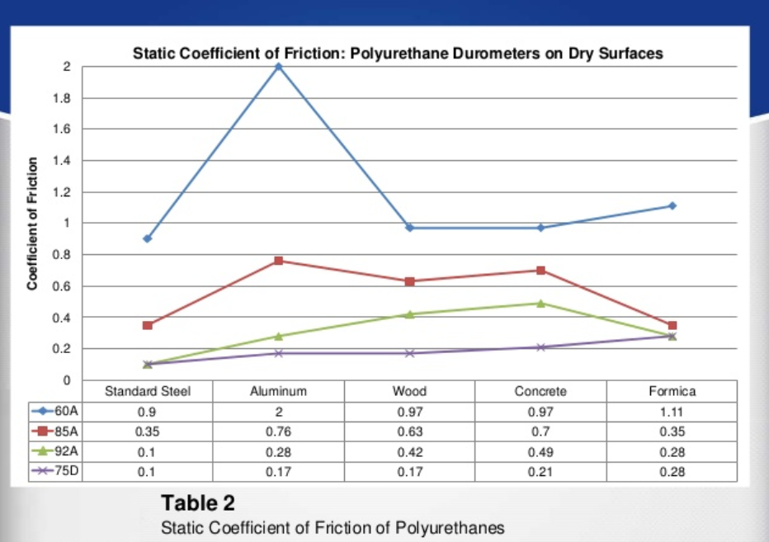

Figure (12): Static coefficient of friction
The polyurethane durometers is the hardness of any soft material such as rubber, plastic, polyurethane, or non-metallic material is measured in durometer, which is similar to how steel is measured on the Rockwell scale. There are a various method with which to measure durometer to encompass the wide range of hardness which these materials come in.
The Shore A hardness scale is the most commonly used scale in production and manufacturing applications due to its wide range and versatility of uses within the scale. The Shore A scale can range from parts that are flexible and soft in nature (0-40A), to semi-flexible and medium hard (50-80A), to very hard and rigid (90-100A). Meridian Laboratory operates primarily in the Shore A scale and commonly offers 40A, 55A, 70A, 80A, 90A in durometer choices, but is not limited to these durometers.
The hardest scale in plastic, rubber, and polyurethane measurement is Shore D. Shore D can most commonly be associated with hard rubbers and plastics, but also some polyurethanes. Meridian Laboratory offers precision polyurethane parts in the Shore D scale to 60D. _{[10]}
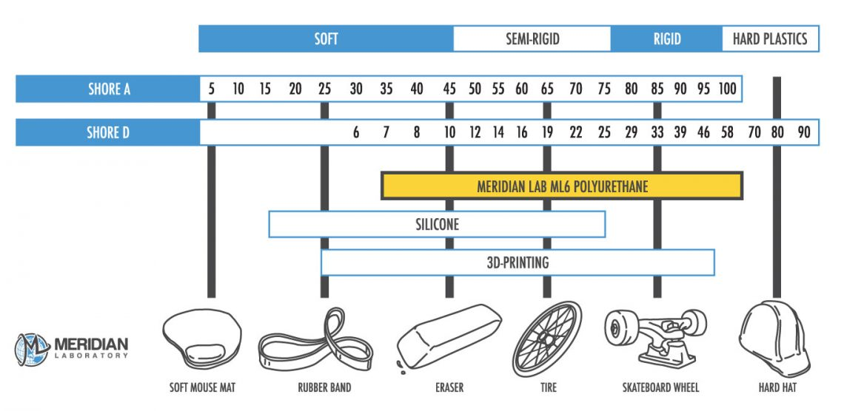

Figure (3.13): Shore A & D scale
3- Spindle parameter
The maximum needed torque which produced from drill (Tc) = 6.582641434 N.m
The maximum needed speed which produced from drill (W) = 20000 rpm
Drill parameters:
No load speed: 16,000-35,000 RPM
Voltage : 220 Volt
Amperage : 7 A
Spindle lock : yes
Weight : 1.92 kg
Width : 10.5 cm
Length : 10.5 cm
Horse power : 1.25 max
Collet capacity : 1/4"
Cord length : 3.048 m

Figure (3.14): selected spindle

Chapter 4


Control system

4.1 introduction
A control system is an interconnection of components forming a system configuration that will provide a desired system response. The basis for analysis of a system is the foundation provided by linear system theory, which assumes a cause–effect relationship for the components of a system .Therefore a component or process to be controlled can be represented by a block, as shown in Figure 4.1. The input–output relationship represents the cause-and-effect relationship of the process, which in turn represents a processing of the input signal to provide an output signal variable, often with a power amplification. _{[11]}
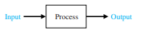

Figure (4.1): input output relation

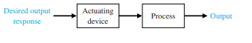

Figure (4.2): open-loop system

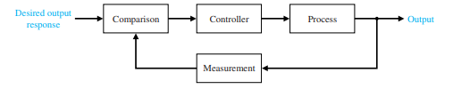
Figure (4.3): closed-loop system

4.2: open and close loop system
There are two types of control systems on robot. The overall accuracy of the robot is determined by the type of control loop used.

4.2.1 Open Loop System
An open-loop control system utilizes a controller or control actuator to obtain the desired response, as shown in Figure (4.4). An open-loop system is a system without feedback. An open-loop control system utilizes an actuating device to control the process directly without using feedback.

Figure (4.4): open-loop system

Stepper motors are able to operate in an open loop system, for CNC applications. And in this project stepper motors do not require feedback hardware since it is working on small speed with accurate steps. The price for an open loop CNC system is much cheaper and simpler than a closed loop system. _{[11]}

4.2.2: Closed Loop System
In contrast to an open-loop control system, a closed-loop control system utilizes an additional measure of the actual output to compare the actual output with the desired output response. The measure of the output is called the feedback signal. A simple closed-loop feedback control system is shown in Figure (4.5)

Figure (4.5): closed-loop system
A feedback control system often uses a function of a prescribed relationship between the output and reference input to control the process. Often the difference between the output of the process under control and the reference input is amplified and used to control the process so that the difference is continually reduced. In general, the difference between the desired output and the actual output is equal to the error, which is then adjusted by the controller. The output of the controller causes the actuator to modulate the process in order to reduce the error. The sequence is such, for instance, that if a ship is heading incorrectly to the right, the rudder is actuated to direct the ship to the left. The system shown in Figure 1.3 is a negative feedback control system, because the output is subtracted from the input and the difference is used as the input signal to the controller. The feedback concept has been the foundation for control system analysis and design. _{[11]}

A closed-loop control system uses a measurement of the output and feedback of this signal to compare it with the desired output (reference or command).
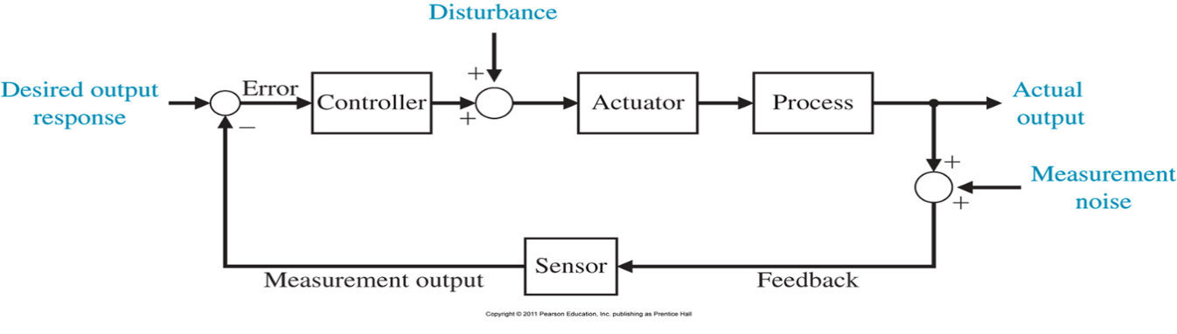
Closed-loop control has many advantages over open-loop control including the ability to reject external disturbances and improve measurement noise attenuation. We incorporate the disturbances and measurement noise in the block diagram as external inputs, as illustrated in Figure (4.6)

Figure (4.6): Feedback with disturbance
External disturbances and measurement noise are inevitable in real-world applications and must be addressed in practical control system designs.
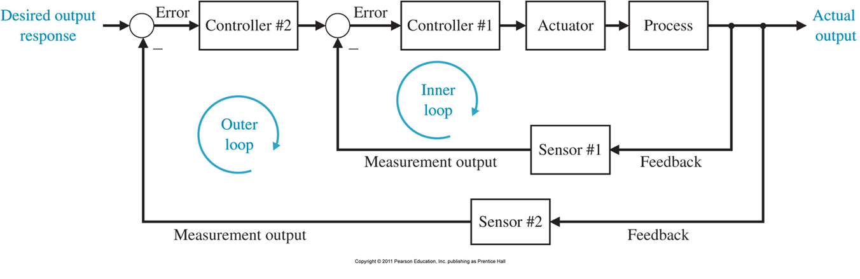
The feedback systems in Figures 4.3 and 4.4 are single-loop feedback systems. Many feedback control systems contain more than one feedback loop. A common multi-loop feedback control system is illustrated in Figure 4.7 with an inner loop and an outer loop.
Figure (4.7): Feedback inner and outer loop
In this scenario, the inner loop has a controller and a sensor, and the outer loop has a controller and sensor. Other varieties of multi-loop feedback systems are considered as they represent more practical situations found in real-world applications. However, the single-loop feedback system is used for learning about the benefits of feedback control systems since the outcomes readily extend to multi-loop systems.
Due to the increasing complexity of the system under control and the interest in achieving optimum performance, the importance of control system engineering has grown in the past decade. Furthermore, as the systems become more complex, the interrelationship of many controlled variables must be considered in the control scheme. A block diagram depicting a multivariable control system is shown in Figure (4.8). _{[1]}
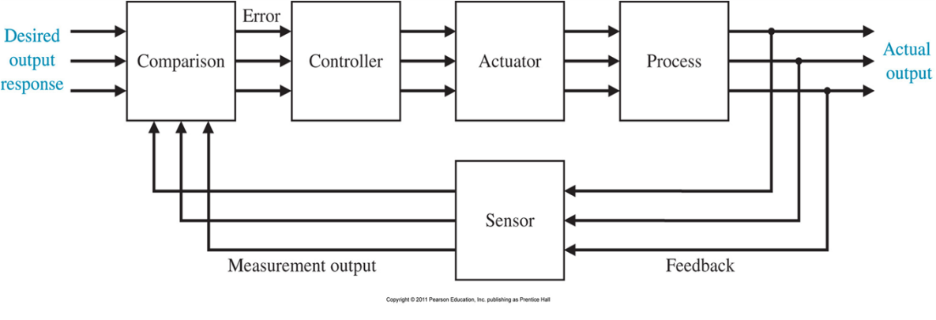
Figure (4.8): multivariable control system
The most common type of closed loop controller system. Which is a system of analog device is responsible for the feedback signal. Most of these closed loop controllers are PID or proportional integral derivative controllers. A PID controller attempts to correct the error between a measured variable and a desired set point by calculating and then outputting a corrective action that can adjust the process accordingly and rapidly, to keep the error minimal. _{[11]}

4.3 PID controller
The PID controller is by far the most common control algorithm. Most practical feedback loops are based on PID control or some minor variations of it. Many controllers do not even use derivative action. The PID controllers appear in many different forms, as a stand-alone controllers, they can also be part of a DDC (Direct Digital Control) package or a hierarchical distributed process control system or they are built into embedded systems. _{[3]}
U(t) = ke(t) + ki Z t 0 e(τ )dτ + kd de dt
Where u is the control signal and e is the control error (e = r − y), the P-term (which is proportional to the error), the I-term (which is proportional to the integral of the error), and the D-term (which is proportional to the derivative of the error).
The controller parameters are proportional gain k, integral gain ki and derivative gain kd. _{[12]}
Applying Laplace transformation results in the transformed PID controller equation.
U(s) =K_{P} + K_{I} $\frac{e(s) }{s}$+ K_{P} s e(s)

With the PID controller transfer function
G(s) = (K_{P} + K_{I} $\frac{1}{S}$ + K_{D} s) * e(s)

4.3.1 Loop tuning
Tuning is the art of selecting values for the tuning parameters P, T_{I}, and T _{D} so that the controller will be able to eliminate an error quickly without causing the process variable to fluctuate excessively. _{[6]}
In this project we used Ziegler-Nichols’ Tuning Methods since the stepper motors are controlled with known commands (directions), it’s a two special methods for tuning of PID controllers developed by Ziegler and Nichols in the 1940s are still commonly used. They are based on the following idea: Make a simple experiment, extract some features of process dynamics from the experimental data, and determine controller parameters from the features one method is based on the open-loop step response, Another method is based on frequency response [3], Ziegler and Nichols also described a closed loop-tuning technique that is conducted with the controller in automatic mode, but with the integral and derivative actions shut off. The controller gain is increased until even the slightest error causes a sustained oscillation in the process variable. _{[13]}

4.3.2 Feed-forward
Combined feed forward plus feedback control can significantly improve performance over simple feedback control whenever there is a major disturbance that can be measured before it affects the process output. In the most ideal situation, feed forward control can entirely eliminate the effect of the measured disturbance on the process output. Even when there are modeling errors, feed forward control can often reduce the effect of the
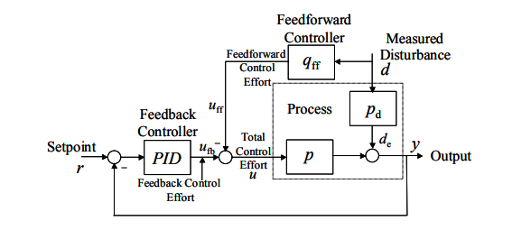
measured disturbance on the output better than that achievable by feedback control alone Feed forward control is always used along with feedback control because a feedback control system is required to track set point changes and to suppress unmeasured disturbances that are always present in any real process. _{[14]}
Figure (4.9): feed-forward/feedback control structure
4.4 Mapping
4.4.1 Introduction
Robot mapping is concerned with developing techniques that enable a mobile robot to construct and maintain a model of its environment based on spatial information gathered over time. Typically, the spatial information stems from directly perceiving the environment through external sensors. In addition, internal sensors that provides information about change of location within the environment. There are, however, many more ways of acquiring spatial information, including external representations such as floor plans, sketches, or written descriptions, as well as direct communication with other robots or with humans. _{[15]}
Both industrial and family mobile robot, though vary in sizes, prices, as well as functionalities, they must solve three common problems, which are “Localization, Mapping and Path Planning.” Solving these three problems is the prerequisite for a mobile robot to perform certain tasks.
Robot need to know where it is (Localization), what the world look like around it (Mapping), and then decide how to get there (Path Planning). The relation between mapping and path planning is clear. Without a map, path planning can’t be performed. While the relation between Mapping and Localization is not clear, they are always attached together. In robotics, it is a chicken and egg problem. _{[11]}

4.4.2 Mapping algorithm
When the robot start moving from line (L) to execute a program command uploaded to robot, the translation position (X,Y) and translation velocity (V_{x},V_{y}) is determined from output of the G-cod file that is produced from Estlcam software which is sent to microcontroller then for the robot.
Translate in global frame (X,Y) , but the robot has to change its elongation angel(ψ) to stay inside the work piece and this changing of angel will cause rotation of robot about tool point with angular velocity ω =$\frac{dψ}{dt}$.
By receiving data from encoder thus will give the parameters) L1 , L2 ,L3 (, at each stage of motion, The angels (ψ ,θ) can calculated mathematically, with the distant between center of tool and center of robot equal 18 cm and (X) is the distant between ref 1 and ref 2 , as shown in figure (4.10)

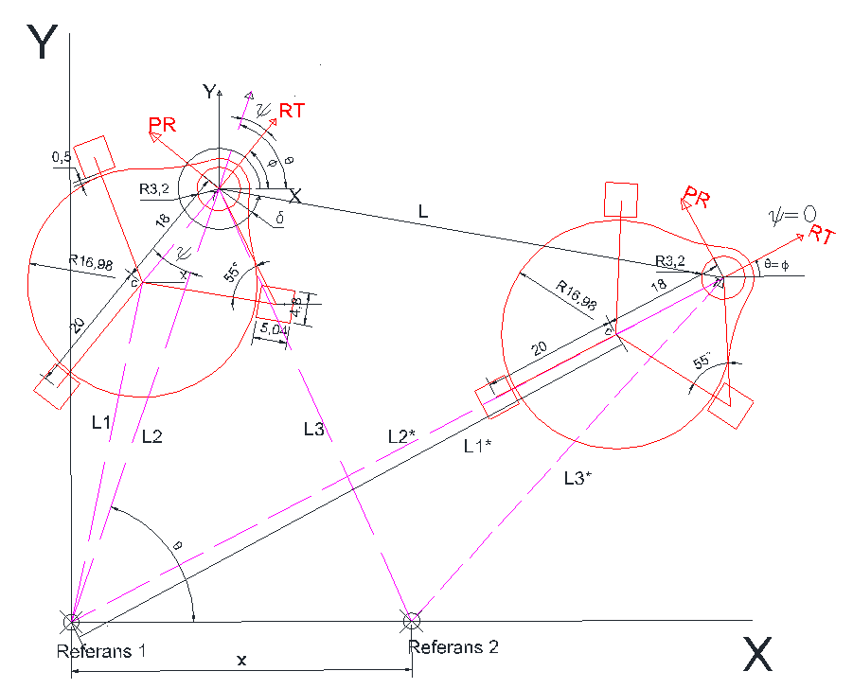

Figure (4.10): Calculation of L1, L2, L3

(1) ψ = $\cos^{-1}{\frac{{L2}^{2}+{18}^{2}-{L1}^{2}}{2*L2*18}}$ θ
(2) θ = $\cos^{-1}{\frac{{L2}^{2}+X^{2}-{L3}^{2}}{2*L2*X}}$
(3) ø=θ-ψ = $\tan^{-1}{\frac{dy}{dx}}$δ
The mechanism robot motion in the (global frame) translation motion (X,Y) and rotational motion converted to the wheels by spatial procedure As it will be mentioned in the kinematic part.
4.5 Modeling
4.5.1 Introduction
Modeling of the dynamical systems is in the focus of attention of scientists since many decades. Today there is a main motivation to have necessary information for automated control of the dynamical systems.
Dynamical systems can be technical (e.g. electrical systems, mechanical systems etc.), biological (e.g. blood pressure control, insulin control etc.) ones, and also they can represent many other branches of economics, society, sciences etc. Dynamical modeling is necessary for computer aided preliminary design, too. There are many powerful tools to design a control system for the first possible scheme. The designed system must be tested for design criteria, and in case of necessity must be re-designed. Purpose of the author is to present a typical set of possible dynamical systems applied in Mechatronics, and, in Robotics, too. _{[16]}

4.5.2 Kinematics
It is necessary to connect all variables affecting in the motion together in suitable shape to understand the motion of the robot in the environment, the design, Figure 4.11. ensures translational motion of robot in global frame with translation position (X,Y) and velocity (V_{x},V_{y}) , and rotational motion about tool point in local frame with angular position (ψ) and angular velocity (ω) ,the control of the robot movement come from controlling of the three omni-wheels rolling with angular position (θ) and angular velocity (Wi) and it’s the same for stepper motor.
The local frame identify with robot elongation and its perpendicular line (RT,PR) and its center in the tool point and connected with robot, the global frame identify with X-axis and Y-axis and its center in the reference 1, the angle (ɸ) is the rotational angel between global frame and local frame The direction of each wheel sloping from x-axis by angel (φ+ σi) in global frame, and when (φ=90 degree) the (σ1,σ2,σ3) =(30,150,270).
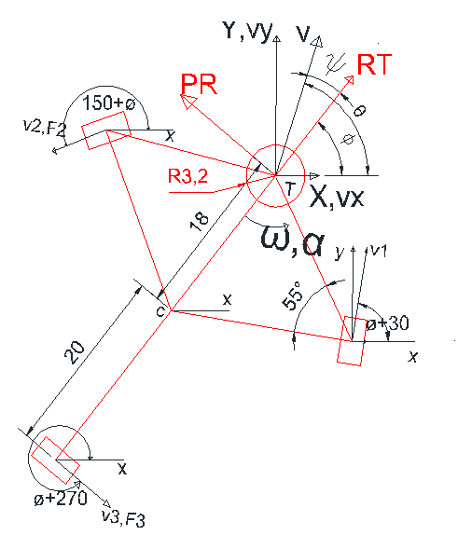

Figure (4.11): Translation motion of the robot
The wheel motion occurs by the transitional motion of tool point and rotational motion about tool point, in every step of motion the robot adjust its direction by (ψ degree) in order to does not come out of work pies aspects.
The motion can express as (V_{i}, translate and Vi, rotate) and its respectively (V₁, V₂, V₃).
- Vi = Vi, translate + Vi, rot ….. equ.1
Where V_{i}: wheel velocity
Translation velocity
V translation, I = V_{x} * cos(σi+φ) + V_{y} * sin(σi+φ) ….. equ.2
Rotational velocity
V rotation =R_{l}.ω ….. equ.3
R_{I}: the distant between wheels center and tool point
ω = $\frac{dψ}{dt}$
The V_{i} can written as
V_{i} = r*W_{i} …..equ.4 ; r: the omni-wheel radius
W_{i} = $\frac{1}{r}(Vx*cos(σi+φ)+Vy*sin(σi+φ)+Riω)$…. equ.5
The angular velocity can written by matrix connect it with the velocity vector of global frame (V_{x},V_{y}) and angular velocity of robot about tool point which called Jacobean matrix
W_{i} =J⁻¹*$\dot{U}$ …… equ.6
J⁻¹ $=\begin{matrix}cos({\frac{π}{6}+ø)} & sin({\frac{π}{6}+ø)} & \sqrt{300}*cos(55) \\ cos(5{\frac{π}{6}+ø)} & sin(5{\frac{π}{6}+ø)} & \sqrt{300}*cos(55) \\ cos(3{\frac{π}{2}+ø)} & sin(3{\frac{π}{2}+ø)} & 38\end{matrix}$ , $\dot{U}=\left[ \begin{matrix}Vx \\ Vy \\ ω\end{matrix}\right]$

$$\left[\begin{matrix}W1 \\ W2 \\ W3\end{matrix} \right]=\frac{1}{r}*\left[\begin{matrix}cos⁡({\frac{π}{6}+ø)} & sin⁡({\frac{π}{6}+ø)} & \sqrt{300}*\cos\left(55\right) \\ cos⁡(5{\frac{π}{6}+ø)} & sin⁡(5{\frac{π}{6}+ø)} & \sqrt{300}*\cos\left(55\right) \\ cos⁡(3{\frac{π}{2}+ø)} & sin⁡(3{\frac{π}{2}+ø)} & 38\end{matrix}\right] *\left[ \begin{matrix}Vx \\ Vy \\ ω\end{matrix}\right]$$

4.5.3 Dynamic
To evaluate the specification of the motors which drive the wheels , the dynamic model must be made , the torque of wheel rod evaluate by knowing the all the forces affecting on the wheel , all of this forces is resulted of cutting and grooving process and robot body moment of inertia, this operating forces divided into forces for accelerating and decelerating the robot in the global frame and rotating the robot bout tool point in local frame under its moment of inertia and another forces affecting robot resulting of unbalance of surface which robot move on it and where Impurities in front if wheel but all of this forces cancel because the surface is supposed to be balanced and clean, more over the friction force with surface and the friction coefficient for traction of the robot.
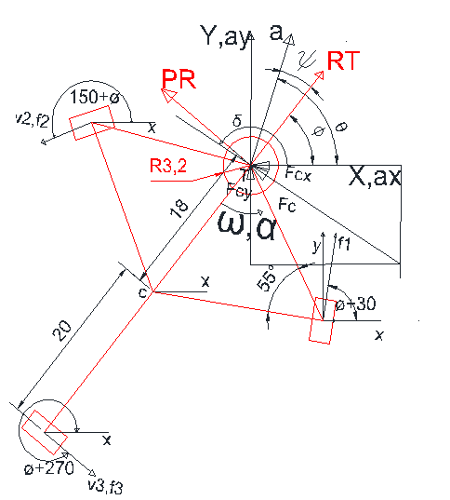
Figure (4.12): dynamics module of robot

4.5.4 Base inertia
Because of all forces effected on the robot which was previously reported, the external forces must be provided to robot and this force resulting from the transformation of torque in the motor into force push the robot by traction of the wheels with material surface as according to the equation.1 and this need suitable friction coefficient between wheel and surface of material.
- The torque of each motor
$\vec{ TLi}$= $\vec{fi}$ $*\vec{r}$ …. Equ.1, Ti: motor torque, r: wheel radius

- The newton second low
$\vec{Fi}$ = M *$\vec{\ddot{U}}$ ….. Equ.2
- Robot mass
M=$\left[\begin{matrix}M & 0 & 0 \\ 0 & M & 0 \\ 0 & 0 & Jz\end{matrix}\right]$ $,\vec{\ddot{U}}=\left[\begin{matrix}ax +{ Fc cos(δ)}/M \\ ay+{Fc\sin{(δ)}}/M \\ α+\frac{Tc}{Jz} \end{matrix}\right]$: global acceleration vector

$\vec{Fi}= \left[\begin{matrix}M & 0 & 0 \\ 0 & M & 0 \\ 0 & 0 & Jz\end{matrix}\right]$ * $\left[\begin{matrix}ax +{ Fc cos(δ)}/M \\ ay+{Fc\sin{(δ)}}/M \\ α+\frac{Tc}{Jz} \end{matrix}\right]$
- Fi: wheel force
- A_{x}: global acceleration X-axis component of
- A_{y}: global acceleration Y-axis component of
- JZ: moment of inertia about Tool Point
- FC: cutting force
- Tc: cutting torque
- α = $\frac{dω}{dt} :$ angular acceleration about tool point
- M: robot mass
- $δ$: The slope angle of cutting path
- The forces on x-axis

$$Fx=\sum_{n=0}^{3}{Fxn}$$
$$Fx = f1\cos{(2\frac{π}{3}-\left(\frac{π}{2}-ø\right))+} f2 \cos{(4}\frac{π}{3}-(\frac{π}{2}-ø)) +f3\cos{(2π-(\frac{π}{2}}-ø)) -Fc cosδ$$
$$Fx =f1cos({\frac{π}{6}+ø)+}f2cos({5\frac{π}{6}+ø)+f3\cos{(7\frac{π}{6}+ø) -Fc cosδ}}$$

- The forces of Y-axis
$$Fy=\sum_{n=0}^{3}{Fyn}$$
$$Fy= f1\sin{(2\frac{π}{3}-\left(\frac{π}{2}-ø\right))}{+} f2 sin⁡(\frac{π}{3}-(\frac{π}{2}-ø)) +f3\cos{(2π-(\frac{π}{2}}-ø)) -FC sinδ$$
$$Fy=f1sin({\frac{π}{6}+ø)+}f2sin({5\frac{π}{6}+ø)+f3\sin{(7\frac{π}{6}+ø) - FC sinδ}}$$
- The moment about tool point
$$Mt=\sum_{n=0}^{3}{Rn.fn}$$
$$Mt =α*Jz= f1\sqrt{300}cos{(55)+} f2 \sqrt{300}\cos{(55}) +f3*38 -Tc$$

The forces can be represented by matrix
F=R *fi …… Equ.3
R =$\left[\begin{matrix}cos({\frac{π}{6}+ø)} & cos(5{\frac{π}{6}+ø)} & cos(3{\frac{π}{2}+ø)} \\ sin({\frac{π}{6}+ø)} & sin(5{\frac{π}{6}+ø)} & sin(3{\frac{π}{2}+ø) } \\ \sqrt{300}cos{(55)} & \sqrt{300}cos{(55)} & 38\end{matrix}\right]$

From equation 1 and 2
TLi =r* $R^{-1}*M* \vec{\ddot{U}}$ …… Equ.4

$$\left[\begin{matrix}TL1 \\ TL2 \\ TL2\end{matrix}\right]= r * {\left[\begin{matrix}cos({\frac{π}{6}+ø)} & cos(5{\frac{π}{6}+ø)} & cos(3{\frac{π}{2}+ø)} \\ sin({\frac{π}{6}+ø)} & sin(5{\frac{π}{6}+ø)} & sin(3{\frac{π}{2}+ø) } \\ \sqrt{300}cos{(55)} & \sqrt{300}cos{(55)} & 38\end{matrix}\right]}^{-1}* \left[\begin{matrix}M & 0 & 0 \\ 0 & M & 0 \\ 0 & 0 & Jz\end{matrix}\right]* \left[\begin{matrix}ax +{ Fc cos(δ)}/M \\ ay+{Fc\sin{(δ)}}/M \\ α+\frac{Tc}{Jz} \end{matrix}\right]$$

Another procedure to evaluate motors torque
- Summation of force on wheel 1
F1=M*((AX+$\frac{FC}{M}*$COS(δ))COS(30+φ))+Ay+$\frac{FC}{M}*$SIN(30+φ))+$\frac{1}{R1}$*((Jz*α)+Tc)

- Summation of force on wheel 2
F2=M*((AX+$\frac{FC}{M}*$COS(δ))COS(150+φ))+Ay+$\frac{FC}{M}*$SIN(150+φ))+$\frac{1}{R2}$*((Jz*α)+Tc)

- Summation of force on wheel 3
F3=M*((AX+$\frac{FC}{M}$COS(δ)(COS (270+φ))+Ay+$\frac{FC}{M}$SIN(270+φ))+$\frac{1}{R3}$*((Jz*α)+Tc)

$$\left[\begin{matrix}TL1 \\ TL2 \\ TL2\end{matrix}\right]= r *\left[\begin{matrix}cos({\frac{π}{6}+ø)} & sin({\frac{π}{6}+ø)} & \frac{1}{\sqrt{300}*cos(55)} \\ cos(5{\frac{π}{6}+ø)} & sin(5{\frac{π}{6}+ø)} & \frac{1}{\sqrt{300}*cos(55)} \\ cos(3{\frac{π}{2}+ø)} & sin(3{\frac{π}{2}+ø)} & \frac{1}{38}\end{matrix}\right] * \left[\begin{matrix}M & 0 & 0 \\ 0 & M & 0 \\ 0 & 0 & Jz\end{matrix}\right]* \left[\begin{matrix}ax +{ Fc cos(δ)}/M \\ ay+{Fc\sin{(δ)}}/M \\ α+\frac{Tc}{Jz} \end{matrix}\right]$$

4.5.5 Friction force
The importance of calculating friction force between Omni-wheels and the sheet surface is to produce enough traction force to acceleration and de acceleration the robot with all louds effected on it, therefore it is important to evaluate the necessary friction coefficient to prevent the Omni-wheels from slipping
F rolling = $\frac{M}{3}$ *g *$\frac{Mr}{r}$ ….. Equ.5
Mr: The dynamic rolling friction coefficient
g: acceleration gravity

4.6 Control algorithm
In order to achieve the desired motion of the robot, the G-cod file which produced from Estlcam software in the global frame with the kinematic relationship which will be explained in kinematic part must be known. To control the angle and speed of motors and wheel that will move the robot according to input.

- Omni wheels
The reference motion for omni-wheels is known as reference angular position $\begin{matrix}θref1 \\ θref2 \\ θref3\end{matrix}$ , reference angular velocity $\begin{matrix}Wref1 \\ Wref2 \\ Wref3\end{matrix}$ but knowing the reference motion is not enough because of disturbance that come from interaction of wheels with material surface which can be expressed as loud torque $\begin{matrix}TL1 \\ TL2 \\ TL2\end{matrix}$ which will be explained in dynamic part.
Stepper motor can operate with both open and close loop control system, each according to the motor use in the system.
With omni-wheels following (angular position $\begin{matrix}θ1 \\ θ2 \\ θ3\end{matrix}$ , angular velocity $\begin{matrix}W1 \\ W2 \\ W3\end{matrix}$ and loud torque $\begin{matrix}TL1 \\ TL2 \\ TL2\end{matrix}$ ) that will be disturbance for controlling each stepper motors.
There are two possible method for controlling these motors either it’s a close loop control system or open loop control system which depend on the desired motion accuracy needed from the system, and in this project because of low operating speed of the system and high accuracy of stepper motor motion, open loop control system is used for motors in this project.
Bipolar series configuration stepper motor, both half of the phases are connected in series, the same motor will produce 40% more torque in the low and mid speed range and four times inductance of the same motor operated in unipolar configuration although the motor has good low speed torque the torque will drop off rapidly at high speed, since this system is operating in low speed and high torque, bipolar series configuration will be used.

- microcontroller
In this system two microcontroller are going to be used, the first microcontroller is going to receive the G-code file that was produced by Estlcam this file will give value of x-y z with direction and the feed rate for the cutting tool, all of these will be output of the first microcontroller and input for the second microcontroller that holds the code for operating this robot it which will take values of x and y as an input and calculate it to step value in order to control the motors more and specific details will be explained later on, and to mention that it will also receive positioning data or pluses from encoder as an input to be included in the code.
As for value of z and feed rate for the tool will be connected directly to the output of the second microcontroller, so it will be sent directly to VFD.

4.7 Controller
Microcontrollers are widely used in embedded systems and make devices work according to needs and requirements, Arduino is a very valuable addition in the electronics it is an open-source platform, means the boards and software are readily available and anyone can modify and optimize the boards for better functionality. The software used for Arduino devices is called IDE (Integrated Development Environment) which it can be programmed using C and C++ language.
4.7.2 Arduino Mega
The controller that is used for receiving Arduino Uno output data with the positioning feedback from sensor, the code that is written to the board will make the robot function according to the input. And it will also be used for shielding. Figure (4.13) shows Arduino Mega 2560 is a Microcontroller board based on Atmega2560.
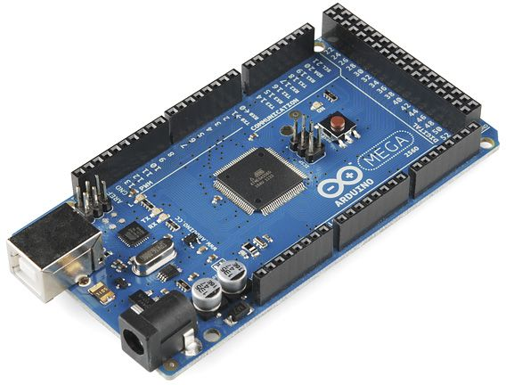

Figure (4.13): Arduino Mega
- There is no much difference between Arduino Uno and Arduino Mega except later comes with more memory space, bigger size and more I/O pins
- There are 54 digital I/O pins and 16 analog pins incorporated on the board that make this device unique and stand out from others.
- Out of 54 digital I/O, 15 are used for PWM.
- A crystal oscillator of 16MHz frequency is added on the board.
- It comes with USB cable port that is used to connect and transfer code from computer to the board.
- DC power jack is coupled with the board that is used to power the board. Some version of Arduino board lacks this feature like Arduino Pro Mini doesn’t come with DC power jack.
- ICSP header is an addition to Arduino Mega which is used for programming the Arduino and uploading the code from the computer.
- It comes with two voltage regulator i.e. 5V and 3.3V which provides the flexibility to regulate the voltage as per requirements as compared to Arduino Pro Mini which comes with only one voltage regulator.
- Uses Arduino software.
- There is a reset button and 4 hardware serial port called USART which produces a maximum speed for setting up communication.
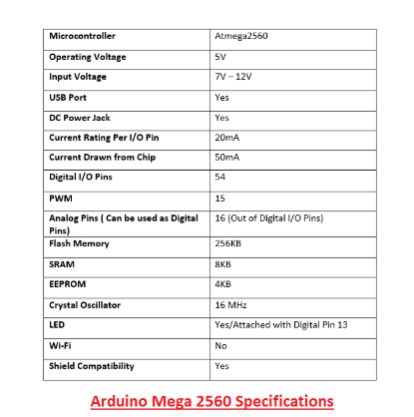

Table (4.1)
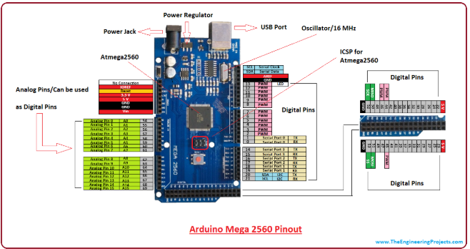Figure (4.14): Arduino Mega pins
Arduino Mega 2560 can be programmed using Arduino Software called IDE which supports C programming.
- The code you make on the software is called sketch which is burned in the software and then transferred to the board through USB cable.
- It comes with a built-in bootloader which rules out the usage of an external burner for burning the code into the board.
- The bootloader communicates using STK500 protocol.
- Multitasking is another feature where Arduino mega has. However, Arduino IDE Software doesn’t support multitasking feature but the use of other operating systems like FreeRTOS and RTX to write C program for this purpose. Gives the flexibility to build the program using ISP connector._{[17]}

4.7.4 Arduino Nano
The controller that is used for receiving the G-code file is Arduino Nano Figure (4.15) which is a small, compatible, flexible and breadboard friendly Microcontroller board, developed by Arduino.cc in Italy, based on ATmega328p ( Arduino Nano V3.x) / Atmega168 ( Arduino Nano V3.x).It comes with exactly the same functionality as in Arduino UNO but quite in small size.
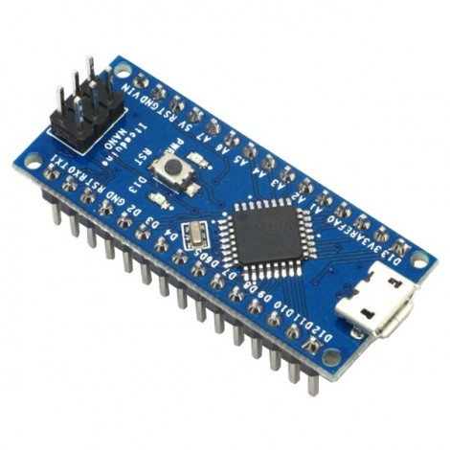
Figure (4.15): Arduino Nano

- It comes with an operating voltage of 5V, however, the input voltage can vary from 7 to 12V
- Arduino Nano Pinout contains 14 digital pins, 8 analog Pins, 2 Reset Pins & 6 Power Pins each of these Digital & Analog Pins are assigned with multiple functions but their main function is to be configured as input or output they are acted as input pins when they are interfaced with sensors, but if its driving some load then they are used as output.
- Arduino Nano comes with a crystal oscillator of frequency 16 MHz. It is used to produce a clock of precise frequency using constant voltage.
- Flash memory is 16KB or 32KB that all depends on the Atmega board i.e Atmega168 comes with 16KB of flash memory while Atmega328 comes with a flash memory of 32KB. Flash memory is used for storing code. The 2KB of memory out of total flash memory is used for a bootloader.
- The SRAM can vary from 1KB or 2KB and EEPROM is 512 bytes or 1KB for Atmega168 and Atmega328 respectively.
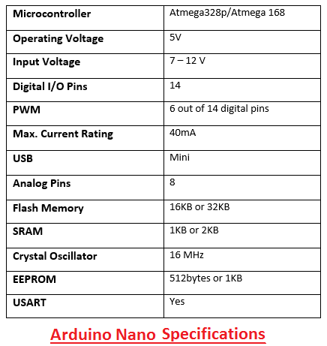
Table (4.2): Arduino nano specification
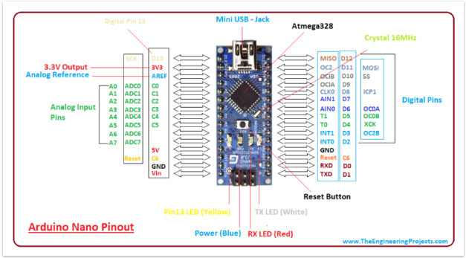
Figure (4.16): Arduino Nano Pins

The Nano device comes with an ability to set up a communication with other controllers and computers.
- The serial communication is carried out by the digital pins like pin 0 (Rx) and pin 1 (Tx) where Rx is used for receiving data and Tx is used for the transmission of data.
- The serial monitor is added on the Arduino Software which is used to transmit textual data to or from the board.
- FTDI drivers are also included in the software which behave as a virtual com port to the software.
- The Tx and Rx pins come with an LED which blinks as the data is transmitted between FTDI and USB connection to the computer, arduino Software Serial Library is used for carrying out a serial communication between the board and the computer
- Apart from serial communication the Nano board also support I2C and SPI communication. The Wire Library inside the Arduino Software is accessed to use the I2C bus, the Arduino Nano is programmed by Arduino Software. _{[18]}

4.8 positioning system
In this project adjusting the robot to its correct position to unsour the perfect motion and result positioning system which will send data to arduino controller for keeping the robot on track with input. After many researching to find the most suitable draw wire incremental encoder with RS485 module was the best option.

4.8.1 Encoder
The draw-wire displacement sensor measure linear movement using a highly flexible steal cable. The cable drum is attached to a sensor element which provide a proportional output signal. Measurement are performed with high accuracy and high dynamic response. [27]
An incremental encoder is coupled to a spring loaded-reel through the use of a mechanical coupling device, internal to the housing of the reel. As the shaft rotates, pulses are evaluated and counted by electronics circuit to determine rotating direction and pulses number. The starting point of the counting can be settable, infinite accumulation and measurement of multiple turns are achievable, when the number of pulses is fixed , by means of A and B signal of 90 degree phase different, the original number of pulses id doubled or quadrupled to increase resolution.
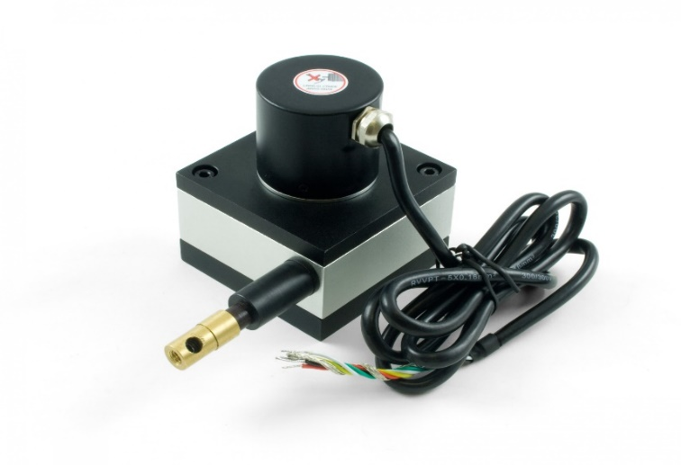
Figure (4.17): wire encoder
The principle of an optical incremental encoder for position measurement an encoder is an electrical mechanical device that convert linear or rotary displacement into digital or pulse signal. The most popular type of encoder is optical encoder, which consists of a rotating disk, a light source and a photo detector (light sensor). The disk, which is mounted on the rotating shaft, has patterns of opaque and transparent sector coded into the disk

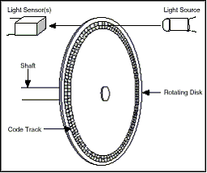
Figure (4.18): encoder structure

As the disk rotates, these patterns interrupt the light emitted onto the photo detector, generating a digital or pules for each incremental step in its rotation. Although the incremental encoder generates does not output absolute position, it can provide high resolution at acceptable pries for example , an incremental encoder with a signal code trick , referred to as a tachometer encoder, generates a pulse signal whose frequency indicates the velocity of displacement. However, the output of the signal-channel encoder does not indicate direction, to determine direction the two channel, or quadrature, encoder uses two detectors and two code tracks.

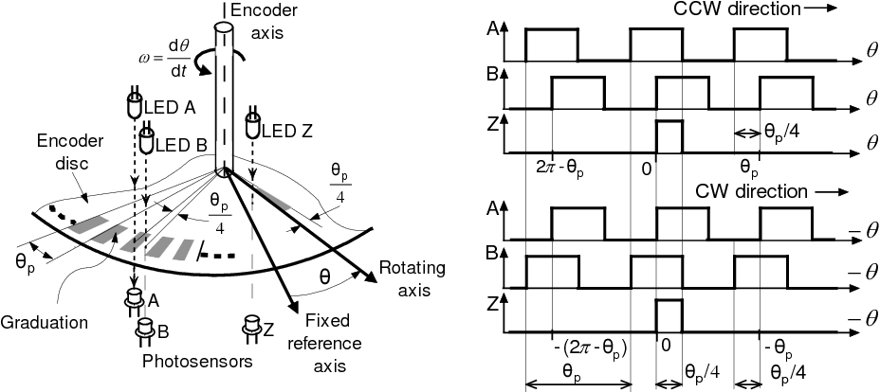
Figure (4.19): incremental encoder output signal [3ى ل=نلنل-
The most common type of incremental encoder uses two output channels (A and B) to sense position. Using two code tracks with sectors positioned 90° out of phase, the two output channels of the quadrature encoder indicate both position and direction of rotation. If A leads B, for example, the disk is rotating in a clockwise direction. If B leads A, then the disk is rotating in a counter-clockwise direction. Therefore, by monitoring both the number of pulses and the relative phase of signals A and B, you can track both the position and direction of rotation.
In addition, some quadrature detectors include a third output channel Z, called a zero or reference signal, which supplies a single pulse per revolution. This single pulse can be used for precise determination of a reference position.

4.8.2 RS485 module
This low power transceiver module is based on the Maxim MAX485 IC to allow serial communication over very long cable runs (up 4000 feet / 1200 meters). Serial data can be transmitted in both directions (half duplex) at a data rate up to 2.5Mbps. The modules operate from a standard 5V power supply and use 5V logic levels allowing them to be interfaced to the hardware serial ports of microcontrollers such as Arduino/PIC etc. Direction of communication can be controlled with just one digital pin. It is also possible to connect multiple modules together for communication between 2 or more devices. For even greater distances two modules can be configured as a repeater. Each module contains one driver and one receiver. Drivers are short-circuit current limited and are protected against excessive power dissipation by thermal shutdown circuitry that places the driver outputs into a high-impedance state. The receiver input has a fail-safe feature that guarantees a logic-high output if the input is open circuit.
Data connections to the modules are provided by a standard 0.1" pitch header pins which can also be soldered into standard prototyping PCB and breadboards. Screw terminals provide convention connection to the actual data cable. [28]
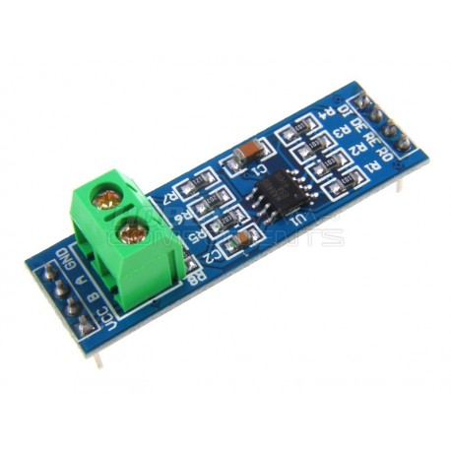

Figure (4.20): RS485 module

4.8.2 Communication & networking between encoder and RS485 module:
This system was made to connect draw-wire encoder with arduino maga that is going to receive the data or pulses from the encoder using RS485 communication all of this to ensure a correct decoding and receiving of data to determine the rotation way and the relative movement, this system was developed since the encoder that is used holds no smart ship (ICU) so there was no possible way to communicate with arduino so RS485 interference was used in order to make that communication possible between this encoder and arduino.
This proposed positioning system structure allows meeting the mapping algorithm that was discussed earlier on this project, that will able the robot to be on the right track of movement changing of it position according to the data that will be given to it through the code.
With the G-code and positioning system the robot will move and function as it desired.

4.9 Software
Estlcam
The software that is used in this system is Estlcam, so what is Estlcam. Estlcam is a CAM software to convert drawings and 3d models into CNC programs for your machine its general workflow consists of 3 steps:
    - First you need a .dxf drawing or a .stl 3d model created by a CAD program of your choice or downloaded from the internet...
    - The second step is processing these files with Estlcam to create a CNC program for your CNC control software...

    - This can then be used to control your machine - either by external software like Mach3, LinuxCNC, WinPC-NC and many more - or alternatively using Estlcams integrated CNC controller. [19]

4.9.1 Tablet
Many possible solutions and thoughts were put into consideration for finding the best interference between the user and the program for easily uploading the drawing to software and sending it to the robot with the ability for user to see the ongoing process as a result to all of these tablet is the perfect option this tablet will be using windows software.
Tablet is a highly portable PC whose primary interface is a touch screen that occupies the full length/width of the device but whose speaker and microphone are not positioned for hand-held calling. In popular perception, however, tablets simply combine the best aspects of smartphones and laptop PCs. [20]

Figure (4.21): table that uses windows

4.10 Modeling and simulation of stepper motors:
Stepper Motors can be defined as DC Motors that can move in discrete steps. They have multiple coils. Each phase is energized in order to provide step by step rotation of motor. Then, highly precise positioning and speed control can be obtained in computer controlled stepping applications. Therefore, stepper motors are the most preferred motors for many precise motion control applications. _{[23]}
Hybrid Stepper Motors are widely used in highly precise position controlled applications such as robotic systems, 3d printers, etc. _{[24].} This type of stepper motors have all features that other types of stepper motors behave. Hybrid stepper motors use disc rotor which is magnetized longitudinal to produce small step angle and low inertia torque.
Therefore, hybrid stepper motors are more costly via according to other type of stepper motors and have more complex structure. _{[21]}

4.10.1 Stepper Motor Modeling
A. Mathematical Modelling
In this section, the mathematical model of a hybrid stepper motor is derived. Figure (4.17) shows the schematic drawing of a simple two-phase hybrid stepper motor with three teeth _{[22].}
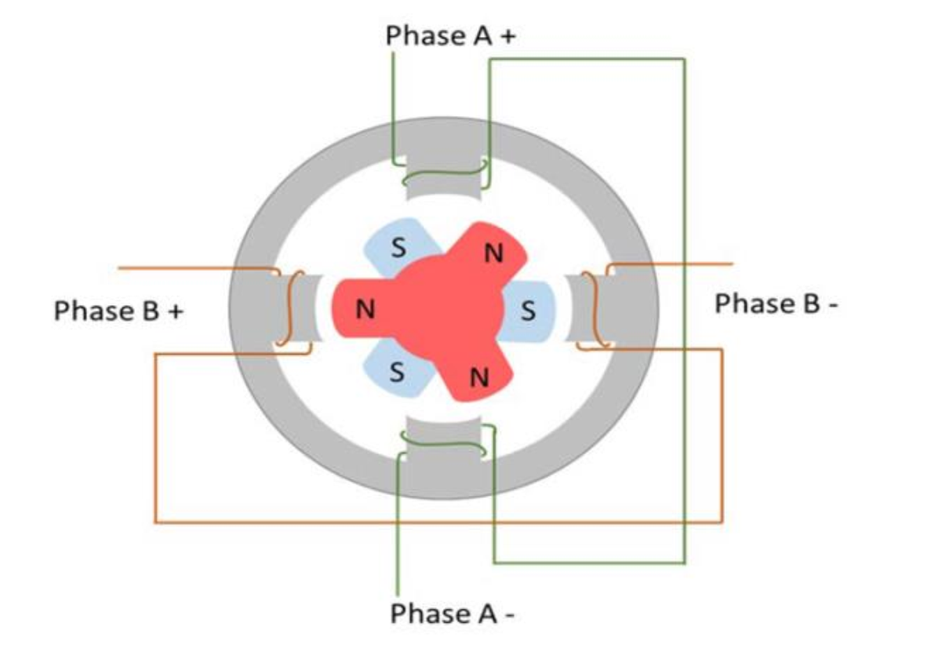
Figure (4.22): Schematic view of a stepper motor with three teeth .
The mathematical model of a stepper model could be divided into two sub-models, electrical model and mechanical model. Starting with the electrical model, each phase of the stepper motor phases could be modelled as an RL circuit plus a back electromotive force (emf) in Figure (4.23) _{[23].}

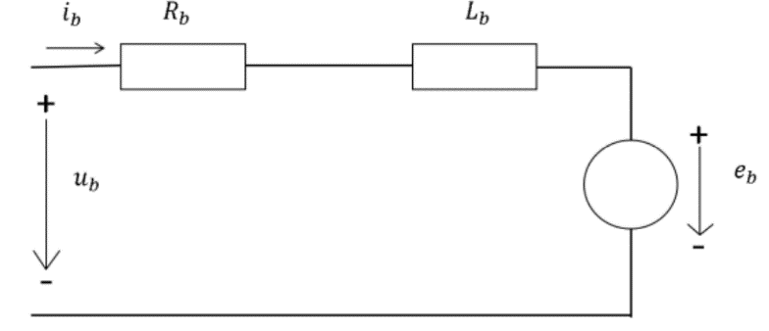
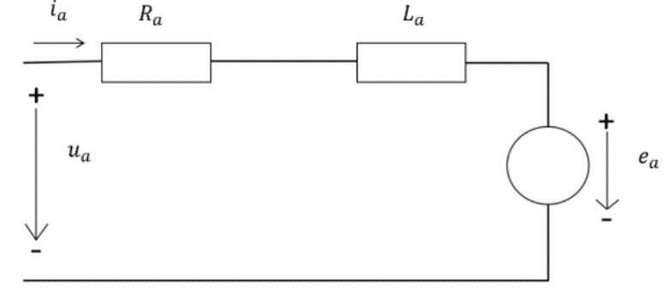
Figure (4.23): The equivalent circuits of hybrid stepper motor.
According to the differential equations of phase a and phase b are given by (1) and (2), respectively, _{[26]}
- L_{a}* $\frac{dia(t)}{dt}$ = -R_{a}*i_{a}(t) –e_{a}(t) +u_{a}(t) …… (1)
- L_{b}* $\frac{dib(t)}{dt}$ = -R_{b}*ib(t) –e_{b}(t) +u_{b}(t) …… (2)
Where e_{a}(t) = K_{m} * w_{m}*sin(p*Θ_{m}) &
e_{b}(t) = K_{m} * w_{m}*sin(p*Θ_{m})
In equation (1) and (2), the phase resistances and inductances are assumed to be equal R[Ω] and L[H]. Moreover, and are the terminal voltages [V], and are the back emf [V], is the motor constant, is the number or motor poles pairs (teeth), is the rotor (mechanical) angular speed [rad/s], and is the rotor (mechanical) angular position [rad].

The differential equation of the mechanical sub-system is given by (3),
- J_{m} $\frac{dwm}{dt}$ = τ_{em} – B*w_{m} – τ_{dm} – τ_{l} …… (3)
Where τ_{em} = K_{m}(-i_{a}*sin(pΘ_{m}))+i_{b}*cos(pΘm) & τ_{dm}= T_{dm}* sin(2pΘ_{m}+α)
In the mechanical model, J_{m} [kg.m2] is the motor moment of inertia, B[kg/s.m] is the motor viscous friction coefficient, τ_{em} [N.m] is the electromagnetic torque, T_{dm} [N.m ] is the detent torque applied, α is the phase shift related to τdm, and τ_{l}[N.m ] is the applied load torque. _{[27]}
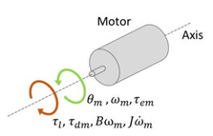
Figure (4.24): The mechanical sub-system of the hybrid stepper motor.

4.10.2 Closed Loop Position Control, PID controller
The behavior of the system as observed by a signal transducer or sensor is compared with the desired or command value of that variable, and the difference or error is sent to a controller, which in turn directs the actuator such that it reduces the error. In complex systems the actuators themselves are imbedded control subsystems, with their own brains, sensors and muscle. In order to control the position of hybrid stepper motor, field oriented control (FOC) method is used in this research. The main idea of FOC is to change the electrical signals from one coordinate to another. This transformation is done to transform these signals from the reference frame linked to stator phases to the rotating frame linked to the rotor to control the produced torque precisely since it is directly related to the current in one of the axis of this new frame [4]. FOC is the most commonly used method to control AC motors especially induction motors. It is used to control the speed and position of the motor by controlling its torque, this controlling technique achieves a very precise response close to DC motors drives. The main advantages of FOC are the very fast transient response and smooth operation. Moreover, according to the literature, this controlling method is used with synchronous machines and stepper motors [4]. According to [4], park transformation is used to transform the electrical model from a and b frame to d and q frame. The new transformed electrical model is given by (4) and (5). _{[24]}
L $\frac{did}{dt}$= - Ri_{d} + pLi_{q}w_{m} + u_{d} …… (4)
L $\frac{diq}{dt}$= - Ri_{q} - pLi_{d}w_{m} + u_{q} – K_{m}w_{m} …… (5)
As can be seen from (4) and (5) the currents and are coupled, [4] proposed a method to decouple them, the new electrical decoupled and linear system is given by (6) and (7)._{[27]}
- L $\frac{did}{dt}$= - Ri_{d}+u_{d}^{lin} …….. (6)
- L $\frac{diq}{dt}$= - Ri_{q}+u_{q}^{lin} …….. (7)
In order to achieve this decoupling, the electrical drive system adds the quantities u_{d}^{dec} and u_{d}^{dec} to the desired u_{d}^{lin} and u_{q}^{lin}. The equations of these two quantities are given by (8) and (9). _{[10]}
- u_{d}^{dec} = -Lpw_{m}i_{p} …….. (8)
- u_{q}^{dec} = Lpw_{m}i_{d} + K_{m}w_{m} .…….. (9)
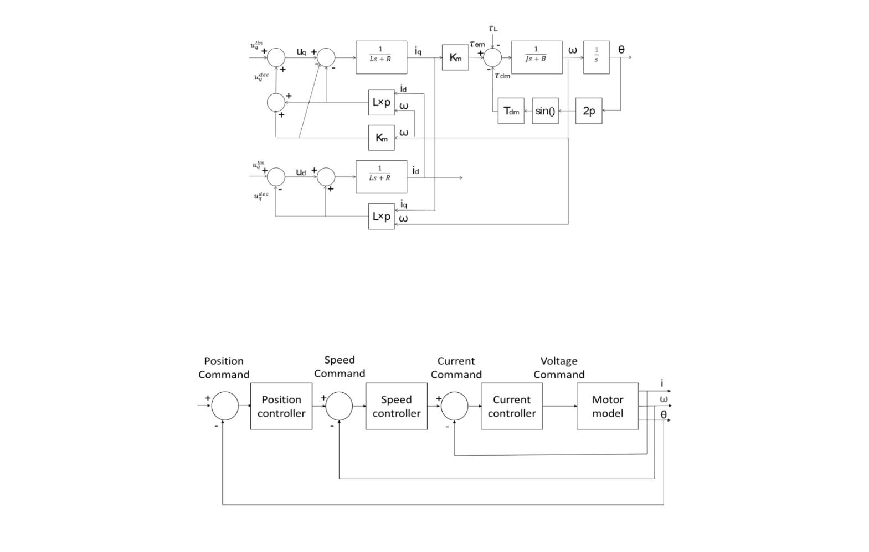
The block diagram of the decoupled system with the electrical drive subsystem, electrical subsystem in d and q frame, and the mechanical subsystem is shown in Figure (4.27). _{[23]}

Figure (4.25): Block diagram of decoupled stepper motor.

Now, the configuration of the motor closed-loop drive system mentioned in [6] is considered in this research. In this configuration, three controllers are required, one for the position, the other for the speed and the third one for the current. The most inner loop is the current controller loop and it has the largest bandwidth. The most outer loop is the position control loop. Figure (4.26) shows the block diagram of this control configuration. _{[24]}

Figure (4.26): Closed loop control system of stepper motor.

4.10.3 Simulink Model
For the bipolar stepper motor studied in this research, the model block diagram which has the mechanical subsystem, d-phase electrical subsystem and q-phase electrical subsystem and two control loops; position loop, speed loop with three controllers is shown in Figure (4.22). 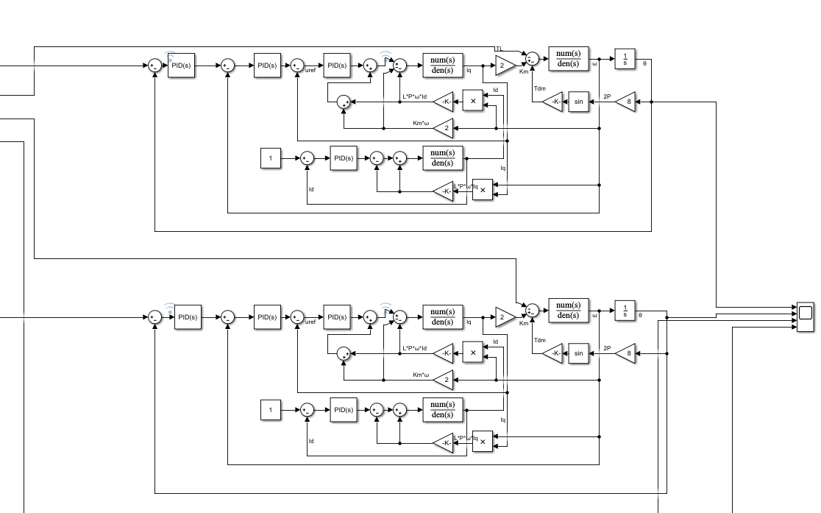
Figure (4.27): Speed loop controller

Since four PID controllers are required to control this system, subsystems for these controllers are built. _{[27]}
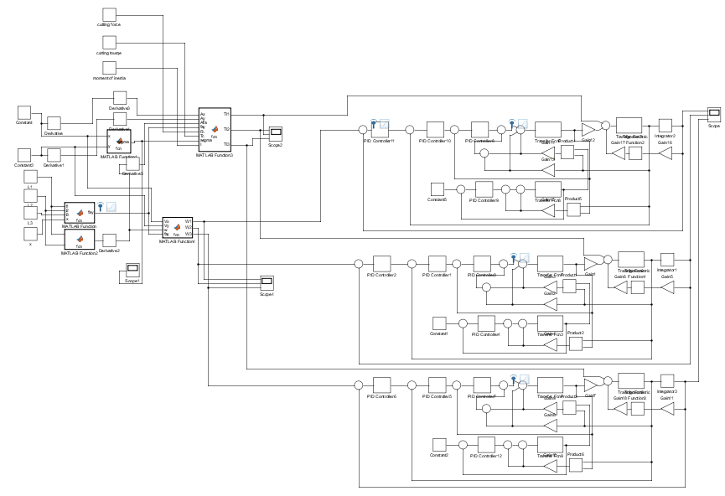
Figure (4.28): Electrical subsystem
This part assumed that a small differential steps took from the GRBL code from Arduino and applied to the inputs of the system represented by Θ₁, Θ₂, Θ₃. Figure (4.29.1) shows the unit step input driven to the system Θ₁, Θ₂, Θ₃.
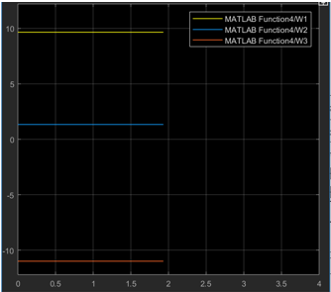

Figure (4.29.1): Unit step input driven to system
Figure (4.29.2) shows the response of the stepper motors after compensating with Zegeler Nichols method of choosing the PID, the response shows the wheels angels of motions after applying a step input.
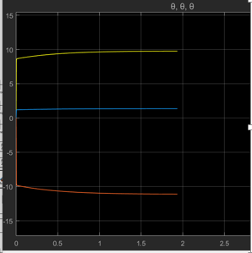
Figure (4.29.2): response after compensating

4.11 Code
So in this project a special code was formed to control this system, it take Ɵ and direction as an input this method was mentioned earlier on, so it can be implemented in the equations that was produced based on specific calculations, after that the output of this matrix will be reformed as step value by dividing output value by full step value of motor which equal to (1.8),the cumulative method was used which is formatted by adding plus by plus thus each ten pulses were taken to be executed at ones each time, another thing was taken into consideration is if any produced step was not full it will be held to be added in the next step and as a result no step will go to waste. The direction is also not forgiven since it was taken in consideration in the equations.
Firstly as it can be seen here the necessary variables where defined with the needed libraries:
unsigned long time;
#include<Math.h>
#include<Process.h>
#define CHK(x,y) (x & (1<<y))
double L1;
double L2;
double L3;
int count = 0;
double Dx ; //from ESTL
double Dy ;
double Dz ;//from ESTL
int valx=0 ; //from ESTL
int valy=0 ;
int valz=0;//from ESTL
float step1=0;
float step2=0;
float step3=0;
float t = 0;// present direction for y
float r = 0;
float n = 0;// present direction for z
float t1 = 0;
float t2 = 0;
float t3 = 0;
int Y=0;//value of y after 50time
int X=0;//value of x after 50time
int Z=0;
const double leng1 = 18 ; //distance between center of robot and tool
const double leng2 = 120 ; // distance between references x
float consttimeexc = 3750 ;
float number=0.0;

Secondly the pin mode for each motor was defined and the suitable baud rate was selected:
void setup() {
Serial.begin (57600);
pinMode (7, OUTPUT); // motor1
pinMode (8, OUTPUT); // motor2
pinMode (9, OUTPUT); // motor3
pinMode (10, OUTPUT); // motor Z
pinMode (3, INPUT); // Dy
pinMode (4, INPUT);// Dx
pinMode (5, INPUT);// valx
pinMode (6, INPUT); // valy
pinMode (11, OUTPUT);// valz
pinMode (12, OUTPUT);
}
Thirdly the code started with instruction to make the process of arduino faster since the Esltcam is quiet fast to make sure nothing from the data received is messing, after that the data will be performed in the equations with no forgetting to check the direction hence it can be also performed in the equations, the next step after is taking the output of these formulas and converting it to steps as it was mentioned earlier and not forgetting to perform the methods that was also mentioned earlier.
void loop() {
X=0;
Y=0;
float theta = PI/2;
float fay = PI/2;
float Psi =(-PI/3) ; // the angel of moving for the robot
for(int i=0;i<10;i++) {
Dx=digitalRead (3);
Dy=digitalRead (4);
if (Dx > 0.5){r = -1;}
else if (Dx<=0.5) {r=1;}
if (Dy > 0.5){t = -1;}
else if (Dy<=0.5) {t=1;}

valy=digitalRead(5);
valx=digitalRead(6);
if (valy ==1){Y++;}
if (valx ==1){X++;}
}
float val1 ;
float val2;
float val3;
val1 =((1/0.0623)*(X*r*cos((PI/6)+fay)) +(2.2*Y*t*sin((PI/6)+fay)) +(18*tan(Psi)));
val2 =((1/0.0623)*(X*r*cos((5*(PI/6))+fay))+(2.2*Y*t*sin((5*(PI/6))+fay))+(18*tan(Psi)));
val3 =((1/0.0623)*(X*r*cos((3*(PI/2))+fay))+(2.2*Y*t*sin((3*(PI/2))+fay))+(45*tan(Psi)));
float step1 = 0 ;
float step2 = 0 ;
float step3 = 0 ;
step1 = ((step1 + val1)) ; // the value of theta at it is
int mod1 = (int)step1; // convert theta to full steps
float t1 = step1 - mod1;
step1 = mod1;
for(double i=0;i<abs(step1/1.8);i++){
if (step1< 0){digitalWrite(10,LOW);}
else if (step1>=0) {digitalWrite(10,HIGH);}
digitalWrite(7,HIGH);
delayMicroseconds(200);
digitalWrite(7,LOW);
delayMicroseconds(200);
}
step2 = (step2 + val2) ;
int mod2 = (int)step2; // convert theta to full steps
float t2 = step2 - mod2;
step2 = mod2;
for(double i=0;i< abs(step2/1.8);i++){
if (step2 < 0){digitalWrite(11,HIGH);}
else if (step2 >=0) {digitalWrite(11,LOW);}
digitalWrite(8,HIGH);
delayMicroseconds(200);
digitalWrite(8,LOW);
delayMicroseconds(200);
}
step3 = (step3 + val3);
int mod3 = (int)step3; // convert theta to full steps
float t3 = step3 - mod3;
step3 = mod3;
for (double i=0;i<abs(step3/1.8);i++){
if (step3 < 0){digitalWrite(12,HIGH);}
else if (step3>=0) {digitalWrite(12,LOW);}
digitalWrite(9,HIGH);
delayMicroseconds(200);
digitalWrite(9,LOW);
delayMicroseconds(200);
}
}

Chapter 5
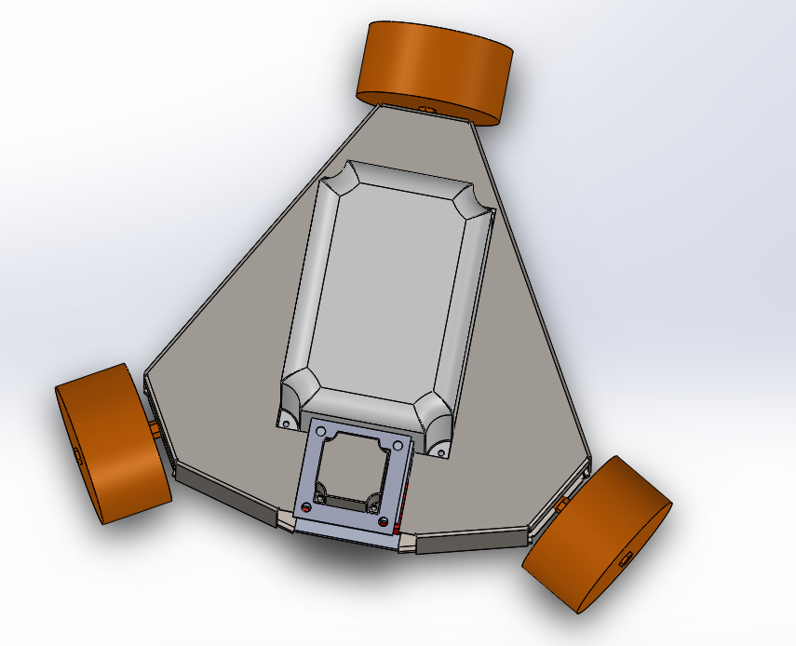

Shape of AXELO
5.1 Introduction :
This chapter show the final rustle of Axelo Robot body (shape)
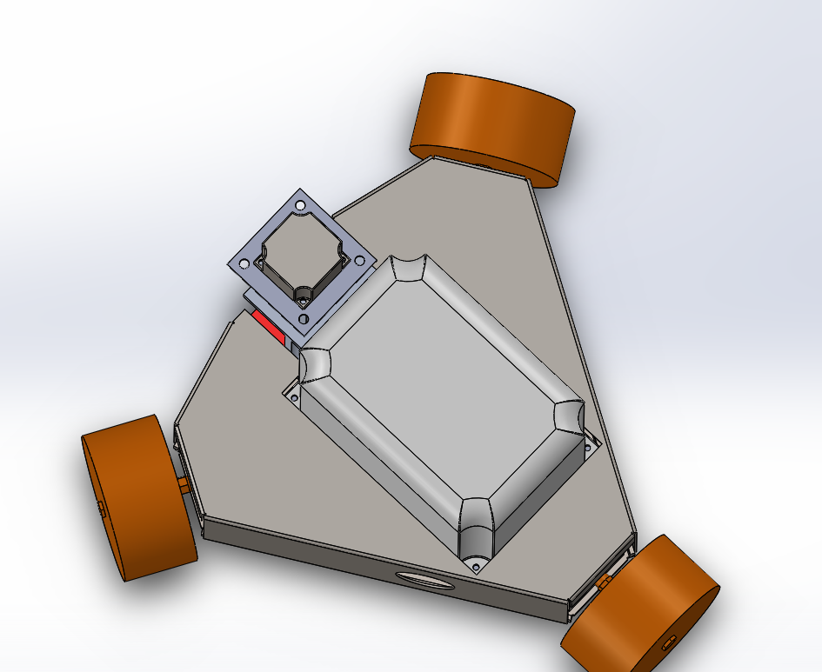

Figure (5.1): Axelo shape using solid
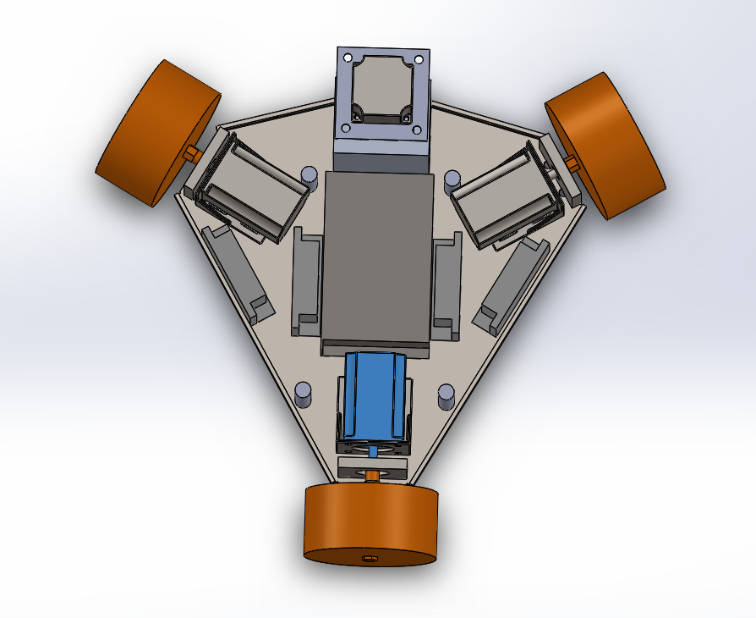

Figure (5.2): Axelo shape without the outer cover

Chapter 6


Non-Technical issues
6.1 cost analyses
In this project, it was decided that some of the components will be bought from Jordan (Amman) as it happened in the first semester since it was available, and as for the other component it was bought from china.
In this table it shows the components, quantity and its price online with the total cost.
product name | model no. | quantity | price($)/psc
1.5KW air-cooled spindle 110/220V+ Huanyang frequency converter + ER11 (1-7mm) |  | 1 | 162
Pull wire encoder displacement 600puls | ST5909X2508-A | 3 | 87
Linear Slider | YR-90G-P10-L300-C9 | 1 | 59
omni wheel | ROTACASTER R3-125mm-85A-19hexa bore- omnidirectional | 3 | 180
stepper motor driver | 1Pc Motor Driver 4.0A 42V DC 42/57/86 Pace Microstep Driver | 4 | 40
grooving and cutting tools (6mm-12mm) | FXC-99 | Min order(10) | 30
miling aluminum tool (2mm-12mm) | B BKSE | Min order(10) | 30
90 Degree HSS Chamfer Cutter End Mill Drill Mil | 6.3MM: 6.3mm*5mm*37mm | 1 | 26
shaft & keyway | 18mm*60mm | 3 | 42
Stainless sheet metal | 3mm/1.5mm | 1 | 55
Power supply 12V/10A |  | 2 | 27
Screw and nuts | 5mm/4mm *10mm | 50 | 7
Rs485 module |  | 1 | 6.90
Tablet with windows software |  | 1 | 125.35
Total price |  | 919.25$
Table (5.1)

The table below shows component that was bought in first semester
product name | model no. | quantity | price($)/psc
Arduino CNC shield v3.10 GRBL compatible |  | 1 | 16.92$
stepper motor drives | MP6500 | 4 | 7.05$
Nano V3.0 ATmega328P Controller Board for Arduino | BLUE 242392201 | 2 | 14.41
for Arduino Android IOS HM-10 BLE Bluetooth 4.0 CC2540 CC2541 Wireless Module SP | HM-10 CC2540 CC2541 | 4 | 18.33
stepper motor driver carrier (ramp.14 shield) | 3DP-00065 | 1 | 21.15
 |  |  | $168.41
Table (5.2)
Total price $168.41 with no shipping added, Shipping will cost up to 100$
So in total the whole project has coasted the following price = 1087.66$
6.2 Ethics and environment
Axelo CNC robot takes environment into consideration, it has a minimal effect and hazard on the environment with no chemical waste since it only uses electricity no fuel or other chemical is used. It also has no radiation and most importantly it is safe for human use.
In this project there was no Plagiarism every source that the information was gathered from was mentioned for its credit.
And also the mention of a similar robot to Axelo is Goliath CNC robot which is a portable robot that mills, cuts, and engraves any materials, Goliath comes with a patented sensor system, which triangulates the position of the robot, it can carves out pockets or drills large holes and is also have the change of orientation feature, it was developed by Springa company. _{[26]}

Chapter 7
Conclusion
Robots are taking a huge part in technology and industry, making it changes the use of conventional machine in to intelligent robot.
For this robot a special study was created and the optimum component was chosen to meet the specification of this system, this system like any CNC takes CAD/CAM file to create any shaped material.
This project changes the fixed shaped CNC machine into a portable, small sized CNC robot because of this advantages of Axelo it can be used in any place unlimited size plates of the material.

Reference
[1] J.R. Walker,(2000),Machining Fundamental from basic to advance, the Goodheart-willcox Inc., library of congress card.
[2] Alucobond Alucore,(2018), Retrieved November 30, 2018 from http://alucobond.com.sg/products/alucobond/product-properties
[3] P.smid,2003, CNC programming handbook second Edition ,Avenue of America , New York .
[4] PhD P. Groover,(2002), Automated & Production system, Department of Industrial engineering, Lehigh university.
[5] S. Killoilgh, and F. Pin," Design of an Omnidirectional and Holonomic Wheeled Platform Prototype", Proc. IEEE Int. Conf. on Robotics and Automation, pp. 84-90, France, 1992.
[6] Prof. Robert L.mott (2013)," machine elements design'', The University of Dayton, 5th ED, Prentice Hall
[7] Bill, Earl. (2014). what is stepper a motor. Retrieved November 20, 2018 from https://learn.adafruit.com/all-about-stepper-motors/what-is-a-stepper-motor.
[8]DFrobot, TB6600 Stepper Motor Driver SKU DRI0043, (n.d), Retrieved April 18 2019 from https://wiki.dfrobot.com/TB6600_Stepper_Motor_Driver_SKU__DRI0043
[9]VDS.com, what is a VDF,(2017), Retrieved April 18 2019 from https://www.vfds.com/blog/what-is-a-vfd
[10] Meridian laboratory- polyurethane durometer,(2017), Retrieved December 1 2018 from https://www.meridianlab.com/ml6-precision-polyurethane/durometer-information/
[11] Richard C. Dorf, Robert H. Bishop,(2011), modern control system,12th edition, Prentice Hall
[12] K. J. Åström and R. M. Murray, (2004), Analysis and Design of Feedback Systems, Preprint.
[13] VaNCE J. VANDOREN,(2003),Loop Tuning Fundamentals, Retrieved November 22 2018 from https://www.controleng.com/articles/loop-tuning-fundamentals/
[14] Babu Joseph, Coleman Brosilow,(2002), Techniques of Model-Based Control
[15] J.O. Wallgrün,(2010), Hierarchical Voronoi Graphs: Spatial Representation and Reasoning for Mobile Robots
[16] Szabolcsi Róbert,(2009), MODELLING OF DYNAMICAL SYSTEMS, IV. Évfolyam szám.
[17] Adnan Aqeel,(2018), introduction to Arduino Mega, Retrieved December 4 2018 from https://www.theengineeringprojects.com/2018/06/introduction-to-arduino-mega-2560.html
[18] Adnan Aqeel,(2018), introduction to Arduino Nano, Retrieved December 4 2018 from https://www.theengineeringprojects.com/2018/06/introduction-to-arduino-nano.html
[19]Eslcam, Retrieved April 20 2019 from https://www.estlcam.de
[20] Lenovo, what is a tablet pc,(n.d), Retrieved April 20 2019 from https://www.lenovo.com/gb/en/faqs/laptop-faqs/what-is-a-tablet-pc/
[21] A. Morar, “Stepper motor model for dynamic simulation”, University of Targue-Mures, vol. 44, no. 2, pp. 117- 122, June
2003.
[22] K. M. Le, H. Van Hoang and J. W. Jeon, “An Advanced ClosedLoop Control to Improve the Performance of Hybrid Stepper
Motors”, IEEE Transactions on Power Electronics, vol. 32, no. 9, pp. 7244-7255, Sep. 2017
[23] M. Aydin, “Stepper Motors”, Lecture Notes, Kocaeli University Mechatronics Engineering Department , May 2017.
[24]Ruilope R. P., “Modelling and Control of Stepper Motors For High Accuracy Positioning System Used in Radioactive Environments”,Thesis, Politechnical University of Madrid, 2014.
[25] Recent Innovations in Mechatronics (RIiM) Vol. 5. (2018). No. 1. DOI: 10.17667/riim.2018.1/7
[26] Goliath CNC - An Autonomous Robotic Machine Tool for Makers,(2018), Retrieved December 7 2018 from https://www.kickstarter.com/projects/2130625347/goliath-cnc-an-autonomous-robotic-machine-tool-for/description
[27] Roundss ,(n.d), retrieved April 24, 2019 from http://www.roundssencoder.com/pro_dr.asp?fbclid=IwAR037sYGhNf737rqUtc2fWMnZyJvMCbUf9n9vn5eO_27dkuMAaIevoEJj6g
[28]Hoppy components, (2018), Retrieved April 28 2019 from https://hobbycomponents.com/wired-wireless/663-max485-rs485-transceiver-module

