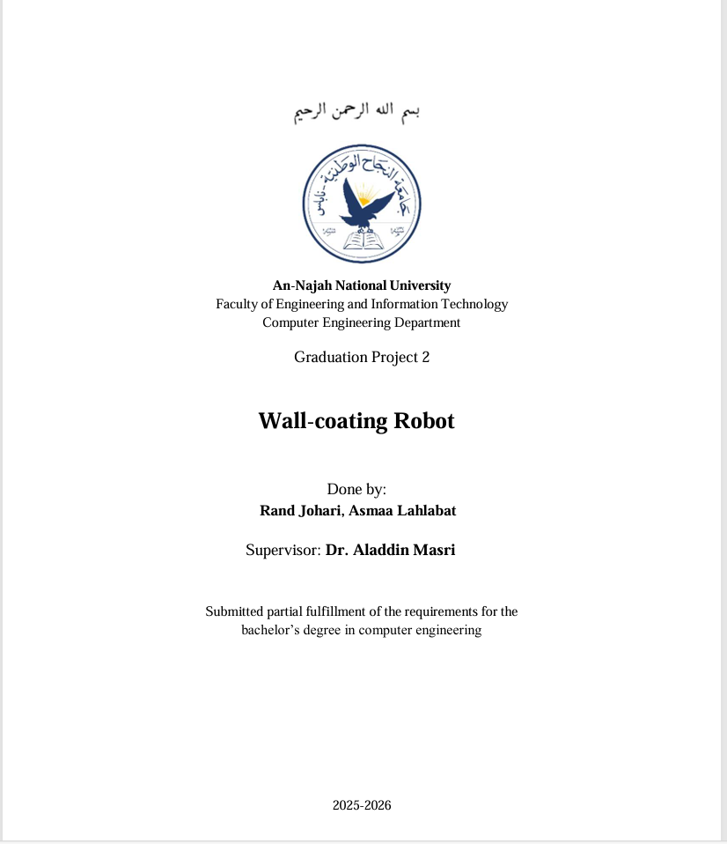
Abstract
This project presents the design and development of a wall-painting system that aims to improve efficiency, consistency, and safety in wall-coating tasks. The robot automates key parts of the process by using sensors and control logic to detect paintable surfaces, plan coverage paths, and apply paint with minimal human intervention. The work focuses on achieving reliable and repeatable motion, reducing manual effort and rework, and maintaining good coating quality. The system is tested and tuned to evaluate coverage uniformity, operational stability, and ease of use. Although commercial robotic painting solutions exist, this project represents a novel and practical student implementation in our department and serves as a step toward smarter and more automated painting workflows

