

Computer Engineering Department

Software Graduate Project


Students:
Ahmad Hussein
Oday Yamak

Supervisor:
Dr. Oula Mardawi

Acknowledgment
First and foremost, we would like to express our heartfelt gratitude to Dr. Ola Mardawi for her invaluable guidance, unwavering support, and expertise throughout the development of this project. Her insightful feedback and constant encouragement have been instrumental in shaping this work, and we are truly grateful for the opportunity to learn and grow under her mentorship.
Finally, we extend our deepest appreciation to our families and friends for their continuous support, encouragement, and motivation during this academic journey.

Abstract
FashionHub is a smart web-based e-commerce platform designed to provide a modern and interactive clothing shopping experience for users while supporting efficient management for administrators and employees. The system enables customers to browse and purchase fashion products, write reviews, and includes a tracking system for both orders and products to ensure accurate monitoring and better management. In addition, FashionHub introduces advanced features such as T-shirt design customization and virtual try-on to enhance user engagement and improve decision-making during shopping. The platform supports multiple user roles, including admin, employee, and customer, with role-based access control to ensure secure and organized operations. Users can sign up and sign in using email authentication, reset forgotten passwords through email verification, and explore products as guests without creating an account. FashionHub is developed using React for the front end and Node.js with MongoDB for the backend, providing a scalable and responsive architecture. The system also includes essential security mechanisms such as password salting and supports key testing practices such as GWT, ensuring reliability and maintainability for future development.
.
Table of Contents
- Introduction 5
- Constraints & Earlier Work 5
  - Constraints 5
    - Technological Constraints 5
    - Resource Constraints 5
    - Operational Constraints 6
    - User Experience Constraints 6
  - Constraints 5
    - Earlier Work 6

- Literature Review 7
  - E-commerce Platform Evolution (UX & Checkout) 7
  - Virtual Try-On in Online Apparel Shopping 7
  - Interactive Product Customization (Studio Design) 7
  - Real-time Communication in E-commerce (Chat & Live Support) 8
  - Architecture Choices for Scalable E-commerce Backends 8
  - Database Technologies for E-commerce Workloads 8
  - Authentication and Security (Salting, Hashing, JWT) 8
  - Research Gaps and Opportunities 8
- Methodology 8
  - Technology Stack Selection 8
    - Frontend Technologies 9
    - Backend Technologies 9
    - Database Technologies 10
    - Development Tools and Frameworks 10
    - Authentication and Security Technologies 10
  - Discussion of Results 11
    - Achievement of Project Objectives 11
  - Future Work and Recommendations 12
    - Technical Enhancements 12
    - Feature Expansion 12
- User-Friendly Interface 12
5.1 Web Site 12
5.1.1 Log in Page 12
5.1.2 Visitors & Customers Side 17
5.1.3 Customers Side 19
5.1.4 Admin Side 31
5.1.5 Employee Side 40
5.2 Mobile Application 53-58

- Conclusion 59

List of Figures

• Figure 1: Login page showing email/password sign-in with “Forgot password” and Google OAuth sign-in option.
• Figure 2: Sign-up page for creating a new account with user details, password confirmation, and Google OAuth registration option.
• Figure 3: Forgot Password page allowing users to request a password reset link by entering their email address.
• Figure 4: Confirmation screen indicating that the password reset link has been sent to the user’s email address.
• Figure 5: Password reset email received in Gmail containing a “Reset Password” button and a secure reset link to complete the password recovery process.
• Figure 6: FashionHub homepage hero slider highlighting a featured collection with a call-to-action button for quick shopping.
• Figure 7: Home page “New Collection” section displaying the latest arrivals in a product carousel/grid for quick browsing.
• Figure 8: Home page section highlighting the Virtual Try-On feature with a direct call-to-action button to start the experience.
• Figure 9: Home page collections section showcasing categorized product listings (Men’s, Women’s, and Kids) with quick access to items and “View All” navigation for each category.
• Figure 10: Featured Collection section on the home page highlighting selected products with a “View All Products” call-to-action.
• Figure 11: Customer Testimonials section on the home page displaying user ratings and feedback cards.
• Figure 12: Home Page (Language, Region & Dark/Light Mode Settings)
• Figure 13: Home Page Product Search Popup (Quick Search Dialog).
• Figure 14: Shopping Cart Page (Empty Cart State).
• Figure 15: Shop Collection Page (Product Listing with Search, Filters, and Category Navigation)
• Figure 16: Exclusive Sales page highlighting discounted products available in the sale section.
• Figure 17: Contact Us page providing store contact information and a message form for customer inquiries and support
• Figure 18: Customer account dropdown menu.
• Figure 19: My Designs page for managing saved studio designs.
• Figure 20: Customer Profile page (My Account).
• Figure 21: Orders tab in the My Account page
• Figure 22: My Account – Designs Tab
• Figure 23: My Account – Addresses Tab
• Figure 24: My Account – Settings Tab
• Figure 25: Product Details Page
• Figure 26: Shopping Cart Page
• Figure 27: Checkout Page
• Figure 28: Order placement in progress.
• Figure 29: Stripe Card Payment Page
• Figure 30: Order Success Confirmation Page
• Figure 31: Leave a Review Form
• Figure 32: Design Studio (Product Customization Workspace)
• Figure 33: Virtual Try-On Page
• Figure 34: Admin Dashboard Overview
• Figure 35: Admin Analytics dashboard.
• Figure 36: Admin Reports Page
• Figure 37: Admin Settings Page
• Figure 38: Admin Products page
• Figure 39: Add New Product Form (Admin).
• Figure 40: Admin Studio Products page
• Figure 41: Add Studio Product Form
• Figure 42: Admin Orders management page
• Figure 43: Order Details pop-up window in the Admin Orders page
• Figure 44: Admin Order Tracking page showing the tracking list for all customer orders.
• Figure 45: Customers management page in the Admin Dashboard.
• Figure 46: Reviews moderation page in the Admin Dashboard.
• Figure 47: Staff Management page in the Admin Dashboard.
• Figure 48: Staff Chat page in the Admin Dashboard
• Figure 49: Virtual Try-On Products management page (Admin Side).
• Figure 50: Home Slider management page
• Figure 51: Edit Slider form.
• Figure 52: Employee Dashboard Overview
• Figure 53: Orders Management
• Figure 54: Order Details (Employee)
• Figure 55: In-Progress Orders (Employee)
• Figure 56: Completed Orders Tab
• Figure 57: Manufacturing Progress
• Figure 58: Add New Product (Employee Panel)
• Figure 59: Add Studio Product (Employee Panel)
• Figure 60: Customers List (Employee Panel)
• Figure 61: Staff Chat (Employee Panel)

Introduction
In the digital age, online shopping has become a major part of everyday life, especially in the fashion industry where customers seek convenience, variety, and quick access to the latest trends. However, many online clothing stores still face limitations such as low interactivity, difficulty in choosing the right style, and a lack of engaging customer experience. At the same time, managing clothing products, customer accounts, and orders efficiently requires a well-structured and secure system.
FashionHub was developed to provide a modern online clothing platform that enhances the shopping journey for customers and supports smooth management for employees and administrators. The platform focuses on delivering an improved user experience through interactive and practical features that make fashion shopping easier and more enjoyable. By offering a reliable and scalable solution, FashionHub aims to support the growth of online retail and deliver a complete e-commerce experience in today’s competitive market.

Constraints & Earlier Work

Constraints

Technological Constraints

Compatibility: Ensuring the platform works reliably across modern browsers and devices, including camera support for the Try-On feature.
Performance: Maintaining smooth performance for the storefront and dashboards, and handling heavier features such as Studio customization and real-time chat.
Security: Protecting user accounts and data, and securing checkout and payment transactions through safe authentication and Stripe verification

Resource Constraints

Time: Limited development time, requiring efficient implementation and reuse of components across the store, admin, partner, and employee panels.

Operational Constraints

Scalability: Designing the backend and database to handle increasing traffic, orders, and concurrent users, including real-time messaging connections.
Deployment & Configuration: Managing environment setup (API URLs, database, Stripe keys), CORS/HTTPS requirements, and stable operation across frontend/backend services.

User Experience Constraints
Usability: Ensuring the shopping flow, checkout, Studio customization, and partner/admin dashboards are intuitive for both customers and staff users.
Accessibility: Making the interface readable and easy to navigate for users with different technical levels and devices, with clear guidance when permissions (e.g., camera) are not available

Constraints

Earlier Work
The fashion e-commerce domain is highly mature, and several well-known platforms such as SHEIN, ASOS, and Zara have set strong standards for online clothing shopping. These platforms provide large product catalogs, filtering and search, size guides, discounts, and efficient order handling. However, most mainstream fashion stores focus mainly on product browsing and purchasing, with limited support for deep customization of clothing items by the customer.

Before Fashion Hub, many fashion businesses relied on ready-made e-commerce solutions or fashion-oriented storefronts. While these systems help with product listings, carts, and checkout, advanced capabilities such as interactive clothing design (Studio customization), camera-based virtual try-on, and real-time communication between staff members and administrators are often not built-in and usually require external tools, plugins, or additional development effort. This reduces flexibility and increases cost and complexity, especially for teams aiming for a unified, integrated experience within one platform.

Literature Review

E-commerce Platform Evolution (UX & Checkout)

The evolution of e-commerce platforms has been widely discussed in academic research, with a strong focus on improving usability and reducing friction in checkout. Butnampetch et al. [1] studied checkout usability across e-commerce and mobile commerce and showed that usability issues in checkout significantly impact user success and completion of purchases. In addition, recent marketing research highlights that cart and checkout abandonment are complex behaviors influenced by both platform design and the customer journey, reinforcing the importance of clear flows and feedback in modern stores like Fashion Hub [2].

Virtual Try-On in Online Apparel Shopping

Virtual try-on (VTO) has become a major research topic in fashion e-commerce because it can reduce uncertainty about appearance and fit. Kim and Forsythe [3] investigated VTO adoption in online apparel shopping and showed that both functional value (usefulness) and hedonic value (enjoyment) influence user acceptance and repurchase intention. More recently, Chen et al. [4] conducted a systematic review of VTO systems in fashion consumption and identified key factors shaping adoption and purchase-related outcomes, supporting Fashion Hub’s inclusion of camera-based try-on as an engagement-enhancing feature.

Interactive Product Customization (Studio Design)

Product customization is frequently studied as a way to increase engagement and customer-perceived value. Ettis and Sellami [5] found that interactivity and telepresence increase users’ flow state during customization, which improves perceived value and positively influences purchase intention and revisit behavior. This supports Fashion Hub’s Studio feature (designing t-shirts/hoodies) as a method to improve user involvement and strengthen the shopping experience beyond standard product browsing.

3.4 Real-time Communication in E-commerce (Internal Staff Communication)
Real-time communication is increasingly integrated into e-commerce platforms to improve internal responsiveness and coordination between administrators and staff. Murley et al. [6] analyzed the real-time web ecosystem and highlighted WebSocket adoption along with common security and implementation pitfalls, which is directly relevant to Fashion Hub’s Socket.IO–based internal staff chat system. Rather than focusing on customer-facing live support, this form of communication supports operational workflows such as order handling, issue resolution, and internal coordination. In addition, Almas et al. [7] provide empirical evidence that timely real-time communication improves organizational efficiency and service quality in e-commerce environments, reinforcing the value of admin–staff chat features for internal support and platform management.

3.5 Architecture Choices for Scalable E-commerce Backends

E-commerce backends must handle growing user traffic, concurrent sessions, and order processing reliably. Recent research emphasizes that service-oriented approaches (including microservices) can improve scalability, resilience, and maintainability when applied with correct API design and data consistency strategies. A recent Springer chapter discusses how microservices practices can enhance scalability and fault isolation in e-commerce environments [8], which informs architectural decisions even when implementing a modular API (as in Fashion Hub’s Express-based backend).

Database Technologies for E-commerce Workloads
Selecting an appropriate database is essential for performance and scalability, especially for product catalogs and transaction-related operations. Makris et al. [9] compared MongoDB and PostgreSQL performance and showed that indexing and query patterns have a major effect on response time, with relational systems often outperforming on many query types. These findings highlight the importance of designing efficient queries, indexes, and data access patterns for Fashion Hub’s MongoDB-based data models (products, orders, reviews, favorites, notifications).

Authentication and Security (Salting, Hashing, JWT)
Authentication security is a core requirement for e-commerce systems due to sensitive user and transaction data. Provos and Mazières [10] introduced bcrypt as an adaptive password hashing scheme designed to remain resistant to brute-force attacks as hardware improves, supporting Fashion Hub’s use of salted hashing for password storage. For token-based authentication, researchers also highlight that JWT usage can introduce security risks if cryptographic practices are incorrect. JWTKey proposes automated detection of cryptographic vulnerabilities in JWT applications [11], and a separate security analysis discusses JWT attack scenarios and countermeasures [12], reinforcing the need for careful token handling and secure configuration in multi-role systems such as Fashion Hub.

Research Gaps and Opportunities
Although research covers VTO, customization, authentication, and real-time communication individually, fewer studies address integrated platforms that combine all of these capabilities into a single unified fashion e-commerce system. Systematic reviews emphasize that VTO adoption is influenced by many technical and psychological factors [4], while customization research links interactivity to flow and purchase outcomes [5]. Fashion Hub fits an opportunity area by integrating a full e-commerce workflow with studio-based customization, camera-based try-on, and real-time staff communication within one platform.

Methodology

Technology Stack Selection

Frontend Technologies

• Next.js (React Framework)
We used Next.js to build the web front-end because it provides a structured routing system and supports building a fast e-commerce UI with reusable pages and components (storefront + dashboards). In our project, Next.js is the core framework used for all main pages and UI modules.
• React (Component-Based UI)
The UI is implemented using React components to support reusability and maintainability across the system (product pages, cart/checkout, user profile, admin/partner/employee interfaces).
• Tailwind CSS (Styling & Responsiveness)
Tailwind CSS is used to build a responsive, mobile-friendly interface efficiently and to keep a consistent design system across the storefront and dashboards.
• Radix UI (UI Components)
The project uses Radix UI components to implement common UI patterns (dialogs, menus, tabs, etc.) with good accessibility support.
• Studio / Customization Tools (Design Feature)
For the clothing design/customization feature (Studio), the front-end uses libraries and browser-based rendering tools to allow users to add and edit text/images and export the design preview (e.g., DOM capture).
• Virtual Try-On (Camera-Based Frontend)
The Try-On feature is implemented on the front end using a dedicated try-on page that loads a camera-based experience from static files (HTML/CSS/JS) via an iframe.
• Capacitor (Mobile Packaging – Optional)
The project includes Capacitor configuration to allow packaging the same web app into a mobile app build (Android/iOS) when needed.
• Google Sign-In (Front-end OAuth Client)
The front-end includes Google OAuth client integration to support “Sign in with Google”.

Backend Technologies

Node.js (Runtime Environment)
The backend is built using Node.js as the server-side runtime to handle requests, business logic, and integrations for the e-commerce platform.
Express.js (RESTful API Framework)
Express.js is used to implement the backend REST API and organize the system into routes/controllers for core modules such as products, cart, orders, design features, and dashboard operations.
Socket.IO (Real-time Communication)
Socket.IO is used to enable real-time features, mainly the staff chat module, providing event-based messaging and live interaction between connected clients.
Stripe (Payment Processing Integration)
The backend integrates Stripe to support online payments by creating checkout/payment sessions and handling payment-related backend workflows.
Nodemailer (Email Service Integration)
Nodemailer is used for email delivery workflows in the system (e.g., sending system emails related to account and platform operations).

Database Technologies
Fashion Hub uses MongoDB as the main database to store platform data in a flexible document-based structure, which fits e-commerce requirements and supports changing product attributes and user-related features.
Mongoose (ODM)
Mongoose is used to define schemas/models, validate data, and standardize database operations across the backend.
Core Collections / Models
The database includes models for key entities such as Users, Products, Carts, Orders, Reviews, Favorites, Designs, and dashboard-related entities (e.g., partner/supplier modules and settings).

Development Tools and Frameworks
Development Environment
The development environment was selected to maximize productivity and maintain consistent code quality while building the Fashion Hub platform (Next.js frontend + Express backend).
Justification: Visual Studio Code was chosen as the primary IDE because it provides strong support for JavaScript/TypeScript, React/Next.js development, and Node.js debugging. Its extension ecosystem (ESLint/Prettier, Git integration, and code navigation tools) helped maintain clean and readable code across both the frontend and backend. Git version control with GitHub was used to manage collaboration, track changes, and maintain stable project versions during development.
Comparison with Alternatives: WebStorm/IntelliJ IDEA were considered as full-featured IDEs, but they were not selected because VS Code offered the required features with lighter resource usage and a flexible extension-based setup. Sublime Text was also considered, but it was excluded due to weaker built-in debugging and project management compared to VS Code for full-stack development.
Integration Considerations: VS Code’s integrated terminal enabled seamless command-line workflows for running the Next.js frontend, the Express backend, and package scripts using npm. Workspace settings supported consistent formatting and linting rules across the project, helping keep the codebase uniform across different modules (storefront, dashboards, Studio, and Try-On).

Authentication and Security Technologies

Email-based Authentication (Sign Up / Sign In)
Fashion Hub supports account creation and login using email + password, providing a standard authentication flow for customers and staff users.

JWT (JSON Web Tokens) for Session Management
The backend uses JWT (jsonwebtoken) to manage user sessions and protect private API routes. Tokens are used to identify the user after login and to authorize access to protected features.

Password Hashing with Salting (bcryptjs)
User passwords are not stored as plain text. The system uses bcryptjs with salt + hashing (e.g., genSalt(12)) before saving passwords to the database, which improves resistance against brute-force and rainbow-table attacks.

Forgot/Reset Password via Email (Secure Token Handling)
The password reset feature is implemented through email delivery, where the backend generates a reset token and stores it hashed using SHA-256 (via Node.js crypto) instead of storing the raw token. This reduces risk if database contents are exposed.

Google OAuth Sign-In (Google Authentication)
The platform supports Google login using Google OAuth. The frontend uses the Google OAuth client library, and the backend validates Google tokens using Google’s authentication library before creating/logging in the user.

Role-Based Authorization (Multi-role Access Control)
The system applies role-based access control to separate permissions between different user types (e.g., customer/admin/employee, and partner-related access), ensuring each role can access only the appropriate dashboard and operations.

Discussion of Results

Achievement of Project Objectives

The Fashion Hub platform achieves the main objectives defined at the start of the project by delivering a complete fashion e-commerce solution enhanced with interactive and secure features:
Complete E-commerce Functionality:
The platform provides the essential online shopping workflow, including product browsing (with guest access), cart and checkout processes, and an order/product tracking system that allows users to follow purchase progress and view order details.
Personalization through Studio Customization:
Fashion Hub successfully implements a Studio module that enables users to design and customize apparel by adding text and images, adjusting positioning, and saving designs. This fulfills the objective of offering a personalized shopping experience beyond standard clothing stores.
Enhanced Product Visualization via Virtual Try-On:
The system integrates a camera-based Virtual Try-On feature, allowing users to preview clothing in an interactive manner before purchasing. This supports the objective of increasing user confidence and improving engagement during product selection.
Account Management and Accessibility:
Authentication goals were met by supporting email-based sign up/sign in, forgot password via email, and Google sign-in. These options improve accessibility and reduce friction for different user preferences.
Security and User Data Protection:
Security requirements were addressed by applying bcrypt salting and hashing for password storage and using secure reset-token handling for password recovery. These measures strengthen protection of user credentials and reduce common authentication risks.
Multi-role Structure and Internal Coordination:
The platform supports different user roles and interfaces, including the customer-facing storefront and staff-facing modules. In addition, a real-time staff chat feature was implemented using Socket.IO, which enhances internal communication and supports faster coordination when managing the platform.
Overall, the delivered system aligns closely with the planned objectives and demonstrates that Fashion Hub provides a modern, user-focused fashion e-commerce platform combining shopping, customization, virtual try-on, and secure account management within a unified solution.

Future Work and Recommendations

Technical Enhancements

Several technical enhancements can be considered to improve Fashion Hub in future iterations:
Virtual Try-On Improvements:
Enhance the try-on experience by improving alignment and realism, adding size/fit adjustments, and optimizing camera performance across devices. A fallback mode (photo upload or basic preview) can also be added for users who deny camera permissions.
Studio Feature Expansion:
Extend the Studio module to support more clothing types (beyond basic items), advanced editing tools (layers, templates, snapping guides), and higher-quality export options. Saving multiple design versions and enabling design sharing could further improve usability.
Performance Optimization:
Optimize front-end performance through better image compression, lazy loading for product media, and reducing re-rendering in Studio pages. Backend performance can be improved with caching for frequently accessed data (e.g., product listings).
Stronger Search and Filtering:
Add advanced product search and filtering capabilities (size, color, price range, category, availability) and improve sorting to enhance product discovery.
Scalability and Reliability Enhancements:
Improve system scalability by adding monitoring and logging, handling high concurrent usage more efficiently, and strengthening error handling for payments and real-time chat connections.
Security Hardening:
Introduce additional security layers such as refresh-token rotation, stricter rate limiting for auth endpoints, and improved audit logging for admin/staff actions.
Testing and Quality Assurance:
Add automated testing (unit/integration tests) for critical modules such as authentication, orders, and payment verification to reduce regressions and improve long-term maintainability.

Feature Work

Several feature-level improvements can be implemented in future versions of Fashion Hub to expand functionality and increase business value:
External Similar-Product Recommendations (Cross-site Alternatives):
A future feature can recommend similar products from external partner fashion websites when a user likes a specific attribute (e.g., color) but does not prefer the exact item. This would require coordination with those platforms and technical integration (APIs/affiliate feeds) to retrieve comparable products and present them in a consistent format inside Fashion Hub.
Supplier-to-Admin Purchasing Workflow (In-platform Supplier Management):
Fashion Hub can be extended to support a complete supplier workflow inside the platform. Suppliers would submit product offers (catalog, pricing, and stock) through the system, and the admin would be able to review, purchase/approve items, and publish selected products directly to the store with controlled pricing and availability.
AI-Assisted Design Improvements (Studio Enhancement):
Another future enhancement is integrating AI-based design assistance in the Studio module. After the user creates a design, the system can provide improvement suggestions (color harmony, typography, alignment, spacing) and generate alternative variations to help users produce higher-quality customized apparel designs.
Personalized Recommendations (User Behavior-based):
The platform can implement a recommendation engine based on user interactions (views, favorites, cart actions, and purchases) to generate “Recommended for you” sections and smarter product suggestions, improving product discovery and conversion.

User-Friendly Interface

Wep Site

Login Page

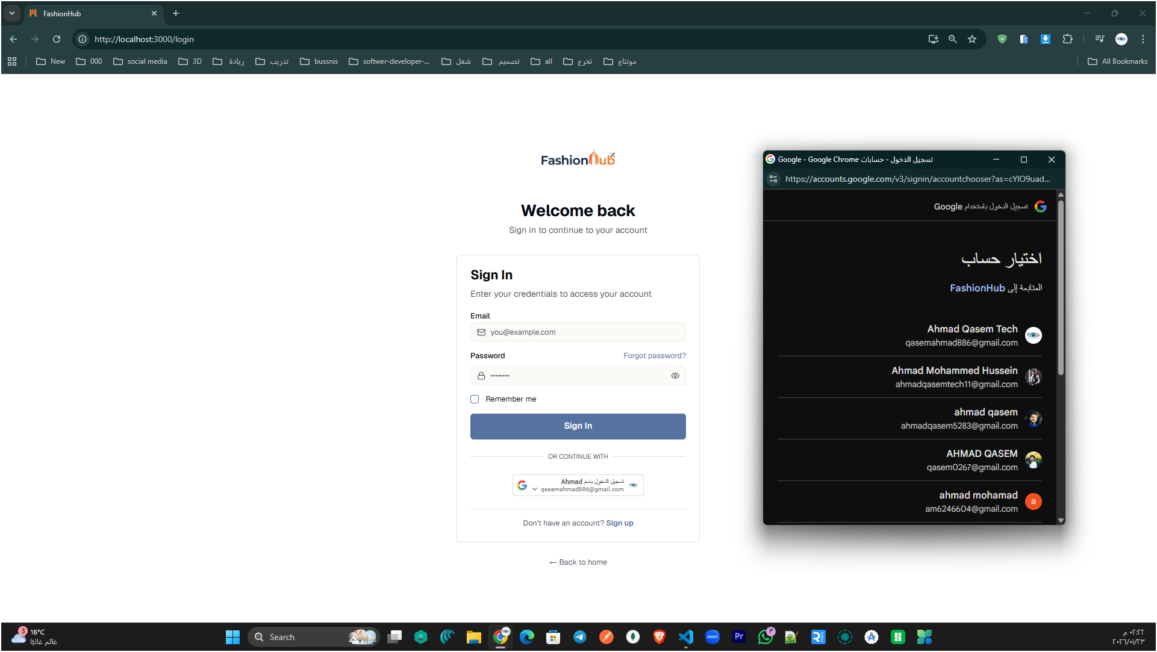

Figure 1: Login page showing email/password sign-in with “Forgot password” and Google OAuth sign-in option

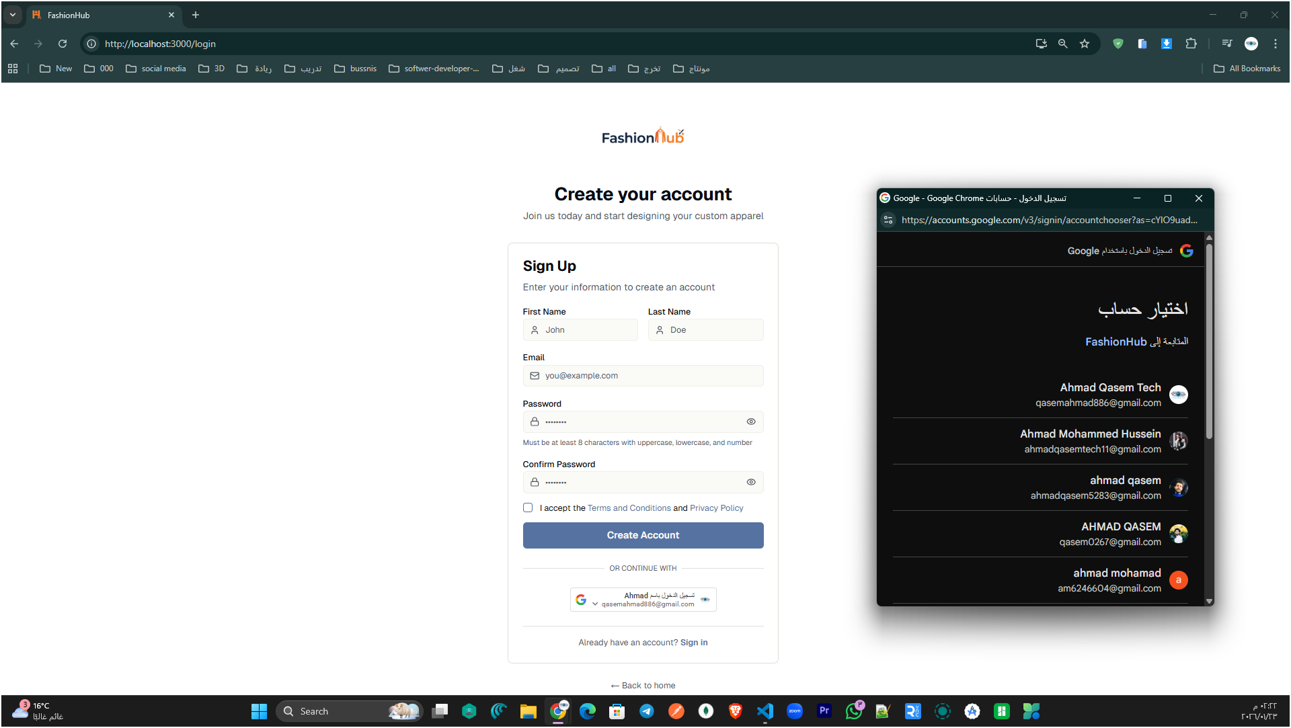

Figure 2: Sign-up page for creating a new account with user details, password confirmation, and Google OAuth registration option.

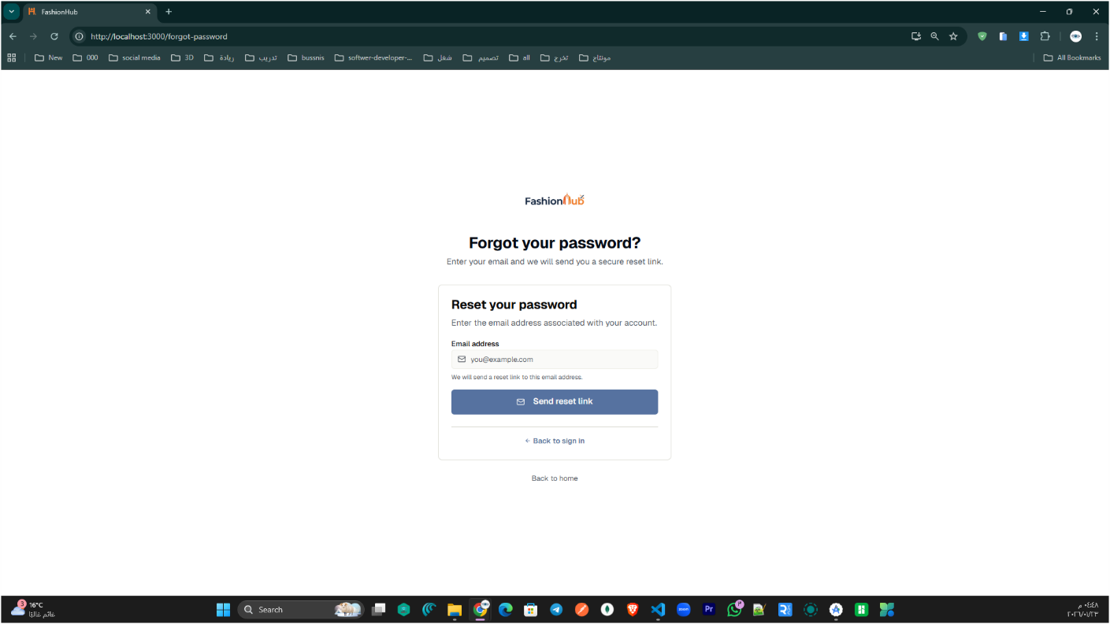

Figure 3: Forgot Password page allowing users to request a password reset link by entering their email address.

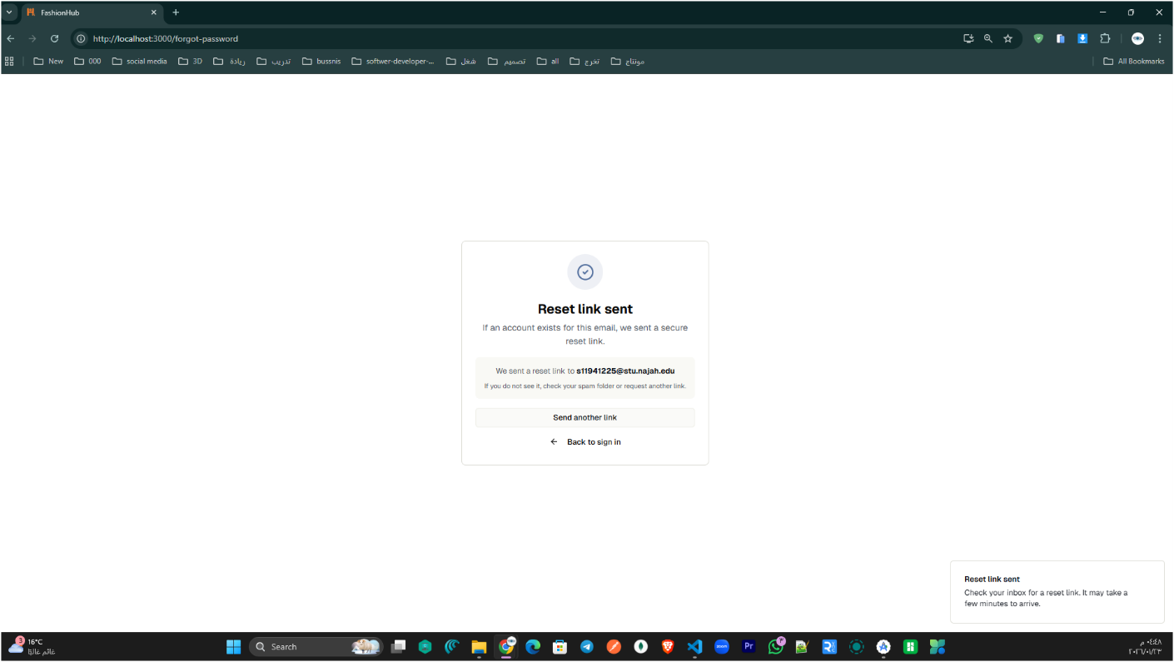

Figure 4: Confirmation screen indicating that the password reset link has been sent to the user’s email address.

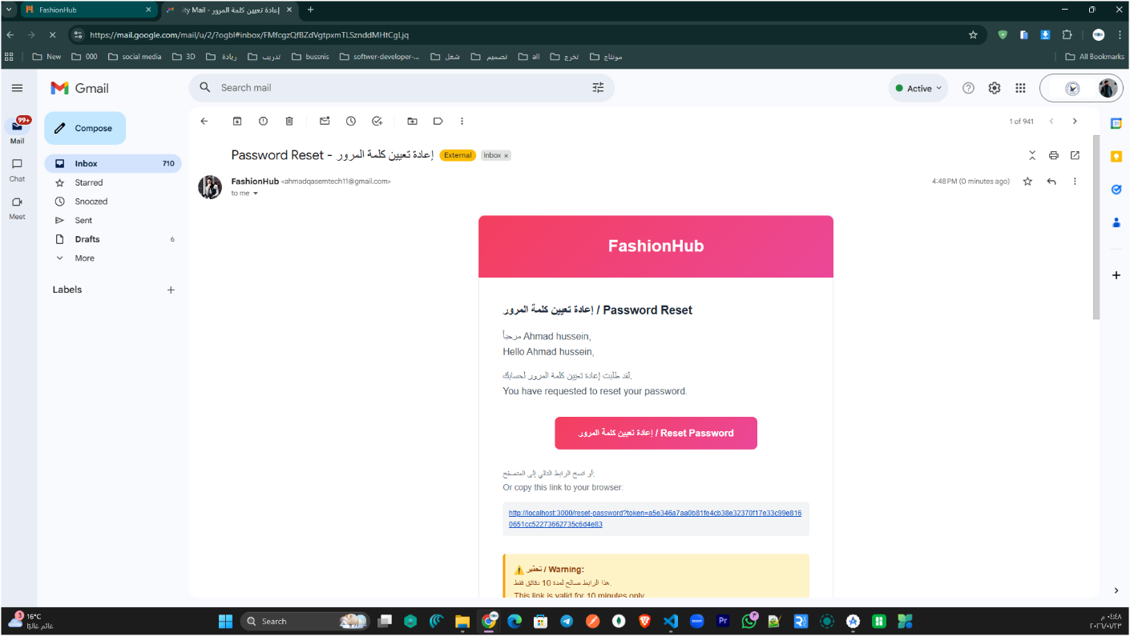

Figure 5: Password reset email received in Gmail containing a “Reset Password” button and a secure reset link to complete the password recovery process.

The login module in FashionHub provides a complete and secure authentication flow for users. It starts with the Sign In page, where users can access their accounts using email/password or Google Sign-In for faster login. New users can create an account through the Sign Up page by entering their basic information and confirming their password. In case a user forgets their password, the Forgot Password page allows them to request a reset link by entering their registered email. After submitting the request, the system shows a confirmation message indicating that the reset link has been sent. Finally, the user receives an email containing a secure password reset link/button, allowing them to set a new password and regain access to their account.

Visitors & Customers Side

In FashionHub, the store interface supports two types of users: Visitors (Guests) and Customers (Registered Users). Visitors can browse the entire website without signing in, including viewing products, product details, collections, and current offers. Customers have the same browsing experience, but after logging in they gain access to full features such as adding items to the cart and completing checkout, tracking orders, saving favorites, and saving/reusing their Studio designs (My Designs). This separation keeps browsing simple and open for everyone, while restricting sensitive actions (purchases and account-related data) to authenticated users only.

Home Page: The main entry point of FashionHub, providing quick access to featured sections, categories, and the overall shopping experience.

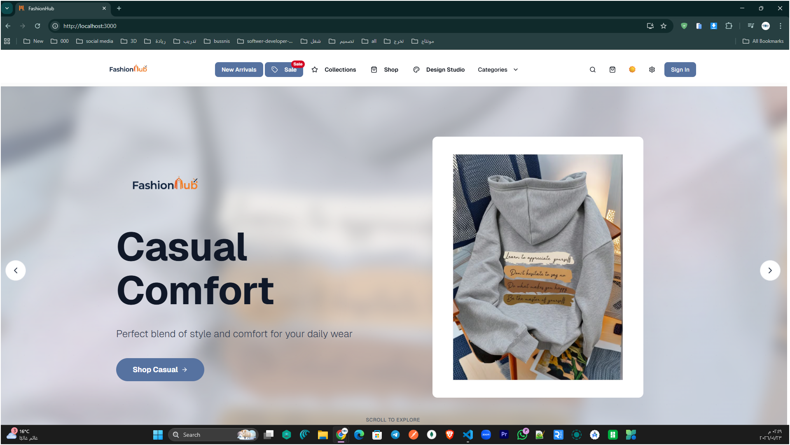

Figure 6: FashionHub homepage hero slider highlighting a featured collection with a call-to-action button for quick shopping.

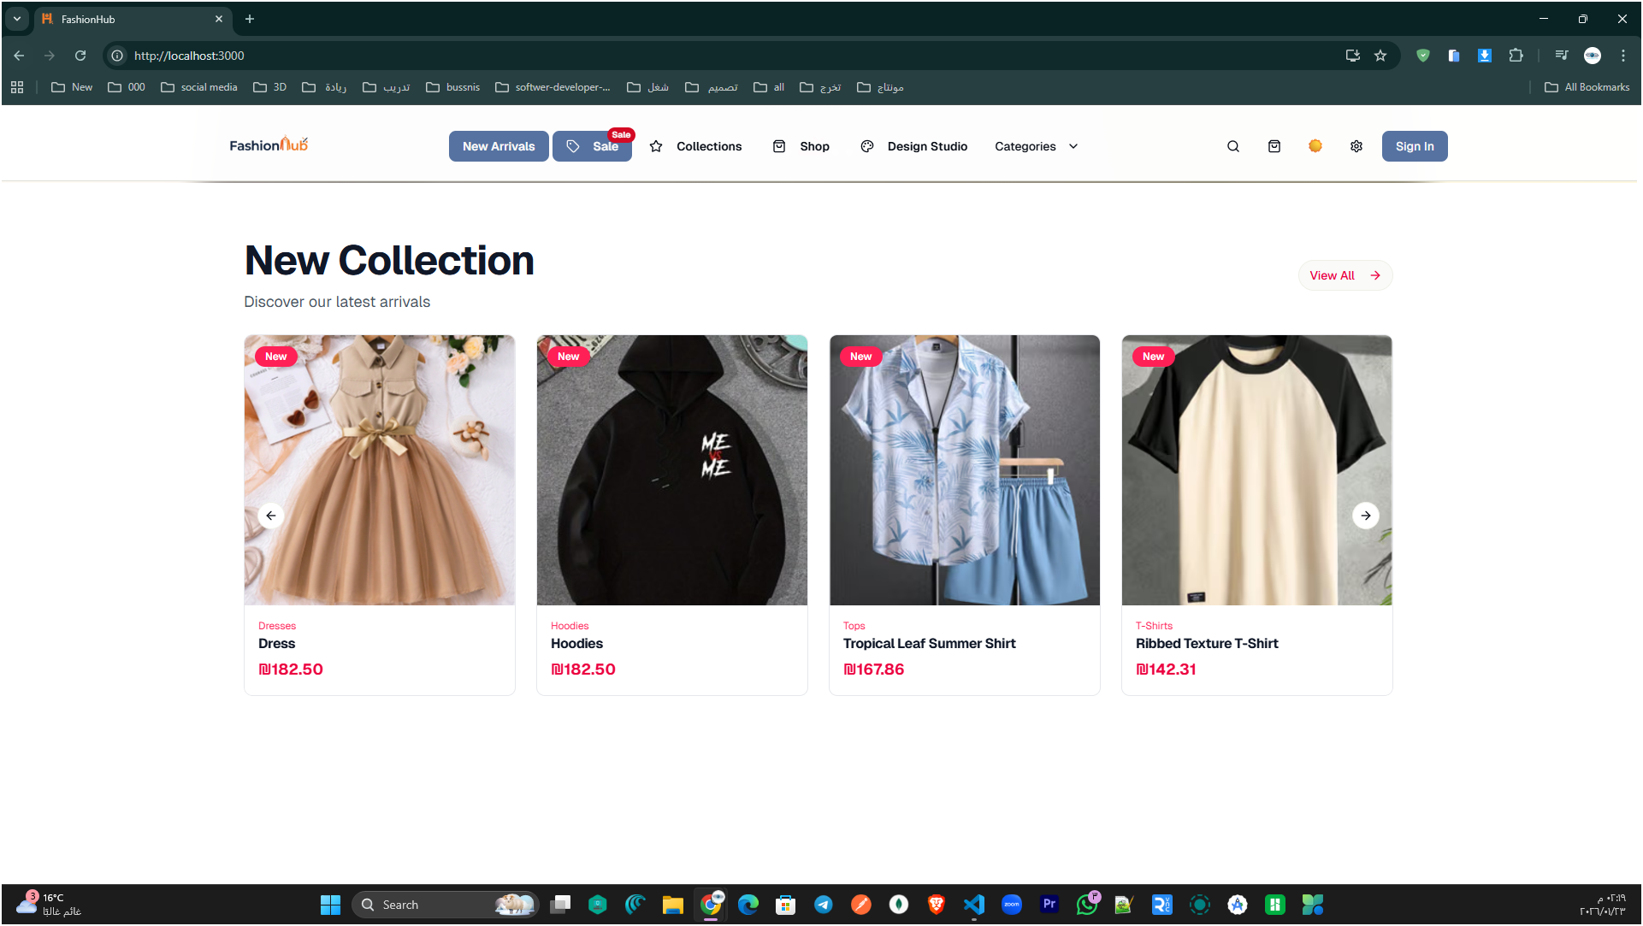

Figure 7: Home page “New Collection” section displaying the latest arrivals in a product carousel/grid for quick browsing.

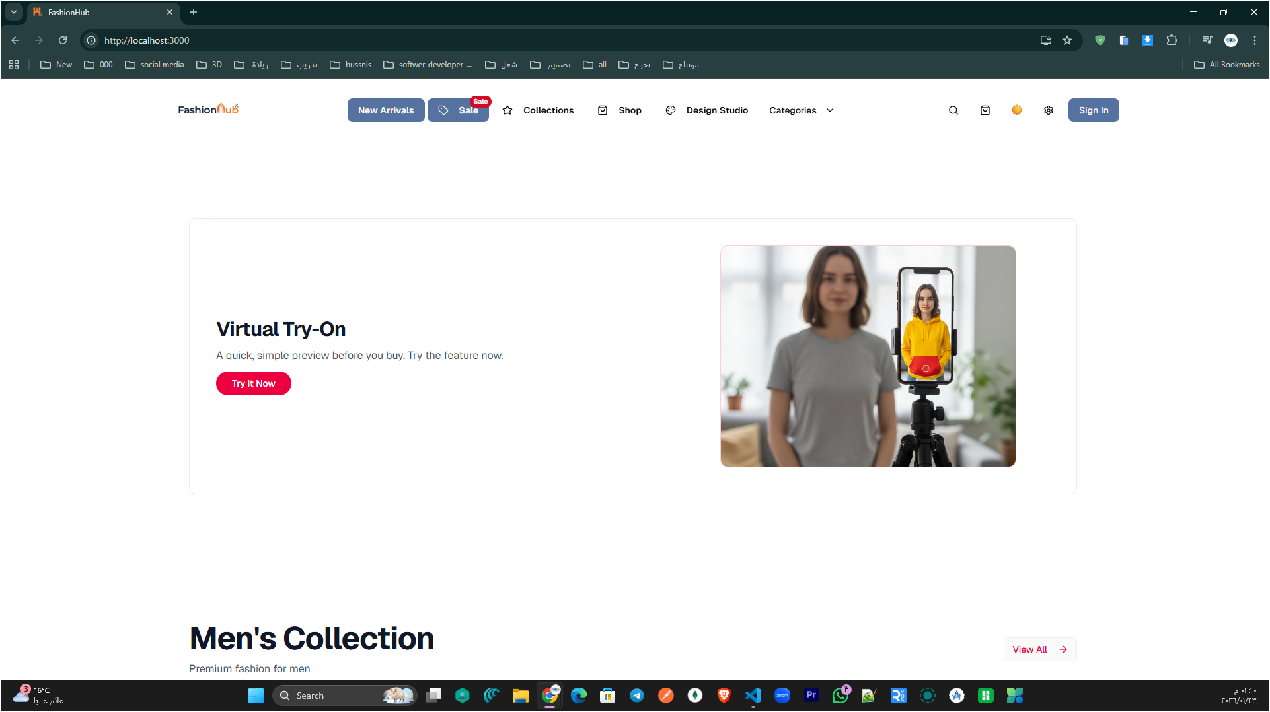

Figure 8: Home page section highlighting the Virtual Try-On feature with a direct call-to-action button to start the experience.

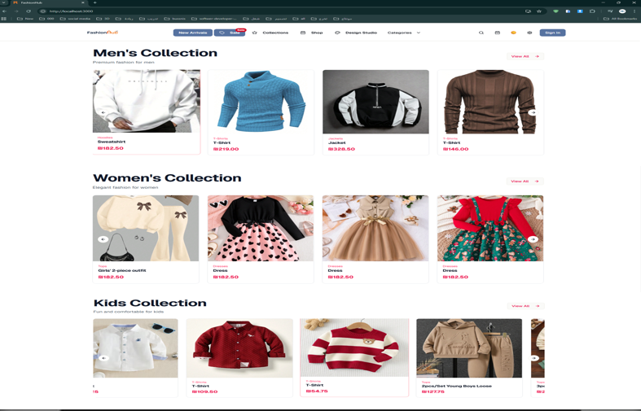

Figure 9: Home page collections section showcasing categorized product listings (Men’s, Women’s, and Kids) with quick access to items and “View All” navigation for each category.

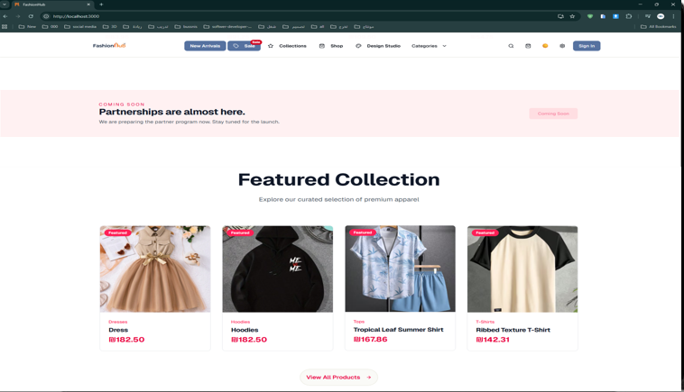

Figure 10: Featured Collection section on the home page highlighting selected products with a “View All Products” call-to-action.

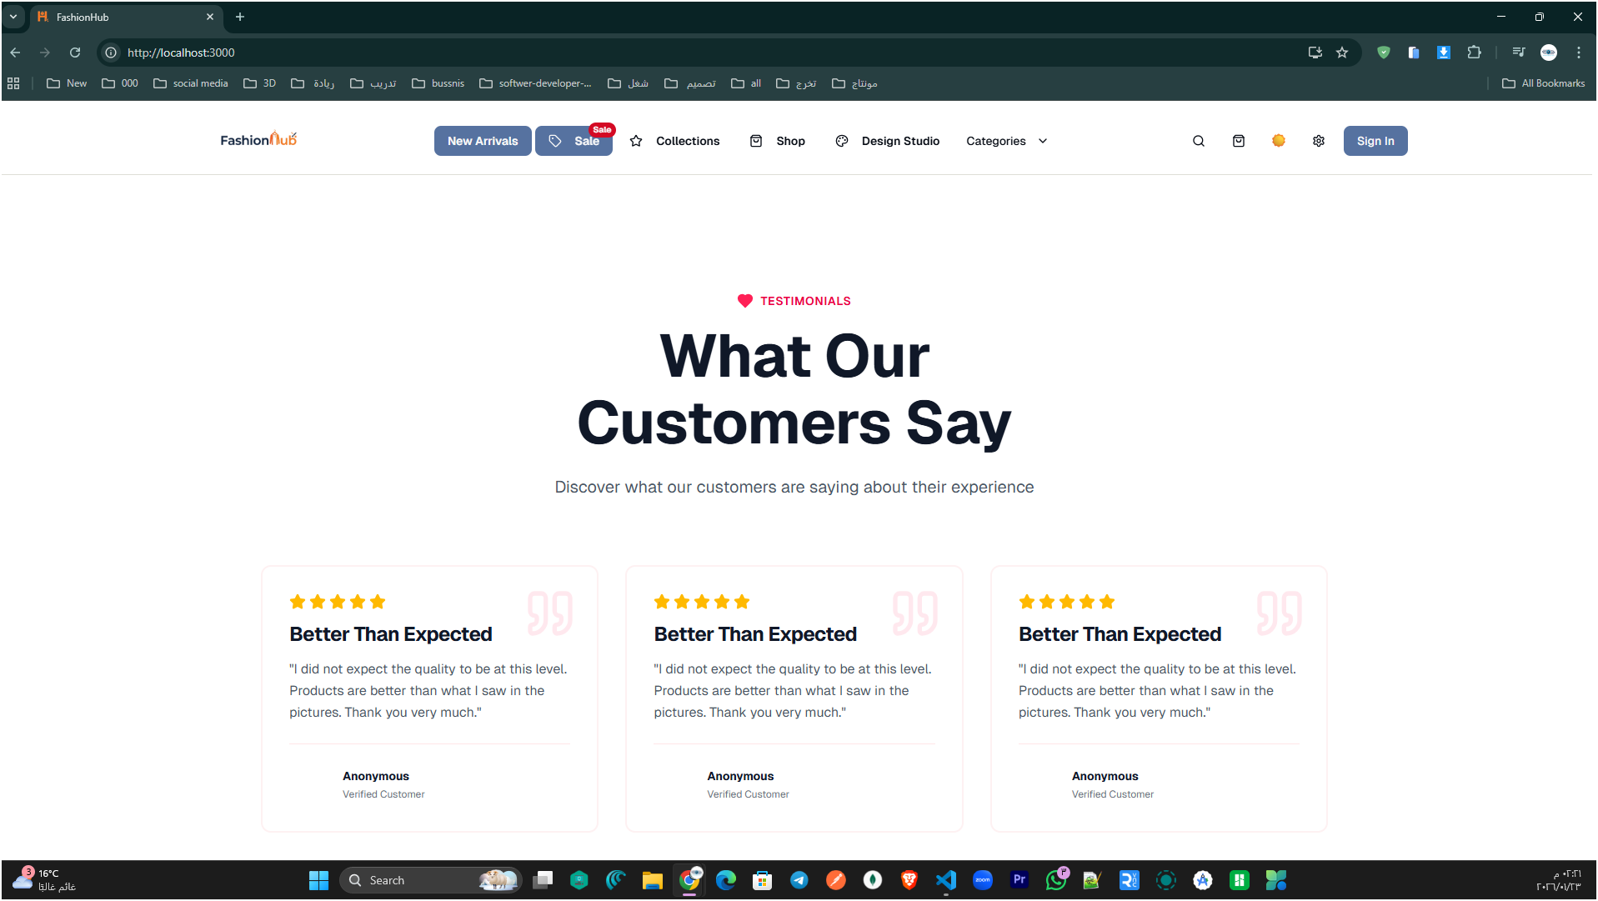

Figure 11: Customer Testimonials section on the home page displaying user ratings and feedback cards.

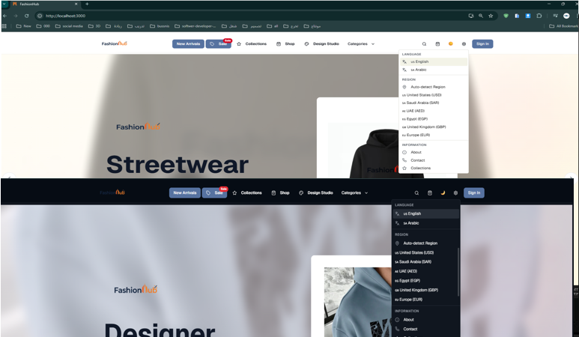

Figure 12: Home Page (Language, Region & Dark/Light Mode Settings)

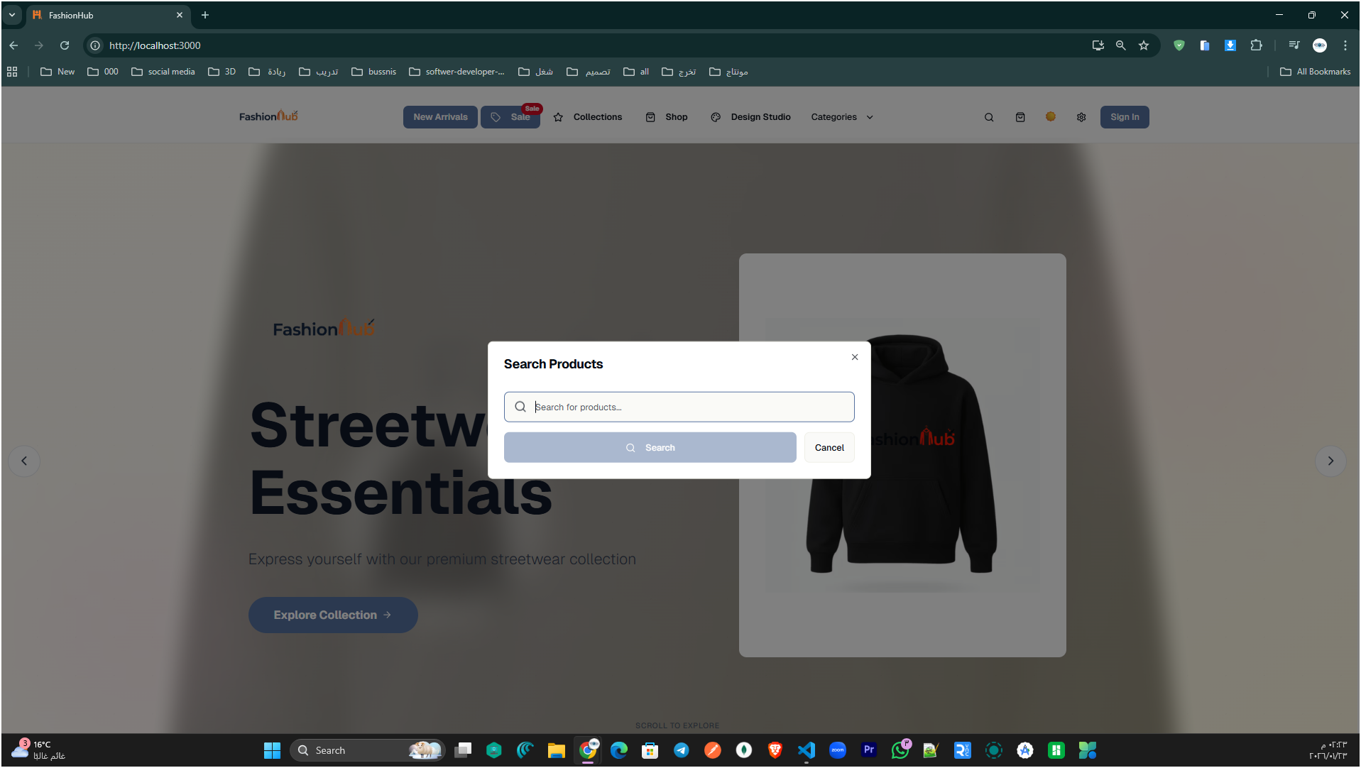

Figure 13: Home Page Product Search Popup (Quick Search Dialog).

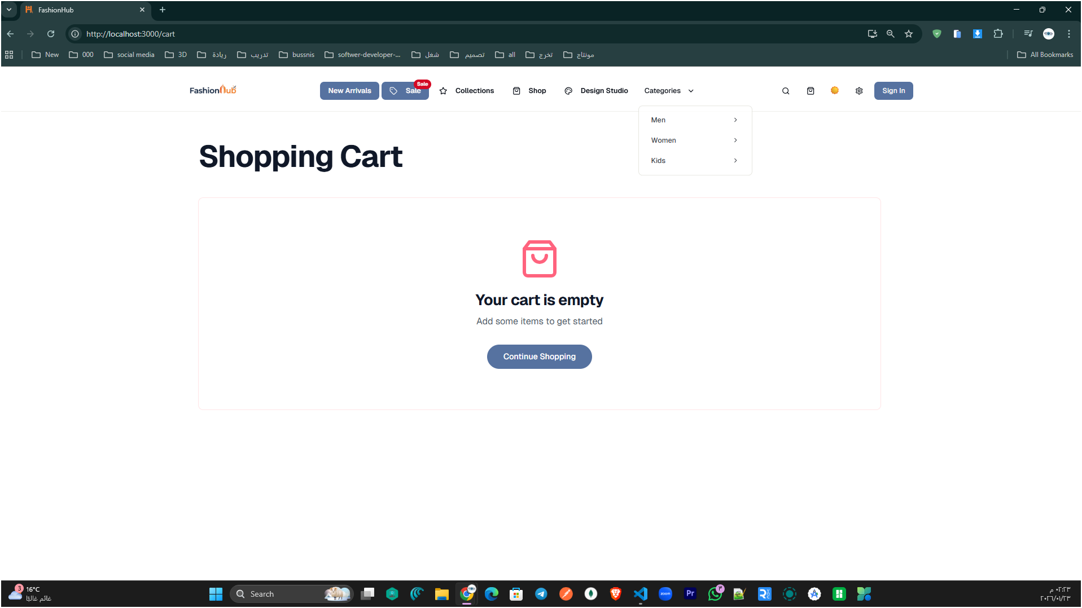

Figure 14: Shopping Cart Page (Empty Cart State).

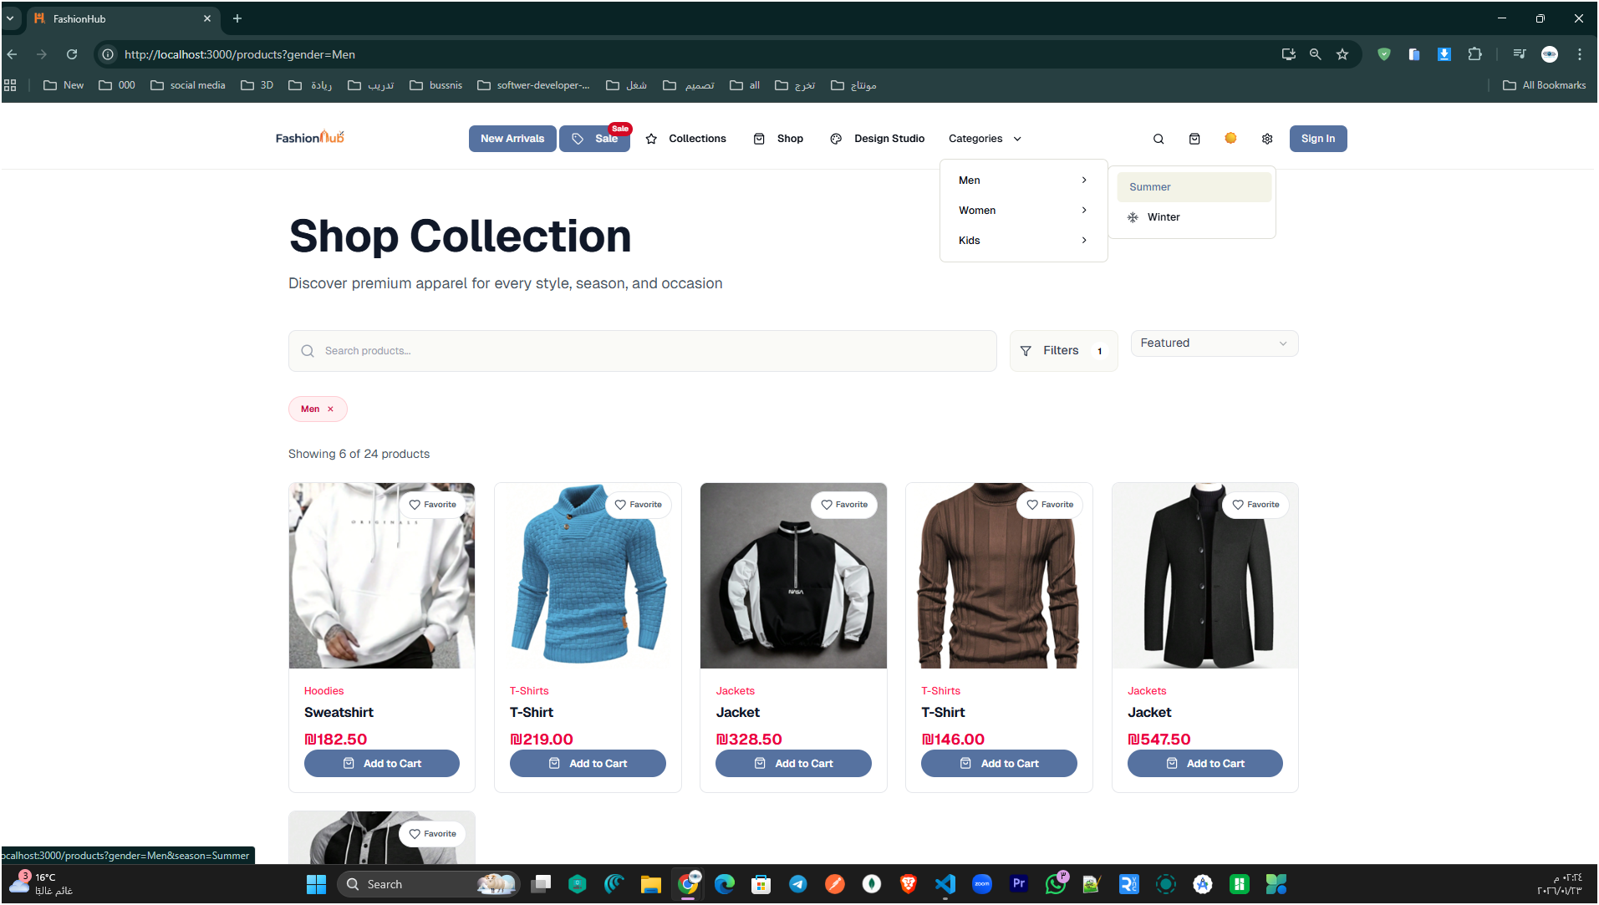

Figure 15: Shop Collection Page (Product Listing with Search, Filters, and Category Navigation)

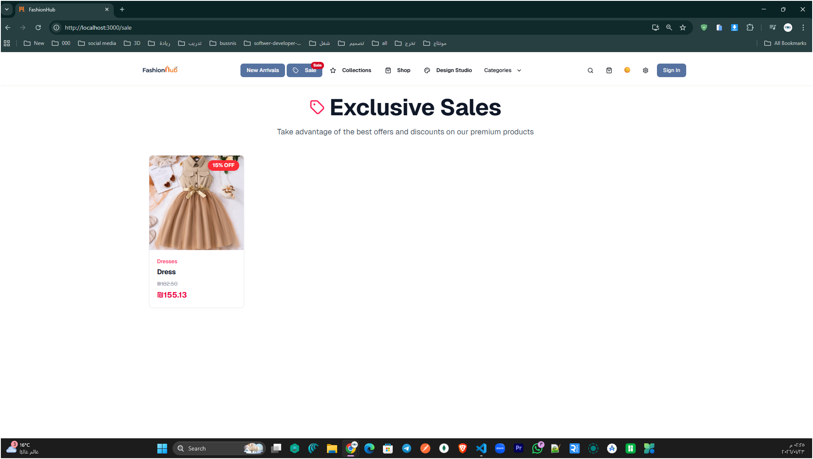

Figure 16: Exclusive Sales page highlighting discounted products available in the sale section.

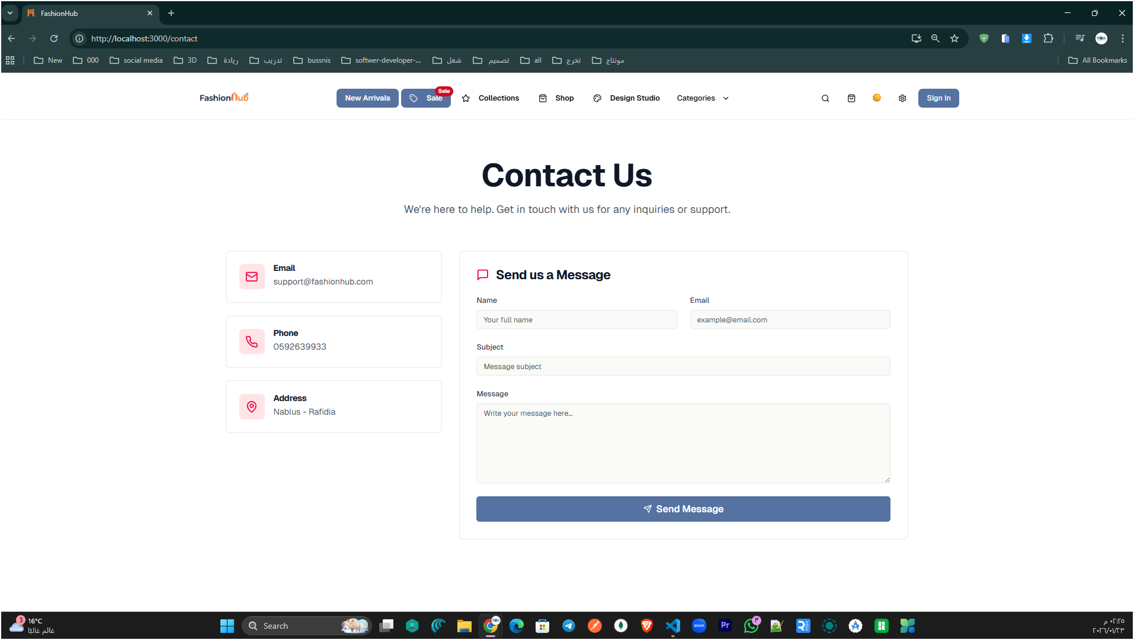

Figure 17: Contact Us page providing store contact information and a message form for customer inquiries and support

Customers Side
Customers Side represents the experience of registered users in Fashion Hub after signing in. It includes all core shopping functionalities such as browsing products and collections, managing the shopping cart, completing checkout, tracking orders, and interacting with personalized features like favorites and saved studio designs. This section highlights how the platform provides a complete and secure shopping journey, where user-specific actions are available only to authenticated customers.
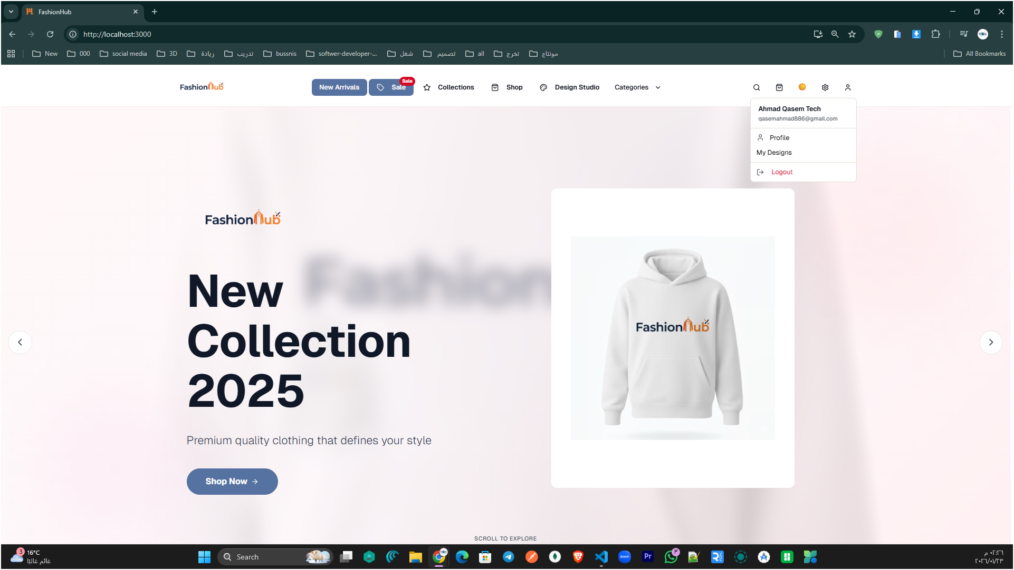
Figure 18: Customer account dropdown menu.

The figure shows the interface of a registered user (Customer) after logging in, where the account name appears in the top navigation bar along with options to manage the profile, quick access to studio designs (My Designs), and logout.

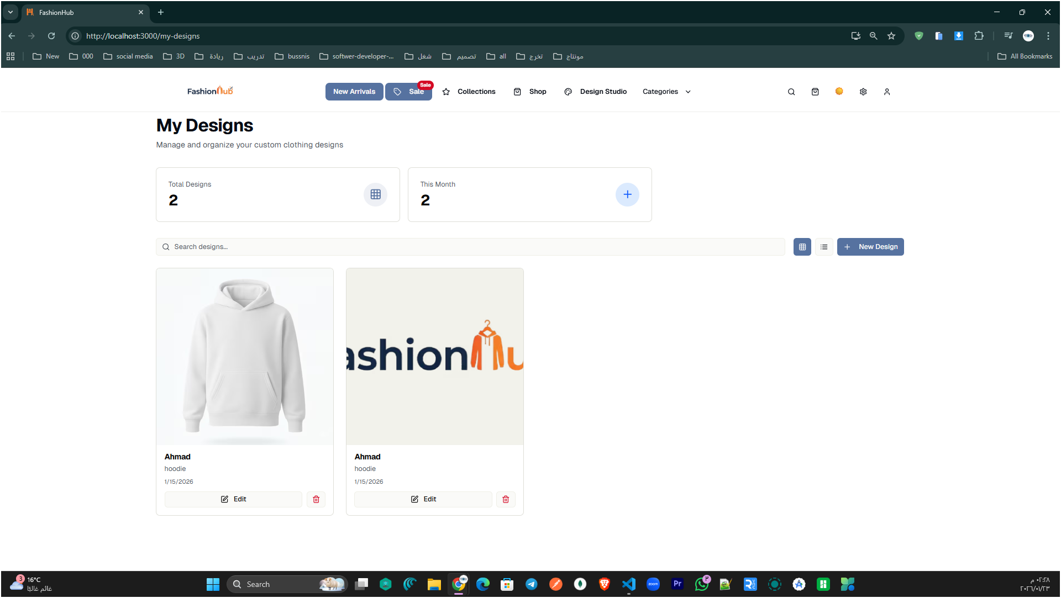

Figure 19: My Designs page for managing saved studio designs.

This page lets the logged-in customer view, search, and manage their saved studio designs, with options to create new designs, edit existing ones, or delete them.

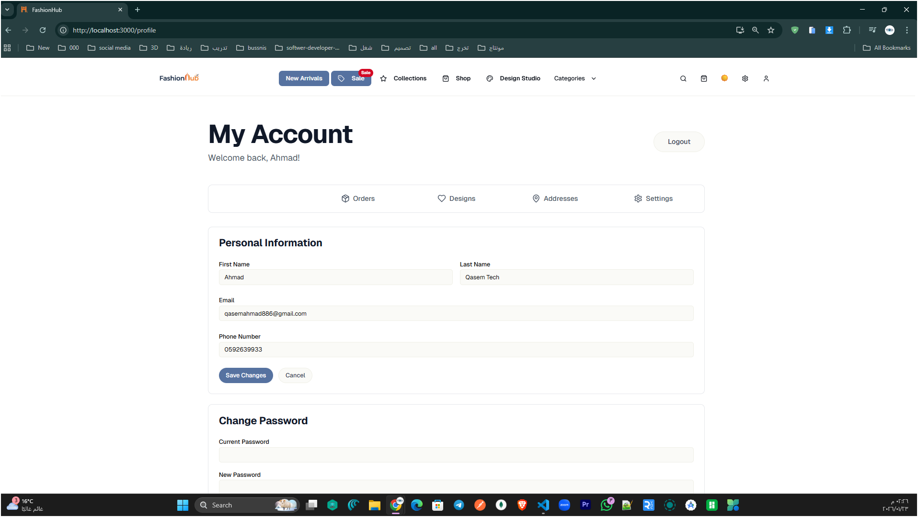
Figure 20: Customer Profile page (My Account).
The My Account – Profile view enables customers to manage their account details (name, email, phone) and change their password in one place.
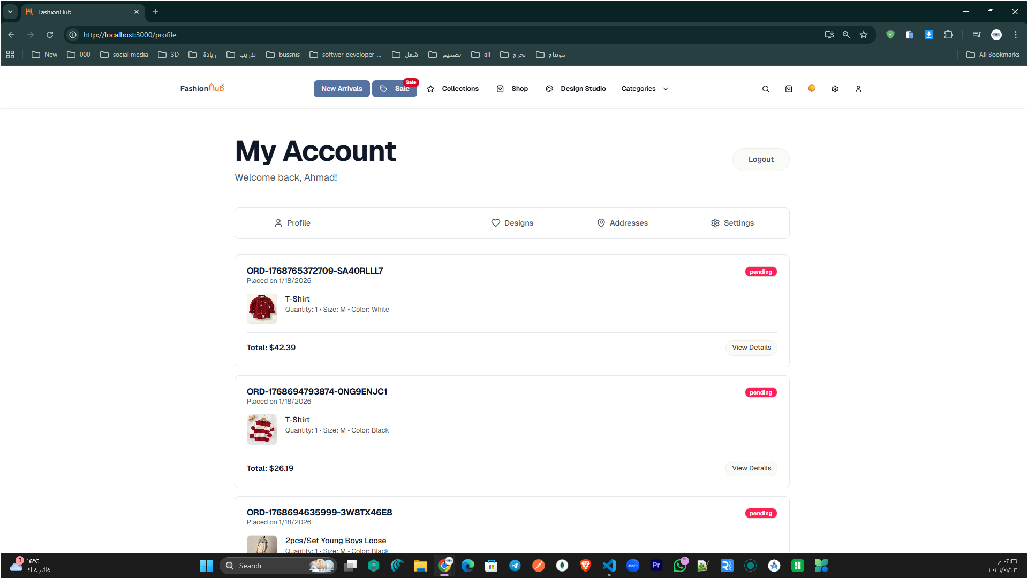
Figure 21: Orders tab in the My Account page
This view displays the customer’s previous orders inside the profile area, including order IDs, purchase dates, current status (e.g., pending), and quick access to full order details.

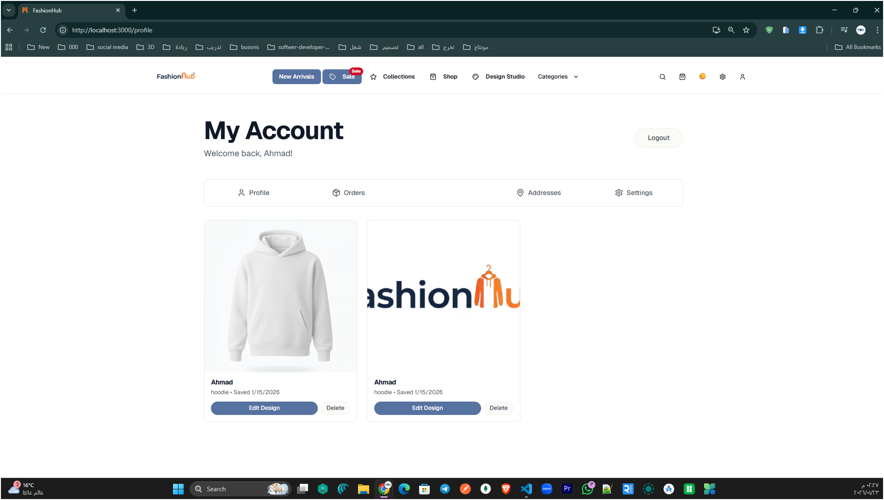

Figure 22: My Account – Designs tab

This tab shows the customer’s saved studio designs, with options to edit or delete each design directly from the account page.

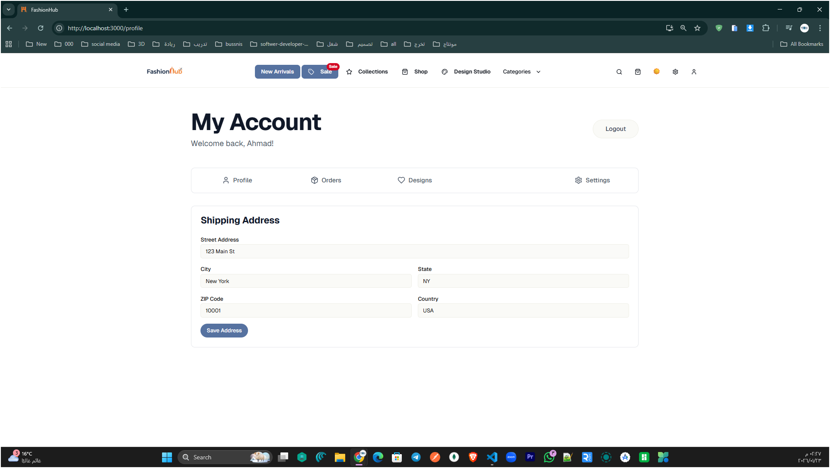

Figure 23: My Account – Addresses tab

This section lets the customer add or update their shipping address details (street, city, state, ZIP, and country) and save them for faster checkout.

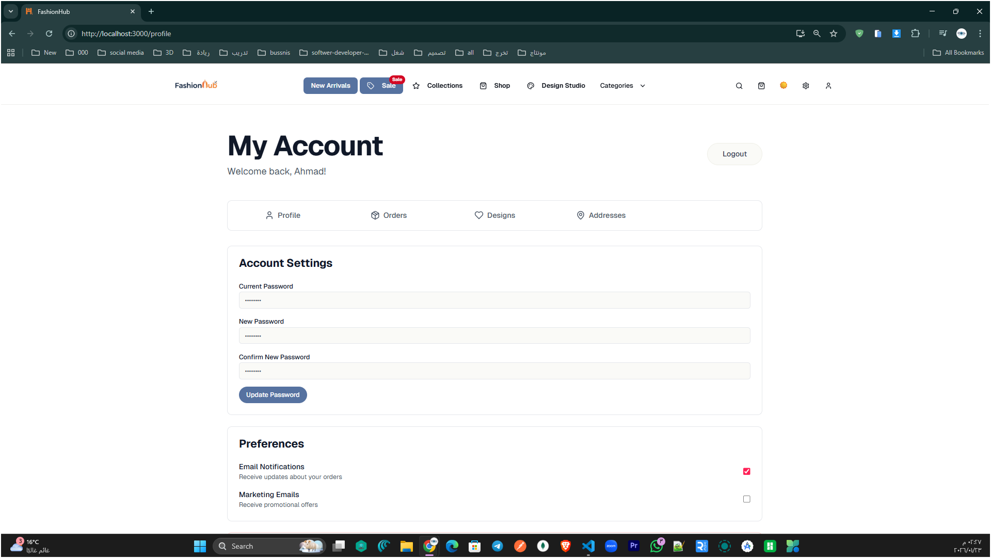

Figure 24: My Account – Settings tab.

This page allows the customer to update their account security by changing the password, and manage preferences such as email notifications and marketing emails.

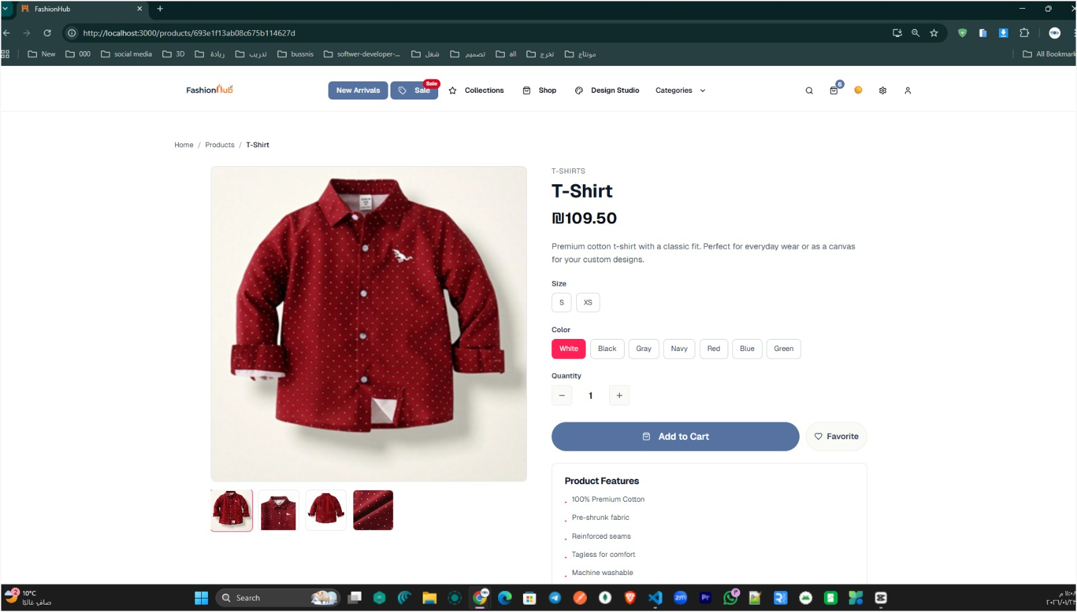

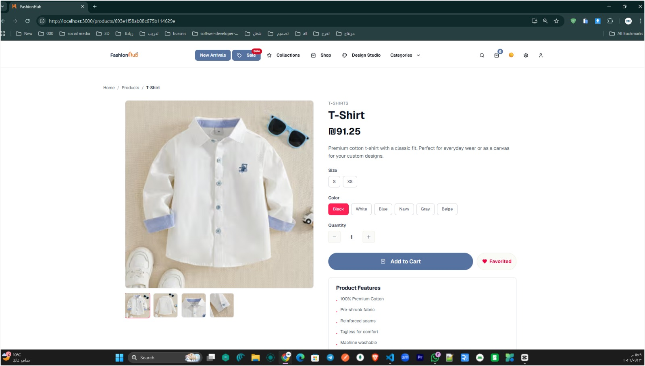

Figure 25: Product Details page.

This page displays full product information and lets the customer choose size, color, and quantity, then add the item to the cart or save it to Favorites.

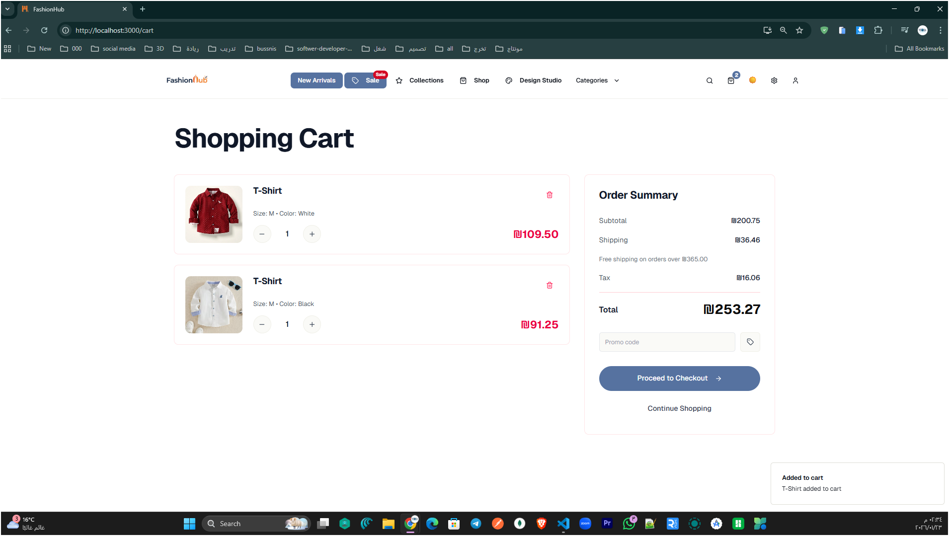

Figure 26: Shopping Cart page.

This page lists the selected items with quantity controls and shows an order summary (subtotal, shipping, tax, total) with an option to proceed to checkout.

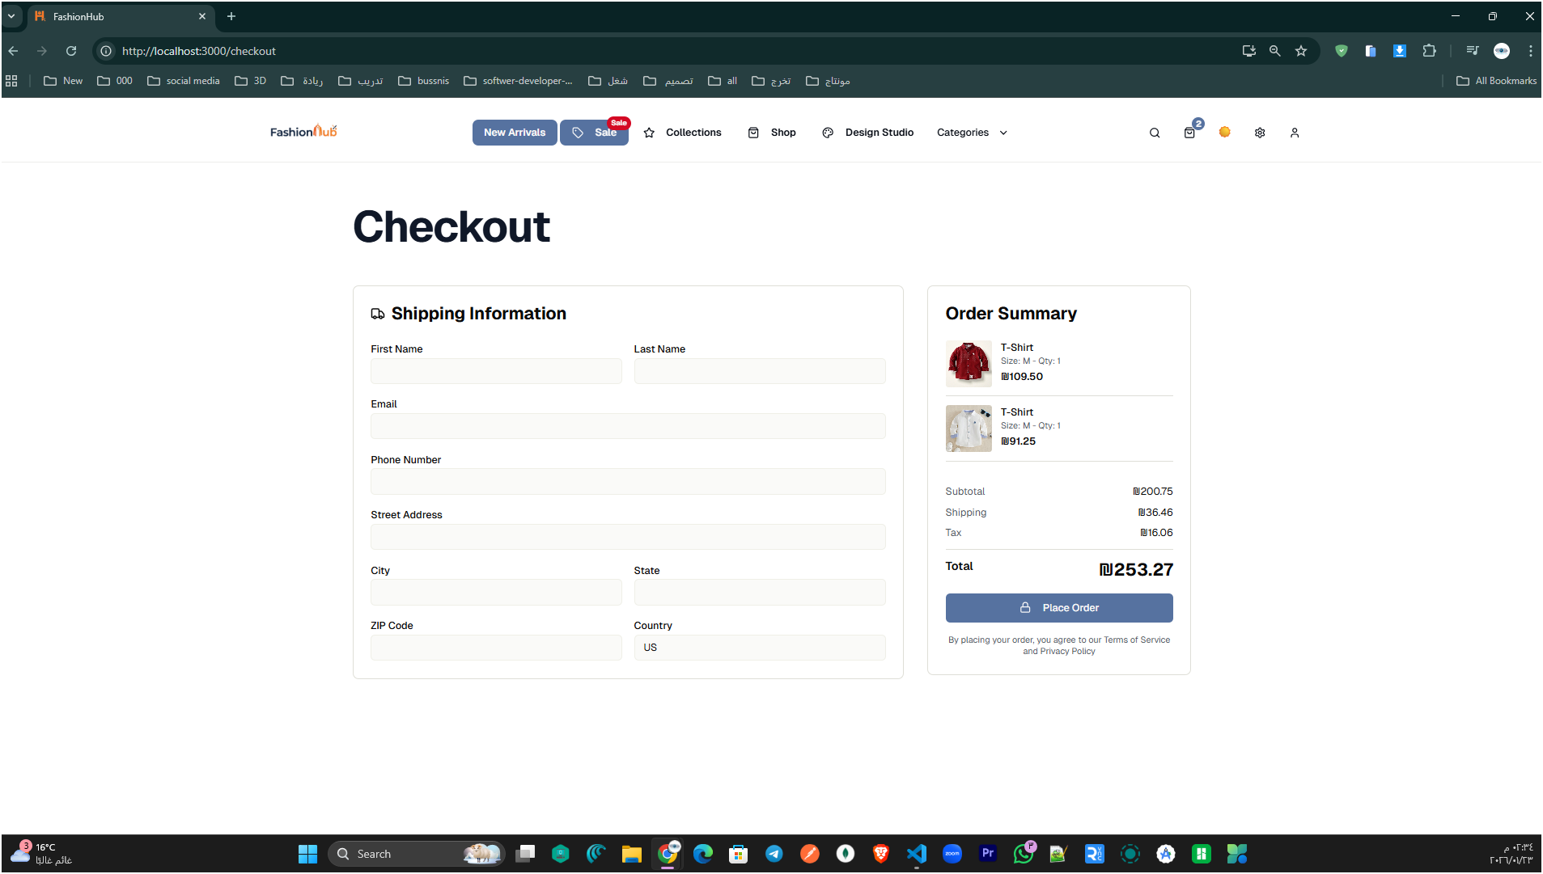
Figure 27: Checkout page.

This page collects the customer’s shipping details and displays an order summary, allowing the user to confirm the total and place the order.

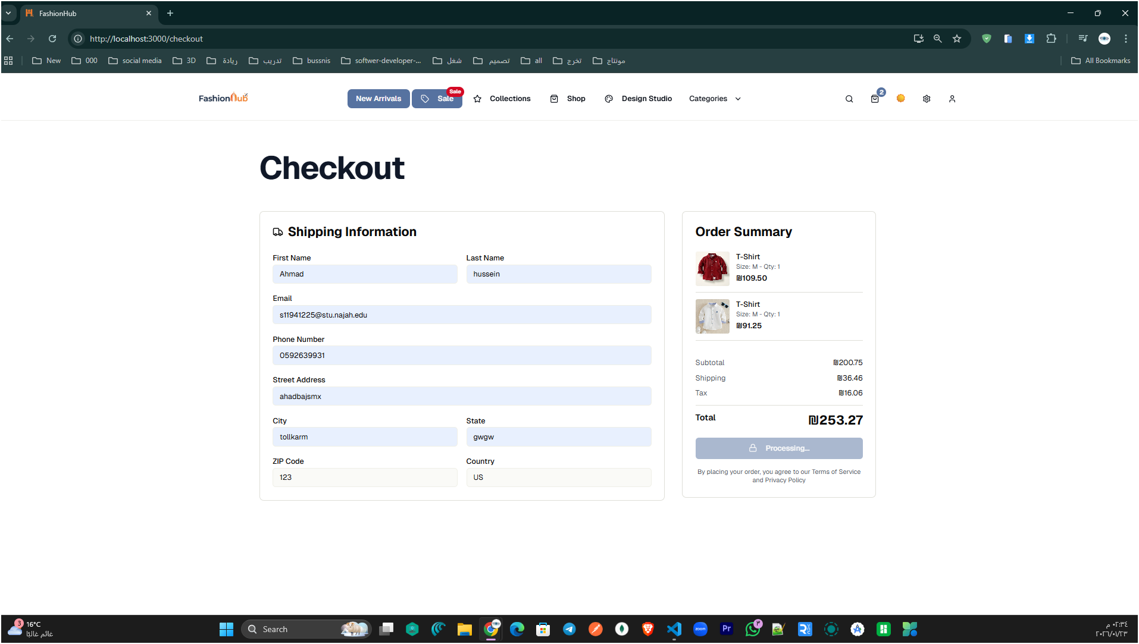

Figure 28: Order placement in progress.

This page shows the checkout after the shipping form is filled, with the “Processing…” state indicating the order is being submitted while the order summary and total are confirmed.

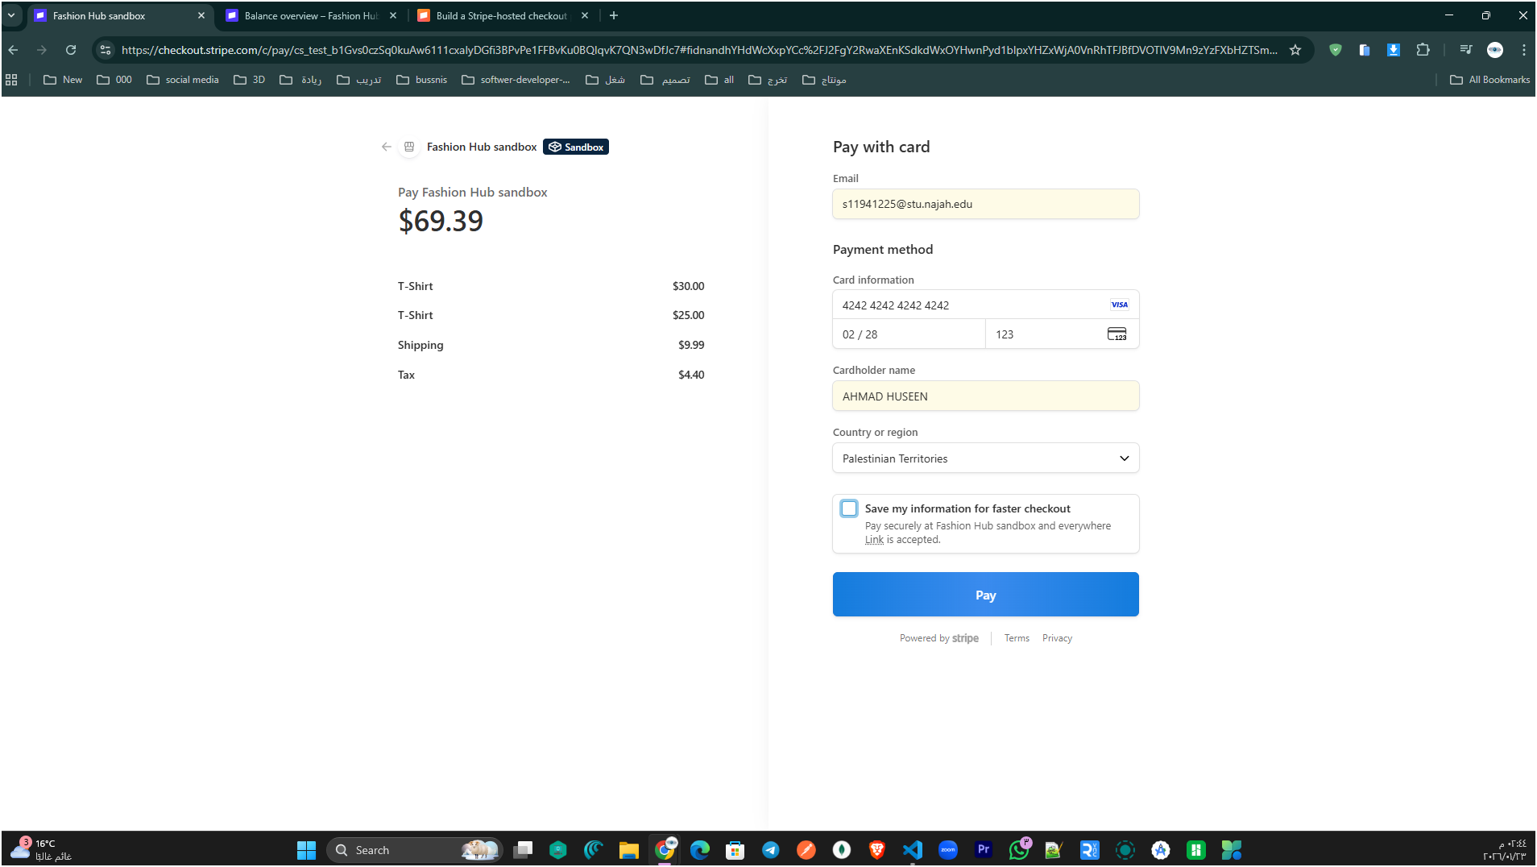

Figure 29:

This figure shows the Stripe-hosted checkout used to securely complete the payment, where the customer enters card details and confirms the final amount before clicking Pay.

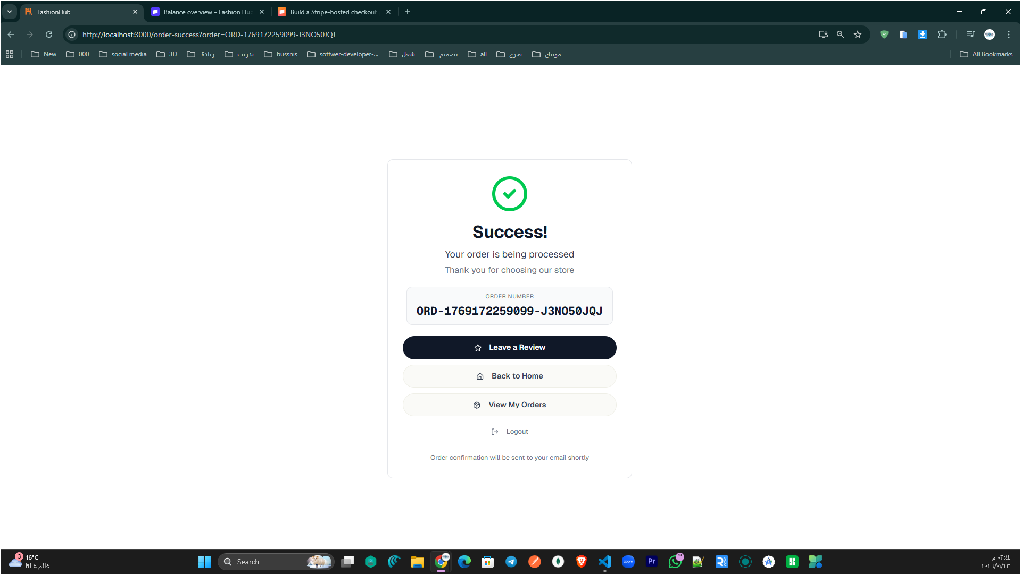

Figure 30: Order success confirmation page

This page confirms that the payment was completed successfully and the order is being processed, showing the order number and quick actions like View My Orders and Back to Home.

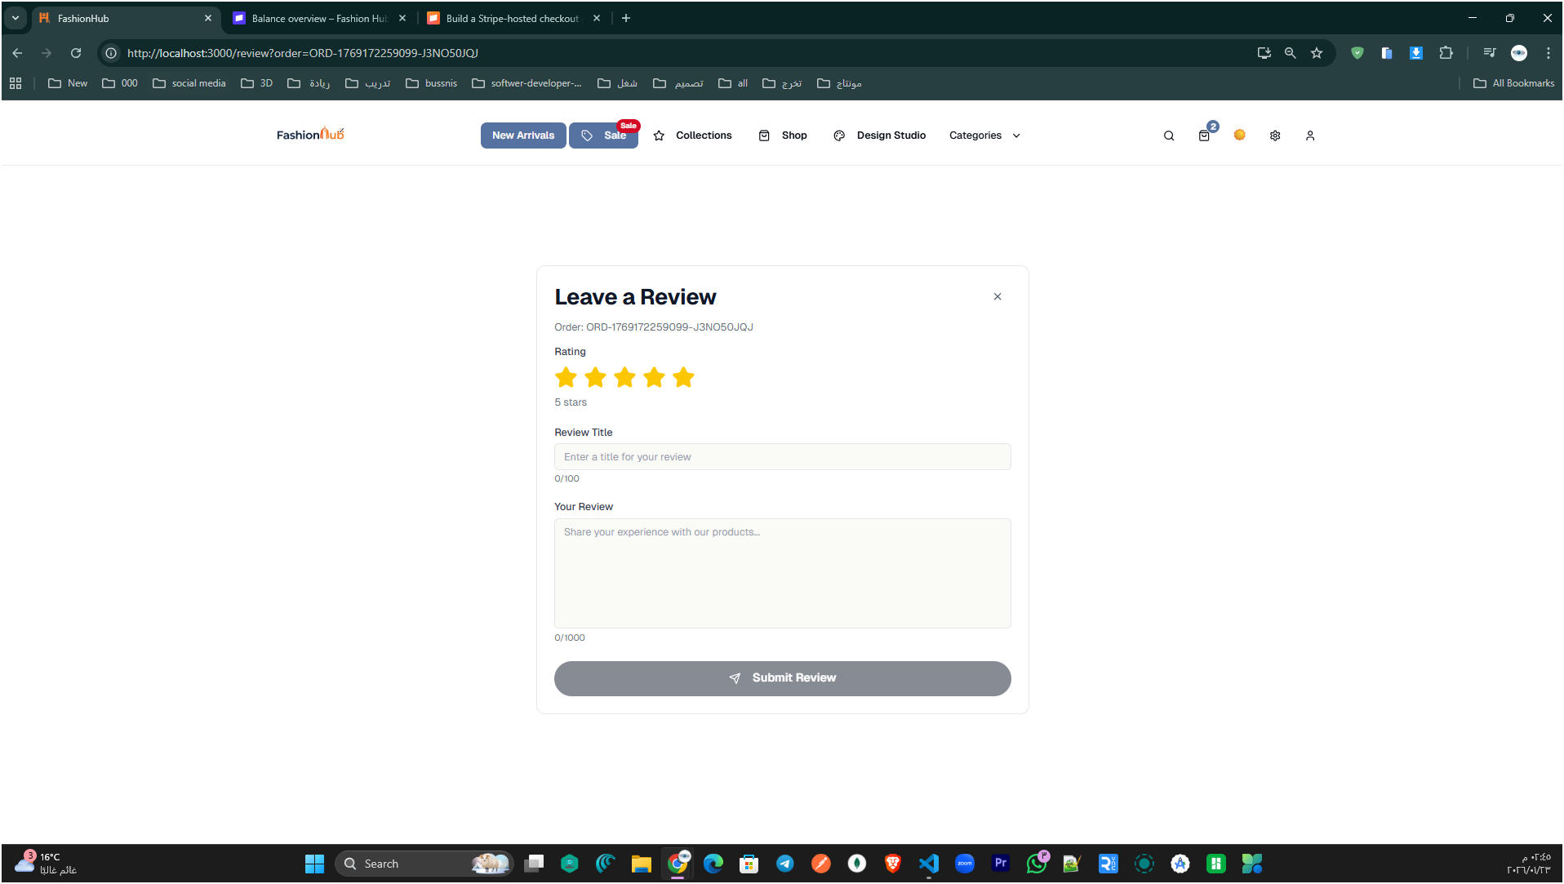

Figure 31: Leave a Review form.

This page lets the customer rate the completed order (star rating) and submit written feedback by adding a review title and comment, then clicking Submit Review.

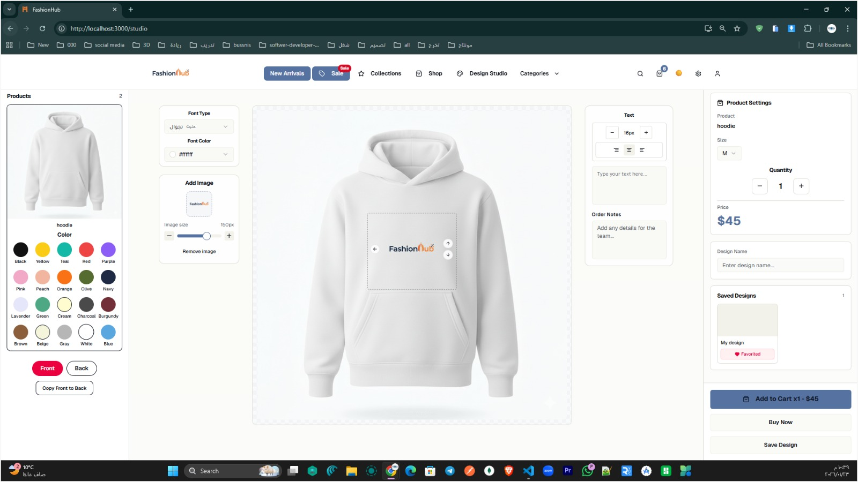

Figure 32: Design Studio (Product Customization Workspace).

This screen represents the Design Studio feature in FashionHub, where a customer can create a fully customized apparel design before purchasing. The center area is the main canvas, showing the selected product (hoodie) with a printable/designable zone where elements can be placed and repositioned.
On the left panel, the customer can choose the base product color from a palette and switch between Front / Back views, with an option to copy the front design to the back for faster design creation.
In the editing tools section, the user can customize typography by selecting font type and color, and can also add an image/logo, control its size, or remove it. On the right-side tools, the customer can add text with formatting controls (size, alignment, and styling options) and write order notes to communicate extra instructions.
The Product Settings panel on the far right allows selecting product options such as size, adjusting quantity, and viewing the price. The customer can also enter a design name and manage saved designs (previewing previously saved work). Finally, the user can proceed by choosing Add to Cart, Buy Now, or Save Design, making the design studio directly connected to the purchasing flow.

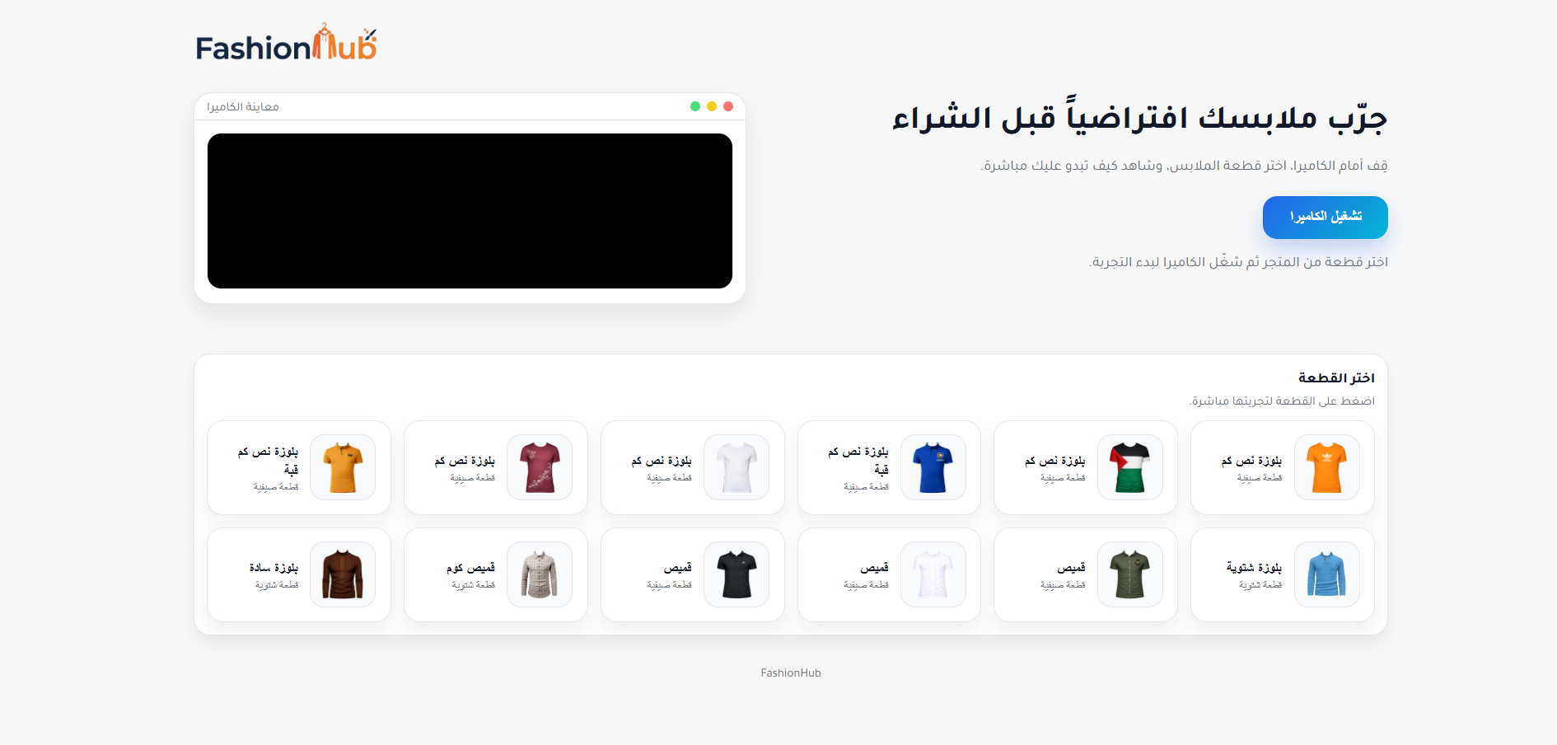
Figure 33: Virtual Try-On page.
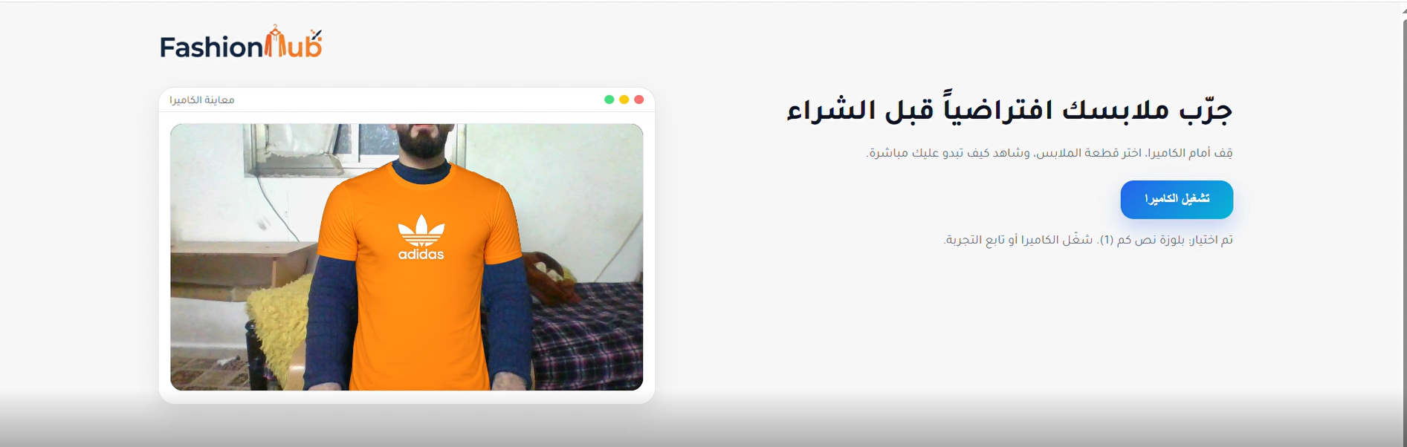

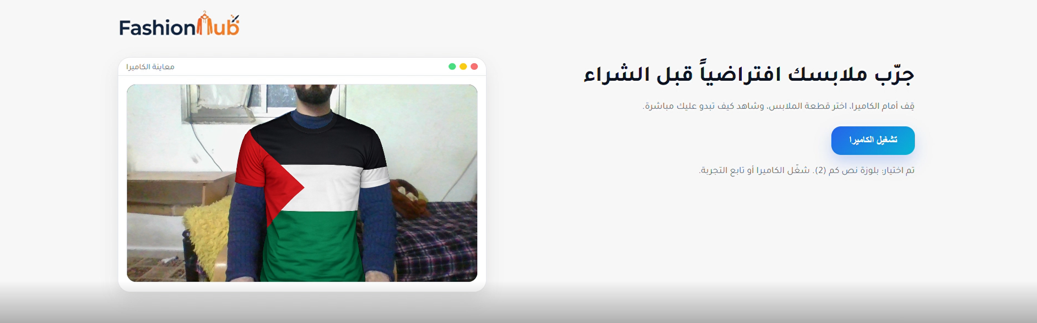

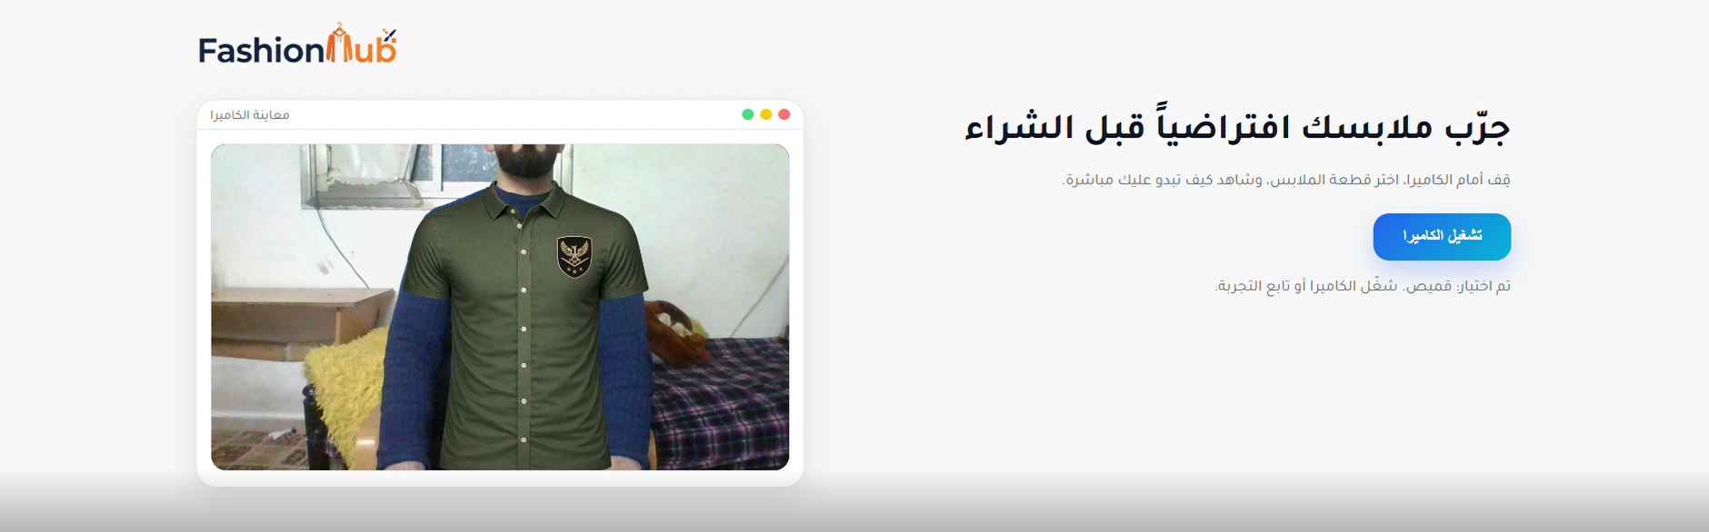
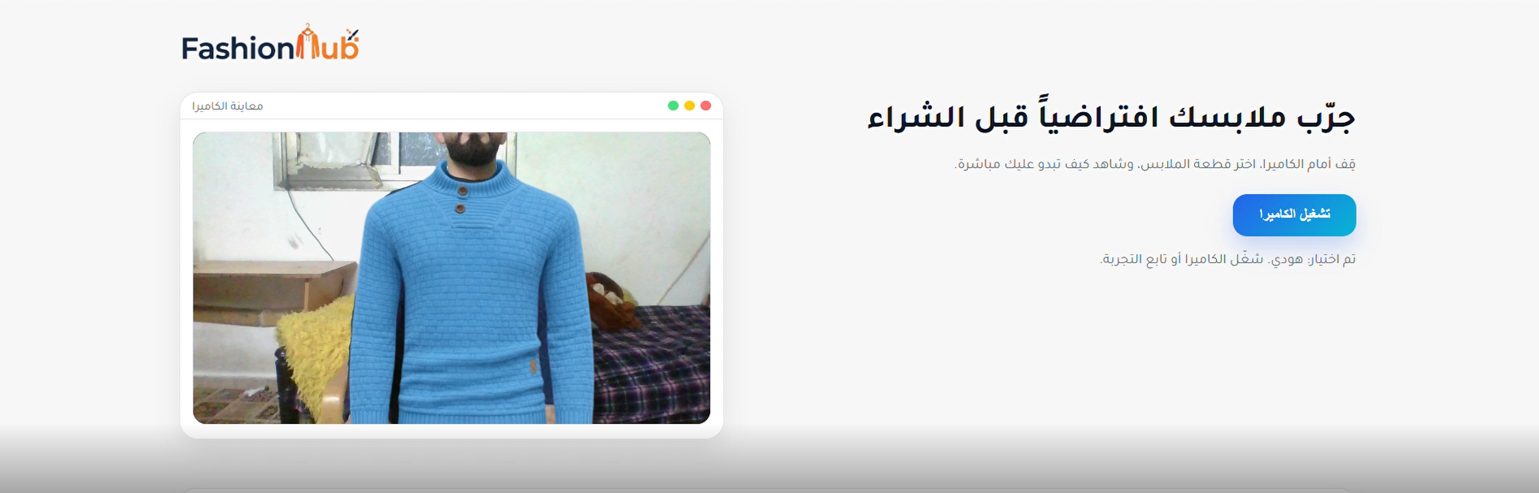

This screen shows the Virtual Try-On feature, where the user can enable the camera to preview clothing virtually before purchasing. The interface provides a list of available items to select from, allowing the customer to choose a product and test how it appears in real time through the camera feed.

Admin Side

In FashionHub, the Admin Side provides a centralized control panel for managing the entire platform. Through this interface, the administrator can monitor system activity, manage products and orders, control users and employees, and configure key store features and content (such as the homepage slider and virtual experience settings). This section highlights the tools available to admins to keep the store organized, maintain smooth operations, and ensure that both customers and staff have an efficient and reliable experience.

Dashboard

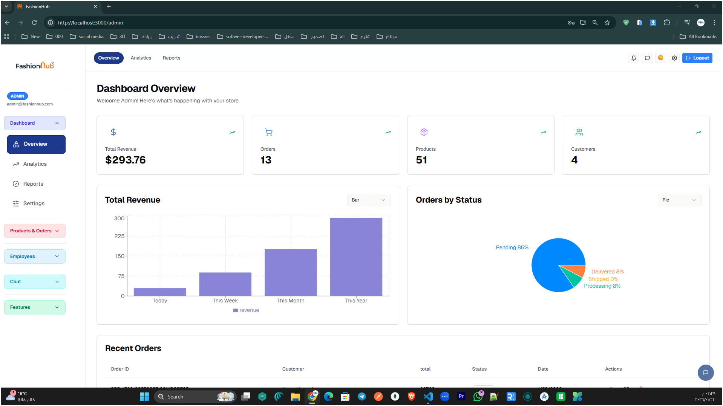

Figure 34: Admin dashboard overview

This page shows the admin overview dashboard, summarizing key store metrics (revenue, orders, products, and customers) with visual charts and a recent orders section to monitor overall store performance.

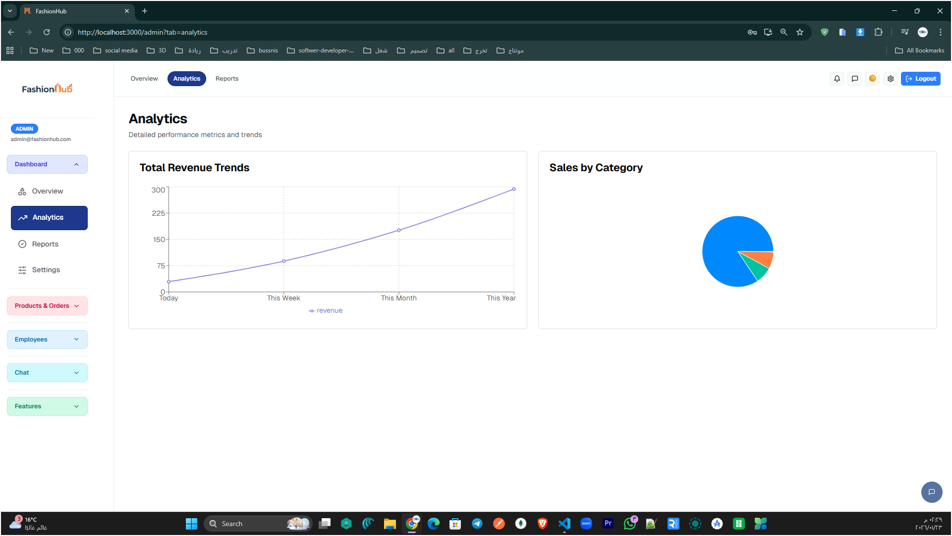
Figure 35: Admin analytics dashboard.

This screen presents the admin analytics view, showing total revenue trends over time and a category-based sales breakdown to help track store performance and identify best-selling categories.

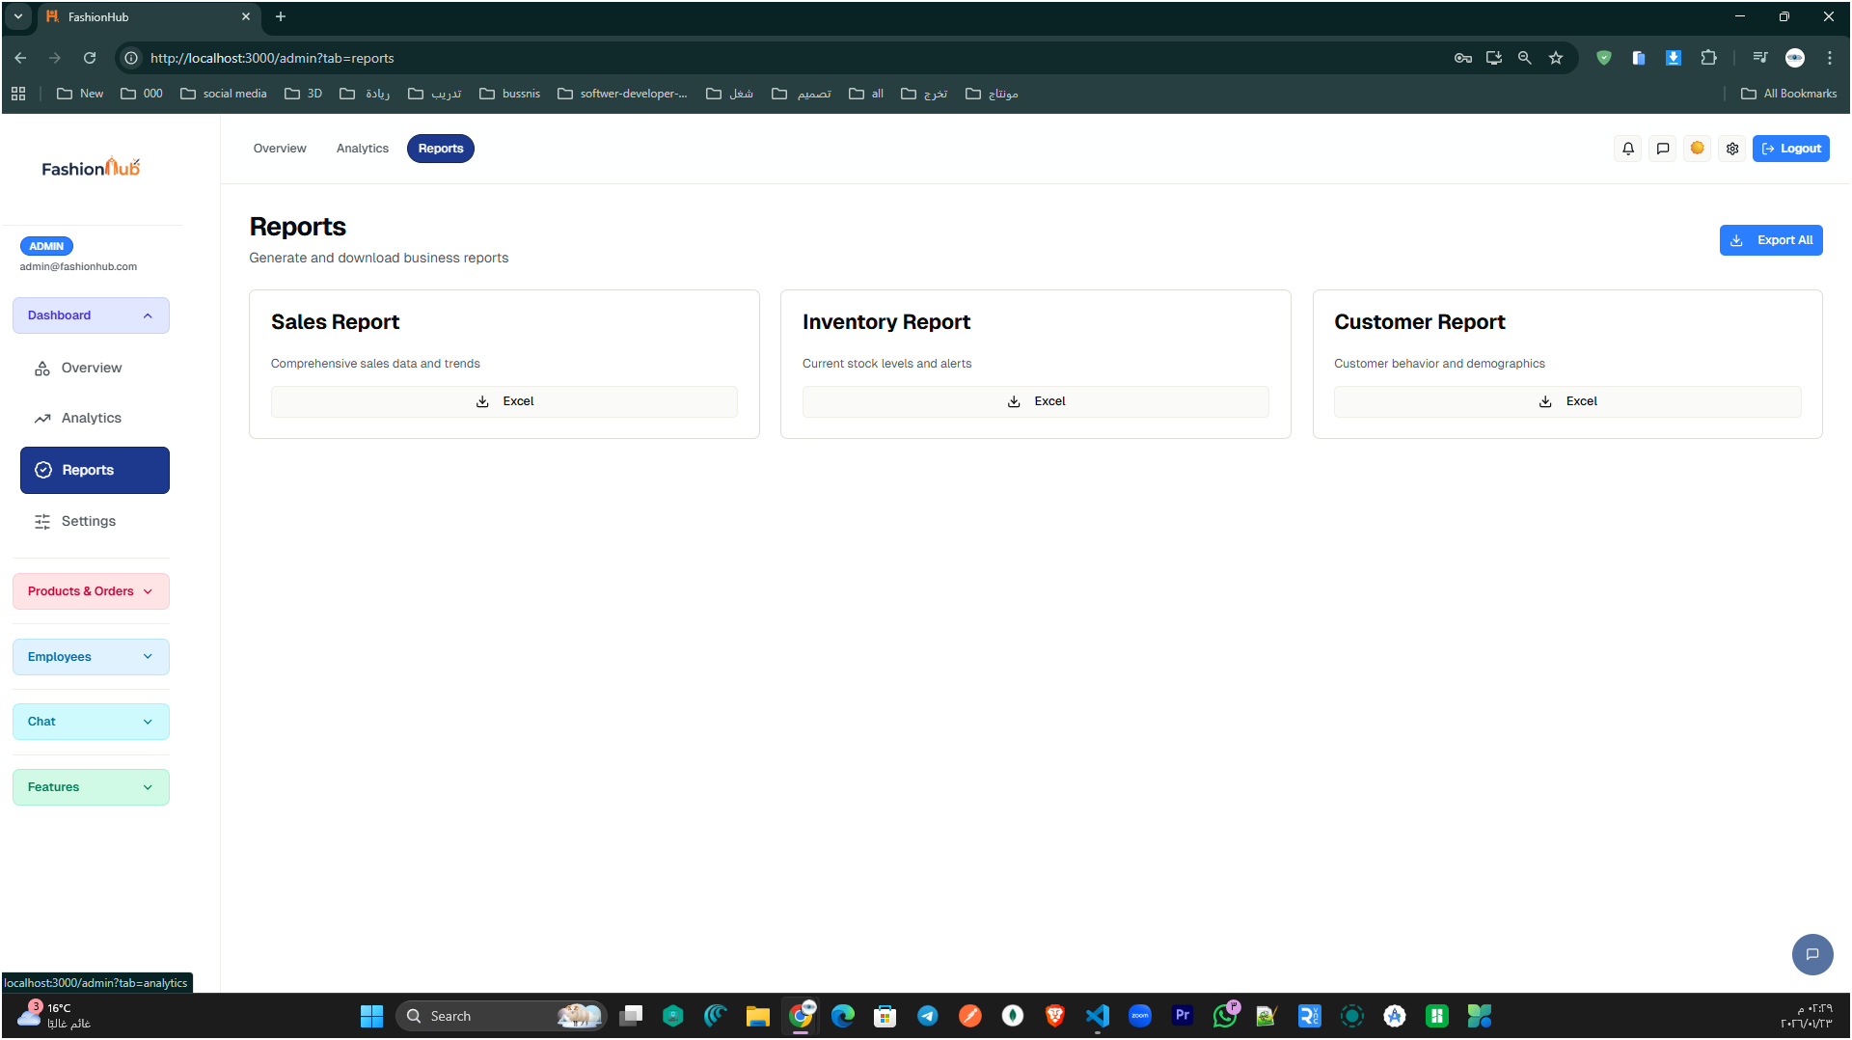
Figure 36: Admin reports page

This page allows the admin to generate and export key business reports (Sales, Inventory, and Customer reports) in Excel format for analysis and record keeping.

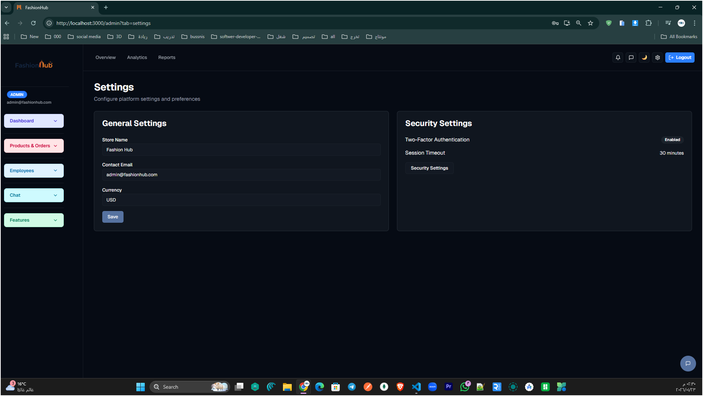
Figure 37: Admin settings page.

This page lets the admin configure store-wide settings such as store name, contact email, and currency, along with security options like two-factor authentication and session timeout.

Prodacts&Orders

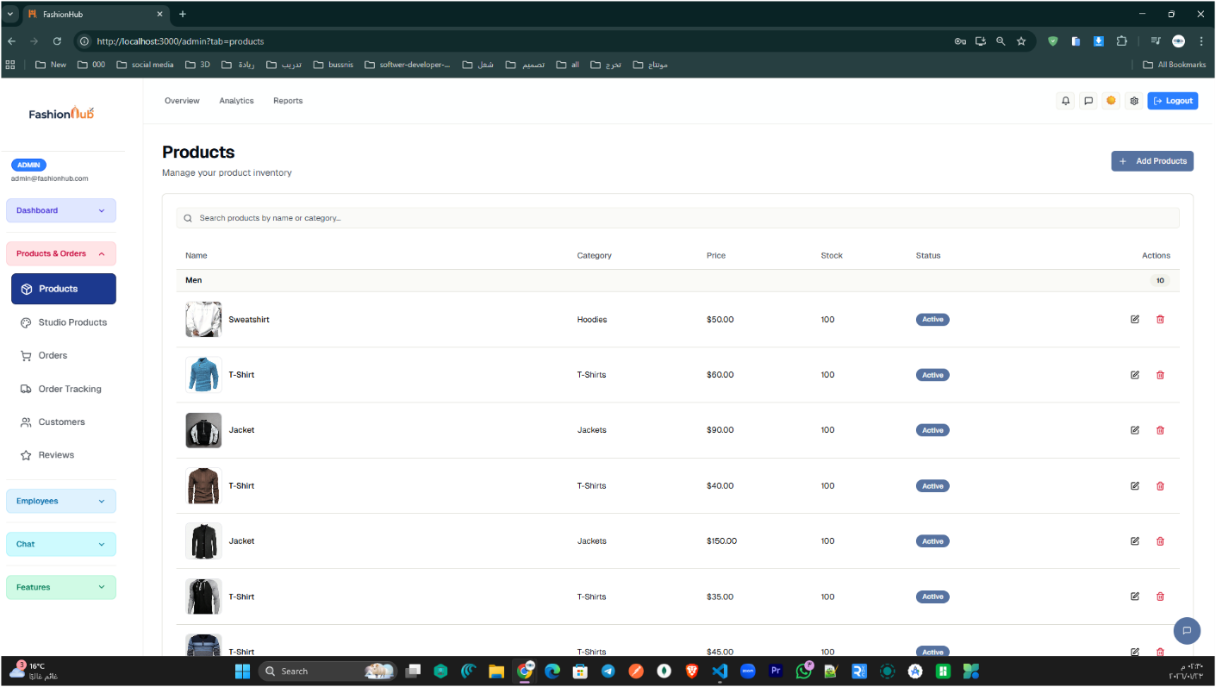

Figure 38: Admin Products page.

This page allows the admin to manage the store’s product inventory in a clear table view. It includes a search bar for quick lookup, and displays key product details such as category, price, stock level, and status (Active). From the Actions column, the admin can edit or delete products, and can also use the Add Products button to create and publish new items to the store.

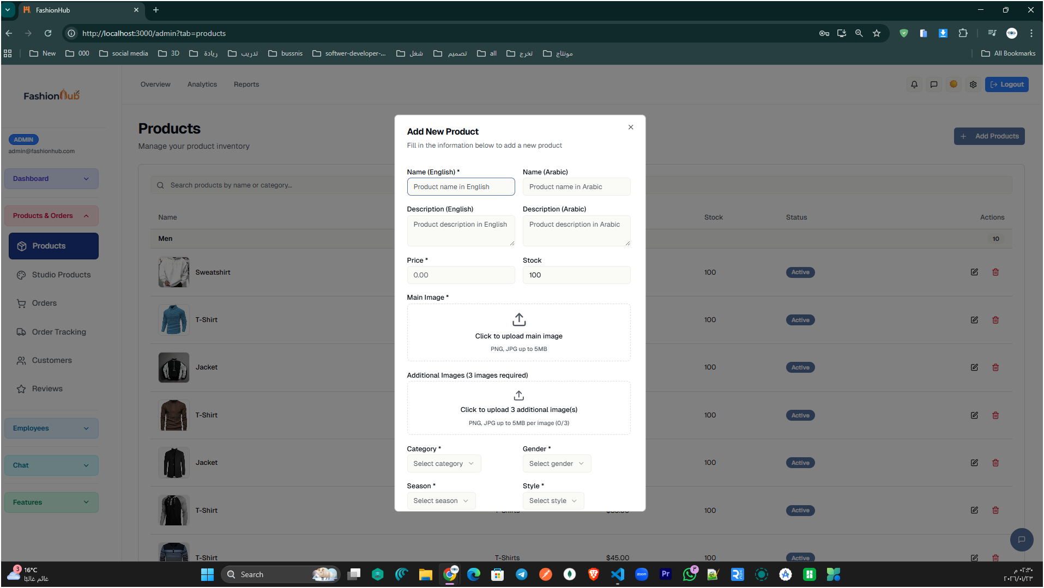

Figure 39: Add New Product form (Admin).

This screen shows the admin interface used to create a new product and add it to the store inventory. The form supports bilingual content (English/Arabic) for the product name and description, so the same item can be displayed in both languages on the storefront. The admin can also set price and stock quantity, and upload a main product image plus additional images to build a complete product gallery. Finally, the product is categorized using dropdown fields such as Category, Gender, Season, and Style, which helps organize items and improve filtering/search across the store.

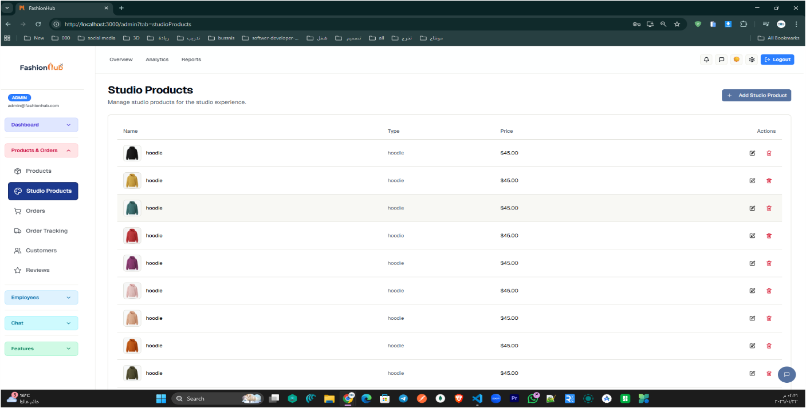

Figure 40: Admin Studio Products page

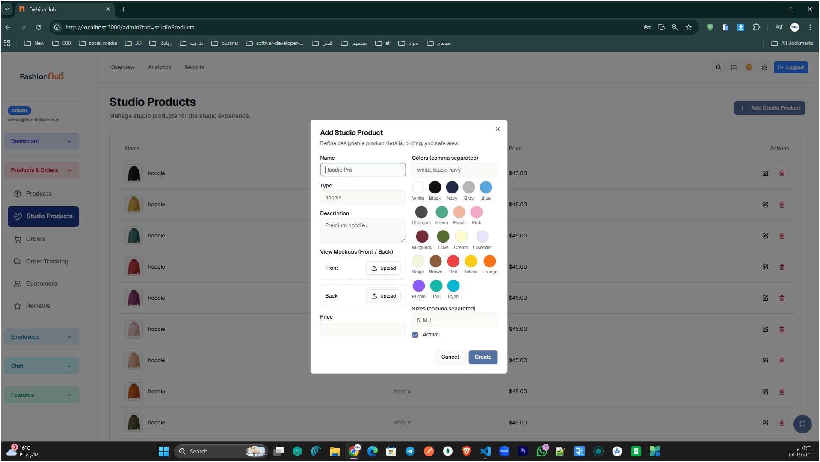

Figure 41: Add Studio Product form.

This pop-up form allows the admin to create a new Design Studio item by entering the product name, type, and description, then uploading front and back mockups. The admin can also define available colors (as selectable swatches), supported sizes, set the price, and choose whether the item is active before clicking Create to add it to the studio catalog.

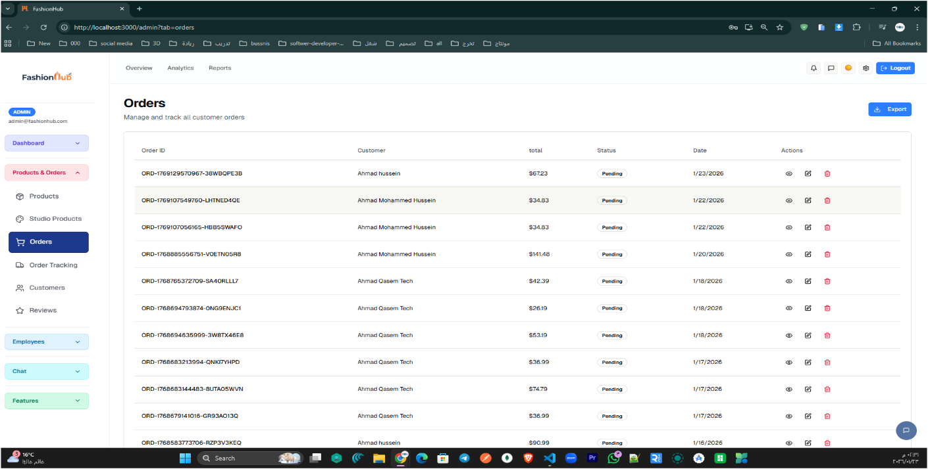
Figure 42: Admin Orders management page

This page gives the admin a full list of customer orders with key details such as Order ID, customer name, total amount, status, and date. From the actions column, the admin can view order details, edit/update the order, or delete it, and can also export the orders list for reporting or record-keeping.

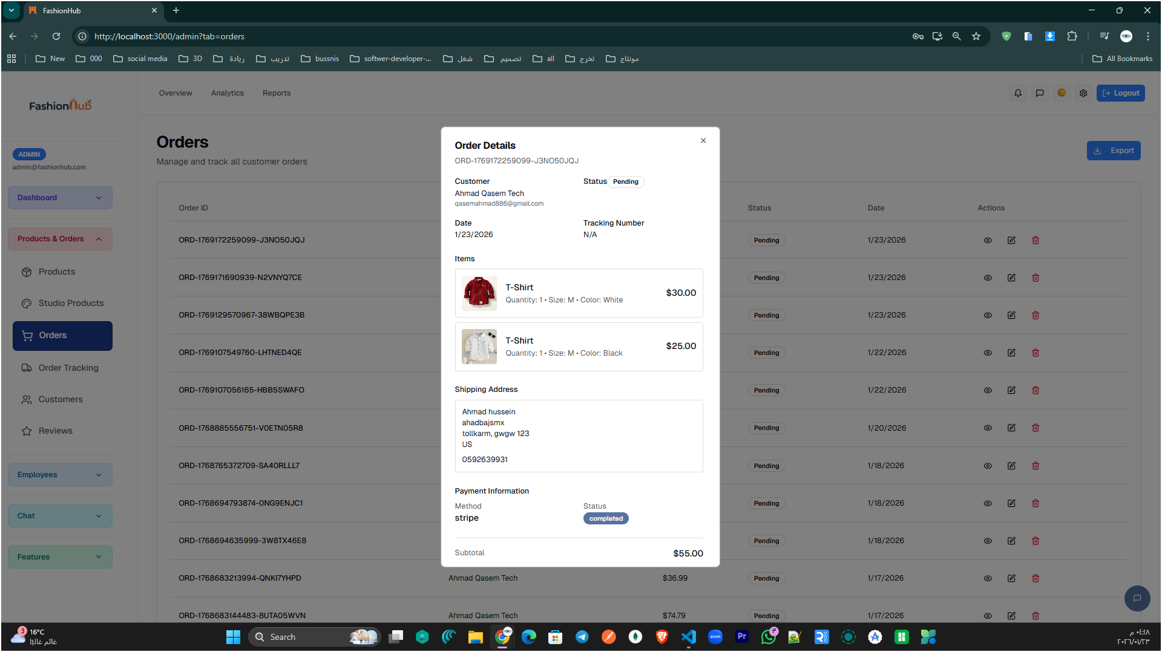

Figure 43: Order Details pop-up window in the Admin Orders page

This pop-up appears when the admin clicks View on an order. It shows a complete summary of the selected order, including customer information, order date, current status, and the items purchased (with quantity, size, color, and price). It also displays the shipping address and payment information (method and payment status), helping the admin review the order quickly without leaving the orders list.

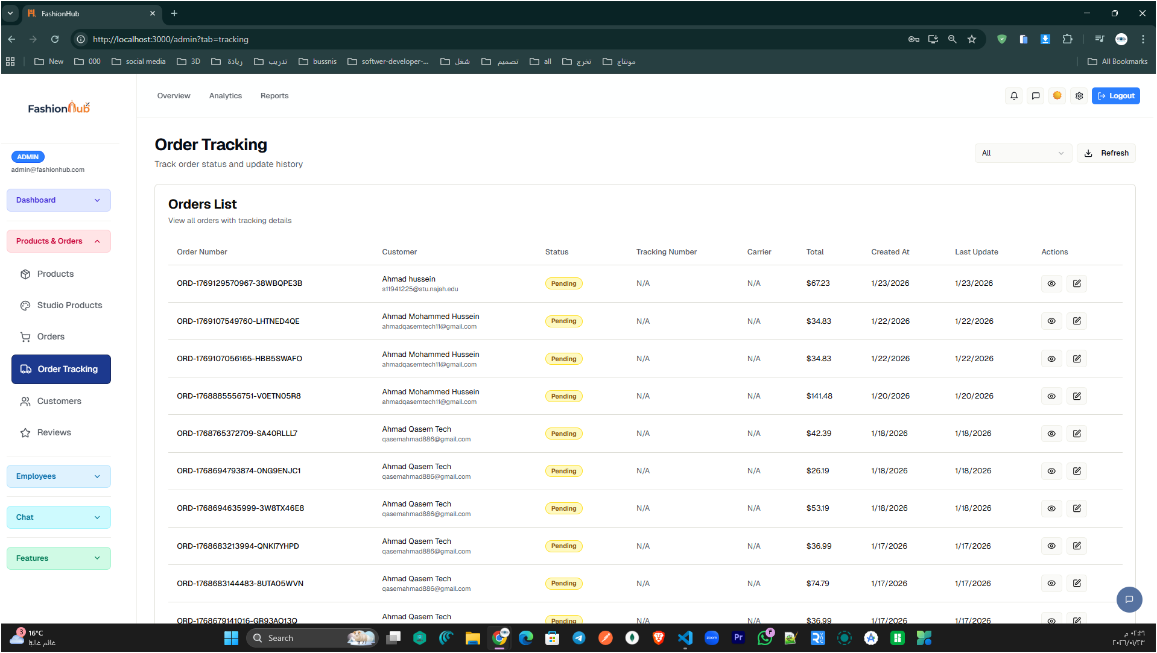

Figure 44: Admin Order Tracking page showing the tracking list for all customer orders.

This page helps the admin monitor delivery progress by listing each order with its order number, customer, current status, and tracking-related details such as tracking number and carrier (if available). It also includes total amount, created date, and last update to quickly see recent changes. From the actions column, the admin can open or update an order’s tracking record, making it easier to manage order fulfillment in one place.

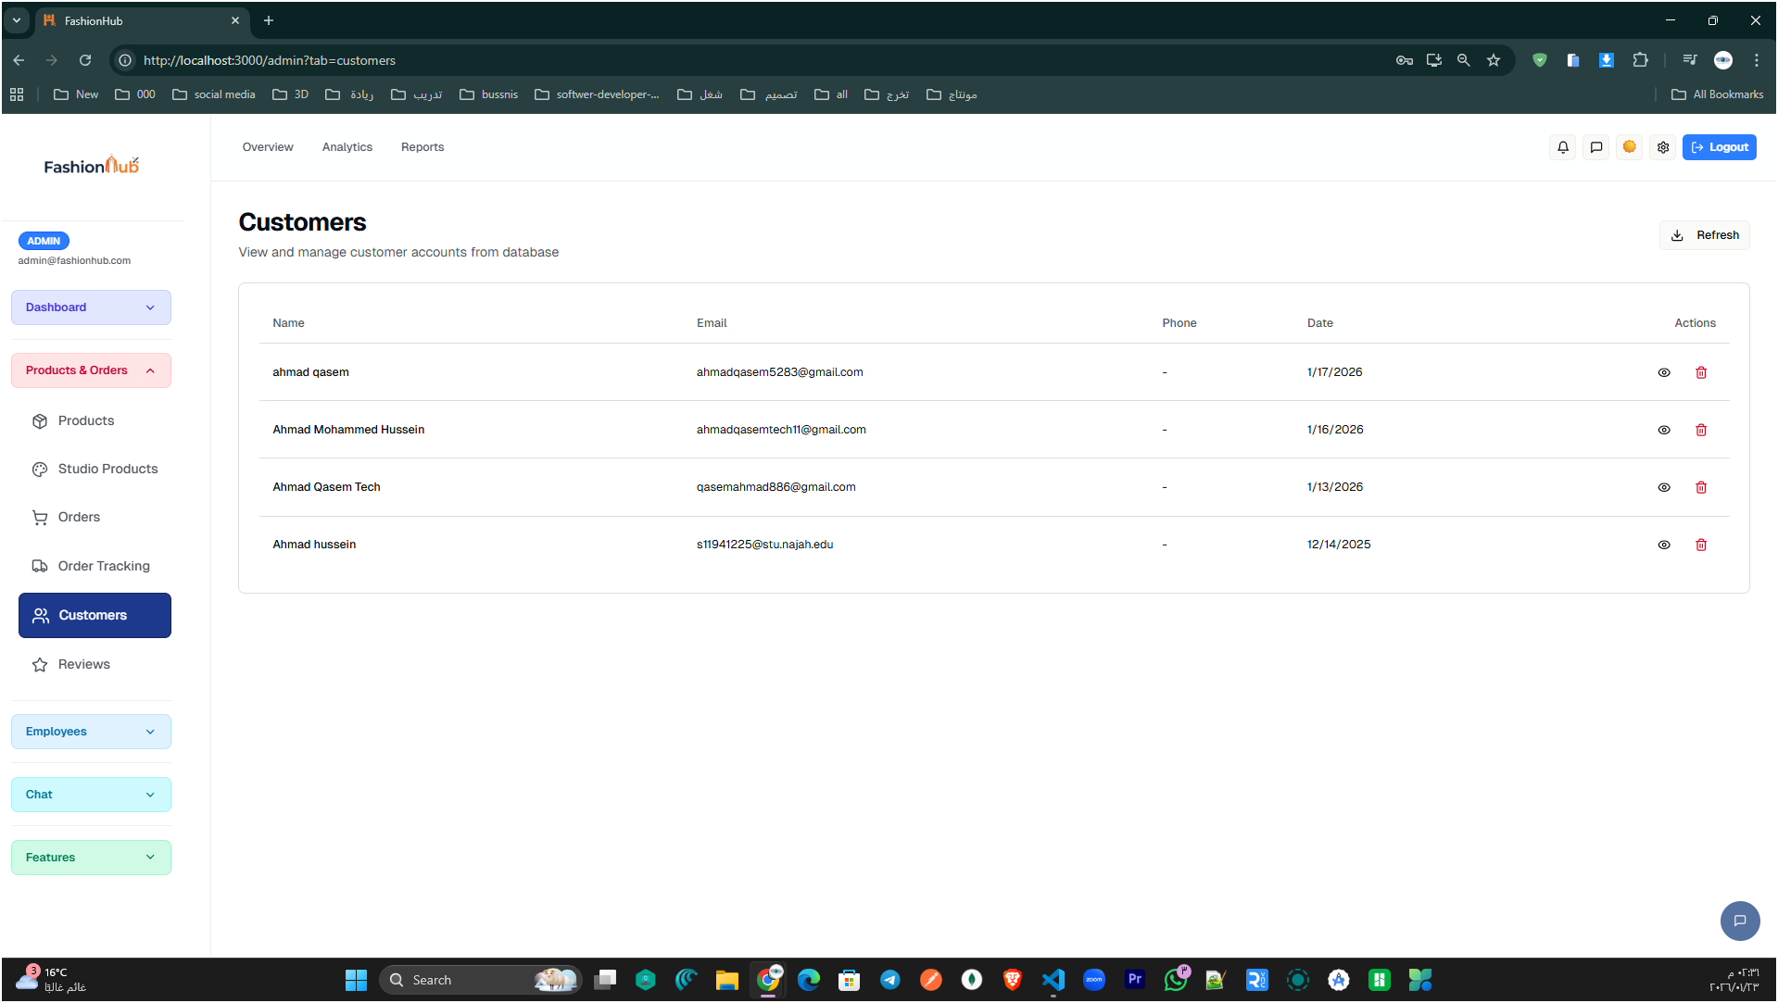

Figure 45: Customers management page in the Admin Dashboard.

This page allows the admin to view and manage all registered customers stored in the system database. It lists key details such as name, email, phone number, and registration date, making it easy to monitor the user base. From the Actions column, the admin can open a customer record for review or remove a customer when necessary.

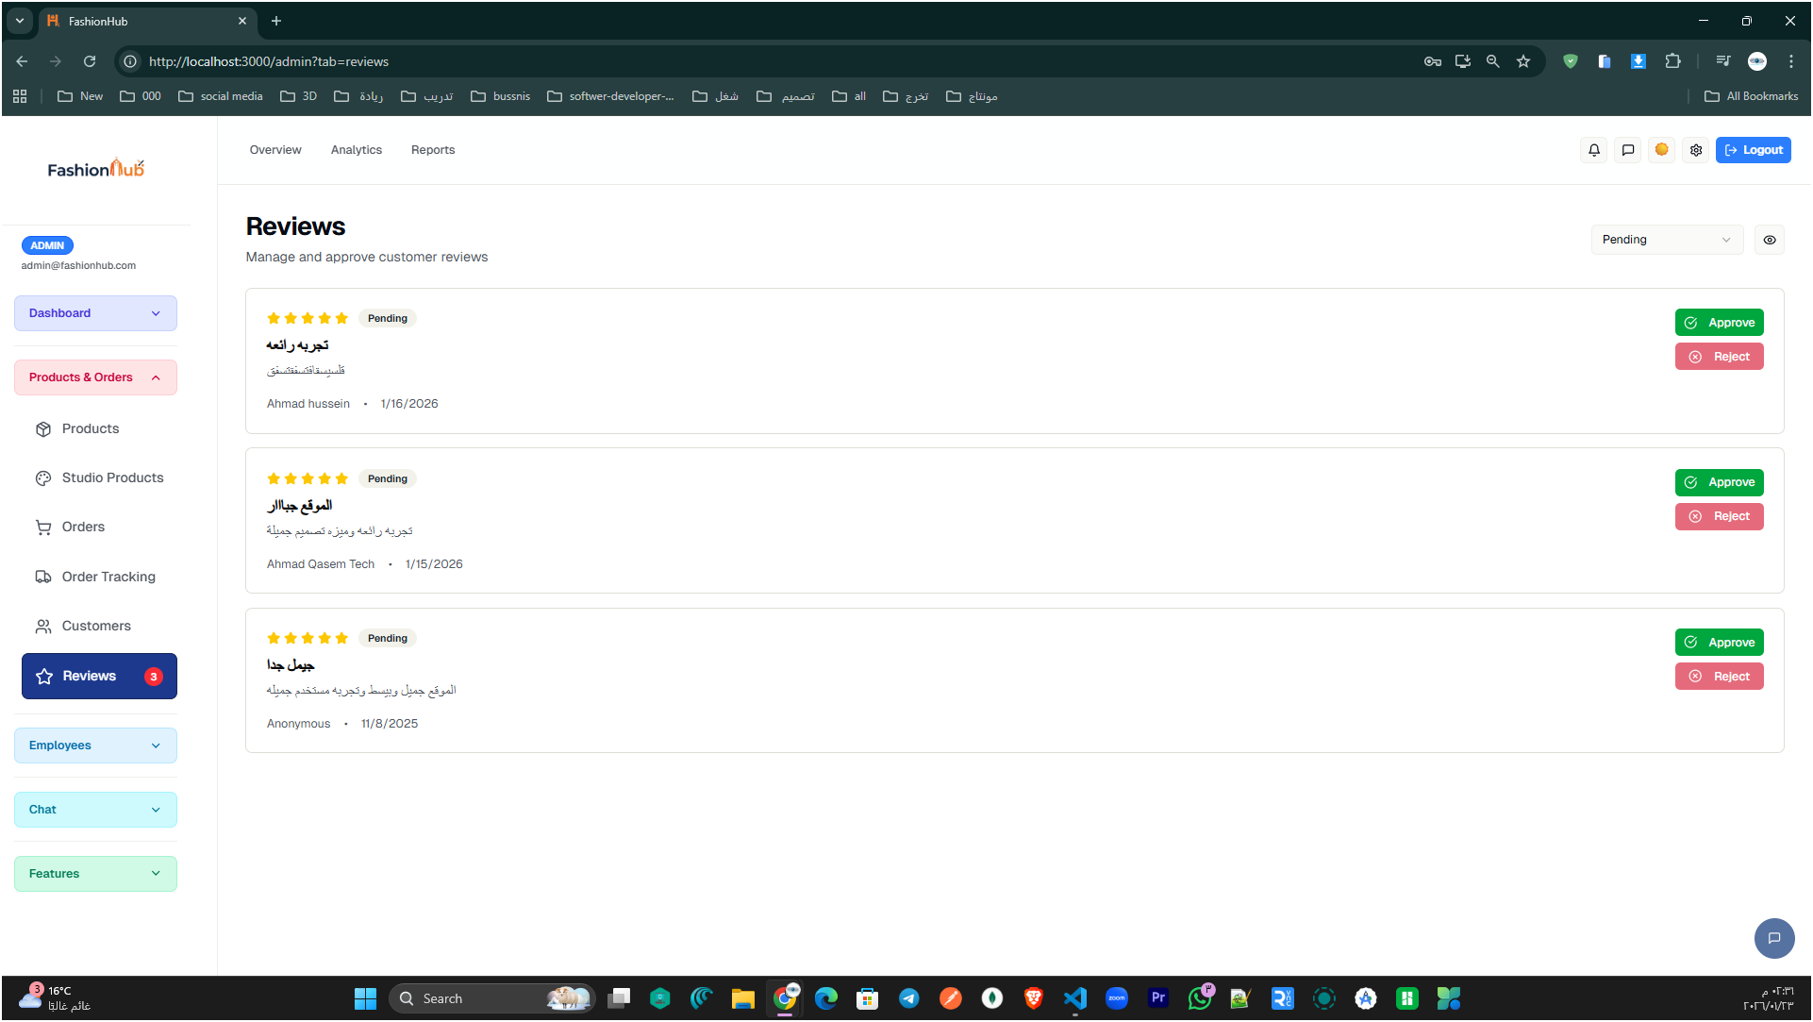

Figure 46: Reviews moderation page in the Admin Dashboard.

This page lets the admin manage customer reviews before they appear publicly on the store. Each review card shows the rating (stars), review title/content, the customer name, and the submission date, along with its current status (e.g., Pending). The admin can quickly Approve a review to publish it or Reject it to remove inappropriate or low-quality feedback, helping keep the testimonials section reliable and professional.

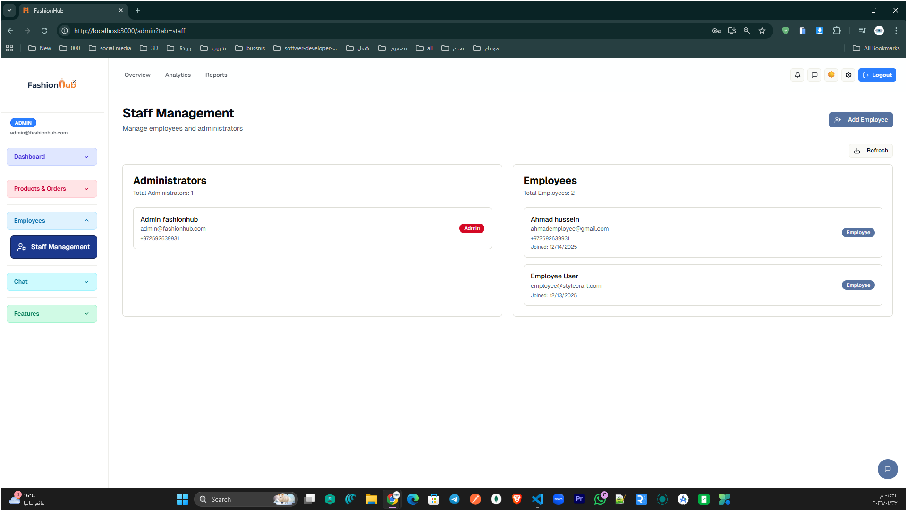

Figure 47: Staff Management page in the Admin Dashboard.

This section allows the admin to manage the store team by separating users into Administrators and Employees. It shows each staff member’s basic information (such as name/email) and their assigned role badge, which helps control permissions and responsibilities From here, the admin can also add new team members using the Add Employee button and keep the staff list updated using the refresh option.

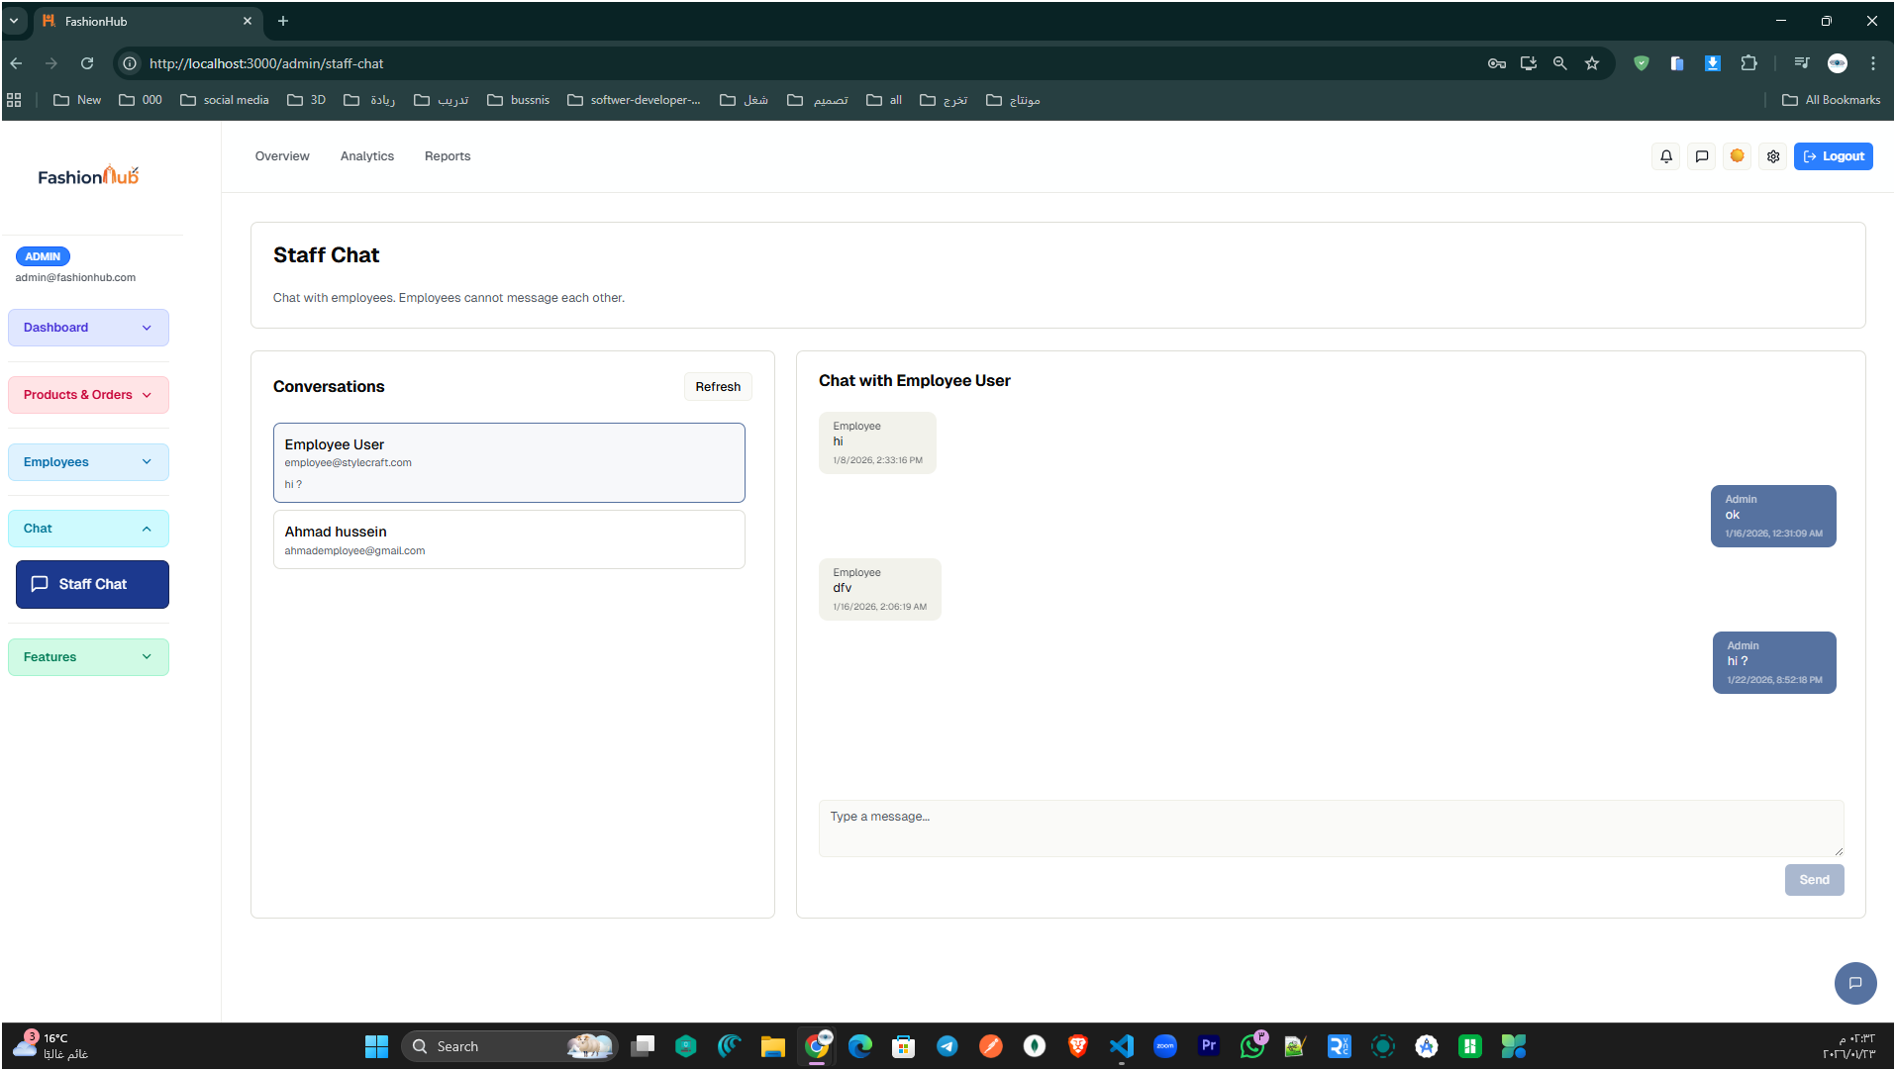

Figure 48: Staff Chat page in the Admin Dashboard

This page provides an internal messaging channel where the admin can communicate directly with employees. On the left, the admin can see and select ongoing conversations with different staff members, while the right side displays the full chat history and a message input box to send new messages. This feature helps with quick coordination and support inside the system, without needing external communication tools.

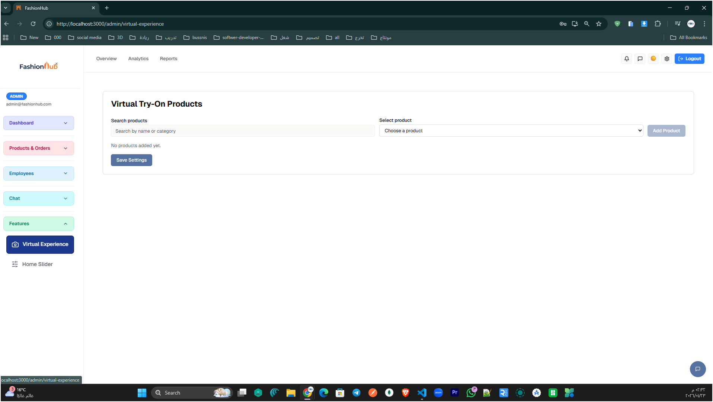
Figure 49: Virtual Try-On Products management page (Admin Side).

This screen lets the admin configure which products appear in the Virtual Try-On feature. The admin can search the catalog, choose a product from the dropdown, and add it to the try-on list, then save the settings so only selected items are available for the virtual experience. This helps control and organize the try-on content from the dashboard.

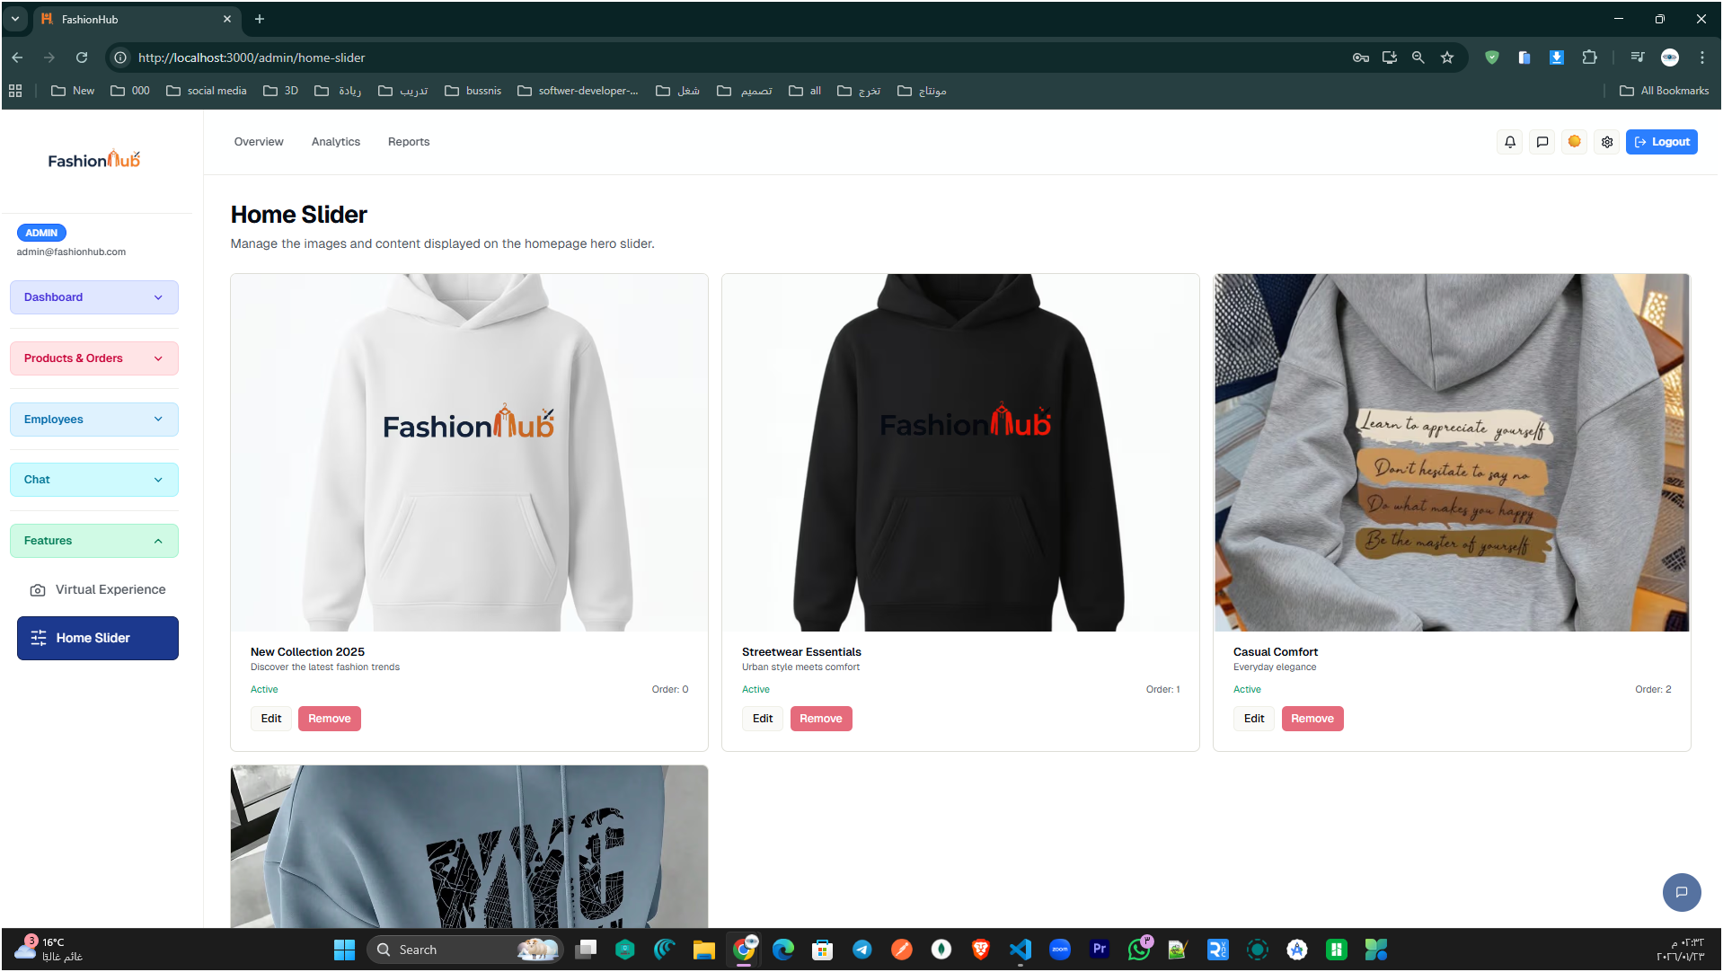
Figure 50: Home Slider management page

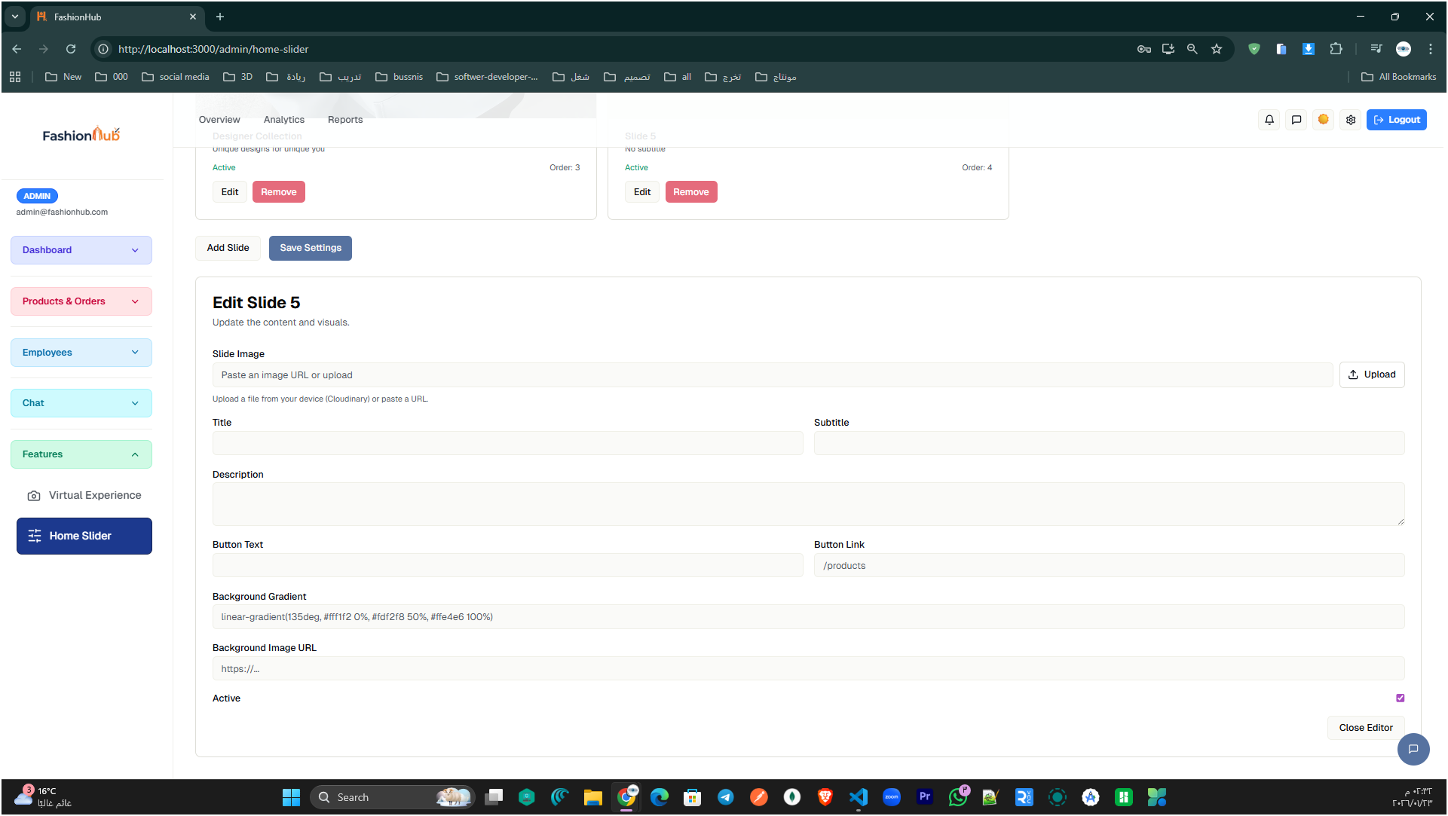

Figure 51: Edit Slider form.

These two screens show how the admin controls the homepage hero slider in FashionHub. First, the admin can view all slider items, see which ones are active, and quickly edit or remove any slide. Then, through the edit form, the admin can update the slide image and text (title/description), set the button link, adjust the background style, and enable/disable the slide to decide whether it appears on the homepage.

Employee Side

FashionHub provides a dedicated interface for employees to support daily store operations without accessing full admin controls. This side focuses on practical tasks such as handling assigned requests, following up on orders and customers when needed, and communicating internally through the staff chat. The goal is to keep the workflow simple and secure by giving employees only the tools they need to complete their responsibilities efficiently.

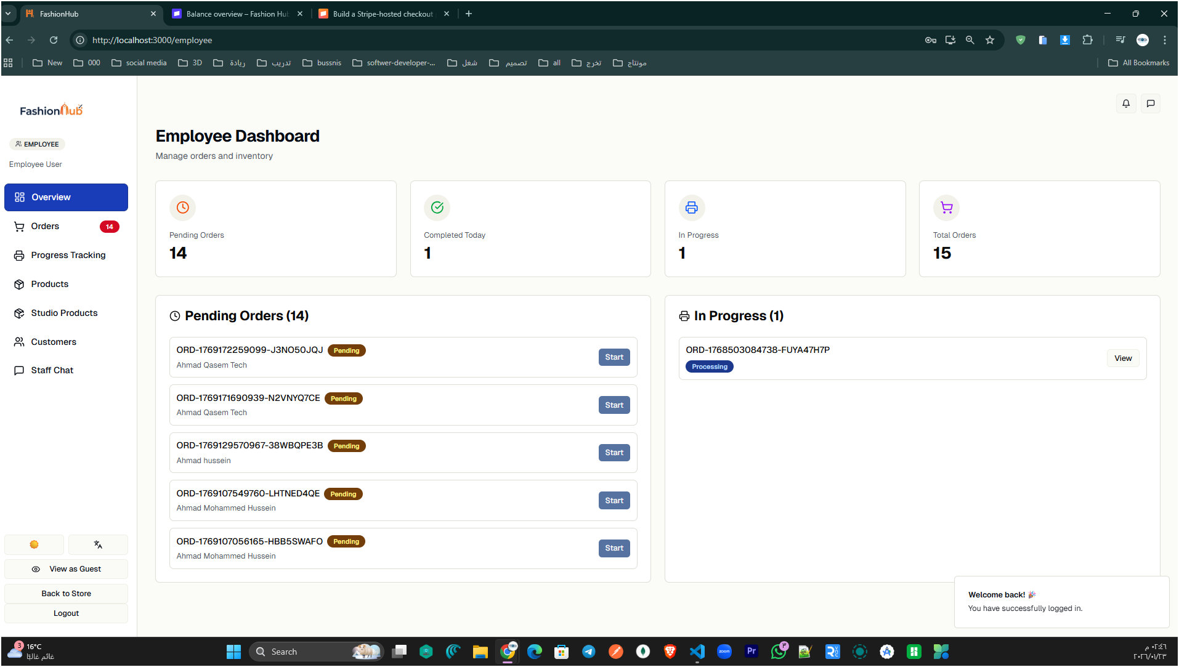

Figure 52: Employee Dashboard (Overview)

This screen presents the employee’s main dashboard after login, summarizing key order metrics (pending, in-progress, completed) and displaying categorized lists with quick actions like Start or View to handle orders efficiently.

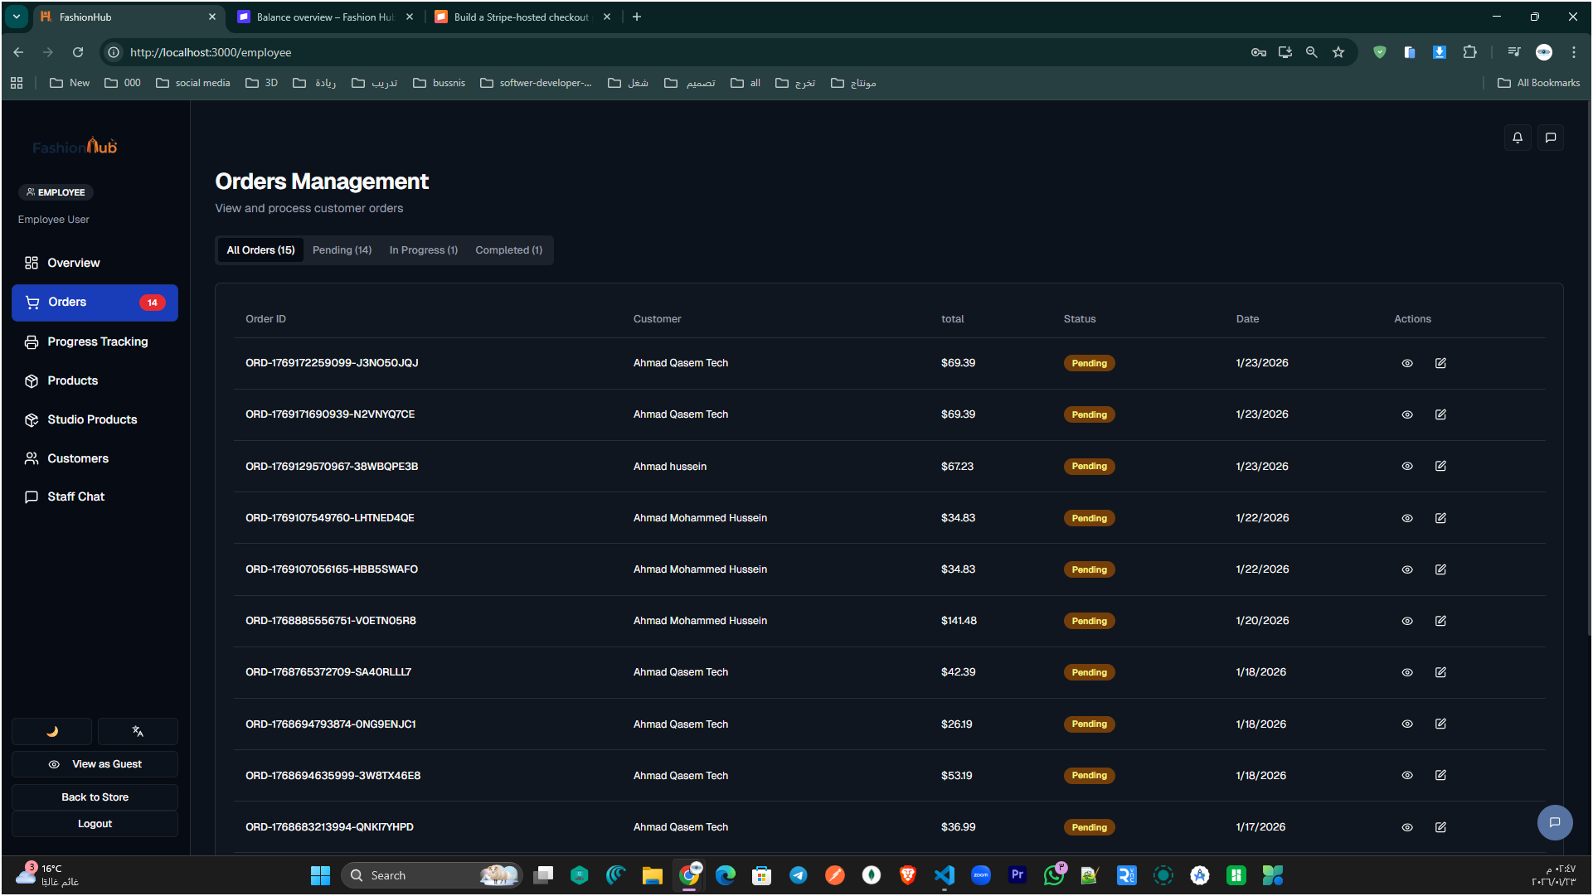

Figure 53: Orders Management

This page lets employees view and manage all incoming orders in one table, with filters by status (Pending / In Progress / Completed). From the Actions column, staff can quickly open order details and proceed with processing each order.

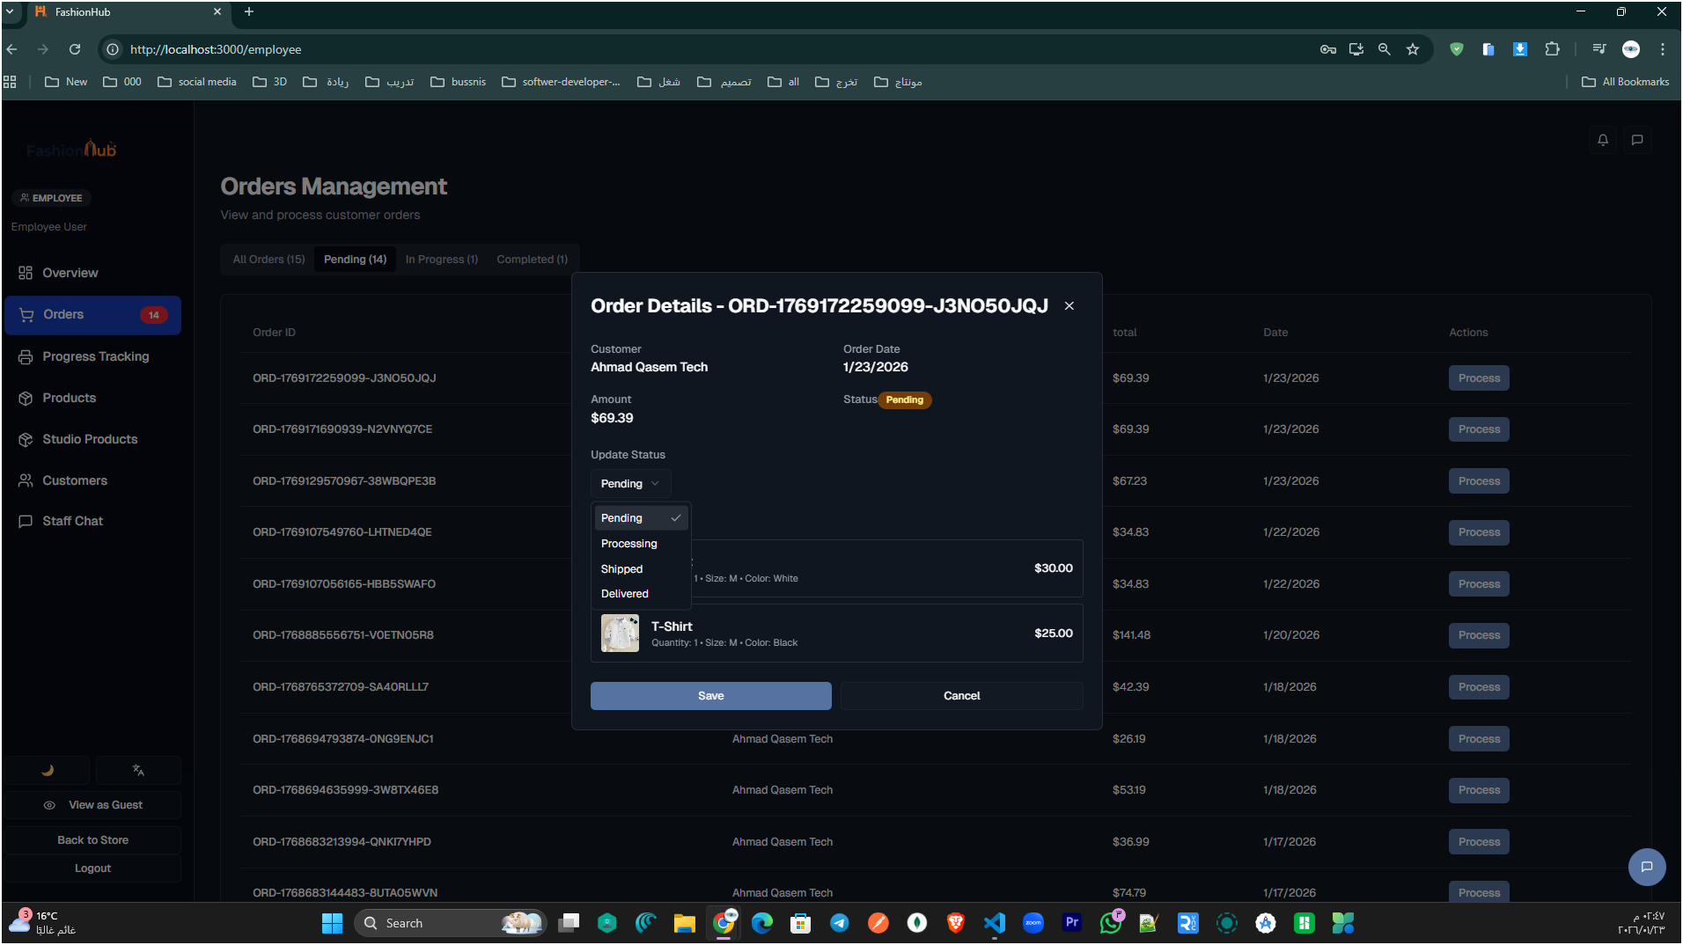
Figure 54: Order Details (Employee)

This popup displays the selected order information (customer, date, total, and items) and allows the employee to update the order status from the dropdown (e.g., Pending, Processing, Shipped, Delivered) then save the changes to keep tracking accurate.

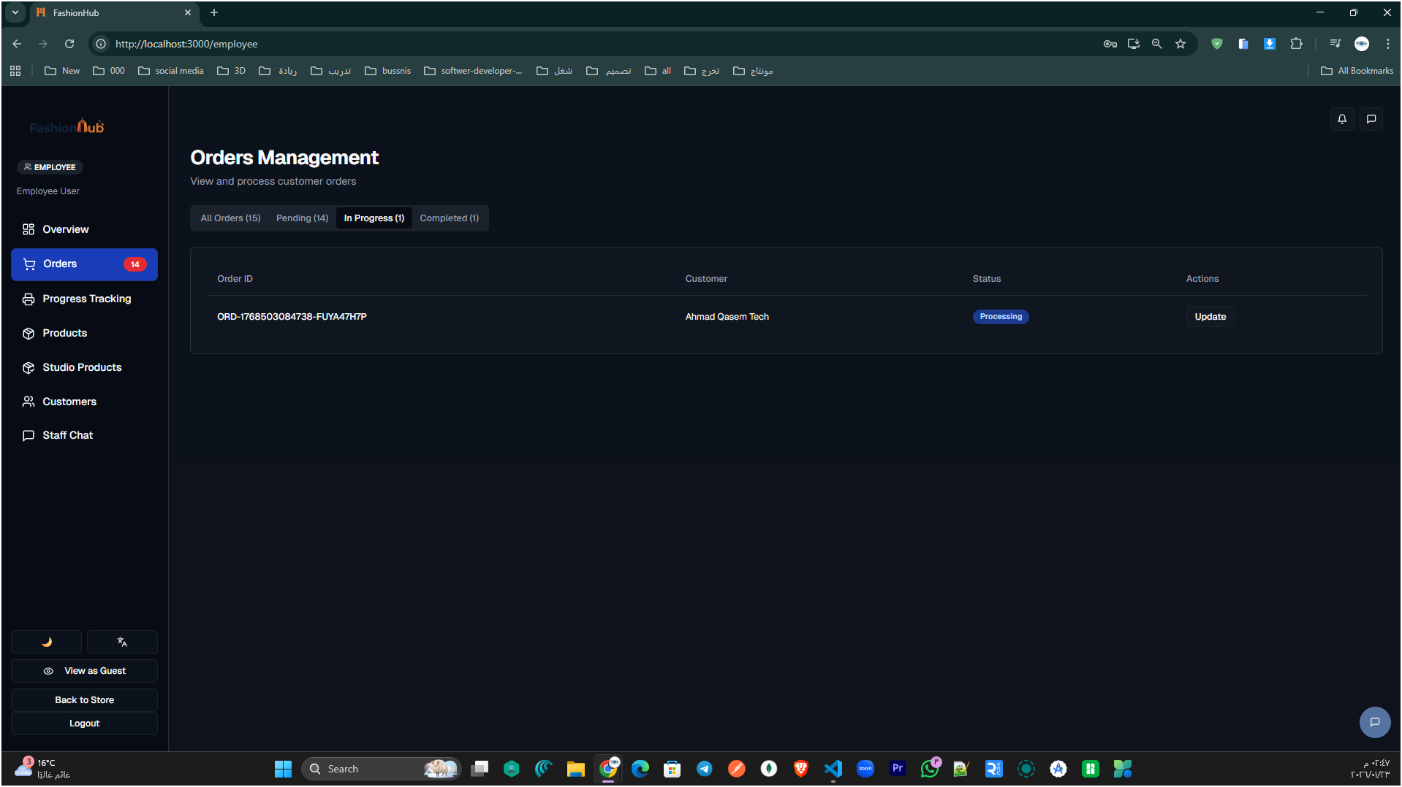

Figure 55: In-Progress Orders (Employee)

This screen filters orders to show only the ones currently In Progress, displaying the order ID, customer, and current status. The employee can click Update to edit the order status and keep the workflow moving.

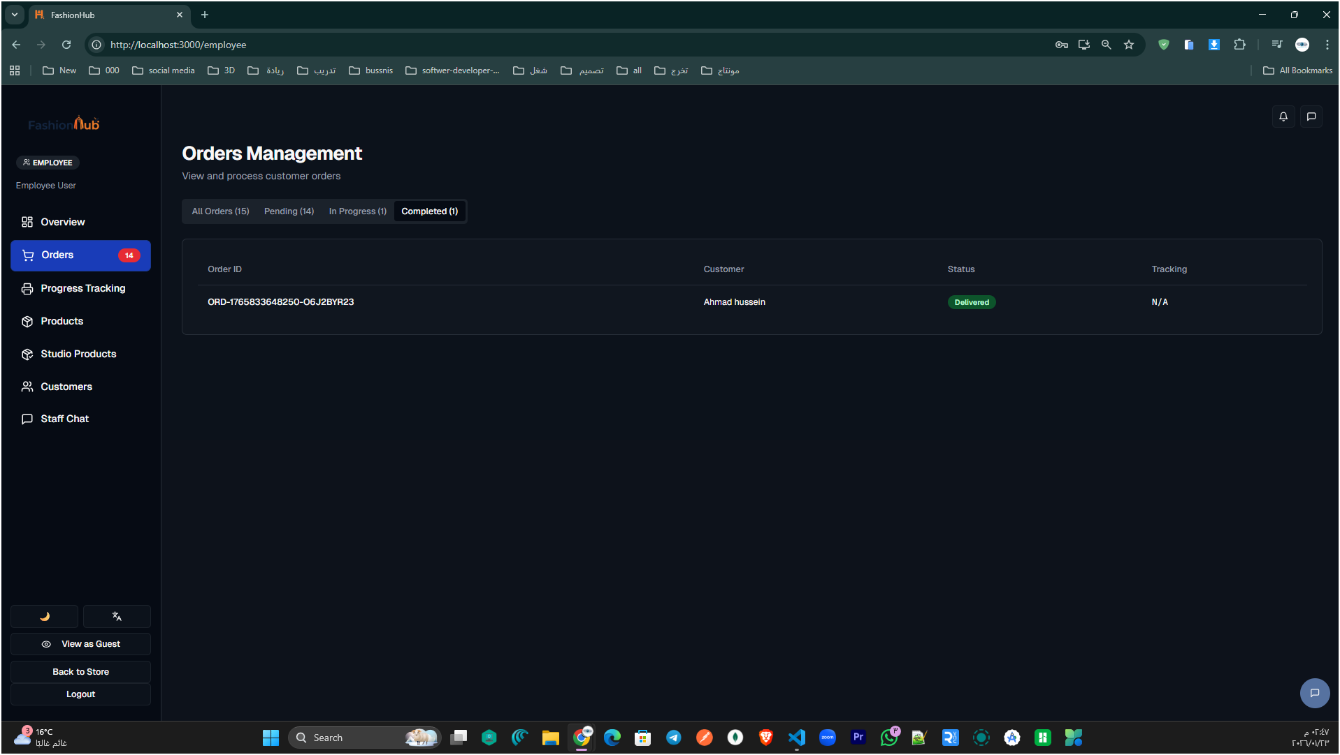
Figure 56: Completed Orders Tab

This tab displays finished orders with a “Delivered” status, helping employees confirm fulfillment. It also shows tracking availability (e.g., N/A) for reference and record-keeping.

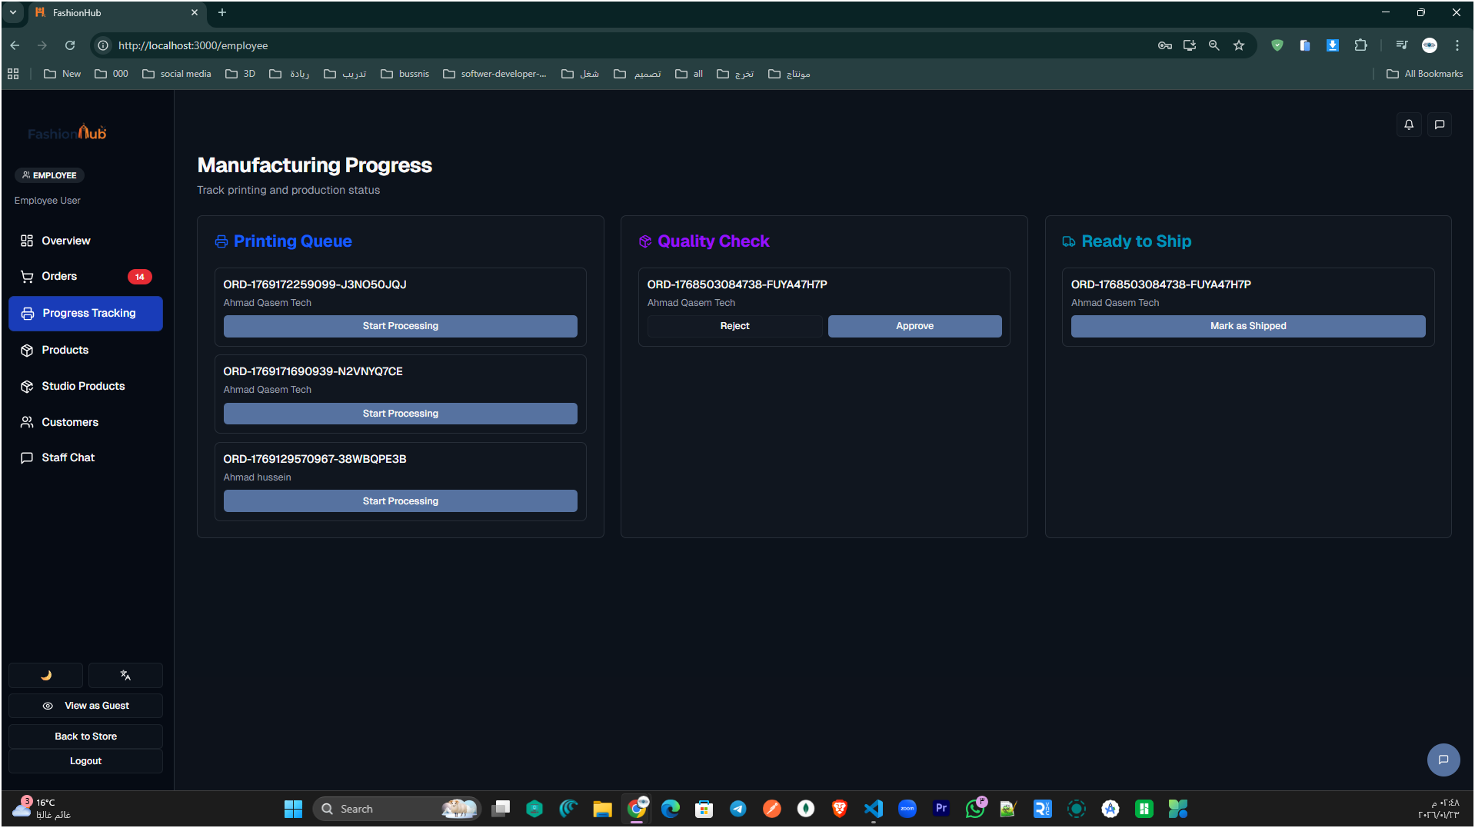

Figure 57: Manufacturing Progress

This page helps employees follow each order through the internal production pipeline. Orders start in the Printing Queue, where staff can begin work using the Start Processing button. After printing, the order moves to Quality Check, where it can be Approved or Rejected based on inspection results. Once approved, the order appears under Ready to Ship, allowing the employee to finalize the process by marking it as shipped.

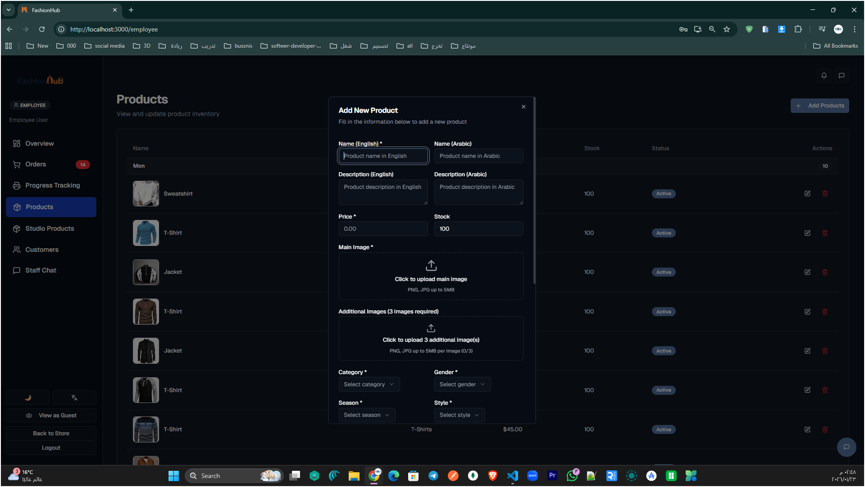
Figure 58: Add New Product (Employee Panel)

This screen lets the employee create a new product by entering bilingual details (English/Arabic) such as the product name and description. The employee can set the price and stock quantity, then upload the main product image and additional images to build a complete product gallery. At the bottom, the product is organized using dropdowns like Category, Gender, Season, and Style, ensuring it appears correctly in the store filters and collections.

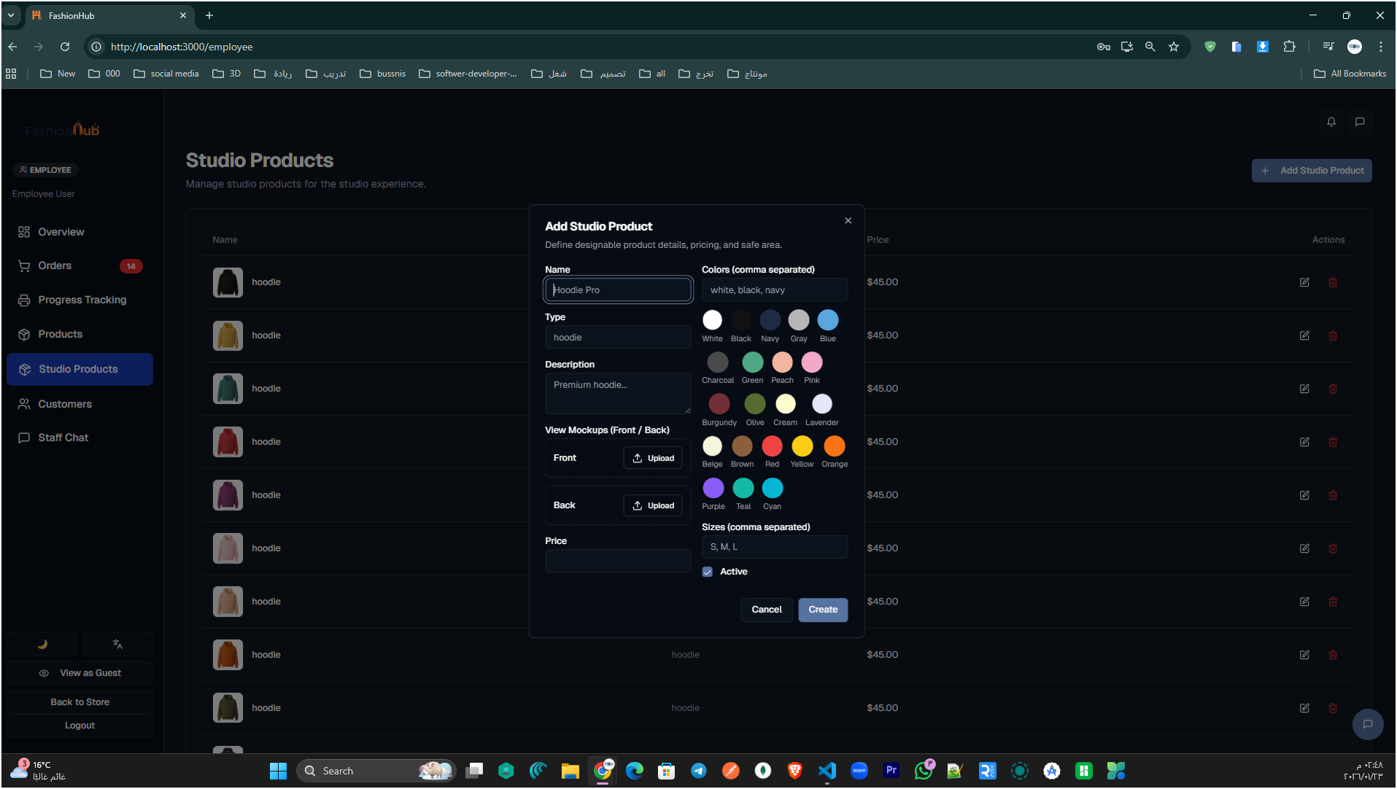Figure 59: Add Studio Product (Employee Panel)

This window is used to add a Studio Product that will be available inside the Design Studio (customization area). The employee enters the product name, type, description, and base price, then defines the allowed colors and sizes that customers can choose from while designing. The form also includes uploading the front and back mockups, which are the main previews used in the studio. Finally, the employee can toggle the product as Active and click Create to publish it to the studio product list.

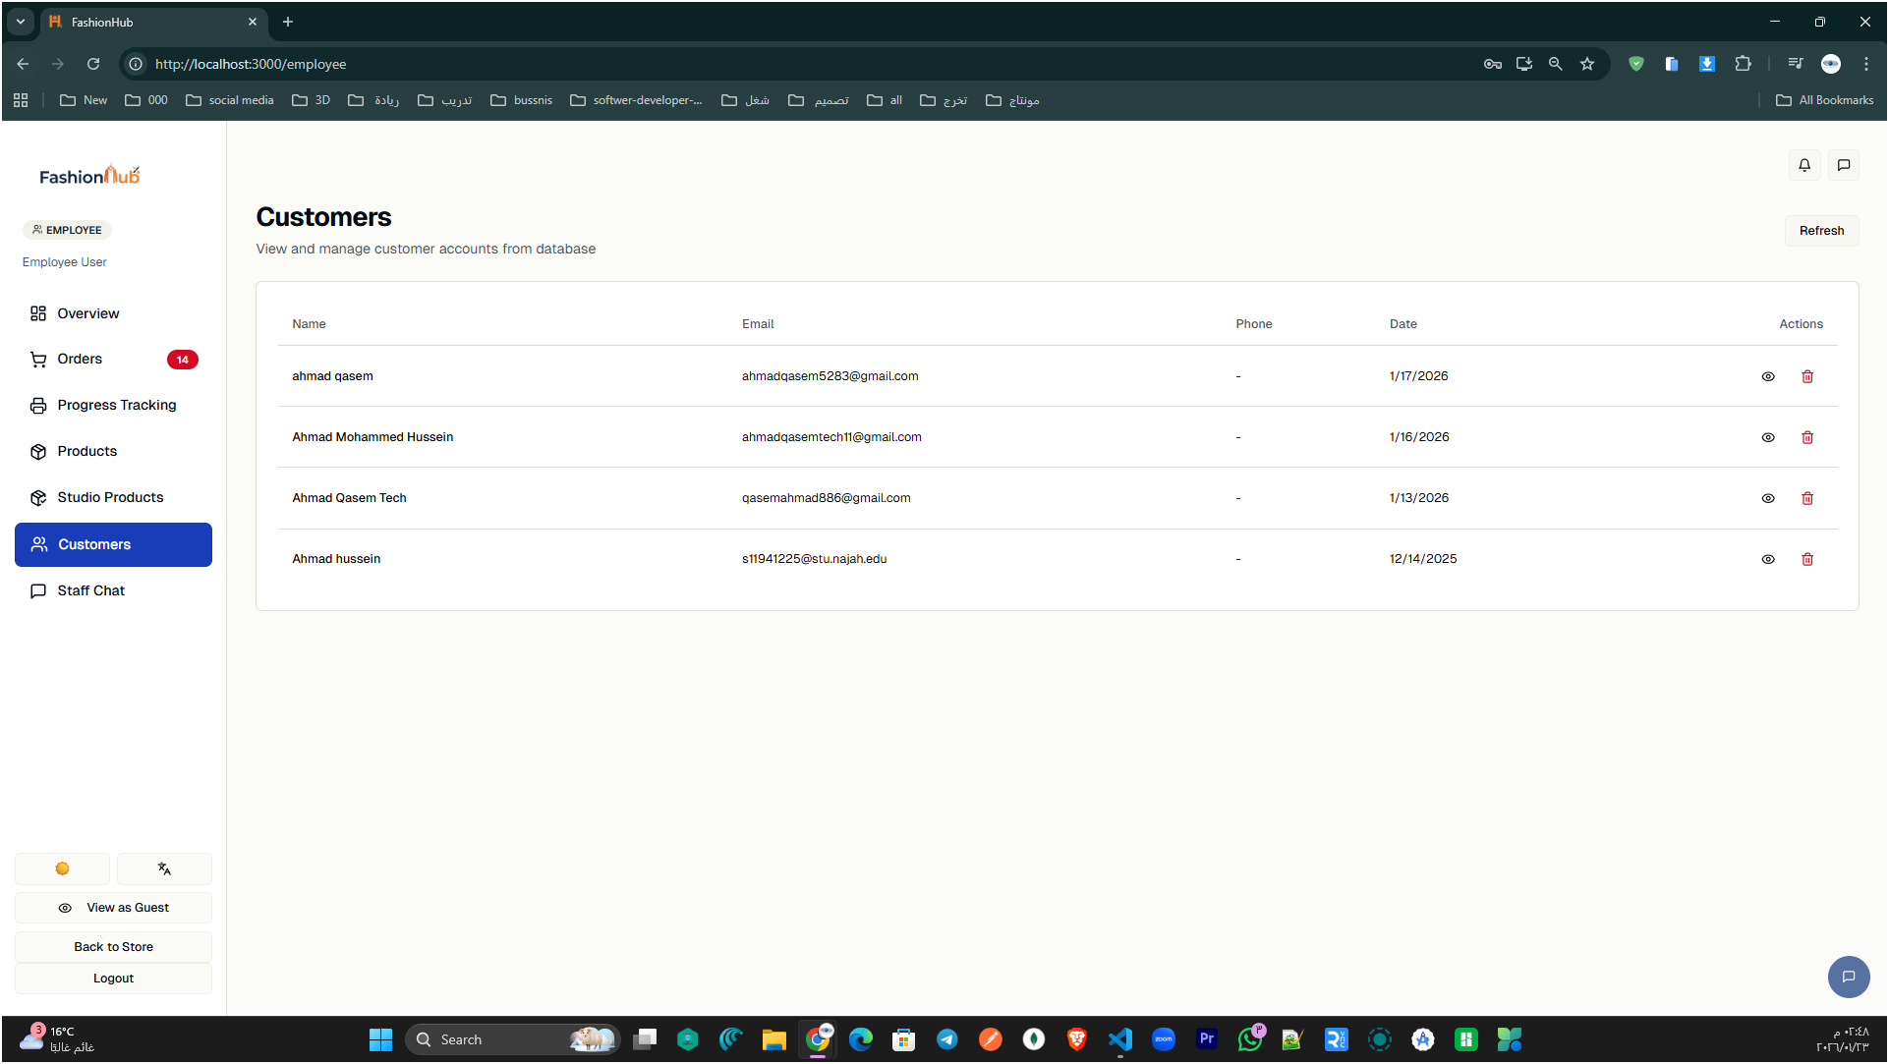

Figure 60: Customers List (Employee Panel)

This page lists all registered customers in a table (name, email, phone, and join date). The employee can quickly review customer records and use the actions column to view or manage each account

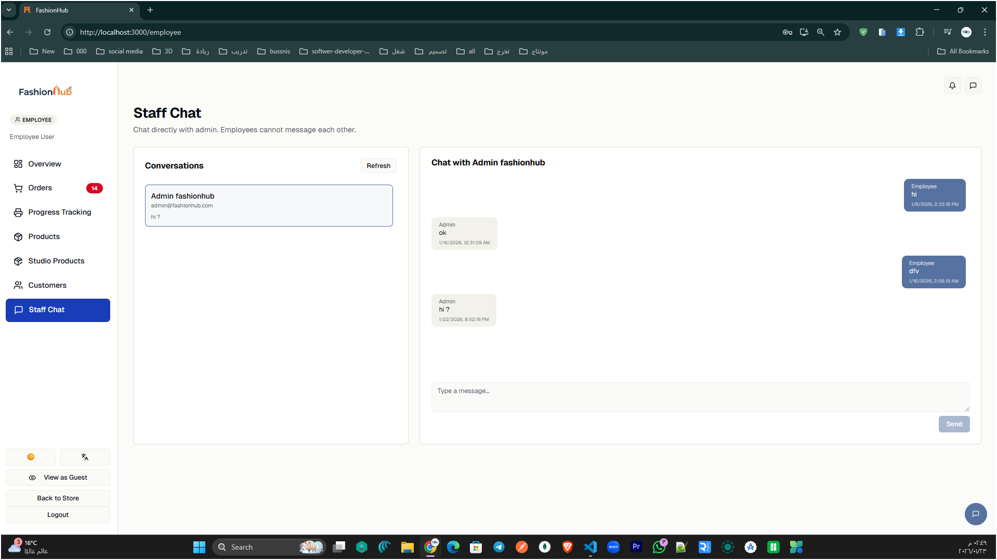

Figure 61: Staff Chat (Employee Panel)

This screen provides a direct messaging channel between the employee and the admin. Conversations appear on the left, while the selected chat is shown on the right with a message box to send new updates or questions

  - Mobile Application
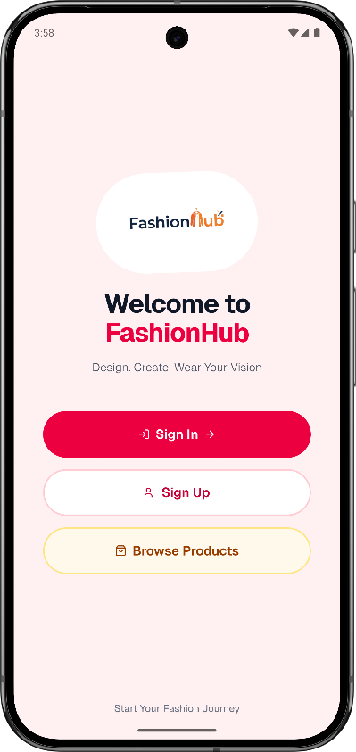
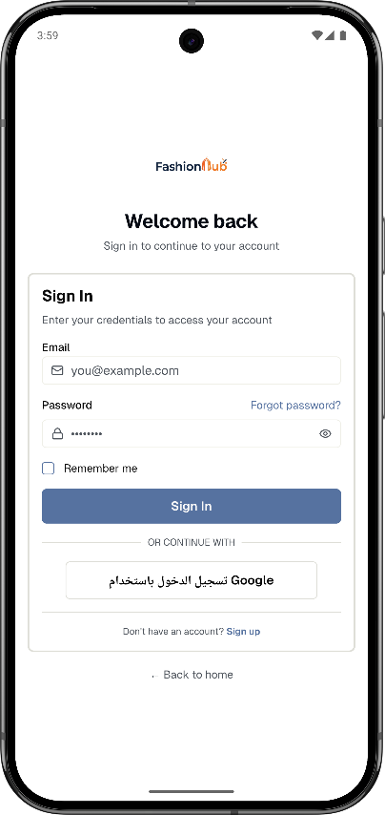
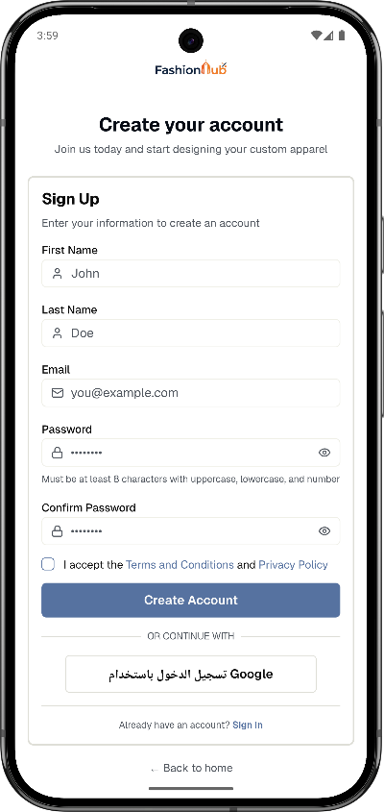

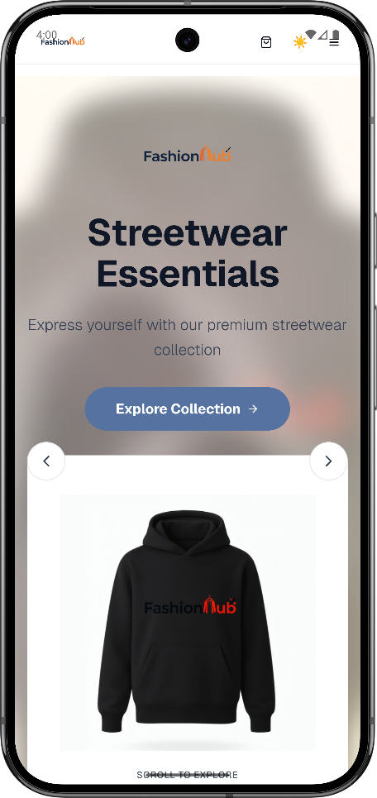
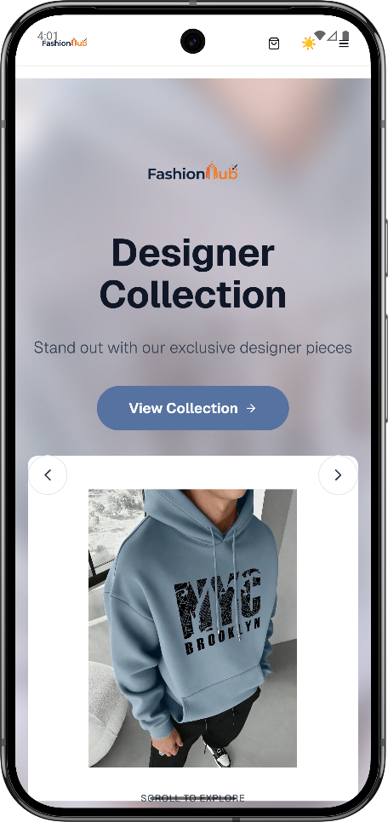
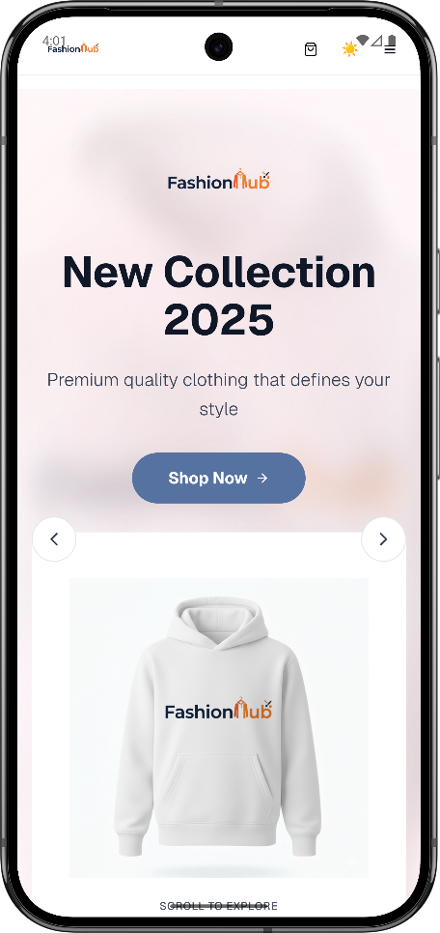
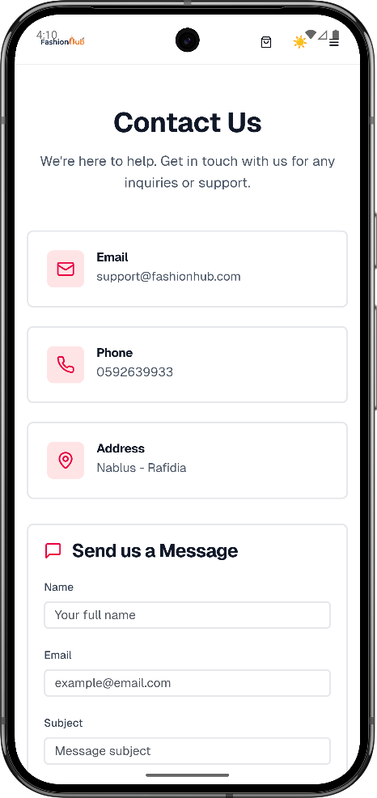
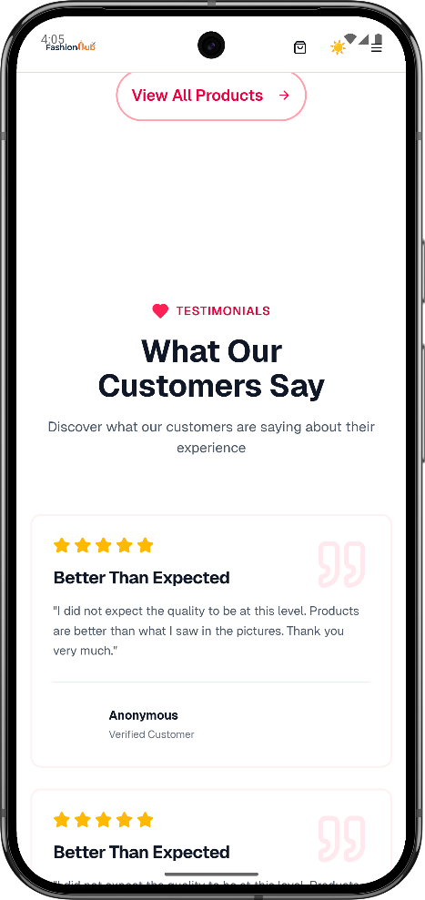
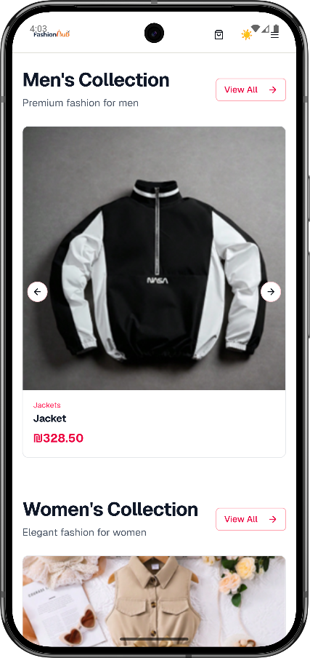
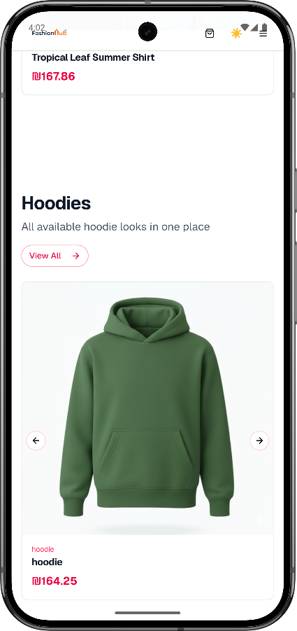
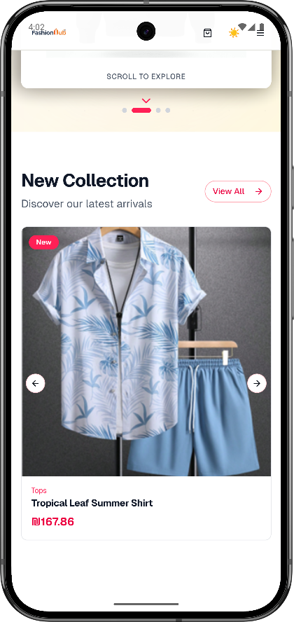
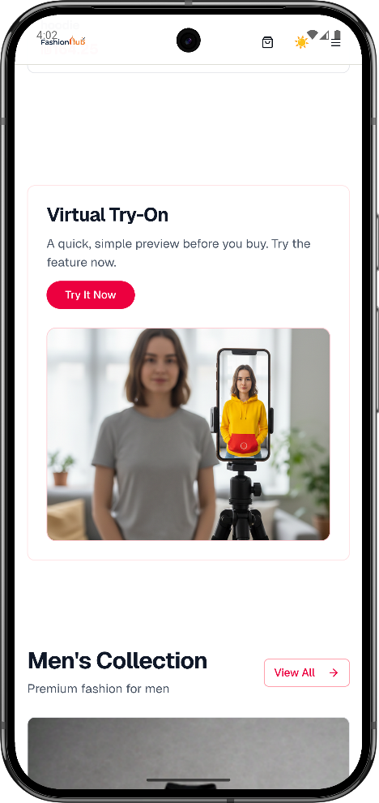
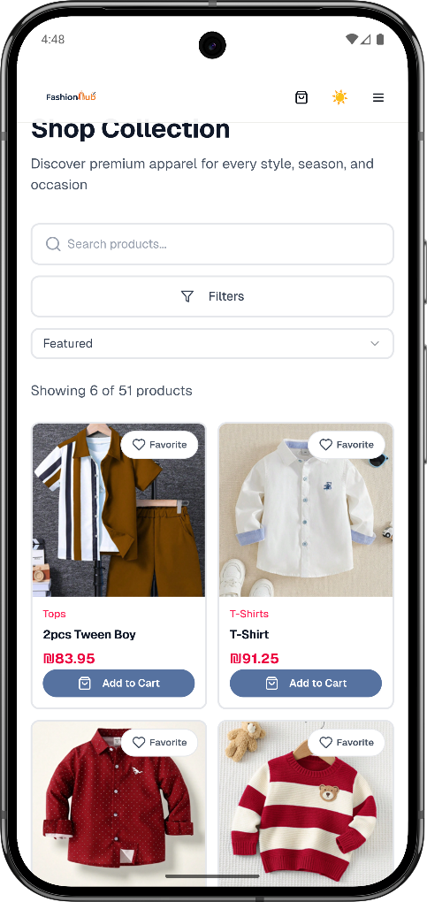
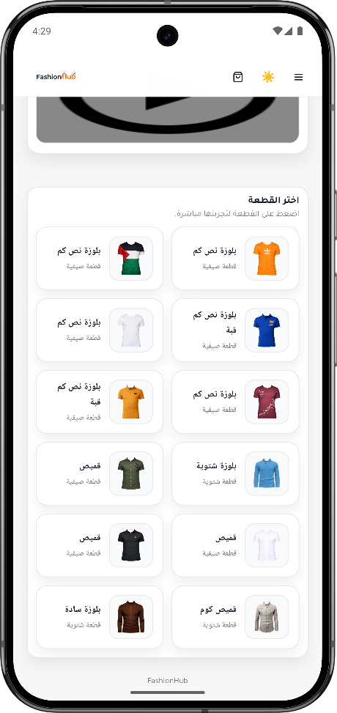
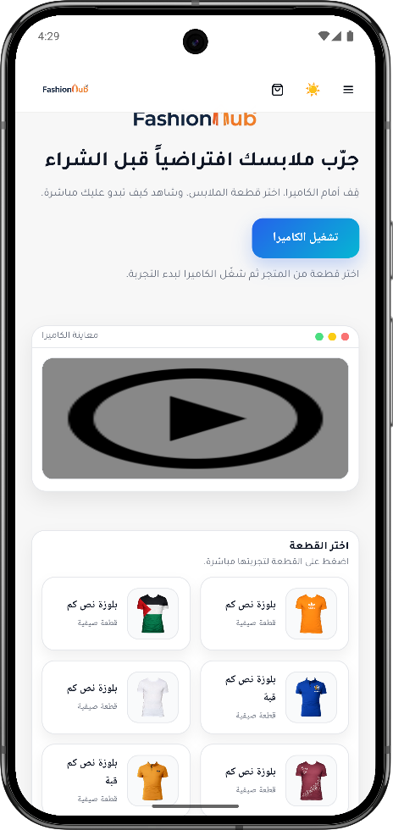
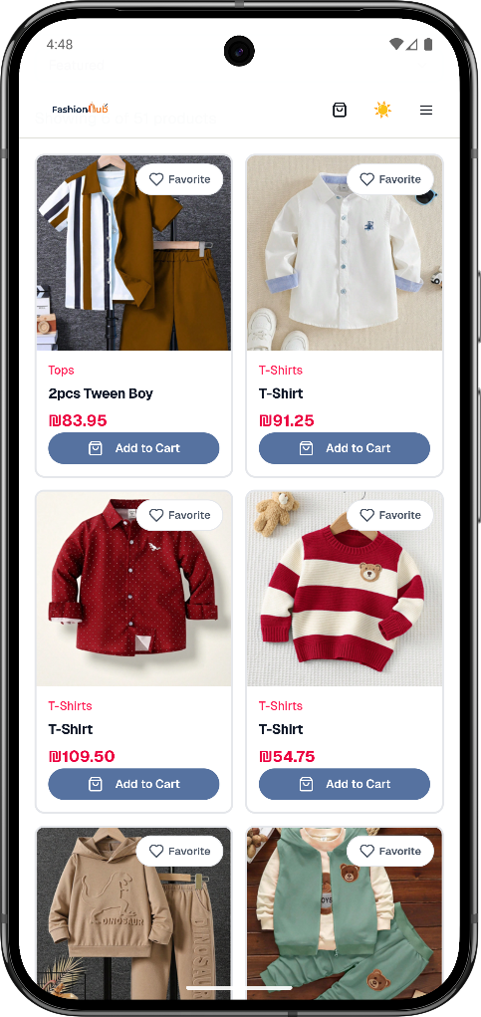
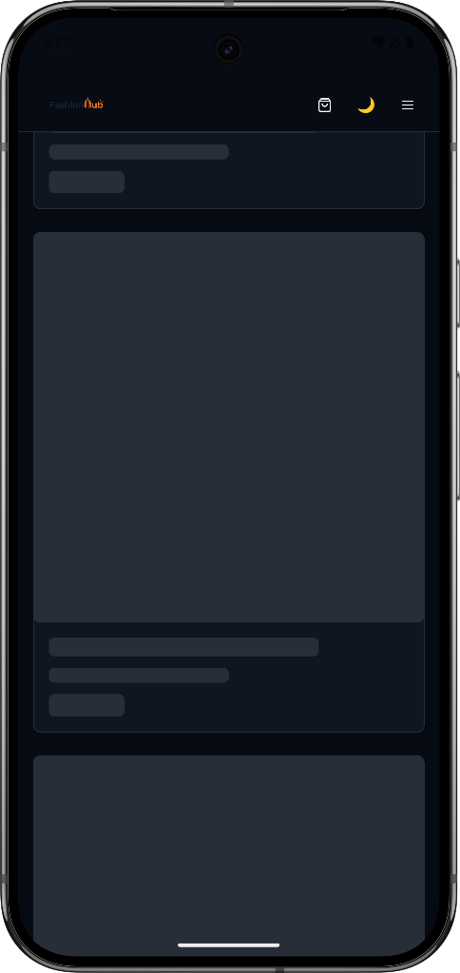
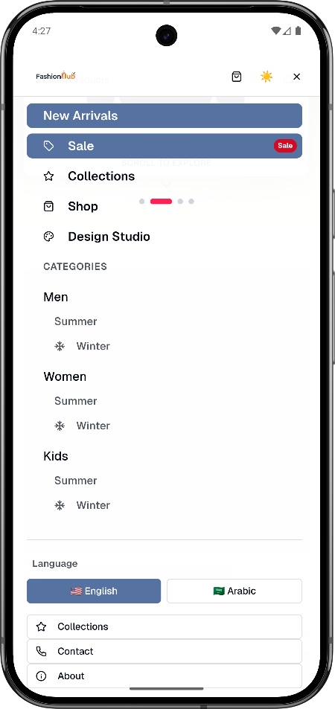
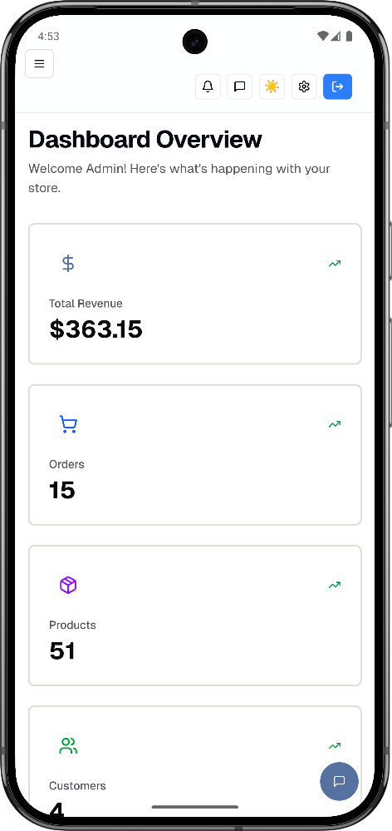
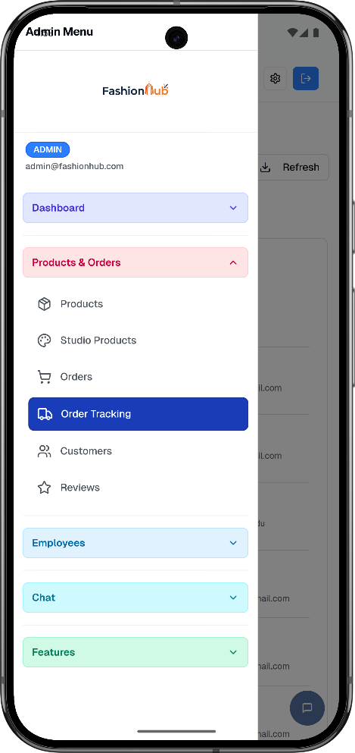
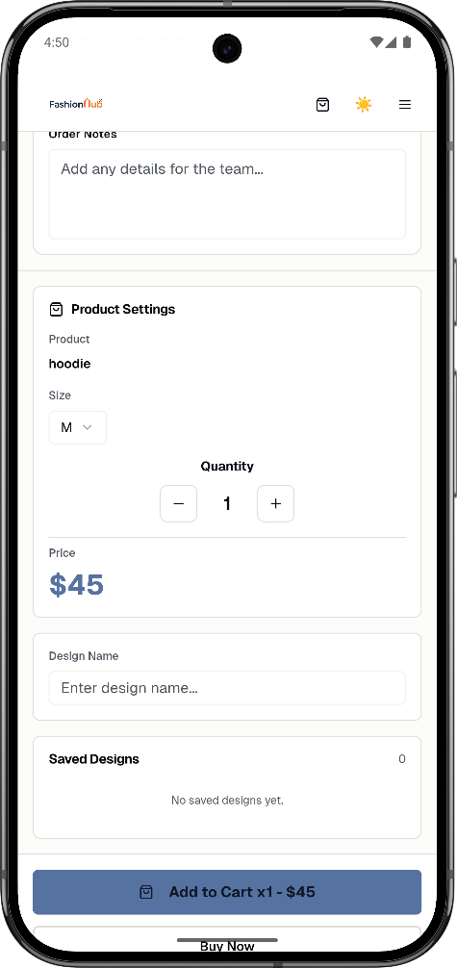
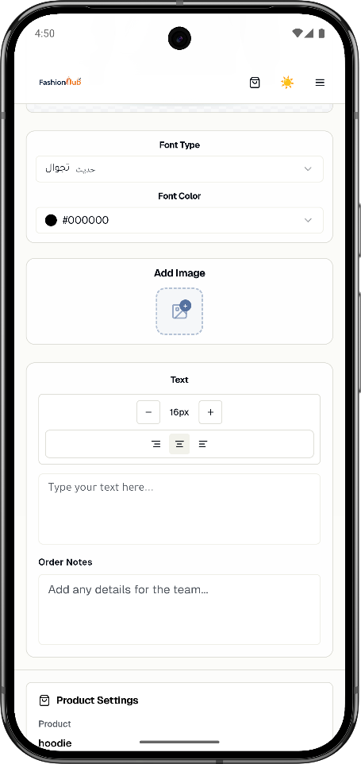
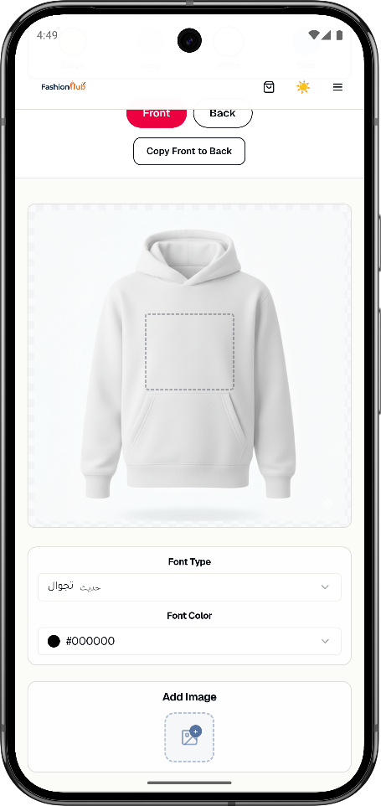
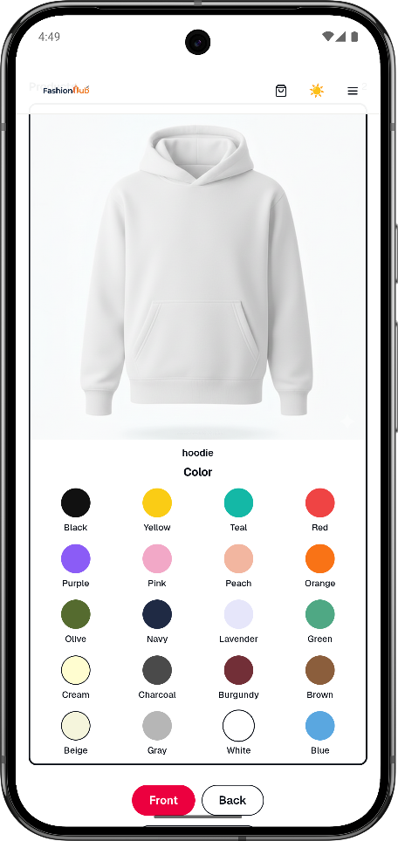
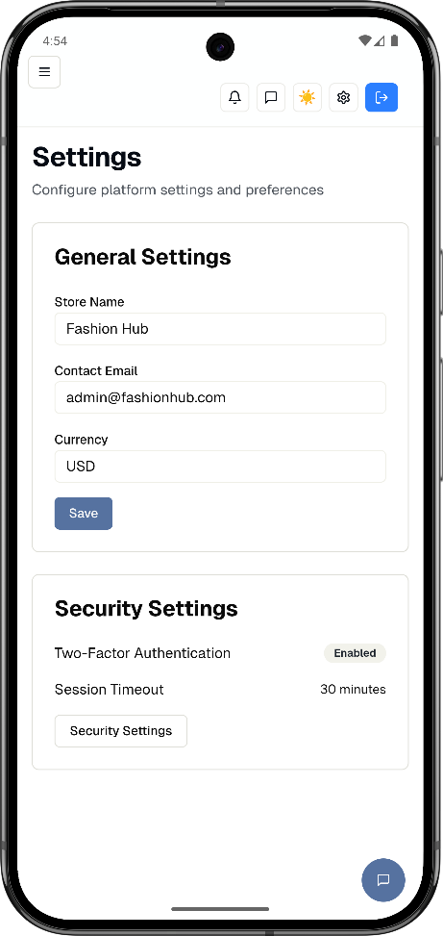
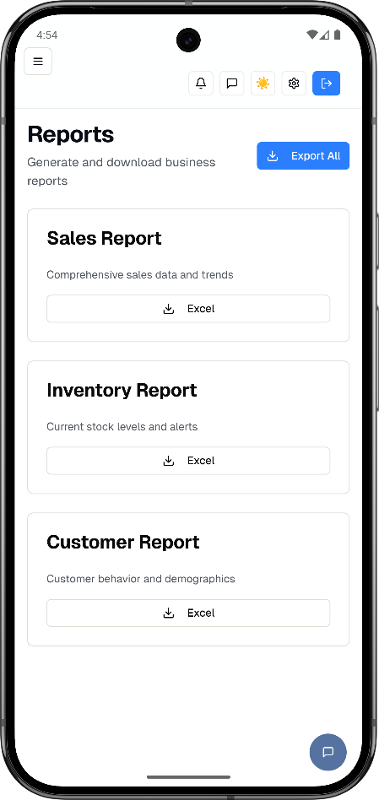
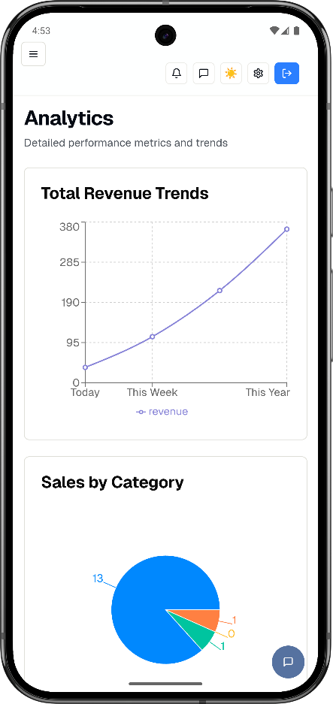
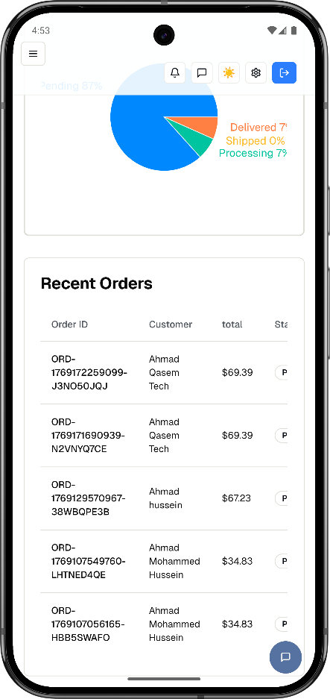
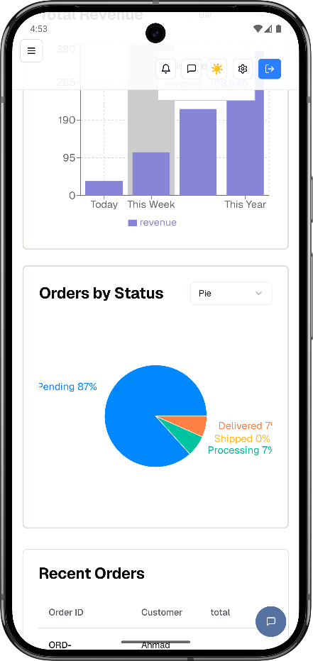
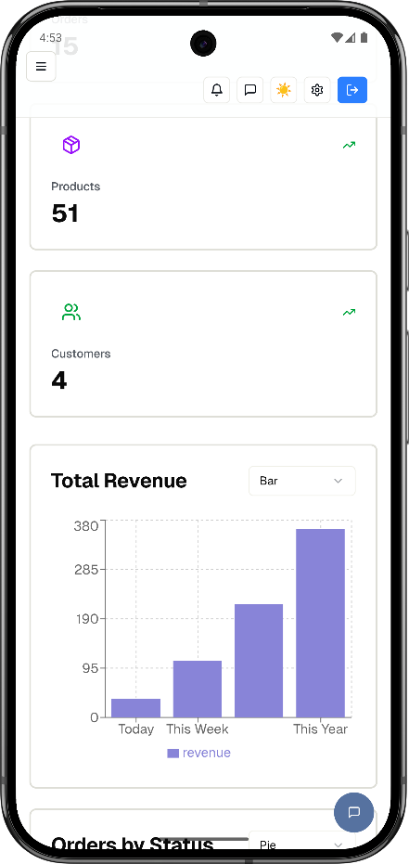
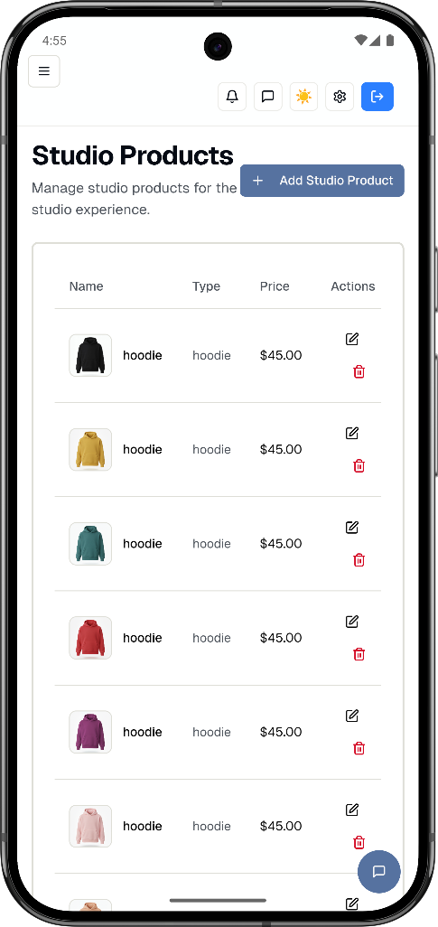
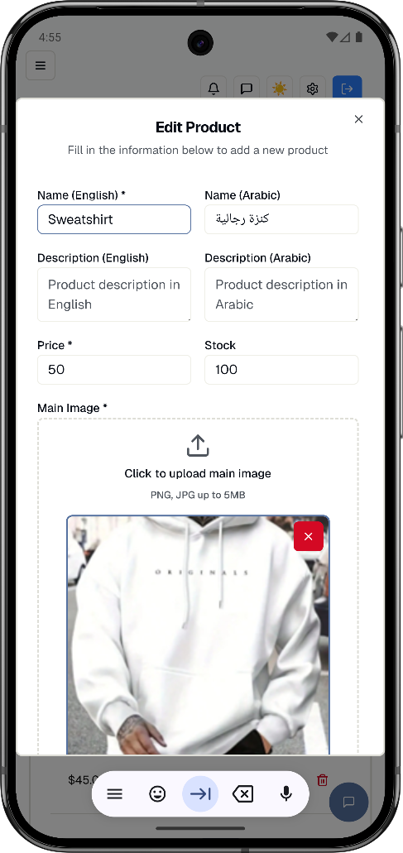
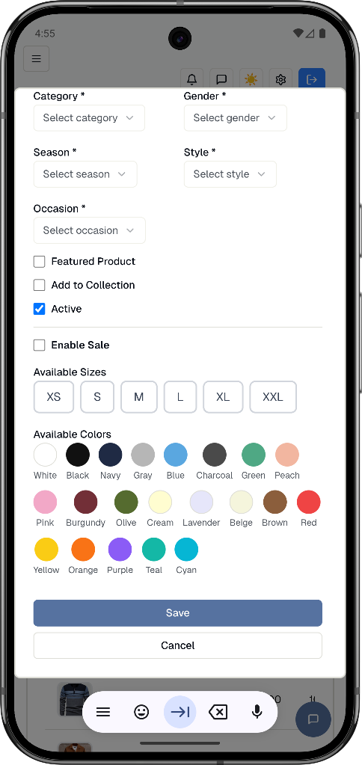
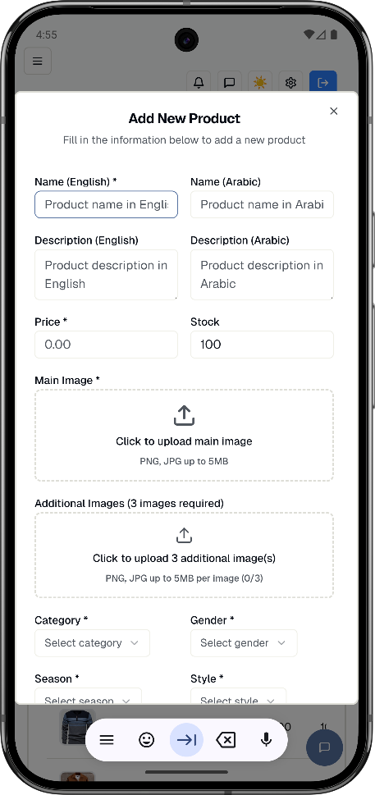
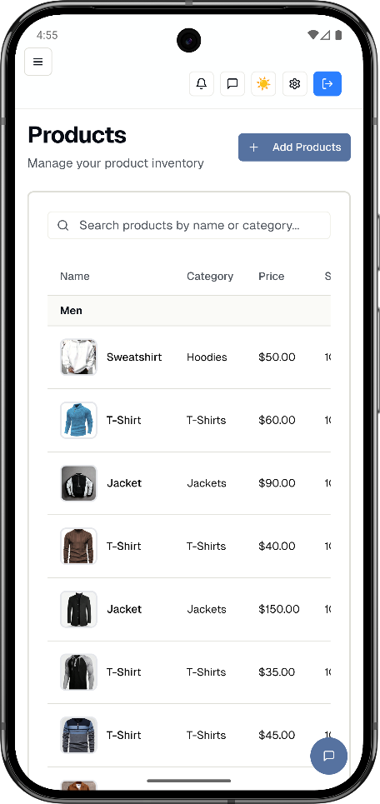
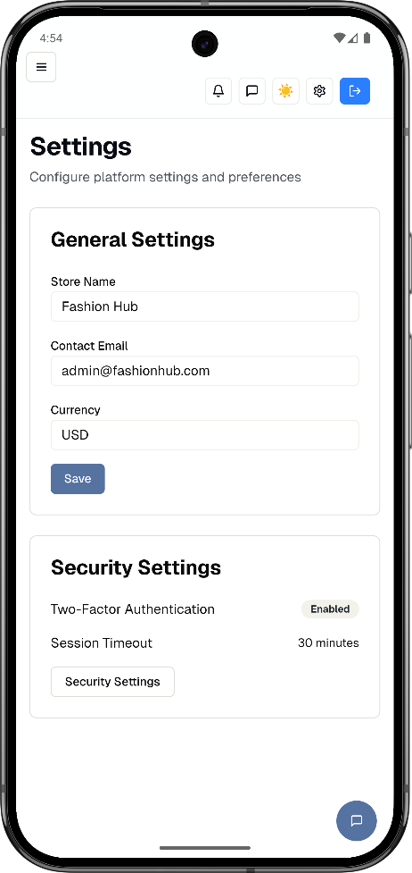

Conclusion

This project presented the design and implementation of FashionHub, a modern e-commerce platform that combines traditional online shopping with interactive features that improve the customer experience. The system supports a complete shopping journey, starting from browsing products and viewing details, through cart management and checkout, and ending with secure payment integration and order confirmation. In addition, customers can leave reviews and manage their personal accounts, including orders, saved designs, addresses, and account settings.

A major highlight of FashionHub is the Design Studio, which enables users to customize clothing items by adding text and images, selecting colors, and saving designs for later use. The platform also introduces a Virtual Try-On feature to help users visualize selected items before purchase, providing a more engaging and confident shopping experience.

From the management perspective, the system offers dedicated dashboards for Admin and Employee roles. Admins can manage products, studio items, customers, orders, tracking, reviews, staff, and homepage slider content. Employees can process and update order statuses through a structured manufacturing workflow (printing, quality check, and ready-to-ship), ensuring smoother order handling and better operational control.

Overall, FashionHub successfully delivers an integrated solution that enhances both customer interaction and backend management. The system is scalable and can be extended in future work by adding advanced analytics, recommendation features, multilingual improvements, and additional payment/shipping integrations.

References

[1] P. Butnampetch, P. Sasithonwan, B. Teeranan, and T. Chintakovid, “Usability Studies of E-Commerce Checkout Process: A Perspective from Thailand,” HCI International (HCII 2020), Springer.
[2] D. He, N. Pentina, and others, “A model of online shopping cart abandonment: evidence from e-tail …,” Journal of the Academy of Marketing Science, 2022.
[3] J. Kim and S. Forsythe, “Adoption of Virtual Try-on technology for online apparel shopping,” Journal of Interactive Marketing, 2008
.
[4] C. Chen, J. Ni, and P. Zhang, “Virtual Try-On Systems in Fashion Consumption: A Systematic Review,” Applied Sciences, 2024
.
[5] S. A. Ettis and A. Sellami, “I’ll do it for myself: Enhancing customer value through online product customization experience,” Journal of Retailing and Consumer Services, 2024.
[6] P. Murley, Z. Ma, J. Mason, M. Bailey, and A. Kharraz, “WebSocket Adoption and the Landscape of the Real-Time Web,” Proceedings of The Web Conference (WWW ’21), 2021.
[7] (Authors as listed in the paper), “Real-Time Customer Communication in E-Commerce: Improving Customer …,” 2024.
[8] “Leveraging Microservices Architecture to Enhance Scalability and …,” Springer, 2025.
[9] A. Makris and others, “MongoDB Vs PostgreSQL: A comparative study on performance aspects,” 2020.
[10] N. Provos and D. Mazières, “A Future-Adaptable Password Scheme,” USENIX Annual Technical Conference, 1999.
[11] “JWTKey: Automatic Cryptographic Vulnerability Detection in JWT …,” Springer, 2023.
[12] “Security analysis of JSON web tokens—Attack scenarios and countermeasures,” Aalborg University project report (PDF).

OurPlatform API Documentation: https://swgp22.postman.co/workspace/d5924c52-f377-4001-9fec174d17148d6d
• React: https://react.dev/
• Node Js : https://nodejs.org/en/docs
• MongDB : https://www.mongodb.com
• Mongoose : https://mongoosejs.com
• Express.Js : https://expressjs.com
• JWT (JSON Web Token) : https://jwt.io/
• Nodemailer : https://nodemailer.com
• Cloudinary: https://cloudinary.com
• Multer: https://github.com/expressjs/multer
• VSCode: https://code.visualstudio.com/

