Requirements of Graduation Project report


Faculty of Engineering & Information Technology

Building Energy Management Study and Simulation At Ithar School In Nablus City

Prepared by:
Hala Barahmeh
Manar Barahmeh
Tasneem Abusaleh

Supervisor:
Dr.Mohammed Al Sayed

Presented in partial fulfillment of the requirements for Bachelor degree in (Energy and environment engineering, Mechanical engineering)
Contents
Acknowledgments: 6
Abstract: 7
Chapter 1: 1
INTRODUCTION 1
1.1Overview: 1
1.1.1 Energy sector in Palestine. 1
1.1.2 Energy Management 3
1.1.3 Energy Management in buildings: 4
1.1.4 Designbuilder Software: 5
1.2 The existing problem: 5
1.3 Project Motivation: 6
1.4 Project Methodology 6
Chapter 2: 7
LITERATURE REVIEW 7
Chapter 3: 8
METHODOLOGY 8
3.1 The first stage: Building’s Structure 8
3.2 The second stage: Data Collection 9
3.3 The third stage: Simulation Parameters 11
3.3.1 Construction and opening glazing: 11
3.3.2 Activity and occupancy: 13
3.3.3 Lighting: 14
3.3.4 HVAC: 15
3.4 The fourth stage: 18
3.4.1 Daylight condition: 18
3.4.2 Heating Design: 20
3.4.3 Cooling design: 21
3.4.4 Simulation: 22
3.5 The fifth stage: Trials for motivations on the building 22
3.6 The sixth stage: Grid-Connected Photo Voltaic System design 23
Chapter 4: 29
RESULTS & DISCUSSION 29
4.1 The existing condition for the building 29
4.1.1 Lighting for the existing case 29
4.1.2 Comfort measures for the building on the existing conditions. 31
4.2 Replacing the existing lamps with LED simulation. 32
4.2.1 Lighting intensity changes. 32
4.2.2 Electricity consumption changes for the LED lamps case. 33
4.4 Adding HVAC system (split unit) 38
4.4.1 Comfort measures. 38
4.5 PV system Results 40
5.2 Building envelop 52
5.2.1 Walls Performance 52
To find actual U for the walls, we use DesignBuilder data according to the type of walls of the school that has been added to the program 52
Chapter 6: 53
CONCLUSION 53
Works Cited 55

List of Figures:
Figure 1: Total imported energy (Tirajul) in the Palestinian territories. 2
Figure 2: Average monthly household consumption of electricity (kWh) in the Palestinian Territory. 2
Figure 3: Energy Management Cycle. 4
Figure 4: Building Energy Management Factors. 4
Figure 5: The school's building side view. 8
Figure 6: Lux meter. 9
Figure 7: External wall material. Figure 8: Internal wall material. 11
Figure 9: Ground floor material. Figure 10: Roof material. 12
Figure 11: Slab material. 12
Figure 12: Window glass material. 13
Figure 13: F1 daylight map 18
Figure 14: F2 daylight map 18
Figure 15: F3 daylight map 19
Figure 16: Roof daylight map 19
Figure 17: Heating design for the school building 20
Figure 18: Cooling design for the school building 21
Figure 19: Simulation of the whole building 22
Figure 20: Meteorological data from PVsyst. 23
Figure 21: Orientation of the PV arrays. 24
Figure 22: PV type specifications. 24
Figure 23: Inverter specifications. 25
Figure 24: PVsyst design. 25
Figure 25: A view for the building from DesignBuilder. 26
Figure 26: An upper view for the building from DesignBuiler. 26
Figure 27: DesignBuilder specifications. 27
Figure 28: Fuel breakdown on the existing case 30
Figure 29: Internal gains for the existing case. 31
Figure 30: Comfort for the existing case. 31
Figure 31: Total fuel consumption for the existing case. 32
Figure 32: F2 lighting with LED. 33
Figure 33: F3 lighting with LED. 33
Figure 34: Consumption of electricity with LED. 34
Figure 35: Internal gains in case of LED lamps. 35
Figure 36: Comfort figure for the last simulation. 36
Figure 37: Fuel consumption for the last improvement. 37
Figure 38: total electricity consumption for the final case. 37
Figure 39: Building load curve. 39
Figure 40: Comfor measures. 39
Figure 41: Fuel breakdown. 40
Figure 42: Total fuel consumption 40
Figure 43: CO2 measures. 41

List of Tabels:
Table 1: Building zones data. 10
Table 2: Occupancy schedule of the school. 13
Table 3: Detailed artificial light information of the school building 14
Table 4: Occupancy schedule of the lighting in the school 15
Table 5: Ventilation schedule for the entire building 15
Table 6: Heating schedule for the first floor 16
Table 7: Cooling schedule of the whole building 16
Table 8: Hot water consumption 17
Table 9: Site and Source Energy 27
Table 10: Site and source energy factors 27
Table 11: Fuel end use 38
Table 12: Insolation data. 42
Table 13: ABB inverter specification 44
Table 14: PV specifications 44
Table 15: project investment 46

Acknowledgments:

We would like to express our gratitude to our supervisor, Dr. Mohammad Alsayed for the useful guidance, help and engagement through the learning process of this graduation project. We are also grateful for our project examiners, Dr.Aysar Yasin and Eng. Mutaz Shihab Aldin for their fair judgments for our first part of the project and for their helpful and useful comments and remarks. Furthermore, we would like to thank our department and the head of the department for the support during the working process.
Also, we would deeply like to thank the school principle for the cooperation and the help provided for the data we needed during the working process.
Finally, the three of us would like to thank our friends and family for the support. We are very grateful

Abstract:

The proposed project aims to apply energy management in the existed building in Palestine since buildings represent a large proportion of energy consumption which is almost 70% of the total consumption in the country. Schools would be a considerable graduation project because they are considered to be one of the most popular buildings in the country, and as we aim to increase the awareness of the importance of energy management as a mean of reducing energy consumption, and increasing energy efficiency which leads directly to human comfort.
To do so, a suitable software program “Designbuilder” was defined in which all the building components were built and all the parameters that affect the energy system were defined also. The software program was chosen for its reliability and variety of parameters it provides which help in evaluating the energy situation.
Second part includes the simulation and the analysis of the current energy situation of the school building, in which heating and cooling design were calculated, and the comfort data were shown. The results showed that lighting consumes the largest proportion of electricity nearly 75% and the peak season is winter which means that the school needs heating improvements.
The final part of the first part was few trials of improvements included HVAC system and LED lamps that have been applied into the Designbuilder to estimate their feasibility. And the results showed that the comfort sufficiently increased but the electricity consumption also increased.
For the second part of our graduation project, three different algorithms and criteria were used and applied for designing the grid-connected PV system. In addition to the hand sizing and conventional PV sizing calculations, The results shows that school needs 11 kW PV and the SPP is nearly 5 years .PVsyst software and DesginBuilder software were also used.This was done in order to compare the results and come up with the best possible results.

Chapter 1:

INTRODUCTION

1.1Overview:

Energy is defined to be a measure of the ability of a body or system to do work or produce a change. There are two main source of energy; conventional sources such as coal, oil and natural gas and renewable sources. The world relies on conventional sources the most and millions of tons are consumed every day. This causes damage and has extreme effects on the environment we live in.
The production and use of fossil fuels emit greenhouse gases (Gases that trap heat in the atmosphere are called greenhouse gases ). Increases in the different greenhouse gases have other effects apart from global warming including ocean acidification, smog pollution, ozone depletion as well as changes to plant growth and nutrition levels.
The most important challenge of the 21st century is filling the gap between energy supply and demand with clean, reliable and inexpensive energy. While new sources of energy are gradually changing the landscape, products made from fossil fuels continue to heat our homes, fuel our cars and power our computers. Despite extraordinary advances in technology, rapid economic growth in countries like China and India will require more energy. Some solutions are being implemented today.

1.1.1 Energy sector in Palestine.

The energy situation in Palestinian territories (West Bank and Gaza) is highly different compared to other countries in the Middle East due to non-availability of fossil fuels and it has an unusual position in at least many respects. First, as a small energy market with no developed domestic resources of commercial energy, it is almost entirely dependent on imported energy supplies, specifically electricity and oil products. Because of political and logistical factors, nearly all of these supplies at present come from Israel. Second, unusual challenge is the constraints imposed by Israeli policies and actions on the ability of the Palestinian Authority to operate and develop its energy systems.
About the consumption of energy, the most important measure in the energy balance of Palestine is the total consumption of 5.12 billion kWh per year. Per capita this is an average of 1,125 kWh.

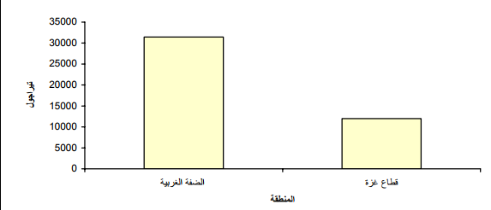
Figure 1: Total imported energy (Tirajul) in the Palestinian territories.

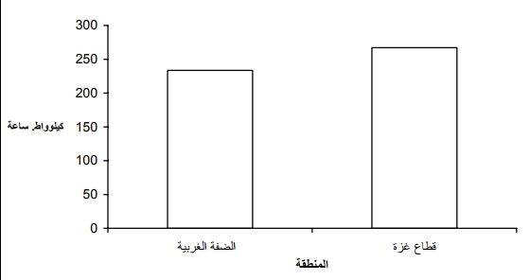
Figure 2: Average monthly household consumption of electricity (kWh) in the Palestinian Territory.

1.1.2 Energy Management
As mentioned earlier, the environmental problems and global warming are the results of excessive consumption of conventional energy sources. Science these days is directed to subjects and tools that can help saving the environment and reducing the effects, such as the use of renewable energy sources, using cleaner conventional fuels-Natural Gas, and energy management.
Energy management (EM) is the process of monitoring, controlling, and conserving energy use. In other words, it can be described as the act of reducing the use of energy while preserving the quality of the equipment or the system. Not only energy management can reduce the environmental effects and emissions, but also it is economically necessary. Applying EM in organizations, factories or any association reduces the annual cost paid on fuels therefore reducing the risk for a project by increasing the profitability.
Energy Management is a four-step process, so in order to achieve a good EM the following actions have to be done properly:
- The first step: measure the consumption of energy and data collection.
This action is needed to know the consumption existing equipment’s and to identify the ones that cause waste of energy. A good approach to energy-data collection is to fit interval-measuring systems that automatically measure and record energy consumption at short, regular periods.
- The second step: identify chances to save some energy.
The detailed data collected in the first step when presenting them in a figure show the weak points and give a pattern that clarifies which weakness point to start with. Obviously start with the most effective and cheapest.
- The third step: Targeting the opportunities to save energy. After making a decision for the energy saving opportunity chosen, pick the most suitable criteria for energy management.
- The forth step: Monitor, track, keep an eye open on your system.
For a successful energy management application, monitoring and periodic maintenance must be done to keep the profit continuous. Then the cycle goes back to the first step.
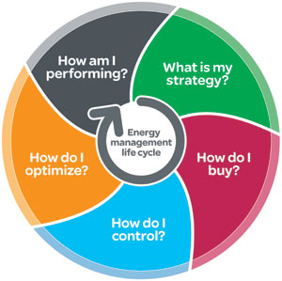
Figure 3: Energy Management Cycle.

1.1.3 Energy Management in buildings:

Buildings consume a large portion of the world’s energy. The nature of buildings is changing from static and passive structures to dynamic and active environments. Therefore, effective energy management is becoming important to do in buildings.
Building Energy Management (BEM) is a monitoring system that has the ability to control energy consumption in the space. The system can have be applied on energy consumption utilities in the building: such as heating, ventilation and air conditioning (HVAC) to lighting, maintenance and energy management.

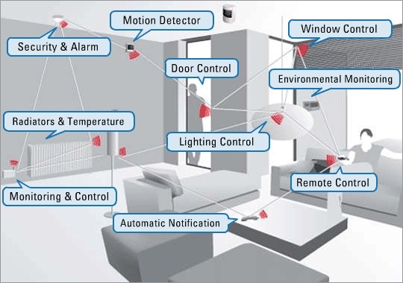
Figure 4: Building Energy Management Factors.

1.1.4 Designbuilder Software:

DesignBuilder is a state-of-the-art software tool for checking building energy, carbon, lighting and comfort performance. Developed to simplify the process of building simulation. DesignBuilder allows you to rapidly compare the function and performance of building designs and deliver results on time. This software was used in the project.

1.1.4.1 Designbuilder for engineers
DesignBuilder Packages for Engineers are an integrated set of high-productivity tools to assist with sustainable building design. Leading services engineers and energy modellers across the world use DesignBuilder to gain an insight into the impact of their design strategies on building environmental performance.

1.1.4.2 Designbuilder for architects
Ensuring your designs meet performance targets at the early design stages has never been easier with DesignBuilder Architectural software. Whether you model in DesignBuilder or import from BIM, accurate and reliable energy and daylighting performance data helps inform your design decisions

1.1.4.3 Desifnbuilder for energy
DesignBuilder Energy Assessor packages are used by the UK’s leading non-domestic energy assessors to give them an edge in today’s competitive market. A uniquely productive workflow coupled to the latest approved calculations allows you to provide an excellent quality EPC and Part-L2 service on time and on budget.

1.2 The existing problem:

This project building energy management study is done on a private primary school building (Ithar School) built in 2002 which is located in Nablus city-Beiblos street. The main outcome from this project was to evaluate the existing conditions of the building and to know how far or close it is from human comfort. Moreover, the project gives a few suggestions and solutions to get closer for the human comfort zone.

1.3 Project Motivation:

The main objective of the graduation project is to employ the knowledge and skills gained by studying at An Najah University to make a practical and tangible project that can accomplish useful tasks. However, there are some other sub-objectives such as:
- The project fulfills the requirements for practicing energy management in Palestine.
- To get the ability to work within a team of different people having dissimilar thinking criteria.
- To get an idea about the real work and its pressure.
- To experience designing a grid-connected solar system for a real-existing building and to learn how to get over obstacles successfully.
- To work with different software programs and come up with the best results possible.

1.4 Project Methodology

The following steps have been followed to complete this project:
- The idea was offered by the supervisor of the project.
- Four site visits were done to collect data.
- Practicing the use of measuring devices.
- Searching for the data needed in the simulation process.
- Practicing simulation using Desginbuilder software.
- The simulation was created.
- Data needed for the PV system design were collected.
- Both Designbuilder software and PVsyst software were used to get the best optimization for the system design.
- The economy of the system was calculated.

Chapter 2:

LITERATURE REVIEW

The idea of the project is to manage and reduce energy consumption of school building in Nablus city (Ithar-School).
In graduation project 1, we did an energy simulation for the existing school building by gathering data about the consumption of the energy in the building, so we used the Design-Builder software for the simulation which helped us clarifying the condition of energy in the school.
There are many projects use energy management system to improve and manage the use of energy in the building, here we will mention some of them:

- The United Arab Emirates (UAE) interests on large scale to improve and establish building regarding to Energy Management System, so there are many projects in different state, like The Sheikh Zayed Private Academy Gems Education on an area of 22000 $m^{2}$ in Abu Dhabi.
- In Jordan World Health Organization Building on an area of 28,218$m^{2}$.
- In Egypt there is a project of Building Management System (BMS), the aim of the project is to contribute to the rationalization of energy by controlling the work of equipment and devices such as central air conditioning, ventilation units, lighting units, water control and water pumps.
In graduated project 2, we studied the school’s demand of electricity to calculate how many kwh/year it’s consume, so to made our simulation and calculation to design a suitable PV system.
At recent years, most of the developed countries installed PV system as an alternative of conventional source of energy.
In our country there are many PV system installed, her some examples:
- Ramallah Cultural Palace Project
- Al Najah National Hospital
- Many of school

Chapter 3:

METHODOLOGY

The proposed idea was about making an energy management study for a school building by creating a model for building and the output is going to be a whole energy simulation and few trials to improve the efficiency of the building while trying to reach the comfort zone. This simulation is to be done using the Designbuilder software.
Energy Management in Building is an important science in the new world since buildings consume huge amounts of fossil fuels in heating, cooling lighting and all other aspects of life. Yet it is not a common science in Palestine, that inspired the team members and the graduation project’s supervisor to give BEM a try and see if it can make an improvement in real life or not.
Our working procedures were divided into six main stages as explained below:

3.1 The first stage: Building’s Structure

We decided to look for a school building in Nablus city for our project, and we came up with “Ithar Modern School”, a private primary school located in Beiblos Street- Nablus city, was built in 2002, consisting of five flats: the ground floor-parking and play area for the pre-school students, first floor: administration and internal yard, the second, the third and the roof have classrooms and yards. For more details about the school building see table.
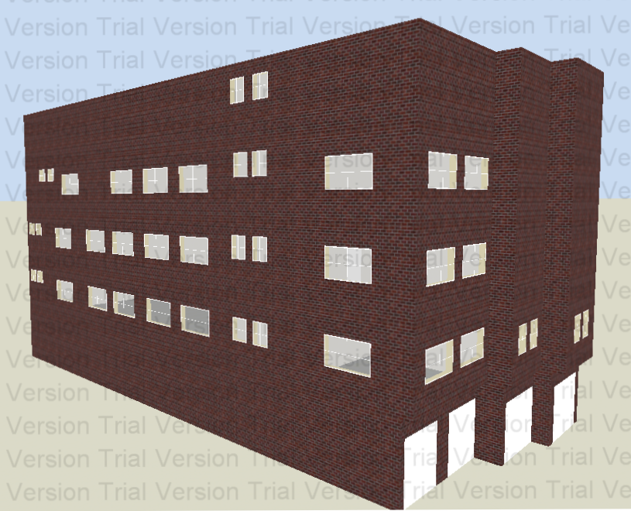
Figure 5: The school's building side view.

3.2 The second stage: Data Collection

The next step of our work was a checkup visit to check and get an overall picture of the building and the work that is going to be done. Then other visits were done too to collect data using metering devices. The lux meter were used to measure the lighting lux in each room (a lux meter is a device used to measure the amount of light).
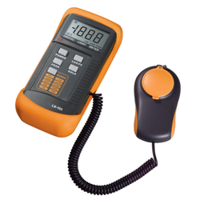
Figure 6: Lux meter.

After collecting all the data needed for the simulation, we started working on the designbuilder-which is an energy simulation software. Then we entered the data step by step which going to be shown in details.

Table 1: Building zones data.
Flat | Rooms | No. of outer windows | No/ of outer doors | Lux
GF | Internal yard | none | 3 | 114
GF | Playing room | None | None | 137
GF | Bathroom | None | none | 254
GF | Stairs | None | none | 114
F1 | Administration | 2 | none | 253
F1 | Teachers’ | 2 | none | 946
F1 | Kitchen | 2 | none | 252
F1 | Bathroom | None | None | 252
F1 | Internal yard | 8 | 3 | 178.4
F1 | Corridor & stairs | 2 | 1 | N.L
F2 | Classroom (8) | 2 | None | 274.32
F2 | Bathroom | 2 | None | 240
F2 | Corridor & stairs | 2 | None | N.L
F3 | Classroom (8) | 2 | None | 557.83
F3 | Bathroom | 2 | none | 310
F3 | Corridor & stairs | 2 | None | N.L
Roof | Classroom (6) | 2 | None | 333.15
Roof | Bathroom | 2 | None
Roof | Corridor & stairs | Outer space

3.3 The third stage: Simulation Parameters
In this stage we will talk about the parameters that have been taken into consideration in terms of energy consumption for the design of the school building.

3.3.1 Construction and opening glazing:
In this part, the materials used in the construction of the building and the windows are to be shown. They were guessed based on the common materials used in the region. The figures below show each element and the materials, starting with the external walls of the building.

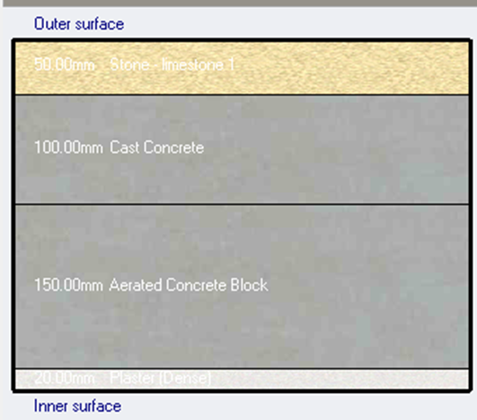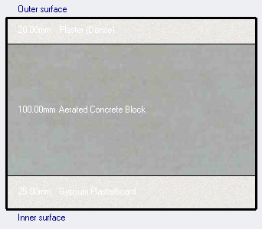
Figure 7: External wall material. Figure 8: Internal wall material.

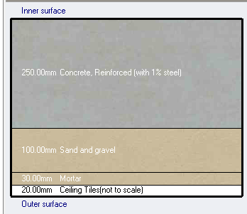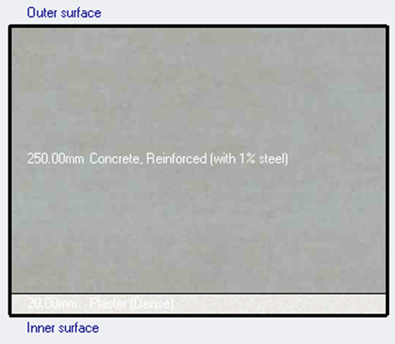
Figure 9: Ground floor material. Figure 10: Roof material.

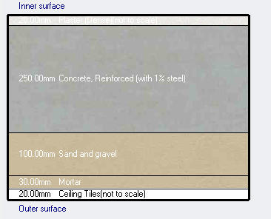
Figure 11: Slab material.

For the windows, the glass type is single clear 6 mm thickness with one aluminum vertical divider.
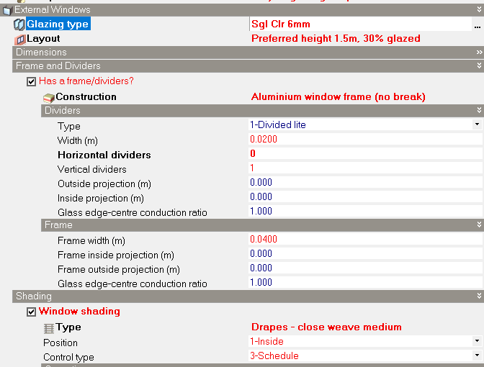
Figure 12: Window glass material.

3.3.2 Activity and occupancy:
Human activity is on of parameters that play an important role in building simulation and affect any decision in choosing the suitable improvements. Since our project is a school, the occupancy duration is from the mid of August until the end of May. The staff of the school starts at 8:00 AM and leaves at 3:00PM each day except the weekend (Friday and Saturday) , the table below show the detailed information of the school occupancy.

Table 2: Occupancy schedule of the school.
Flat | Number of occupants | Occupancy time | Type of activity
GF | 25 | One hour per day | Playing + reading
F1 | 24 | 7:30AM – 1:00PM | Administrative work
F2 | 176 | 8:00AM- 1:30PM | Studying
F3 | 198 | 8:00AM- 1:30PM | Studying
Roof | 132 | 8:00AM- 1:30PM | Studying

3.3.3 Lighting:
Given existing lighting information is an indicator of how efficient both the daylight and the artificial light in the building. The detailed information below represents the existing condition of the school, and has been added to the lighting box of the Designbuilder software.

Table 3: Detailed artificial light information of the school building
Flat | Number of lamps | Type of lamps | Luminaire type
GF | 20 | T8 (25mm diam) Fluorescent - | Surface mount
F1 | 48 | LED | Surface mount
F2 | 66 | T8 (25mm diam) Fluorescent - | Surface mount
F3 | 76 | T8 (25mm diam) Fluorescent - | Surface mount
Roof | 44 | LED | Surface mount

Table 4: Occupancy schedule of the lighting in the school
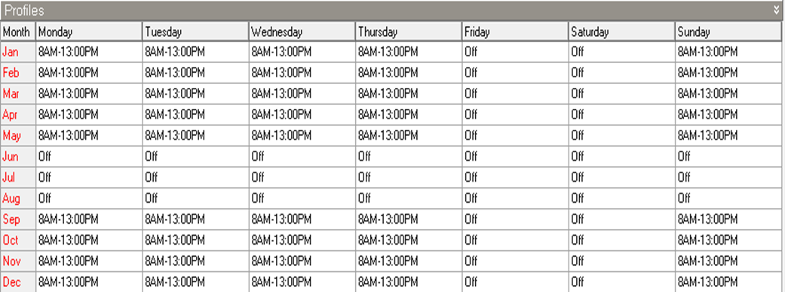

3.3.4 HVAC:
For cooling, electric fans are used in each room. While for heating, electric heaters are used in the first floor for the administration and teachers’ rooms. For hot water, instantaneous electric water heater is used in the second floor. The ventilation in the building is natural depending on openings: windows and doors.
The figures below show the schedule for the elements mentioned above.
Table 5: Ventilation schedule for the entire building
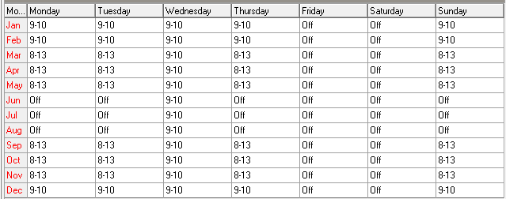

Table 6: Heating schedule for the first floor
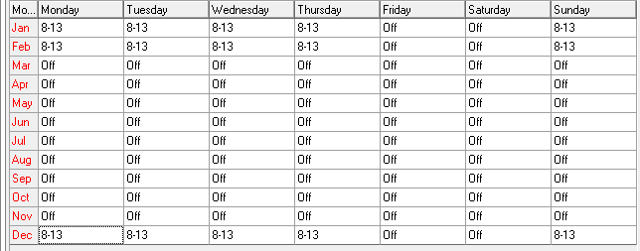

Table 7: Cooling schedule of the whole building
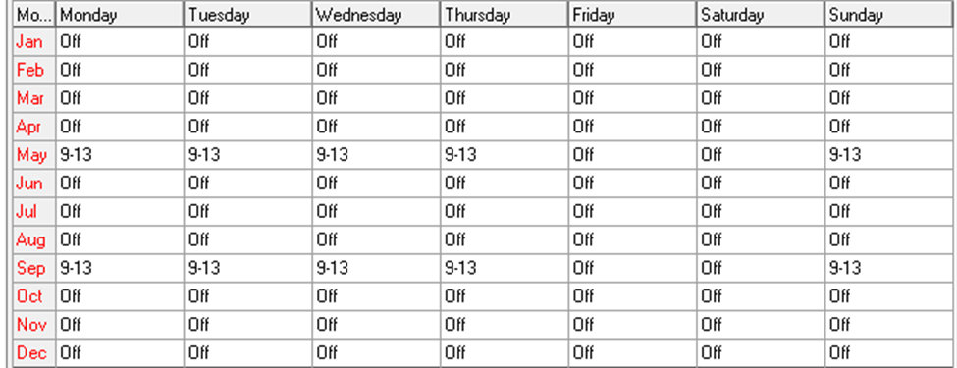

Table 8: Hot water consumption
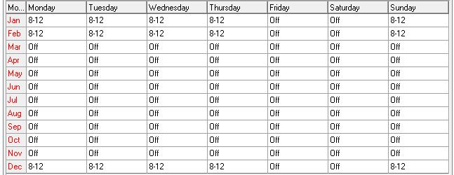

3.4 The fourth stage:

The procedure followed by the previous step was the evaluation of the existing condition of the building; by executing a simulation in the Designbuilder software and this included daylight condition, heating and cooling design,

3.4.1 Daylight condition:
The daylight illuminance maps of the floors building are given below and they show the distribution of the natural daylight availability for a horizontal slice.
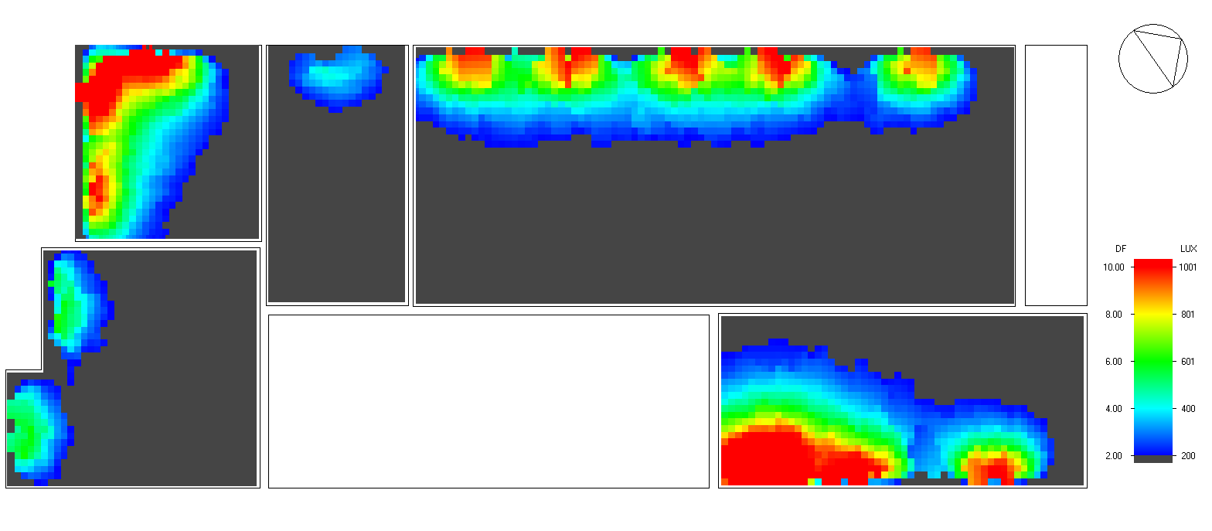
Figure 13: F1 daylight map

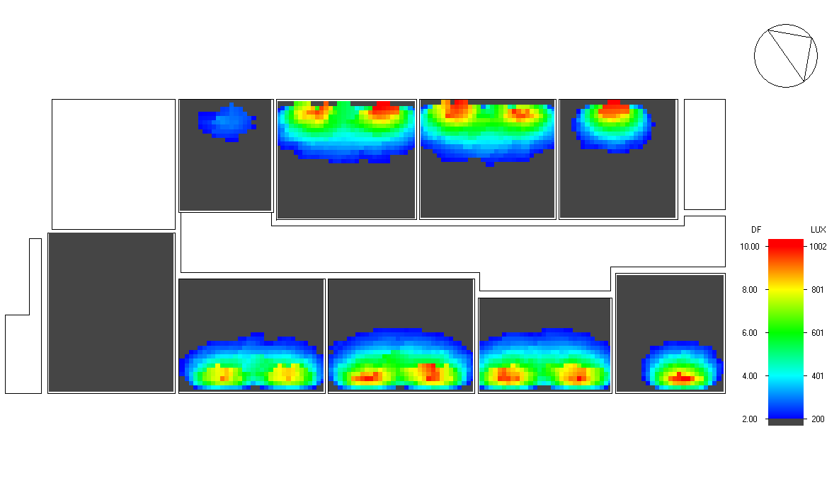
Figure 14: F2 daylight map
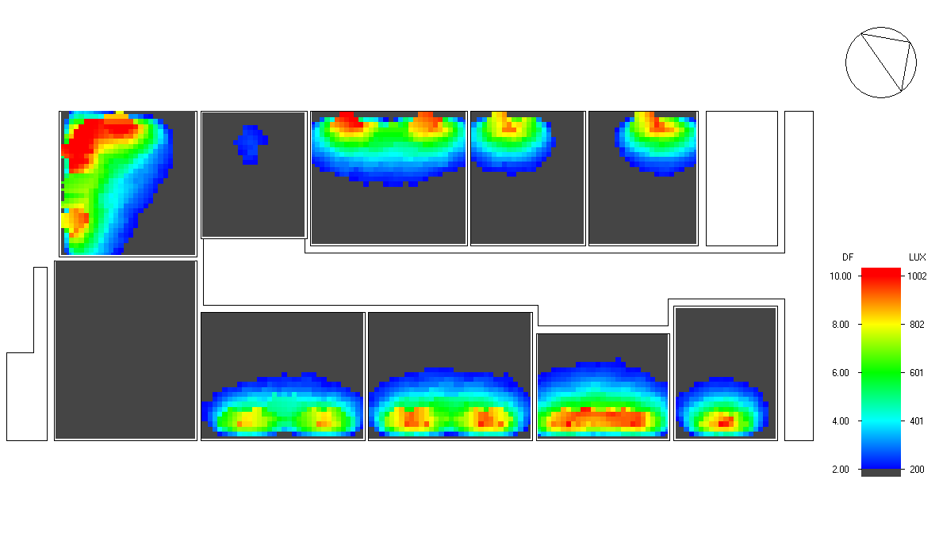
Figure 15: F3 daylight map

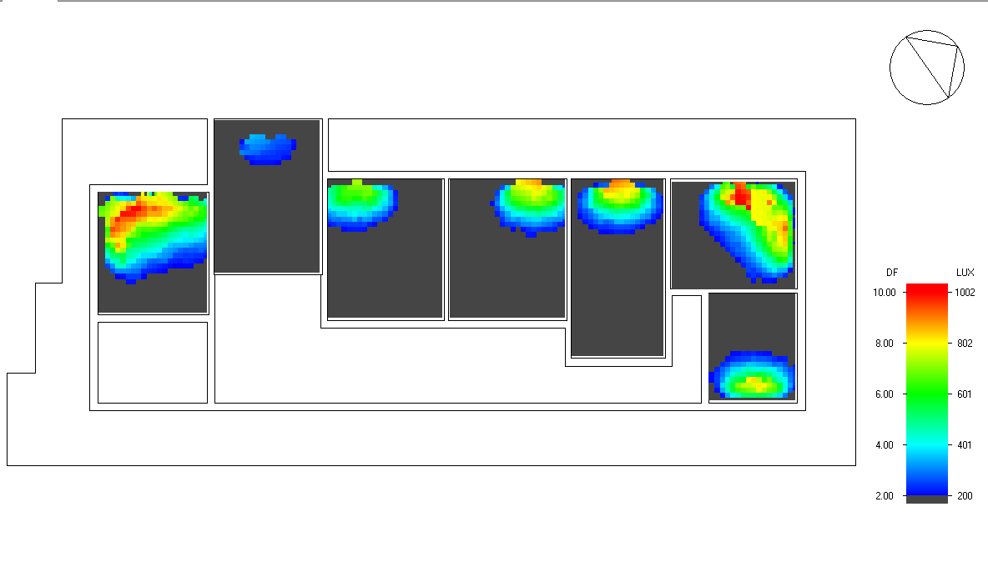
Figure 16: Roof daylight map

3.4.2 Heating Design:

This procedure has done after adding all the parameters needed for the building, we choose the heating design calculations from the Designbuilder software and the following screen figure below view the average and the total winter steady-state design data for the whole school building as it appears in the software.

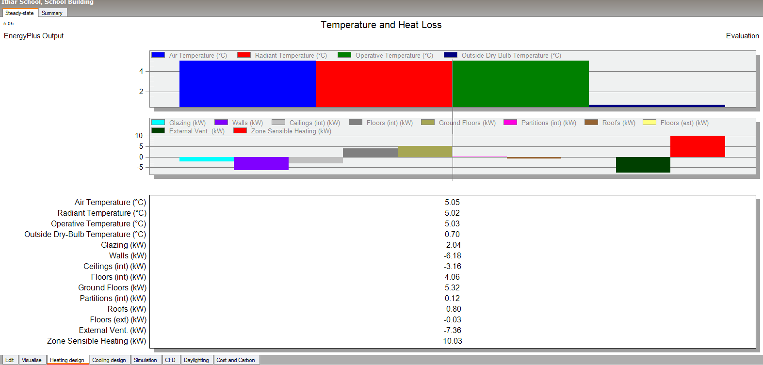
Figure 17: Heating design for the school building

3.4.3 Cooling design:

The cooling design calculation was selected from the Designbuilder. The screen figure below displays the summertime design data for the existing condition of the school building.

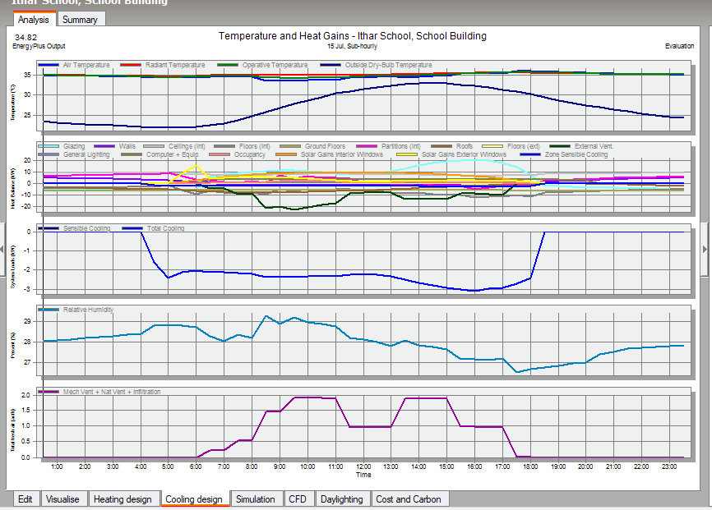
Figure 18: Cooling design for the school building

3.4.4 Simulation:
The whole simulation for the building was selected and shown as the screen figure below
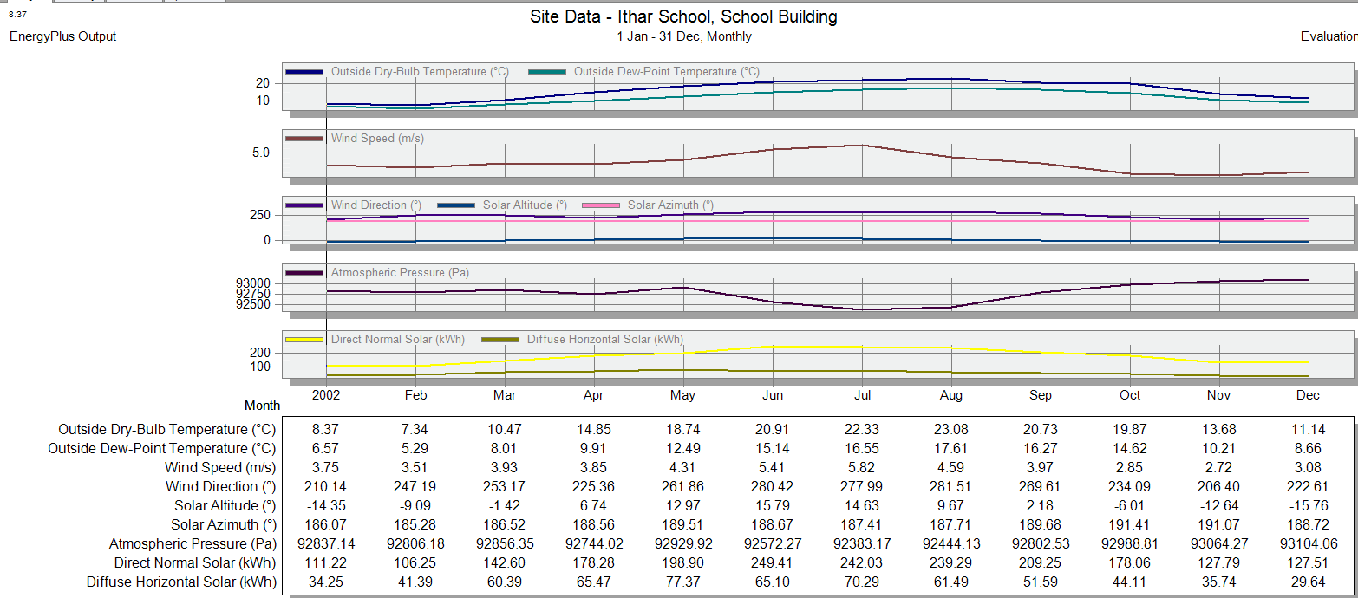
Figure 19: Simulation of the whole building

3.5 The fifth stage: Trials for motivations on the building
The final step of the first part of the project procedure was applying few trials for the building with its existing condition through the Designbuilder software in order to see if this will affect the energy efficiency of the school and weather its feasible or not. The trials that have been done are the following:
- LED lamp option:
We chose to replace the existing lamps of the school from Fluorescent (T8, 25 diam) to LED lamps

- HVAC system was applied by using split for the entire school.

3.6 The sixth stage: Grid-Connected Photo Voltaic System design

At this stage, grid-connected PV system was designed to meet the load consumption of the building. For this part both Designbuilder software and PVsyst software were used. Furthermore, the results from both programs were compared with the hand sizing and calculations.

3.6.1 PVsyst Design:

Starting with the PV system design using the PVsyst software, the following figures and table show the assumptions and the methodology for the design.

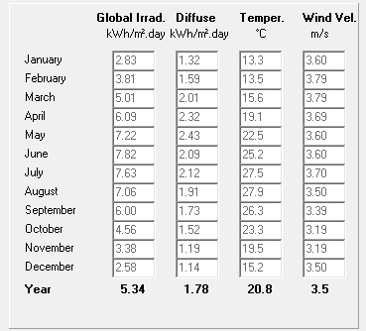
Figure 20: Meteorological data from PVsyst.
The next figure shows that the PV arrays were oriented to the true south, at zeroº azimuth angle, 30º tilt angle.
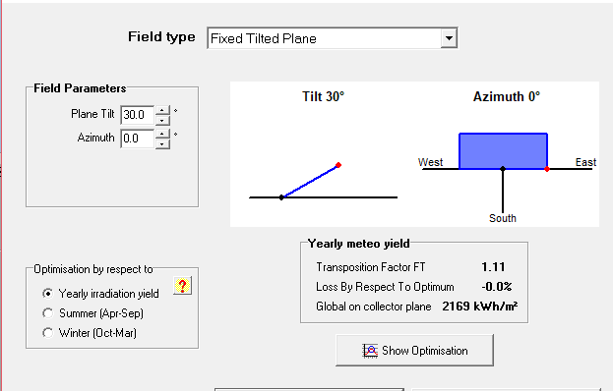
Figure 21: Orientation of the PV arrays.
Using 11 kW peak and the following PV and inverter types, the most suitable design was three PV arrays with 12 PV modules in series in each array. The chosen PV type is from JinkoSolar company, with 305 Wp. And for the inverter, it was from ABB company, 6 Kw with 2 maximum power point trackers.
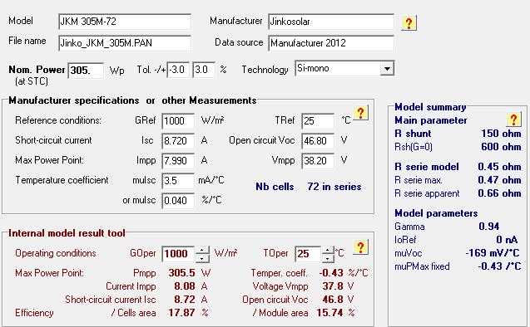
Figure 22: PV type specifications.
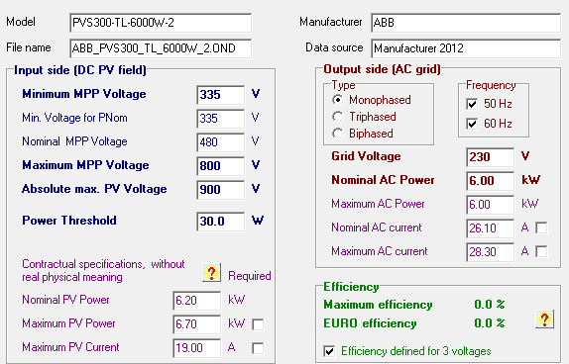
Figure 23: Inverter specifications.

.

3.6.2 DesignBuiler PV-system
In this part the first step was to install the PV modules on the roof of the building. The details about the PV designing procedures will be explained in details in the results chapter. The design from PVsyst software was used and applied

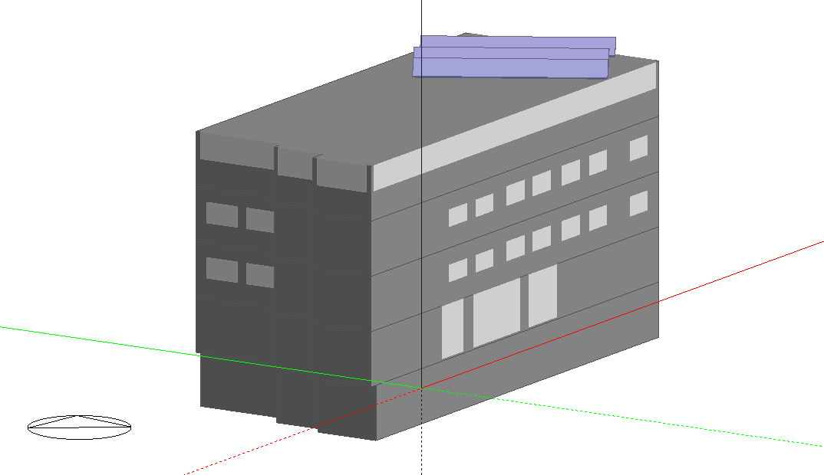
Figure 24: A view for the building from DesignBuilder.
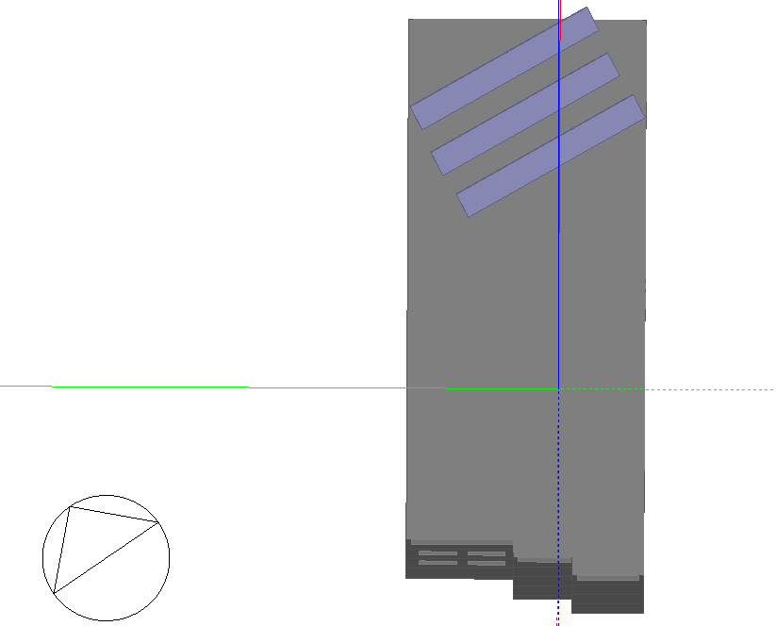
Figure 25: An upper view for the building from DesignBuiler.
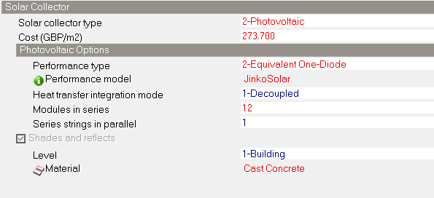
Figure 26: DesignBuilder specifications.
Table 9: Site and Source Energy
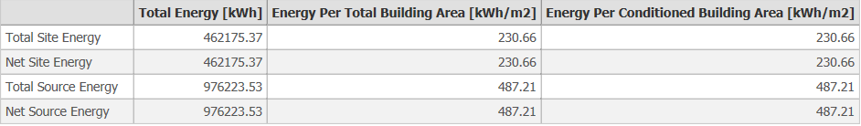
Table 10: Site and source energy factors
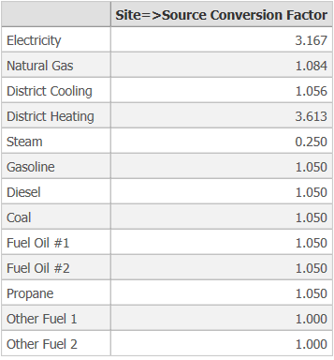

For the PV cell type, Eagle 60 model from Jinko Solar Company was chosen. Figure() shows the structure and measurements for the module. Tables () and () clarify the mechanical details and specifications of the module respectively.
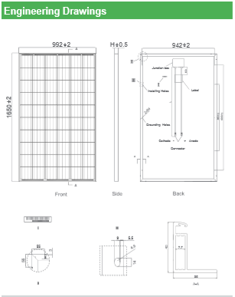

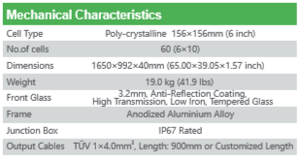

Chapter 4:

RESULTS & DISCUSSION

During the BEM study, three energy simulations were done. The first simulation was on the existing case for the building, to see the energy consumption of the building and look for places that can be improved. After that, the existing lighting system was changed-that is the fluorescent lamps where replaced with LED lamps (noting that the building already had LED lamps in the first floor and the roof). Finally, a trial for adding HVAC system was done in order to prepare for the next project on the second semester.

4.1 The existing condition for the building
The first energy simulation that evaluates the existing energy condition of the building tells the following:

4.1.1 Lighting for the existing case
Starting with the daylight, Figures 13-16 show the current lighting intensity in the building. The lighting lamps used are from the type T8-34watt per lamp in the entire building except for the first floor and the roof where LED lamps are used. The orange color is an indication for the highest intensity factor of lighting in the room (10%), while the grey notes for the lowest intensity factor (2%). The figures show that the highest intensity exists in the first floor-LED lamps. Also, the lighting appears to be spreading away more than it does in the above floors.
The figure 20 below shows the fuel consumption in the building. The yellow line indicates for the lighting electricity consumption in the building (average of 1200 kWh per month).
Moreover, figure 21 shows that the internal heat gain that the existing lighting system causes is an average of 1100 kWh per month.

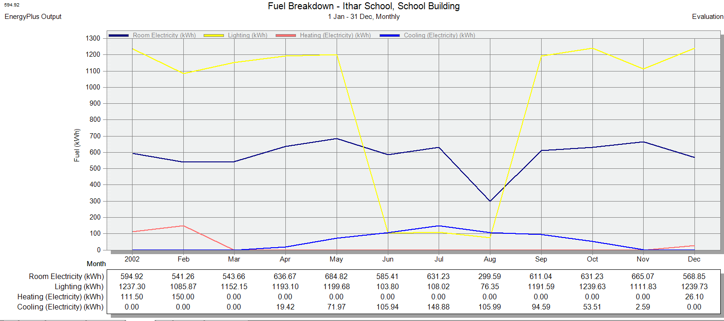
Figure 27: Fuel breakdown on the existing case

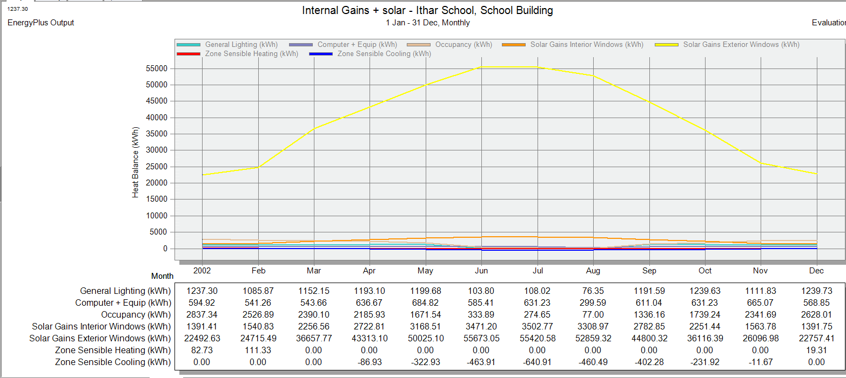
Figure 28: Internal gains for the existing case.

4.1.2 Comfort measures for the building on the existing conditions.

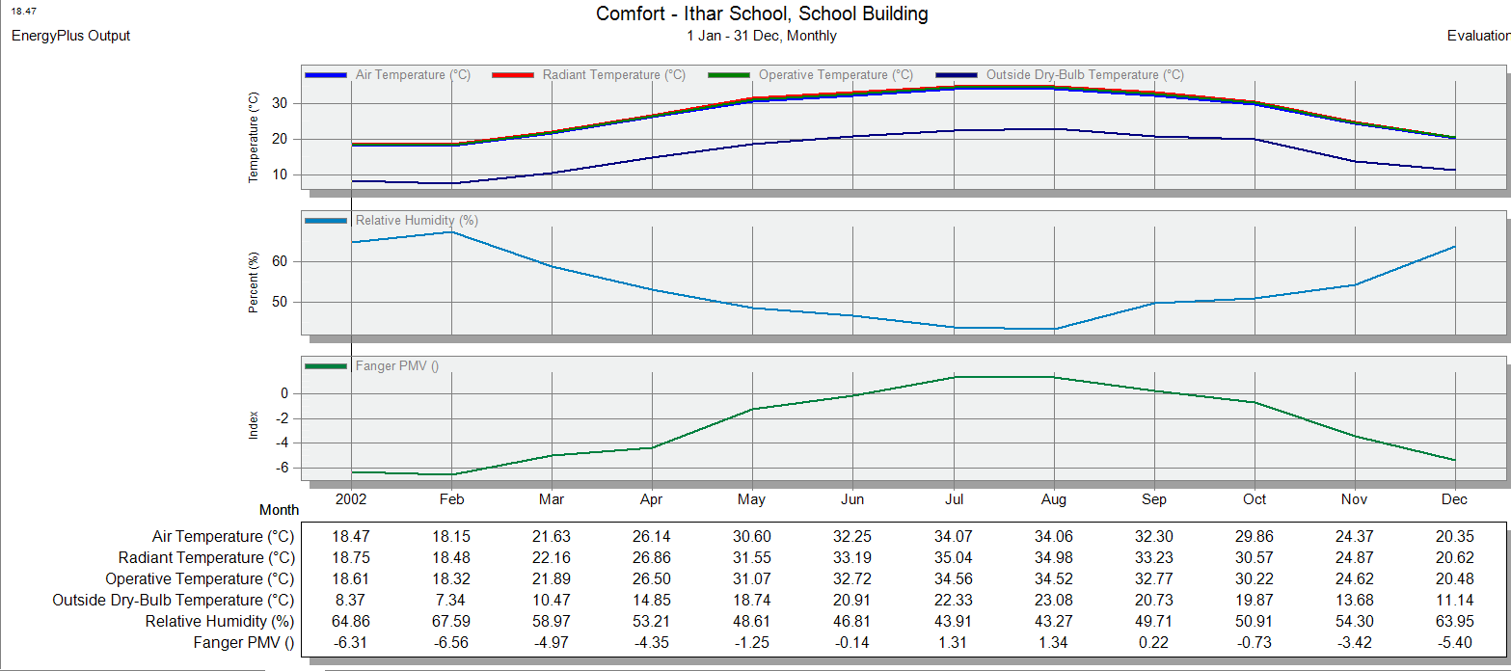
Figure 29: Comfort for the existing case.
The figure above gives indications for the temperatures inside and outside the building over the year. In winter months, the average operative temperature (inside the building) is about an average of 19ºC. While in the hot working months (May, September and October) has an average of 29.24ºc. March, April and November are the closest months for comfort zone according to the operative temperature (24.2ºC). The cold and hot months are lower and higher from the comfort temperature (25ºC) 5 and 4 degrees alternatively.
Figure 21 shows that the average internal heat gain from the occupancy (600 kWh per month), which is considered to be positive in winter and negative in summer.
From figure 20 we see that the fuel consumption on heating is only 26 kWh in the year, which makes sense since there are only electric heaters in the first floor only (administration and teachers’ rooms). The cooling consumption is higher since there are electric fans in each classroom and the first floor. Yet the consumption of energy from heating and cooling is low and does not need any improvements. In fact, they will increase in case of an improvement.

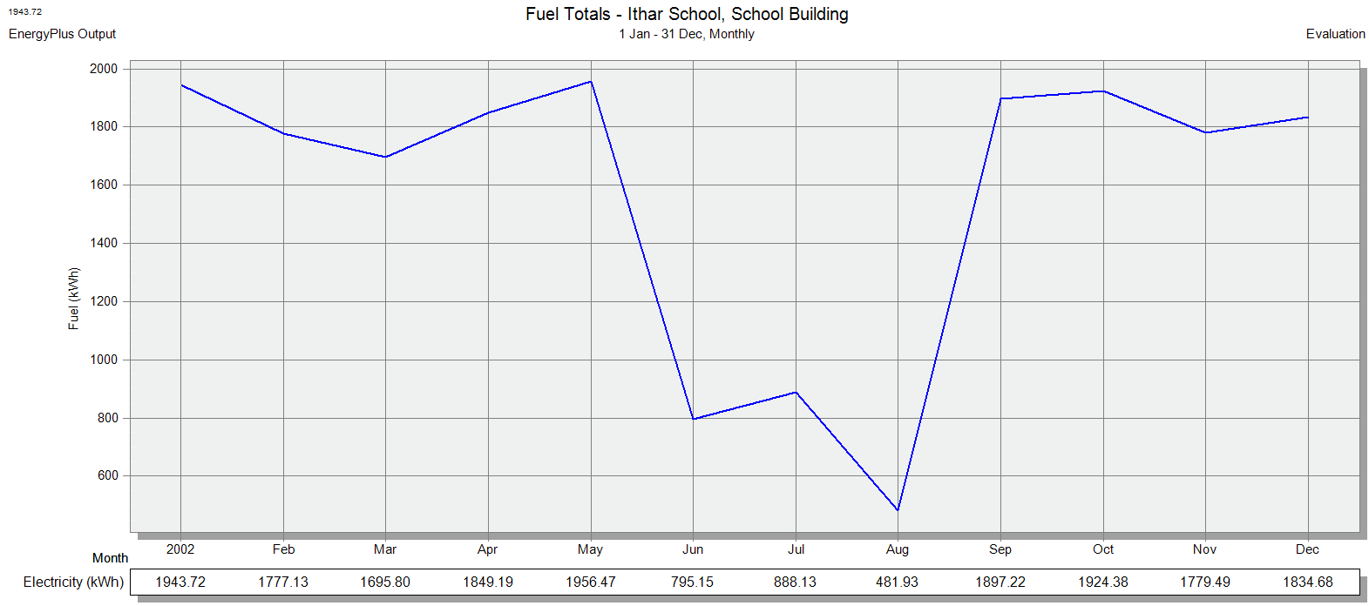Figure 30: Total fuel consumption for the existing case.

4.2 Replacing the existing lamps with LED simulation.
In this part, we will discuss the changes when changing the lighting system.

4.2.1 Lighting intensity changes.
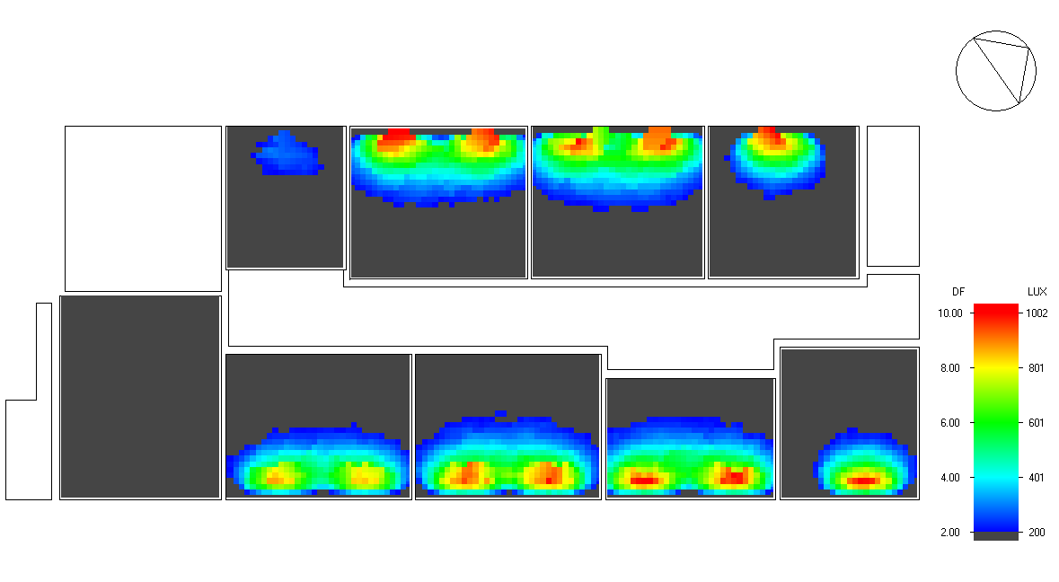
Figure 31: F2 lighting with LED.

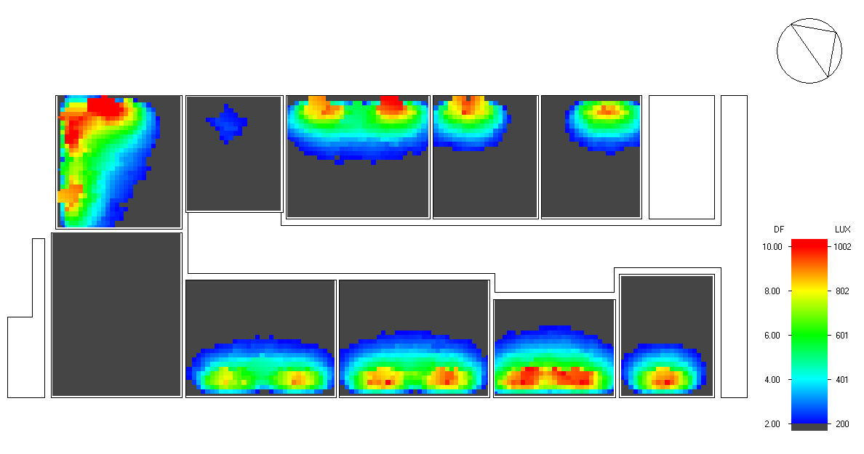
Figure 32: F3 lighting with LED.
The above two figures show the lighting intensity in the second and third floor of the building after replacing the lamps with LED lamps. Comparing figures 24, 25 with figures 13 and 14 we can definitely tell that lighting has improved (the orange color is more in LED lamps case and the light spreads away more).

4.2.2 Electricity consumption changes for the LED lamps case.

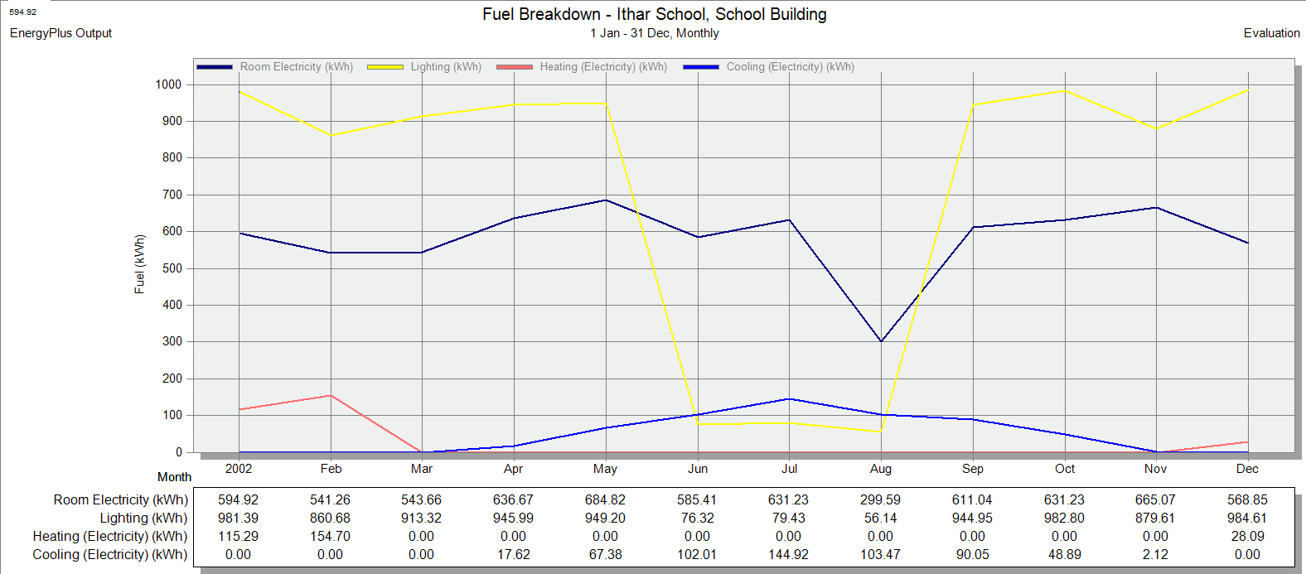
Figure 33: Consumption of electricity with LED.

Figure 26 shows the reduction in electricity consumption from the original condition. The average consumption in the LED case is almost 800kWh.

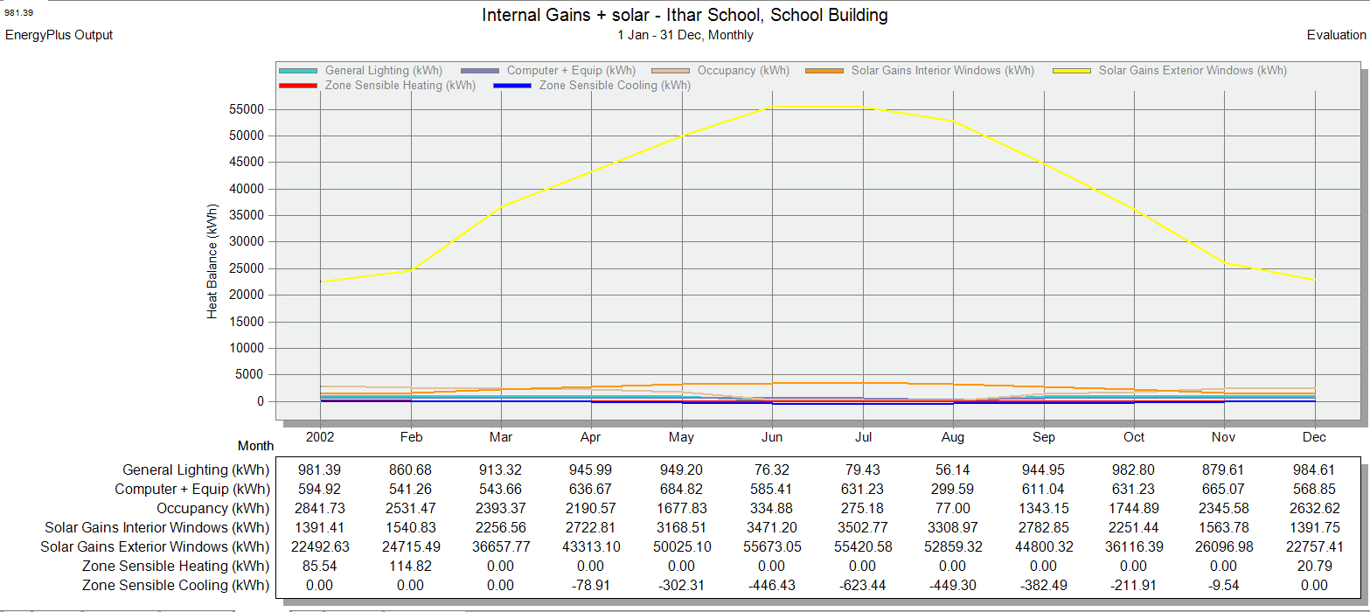
Figure 34: Internal gains in case of LED lamps.

Also the figure above shows the reduction in internal heat gain from electricity from the original case. Almost 300-400 kWh reduction.

4.3 Lighting system hand calculations
In this section the Description and Data about lighting system components, current consumption, level taken by lux meter, expected savings will be listed.
4.3.1 Lighting level
Table () below shows results from luxmeter, it was noted that the lighting levels in the classrooms and school in general was not highly compliant with required illumination standards .This bad level of lighting may come from the Lamp mortality and/or the bad design and distribution.
Table(11): Lux readings
Flat | Rooms | No. of outer windows | No/ of outer doors | Lux | Lux standard
GF | Internal yard | none | 3 | 114 | 300
GF | Playing room | None | None | 137 | 300
GF | Bathroom | None | none | 254
GF | Stairs | None | none | 114 | 100-150
F1 | Administration | 2 | none | 253 | 400-500
F1 | Teachers’ | 2 | none | 946 | 400-500
F1 | Kitchen | 2 | none | 252 | 400-500
F1 | Bathroom | None | None | 252
F1 | Internal yard | 8 | 3 | 178.4 | 300
F1 | Corridor & stairs | 2 | 1 | N.L | 300
F2 | Classroom (8) | 2 | None | 274.32 | 500
F2 | Bathroom | 2 | None | 240
F2 | Corridor & stairs | 2 | None | N.L | 300
F3 | Classroom (8) | 2 | None | 557.83 | 500
F3 | Bathroom | 2 | none | 310
F3 | Corridor & stairs | 2 | None | N.L | 300
Roof | Classroom (6) | 2 | None | 333.15 | 500
Roof | Bathroom | 2 | None
Roof | Corridor & stairs | Outer space |  |  | 300

4.3.2 Lighting system consumption and Relamping scenario:
Data analysis:

- Energy consumption= $\frac{ Kwh/lamp}{year}×number of hours×number of lamps$
- Annual cost =Total energy consumption (Kwh/year)×0.6 (Nis/Kwh)
- power saved = (𝑜𝑙𝑑𝑊×# 𝑜𝑓𝑙𝑎𝑚𝑝𝑠) – (𝑛𝑒𝑤𝑊× #𝑜𝑓𝑙𝑎𝑚𝑝)
- Energy saved = 𝑝𝑜𝑤𝑒𝑟𝑠𝑎𝑣𝑒𝑑 × 𝑜𝑝𝑒𝑟𝑎𝑡𝑖𝑛𝑔 ℎ𝑜𝑢𝑟𝑠×utilization factor
- cost saved = 𝑒𝑛𝑒𝑟𝑔𝑦𝑠𝑎𝑣𝑒𝑑 × 𝑐𝑜𝑠𝑡 for one e energy unit
- Total investment cost = 𝑐𝑜𝑠𝑡𝑜𝑓𝑙𝑎𝑚𝑝 × 𝑛𝑢𝑚𝑏𝑒𝑟𝑜𝑓 lamps ×installation cost
- total installation cost = cost saved × number of days
- SPBP= $\frac{investment}{saving}$

Table ( 12): RELAMPING for the existing type of lamps
 | Lamp type | Watts | Life time | Price (NIS)
Old lighting system | Fluorescent T8 | 34 | 10000 | 5
New lighting system | LED | 18 | 25000 | 10

Energy saving = ( 81 fixture) × (2 lamps/fixture) × (34-18) (1674 hours /year) =4339.008 NIS/year
Energy Cost Savings (ECS)= (6779.7 KWh) × (0.6NIS/Kwh) = 2603.4NIS/year
Total annual use = (162 lamps)(1674/year) = 271188 lamp hour
Number of lights needed per year for old lamps = (271188 lamp hour )/(10000 ) = 27 lamps
Number of lights needed per year for new lamps = (271188 lamp hour)/(25000)= 10 lamps
Annual cost for old lamps = ( # of lamps )( price of lamp)
= ( 27 lamps )(5 NIS ) = 140 NIS
Annual cost for new lamps = ( # of lamps )( price of lamp)
= (10 lamps)(10 NIS) = 100 NIS
Annual Lamp Cost Savings (ALCS)=(140 NIS)𝑜𝑙𝑑−(100 )𝑛𝑒𝑤
= 40 NIS
TOTAL ANNUAL COST SAVINGS = 4067.82 NIS/YEAR +40 NIS / YEAR = 4107.82 NIS
Total investment = 81 )(2) (18) (1674) = 2928.83 NIS
SPP= total investment/ savings = 1.12

4.4 Adding HVAC system (split unit)
The results out of this trial are obvious and expected, yet we decided to do it as an introduction for the next semester where we are planning to design the most suitable and effective HVAC system for the building.

4.4.1 Comfort measures.
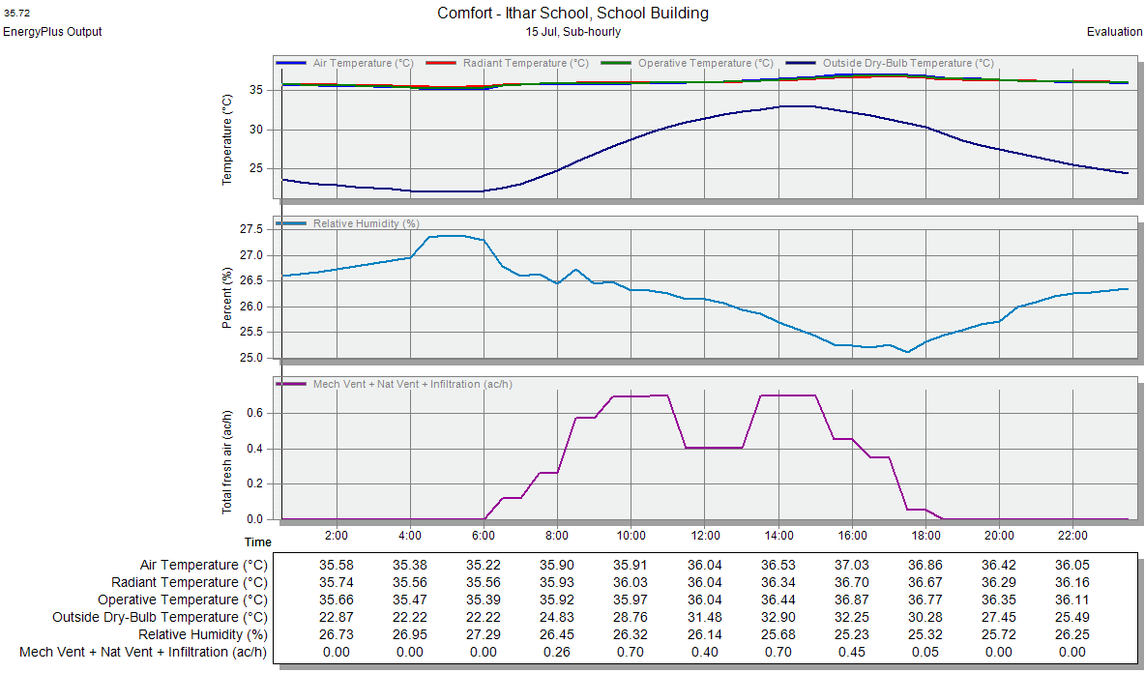
Figure 35: Comfort figure for the last simulation.

Starting with the heating design, the average operative temperature in winter months has increased noticeably, that is, now it has an average of 35ºC. From the graph we can see that split units are not the most suitable HVAC system.
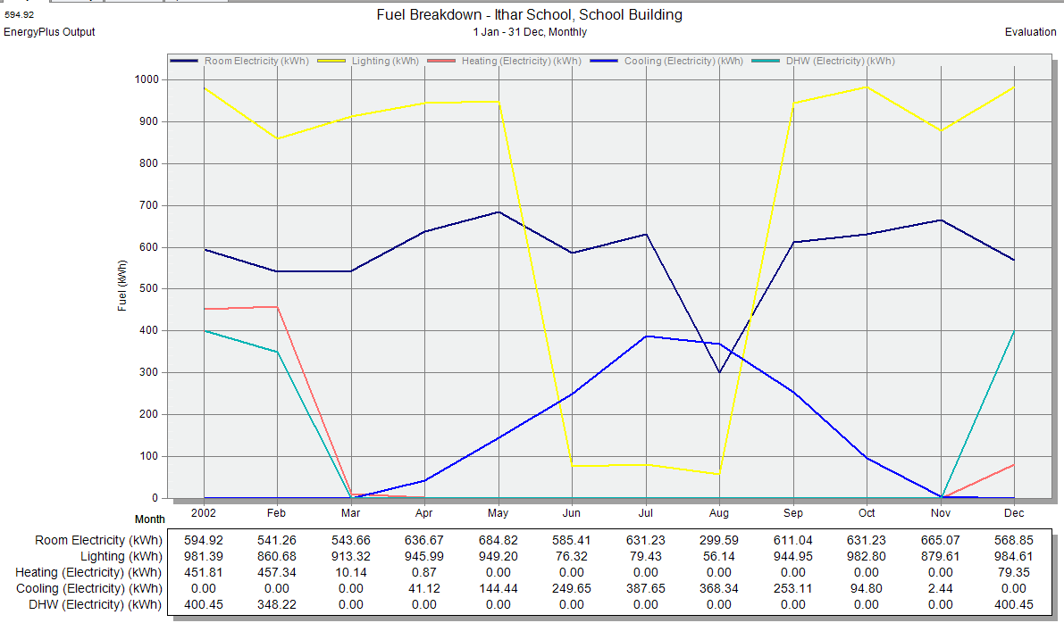
Figure 36: Fuel consumption for the last improvement.
The figure above shows the expected increase in consumption of electricity on HVAC system all over the year.
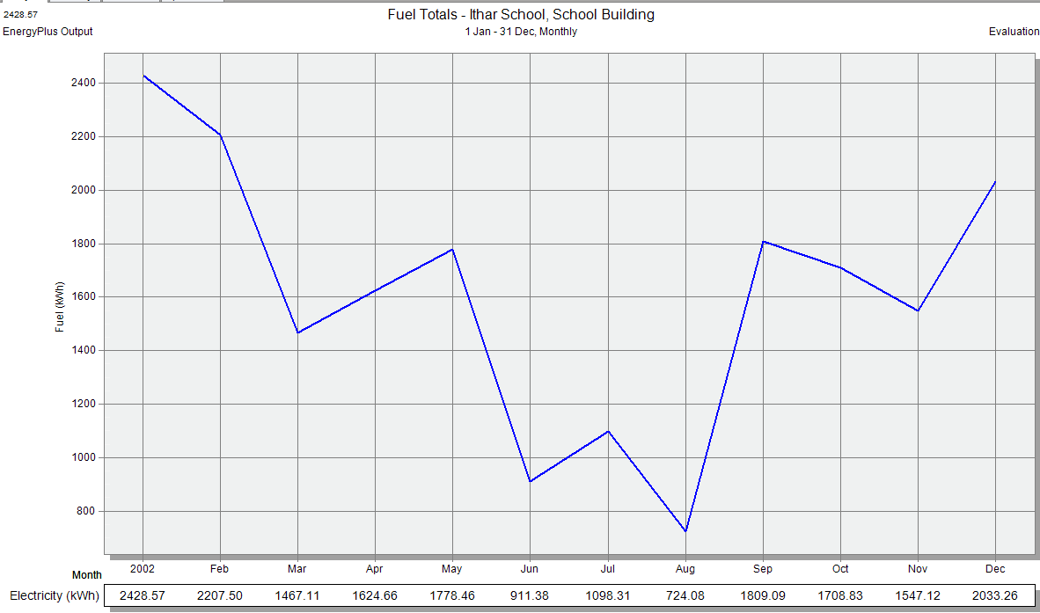
Figure 37: total electricity consumption for the final case.

4.5 PV system Results

4.5.1 PVsyst Results and Simulation

4.5.2 DesignBuilder Results and Simulation

The DesignBuilder simulation shows the consumption for each energy utilizing category and the comfort scales and parameters for each.
Table 12: Fuel end use
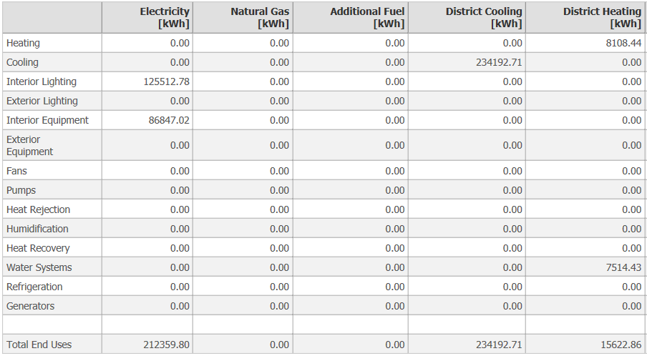

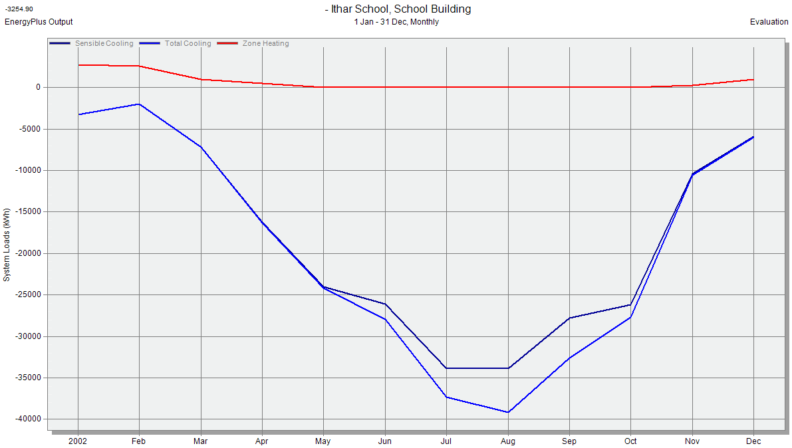
Figure 38: Building load curve.
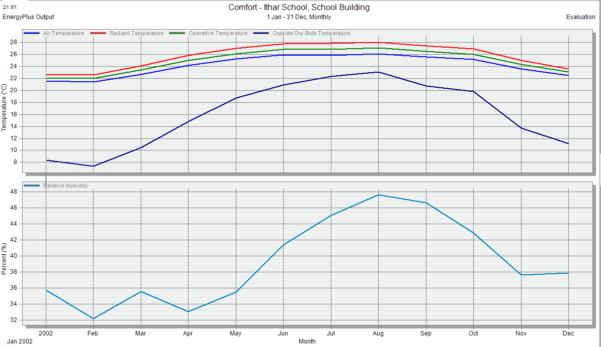
Figure 39: Comfor measures.

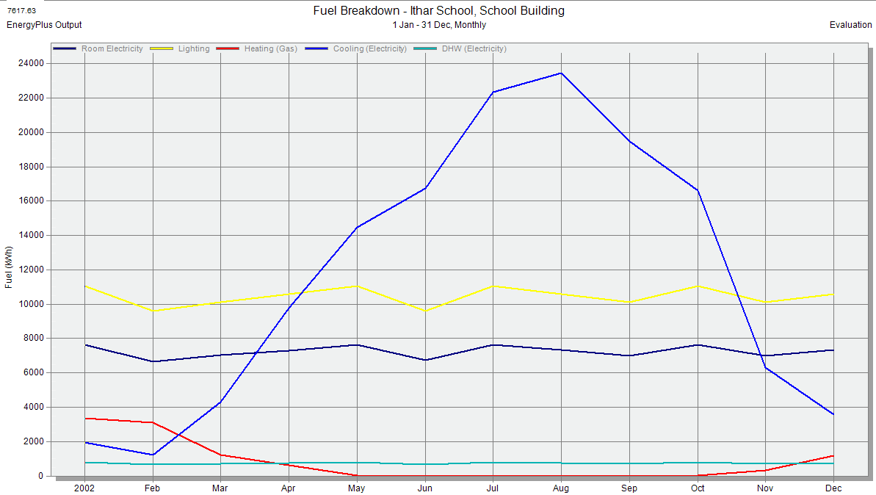
Figure 40: Fuel breakdown.
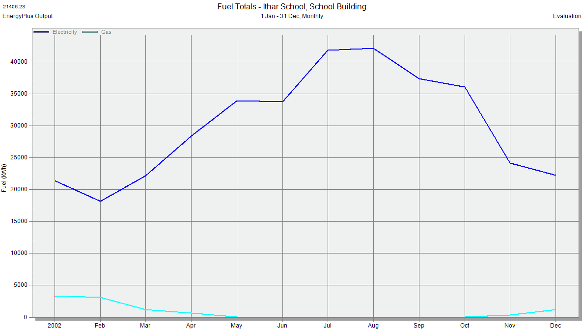
Figure 41: Total fuel consumption

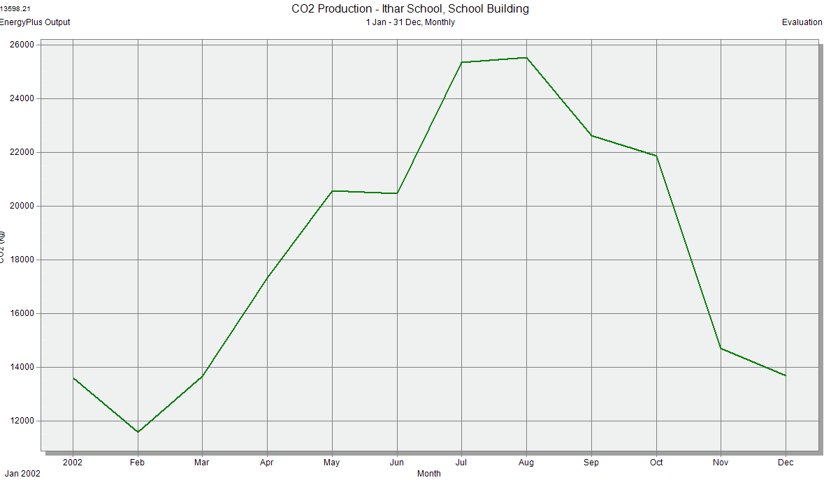
Figure 42: CO2 measures.

4.5.3 Conventional PV design and calculations.

The PV panels will be installed on the school roof; its available open area is near 220 m2. This area is recommended for a PV project because it's open from the south (approximately no shadow).

Assumptions:
- Available surface area is 220 m2.
- The load for the school is 60.61 kwh/day AC which is equal to 49.91kwh DC.
and the KWP= (49.91/5.34)= 11.04 kwp
- PV panel is monocrystalline type Jinkosolar brand provide 305wp
- Numbers of PV panels required for 11.04 kwp system are 36 panels.
- The average solar radiation in Nablus city from PVSYS simulation program are shown in the table below in kWh/m2/day :
Table 13: Insolation data.

Load Estimation:
- The consumption for our case study of Ithar school is 13785.67 kwh/year which is equal to 69.6kwh/day AC
- The load DC= 69.6kwh AC/1.49= 49.9 kwh

- Ppeak= (49.9kwh*1.25)/(5.34kwh/m2/day)= 11 kW

Quantities of Components:
After determining the size of the system (11 kWp), the quantities were determined as shown in following:
- Number of PV panels: #of PV's = $\frac{load}{ PV^{'}s wattage}=\frac{11.6kW}{.305kW}=36$ panels
- Inverters: Two inverters.
- Surge arrester: it is used to protect from high voltage caused by thunderbolt, so there must be one after each string. The chosen inverter has two strings so 12 SPD were needed.
- DC circuit breakers: CB used to protect the inverter and panels from high current, must be one after each string.
- AC circuit breakers and earth leakage: positioned after the inverter to protect the AC side
- Steel structure: one for each 1 kW.
- Energy meter(KWHM): calculates the amount of energy consumed
The following two tables are the specifications for inverter and panels from there data sheet attached in the appendix.

Table 14: ABB inverter specification
Inverter /charger specifications
Type | ABB
Rated power | 6 kW
Max input current | 28.3 A
Max voltage | 800 V
AC frequency /range | 50Hz/60 Hz
Max. efficiency | 97.1%

Table 15: PV specifications
PV module specification
Type | Jinkosolar monocrystaline
Maximum power (P max) | 305 Wp
Maximum voltage (V max) | 38.2 V
Maximum current (I max) | 8.91 A
Short circuit current (I s.c) | 8.9 A
Open circuit voltage (V o.c) | 46.4 V
Efficiency | 16.52%

System design calculations:
The first question in this step was how to connect the panels? Series or parallel? This question was answered depends on the inverter and panels specifications; where the connection of panels in series or in parallel is restricted by max tracker current in case of parallel and the operating voltage range in case of series, where the volt from connection of panels in series mustn't exceed the operating voltage for each tracker, and the current from parallel connection of the two strings mustn't exceed the max input current for the tracker, In addition to notice the tracker power as shown in the equations below.
  - String current= # of strings $×$ panel's short circuit current $≤$ inverter Max input current
  - String voltage = #of panels $×$panel's open circuit voltage $≤$ inverter operating range
  - Output Power = String Input current $×$ String voltage$≤$ inverter max power.
We have chosen 2 inverters 6KW each, 2 strings for the first one and the third string on the second inverter

  - Number of modules = 36
  - Number of strings= 4
  - Number of modules in series in each string= 9
  - String current 2 $×$ 8.98= 17.9 $≤$ 28.3 for one inverter
  - String voltage = 9$×$46.4 = $418.41≤$ 800 for one inverter
  - Output Power = 26.9$×$ 556.8=14.9$≤$ 6*2= 12 kw.

- DC. Circuit breaker current =string current$\left(8.98\right)×safetyfactor(1.2)$ = 11 A

- AC. Circuit breaker current = inverter rated current(28) $×$ safety factor (1.25)=35.25$≈40A$

- Earth leakage circuit breaker (ELR) = it's sensitivity determined according to the loads, and for industrial loads it's 300mA
- Cables have been chosen according to standard such that the cables between panels are 6 mm², array cables are 10 mm², AC connection cables are 6 mm² and earth leakage protection cables are 10 mm².

Initial investment:
The capital investment of the project is calculated in the following table:

Table16: project investment
Component | Unit | Unit price($) | Total price($)
Solar panels | 36 | 165 | 5940
Solar inverter | 2 | 2440 | 4880
Surge asserter(SPD) | 4 | 8 | 24
Steel structure | 36 | 68 | 2448
ACcircuit breaker(CB) | 4 | 30 | 90
DC circuit breaker(CB | 4 | 55 | 165
Energy meter(KWHM) | 1 | 450 | 450
ELR | 4 | 47 | 141
Labor cost | *** |  | 1000
Cables | *** |  | 2200
Salvage value | 3.5% capital cost
Total investment | 17338

Savings from the system:
Monthly savings were calculated based on monthly solar radiation from PVSYS software and the college demand values from energy research Centre at the university. The results listed in the table below, Where saving calculated from the equation:
Saving = 1700 kwh * 11.6 *0.56 NIS/$ = 11043.2 NIS/3.5$= 3155$
Simple pay back period (SPP)= 17338/3155 = 5.4 years

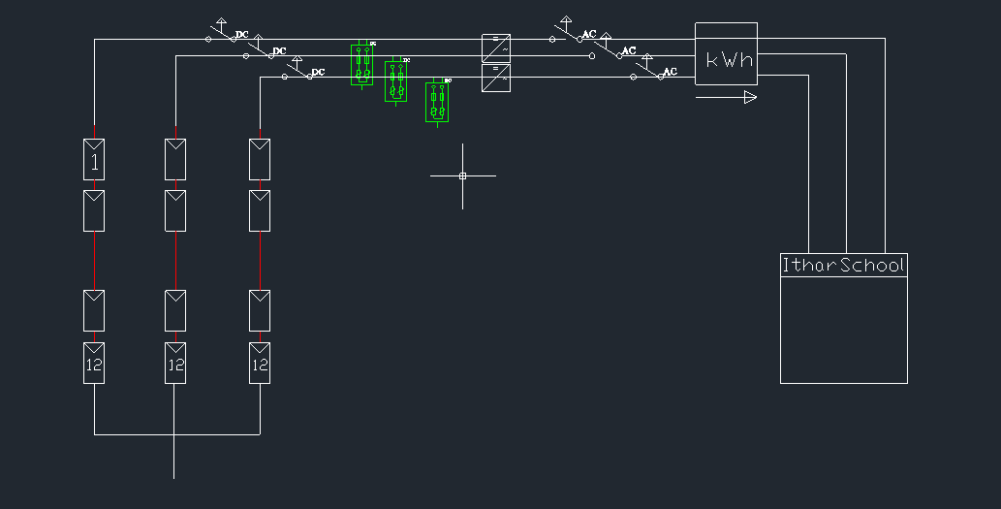
Figure 43: PV electrical diagram

4.5.3 Results from PVSYST:
After applying the PV parameters from modules to inverter and the KWp of the load to the PVSYST simulation programs we got the same distribution of our modules and report was given from the program
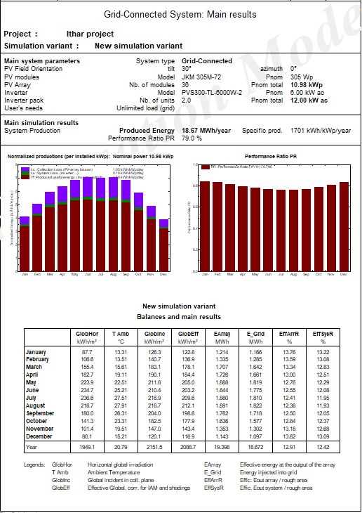
Figure 44:Reported results from PVSYST
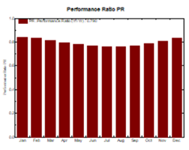
Figure 45:Performance ratio of the system
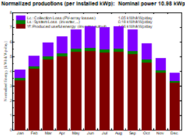
Figure 46: Normalized production from the PV

5.2 Building envelop

5.2.1 Walls Performance

To find actual U for the walls, we use DesignBuilder data according to the type of walls of the school that has been added to the program
Uvalue is 1.2 w/m2.k.
Q_{old} =U$×$A $×$ΔT $×$31 $×$24 = 1.2$×1×\left(18.3-25\right)×31×24=$5981.76 W
The recommended solution is using product which is called Nansulate, paint-oninsulation with extremely low thermal conductivity. Patented and manufactured by Industrial Nanotech, At $66 per gallon and covering about 150 square feet (13.93m2), Nansulate offers a highly economical solution to insulating walls.
Unfortunately, there are no data that directly compare the performance of Nansulate with that of conventional insulations. That's because conventional insulations inhibit heat conduction as a function of their thickness (R-value per inch), whereas Nansulate is a nonconductor (insulator) that blocks both conductive and radiant heat flow. There is, however, a great deal of information about Nansulate's performance based on real-life tests in industrial and residential settings. Factory owners have reported savings of 20 percent or more on their energy costs. Home energy savings of 20 to 40 percent are reported in testimonials on the Industrial Nanotech Web site [27]. We consider that this insulation will save 30% of Q ,so the new Q will equal to4187.3W.

Chapter 6:

CONCLUSION

This graduation project is an energy management study on a school building in Nablus city. Energy simulation on the building was done using the DesignBuilder software on the existing condition of the building which shows that lighting system is the most energy consuming system in the school, and need some modifications to fit the standard. The challenges were to improve the lighting system in the college, with minimum consumption of energy without negatively affect the. The suggestions show good saving opportunity in the lighting system.
The simulation also gives us a predicted indication that the critical months with relative to human comfort of the year are winter months and

Different trials were applied to the school both in DesignBuilder and by hand calculation to predict the energy saving solutions

Recommendation:
The previous suggestions are the main for saving, but there are some techniques to maintain the consumption and the light level good for longer time:
- Relamping: we got a saving about 4107.82 SPP nearly in one year also we suggest group relamping to reduce labor and lamp costs, allow lamp maintenance to be schedules, maintain higher and more uniform lighting levels
- PV: Grid connected PV system was found to be feasible since the SPP is almost 5 years
- Nansulate, paint : as an insulation since applying HVAC system wouldn’t be feasible in our case then applying this kind of insulation would reduce heat transfere and raise the human comfort

- Periodic maintenance: as known dusts reduce the light comes from the lamp, which is negative thing. Periodic maintenance will prevent this from happen

Works Cited
Anon., 2008. Building Energy Management Systems (BEMS), s.l.: http://www.climatetechwiki.org/technology/jiqweb-bems#Introduction.
Anon., 2008. استهلاك الطاقة في الاراضي الفلسطينية, رام الله: جهاز الاحصاء المركزي الفلسطيني.
] Khatib,T . A Review of Designing Installing and Evaluating Standalone Photovoltaic Systems,2010,10(13), 1212-1228.
Bose, A., 2013. ImprotantIndia. [Online]
Available at: https://www.importantindia.com/4671/conventional-and-non-conventional-sources-of-energy/
[Accessed November 2017].
V. M. Zavala, M. Anitescu, E. Constantinescu, S. Leyffer, J. Wang, G. Conzelmann, "Proactive Energy Management for Next-Generation Building Systems", in: Proc. IBPSA-USA SimBuild 2010, New York, NJ, USA, August 11-13, 2010.
C, N., 2017. Energy Management: Meaning, Steps and Objectives. [Online]
Available at: http://www.businessmanagementideas.com/energy-management/energy-management-meaning-steps-and-objectives/6348
[Accessed November 2017].
Gressani, D., 2007. West Bank and Gaza Energy Sector Review, s.l.: (MNSSD) .
Qian, Y., 2017. Energy Management in Buildings. IEEE Access, Volume 3.244.

