

An-Najah National University
College of Engineering and Information Technology
Department of Architecture
Summary of the Jenin Cultural Center
Research submitted to obtain a bachelor’s degree in architecture
student preparation:
Ahmed Ali Abu Al-Rob

Supervisor:
Dr.. Forgive Mona

2023/2024
Summary
This research is considered a graduation project in architecture under the title “Jenin Cultural Center.” The project aims to establish a multi-purpose cultural center in the city of Jenin to meet the needs of the local community and promote culture and arts in the region.
Culture is one of the basic elements that define the identity of societies and reflects their traditions, values ​​and creativity. Cultural centers play a pivotal role in preserving cultural heritage, developing the arts, and promoting community understanding. The need for these centers is increasing in developing cities, such as Jenin, to support cultural, social and economic growth..
Project goals:
Providing a designated space for cultural and artistic events.
Promoting local cultural heritage and encouraging creativity.
Supporting education and professional development in the fields of arts and culture.
Promoting social interaction and communication between various segments of society.

Elements of the cultural center:
Administrative section:
Administrative offices and meeting rooms to manage cultural activities and coordinate with various parties.
Facilities to support staff and visitors, such as reception desks and waiting rooms.

Section on cultural activities:
A public library containing books and references in various cultural fields.
Lecture halls and workshops for organizing educational and training events.
A theater equipped to host theatrical performances and concerts.

Section on recreational activities:
Open spaces for outdoor events, such as parks and green spaces.
Multi-purpose halls that can be used for art exhibitions and social activities.

Section on public services:
Restaurants and cafeterias to provide food and beverage services to visitors.
Car parking and maintenance and cleaning facilities.
The importance of the project:
The Cultural Center in Jenin represents an important step towards strengthening the cultural infrastructure in the city, which will contribute to enhancing social understanding, developing local talent, and supporting the local economy by attracting tourists and investors. The project will also provide a space that combines education and entertainment, creating a stimulating environment for creativity and learning..
.

The architectural idea of ​​the center:
Designing a cultural center in the city of Jenin to serve as a cultural beacon offering a variety of cultural, educational and recreational activities for all groups.
The shape was divided so that it became a large entrance and spaces that included the activities of the people of Jenin camp, in contrast to the narrow building in the camp, so that people were taken out of the camp atmosphere and the harassment to which they were exposed and exposed to a social and interactive atmosphere. This was done by creating chairs for sitting and a special area for playing and interacting. The project targets all ages because it contains jobs for all groups.
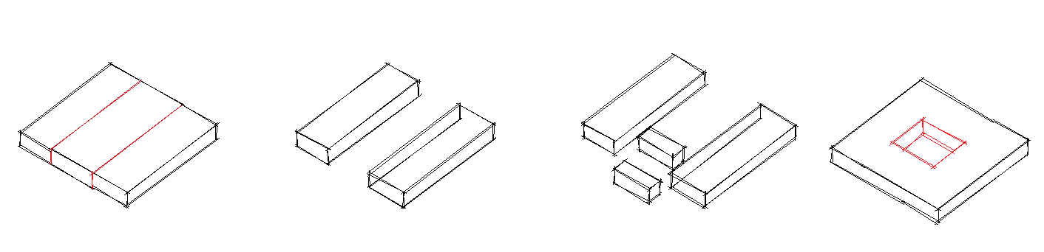

The ram was treated as an idea indicating the adherence and rootedness of the people of Jenin, and the shape that emerges from the ground continuously gives a feeling of strength and flow. The stadium is designated for people with special needs, in addition to what looks like an amphitheater for public events
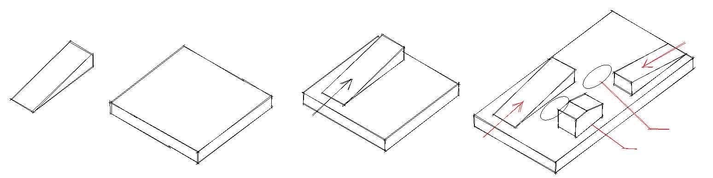

External shots:
