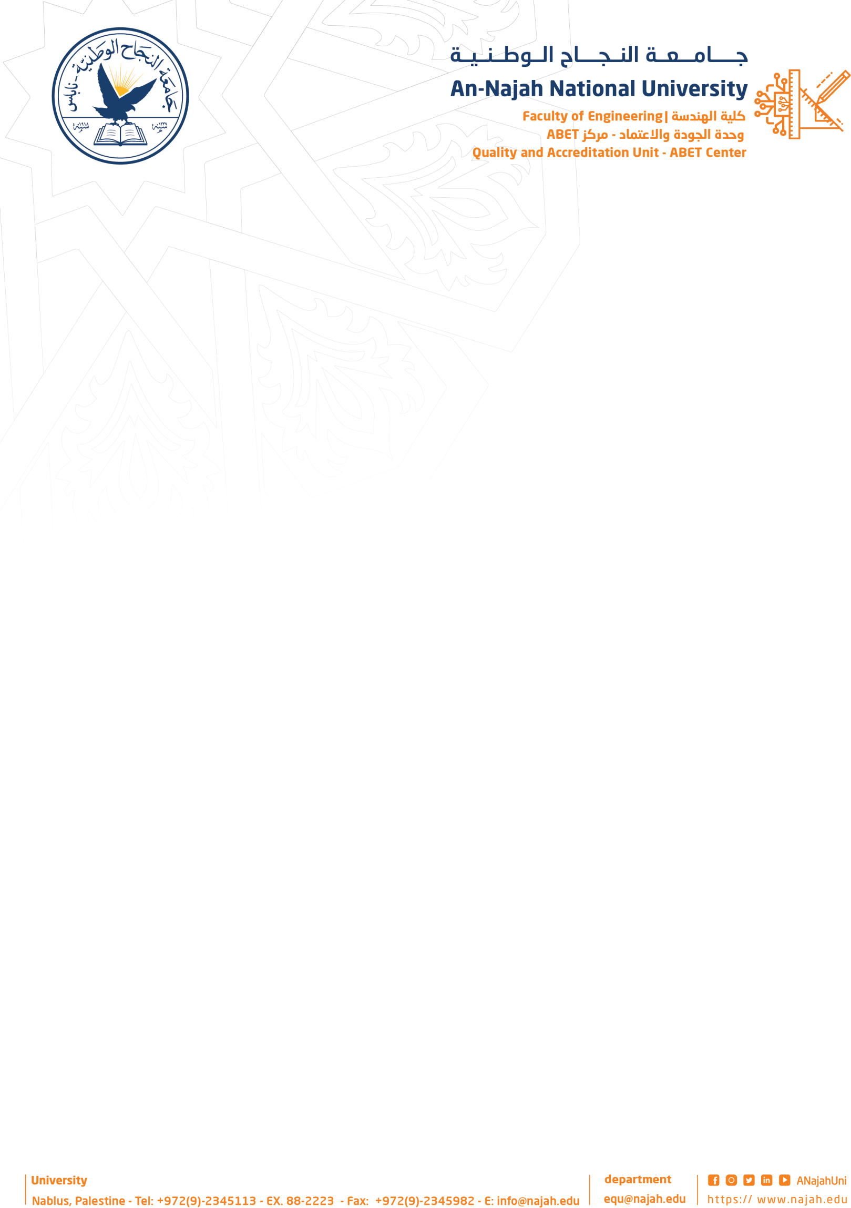

Project title: Echo Vision
Academic Year: 2025/2026
Group Members: Eyas abu saeed Department Name: Computer Engineering Mohammed dawabshieh
…………………………………………...
……………………………………………
Project Type Hardware
Supervisor Name: Dr.Samer Arandi

Project’s Abstract:

This project aims to develop an automated waste sorting system that classifies waste materials such as plastic, cardboard, and paper. The system is designed to improve and accelerate the recycling process by sorting waste accurately and efficiently, helping maximize the benefits of recycling while reducing the need for manual labor.

The proposed system is fully automated. Waste items are placed on a conveyor belt, which transports them to a robotic arm. A camera captures images of each item, and an artificial intelligence model identifies the type of material. Based on the detected category, the robotic arm picks up the item and places it into the appropriate box.

The main objective of this project is to build a complete automated waste sorting system that operates without human intervention. This increases sorting speed, improves recycling efficiency, and reduces human effort and errors.

The system is powered by a Raspberry Pi 4 utilizing a YOLOv8 object detection model. While general-purpose YOLOv8 models cover a wide variety of classes and can sometimes exhibit lower accuracy specifically with bottles and containers, the model was further trained and enhanced with an additional custom dataset of container images. This targeted retraining ensures exceptionally high accuracy and robust real-time performance in identifying and sorting bottles alongside all other waste categories..

