AN NAJ NATIONAL UNIVERSITY

Cisternina Robot

Prepared by:
Ahmad Nabulsi & Mazen Alkoa’

Submitted to:
M.S. Haya Samaaneh

2012
Ahmad

Contents
Abstract 2
Introduction 2
Overview 2
Existing Problems 2
Related work 3
Motivation for Carrying out project 3
Main Contribution 3
Report Organization 3
Methodology 4
Model 4
PROJECT SPECIFICATIONS 5
Motors 6
Power 6
PSP Touch Screen-LCD-08448 6
Color sensor 9
Features 10
GSM 11
GSM SERVICES 11
XBee 12
Microcontroller 12
Noise and disturbances 13
Control Of Motors 14
Pulse-width modulation(PWM), or pulse-duration modulation 14
Conclusions and Recommendations 17
Conclusions 17
Recommendations 17
References 17

Abstract
The design and construction of a “Remotely controlled Exploratory” robot to be used as an exploratory tool by one local network, is discussed. The “Remotely controlled Exploratory” robot is remotely controlled by a mobile phone using GPRS and it is able to receive and reply to TCP commands.
The robot can be used for military operations and we build the robot in a way that makes it capable to be used for this aim. We make the model in the shape of tank and construct it from materials that are strong such as steel sprockets.
The design and construction of this telecommunication robot required a lot of expertise in many different fields such as Mechanics, Electronics, Telecommunication and Software development. This document covers every aspect of the project, from the conceptual ideas to the detailed design of each main part of the system.

Introduction

Overview
The aim of this project is to design a program controlled robot that can maneuver through locations that is risky accessible and to take picture when needed.

Existing Problems
A lot of military bases want to use something like our module which we made in the shape of tank for discovery and war and control it from a remote control unit far from danger.
- Building model and mechanical design
- Finding suitable motors and do the required gearing system
- Building the electronic and control circuit to combine components with each other
- Applying touch screen to move the robot on a specific path
- Implementing the color sensor
- Configuring and programming the GPRS modem.
- Connecting the wireless camera to capturing the area .

Related work
In many industries, the trend is to program all systems and make use of machines or robots in most of the critical sections of the production chain .So we try to build a robot to apply electrical and electronic approaches.

Motivation for Carrying out project
Entering the world of robotics and building hardware system as well as sensor and programming .Moreover to compete students in this filed.

Main Contribution
The main object of our project is to help to reach risky locations and to explore the location sent to as well as color detection and following.

Report Organization
In this report I start with an abstraction of my project then small introduction about what my project will do.
After that I the methodology I wrote about everything I do and the main ideas I use them in order to achieve the goals of this project.
And at least I consider the result and the challenges I face for achieving the first version of this software.

Methodology
In this chapter we will discuss the way in order to approach our target, in order to make some model can represent our target and what we did to achieve our goals:

Model
At first we build our model for this project form wood as shown in fig.1 blow, and then we put the chain and gears to our model. 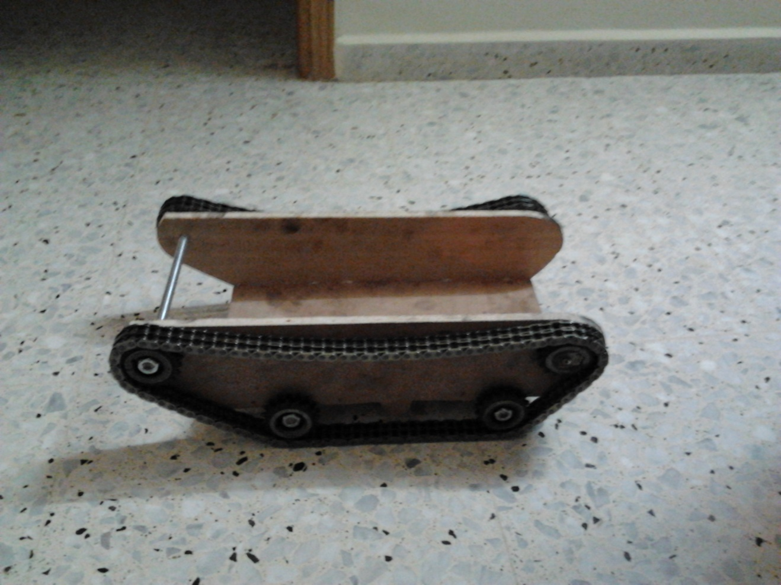
Figure 1: Robot Model
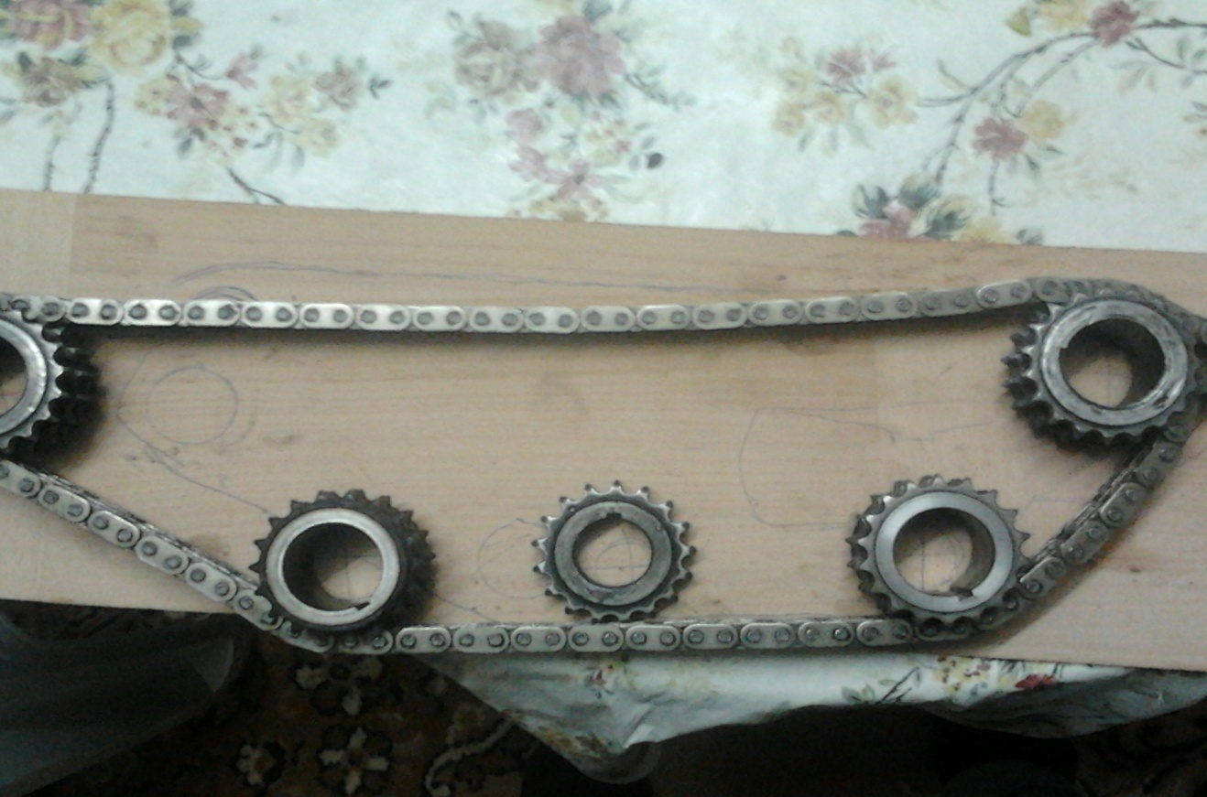
Figure 2: First Sketch

PROJECT SPECIFICATIONS
It was specified that the robot should:
- Be mobile
- Be remotely controlled via the GSM or GPRS network
- Send and receive SMS messages
- has touch screen
- Incorporate a IR camera
- Incorporate a color sensor
- has a Xbee module for communication (alternative for GPRS modem but GPRS communication is still found between mobile and computer and the Xbee between computer and the module)

Motors
We use a DC motors that have these features are:
- Motors are used car glass motors.
- Internal gearing.
- High output torque.
- Input signal is 12V DC.
- Input current for both motors at max load equal 2.6A.
- Motor immediately stalls without input signal.

Power
Power is a critical part of our design, because we had to make sure that we were not overloading or supplying too little power to any component. Either case would have been dangerous to the components. To keep each major component independent of the other, we have two set of power supplies: one for the pic at 5v, the second for the motors at 12 v.

PSP Touch Screen-LCD-08448
The PSP touch screen is a 4 wire analog resistive touch screen. This means by touching the screen at one point, a resistance between each edge is formed for both the x and y axis. As you move your finger or stylus across the screen the resistance changes between opposing sides of each axis. By applying a voltage across each axis, a changing resistance results in a changing voltage. Thus an ADC on a microcontroller can be used to find x and y positions
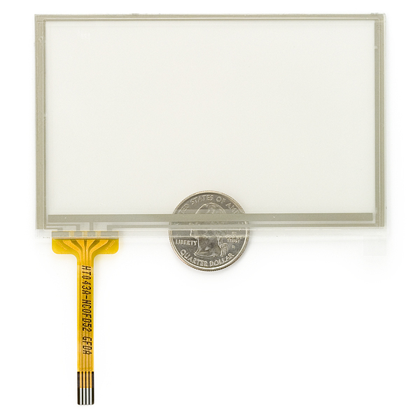
Figure 3

This is the SMD connector for the PSP touch screen. 4-pin right angle good, friction fit connector with 1 mm pitch. This connector is compatible with the PSP Touch Screen
Figure 4
The four pins control 4 buss bars located around the peripheral of the touch screen. In order to read either an x or a y position, two opposing bars need to be powered and a third orthogonal bar is used to measure the divided voltage.

Figure 5

This configuration means that the voltage, ground, and sense bar need to be continually switched in order to quickly read x and y positions:
Figure 6

Color sensor
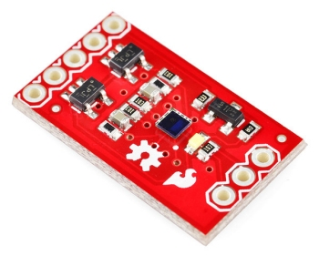
Figure 7
Description
The ADJD-S311-CR999 is a cost effective, 4 channels (RGB+CLEAR) digital output sensor in miniature surface- mount package with a e size of 2.2 x 2.2 x 0.76mm. It is a CMOS IC with integrated RGB filters and analog-to-digital converter front end. This device is designed to cater for wide dynamic range of illumination level and is ideal for applications like portable or mobile devices, which demand higher integration, smaller size and low power consumption. Sensitivity control is performed by the serial interface and can be optimized individually for the different color channel. The sensor can also be used in conjunction with a white LED for reflective color management.

Features
• Fully integrated RGB+ clear digital color sensor
• 10 bit resolution per channel output
• Built in oscillator/selectable external clock
• Low supply voltage (VDD) .5V
• Digital I/O via 2-wire serial interface
• Adjustable sensitivity for different levels of illumination
• Low power mode (sleep mode)
• Independent gain selection for each channel • 0°C to 70°C operating temperature
• Industry’s smallest form factor
- CSP 2.2 x 2.2 x 0.76mm
• Lead free package

GSM

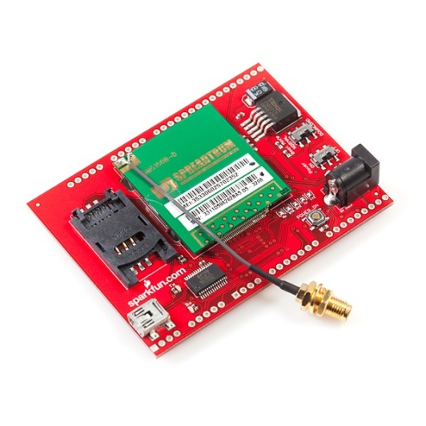
Figure 8

GSM SERVICES
GSM offers three categories of services. The first category of services is related to the transportation of data to or from an ISDN terminal. These services are referred to as bearer services. The second category of services is referred to as Tele-services. This category includes services such as telephony and SMS. The third category of services is referred to as supplementary services. This include services such as caller identification, call forwarding, call waiting, multiparty conversations, and barring of outgoing calls
We use the GSM in our project as Tele-services

XBee
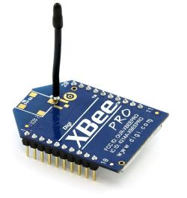
Figure 9
The Xbee and Xbee-PRO RF Modules were engineered to meet IEEE 802.15.4 standards and support the unique needs of low-cost, low-power wireless sensor networks. The modules require minimal power and provide reliable delivery of data between devices.
The modules operate within the ISM 2.4 GHz frequency band and are pin-for-pin compatible with each other.

And we have used the Xbee pro due to its features such as the distance that is reached and because it is faster and more secure.

Microcontroller
The brain of the project, the centre of process and the decision maker is microcontroller PIC. It’s very popular, easy to program, it has modules support our requirements, and we are well trained to use it.
- We choosed PIC18F4620 with RISK CPU.
- 8K*14 words flash program memory which is enough.
- 5v power supply is required.
- Current source/sink up to 25mA.
- It includes timers, interrupts, adc, PWM, etc.
- 32 I/O pins implemented in 5 ports.
- Max current into VDD=250mA.
- A programmer circuit was built to download code to PIC, JDM programmer.
- Software used was PIC-C with CCS compiler.

Noise and disturbances
The biggest enemy to PIC was noise. The high frequency signals received from communication devices and a motor cause the PIC to become unstable and suffer from changing values of the registers which sometimes results in restart in PIC. When problem occurs and PIC outputs unpredicted results, it can be tested isolating PIC from input-output and then manually input data and test output on LEDs.
Solution
- Output side: motor causes high frequency signals especially during commutation. It can be solved by completely separating control circuit from power circuit and connecting them through photo or optocoupler.

Optocoupler

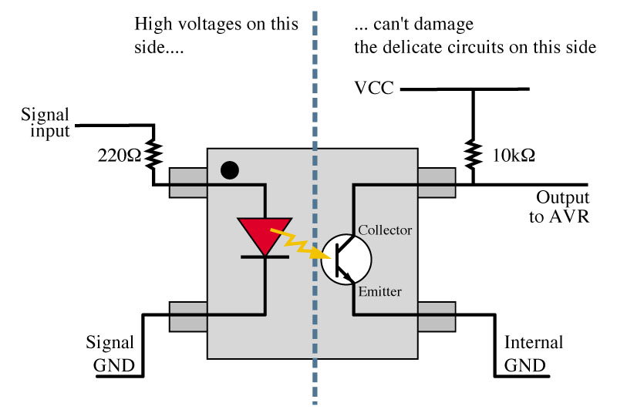
Figure 10
Optocoupler is an electronic device designed to transfer electrical signals by utilizing light waves to provide coupling with electrical isolation between its input and output.
The main purpose of an opto-isolator is "to prevent high voltage or rapidly changing voltages on one side of the circuit from damaging components or distorting transmissions on the other side.
The control circuit and power circuit must be completely separated even the ground, in order to avoid noise of microcontroller by machine. The two circuits interact through photocoupler.
The first circuit transmits light by sending signals to LED. At the receiving side a photo transistor is affected by light transfers signal to power circuit.

When input=0
Transistor is off impedance is ∞ .
Inverter receives 1 and output = 0

When input=1
Transistor is on and saturated
Inverter receives low voltage=0 and output=1.

Control of Motors
At first, we faced a problem with the high speed of the motor, and the robot became unstable and uncontrolled. So, we had to decrease the speed of the motor, we did this by decreasing the voltage which comes from the supply and decreasing the current using PWM.

Pulse-width modulation (PWM), or pulse-duration modulation
(PWM), is a commonly used technique for controlling power to inertial electrical devices, made practical by modern electronic power switches.
The average value of voltage (and current) fed to the load is controlled by turning the switch between supply and load on and off at a fast pace. The longer the switch is on compared to the off periods, the higher the power supplied to the load is.
The PWM switching frequency has to be much faster than what would affect the load, which is to say the device that uses the power. The term duty cycle describes the proportion of 'on' time to the regular interval or 'period' of time; a low duty cycle corresponds to low power, because the power is off for most of the time. Duty cycle is expressed in percent, 100% being fully on.
The main advantage of PWM is that power loss in the switching devices is very low. When a switch is off there is practically no current, and when it is on, there is almost no voltage drop across the switch. Power loss, being the product of voltage and current, is thus in both cases close to zero. PWM also works well with digital controls, which, because of their on/off nature, can easily set the needed duty cycle.
When we need to run the motor we don’t want to give it DC signal, instead, we will give it pulses like a switching. We mean to run the motor on periods, one time is on and the other time is off. You can see the square pulses that we need in figure below:

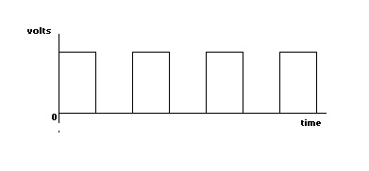
Figure 11

$Vavg=\frac{Voltage 1*T on+Voltage2*T off}{T on+T off}$…………… Equ. (3)

After many experiments we saw that the best way to run the motor is to
make it ran on a voltage equal 8V ,by using equation (3)

$Vavg=\frac{Voltage 1*T on+Voltage2*T off}{T on+T off}$

We can calculate a duty cycle by using equation (4) .

Duty cycle = $\frac{T on}{T on+T off}$ …………. Equ.(4)

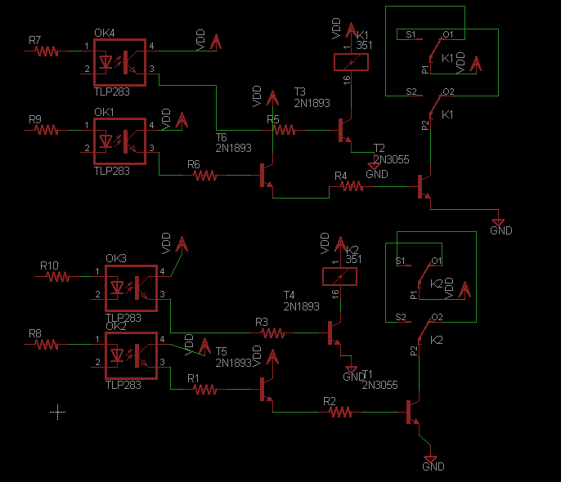
Figure 12

Conclusions and Recommendations

Conclusions
From our project we can conclude that we can use new technologies in many fields in new way, such using touch screen and using the new wireless communication technique in controlling robotic systems.
Also now we gain a lot of knowledge and experience also new skills in solving problems such as noise and other problems in designing robots.

Recommendations
For future work on this project we must have an ultrasonic sensors to detect the obstacles and walls and to improve the image processing algorithms and to improve the model of the robot because it’s the first time we create a robot we made it from wood to facilitates modification.

References
- http://www.sparkfun.com/products/8448

- http http://www.sparkfun.com/products/9224

- http://www.digi.com/pdf/ds_xbeemultipointmodules.pdf

- http://www.ccsinfo.com/forum/viewtopic.php?t=47663

- http://www.anddev.org/tcp_sockets-t276.html

