An-Najah National University
Faculty of Engineering and Information Technology
Energy Engineering and Environment Department
Measuring the Level of Awareness about Renewable Energy for Fourth Graders in Palestine
Prepared by:
Abeer Albada & Fuad Abu Mwais
Supervisor:
Dr. Tamer Khatib
This project is Submitted in Partial fulfillment of the Requirements for the Bachelor Degree on Energy Engineering and Environment, Faculty of Engineering and Information Technology, An-Najah National University, Nablus – Palestine.

December, 2016

Acknowledgment
This project was supported by the Ministry of Education and Higher Education, and we thank everyone who helped us from the ministry.
We would also like to thank the teachers in the schools of Talaa’ Al-Amal Privet School for Girls, Al-Shiekh Asad Sharf Public School for Girls, Al-Islamya Privet School for Boys, Ibn Qutayba Public School for Boys, Girls Camp No.1 UNRWA School for Girls and Boys Camp No.1 UNRWA School for boys for helping us deal with children, for helping us hand out the questionnaires and helping us collect them.
We also thank Dr. Alya Asali for sharing her experience in the field of questionnaires with us and guiding us though out the project.
And finally, we express our deepest gratitude to Prof. Tamer Khatib for supervising our work and guiding us, and being there for our help all the time.

Abbreviations
Table 1 Abbreviations
Abbreviation | Explanation
STS | Science-Technology-Society
SS&C | Scope, Sequence, and Coordination
NSES | National Science Education Standards
TIMSS | Trends in International Mathematics and Science Study
ACER | Australian Council for Educational Research
RE | Renewable Energy
SPSS | Statistical Package for the Social Sciences

Table of Contents
Acknowledgment i
Abbreviations ii
List of Tables iv
List of Appendix v
Abstract 1
Introduction 2
Chapter I: Renewable Energy 3
Chapter II: Importance of Evaluation of School Curriculums 5
Chapter III: TIMSS Evaluation Standards 7
Chapter IV: Importance of Increasing the Level of Awareness about RE 11
Objectives of the Study 12
Literature Review 13
Methodology 16
Evaluation of the General Science Curriculum of the Fourth Grade 16
Questionnaire Design 17
Data Collection 18
Data Analyzing 19
Results 21
Evaluation of the General Science Curriculum of the Fourth Grade 21
Analyzed Data 24
Conclusion 34
Recommendations 35
Bibliography 36
Appendix 38
Appendix A: Topics and Subtopics of Physical Science Field 38
Appendix B: Memorandum of Facilitating a Task 40
Appendix C: Questionnaire 41

List of Tables
Table 1 Abbreviations ii
Table 2 Fourth Grade Content Domains 9
Table 3 Fourth Grade Cognitive Domains 9
Table 4 How the Data being Analyzed Using the SPSS 20
Table 5 How Much the General Science Book for the 4th Grade in Palestine Contains the TIMSS Standards for Science Domain (Physical Science Field) according to the Researchers Analysis and the Frequency Distribution of each Subtopic 21
Table 6 Results of the Analyzed Data 25

List of Appendix

Appendix A 38
Appendix B 40
Appendix C 41

Abstract
This project studies the behavior of school children in Palestine towards renewable energy, and their knowledge of renewable energy sources and the difference between different school types and teaching systems on that. A questionnaire of 26 questions was designed after studying the curriculums being taught to those children, and it was given out to 300 children (150 boys and 150 girls) in 3 different types of schools (Private, Public and UNRWA) schools. The objective is to raise the awareness of those children towards the importance of renewable energy, and to check if the curriculums being taught to them satisfy this side. The results, which were obtained using the SPSS program, show a difference in the level of knowledge between children in different schools, and between children with different performances.

Introduction

The tremendous demand on fossil fuel to produce energy is one of the most trending public concerns nowadays, as this source of energy is nonrenewable, unsustainable and contributed in many environmental problems especially in global warming. Mention that the demand is increasing daily since the world is rapidly developing. Therefore, the renewable energy resources appear to be one of the most effective and efficient solutions to this tragedy that the world is facing. Renewable energy has a bright future since its resources have a great ability to provide a radical profit to our climate, health and economy, but this technology is not applied in a way to depend on as a source of energy especially here in Palestine, since most people don’t realize its importance and potential and also they only trust in the effectiveness of regular sources, this is due to the lack of awareness and cognition regarding to the matter. This awareness which arises by the general knowledge that is stemming from personal knowledge and from the education in the primary and secondary stages. The awareness about the environment and the renewable energy is a must and important especially in the 21th century which suffers from many serious environmental issues and point out that the resources of the unsustainable energy are depleting in one way or another. The low of awareness that the communities have, leads to a wide disapproval to any new technologies of energy. Therefore, the first step in spreading out and publicize this kind of technology is by introducing people to its importance, effectiveness and its capability, by increasing the level of awareness about the renewable energy in all society sectors especially in elementary school aged children, in order to have a more conscious society in the future.

Chapter I: Renewable Energy
Fossil fuels are the major source of energy to the world. Oil, coal and natural gas are nonrenewable energy resources, at some point they will dwindle; since they are finite resources, becoming too expensive and too environmentally damaging. Therefore, there should be an alternative source to depend on. Renewable energy (RE) with its different types is the key to this dilemma.
RE’s are sources of clean, inexhaustible and increasingly competitive energy, it’s extracted from easily-replenished sources like the sun, wind, water. Unlike fossil fuels, they are characterized by diversity, abundance and potential for use anywhere on the planet, they produce neither greenhouse gases – which cause climate change – nor polluting emissions and they are considered as a clean source of energy as it minimizes carbon pollution and has a much lower impact on our environment.
In order to secure the future to ourselves and generation to follow, it is a must to reduce the energy consumption and greenhouse gases, such as carbon dioxide. For that, RE is a critical part of reducing global carbon emissions and the pace of investment has greatly increased as the cost of technologies fall and efficiency continues to rise. As (Steiner, 2015) the executive director of the United Nation environment program has reported, “global investment in renewable energy increased for the first time in three years last year (2014) to $270bn, a 17 per cent rise from 2013”. Anyhow, the benefits in spreading out the use of RE is not restricted in reducing carbon emissions; there are many profits of this source of energy, it is essential for electrification of many rural areas in developing world, Long-term certainty; as the price of the fossil fuels and nuclear power is in a long term evolution, many policy measures and financial support have heavily encouraged renewables. Finally, Energy security; as it’s known the majority of oil & gas sources are concentrated in certain regions and as the demand on these two sources have increased, nowadays, it is getting technically challenging and more expensive to reach them, whereas the RE is a global source. It provides security of supply, helping a nation reduce its dependence on imported sources.

Chapter II: Importance of Evaluation of School Curriculums

In general, school mission is to educate, advocate, and raise awareness about many different important and contemporary subjects. And the best way to address the student’s mind is through the curriculum, which is the elixir of the entire educational process, without it we can't persuade any educational endeavors. It is the alphabet of the education pathway, since the main aims of the education process are reflected in the curriculum. Therefore, the Palestinian education system must be competitor to such a changing world.
According to the importance of educational curricula as one of the basic components of the educational process, it requires, as stated by (Abouel-Seoud, 2001) a continuing review of the education policy, its system and content, developing and evaluation, as the educational systems have become responsible for Inclusive development of the human and his future.
Many educational studies have unanimously agreed on the importance of the curriculum evaluation, and its relation with the educational process. Where the evaluation process, is necessary and important for all the various stages that the curriculum goes through from planning and preparation (Ahmed & Zaki, 1988).
The significance of the evaluation process lies in identifying the positive and the negative sides of the curriculum, its characteristics and features. Where the accomplishment and the success of the curriculum depends on this process and also on how much it has achieved from the established objectives. Therefore, the development process of the curriculum should be, in somehow, connected to the rapid changes and requirements of this century and also be affected by different variables from studies and researches (Allagany, 1989).
In agreement with (Salem, 1996) the general science curriculum of the 21th century is dynamic, rapidly changing and invests the possibilities of the science and technology and their use as a base of its content. It also aims to create a sophisticated civilian who optimizes the use of the science and has the ability to keep pace with development. Therefore, these curriculums should be subjected to experimentation, continuous assessment and adjustment in order to be in line with these rapid changes in this century.
The general science curriculums are the ones that need reviewing, modification and development continuously, as they mainly depend on the rapid and accelerated change in science and technology that led to a huge change in many different sectors of life, socially, culturally and economically. Due to its huge importance, many different countries around the world gave its attention and reform efforts in order to keep it in line with recent developments and new requirements. Mention that all these efforts were exerted to achieve the educational goals for each country individually and also to accomplish the main objective of the educational process, which is to create a scientifically cultured person in general.

Chapter III: TIMSS Evaluation Standards

At the mid-twentieth century, reform movements in science and scientific education have started, where their main target was and still to improve and develop science curriculum commensurate with the enormous science and technology progress.
There are many reform movements that make great efforts to broaden science, the main prominent six movements as reported by (Dinucci, 1997) are: Science-Technology-Society movement (STS), Science for All Americans (Project 2061), Scope, Sequence, and Coordination project (SS&C), the National Science Education Standards (NSES), National Education Goals: America 2000 and the Trends in International Mathematics and Science Study (TIMSS). These movements present a vision of a scientifically literate populace. They outline what students need to know, understand, and be able to be scientifically literate at different grade levels and also describe an educational system in which all students demonstrate high levels of performance.
Trends in International Mathematics and Science Study (TIMSS) has been conducted every four years since 1995, with the most recent assessment in 2015, it is an international assessments of student achievement dedicated to improving teaching and learning in mathematics and science. According to the Australian Council for Educational Research (ACER), TIMSS is a large-scale assessment designed to inform educational policy and practice by providing an international perspective on teaching and learning in mathematics and science. As reported by U.S. Department of Education, TIMSS focused on students at three stages of their education: midway through elementary school, midway through lower secondary school and at the end of upper secondary school (Committee on Science Education K-12 and Mathematical Sciences Education Board, 1999).
TIMSS project set a designed measures to interpret differences in national educational systems in order to help improve the teaching and learning in mathematics and science at middle primary and lower secondary levels, and collects background information on student, classroom and school contexts through questionnaires.
The great importance of TIMSS project is steamed from its ability to measure progress in the teaching and learning of mathematics and science compared with other countries at the same time, TIMSS provides comparative results of the position of a particular country students in comparison to other participating countries and ability to access to the most important and the best means to better education and through the comparison of results of tests in specific country with the results of other countries in the context of policies and educational systems in place that lead to high collection rates of the students. So these were the main reasons for choosing TIMSS standards.
As for the general science curriculum, TIMSS (Martin, Mullis, Foy, & Stanco, 2012) have conducted a scale for science assessment that basically based on two essential dimensions:
- A content dimension specifying the domains or subject matter to be assessed within science. Which subjected into three main domains: Life Science, Physical Science and Earth Science.; and
- A cognitive dimension specifying the domains or thinking processes expected of students as they engage with the science content. This domain is subjected into three main domains which are, Knowing, Applying and Reasoning.
Table 2 Fourth Grade Content Domains
45% Life Science
35% Physical Science
20% Earth Science

Table 3 Fourth Grade Cognitive Domains
40% Knowing
40% Applying
20% Reasoning

According to the TIMSS (Martin, Mullis, Foy, & Stanco, 2012) the topics that the physical science field should contain are; classification of the substance and its characteristics, energy sources and their effects, light, electricity and magnetism, force and motion.
The fundamental objectives of teaching the TIMSS is to develop critical thinking skills, develop deeper understanding for subjects and develop information literacy, since TIMSS depends on inquiry-based learning technique.
Perhaps the most distinguishing feature of the present era, is the growing awareness about the importance of the school book and curriculum as they are considered the base point of development and progress therefore many states started to adopt educational policies related to distinct philosophies inspired by their legislation and organizations based on the composition of the assets of the society and its nature (Tammous, 2002).
Textbook is the most important influence on what is learned at school (Chandler & Brosnan, 1995). According to our point of view, the school textbook is mainstay of the educational process, the curriculum implementation tool and it is a scientific framework which organizes, controls and defines the relationship between the teacher and the learner.
From this point on, the general science book is just like any other textbooks, it is the framework and the base point that contains scientific knowledge, natural and human phenomena, reading and learning and research and survey and analysis skills, mental skills and controversial contemporary issues (Jarolimek, 1977).

Chapter IV: Importance of Increasing the Level of Awareness about RE
In general, having an acceptable level of awareness about critical subjects nowadays, no matter what are, is a good indicator of how much a person is educated, knowledgeable, have concerns and sensitivities towards different issues.
As it is known, saving the environment, climate change and managing fossil fuel reserves from diminishing are, today, ones of the biggest challenges facing the planet. Therefore, to secure our future and the generations to follow, and In order to limit the negative effect of using the nonrenewable energy sources, it is a must to increase the citizen awareness about the importance of using RE to the environment, to our health and to the world in general, also to convince them of its capability and it’s a source of energy which can be depend on.
The society is divided into, based on the age, four categories which are child, teen, youth and adult. And this study focuses on the children sector to measure the level of their awareness about RE. Since educating the younger generation on renewable energies is incredibly important as it is going to play a vital role in our future and also to produce children who are familiar with the most trending issues that the planet is facing, where also they can be a part to improve and develop and not being a barrier.

Objectives of the Study

This study aims to evaluate a specific domain which is, renewable and nonrenewable resources, in the general science book of fourth grade, which the Ministry of Education and Higher Education in Palestine approved to be taught starting from school year 2015/2016. Since, the essential source of information and knowledge for the primary stage students is the school textbook. Then measuring the level of awareness of these students about renewable and nonrenewable resources. In order to suggest the best action to raise the level of awareness of the children. In order to draw their attention to this issue, the importance of RE, as it is appear, it has a significant role in improving public health and environmental quality.

Literature Review
Education in general has the main role in cultivating the awareness of RE, where it’s important for the students to become future responsible energy consumers. Therefore, several studies focusing on the relation of the awareness about RE of the students and the education have been conducted.
Starting by, (Gray & Zahedi, 1999) study, the authors of this paper state that the lack of public awareness about RE is one of the barriers hindering RE development in Australia. And in order to have a new energy mix such like, using roofs of the civilians’ houses and walls of their buildings for the purposes of electricity generation, can’t be completely established without the encouragement of members of the public. Therefore, a survey have been carried out to discover the public’s knowledge and opinion on renewable and non-renewable energies, then the results have been discussed and suggested ways which can be used to raise public awareness of the issue in Australia. The study showed out that 78% of people said they knew the meaning of the term “Fossil Fuel”, 16% heard about it but don’t know its meaning and 6% never heard of the term. Where, 58% of people said they knew the meaning of the term “RE”, 24% said they had heard of the term but did not know what it meant and 18% said they had never heard of the term. Overall, it was concluded that the participants appeared well educated to the secondary school level. This is evident by their awareness of the three major sources of renewable energy, all of which are documented in school curriculums. And there is Lack of formal post-secondary education about the topic is possibly evident by the low awareness of the term ‘Biomass’ where, 23% of the participants didn’t know what it means.
A research work was carried out in Akola district of Maharashtra state, India, for the assessment of awareness among the general public about renewable energy sources. The information gathered was analyzed for respondents’ attitudes towards issues such as, knowledge of renewable energy sources and power generation. According to the collected data, it was confirmed that the public understands mostly that renewable energy is the nonpolluting source and going for utilization of renewable energy is a very good idea. It was also clear that people knew about wind and atomic energy generation systems. As for the comparison of the energy generation from the renewable energy with that from fossil fuel public opinion was that renewable energy was much better (Khambalkar, Katkhede, Dahatonde, & Nage, 2010).
A study was conducted in Turkey, which aimed to determine energy saving behavior and energy awareness of secondary school students and the effects of socio-demographic characteristics (gender, residential area and grade level) on energy saving and energy awareness, it was observed that secondary school students had a high level of awareness about renewable energy sources and saving; however, they had a moderate level of interest in energy. Also It was found that energy saving and energy awareness of secondary school students varied according to grade levels sixth grade students had more awareness for energy saving than 7th and 8th grade students. Based on this view, it can be suggested that the secondary school learning process provides insufficient education for energy saving behavior (Aktamis, 2011).
A survey study was conducted in Jordan, it aimed to investigate the level of awareness and prevailing attitudes of school students toward renewable energy (RE) in a country which is heavily reliant on fossil fuels despite having high RE resources. It had been developed a suitable questionnaire. In total, 617 respondents from both rural and urban areas filled in the questionnaire. The results indicate that students have limited ability to distinguish renewable from non-renewable energy sources despite many respondents being aquatinted with the common RE sources like solar and wind. Furthermore, over 50% of students are unaware of biofuels such as biodiesel and bioethanol. Nevertheless, 87% of students consider RE to be a viable future energy option, and generally exhibit a positive attitude and willingness to adopt RE even at high prices. Overall, young females appear to be more acquainted with RE than young males. Likewise, students studying in urban areas are more aware of RE and more strongly support their adoption (Zyadin, Puhakka, Ahponen, Cronberg, & Paavo, 2011).

Methodology

Evaluation of the General Science Curriculum of the Fourth Grade
The study started by thoroughly analyzing the school curricula of the general science book of the fourth grade which the Ministry of Education and Higher Education in Palestine approved to be taught starting from school year 2016/2017 based on the TIMSS standards.
As this study concentrates on the RE, therefore, the evaluation focused on the physical science field to determine how much the general science book for the fourth grade in Palestine contains the TIMSS standards in science domain (physical science field).
Mention that the main topics that the physical science field should contain are; classification of the substance and its characteristics, energy sources and their effects, light, electricity and magnetism, force and motion. And the weight of the physical science domain that the general science should contain is 35% according to TIMSS standards (Martin, Mullis, Foy, & Stanco, 2012).
Then the main topics had been detailed for sub-topics (Appendix A), the researchers had counted how many times the subtopic have been repeated clearly in order to find the frequency distribution of each subtopic. Finally, the weight of the physical science field is the sum of all the individual frequencies then it had been compared with the adopted one.

Questionnaire Design
In order to develop a questionnaire that match the level of our audience, who are the primary students; a quick analyzing for the general science books from first grade to the fourth grade had been done, to extract suitable questions in relevance with the RE.
A questionnaire was established for this study with one type of questions, multiple choice questions. The questionnaire started with questions regarding gender, residence, type of school, grades, employment status for parents, educational attainment level of the mother/father and then followed by another eleven questions relevance with RE. The type of questions are where respondents have only three choices (Yes, no and don’t know) to answer the questions.
The draft copy of the questionnaire was sent to an expert in the field of education, then twenty students from the fourth grade from Nablus were randomly asked to fill in the questionnaire, and any accompanying notes from the students were taken into account. This pre-testing process detected unnecessary and unclear questions, and, as a result, the unnecessary questions were deleted and unclear ones rephrased (Appendix C).

Data Collection
In fall 2016, formal letters were sent to six schools (Appendix B) for both genders including the three types of schools (private, public and UNRWA) requesting permission to visit and disseminate the questionnaires. Before questionnaire dissemination, the researchers explained the questionnaire’s aims and questions to the students. Mention that the researchers attended the dissemination sessions in order to provide clarification and assist students as required. In total, 600 questionnaires responses were collected. Then, the data was analyzed using the SPSS program.

Data Analyzing
The analysis of the data collected from the results of the questionnaire was done using the SPSS program. First, the researchers entered the questions to the SPSS as numbers respectively (each question takes a number from 1 to 26 in this case), and then it has been verified how many choices of answers each question has, also as numbers, (for example, in the first question 1-1 means male studying in private school). The last question in the first page which is question number 8 in the program (Appendix C) was put in the program as 5 different questions (8a, 8b, 8c, 8d, 8f) as it could have multiple answers at the same time. And in the last page each picture was put as a question with a number and it could take 1 of 3 different answers (1 is renewable, 2 non-renewable and 3 is not knowing) and that’s how they became 26 questions in SPSS, as shown in figure 1.
The SPSS program then analyzes the data and gives detailed results about each question, and gives an indicator called Cronbach's Alpha, which indicates the reliability of the results. The Alpha indicator should be between 0.6 and 1 to consider the test reliable, and if it is lower than that the program will show the questions that lowered the reliability and recommends that those questions should be excluded from the questionnaire, which are usually the questions that are answered with the same answer the majority of times.
In SPSS it is recommended that each question should have a null choice of answer, and that is presented as the “don’t know” choice to each question.

Table 4 How the Data being Analyzed Using the SPSS
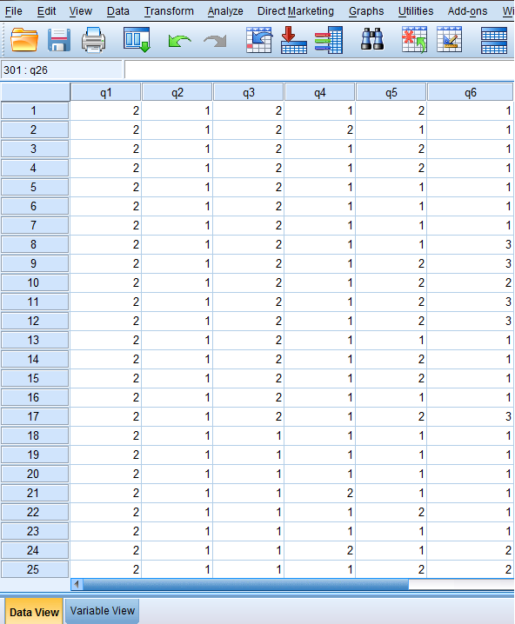

Results

Evaluation of the General Science Curriculum of the Fourth Grade
According to the TIMSS (Martin, Mullis, Foy, & Stanco, 2012), the main the topics that the physical science field should contain are; classification of the substance and its characteristics, energy sources and their effects, light, electricity and magnetism, force and motion.
The following Table 4 shows the frequency distribution of each main topic and subtopic in the science curriculum for the fourth grade. In total, it shows the percentage of the physical science field.
Table 5 How Much the General Science Book for the 4th Grade in Palestine Contains the TIMSS Standards for Science Domain (Physical Science Field) according to the Researchers Analysis and the Frequency Distribution of each Subtopic
TIMSS Standards |  | Frequency | Percentage%
 | Classification of the substance and its characteristics:
 | - Mention the states of matter and phase change. | - | 0%
 | - Recognize that the matter can change from phase to another by heating, cooling, evaporating and condensation. | - | 0%
 | - Explains the matter transformation using the terms of heating, evaporating, condensation, freezing and smelting. | - | 0%
 | - Classifying the matters according to their physical properties | - | 0%
 | - Identifying the properties of metals and their uses. | - | 0%
 | - Identifying the properties of the water and its uses in its three different phases ( solid, liquid and gas) | - | 0%
 | - Have the ability to distinguish between pure substances and mixtures. | - | 0%
 | - To demonstrate the physical separation techniques of mixtures into components. | - | 0%
 | - To recognize the physical and chemical changes that occurs to a substance. | - | 0%
 | Total | - | 0%
 | Energy Sources and their effects:
 | - Mention different energy sources. | - | 0%
 | - Demonstrate the practical uses of the energy. | - | 0%
 | - Recognize that the heat transfer from hot body to cold body. | - | 0%
 | - Compare between some substances according to its heat conductivity. | - | 0%
 | Total | - | 0%
 | Light:
 | - Recognize the familiar light sources ( candle, light bulb, sun) | 11 | 5.12%
 | - Concludes some of the light properties. | 14 | 6.51%
 | - Encages between the familiar physical phenomena and the light properties. ( Reflection, rainbow and shadow) | 19 | 8.82%
 | Total | 44 | 20.45%
 | Electricity and Magnetism:
 | - Explains the need for a complete electrical path to the simple electrical devices in order to operate. | 8 | 3.70%
 | - Classifying the substances according to their electrical conductivity and dielectric. | 6 | 2.70%
 | - Recognize that the magnetic has two poles, north and south poles. | 3 | 1.39%
 | - Concludes that the similar poles of the magnetic repel and different poles attract. | 5 | 2.30%
 | - Demonstrate the ability of the magnetic to attract materials and objects. | 3 | 1.39%
 | Total | 27 | 11.48%
 | Force and Motion:
 | - Recognize the forces that makes the body moves. (Gravity and push/pull) | - | 0%
 | - Compare between the large force and small force that makes the body moves. | - | 0%
 | - Explains that the reason of changing a place of a body is related to the applied force upon it. | - | 0%
 | - Mention the general types of forces. | - | 0%
 | Total | - | 0%
Overall total for the physical science domain |  | 71 | 31.93%

As it’s shown in Table 4, the light subtopic received 20.45% and electricity and magnetism received 11.48%. While the general science book of the fourth grade didn’t contain any of the other three subtopics (classification of the substance and its characteristics, energy sources and their effects and force and motion). Despite that the physical science domain received 31.93% of the assessment emphasis and it is close to the adopted ratio which is 35%, but as the evaluation results showed, the energy subtopic wasn’t mentioned at all, neither declared nor alluded. And this is a shortcomings in the general science book content. These results are consistent with (Al-Jahuri & Al-Khrusi, 2010) study.

Analyzed Data
The data was analyzed using the SPSS program, where 300 questionnaires were given out to 5th graders as follows:
  - 100 questionnaires were given out to private school kids (50 girls, 50 boys).
  - 100 questionnaires given out to public school kids (50 girls, 50 boys).
  - 100 questionnaires given out to UNRWA kids (50 girls, 50 boys).
The missing value in here indicates the option of not knowing the answer or not knowing what the question means, and this was explained to the kids.
Table 5, shows the results of the collected data, as the sample had been analyzed all at once without any specification or categorization since the difference in the answers based on gender or type of school was slight, therefore we had ignored it.

Table 6 Results of the Analyzed Data
Question | Results
Do you know how the electricity is produced? | Yes | 82.3% | 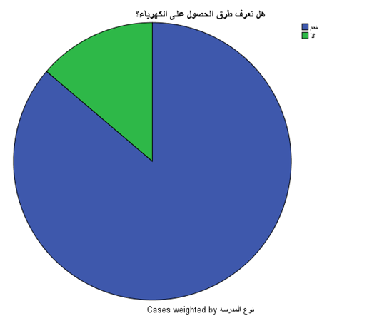
Do you know how the electricity is produced? | No | 13.2%
Do you know how the electricity is produced? | Missing Value | 4.5%
Can the sun /gas be used to produce electricity? | Yes | 67.8% | 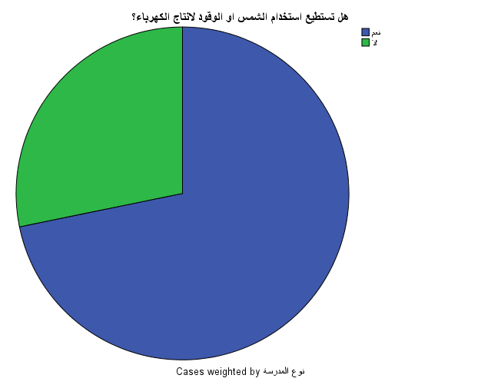
Can the sun /gas be used to produce electricity? | No | 26.7%
Can the sun /gas be used to produce electricity? | Missing Value | 5.5%

Is the best way to heat water is by using the sun? | Yes | 53.5% | 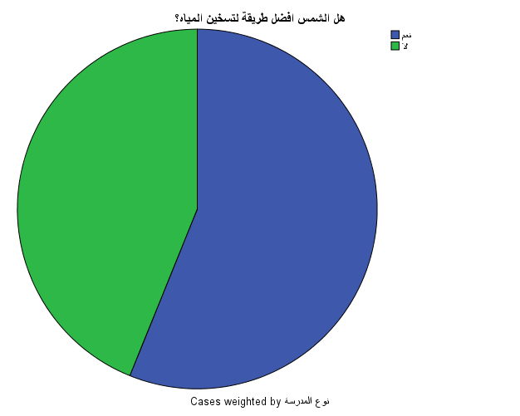
Is the best way to heat water is by using the sun? | No | 41.8%
Is the best way to heat water is by using the sun? | Missing Value | 4.7%
Is the best way to heat water is by using the gas? | Yes | 41.7% | 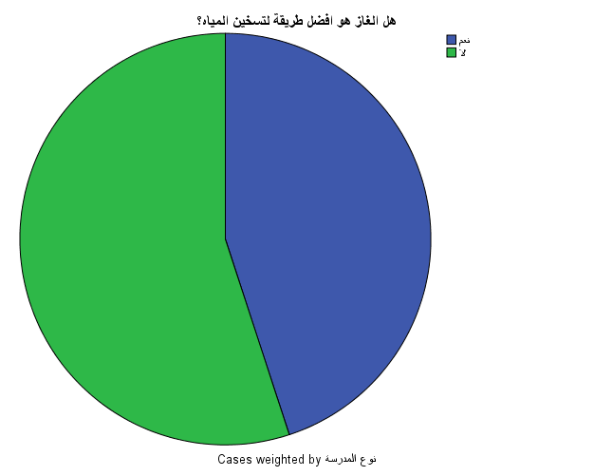
Is the best way to heat water is by using the gas? | No | 51.0%
Is the best way to heat water is by using the gas? | Missing Value | 7.3%

Do you know the differences between renewable and nonrenewable energy? | Yes | 53.0% | 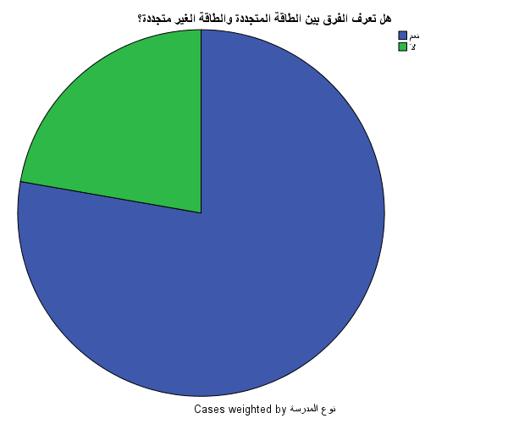
 | No | 15.2%
 | Missing Value | 31.8%
Can we use the wind to produce electricity? | Yes | 69.50% | 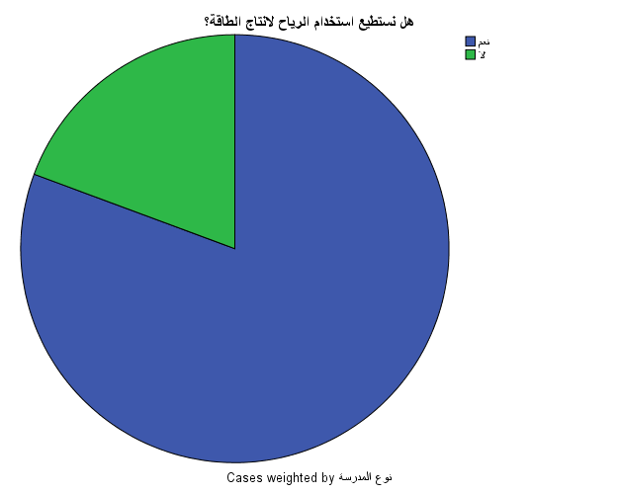
Can we use the wind to produce electricity? | No | 16.70%
Can we use the wind to produce electricity? | Missing Value | 13.80%

Do you know how the sun is used to produce electricity? | Yes | 66.8% | 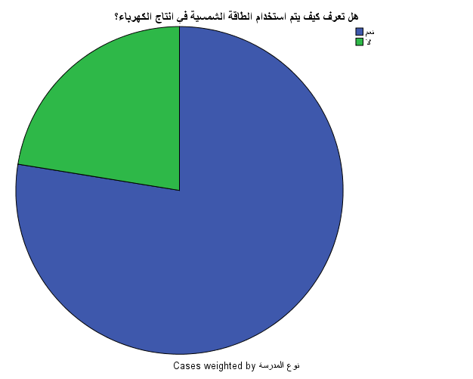
Do you know how the sun is used to produce electricity? | No | 19.3%
Do you know how the sun is used to produce electricity? | Missing Value | 13.8%
Do you know what the sources of energy are? | Yes | 83.20% | 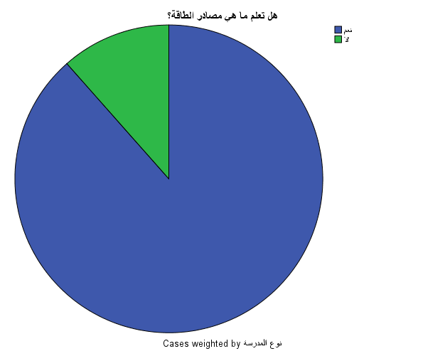
Do you know what the sources of energy are? | No | 10.80%
Do you know what the sources of energy are? | Missing Value | 6.0%

Is using the fossil fuels to produce electricity has a negative effect on the environment? | Yes | 68.3% | 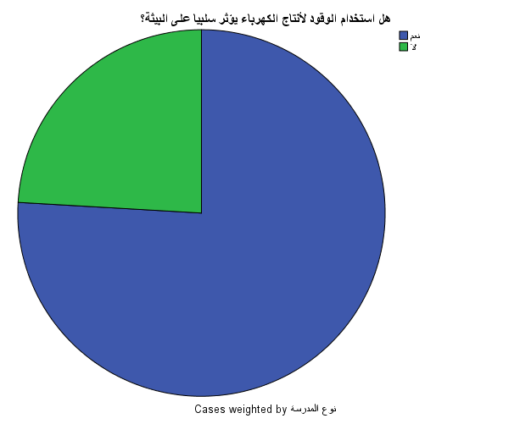
 | No | 21.7%
 | Missing Value | 10.0%
Do you know what the clean energy is? | Yes | 59.7% | 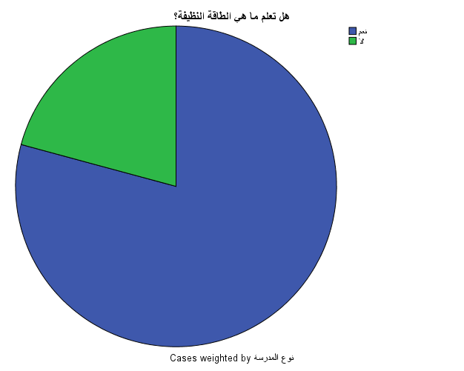
Do you know what the clean energy is? | No | 15.7%
Do you know what the clean energy is? | Missing Value | 24.7%

Is burning the wood considered as a renewable source of energy? | Yes | 75.30% | 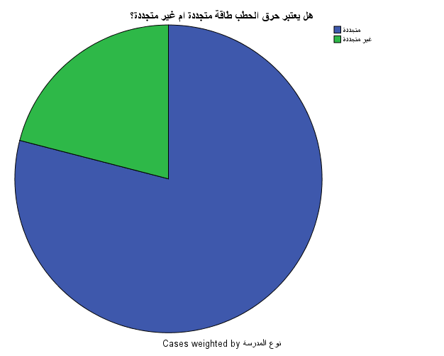
 | No | 20.00%
 | Missing Value | 4.70%
Is using the water to produce electricity considered as a renewable source of energy? | Yes | 65.20% | 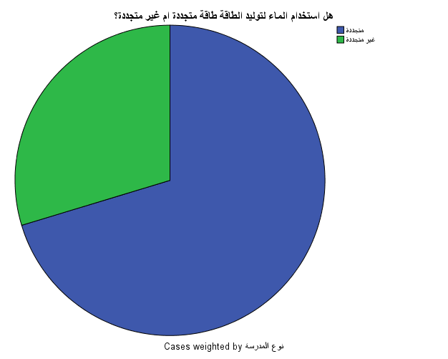
 | No | 75.50%
 | Missing Value | 7.30%

Is the gas considered as a renewable source of energy? | Yes | 47.00% | 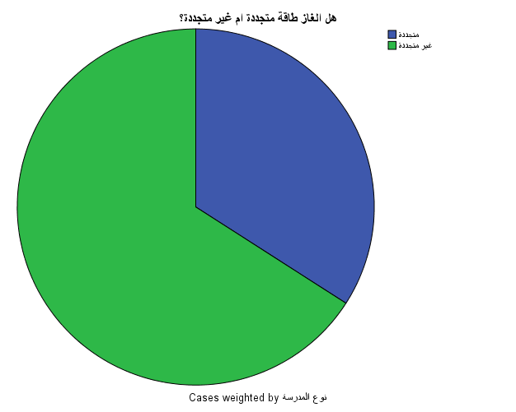
Is the gas considered as a renewable source of energy? | No | 38.50%
Is the gas considered as a renewable source of energy? | Missing Value | 11.50%
Is the electricity considered as a renewable source of energy? | Yes | 47.00% | 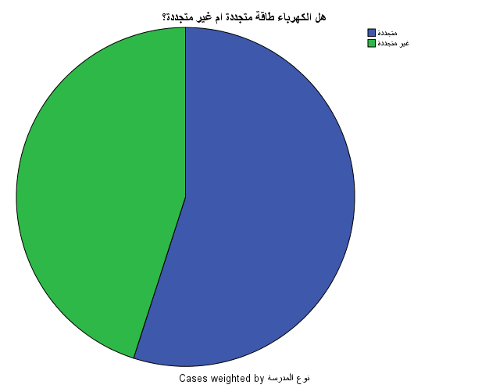
 | No | 38.50%
 | Missing Value | 14.50%

Is the sun considered as a renewable source of energy? | Yes | 81.20% | 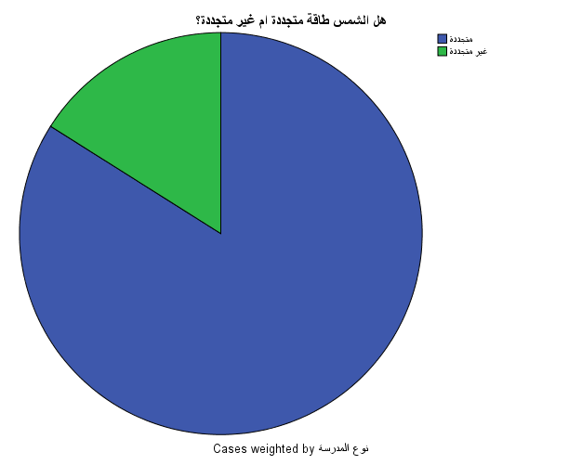
Is the sun considered as a renewable source of energy? | No | 15.50%
Is the sun considered as a renewable source of energy? | Missing Value | 3.30%
Is the wind considered as a renewable source of energy? | Yes | 78.30% | 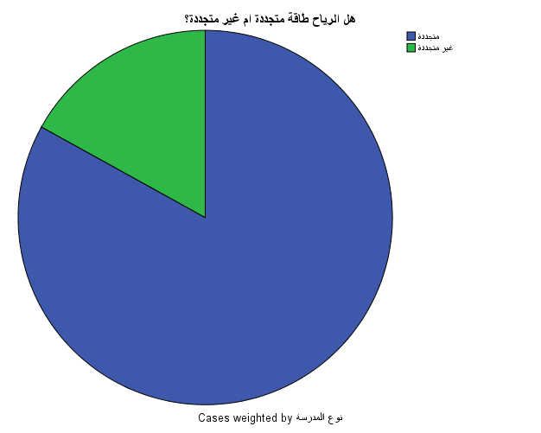
Is the wind considered as a renewable source of energy? | No | 16.00%
Is the wind considered as a renewable source of energy? | Missing Value | 5.70%

Is the coal considered as a renewable source of energy? | Yes | 78.30% | 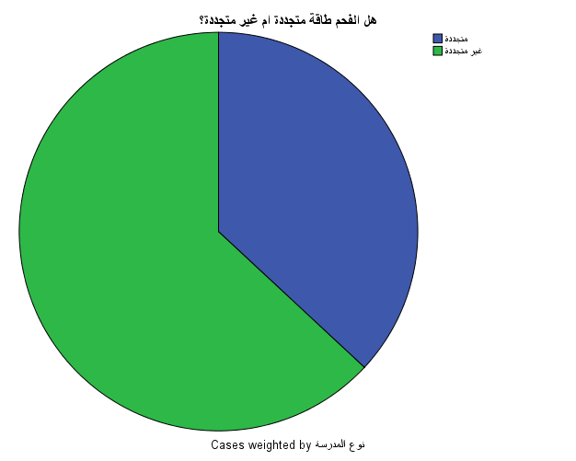
Is the coal considered as a renewable source of energy? | No | 16.00%
Is the coal considered as a renewable source of energy? | Missing Value | 5.70%
Is using the solar water heater considered as a way to use a renewable source of energy? | Yes | 76.50%
 | No | 19.00%
 | Missing Value | 4.30%

Conclusion
Based on the evaluation of the science curriculum, it is obvious that there is a massive lack in RE education. And as the evaluation results showed, the energy subtopic wasn’t mentioned at all, neither declared nor alluded. And this is a shortcomings in the general science book content. and this, in one way or another, has a huge effect on the students’ attitude towards the RE.
According to the results of the analyzed data, it is seen that the overall level of knowledge of 5th graders towards renewable energy is quite low. It is quite obvious in some of the result of the questions and the missing values of the questions which indicate that there are problems in understanding and being familiar with those terms used in the questions.
For the last page of the questionnaire, the results in identifying the shapes that are related to renewable energy like solar water heaters and the sun are relatively better than the results of identifying the shapes that indicate non-renewable energy, which indicates there is a lack of understanding of the concept of non-renewable energy.

Recommendations
- It is suggested to restudy and review the curriculums of the General Science book for children between 6 to 10 years old, and make sure that it has more information about renewable energy and the concepts of renewable and non-renewable energy.
- It is also recommended to make some field trips to renewable energy projects sites, to introduce the students to renewable energy in person.

Bibliography
Abouel-Seoud, M. (2001). Recent Trends in Elementary Science Curricula. The Future of Arabic Education Journal, 7, 220-254.
Ahmed, K. K., & Zaki, S. I. (1988). Teaching Science. Cairo: Dar Al Nahda Al Arabeya For Publishing.
Aktamis, H. (2011). Determining Energy Saving Behavior and Energy Awareness of Secondary School Students According to Socio-Demographic Characteristics. Academic Journals, 6(3), 243-250.
Al-Jahuri, N., & Al-Khrusi, H. (2010). Analysis the General Science Books for Eighth graders in Sultanate of Oman in view of TIMES Standards. The Fourteenth Scientific Conference: (Science Education Standers, the Idea and the Application). Sultanate of Oman.
Allagany, A. H. (1989). Curriculum Theory and Practice (3 ed.). Cairo: Alam Al Kotob.
Chandler, D. G., & Brosnan, P. A. (1995). A Comparison between Mathematics Textbook content and a Statewide Mathematics Proficiency Test. School Science and Mathematics. School Science and Mathematics Association, 95(3), 118-123.
Committee on Science Education K-12 and Mathematical Sciences Education Board, B. o. (1999). Global Perspectives for Local Action: Using TIMSS to Improve U.S. Mathematics and Science Education. Washington, D.C.: National Academies Press.
Dinucci, J. R. (1997). Science Reform Movements and their Effects on Teachers' Knowledge, Curriculum Development and Instruction. The Claremont Graduate University. United States: Database copyright ProQuest LLC. Retrieved from http://search.proquest.com/docview/304341306
Gray, R., & Zahedi, A. (1999). Renewable sources of energy and public awareness in Australia. Solar99 Opportunities in a Competitive Marketplace, 37th Annual Conf. of the Australian &amp; New Zealand Solar Energy Soc - Geelong Vic Australia, 59-59.
Jarolimek, J. (1977). Social Studies Competencies And Skills: Learning To Teach As An Intern. New York: Macmillan Publishers.
Khambalkar, V. P., Katkhede, S. S., Dahatonde, S., & Nage, N. D. (2010). Renewable Energy: An Assessment of Public Awareness. International Journal of Ambient Energy, 31, 133-142. doi:10.1080/01430750.2010.9675112
Martin, M. O., Mullis, I. V., Foy, P., & Stanco, a. G. (2012). Timss 2011 International Results in Science. Chestnut Hill, Massachusetts, USA: TIMSS & PIRLS International Study Center and International Association for the Evaluation of Educational Achievement (IEA). Retrieved October 24, 2016, from http://www.bc.edu/content/dam/files/research_sites/timssandpirls/timss2011/downloads/T11_IR_Science_FullBook.pdf
Salem, M. S. (1996). The Development of Science Curricula of Public Education in Arab Countries. Science Education, 1(2), 1-19.
Steiner, A. (2015, April 20). The world is finally producing renewable energy at an industrial scale. the guardian newspaper. Retrieved November 7, 2016, from www.theguardian.com
Tammous, R. D. (2002). The Evaluation of the Arabic Language Book for the sixth grade by the Arabic Language Teachers in Palestine and its relationship to their attitudes towards modernization.
Zyadin, A., Puhakka, A., Ahponen, P., Cronberg, T., & Paavo, P. (2011). School Students’ Knowledge, Perceptions, and Attitudes toward Renewable Energy. International Journal of Green Energy, 62, 341–348.

Appendix

Appendix A: Topics and Subtopics of Physical Science Field
TIMSS Standards |  | Frequency | Percentage%
 | Classification of the substance and its characteristics:
 | - Mention the states of matter and phase change.
 | - Recognize that the matter can change from phase to another by heating, cooling, evaporating and condensation.
 | - Explains the matter transformation using the terms of heating, evaporating, condensation, freezing and smelting.
 | - Classifying the matters according to their physical properties
 | - Identifying the properties of metals and their uses.
 | - Identifying the properties of the water and its uses in its three different phases ( solid, liquid and gas)
 | - Have the ability to distinguish between pure substances and mixtures.
 | - To demonstrate the physical separation techniques of mixtures into components.
 | - To recognize the physical and chemical changes that occurs to a substance.
 | Total
 | Energy Sources and their effects:
 | - Mention different energy sources.
 | - Demonstrate the practical uses of the energy.
 | - Recognize that the heat transfer from hot body to cold body.
 | - Compare between some substances according to its heat conductivity.
 | Total
 | Light:
 | - Recognize the familiar light sources ( candle, light bulb, sun)
 | - Concludes some of the light properties.
 | - Encages between the familiar physical phenomena and the light properties. ( Reflection, rainbow and shadow)
 | Total
 | Electricity and Magnetism:
 | - Explains the need for a complete electrical path to the simple electrical devices in order to operate.
 | - Classifying the substances according to their electrical conductivity and dielectric.
 | - Recognize that the magnetic has two poles, north and south poles.
 | - Concludes that the similar poles of the magnetic repel and different poles attract.
 | - Demonstrate the ability of the magnetic to attract materials and objects.
 | Total
 | Force and Motion:
 | - Recognize the forces that makes the body moves. (Gravity and push/pull)
 | - Compare between the large force and small force that makes the body moves.
 | - Explains that the reason of changing a place of a body is related to the applied force upon it.
 | - Mention the general types of forces.
 | Total
Overall total for the physical science domain

Appendix B: Memorandum of Facilitating a Task

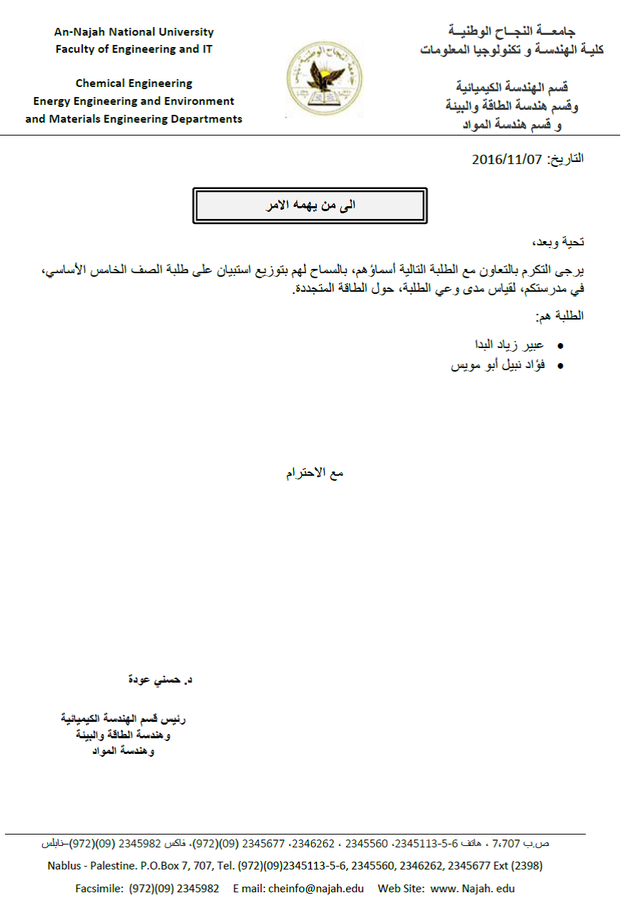

Appendix C: Questionnaire

إستبيان حول دراسة مستوى الوعي في الطاقة المتجددة
هذا الإستبيان يتضمن أسئلة متنوعة عن الطاقة المتجددة، لقياس مستوى الوعي لدى طلاب المدارس في الصف الرابع. جميع المعلومات التي سيتم الحصول عليها من هذا الإسبيان سيتم توظيفها لأغراض علمية فقط.
معلومات عامة عن الطالب/ة
النوع الاجتماعي |  | طالب
النوع الاجتماعي |  | طالبة
نوع المدرسة |  | خاصة
نوع المدرسة |  | حكومية
نوع المدرسة |  | أنوروا
مستوى التحصيل المدرسي |  | ممتاز (90-100)
مستوى التحصيل المدرسي |  | جيد جدا (80-89)
مستوى التحصيل المدرسي |  | جيد (70-79)
مستوى التحصيل المدرسي |  | مقبول (60-69)
مستوى التحصيل المدرسي |  | ضعيف (50-59)
مكان الأقامة |  | مدينة
مكان الأقامة |  | قرية
مكان الأقامة |  | مخيم
الحالة الوظيفية للأهل |  | كلاهما يعملان
الحالة الوظيفية للأهل |  | احدهما يعمل
الحالة الوظيفية للأهل |  | لا أحد منهما يعمل
مستوى التحصيل العلمي للأم |  | شهادة جامعية
مستوى التحصيل العلمي للأم |  | الثانوية العامة
مستوى التحصيل العلمي للأم |  | غير ذلك
مستوى التحصيل العلمي للأب |  | شهادة جامعية
مستوى التحصيل العلمي للأب |  | الثانوية العامة
مستوى التحصيل العلمي للأب |  | غير ذلك
كيف تقضي وقت الفراغ عادة خارج اطار ساعات الدراسة ؟ |  | اللعب في الخارج
كيف تقضي وقت الفراغ عادة خارج اطار ساعات الدراسة ؟ |  | قراءة
كيف تقضي وقت الفراغ عادة خارج اطار ساعات الدراسة ؟ |  | مشاهدة التلفاز
كيف تقضي وقت الفراغ عادة خارج اطار ساعات الدراسة ؟ |  | استخدام الحاسوب / الموبايل/ الانترنت/ال IPad
كيف تقضي وقت الفراغ عادة خارج اطار ساعات الدراسة ؟ |  | تعلم مهارات جديدة

هل تعرف/ي ماهي طرق الحصول على الكهرباء ؟ |  | نعم
هل تعرف/ي ماهي طرق الحصول على الكهرباء ؟ |  | لا
هل تعرف/ي ماهي طرق الحصول على الكهرباء ؟ |  | لا أعلم
هل نستطيع استخدام الشمس و الوقود كمصدر لانتاج الكهرباء ؟ |  | نعم
هل نستطيع استخدام الشمس و الوقود كمصدر لانتاج الكهرباء ؟ |  | لا
هل نستطيع استخدام الشمس و الوقود كمصدر لانتاج الكهرباء ؟ |  | لا أعلم
هل الشمس هي افضل طريقة لتسخين المياه ؟ |  | نعم
هل الشمس هي افضل طريقة لتسخين المياه ؟ |  | لا
هل الشمس هي افضل طريقة لتسخين المياه ؟ |  | لا أعلم
هل الغاز هو افضل طريقة لتسخين المياه ؟ |  | نعم
هل الغاز هو افضل طريقة لتسخين المياه ؟ |  | لا
هل الغاز هو افضل طريقة لتسخين المياه ؟ |  | لا اعلم
هل تعرف/ي ما الفرق بين الطاقة المتجددة و الطاقة الغير متجددة ؟ |  | نعم
 |  | لا
 |  | لا أعلم
هل نستطيع استخدام الرياح لانتاج الطاقة ؟ |  | نعم
هل نستطيع استخدام الرياح لانتاج الطاقة ؟ |  | لا
هل نستطيع استخدام الرياح لانتاج الطاقة ؟ |  | لا أعلم
هل تعرف/ي كيف يتم استخدام الطاقة الموجوة في الشمس لانتاج الكهرباء ؟ |  | نعم
 |  | لا
 |  | لا أعلم
هل تعلم/ي ما هي مصادر الطاقة ؟ |  | نعم
هل تعلم/ي ما هي مصادر الطاقة ؟ |  | لا
هل تعلم/ي ما هي مصادر الطاقة ؟ |  | لا أعلم
هل استخدام الوقود لإنتاج الكهرباء يؤثر سلبياً على البيئة ؟ |  | نعم
هل استخدام الوقود لإنتاج الكهرباء يؤثر سلبياً على البيئة ؟ |  | لا
هل استخدام الوقود لإنتاج الكهرباء يؤثر سلبياً على البيئة ؟ |  | لا أعلم
هل تعرف/ي ما هي الطاقة النظيفة ؟ |  | نعم
هل تعرف/ي ما هي الطاقة النظيفة ؟ |  | لا
هل تعرف/ي ما هي الطاقة النظيفة ؟ |  | لا أعلم

