Introduction :

What is our project?
Storing Robot is a moving arm robot attached to mobile base that is doing mainly the classification of objects based on a tag. Each object has a specific tag, and the robot included an RFID reader that reads it. Then the robot arm will move in certain moves to reach shelf where the object must be put.
We added some feeling – around IR range finder sensor that could know where the object is so it moves toward it. This added some dynamic moves to the robot.
We allow the robot to move in a pre-defined path that is already known to the robot.

Why we choose it?
This robot is a mixture of mechanical design, different types of motors (DC, Stepper and Servo – motors) with drivers circuits and sensors. So it is a combination of very good tools that we could learn in a graduation project, it entered us to robotics world ,obtained good strong background in design and study different motors .

Where can be used?
- This type of robots are used in Industrial application. Usually it used to move objects in production lines.
- It used also in big inventories to do classifications.
- If an extra bar-code reader is added we could use it to classify medicine in medical inventories on shelves.

Studying and Analyzing project with details:

We started the project with studying and analyzing these main points, and trying to answer many related questions:
- Project characteristics.
- Project Block Diagram.
- Project features.
- Project usage.
- Project future expansion.
- Project Technical Requirement (Software and Hardware).
- Mathematical Background.

Project Characteristics:
- It has an arm that moves.
- It must have some ability to do a reading for a tag.
- It might move from place to another (mobile robot).
- It might see the environment around it.

Block Diagram:

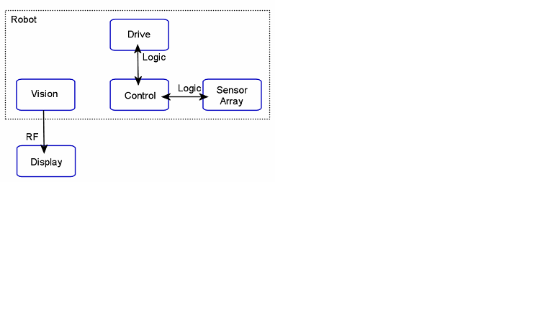
Figure1: Main Block Diagram
Reach shelves
Put in the right shelf
Reverse moving
Rotate the base motor
Moving robotic arm

Moving the robot body
Catch the object
Read tag
Decide the right shelf
Rotate the base motor

Figure2: Steps Block Diagram

Project Features:
Storing Robot brings a sophisticated Articulated Robotic Arm to facilitate the Industrial/Research installations with object manipulation capabilities. It is a robotic arm with moving plates that is used to classify and ordering objects according to the tags on each .
Based on modular design the complete arm can be used in flexible configurations. The project comes with its control unit , servo motors, stepper motor, moving DC base and control software which makes it a complete solution for any specific needs.
In general any robot arm has a specific general features that is known for, and for our project we could accomplish these features:

- Degree of Freedom:5
  - Number of actual total actuators in the project: DC motor for mobility, Stepper motor for base, two servo motors , middle joint servo motor and claw joint servo motor.
- Payload Capacity(Fully Extended) : 1 Kg
  - Maximum load can be hold.
- Maximum Reach(Fully Extended) : 450mm
- Envelope : Hemispherical
- Rated speed(Adjustable) : 0-0.3 m/s
- Joint speed(Adjustable) : 0-60 rpm
  - Operating Speed of the servo motor: 0.20sec/60degree (4.8V).
- Hardware interface : USB
- Control Software and Microcontroller: Arduino Microcontroller and Software.
- Shoulder Base Spin : 150°
  - Final angle of the servo motor rotation – 20% error
- Shoulder Pitch : 150°
- Elbow Pitch : 150°
- Wrist Roll Spin : 180°
- Wrist Pitch : 180°
- Gripper Opening(Max) : 65mm

Project Usage:
It has been used everywhere:
- In line of productions – factories.
- Large inventories – classify products.
- Medical Inventories.

Project Future Expansion:
This project could be improved in the future work by adding many hardware. We could add more dynamic moves through more feeling to the environment around using a camera and image processing.

Mathematical Background:
Arm calculation
The equations used in the calculator to determine the torque required at any given lifting joint (raising the arm vertically) in a robotic arm are presented here.
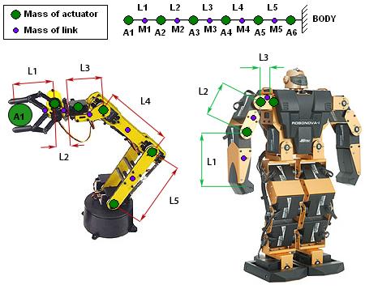
Figure3 : Arm Calculation (ref: www.robotshop.com)
As a result depended on figure 3 with the equations shown below ,we have:
A1=0.45 kg , A2=0.044 kg , A3=0 , A4=0 , A5= 0.044 kg
L1=10 cm , L2=0 , L3 = 0 , L4= 15cm , L5 = 20 cm
M1=1.25 kg/cm , M2=0 , M3 = 0 , M4 = 3.22 kg/cm , M5 = 6 kg/cm
And that result is suitable to servo motor that we had with torque = 5.2 – 6.5 kg/cm

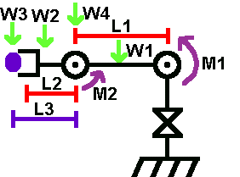
Figure4: Robot Calculation (ref: www.societyofrobots.com)

Torque About Joint 1:
M1 = L1/2 * W1 + L1 * W4 + (L1 + L2/2) * W2 + (L1 + L3) * W3--------------------------------(equation 1)
After different trials and calculations we got
M1 = 20/2 *0.5 + 20 * 0.044 + (20 + 15/2)*0.55 + (20+25)*0.45 = 6kg/cm
Torque About Joint 2:
M2 = L2/2 * W2 + L3 * W3--------------------------------------------------------------------------(equation 2)
After different trials and calculations we got
M2 = 15l2*0.55 + 25 * 0.45 = 3.22kg/cm

Choosing suitable wheels
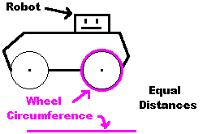
Figures5: Wheels Calculations (ref: www.societyofrobots.com )
Velocity= circumference * rpm --------------------------------------------------------------------------(equation 3)
Velocity = diameter * pi * rpm OR Velocity = 2 * radius * pi * rpm-----------------------------(equation 4)
For example, if the motor has a rotation speed (under load) of 100rpm (determined by looking up the motor part number online) and we want to travel at 3 feet per second, calculate:
3 ft/s = diameter * pi * 100rpm
3 ft/s = diameter * pi * 1.67rps (rotations per second)
diameter = 3 ft/s / (3.14 * 1.67 rps)
diameter = 0.57 ft, or 6.89"
We depended four wheels with 8 cm diameter for each .
Motor Torque and Force
High force is required to push other robots around, or to go up hills and rough terrain, or have high acceleration. As calculatable with statics, just by knowing your wheel diameter and motor torque, you can determine the force your robot is capable of.
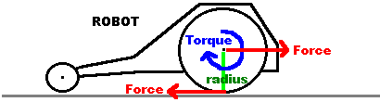
Figure6 : Force and Torque (ref: www.societyofrobots.com )

Torque = Distance * Force --------------------------------------------------------------------------------------(equation 5)
Distance = Wheel Radius ----------------------------------------------------------------------------------------(equation 6)
Force = Torque / Wheel Radius --------------------------------------------------------------------------------(equation 7)

Project Technical Requirement (Software and Hardware):
To satisfy the project characteristics we looked for the possible hardware / software that we might use to do the functionality with good quality and low cost.
Also we took into account:
- Scalability in future.
- Easy solution that use already existing technology.
- Low cost and good quality.
We depended the following hardware:
- ALUCOBOND Aluminum material for mechanical design
- ARDUINO microcontroller
- Four servo motor
- One stepper motor
- One DC motor with four wheels and gears
- power source(two +9 V battery and charger output +5v)
- RFID reader ID-2
- Three different tags
- Suitable Antenna
- ULN2003 driver IC
- H-bridge driver circuit
- IR sensor
- Builder suitable border
- Suitable shelves

Research and analysis:
Robots building started with design. So we looked for many simple similar designs and we draw a similar simple and good AutoCAD design as you see in appendix 1 .
Then we built the mechanical design from smooth gentle material (ALUCOBOND Aluminum).
We made a research about the actuators we may use to move the robot, we made tests and studies to the three main motors:
- Servo motors.
- Stepper motors.
- DC motors.
We wanted to have only one type of motors in robots to simplify the work and test but we discovered that this will not be easy to be accomplished due to many factors included:
- Precision of motors and relation with precision movement.
- Torque of model and the relation with motor torque.
- Easy to be controlled.
- Motors that could have easy feedback.
- Type of rotation needed.

Also we studied how we could do reading of tags, There are many types of coding to tags to identify objects:
- Bar code reader.
- RFID tags reader.

We used RFID Reader and RDIF tags for many reasons:
- New technology.
- Unique numbers for products.
- Now is being expanded in market products.
- Exist here and small enough to be used on the robotic arm.

How to make a good suitable arm for the robot:
- We build a simple mechanical design.
- We added 5 points of freedom to the arm.
- As precision is high needed we used to move the joints 4 servo motors.
- 2 servo motors used for the base where the highest torque and weight is needed.
- 1 servo motor on the middle joint.
- 1 servo motor on the claw joint.
- We made a simple claw that close and open to hold an object.

How to make the robot read the tag?
- We made many researches in the availability of the methods of coding tags.
- We studied about the Bar coding system.
- We studied about the RFID tags and using in manufacturing and production.
Why we choose the RFID tags? For many reasons:
- Availability.
- Future usage in industry.
- Easy to read and control .
- Suitable for our needed application.

Rotation of the base clock wise and counter clock wise:
How to make the robot has more freedom?
We added a clock wise , counter clock wise joint on the base. We used stepper motor to move the whole robot body clock wise and counter clock wise on the base.
Unipolar stepper motor with its ULN2003 driver.

Mobility:
How to make robot move from one place to another ?
We added a functionality of moving the robot in straight line using a dc motor and some wheels.
We hacked an RC 27MHz car, and we made use of the DC motor, the H-bridge , and the gears and wheels available. We design a base to put the whole robot body on the car.
We controlled the Car speed through the microcontroller. By calculating the motor speed, and the distance that the car need to move we got the time for the motor to work. We added the time as the time that the pulse of the DC motor need to remain high.
And we added a simple path that the car move through.

Instructions given to Robot (Microcontroller):
- We used the Microcontroller Arduino.
- We build it with the minimum enough resources.
  - It has high stability.
  - Easy to use.
  - Can be expanded with many shells.
  - Good software.

Design and Building the mechanical structure:

Degrees of Freedom (DOF):
The degrees of freedom, or DOF, is a very important term to understand. Each degree of freedom is a joint on the arm, a place where it can bend or rotate or translate. You can typically identify the number of degrees of freedom by the number of actuators on the robot arm.
Total degree of freedom in the arm is 5. Including the stepper motor and the DC motor in the car that is moving the robot body.
But for the arm:
- We added 3 points of freedom to the arm.
- As precision is high needed we used to move the joints with 4 servo motors.
  - 2 servo motors used for the base where the highest torque and weight is needed.
  - 1 servo motor on the middle joint.
  - 1 servo motor on the claw joint.
- We made a simple claw that close and open to hold an object.

Material used for building:
ALUCOBOND aluminum shows excellent product properties such as extraordinary flatness, a large variety of colors and perfect formability. It has been developed as a rigid and, at the same time, flexible fascia material for architecture.

AutoCAD design:

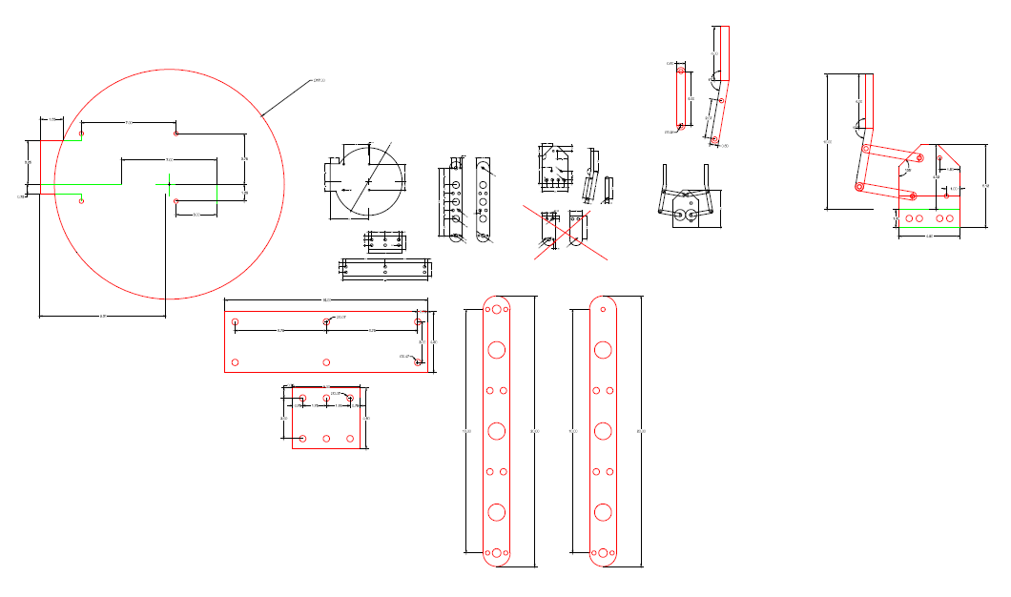
Figure7 : AutoCad Design

Final Mechanical Design:

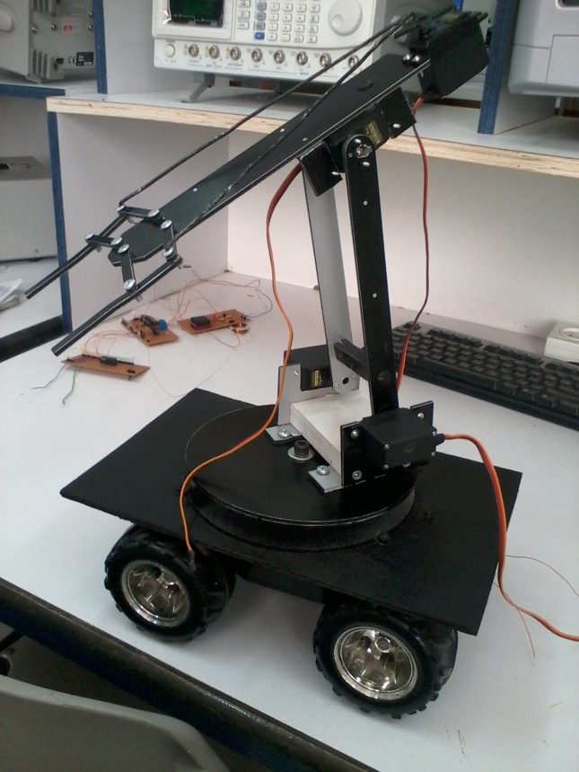
Figure8: Mechanical Design1

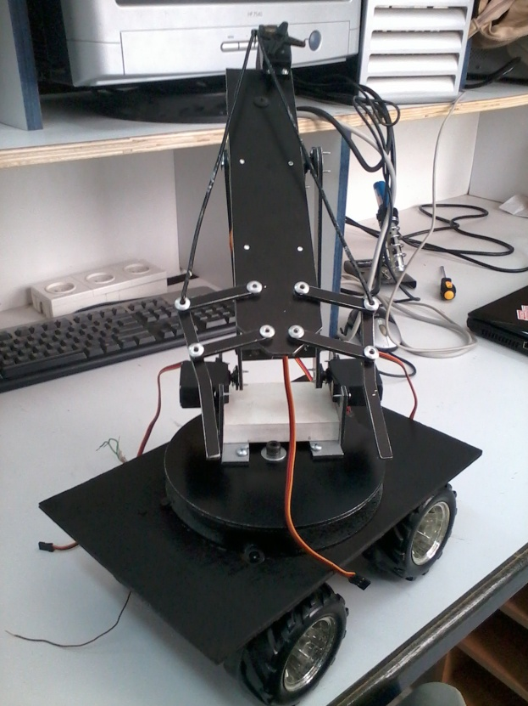
Figure9: Mechanical Design2

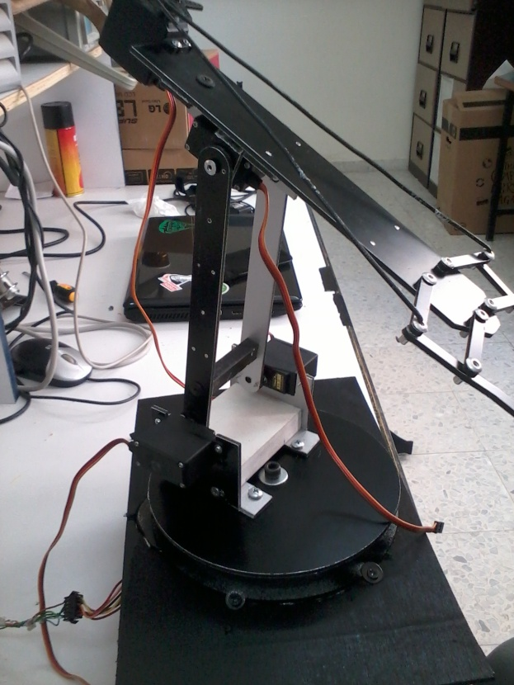
Figure10: Mechanical Design3

Microcontroller – Building and testing the Arduino Microcontroller:

Main Components:
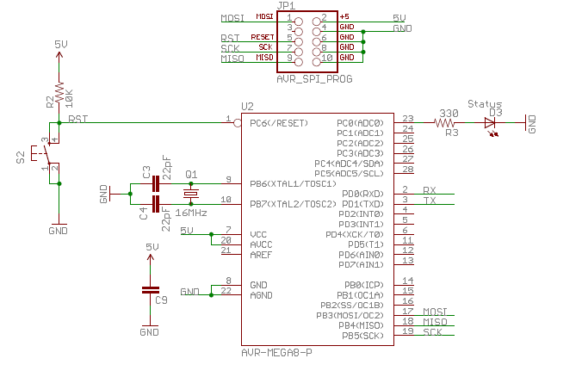
Figure11: MC Main components (ref: http://www.sparkfun.com/)

Real Design:

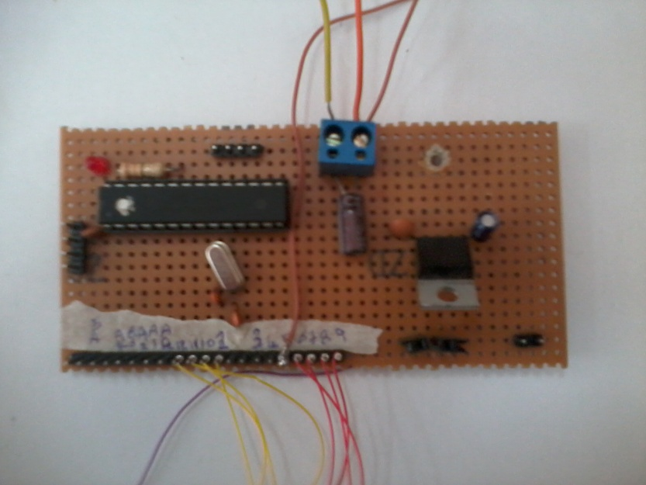
Figure12: MC Circuit

Pin Diagram for the ATMEGA168:
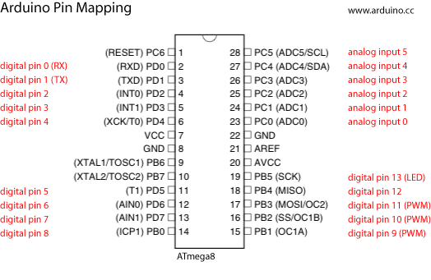
Figure13: MC Pin diagram (ref: http://www.sparkfun.com/)

We tested it by writing code for blinking:
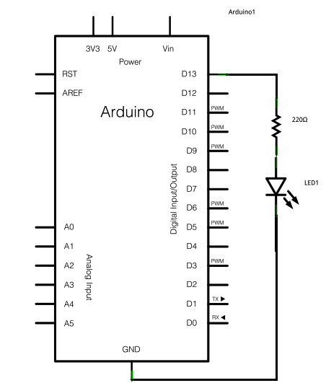
Figure14: Blinking Code (ref: www.arduino.com )
Code:
/*
Blink
Turns on an LED on for one second, then off for one second, repeatedly.
This example code is in the public domain.
*/
// Pin 13 has an LED connected on most Arduino boards.
// give it a name:
int led = 13;
// the setup routine runs once when you press reset:
void setup() {
// initialize the digital pin as an output.
pinMode(led, OUTPUT);
}
// the loop routine runs over and over again forever:
void loop() {
digitalWrite(led, HIGH); // turn the LED on (HIGH is the voltage level)
delay(1000); // wait for a second
digitalWrite(led, LOW); // turn the LED off by making the voltage LOW
delay(1000); // wait for a second
}

Testing and Controlling the Servo motors (for Arm joints):

Servo motors characteristics:
In general the Servo motors are better for the précised movements and rotations, since it has an internal feedback and it can be controlled using sending the exact angle we want to go to. We depended servo shown in figure 14 .
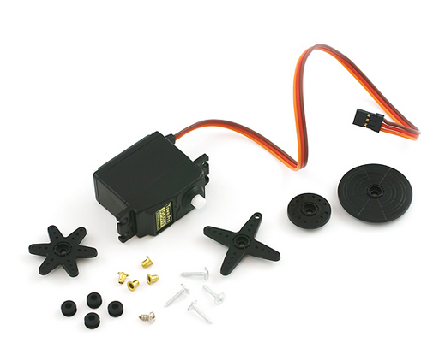
Figure15 : Servo Motor (ref: http://www.sparkfun.com/)
Servo being used is a large 180 rotation servo, it has the following features:
Weight: 41g
Features:
- 3 pole ferrite, all nylon gear
- Operating Voltage: 4.8V~6.0V
- Operating speed:
  - 0.20sec/60degree (4.8V)
  - 0.16sec/60degree (6.0V)
- Stall torque:
  - 5.2kg/cm (4.8V)
  - 6.5kg/cm (6.0V)
It can hold an object of weight maximum of 1.5 Kg.
Control chart of the Servo Motor:
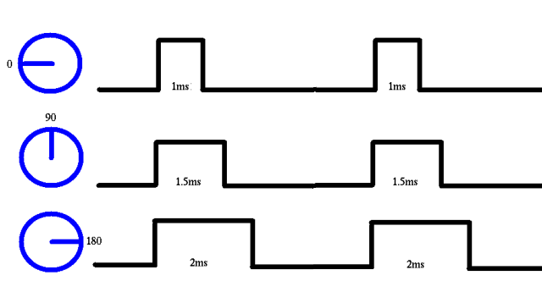
Figure2: Timing Pulses for Servo (ref: http://www.sparkfun.com/)

Interfacing with Microcontroller:
Interfacing the Servo motor with Arduino microcontroller is pretty easy. For coding controlling the servo a library called Servo Library in Arduino is used.
The Servo library supports up to 12 motors on most Arduino.
Main methods of library that is used in the code:

Syntax
servo.attach(pin)
servo.attach(pin, min, max)

Description
Attach the Servo variable to a pin.

Syntax
servo.write(angle)

Description
Writes a value to the servo, controlling the shaft accordingly. On a standard servo, this will set the angle of the shaft (in degrees), moving the shaft to that orientation.

Syntax
servo.read()

Description
Read the current angle of the servo (the value passed to the last call to write()).

Servo motors have three wires: power, ground, and signal. The power wire is typically red, and should be connected to the 5V pin on the Arduino board. The ground wire is typically black or brown and should be connected to a ground pin on the Arduino board. The signal pin is typically yellow, orange or white and should be connected to pin 9 on the Arduino board for testing.
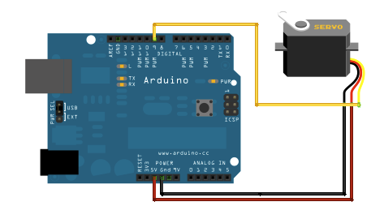
Figure17: MC and Servo (ref: www.arduino.com )
Schematic:
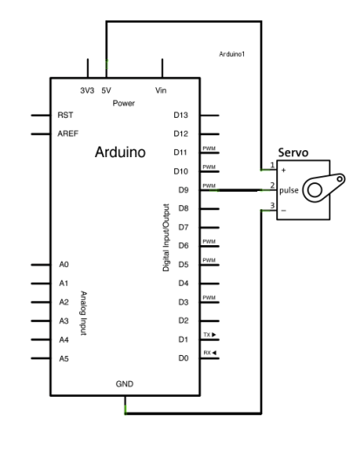
Figure18: Schematic Servo and MC (ref: www.arduino.com)
Code:
// Sweep
// by BARRAGAN <http://barraganstudio.com>
// This example code is in the public domain.
#include <Servo.h>
Servo myservo; // create servo object to control a servo
// a maximum of eight servo objects can be created
int pos = 0; // variable to store the servo position
void setup()
{
myservo.attach(9); // attaches the servo on pin 9 to the servo object
}
void loop()
{
for(pos = 0; pos < 180; pos += 1) // goes from 0 degrees to 180 degrees
{ // in steps of 1 degree
myservo.write(pos); // tell servo to go to position in variable 'pos'
delay(15); // waits 15ms for the servo to reach the position
}
for(pos = 180; pos>=1; pos-=1) // goes from 180 degrees to 0 degrees
{
myservo.write(pos); // tell servo to go to position in variable 'pos'
delay(15); // waits 15ms for the servo to reach the position
}
}

Control the 4 servos with pre-defined moves:
We wrote a code that send a sequence of angles to the four servos sequentially, so a series of movements will happen.
Example:
posc = claw.read();
//claw
for (posc; posc>=45; posc--){
claw.write(posc);
delay(20);
}
delay(2000);

Control the 4 servos from keyboard:
After that, we wrote a code for controlling angles of the servos from the keyboard using the serial cable. This helps us to determine the appropriate angles that the servo needs to rotate for each shelf.
We have three shelves, and the arm should be moved to different angles according to which shelf.
if(Serial.available()>0)
{
p = Serial.read();
if (p == 'A')
{
Serial.println("base motors increasing");
if (posr <= 170)
{
for (int i = 1; i<=5; i++){
posr = posr+1;
rightbase.write(posr);
leftbase.write(180 - posr);
delay(20);
}
Serial.println(posr);
} else {
Serial.println("do nothing");
}

Testing and Controlling Stepper Motor (for Base rotation):
A stepper motor is a permanent magnet or variable reluctance dc motor that has the following performance characteristics:
1. Rotation in both directions.
2. Precision angular incremental changes.
3. Repetition of accurate motion or velocity profiles.
4. Holding torque at zero speed.
5. Capability for digital control.
A unipolar stepper as in figure 17 is a motor that has one winding with center tap per phase. Each section of windings is switched on for each direction of magnetic field. Since in this arrangement a magnetic pole can be reversed without switching the direction of current.
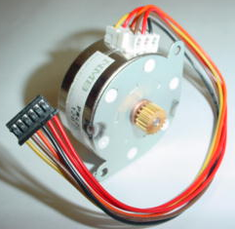
Figure19: Unipolar Stepper Motor (ref: http://music.columbia.edu )

Design Base to move Clock wise and Counter clock wise:
Mechanical Structure of the base circulating stepper:
We allowed the stepper motor to transform the motion to the main circle that rotate the base through a rubber tape that circulate.

Building driving circuit for steeper motor:
After reading about stepper motor, the one we used has 6 connectors of which two are power (VCC) and the other four are used to drive the motor sending synchronous signals.
We done test for it sequences .
Driving circuit used: ULN2003A, which has the following features:

FEATURES:
• 500-mA-Rated Collector Current (Single Output)
• High-Voltage Outputs: 50 V
• Output Clamp Diodes
• Inputs Compatible With Various Types of Logic
• Relay-Driver Applications

DESCRIPTION
The ULN2003A is high-voltage high-current Darlington transistor arrays. Each consists of seven NPN Darlington pairs that feature high-voltage outputs with common-cathode clamp diodes for switching inductive loads. It allows the connection of devices and components that need much higher current than the ones that the ATMEGA168 from our Arduino board can offer. Applications include relay drivers, hammer drivers, lamp drivers, display drivers (LED and gas discharge), line drivers, and logic buffers.

Testing the Stepper motor:
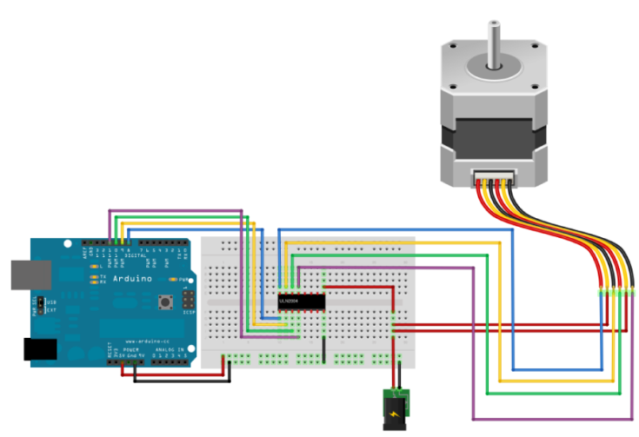
Figure20 : Stepper and MC (ref: www.arduino.com)
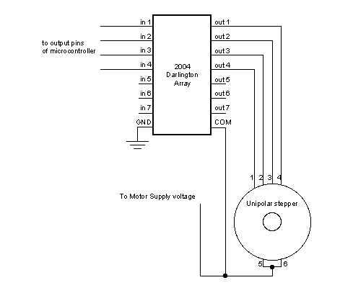
ULN2003
Figure21 : Schematic Stepper and MC (ref: www.arduino.com )

Real Circuit:
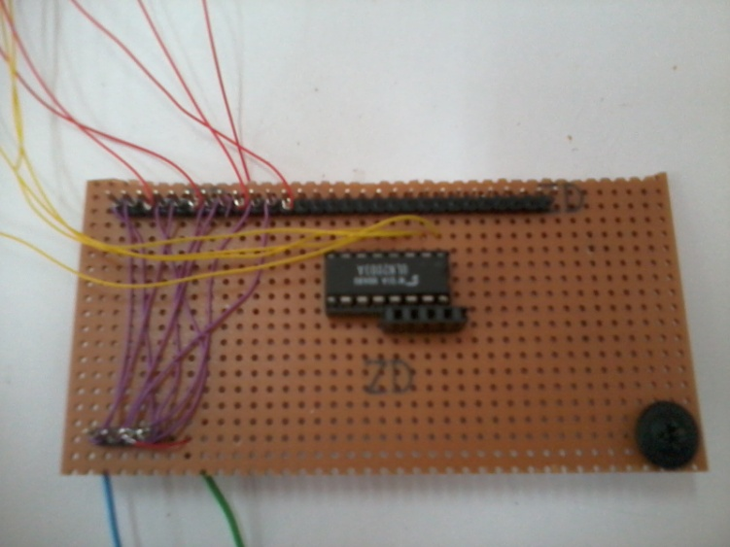
Figure22: ULN2003A Stepper Driver
Code:
The first example is the basic code to make the motor spin in one direction.
0011  0110  1100  1001 | Hi-Torque, Two-Phase | Hi Torque - This sequence energizes two adjacent phases, which offers an improved torque-speed product and greater holding torque.
while (1) {
digitalWrite(motorPin1, HIGH);
digitalWrite(motorPin2, HIGH);
digitalWrite(motorPin3, LOW);
digitalWrite(motorPin4, LOW);
delay(delayTime);

digitalWrite(motorPin1, LOW);
digitalWrite(motorPin2, HIGH);
digitalWrite(motorPin3, HIGH);
digitalWrite(motorPin4, LOW);
delay(delayTime);

digitalWrite(motorPin1, LOW);
digitalWrite(motorPin2, LOW);
digitalWrite(motorPin3, HIGH);
digitalWrite(motorPin4, HIGH);
delay(delayTime);

}

By inverting the sequence the motor will rotate in the reverse direction.

Building circuit for RFID reader ID-2 (125 kHz):

RFID Concept and Characteristics:
We depend here on RFID reader ID -2 sensor as a sensor that will read the tags and controlling the motors according to that reading .
The ID-2 is a smaller module requiring an external antenna. We hooked up an antenna, power the module, hold up a card, and we got a serial string output containing the unique ID of the card.
Features:
- 5V supply
- 125kHz read frequency
- EM4001 64-bit RFID tag compatible
- 9600bps TTL and RS232 output
- Magnetic stripe emulation output
Dimensions: 19x21mm
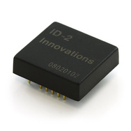
Figure23: RFID REader ID-2(ref: http://www.sparkfun.com/)
Figure24: Pin Diagram (ref: http://www.sparkfun.com/)
Figures25: RFID Parameters (ref: http://www.sparkfun.com/)

Figure26: Circuit Diagram for RFID reader ( ref: http://www.sparkfun.com/)

Real Circuit:
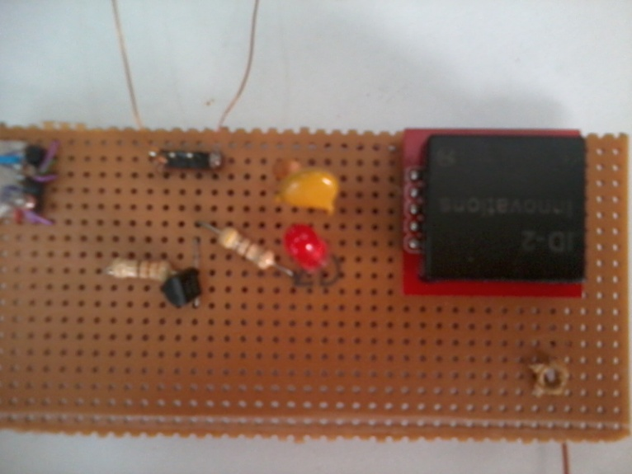
Figure27: RFID Built Crcuit (ref: http://www.sparkfun.com/)

Choosing the right Antenna for ID-2:
The RFID reader antenna transmits a wave that has both electrical and magnetic properties and is known as an electromagnetic wave.
Designing Coils Antennas for ID2:
The recommended Inductance is 1.08mH to be used with an internal tuning capacitor of 1n5. In general the bigger the antenna the better, provided the reader is generating enough field strength to excite the tag. The ID-2 is relatively low power so a maximum coil size of 15x15cm is recommended if it is intended to read ISO cards. If the reader is intended to read glass tags the maximum coil size should be smaller, say 10x10cm.
It was found that 63 turns on a 120mm diameter former gave an inductance of 1.08mH.
A tuning capacitor is added, It is recommended that the internal 1n5 capacitor is used for tuning, however a capacitor may be also be added externally if an external antenna of less than 1.08mH is used. The combined capacitance should not exceed 2n7.
Types of tested Antenna:
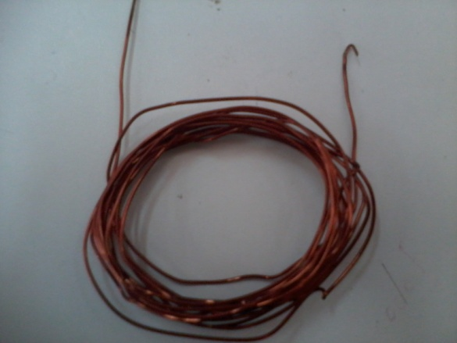
Figure28: Antenna with Thick wires
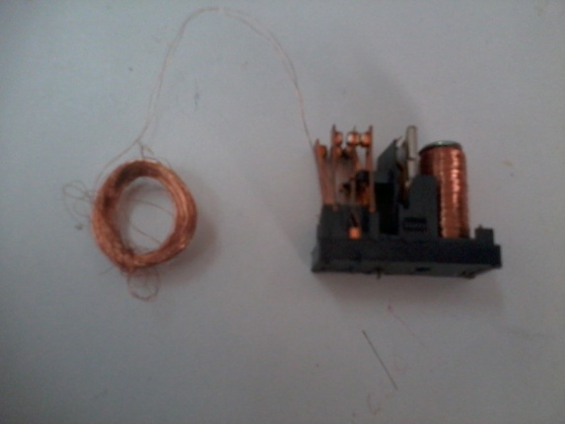
Figure29: Antenna from thin wires
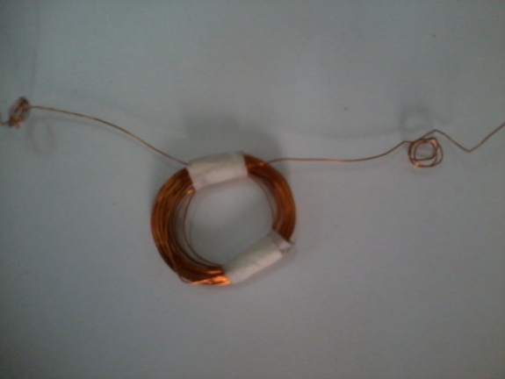
Figure30: Suitable Antenna diameter that works well

Types of Tags used:
Card tags each has a unique number.

Figures31: Cards Tags

Reading RFID tags from MC:
A test has been made to try reading the RFID tags from the MC. We connect the transmitter pin from the RFID with virtual receiver pin in MC. We made a pin to be virtual receiver using the SoftwareSerial Library in Arduino. This library made any two pins to act like a serial transmitter and receiver.
Tag number Data format:
Output Data Structure - ASCII - 9600 Baud, No Parity, 1 stop bit.
STX (02h) | DATA (10 ASCII) | CHECK SUM (2 ASCII) | CR | LF | ETX (03h)
The 1byte (2 ASCII characters).
Check sum is the “Exclusive OR” of the 5 hex bytes (10 ASCII) Data characters.
Code:
if(mySerial.available() > 0) {
if((val = mySerial.read()) == 2) { // check for header
bytesread = 0;
while (bytesread < 12) { // read 10 digit code + 2 digit checksum
if( mySerial.available() > 0) {
val = mySerial.read();
if((val == 0x0D)||(val == 0x0A)||(val == 0x03)||(val == 0x02)) { // if header or stop bytes before the 10 digit reading
break; // stop reading
}
// Do Ascii/Hex conversion:
if ((val >= '0') && (val <= '9')) {
val = val - '0';
} else if ((val >= 'A') && (val <= 'F')) {
val = 10 + val - 'A';
}
// Every two hex-digits, add byte to code:
if (bytesread & 1 == 1) {
// make some space for this hex-digit by
// shifting the previous hex-digit with 4 bits to the left:
code[bytesread >> 1] = (val | (tempbyte << 4));
if (bytesread >> 1 != 5) { // If we're at the checksum byte,
checksum ^= code[bytesread >> 1]; // Calculate the checksum... (XOR)
};
} else {
tempbyte = val; // Store the first hex digit first...
};
bytesread++; // ready to read next digit
}
}
// Output to mySerial:
if (bytesread == 12) { // if 12 digit read is complete
mySerial.print("5-byte code: ");
for (i=0; i<5; i++) {
if (code[i] < 16) mySerial.print("0");
mySerial.print(code[i], HEX);
mySerial.print(" ");
}
mySerial.println();
mySerial.print("Checksum: ");
mySerial.print(code[5], HEX);
mySerial.println(code[5] == checksum ? " -- passed." : " -- error.");
mySerial.println();
}
bytesread = 0;
}
}

First Integration of the Project:

In this step, we connect together the circuits of servo motors, stepper motor and RFID -2 circuit , we faced problem of controlling these parameter.
The problem was: the servo and stepper is working well, but the RFID-2 do not read tags. We discovered after a while that there was problem in the delay time which is needed for RFID-2 to finish reading the tag. So time is not enough for the data to be available on the serial buffer. Also the Antenna of the RFID-2 which read tags of the cards must be perpendicular on the tags so it can read the tags correctly.
We solved that problem by increase the value time delay with many tests till we reach to the value suitable for the buffer and serial to read and get the action after reading to move to the exact position.
Code:
void takeObject(){
rightbase.attach(9);
leftbase.attach(8);
middle.attach(7);
claw.attach(6);
//middle
for (posm; posm<=85; posm++){
middle.write(posm);
delay(20);
}
delay(2000);
for (posr; posr>=120; posr--){
rightbase.write(posr);
leftbase.write(180 - posr);
delay(20);

}
delay(2000);
for (posm; posm<=135; posm++){
middle.write(posm);
delay(20);
}
delay(2000);
for (posr; posr>=65; posr--){
rightbase.write(posr);
leftbase.write(180 - posr);
delay(20);
}
delay(2000);
delay(2000);//enough delay time
delay(8000);//enough delay time
read_tag();
delay(2000);
if (code[3] == 0x03) {
Serial.println("tag1");
delay (2000);
}
if (code[3] == 0x06) {
Serial.println("tag2");
delay(2000);
}
for (posc; posc<=110; posc++){
claw.write(posc);
delay(20);
}
delay(2000);
}

Mobility- Building the moving base with it wheels and motors:
Instead of building new mechanical design for the car, we hacked a 27KHz RC car.
We brought an already built moved RC car and disconnected the receiver in it to disconnect control from remote control circuit. Then we connected it directly to the microcontroller so it is now can be controlled from a microcontroller.
The circuit of the car shown below:
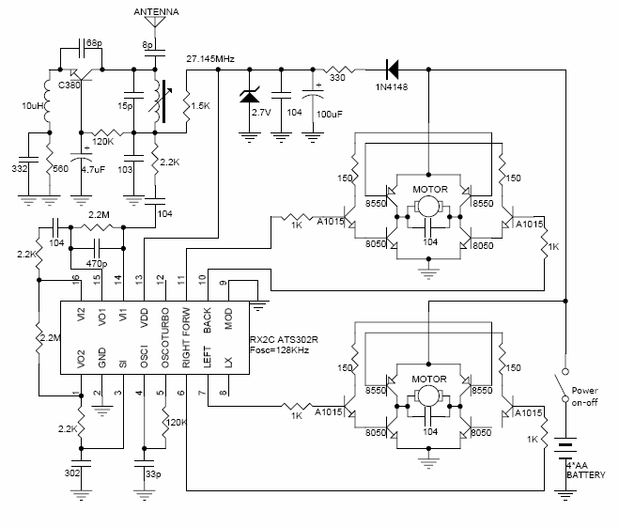
Figure32: RC Car circuit (ref: www.instructable.com)
The motor inside it is DC motr as in figure 31 below:
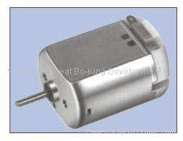
Figure33: DC motor (ref: www.instructable.com)

Building the driving circuit and writing the code for the car:
In the moving plate the driving circuit is as following and the motor is a DC motor. It is almost any toy RC car might be using the above or almost similar architecture. All these cars have 2 H-Bridges on a small board mounted inside. Almost all the cars these days use a variation on the RX2C toy car chip (i.e. pins 6,7,10,11 are the drivers for H-Bridge) and these boards can accept logic voltage levels regardless of the battery voltages.
Also figuring out the H-Bridge inputs are easy - and usually are the pins connected to 2.2k resistor or 1K resistor.
The steps involved in making this work:
1) We removed the RC chip.
2) We soldered 4 wires to the H-Bridge Terminals.
3) We soldered a wire to the negative terminal of battery - to power the Arduino.
4) We soldered a wire to the positive side of the switch - to power the Arduino.
RX2C chip configuration as follows:
- Wide and low operating voltage range
- 5- function remote controller controlling forward /backward /turbo / right / left
- Provide two transmissive interface (RF and IR) for different application
- Few external components needed and oscillator with an external resistor and a capacitance
- Low stand by current and low operating current
- Auto power –OFF function for TX2C ATS302T
- Internal , selectable DC_DC converter which need few external components
- RX2C ATS302T has very strong driving ability about five function - output
- Typical oscillator frequency:
RF: 128 KHz
IR : 114 KHz (carrier frequency :57 KHz)
IR : 76 KHz ( Carrier frequency : 38 KHz)

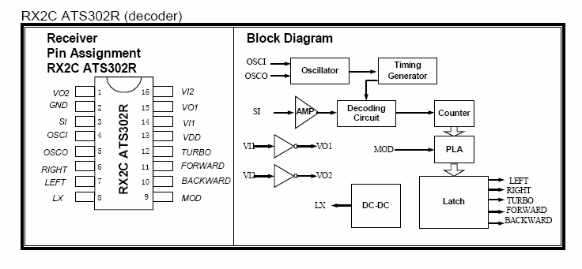
From microcontroller
microcontroller

Figure34: Pin Diagram for RC chip (ref: www.instructable.com)

Real Circuit as follow:
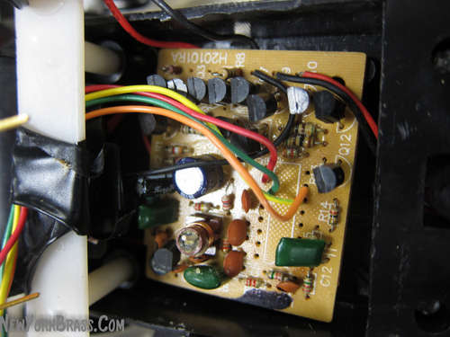
Figure35: HBridge and DC mtor circuit (ref: www.instructable.com)

Code:
We tested the motor by sending pulses HIGH and LOW:
void go_dc(){
digitalWrite(A3, HIGH);
delay(1200); //according to distance the car must move and the motor speed we calculated time needed for the car to reach shelf.
digitalWrite(A3, LOW);
delay(5000);
}
void rev_DC(){
digitalWrite(A1, HIGH);
delay(700);
digitalWrite(A1, LOW);
delay(5000);
}
We tried different value for time delay in both pulse HIGH and LOW depended on the speed of the motors , total torque it hold, frictions and the total distance it passed , we depended (1500) in forward and (700) for reverse motion.

IR Range Finder Circuit to Detect Object:
IR Range Finder sensor is used in our project to allow more dynamic feeling of the robot with the environment.
It can detect ranges between 15cm 2.4 V and 150cm 0.4V. We used the output voltage to determine if an object is exist in the range of the robot.
We used comparison to see, if object is in the range, we do some modifications on the robot movements, so we move the stepper and servos motor according to new position.
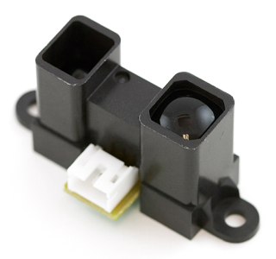
Figure36: IR Range Finder (ref: www.SparkFun.com)

Code to compare the output:
val = analogRead(analogPin); // read the output pin of the IR range finder sensor
Serial.println(val); // debug value
if( val > 300 && val < 500){
Serial.println("take object"); // compare if the object is in the range or not
}
else {
Serial.println("no object");
}
delay(5000);

Finalizing and Testing the total project:
In this step after connecting all circuits together we reused the keyboard code to re-adjusted the exact position of each servo motor of the robotic arm and stepper motor we have to calculate the correct angles for each shelf.
After we got exact position we enter them to the final code according to the dimension of the shelf we have.
We tested the car moving forward and backward while get and put the objects on shelves with needed exact time delay depend on PWM.
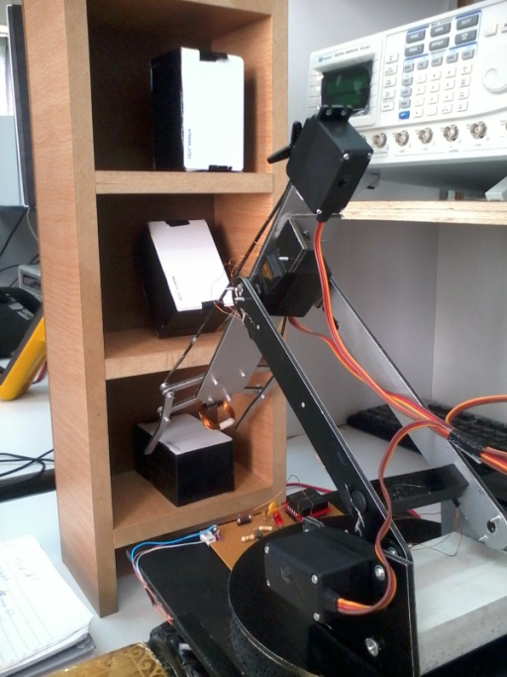
Figure37: Robot is putting the object on shelf
The final Robot:
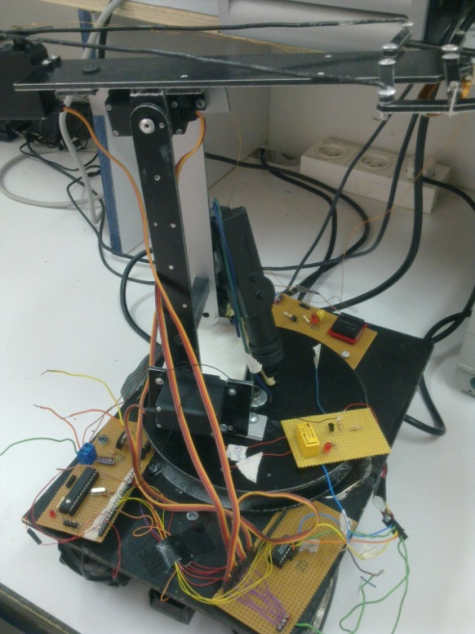
Figure38: Final Design

Shelves and Car Path:
We made a simulation for the shelves we will use to put objects on and a path that the car will use to move within it.
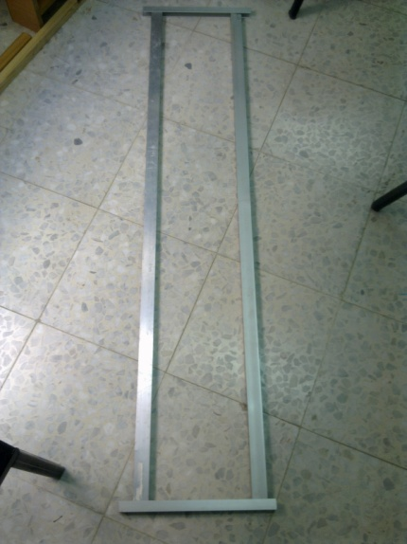
Figure39: Car Path

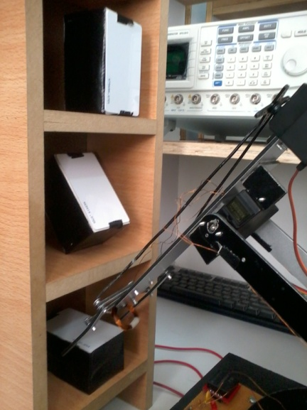
Figure40 : Shelves and Robot

Powering the Robot:

Power Supply

This is used to power the whole system i.e. the Control Unit, RFID Sensing Unit ,IR range finder sensor , the Servo Motors ,the Stepper Motors and DC moving plate .
We isolated the actuators from the control units. So we used for the RFID-Sensor, the MC and any other sensors +5Volt , we built voltage regulator with +9 V to step down to +5 V and used it.

Around other battery +9V with 1A current which is required to power the stepper motor , the +5V with 3A current to power the 4 servos together, since they are not working all in the same time we used here charger with fix +5v to power four servo motors.

An independent recharging battery of about +7V is powered the DC motors in the moving car plate.
For powering the Control Unit and the RFID Sensing Unit, we built a power circuit that has an input dependant fixed battery of +9V and has an output of fixed regulated +5V to power both two circuits.

Conclusion

In that project we have interfaced the robot that has different types of motors with Arduino microcontroller and other different sensor to achieve it function in correct form.

From our work, we deduced that our STORING ROBOT can be much intelligent and are therefore able to classify objects and rearrange stores alone in correct functional way. They can be very precise in their movements, reduce costs for more workers , improve working conditions, reduce material wastage and improve function quality in stores and factories.

This is why they’re very important in industries , big stores and factories because the overall objective of industrial engineering is productivity and functionality and our STORING ROBOT achieve it.

Meanwhile, intelligent Control for motors and sensors with Intelligent Microcontroller (Arduino)to
perform tasks with minimum supervision and interaction with a human operator.

This project can be further enhanced with image processing involving electrical and computer engineers to work together to create more complex, intelligent robots .

Cost
Table 1 lists the cost of the parts we used for our project.

Part | Unit Cost (NIS) | Number Used | Total Cost  (NIS)
Arduino Microcontroller | 100 | 1 | 100
USB to serial connection | 50 | 1 | 50
Mechanical design | 150 | 1 | 150
Servo motor | 80 | 5 | 400
Stepper motor | 40 | 1 | 40
DC motor &moving car | 100 | 1 | 100
RFID -2 reader | 150 | 1 | 150
Tags | 30 | 3 | 90
Charger and socket | 50 | 1 | 50
battaries | 10 | 5 | 50
IR range detector | 30 | 1 | 30
Drivers and other electronics | 70 | 1 | 70
Shelves & car path | 50 | 1 | 50
boards | Depend on the length |  | 20
Total Parts Cost | 1350 NIS
Table (1)

References:

- www.societyofrobots.com
- www.robotshop.com
- www.instructable.com
- www.arduino.com
- www.sparkfun.com

APPENDICES:

Appendix 1: AutoCAD Design for the robot arm component:

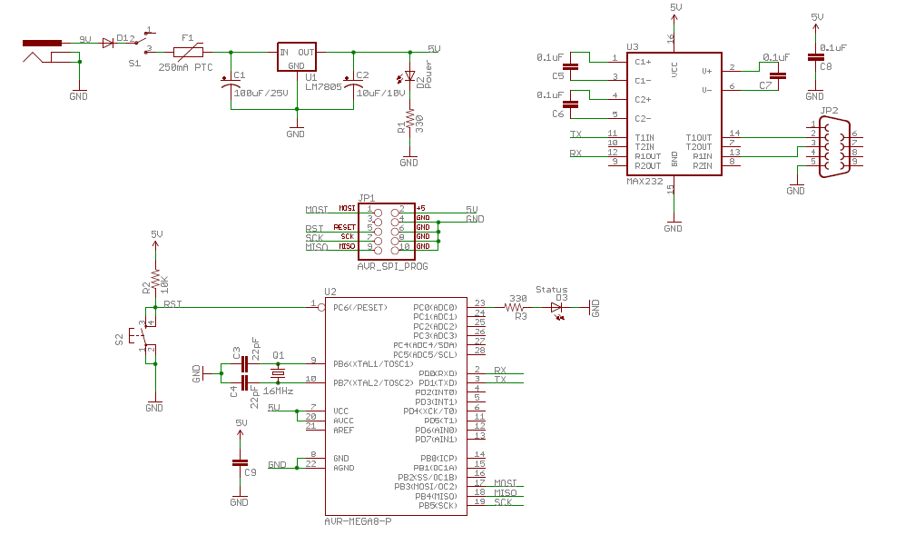
Appendix 2: Arduino MC Circuit Schematic:

Appendix 3: Final Code:

#include <Servo.h>
Servo rightbase;
Servo leftbase;
Servo middle;
Servo claw;

int posr = 0;
int posl = 0;
int posm = 0;
int posc = 0;

boolean flag = 0;

//variables for reading tag
byte i = 0;
byte val = 0;
byte code[6];
byte checksum = 0;
byte bytesread = 0;
byte tempbyte = 0;

int motorPin1 = 2;
int motorPin2 = 10;
int motorPin3 = 11;
int motorPin4 = 12;
int delayTime = 50;
#include <SoftwareSerial.h>
SoftwareSerial mySerial(5, 4); //RX, TX
void setup() {
mySerial.begin(9600); // connect to the mySerial port
//mySerial.println("ready to go");
Serial.begin(9600);

//servo pins
pinMode(9, OUTPUT);
pinMode(8, OUTPUT);
pinMode(7, OUTPUT);
pinMode(6, OUTPUT);

//serial pins
pinMode(5, INPUT);
pinMode(4, OUTPUT);

//stepper pins
pinMode(motorPin1, OUTPUT);
pinMode(motorPin2, OUTPUT);
pinMode(motorPin3, OUTPUT);
pinMode(motorPin4, OUTPUT);

//DC motor pins
pinMode(A1, OUTPUT);
pinMode(A3, OUTPUT);
//serial tx high
digitalWrite(4, HIGH);
// all coils off
digitalWrite(motorPin1, 0);
digitalWrite(motorPin2, 0);
digitalWrite(motorPin3, 0);
digitalWrite(motorPin4, 0);

//mySerial.println("go initial");

goInitial();
delay(3000);
}
void loop () {
takeObject();
goInitial1(); //go initial with closing claw
right(6); //left
all_coils_off();
delay(2000);
//comparison between three shelfs
if (code[3] == 0x03) {
go_dc(); //move forward to reach shelf
delay(2000);
releaseObject1();
Serial.println("done tage 1");

}
if (code[3] == 0x06) {
go_dc(); //move forward to reach shelf
delay(2000);
releaseObject2();
Serial.println("done tage 2");
}
if (code[3] == 0x42) {
go_dc(); //move forward to reach shelf
delay(2000);
releaseObject3();
Serial.println("done tage 3");
}
//}

delay(2000);
rev_DC();
delay(2000);

goInitial1();
delay(1000);

left(6); //move right
all_coils_off();

delay(2000);

}
void goInitial(){

rightbase.attach(9);
leftbase.attach(8);
middle.attach(7);
claw.attach(6);

posr = rightbase.read();
//Serial.println(posr);
//Serial.println("rightbase angle");

posl = leftbase.read();
//Serial.println(posl);
//Serial.println("leftbase angle");

for (posr; posr<=150; posr++){

rightbase.write(posr);
leftbase.write(180 - posr);
delay(20);

}

delay(2000);
posm = middle.read();
//Serial.println(posm);
//Serial.println("middle angle");
//middle
for (posm; posm>=60; posm--){
middle.write(posm);
delay(20);
}
delay(2000);

//claw
posc = claw.read();
//Serial.println(posc);
//Serial.println("claw angle");
//claw
for (posc; posc>=45; posc--){

claw.write(posc);
delay(20);

}
delay(2000);
}

void goInitial1(){
rightbase.attach(9);
leftbase.attach(8);
middle.attach(7);
claw.attach(6);

posr = rightbase.read();
//Serial.println(posr);
//Serial.println("rightbase angle");

posl = leftbase.read();
//Serial.println(posl);
//Serial.println("leftbase angle");
for (posr; posr<=150; posr++){

rightbase.write(posr);
leftbase.write(180 - posr);
delay(20);

}
delay(2000);
posm = middle.read();
//Serial.println(posm);
//Serial.println("middle angle");

//middle
for (posm; posm>=60; posm--){
middle.write(posm);
delay(20);
}
delay(2000);

}
void takeObject(){
rightbase.attach(9);
leftbase.attach(8);
middle.attach(7);
claw.attach(6);

//middle
for (posm; posm<=85; posm++){
middle.write(posm);
delay(20);
}
delay(2000);

for (posr; posr>=120; posr--){
rightbase.write(posr);
leftbase.write(180 - posr);
delay(20);

}
delay(2000);
for (posm; posm<=135; posm++){
middle.write(posm);
delay(20);
}
delay(2000);
for (posr; posr>=65; posr--){

rightbase.write(posr);
leftbase.write(180 - posr);
delay(20);
}
delay(2000);
delay(2000);
delay(8000);

read_tag();
delay(2000);
if (code[3] == 0x03) {
Serial.println("tag1");
delay (2000);
}
if (code[3] == 0x06) {
Serial.println("tag2");
delay(2000);
}
for (posc; posc<=110; posc++){
claw.write(posc);
delay(20);

}
delay(2000);
}
void releaseObject1(){ //release tag 1

//middle
for (posm; posm<=85; posm++){
middle.write(posm);
delay(20);
}
delay(2000);

for (posr; posr>=115; posr--){
rightbase.write(posr);
leftbase.write(180 - posr);
delay(20);
}
delay(2000);
for (posm; posm<=110; posm++){
middle.write(posm);
delay(20);
}
delay(2000);

for (posr; posr>=100; posr--){
rightbase.write(posr);
leftbase.write(180 - posr);
delay(20);

}
delay(2000);

for (posm; posm<=130; posm++){
middle.write(posm);
delay(20);
}
delay(2000);

for (posr; posr>=90; posr--){

rightbase.write(posr);
leftbase.write(180 - posr);
delay(20);

}
delay(2000);

for (posm; posm<=140; posm++){
middle.write(posm);
delay(20);
}
delay(2000);
for (posr; posr>=80; posr--){
rightbase.write(posr);
leftbase.write(180 - posr);
delay(20);
}
delay(2000);

for (posc; posc>=45; posc--){

claw.write(posc);
delay(20);

}
delay(2000);

for (posm; posm<=150; posm++){
middle.write(posm);
delay(20);
}
delay(2000);

}

void releaseObject2(){ //release tag 2

//middle
for (posm; posm<=100; posm++){
middle.write(posm);
delay(20);
}
delay(2000);
for (posr; posr>=125; posr--){
rightbase.write(posr);
leftbase.write(180 - posr);
delay(20);

}
delay(2000);
for (posm; posm<=130; posm++){
middle.write(posm);
delay(20);
}
delay(2000);
for (posr; posr>=115; posr--){
rightbase.write(posr);
leftbase.write(180 - posr);
delay(20);

}
delay(2000);
for (posm; posm<=140; posm++){
middle.write(posm);
delay(20);
}
delay(2000);
for (posr; posr>=105; posr--){
rightbase.write(posr);
leftbase.write(180 - posr);
delay(20);

}
delay(2000);
for (posc; posc>=55; posc--){
claw.write(posc);
delay(20);
}
delay(2000);
for (posm; posm<=150; posm++){
middle.write(posm);
delay(20);
}
delay(2000);

}

void releaseObject3(){ //release tag 3
for (posm; posm<=160; posm++){
middle.write(posm);
delay(20);
}
delay(2000);
for (posr; posr>=130; posr--){
rightbase.write(posr);
leftbase.write(180 - posr);
delay(20);
}
delay(2000);

for (posm; posm<=175; posm++){
middle.write(posm);
delay(20);
}
delay(2000);
for (posr; posr>=105; posr--){
rightbase.write(posr);
leftbase.write(180 - posr);
delay(20);
}
delay(2000);
for (posc; posc>=45; posc--){
claw.write(posc);
delay(20);

}
delay(2000);
for (posm; posm>=160; posm--){
middle.write(posm);
delay(20);
}
delay(2000);
}
//stepper motor stop
void all_coils_off(void) {

digitalWrite(motorPin1, 0);
digitalWrite(motorPin2, 0);
digitalWrite(motorPin3, 0);
digitalWrite(motorPin4, 0);
}
//stepper motor left
void left(int j) {
for(int i =0; i<j; i++) {
digitalWrite(motorPin1, HIGH);
digitalWrite(motorPin2, HIGH);
digitalWrite(motorPin3, LOW);
digitalWrite(motorPin4, LOW);
delay(delayTime);
digitalWrite(motorPin1, LOW);
digitalWrite(motorPin2, HIGH);
digitalWrite(motorPin3, HIGH);
digitalWrite(motorPin4, LOW);
delay(delayTime);
digitalWrite(motorPin1, LOW);
digitalWrite(motorPin2, LOW);
digitalWrite(motorPin3, HIGH);
digitalWrite(motorPin4, HIGH);
delay(delayTime);
digitalWrite(motorPin1, HIGH);
digitalWrite(motorPin2, LOW);
digitalWrite(motorPin3, LOW);
digitalWrite(motorPin4, HIGH);
delay(delayTime);
}

}
//stepper motor right
void right(int j) {
for(int i = 0; i< j; i++){
digitalWrite(motorPin1, HIGH);
digitalWrite(motorPin2, LOW);
digitalWrite(motorPin3, LOW);
digitalWrite(motorPin4, HIGH);
delay(delayTime);
digitalWrite(motorPin1, LOW);
digitalWrite(motorPin2, LOW);
digitalWrite(motorPin3, HIGH);
digitalWrite(motorPin4, HIGH);
delay(delayTime);
digitalWrite(motorPin1, LOW);
digitalWrite(motorPin2, HIGH);
digitalWrite(motorPin3, HIGH);
digitalWrite(motorPin4, LOW);
delay(delayTime);
digitalWrite(motorPin1, HIGH);
digitalWrite(motorPin2, HIGH);
digitalWrite(motorPin3, LOW);
digitalWrite(motorPin4, LOW);
delay(delayTime);
}
}
void read_tag(){
i = 0;
val = 0;
checksum = 0;
bytesread = 0;
tempbyte = 0;
flag = 1;
while(mySerial.available() > 0){
if((val = mySerial.read()) == 2) { // check for header
bytesread = 0;
while (bytesread < 12) { // read 10 digit code + 2 digit checksum
if( mySerial.available() > 0) {
val = mySerial.read();
if((val == 0x0D)||(val == 0x0A)||(val == 0x03)||(val == 0x02)) { // if header or stop bytes before the 10 digit reading
break; // stop reading
}
// Do Ascii/Hex conversion:
if ((val >= '0') && (val <= '9')) {
val = val - '0';
} else if ((val >= 'A') && (val <= 'F')) {
val = 10 + val - 'A';
}
// Every two hex-digits, add byte to code:
if (bytesread & 1 == 1) {
// make some space for this hex-digit by
// shifting the previous hex-digit with 4 bits to the left:
code[bytesread >> 1] = (val | (tempbyte << 4));

if (bytesread >> 1 != 5) { // If we're at the checksum byte,
checksum ^= code[bytesread >> 1]; // Calculate the checksum... (XOR)
};
} else {
tempbyte = val; // Store the first hex digit first...
};
bytesread++; // ready to read next digit
}

}
}
}

}
void go_dc(){
digitalWrite(A3, HIGH);
delay(1500);
digitalWrite(A3, LOW);
delay(5000);
}
void rev_DC(){
digitalWrite(A1, HIGH);
delay(700);
digitalWrite(A1, LOW);
delay(5000);

}

Appendix 4 : Servo Datasheet:

Servo - Large
sku: ROB-09064
Description: Here is a simple, low-cost, high quality servo for all your mechatronic needs. Large servo with a standard 3 pin power and control cable. Includes hardware as shown.
Weight: 41g
Dimensions: 41 x 20 x 38mm
Features:

- 3 pole ferrite, all nylon gear
- Top ball bearing
- Operating Voltage: 4.8V~6.0V
- Operating speed:
  - 0.20sec/60degree (4.8V)
  - 0.16sec/60degree (6.0V)
- Stall torque:
  - 5.2kg*cm (4.8V)
  - 6.5kg*cm (6.0V)
- Temperature Range: -20℃~60℃
- Dead band width: 4µs
- Connector wire length: 32cm

Appendix 5 : RFID Datasheet:

