

Graduation Project.
REAL TOR System.

Baraa Hakawati.

MIS – Engineering & IT - NNU
Nablus, Palestine

Index
Abstract.……………………................................…..page 1

Introduction.………………………………………..page 3

Problem..………………………………………........Page 4

Discussion And Analysis In Database..………........Page 5

Dependences...…………………………………..…..page 6

Users...…………………………………………..…..page 6

Functional Requirements.……………...….......…...page 6

Reasoms why we use web development full stack.…page 7

Charts and Diagrams……………………………….page 7

Usege……………………………………………....page 13

Fyture Work……………………………………….page 13

Development…………………………………...….page 13

Snapshots………………………………………….page 13

Conclusion…………………………………….….page 18

- Abstract
We suggest building a software project that can handle various activities in the process of searching for property to buy and manage efficiently.
Real estate Scope are now growing at the same time as the need to manage its operations and missions. The best way to improve these activities is to develop an online business. In addition, today's generation encourages high-tech services, especially via the Internet.
The project has been carefully developed to help property owners complete their business operations. This project provides the best way to maintain user information and meet its needs. The new feature added in our project is sending messages via the website between the seller and the buyer. We will develop the system using the web applications php, HTML, CSS, JS, Jquery and Ajax.

- Introduction
In These days, real estate is handled by its seller in a certain way different from the buyer ,each of them has different activities .

In fact, the owner deals with most types of activities such as the presentation of the property or delete it and correspondence with customers and management alerts received from the website ,generally these are some of the actions taken by the owner . As for the buyer, he identifies the property concerned and is waiting to receive a message from the owner to contact him to agree on the details . We have excelled in our website on many famous websites for the sale of property in Palestine such as ( Sellme , buysell , شو بدك من فلسطين , عقار فلسطين ) by : Provide more accurate information about the property from the above mentioned sites , A messaging system is available at the same site rather than an effort, wasting time in personal interviews between the seller and buyer and losing money in phone calls , provide a system of alerts to both parties buyer and seller to inform them of the occurrence of a process on the site directly inspired , Easier to search and more freedom through the possibility of searching for the specifications of the property , and provide comprehensive images of the real estate in all respects (in the case of sufficient time will be added VR, 3D and 360 images) .

Problem

Problem Statement :
In recent days, the scope of real estate purchase and sale has expanded considerably from what it was in the past. It has become very urgent to take advantage of IT technologies to facilitate the process of carrying out activities in this field . Let's take a look at the process of buying a property these days:

In the beginning, a person will consult his family to develop appropriate specifications for the property that suits them and meet their needs. Then he will inquire about property for sale from people close to him. If he does not find it, he will turns to the brokerage companies and brokers who will work hardly to get the most ratio of selected Property to be purchased. Then the person who wants to buy the property will enter an unknown maze with the owner of the property that he wants to buy the property from him , in terms of the difference in the method of payment or the value of the amount to be paid to the property, such as the violation of dates in meetings between the parties and so on , and the sale may be successful and may fail .

Problem analysis :
As discussed earlier our main problem area focuses on the “Process of buying a property”, there are lot of problems in that area which are associated with both the seller and the buyer.

The buyer spends a lot of time inquiring about a property for sale by his friends and people close to him and often gets little result .

Money is wasted by the seller in the process of placing ads to sell his property .

The seller loses a certain amount of money if the sale is made through a broker .

Wasting time in negotiations between seller and buyer .

Waste money in phone calls between seller and buyer .

Effort and waste of money in the field of real estate inspection .

Problem Solution :
The solution to the problems mentioned above is very simple. It is necessary to develop a website that allows both the seller and the buyer to fulfill their desires .

Website design allows the buyer to search for any real estate he wants in any area .

The site allows the seller to place free ads on it .

The site provides a free messaging system between the seller and the buyer to avoid wasting money in phone calls .

The site allows the seller to place the full details of his property freely .

The site allows the seller to place pictures of his entire property on it .

Add alerts on the site to alert the seller and buyer in the event of any activity on the site directly related to them .

Discussion And Analysis in Database
As a result of the database, we have built the main tables very carefully and we have made sure to make these tables as organized as possible, and we are careful to reduce the size of the database as much as possible and choose the information that needs to be met with great care and accuracy.
As we said earlier there are two types of users in this website are the seller and the buyer. It is worth mentioning that both accounts have the same information and to avoid the repetition in the data and to maintain the structure of the database we merged the two accounts in one table that called users .
They can be distinguished by a colom that carries a value of 0 for the seller and a value of 1 for the buyer .
In addition to the above, there is a direct relationship between the tables in the database, as between the table property and the user table, the user type of seller can add a property to the database or delete a property from the database as he pleases and whenever he wants .

Dependencies
REAL TOR management system has to have information to start management and in this section we will talk about them and the relationships between others. The information of owner is required to access the management and start doing activities the information of owner are first name,last name ,username , address, phone number, identification number , account type , and email address. Information of buyer are the same.
For the property, the information I need is, its area, its title, its type, its description, its price, the identification number of its owner .

Users
We have two types of users in the REAL TOR system project. They are seller and buyer. The system should allow the seller to control his activity by adding the property, editing the property, delete a property, accepting buyers and messageing them .
The system allows the buyer only to modify his data as the case of the seller and search for the appropriate property and show interest in it and waiting for a letter from the owner of the property tells him what he should send him and then agree on the rest of the details .

Functional requirements

All users should log into system.

Seller can add and edit property .
- Seller can view interested buyers.
- Seller can edit his account.
- Buyer can search for a property.
- Buyer can edit his information and account.

Log into system

All users should log into system before any transaction to have authentication to enter system and start doing activities.

Add and Edit property

The seller can display his property and can also modify the data for this property after it is displayed on the website .

View interested buyers.

The seller can see buyers interested in his property .

Edit seller account

The seller can change his personal data and change his account settings .

Searching for property.

The buyer can find the right property for him in any area he wants

Edit buyer account

The buyer can change his personal data and change his account settings .

Reasons Why we used the web development full stack

We chose this method in the development of our site for several reasons, the most important of which is the cost of material damage and choose the appropriate design for us freely and for more effective security reasons and to facilitate future development and maintenance .

Charts And Diagrams

Entity Relationship Diagram ( ERD )

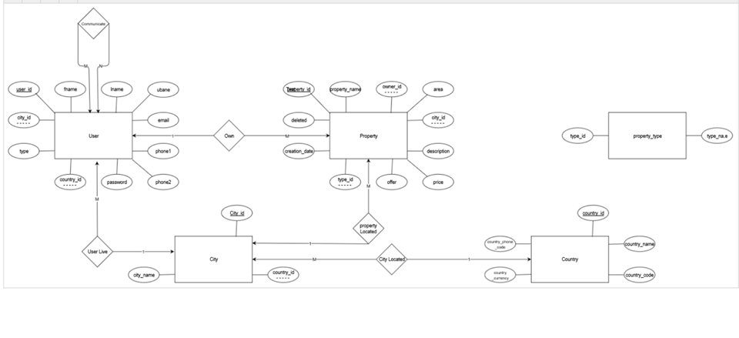

Context Diagram 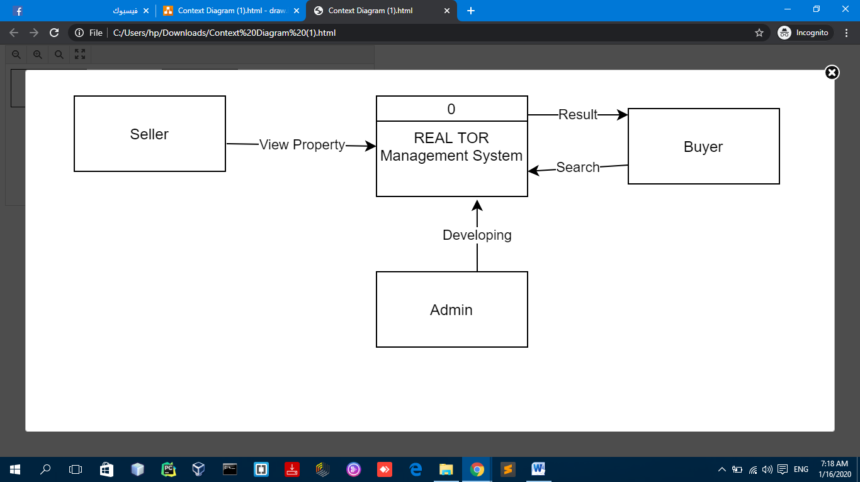

Level 1 Diagram 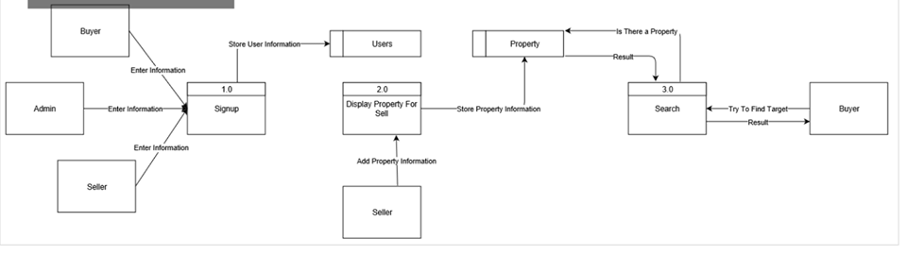

Level 2 Diagram ( Process 3 ) 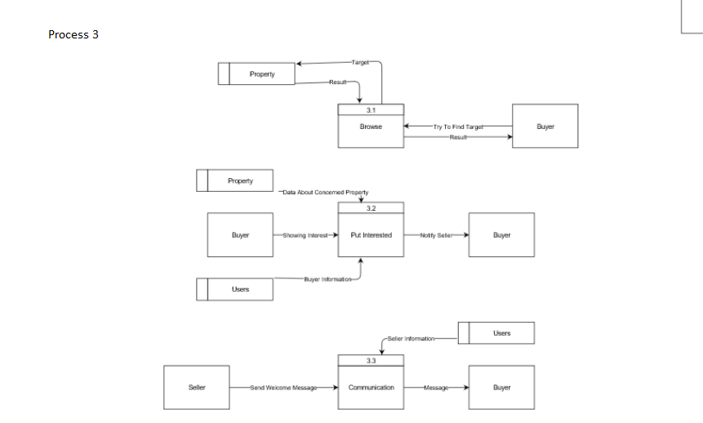

Admin Use-case Diagram 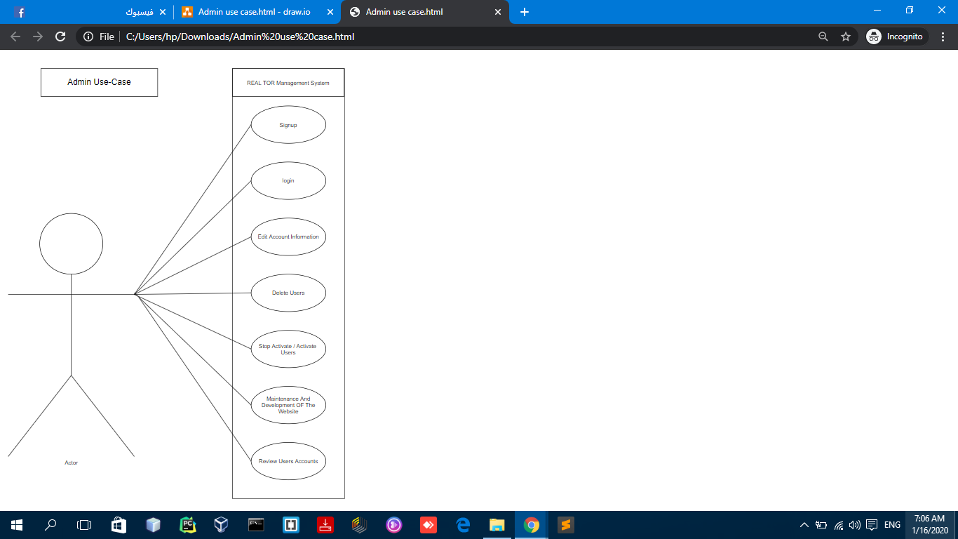

Seller Use-case Diagram 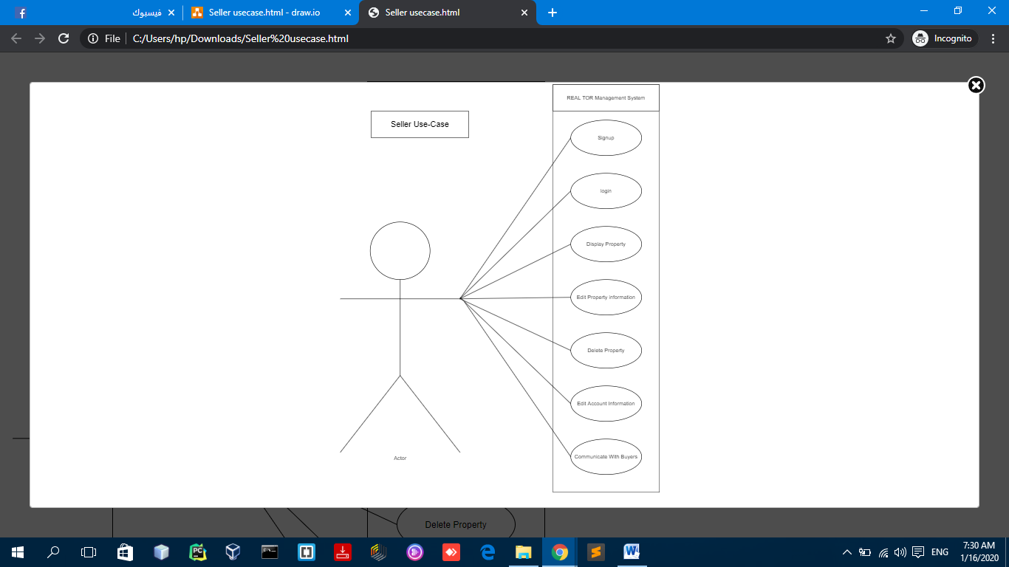

Buyer Use-case Diagram 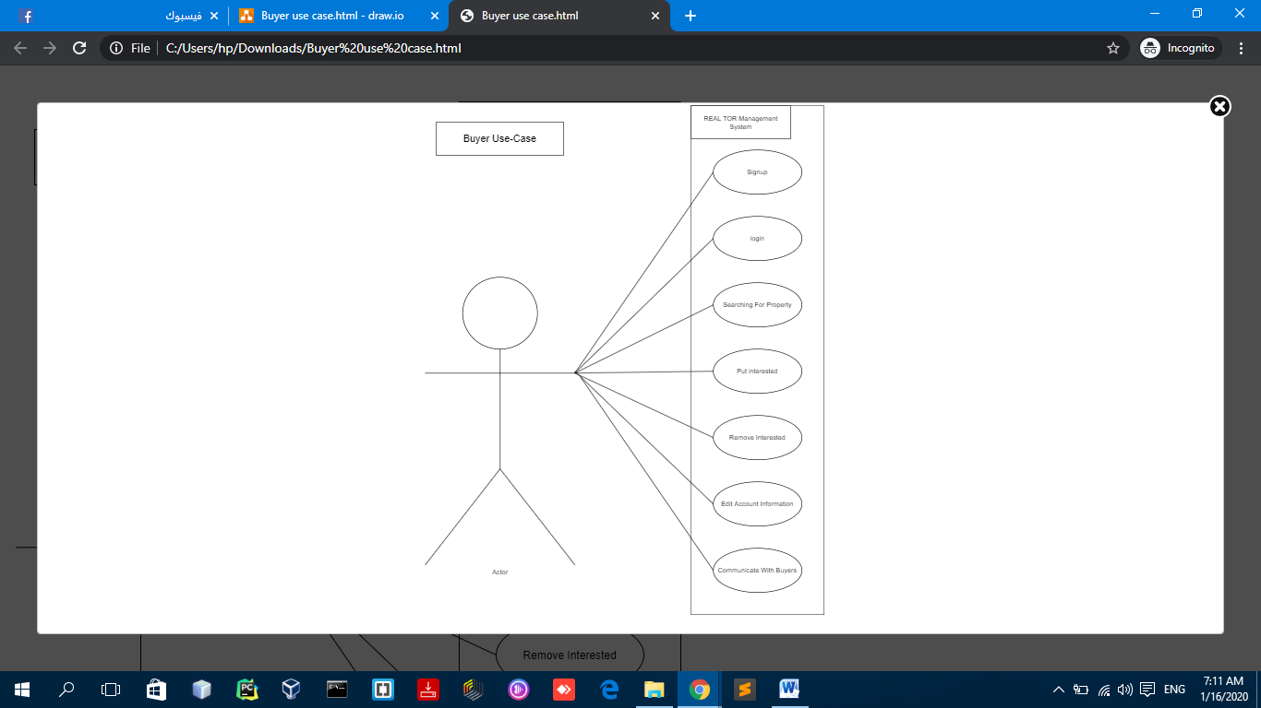

Class Diagram

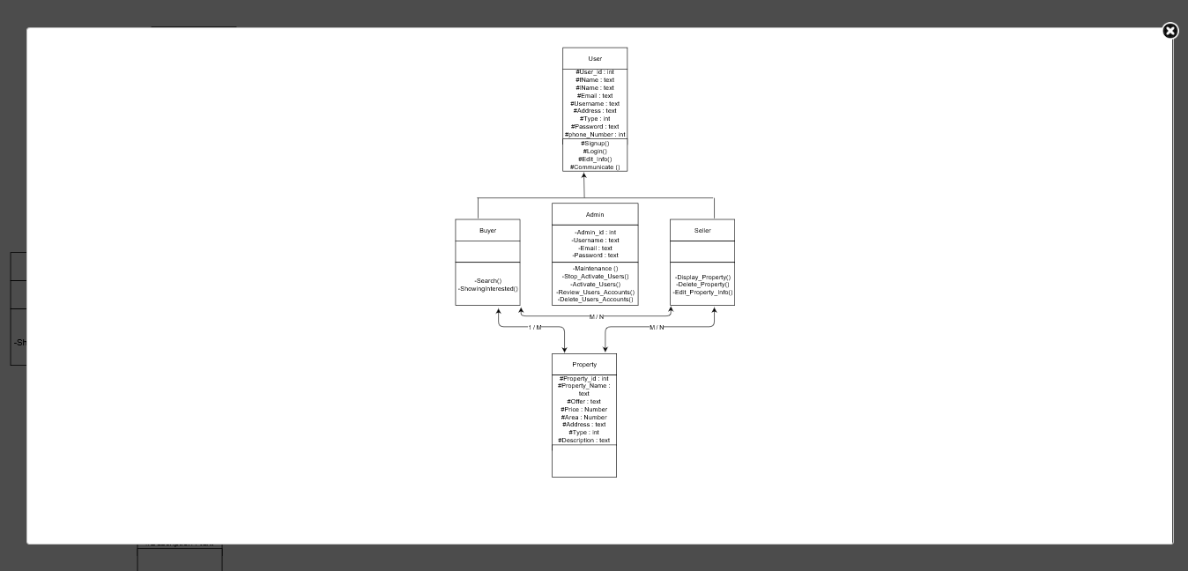 9.9 Gant Chart

Usage

This system can be used by anyone with the same requirements as described in this report. The system works under English (temporarily), so after the analysis, we have done as much as we can. The buyer can use this system as easily as possible to find suitable properties for him. The landlord can use the system to display his property and discuss the buyers interested in his property and can be used to make the tasks as easy as possible systematically instead of traditional research and carrying the effort and burden and costs as in the normal life .

Future work

Adding the GPS into our project .
- The project will go on to become more effective to offer three versions operating in different systems, namely IOS, Android and Windows to become one of the most important mobile applications in our country .

Adding more functions to the System like the geographic information's system (GIS
- Evaluate our system to support the Arabic language to be one of the main languages in our system .
- using The AI and retrieval technology to support customers by notifaied them about any property type that they are request if its available .
- Developing the searching process to become an advanced search .

Development The system implemented using HTML , CSS , JS , PHP , Ajax , and Jquery environment in addition, bootstrap used to set usable stylesheet and easy to understand for users who use the system. HTML 5 used in REAL TOR system that can be available to the most browsers on different devices. We have used two main programs to implement the system and they are: brackets for implementing the web pages, client side and server side. We have used PHP in server side. Second program is PHPMyAdmin to implement the database and design it then connect it throw services to REAL TOR system.

Snapshots 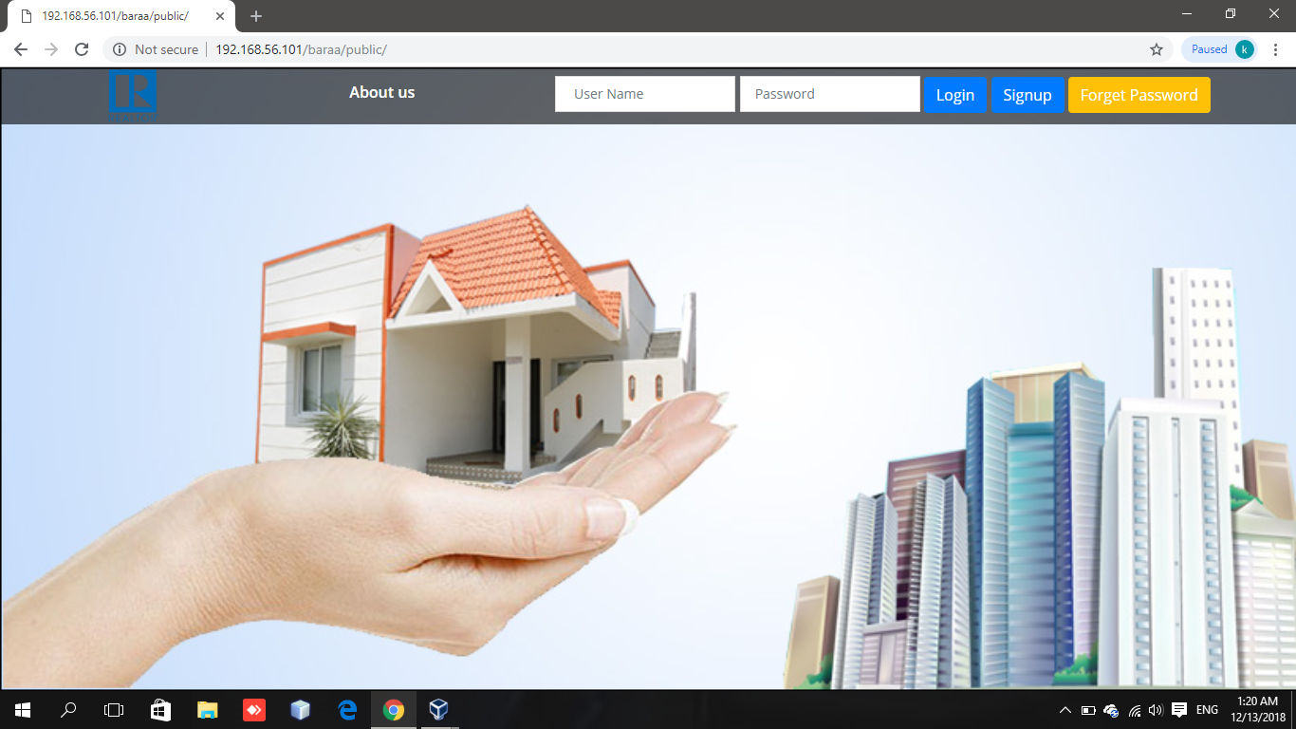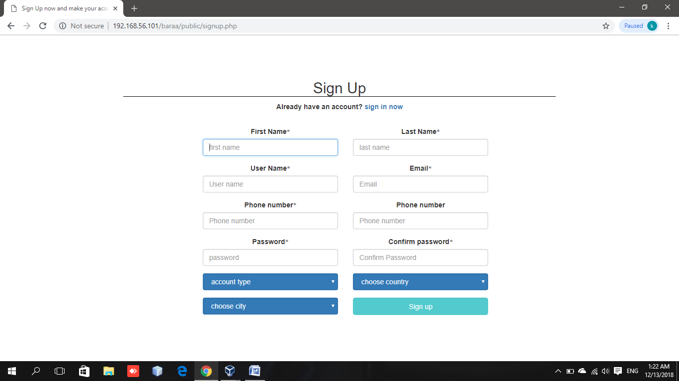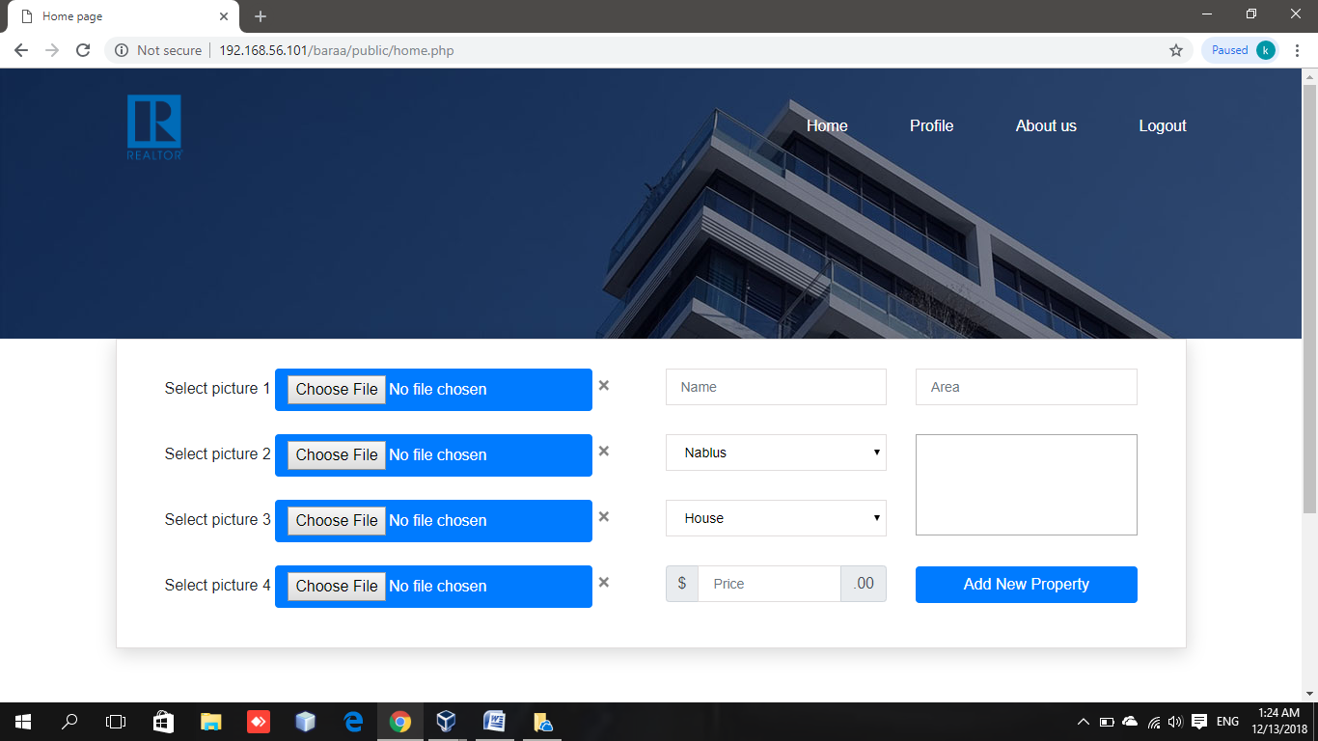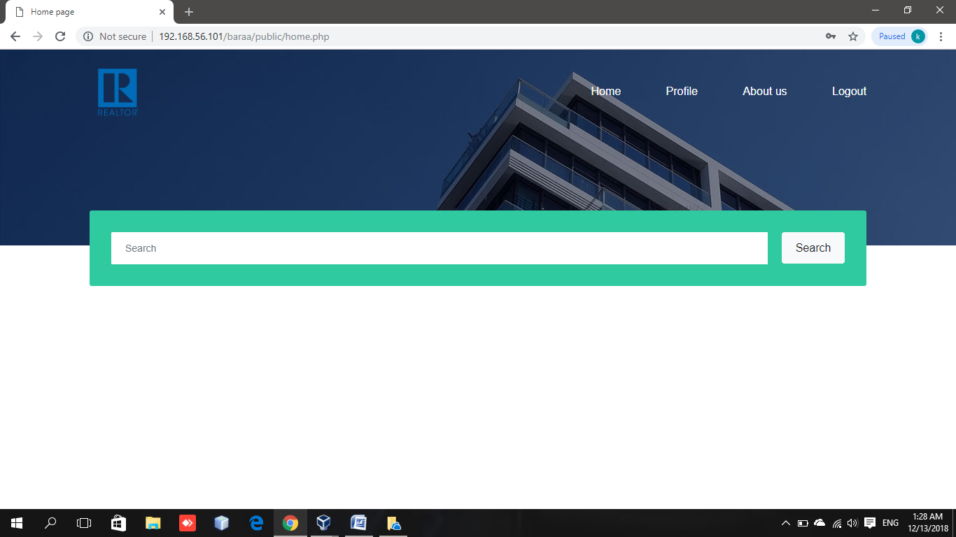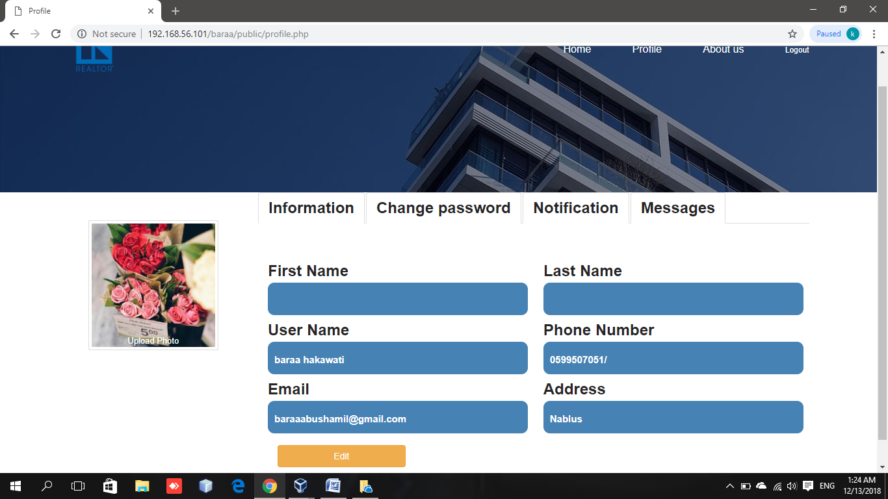

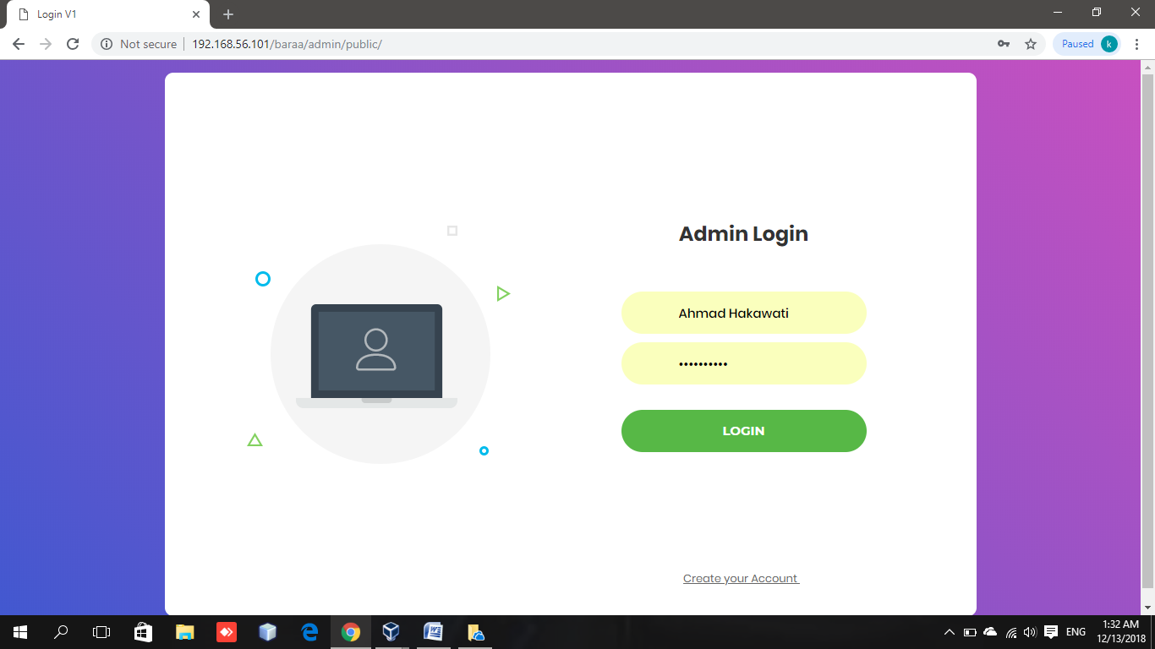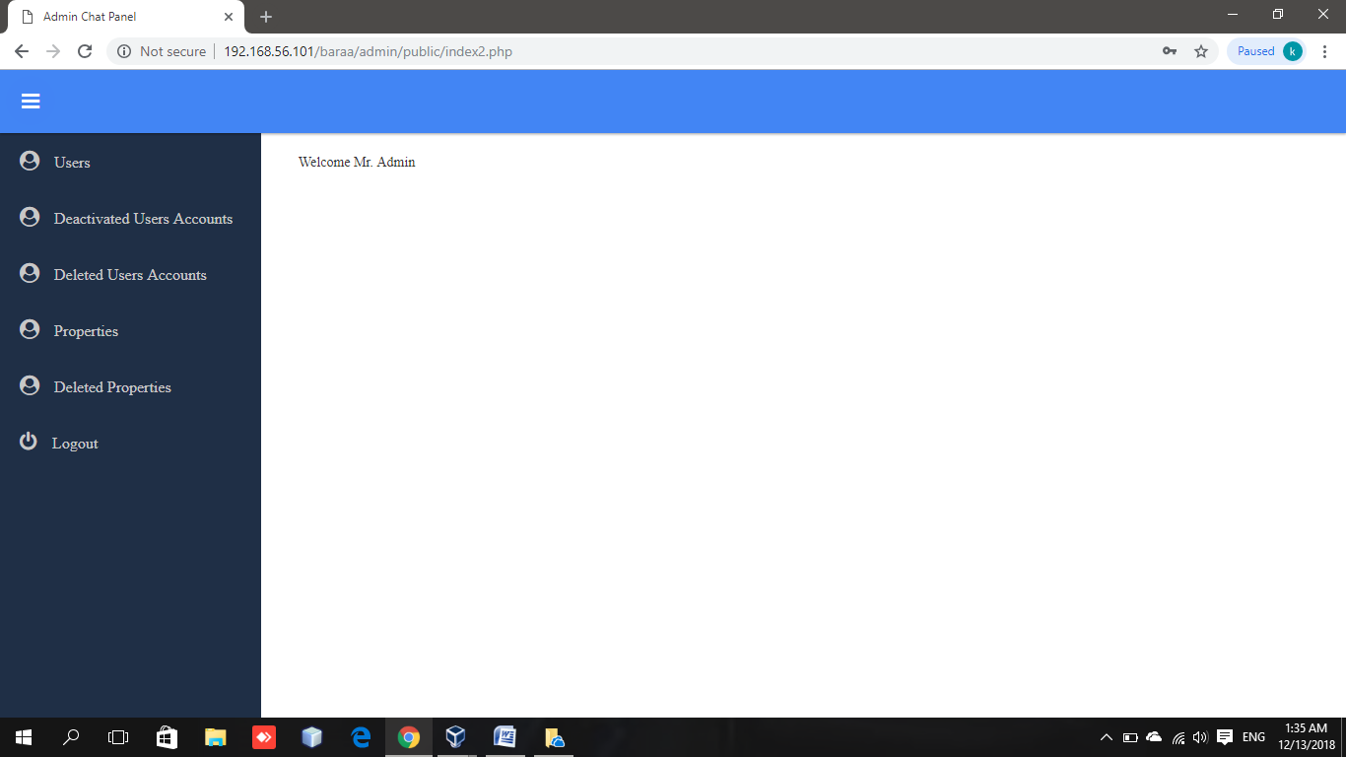

Conclusion

After running the program the users should be able to have the outputs as in real. Seller should be able to display his property, buyer should be able to search for property and interact by puting his interested on property and finally receive message from the owner of property. The system should be an easy graphical user interface that allow user to use the system easily. This system serve times for users and solve the problems which we talked about them.

