
An-Najah National University
Faculty of Engineering & Information Technology Department of Computer Engineering

Graduation Project I



Stay social

Done by:
Deyar Idhilie

Supervised by:
Dr. Sufyan Samara

Presented in partial fulfillment of the requirements for
Bachelor Degree in Computer Engineering

Acknowledgment
First and foremost, praises and thanks to God, for His showers of blessings throughout The work to complete the project successfully. I’m also thankful for my friends who have been with me all the time.

Abstract:

Communication is a desire that has been hard-wired in humans since ever, Its history can be traced back since the origin of speech circa. In fact, It was an effective survival mechanism for our ancestors, they shared information about food supplies,

dangerous animals, and weather patterns. And up till this day, talking and sharing information make life easier. Even our values were passed on from conversations with our family, community, school and mosques.

Meeting new individuals exposes you to a vast array of fresh perspectives, feelings, attitudes, and viewpoints. You might learn about stuff you had no idea existed.

By offering you a fresh perspective, it might extend your horizons and give you a new sense of direction. You might choose to change your career. You can decide to research a

novel and interesting topic or learn a new things that a recent acquaintance showed you.

The probabilities are endless!

However, meeting new people is not that easy for all, This is where our application come to help. We seek to build a mobile application that give the chance to never miss the joy. The app will match you with others that are also free and curious to

meet new people. After logging in the app and completing your profile, you could choose at anytime to tell your surroundings that you’re looking to meet someone that is also want

to do the same activity as you. You could also add a preferable gender, age range. Using Machine Learning algorithms, the app will assign you to meet compatible people to raise

your chances to enjoy the experience. If you both agreed to match, you could use the chatting feature to agree on the meeting details.

Contents
Table of figures 4
Introduction 6
Constraints, standards and earlier work 6
Literature review 6
Methodology 8
Tools, Programming Languages, and Technologies 8
Architecture 12
Features Of The Application 13
Implementation 15
● Home screen 22
● Edit profile page 24
● View date 25
● Other profile page 27
● Notifications and requests page: 27
● Chats screen 28
● Log in screen 30
● Forget Password 31
● Machine learning : Find how much people are similar using cosine similarity 33
Results and Discussion 36
Conclusions and Recommendation 36

Table of figures

Figure 1Online dating statistics by the numbers. 8
Figure 2layered architecture 13
Figure 3app icon 15
Figure 4App launch icon 15
Figure 5welcome screen 16
Figure 6 signup page 17
Figure 7 Signup form validation 17
Figure 8 email field validation 18
Figure 9 phone number validation 18
Figure 10 obscure text 18
Figure 11 unhide password 18
Figure 12 password and confirm password 18
Figure 13 phone is taken message 18
Figure 14 username is taken message 18
Figure 15 email is taken message 18
Figure 16 choose profile image 1 19
Figure 17 create profile 19
Figure 18 choose profile image 2 20
Figure 19 bio validation 20
Figure 20set privacy 21
Figure 21 add your interests 21
Figure 22 location permissions 22
Figure 23home page 22
Figure 24create date 23
Figure 25create date required fields 24
Figure 26create date success message 24
Figure 27 view date 26
Figure 28request to join 26
Figure 29others profile 27
Figure 30 notification page 28
Figure 31 chat page 28
Figure 32chat screen 29
Figure 33the other user chat screen 29
Figure 34the other user chat page 30
Figure 35login page 30
Figure 36 login form validation 31
Figure 37enter email 31
Figure 38forget password 31
Figure 39email validation 32
Figure 40check the inbox 32
Figure 41verification email 32
Figure 42 change password page 32
Figure 43cosine similarity 33
Figure 44 data set 35

Introduction

Nowadays, More and more social apps are rising. Those apps shifted the human interactions slowly to virtual based and having friends from all over the world is not something unusual anymore.
While those apps helped making the world a “small village”, they couldn’t replace the face-to-face interaction , That’s why people shifted toward the new trend : Dating and Meeting apps
There are several factors that have led to the existence of social dating and meetings apps. One major factor is the increased use of smartphones and mobile technology. With more and more people using their phones for everything from communication to entertainment, it's no surprise that mobile dating apps have become more popular. Another factor is the changing social norms around dating and relationships. Online dating and apps have become more socially acceptable and mainstream, making it easier for people to meet and connect with potential partners. Additionally, the increasing busyness of modern life and the convenience of being able to connect with others from anywhere at any time have also been contributing factors to the popularity of dating apps.
Introducing the new social app, "Laqeene"! This innovative app helps users create and join unique and exciting dates at any time. Whether you're looking for a fun activity with a new friend , a food mate or study partner, Laqeene makes it easy to find and connect with like-minded individuals. With its intuitive interface and built-in chat feature, users can easily plan, coordinate, and get to know their date before meeting in person. Join the revolution of socializing with LAQEENE!

Constraints, standards and earlier work

Since our application is location based, GPS lack of accuracy was one of the main problems facing the app

Literature review

The history of dating apps can be traced back to the early days of the internet. One of the first dating websites, Match.com, was launched in 1995, followed by eHarmony in 2000. These early dating websites primarily focused on matching users based on their answers to lengthy questionnaires and personal profile information.

In the early 2010s, the first dating apps began to appear on smartphones. These apps, such as Tinder and Grindr, utilized the GPS functionality of smartphones to match users based on their location. This shift to mobile technology and location-based matching greatly increased the convenience and accessibility of online dating for users.

Over time, dating apps have continued to evolve and expand their features. Some apps, such as Bumble and Hinge, have introduced additional ways for users to connect, such as through video chat or community-building features. Other apps, such as OkCupid and Hily, have focused on more in-depth matching algorithms to help users find more compatible partners.

Recently, dating apps have also begun to focus on more specific niche markets, catering to groups like LGBTQ+ communities, religious groups, and even specific professions.

In summary, dating apps have evolved from early websites that relied on lengthy questionnaires to modern mobile apps that utilize location-based matching and other features to connect users in more convenient and effective ways.

LAQEEEN is a special application available in. The main reason that encouraged me to develop this idea of the application and working on it is the huge demand of people to find similar app that work in our country

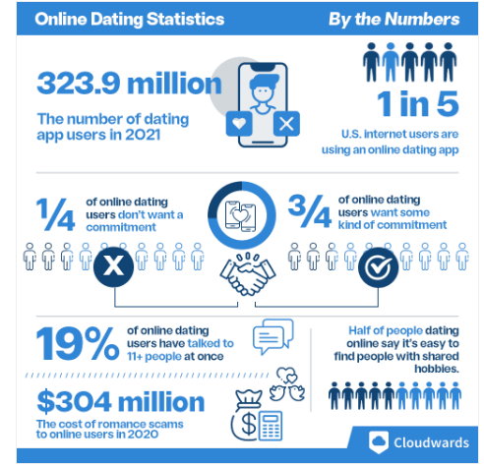
Figure 1Online dating statistics by the numbers.

Methodology

Tools, Programming Languages, and Technologies

Mobile application

When developing a mobile app the options are wide, you could choose a native framework to use or a cross-platform and still there are more than one option for each. After asking and searching . I chose the followings

UI/UX

For design ideas, I used Pinterest as my inspiration. I tried to create a user-friendly and eye-reliving design

Frontend-side:

The mobile application was built using flutter framework ,Why flutter?
Flutter is Google’s free and open-source UI framework for creating native mobile applications. Released in 2017, Flutter allows developers to build mobile applications for both iOS and Android with a single codebase and programming language. This capability makes building iOS and Android apps simpler and faster. Although Flutter is a newer cross-platform framework, more and more companies have chosen Flutter over frameworks such as Xamarin, Cor dova, and React Native.

Server-side
For developing the server side of the system, Node JS was used. Node JS is an open-source, cross-platform, back-end JavaScript runtime environment that runs on a JavaScript Engine. In addition to express framework, that was used as a routing middleware. Also, the libraries nodemon was used to manage server and any modification on it.

Database

MongoDB

Node.js and MongoDB are often used together because they complement each other well in terms of their strengths and capabilities.

Node.js is well-suited for building scalable and high-performance server-side applications. It is also known for its fast and efficient performance, as well as its ability to handle large numbers of concurrent connections.

MongoDB, on the other hand, is a popular NoSQL database that is designed to handle large amounts of unstructured data. It is known for its scalability, flexibility and high-performance, which makes it well-suited for storing and retrieving large amounts of data quickly.
They are often used together is because they are both built on JavaScript. This means that developers can use the same language for both the server-side and the database, making the development process more efficient and streamlined.
Another reason is that MongoDB stores data in a JSON-like format, which makes it easy to integrate with Node.js and other JavaScript-based technologies. This allows us to easily store, retrieve, and manipulate data within the application, without having to deal with the complexity of a relational database.
The library mongoose helped to use the nodejs mongodb driver.\

Google Cloud Service

Using google cloud bucket, user profile image is saved

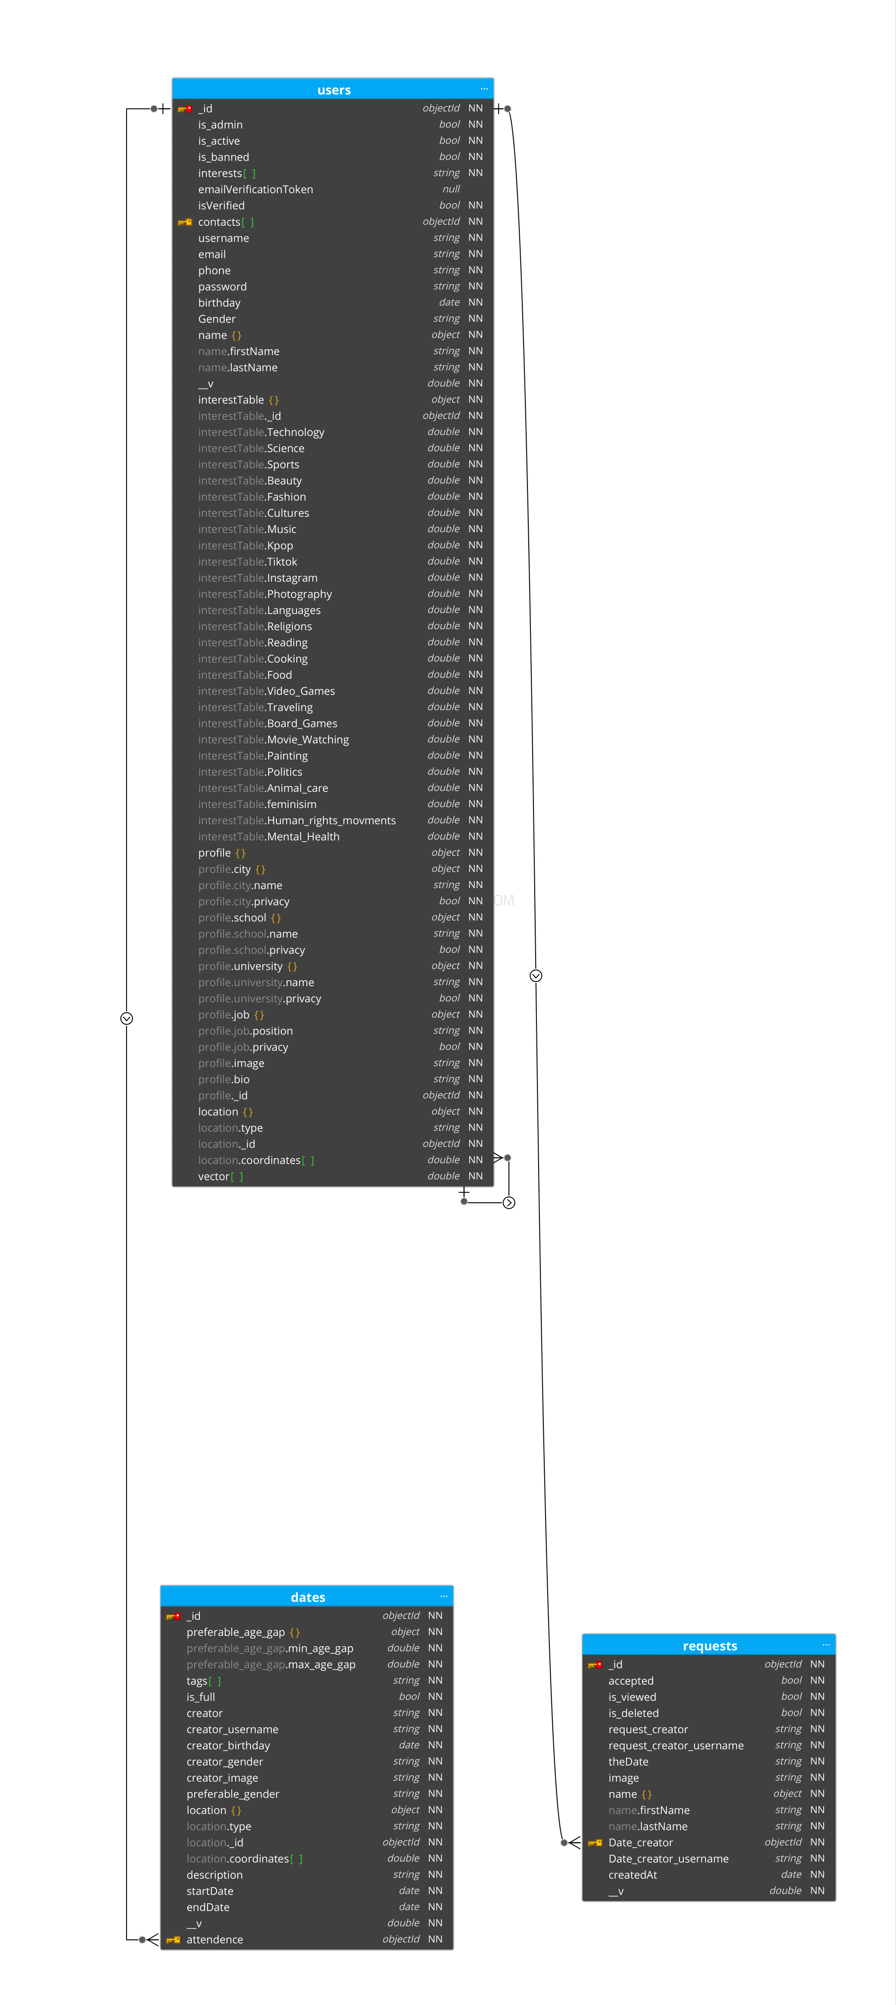

IDEs

Android studio was used to create virtual devices-emulator to run and test the code on.
VS code where used to develop both flutter-frontend-side and Nodejs-server-side, In addition to its support for different programming languages and the git source control support , it also support high number of extensions make it a great choice.

Version Control

We were working on a team, so we needed a way to share the work and
for code integration, so we used Git and the GitHub server

API Endpoints Testing

Since Rest API is used to connect and handle requests/responses between front and back ends , we have to test each endpoint before we can integrate it to the client ,for this Postman is used.

Postman is an API (application programming interface) development tool
which helps to build, test and modify APIs. Almost any functionality that
could be needed by any developer is encapsulated in this tool.

Architecture

Physical architecture

The client is hosted on mobile device while the server is hosted and ran locally, The database is hosted on cloud Using MongoDB Atlas .Following Rest API approach, Client sends http requests to server side and the server send http response back. The REST API approach suggest that the anything needed to be done in the system is one of four operations known as CRUD or in REST API way , post, get, put, delete (let’s not forget the patch) .

Logical architecture

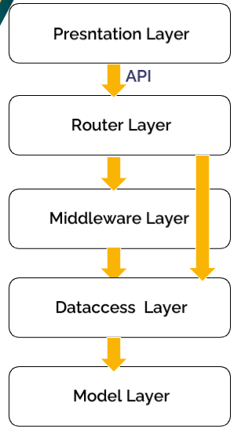
Figure 2layered architecture

Features Of The Application

-Geolocation

Since our application is location based, the application need to gain permission to use the device gps and get user position

- Google map Integration

Google map is used to show user location and show dates around .

- filtering by tag

The user could choose from a list of tags, then only dates with such label will appear .

- create/update user profile

User could create a profile or keep it empty. The job, city, school ,and university fields in the profile could be set as private/public . Profile Image will be set as the default profile if user didn’t choose

- create new date

User should specify the date, starting and ending time. In addition to a must write description , the written description by the date creator would help the reader figure a little bit of his/her personality. Some options to be added to the date such as, a preferable gender, a preferable age gap and tags. Tags are used to ease searching for user

- Get dates around on map load

The map is the homepage of the app whenever the user enter this page , the app calculate the visible area and boundaries on the map and with map center to find the area the search need to be in . after finding the search distance, the map return the dates located in this area. Taking in count the date status and its creator preferences.

-Join a date

If a user is interested to join a date , first thing need to be done is to sent a request to the date creator where he/she could either accept or decline the request.

- Accept /Decline a request

Requests to join a date are sent to date creator, where he/she have the choice to decline or accept , if a request is accepted the rest of the requests for the same date will be declined automatically

- Chat system

Chat system is used to help the users get to know each other and get the chance to agree on more details for the date they setup

Implementation

Mobile Application

Application customized logo

Figure 3app icon

Launch Icon and App name

Figure 4App launch icon

Welcome screen

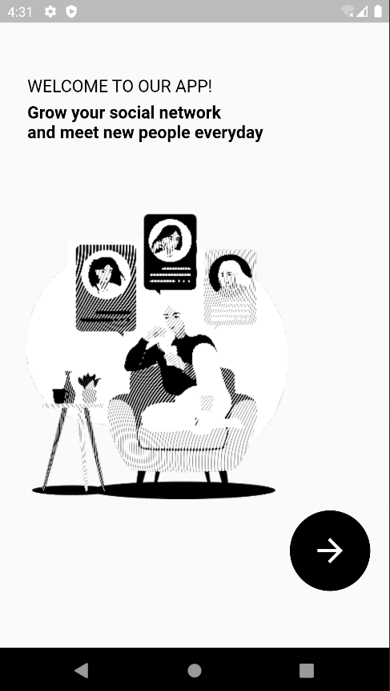
This is the onboarding screen which is made to welcome the new user. It would be annoying to keep seeing this welcome screen over and over that’s why it’s only visible for people on the first time ever in the app otherwise it will not be shown
Figure 5welcome screen

Sign up screen

After, the user is asked to register new account. Note that the app indicates that it’s the user first time in the app that’s why it lands the user in signup page

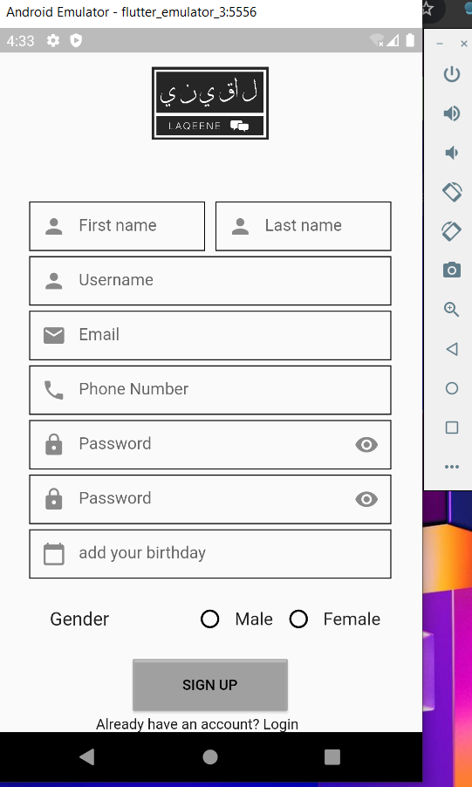
Figure 6 signup page

Form validation:

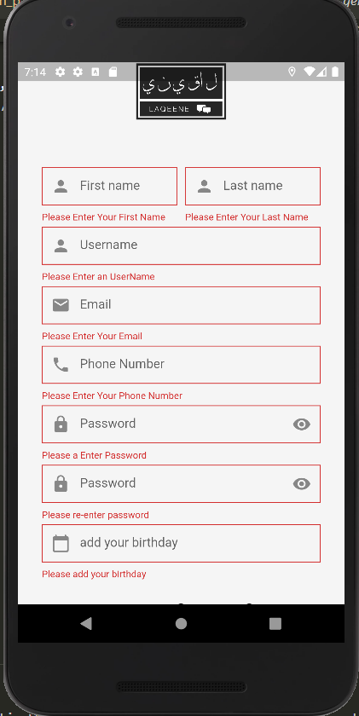
Figure 7 Signup form validation
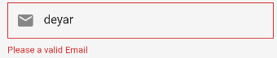
Figure 8 email field validation

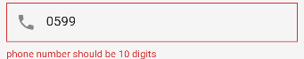
Figure 9 phone number validation


Figure 10 obscure text


Figure 11 unhide password
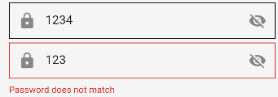
Figure 12 password and confirm password

There are some limitations in the information like, Username, phone number ,and email they must be unique. or a warning massage will appear.


Figure 13 phone is taken message

Figure 14 username is taken message

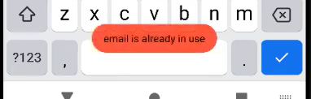
Figure 15 email is taken message

Create profile screen

After sign up the user needs to create his/ her profile, And even if he/she leave the application they would comeback to the profile page .nothing is required in the profile page u could leave your profile empty

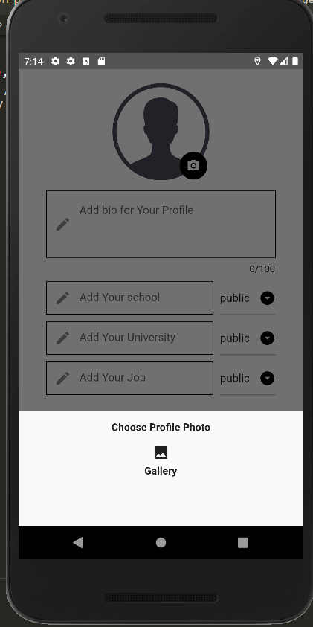
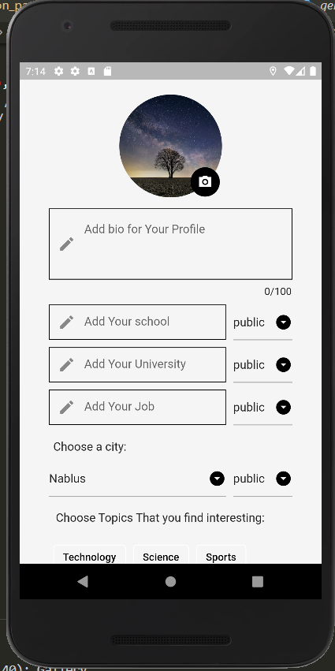
Figure 16 choose profile image 1
Figure 17 create profile

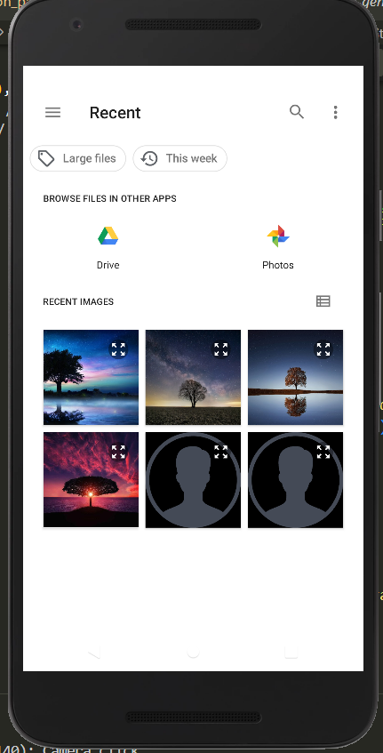
Figure 18 choose profile image 2

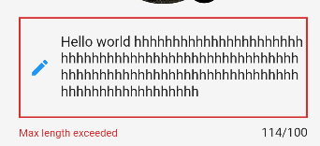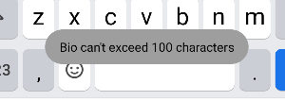
Figure 19 bio validation

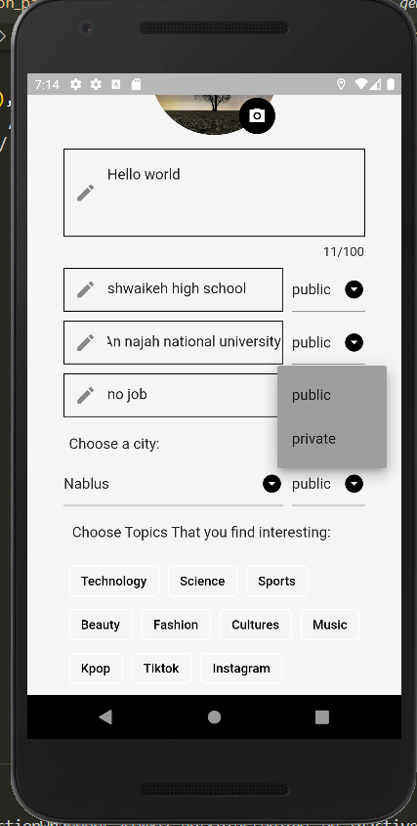
Figure 20set privacy

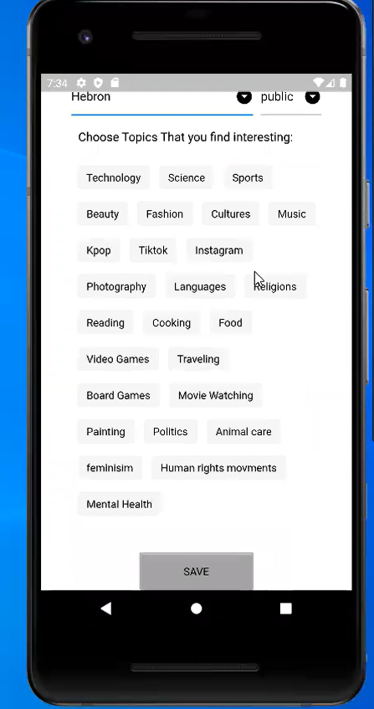
Figure 21 add your interests

Home screen
As soon as you registered/logged in the app, the system will ask for permission to your location .Home screen is a map that shows your location and any dates around you in the visible area of the map

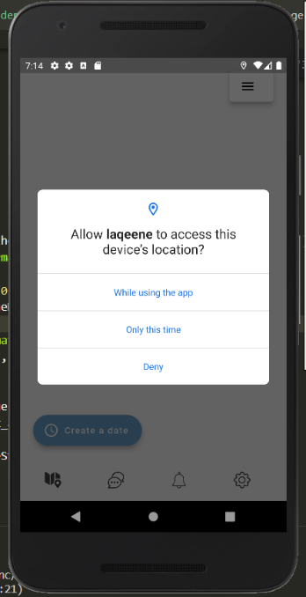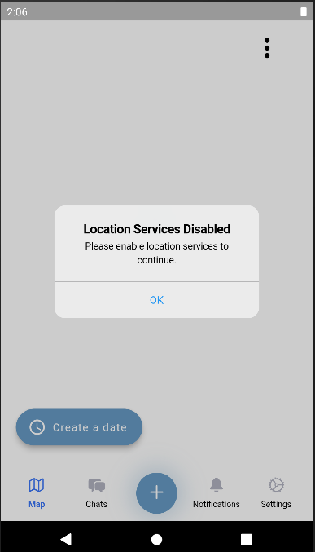
Figure 22 location permissions
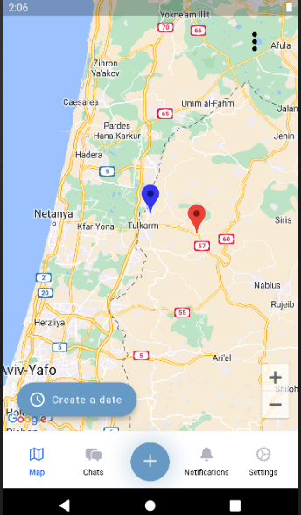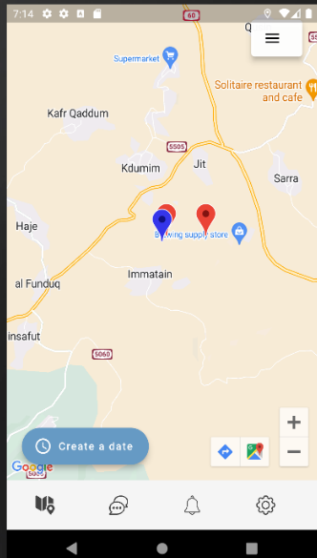
Figure 23home page
From create a date button, you could make your own date, as mentioned before
Adding description, date, start time, and end time is required. For age gap and gender , if not selected the app will use the default value which are no gender and any age gap between 0 to 100 is acceptable

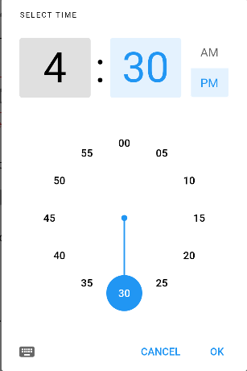
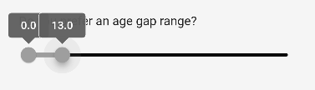
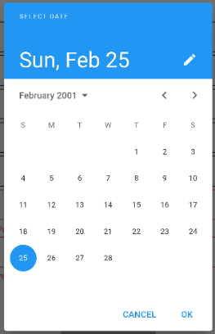
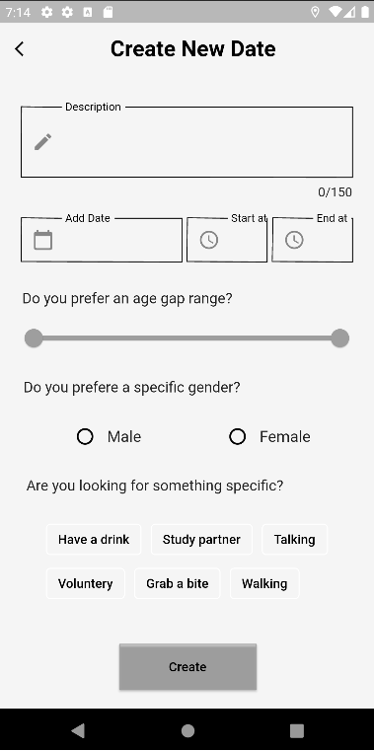
Figure 24create date
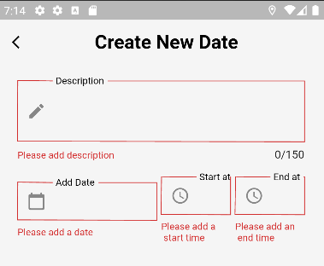
Figure 25create date required fields

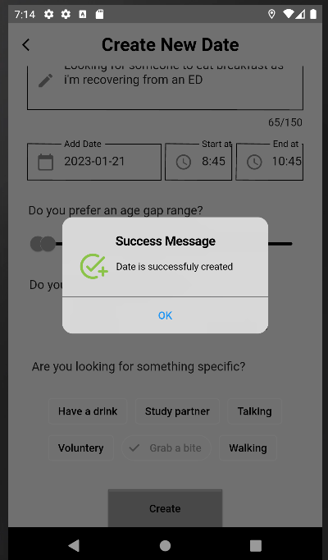
Figure 26create date success message

Edit profile page
User could edit his profile image, or any other parts from his profile, also change his/her interests

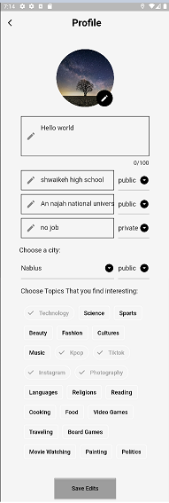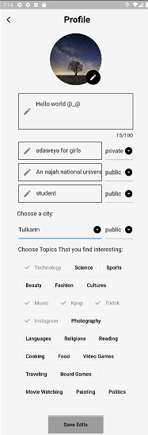

View date
When clicking on the red marker on the map(the blue one is your location)
. you will be able to see who created the date , the distance between you and them , their gender, the age gap between the two of you, the date description they wrote, the date, start time , end time and tags if any
You could send request to the creator to join him/her on the date by clicking join
The Haversine formula is used to calculate the distance between two points on Earth. The formula takes into account the Earth's curvature and calculates the shortest distance (great circle distance) between two points on a sphere. The formula requires the latitude and longitude of both points, as well as the radius of the Earth (which is often assumed to be 6,371 km).
Haversine formula is:
a = sin²(Δlat/2) + cos(lat1).cos(lat2).sin²(Δlong/2)
c = 2.atan2(√a, √(1−a))
d = R.c
Where lat1, long1 and lat2, long2 are the latitude and longitude of the two points, R is the radius of the Earth, and d is the distance between the points.
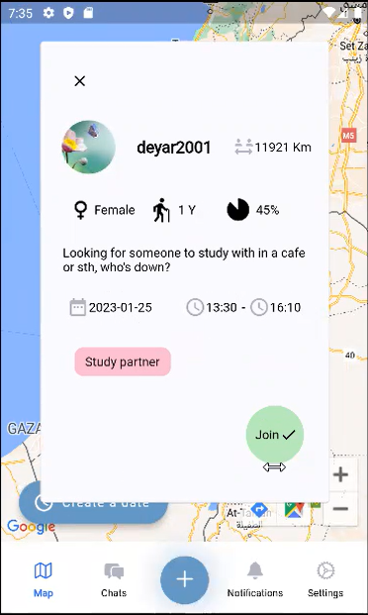
Figure 27 view date
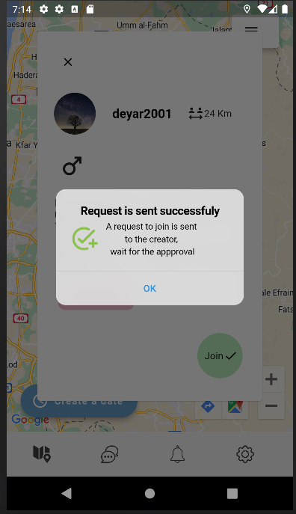
Figure 28request to join

Other profile page
By clicking on the user image in the date page you can view his /her profile , you can only view what is public

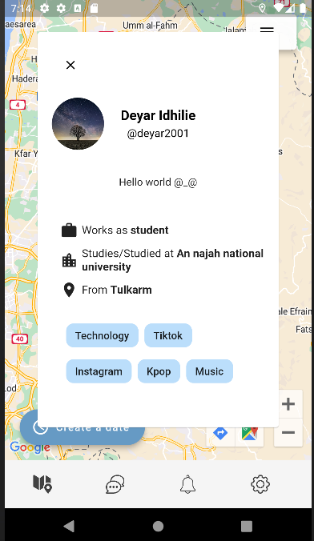
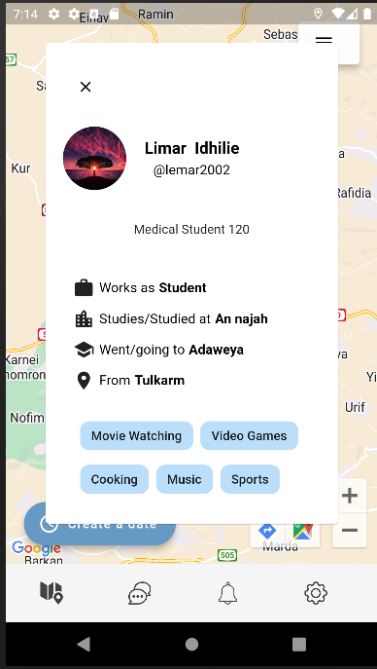
Figure 29others profile

Notifications and requests page:

In this page the user could see who requested to join his date , he could accept, decline or leave it hanging . Note that when the user accept a request all the other requests that are made by others for the same date will be declined automatically.

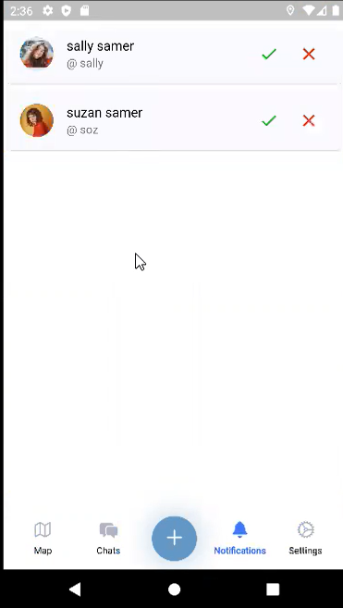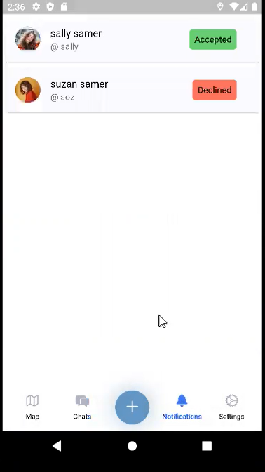
Figure 30 notification page

Chats screen

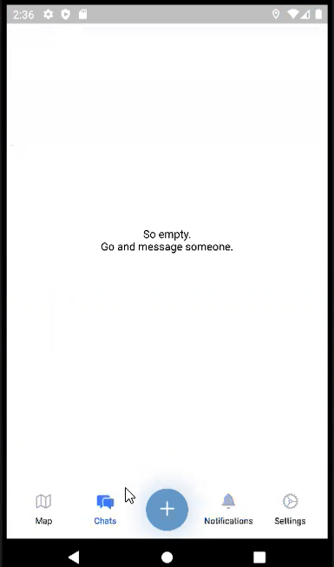
Figure 31 chat page

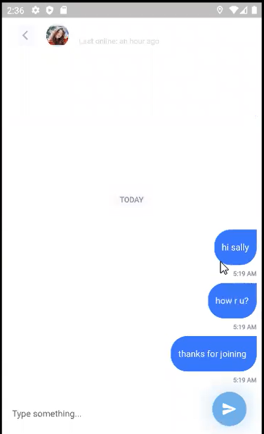
Figure 32chat screen
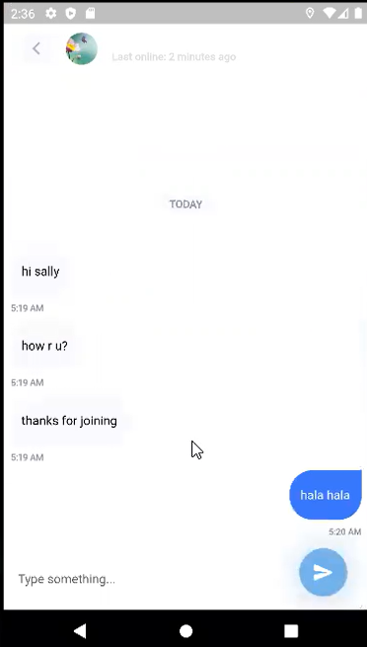
Figure 33the other user chat screen
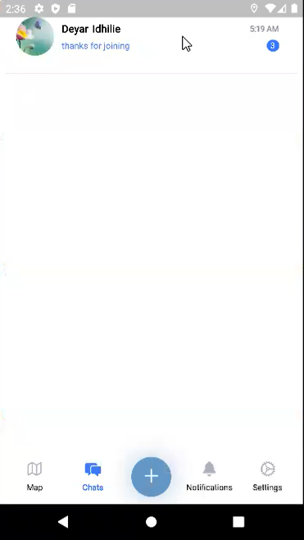
Figure 34the other user chat page

Log in screen
You either login using your phone number or username

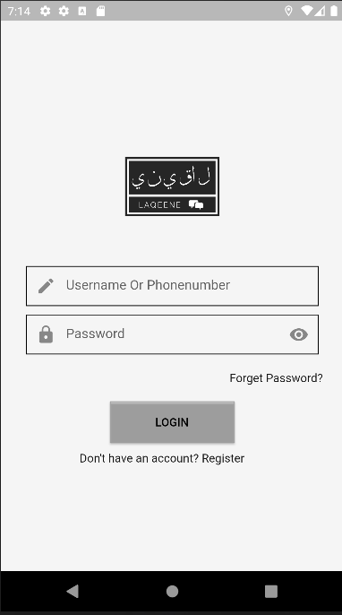
Figure 35login page

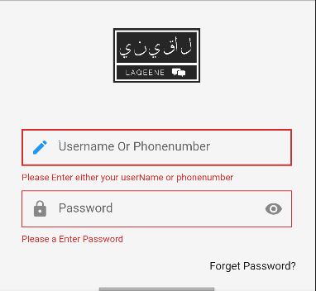

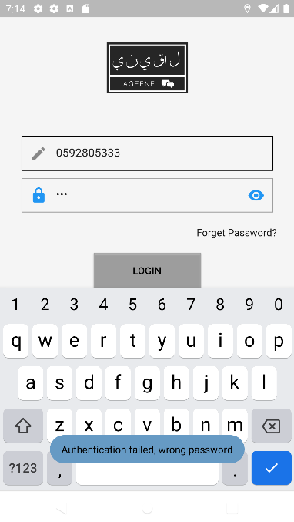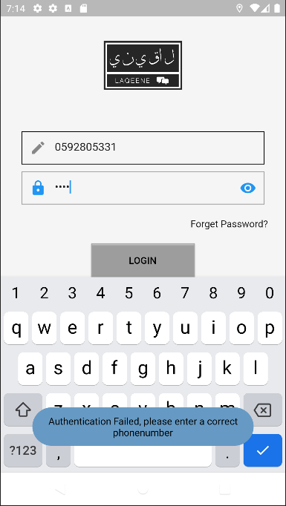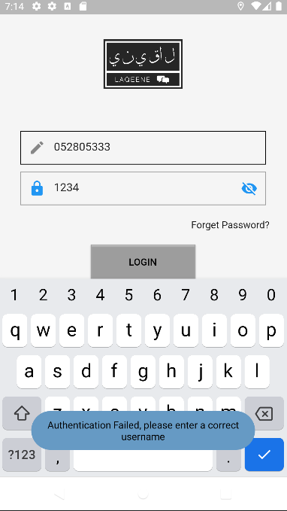
Figure 36 login form validation

Forget Password

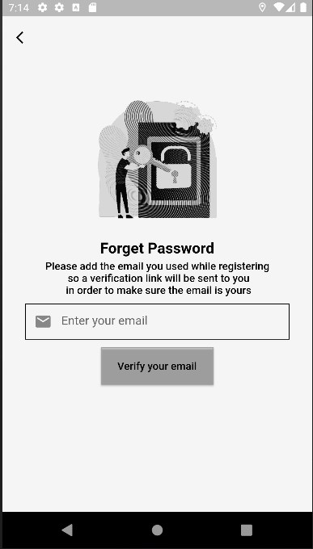
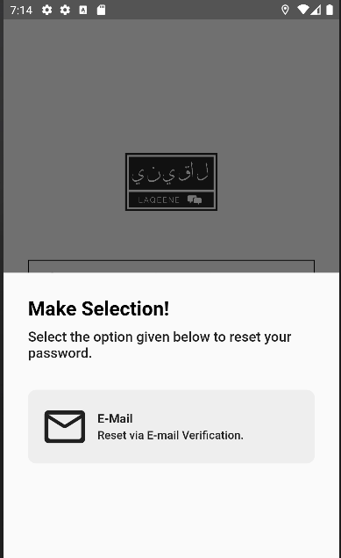
Figure 38forget password
Figure 37enter email

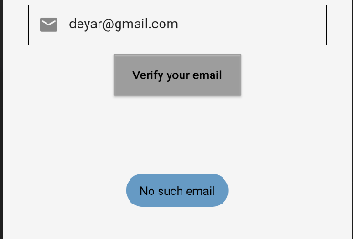
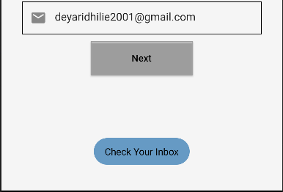
Figure 39email validation
Figure 40check the inbox


Figure 41verification email

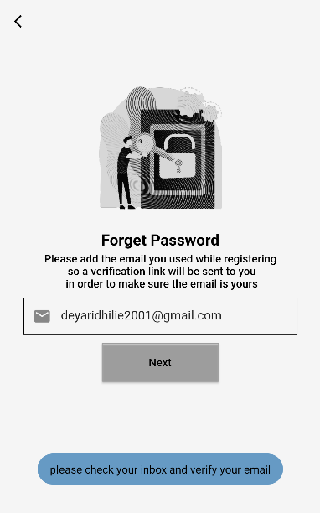
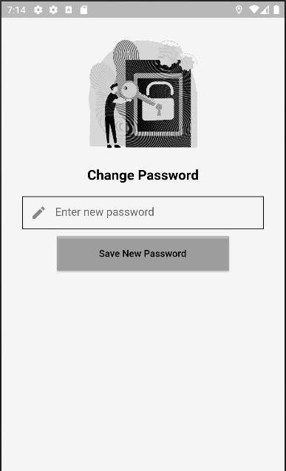
Figure 42 change password page

Machine learning : Find how much people are similar using cosine similarity

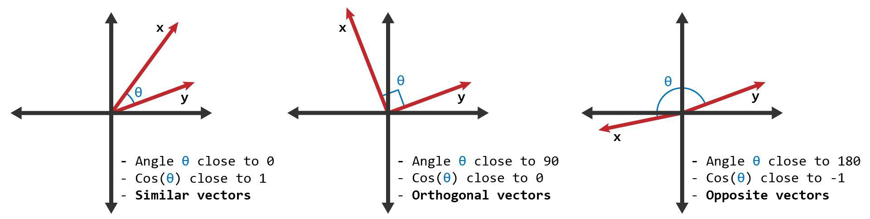
Figure 43cosine similarity

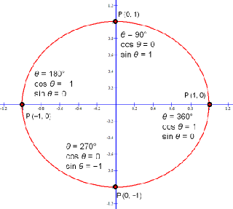
Cosine similarity is a measure of similarity between two non-zero vectors of an inner product space that measures the cosine of the angle between them. Cosine similarity ranges from -1 to 1, where 1 is the similarity between two identical vectors and -1 is the similarity between two vectors that are completely dissimilar.
In machine learning, cosine similarity is often used as a similarity metric in natural language processing and information retrieval tasks. For example, it can be used to measure the similarity between two documents by representing each document as a vector of its word frequencies, and then computing the cosine similarity between the two vectors. This can be used in tasks such as document retrieval and clustering.
It can also be used in recommendation systems, where the similarity between users or items is computed using cosine similarity. This can be used to recommend items to users that are similar to items they have previously liked.
Cosine similarity is also often used as a distance metric in clustering algorithms such as k-means and hierarchical clustering. In these algorithms, the similarity between two points is computed as the cosine of the angle between their feature vectors, and points that are similar are grouped into the same cluster.

When the user enter his/her interests , A map in created that indicates what he is interested in and what’s not from all the options he/she were given. Then a vector of those 0 and 1 s are generated. When the user request to get the date around a list of active users is generated and by accessing the vector saved in the user document , the cosine similarity is calculated between the user and those active users. The similarity value between each one and the user will be returned in the date body do the user could view

. 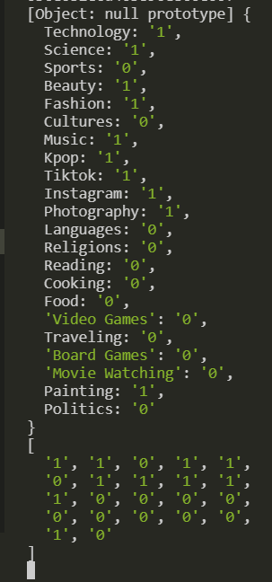
Figure 44 data set

Results and Discussion

As a result of this course , I was able to build this social meeting application ,
That -and after many people saying this – people would love to have such application in our country . I was able to fill my proposal requirements
Learning
IN this experience I had to learn and use flutter for the frontend, Node JS for the backend and use Mongo DB for the database. In addition to the increase of my ability to search and find solutions for my questions

Challenges
The unfortunate life we live as Palestinians that made this semester hard on every individuals .The lack of decent internet connection and the emulator crazy cpu usage were the main challenges for me.

Conclusions and Recommendation
Conclusion
we were able to create LAQEENE application as a solution for the lack of the needed human interaction for some

Recommendations
In order to improve the application, we can add choose place to go options and make profits by taking a percentage from any reservation made by us

What was learned
- Flutter framework with dart language
- On the Server side we used Node js language witj express framework.
- Build Restful API requests

- References

- Fanni App – app on google play
- https://flutter.dev/
- https://www.mongodb.com/docs/manual/

