

An-Najah National University

Faculty of Engineering

Energy and Environmental Engineering Department
Energy Management of a Green Building using Simulation software – Applied in Scientific Academy School
Graduation Project-II
submitted to:

Department of Energy and Environmental Engineering Faculty of Engineering and Information Technology

An-Najah National University

In partial fulfillment of the requirements for a Bachelor degree in Energy
and Environmental Engineering

Supervisor Name: -
Dr. Mohammed Alsayed

Students Name:-
Leena Abu Alrub
Rawan Tuffaha

May 2021

Declaration

We hereby announce that the project titled " Energy Management of a Green Building using Simulation software – Applied in Scientific Academy School " will be submitted to the College of Engineering and Information Technology, especially to the Energy and Environmental Engineering Department at An-Najah National University, to partially achieve the Bachelor's degree in Energy Engineering. And this project will not be submitted to any other place for granting any other degree.

Acknowledgments

First, we thank God for granting us the ability to complete this project completely and successfully. We grabbed this opportunity to express our gratitude and thanks to all who contributed to help us to complete this project as it should be done.
We would like to express our sincere gratitude to our supervisor Dr. Mohamed El-Sayed for his extraordinary support, for his patience, and motivation. He is helping us and giving us advice and guidance and counseling.
We also want to thank our families and friends and colleagues for their continued support throughout the study period. Furthermore, we thank all the teaching staff and assistants for their great help.

Table of Contents
Declaration I
Acknowledgments II
List of Figures V
List of Tables VI
Nomenclature VIII
Abstract 1
Ch.1 Introduction 2
1.1 General Background 3
1.2 Leadership in Energy and Environment Design(LEED) 3
1.2.1 History of LEED 3
1.2.2 LEED Certification Benefits 4
1.2.3 LEED Rating System 4
1.2.4 LEED Certification 5
1.2.5 LEED Prerequisites, Credits, and Points 7
1.3 Scientific Academy School 9
1.4 Problem Statement 10
1.5 Research Objective 10
1.6 Research Question 11
1.7 Report Structure 11
Ch.2 Literature Review 12
Ch.3 Methodology 18
3.1DesignBuilder Software 19
3.2Energy 3D Software 19
3.3PVsyst Software 20
Ch.4 Data 21
4.1 Data Collection 21
4.2 Data Analysis 22
4.2.1 Model Inputs-Constant 23
4.2.2 Model Inputs-Variables 26
4.3 Equations 28

Table of Contents
Ch.5 Result and Discussion 29
5.1 First semester 32
5.1.1 Base Case 32
5.1.2 Case One 36
5.2 Second Semester 40
5.2.1 Base Case 40
5.2.2 Case One 44
5.3 Case Two 48
5.3.1 Design 48
5.3.2 Result of PV module. 50
5.4 Saving 52
Ch.6 Conclusion 54
References 55

List of Figures
Figure 1: LEED Certification 8
Figure 2:Plan of the ground floor in school 9
Figure 3:The general structure of data flow 21
Figure 4:Building Shell in DesignBulider. 23
Figure 5:Building Shell in Energy3D 24
Figure 6:Activities Definition of Ground floor 24
Figure 7:Layers of external walls 28
Figure 8:The distribution of daylight factor in the Ground floor. 31
Figure 9:The distribution of daylight factor in the First floor. 31
Figure 10:The distribution of daylight factor in the second floor 31
Figure 11:simulation result in the first semester for thermal comfort in Base Case 34
Figure 12:The fanger graph of the school building in first semester Base Case 34
Figure 13:The heating load of the school building in the first semester Base Case. 35
Figure 14:The cooling load of the school building in the first semester Base Case. 35
Figure 15:simulation result in the first semester for thermal comfort in Case One 38
Figure 16:The fanger graph of the school building in first semester Case One. 38
Figure 17:The heating load of the school building in first semester Case One 39
Figure 18:The cooling load of the school building in first semester Case One 39
Figure 19:simulation result in the second semester for thermal comfort in Base Case 42
Figure 20:The fanger graph of the school building in second semester Base Case 42
Figure 21:The heating load of the school building in second semester Base Case 43
Figure 22:The cooling load of the school building in the second semester Base Case. 43
Figure 23:simulation result in the second semester for thermal comfort in Case One 46
Figure 24:The fanger graph of the school building in second semester Case One 46
Figure 25:The heating load of the school building in second semester Case One 47
Figure 26:The cooling load of the school building in second semester Case One 47
Figure 27:Simulation from PV system 48
Figure 28:Power, module area and number and power of inverter. 48
Figure 29:Distribution of Cells 49
Figure 30:Normalized productions (per installed kWp) 50
Figure 31:Performance Ratio PR. 50

List of Tables
Table 1: Energy conservation measures. 18
Table 2: Site Location 23
Table 3: The Designed temperatures. 25
Table 4: Building Envelope Constructions for Roof. 25
Table 5: Building Envelope Constructions for the Ground floor. 25
Table 6: Building Envelope Constructions for the internal floor. 26
Table 7: Building Envelope Constructions for internal partitions 26
Table 8: Building Envelope Constructions for doors 26
Table 9: Window type. 26
Table 10: The lighting load. 27
Table 11: Layers of external walls. 27
Table 12: Thermal properties. 28
Table 13: Area Building. 29
Table 14: Daylight Factor in some spaces of Ground floor 29
Table 15: Daylight Factor in some spaces of First floor 30
Table 16: Daylight Factor in some spaces of Second floor 30
Table 17: Site Energy 32
Table 18: End Use. 32
Table 19: Utility Use per Conditioned Floor Area 33
Table 20: Utility Use per Total Floor Area. 33
Table 21: Comfort and Set point Not Met Summary 33
Table 22: Total heating and cooling capacity design 33
Table 23: Site Energy 36
Table 24: End Uses 36
Table 25: Utility Use Per Conditioned Floor Area 37
Table 26: Utility Use Per Total Floor Area 37
Table 27: Comfort and Set point Not Met Summary 37

List of Tables
Table 28: Total heating and cooling capacity design 37
Table 29: Site Energy 40
Table 30: End Use 40
Table 31: Utility Use Per Conditioned Floor Area 41
Table 32: Utility Use Per Total Floor Area 41
Table 33: Comfort and Set point Not Met Summary 41
Table 34: Total heating and cooling capacity design 41
Table 35: Site Energy 44
Table 36: End Use 44
Table 37: Utility Use Per Conditioned Floor Area 45
Table 38: Utility Use Per Total Floor Area 45
Table 39: Comfort and Set point Not Met Summary 45
Table 40: Total heating and cooling capacity design 45
Table 41: Balances and main results 51
Table 42: Total site Energy Saving 52
Table 43: Total Heating Saving 52
Table 44: Total Cooling Saving 52
Table 45: Total Lighting Saving 53
Table 46: Utility Use Per Total Floor Area Saving 53
Table 47: Time Not Comfortable Saving 53
Table 48: Total Heating, Cooling Capacity Saving 53

Nomenclature

HVAC | Heating, Ventilation, and Air Conditioning. | GlobHor | Global Horizontal Irradiation.
BEIT | Buildings Energy Investigation Tools. | DiffHor | Horizontal Diffuse Irradiation.
LEED | Leadership of Energy and Environmental Design. | T_Amb | Ambient Temperature.
DDM | Degree Day Method. | GlobInc | Global Incident in Coll. Plane.
LCC | Life Cycle Costing. | GlobEff | Effective Global, Corr. for IAM and Shadings.
DD | Degree Days. | EArray | Effective Energy at the Output of the Array.
SPBP | Simple Payback Period. | E_Grid | Energy Injected into Grid.
EMO | Energy Management Opportunities. | PR | Performance Ratio.
ECMs | Energy Conservation Measures. | TRNSYS | Transient Systems Simulation Program.
kWh | kilo Watt-hour. | USGBC | United States Green Building Council
LED | Light-Emitting Diode. | GBES | Green Building Education Service
PV | Photovoltaic. | ASHRAE | American Society of Heating, Refrigerating and Air-Conditioning Engineers
EMS | Energy Management System. | EE | System for Built Environment Efficiency.
IEQ | Indoor Environmental Quality. | CASBEE | Comprehensive Assessment System for Built Environment Efficiency.
BIM | Building Information Modeling. | ND | Neighborhood Development.
UK | United Kingdom. | O+M | Building Operations and Maintenance.
ESP-R | Environmental Systems Performance – Research. | ID+C | Interior Design and Construction.
BLAST | Basic Local Alignment Search Tool. | BD+C | Building Design and Construction
HVAC-SIM+ | HVAC SIMulation PLUS. | kW | kilo Watt.
BREEAM | Building Research Establishment Environmental Assessment Method. | NIS | New Israel Shekel.

Abstract

The concept of green buildings has emerged recently to help solve some issues related to the environment, energy, and economy. To meet green building requirements, this report describes an integrated design approach to improving energy efficiency in schools using simulation software.
Therefore, work has been done on adjusting several parameters of the largest energy consumption by referring to the basic condition of the building taken in the simulation. The lighting system was modified by changing the type of lighting used in the basic scenario of the school, in addition to improving the building envelope to liberate the performance of the HVAC system by changing the type of glass used for windows and adding insulation to the external walls.
The results showed that, after introducing modifications to the school building envelope, the total site energy per kilowatt-hour consumed during the school year was reduced from 106,654 kWh in the base case to 91,022 kWh in case one. While the total savings between the two cases annually is about 9,379 NIS, and the total savings for the month is 1,172 NIS. Thus, a saving of 14.66% of the total site energy consumption needs can be achieved.

Ch.1 Introduction

Green buildings are a structure that indicates efficiency in our use of the resources available to us and responsible for the environment throughout our life. It is a balance between two key factors, the sustainable environment and the construction of buildings. Sustainability refers to meeting the needs of the current generation without tampering with or compromising future needs. Therefore, we must primarily and principally care when designing and constructing buildings, at a very important point, which is to reduce the annual energy consumption in buildings as much as possible, so that we have an opportunity to provide it for the future. We can use renewable energy sources to help us save energy. For example, it is worth taking into account when designing buildings, the direction of the sun, or the general weather conditions in the area, which helps us reduce the use of external heating and cooling systems. The Green Building Council in Palestine was established in 2011 and its main objective is to raise awareness and help backward sectors to work with the standards of the World Green Building Council.
Our cities' growth and prosperity have a significant effect on our natural ecosystem. Many of our natural resources are used in the manufacture, planting, maintenance, and service of the buildings in which we live and work.
Buildings account for 40% of electricity consumption, 38% of greenhouse gas emissions, 12% of potable water, and 20% of solid waste sources in developing countries, according to Maggie Comstock, a former policy advisor at the USGBC (Comstock, 2013).
Buildings have been described by the Intergovernmental Panel on Climate Change as the most effective and least expensive way to minimize greenhouse gas emissions and combat climate change. Green buildings have many co-benefits in addition to reduced pollution and environmental conservation, such as cost savings, job growth, and increased human wellbeing and productivity. To achieve tangible results in this area, the green building sector should make concerted efforts to incorporate and jointly support different means, such as research, technology, economic initiatives, regulation, and administration.
Green architecture, energy conservation, and carbon control should be brought to the attention of city planners and architects. Simultaneously, planning and construction institutes can hire more people in fields like structural technology, urban ecology, indoor air quality, water and wastewater systems, heating, cooling, and air conditioning, and energy conservation. Experts from different backgrounds should be able to participate in architecture and planning through a mechanism. Planning for regional energy sources can also be introduced.

General Background

Knowledge of energy investigation tools is essential for both engineers and builders to provide useful designs in their buildings. Building Energy Investigation Tools (BEIT) studies the energetic energy requirements of a building by using computer models and imitation techniques. Also, it plays an important role in helping to plan, commission, and evaluate buildings. It also supports the engineers' work in adopting an energy-efficient and cost-effective building design and helps them judge different design options. BEIT assists constructors and designers in identifying the potentials for energy savings and thus assessing the energy performance of the building. Today, many BEITs are available that focus only on simplified rapid energy analysis (i.e. annual energy use in buildings).
In this study, the school was used to predict data using the BEIT. Alongside the results of the DesignBuilder, Energy3D, and PVsyst software in which the technique of detailing the construction of walls and ceiling is included to better analyze the data. The current work has been divided into which are the visualization of the structure, the training of input data in a format usable directly for energy testing and analysis. The report highlights making this building more energy-efficient and trying to reduce the amount of energy it consumes annually during operation.

Leadership in Energy and Environment Design(LEED)

(GBES, 2014) defines LEED as "Leadership in Energy and Environmental Design." LEED is a cutting-edge certification scheme for high-performance buildings and sustainable communities.

History of LEED

The LEED Green Building Rating System was created by the United States Green Building Council (USGBC), and it is the USGBC's primary vehicle for encouraging environmental architecture and development. The LEED rating system was developed by volunteer committees. Between 1994 and 2013, LEED evolved from a single new building standard to a complex set of interconnected requirements that encompassed all facets of the development and construction process. LEED has now expanded from six volunteers on one committee to nearly 200 volunteers on nearly 20 committees, as well as nearly 150 experienced employees.
LEED was developed to achieve a range of specific objectives, including identifying "green building" by creating a shared measuring system, promoting integrative; whole-building design practice, recognizing environmental leadership in the construction industry, simulating green competition, raising customer understanding of green building benefits, and transforming the construction sector. Also, LEED aids in the evaluation of a building's success during its life cycle. Also, LEED aids in the evaluation of a building's success during its life cycle.

LEED Certification Benefits

For the life of the house, LEED certification saves money. Green architecture has several financial advantages, including reduced maintenance costs, improved building value, higher occupancy rates, and higher rentals. Simply put, LEED-certified buildings use core services more effectively than traditional buildings that are designed under code or on a tight budget. Buildings that have earned the LEED certification have cleaner jobs and working conditions, which leads to increased efficiency and better employee fitness and convenience. The USGBC has also assembled a lengthy list of advantages of pursuing a LEED policy, which includes everything from improved air and water quality to reduced solid waste, all of which favor residents, occupiers, and society as a whole.

LEED Rating System

LEED is a versatile device that can be extended to a variety of building styles (commercial vs. residential) and extends beyond the footprint of the building. Because of this versatility, various LEED models are available based on the project type.
There are four major types in LEED ranking systems:
- Building Design and Construction (BD+C)
There are ten LEED ranking systems in the first division, Building Design, and Construction. These classification schemes serve as recommendations for both new construction and repairs of existing structures. This group includes structures such as schools, hospitals, stores, data centers, warehouses, office buildings, and residential buildings.
- Interior Design and Construction (ID+C)
Interior Design and Construction is the second level, which was created primarily for renters leasing a part of a larger property.
This includes the interiors of commercial houses, department stores, and hospitals. This alternative will be pursued by a company leasing commercial office space or, for example, a Starbucks in a strip mall.

- Building Operations and Maintenance (O+M)
Building Operations and Maintenance is the third level, which may be used by building owners and managers to assess operations and maintenance as well as make small modifications without having to install it. This group includes schools, hospitals, stores, data centers, and warehouses.
- Neighborhood Development (ND)
The fourth and final division is LEED for Community Development, which is the first nationwide initiative for neighborhood planning which incorporates the concepts of smart growth, urbanism, and green building. LEED-ND refers to new land construction and redevelopment projects that have residential, nonresidential, or mixed-use components. From strategic design to building, projects will be at any point of the production phase.
Any neighborhood-scale project that is currently in any stage of planning and construction and is up to 75 percent completed is qualified for LEED-ND Plan designation. This service was created by the USGBC to assist developers in marketing and funding their developments to potential tenants, financiers, government officials, and others. By reaffirming their long-term sustainability plans LEED-ND Built Project is intended for neighborhood-scale developments that are nearing completion or have recently been completed.

LEED Certification

To receive LEED certification, a construction project shall meet certain requirements and targets in the following categories:

- Location and Transportation
The location of a building is almost as significant as how it is constructed, and it is an important aspect of a green building. Via its place, a building can meet the needs of the local population, encourage active street life, foster healthier lifestyles, and help to reduce greenhouse gas emissions in a variety of ways. When selecting a construction site, it is better if the project (building) is linked to the city through walking pathways and cycling lanes, allowing people to ride their bikes or walk to the building. To use public transit, both of which help to reduce the greenhouse emissions associated with commuting. Mention that walking or biking instead of driving helps to minimize air pollution while also encouraging physical exercise.

- Materials and Resources

Any structure's base is made up of materials. Green houses, in particular, should mitigate the embodied impacts associated with the whole life-cycle of construction materials, reduce the harms associated with materials by using fewer, identifying materials with environmentally preferable qualities, using locally harvested materials, and reducing wastes.

- Water Efficiency
The primary goal of sustainable construction is to reduce water use while still ensuring water quality. Sustainably using scarce water supply to realize more functions and making it more effective by recycling or irrigation is what sustainable water use entails in general. Water conservation contributes to the protection of our aquifers and clean fresh water supplies by decreasing the amount of water used for buildings and landscaping, reducing urban water usage, and reducing the need for water treatment (GBES, 2014).

- Energy and Atmosphere
The importance of energy efficiency is growing by the day when the causes of global warming and air pollution are related to rising energy consumption and fossil fuel burning.
In houses, energy efficiency involves using less energy and promoting the use of more environmentally sustainable sources of energy.
Green buildings can minimize energy demand by harvesting renewable, event energy such as sunshine, wind, and geothermal potential, as well as encouraging local energy uses to reduce loads.
Green buildings also encourage energy conservation, which means they use less energy to do the same amount of work.

- Sustainable Sites
Site preservation refers to the interaction between a building and the world around it, as well as the creation of synergies between the two. It encompasses a variety of policies that understand the critical partnerships between structures, landscapes, and ecosystem services. It focuses on restoring project site features, connecting the site with local and regional habitats, and preserving the site's natural resources. Integrating the site with local and regional habitats, as well as protecting the biodiversity that natural systems depend on

- Indoor Environmental Quality
The environments inside a house, including air quality, lighting, thermal conditions, acoustics, and their impact on occupants, are referred to as indoor environmental quality.
Better indoor environmental quality benefits human health, improves the quality of living, decreases discomfort and future accidents, can improve the lives of building tenants, increases the building's resale value, and reduces responsibility for building owners.
The key goal of any strategy used to improve indoor environmental conditions is to provide relaxing and pleasant spaces for inhabitants while reducing the likelihood of building-related health issues.

LEED Prerequisites, Credits, and Points

- Prerequisites :
LEED (Leadership in Energy and Environmental (GBES, 2014) Certification translates to cleaner, more sustainable living, learning, working, and playing environments for us, as well as reduced environmental tension. by promoting energy- and resource-efficient construction. Although project managers may select the credits they choose to receive, prerequisites provide the minimum criteria that must be met by all buildings to obtain LEED certification.
Additionally, completing prerequisite conditions would not earn you any points. Any LEED Rating System starts with a set of prerequisites. Since prerequisites are needed for the project to be accepted, they do not award the project any points. A mandatory project feature, calculation, efficiency, importance, or feature as defined by the LEED rating system is referred to as a "prerequisite." The core requirements that determine green building success are called prerequisites. Each project must meet all of the requirements outlined in the LEED rating framework to be registered. A proposal would be ineligible for approval if it fails to fulfill all of the prerequisites.

- Credits :
These are the features that set a built structure apart from the others. As a building owner/manager/etc., you have complete freedom to pursue whatever credit you choose under your preferred ranking scheme, as long as it is applicable to your project class. Certain credits complement prerequisites or also other credits, resulting in synergistic effects. Each category of sustainability has a set of credits that identify a specific sustainability target. The credit's 'purpose' refers to the credit's sustainability target. It is not necessary for the project to receive any of the credits. Credits are an extra feature. Just enough credits for the qualification standard the project is striving for – certified silver, gold, or platinum – are required. The project is therefore exempt from submitting any paperwork for credits that it is not pursuing.
A non-mandatory project characteristic, measurement, efficiency, worth, or feature as defined within a LEED rating system is referred to as "credit." Credits are specific aspects of urban architecture that add to the overall success of a green building. There is no single credit that is required; credits are chosen and sought at the discretion of the LEED project team.

- Points :
The bigger the payout, the more points you have. There are many benefits of LEED certification, ranging from cleaner spaces to buildings that conserve money and energy.
The amount of LEED certification a project receives is determined by the number of points it receives. There are four qualification levels shown in figure 1:
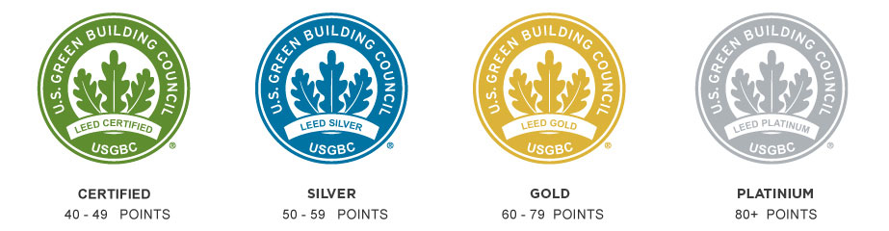
Figure 1: LEED Certification

Scientific Academy School

The Scientific Academy School is located in Jenin city, in the West Bank of Palestine. This school includes the primary to intermediate stages, and it consists of 3 floors with a total area of 2516.70 square meters, in addition to large outdoor spaces. It includes a large number of classrooms in addition to scientific laboratories and public facilities such as dining halls and bathrooms. Figure 2 shows the architectural plan for the ground floor of the proposed model.

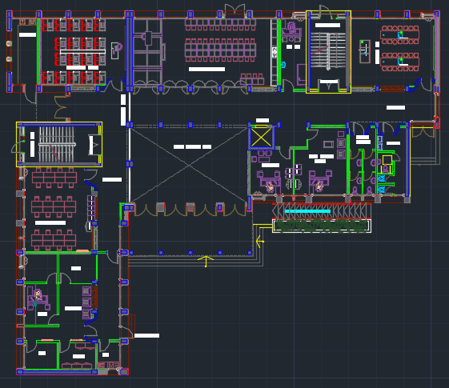
Figure 2: Plan of the ground floor in the school.

Problem Statement

The health and environmental consequences of consumer redesign are usually not well understood. So that the building laws and local regulations clarify the instructions and instructions for homeowners and builders, but these laws focus mainly on safety issues and energy efficiency standards. Modern building science also guides us that a better job can be done to protect consumers and provide the best for them. Over the past years, the focus in green buildings has been on the commercial and institutional building sectors, and this is due to the success of the Green Building Council and its Leadership in the field of Energy and Environmental Design (LEED) classification system. The challenges of green buildings are currently receiving wide attention. Efforts to influence the market are confusing and disjointed for the consumer.
As the design of green buildings in Palestine in particular, poses some challenges, for example, global environmental standards are additional requirements for Palestinian workers and contractors who are accustomed to the old and traditional methods of building and maintaining the site. There are many simulation tools available to us, but there is a clear lack of studies encouraging the use of these programs in Palestine to simulate buildings and obtain the greatest amount of energy savings. Even the concept of green buildings is not considered and taken into account when building.

Research Objective

The main objective of this report is to model the building of the Scientific Academy School in Jenin city, which is one of the few local buildings classified as green buildings, with an emphasis on the efficient use of available resources, to reduce the amount of energy consumed during operation and thus reduce the costs of the entire building, and reduce the cost of maintenance and the need for renovation using the DesignBuilder, Energy3D, and PVsyst software. It is known to us that the green building concept is a guarantee that the business will remain protected from any increase in energy prices in the future. To do so on the chosen case study, this research is intended to fulfill the following objectives:
- Build a suitable model and check its accuracy
- Proposing, analyzing, and comparing potential EMO
- Drawing a suitable action plan.

Research Question

Is modifying some of the building's specifications to make it energy efficient be significant, and Is the use of simulation tools for energy economically feasible or not?

Report Structure

In this report, the life cycle cost of the school that is declared will be analyzed. Where the operation will be on several scenarios of energy consumption, and then compared to the current basic consumption, to determine the groups that will lead to the reduction of the cost of the life cycle. Where this research framework can be summarized as follows:
1- Selecting some measures by which energy can be conserved on-site and simulated through the DesignBuilder, Energy3D, and PVsyst software.
2- Analysing the energy consumption results of the selected measures.
3- Calculating the life cycle cost of the building after all the measures that have been taken and applied.

Ch.2 Literature Review

Many studies have shown that energy and water efficiency measures are required to improve building performance and resource consumption, which played an essential role in the promotion and development of our research. [1]1st In a 2014 study, researchers looked into the impact of shading devices in enhancing building energy efficiency in both hot and dry climates. The Energy Simulator (TRNSYS) tool was used to investigate the influence of shading on energy consumption decrease. The research found that, in addition to reducing the cooling energy load by 8%, the efficiency of shade is controlled by the building's design and orientation.
This research also looked into using a shading device to reduce building energy use. [2] A study released in 2004 looked at how energy-saving envelopes are constructed for high and high-rise apartments, and found that factors such insulation, window size, thermal mass, type of glass, and exterior shading, as well as wall insulation, have a negative impact on the annual cooling energy required. And the maximum cooling load in Hong Kong's high-rise apartment structures. The outcome was a 31.4 percent reduction in annual cooling capacity and a 36.8% reduction in initial cooling load. [3] In 2011, a scholarly report on developing zero-energy buildings in Jordan was published. An examination of Jordanian home energy needs, as well as energy conservation potential, was included in the study. It was discovered that adding insulation to a home's outside walls had no substantial impact on the home's cooling load, but it does cut the heating load by 40%. [4] A sustainable city was designed in Jordan in another project. The location of the sustainable city was determined using energy and water indicators, and consideration will be made to merging energy-saving structures with local climate technologies to reduce energy use in buildings. [5] Another study concluded that for the hydroponics facility developed in Jordan, a combination of good ventilation and 50 percent green shading was adequate to reduce the temperature by roughly 10 degrees.[6] In the literature, a study of the building management system has been conducted. The energy scheduling research in a grid-connected residential community with wind energy is an example. [7] A study on how weather impacts the short-term pregnancy prediction generation approach was also released. [8] Data was taken from a previous study to increase building energy efficiency. [9] In 2014, a research report addressing the technological and economic viability of building photovoltaic was published, exploring the possibility of BIPVs in realizing the aim of zero energy buildings. A study was also included in the report that explained the understandable energy yield and viability of BIPVs in many European locales. [10] At Al-Ahliyya Amman University, many techniques to reduce energy to reduce power demand were adopted and explored in one study.
The viability of installing wind and PV systems utilizing traditional carbon nanotube panels was investigated, as well as the upgrading of the building envelope system. According to the findings, the independent hybrid carbon nanotube system was the best option for this strategy. To investigate the efficacy of water use in green buildings, [11In 2016, a study was presented that was a mathematical exercise to quantify how much water is saved by green building practices. A baseline for water use has also been established for all types of buildings to serve as a standard for measuring the efficiency of water supply for specific structures, with green buildings saving an average of 37.6 percent compared to basic buildings. [12] Research of the effects of glass properties on 4 and 20 story buildings, as well as heating and cooling loads for glass wall diversity, is underway. Some findings also demonstrate that for both 20 and 4-story buildings, a maximum of 10 points for Leadership in Energy and Environmental Design (LEED) of up to 20% and 16 points for LEED 100 percent can be reached. Many prior studies, in addition to the ones mentioned above, have contributed to the improvement of building insulation. DDM is used in the majority of these contributions. [13] Using the LCC approach, systematic work was done in one study to find the appropriate insulation thickness for heating purposes in Palestine. After dividing Palestine into three sections, namely the coast, the highlands, and the Jordan Valley, rock wool insulation and polystyrene were considered in the analysis. The findings show that polystyrene insulation performed better in terms of delivering an appropriate lower insulation thickness, with a thickness of roughly 5 cm. The recovery time for rock wool was shorter, ranging from 1 to 1.7 years. Likewise, [14] In 16 Turkish cities, a new study was undertaken using the LCC technique to analyze the effect of five fuels and various types of walls until the ideal insulation thickness for heating was established. As a result, the cities were separated into four climate-related regions. The optimal thickness varied between 2-17 cm in warm towns, whereas the recovery duration was extended to 4.5 years in cold towns due to considerable disparities in climatic conditions between the analyzed locations. Other studies, on the other hand, looked at increasing insulation thickness while lowering emissions (carbon dioxide and sulfur dioxide) and environmental impact. [15] In the case of Denizli, Turkey, the LCC methodology was used, as well as an analysis of the environmental impact of winter heating and the optimum insulation thickness in the exterior walls.
The investigation also took into account coal fuel and expanded polystyrene insulation. The results demonstrated a 46.6 percent reduction in energy usage, as well as a 41.53 percent reduction in carbon dioxide and sulfur dioxide emissions.
Other research in [13] Other methodologies were utilized, such as finding the ideal insulating thickness under the stable conditions of the Tunisian scenario. To estimate the annual cooling transport loads of two distinct types of insulation materials and two distinct wall configurations, the study used the Fourier limited complex method. Following the LCC analysis, the results were analyzed and compared to the DDM methodology. When the two were compared, the findings of the sophisticated finite Fourier transform resulted in better insulation and larger thickness, a longer payback period, and fewer energy savings over the life cycle. The difference between the two approaches was less than 20%. According to some publications, this methodology resulted in an optimal insulating thickness of 5.7 cm and a payback period of 3.11 years.
[16] Based on life cycle cost, the effort has been done to enhance the insulation thickness in exterior walls in this study. This research looked at eight governorates in Palestine. In this study, the composition of meteorological data, energy prices, types of insulation, and an external wall model were all taken into account. Polystyrene and polyurethane were used as insulating materials in the investigation. In the winter, LNG fuel was used for heating, while in the summer, electricity was used for cooling. The results suggest that the kind of insulation and DD have the greatest influence on the thickness of the insulation, Polystyrene costs $ 83 per cubic meter, while polyurethane costs $ 171.43 per cubic meter. The age of the SPBPs ranged from 0.9 to 1.6 years.
To provide a proper learning environment, school facilities must meet certain indoor environmental standards, such as thermal comfort, indoor air quality, ventilation, and a quiet atmosphere. In general, electricity consumption rises in lockstep with the need for indoor environmental comfort, resulting in higher energy expenses in school buildings.
Due to the high cost of electricity, schools should maintain their buildings with an eye on energy saving to save running costs and provide a comfortable interior environment for their pupils. To implement energy conservation measures, building operations must be linked to an effective energy management methodology and proper facilities management practices.
This can be performed by tracking and directing energy usage, which comprises reducing energy consumption utilizing management tactics and pursuing a quality improvement process [17]. The evaluation of energy efficiency should be the focus of the design of an Energy Management System (EMS) [18], It entails a detailed examination of an installation's energy consumption requirements and is an important tool for arming managers with the information they need to make reasonable decisions [19].
Portugal has started a major refurbishment drive for high school buildings during the previous two years. By expanding the currently developed area, this ambitious policy aims to address the physical degradation of the housing stock, as well as environmental comfort, sanitary conditions, and the practical adequacy of teaching and learning facilities. It also comprises the long-term upkeep of the classrooms after they have been modernized, as well as the opening of the schools to the general public [20].
High-rise structures built towards the end of the nineteenth century were able to incorporate any technological progress into their architectural and construction methods. Furthermore, these structures are frequently amenable to experimentation and, historically, have been the type of organization that has encouraged it. As a result, from the time they were first constructed to the present day, High-rise buildings' energy consumption has decreased as a result of advancements in their construction, materials, infrastructure, and service phases. High-rise structures have been divided into five separate energy generations based on their energy usage variances as a result of this continual shift and growth.
The 1916 New York Zoning Law, (2) postwar curtain wall developments, (3) 1970s oil shortages, and (4) environmental consciousness at the end of the 1990s all played a role in establishing these energy generations [22]. Although the last two phases of high-rise building development are still being completed, the first three generations of high-rise architecture elements are no longer in question. Only a few studies in the literature have looked at the energy use of high-rise residential structures.
Structure and construction techniques, environmental consequences, interior environmental efficiency (IEQ) and energy use, the impact of building envelope thermo physical qualities on energy consumption, energy losses produced by windows and other façade openings, and consumer expectations on energy consumption are among the subjects covered in these research [23,24–27].
One of the research in the literature looks at the environmental assessments of users living in high-rise res-identical buildings in Korea. When people live in a high-rise house, the analysis reveals that there are variations between the criteria for which they are pleased and the parameters with which they are concerned. Users are dissatisfied with energy usage and IEQ, both of which are crucial components for sustainability, even though living in a high-rise structure satisfies them in terms of mobility, comfort, and location.
In actuality, the building envelope accounts for 75 percent of heat loss/gain, with the remaining losses and gains being driven by the structure's orientation and ventilation apertures on the façade [28, 29]. However, the survey claims that, after security, the building's energy consumption is the most important aspect for users [30]. The study of house envelope architecture is being done to increase the energy efficiency of homes. In addition, the building envelope is emphasized as the most essential aspect in the energy use of the building [31]. The façade architecture and the thermo physical qualities of the materials used are two important factors in determining the energy performance of high-rise structures, which have significantly more surface area than ordinary buildings.
75 percent of heat loss/gain is caused by the building envelope, with the remainder losses and gains being caused by the building's orientation and ventilation apertures on the façade. [28, 29]. Furthermore, in today's high-rise residential buildings, the trans-patency diminishes the thermal tolerance of the building envelope and increases heat loss/gains, resulting in a higher energy demand to maintain indoor thermal comfort.
In this scenario, the importance of the building envelope in terms of energy usage in high-rise buildings is demonstrated. Until 1970, the average energy consumption of air-conditioned high-rise buildings with a glass façade that was completely isolated to the outside world was 1,000 kWh/m² [32]. Buildings' overall energy use now ranges between 150 and 300 kWh/m², indicating that their current state is unsustainable [33].

These constructions were created to have a naturally ventilated and semi-conditioned indoor climate as a result of the energy crises of the 1980s and 1990s, lowering the consumption value to an average of 400 kWh/m². Depending on the location of the building, however, 100–200 kWh/m² could be reached by being ecologically conscious and employing high-insulating materials [32]. In high-rise structures with a single-layered façade, increasing the thermal resistance of the façade necessitates the use of film-layer or layered glass, depending on the high degree of transparency [23].
In high-rise buildings, increasing height increases heating loads while decreases cooling loads, especially in hot and cold climes [34]. Furthermore, in terms of establishing a sufficient IEQ for customer convenience and energy savings, natural ventilation is preferable to mechanical ventilation. Natural ventilation facilities for each high-rise building, on the other hand, are not viable. High-rise structures' greater height has a significant impact on natural ventilation, as well as heating and cooling loads. Another problem, As a result, there is an increase in the number of people in the buildings. One of the most significant concerns, when high-rise buildings are used for residential purposes, is the difficulty to open a window [35].
As a result, in a high-rise, residential buildings, constructing the building envelope as a double-skinned façade delivers thermal comfort through layered construction, fresh indoor air quality through natural ventilation opportunities, acoustic comfort via noise absorption, and lighting comfort through sun control components, and may easily and sustainably provide IEQ and occupant protection [36].
The fact that high-rise structures consume a substantial amount of energy emphasizes the need for their energy-efficient design. The energy requirements of these structures can now be measured before construction, and suitable improvement actions can be applied early in the life cycle, thanks to technological advancements. In addition to freshly constructed structures, Existing high-rise buildings can be examined and their energy usage lowered, resulting in a 10 to 50 percent increase in energy efficiency [37].
Building information modeling (BIM), a 21st-century product defined as the use of a computer as a multi-user archive/database, is gaining popularity as a tool for analyzing the energy consumption figures of both new and existing structures. The structure is represented as a composite database of coordinated data in Building Information Modeling (BIM), allowing you to access and review all of the data you'll need for the project [38]. As a result, a variety of tests, spanning from building structural analysis to environmental analysis, may be conducted. Because of the difficulty of project management and the complexity of building projects, it may be claimed that projects can move more easily and swiftly inside dependent programs. Construction projects that use BIM are becoming more common in several countries, including Germany, France, Finland, and Norway [39].
BIM adoption has been extremely slow in emerging countries like Turkey, where the construction sector is a major contributor to national economic development. Turkey recently completed the shift from Level-0 to Level-1, whereas other countries are still in the process. The United Kingdom, for example, uses BIM at Level 2. Turkey is striving to achieve Level 2 at the moment. The adoption of BIM in Turkey, which is still dominated by 2D and 3D CAD-based project creation, began to pick up speed after 2007. This is due to a greater awareness of sustainability, green buildings, and energy conservation in particular. The Turkish building market has been aggressively enforcing energy efficiency policies and laws (Energy Efficiency Law No. 5627, Regulation on Energy Performance in Buildings, and so on) since 2007. In areas such as project energy efficiency models and project carbon footprint reduction, BIM contributes to green design, Waste reduction, material quality calculations, and LEED documentation are all examples of LEED documentation [40]. BIM has numerous dimensions since it measures the entire manufacturing process as a whole.
The 6th dimension of BIM includes a code for energy analysis with a focus on sustainability [41]. In this situation, “gbxml” extension models created from BIM-based tools can be utilized to assess the building's energy consumption using Energy Plus. ESP-R, BLAST, HVAC-SIM+, TRNSYS, and more programs are examples. [42]. Since 2000, high-rise buildings, which began construction after 1950 in Turkey's construction market, have been built at a rapid pace, with their numbers steadily rising. BIM is rarely used in the construction of these high-tech structures. The BIM model is utilized in large-scale and prestigious construction projects, as well as for sustainable building certification systems like BREEAM, LEED, CASBEE, and others. In high-rise structures, certification procedures are employed to document the availability of energy efficiency, Sustainability, user comfort, and health are all factors to consider. Turkey, on the other hand, has a modest number of high-rise structures that have been certified for energy efficiency on both a global and national level.

Ch.3 Methodology

The methodology can be summarized in the following points:
Step 1: Gathered the necessary information about the school to build the model within the program. Either from the engineer supervising the establishment of the school or the school administrators.

Step 2: Defined the energy conservation measures to be applied to the building. So that some measures were taken, which will be studied and compared from the base case of the building. The following is an explanation of the cases to be worked on:

• Base Case: The basic case describes the current building, including its windows, doors, and walls, in addition to the loads related to lighting and air conditioning systems found in the established school.

• Case One: From using DesignBuilder software, replacing the window type with a more efficient one to conserve energy and replacing the existing lighting system with a more efficient lighting system to conserve energy then add insulation for external walls.

• Case Two: From using Energy3D and PVsyst software, design PV system for building, Table 1 shows the cases mentioned above.

Table 1: Energy conservation measures.
ECM_{S} | Base Case | Case One | Case Two
Window glazing
Lighting system
Insulation
PV system

Step 3: The base case energy model is generated on the DesignBuilder, Energy3D, and PVsyst software. So that the information collected was entered.
Step 4: Then made to develop a green building model according to the Energy Conservation Measures (ECMs) that were identified in the second step.
Step 5: Conducted a life cycle cost analysis for each identified case to identify the lowest energy-consuming state.
Step 6: Discussed the findings of this study.

3.1DesignBuilder Software

There are several programs for simulating building thermal efficiency and energy consumption, but only a few can simulate a building and its envelope fully. As a result, the National Housing and Construction Research Center-accredited Design-Builder program was selected for this experiment. It has also been used in the Egyptian Energy Code and the United Kingdom's permitted uses of (Energy plus & Visual DOE4) since 2010.
Engineer Mohamed Abdel Razek of the National Center for Housing and Building Science is one of the researchers who studied the standard "DOE4", which uses Design Builder software but does not standardize DesignBuilder software as a whole. The natural ventilation solution allows for accurate simulations of natural ventilation air flows with minimal effort, and this software offers an atmosphere in which you can assess different design solutions for environmental comfort, energy efficiency, and visual appearance.

3.2Energy 3D Software

Energy3D is a simulation-based modeling platform for creating green buildings and power plants that use solar energy to achieve long-term sustainability. Users can easily draw or import a realistic-looking structure, superimpose it on a map picture (e.g., Google Maps or lot maps), and then measure its energy efficiency for every given day and location.
Energy3D can quickly produce time graphs (like data loggers) and heat maps (like infrared cameras) for in-depth studies based on computational physics and weather data. Artificial intelligence is also used to aid generative architecture, engineering optimization, and automated evaluation. Energy3D helps users to print the pattern, cut out the bits, and use them to assemble a physical scale model at the end. It was created specifically to offer a simulation framework for engineering design to promote science and engineering education and training at all levels, from middle school to graduate school.

3.3PVsyst Software

PVsyst is a PC software kit that allows you to study, size, and analyze full PV systems. It contains vast metro and PV system components databases, as well as general solar energy resources, and deals with grid-connected, stand-alone, pumping, and DC-grid (public transportation) PV systems. Architects, developers, and researchers will benefit from this software. It may also be used for educational purposes.

Ch.4 Data

4.1 Data Collection

By reviewing the literature, we arrive at a specific data flow that needs to be considered in this analysis. The research is based on determining the different energy costs of the building. These data are classified into different groups that can be represented as follows:

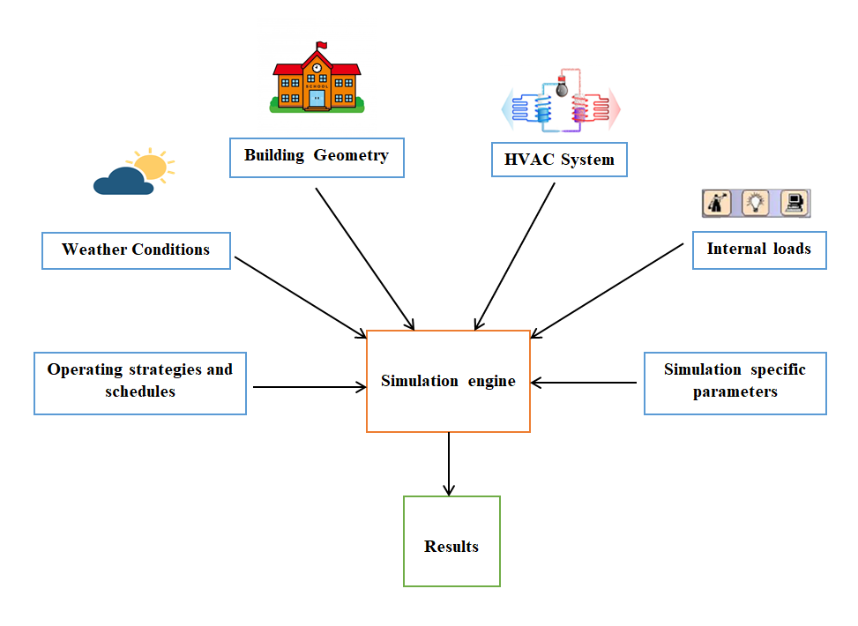
Figure 3: The general structure of data flow.

Through the previous figure 3, we note that it includes all the data required to be collected, and the following is a detail of it:

- Occupancy data:
- Occupancy Profile - Residential
- Hours of use

- Physical data:
- Area (m²)
- HVAC system (capacity, type, wattage)
- Windows and Glazing (directional, glazing type, single / double-pane)
- Wall and insulation details (thickness, material, U-value)
- Lighting system details (type, distribution, lumens / m²)

- Cost data
- Construction cost
- Monthly costs

4.2 Data Analysis

The inputs are classified into two classes - constants and variables. The fixed inputs are the inputs that have remained constant throughout the simulation work and in all cases that have been taken, while the variable inputs are those inputs that have been modified and changed to achieve rationalization in energy consumption.
Through the simulation application, the building's location or weather data were not changed in any of the cases. This report aims to determine which systems had the greatest impact on energy consumption. We considered the following inputs to be constants in all simulations.

Model Inputs-Constant

- Site and weather.

The case studied as part of a mid-rise school building located in the city of Jenin in the West Bank of Palestine, occupying an area of 27090 square feet, and it is 3 floors. The weather data of Jerusalem was used so that it was closest to the climate of the area in which the building is located. Table 2 shows the Site Location.

Table 2: Site Location.
latitude | 31.87°
longitude | 35.22°
ASHRAE climate zone | 3C
Elevation above the sea | 759 m
Exposure to wind | Normal
Site orientation | 0°

- School location.
The design was modeled using “DesignBuilder version 4.6” to evaluate each case separately the Heating design, Cooling design, and Simulation. Figure 4 shows the model on the Design-Builder and figure 5 shows the model on the Energy3D.
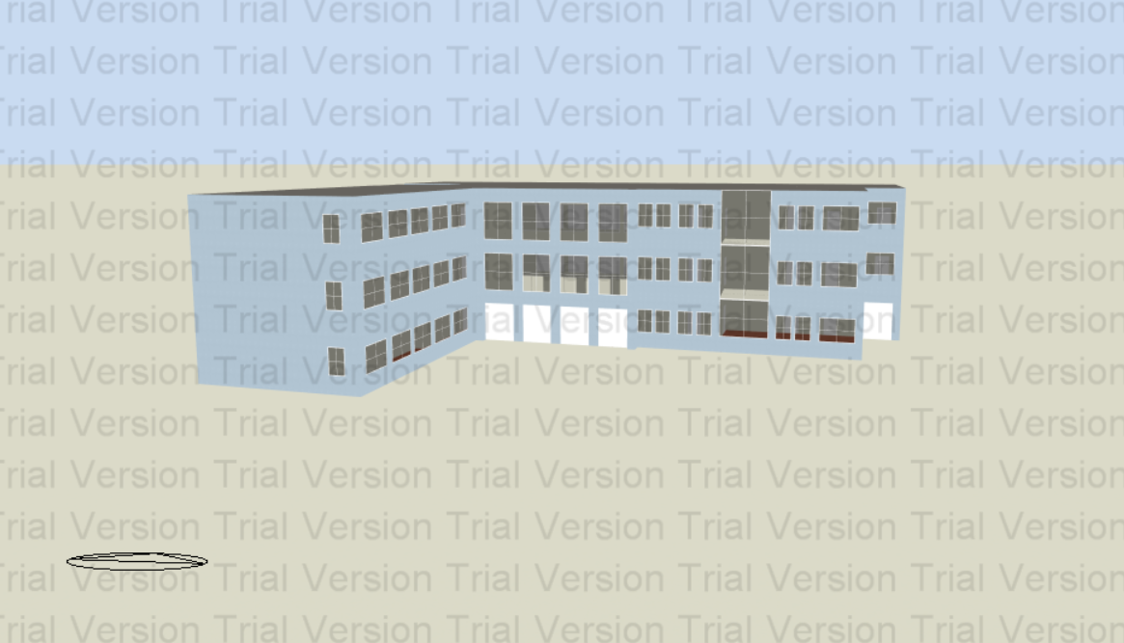
Figure 4: Building Shell in DesignBuilder.

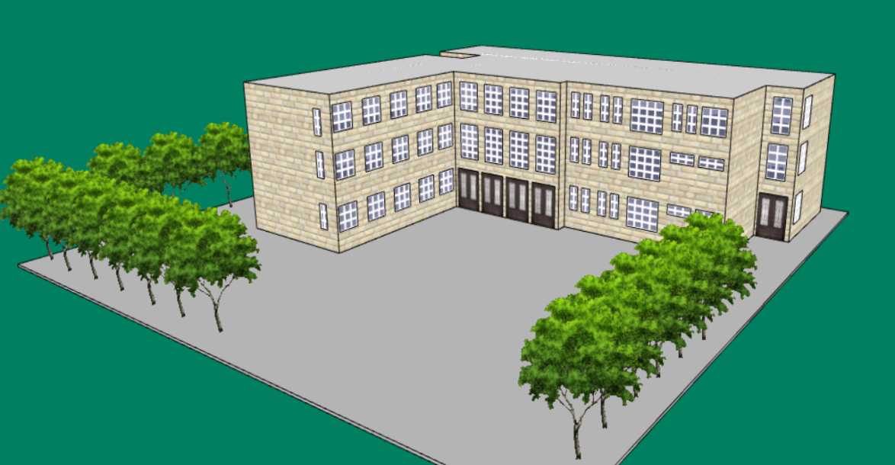
Figure 5: Building Shell in Energy3D.

- Activities Definition

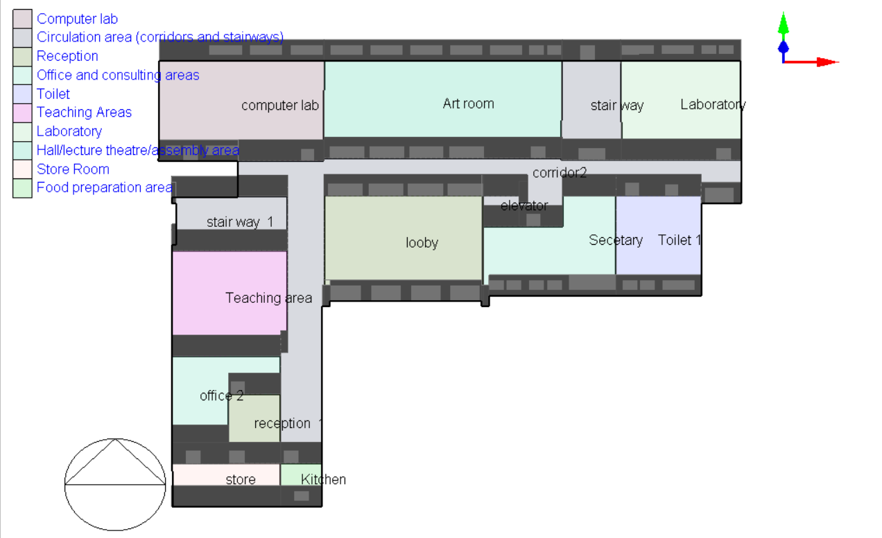
An example for the activities in GF floor definition in the DesignBuilder is shown in.
Figure 6: Activities Definition of Ground floor.

- Designed temperatures.

Table 3 shows the temperatures that were relied upon by the design during the winter and summer seasons.

Table 3: The Designed temperatures.
Season | Winter | Summer
Outside design Temperature [C°] | 0.7 | 32.9
Wind speed [m/s] | 12.1 | 0
Wind Direction [°] | 0 | 0

- Building Envelope Constructions.

The concept of the building envelope is mainly related to the design and construction of the exterior of the building. So that a good building envelope includes the use of environmentally friendly materials and modern designs for the exterior walls, so that they are at the same time friendly to the climate surrounding the area, structurally sound, and aesthetically pleasing. The school building envelope consists of its roof, the ground floor, and of course the exterior walls. Table (4- 8) shows the materials and thicknesses of the building envelope constructions

Table 4: Building Envelope Constructions for the Roof.
Material | Thickness[m]
Asphalt | 0.004
Concrete | 0.04
Brick | 0.2000
Cement /plaster | 0.2000

Table 5: Building Envelope Constructions for the Ground floor.
Material | Thickness[m]
Soil | 0.0300
Sand and gravel | 0.0500
Cast concrete | 0.1000
Mortar | 0.0300
Terrazzo | 0.0300

Table 6: Building Envelope Constructions for the internal floor.
Material | Thickness[m]
Brick | 0. 2000
Sand and gravel | 0.0300
Cast concrete | 0.0600
Mortar | 0.0400
Cement /plaster | 0.0200
Terrazzo | 0.0300

Table 7: Building Envelope Constructions for the internal partitions.
Material | Thickness[m]
Cement /plaster | 0.0150
Concrete block | 0.0700
Cement /plaster | 0.0150

Table 8: Building Envelope Constructions for the doors.
Doors | Steel, Urethane Foam

Model Inputs-Variables

- Window type :

Because the external windows constitute a large part of the thermal loads of the building, we have changed the quality of the glass used in the basic case of the school with a more efficient glass quality in reducing the total energy consumption, so the Double clear glass was replaced by double reflective glass. Below is a table showing the details.

Table 9: Window type.
Case | Type of window glass
Base case | Double Clear glass
Case one | Double Reflective Clear glass

- Lighting :

This type of lamp that uses LEDs to produce light is more energy-efficient than fluorescent lamps. The use of LEDs as the main source of illumination within the building rather than fluorescent lamps has been studied as an energy efficiency strategy to reduce the building's internal energy load. Table 10 illustrates the lighting load in both cases [21].

Table 10: The lighting load.
Case | Type of lighting | Lighting load W/m²
Base case | fluorescent | 9.9
Case one | LED | 7.5

- Insulation :
The Insulation material was used in this project is EPS expanded Polystyrene. Because of, its very high moisture resistance "waterproofing" helps protect from fluctuations in weather conditions. Table 11 shows the layers of the outer walls of the building with their thickness, as the basic case was without the presence of insulation, while the first case was added to the insulation, and table 12 shows the external walls thermal properties.

Table 11: Layers of external walls.
Layers Material | Thickness (Base case) | Thickness (case one)
Limestone | 7cm | 7cm
Concrete block | 20cm | 20cm
EPS Expanded Polystyrene | - | 5 cm
Concrete block | 7cm | 7cm
Cement plaster | 3cm | 3cm

External wall with insulation (42 cm) thickness, and external wall without insulation (37cm) thickness. Figure 7 shows Layers of the external walls with/without insulation.
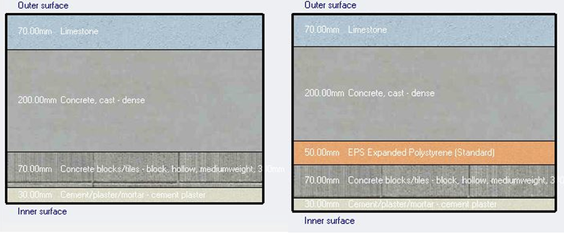
Figure 7: Layers of external walls

Table 12: Thermal properties.
Case | U-value (W/m²-k)
External walls with insulation | 0.586
External walls without insulation | 2.186

4.3 Equations

$Saving in consumption=consumption in base case-consumption in the second case$(3.1)

$\% of saving=\frac{Saving in consumption }{in the base case}$ (3.2)

Ch.5 Result and Discussion

These simulations are taken from DesignBuilder, and they will be constant during the yearly studying period.
Table 13: Area Building.
 | Area [m²]
Total Building Area | 2516.7
Net Conditioned Building Area | 1646.67
Unconditioned Building Area | 870.03

Too much light can cause overheating in the summer or excessive heat loss in the winter (as the thermal performance of the glazing layer is typically poorer than the rest of a wall or roof construction). According to BR 209 (Site Layout Planning for Daylight and Sunlight: A Guide to Good Practice), interiors with Average daylight factors of more than 6% are more prone to have these problems. Average daylight factors should ideally vary from 2% to 5% to provide adequate daylight. Table14-16 shows the average daylight factor in all buildings.
Table 14: Daylight Factor in some spaces of Ground floor.
Zone | Floor Area within Limits (%) | Average Daylight Factor (%)
computer lab | GF | 3.157
corridor | GF | 2.073
lobby | GF | 4.501
elevator | GF | 0
Secretary | GF | 5.138
Toilet | GF | 3.16
stair way1 | GF | 0
Teaching area | GF | 2.468
stair way 2 | GF | 0
Laboratory | GF | 3.468
Art room | GF | 3.914
office | GF | 4.719
reception | GF | 0
store | GF | 2.909
Kitchen | GF | 9.176

Table 15: Daylight Factor in some spaces of the First floor.
Zone | Floor Area within Limits (%) | Average Daylight Factor (%)
class room 1 | F1 | 3.555
corridor | F1 | 2.566
lobby | F1 | 6.909
elevator | F1 | 0
head teacher | F1 | 5.716
Toilet | F1 | 3.258
stair way1 | F1 | 1.37
Teaching area | F1 | 2.471
Stair way2 | F1 | 2.402
class room 2 | F1 | 3.457
class room 3 | F1 | 3.9
office | F1 | 4.706
reception | F1 | 0
store | F1 | 2.908
Kitchen | F1 | 9.313

Table 16: Daylight Factor in some spaces of the Second floor.
Zone | Floor Area within Limits (%) | Average Daylight Factor (%)
class room 1 | F2 | 4.413
corridor | F2 | 2.776
lobby | F2 | 4.265
elevator | F2 | 0
class room 2 | F2 | 6.027
class room 3 | F2 | 3.364
stair way 1 | F2 | 1.295
class room 4 | F2 | 2.588
Stair way 2 | F2 | 2.396
class room 5 | F2 | 3.601
class room 6 | F2 | 4.023
office | F2 | 4.816
reception | F2 | 0
store | F2 | 2.94
Kitchen | F2 | 9.761

The previous tables show the average daylight factor for the school building which is about 3.282%. Where the percentage is within the range is good. Figure8-10 shows the distribution daylight factor in all floors.

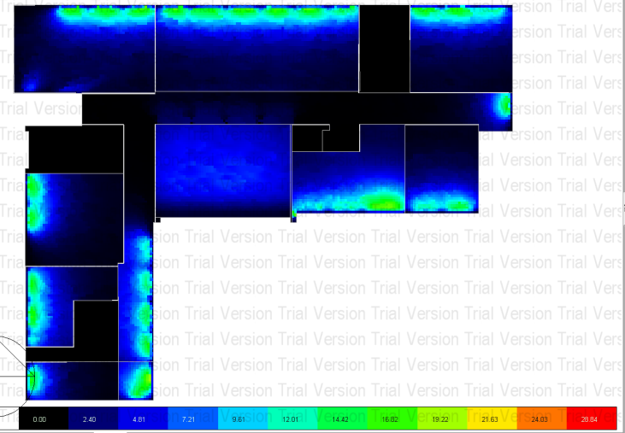
Figure 8: The distribution of daylight factor in the Ground floor.
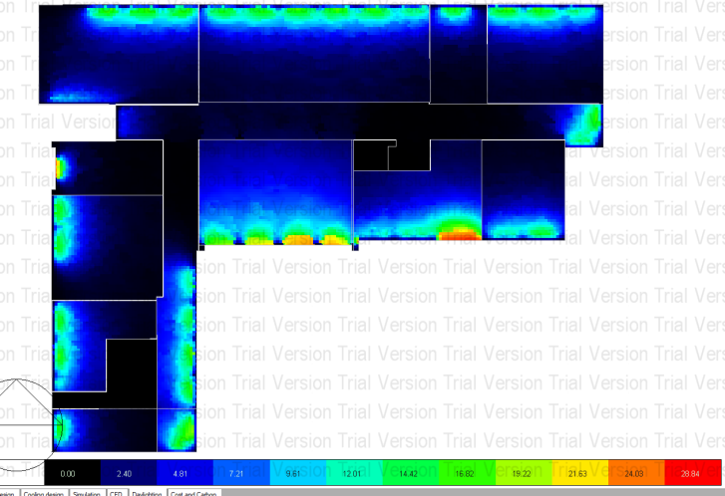
Figure 9: The distribution of daylight factor in the First floor.
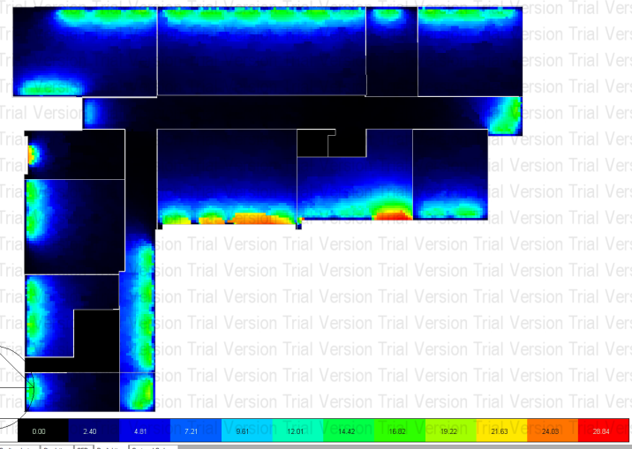
Figure 10: The distribution of daylight factor in the second floor.

5.1 First semester

The first semester runs from September to December, These simulations are taken from DesignBuilder. And it describes the results of the cases that have been previously mentioned in the methodology

5.1.1 Base Case

The inputs were entered into the base case as explained in the data analysis. The average total energy consumed during the first semester is 54309.48 kWh, as shown in table 17, and the total end-use equals 52880.35 kWh. The rate of electricity consumption varies in the following regions: Interior Lighting, Heating, Cooling, as it was discovered that the highest consumption period was Interior Lighting 19278.17 kWh then cooling 14745.08 kWh. As shown in table 18. The utility use per conditioned floor area. It is shown in table 19, the amount of electricity density in relation to the lighting system and HVAC system. It is about 13.61 and 13.48 kWh/m², respectively, while the total is about 37.33 kWh/m² and the utility use per total floor area the amount of the electricity intensity of the lighting system and HVAC system. In order, it is about 8.43, 8.35 kWh/m² respectively, while the total is about 23.13 kWh/m². As shown in table 20. The Comfort and Set point Not Met Summary show time set point not met during occupied heating and cooling also show time not comfortable based on simple ASHRAE 55-2004, as shown in table 21. The total heating and cooling capacity design are shown in table 22 for each floor.
Table 17: Site Energy.
 | Total Energy [kWh] | Energy Per Total Building Area [kWh/m²] | Energy Per Conditioned Building Area [kWh/m²]
Total Site Energy | 54309.48 | 23.75 | 38.34
Net Site Energy | 54309.48 | 23.75 | 38.34

Table 18: End Use.
 | Electricity [kWh] | Natural Gas [kWh]
Heating | 0.28 | 1429.13
Cooling | 14745.08 | 0.00
Interior Lighting | 19278.17 | 0.00
Exterior Lighting | 0.00 | 0.00
Interior Equipment | 14514.97 | 0.00
Exterior Equipment | 0.00 | 0.00
Fans | 4323.86 | 0.00
Pumps | 17.98 | 0.00
Total End Uses | 52880.35 | 1429.13

Table 19: Utility Use Per Conditioned Floor Area.
 | Electricity Intensity [kWh/m²] | Natural Gas Intensity [kWh/m²]
Lighting | 13.61 | 0.00
HVAC | 13.48 | 1.01
Other | 10.25 | 0.00
Total | 37.33 | 1.01

Table 20: Utility Use Per Total Floor Area.
 | Electricity Intensity [kWh/m²] | Natural Gas Intensity [kWh/m²]
Lighting | 8.43 | 0.00
HVAC | 8.35 | 0.63
Other | 6.35 | 0.00
Total | 23.13 | 0.63

Table 21: Comfort and Setpoint Not Met Summary.
 | Facility [Hours]
Time Setpoint Not Met During Occupied Heating | 0.00
Time Setpoint Not Met During Occupied Cooling | 9.83
Time Not Comfortable Based on Simple ASHRAE 55-2004 | 1165.17

Table 22: Total heating and cooling capacity design.
 | Total heating capacity design[kW] | Total cooling capacity design[kW]
Ground floor | 71.930 | 12.95
First floor | 70.260 | 22.16
Second floor | 88.570 | 10.72
Total building | 230.760 | 47.39

The simulation results in the first semester Base Case for thermal comfort the PMV (prediction mean value) in the School building as shown in Figure 11.
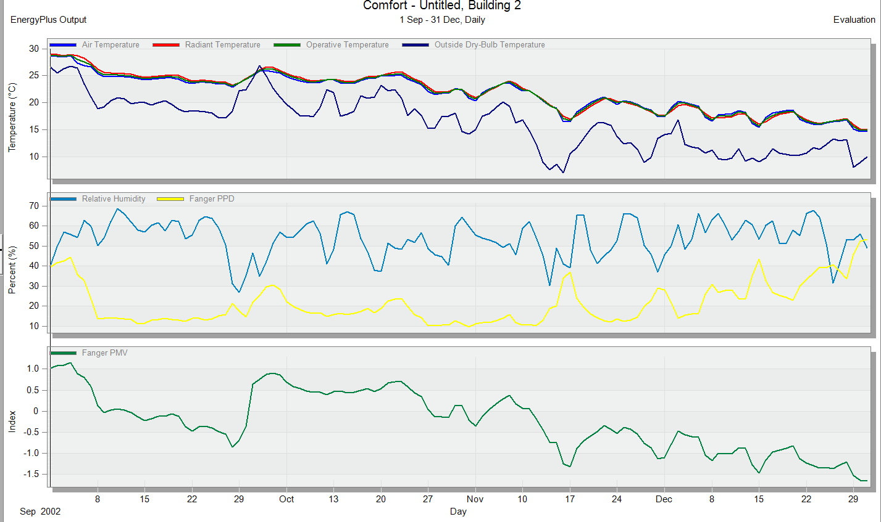
Figure11: simulation result in the first semester for thermal comfort in Base Case.
The fanger graph is used to analyze the comfort in the center .where the figure12 shown the school building in Base Case in the first semester does not achieve a rest zone due to its fall in the range ( 1.0 to -1.0).
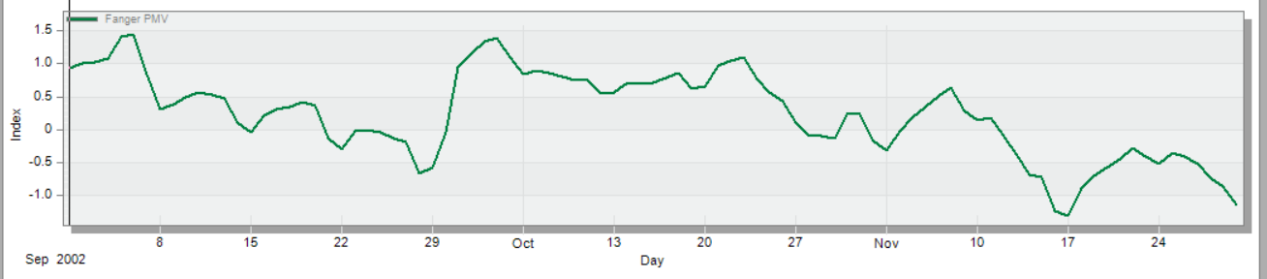

Figure 12: The fanger graph of the school building in the first semester Base Case.

The heating load in the school building shows the temperature and the heat loss as shown in figure 13 shows air, radiant, operative, and outside dry-bulb temperature. Figure 14 shows the cooling load in the school building shows: air, radiant, operative and outside dry-bulb temperature, relative humidity, and ventilation –infiltration.
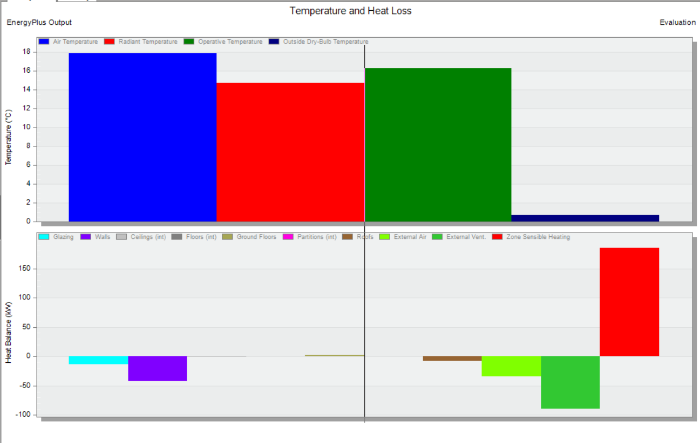Figure 13: The heating load of the school building in the first semester Base Case.

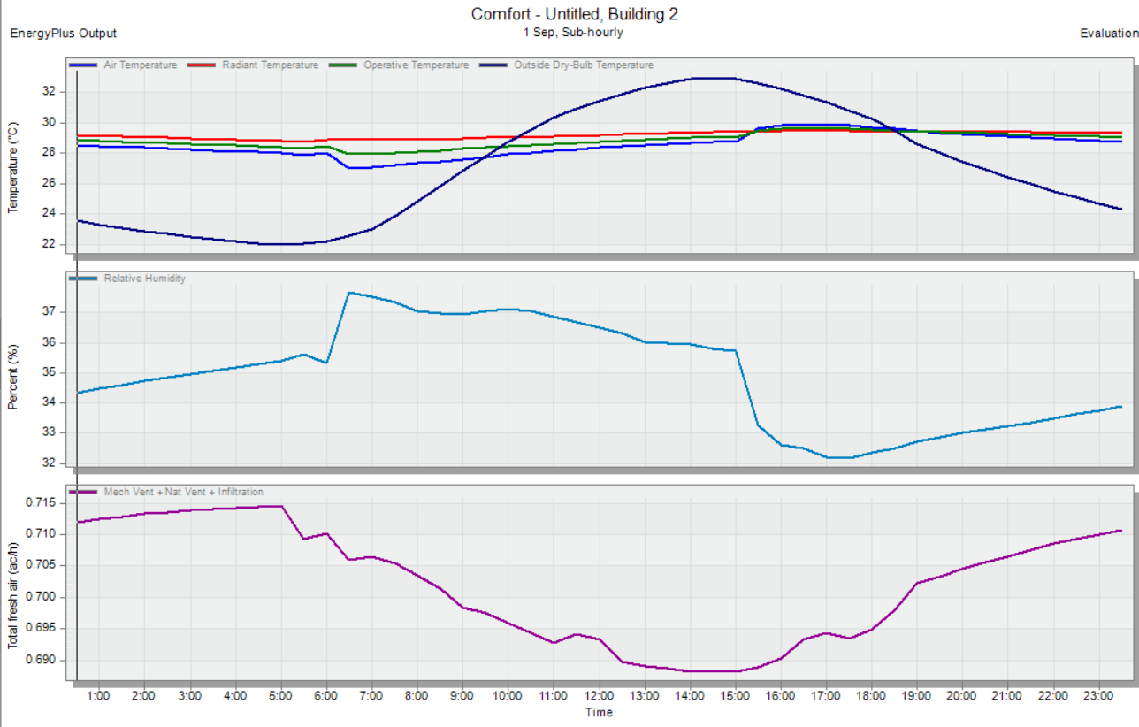Figure 14: The cooling load of the school building in the first semester Base Case.

5.1.2 Case One

The inputs were entered into case one as explained in the data analysis. The average total energy consumed during the first semester is 46556.07 kWh, as shown in table 23, and the total end-use equals 45641.53 kWh.The rate of electricity consumption varies in the following regions: Interior Lighting, Heating, Cooling, as it was discovered that the highest consumption period was Interior Lighting 14604.67 kWh then cooling 12869.98 kWh. As shown in the table 24. The utility use per conditioned floor area. It is shown in the table 25, the amount of electricity density in relation to the lighting system and HVAC system. It is about 10.31 and 11.66 kWh/m² respectively, while the total is about 32.22 kWh/m² and the utility use per total floor area the amount of the electricity intensity of the lighting system and HVAC system .In order, it is about 6.39, 7.23 kWh/m² respectively , while the total is about 19.96 kWh/m². As shown in the table 26. The Comfort and Set point Not Met Summary show time set point not met during occupied heating and cooling also show time not comfortable based on simple ASHRAE 55-2004, as shown in the table 27. The total heating and cooling capacity design as shown in the table 28 for each floor.

Table 23: Site Energy.
 | Total Energy [kWh] | Energy Per Total Building Area [kWh/m²] | Energy Per Conditioned Building Area [kWh/m²]
Total Site Energy | 46556.07 | 20.36 | 32.87
Net Site Energy | 46556.07 | 20.36 | 32.87

Table 24: End Uses.
 | Electricity [kWh] | Natural Gas [kWh]
Heating | 0.19 | 914.53
Cooling | 12869.98 | 0.00
Interior Lighting | 14604.67 | 0.00
Exterior Lighting | 0.00 | 0.00
Interior Equipment | 14514.97 | 0.00
Exterior Equipment | 0.00 | 0.00
Fans | 3635.08 | 0.00
Pumps | 16.64 | 0.00
Total End Uses | 45641.53 | 914.53

Table 25: Utility Use Per Conditioned Floor Area
 | Electricity Intensity [kWh/m²] | Natural Gas Intensity [kWh/m²]
Lighting | 10.31 | 0.00
HVAC | 11.66 | 0.65
Other | 10.25 | 0.00
Total | 32.22 | 0.65

Table 26: Utility Use Per Total Floor Area
 | Electricity Intensity [kWh/m²] | Natural Gas Intensity [kWh/m²]
Lighting | 6.39 | 0.00
HVAC | 7.23 | 0.40
Other | 6.35 | 0.00
Total | 19.96 | 0.40

Table 27: Comfort and Setpoint Not Met Summary
 | Facility [Hours]
Time Setpoint Not Met During Occupied Heating | 0.00
Time Setpoint Not Met During Occupied Cooling | 3.67
Time Not Comfortable Based on Simple ASHRAE 55-2004 | 1125.00

Table28: Total heating and cooling capacity design.
 | Total heating capacity design[kW] | Total cooling capacity design[kW]
Ground floor | 60.710 | 8.99
First floor | 57.730 | 17.29
Second floor | 76.050 | 8.89
Total building | 194.490 | 35.17

The simulation results in the first semester Case One for thermal comfort the PMV (prediction mean value) in the School building as shown in Figure 15.
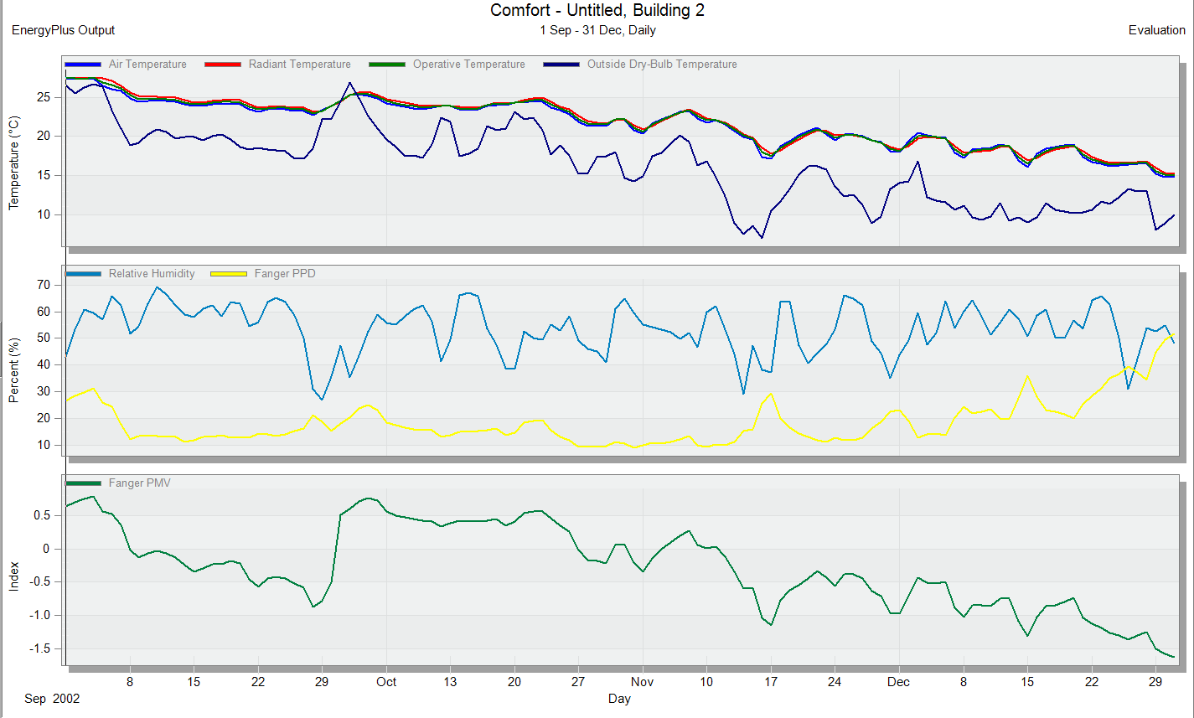Figure 15: simulation results in the first semester for thermal comfort in Case One.

The fanger graph is used to analyze the comfort in the center .where the figure16 shown the school building in Base One in the first semester in achieving a comfort zone because of it fall in rang (-0.5 to0.5) which is good.
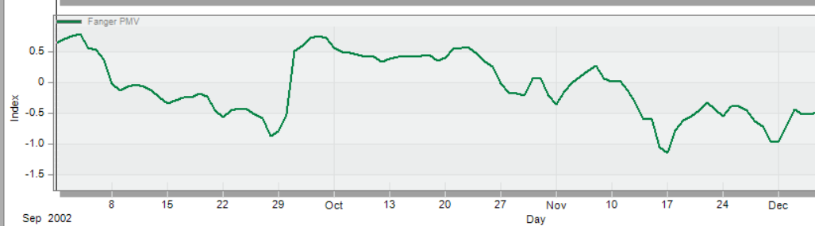
Figure 16: The fanger graph of the school building in the first semester Case One.

The heating load in the school building shows the temperature and the heat loss as shown in figure 17 shows air, radiant, operative, and outside dry-bulb temperature. Figure 18 shows the cooling load in the school building shows: air, radiant, operative and outside dry-bulb temperature, relative humidity, and ventilation –infiltration.
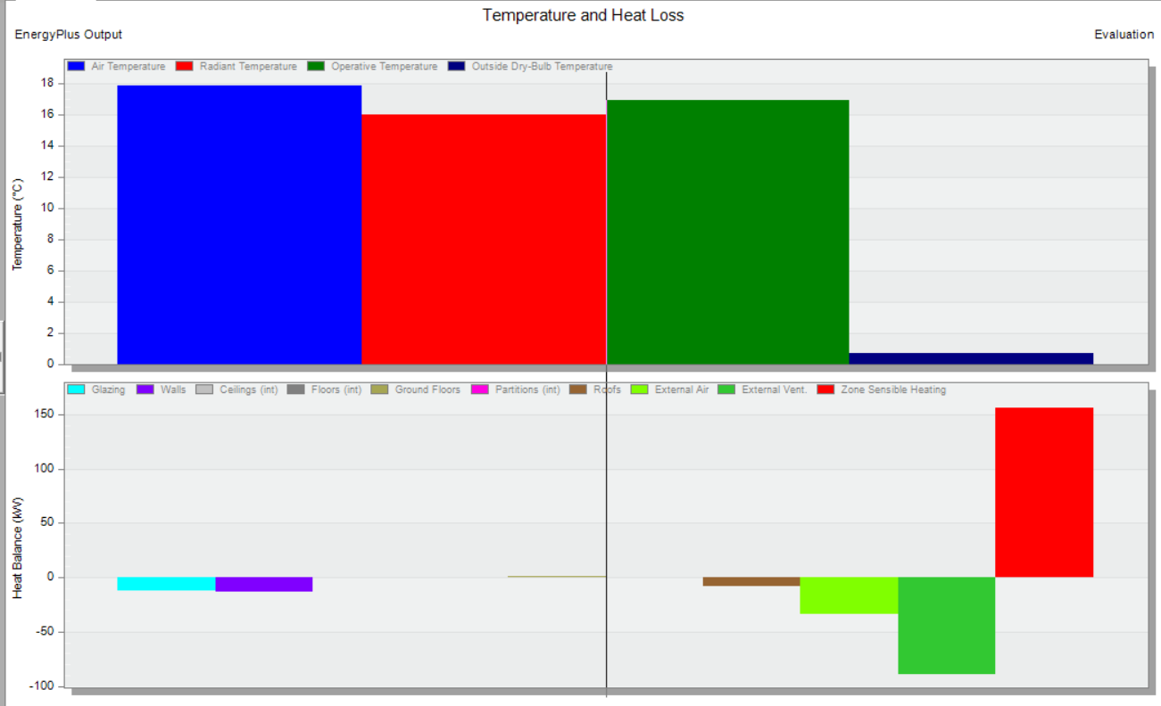Figure 17: The heating load of the school building in the first semester Case One.

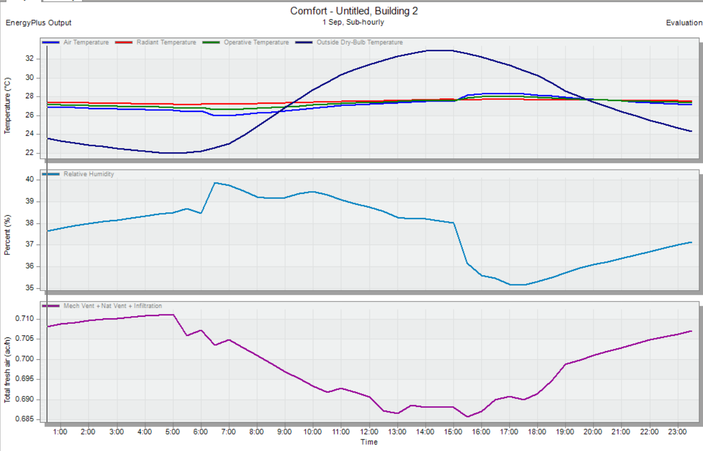Figure 18: The cooling load of the school building in the first semester Case One.

5.2 Second Semester

The Second semester runs from February to May, These simulations are taken from DesignBuilder. And it describes the results of the cases that have been previously mentioned in the methodology.

5.2.1 Base Case

The inputs were entered into base case as explained in the data analysis. The average total energy consumed during the second semester is 52345.45 kWh, as shown in table 29, and the total end-use equals 46099.94kWh.The rate of electricity consumption varies in the following regions: Interior Lighting, Heating, Cooling, as it was discovered that the highest consumption period was Interior Lighting 18631.01 kWh then cooling 9199.19 kWh. As shown in table 30. The utility use per conditioned floor area. It is shown in table 31, the amount of electricity density in relation to the lighting system and HVAC system. It is about 13.15 and 9.51 kWh/m² respectively, while the total is about 32.55 kWh/m² and the utility use per total floor area the amount of the electricity intensity of the lighting system and HVAC system. In order, it is about 8.15, 5.89 kWh/m² respectively, while the total is about 20.16 kWh/m². As shown in table 32. The Comfort and Set point Not Met Summary show time set point not met during occupied heating and cooling also show time not comfortable based on simple ASHRAE 55-2004, as shown in table 33. The total heating and cooling capacity design are shown in table 34 for each floor.
Table 29: Site Energy.
 | Total Energy [kWh] | Energy Per Total Building Area [kWh/m²] | Energy Per Conditioned Building Area [kWh/m²]
Total Site Energy | 52345.45 | 22.89 | 36.96
Net Site Energy | 52345.45 | 22.89 | 36.96

Table 30: End Use.
 | Electricity [kWh] | Natural Gas [kWh]
Heating | 1.23 | 6245.50
Cooling | 9199.19 | 0.00
Interior Lighting | 18631.01 | 0.00
Exterior Lighting | 0.00 | 0.00
Interior Equipment | 14004.26 | 0.00
Exterior Equipment | 0.00 | 0.00
Fans | 4252.98 | 0.00
Pumps | 11.27 | 0.00
Total End Uses | 46099.94 | 6245.50

Table 31: Utility Use Per Conditioned Floor Area.
 | Electricity Intensity [kWh/m²] | Natural Gas Intensity [kWh/m²]
Lighting | 13.15 | 0.00
HVAC | 9.51 | 4.41
Other | 9.89 | 0.00
Total | 32.55 | 4.41

Table 32: Utility Use Per Total Floor Area.
 | Electricity Intensity [kWh/m²] | Natural Gas Intensity [kWh/m²]
Lighting | 8.15 | 0.00
HVAC | 5.89 | 2.73
Other | 6.13 | 0.00
Total | 20.16 | 2.73

Table 33: Comfort and Setpoint Not Met Summary.
 | Facility [Hours]
Time Setpoint Not Met During Occupied Heating | 0.00
Time Setpoint Not Met During Occupied Cooling | 0.00
Time Not Comfortable Based on Simple ASHRAE 55-2004 | 1118.33

Table 34: Total heating and cooling capacity design.
 | Total heating capacity design[kW] | Total cooling capacity design[kW]
Ground floor | 71.930 | 12.28
First floor | 70.260 | 23.57
Second floor | 88.570 | 9.14
Total building | 230.760 | 46.35

The simulation results in the Second semester Base Case for thermal comfort the PMV (prediction mean value) in the School building as shown in Figure 19.
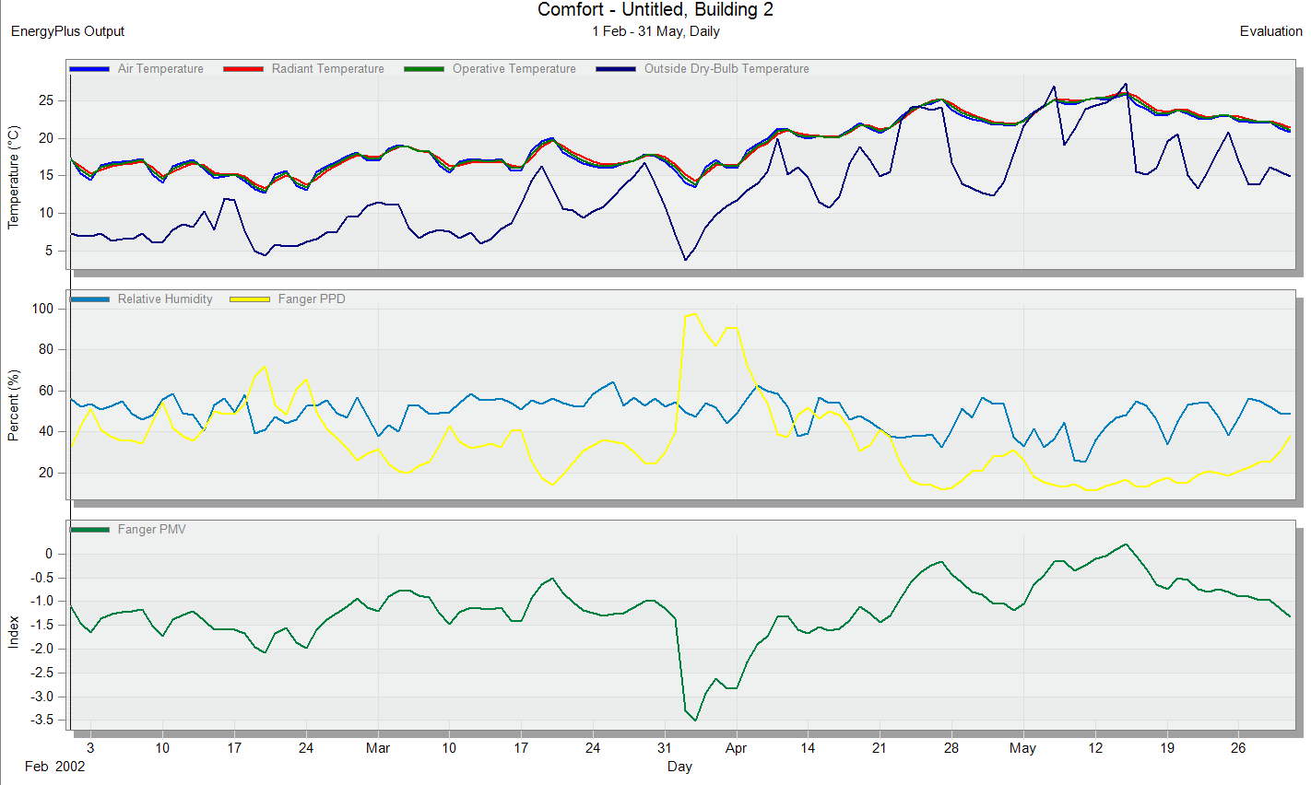
Figure19: simulation results in the second semester for thermal comfort in Base Case.
The fanger graph is used to analyze the comfort in the center .where the figure20 shown the school building in Base Case in the second semester does not achieve a rest zone due to its fall in the range (-1.3to-0.5).
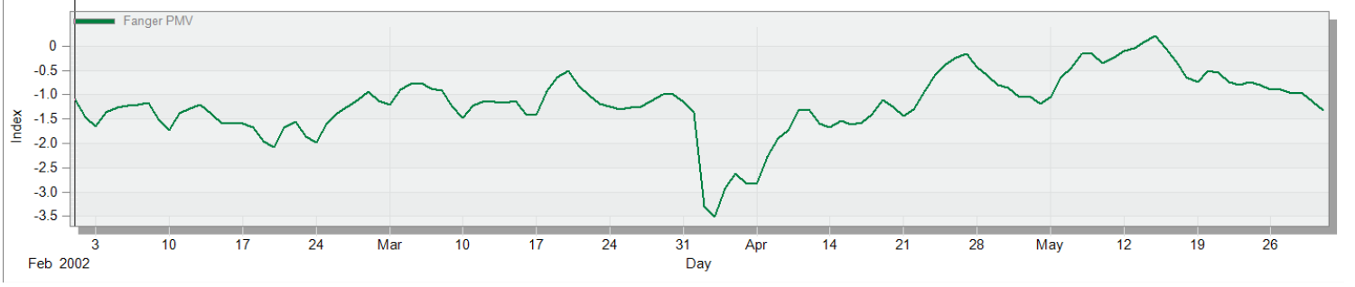Figure 20: The fanger graph of the school building in the second semester Base Case.

The heating load in the school building shows the temperature and the heat loss as shown in figure 21 shows air, radiant, operative, and outside dry-bulb temperature. Figure 22 shows the cooling load in the school building shows: air, radiant, operative and outside dry-bulb temperature, relative humidity, and ventilation –infiltration.
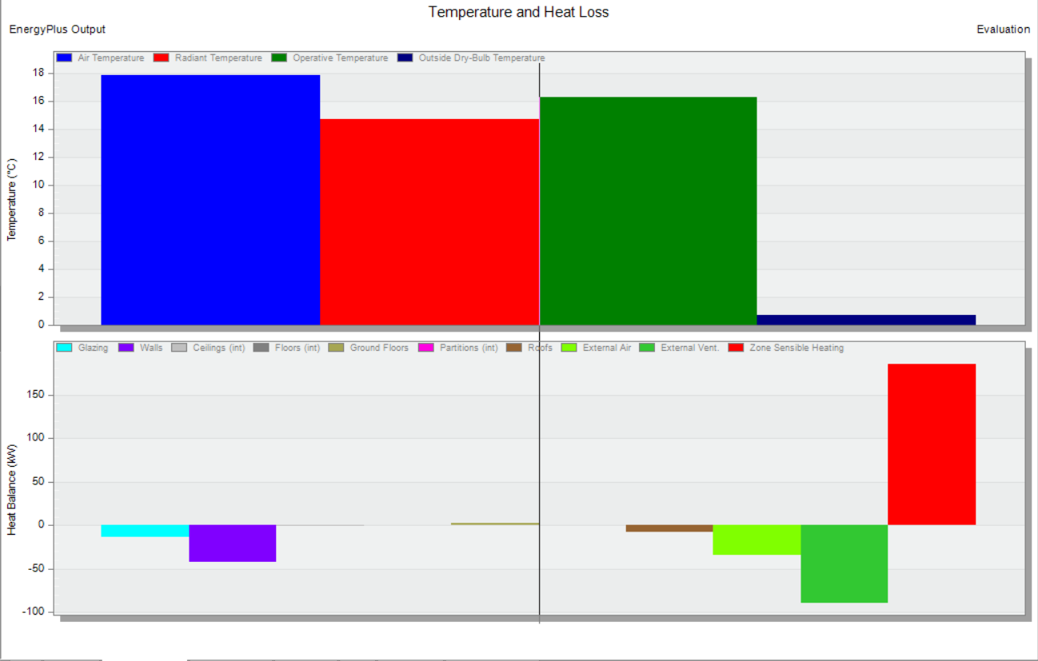Figure 21: The heating load of the school building in the second semester Base Case.
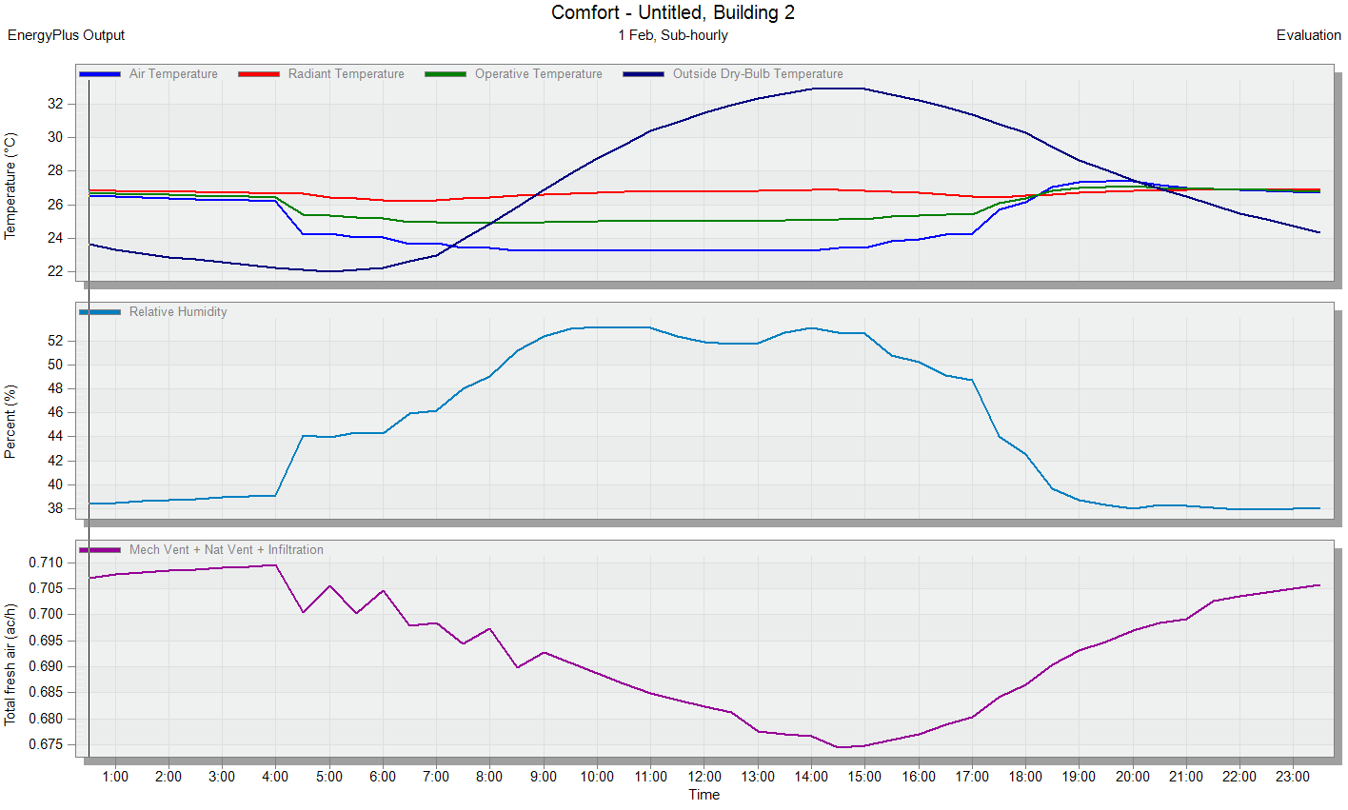
Figure22: The cooling load of the school building in the second semester Base Case.

5.2.2 Case One

The inputs were entered into case one as explained in the data analysis. The average total energy consumed during the second semester is 44466.10 kWh, as shown in table 35, and the total end-use equals 40147.20 kWh.The rate of electricity consumption varies in the following regions: Interior Lighting, Heating, Cooling, as it was discovered that the highest consumption period was Interior Lighting 14114.40 kWh then cooling 8441.93 kWh. As shown in table 36. The utility use per conditioned floor area. It is shown in table 37, the amount of electricity density in relation to the lighting system and HVAC system. It is about 9.97 and 8.49 kWh/m² respectively, while the total is about 28.34 kWh/m² and the utility use per total floor area the amount of the electricity intensity of the lighting system and HVAC system. In order, it is about 6.17, 5.26 kWh/m² respectively, while the total is about 17.56 kWh/m². As shown in table 38. The Comfort and Set point Not Met Summary show time set point not met during occupied heating and cooling also show time not comfortable based on simple ASHRAE 55-2004, as shown in table 39. The total heating and cooling capacity design are shown in table 40 for each floor.

Table 35: Site Energy.
 | Total Energy [kWh] | Energy Per Total Building Area [kWh/m²] | Energy Per Conditioned Building Area [kWh/m²]
Total Site Energy | 44466.10 | 19.45 | 31.39
Net Site Energy | 44466.10 | 19.45 | 31.39

Table 36: End Use.
 | Electricity [kWh] | Natural Gas [kWh]
Heating | 0.89 | 4318.90
Cooling | 8441.93 | 0.00
Interior Lighting | 14114.40 | 0.00
Exterior Lighting | 0.00 | 0.00
Interior Equipment | 14004.26 | 0.00
Exterior Equipment
Fans | 3575.49 | 0.00
Pumps | 10.23 | 0.00
Total End Uses | 40147.20 | 4318.90

Table 37: Utility Use Per Conditioned Floor Area.
 | Electricity Intensity [kWh/m²] | Natural Gas Intensity [kWh/m²]
Lighting | 9.97 | 0.00
HVAC | 8.49 | 3.05
Other | 9.89 | 0.00
Total | 28.34 | 3.05

Table 38: Utility Use Per Total Floor Area.
 | Electricity Intensity [kWh/m²] | Natural Gas Intensity [kWh/m²]
Lighting | 6.17 | 0.00
HVAC | 5.26 | 1.89
Other | 6.13 | 0.00
Total | 17.56 | 1.89

Table 39: Comfort and Setpoint Not Met Summary.
 | Facility [Hours]
Time Setpoint Not Met During Occupied Heating | 0.00
Time Setpoint Not Met During Occupied Cooling | 0.00
Time Not Comfortable Based on Simple ASHRAE 55-2004 | 1104.00

Table 40: Total heating and cooling capacity design.
 | Total heating capacity design[kW] | Total cooling capacity design[kW]
Ground floor | 60.710 | 8.59
First floor | 57.730 | 17.51
Second floor | 76.050 | 7.11
Total building | 194.490 | 33.20

The simulation results in the Second semester Case One for thermal comfort the PMV (prediction mean value) in the School building as shown in Figure 23.
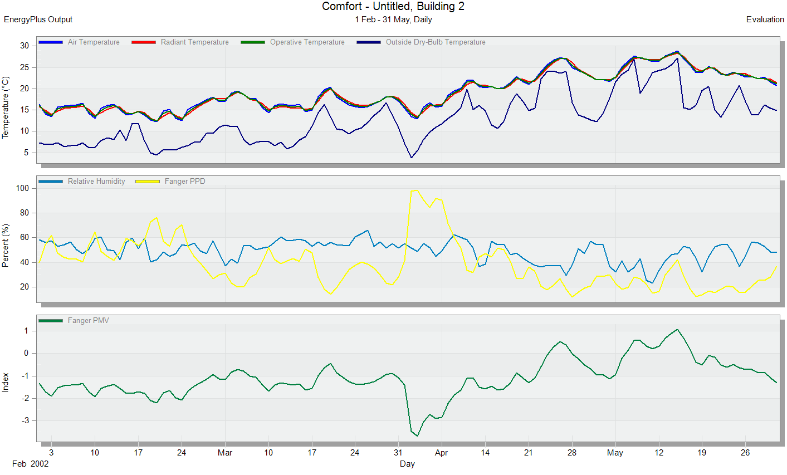Figure 23: simulation results in the second semester for thermal comfort in Case One
The fanger graph is used to analyze the comfort in the center .where figure24 shown the school building in Base One in the second semester in achieving a comfort zone because of it fall in rang (-0.5 to0.5) which is good.
Figure 24: The fanger graph of the school building in the second semester Case One.

The heating load in the school building shows the temperature and the heat loss as shown in figure 25 shows air, radiant, operative, and outside dry-bulb temperature. Figure 26 shows the cooling load in the school building shows: air, radiant, operative and outside dry-bulb temperature, relative humidity, and ventilation –infiltration.
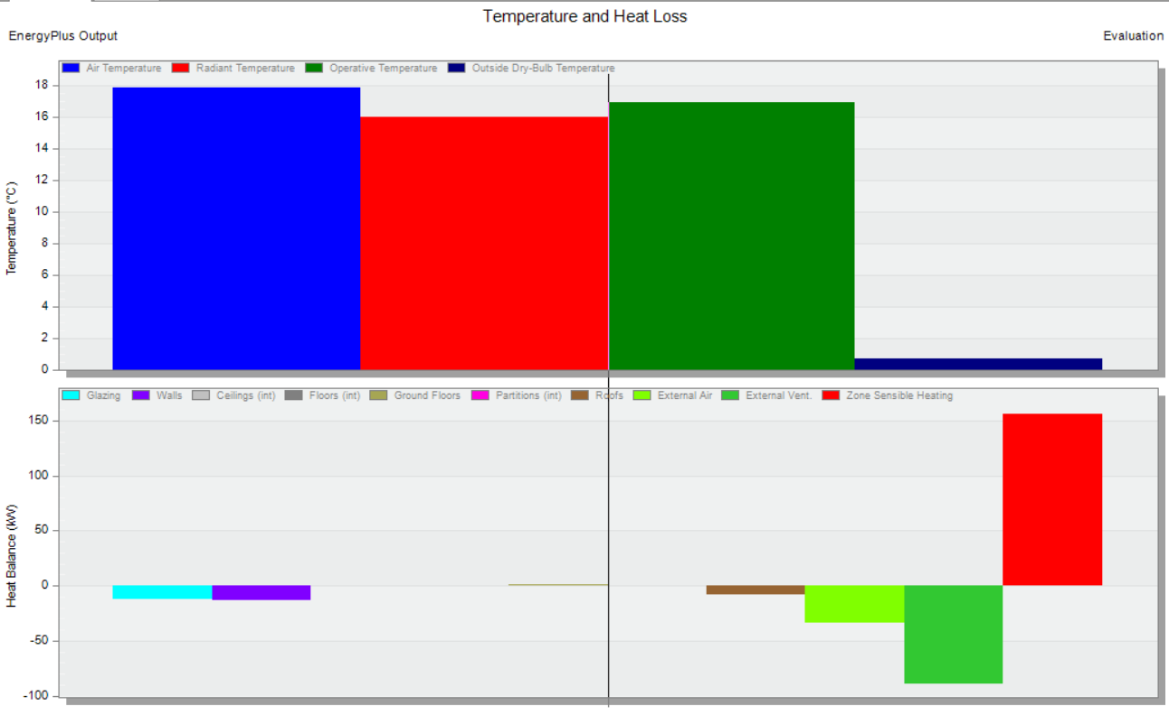Figure 25: The heating load of the school building in the second semester Case One.
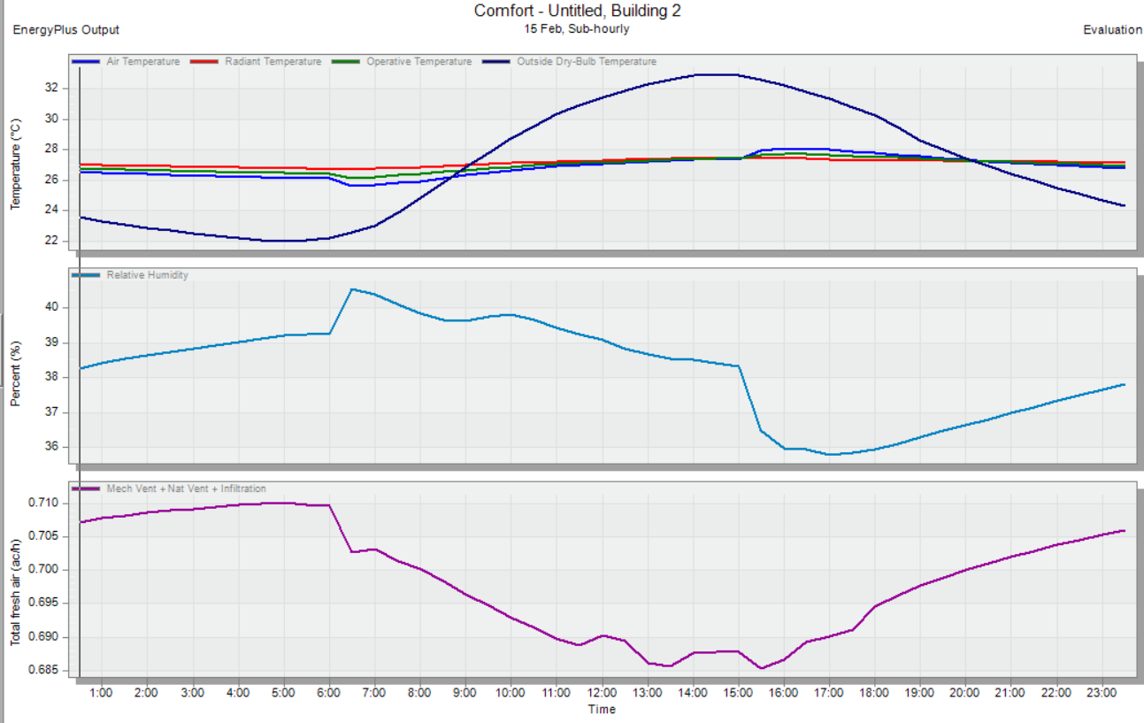Figure 26: The cooling load of the school building in the second semester Case One.

5.3 Case Two

The PV design relied on the results of the annual consumption obtained from the Program DesignBuilder, after making adjustments in case one, of an amendment to the type of glass, the quality of lighting, and adding insulation to external walls.

5.3.1 Design

The design was based on the PVsyst program, where the consumption in the first semester was 46556.07 kWh and in the second semester 44,466.10 kWh, which is equivalent to 91022.17 kWh per year. And since each kilowatt of cells in Palestine produces 1700 kWh, so the size of the system that we will design will be 53.5 kW.
The simulations of PVsyst are summarized in Figure 27.
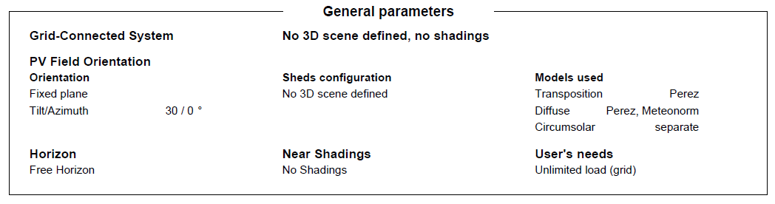
Figure 27: Simulation from the PV system.
Jinkosolar manufacture of Si-mono was selected to determine the number of modules, Power, module area, and number and power of inverter as shown in below Figure 28.
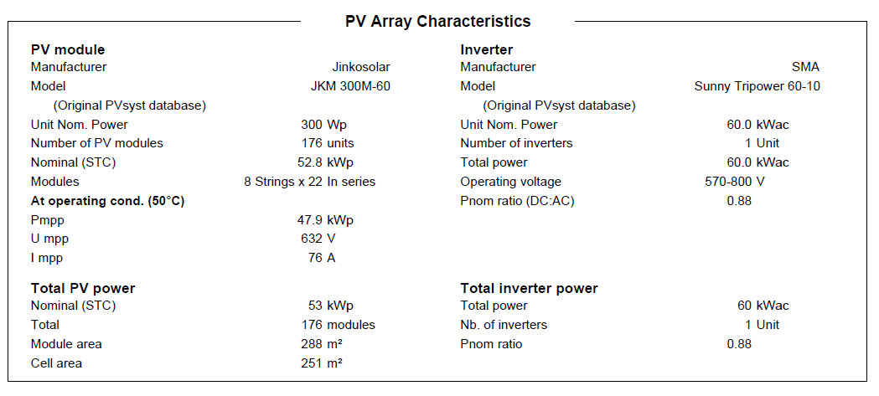Figure 28: Power, module area, and number and power of the inverter.

Figure 29 shows the distribution of cells on the roof of the building using Energy3D software.

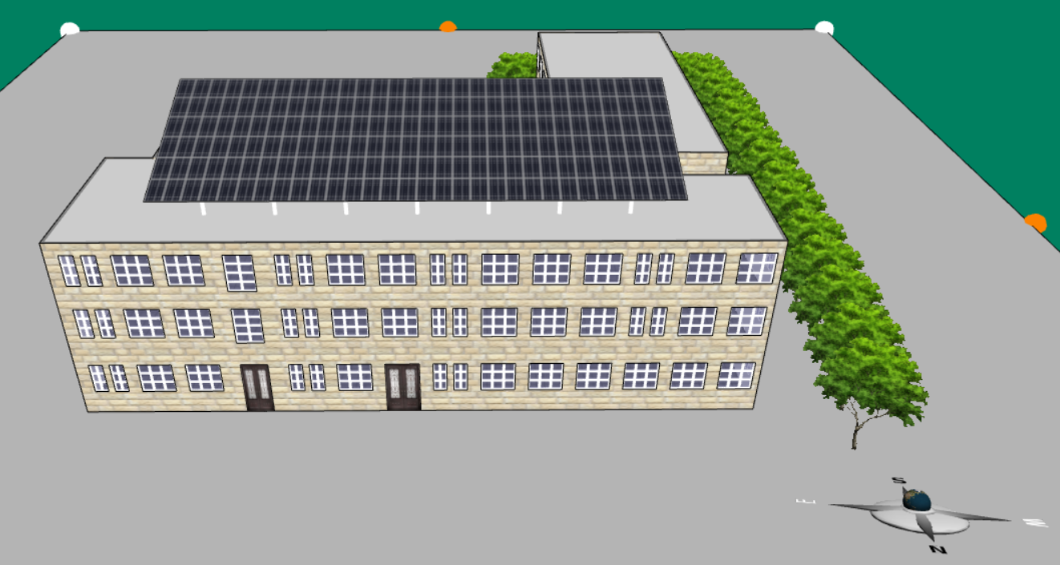
Figure 29: Distribution of Cells.

5.3.2 Result of PV module.

The main simulation results of system production are summarized as shown below in Figure 30-31 and Table 41.

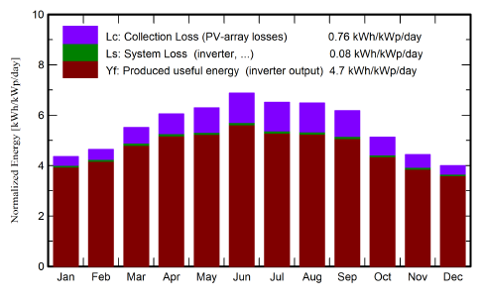
Figure 30: Normalized productions (per installed kWp).

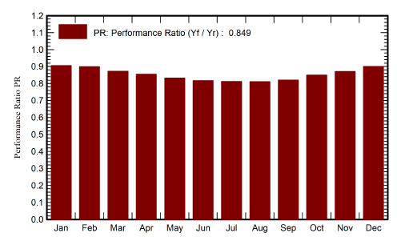
Figure 31: Performance Ratio PR.

Table 41: Balances and main results.
 | GlobHor  kWh/m² | DiffHor  kWh/m² | T_Amb  °C | GlobInc  kWh/m² | GlobEff  kWh/m² | EArray  MWh | E_Grid  MWh | PR ratio
January | 91.9 | 36.12 | 7.61 | 135.1 | 132.2 | 6.577 | 6.460 | 0.905
February | 100.8 | 47.15 | 9.18 | 130.0 | 127.1 | 6.282 | 6.173 | 0.899
March | 147.7 | 59.57 | 12.75 | 170.8 | 167.1 | 8.005 | 7.866 | 0.872
April | 174.5 | 73.59 | 16.72 | 181.6 | 177.2 | 8.345 | 8.203 | 0.856
May | 208.3 | 71.83 | 21.59 | 195.0 | 189.5 | 8.720 | 8.577 | 0.833
June | 130.9 | 61.52 | 24.56 | 206.4 | 200.0 | 9.050 | 8.903 | 0.817
July | 220.2 | 73.08 | 26.92 | 201.9 | 195.8 | 8.799 | 8.658 | 0.812
August | 200.9 | 68.84 | 26.66 | 200.8 | 198.4 | 8.739 | 8.600 | 0.811
September | 165.6 | 53.31 | 23.83 | 185.4 | 181.0 | 8.171 | 8.040 | 0.821
October | 127.9 | 55.09 | 20.39 | 158.8 | 155.1 | 7.245 | 7.127 | 0.850
November | 94.3 | 36.89 | 14.04 | 133.0 | 130.2 | 6.230 | 6.122 | 0.872
December | 82.5 | 34.98 | 9.51 | 124.0 | 121.1 | 6.001 | 5.896 | 0.901
Year | 1845.5 | 671.96 | 17.86 | 2022.7 | 1971.6 | 92.163 | 90.624 | 0.849

5.4 Saving

The price of a kilowatt-hour of electricity in Palestine is about 0.6 NIS/kWh, and the price of gas is about 4.79 NIS/kg. The total site energy per kilowatt-hour consumed during the school year in the base case is 106,654.93 kWh, and the total annual NIS is equal to 63992.958 NIS, while the total monthly NIS is equal to 7999.11975 NIS and the total site energy per kilowatt-hour consumed during the school year in the case one is 91022.17 kWh, and the total annual NIS is equal to 54613.302 NIS, while the total monthly NIS is equal to 6826.66275 NIS, and the total savings between the two cases annually are 9379,656 NIS, while the total savings per month is 1172,457 NIS, as shown in Table 42.
Table 42: Total site Energy Saving.
 | Total site Energy [kWh] | Annual cost[₪] | Cost per month[₪] | Annual Saving[₪] | Saving per month[₪] | Saving percentage
Base Case | 106654.93 | 63992.958 | 7999.11975 | 9379.656 | 1172.457 | 14.66%
Case One | 91022.17 | 54613.302 | 6826.66275 | 9379.656 | 1172.457 | 14.66%

The total savings in the price of electricity varies in the following areas: Heating, Cooling, and Lighting, as it was discovered that the highest annual saving period between the two cases was for lighting 5514,066 NIS, then cooling 1579,416 NIS. Finally, heating is 859,805 NIS. Tables 43-45 also show the savings in the price of electricity per month for lighting, cooling, and heating.
Table 43: Total Heating Saving.
 | Heating  [kWh] | Annual cost[₪] | Cost per month[₪] | Annual Saving[₪] | Saving per month[₪] | Saving percentage
Base Case | 7674.63 | 2703.049831 | 337.8812289 | 859.805 | 107.475625 | 31.81%
Case One | 5233.43 | 1843.244831 | 230.4056039 | 859.805 | 107.475625 | 31.81%

Table 44: Total Cooling Saving.
 | Cooling  [kWh] | Annual cost[₪] | Cost per month[₪] | Annual Saving[₪] | Saving per month[₪] | Saving percentage
Base Case | 23944.27 | 14366.562 | 8619.9372 | 1579.416 | 947.6496 | 10.99%
Case One | 21311.91 | 12787.146 | 7672.2876 | 1579.416 | 947.6496 | 10.99%

Table 45: Total Lighting Saving.
 | Lighting  [kWh] | Annual cost[₪] | Cost per month[₪] | Annual Saving[₪] | Saving per month[₪] | Saving percentage
Base Case | 37909.18 | 22745.508 | 13647.3048 | 5514.066 | 3308.4396 | 24.24%
Case One | 28719.07 | 17231.442 | 10338.8652 | 5514.066 | 3308.4396 | 24.24%

The total savings and utility use varies per floor area. Table 46 shows the annual rate of savings between the two states in the electricity intensity of the lighting and air conditioning system. About 4.02 and 11.75 kWh / m² respectively, while the total natural gas intensity saving is around 1.07 kWh / m².
Table 46: Utility Use Per Total Floor Area Saving.
 | Base Case | Case One | Saving | Saving percentage
Lighting utilty [kWh/m²] | 16.58 | 12.56 | 4.02 | 24.25%
HVAC-Electrical [kWh/m²] | 14.24 | 12.49 | 1.75 | 12.29%
HVAC- Gas [kWh/m²] | 3.36 | 2.29 | 1.07 | 31.85%

The exact time not fulfilled between the two cases annually during the heating and cooling time Uncomfortable based on simple ASHRAE 55-2004 is approximately 54.5 hours, as shown in Table 47.
Table 47: Time Not Comfortable Saving.
 | Time Not Comfortable [h] | Saving
Base Case | 2283.5 | 54.5
Case One | 2229 | 54.5

Total savings in the heating design and cooling capacity between the two cases annually is 72.54, 25.37 respectively as shown in Table 48 for the building.
Table 48: Total Heating, Cooling Capacity Saving.
 | Base Case | Case One | Saving
Total heating capacity [kW] | 461.52 | 388.98 | 72.54
Total cooling capacity [kW] | 93.74 | 68.37 | 25.37

Ch.6 Conclusion

In this report, it was found that the importance of using the concept of green buildings contributes to reducing energy consumption in buildings in Palestine, especially the school sector. Energy conservation measures have been taken using energy simulation data from the building's base condition. This shows the energy simulation compared to the first case with specific results.

In the first case, changing the type of glass and the type of lighting used in the base case and adding insulation to the external walls led to a significant reduction in energy consumption annually in the cooling system, the lighting sector, and the heating system, so that the total consumption in the base case in the cooling system was 23944.27 kWh, and after the change, it reached About 21311.91 kWh. While the total consumption in the base case in the lighting sector was 37909.18 kWh, and after the changeover, it reached about 28719.07 kWh. The total consumption in the base case in the heating system was 7674.63 kWh and after the changeover, it reached about 5233.43 kWh.

When changing in the first case in the simulation, excellent results were obtained, so that the total annual energy consumption price for the cooling system, the lighting sector, and the heating system, respectively, was 12,787.146 NIS, 17231.442 NIS, and 3140.058NIS. The work was aimed at modifying important factors in energy consumption at the initial stage, such as the lighting system, the cooling system, and the heating system.

References

[1] Samanta A, Saha S, Biswas J, Dutta A. Evaluation of the impact of shading devices on energy consumption of buildings in tropical regions. J Energy Resour Technol 2014;136:024503.
[2] Cheung CK, Fuller RJ, Luther MB. Energy-efficient envelope design for high-rise apartments. Energy Buildings 2005;37:37–48.
[3] Kiwan S, Badarneh N. Zero Net Energy Building in Jordan. In: GCREEDER 2011, Amman, Jordan, April 26th–28th, 2011.
[4] Alkhalidi A, Qoaider L, Khashman A et al. Energy and water as indicators for sustainable city site selection and design in Jordan using a smart grid. Sustain Cities Soc 2018;37:125–32.
[5] Alkhalidi A, Khawaja M, Abusubaih D. Energy-efficient cooling and heating of aquaponics facilities based on regional climate. Int J Low-Carbon Technol 2019.
[6] Kakran S, Chanana S. An energy scheduling method for multiple users of residential community connected to the grid and wind energy source. Build ServEng Res Technol 2018;39:295–309.
[7] Zhu G, Chow TT, Tse N.Short-term load forecasting coupled with weather profile generation methodology. Build ServEng Res Technol 2017; https://doi.org/10.1177/0143624417740858.
[8] Fan C, Xiao F. Mining big building operational data for improving building energy efficiency: a case study. Build ServEng Res Technol 2017;39:117–3128.
[9] Kylili A, Fokaides PA. Investigation of building-integrated photovoltaics potential in achieving the zero energy building target. Indoor Built Environ 2014;23:92–106.
[10] Alkhalidi A, Hassan W. Comparing between best energy-efficient techniques worldwide with the existing solution implemented in AlAhliyya Amman University. Int J of Thermal & Environ Eng 2018;17: 1–10.
[11] Cheng CL, Peng JJ, Ho MC et al. Evaluation of water efficiency in green building in Taiwan. Watermark 2016;8:236.
[12] Alkhalidi A, Jarad H, Juaidy M. Glass properties selection effect on LEED points for core and shell high rise residential building in Jordan. Int J of Thermal & Environ Eng 2016;13:29–35.
[13] A. Hasan, "Optimizing insulation thickness for buildings using life cycle cost", Applied Energy, vol. 63, no. 2, pp. 115-124, 1999.

[14] A. Bolattürk, "Determination of optimum insulation thickness for building walls concerning various fuels and climate zones in Turkey",
Applied Thermal Engineering, vol. 26, no. 11-12, pp. 1301-1309, 2006.
[15] N. Daouas, Z. Hassen and H. Aissia, "Analytical periodic solution for the study of thermal performance and the optimum insulation thickness of
building walls in Tunisia", Applied Thermal Engineering, vol. 30, no. 4, pp. 319-326, 2010.
[16] Mohammed F. Alsayed and Rawan A. Tayeh, Life CycleCost Analysis for Determining Optimal Insulation Thickness in PalestinianB u I l d I n g s, Journal of Building Engineering.
[17] BRESCU, Good Practice Guide 286: Energy performance in the government’s civil estate. London: Building Research Energy Conservation Support Unit, (2000).
[18] W. Turner and S. Doty, Energy Management Handbook: Sixth Edition. The Fairmont Press Inc., (2004), p. 850.
[19] A. Thumann and W. Younger, Handbook of Energy Audits: Sixth Edition. The Fairmont Press Inc, (2003), p. 440.
[20] A. Blyth, R. Almeida, D. Forrester, and A. Gorey, “Modernising Secondary School.

[21] United States Department of Energy’s (DOE). How energy-efficient light
bulbs compare with traditional incandescent. (March 2018, date last accessed).
Buildings in Portugal”, OECD Publishing, Paris (2012).
[22] Oldfield, P., Trabuco, D., & Wood, A. (2009). Five energy generations of tall buildings: a historical analysis of energy consumption in high-rise buildings. The Journal of Architecture, 14 (5), 591–613
[23] Hassan, A. S., & Al-Ashwal, N. T. (2015). Impact of building envelope modification on the energy performance of high-rise apartments in Kuala Lumpur, Malaysia. International Transaction Journal of Engineering, Management, Applied Sciences &Technologies, 6 (3), 91–105.
[24] Lai, J. H. K., & Yik, F. W. H. (2009). Perception of importance and performance of the indoor environmental quality of high-rise residential buildings. Building and Environment, 44, 352–360.
[25] Choi, I. Y., Cho, S. H., & Kim, J. T. (2012). Energy consumption characteristics of high-rise apartment buildings according to building shape and mixed-use development. Energy and Buildings, 46, 123–131.
[26] Yaşar, Y., & Kalfa, S. M. (2012). The effects of window alternatives on energy efficiency and building economy in high-rise residential buildings in moderate to humid climates. Energy Conversion and Management, 64, 170–181.
[27] Lee, T. K., & Kim, J. T. (2015). Residents’ response son indoor environment quality and energy use in apartments. Energy and Buildings, 98, 34–38.
[28] Sev, A., & Özgen, A. (2003). Yüksek Binalarda Sürdürülebilirlik ve Doğal Havalandırma, Yapı Dergisi, 262: 92–99.
[29] Mirrahimi, S., Mohamed, M. F., Haw, L. C., Ibrahim, N. L. N., Yusoff, W. F. M., & Aflaki, A. (2016). The effect of building envelope on the thermal comfort and energy saving for high-rise buildings in a hot humid climate. Renewable and Sustainable Energy Reviews, 53, 1508–1519.
[39] Lee, K. (2007). Sustainability assessment and development direction of super high-rise residential complexes from the viewpoints of a resident. Journal of Asian Architecture and Building Engineering, 6 (1),127–134.
[31] De Boeck, L., Audenaert, A., & De Mesmaeker, L.(2015). Improving the energy performance of residential buildings: A literature review. Renewable Sustainable Energy Reviews, 52, 960–975.
[32] http://cartografareilpresente.org/en/article256(Accessed 15.04.2017)
[33] https://www.ovoenergy.com/guides/energy-guides(Accessed 27.12.2016)
[34] Sarogloua, T., Meir, I. A., & Theodosiou, T. (2017). Quantifying energy consumption in skyscrapers of various heights. Procedia Environmental Sciences, 38,314–321
[35] Cho, G. Y., Yeo, M. S., & Kim, K. W. (2013). Design parameters of double-skin facade for improving the performance of natural ventilation in high-rise residential buildings. Journal of Asian Architecture and Building Engineering, 12(1), 125–132.
[36] Aydin, D., & Mihlayanlar, E. (2017). An investigation for indoor environmental quality in high-rise residential buildings. Megaron, 12(2), 213–227.
[37] Aydin, D., & Mihlayanlar, E. (2017). A solution for energy efficiency of existing high-rise buildings: Retrofit. International Refereed Engineering and Sciences, 9, 1–25.
[38] Silver, P., & Mclean, W. (2013). Introduction to Architectural Technology, London, UK: LaurenceKing Publishing.
[39] Kubba, S., (2012). Handbook of Green Building Design, and Construction, UK: Elsevier
[40] McGraw Hill (2010). Green BIM: How building information modeling is contributing to green design and construction. Bedford, MA: McGraw Hill Construction.

[41] Dallasega, P., Marengo, E., Nutt, W., Rescic , L., Matt ,D. T., & Rauch, E. (2015). Design of a framework for supporting the execution-management of small and medium-sized projects in the ACE industry. Proceedings of the 4The International Workshop on Design in Civil and Environmental Engineering, Taipei, Taiwan.
[42] Ma, Z., Cooper, P., Daly, D., & Ledo, L. (2012).Existing building retrofits: Methodology and state-of-the-art. Energy and Buildings, 55, 889–902.

