بسم الله الرحمن الرحيم
Al-Najah National University
Faculty of Engineering
Computer Engineering Department

Graduation Project Documentation
Pharmacy & Inventory Managment Website

Presented to:
Dr.Raed Al-Qadi & | Dr.Luai Malhis
Anas Tomah & | Haya Samaaneh

From
Rana Sabbah & | Manar Salman

21-12-2009
Introduction…
This website was designed for pharmacy and inventory management system. We have used PHP language programming and mysql server for database storage. This system has many features, the main function is making orders by a pharmacy and sending it to the inventory then the inventory will send his response bake to that pharmacy…

Our Website…
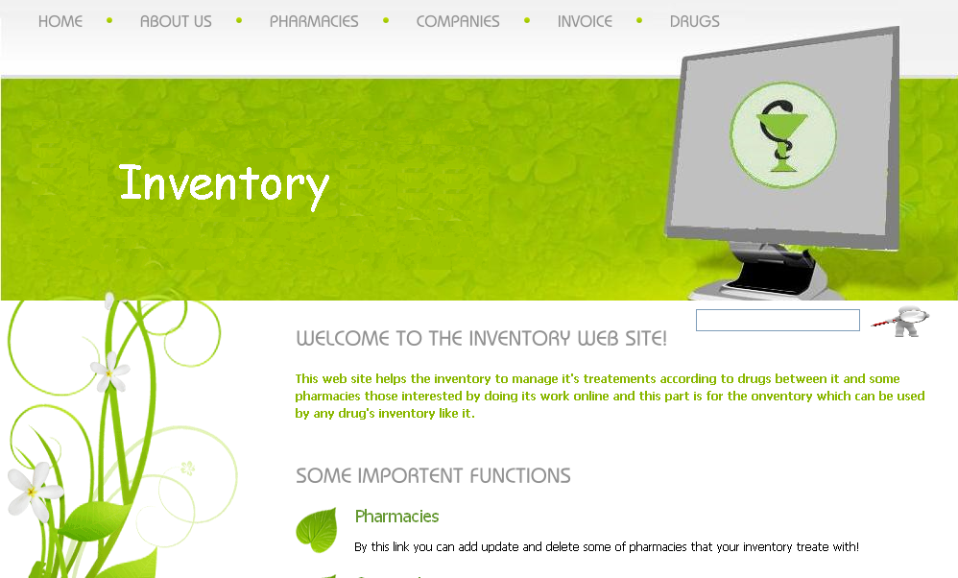

Here we will show all the features in our website, first starting with the inventory…
* HOME, that is the home page of the website, and contains some information about the inventory.
* ABOUT US, which tells the browsing one about the team of the work…Manar Salman and Rana Sabbah.
* PHARMACIES, by this link you can see all the pharmacies that are treating with you and some information about each one, like address, of course you can add, update and delete any one you want…
* COMPANIES, this link also make you see the drugs companies you take drugs from and some information about each; you can add, update and delete any information about any one…
* DRUGS, by this one you can see all the drugs in your inventory, their names, costs, available quantities you have and their divisions.
* The main function of the inventory could be done by the INVOICE link… this link helps you to save all the coming orders from pharmacies and then you can see the main information about that order, and a DETAILS link appears to see what drugs this pharmacy needs and quantities you have and prices, by clicking on the PREPAIR button an invoice containing the information of the asking pharmacy and drugs, quantities and prices you will offer will be prepared and saved in a file.
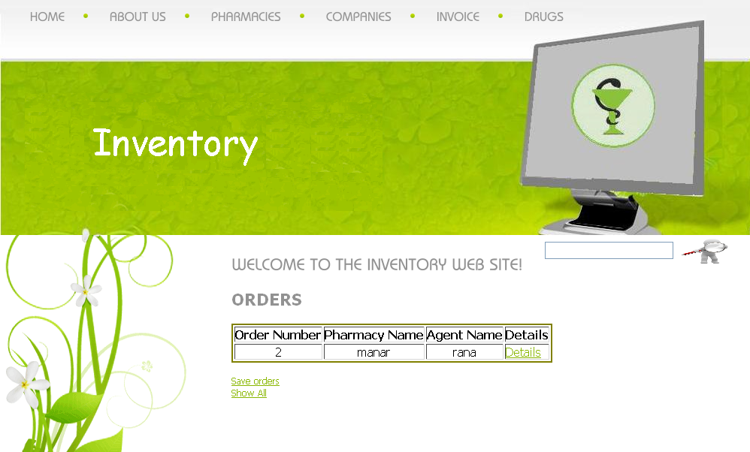
If we press on details link we will see
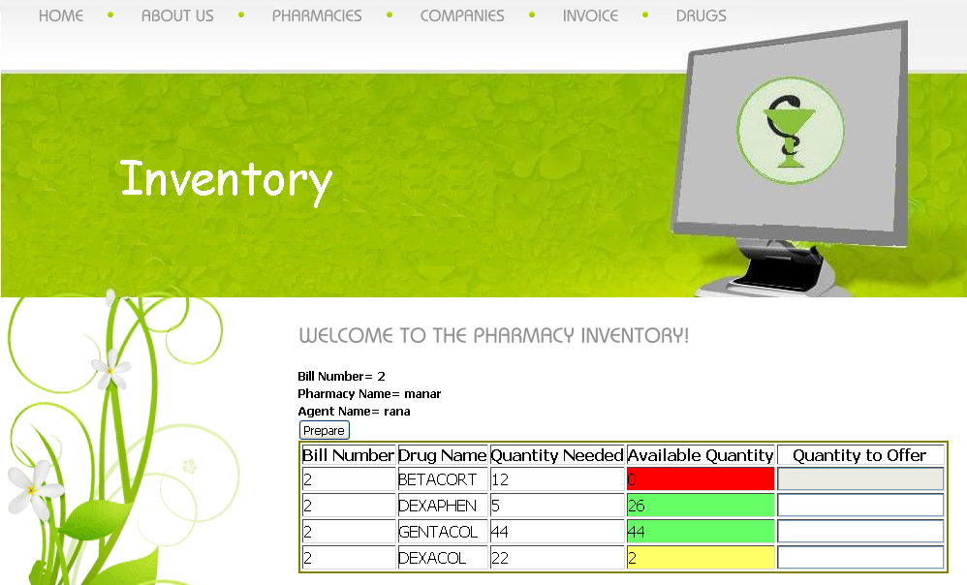
The colors appear are indicators on the quantities…if it was more than 10 you are in safe side, but if it was less than 10 it will be yellow, but if you don’t have any it will be RED…

* SEARCH, an additional feature in the inventory home page is the search feature… all you have to do is to write the name of the drug and all available information will be displayed to you…


On the other hand of this website the pharmacy.
Pharmacy has also main features that will be explained here…
Pharmacy talks to the Inventory by sending orders
of which drugs it needs , and quantity required of each drug .
Inventory replies with the quantity that it can offers .
On other side , pharmacy talks to customers those come to buy specific drugs.
Pharmacist can buy some drugs that not classified as dangerous.On the other hand, poison drugs must not be baught unless there is a prescription comes from a doctor .This needs doctors to insert daily their prescriptions .
* DRUGS :
Here you can see all pharmacy drugs divided according to its form.. each pharmacy manager can add, update and delete any drug!
Also you can search easily about a specific drug and see all information about ..
* ORDERS :
pharmacist has the ability to send an order to the inventory about what drugs his pharmacy requires ..
get inventory’s drugs(inventory prepare a page of it’s drugs that pharmacy calls) --->>pharmacy choose drugs with certain quantities --->>send an order--- >> wait for a Reply as a Burchase Invoice ..

INVOICE :
This link helps pharmacy to prepare an invoice for any customer, he can only buy nonpoison drugs directly; poison drugs need a prescription from a Doctor .. He has to check !!!

USERS :
Add , update ,delete customers . Their accounts include percentage of insurance if they have ..

Summery..
Pharmacy and inventory management system is designed to help the pharmacists to manage their works in two ways ..
First one with the inventory and the second one with its own customers and drugs .

