
بسم الله الرحمن الرحيم

An-Najah National University

Faculty of Engineering & Information Technology

Department of : Computer Engineering

Smart table

Prepared by: date : 1/23/2026

Yazan jamal ali ahmad - 11844741
Firas kayed -11819869

Supervised by:

Dr. Hanaal Abuzanat
Dr. Saed Tarapiah

Presented in partial fulfilment of the requirements for Bachelor degree in (Computer Engineering ).

Abstract ____________________________________________ page 1
Introduction _________________________________________ page 2
Theoretical Background and Previous Work_______________page 3 Methodology _________________________________________page 4
Results and Analysis___________________________________page 11
Discussion___________________________________________page 14
Conclusions__________________________________________page 16
Future work_________________________________________page 17

1-Abstract | Page 1
- chapter 1 : Introduction  - Background  - Objectives  - Significance of the Project  - Organization of the Report | Page 2  Page 2  Page 2  Page 3  Page 3
- chapter 2 : Theoretical Background  2.1 Smart Systems and Internet of Things (IoT)  2.2 Computer Vision and Object Detection  2.3 Temperature Control Systems  2.4 Related Work | Page 3  Page 3  Page 4  Page 4  Page 4
- Chapter 3: Methodology  3.1 System Overview  3.2 Hardware Components  3.3 Software Components  3.4 Communication and Data Flow  3.5 Decision-Making Algorithm  3.6 Safety and Constraints | Page 4  Page 4  Page 5  Page 9  Page 10  Page 10  Page 10
- Chapter 4 – Results and Analysis  4.1 System Operation Results  4.2 Food Detection Results  4.3 Temperature-Based Control Results  4.4 Web Interface Output  4.5 Analysis of System Performance  4.6 Summary  4.7 Audio Feedback Results | Page 11  Page 11  Page 11  Page 12  Page 12  Page 13  Page 13  Page 13
- Chapter 5 – Discussion  5.1 Interpretation of Results  5.2 Effectiveness of Temperature Control  5.3 Integration of Raspberry Pi and IoT Components  5.4 System Limitations  5.5 Comparison with Existing Approaches  5.6 Practical Implications  5.7 Summary | Page 14  Page 14  Page 14  Page 14  Page 15  Page 15  Page 16  Page 16
- Chapter 6 –Conclusions  6.2 Recommendations and Future Work | Page 16  Page 16
- Chapter 7-Future works  7.1 Planned Enhancements  7.2 Future System Development Approach | Page 17  Page 17  Page 17

Project’s Abstract:

Why do you think this project is important?
This project is important because it combines artificial intelligence and IoT technology to help individuals make healthier food choices and maintain the appropriate storage conditions for different types of food. It contributes to reducing food waste and raising nutritional awareness.

Objectives:
1. Provide users with nutritional advice and recommended food quantities.
2. Maintain suitable environmental conditions for food preservation or alert users when food is at risk of spoilage

Methodology:
The project uses a Raspberry Pi as the main controller. A camera captures food images periodically,
and an AI model (trained using Python libraries such as OpenCV and YOLOv8) identifies the type of food. The system retrieves related nutritional information, benefits, and possible risks from a database (MySQL or CSV). The Raspberry Pi reads environmental data (temperature and humidity) using a DHT11 sensor and controls a cooling fan or heating plate through relays to maintain optimal storage conditions. It also provides health recommendations based on the recognized food.

Significance:
The system integrates AI-based image recognition with smart environment control, offering practical applications in health, food storage, and smart kitchens. While similar technologies exist, this system provides a more comprehensive combination of nutritional advice and automated environmental adjustment.

1

Chapter 1: Introduction

  - Background

Smart Furniture is an emerging area that utilizes Artificial Intelligence (AI), sensing, and automation to provide higher comfort levels for users and boost the efficiency of daily life due to the rapid increase in usage of Smart Systems. Food handling and temperature management are important Smart System areas because keeping food at the right temperature affects its overall quality, safety, and enjoyment of the user.

Unlike traditional furniture, no intelligence exists to identify food or its thermal state.

When cold food is served, it will eventually become warmer than intended because the table does not know it was cold; therefore, hot food can eventually become too hot as well.
Technological advances in computer vision systems, embedded systems, and certain Internet of Things (IoT) platforms, such as the Raspberry Pi, have created new ways to build systems that will be able to identify objects and automatically respond to environmental changes.
In this project, we will demonstrate a Smart Table that makes use of Artificial Intelligence (AI), embedded control driven by ESP32, and decision-making based on sensors that identify the type of food being placed on the table and, based on the temperature of the food, will maintain an appropriate thermal environment for it.

  - Objectives

The main objectives of this graduation project are:
To design and implement a smart table capable of identifying different types of food using computer vision executed on a Raspberry Pi.

To measure the surrounding temperature using an embedded sensor connected to an ESP32 microcontroller.

To automatically decide whether the food requires heating, cooling, or no action based on predefined temperature ranges.

To control heating and cooling elements through the ESP32.
To display real-time information about the detected food through a web-based interface developed using Flask.

To demonstrate the integration of artificial intelligence with IoT systems in a smart furniture application.
2

  - Significance of the Project
This project demonstrates the practical integration of artificial intelligence, embedded systems, and IoT technologies in a real-world application. The Smart Table improves food handling convenience by automatically maintaining suitable temperature conditions without user intervention. The system can be useful in homes, restaurants, hospitals, and smart kitchens.
From an academic perspective, the project applies knowledge from multiple engineering domains, including Raspberry Pi–based computing, embedded systems, computer vision, networking, and software development. It also provides a foundation for future smart furniture designs and intelligent food management systems.
  - Organization of the Report
This report is organized as follows:
Chapter 1 introduces the project and its objectives. Chapter 2 presents the theoretical background and related work. Chapter 3 describes the methodology and system implementation. Chapter 4 presents the results and system behavior. Chapter 5 discusses the obtained results and limitations. Finally, Chapter 6 concludes the report and suggests future improvements.

Chapter 2: Theoretical Background and Previous Work

2.1 Smart Systems and Internet of Things (IoT)

The Internet of Things (IoT) refers to interconnected devices capable of sensing, processing, and exchanging data over a network. IoT systems typically consist of sensors, microcontrollers, actuators, and communication modules. In smart environments, IoT enables automation by allowing devices to react to real-time data without human intervention.
In this project, the ESP32 microcontroller acts as an IoT node that collects temperature data and controls actuators based on commands received wirelessly from the Raspberry Pi, which functions as the central processing unit.

3

2.2 Computer Vision and Object Detection
Computer vision is a field of artificial intelligence that enables machines to interpret visual information from images or video streams. Object detection is a key task in computer vision that involves identifying objects and their locations within an image.
Modern object detection models, such as YOLO (You Only Look Once), provide fast and accurate real-time detection. In this project, a trained YOLO model is executed on a Raspberry Pi to recognize food items placed on the table and determine their category.

2.3 Temperature Control Systems
Temperature control systems are widely used in industrial, medical, and domestic applications. These systems typically involve sensors for temperature measurement and actuators such as heaters or cooling fans. A control algorithm determines the appropriate action based on predefined temperature thresholds.
The Smart Table uses predefined temperature ranges for different food types. The decision-making logic is performed on the Raspberry Pi, while the physical actuation is handled by the ESP32.

2.4 Related Work
Previous studies have explored smart kitchen systems, intelligent food monitoring, and automated temperature control. However, many existing systems focus on storage appliances such as refrigerators or ovens. This project differs by introducing intelligence into a simple furniture element (a table) and by combining Raspberry Pi–based object detection with ESP32-based temperature control in a compact system.

Chapter 3: Methodology

3.1 System Overview

- Embedded Control Unit (ESP32) – temperature sensing and actuator control
- Artificial Intelligence and Decision Unit (Raspberry Pi) – food detection and control logic
- Web-Based User Interface (Flask) – information display

These components communicate wirelessly to detect food, analyze temperature conditions, and control heating or cooling actions.

4
In the Figure the Raspberry Pi setup used in the Smart Table system, including the camera module for food detection and the audio output device used for voice feedback.
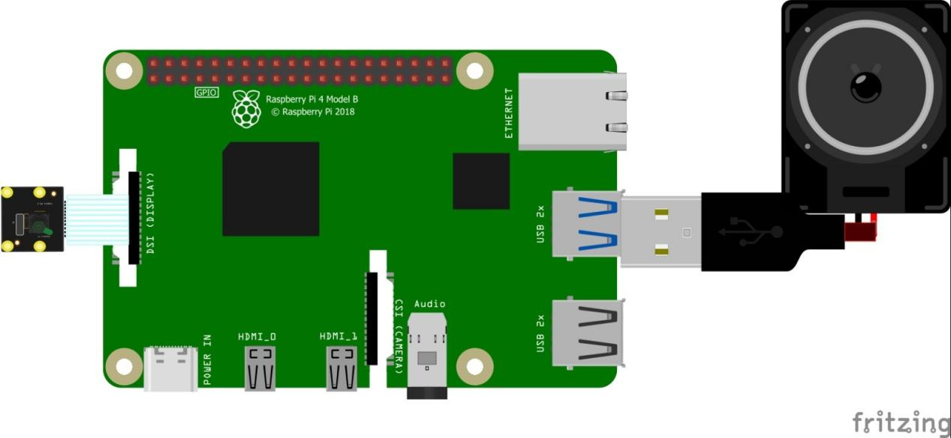

3.2 Hardware Components

- Raspberry Pi: Acts as the main processing unit for computer vision, decision-making, and web interface hosting.

5
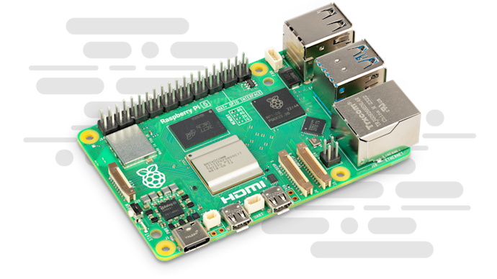

- ESP32 Microcontroller: Used for temperature sensing, actuator control, and wireless communication.
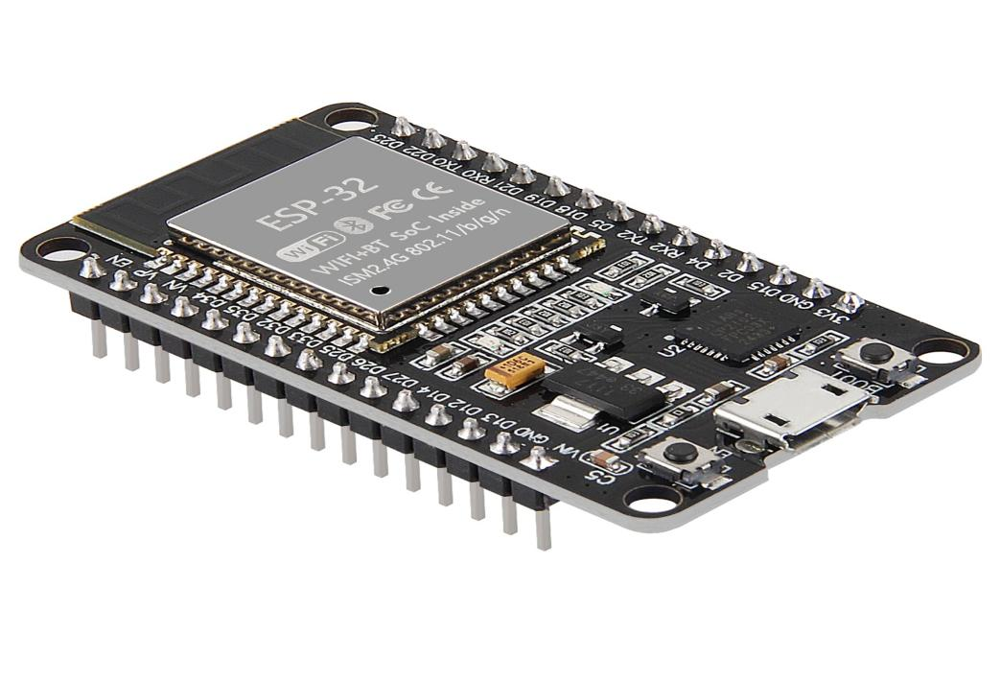

- DHT11 Sensor: Measures ambient temperature and humidity.

6
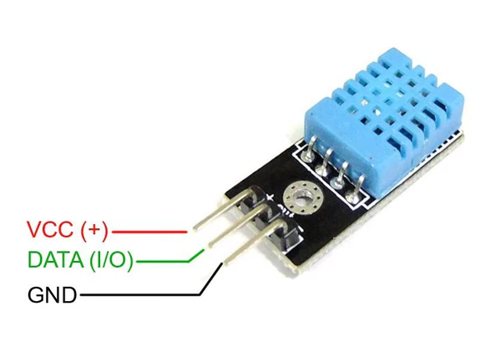
- Heating Element: Activated when the food temperature is below the desired range.
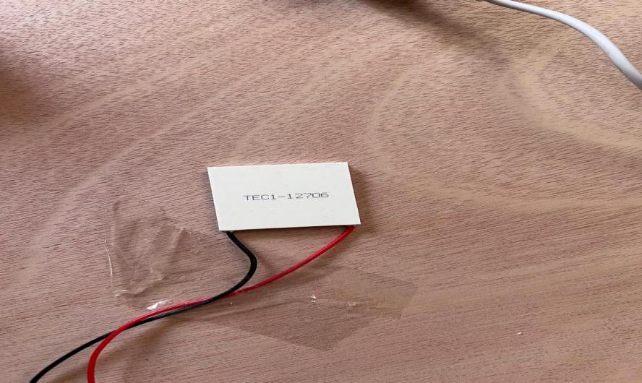

- Cooling Fan: Activated when the food temperature exceeds the desired range

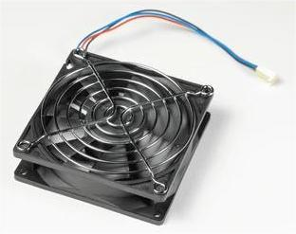
- Buzzer: Provides audible feedback during system operation.

7
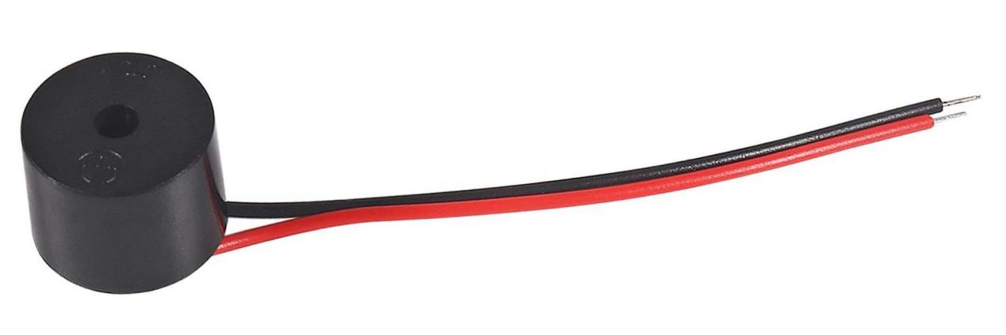

- Camera Module: Captures images of the food placed on the table.

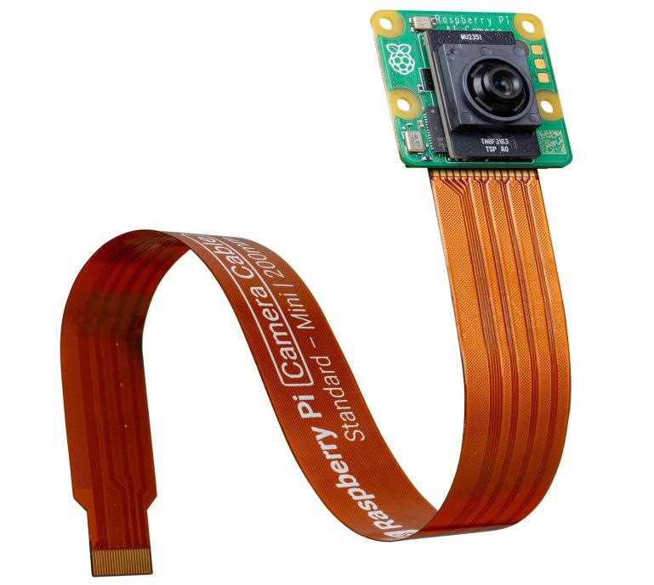
- Relay Modules:Relay modules are used in the Smart Table system to control high-power components such as the heating element and cooling fan. Since the ESP32 operates at low voltage and low current levels, direct control of these components is not possible. The relays act as electrically isolated switches, allowing the ESP32 to safely activate or deactivate the heating and cooling devices based on received control signals.
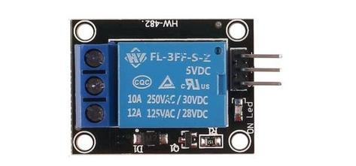

8

In the Figure shows the ESP32-based control unit, including the temperature sensor, relay modules, heating and cooling elements, and buzzer used for system feedback.

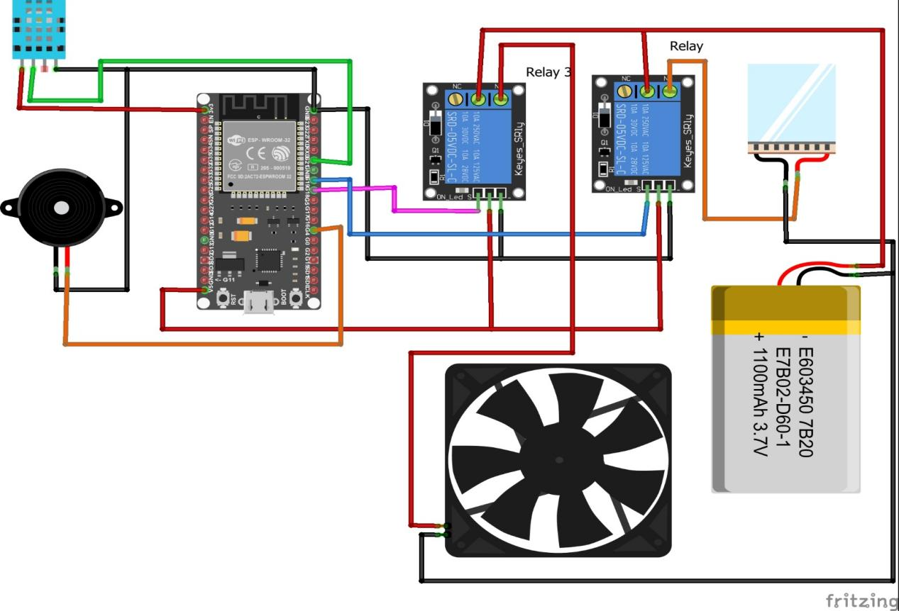

3.3 Software Components

- YOLO Object Detection Model running on the Raspberry Pi.
- Python Control Program on the Raspberry Pi for image processing and decision-making.
- Flask Web Application hosted on the Raspberry Pi.
- ESP32 Firmware (C++) for sensor reading and actuator control.
- Audio Feedback Module:
A text-to-speech module running on the Raspberry Pi is used to generate voice output. After detecting the food item, the system converts the food name and its description into audio and plays it through a connected speaker, providing real-time auditory feedback to the user.

9

3.4 Communication and Data Flow
The ESP32 operates as a Wi-Fi access point and hosts a TCP server that enables wireless communication with the Raspberry Pi. The Raspberry Pi connects to the ESP32 network, receives temperature and humidity readings measured by the DHT11 sensor, and processes this data as part of the system’s decision-making logic.
After detecting the food type using the camera and the YOLO object detection model, the Raspberry Pi compares the measured temperature with the predefined temperature range associated with the detected food. Based on this comparison, the Raspberry Pi determines whether heating, cooling, or no action is required.
The control decision is then transmitted from the Raspberry Pi to the ESP32 over the TCP connection. Upon receiving the command, the ESP32 activates the appropriate relay module, which in turn controls the corresponding hardware component. Specifically, one relay is used to switch the heating element, while another relay controls the cooling fan. This mechanism allows the low-power ESP32 to safely control higher-power devices through electrical isolation.

3.5 Decision-Making Algorithm

For each detected food item, a predefined temperature range is assigned. The Raspberry Pi compares the measured temperature with this range:

- If the temperature is within the acceptable range, no action is taken.
- If the temperature is higher than the maximum limit, the cooling system is activated.
- If the temperature is lower than the minimum limit, the heating system is activated.

The final decision is transmitted to the ESP32 for execution.

3.6 Safety and Constraints

The system is designed with basic safety considerations, including controlled activation of heating and cooling elements. Constraints include ambient temperature measurement accuracy, camera detection reliability, and environmental lighting conditions.

10

Chapter 4: Results and Analysis

4.1 System Operation Results
The Smart Table system was tested under various operating conditions to evaluate its ability to detect food items, measure temperature, and perform appropriate heating or cooling actions. During operation, a camera connected to the Raspberry Pi continuously captured video frames of the table surface. These frames were processed in real time using a trained YOLO object detection model running on the Raspberry Pi.
When a food item was detected, the system identified its class and selected the detection with the highest confidence. The Raspberry Pi then retrieved the predefined temperature range associated with the detected food type. At the same time, the ESP32 microcontroller measured the ambient temperature using the DHT11 sensor and transmitted this data to the Raspberry Pi via a wireless TCP connection.
Based on the comparison between the measured temperature and the desired temperature range, the Raspberry Pi automatically selected one of three actions: heating, cooling, or no action. This decision was then sent back to the ESP32 for execution. The system operated continuously and updated its decisions in real time as long as a food item was detected on the table.

4.2 Food Detection Results
The YOLO-based object detection model running on the Raspberry Pi successfully identified multiple food types, including apples, bananas, burgers, and pizza. The detection process selected the object with the highest confidence score in each frame to avoid ambiguity when multiple objects were present.
For each detected food item, the Raspberry Pi generated descriptive information such as the food name and a short explanation of its condition. This information was stored in a text file and displayed through the Flask-based web interface. The detection results were updated dynamically whenever the detected food item changed.
When no food item was detected on the table, the system remained idle and no heating or cooling action was triggered.

11

4.3 Temperature-Based Control Results
The temperature control behavior of the Smart Table was evaluated by comparing the ambient temperature measured by the ESP32 with the predefined temperature limits associated with each detected food type. The system responded according to the following conditions:
1. Normal Temperature Condition:
When the measured temperature was within the acceptable range of the detected food item, the Raspberry Pi instructed the ESP32 to keep both the heating and cooling elements turned off. In this case, no relay was activated, and the system remained in an idle state.
2. High Temperature Condition:
When the measured temperature exceeded the maximum allowable value for the detected food, the Raspberry Pi sent a cooling command to the ESP32. The ESP32 activated the corresponding relay module, which switched on the cooling fan to reduce the temperature.
3. Low Temperature Condition:
When the measured temperature dropped below the minimum allowable value, the Raspberry Pi sent a heating command to the ESP32. The ESP32 activated the appropriate relay module, which powered the heating element to increase the temperature.
In all cases, the ESP32 successfully executed the received commands, and correct relay operation was observed while controlling the heating and cooling hardware components.

4.4 Web Interface Output
The Flask-based web interface hosted on the Raspberry Pi displayed real-time information about the detected food item. The interface showed the food name and descriptive text explaining whether the food required heating, cooling, or no action. The displayed information was refreshed periodically, ensuring that the user always observed the most recent detection result.
The web interface provided a simple and effective method for monitoring system behavior without requiring direct interaction with the embedded hardware.

12

4.5 Analysis of System Performance
The Smart Table system demonstrated reliable integration between Raspberry Pi–based artificial intelligence, ESP32-based embedded control, and wireless communication. Real-time food detection enabled the system to react promptly to changes in the type of food placed on the table.
System performance was influenced by several factors. Temperature measurements were based on ambient conditions rather than direct food surface temperature, which may introduce discrepancies in certain environments. Additionally, food detection accuracy depended on lighting conditions, camera positioning, and visual clarity of the food items.
Despite these limitations, the system consistently fulfilled its intended functionality and demonstrated the feasibility of combining AI and IoT technologies in a smart furniture application.

4.6 Summary
The results confirm that the Smart Table system is capable of detecting food items using a Raspberry Pi, evaluating temperature conditions through an ESP32, and automatically controlling heating and cooling elements. The integration of object detection with sensor-based control provides an effective solution for intelligent food temperature management and validates the overall system design.
4.7 Audio Feedback Results
In addition to visual output, the Smart Table system provides audio feedback through a speaker connected to the Raspberry Pi. When a food item is detected, the system announces the name of the food and its associated details using a text-to-speech mechanism.
This feature was observed to operate in real time and synchronized with the visual detection results. The audio feedback enhanced user interaction and accessibility by allowing users to receive system information without continuously monitoring the display.

13

Chapter 5: Discussion

5.1 Interpretation of Results
The results demonstrate that the Smart Table system successfully integrates Raspberry Pi–based artificial intelligence with ESP32-based embedded control to achieve automated food temperature management. The system was able to identify food items, evaluate temperature conditions, and activate appropriate heating or cooling mechanisms without user intervention.
The use of object detection on the Raspberry Pi enabled intelligent decision-making by allowing the system to adapt its behavior based on the detected food type rather than relying on fixed temperature settings.

5.2 Effectiveness of Temperature Control
The temperature control strategy implemented in the Smart Table proved effective for basic food temperature management. When the measured temperature fell within the acceptable range, the Raspberry Pi correctly instructed the ESP32 to remain in an idle state. When the temperature exceeded or dropped below the defined thresholds, appropriate cooling or heating actions were triggered.
This rule-based control approach provided stable and predictable system behavior while maintaining simplicity in implementation.

5.3 Integration of Raspberry Pi and IoT Components
A key contribution of this project is the successful integration of a Raspberry Pi as an edge computing device with an ESP32 as an IoT node. The Raspberry Pi handled computationally intensive tasks such as image processing, object detection, and decision-making, while the ESP32 focused on sensor acquisition and actuator control.
This distributed architecture improved system flexibility and scalability and allowed each component to perform tasks suited to its capabilities.

14

5.4 System Limitations
Several limitations were identified during system operation. The DHT11 sensor measures ambient temperature rather than the actual surface temperature of the food, which may result in inaccurate thermal assessment in some scenarios. Additionally, object detection accuracy was influenced by lighting conditions, camera angle, and visual occlusions.
The system also relied on predefined temperature ranges for each food type, limiting adaptability to individual user preferences or uncommon food items.

5.5 Comparison with Existing Approaches
Compared to conventional temperature control systems that operate independently of object recognition, the Smart Table provides a more intelligent and context-aware solution. Unlike smart appliances such as refrigerators or ovens, the proposed system introduces intelligence into a table, which is traditionally a passive object.
The combination of Raspberry Pi–based computer vision with ESP32-based actuation distinguishes this system from existing approaches and highlights its novelty.

5.6 Practical Implications
The Smart Table has practical applications in domestic and commercial environments. In homes, it can improve user convenience by maintaining food temperature automatically. In restaurants, it may assist in preserving food quality during serving.
From an educational standpoint, the project demonstrates a multidisciplinary approach involving computer vision, embedded systems, IoT, and web technologies.
The inclusion of audio feedback further improves system usability, particularly for hands-free operation and accessibility. By announcing the detected food name and details, the Smart Table provides an intuitive user experience suitable for real-world environments.

15

5.7 Summary
The discussion confirms that the Smart Table system meets its objectives and demonstrates effective integration of Raspberry Pi, ESP32, and AI technologies. While certain limitations exist, the system provides a solid foundation for future development.
Chapter 6: Conclusions and Recommendations

6.1 Conclusions
This graduation project presented the design and implementation of a Smart Table system that integrates Raspberry Pi–based artificial intelligence, ESP32 embedded control, and Internet of Things technologies to automatically manage food temperature. The system successfully detected food items, analyzed temperature conditions, and controlled heating and cooling elements without user intervention.
The results demonstrated reliable real-time performance, effective wireless communication between system components, and successful separation of processing and control tasks. The Raspberry Pi served as the central intelligence unit, while the ESP32 ensured reliable sensing and actuation.
Overall, the project validated the feasibility of using AI and IoT technologies in smart furniture applications.

6.2 Recommendations and Future Work
Several enhancements can be considered for future development. Improving temperature sensing by using non-contact infrared sensors could increase accuracy. Expanding the object detection model to include additional food types would improve system applicability.
Future work may also include user-defined temperature preferences, cloud-based data logging, mobile application integration, and improved web interface visualization. Additionally, advanced control strategies could be explored to enhance system efficiency and responsiveness.

16

Chapter 7: Future Work

7.1 Planned Enhancements
Although the Smart Table system successfully achieved its objectives, several enhancements can be considered for future development. One important improvement is the use of more accurate temperature sensing techniques, such as infrared sensors, to directly measure the surface temperature of the food rather than ambient temperature.
Expanding the food recognition database by training the object detection model on a larger variety of food items would also increase system usability. This would allow the Smart Table to handle more real-world scenarios and adapt to different user needs.
Another planned enhancement is improving the audio feedback system by providing more detailed spoken information, such as recommended serving temperatures or food safety warnings.

7.2 Future System Development Approach
Future versions of the Smart Table can incorporate cloud connectivity to store temperature data and system logs for long-term analysis. A mobile application could also be developed to allow users to monitor and control the system remotely.
Additionally, the decision-making logic could be enhanced by introducing adaptive or learning-based algorithms that adjust temperature thresholds based on user preferences or historical data. From a hardware perspective, improving power management and integrating compact relay modules could make the system more energy efficient and suitable for commercial deployment.
Overall, these future developments would further enhance the intelligence, usability, and scalability of the Smart Table system.

17

This report was written by students at the ( Computer ) Engineering Department,
Faculty of Engineering, An-Najah National University. It has not been altered or
corrected, other than editorial corrections, as a result of assessment and it may contain
language as well as content errors. The views expressed in it together with any
outcomes and recommendations are solely those of the students. An-Najah National
University accepts no responsibility or liability for the consequences of this report
being used for a purpose other than the purpose for which it was commissioned.

Thanks for reading

