
Drawing Robot

Group Members:
Hedaya Omar
Isra’ Abdulhaq

This Report Submitted in fulfillment of Hardware
Graduation Project (66582)
At
Department of Computer Engineering
Faculty of Engineering
An_Najah National University
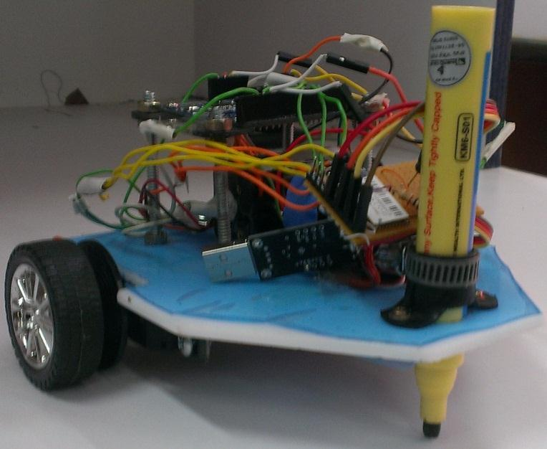
May 5, 2013

Instructors:
Dr. Raed Alqadi
Dr. Luai Malhis
Dr. Haya Samaneh

Table of Contents
Abstract 3
1. Introduction 4
1.1. Purpose (Motivation) 4
1.2. Overview: 4
1.2.1. Specification 4
1.2.2. Features: 4
1.3. Subprojects 5
1.3.1. Battery and Voltage Regulator: 5
1.3.2. Arduino Microcontroller 5
1.3.3. Actuator (Servos motor) 5
1.3.4. Bluetooth SMD Module - RN-42: 5
1.3.5. Photo Interrupter GP1A57HRJ00F: 6
1.3.6. Other parts (Wheels, body, pin, wires, screws, rubber O-ring) 6
1.4. Report Organization: 6
2. Design Procedure 8
2.1. Design Analysis 8
2.1.1. Robot Design 8
2.1.1.1. Servos 8
2.1.1.2. Photo interrupter 10
2.1.1.3. Preparing the model 11
2.1.1.4. Traveling a Specific Distance 11
2.1.1.5. Writing Movement Functions 12
2.1.1.6. Controlling car via Bluetooth 12
2.1.2. Android Application 13
2.2. Design verification 14
3. Methodology 15
4. Project Costs 16
5. Result and Discussion 19
6. Result Snapshot 20
7. Conclusion and recommendation 23
8. Future Work 24
8. References 25

Table of Figures

Figure 1: Continuous Full Rotation Servo Motor 8
Figure 2: Down the pin 8
Figure 3: Up the pin 8
Figure 4: photo interrupter 9
Figure 5:internal design 9
Figure 6: Photo interrupter mechanism 10
Figure 7: Car model Design 10
Figure 8: Drawing R 19
Figure 9: Drawing D 19
Figure 10: Drawing A 19
Figure 11: Drawing E 19
Figure 12: Drawing H 20
Figure 13: Drawing Square 20
Figure 14: Circle and Square 20
Figure 15: Drawing L 20
Figure 16: Drawing Circle 21
Figure 17 : Samples 21

Acknowledgment:
We would like to express our gratitude to all those who gave us the possibility to complete this project. We want to thank the Department of computer Engineering. We want furthermore to thank Dr.Raed Alqadi who encouraged us to go ahead with our project and give us any information we need and the feedback continuously. Also, we are thankful to all doctors for their support.
We are deeply indebted to our Uncle Abo Taleb whose helped us greatly by cutting the piece of Teflon that we needed in our robot design and open holes in it to make us easy integrated the servos, wheels and photo filters. We are thankful to our brothers that help us to get some component like batteries and Bluetooth and sisters that support us all the time.
Especially, we would like to give our special thanks to our parents who encouraged us and enabled us to complete this work. And at last but not the least we would like to thank God for the successful completion of our project.

Abstract

Our project is a drawing robot that draws shapes like a circle, Rectangle and letters etc. We remotely send the object that we want to draw, and then the robot will draw it on the paper.
The importance of our project is summarized to facilitate the work of writing and drawing on large posters. So the robot will do this task instead of hand writing or drawing which need more effort to do this.

The objectives of our project are to reduce the time needed to draw in big posters and also increase the accuracy.
The aspects that the project will cover are summarized in two points; first, sending data to the microcontroller wireless, second, Analyzing this data and drawing some shapes by the robot car.

The methodology of this project will be as follows:
Using Arduino Pro microcontroller and two servos to move the robot and a third servo we added to move the marker pen up and down. Basically, we send character from android application and according to this character we draw the corresponding shape by the robot.
We used the Bluetooth RN42 and connected it to the arduino to manipulate the process of sending data from the android application.

Introduction

1.1. Purpose (Motivation)

The purpose of our project is to draw on large posters, layouts playgrounds and streets. So the robot will do this task instead of human that need efforts to do that and reduce the time and cost as much as can.
Also it can be used for edutainment purposes and teaching kids the characters, figures and shapes in a fun way by drawing the element in front of them using our nice small car robot.

1.2. Overview:

1.2.1. Specification

This project is divided into three main components. The first main component is servo pin (standard servo motor that connected to the pin that drawing). The servo pin controlled by Arduino microcontroller and then it is up and down the pen depending on arduino signal. The second main component is the servo wheels (servos connected with wheels). This provides the animation for the car depending on signals from controller. These signals decide the distance, speed, and the direction of the wheels. Lastly, the third main component is the android mobile which send the date to the microcontroller via Bluetooth. Once the microcontroller receives the data from the android mobile by Bluetooth, this data are activate a specific shape then draw.

1.2.2. Features:

- Applicable project.

- User friendly just control the car using android application without any difficulties

- Reasonable cost device

- Used by multi purposes

1.3. Subprojects

1.3.1. Battery and Voltage Regulator:

A 9V chargeable battery was used to feed our microcontroller (arduino pro mini) with built in voltage regulator which regulates our input to +5 volts. Another source of power (1.2*(4 chargeable batteries)V was used to feed the servo motors directly, Also we need 3.3V which is not available directly to feed the Bluetooth RN42 so we used a 1085 regulator that regulates Arduino voltage(5 V)to 3.3 V output that use as input for Bluetooth. Furthermore, some decoupling capacitors were used to decrease the noise output of this regulator.

1.3.2. Arduino Microcontroller

We used Arduino Pro 328 - 5V/16MHz. The main features that brought our attention to this microcontroller is that it is support more than 2 servo motors (2 PWM) without any sophistication and we need 3 servo motor in our project, also its smaller footprint and lighter weight than other arduino boards because it doesn’t has any headers and this is very important for our project because we need our car to be light as much as can to make it move smoothly. Also compatible with Arduino shields, this make working with Bluetooth not very difficult, and its low cost compared with Arduino Uno (inc, 2013).

1.3.3. Actuator (Servos motor)

An “actuator” can be defined as a device that converts energy (in robotics, that energy tends to be electrical) into physical motion, motors is the type of actuators, we use a standard servo motor that rotate 180 degree to up and down the pin but this type of motors are unable to continually rotate, meaning that they can't be used for driving wheels (unless modified) so we use full rotation servo motors to move our robot.

1.3.4. Bluetooth SMD Module - RN-42:

In our project we used Bluetooth RN 42 to transfer the data between mobile and Arduino that controlled the movement of the wheels. This chip is simple to integrate into an embedded system or simply connect to an existing device. In this project, we concentrate on the UART and connected the TX and RX to the microcontroller to send data serially from the android application. And we connected the GND to the Arduino GND and VCC is connected to the regulated voltage from Arduino VCC. Also, we connected a series current limiting/voltage dropping resistor (10K and 20K ohms) on the RX (Sparkfun, 2013).

1.3.5. Photo Interrupter GP1A57HRJ00F:

This sensor is composed of an infrared emitter on one upright and a shielded infrared detector on the other. By emitting a beam of infrared light from one upright to the other, the sensor can detect when an object passes between the uprights, breaking the beam. The gap width equals to 10mm.We connected the photo interrupter to the breakout board, a simple breakout PCB for the GP1A57HR photo interrupter. This PCB has three connections for PWR, GND, and Signal. We used this sensor to detect the number of steps that the wheel will rotate and compare them to the required steps that the wheel must be rotated according to the input distance.

1.3.6. Other parts (Wheels, body, pin, wires, screws, rubber O-ring)

We have taken into account that the shape of the car and its content should be very light to make the movement easy therefore we chose Teflon to be the body of the car is characterized by lightness and strength and we have linking wheels with a circular perforated eight holes, these holes allow passing the light emitted by transistors located within the opt coupler and thus it specifies the number of the steps that the car will move and then we linking all of these with motors, and put the pen in an appropriate manner maintain the balance of the car and ease of movement.

1.4. Report Organization:

We organized this documentation as the following: In chapter one section one, two, and three we introduced our project by talking about motivation and added an overview about our project, also we added some special information to introduce the main parts of our project.
In chapter two, we discussed the design procedure, in section one, we talked about design analysis, in subsection 2.1.1, we started to explain the first part of our project which is a robot design and this section is branched into more than one subsection that introduce the main parts of the robot, so in subsection 2.1.1.1, we added some details to the servo motors and in 2.1.1.2, we introduced the photo interrupter in depth and in subsection 2.1.1.3, we discussed the main point in preparing the model. In subsection 2.1.1.4, we introduced the main point in which the movement of the robot depending on it and in 2.1.1.5, the discussion is focused on the writing the movement equation. And in subsection 2.1.1.6, is focused on the second part of our project which is controlling robot via Bluetooth. Return to subsection 2.1.2 which explains in detail the Android application. In section 2.2, we explained the design verification. Going ahead to the chapter three we added the methodology of our work step by step. In chapter four, we discussed the costs of our project. Chapter five represents the result and discussion.
In chapter six, we enclosed some snapshots of our work, like some characters drawn by the robot etc. And in chapter seven we conclude our work in this project. While in chapter eight, we introduced our future work in this project.
Finally, in chapter nine, we added the references that we are used them during our work in this project.

Design Procedure

The following sections examine different approaches to the design and how we chose the final design of these components as well as the steps we took to create the final design. At first our perception about the project was quite different from what exists at the present time we were thinking about bringing a model contains the microcontroller, wheels, motors, hall effect sensors, as well rings with holes, body, even screws and wires, and we will linking and attach everything depending on model design, but the availability of this model was very difficult, as was the time required to bring this model is very long compared with the time of delivery of this project. So we bring each part from different sources in different times.

2.1. Design Analysis

Our project consist of two parts the robot design and the Android application, first we will discuss step by step the robot design:

2.1.1. Robot Design

The robot is built from hardware parts: servos motor, wheels, and photo interrupter sensors, round servo horn, wires, board, and pen. And software part which Arduino 1.0.4 software in c++ language.

2.1.1.1. Servos

In this project we need two wheels only to move the car and each wheel needs to be attached with servo motor. But the difficulty was in choosing the right motor so we searched and read a lot on the internet then we find that continuous full rotation servo motor is the best in our case it has built in H-bridge and also there is a gear box that reduce the speed and increase the torque but the problem with this type of motor that it doesn’t have a feedback mechanism so we solve this problem using photo interrupter (we explain this in the next section) (Inc, 2013).

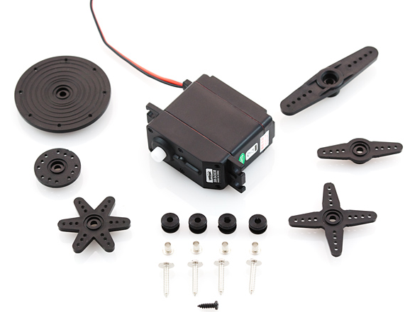

Figure 1: Continuous Full Rotation Servo Motor

Also we need another servo that up and down an arm so the pin is up and down but the standard servo which rotate 180 degree and have a feedback mechanism can do this mission
This servo connected with small arm that linked with small circular thing so when pin is dawn to draw this arm is up and when the car is move without drawing the arm with circular thing is down to the ground so it is up the pen and no ink on the paper. The figures below show how this servo works.

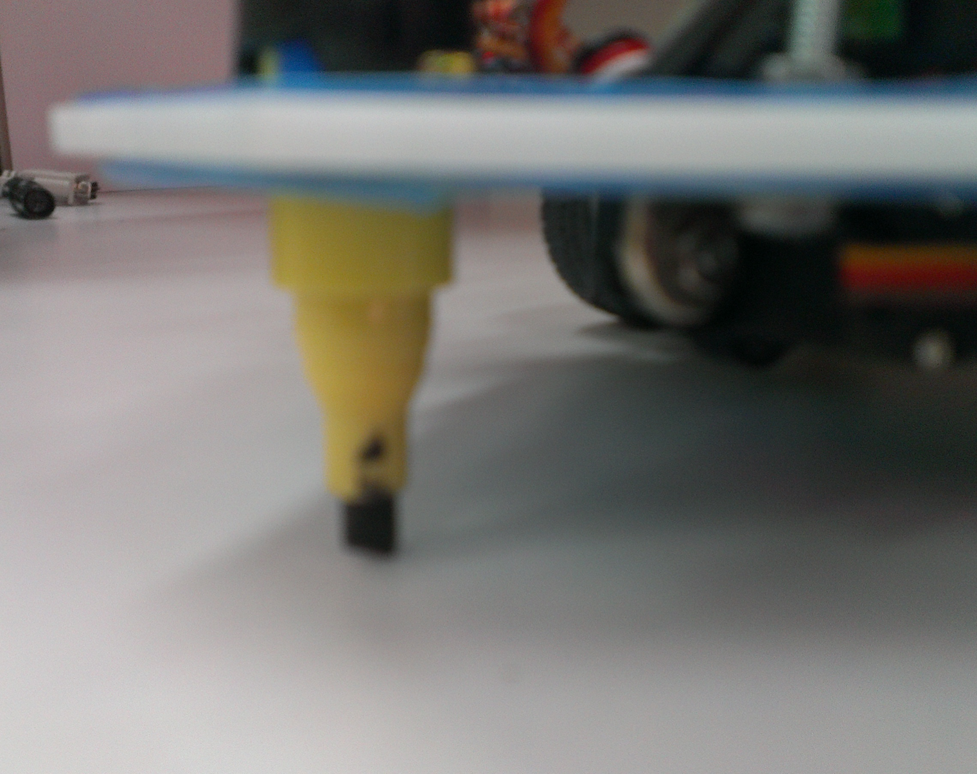  Figure 2: Down the pin | 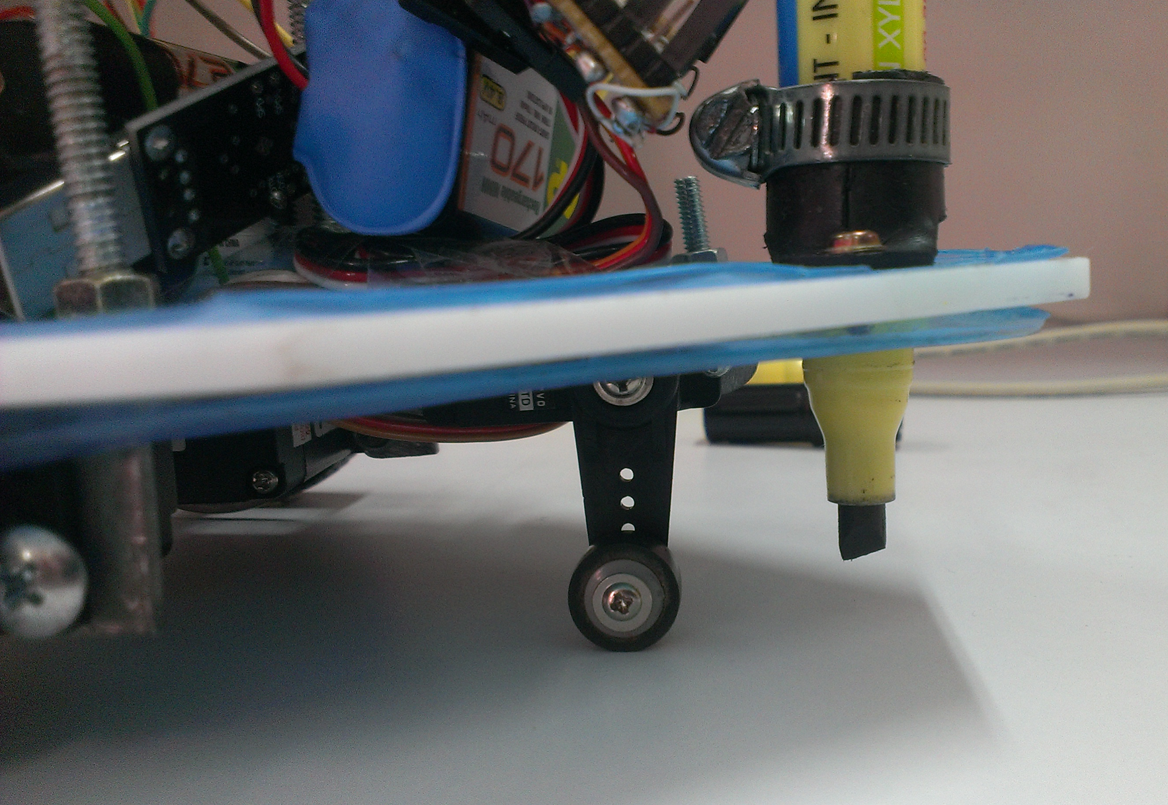  Figure 3: Up the pin

After we decide which types of motor to use and understand their working mechanisms we started connecting and testing them. We connected the three wires of the servo to GND and SIG (PWM) and VCC to control it. Also, we used the servo library to control it in software so, on a continuous rotation servo library, the write function will set the speed of the servo (with 0 being full-speed in one direction, 180 being full speed in the other, and a value near 90 being no movement. Whereas the standard servo that used to rise the pen up and down which rotate from 0 until 180 degree and the write function control the angle of rotation.

2.1.1.2. Photo interrupter

we prepared the photo interrupter to the breakout board and connect both the GND and the VCC for both to the Arduino and the signal for each one to the pin 2 and 3 that attach to the interrupter and call both functions countRight and countLeft to change the value of rcount and lcount variable. Then we passed the horn of the servo through the sensor to detect the number of pulses and we read the result from the serial and make sure that both of them are working correctly (Attic, 2013) (Sparkfun, 2013).
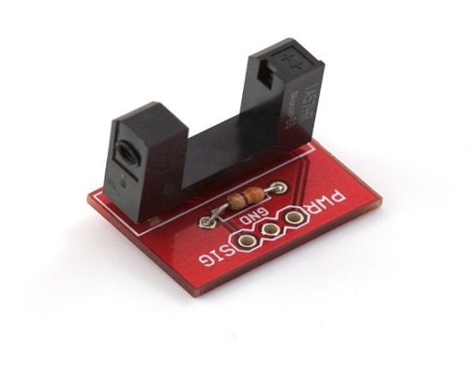  Figure 4: photo interrupter | 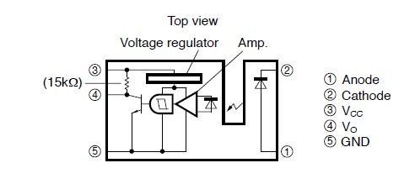  Figure 5:internal design

More details about photo interrupter mechanism
Servo rotates the disks with optical windows, as shown in Figure6. Light from emitters that located in first side of photo interrupter passes through the openings in the disk to detectors in the other side. As the shaft is rotated, the light beams are broken. Then pulses is creating and because we attach this photo interrupter with interrupts on the arduino and trigger it on change so we can calculate how many pulses we have and this help us to calculate the travelling distance | 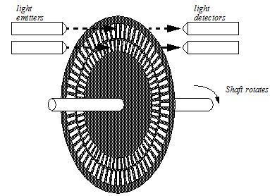  Figure 6: Photo interrupter mechanism

2.1.1.3. Preparing the model

After the completion of testing the motors, photo interrupters, and make sure that they are working properly, and the movement of the motor is set a pulses as a result of cutting the light emitted from photo interrupter, and the photo interrupter can correctly count the number of pulses we begin processing model integrated and reach to our final design the image below show our car design.
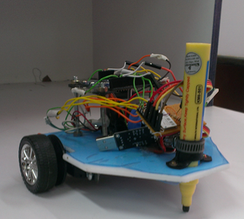
Figure 7: Car model Design

2.1.1.4. Traveling a Specific Distance

In this step, we will program our robot to travel a specific distance. Each time the robot's wheels make one complete turn; the robot travels a distance equal to the circumference of the wheel. To make the robot travel a specific distance, we first determine how many pulses are needed for the wheel to rotate a full 360 degrees which is 8 pulses because the servo horn has 8 holes and we make sure by printing on the Arduino serial the pulses count, we calculate the wheel's circumference which is 4.8 cm, and then determine how far the robot travels with every pulse that we send to the servo motors. After that we can calculate number of steps that refer to the specific distance that the servo must rotate.

Our calculations:
Wheel circumference = wheel diameter * pi
Distance-per-pulse = wheel circumference / pulses needed for a 360-degree wheel rotation
Number of Steps = distance / distance-per-pulse
Now in our arduino code we compare the number of steps with the counter of each interrupt and if it is equal this mean that the car travels its specific distance so we detach the servos and stop the wheels.

2.1.1.5. Writing Movement Functions

The movement of the cars can be achieved by calling main three functions with appropriate sequence, redundant and parameter these functions are:
Go (int distance, int speed):
We pass the distance which car move and the speed of it. Because we connected these two servos opposite to each other to act as a wheels we forced to write negative speed reverse the direction of the wheel to be as the first one.
Go Back (int distance, int speed)
The same as Go function but reverse the direction for each one.
Rotate (int distance, int speed)
We implement rotation by rotate each wheel opposite to each other.
And we used these functions to draw samples of shapes and characters like circle, square, A, D, R etc.

2.1.1.6. Controlling car via Bluetooth

After making sure that the car has drawn the required letters and shapes and it working correctly we decide to control it via Bluetooth so first of all we connect Bluetooth just with regulated power (No connection with arduino) and then searching on devices on our mobiles so we found it which is called RN DD7D and making pair with it after entering the default password (1234) that come with the company. After that we make sure that the Bluetooth working correctly.

2.1.2. Android Application

First of our work we make a simple android project that just sends data via Bluetooth to arduino and print the data received to the arduino serial, then we make it just go or go back depend of value received if 1 means that go and if 0 means go back and finally we make our final application that make the car draw any thing depend on what user want.

More Details:
We read in android developer website the steps to make a complete application that support the Bluetooth and below we wrote some of headline in our code.
First of all we should write the permission in android manifest file
<uses-permission android:name="android.permission.BLUETOOTH_ADMIN" />
<uses-permission android:name="android.permission.BLUETOOTH" />

Then there are two things to make connections
- A MAC address for the Bluetooth.

Our MAC address is 0006664EDD7D.

private static String address = "00:06:66:4E:DD:7D";

- A Service ID or UUID in this case we are using the UUID for SPP.

private static final UUID MY_UUID = UUID.fromString("00001101-0000-1000-8000-00805F9B34FB");

After that, we created a data stream so we can talk to server.

outStream = btSocket.getOutputStream();

And this is how to send data:

This code for each button

public void onClick(View v) {sendData("here we put the data we want to send");}

and the send function is below

private void sendData(String message) {
byte[] msgBuffer = message.getBytes();

try {
outStream.write(msgBuffer);
}

}

2.2. Design verification

We broke our project into small pieces and tested each one individually to determine where the error is and corrected it then built our next step on right previous one we talked about these things previously but now we will summarize it:
- Servos testing by try sweep code that make them rotate clockwise and counterclockwise.

- Photo interrupter testing by attaching them to arduino interrupts so they count on each change and print the result on arduino serial.

- Traveling specific distance testing.

- Bluetooth testing by connecting it just to power and search on it and pairing it.

- Android application just by send data from android and print it on arduino serial.

- Whole project testing , the complete project include the software part and hardware one.

Sometimes when something doesn’t work or doesn’t work as we expected, we need to re-test again, as the completion of the testing stage and go to the next one does not mean that if something crashed we will not go back to the previous stage, and this are the problem that we face in the projects. Re-testing hardware component will continually because it may be break down at any moment.

3. Methodology

To achieve our goals and reach of our final result as we want we did this steps:
- Analyze the project requirements.

- Collecting the component.

- Install needed software.

- Testing each part.

- Integrating and implementing HW and SW.

- Final checking.

4. Project Costs

The table below shows the component that we need with its price

Table 1: Project Costs
Part Name | Part Image | Number of Parts | price
Microcontroller (Atmega328) | 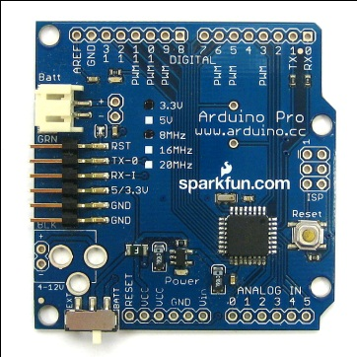 | 1 | 120 NIS
Standard Servo | 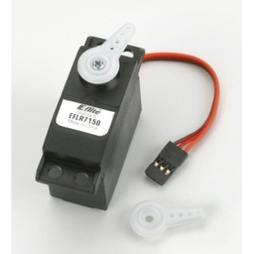 | 2 (one of them is damaged) | 64 x 2 NIS
Continuous Large Servo | 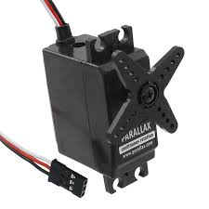 | 2 | 75 x 2 NIS
Photo Interrupter &  Breakout board | 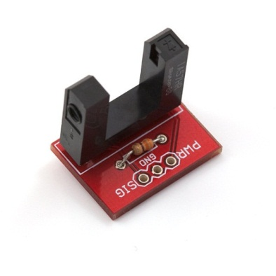 | 2 | 13 x 2 NIS
Wheels | 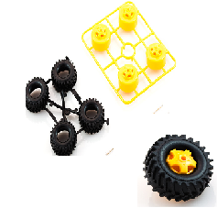 | 1(Not used) | 30 NIS
Wheels from toy | 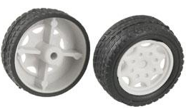 | 1 | 10 NIS
Bluetooth RN 42 | 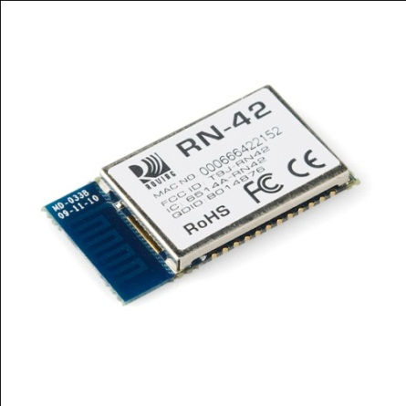 | 1 | 140 NIS
Regulator LM1085 + 2 capacitors 10 Micro Farad. | 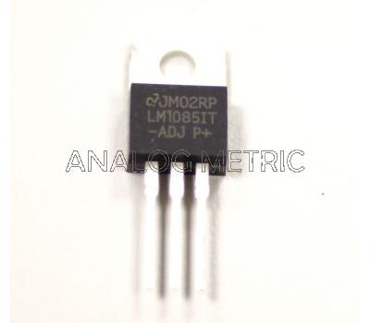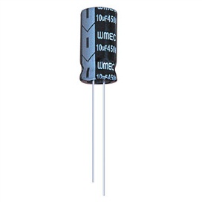 | 1 | 14 NIS
Regulator LM 317 + Potentiometer +Resistor 390 ohms | 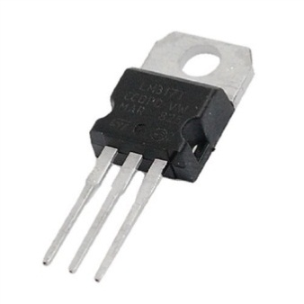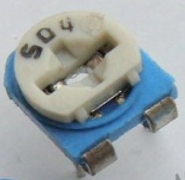 | 1 | 7 NIS (Not Used)
Rechargeable Battery (1.4 volts) | 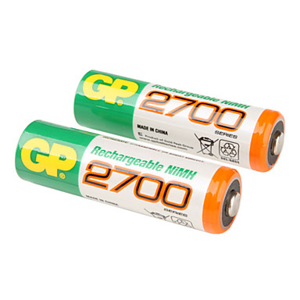 | 4 | 30 x 4 NIS
Rechargeable Battery (9 volts) | 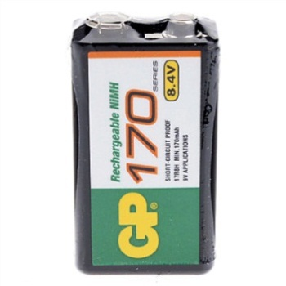 | 1 | 40 NIS
Pen | 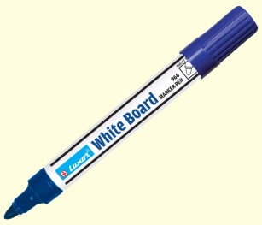 | 6 | 6 x3 NIS
Pasteboard |  | 8 | 8 x1.5 NIS

Total cost = 821 NIS

5. Result and Discussion

Now we have an integrated robot does its job for which it have been designed, which is drawing on large posters, layout playgrounds and streets where the results obtained are summarized as the follow:
That the car we have can draw letters and shapes through the receiving data from Arduino, which in turn it receives the required data from the mobile user wireless, via Bluetooth.
The first part is the robot
The robot can go any distance possible gives it but we have set a fixed distance so that they are suitable for the size of the paper to draw on, but in the case that the project practically applied, it can walk for long distances as much as can.
There is a set of problems we face
- The weight of the pen sometimes affects the balance of the rotation of the robot, because we forced to change the pen many times. So, we changed the code many times.

- The servos that we used with low quality and the quality of one of them became low than the other and this also affect the accuracy for the rotation of the robot.

- We rotate the standard servo in wrong manner at the first time and each time this servo hit the board of the robot and this damaged the servo and we forced to buy another one.

- We must use a large piece of paper because when we used the small papers that we connected to each other using stuck could affect the route of the robot.

The second part is the mobile application
This application developed to send data to the microcontroller on the robot which received by a Bluetooth RN 42. And depending on data value the car draw something and this achieved by connection Bluetooth with TX and RX with arduino, however to reach this result we face some of problems:
At first we connected this Bluetooth to the pin 0 and 1 (TX and RX) but this Bluetooth does not received any thing, but when we changed the pins that the Bluetooth is connected to pin 4 and 5 and with data rate 115200 Hertz it works, the reason for this because the first two pin is used for serial connection from computer and it is reserved.
At the end the entire previous problem has resolved totally to reach our final result which is a good result that we are looking at.

6. Result Snapshot

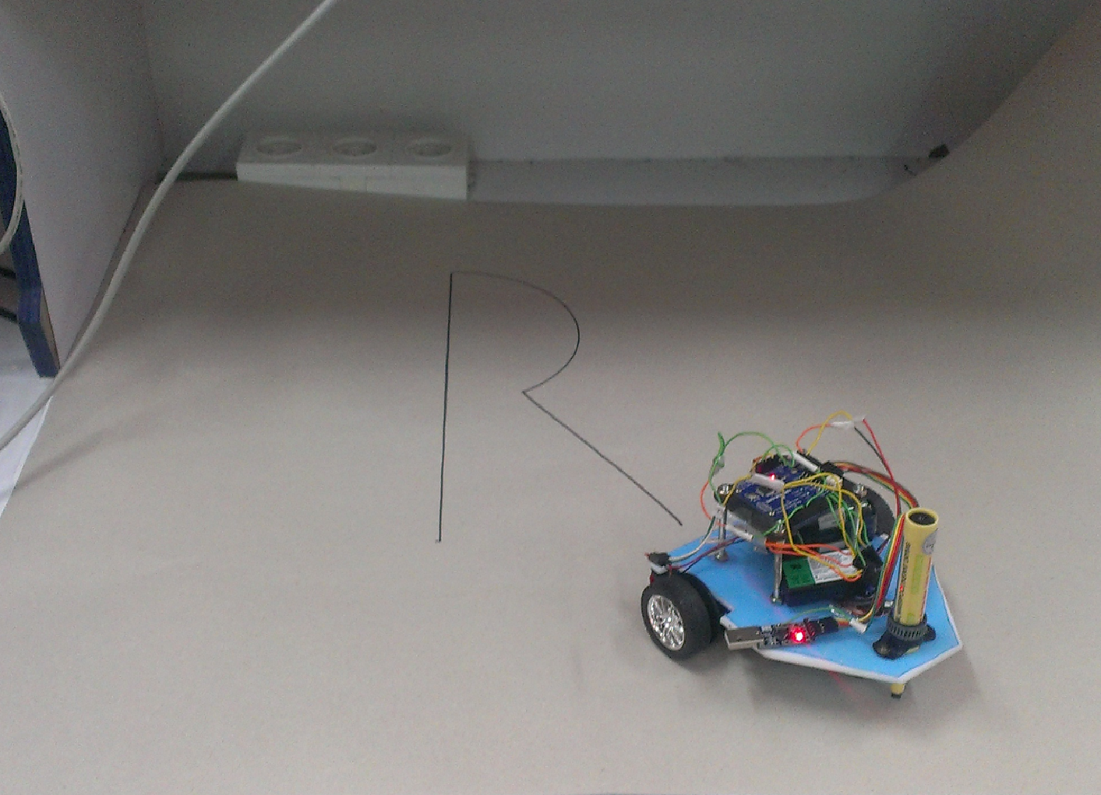  Figure 8: Drawing R | 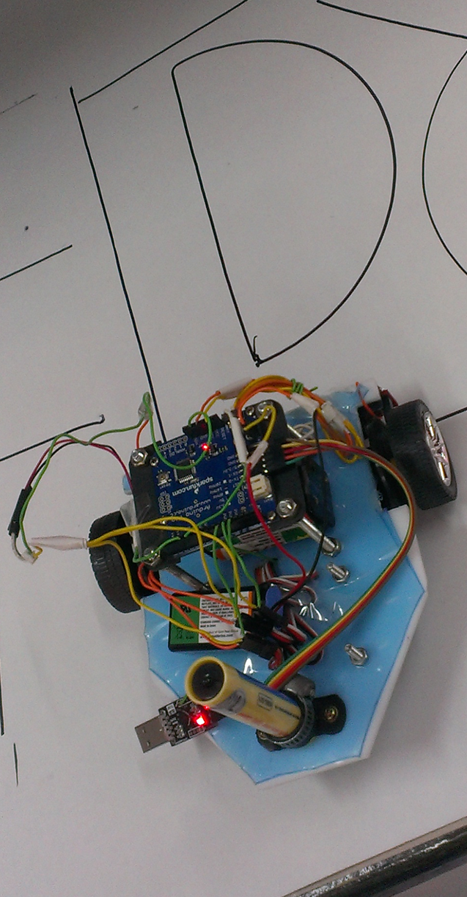  Figure 9: Drawing D
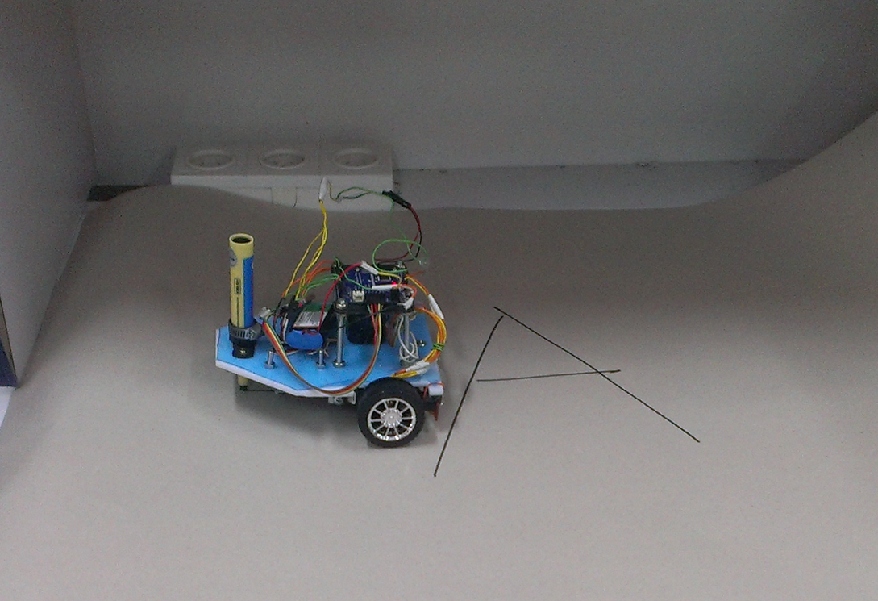  Figure 10: Drawing A | 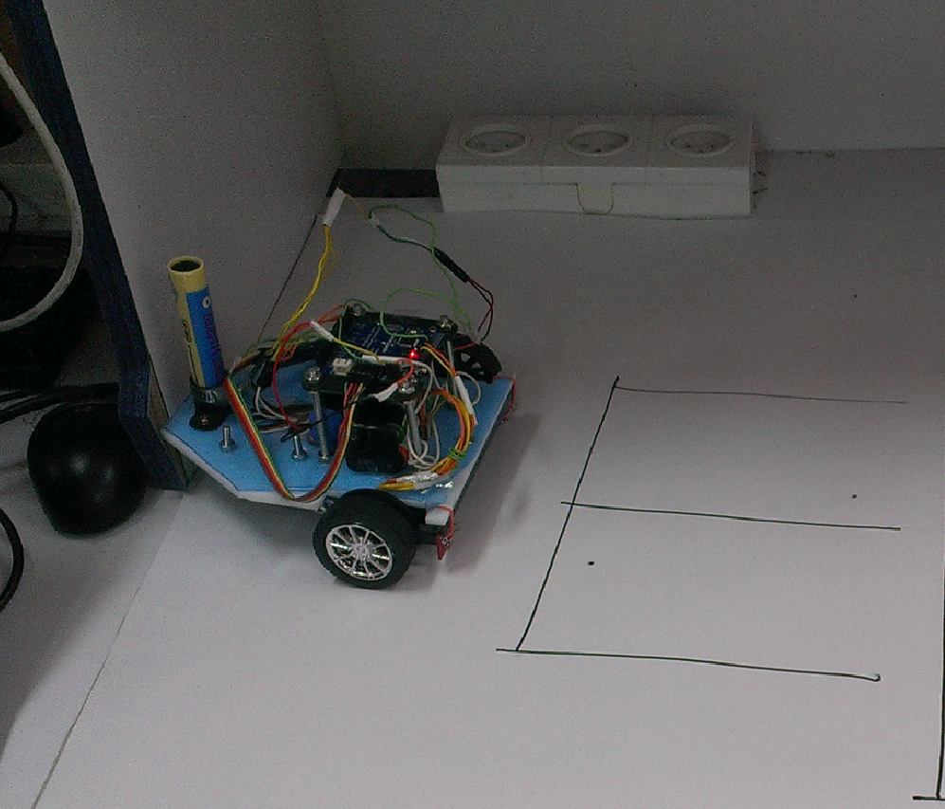  Figure 11: Drawing E
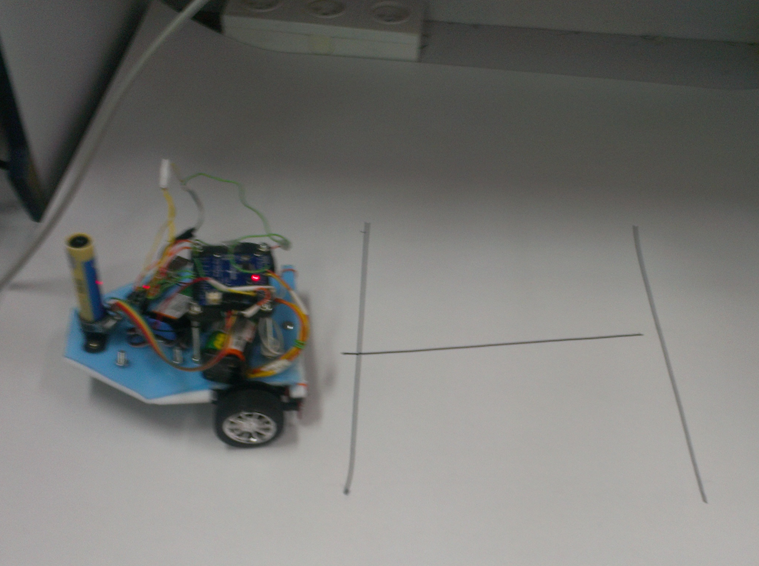  Figure 12: Drawing H | 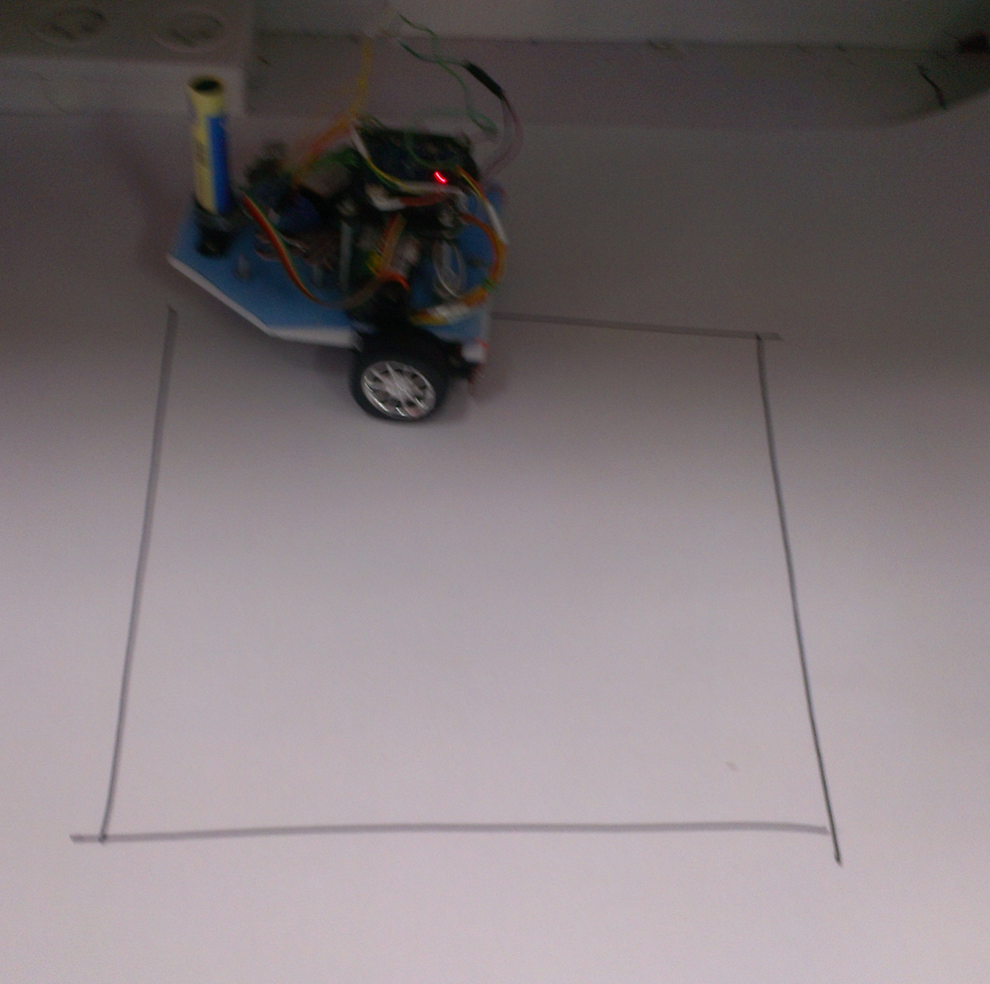  Figure 13: Drawing Square
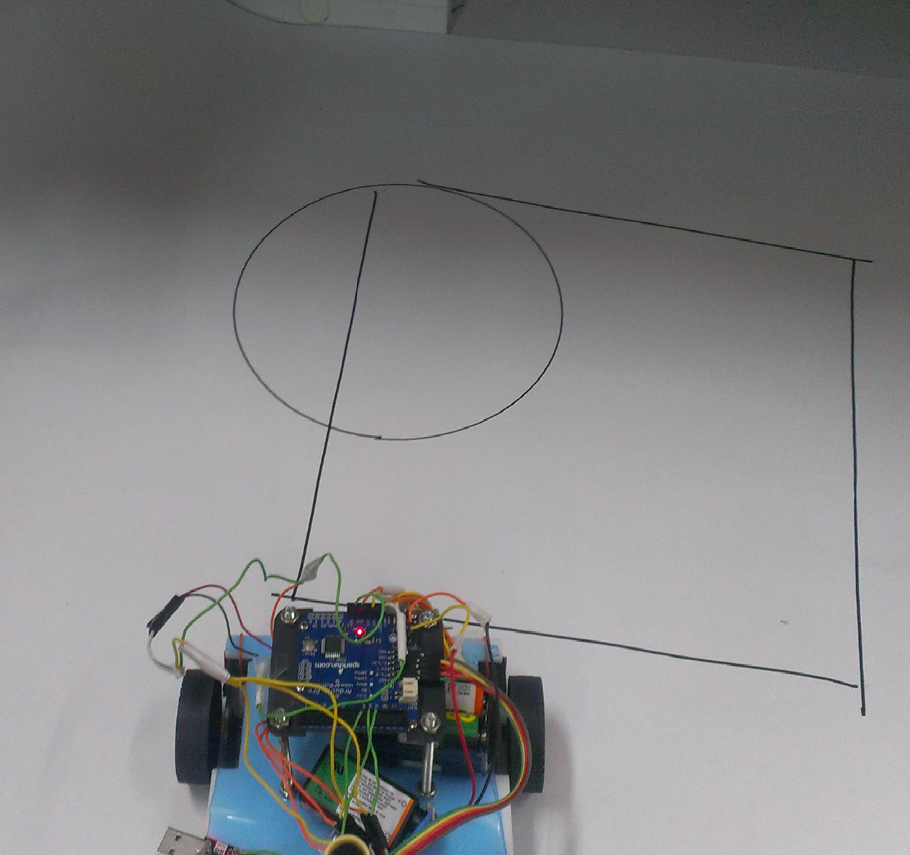  Figure 14: Circle and Square | 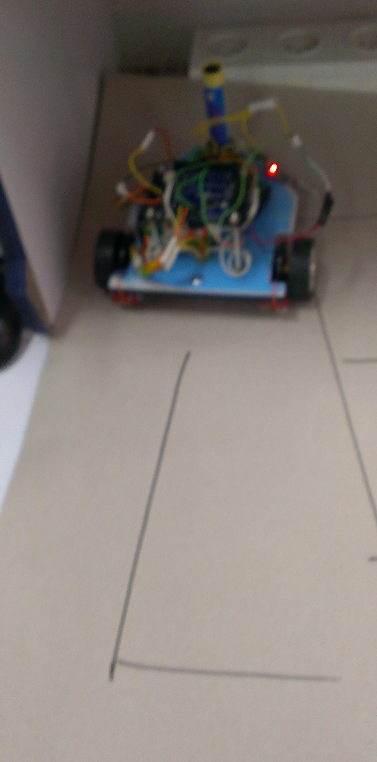  Figure 15: Drawing L
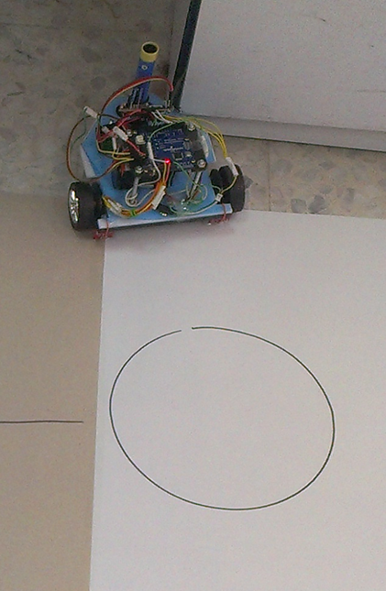  Figure 16: Drawing Circle | 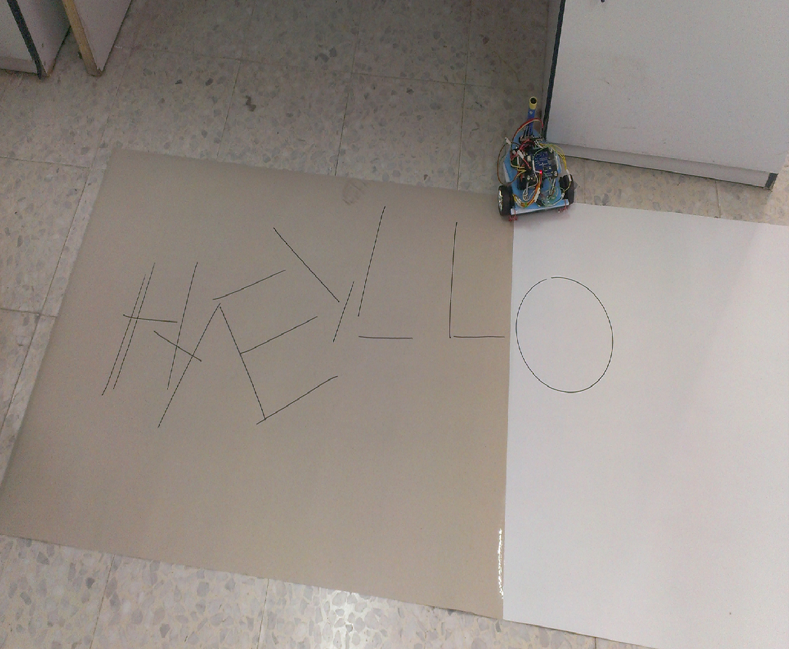  Figure 17 : Samples

7. Conclusion and recommendation

Overall, the project was a success. Almost of the functionality proposed in the initial design was achieved. The car can draw and receive data remotely via Bluetooth and despite the difficulties that we faced in obtaining project component and the delay in start of the project because the component not available and the difficulties that we talked about earlier, we overcame all the problems and solved little by little until we reach our final result that we expected since the beginning of the project and now we are satisfied with what we have reached, but there are some recommendations that should be taken into consideration if the project is applied in a practical. Pen that used for drawing should be bottled by the ink so as not to be replaced every time and even keep a certain percentage of ink and thus the balance of the car remains constant also we prefer to use good-quality high-efficiency motor and therefore the speed of motor remains constant for a good time these are some of recommendations that we have.

8. Future Work

We've talked previously that the project is designed for many goals, including educational goals and in order to achieve this goal, we can develop the project so the user can free drawing on Mobile and thus transfer pixels and mapping each pixel to some centimeters also that we can use and erasable white board and make an small eraser that can erase any line we want, more and more we can use many colors and make it draw in specific boarder without going out with these of borders.

8. References

Sparkfun. (2013). Retrieved from https://www.sparkfun.com/products/9299
Sparkfun. (2013). Retrieved from https://www.sparkfun.com/products/10253
Attic, T. (2013). Retrieved from http://shop.trinculosattic.com/products/photo-interrupter-gp1a57hrj00f-breakout-board
inc, R. D. (2013). RobotShop.com. Retrieved from http://www.robotshop.com/arduino-microcontroller-comparison.html
Inc, R. D. (2013). RobotShop.com. Retrieved from http://www.robotshop.com/blog/en/how-to-make-a-robot-lesson-3-actuators-2-3703

- Schematic of our project:
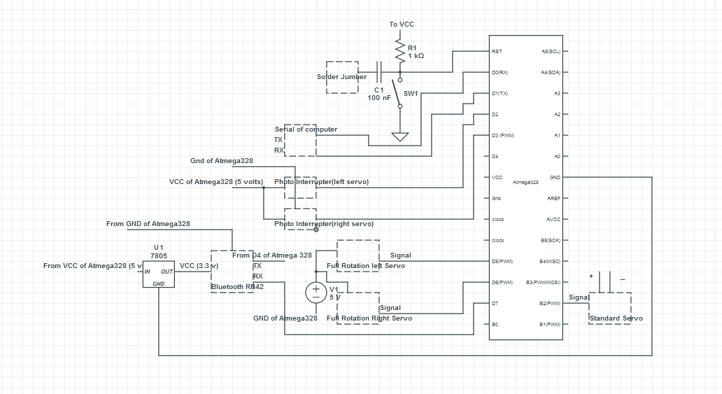

10. Appendices.
- Flow Chart:

