
AN-NAJAH NATIONAL UNIVERSITY
FACULTY OF ENGINEERING

ENERGY AND ENVIRONMENTAL DEPARTMENT

Comparison Between Chiller and VRF systems
“Youth Development Resource Center, Jericho”

Graduation Project Submitted In Partial Fulfillment of The Requirements For The Degree of B.Sc. InEnergy and Environmental Department

Supervisor:The students:
Eng. Ibrahim Khaswan Doaa Arandy
Thanaa Daraghmeh

May – 2017

- Acknowledgment

We would like to thank Allah, to reconcile us to each step and for giving us everything to make our work completed without laziness and foil.
We acknowledge our sincereindebtednessand gratitude to our parents for their helps in each level of our study until we reach this high degree in our university.

Our sincere thanks go to our supervisor Eng. Ibrahim Khaswan for his invaluable guidance, continuous encouragement and constant support in making this project possible.

Also, we thank Dr. HusniOdeh, the head of our department and all our Instructors in the Energy and Environmental Engineering Department and everyone for helping us conducting this project.

- Disclaimer

This report was written by students at the Energy and Environment Engineering Department, Faculty of Engineering, An-Najah National University. It has not been altered or corrected, other than editorial corrections, as a result of assessment and it may contain language as well as content errors. The views expressed in it together with any outcomes and recommendations are solely those of the students. An-Najah National University accepts no responsibility or liability for the consequences of this report being used for a purpose other than the purpose for which it was commissioned.

- Table of Contents

Acknowledgment………………………………….……………………………………..3
Disclaimer………………………………………………………………………………..4
List of Figures……………………………………………………………………………6
List of Tables…………………………………………………………………………….7
Abstract 8
Chapter 1 (Introduction) 9
1.1 General background 10
1.2 Statement of the problem 10
1.3 Objectives of the works 10
1.4. Scope of the work 10

Chapter 2 (Standards/ Codes and Earlier Coursework) 11
2.1. Standards: 12
2.2. Earlier coursework : 12

Chapter 3 (Literature Review) 13

Chapter 4(Center Description ) 17
4.1. Introduction…………………………………………………………………18
4.2. Outside Design Condition…………………………………………………..18
4.3 Inside Design Condition…………………………………………………….18
4.4 Center Construction…………………………………………………………18
Chapter 5 (Methodology)………………………………………………………………20
Chapter 10 (Results and Conclusion)……………………………………………………………………………53
References …………………………………………………………………………….56

- List of Tables

Table 1:Percentages of energy savings in HVAC consumption…………………..15
Table2: Potential HVAC energy savings from VRF systems …………………….15
Table3:Case study for 1000TR capacity system…………………………………..16
Table4 :Dimensions and specification for each material in the external walls….19
Table 5: The dimensions and specification for the material in the internal wall…20
Table 6 : Specification of the ceiling materials……………………………………...21
Table 7 : The specification for windows and doors…………………………………22

- Abstract :

As concern for the environment has been dramatically raised over the recent decade, Governments have increased their efforts to reduce environmental impact. In construction field development , strategies and technologies was conducted to reduce the effects on the environment and reduce energy costs. HVAC (Heating, Ventilation and Air Conditioning) systems are obviously one of the key factors of building energy consumption.

Now a days selection of the most appropriate HVAC system is very important to get best results in both economic and environmental view points.

In our graduation project we will conduct a comparison between the chiller system and the Variable Refrigerant Volume System (VRV System) for a youth center located in Jericho.

In the beginning of our Report we illustrated Air Conditioning Types , there are five different types of air condition, we discussed them and mentioned the differences between them.

Then we focusedthe study on the chilled water and VRV systems, we discussed types and the principle of work for each systems.

Also, Energy Efficient, Energy Saving , Enhanced Indoor Air Quality, Maintainability, Reliability, Flexibility, is illustrated for the systems.
We will design both systems and compare between both systems economically and environmentally then write the observations and recommendations.

Chapter (One)
Introduction

  - General background

HVAC systems – or Heating, Ventilation and Air-Conditioning systems – control the environment for people and equipment in our facilities. They account for about 13% of the electrical energy use in a typical residential building; and about 20% in a typical commercial or institutional building. HVAC use in an office building might be as high as 30 – 50%.

  - Statement of the Problem

The world demand of energy for air conditioning system has been increasing tremendously for the past decade.
In order to reduce electricity consumption the designer should select the right HVAC system for a given application.At the time of designing a HVAC project, it is required to understand the project requirements, type of application, duty conditions and compliance to relevant standards. In order to decide which air conditioning system to be used for any particular project, it becomes essential to evaluate different HVAC technologies & systems that will best suit for that project.

  - Objectives and Importance of the work
The three central functions of heating, ventilation, and air conditioning are interrelated, especially with the need to provide thermal comfort and acceptable indoor air quality within reasonable installation, operation, and maintenance costs. HVAC systems can provide ventilation, reduce air infiltration, and maintain pressure relationships between spaces.More than half of the energy used in the typical home goes to heating and cooling.[2] That’s why, as a homeowner, it’s imperative to make smart decisions about your home’s heating, ventilating and air conditioning system. It can make all the difference in your utility bills—and your comfort.
  - Scope of the work
In our work,we will conduct a comparison between the chilled water system and the Variable Refrigerant Volume System (VRV System) for a youth center located in Jericho. We will design both systems and compare between both systems economically and environmentally and write the observations and recommendations.

Chapter (Two)
Standards/Codes and earlier Coursework
Standards:
- ASHRAE Standards and Guidelines.
- Jordanian Source Code for the design of heating and air conditioning systems.

Earlier coursework:
The Courses used in this project are Heating, Ventilating, and airConditioning , Heat Transfer , Energy Management , and Engineering Economy.
- From heating, ventilating, and air conditioning course we learnt how to calculate the load that needed for heating and cooling .
- From Heat transfer course we learnt about heat transfer mechanism which is conduction, convection and radiation .
- From Energy management and Engineering Economy courses. we learnt how to calculate the total cost for any project , annual saving cost and simple pay back period.

Chapter (Three)
Literature Review

In this chapter we will talk about some of the previous studies that have been conducted comparing the Chiller and VRF systems.

On December 2013, A Thesis of COMPARATIVE ANALYSIS OF THE VRF SYSTEM AND CONVENTIONAL HVAC SYSTEMS, FOCUSED ON LIFE-CYCLE COST Presented by JAESUK PARK to the Academic Faculty, for the Degree Master of Science, Georgia Institute of Technology.

The analysis covers six building types-medium office, standalone retail, primary school, hotel, hospital, and apartment-in eleven climate zones.
Energy simulations conducted by energy plus are done for each building type in each climate zone, The life-cycle cost analysis provides Net Savings, Saving to Investment ratio, and payback period .

The study investigates two aspects of VRVsystems: efficient energy performance and economic benefits. The analysis leads to the following conclusions:

With the results of simulations according to the models, the reference buildings equipped with conventional HVAC systems and alternative VRF system are compared with respect to delivered energy consumptions by end energy type,
i.e. electricity and natural gas. Because VRF systems generate heat with electricity instead of natural gas, which most reference systems use for heating, comparing savings by end uses separately may illustrate large gaps between electricity and natural gas.

In order to perform a more appropriate comparison between VRF systems and reference systems, source energy, also known as primary energy, is computed. Source energy represents the total amount of raw fuel that is required to operate the building.Site energy consumption in the form of electricity and natural gas are converted into source energies multiplied by 3.34 and 1.047, respectively as derived from (STAR, 2011).

Using these factors, an overall comparison of the average savings in energy
consumption of VRF systems over conventional systems can be calculated and averaged over all building types and locations.

The resulting number is 39.6 percent, where the average per building types over all locations ranges from 29.2 percent, in stand-alone retail, to 59.9 percent, in hospital.
The average saving in total building energy consumption (taken over all energy consumption in the building) is 16.4 percent.

Percentages of energy savings for each building type are shown in Table 1 and 2
Table 1 : Percentages of energy savings in HVAC consumption
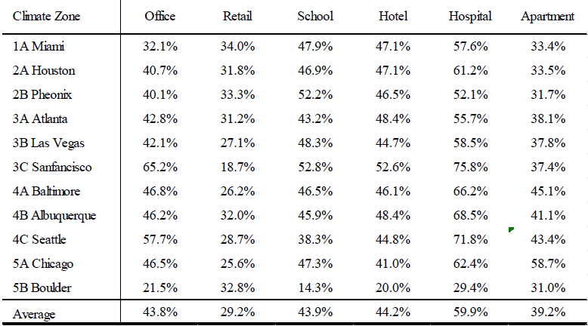
Table 2 : Potential HVAC energy savings from VRF systems compared to other systems
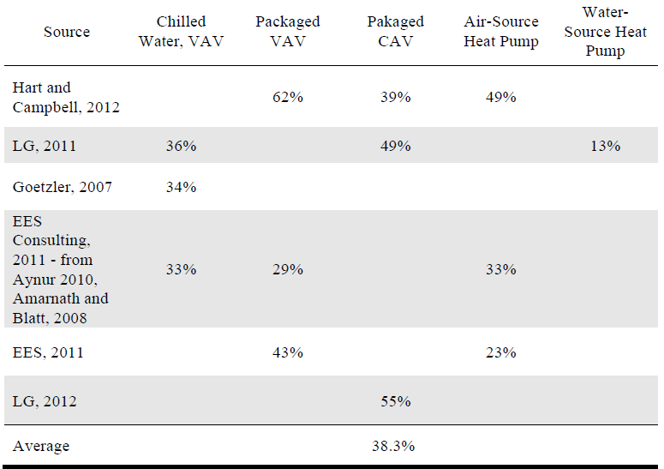
Another Case study was conducted for 1000TR capacity system (VRV and W/C Chiller). System Architecture, Reliability (Oil Management& Refrigerant flood back) have been discussed in this study.
The Results shows that For smaller systems, up to 100 ~ 200 TR, with limited Out Door Units and Indoor Units, VRF system can be a good solution, as for smaller central plant system, space availability for chillers, Air Handling Units (AHUs) may not be available. Also, for such small systems, the VRF system can remain simple with limited refrigerant piping and without much complexities.

when the installation size starts increasing, VRF systems, becoming complex and in such cases, planning the installation for a central plant is always beneficial.
The life cycle cost of such a system was not only lower than the VRV system, but it also avoids safety related issues such as leakage of refrigerant in conditioned space, better air circulation, better indoor air quality, etc.

Table 3 :Case study for 1000TR capacity system

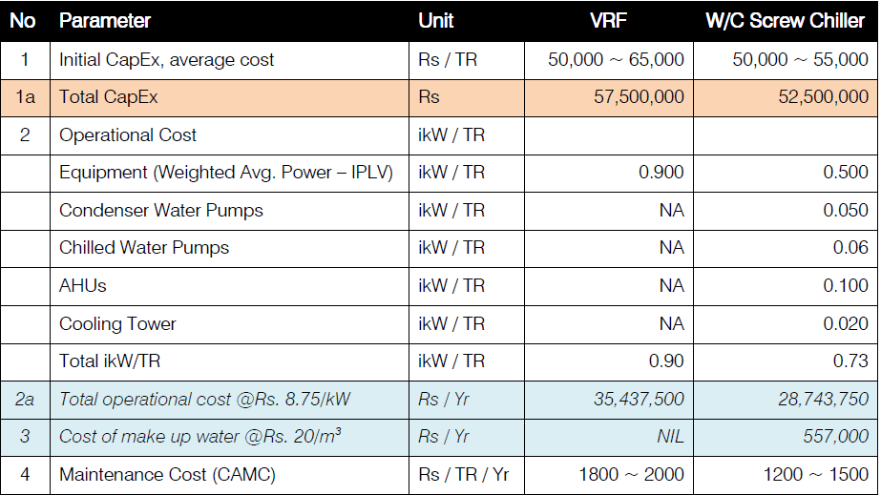
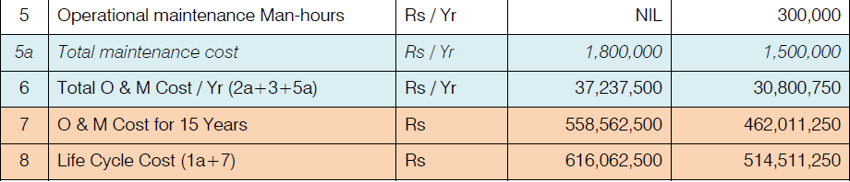

CHAPTER (Four)

CENTER DESCRIPTION

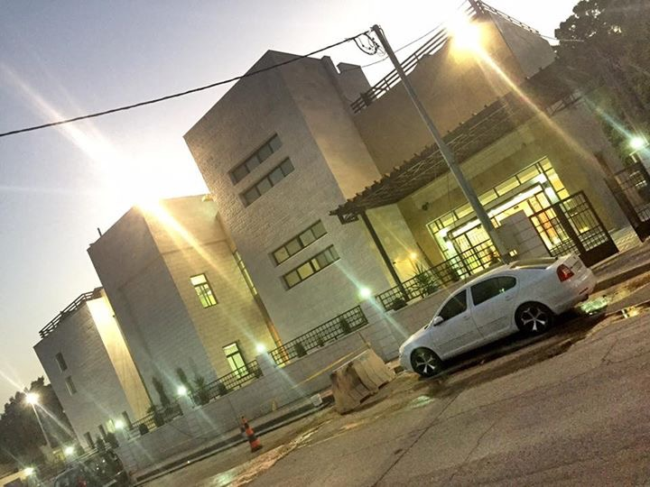

4.1 Introduction:
This chapter shows the details of the Building that explain the parameters which used through design, the location of the building and the condition of design are explained.
Also, in this chapter the construction details of the Center is described.

Youth Development Resource Centerconsists of Ground floor, First Floor & Second Floor.
The location: Palestine Country / West Bank in Jericho City that lies at latitude: 31˚

4.2 Outside Design Condition:
Cooling design conditions (in summer):
- Dry bulb temperature is (43-45) ˚C.
- Average Relative humidity is (50-56) %.
Heating design conditions (in winter):
- Dry bulb temperature is 10 ˚C.
- Average Relative humidity is (74-81)%.

4.3 Inside Design Conditions:
- Dry bulb temperature is (23-24) ˚C
- Average Relative humidity is 50%

4.4 Center Construction:
In this section, the Center construction such as external, internal walls, the ceiling, and the Center windows and doors are described briefly.

4.4.1 External walls:
The external wall consists of five different materials from (out side to inside); these materials are stone, concrete, insulation, Concrete block and Painted plaster. Where the dimension for each material is shownin figure (2) the specification and the thickness for each materials are tabulated in table (4).

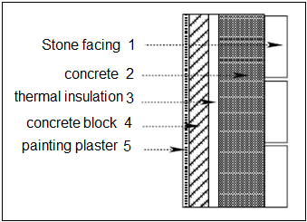
Figure (2): schematic for external walls
Table (4) :Dimensions and specification for each material in the external walls
No. | Material | Thickness  ∆X  (m) | Thermal conductivity (K) (W/m.K) | Thermal resistance (R) (m².K/W) | Density  (ρ) kg/m³ | Specific heat (CP) (KJ/Kg.C˚)
1 | Stone facing | 0.07 | 1.7 | 0.029 | 2250 | 1.675
2 | Concrete | 0.10 | 1.75 | 0.0857 | 2300 | 0.8374
3 | Thermal insulation | 0.03 | 0.04 | 1.25 | 25 | 0.8374
4 | Concrete block | 0.10 | 0.833 | 0.120 | 1400 | 0.8374
5 | Painted plaster | 0.02 | 1.2 | 0.0167 | 1800 | 0.8374

4.4.2 Internal walls:
The internal walls consists two materials. These materials are concrete block in the middle and painted plaster cover.
Where the dimension for each material is shown in figure (3) .The specification and the thickness for each material are tabulated in table (5).
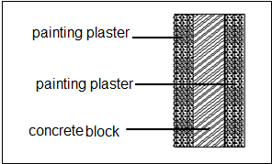
Figure (3): schematic for internal walls

Table (5) represents the dimensions and specification for the material in the internal wall

Material | Thickness (m) | Thermal conductivity (K) (W/m.K) | Thermal resistance (R) (m².K/W) | Density (ρ) (kg/m³) | Specific heat (CP) (KJ/Kg.C˚)
Painted plaster | 0.02 | 1.2 | 0.0167 | 1800 | 0.8374
Concrete block | 0.10 | 0.833 | 0.120 | 1400 | 0.8374

4.4.3 Ceiling:
The ceiling includes six different materials from (top to the bottom) surface. These materials are:
Asphalt, concrete, polystyrene, reinforced concrete, block and plaster. Figure (4) shows the arrangement of these materials and their thickness and the specifications for each material are tabulated in table (6).
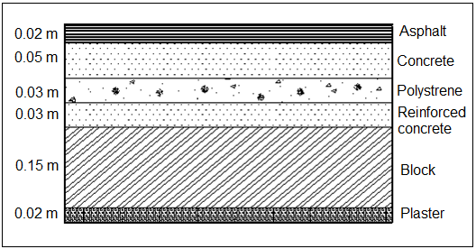
Figure (4): Schematic for the ceiling

Table (6) : Specification of the ceiling materials
Material | Thickness (m) | Thermal conductivity (K) (W/m.K) | Thermal resistance (R) (m².K/W) | Density (ρ) (kg/m³) | Specific heat (CP) (KJ/Kg.C˚)
Asphalt | 0.02 | 0.7 | 0.0286 | 2000 | 1
concrete | 0.05 | 1.75 | 0.0286 | 2300 | 0.8374
Polystyrenes | 0.05 | 0.03 | 0.60 | 25 | 0.8374
Reinforced concrete | 0.03 | 1.75 | 0.0171 | 2300 | 0.8374
Cement brick (block) | 0.18 | 0.95 | 0.158 | 1400 | 0.8374
Plaster | 0.02 | 1.2 | 0.0167 | 1800 | 0.8374

4.4.4 Windows and Doors:
The dimensions of windows and door are required in order to calculate the heat transfer through them.
The dimension for their windows and doors are tabulated in table (7).

Table (7): the specification for windows and doors
Windows and doors | The Dimension | Thickness
Rooms windows | 2.2m *1.2m | Double clear glass with 6 mm thickness.
Bath roomWindows | .8m *.8m | Double clear glass with 6 mm thickness.
Internal door | 2 m*1 m | 5 cm thickness  With wood
External door | 4 m*2 m | 10 mm Made from hardened glass sikorite

Chapter (Five)
Methodology
Literature Review
Selecting the suitable study area

Studying Air Conditioning Types

Studying Chiller and VRV System
- How it Works
- Types of the System

For Both System Studying
- Enhanced Indoor Air Quality
- Energy Efficient
- Maintainability
- Reliability
- Supply where we need it, when we need it
- Flexibility
- Energy Saving

Reporting

Figure 5 :Research methodology
Chapter (Six)

Air Conditioning Systems

6.1 Introduction

HVAC, pronounced H-V-A-C is an initialize acronym that stands for (Heating, Ventilation and Air Conditioning). The goal from this system is to provide proper air flow, heating, and cooling to each room. In this process HVAC systems can reduce air infiltration and maintain pressure relationships between spaces. In HVAC Industries there are so many standard organizations such as ASHRAE, SMACNA, ACCA, Uniform Mechanical Code, International Mechanical Code, and AMCA have been established to support the industry and encourage high standards and achievement.

Heating

Heating systems may be classified as central or local. Central heating is often used in cold climates to heat private houses and public buildings. Such a system contains a boiler, furnace, or heat pump to heat water, steam, or air, all in a central location such as a furnace room in a home or a mechanical room in a large building. The system also contains either ductwork, for forced air systems, or piping to distribute a heated fluid and radiators to transfer this heat to the air, and in another type of heating by using out door unit connected to indoor unit also the outdoor and indoor units provided with refrigerant gas and control system such as in VRV system, in other system we use a hot water from Boiler or heat pump flow in pipes that in under floor heating.

Heat Loss

The heat loss is divided into two groups:
1. The heat transmission losses through the confining walls, floor, ceiling, glass, or other surfaces.
2. The infiltration losses through cracks and openings, or heat required to warm outdoor air used for ventilation.
As a basis for design, the most unfavorable but economical combination of temperature and wind speed is chosen. The wind speed has great effect on high infiltration loss and on outside surface resistance in conduction heat transfer.
Normally, the heating load is estimated for winter design temperature usually occurring at night; therefore, internal heat gain is neglected except for theaters, assembly halls, industrial plant and commercial buildings. Internal heat gain is the sensible and latent heat emitted within an internal space by the occupants, lighting, electric motors, electronic equipment, etc.
People areloses heat by four modes:
- Evaporation: this accounts for the removal of a bout 25% of the body heat. There are two mechanics of evaporation and a balancing reaction to respond to varying environment; Respiration, Insensible skin moisture
- Radiation: as the body or the clothing over it is at a higher temperature than the environment, heat loss from the body to the environment takes place continuously. The heat loss from the body by this modes accounts for about 45% of total heat loss of the body.
- Convection: heat is removal from the body by the air movement around the body; the air movement is due to heating the air in contact with the body, or by the wind in the environment. The heat loss by convection accounts to about 30% of the total heat loss by the body.
- Conduction: this heat loss results from direct contact of the body with object in its surrounding. However, as far as normal human beings are considered the heat loss by this mode is negligible.

Cooling

The cooling load is the rate at which heat must be removed from space in order to maintain the desired conditions in the space, generally a dry-bulb temperature and relative humidity.
The components of the cooling load includes :
- Heat transmitted through internal wall, floor and ceiling.
- Heat from solar effect:
  - Solar radiation through the glass.
  - Solar radiation absorb by external wall.
- Ventilation and infiltration sensible and latent cooling load.
- Sensible and latent heat produced by light devices , motors , person and equipment.

COMFORT ZONE

The main objective of air conditioning is to maintain the environment in enclosed spaces at conditions that induced the feeling of comfort to human.
This feeling of comfort is influenced by a number of related parameter including temperature, humidity, air motion and purity.

ASHRAE COMFORT CHART

ASHRE is American society of heating refrigeration and air conditioning engineers.

There is no rigid rule that indicates the best atmospheric condition for comfort for all people. This is because it is affected by several factors such as health, age, activity, clothing, food, etc. Comfort conditions are obtained as a result of tests in which people are subjected to air as various combinations of temperature and relative humidity’s.
The results of such tests indicate that a person will feel just about as cool at 24C and 60% relative humidity as at 26C and 30% relative humidity.
Studies conducted by ASHRAEwith relative humidity between 30% and 70% indicated that 98% of people feel comfortable when the temperature and relative humidity combinations fall in a comfort zone such as that indicated in figure (6.1)

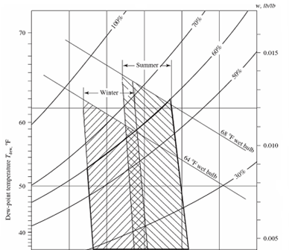

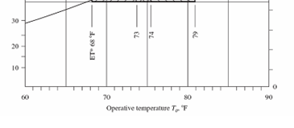

Figure 6.1: ASHRAE Comfort Chart.
This comfort zone covers a wide range of applications such as houses, offices, schools, hospitals, theaters, restaurants, shops, etc.
The most recommended design conditions for comfort are 24.5C dry bulb temperature and 40% relative humidity with air velocity less than 0.23 m/s.
The comfort zone of figure (6.1) is considered a standard comfort zones for summer and for winter applications. It sets the limit of both the operation temperature and humidity contents of air for these zones.

Ventilation

Ventilating is the process of "changing" or replacing air in any space to control temperature or remove moisture, smoke, dust and airborne bacteria. Ventilation includes both the exchange of air to the outside as well as circulation of air within the building. It is one of the most important factors for maintaining acceptable indoor air quality in buildings. Methods for ventilating a building may be divided into mechanical forced and natural the mechanical force ventilation is by using a mechanical equipment such as ducts and fans and grills and there is to control indoor air quality. Excess humidity and contaminants can often be controlled via replacement with outside air and the other type of ventilation is natural ventilation and this by windows and doors without the use of a fan or other mechanical systems.

6.2 Air Conditioning Systems :

Air conditioning system are divided into several types depending on the orientation, fluid inside pipes and out side pipes working refrigerant. Working fluid, compressor type, condenser or evaporator type etc.
It can be divided as follows
- Water cooled chillers or air cooled chillers( condenser is cooled by water cooling towers or air cooled)
- Heat pump or cooling only chillers or out door units
- Split or packaged
- Roof tops or wall mounted
- Vertical or horizontal
- R410,407,134, refrigerants of the floroclorocarbon or the old refrigerants R22
- Water is the working fluid or the VRV system where the refrigerant is also the working fluid.
- High ambient or normal units.
- Scroll ,screw , reciprocating compressors. Open type or closed or hermetic type. Or maybe Simi hermetic
- Ducted indoor units or wall mounted or maybe floor mounted or caste type.
- Absorption cycle chillers

There are five different types of air condition; these types are single package central air, Split System Central Air Conditioning (ducted A/C), Ductless Air Conditioning, Portable Air Conditioning and evaporating coolers.

Single-Package Central Air conditioners are most commonly used in industrial applications. All the components are mounted in one package. This is typically located on the roof of a building or occasionally on the wall.

Split System Central Air Conditioning (ducted A/C). A split packaged unit, sometimes called a split system as shown in fig. (6) [8], splits the packaged unit into an indoor air handler and an outdoor condensing unit, which is most probably mounted outdoors, on the rooftop, on a podium, or in some other adjacent place, the indoor air handler and outdoor condensing unit are connected by refrigerant pipes.
An air handler for split packaged units usually has a cooling capacity from 3 to 80 tons (10 to 280 kW), a supply volume flow rate of 1200 to 32,000 cfm (565 to 15,100 L / s), and a maximum fan total pressure of 5.0 in. WC (1250 Pa) for medium size and large units.
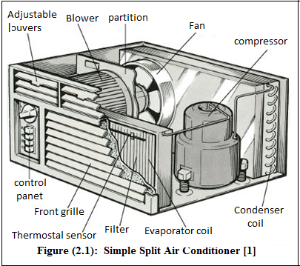
Figure (6) : Simple Split Air Conditioner

Ductless Air Conditioning: For homes that do not have ducting already in place there have been real advancements in ductless air conditioning units As shown in fig. (7). While which not typically able to cool an entire home if there is a very open floor plan which allows to keep the noisy parts of the process outside during cooling the area that surrounds the ductless A/C unit.

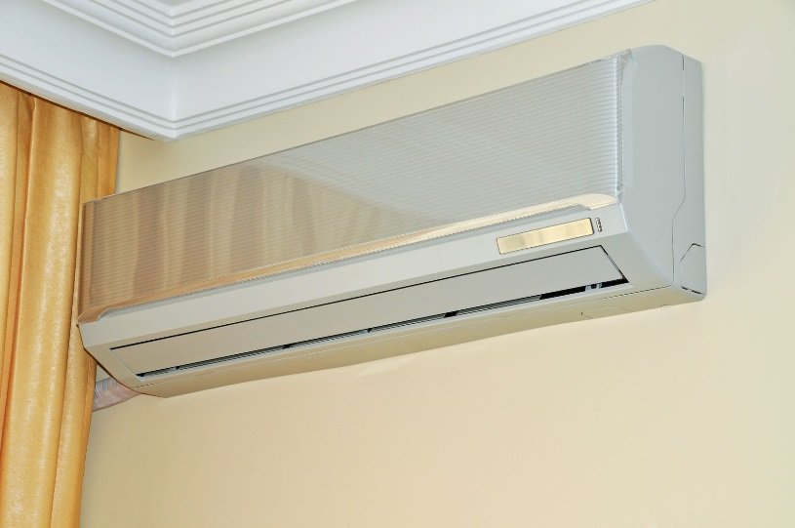
Figure 7 : Ductless Air Conditioning

Portable Air Conditioning: For those on budget used for a room that refuses to cool as well as the rest of the house As shown in Fig. (8). A portable unit is an economical option. It will be noisier, allow some warm outside air into the house, and have a more limited cooling area but it will make a significant difference on the temperature inside the room.
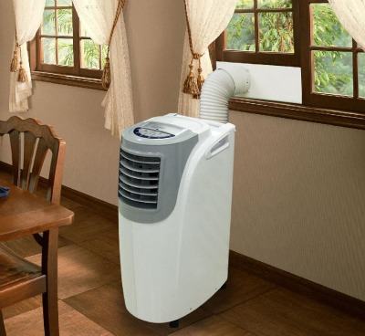
Figure 8 : Portable Air Conditioning

Evaporation coolers: Also known as “swamp coolers” evaporation coolers pull air through damp pads cooling it as the air evaporates the water that becomes attached to it.

6.3 Comparison between the systems :

Split Air-conditioning Systems:
Split type air conditioning systems are one-to- one systems consisting of one evaporator (fan coil) unit connected to an external condensing unit. Both the indoor and outdoor units are connected through copper tubing and electrical cabling.
The indoor part (evaporator) pulls heat out from the surrounding air while the outdoor condensing unit transfers the heat into the environment.

Fig (6.2): split air system

Advantages of using Split Air-conditioners
• Low initial cost, less noise and ease of installation;
• Good alternative to ducted systems;
• Each system is totally independent and has its own control.

Disadvantages
• There is limitation on the distance between the indoor and outdoor unit i.e. refrigerant piping can’t exceed the limits stipulated by the manufacturer (usually 100 to 150 ft) otherwise the performance will suffer;
• Maintenance (cleaning/change of filters) is within the occupied space;
• Limited air throw which can lead to possible hot/cold spots;

• Impact on building aesthetics of large building because too many outdoor units will spoil the appearance of the building.

Multi-Split Systems
A multi-type air conditioning system operates on the same principles as a split type air- conditioning system however in this case there are ‘multiple’ evaporator units connected to one external condensing unit. These simple systems were designed mainly for small to medium commercial applications where the installation of ductwork was either too expensive.
The small-bore refrigerant piping, which connects the indoor and outdoor units requires much lower space and is easier to install than the metal ducting. Each indoor unit has its own set of refrigerant pipe work connecting it to the outdoor unit.

Fig 6.3: Multi split system
Advantages of Multi-splits
• The fact that one large condenser can be connected to multiple evaporators within the building reduces and/or eliminates the need for ductwork installation completely.
• Multi-splits are suitable for single thermal zone (defined below) applications with very similar heat gains/losses.

Drawbacks
• Inability to provide individual control;
• Multi-split systems turn OFF or ON completely in response to a single thermostat/control station which operates the whole system. These systems are therefore not suitable for areas/rooms with variable heat gain/loss characteristics.

Chapter (Seven)

Cooling load calculation

7.1 Introduction:
The cooling load is the rate at which heat must be removed from space in order to maintain the desired conditions in the space, generally a dry-bulb temperature and relative humidity. The cooling load for a space can be made up of many components, including:
- Conduction heat gain from outdoors through the roof, exterior walls, and windows. (This includes the effects of the sun shining on these exterior surfaces.)
- Solar radiation heat gain through windows.
- Conduction heat gain from adjoining spaces through the ceiling, interior partition walls, and floor.
- Internal heat gains due to people, lights, and equipment in the space.
- Heat gain due to hot, humid air infiltrating into the space from outdoors through doors, windows, and small cracks in the building envelope. In addition, the cooling coil in the building HVAC system has to handle other components of the total building cooling load, including:
- Heat gain due to outdoor air deliberately brought into the building for ventilation purposes.
- Heat generated by the fans in the system and possibly other heat gains in the system.

7.2 Peak Hour:
One of the more difficult aspects of estimating the maximum cooling load for a space is determining the time at which this maximum load will occur. This is because the individual components that make up the space cooling load often peak at different times of the day, or even different months of the year.
For example, the heat gain through the roof will be highest in the late afternoon, when it is warm outside and the sun has been shining on it all day. Conversely, the heat gain due to the sun shining through an east-facing window will be highest in the early morning when the sun is rising in the east and shining directly into the window.
Fig (7.1): Peak heat gain from the roof and east facing window.

7.3 Cooling Load Methods:
There are five standard methods for the calculation of heat load. These methods deal with the sensible heat load. However, for the latent heat, the main source is people. Heat gain from people has two components, sensible and latent. The total values and proportions of sensible and latent heat vary depending on the level of activity, age and gender. The latent heat gain is assumed to become cooling load instantly, whereas the sensible heat gain is partially delayed depending on the characteristics of the conditioned space. According to the ASHRAE regulations, the sensible heat gain from people is assumed 30% convection (instant cooling load) and 70% radioactive (delayed portion).
The five methods which will be presented here are:
- The Heat Balance Method (ASHRAE 2001)
- The Radiant Time Series (ASHRAE 2001)
- The Admittance Method (CIBSE 1986)VDI Methods (1996)
- CLTD/SCL/CLF (ASHRAE 1997)
(In our project For the Youth Center we will use theCLTD/SCL/CLF method)

We determine the basic point to start with design, using the specially designed excel sheet for selected floor,we will show the final results and sample calculation would show in this chapter .

7.4 Sample of Calculation for Cooling Load:
Sample calculation for Conference Room at Ground floor (36 m²) :

- The orientation of the room is W
- Area of the ceiling of the room = 36 m²
- Area of the W window = 3.75 m²
- Area of the outside W wall of the room = 18 – 3.75 = 14.25 m²

- The outside cooling design conditions :
- Dry bulb temperature (To) be 43 ˚C.
- Relative humidity (Ф_{o}) is 55 %.
- Moisture content (W_{o}) is 28 g of water/ Kg of dry air.
- The wind speed at Jericho is 4 m/s.

- The inside cooling design conditions :
- Dry bulb temperature (Ti) be 27 ˚C.
- Relative humidity (Фi) is 50%.
- Moisture content (Wi) is 14 g of water/ Kg of dry air.

- The Equipment's are used in this room are:
- Laptop
- Projector

- Some Parameters were taken in consideration:

- Wall color assumed to be Medium color so the color factor K=0.83
- Ceiling color assumed to be Medium colored so that the color factor K= 0.5 .
- The equipment that used in this room were Laptop, Projector.
- Wall group is A, and ceiling group 12.
- We selected peak hour at 16 PM at June.
- The elevation for this floor about (3 m).
Note: In the calculation of cooling load, orientation is an important and basic factor during calculation as shown in the following sample of calculation.

- For ceiling and roof:
CLTD = 17 from table (9-1)
LM = 1.1 from table (9-2)

- For Walls:
Table (7.1): Factor for walls
Direction | CLTD  Table (9-4) | LM  Table (9-2) | K
N | 6 | 0.5 | 0.83
S | 8 | -2.2 | 0.83
E | 13 | 0 | 0.83
W | 10 | 0 | 0.83

- For windows:
Table (7.2): Factor for windows
Direction | SHG  Table(9-7) | SC  Table(9-8) | CLF  Table(9-10) | CLTD  Table(9-12)
N | 139 | 0.83 | 0.74 | 8
S | 189 | 0.83 | 0.47 | 8
E | 675 | 0.83 | 0.26 | 8
W | 675 | 0.83 | 0.5 | 8

Note :The Following equations are interested in excel sheet and all the results are built on this equation.

- In cooling load calculation we must find the unconditional temperature :

T_{un}= T_{in} + 2/3 (To– T_{in})

First : Q From Conduction

- CLTD _{corr. of ceiling} = (CLTD +LM)*K + (25.5-Ti) + (To-29.4)
= ( 17 + 1.1 ) * 0.5 + ( 25.5 – 26 ) + ( 45 – 29.4) = 24.2 ºC

- Q _{ceiling} = (CLTD)_{corr}* U*A = 24.2 * .88 * 36 = 766.6 W

- CLTD _{corr of wall} = (CLTD +LM)*K + (25.5-Ti) + (To-29.4)
= ( 10 + 0 ) * 0.83 + ( 25.5 - 26 ) + ( 45 - 29.4 ) = 17.4 ºC

- Q _{wall} = (CLTD)_{corr}* U*A = 17.4 * 0.88 * 14.25 = 213.2 W

- CLTD _{corr. of window} = (CLTD +LM)*K + (25.5-Ti) + (To-29.4)

= ( 8 + 0 ) * 1 + (25.5 – 26) + (45 – 29.4) = 23.1 ºC

- Q _{convection window} = (CLTD)_{corr.}* U*A = 23.1* 3.5 *3.75= 303.19 W

- Q _{transmitted window} = A*SHG*SC*CLF = 3.75 * 675 * 0.83 * 0.5 = 1050.4 W

- Q _{window} = Q _{transmitted}+ Q _{convection} = 1050.4+ 303.19 = 1353.59 W

- Q _{cond. Total} = ∑ (Qc + Q wa +Q wi) = 766.6 + 213.2 + 1353.59 = 2333.39 w

Second : Q From People

- Number of people in this room is n = 10
- Q _{s. people} = q_{s}* n *CLF = 70 * 10 * 1 = 700 w
- Q _{L. people} = q_{l}* n = 44 * 10 = 440 w

Third : Q From Ventilation
Note: in our calculation we used ventilation and we find it using (ACH)
- ACH = 2 (Air Change per Hour)
- Also, we use 10 L/Person
- Q_{s ,vent}= 1.2 * V*n *∆T = 1.2 *10*10 *(45 - 26) = 2280 w
- Q_{L, vent} = 3 * V *n *∆W = 3* 10*10 *(28 – 14) = 4200 w

Forth : Q From Light
- Q_{s light} = qs * Area * CLF = 32 * 36 * 1 = 1152 w

Fifth : Equipment
- Qs _{Equipment} = qs * CLF = 300 * 1 = 300 w
- Ql_{Equipment} = 0

Q Total

- Q _{total} = Q l _{total} +Qs _{total}+ Q _{cond. Total} = 11405.39 w = 11.405 kw

Table 7.1 : Summary of Cooling Load For the Center
Ground Floor
Zone | Area (m²) | Q sensible (KW) | Q Total (KW) | Flow Rate  (L/s) | Flow Rate  (CFM)
Lobby | 37 | 7.5 | 10 | 429 | 909.5
Computer Room | 57 | 12 | 19 | 814 | 1725.68
Conference Room | 36 | 6 | 11 | 471 | 998.5
Cafeteria | 68 | 18 | 20 | 857 | 1817
Office 1 | 20 | 4.5 | 6 | 257 | 544.8
Office 2 | 18 | 4 | 5 | 214 | 453.6
Office 3 | 18 | 4 | 5 | 214 | 454
Corridor | 23 | 6 | 7 | 300 | 636

First Floor
Zone | Area (m²) | Q sensible (KW) | Q Total (KW) | Flow Rate  (L/s) | Flow Rate  (CFM)
Control Room | 23 | 4 | 5 | 214 | 453.68
Media Center Room | 20 | 4 | 5 | 214 | 428
Rest Room | 26 | 4 | 8 | 342.85 | 726.85
General Purpose Room | 67 | 18 | 20 | 857 | 1817
Hall 1 | 56 | 15 | 17 | 728.5 | 1544.42
Hall 2 | 63 | 15 | 19 | 814.28 | 1726.27
Hall 3 | 67 | 19 | 20 | 857 | 1817
Corridor | 30 | 8 | 9 | 386 | 818.32

Summary:
- Total Conditioned space in the building : 629 m²
- Total cooling load for the building : 186.5 KW
- Total load of the chiller for the building : 53.285 Ton _{ref.}

Table (7.2): Cooling load summery

 | Qsensible  (kw) | Q latent  (KW) | Q total  (kw)
Ground floor | 62 | 21 | 83
First floor | 87 | 16 | 103
Total | 149 KW | 37 KW | 186 KW

Chapter (Eight)

Chiller and VRF Systems

Chiller System

A chiller is a heat transfer device that uses mechanical refrigeration to remove heat from process load and transfers the heat to the environment.

- The Principle of Work:

Much like how the split system works, a chiller works by removing heat from a heat source to an environment where temperature must be maintained on our needs. This heat removal process is based on the principle that heat will move from a hotter source to a colder source. A chiller consist of two main fluid circuit- a refrigeration circuit which is where the vapor compression cycle takes place and a cooling fluid where usually water is used [13]. The cooling fluid is placed on evaporator and condenser part of the vapor compression cycle.

When refrigerant enters the evaporator stage, the cooling effect is transferred to the water by heat exchange to make the water cooled typically to 7°C. The water is then pumped to the Air Handling Unit or Fan Coil Unit where air is conditioned by the cold water before being distributed to rooms. The result is a cool air typically 22°C which is blown through the ducting system and into the rooms.

- Types of Chiller

Chiller is divided as Air Cooled and Water Cooled Chiller. The difference is only in the condenser.

In an Air Cooled Chiller, the fan will blow air to the refrigerant coil into the air just like the outdoor unit of a split system.
In Water Cooled Chiller, the condenser is coupled to a third fluid-water circuit to cool the refrigerant.
Heat is transferred to the water more efficiently by heat exchange. The water will then be sent to Cooling Tower to be re-cooled. In a cooling tower, cooling of the main mass of water is obtained by the evaporation of a small proportion into the air stream. Cooled water leaving the tower will be 3–8º K warmer than the incoming air wet bulb temperature [13]. The closest it gets to the wet bulb temperature, the better, the cooling tower is.

Since water is a better heat exchange media, a water cooled chiller is almost always more efficient in terms of COP than air cooled chillers. However, it needs more components like cooling towers which will need more investment cost and more space and is good for low humidity weather.

Equipment Selection
For Selection of Fan Coil unit We use the following Petra Catalog :

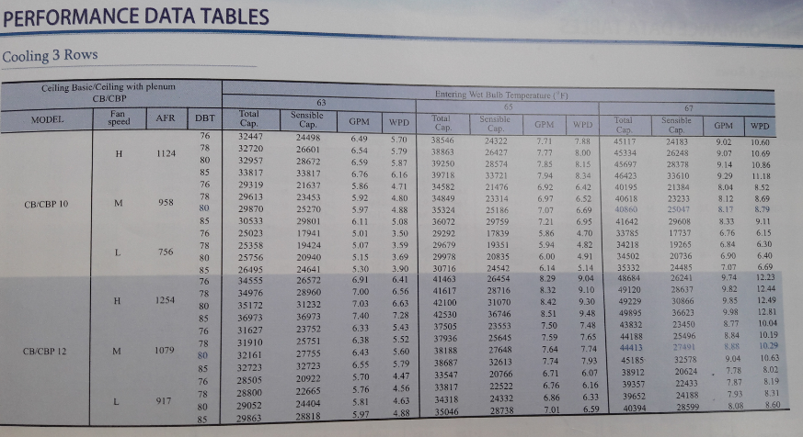

Fan Coil unit Table for each room :

Ground Floor
Zone | Area (m²) | Q sensible (KW) | Q Total (KW) | Flow Rate  (L/s) | Flow Rate  (CFM) | Model | Number of Rows | Indoor Unit  (KW)
Lobby | 37 | 7.5 | 10 | 429 | 909.5 | CB/CBP 12 | 3 | 12
Computer Room | 57 | 12 | 19 | 814 | 1725.68 | CB/CBP 24 | 3 | 24
Conference Room | 36 | 6 | 11 | 471 | 998.5 | CB/CBP 12 | 3 | 12
Cafeteria | 68 | 18 | 20 | 857 | 1817 | CB/CBP 24 | 3 | 24
Office 1 | 20 | 4.5 | 6 | 257 | 544.8 | CB/CBP 6 | 3 | 7
Office 2 | 18 | 4 | 5 | 214 | 453.6 | CB/CBP 6 | 3 | 7
Office 3 | 18 | 4 | 5 | 214 | 454 | CB/CBP 6 | 3 | 7
Corridor | 23 | 6 | 7 | 300 | 636 | CB/CBP 6 | 3 | 7

First Floor
Zone | Area (m²) | Q sensible (KW) | Q Total (KW) | Flow Rate  (L/s) | Flow Rate  (CFM) | Model | Number of Rows | Indoor Unit  (KW)
Control Room | 23 | 4 | 5 | 214 | 453.68 | CB/CBP 6 | 3 | 7
Media Center Room | 20 | 4 | 5 | 214 | 428 | CB/CBP 6 | 3 | 7
Rest Room | 26 | 4 | 8 | 342.85 | 726.85 | CB/CBP 8 | 3 | 8.5
General Purpose Room | 67 | 18 | 20 | 857 | 1817 | CB/CBP 24 | 3 | 24
Hall 1 | 56 | 15 | 17 | 728.5 | 1544.42 | DC 18 | 3 | 17
Hall 2 | 63 | 15 | 19 | 814.28 | 1726.27 | CB/CBP 24 | 3 | 24
Hall 3 | 67 | 19 | 20 | 857 | 1817 | CB/CBP 24 | 3 | 24
Corridor | 30 | 8 | 9 | 386 | 818.32 | CB/CBP 12 | 3 | 12

Total Cooling Load After Selection for the Center = 223.5 kw = 63.85 Ton
For Selection of Chiller we use the APX Catalog
(Air Cooled water Chiller with Semi-Hermetic Reciprocating Compressor)
And the Suitable Model is APX 75-2S
The Capacity For this Model in T.R = 69.13

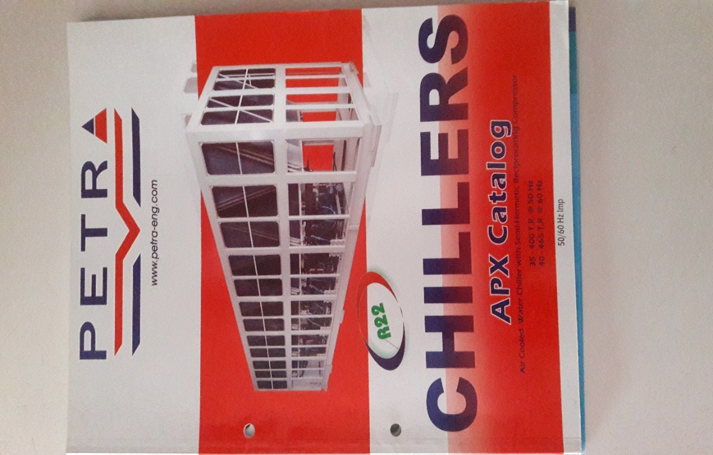
By using :
LWT (Leaving Chilled Water Temp.)= 46 ⁰F = 7.7⁰C
Entering Condenser Air = 105⁰F =approximately 43⁰C

Chapter (Nine)
Pipes and Duct Design

9.1 Pipe Design
Piping network are used to transmit the cold water from the chiller to the fan coil units in order to cool down the air. pipes design depends on the speed of water in pipes and quantity of air and water that need to flow throw the pipes. Also, there depends on some calculations in the previous chapters.
9.1.1 Pipe design procedure
- Calculate the total cooling load for the floor.
- Calculate the mass flow rate for the water.
- Estimate the pressure head in (Kpa).
- The pressure head per unit length is calculated and it should be between range from (200< ∆P/L<550).
- Tabulate the diameter of the pipes corresponding to the mass flow rate by using table (9.1) ,after the calculation of each diameter.
- Then Estimate the diameter of the pipe entering to the floor .
Table ( 9.1 ) : Pipe sizing table
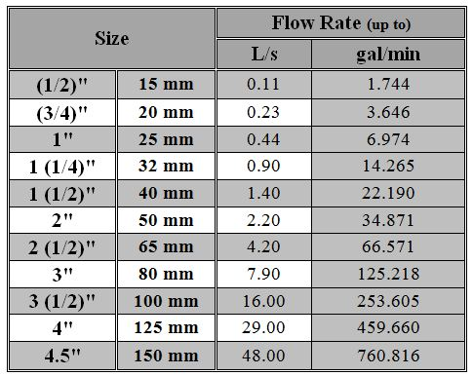
9.1.2 Sample of calculation of pipe design :
For the (Computer room) in the Ground floor the mass flow rate = 0.453 L/s .
Then by using the above table, the suitable diameter = 1(1/4)”. Then find all dimensions of the pipes by using the procedure in the previous point corresponding to the mass flow rate .And the main pipe diameter that entering each floor by summation each mass flow rate entering fan coil units.

9.2 Duct Design

Ducts are used in heating, ventilation, and air conditioning to deliver and remove air, these needed air flows include for example, supply air, return air, and exhaust air. Ducts also deliver, most commonly as part of the supply air, ventilation air. As such, air ducts are one method of ensuring acceptable indoor air quality as well as thermal comfort. A duct system is often called ductwork. Planning 'laying out', sizing, optimizing, detailing, and finding the pressure losses through a duct system is called Duct design.
Air like other fluid, it faces retardation force called drag force, so ducts need pressure rise in order the air be able to flow inside the ducts, because the drag force which acting on the air flow produces pressure loss of the flow.
Air ducts is usually used in all central systems, there are two types:
- Circular duct: As shown in figure (9.1).
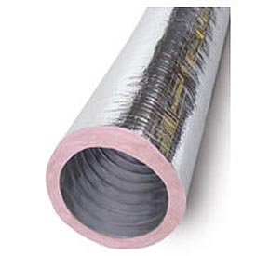

Fig. (9.1) : Circular duct
- Square or rectangular duct: As shown in figure (9.2), its width and height calculated from C++ software .
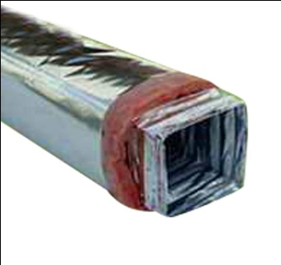

Figure (9.2): rectangular duct

Insulation is very important in duct design because it reduce the noise from movement of air through duct and to keep the temperature of the air to remain hot or cold. The insulation type which used is shown in figure (9.3).
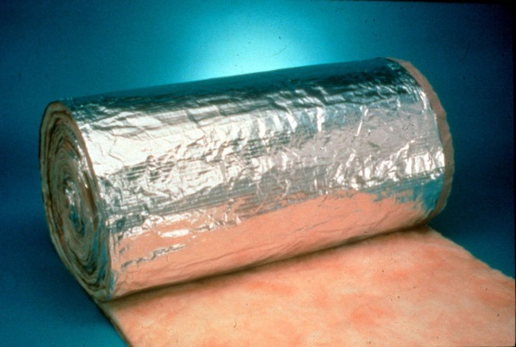

Figure (9.3): Insulation of Duct
Some types, fixed one as shown in figure (9.1) and figure (9.2), other types is removable used for short distance as shown in figure (9.4).
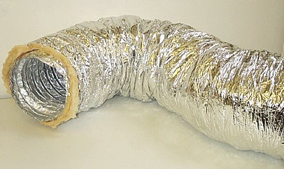

Figure (9.4): Removable duct

9.2.1 Duct system components

Besides the ducts themselves, complete ducting systems contain many other components:.
- Take-offsStacks.
- Vibration isolators.
- HeadsDampers.
- Terminal units.
- Air terminals.

9.2.2 Design procedures:
- Number of grills and diffusers are calculated and distributed uniformly.
- The total sensible heat for room.
- The V_{circulation} for room.
- The initial velocity for the main duct is 5 m/s.
- Fixed the pressure drop.
- The diameter is calculated .
- The height and width of the rectangular ducts are determined .

For duct design we use constant pressure drop method (through the duct network is kept constant)
$V_{circulation}=\frac{Qtotal}{1.2*\left(T_{circ}-T_{i}\right)}$ (9.1)

Variable Refrigerant Flow or VRF Systems

The name meaning :

Variable refrigerant flow (VRF) is an HVAC technology invented in Japan in the 1990s.The VRF technology/system was developed and designed by Daikin Industries, Japan who named and protected the term variable refrigerant volume (VRV) system so other manufacturers use the term VRF "variable refrigerant flow". In essence both are same.

Variable refrigerant volume (VRV) is an air-condition system configuration where there is one outdoor condensing unit and multiple indoor units. The term variable refrigerant flow refers to the ability of the system to control the amount of refrigerant flowing to the multiple evaporators (indoor units), enabling the use of many evaporators of differing capacities and configurations connected to a single condensing unit. The arrangement provides an individualized comfort control, and simultaneous heating and cooling in different zones.
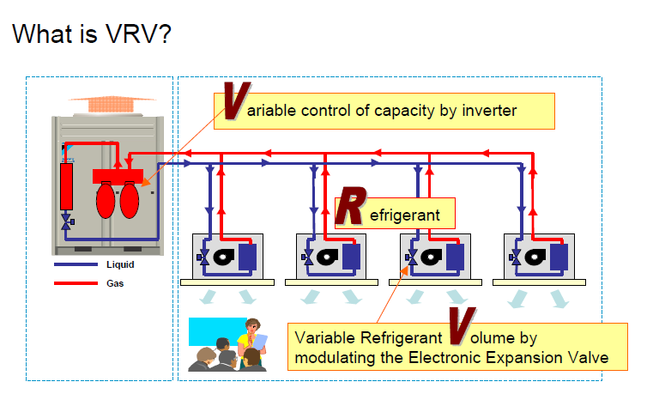
Fig. (9.5) :meaning of VRV

OVERVIEW OF VRF SYSTEMS

The primary function of all air-conditioning systems is to provide thermal comfort for building occupants. There are a wide range of air conditioning systems available, starting from the basic window-fitted units to the small split systems, to the medium scale package units, to the large chilled water systems, and currently to the variable refrigerant flow (VRF) systems.

The term VRF refers to the ability of the system to control the amount of refrigerant flowing to each of the evaporators, enabling the use of many evaporators of differing capacities and configurations, individualized comfort control, simultaneous heating and cooling in different zones, and heat recovery from one zone to another. VRF systems operate on the direct expansion (DX) principle meaning that heat is transferred to or from the space directly by circulating refrigerant to evaporators located near or within the conditioned space. Refrigerant flow control is the key to many advantages as well as the major technical challenge of VRF systems.

Fig. (9.6) : VRF system

Pipe and branches:

VRF systems are engineered systems and use complex refrigerant and oil control circuitry. The refrigerant pipe-work uses a number of separation tubes and/or headers , A separation tube has 2 branches whereas a header has more than 2 branches.
Either of the separation tube or header, or both, can be used for branches. However, the separation tube is NEVER provided after the header because of balancing issues.
Note: Refrigerant piping runs of more than 200 ft are possible

Fig. (9.7) :separation tube
Fig. (9.8) : header

Compared to multi-split systems, VRF systems minimize the refrigerant path and use less copper tubing. Minimizing the refrigerant path allows for maximizing the efficiency of refrigerant work.
Fig. (9.9) :multi-split and vrf pipes comparison

Design Considerations for VRF Systems

Deciding what HVAC system best suits your application will depend on several variables such as building characteristics; cooling and heating load requirements; fresh air needs; accessibility requirements; minimum and maximum outdoor temperatures.

Building Characteristics

VRF systems are typically distributed systems – the outdoor unit is kept at a far off location like the top of the building or remotely at grade level and all the evaporator units are installed at various locations inside the building. Typically the refrigerant pipe-work (liquid and suction lines) is very long, running in several hundred of feet in length for large multi-story buildings.

The maximum allowable length varies among different manufacturers; however the general guidelines are as follows:
• The maximum allowable vertical distance between an outdoor unit and its farthest indoor unit is 164 ft;
• The maximum permissible vertical distance between two individual indoor units is 49 feet,
• The maximum overall refrigerant piping lengths between outdoor and the farthest indoor unit is up to 541 ft.

Fig. (9.10) :distances between outdoor and indoor unit

VRF ADVANTAGES

- Comfort

• The main advantage of a variable refrigerant flow system is its ability to respond individually to fluctuations in space load conditions. The user can set the ambient
temperature of each room as per his/her requirements and the system will automatically adjust the refrigerant flow to suit the requirement

Fig. (9.11) : different temp. requirement

• VRF systems enable wide capacity modulation and bring rooms to the desired temperature extremely quickly
• VRF systems are capable of simultaneous cooling and heating. Each individual indoor unit can be controlled by a programmable thermostat.

- Design Flexibility
• A single condensing unit can be connected to wide range of indoor units of varying capacity (e.g., 0.5 to 4 tons ducted or ductless configurations such as ceiling recessed, wall-mounted and floor console). Current products enable up to 48 indoor units to be supplied by a single condensing unit;
• Suitable for putting an outdoor unit on each floor or in mechanical rooms.

- Energy Efficiency

• VRF systems benefits from the advantages of linear step control in conjunction with inverter and constant speed compressor combination, which allows more precise control of the necessary refrigerant circulation amount required according to the system load.

• A VRF system minimizes or eliminates ductwork completely. This reduces the duct losses often estimated to be 10% to 20% of the total airflow in a ducted system.
• Inverter compressor technology is highly responsive and efficient. The modular arrangement permits staged operation, i.e. Indoor units can easily be turned off in locations requiring no cooling, while the system retains highly efficient operation.

• It is possible to include cooling and heating in a single system which avoids duplicating systems (a reversible heat pump only costs 10% more than a cooling unit).

4) Reliability
Continuous operation is possible even if trouble occurs at an indoor unit.

Indoor Unit
Each indoor unit is controlled individually on the system network. This allows all indoor units continue to run unaffected even if trouble should occur at any indoor unit in one system.

Outdoor Unit
Continuous operation is possible even in the event of compressor failure. There is no immediate system shutdown if trouble occurs in any compressor. The other compressors can continue to operate on an emergency basis.

5) Availability
1) VRF outdoor units can have cooling and heating capacities from 12,000 Btu/h to 300,000 Btu/h;
2) VRF indoor units can have cooling and heating capacities from 5,000 Btu/h to 120,000 Btu/h;
3) The outdoor unit may support up to 48 indoor evaporator.

Equipment Selection
Indoor unit table for each room :

Ground Floor
Zone | Area (m²) | Q sensible (KW) | Q Total (KW) | Flow Rate  (L/s) | Flow Rate  (CFM) | Model | Indoor Unit  (KW)
Lobby | 37 | 7.5 | 10 | 429 | 909.5 | AC036JNHDCH/AA | 11.7
Computer Room | 57 | 12 | 19 | 814 | 1725.68 | NS180HHXEH/XSA | 27
Conference Room | 36 | 6 | 11 | 471 | 998.5 | AC036JNHDCH/AA | 11.7
Cafeteria | 68 | 18 | 20 | 857 | 1817 | NS180HHXEH/XSA | 27
Office 1 | 20 | 4.5 | 6 | 257 | 544.8 | AC024JNHDCH/AA | 7.9
Office 2 | 18 | 4 | 5 | 214 | 453.6 | AC018JNHDCH/AA | 5.8
Office 3 | 18 | 4 | 5 | 214 | 454 | AC018JNHDCH/AA | 5.8
Corridor | 23 | 6 | 7 | 300 | 636 | AC024JNHDCH/AA | 7.9

First Floor
Zone | Area (m²) | Q sensible (KW) | Q Total (KW) | Flow Rate  (L/s) | Flow Rate  (CFM) | Model | Indoor Unit  (KW)
Control Room | 23 | 4 | 5 | 214 | 453.68 | AC018JNHDCH/AA | 5.8
Media Center Room | 20 | 4 | 5 | 214 | 428 | AC018JNHDCH/AA | 5.8
Rest Room | 26 | 4 | 8 | 342.85 | 726.85 | AC030JNHDCH/AA | 9.3
General Purpose Room | 67 | 18 | 20 | 857 | 1817 | NS180HHXEH/XSA | 27
Hall 1 | 56 | 15 | 17 | 728.5 | 1544.42 | NS155HHXEH/XSA | 23
Hall 2 | 63 | 15 | 19 | 814.28 | 1726.27 | NS180HHXEH/XSA | 27
Hall 3 | 67 | 19 | 20 | 857 | 1817 | NS180HHXEH/XSA | 27
Corridor | 30 | 8 | 9 | 386 | 818.32 | AC030JNHDCH/AA | 9.3

Outdoor Unit Selection:
Assuming Combination Ratio 130%
Total Indoor units = 239, So Outdoor unit =239/1.3 = 183.8 Kw
So we Need (3 Modules) every Module = 60 Kw

Outdoor Unit Specifications
Model Code :AM220JXVAGH/EU
Features Type | DVM S
Power Supply | (Outdoor Unit) [φ, #, V, Hz] | 3,4,380-415,50
System | Mode | HEAT PUMP
Performance (nominal) |  | 22.00 HP
Capacity | Cooling [kW] | 61.60 kW
Capacity | Cooling [Btu/h] | 210,200 Btu/h
Power Input (Nominal |  | 17.35 kW
Energy Efficiency | EER (Nominal Cooling | 3.55
Energy Efficiency | COP (Nominal Heating) | 4.15
Compressor | Type | SSC Scroll x 2
Compressor | Model | DS-GB066FAVB x 2
Compressor | Oil (Type) | PVE
Fan | Type | Propeller
Fan | Motor (Output) [W] | 620.0 x 2 W
Fan | Air Flow Rate (High/Mid/Low) [L/S] | 4,833.33
Fan | External Static Pressure  (Min / Std / Max) [Pa] | 78.45 Pa
Piping Connections | Liquid Pipe (φ, mm) | 15.88 mm
Piping Connections | Liquid Pipe (φ, inch) | 5/8"
Piping Connections | Gas Pipe (φ, mm) | 28.58 mm
Piping Connections | Gas Pipe (φ, inch) | 1 1/8"
Piping Connections | Installation Max. Length [m] | 220 m
Piping Connections | Installation Max. Height [m] | 110 m
Refrigerant | Type | R410A  (Fluorinated greenhouse gas)
Refrigerant | Factory Charging (kg) | 8.40 kg
External Dimension  (Outdoor Unit) | Net Weight (kg) | 307.0 kg
External Dimension  (Outdoor Unit) | Net Dimensions (WxHxD) (mm) | 1,295 x 1,695 x 765 mm
Operating Temp. Range | Cooling (°C) | -5.0 ~ 48.0 °C

Chapter Ten
Results and Conclusion

9.1 Results of Comparison between the two systems Economically
Chiller System
Initial Cost :
- The chiller will cost around 45000$
- The fan coils are around 10000$
- Piping is around 12000$
- The Pump costs 5000$
Total Initial Cost = 45000+10000+12000+5000=72000$

Running Cost :
Assuming :
200 days heating and cooling 10 hours a day
20 kw consumption And 0.2 $ \kwh
For Chiller : 20kw*10h*200days*.2$/kwh = 8000$ annually

VRF system

Initial Cost(Investment Cost)= 31000$
Running Cost :
Outdoor Unit :
- 3 modules*60kw out put= 180 kw \3.5= 51 Ton refrigeration
51 \ cop(4.15)= 12.28 kw electrical consumption
12kw*.2$\kwh*10 hrs*200= 4957 $ per year

Note :the duct and the grills are equal cost for both systems

We use the Present Worth Analysis of Alternatives:

- Salvage value for both , the same 5000$ for VRF and /chiller.
- Using MARR = 5% per year
- Life ,years n = 15 year

PW(chiller)= -72,000 - 8000(P/A,5%,15) + 5000(P/F,5%,15)
= -152,555$

PW(VRF)= -31,000 - 4957(P/A,5%,15) + 5000(P/F,5%,15)
= -79,999$

We should select numerically larger PW value which is for the VRF system

OR Applying the following Equation:

PW= -investment difference-( annual cost-annual savings)+salvage value

Conclusion

There are two widely used ways of cooling a large space without using the split system which is using Chillers or VRF/VRV.
Both chillers and VRV use vapor compression cycle much like the split system but with different system and components.

After we analyzed and discussed the description, types, principle of work, features, Energy efficient, Energy saving , advantage and disadvantage of both system in this report, after all that we recognized that the VRF system is the appropriate choice for the center, Beside all the Benefits of this system, Also VRF uses an evolved heat-pump technology with heat recovery systems and sub-cooling built in, which increases effectiveness and efficiency.

The modern VRF technology uses an inverter-driven scroll compressor and permits as many as 48 or more indoor units to operate from one outdoor unit (varies from manufacturer to manufacturer).

The inverter technology reacts to indoor and outdoor temperature fluctuations by varying power consumption and adjusting compressor speed to its optimal energy usage. Inverter provides superior energy efficiency performance and also allows for a comfortable environment by use of smooth capacity control.

Field testing has indicated that this technology can reduce the energy consumption by as much as 30 to 40% a year compared to traditional rotary or reciprocating type compressors.

References

Books

- Mohammed A.AlSaad, Mohmoud A. Hammad. Heating and Air Conditioning For Residential buildings.5th Edition. Jordan : Amman.

- Strategy Guideline: Accurate Heating and Cooling Load Calculations ,Arlan Burdick ,IBACOS, Inc. (7-8)

- Petra Company Catalogue

4.AR09HSFSJWKX_2016 Samsung Ductless Catalog

- DVM_Catalog Samsung

