**An-Najah National University   
Faculty of Engineering**

**Mechanical Engineering Department**



**Graduation Project 2**

**Comparative analysis of energy performance between VRF and conventional chillers air to water systems in a commercial building Systems   
Case study:**

**Hardee’s Restaurant**

**16/6/2021**

### By:

**Orabi Sawalmeh**

**Mahmoud Abdel-latif**

**Supervisor**

**Dr. Ramez Khaldi**

**List of Abbreviations**

**HR** : Hardee’s Restaurant

**AC** : Air Cooled

**ASHRAE** : American Society of Heating, Refrigerating, and Air Conditioning Engineers.

**CAV** : Constant Air Volume

**VAV** : Variable Air Volume

**DX** : Direct expansion

**ECM** : Electronically Commutated Motor

**FCU** : Fan Coil Unit

**HVAC** : Heating Ventilation and Air conditioning

**GHG** : Green House Gases

**kWh** : kilo Watt Hour

**NIS** : New Israeli Shekel

**PCBS** : Palestine Central Bureau of Statistic

**PEA** : Palestinian Energy Authority

**TR** : Ton of Refrigerant

|  |  |  |
| --- | --- | --- |
|  | **Content** | **Page** |
|  | **CHAPTER 1**: Introduction | 6 |
| 1.1 | Energy in West Bank | 7 |
| 1.2 | Heating ventilation and Air conditioning existing systems at West bank | 9 |
| 1.3 | Case study | 12 |
| 1.4 | Hardee’s Restaurant HR Objectives | 22 |
|  | Summary | 23 |
|  | **CHAPTER 2**: Decentralized and centralized air conditioning systems | **24** |
| 2.1 | Decentralized Air conditioning system design | 25 |
| 2.1.1 | Window Air conditioner | 25 |
| 2.1.2 | Split air conditioning systems | 26 |
| 2.1.3 | Variable Refrigerant Flow (VRF) | 27 |
| 2.1.4 | Packaged air conditioners | 28 |
| 2.2 | Centralized air conditioning system design | 29 |
| 2.3 | Comparison between Centralized and Decentralized air conditioning systems | 31 |
| 2.3.1 | Applications, usage, patterns, and zoning comparison | 31 |
| 2.3.2 | Control views | 32 |
| 2.3.3 | Structural design and costs | 33 |
| 2.4 | Cleaning air conditioning system filters | 35 |

|  |  |  |
| --- | --- | --- |
| **No.** | **Content** | **Page** |
|  | **CHAPTER 3:** Variable refrigerant flow (VRF) | **36** |
| 3.1 | Selection and design of variable refrigerant flow(VRF) system component | 37 |
| 3.2 | Duct sizing | 40 |
| 3.3 | Diffuser Selection | 40 |
| 3.4 | Piping length calculations | 41 |
|  | **CHAPTHER 4:** Air to water chiller system (Air cooled) | **47** |
| 4.1 | Air to water chiller design | 48 |
| 4.2 | Selection outdoor unit, indoor unit, and pump for ACLC system | 48 |
| 4.3 | Duct sizing | 50 |
| 4.4 | Diffuser sizing | 50 |
| 4.5 | Piping length calculations | 51 |
|  | **CHAPTER 5:** Economic comparison between VRF and air to water chiller system | **55** |
| 5.1 | VRF Economical part | 56 |
| 5.2 | Chiller air to water system economical part | 58 |
| 5.3 | Conclusion | 59 |
|  | **References** |  |

**Abstract**

Air conditioning systems use the most electricity in West Bank, and with a limited and expansive supply of energy available, energy conservation is essential.

In this study, two air conditioning systems were discussed: the Variable Refrigerant Flow (VRF) system and the Air to Water Chiller system, in order to determine which system was the most feasible alternative. Hardee's Restaurant (HR) was chosen as the case study. Initially, the cooling load for HR was determined to be 124 kw

Based on accurate architecture, energy usage and economic analyses were conducted for the two systems. The specification of an air conditioning system involves choosing system components such as indoor units, outdoor units, tubing, and pumps depending on the cooling load and building configuration. Actual price was determined based on component quotes from production and procurement firms.

The economic analysis was focused on determining the current value of all air conditioning systems. The current value of the VRF method was discovered to be $50828, although it was equivalent to $60608 For use of the Chiller machine. The VRF scheme has a lower negative value, indicating that it is more practical and can save more resources and electricity.

**Chapter One**

**Introduction**

**Introduction and background**

In industrialized countries, the building sector consumes more than 30% of total energy and has surpassed the industrial and transportation sectors in terms of energy consumption. Heating, ventilation, and air conditioning (HVAC) account for over half of total energy use in commercial buildings in developed countries. As the need for enhanced thermal comfort in the built environment grew, so did the widespread usage of HVAC systems, resulting in a constant increase in building energy consumption. As a result, improving the energy efficiency of HVAC systems is critical for lowering building energy and carbon emissions.

A variable air volume (VAV) system is one in which the supply air volume flow rate varies. This mechanism meets a variety of space heating/cooling loads, maintains a predetermined space air temperature and humidity for thermal comfort, and reduces fan power consumption during part-load operations. A VAV system meets the demand for indoor air quality (IAQ) by supplying a minimum amount of outdoor air in accordance with national norms and standards. Packaged VAV with direct-expansion cooling coils and central VAV with chilled-water cooling coils are the two types of VAV systems. Many VAV systems circulate a portion of the returned air while maintaining a steady temperature. At part-load conditions, the VAV system often relies on reheating at zone terminal units to meet zone comfort criteria. In office buildings, the VAV system is the most common HVAC system. Between 2003 and 2016, roughly 50% of newly constructed large office buildings will be served by VAV reheat systems, according to the California Energy Commission's Advanced Variable Air Volume System Design Guide (2016).

A variable refrigerant flow (VRF) system is a refrigerant system that consists of an outdoor unit servicing various interior units and a refrigerant piping network connecting them. The heat pump type and the heat recovery type are the two most prevalent VRF types. The VRF system with a heat pump only provides cooling or heating at a time. The VRF system with heat recovery might provide cooling and heating at the same time. Depending on the cooling source for the external condensers, VRF systems can be classified as air-cooled or water-cooled.

Variable speed compressors in the outside unit and electronic expansion valves (EEVs) in each indoor unit control refrigerant flow in the VRF system. The evaporation temperatures of advanced VRF systems could be modulated to suit the cooling load of the indoor units. Because VRF systems may modulate the refrigerant mass flow rate based on the cooling and/or heating load, up to 60 interior units with varying capacities can be combined with a single outside unit with one or multiple compressors. This enabled zone-level individual comfort management, including simultaneous heating and cooling in separate zones as well as heat recovery from one zone to another. The VRF systems are an excellent fit for applications requiring tailored comfort conditioning due to their exceptional performance in individual and flexible zone level settings. As a result, VRF systems have gotten a lot of attention and are becoming more frequently used, with sales increasing all around the world.

* 1. **Energy in West Bank**

Energy is the source of life for many industries, including residential, commercial, and manufacturing. In recent years, it has been apparent that the need for electricity is growing as the population grows and the reliance on electrical appliances grows.

According to the Palestine Central Bureau of Statistics (PCBS 2005), the Palestinian (West Bank) region's energy consumption is estimated to be 890 GWh/year, which is perceived to be the region's lowest consumption.

The West Bank's energy market is mostly reliant on foreign electricity, with approximately 88 percent coming from Israel and 3 percent coming from Jordan and Egypt. As a result, fuel and electricity prices are among the highest in the country.

HVAC systems use the most energy in the West Bank, according to (PCBS 2004), with electricity being the primary source of air conditioning in the majority of West Bank households. During the summer of 2004, 80.7 percent of households used power for air conditioning. Energy expenditure was projected to be one-third of the consumer monthly budget in winter and two-thirds of the consumer monthly budget in summer.

The Palestinian Energy Authority (PEA) has implemented a series of policies in order to maintain these alarming levels of energy usage. In March 2012, the Palestinian Authority's cabinet adopted the national energy quality action plan, a policy centered on energy efficiency (NEEAP). This initiative aims to reduce energy use in critical industries in Palestine, thus lowering GHG greenhouse gas emissions. The primary aim and objective for this initiative is to achieve 384GWh of total electricity electrical savings between 2012 and 2020, while ramping up this amount of savings over a 9-year cycle in many west bank energy sectors such as industrial, homes, and water pumping.

The PEA's energy-saving strategy covered both markets, but the possible savings differed. Households have the greatest potential for savings; however, people are difficult to persuade to use energy retrofits and make improvements in their homes. Although the industrial sector has a smaller capacity for energy savings, unlike the residential sector, it can adapt to policies and retrofits to conserve energy. Because of the size of the manufacturing and services sectors, as well as their higher energy usage than the residential sector, any minor amount of energy savings would be more efficient and will save far more energy than the residential sector.

According to several studies conducted by PEA, the HVAC market is the most cost-efficient application segment.

All of these figures were forecasted if the proposed measures and energy audits in each technology group were applied. It is clear that HVAC devices are the most cost-effective main category, accounting for about 43 percent of the total cost of energy consumed. For example, at a marginal cost of 19 percent of the total cost of energy consumed, 29GWh equivalent energy could be saved each year in audited facilities largely by focusing on the HVAC, lighting, and heat recovery areas of energy management actions.

**Problem statement**

As a result, HVAC systems consume the most electricity and hence provide the most energy-saving potential by introducing energy-saving audits or opportunities within the system, structure, and surroundings. More information about HVAC various systems (centralized and decentralized), every system component and content, every system energy usage and implementation will be addressed in the following chapters. Also addressed would be the energy-saving opportunities within each consolidated and decentralized air conditioning system that could save the most energy, such as part performance enhancement or part replacement. In addition, there are several retrofit experiments that can save energy when applied to each device.

The following chapters also contain a case study that contrasts two air conditioning systems: variable refrigerant flow system and air to water chiller system in a specific building (Hardee's Restaurant -HR. At the conclusion of the report, a distinction was made between the two competing air conditioning systems, air cooled system and variable refrigerant flow system, to determine which one is better and has the most potential for energy savings.

* 1. **Heating Ventilation and Air Conditioning Existing Systems at West Bank**

There are numerous types of air conditioning systems, each with its own set of properties, characteristics, equipment, components, communication method, expense, and so on.

In general, air conditioning systems are divided into two types:

1. Centralized air conditioning systems
2. Decentralized air conditioning systems

The first type is central air conditioning systems, which service and feed several spaces from a single base position and typically use chilled water to circulate air through a large sheet metal work (ductwork) within the spaces to be conditioned.

In the second group, decentralized air conditioning systems provide service to small or several small spaces from bases located inside or near the room. Air is directly cooled by mixing heat with the refrigerant. The most popular form of expansion in this group is direct expansion (DX).

The most appropriate air conditioning system is determined by a number of factors, including thermal comfort, building construction, included rooms, efficiency and energy usage, life cycle, and cost. Any of these criteria has an impact on the collection, such as thermal comfort, and provides information about the building's interior climate; Whether or not people are comfortable with the temperature and humidity of the indoor air, a variety of factors, such as activity level (what are people doing inside?), interfere with this warmth. The full definition of this thermal comfort can be found in the American Society of Heating and Air-Conditioning Engineers (ASHRAE) standard 55-1981.

Building architecture, including the function of the construction, area classification, occupation, style of building layout, materials and thickness of walls and roofs, will all affect the air conditioning category range.

Spaces included or available play an important role in choosing an air conditioning category because mechanical rooms need a significant amount of space to house or maintain air conditioning equipment.

The most critical factor affecting our decision is expense and energy consumption, since each item in our selection must use as little energy as possible while also meeting output criteria.

Centralized air conditioning contains a closed circle of water that starts with chilled water delivered from a chiller at one base position and circulated to fan coil units (FCU) or air handling units (AHU) located inside building spaces, during which such a fan will cause air to be heat exchanged with this chilled water to be cooled and moved through duct work.

This figure shows the main component of central air conditioning, as we can see the parts are condenser, evaporator, compressor, cooling tower, pumps, and FCU.

Cooled water flows from the evaporator portion to the FCU's inlet, where it exchanges heat with the air provided by the fan.

Return water exits the FCU and flows to the chiller evaporator to complete the cycle, with the system energized by a pump to keep the system pressurized. Cooled air exits the FCU and enters the indoor space through duct work, finishing with a supply diffuser and return grill. The air is drawn back inside by a return air fan to the FCU to be cooled again, either alone or in combination with fresh air, and then cooled with the fresh air.

The condenser inside the chiller is linked to a cooling tower; hot water exits the condenser and is pushed by a pump into the cooling tower to reject heat there before returning by a piping mechanism to the condenser.

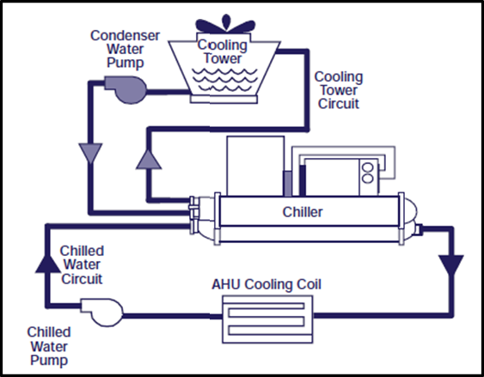

Fig 1.1: main component of central air conditioning system

**Central system category divided into three main types:**

1. Central systems with Constant Air Volume (CAV) air handling units
2. Central systems with Variable Air Volume (VAV) air handling units
3. Central systems with fan coil units (Water systems)

The distinction between both types is that the CAV system uses all air at a constant rate, the VAV system uses air but at a variable volume that supplies various zones, while the FCU fan coil unit system uses all water in a piping system with a ductless system, and the water enters the FCU to exchange heat with air.

Chilled water is not used as an intermediate cooling medium in a decentralized air conditioning system. Direct expansion (DX) is one of many common names for Decentralized air conditioning systems that directly heat exchanging heat with refrigerant style inside cooling coil to provide cooling into single room or spaces rather than the whole house. Individual systems, floor-by-floor systems, unitary systems also commonly names of this category.

Cooling coils, refrigerant coils, regulators, fans, filters, compressor, and condenser are only a few of the components in a decentralized device. Inside this kit, heat rejection and cooling take place.

Decentralized solutions include VRF systems, packaged air conditioners, split air conditioning systems, and window air conditioners. They seem to operate on the same theory. In this study, we will concentrate on the concepts and requirements of VRF air conditioning systems.

VRF air conditioning system (Variable Refrigerant Flow); a one-of-a-kind system that can accommodate several spaces on an individual basis that can dynamically adjust refrigerant flow based on the building's heating/cooling load.

The core theory and diagram for a VRF structure are depicted in the figure below. First, a compressor in the outdoor unit raises the refrigerant pressure, then the condenser forces the refrigerant reject heat out to meet the expansion valve with high pressure and temperature, and finally, the refrigerant exits the expansion valve with low pressure and temperature. VRF systems are available in two configurations: basic with two pipes that operate all zones in either cooling or heating mode, and complex with several pipes that operate all zones in either cooling or heating mode. The other kind is heat recovery (HR) systems, which have three pipes and can heat and cool some zones at the same time. Any of this is possible with microprocessor-based electronics.

**1.3 Case study: Hardee’s Restaurant (HR)**

Hardee's Restaurant is a special restaurant that offers American style burgers and has customers from all ages.

Hardee's Restaurant is situated on the west-south side of Nablus, in front of An-Najah National University (the new campus), at latitude 32.2, and longitude 35.2. HR has three floors: basement, ground, first, and second floor with a gross area of (495 $m^{2}$) and a height of 3.98m for each.

To have comfortable temperatures in the HR building, an appropriate air conditioning system is needed. Cooling and heating loads should be considered on all floors in order to set an accurate air conditioning system.

Table 1.3.1: Heat transfer coefficient

|  |  |  |
| --- | --- | --- |
| Thermal conductivity (k) w/m.c | Thickness(x)m | Material part |
| 1.2 | 0.02 | Plaster |
| 1.2 | 0.15 | Cement brick |
| 1.2 | 0.03 | Plaster |

Ri=0.12, Ro=0.06

Sample calculation

Uwall in = $\frac{1}{0.12+0.0166+0.125+0.025+0.06}=3.41\frac{w}{m^{2}}.c$

Table1.3.2: Values of Heat transfer coefficient

|  |  |
| --- | --- |
| U ($\frac{w}{m^{2}}$.c) | Typical wall |
| 0.779 | Wall out |
| 3.41 | Wall in |
| 7.19 | Floor |
| Ua = 0.5  Ub = 0.48 | Ceiling |
| For steel doors = 5.8  For aluminum doors = 7 | Doors |
| 3.2 | Windows |
| 3.33 | Freezer and cooler |

Design conditions  
Table 1.3.3: Outside design condition

|  |  |
| --- | --- |
| To | Ø |
| 4°c | 71.1% |

Table 1.3.4: Inside design conditions

|  |  |  |  |  |
| --- | --- | --- | --- | --- |
| T cooler | T freezer | Tu | Ø | Ti |
| 4°c | 0°c | 9.5 °c | 40% | 23 °c |

Areas Calculation

Windows area

Windows types : 1-Aluminum Curtain window (cw)

Cw1 = 40.6 $m^{2}$

Cw2 = 36.5 $m^{2}$

Cw3 = 14.6 $m^{2}$

Cw4 = 20.13 $m^{2}$

Table 1.3.5: Curtain windows area.

|  |  |  |  |  |
| --- | --- | --- | --- | --- |
| CW4 | CW3 | CW2 | CW1 |  |
| .. | 1 | 1 | 1 | Ground floor |
| 1 | .. | .. | 3 | First floor |

2-Aluminum window (w)

w1 = 1.5 $m^{2}$

w2 = 2.25 $m^{2}$

w3 = 1.95 $m^{2}$

Table 1.3.6: Aluminum windows area.

|  |  |  |  |
| --- | --- | --- | --- |
| W3 | W2 | W1 |  |
| .. | 1 | 3 | Ground floor |
| 3 | .. | 3 | First floor |
| .. | 1 | .. | Second floor |

Door’s area

Types of the doors: 1- wooden door (DW)

Dw1 = 1.98 $m^{2}$

Dw2 =1.6 $m^{2}$

Dw3 = 2.2 $m^{2}$

Dw4 = 1.4 $m^{2}$

Table 1.3.7: wooden doors area

|  |  |  |  |  |
| --- | --- | --- | --- | --- |
| Dw4 | Dw3 | Dw2 | Dw1 |  |
| .. | .. | 2 | .. | Basement |
| 1 | 1 | 4 | 2 | Ground floor |
| .. | 3 | 4 | 3 | First floor |
| .. | .. | .. | .. | Roof |

2- Steel doors (DS)

DS1 = 1.98 $m^{2}$

DS2 =4.5 $m^{2}$

DS3 =2.5 $m^{2}$

DS4 =4 $m^{2}$

DS5 =1.05 $m^{2}$

DS6 =4.5 $m^{2}$

DS7 =3 $m^{2}$

DS8 =1.4 $m^{2}$ heat insulated

DS9 =1 $m^{2}$ heat insulated

Table 1.3.8: Steel doors area.

|  |  |  |  |  |  |  |  |  |  |
| --- | --- | --- | --- | --- | --- | --- | --- | --- | --- |
| Ds9 | Ds8 | Ds7 | Ds6 | Ds5 | Ds4 | Ds3 | Ds2 | Ds1 |  |
| .. | .. | .. | .. | .. | .. | .. | .. | 1 | Basement |
| 1 | 3 | 1 | 1 | .. | .. | .. | .. | .. | Ground floor |
| .. | .. | .. | .. | .. | .. | .. | .. | .. | 1st floor |
| .. | .. | .. | .. | .. | .. | .. | .. | 1 | Second floor |

Heat losses calculation

Sample calculation:

Kitchen and cafeteria

Area calculations

Ds8 = 1.4 $m^{2}$

Ds9 = 1 $m^{2}$

Wall freezer = 24.3-1.4 =22.9 $m^{2}$

Wall cooler = 15.49 – 1 - 1.4 = 13.08 $m^{2}$

Window = w2+ 3*w1 + cw3 +cw2 +cw1 = 59.4 $m^{2}$

Wall out = 165.8 - 59.4 =106.4 $m^{2}$

Ds7 = 3 $m^{2}$

Wall in = 84.21 – 3 = 81.21 $m^{2}$

Floor = 202 $m^{2}$

Aa floor = 1/5 * 202 = 40.4 $m^{2}$

Ab floor 4/5 * 202= 161.6 $m^{2}$

#of person kitchen = 25 person

#of person cafeteria = 60 person

V vent kitchen = 25*8 = 200 L/s

V vent cafeteria = 60*10 = 600 L/s

Heat losses calculation ()

-  = u*a*∆T

Table 1.3.9: Heat loss calculations

|  |  |
| --- | --- |
| $Q_{Loss}$ (kw) | Loads |
| 1.94 | Freezer |
| 1.092 | Cooler |
| 3.61 | Window |
| 1.58 | Wall out |
| 3.74 | Wall in |
| 0.23 | Ds7 |
| 1.32 | Floor |

Q vent kitchen = 1.2 * 200*(23-4) = 4.6 KW

Q vent cafeteria = 1.2*19*600 = 13.6 KW

-Total $Q_{Loss}$ = 31.72 kw

|  |  |  |
| --- | --- | --- |
| Load (kw) | Area ($m^{2}$) | **Space** |
| 3.9 | 16 | Employees changing |
| 31.72 | 183 | Kitchen and Cafeteria 1 |
| 2.7 | 4.12 | Office |
| 29 | 142 | Cafeteria 2 |
| 14 | 63 | Kids play room |
| 3.3 | 11 | Meeting room |
| 16.5 | 78 | Second floor |

Table 1.3.10: Calculations for the loads depending on the area for spaces   
  
Total $Q_{Loss}$ for building = 101.12*1.1

Total $Q_{Loss}$ = 111.2 kw

**Cooling load calculation**

Outside design conditions

To = 30°c

Ø = 53.7%

Inside design conditions

Ti = 23 °c

Ø = 40%

Tu = 9.5 °c

Ceiling:

𝑸𝒄𝒊𝒆𝒍𝒊𝒏𝒈 = 𝑼𝑨(𝑪𝑳𝑻𝑫) 𝒄𝒐𝒓𝒗

(𝑪𝑳𝑻𝑫)𝒄𝒐𝒓𝒗 = (𝑪𝑳𝑻𝑫 + 𝑳𝑴)𝑲 + (𝟐𝟓. 𝟓 − 𝑻𝒊 ) + (𝑻𝒐 − 𝟐𝟗. 𝟒)

𝑪𝑳𝑻𝑫 table 9-1

𝑳𝑴 table 9-2

K =1 for dark color k = 0.5 for light color

Walls:

𝑸𝒘𝒂𝒍𝒍 = 𝑼𝑨(𝑪𝑳𝑻𝑫)𝒄𝒐𝒓𝒗

(𝑪𝑳𝑻𝑫)𝒄𝒐𝒓𝒗 = (𝑪𝑳𝑻𝑫 + 𝑳𝑴)𝑲 + (𝟐𝟓. 𝟓 − 𝑻𝒊 ) + (𝑻𝒐 − 𝟐𝟗. 𝟒)

𝑪𝑳𝑻𝑫 table 9-4

𝑳𝑴 table 9-2

K = 1 dark cooler k= 0.83 medium cooler k = 0.65 light

Thermal capacity:

𝒎𝒄 = 𝝆𝒄𝑪𝒄𝑿𝒄

Specific heat = 0.84 (KJ/kg.k) ( insulation , concrete , block , asphalt , plaster)

Calculation Thermal capacity each room:

Wall out:  
Table 1.3.12: explanation for thickness, density, and specific heat for construction material

|  |  |  |  |
| --- | --- | --- | --- |
| Specific heat (KJ/kg.k) | Density (kg/𝒎𝟑 ) | Thickness (x) m | Construction Material |
| 0.84 | 2.25 | 0.07 | Stone |
| 0.84 | 2.3 | 0.2 | Concrete |
| 0.84 | 130 | 0.03 | Insulation |
| 0.84 | 2 | 0.07 | Cement break |
| 0.84 | 1.9 | 0.03 | Plaster |

mc = (0.07 * 2.25 + 0.2*2.3 + 0.03*130 + 0.07*2 +0.03*1.9 ) * 0.84

mc = 3.97

Group G walls

sample calculation:

Meating room

Roof

(𝑪𝑳𝑻𝑫)𝒄𝒐𝒓𝒗 = (𝑪𝑳𝑻𝑫 + 𝑳𝑴)𝑲 + (𝟐𝟓. 𝟓 − 𝑻𝒊 ) + (𝑻𝒐 − 𝟐𝟗. 𝟒)

(𝑪𝑳𝑻𝑫)𝒄𝒐𝒓𝒗 = (17 + 1.1)1 + (𝟐𝟓. 𝟓 − 23) + (30 − 𝟐𝟗. 𝟒)

(𝑪𝑳𝑻𝑫)𝒄𝒐𝒓𝒗 = 21.2 ℃

Wall

(𝑪𝑳𝑻𝑫)𝒄𝒐𝒓𝒗 = (26 +1.1)1 + (𝟐𝟓. 𝟓 − 23) + (30 − 𝟐𝟗. 𝟒)

𝑪𝑳𝑻𝑫) = 30.2 ℃

𝑸roof = 𝑼𝑨(𝑪𝑳𝑻𝑫)𝒄𝒐𝒓𝒗

𝑸roof = 235.3 watt

𝑸wall = 525.9 watt

Bellow ground floor

𝑸b= 100 watt

**Heat transmitted and convection for glass**

Qglass = Qconv + Qtrans

Qconv = UA(CLTD)corr

Qtrans = A(SHG)(SC)(CLF)

Take month june / 4pm/

SC = 0.9

U=3.2

CLTD = 8

CLTD corr = 11.1

Qglass(meting room ) = 840watt

**Heat gained from people and lights and equipment**

-**people**

Qs = qs*n*CLF

Ql = ql*n

CLF=0.85

qs=70

ql=30

Qs = 70*10*0.85= 605watt

Ql = 30*10=290 watt

**lighting**

Q=W*CLF

W=A*10

Q= 14 watt

**Heat gained from equipment for building**

**Qs=1430 watt**

**Ql=3200 watt**

**Cooling load for building:**

Table 1.3.12: Calculations for the loads depending on area for the spaces

|  |  |  |
| --- | --- | --- |
| Load (kw) | Area ($m^{2}$) | **Space** |
| 3.1 | 16 | Employees changing |
| 14.6 | 63 | Kitchen |
| 28 | 120 | Cafeteria 1 |
| 2 | 4.12 | office |
| 32 | 142 | Cafeteria 2 |
| 13.5 | 63 | Kids play room |
| 3.6 | 11 | Meeting room |
| 17.8 | 78 | Second floor |

Total Q =113 kw  
Power cooling = Q(tot) * 1.1 = 124 kw

#### **1.4** **Hardee’s Restaurant (HR) Objectives**

1. In terms of economics, electricity use, regulation, and zoning, centralized and decentralized air conditioning systems, including chillers and variable refrigerant flow air conditioning systems, are compared.
2. The configuration of the variable refrigerant flow air conditioning system at Hardee's Restaurant was based on cooling and heating load measurements, and it included outdoor units, indoor units, a piping system, and duct works.
3. This new chilled (water to air) system at HR was designed using the same cooling and heating load equations used in designing VRF air conditioning systems. It includes outdoor units, indoor units, a piping system, duct work, and the required pumps.
4. Calculating the energy intake of a chiller (from water to air) as well as the variable refrigerant flow mechanism.
5. Calculating the fixed and operating costs with both chiller (water to air) and variable refrigerant flow air conditioning systems.

**Summary**

The West Bank is now experiencing power outages. Strong population leads to high power consumption, which leads to low voltage and high demand for electricity.

According to ( PCBS) figures, HVAC systems use the most energy in the West Bank. The majority of West Bank households use electricity as the primary energy source for air conditioning systems. As a result, any energy savings on these air conditioning devices would continue to reduce the need for electricity.

This study includes a significant analysis of two types of local air conditioning systems: VRF and air cooled systems. Per machine has its own set of properties and components.

The distinction would be made in order to choose the most economically sound scheme. As a result, each device would be analyzed independently before comparing them based on current worth values.

**Chapter Two**

**Decentralized and Centralized Air Conditioning Systems**

* 1. **Decentralized Air Conditioning System Design**

Decentralized applications are more effective in low to medium-demanding environments, and they do well in low-rise buildings such as office buildings and apartments. It is advised whether the initial cost is reasonable for such a project budget.

Instead of cooling whole cities, these devices cool individual rooms. There are many brand names for floor-by-floor structures, unitary systems, and individual systems. Decentralized system engineered and manufactured as a single kit that includes fans, filters, cooling coils, refrigerant side, heating source, controls, and condenser. Each part within this envelop is assembled to provide specific responsibilities and specifications.

There are several types of decentralized structures, each with its own set of requirements and architecture. There are few examples:

* Window air conditioner
* Split air conditioning systems
* Variable refrigerant flow (VRF) split system
* Packaged air conditioners
  + 1. **Window air conditioner**

All parts of a window air conditioner are engineered and manufactured to fit into a single envelop, including the condenser, expansion valve or coil, evaporator, compressor, and cooling coil.

Because of its simplicity in structure and construction, this unit box can be placed directly in a slot in the wall or in a window rack, as seen in the following figure.

This form of decentralized cooling system will only provide cooling where and when it is needed. It comes in a variety of capacities ranging from 0.5 to 3.0 TR.

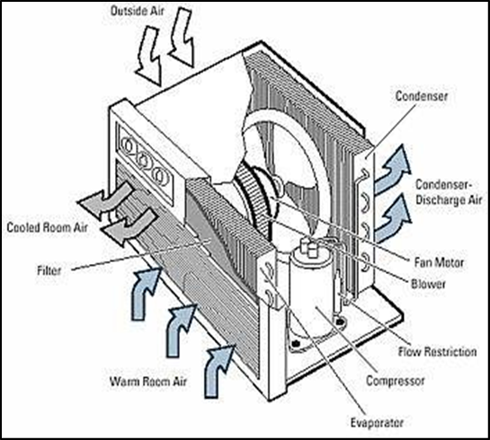

Fig 2.1: Window air conditioner type assembly.

* + 1. **Split air conditioning systems**

This form consists of two sections that work together to meet the requirements. The indoor unit contains the cooling coil, cooling fan, and evaporator, while the outdoor unit contains the pump, expansion valve, and condenser.

The outdoor unit is in charge of delivering cooled refrigerant to the indoor unit through refrigerant tubing, while the indoor unit is in charge of exchanging heat between the air and the cooled refrigerant before delivering cooled air to the room.

The outdoor unit and indoor unit are bound by refrigerant tubing, as seen in the following figure. This pipe distance is crucial and does not exceed 30 meters.

It is obvious that this form of decentralized structure is simple to set up, allowing an engineer to maintain architectural and physical specifications with ease.

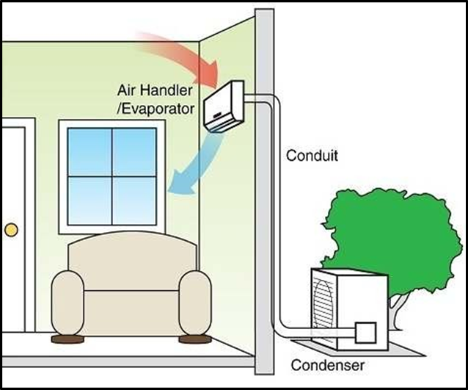

Fig 2.2: split air conditioner arrangement.

* + 1. **Variable refrigerant flow (VRF)**

The variable refrigerant flow system (VRF), which is complex and powerful, is a modern type of decentralized air conditioning system. It can link several indoor units to a single outdoor VRF condensing device via a refrigerant piping system.

VRF systems, for example, may provide both heating and cooling via a control system. By using a hand-held control or wall-mounted keypads, the control system can automatically control refrigerant flow to satisfy the cooling or heating load of the room.

The basic theory for a VRF. First, a compressor raises refrigerant pressure in the outdoor unit, then the condenser makes the refrigerant refuse heat to enter the expansion valve with high pressure liquid, and finally the refrigerant leaves the expansion valve with low pressure and temperature. VRF systems are available in two different configurations: one with two pipes that cools or heats all of the zones, and another with four pipes that cools or heats all of the zones. The other format is heat recovery (HR) systems, which have three pipes and can heat and cool different zones at the same time. All of this is possible thanks to microprocessor-based electronics.

* + 1. **Packaged air conditioners**

Packaged air conditioners are best for cooling capacities that fall in between split and central air conditioning systems. Set rating capacities of 3, 5, 7, 10, and 15 tons are available.

Packaged systems include the compressor, cooling coil, air handling unit, and air filter, all of which are housed in one unit. Packaged air conditioners can be classified into two groups based on the cooling mechanism they use: those with an air cooled condenser and those with a water cooled condenser.

In an air-cooled system, the outside appliance should be placed somewhere where ambient air will cool the refrigeration system's condenser. Since the condenser of the refrigeration device in a water-cooled environment is cooled by water, water must be sufficient at all times to keep the air conditioning system running.

A packed machine, as seen in the figure, will service two or three rooms at the same time. Its usable capacities range from 5 to 100 TR, making it more suitable for use in large spaces or offices.

However, the heavier the tonnage in a packaged structure, the greater the air flow, necessitating the use of ductwork to protect all openings and minimize noise.

* 1. Centralized air conditioning system design

These systems are most effective in mid to high rise buildings of five to seven or more floors, since they use a single base position to support single or multiple zones of cooled air. The following three types of centralized structures can be identified:

* Central systems with Constant Air Volume (CAV) air handling units
* Central systems with Variable Air Volume (VAV) air handling units
* Central systems with fan coil units (All-Water systems)

The constant air volume system (CAV) is a kind of all-air system that uses a constant air volume supply and variable air temperature to sustain a comfortable temperature and humidity (comfort conditions) in served areas.

VAV is an all-air system that can cover several zones by providing air at a constant temperature from the central plant to one or more VAV units in each zone. The volume of air flow to each zone, however, can be changed to meet the cooling load specifications of each zone. The simplicity of air flow management, which can support any number of zones inside the building at the same time, the key benefit of this design over the constant air volume system.

An all-water system with FCU units is a central system with fan coil units. The outdoor unit generates chilled water that is pumped through insulated pipes to the fan coil unit (FCU) within the conditioned room, where heat is exchanged with the air to create cooled air, which is then transferred to the zones and returned to the FCU to be cooled again by cooling coils to complete the loop.

The chilled water plant, the air distribution system, and the condenser water system are the three main subsystems of central systems architecture (or heat rejection system). Any subsystem is in charge of a specific task. The central device water to air is split into three subsystems.

Inside the chiller body evaporator portion, the chilled water substation continues its loop. Pumps pressurize the system by providing chilled water to the evaporator's inlet, which then exits the evaporator through a piping system to supply chilled water to air handling units' cooling coils, where it is heat exchanged with air supplied by fans. Primary and secondary chilled water pumps can be used in the system; the primary water pump keeps the system pressurized and ensures steady water flow through the chiller, while the secondary water pump only supplies chilled water to AHUs in the amounts needed.

Centrifugal compressors (200 to 2000 TR), screw compressors (100 to 750 TR), and reciprocating compressors are the three most popular types of chillers (up to 200 TR). Each has its own set of constraints, characteristics, and peak load performance.

To maintain cooling load standards, the air distribution subsystem is responsible for supplying cooled air to spaces through duct system and registers.

In most buildings, air is returned to the AHU by a return air system, where it is combined with supply air in the recommended number.

Ducted returns or plenum returns are two types of return air systems. Return air devices mounted to the ceiling or walls gather air from each zone and supply it to the AHU through direct duct work in ducted returns. Plenum returns gather air from all zones via return air systems, similar to ducted returns, and transport it to the space between the drop ceiling and the actual ceiling, where it is then returned to the AHU via ductwork or structural channels and conduits.

Prior to heat exchange, the air should be filtered to eliminate specific contaminants (mold, dust, and allergens).

Heat rejection is needed in any refrigeration device. This portion is handled by the condenser water system, which has two heat rejection options:

1. Water cooled
2. Air cooled

Water cooled units are often used in large buildings such as hotels and airports to reject heat absorbed from spaces or zones to water, which can then be rejected by cooling towers or fluid coolers in the same manner.

In residential and light commercial applications, the air cooled alternative is the most popular. Heat may be denied to the ambient air from gaps or zones that have been consumed.

**2.3** **Comparison between Centralized and Decentralized air conditioning systems**

Every building style has its own set of rules, standards, and constraints that influence HVAC system selection, and each HVAC system has its own architecture and properties that influence the type chosen. So, in order to make a decision and choose the appropriate type of HVAC device for our situation, we must first examine each type and summarize each type's configuration, specification, properties, and limitations.

The following are some of the distinctions between centralized and decentralized air conditioning systems that, in the end, make one better than the other in this case:

* Applications, usage patterns and zoning
* Control views, structural design and costs

**2.3.1 Applications, usage patterns, and zoning comparison**

Central systems are used widely for completely air conditioning in large buildings, airports, hotels, shopping malls, theaters…etc. One or more base chillers may be used to have the desired load space, and a hybrid system, which is a mixture of centralized and dispersed systems in which a couple of central plant and packed split units service corridors and lobby, and the packaged system serves individual rooms such as guest rooms and conference rooms, is often chosen.

Centralized devices, such as chillers, are available on the market with a potential capacity of 2000 tons, making them ideal for situations requiring a long period of use and consistency.

Many zones can be served by a single central plant, and there can be a variety of control points so each zone has its own control (thermostat) that sends signals to the main central plant to track chilled water flow.

Since could room has its own air conditioning device that can be turned off without affecting the others, decentralized systems are well suited for buildings with unoccupied spaces during any given period and have possible energy savings. Low to mid-rise buildings with low to occasional air conditioning needs, such as small residential buildings and businesses, favor decentralized systems. However, multiple box units will cover the desired loads in large buildings.

Decentralized systems can provide a workaround for spaces that could need extension or the installation of more facilities.

Since split units can't adapt to multiple sensors (thermostat) signals and don't have modulating power, decentralized systems like split units (DX) are only suggested for single zone applications. Because of the assembly of its material, namely the compressor, which only operates with ON – OFF reaction to the signals coming from a thermostat, it can be either totally shut off or totally shut on, each zone has its own thermostat attached to the single base device. Multiple units are expected to protect multiple zones in an application.

Decentralized air conditioning systems with capacities ranging from 0.5 to 130 tons are available on the market (for roof top package units).

**2.3.2 Control views**

Regulation is critical in all energy-saving processes, including power control. By modulating the chilled water flow rate through the cooling coils usually inside the air handling unit or the fan coil unit, central systems (chilled water type) display strong power control. Decentralized systems, on the other hand, do not have modulating power since their coil temperatures are set during cooling mode, so the only control possible in decentralized systems like (DX) systems is cycling the compressor ON and OFF based on sensor (thermostat) signals.

Centralized air quality management systems provide high-quality air conditioning for installations that need specific control and are vulnerable to environmental conditions. The air quality in decentralized systems is worse than in central systems.

Decentralized air conditioning devices lack climate control precision since there are only two control positions: ON or OFF, causing temperature and relative humidity fluctuations. Owing to the high degree of monitoring between the base unit and the indoor units (for example, FCUs), this can occur in central systems where they are balanced and there are no hot spots in targeted areas When it comes to regulating fresh air and ventilation, a central system has good control over fresh air volumes, allowing for constant or variable quantities, while a decentralized system does not.

For energy savings, we found that most control views are stronger in centralized systems than in decentralized systems. However, individualized control decentralized systems are better because they can provide room by room control, providing heating for spaces that need heat while still providing cooling to neighboring spaces that need cooling without interfering with each other.

Person regulation is not necessarily as flexible in central institutions as it is in autonomous systems. Individual control is possible in the (VAV) central device figure by controlling the air supply speeds to the spaces while keeping the coils at a constant temperature.

Individual control is often possible in central air conditioning systems (CAV) by maintaining the air delivery steady and adjusting the coil temperature. However, this type is not recommended due to the large amounts of energy lost by simultaneous cooling and heating.

**2.3.3 Structural design and costs**

Centralized structures have massive and heavy machinery that necessitates a large area called a mechanical room in every building they are used in.

In mechanical rooms where air handling units or fan coil units are installed with their cooling coils, as well as in plant rooms where cooling water pumps are available, central systems should have a plumping structure and drainage system configuration.

Since decentralized structures are simpler and reduced in scale, there is no need for mechanical rooms to accommodate the machines, allowing for more open space in the house. Since the evaporators in most localized air conditioning systems are placed within or at the borders, plumping must be done in the indoor spaces connected to the zone drainage system itself, and no new special drainage line is needed.

Centralized systems have much higher capital costs than decentralized systems. The cost of capital varies depending on the type of equipment used in the system; for example, a centrifugal chiller is the most expensive, followed by a screw packed chiller, and finally a reciprocating packaged chiller. However, costs differ based on chiller size; for example, centrifugal chillers cost more than reciprocating chillers under 200 tons, but reciprocating chillers become competitive in larger scales.

In addition, central air cooled machines are around 10% to 15% less expensive in capital costs than water cooled machines, while still saving energy or power (running costs), so engineers can calculate the payback period and conduct visibility tests before deciding on which technology to use.

Decentralized air conditioning systems have lower capital costs than central air conditioning systems that are paying by a custom system. Decentralized networks are preferable because they need less materials to install and therefore have lower maintenance costs.

Decentralized solutions often show a good cost saving in terms of engineering costs since they are common size units that are readily available, making installation easier and simpler, saving time and installation operating costs. Central systems have significantly higher construction costs because the equipment and parts are heavier and greater in scale, necessitating additional costs for site handling.

Central air conditioning systems are more costly and time intensive to maintain than localized air conditioning systems. Both of these costs differ in terms of value and time depending on the quality of material used and the capability available.

In most decentralized systems, maintenance can be performed immediately in inhabited spaces, while in central systems, it can be performed inside mechanical rooms or outside.

**2.4 Cleaning air conditioning system filters**

Filters are crucial in air conditioning systems because they ensure that the air within spaces is of high quality and meets ASHRAE requirements. Filters should be used in the return air line because the air inside has several toxic contaminants that must be filtered before recycling. Almost many of these filters have been clogged as a result of toxic contaminants accumulating inside them, making it difficult for air to get through.

Filter blockage in air conditioning systems is a near-serious issue because it reduces indoor air quality and can spread a variety of diseases and illnesses. Furthermore, clogged filters will increase energy consumption because the air would be difficult to circulate, resulting in an increase in pressure.

This figure depicts two filters, one white and the other filthy. Changing air conditioning filters on a regular basis will save you up to 30% on electricity costs.

**Chapter Three**

**Variable Refrigerant Flow (VRF) Design for HR**

**Variable Refrigerant Flow (VRF)**

**Design for HR**

Variable refrigerant flow system is a modern air conditioning system that userefrigerant as the cooling and heating medium, VRF system consists of outdoor units indoor units, and piping system.   
 **What are the components of a VRF system?**  
A compressor with an outdoor coil and several indoor fan coil units are the two main components of a VRF system. The compressor, which works as a pump, is housed in the outside unit and pushes refrigerant through pipe to the indoor coils and back**.**

Selection and Design of Variable Refrigerant Flow (VRF) System Components:

All components selection based on **GCHV**  air conditioning catalogue.

**3.1 : selection indoor unit :**

**Table (3.1) : Hardees Restaurant indoor unit specifications.**

|  |  |  |  |  |
| --- | --- | --- | --- | --- |
| # of IDU | Model IDU | Load (kw) | Area ($m^{2}$) | **Space** |
| 1 | CMV-V36TA/HR1-C | 3.1 | 16 | Employees changing |
| 1 | CMV-V150TB/HR1-B | 14.6 | 63 | Kitchen |
| 2 | CMV-V150TB/HR1-B | 28 | 120 | Cafeteria 1 |
| 1 | CMV-V36TA/HR1-C | 2 | 4.12 | Office |
| 3 | CMV-V120TB/HR1-B | 32 | 142 | Cafeteria 2 |
| 1 | CMV-V150TB/HR1-B | 13.5 | 63 | Kids play room |
| 1 | CMV-V36TA/HR1-C | 3.6 | 11 | Meeting room |
| 2 | CMV-V90TB/HR1-B | 17.8 | 78 | Second floor |

Indoor units was selected from **GCHV** catalogue to cover target zones in all floors as .

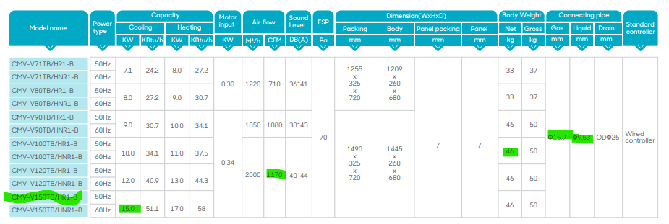

Fig 3.1: explanation of choosing the IDU model from GCHV catalogue

Two outdoor unit has been selected for the building , wich has an estimated area of 495 ${ m}^{2}$**.**

Totally load by indoor unit 123.6 kw

To calculate horse power for outdoor unit (123.6/2.8) = 44.1 hp

Use diversity 6%.

the outdoor selected was 42 hp with mod of (GCHV-E560W/HZR1-DM01 and GCHV-E615W/HZR1-DM01)

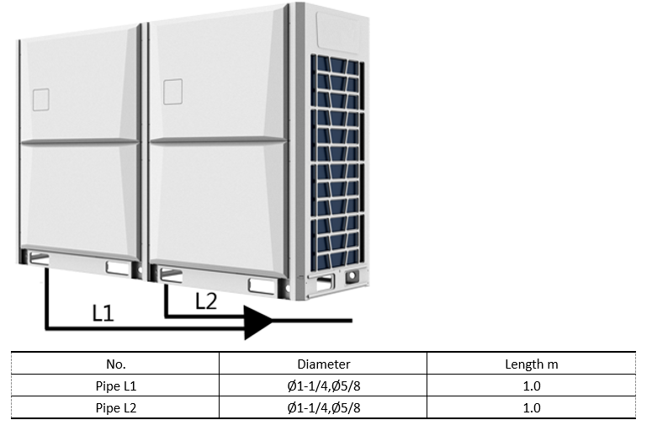

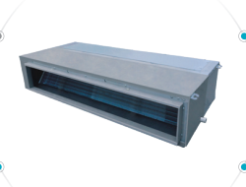

*fig 3.2IND 1*

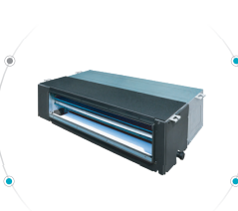

*FIG 3.3indoor unit2*

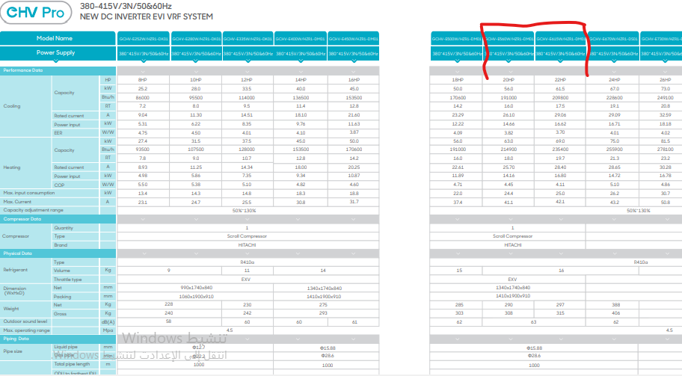

Fig 3.4: explanation of choosing the ODU model from GCHV catalogue.

**3.2 Duct sizing**

Duct: are conduits or passages used in heating, ventilation, and air conditioning

(HVAC) to deliver and remove air.

Several types of channels can be obtained:

Aluminum (AL), Fiberglass duct , Flexible ducting and selected type Galvanized steel .

Because Galvanized mild steel is the standard and most common material used in fabricating ductwork because the zinc coating of this metal prevents rusting and avoids cost of painting.

We have selection the duct from a special software " duct sizing " as show fig 3.6.

Show fig 3.7, 3,8 , 3.9 and 3,10 The dimensions of the duct are shown where the depth is 200 mm, and the program calculates the width in proportion to the amount of air flowing (cfm) .

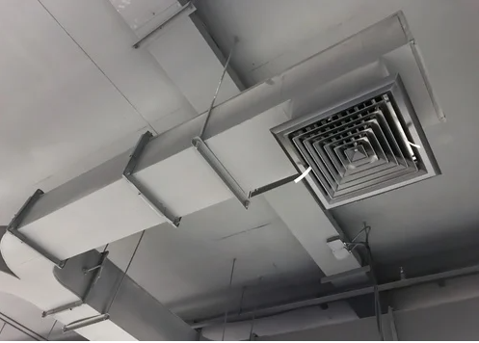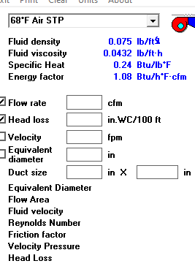

Fig 3.5: Duct sizer calculation software.

**3.3 Diffuser Selection:**

**Table (3.2): Hardee’s diffuser specifications**

|  |  |  |  |
| --- | --- | --- | --- |
| **Space** | **# of user** | **Cfm** | **Modal** |
| Employees changing and meeting room | 4 | 163 | 4-way diffuser 30*30 |
| Cafeteria and officee | 7 | 390 | 4-way diffuser 60*60 |
| Kitchen , kids play and cafeteria | 26 | 293 | 4-way diffuser 40*40 |

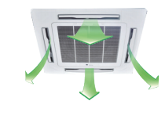

*FIG 3,6 : 4-WAY DIFFUSER*

**3.5: Piping length calculations:**

**Table (3.3): Hardees Restaurant piping length and diameters .**

|  |  |  |  |
| --- | --- | --- | --- |
| **No.** | **Length** | **Gas Pipe** | **Liquid Pipe** |
| (1) | 6.0 m | Ø41.2 | Ø7/8 |
| (2) | 6.0 m | Ø1-1/8 | Ø1/2 |
| (3) | 3.6 m | Ø3/4 | Ø3/8 |
| (4) | 6.2 m | Ø5/8 | Ø3/8 |
| (5) | 5.0 m | Ø5/8 | Ø3/8 |
| (6) | 7.2 m | Ø5/8 | Ø3/8 |
| (7) | 9.0 m | Ø5/4 | Ø3/4 |
| (8) | 4.0 m | Ø1-1/8 | Ø1/2 |
| (9) | 1.0 m | Ø5/8 | Ø3/8 |
| (10) | 1.8 m | Ø7/8 | Ø3/8 |
| (11) | 7.5 m | Ø1/2 | Ø1/4 |
| (12) | 5.0 m | Ø5/8 | Ø3/8 |
| (13) | 6.0 m | Ø5/8 | Ø3/8 |
| (14) | 8.0 m | Ø5/8 | Ø3/8 |
| (15) | 3.0 m | Ø1-1/8 | Ø5/8 |
| (16) | 4.5 m | Ø1-1/8 | Ø5/8 |
| (17) | 1.6 m | Ø1-1/8 | Ø1/2 |
| (18) | 6.3 m | Ø5/8 | Ø3/8 |
| (19) | 1.6 m | Ø7/8 | Ø3/8 |
| (20) | 10.0 m | Ø5/8 | Ø3/8 |
| (21) | 10.8 m | Ø3/4 | Ø3/8 |
| (22) | 2.5 m | Ø1/2 | Ø1/4 |
| (23) | 12.0 m | Ø5/8 | Ø3/8 |

**Table (3.4) : Hardees Restaurant distributor .**

|  |  |  |
| --- | --- | --- |
| **No.** | **Load kW** | **Model** |
| (1) | 124.80 | SP-FQG-N04D |
| (2) | 33.00 | SP-FQG-N03D |
| (3) | 18.00 | SP-FQG-N01D |
| (4) | 91.80 | SP-FQG-N03D |
| (5) | 39.60 | SP-FQG-N03D |
| (6) | 15.60 | SP-FQG-N01D |
| (7) | 24.00 | SP-FQG-N02D |
| (8) | 52.20 | SP-FQG-N03D |
| (9) | 48.60 | SP-FQG-N03D |
| (10) | 45.00 | SP-FQG-N03D |
| (11) | 30.00 | SP-FQG-N02D |

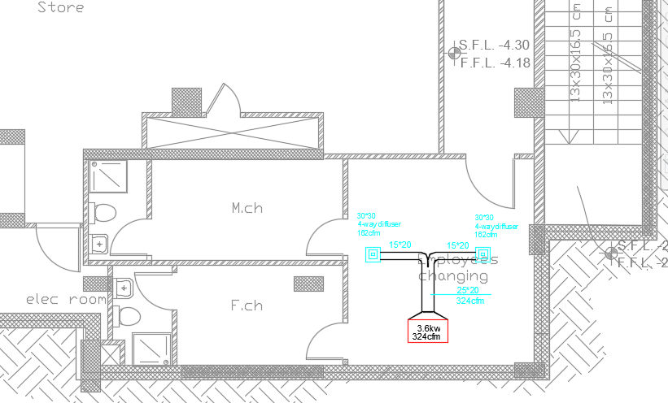

Fig 3.7: Indoor unit’s, diffuser and duct sizing distribution for basement.

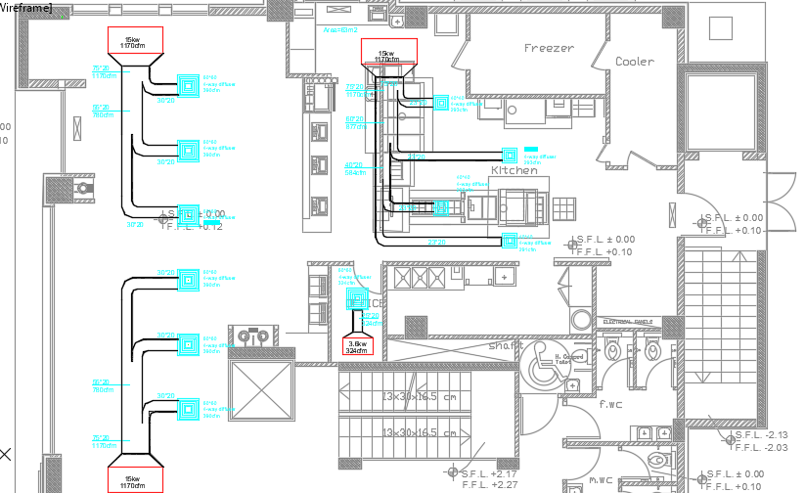

Fig 3.8: Indoor unit’s, diffuser and duct sizing distribution for ground floor.

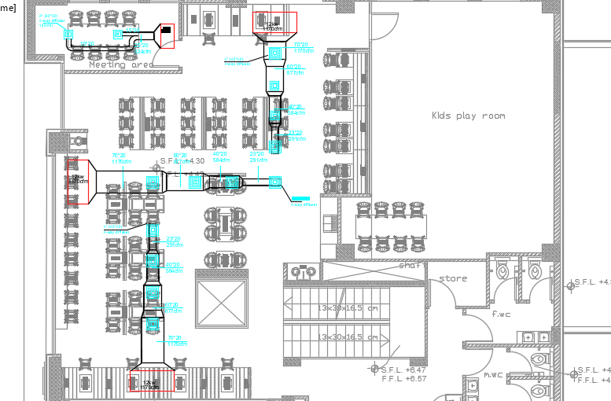

Fig 3.9: Indoor unit’s, diffuser and duct sizing distribution for first floor.

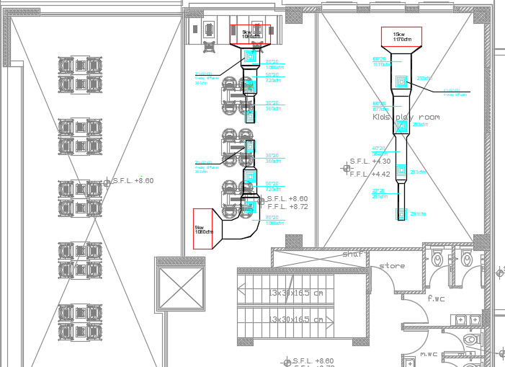

Fig 3.10: Indoor unit’s, diffuser and duct sizing distribution for second floor.



Figure 3.11: Distribution for Hardee's Restaurant piping diagram.

**About pipes : (cupper pipes used)**

**Why copper pipes are used in air conditioners?**

In comparison to aluminum, copper has excellent anti-corrosive qualities. Pipes come into touch with air during the cooling process, causing oxidation within the pipes. Copper can withstand oxidation and corrosion for extended periods of time, extending the life of air conditioners.

**What type of copper tubing is used for HVAC?**

Copper pipe of type L is utilized for indoor plumbing, fire suppression, and some HVAC applications. It's available in both rigid and flexible versions, and it's compatible with sweat, compression, and flare fittings. ‏

**What is a 3 pipe VRF system?**

Heat Recovery VRF Systems, also known as 3-pipe VRF systems, enable for simultaneous heating and cooling of all indoor terminal devices. Each indoor heat recovery unit communicates with the indoor terminal units and thermostats in each zone to decide whether it is necessary to heat or cool the space.

Where strength and protection are required, Type L copper pipe is recommended. Type M copper pipe, on the other hand, is perfectly adequate for standard “in the wall” domestic plumbing. Underground, Type L is commonly used in hot water heating systems, commercial plumbing, and gas lines (where permitted).  
  
  
  
  
  
  
  
  
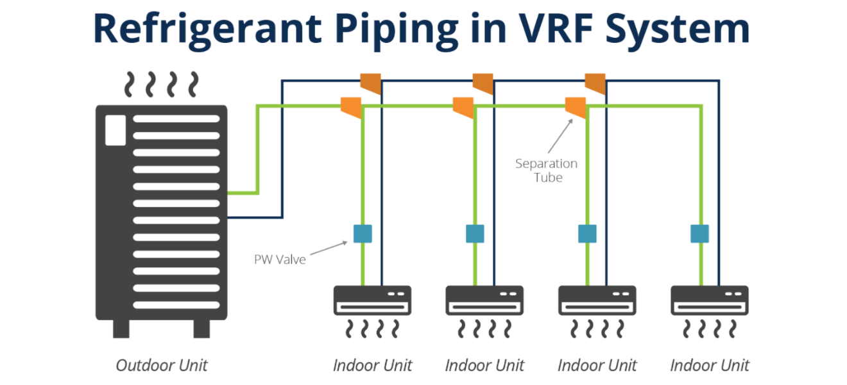  
Fig3.11: Refrigerant-Piping-in-VRF-System.

**Chapter Four**

**Air to Water Chiller System**

**(Air Cooled)**

**4.1 Air to Water Chiller Design**

Chiller air to water air conditioning system or in other name (Air cooled liquid chillers ACLC) consists of many important parts: outdoor units, indoor units, water pumps, ductworks, and water pipes network. Every part integrates the other, and every part design should complete the other.

**4.2: selection outdoor unit , indoor and pump unit for ACLC system**

**-pump selection:**

Qs = ṁ*cp $∆t$

*

ṁ= = $\frac{124}{4.18*5}$ = 5.9 kg/s

pressure drop ( $∆p)$….. ∆𝑷 = (∆𝑷) 𝒇𝒓𝒊𝒄𝒕𝒊𝒐𝒏 + (∆𝒑) 𝒇𝒊𝒕𝒕𝒊n

$L_{total}$ = 1.5 $L_{pipe}$* ….. $L_{total}$ = 1.5 * 45 = 68 m

∆𝑷= 23 kpa

$\frac{∆P }{Ltotal}=235.3 pa$

550 > 235.3>200

Standard pump S 57

All components selection based on GCHV air conditioning catalogue

**-outdoor unit selection:**

The cooling load on HR building are 124 kw = 35 tor.

One outdoor unit has been selected for the building, which has an estimated area of 495 ${ m}^{2}$**.**

Totale load by indoor unit 117.8 kw

Use diversity 10%.

the outdoor selected was 130 kw capacity with mod of **(CLS-F130HW/ZR1B)**

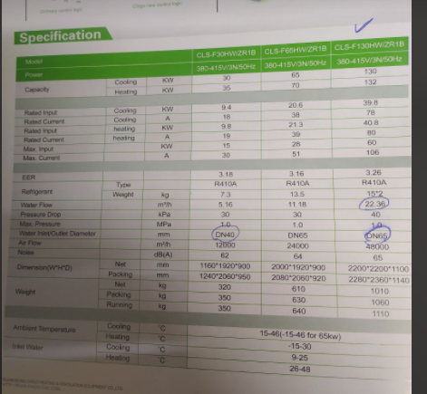

Fig 4.1: explanation of choosing the ODU model from GCHV catalogue.

|  |  |  |  |  |
| --- | --- | --- | --- | --- |
| # Of IDU | Model IDU | Load (kw) | Area ($m^{2}$) | **Space** |
| 1 | CST3-300P12-A | 3.1 | 16 | Employees changing |
| 1 | CST3-1400P30-A | 14.6 | 63 | Kitchen |
| 2 | CST3-1400P30-A | 28 | 120 | Cafeteria 1 |
| 1 | CST3-300P12-A | 2 | 4.12 | Office |
| 3 | CST3-1400P30-A | 32 | 142 | Cafeteria 2 |
| 1 | CST3-1400P30-A | 13.5 | 63 | Kids play room |
| 1 | CST3-300P12-A | 3.6 | 11 | Meeting room |
| 2 | CST3-1200P30-A | 17.8 | 78 | Secand floor |

**-Selection-indoor-unit:  
  
Table (4.1): Hardees Restaurant indoor unit specifications.**

Indoor units were selected from **GCHV** catalogue to cover target zones in all floors as.

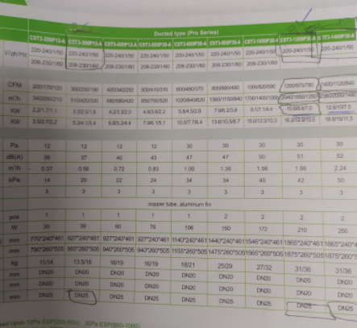

Figure 4.2: explanation of choosing the FCU model from GCHV catalogue

**4.3 Duct sizing**

The duct dimensions have been calculated from a special software " duct sizing " as show fig 3.6.

Show fig 3.7, 3.8, 3.9 and 3.10 The dimensions of the duct are shown where the depth is 200 mm, and the program calculates the width in proportion to the amount of air flowing (cfm).

**4.4: Diffuser Selection:**

**Table (4.2): Hardee’s diffuser specifications.**

|  |  |  |  |
| --- | --- | --- | --- |
| **Space** | **# of user** | **Cfm** | **Modal** |
| Employees changing and meeting room | 4 | 150 | 4-way diffuser 30*30 |
| Cafeteria and office | 7 | 466 | 4-way diffuser 60*60 |
| Kitchen , kids play and cafeteria | 26 | 350 | 4-way diffuser 45*45 |

**4.5: Piping length calculations:**

**Table (4.3): Hardees Restaurant piping length and diameters.**

|  |  |  |  |  |  |
| --- | --- | --- | --- | --- | --- |
| Length of pipe (m) | Diameter ( mm) | $\frac{∆P }{Ltotal}$ (pa) | ṁ (l/s) | Load (kw) | # of pipe |
| 10 | 70 | 235.3 | 5.9 | 124 | P1 |
| 6 | 50 | 235.3 | 1.58 | 33 | P2 |
| 3.6 | 40 | 235.3 | 0.86 | 18 | P3 |
| 6.2 | 32 | 235.3 | 0.72 | 15 | P4 |
| 5 | 25 | 235.3 | 0.43 | 9 | P5 |
| 7.2 | 25 | 235.3 | 0.43 | 9 | P6 |
| 4 | 65 | 235.3 | 4.35 | 91 | P7 |
| 4 | 50 | 235.3 | 1.9 | 39.6 | P8 |
| 1 | 32 | 235.3 | 0.75 | 15.6 | P9 |
| 1.8 | 40 | 235.3 | 1.15 | 24 | P10 |
| 7.5 | 20 | 235.3 | 0.2 | 3.6 | P11 |
| 5 | 32 | 235.3 | 0.57 | 12 | P12 |
| 6 | 32 | 235.3 | 0.57 | 12 | P13 |
| 8 | 32 | 235.3 | 0.57 | 12 | P14 |
| 4 | 50 | 235.3 | 2.46 | 51.4 | P15 |
| 4.5 | 50 | 235.3 | 2.33 | 48.6 | P16 |
| 1.6 | 50 | 235.3 | 2.16 | 45 | P17 |
| 6.3 | 32 | 235.3 | 0.72 | 15 | P18 |
| 1.6 | 40 | 235.3 | 1.43 | 30 | P19 |
| 10 | 32 | 235.3 | 0.72 | 15 | P20 |
| 10.8 | 32 | 235.3 | 0.72 | 15 | P21 |
| 4 | 20 | 235.3 | 0.2 | 3.6 | P22 |
| 12 | 20 | 235.3 | 0.2 | 3.6 | P23 |

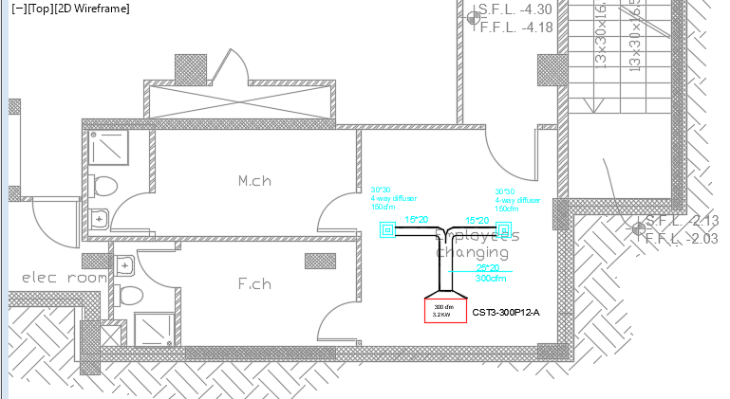

Fig 4.3: Fan coil unit, diffuser and duct sizing distribution for basement.

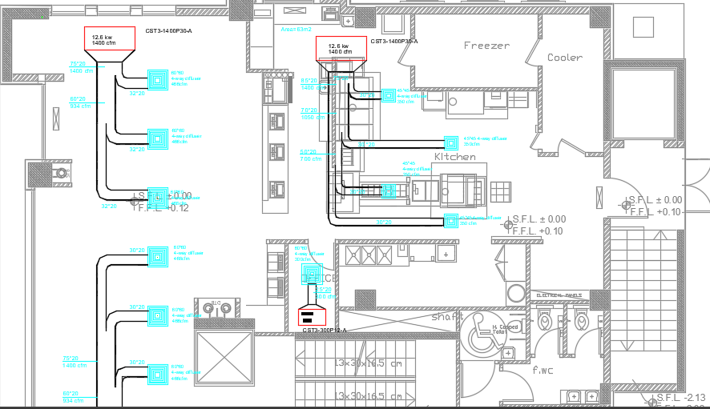

Fig 4.4: Fan coil unit, diffuser and duct sizing distribution for ground floor

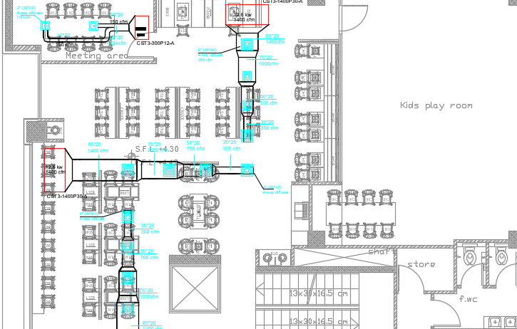

Fig 4.5: Fan coil unit, diffuser and duct sizing distribution for first floor.

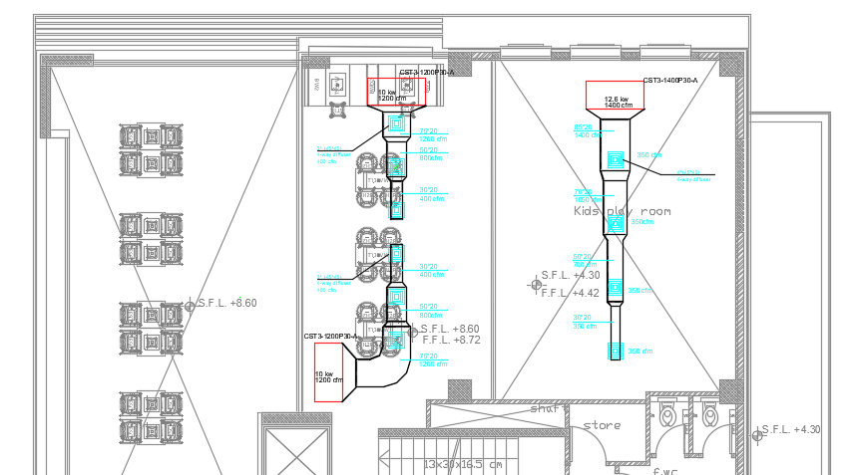

Fig 4.6 Fan coil unit, diffuser and duct sizing distribution for second floor.

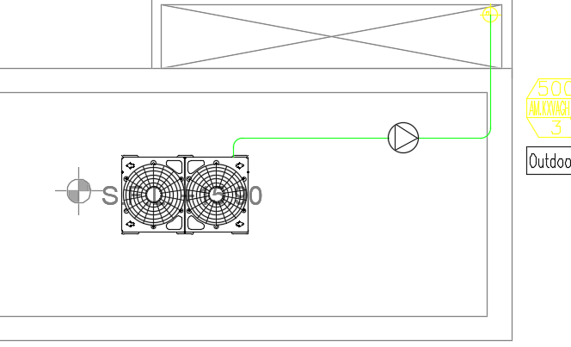 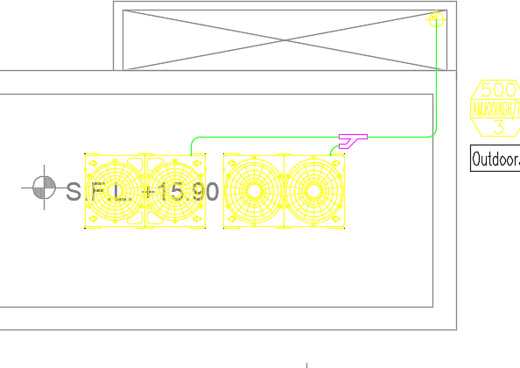

Figure 4.7: VRF and chiller outdoor unit:

**About Pipes: (cupper pipes used)**

As mentioned before in chapter 3 cupper pipes were used but the difference between VRF system and Chillers that the pipes diameters in VRF is smaller than diameters in Chillers because VRF system needs the pipes to transfer gas but the pipes in chillers used to transfer liquid.

**Chapter Five**

**Economic comparison**

**between VRF and Air**

**to water chiller system**

**5.1 VRF economical part**

Indoor units, outdoor units, piping system, ducts, and monitoring system are all analysed economically in this segment.

Any device component has a capital cost, and certain components have an operating cost that varies over time.

A 20-year economic analysis was conducted, with all prices based on producer official prices (Chigo).

* **Capital costs of outdoor units for VRF system**

The building served by outdoor unit with capital cost = $22000.

* **Capital cost of indoor units for VRF system**

All the indoor units at the Hardee’s Restaurant building, and based on the official VRF indoor unit price bid, the overall capital cost $20828.

**-Piping network capital cost for VRF system:**

The pipes used at HR building network was made of isolated

copper, the pipes network was designed to cover all zones and serving all

desired spaces.

Figure (5.1) shows the full description of pipes network at HR building project with all pipes dimension and capital costs.

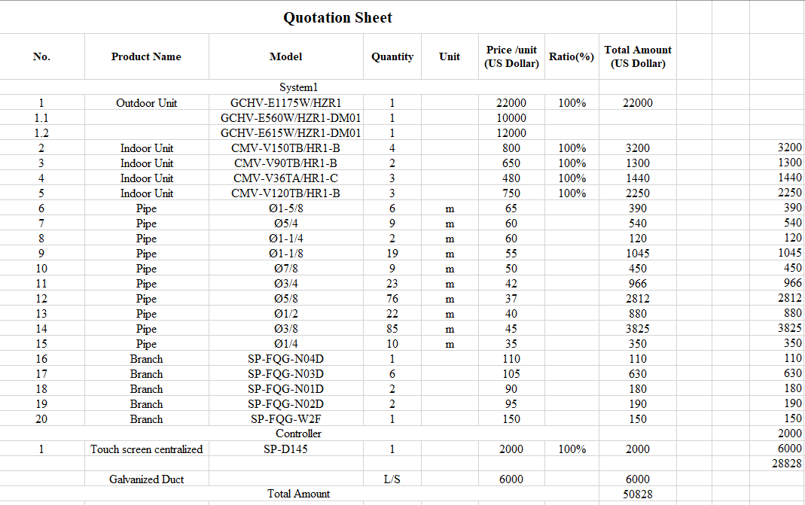

Fig5.1: -Piping network capital cost for VRF system:

Any pipe branch has its own dimension in inches, and the capital cost of pipes is determined by the pipe section's dimension, so each pipe diameter has its own capital cost.

Total capital cost of pipes network = Σ (Ln X Pn) … Eq (5.1)

Where:

n: Pipe diameter

Ln: Total length of pipe diameter n

Pn: Unit price of pipe diameter n

By applying equation (5.1):

Total capital cost of pipes network = $**11378**.  
Total cost for pipes and branches =$12638

**5.2 Chiller air to water system economical part**

Indoor units, outdoor units, piping system, duct, monitoring system, and pumps are all analyzed economically in this segment.

Any device component has a capital cost, and certain components have an operating cost that varies over time.

A 20 year economic analysis was conducted with all prices based on producers official prices (Chigo).

**-Capital costs of outdoor units for Chiller air to water system**

The building served by outdoor unit with capital cost = $25000

Pumps for the chiller cost = $2900

**-Capital cost of indoor units for Chiller air to water system**

All the indoor units at Hardee’s Restaurant building and based on the official Chiller air to water system indoor unit price bid, the over all capital cost is $11530

**-Piping network capital cost for Chiller air to water system:**

The pipes used in Hardee’s Restaurant was made of isolated copper, the pipes network was designed to cover all zones and serving all desired spaces.

Figure 5.2 shows all the economical details and all the piping network

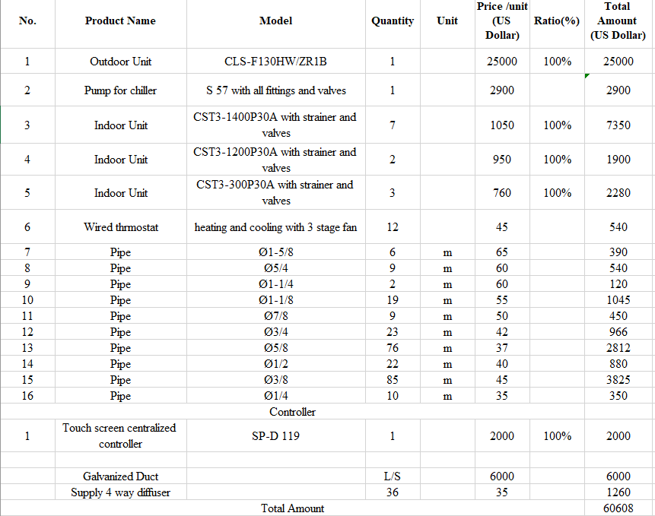

Fig5.1: -Piping network capital cost for VRF system:

Any pipe branch has its own dimension in inches, and the capital cost of pipes is determined by the pipe section's dimension, so each pipe diameter has its own capital cost, by using the same equation Eq (5.1)

Total capital cost of pipes network = Σ (Ln X Pn)

Where:

Total capital cost of pipes network = $**11378**.

**5.3 Conclusion:**

Choosing the greatest equipment for delivering the best facility in a company is one of the most difficult tasks for a business owner. There are a lot of considerations and labor that goes into selecting equipment for the whole organization and its occupants, whether it's VRF systems or water chiller systems that are very energy-efficient and cost-effective. An HVAC system is one such item that requires special attention. HVAC systems are an extremely expensive and energy-consuming component of any business, so they should be chosen carefully. VRF systems and water chiller systems are the two main solutions for commercial or industrial HVAC systems.

In terms of precise control and comfort, VRF Systems are far more adaptable and efficient. Because of their compact footprints, these systems are quite convenient. VRF Systems are much easier to install and less expensive than a water chiller system. VRF Systems can also be easily incorporated into a building's Building Management System (BMS) to provide precise and effective system control.

**References:**

1. Palestine central bureau of statistics (PCBS). (2010-2019) Energy-sector-[Online]-Available-from[:http://www.pcbs.gov.ps/site/lang](http://www.pcbs.gov.ps/site/lang) ar/923/Default.aspx .
2. Chigo catalogues Guangdong Chigo Heating & Ventilation Equipment Co, ltd.

* DC-Inverter-VRF-System   
  CAC-Catalogue
* Air-Cooled   
  Heat-Pump  
  Modular-Chiller  
  [www.chigo-cac.com](http://www.chigo-cac.com)

1. American Society of Heating and Air-Conditioning Engineers (ASHRAE) standard 55-1981.
2. A.Bahtia-Continuing Education and Development (2016)  
   Centralized Vs Decentralized air conditioning systems.
3. Energy saving potential and opportunities for high efficiency electric motors in residential and commercial equipment(2018) building technologies office.
4. Martian doppelbue(2017) – motor efficiency classes
5. Allison bailes (2015) – energy vanguard.
6. Energy Efficiency Improvement, procedures and audit results of electrical, thermal and solar applications in Palestine, Elsevier – Energy policy 33 (2017).
7. Environmental Protection Agency EPA (2018) IAQ building education and assessment model.
8. Carrier chapter three. (2017) piping system.
9. Palestinian, Metrological Department (2016) – Nablus Temperature Distribution.
10. Heating and Air Conditioning for Residential Building. 5th Edition