بسم الله الرحمن الرحيم


An-Najah National University
Chemical Engineering Department

Shaving Cream Manufacturing Plant

Submitted by:
Hiba Shorab.
Najlaa Haj Ali.
Salwa Mekkawi.
Wafa Awad.

Supervisor: Dr. Husni Odeh.

A Graduation Project Submitted to Chemical Engineering Department in Partial Fulfillment of the Requirements for B.S.C/Degree in Chemical Engineering

Table of Contact
Subject Name | No. of Page
List of Tables | 2
List of Figures | 3
List of Appendices | 3
Acronyms | 4
Abstract | 5
Problem | 6
Introduction | 7-15
Methodology | 16-23
Materials | 17
Equipment &Tools | 18-19
Formulation | 19
Methods | 20-21
Time Schedule | 22
Purchasing | 23
Design of main equipment | 24-27
Feasibility study | 28-33
Experimental Part | 34-37
Result & Discussion | 38-47
Summary & Conclusions | 48
Recommendations | 48
References | 49
Appendixes | 50-92

List of Tables
Table Name | No.
Table (1): The Recipe of Kalo faces shaving cream. | 19
Table (2): Test method used on Kalo face. | 20
Table (3): Cost of raw material. | 23
Table (4): Statistics for the consumption of shaving cream. | 28
Table (5): The ingredients of first experiment used to produce shaving cream in first semester. | 34
Table (6): The ingredients of second used to produce shaving cream in first semester. | 35
Table (7): The first experiment raw material used for production of 100 ml shaving cream: | 36
Table (8): The experiment done one same recipe but at different percentage of raw material: | 37
Table (9): Design of mixer and tanks result. | 38
Table (10): Cost of equipment data. | 40
Table (11): Cash cost of production. | 40
Table (12): Projects revenues. | 40
Table (13): Project profit. | 40
Table (14): List of process parameters and their levels. | 41
Table (15): Design matrix for a 4 run geometric P-B design. | 41
Table (16): Experimental data for work. | 42
Table (17): Calculation to draw pareto diagram for viscosity response. | 42
Table (18): Interaction between A &B viscosity response | 43
Table (19): Calculation to draw pareto diagram for pH response. | 43
Table (20): Interaction between A &B PH response | 44

List of Figure
Figure Name | No.
Figure (1): flow work for or shaving cream production. | 16
Figure (2): Raw material used in shaving cream production. | 17
Figure (3): Shaving cream for test its stability. | 21
Figure (4): Time schedule for shaving cream production. | 22
Figure (5): Shaving cream manufacturing plant. | 24
Figure (6): Helical ribbon impellers. | 25
Figure (7): 3D of helical ribbon mixer work. | 25
Figure (8): Mixing vessel features. | 26
Figure (9): Exp.1 didn't have the required characteristic. | 35
Figure (10): Exp.2 it was good in its Performance. | 35
Figure (11): Block diagram for shaving cream plant. | 38
Figure (12): Process flow diagram for shaving cream plant. | 39
Figure (13): Layout of the shaving cream plant (top view). | 39
Figure (14): Pareto diagram for viscosity result. | 42
Figure (15): Interaction between A & B for viscosity response. | 43
Figure (16): Pareto diagram for pH result. | 44
Figure (17): Interaction between A & B for PH response. | 44
Figure (18): Final result taken from the questioners. | 45
Figure (19): Result for Kalo face questioner. | 46

List of Appendices
Appendices Name | No.
Appendix A: Typical Shaving Cream Manufacturing Plant. | 50-55
Appendix B: Commercial shaving cream in Palestine. | 56-60
Appendix C: Questioner about the new product Kalo Face. | 61-62
Appendix D: Palestinian shaving cream specifications & standards. | 63
Appendix E: Formulations for different shaving cream. | 64-88
Appendix F: Cost estimation figures. | 89-92

Acronyms:
Trade name Chemical description
C₁₂: Alkyl Salicylate.
DMDM: 1, 3-Dimethylol-5, 5-Dimethylhydantoin Glydant.
MACKAMIDE C: Cocamide DEA, Coco Diethanolamide.
MACKSTAT AM: DMDM Hydantoin.
SLS: Sodium Lauryl Sulfate.
T.E.A: Triethanolamine.
C_{mixer}: Cost of mixer.
ISBL: Plant cost includes the cost of purchase
OSBL: Offset cost
Contingency: Extra money used in emergency event.

Abstract:
The Shaving cream is a substance applied to the skin to facilitate removal of hair, it softens the beard and moistens the skin and the hair and it also lubricates the passage of razor over the skin, thus making shaving more comfortable and contributing to smoother skin.
This project aims to prepare a new formula of shaving cream with a competitive quality and cost and to design a manufacturing plant to produce 500 Kg per day of shaving cream where the plant consist of three major equipment tanks, mixer and filling machine.
The name of shaving cream product is Kalo face, Kalo face recipe had been developed after conducting a lot of experiment and test to improve it, a questioner had been distributed to the public to know their response on the new product and the result was satisfactory. A fully design of main equipment had been established and the cost of the plant had been estimated to have a prior knowledge on the feasibility of establishing such project. As a result the net profit was found to be 32000 $/monthly, so the project was profitable.

Problem:
The problem is the increasing import and unemployment in the country. The investment of cosmetics industry will contribute to help in solving the above problems. So that, the investment of creams is profitable. There are well known formula with relatively cheap raw materials.

Introduction:
It was found by marketing research that Palestinian market is rich of import shaving creams, and there is only two manufacturing plant of shaving cream, one in Beit Jala and one in Ramallah.
So this project aims to design a shaving cream manufacturing plant to produce shaving cream with high quality to compete the imported product in the market.
The main functional requirements of a wet shaving preparation are to soften the beard, to lubricate the passage of the razor over the face and to support the beard hair. In addition, the preparation should be non-irritating to the skin, should assist in removing shaving debris from the face, and should be stable over a range of temperature, resistant to rapid drying out and collapse, non-corrosive to the razor blade and easily rinsed from the razor and the face.
Beard softening:
Beard softening result from changes in the mechanical properties of hair by absorption of water. Hair absorbs 31per cent of its dry weight of water at 100per cent relative humidity; the relationship between water absorption and relative humidity is non-linear. The force required to cut water –saturated beard hair is about 65 per cent less than that for dry hair. The hydration of hair is accelerated by increases in temperature; however, views differ on the time taken to hydrate hair completely. This ranges from 2 minutes at room temperature, as measured by the force required to cut beard hair through 2.5 to 3minutes at 49 °C (120°F), as measured by creep of scalp hair extrapolated to the thicker beard hair, to 6 minutes at 43°C (110F) as measured by changes in the elasticity of hair. The established view on beard softening is based on measurements of the creep and elasticity of hair, supported by practical shaving tests. This suggests that the rate of softening of the beard can be increased by the addition of a wetting agent to the water, increasing the pH of the water and the removal of sebum from the hair. More recent work suggests that the force required to cut the hair is not reduced by the use of wetting agents, soap solutions or shaving creams below the value for water alone. Similarly, changing the pH over the range 4.0to 9.1 and the presence of sebum on the hair do not influence the cutting force. The importance of the shaving preparation in beard softening clearly differs according to which set of results is accepted. ^{[1]}

Skin lubrication:
There is little published work on the contribution of skin lubrication to the comfort, closeness and speed of wet shaving. Early work by Naylor on the coefficient of frication of plastic materials on skin indicated that friction was lower if skin was dry, greasy or very wet, but higher if skin was merely moist .other work has shown that skin friction is reduced by surfactant solutions, mineral oils and silicone fluids. The force of friction on the skin is not a linear function of the normal load as suggested by monotones law, the deviations being attributed to the elastic behavior of skin. The frictional properties of dry skin were shown to be higher than for wet skin although the absolute values vary for different areas of the face. The type of shaving preparation used does influence the frictional properties to the extent that it is possible to distinguish between different aerosol shaving foam formulations.
One can only speculate on the mechanism of lubrication by the shaving preparation since it depends on the load applied to the razor, the area of contact with the face, the velocity of the razor across the face and the viscosity of the preparation. at high load per unit area and low shaving speeds , boundary lubrication is likely to predominate so that for a low coefficient of friction the shaving preparation should have a high viscosity and from a condensed film. Which interacts strongly with skin to preserve the integrity of the lubrication is likely to predominate. The viscosity of the shaving preparation should be high enough to give a film thickness sufficient to prevent asperity contact, but thereafter the viscosity should be as low as possible. ^{[1]}
Beard softening:
The application of a beard softener containing soaps, synthetic surfactants or possibly urea prior to the application of a brushless cream will allow a more complete wetting and softening of the beard and ensure a close and smooth shave such a formulation may contain a lime soap dispersing agent to improve the wetting action in hard water, a soap-compatible anti-bacterial agent, menthol and a preservative. ^{[1]}

Lather shaving cream:
The undoubted success of foamed shaving preparation is probably due to their economy in use and ability to supply water to the beard by drainage through the plateau borders formed at the junction of bubbles in the foam, thereby maintaining the hair in a fully water saturated condition. The requirements of a good lather shaving cream are the follows:
- It must produce a rich copious lather composed of small bubbles.
- It must be non-irritant.
- It must have good wetting properties.
- It should be smooth, soft and entirely free from lumps.
- It must adhere readily to both face and brush and yet be easily removed on rinsing.
- It must retain a satisfactory consistency and texture over all temperature conditions likely to be encountered in use.
When evaluating foamed shaving preparation such as lather shaving cream, attention should be paid to the following points:
- Ease of transfer to the face.
- Ease of spreading on the face.
- Wetting and closeness of shave.
- Foam texture, rigidity and rheology.
- Foam stability.
- Ease of removal of the lather and shaving debris from the razor and basin.
- Acceptability and compatibility of the perfume.
- Compatibility with the container.
- Effect on the life of the razor blade.
Lather shaving creams are concentrated dispersions of alkali metal soaps in glycerol and water. To maintain the desired level of formability, consistency and product stability, careful control of manufacturing process is essential. Even the slightest change to the formulation or manufacturing procedure can result in a disastrous phase separation of the cream at slightly elevated temperatures. One must therefore be prepared for problem in the scale up of laboratory formulation. ^{[1]}
Lather shaving cream normally contains 30 to 50 per cent soaps. Formulations based on stearic acid alone do not produce a sufficiently voluminous lather and it is usual to add some coconut oil fatty acids. The ratio of stearic acid to coconut oil varies considerably in different product but the inclusion of about 25 percent coconut oil with 75 percent stearic acid will usually be found satisfactory. A mixer of sodium and potassium hydroxides is used to saponify the fatty acids. A cream containing a high level of sodium soaps tends to be thick and stringy, from which it is often difficult to produce a good lather. Lather creams can be made with potassium soaps alone but these tend to be less stable.
In order to prevent premature drying out of the cream, up to 15 percent of a humectants is usually added. This is normally glycerol, but sorbitol or propylene glycol can be used. Humectants also have the effect of making the creams softer; propylene glycol has the greatest influence on the texture of the cream. An improvement in the properties of the cream and the lather has been claimed by replacing glycerol with 1, 3-butylene glycol. Emollients such as lanoline, acetyl alcohol, and mineral oil and fatty acid esters should be kept to a low level (1 percent) if the lathering properties are not to be impaired. Other additives to lather shaving creams, such as synthetic as foam stabilizers, cooling agents, antibacterial agents, etc. ^{[1]}
The pH value of a lather shaving cream is generally around 10. The apparent paradox of a high pH and free fatty acid can be explained in terms of the mixing process. Pockets of unneutralized alkali remain, even under well-controlled manufacturing conditions, because of the high viscosity of the product. As part of the quality control on the lather shaving creams, the level of free fatty acid should be determined as a check on the efficiency of the mixing during manufacture. The free fatty acid level is one of the factors which influence the maximum temperature at which the cream retains a stable consistency. Above this temperature, free fatty acid rises to the surface of the product, in a similar manner to the creaming of an emulsion, and the functioning of the cream is seriously impaired.
Free fatty acids and the less water soluble stearate soaps are responsible for the characteristic pearlescence of lather shaving creams. The pearlescence is a result of the formation within the cream of liquid crystalline phases form depends on the method of manufacture, in particular the rate of cooling and the amount of stirring. It is normal practice amongst manufacturers to store the cream for some time before packing to allow the structure to develop. The slight change in the consistency and foam stability during the immediate post-manufacturing period should be taken into account when testing production batches of lather shave cream. ^{[1]}
The following general guidance can be given in the formulation of lather shaving cream:
Fatty Acids:
Saturated long-chain fatty acids containing 12 to 18 carbon atoms at a level of 7-9 per cent are the main components of lather shaving creams. Lower-molecular-weight fatty acids such as those found in unstripped coconut oil cause skin irritation. The ratio of fatty acids can be varied widely to produce foams with different physical properties.
Fatty acids includes: Stearic Acid, Lauric Acid, Myristic Acid and Oleic Acid wich are used as surfactants.
Bases:
Triethanolamine, potassium hydroxide or mixture of the two are the preferred bases for saponification of the fatty acids. Sodium hydroxide is rarely used and then only as a minor constituent. Mono- and diethanolamine are used occasionally but care is needed to avoid skin irritation.
It is common practice to adjust the quantity of base so that the formulation contains 1-3 percent free fatty acid. The free acid can improve the appearance and lubricity of the foam and by complexing with soap, increase foam stability. However, this may be at the expense of reducing the amount of available foam an increasing the rate at which the foam dries out on the face.
Surfactant:
A wide variety of anionic and nonionic synthetic surfactants can be used in shaving creams to improve such properties as the emulsion stability (for example, self-emulsifying glycerol monostearate), the wetting properties of the foam (for example, sodium lauryl ether sulphate), the water dispersability of the foam and shaving debris (for example, polyethoxylated fatty alcohols), the foam stability (for example, lauric diethanolamide) and emolliency (for example, ethoxylated lanolins). Because of the complex nature of the interactions between surfactants, soaps and free fatty acids, their interfacial properties in the emulsion and foam are not easily predicted.
Humectants:
Polyols such as glycerol, sorbitol or propylene glycol are usually added to shaving foam concentrates at a level of 3-10 per cent. By their ability to bind water, they reduce the tendency of the foam to dry out on the face.
Lubricants:
To assist the passage of the razor over the face and to provide emolliency, additional lubricants such as mineral oils, silicone fluids, lanolin or isopropyl myristate can be included at a level of 1-2 per cent, to supplement the effects of the free fatty acid. Water-soluble polymers such as polyvinyl pyrrolidone, sodium carboxymethyl cellulose or polyacrylic acid and its derivatives can also improve lubricantion and increase foam stability. polyvinylpyrrolidone is said to act as anti-irritant, that is, to reduce the irritancy caused by other compounds.
Corrosion Inhibitors:
Again these are not normally required with suitably lacquered containers. Borax (0.04 per cent, 10 mol) can be used with tinplate containers and 0.25 per cent of sodium silicate 35º. Be solution with aluminum containers.
Pilomotor agents:
It is claimed that a closer shave can be obtained by incorporating into the shaving preparation compounds having pilomotor activity that is, ability to cause the contraction of the arrectores pilorum. This contraction causes the beard hair to be pushed father above the skin surface line by 0.2-0.3 mm. A hair cut in the elevated position will retract below the skin surface as the follicle muscle returns to normal. Such patented compounds included: imidazolines, for example, 2-(2,5- dimethoxy-4,6- dimthylbenzyl) -2-imidazoline, 2-aimno-imidazoline, morpholines, for example 2-(3-hydroxyphenyl)-morpholine, ND 2-(phenylamino)-1,3-diazzcyclopentenes-(2).

Perfume:
Soap-compatible perfumes are used at level of 0.15-0.65 %. ^{[1]}

Emollients:

These ingredients can be massaged into the skin, allowing the blade to glide effortlessly and buffering the skin from the friction and damaging action of shaving. As skin absorbs these ingredients, they act to soften, smooth and slow the process of water evaporation from the skin.

Emollient Ingredients:
- Sweet Almond Oil: Excellent emollient high in oleic, linoleic and other fatty acids, ideal in the treatment of very dry skin.
- Grape Seed Oil: contains proanthocyanidins, very potent antioxidants, helpful for diminishing the sun’s damaging effects and lessening free-radical damage.
- Tea Tree Leaf Oil: Oil with natural disinfecting properties that have been shown to be effective against the bacteria that cause blemishes.
- Sorbitol, silicone and dimethicone copolyol are also examples of emollient ingredients.

Preservatives:
Preservative ingredients help prevent bacteria, mold and yeast from contaminating the shaving cream. Common preservatives include diaolidinyl urea, methylparaben, propylparaben, chloroxylenol and tetrasodium EDTA. Tetrasodium EDTA acts as both a water softener and a preservative.

Emulsifiers:
Emulsifiers act as binding agents, allowing oil and water-based ingredients to combine. Without emulsifiers, the ingredients in shaving cream would separate. These ingredients are also responsible for giving shaving cream its smooth texture. Common emulsifying ingredients include polysorbate 20, stearic acid, Calcium acetate triethanolamine, polyoxyethylene sorbitan monostearate and palmitic acid , borax,cetearyl alcohol, Hydrogenated Castor Oil. ^{[1]}
Some of the early patents on shaving foams provide some useful pointers to the influence of the soap composition on the appearance and properties of the foam. The first aerosol shaving foam patent protected the use of fluorocarbon propellants in aqueous soap solutions enclosed in a pressure resistant container. Triethanolamine stearaete at levels of 8-12 per cent was given as the preferred soap together with smaller amounts of Triethanolamine soaps of coconut fatty acids to prevent gelling at low temperatures. Potassium soaps were also said to give satisfactory shaving foams but sodium stearaete can only be used at very low concentrations because of its tendency to gel. A later patent granted to Colgate –Palmolive suggested that triethanolamine soaps alone do not make a satisfactory aerosol shaving foam because of a tendency for the emulsion to foam inside the container. As a result, the dispensed foam contains large bubbles and a substantial proportion of the emulsion cannot be expelled from the container. The foams described in the patent contain from 4to15per cent soaps, mainly triethanolamine stearaete with minor proportions of potassium and sodium stearaete. ^{[1]}
Triethanolamine stearaete 8.0 %
Sodium stearaete 1.0 %
Potassium stearaete 4.6 %
Water 72.5 %
Perfume 0.9 %
Borax 0.5 %
Propellant (fluorocarbon) 12.5 %
Another patent granted to Colgate-Palmolive claimed that shaving foams containing less than4 per cent of potassium soaps produced the best results in softening hair and reducing its resistance to cutting by the razor blade. Soaps of mono-and diethanolamines were also considered suitable for this purpose, but triethanolamine soaps were found to be ineffective .Since the foam produced by such dilute soap solutions was rather unstable, synthetic thickening agents were include in the composition .Particularly preferred are water-soluble salts of polyacrylic acid and its derivatives with a mean molecular weight between 100000 and 200000 used at concentrations ranging between 0.5 and 3 per cent .These polymers also provide additional lubrication f or the razor blade on skin. A ratio of stearic to coconut fatty acid of 80:20 was claimed to give a better beard-softening effect than other fatty acid mixtures when used at low concentrations. A large proportion of free fatty acid is retained to improve lubricity and foam stability .Other lubricants such as cetyl alcohol or glycerol monostearate are also incorporated to improve the feel of the skin after shaving while nonionic emulsifiers are present to enhance the emulsification of the free fatty acid). ^{[1]}
An example of shaving foam concentration from the patent had the following composition ^{[1]}:
Potassium soap from stearic acid/ coconut oil fatty acids (80:20) 1.5 %
Potassium polyacrylate (polyacryalic acid mol. Wt 100000-200000) 1.0 %
Stearic acid acid/coconut oil fatty acids (80:20) 3.0 %
Polyvinylpyrrolidone 0.5 %
Castor oil 3.0 %
Lauric acid diethanolamide 0.5 %
Polyoxyethylene sorbitan monolaurate 0.5 %
Perfume 0.5 %
Water 89.5 %

Methodology:
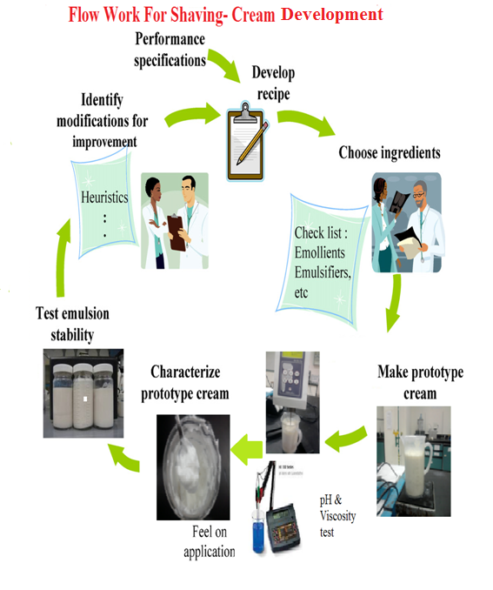
Figure (1): flow work for or shaving cream development. ^{[2]}

- Materials:
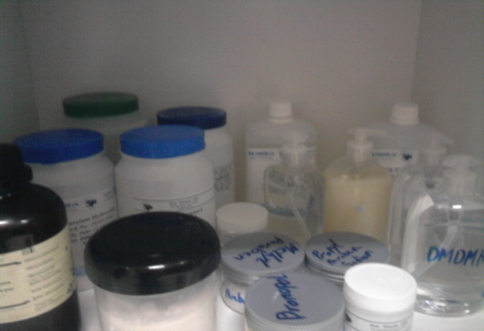
Figure (2): Raw material used in shaving cream production.
Materials that have been used in this semester for experimental work was:
Stearic acid: it was used as surfactant.
Oleic acid: it was used as surfactant.
T.E.A: it was used as base to react with stearic acid and have sponification reaction
Propylene glycol: it was used as humectants.
Lanoline: it was used as lubricants.
DMDM: it was used as preservatives:
Paraffin oil: it was used as lubricants.
Sodium hydroxide: it was used as base.
SLS: it was used as foaming agent.
Sorbitol: it was used as emollient
Methyl prapen: it was used as preservatives.
Tween 20: it was used as emulsifier
Lauramine: it was used as thickener.

- Equipment & Tool:
During the experimental part this tools were used:
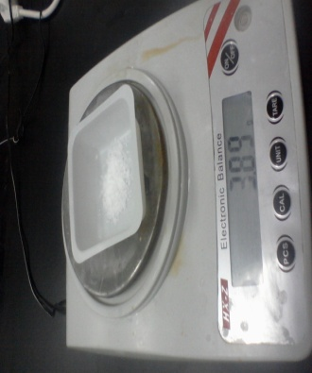 | Electronic balance scale: it's a device used to weight materials in laboratory with accuracy higher than manual weight scale.  It's used to weight the material used in the experiment.
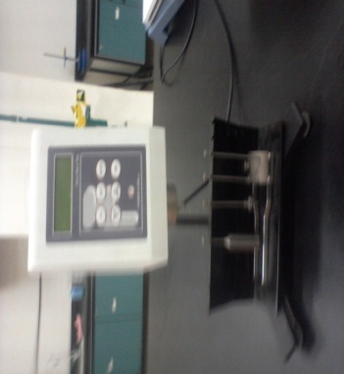 | Viscosity meter: This was used to measure the viscosity of the product.
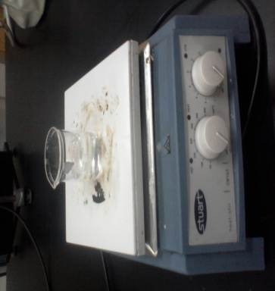 | Hot plate: is often used as an alternative to the Bunsen burner. Some hotplates have a stirring mechanism as part of their design and allows for faster dissolving of some solids by heating and stirring at the same time.  It was used to melt the organic phase, to heat the aqua's phase and to melt stearic acid with T.E.A to make the sponification reaction.
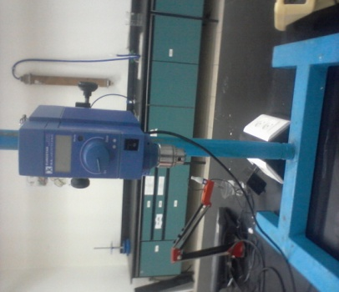 | Mixer: is suitable for the widest range of applications – mixing, emulsifying, homogenizing, disintegrating and dissolving.  It was used to mix all the materials together to have homogenized form.
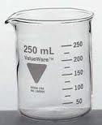 | Beakers: where the materials were melting, heated and mixed, there were three beakers used:  - Beaker to melt the aqua's phase until reached 75 ºC.  - Beaker to melt the organic phase until reached 75 ºC.  - Beaker to heat water.
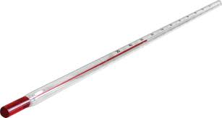 | Thermometer: it's a device used to measure temperature or temperature gradient using a variety of different principles.  It was used to measure the temperature of the phases to insure that’s reached 75 ºC.

- Formulation:
After a lot of experimental work in laboratory and testing the conducted formula. This one had been choose to be used to produce Kalo face shaving cream:
Material | By weight % | Weight | Function
Stearic acid | 13.8 % | 82.8g | Surfactant
T.E.A | 2 % | 12 g | Base
lanoline | 2 % | 12 g | Lubricants
Propylene glycol | 1.4 % | 8.4 g | Humectants
Paraffin oil | 2 % | 12 g | Lubricants
Tween 20 | 2.4 % | 14.4 g | Emulsifier
Lauramine | 1.2 % | 7.2 g | thickener
SLS | 2 % | 12 g | Foaming agent
DMDM | q.s | q.s | preservative
Water | 72.3 % | 434.3 g | Vehicle/Solvent
perfume | q.s | q.s | perfume
Table (1): The Recipe of Kalo face shaving cream:
- Methods:
Manufacturing procedure:
- In a main tank heat water to 75$℃$.
- In separate vessel melt stearic acid, triethanolamine, propylene glycol and tween 20 at 70$℃$ add with mixing to main tank.
- In other tank melt lanoline with paraffin oil and SLS. Add with mixing to main tank, stir until a clear solution is obtained.
- Add preservative mix for 10 min cool and at 35 $℃$ add perfume.

Analytical Test Method:
Table (2): Test method used on Kalo face.
Test | Test methods
Viscosity measuring | Viscosity meter: this device used to know the viscosity of the cream
PH measuring | PH meter, 5-9 (for 10 % solution): to know if the cream Ph in the required rang or not.
Foaming characteristic | By test it on people, to know if it had the desirable foam.
Thicken of the cream | By test it on people, to know if it had enough stick power.
Stability | See if it split after make it (leave it for few days) under normal conditions.

Viscosity meter:
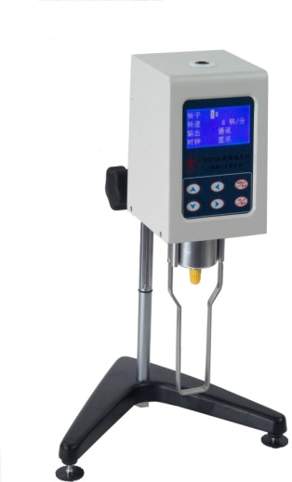

Viscosity meter is used to measure viscosity resistance and absolute viscosity of fluids, including liquid, oil, food, medicines, adhesive, etc.
 | viscosity meter
Display | digital
Rotor speed | 0.3/0.6/1.5/3/6/12/30/60
Speed adjustment | Eight Levels
Rotor | 1,2,3,4,0,(optional)
Measuring range(mPa .s) | 10-2*1000000
Measurement error | 2%

PH meter:
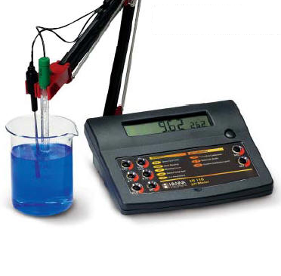
A pH meter is an electronic instrument used for measuring the pH (acidity or alkalinity) of a liquid (though special probes are sometimes used to measure the pH of semi-solid substances). A typical pH meter consists of a special measuring probe (a glass electrode) connected to an electronic meter that measures and displays the pH reading.

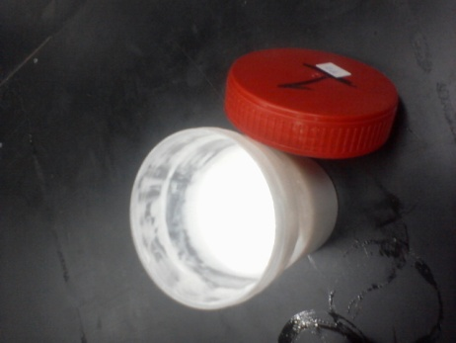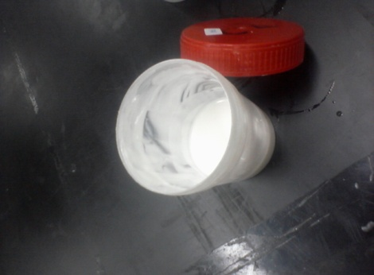
One layer it's stable

Figure (3): Shaving cream for testing its stability.

- Time Schedule:
This schedule had been used to divide the work during this semester, to ensure organizing time and finish on time without delay. The process was done as shown in the figure below:
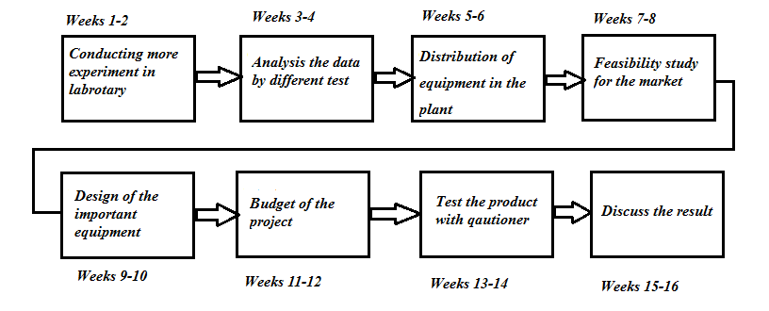
Figure (4): Time schedule for shaving cream production.

- Purchasing:
Table (3): Cost of raw material.
Name of material | Cost (NIS/Kg)
Stearic acid | 10 NIS/Kg
Oleic acid | 13.5 NIS/Kg
T.A.E | 20 NIS/Kg
Propylene glycol | 10.5 NIS/Kg
Lanoline | 20 NIS/Kg
DMDM | 25 NIS/Kg
Parrafine oil | 14 NIS/4 Kg
Sodium hydroxide | 95 NIS/25 Kg
SLS | 15 NIS/Kg
Sorbitol | 8 NIS/Kg
Methyl prapen | 90 NIS/Kg
Tween 20 | 135 NIS/Kg
Lauramine | 10 NIS/Kg

- These material were purchased with small amount to conduct different experiments in the laboratory with cost equal 300 NIS.
- The total budget need to conduct these experiments during this course were 400 NIS including buying the tubes, labels, raw materials.

Design of equipment:
Shaving Cream manufacturing plant consists of the following:
- Wax Melting Vessel

- Water heating Vessel

- Manufacturing vessel

- Storage vessel

- Interconnecting pipeline (electro polished)

- Pumps ( Bump Pump & metering pumps)

- Fully Automatic control panel.

- Working Platform.

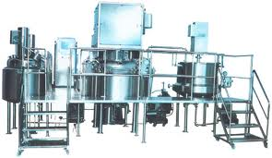
Figure (5): shaving cream manufacturing plant.
Helical ribbon mixers: are generally used in processes where the product is extremely viscous as in shaving cream manufacturing. Helical ribbon mixers are very efficient and are usually utilized in viscosities of > 50,000 centipoises. Helical ribbon impeller is also good for heat transfer and blending of liquids and solids from the surface. Typical processes where helical ribbon mixers are used are toothpaste storage / manufacture, high viscosity adhesives, polymers etc. ^{[3]}
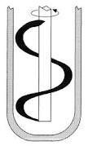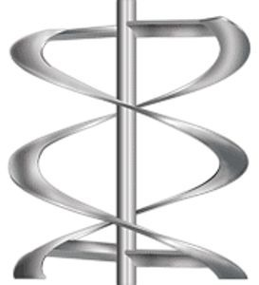
Figure (6): Helical ribbon impellers.

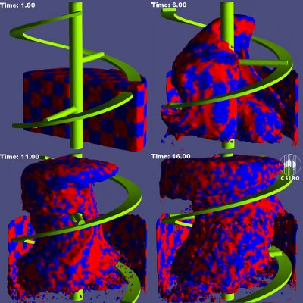
Figure (7): 3D of helical ribbon mixer work. ^{[4]}

Dimension of helical mixer:
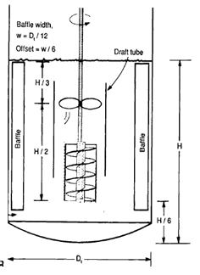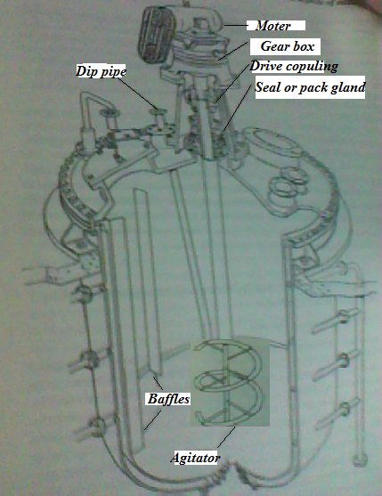
Figure (8): Mixing vessel features. ^{[5]}
Reynolds # = N_{Re} = ND²ρ/µ = 60 *(0.6m) ²*0.9/28727.5*10⁻⁶
= 677 from App.F: figure F.5
The power is 3
N_{p}= Pg/N³*D³* ρ
P=N_{p}*N³D³ ρ/g
P =3*60³*0.6³*0.9/9.8
P = 12.8 KW.
Baffle width= Dt/12 = 0.6/12 = 0.05 m
High of baffle= h/2 = 1.6/2=0.8 m
High of baffle from the bottom = H/6 = 1.6/6 = 0.26 m. ^{[6]}

Design of mixer:
Liquid volume will be 250 L or 0.25 m³.
D = 0.62m

H= 1.6m
V_{L}= (π/4)*D²*H
0.25m³= (π/4)*D²*H
Assume H=2*D
0.25 = (π/4)*D³
D = 0.542 m = 0.6 m
H_{L}=2*0.6 = 1.2m
H_{T}= H+1/3H
H_{T}=1.2+1/3*1.2
H_{T}=1.6m
D_{T}=0.02+0.6=0.62 m.
V_{T}= (π/4)*D³_{T}*H_{T}
V_{T} = (π/4)*0.62³*1.6= 0.399 m³.
Design of tanks (2):
D=0.52 m

H= 1.143 m
Liquid volume will be 125 L or 0.125 m³.
0.125m³= (π/4)*D²*H
Assume H=2*D
0.125 = (π/4)*D³
D=0.43 m = 0.5
H=2*0.43 = 0.86 m.
H_{T}= H+1/3H
H_{T}=0.68+1/3*0.86
H_{T}=1.146 m.
D_{T}=0.02+0.5=0.52 m.
V_{T}= (π/4)*D³_{T}*H_{T} = (π/4)*0.52³*1.143=0.200 m³.

Feasibility study:
Table (4): Statistics for the consumption of shaving cream.
Name of market | Period | Consumption Rate
Al-Nour Al-Jadid Pharmacy | Monthly | 20 Tube
Ibn Sina Pharmacy | Monthly | 15 Tube
Al-Kamal Pharmacy | Monthly | 10 Tube
Swihitan | Monthly | 300 Tube each city in Palestine of OLE Man
Al-Waleed Market | Monthly | 5 Tube
Al-Hasan Pharmacy | Monthly | 6 Tube
Al- Parazely Super Market | Monthly | 10 Tube
Al-Alwal Pharmacy | Monthly | 6 Tube Imported

The date of the survey is insufficient for any feasibility study. But by the help of biggest distribution companies it was found that the Palestinian market sells 500,000 tubes /year. The project is assumed to share 100000 tubes (20%).
It does mean that this project will produce 10 ton/year as estimated below:
100000 (tube) *100 (g/tube) = 10000000 g or ten ton yearly
The capacity of the production line is selected to produce 250kg/charge or batch.
This means that the shaving cream plant must produce 40 charges yearly
Now if we take the batch production time 3.5 hour, it needs to wait for 5-7 days before filling. So two batches can be done per working shift.
In another words the production line can be occupied maximally for one month for shaving cream manufacturing.
For the rest of the year it can be used for other purposes as for production of Face creams, Ointment cream, Toothpaste.

Calculation for capital cost: ^{[6]}
To calculate cost of water Pump:
Package Contents | Pump
Sub Type | Shallow well jet pump
Horsepower (HP) | 1.5
Water Flow (GPM) | 14.5
Warranty | 1 year
Volts | 115 and 230
Material | Cast iron
Capacity of the Pump= 10 L/s.
Cost of pump is 596 $. ^{[7]}
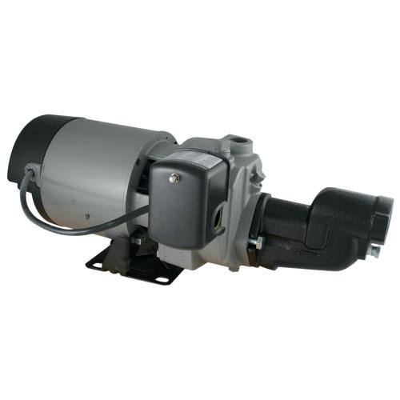

To calculate the cost of vacuum pump:
Capacity of the Pump= 100 L/min.
Its cost about 2000-20000 depends on its capacity, it will be equal 2000 $. ^{[8]}
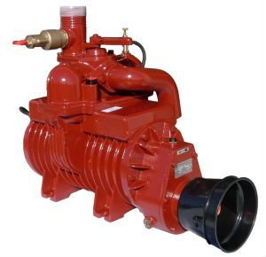
Price: 2000-20000 $.
Specifications
BATTIONI MEC PUMPS are used for
- vacuum trucks;
- gully emptier
- slurry tankers
Air flow: 100 - 13500 l/min (35-480 cfm)

To calculate the cost of mixer (jacketed):
Volume of mixer is 400 L = 0.400 m³.
C_{Mixer} = 14000+15400*(S) ^{0.7}
C_{Mixer} = 14000+15400*(0.400) ^{0.7}
C_{Mixer} = 22108.9 $.
This cost is too high the jacketed mixer can be purchased with 3000 $.
To calculate the cost of two tanks (jacketed):
Volume of mixer is 165 L = 0.165 m³.
C_{Tank} = 14000+15400*(S) ^{0.7}
C_{Tank} = 14000+15400*(0.165) ^{0.7}
C_{Tank} = 18362 $.
This cost is too high the jacketed tank can be purchased with 600 $.
So, for two tanks the cost will be 1200 $.

Cost for filling machine: was found from online industrial sells to be 5000 $. ^{[9]}

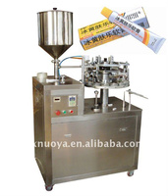

Min. Order: 1 Set
FOB Price: US $5000-30000 / Set
1. Filling and sealing
2. Plastic tubes, aluminum tubes.
3. Volume: 20~200ml 100~500ml
4. Capacity: 40~60 tubes/min.
Type: Filling Machine.

Cost of packaging machine: was found from online industrial sells to be 100000 $. ^{[9]}
Cost of labeling machine: was found from online industrial sells to be 14000 $. ^{[9]}

To calculate the capital cost
$$ISBL=Cost of Mixer+Cost of two Tanks+Cost Of Labeling machine+Cost of Packgaing machine +Pump+vacuum pump+cost of Filling machine$$
$$ISBL=3000+1200+14000+100000+596+2000+5000$$
ISBL= 125796 $.
$$OSBL= 0.4*ISBL$$
$$OSBL= 0.4*125769=50318 \$.$$
$$Cost of engineering= 0.3(OSBL+ISBL)$$
$$Cost of engineering= 0.3\left(50318+125796\right)=52834 \$.$$
$$Cost of contingncy= 0.1(OSBL+ISBL)$$
$$cost of contingncy= 0.1\left(50318+125796\right)=17611 \$.$$

$$Total cost =ISBL+OSBL++cost of conteingncy$$
$$Total cost=125796+50318+17611=193725 \$.$$

Cost of raw material:
Cost of stearic acid = cost *mass flow rate*0.93*20 day
Cost of stearic acid = 10*34.5 Kg/day *0.93*20 day= 6417NIS=2139 $.
Cost of T.E.A = 20*2.5 Kg/day*0.93*20 day= 930 NIS=310 $.
Cost of propylene glycol= 10.5*3.5 Kg/day*0.93*20 day = 683.55 NIS= 227.85 $.
Cost of lanoline = 20*5.7 Kg *0.93/day*20 day =2120 NIS= 706 $.
Cost of DMDM= 25*0.5 Kg/day*0.93*20 day =232.5 NIS =77.5 $.
Cost of paraffin oil= 14*5.6 Kg/day*0.93*20 day =1458 NIS= 486 $.
Cost of tween 20= 135*6 Kg/day*0.93*20 day= 7533 NIS= 2511 $.
Cost of lauramine =10*3 Kg/day*0.93*20 day= 558 NIS= 186 $.
Cost of SLS =15*3 Kg/day*0.93*20 day= 1679 NIS= 558 $.

Total cost of material = Cost of stearic acid + Cost of stearic acid + Cost of T.E.A +Cost of propylene glycol + Cost of lanoline + Cost of DMDM+Cost of paraffin oil+
Cost of tween 20 + Cost of lauiramide
Total cost of material= 9497$.
Cost of utilities:
Cost of cooling water
$$Cost of water=cost*20 day*0.93*flowrate \frac{Kg}{day}$$
$Cost of water=\frac{0.03491NIS}{Kg}*365*0.93*181 \frac{Kg}{day}$= 147 NIS/year = 49 $.
Cost of electricity
$$Cost ofelectricity =cost*20 day*0.93*(Total power kw)$$
$$Cost ofelectricity =0.58*20*0.93*\left(50 \right)=539 NIS=179 \$.$$
$Total cost of utilites=Cost water+Cost of electricity$
$$Total cost of utilites=49+179=228 \$.$$
Total variable cost
$$Cost of variable =Cost of raw material+Cost of utilites$$
$$Cost of variable =9497+228=9725 \$.$$

Estimation of labor requirements:
To calculate the operating labor
$Operating laber=labor No.*working day* 0.93*shaft*cost \$$
$$Operating laber=4*200* 0.93*2*40 \$=59520 \frac{\$}{year}$$
To calculate supervision
$$cost of supervision= 0.25*(Operating)$$
$$cost of supervision= 0.25*59520=14880 \$.$$
To calculate direct salary over head
$$cost Direct salary over head= 0.5*(Operating+supervision)$$
$$cost Direct salary over head= 0.5*\left(59520+14880\right)=74400 \$.$$

To calculate maintenance
$cost maintenace= 0.04*(ISBL)$
$$cost maintenace= 0.04*125796=5032 \$/year$$
To calculate fixed cost
$$Total fixed co=Cost Operating+cost Supervision+cost Direct selarey+cost maintenace$$
$$Total fixed cost=59520+14880+74400+5032=153832 \$/year$$
Cost of total production
$$total cost of production=Fixed+variable$$
$$total cost of production=9725+153832=163557 \$/year$$

Revenues
$revenues =No.producted tube*0.93*20*cost$
$revenues =100000 tube *2 \$=200000 \$$/month.
Gross profit
$$Gross profit=Rrevenues-the product cost$$
$$Gross profit=200000-163557=36443 \$/year$$
Taxis
$$Taxis=0 .145*Gross profit$$
$$Taxis=0 .145*36443= 5284.2 \$/year$$
Net profit
$$Net profit=0 .855*Gross profit$$
$$Net profit=0 .855*36443=32000 \$/year$$

Experimental work:
In last semester two pre-experiments are carried out to ensure the possibility of producing shaving cream.
The next first experiment is done on the base of recipe found in literature. ^{[10]}
Experiment # 1:
Table (5): The ingredients of first experiment used to produce shaving cream in first semester.
Ingredient | Weight g | Function
Stearic Acid | 30 g | Surfactant
Coco Fatty Acid | 3.5g | Surfactant
T.A.E | 19.1g | Base and Emulsifier
Propylene Glycol | 9.4g | Humectants
Glycerin | 10g | Humectants
Lanolin | 5g | Lubricant
SLS (30%) | 12.5g | Foaming agent
Sorbitol 70% | 9.4g | Emollients
Water Q.S. to | 500 L | Vehicle
Fragrance | Q.S | Perfume
MACKSTAT DM | Q.S.
pH: 8.4-8.6

Procedures:

1. In main tank heat water, add TEA, Propylene Glycol, Sorbitol, then heat to 75$℃$.
2. In separate vessel Stearic Acid, Coco Fatty Acid and Lanolin to 70 $℃$ were heated then added with mixing to main tank.
3. Mackamide C was adding. Mixing for 20 minutes was achieved and cooled at 35$℃$. After that remainder materials were add.

Experiment # 2:
Table (6): The ingredients of the second recipe are:
Ingredient | Weight | Function
Stearic Acid | 15 g | Emulsifier
Oleic Acid | 3 g | Surfactant
KOH solution | (3 g KOH+ 10ml H₂O) | Base
Sorbitol | 2 g | Emollient
Lauramine | 4 g | Thickener
Propylene glycol | 3 g | Humectants
Sodium Chloride | 1 g | Thickener
Hot water | 6 ml | Aqua's phase
SLS | 3 g | Foaming agent
Glycerin | 2 g | Humectants

Procedure:
- In main tank , add 15 g of Stearic Acid ,3 g Oleic Acid and KOH solution (KOH 3 g, H₂O 10 ml) ,then heated to 70$℃.$
- In separate vessel 3 g SLS, 1 g NaCl and 6 ml hot water had been weight and melted and was added with mixing to main tank.
- 3 gr of Propylene Glycol, 2 g Glycerin, 2 g Sorbitol and 4 g Lauramide was added with continuous mixing until it had starchy shape.
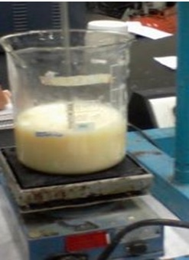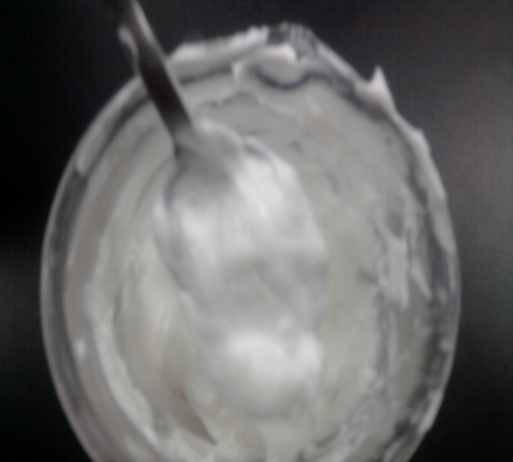
Figure (9): Exp.1 didn't have the required Figure (10):Exp.2 it was good in its characteristic. Performance.

In this semester more experiments had been carried out to develop the best formula to produce Kalo face, this was by conducting the experiment and test it to see the response then analysis the result in order to improve the formula, this where the experiment that carry out :
First experiment:
Table (7): The first experiment raw material used for production of 100 ml shaving cream:
Material | Weight | Function
Stearic acid | 13.8 g | Surfactant
T.E.A | 2.5 g | Base
Lanoline | 2.28 g | Lubricants
Propylene glycol | 1.4 g | Humectants
Paraffin oil | 2.24 g | Lubricants
C 12 | 1.2 g | Emulsifier
DMDM | a.q | preservative
Water | 72.4 g | Vehicle
Perfume | a.q | Perfume
PH | 6.5
Viscosity(mPa.s) | 20000

Procedure:
- In a main tank heat water to 75$℃$.
- In separate vessel melt stearic acid, T.E.A to 70$℃$ and ethoxy ether. Add with mixing to main tank.
- In other tank melt lanoline with paraffin oil. Add with mixing to main tank, stir until a clear solution is obtained.
- Add preservative.mix for 10 min cool and at 35 $℃$ add perfume.

Table (8): The experiment done on same recipe but at different percentage of raw material:
Material | Weight (100 ml) | Weight  (100 ml) | Weight (600 ml) | Function
Stearic acid | 13.8g | 13.8 g | 82.8g | Surfactant
T.E.A | 2.5 g | 2 g | 12 g | Base
Lanoline | 2.28 g | 2 g | 12 g | Lubricants
Propylene glycol | 1.4 g | 1.4 g | 8.4 g | Humectants
Paraffin oil | 2.24 g | 2 g | 12 g | Lubricants
Tween 20 | 2.4 g | 2.4 g | 14.4 g | Emulsifier
Lauramine | 0.8ml | 1.2 ml | 7.2 ml | thickener
SLS | 1.2 g | 2 g | 12 g | Foaming agent
DMDM | a.q | a.q | a.q | preservative
PH | 6.2 | 6.19 | 6.85
Viscosity(mPa.s) | 37455 | 37000 | 39000

Procedure:
- In a main tank heat water to 75$℃$.
- In separate vessel melt stearic acid, T.E.A to 70$℃$ and tween 20. Add with mixing to main tank.
- In other tank melt lanoline with paraffin oil, propylene glycol and SLS. Add with mixing to main tank, stir until a clear solution is obtained.
- Add preservative.mix for 10 min cool and at 35 $℃$ add perfume.

Result:
The size of tanks and their mixers are shown in table (9).
Table (9): Dimension of mixer and tanks result.
Mixer factors | Dimension
High of mixer | 1.6 m
Diameter of mixer | 0.62 m
Volume of mixer | 400 L
Two tanks factor | Dimension
High of tanks | 1.146 m
Diameter of tanks | 0.52 m
Volume of tanks | 200 L

The next figure show the main units used in shaving cream manufacturing plant.
Figure .11 is a block diagram of shaving cream mfg unit.
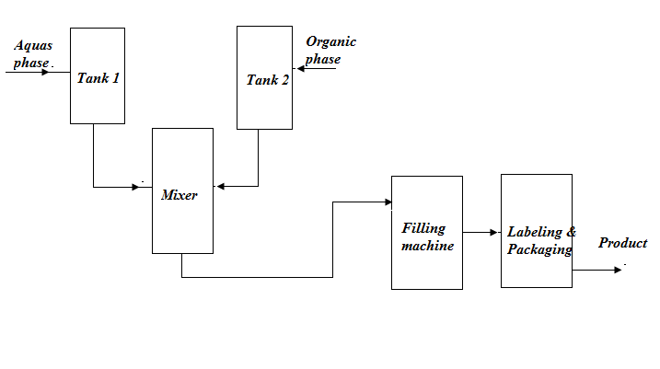
Figure (11): Block diagram for shaving cream plant.
While figure.12 represents the process flow chart. The top view of mfg units are presented in figure.13.
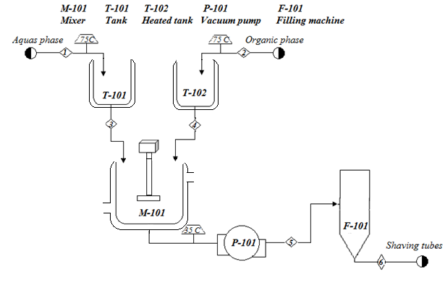
Figure (12): Process flow diagram for shaving cream plant.
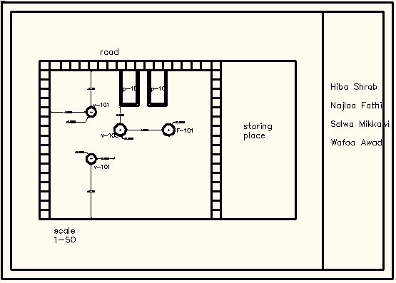
Figure (13): Layout of the shaving cream plant (top view).
Table (10): Cost of equipment data.
Equipment | Cost $
Pump | 596 $
Vacuum pump | 2000 $
Jacketed mixer | 3000 $
Two jacketed tanks | 1200 $
Filling machine | 5000 $
Labeling machine | 14000 $
Packaging machine | 100000 $

Table (11): Cash cost of production.
 | Cost of Product $
Total Variable Cost | 9275$
Total fixed cost | 59520$
cost of Production | 74400$

Table (12): Projects revenues.
 | $/year
Revenue | 200000

Table (13): Project profit.
 | $/year
Cross profit | 36443
Net profit | 32000

Experimental design: technique is a powerful tool to minimize the number of experiments to have optimal measurement conditions. The selected method is screening design experiment: ^{[11]}
K= $\frac{N-1}{L-1}$
= $\frac{4-1}{2-1}$ = 3 factors are required.
- The factor that had been taken in consideration are:
- A: Steraic acid.
- B: Triethanolamine.
- C: SLS.
For 100 Kg sample:
Table (14): List of process parameters and their levels.
Material | High level (+1) | Low level (-1)
Stearic acid | 14.5 g | 13.2 g
Triethanolamine | 1.5 g | 0.5 g
SLS | 1.3 g | 1.15 g

Table (15): Design matrix for a 4 run geometric P-B design.
Trial | A | B | C | pH | Visco.(m Pa)
1 | -1 | +1 | +1 | 5.99 | 1030
2 | +1 | -1 | +1 | 6.43 | 1915
3 | +1 | +1 | -1 | 6.09 | 2800
4 | -1 | -1 | -1 | 6.20 | 592

Table (16): Experimental data for work.
Material | Exp.1 | Exp.2 | Exp.3 | Exp.4
Stearic acid | 13.2 | 14.5 | 14.5 | 13.2
Triethanolamine | 1.5 | 0.5 | 0.5 | 1.5
Lanoline | 2.28 | 2.28 | 2.28 | 2.28
Propylene glycol | 1.4 | 1.4 | 1.4 | 1.4
Parrafine oil | 2.24 | 2.24 | 2.24 | 2.24
Tween 20 | 2.4 | 2.4 | 2.4 | 2.4
Lauriamide | 0.8 | 0.8 | 0.8 | 0.8
SLS | 1.3 | 1.3 | 1.15 | 1.15
DMDM | a.q | a.q | a.q | a.q
Water | 72.5 | 72.5 | 72.5 | 72.5
Perfume | a.q | a.q | a.q | a.q

Accumulation | %Effect | Effect (visc.) | Factor
70.7 | 70.7 | 2138.5 | A
92.5 | 21.8 | 661.5 | B
99.89 | 7.39 | 223.5 | C
3023.5 |  |  | Sum
Table (17): Calculation to draw pareto diagram for viscosity response.

Figure (14): Pareto diagram for viscosity result.

Table (18): Interaction table for viscosity.
A | B | Viscosity
-1 | +1 | 1030
-1 | -1 | 592
1 | -1 | 1915
1 | +1 | 2800

This figure. 15 show that there is interaction between A & B because they are not parallel:

Figure (15): Interaction between A & B for viscosity response.
Viscosity is maximum when A kept at high level and B kept at high level. Viscosity is minimum when A kept at low level and B at low level.

Table (19): Calculation to draw pareto diagram for pH response.
Factor | Effect (pH) | % Effect | Accumulation
B | 0.275 | 54.45 | 54045
A | 0.165 | 32.67 | 87.12
C | 0.065 | 11.1 | 98.22
Sum | 0.505

Figure (16): Pareto diagram for pH result.
Table (20): interaction table of A & B.
A | B | pH
-1 | +1 | 5.99
-1 | -1 | 6.20
+1 | -1 | 6.43
+1 | +1 | 6.09

This figure. 17 show that there is interaction between A & B because they are not parallel:

Figure (17): Interaction between A & B for PH response.
pH is maximum when A kept at low level and B kept at high level. pH is minimum when A kept at high level and B at low level.
Investigation of the questioner on shaving cream:

Figure (18): Final result taken from the questioners.

It was carried out a survey or questioner on Kalo face shaving cream. The questioner is written in Arabic language. The results of the survey are given in figure. [19].
The weak point of Kalo face shaving cream is the foaming and about 36% of questioned people accept its foaming. The other properties are satisfactory and sometimes are excellent. The recommendation is to increase the foaming agents.

These shown the response of people on some of shaving cream performance characteristic:

Figure (19): Result for Kalo face questioner.

Discussion:
During the last 3 months a lot of experiments had been carried out in order to have shaving cream with good characteristics. The first experiment had been taken from the literature with replacement of some material to improve it. The pH & viscosity had been measured and it's foaming, stick power, smell and other factor had been tested in order to determine its quality. The problem is its weak foaming and its weak stick power had been noted. In the second experiment lauramide and tween 20 had been added to recipe to solve the problem and the amount of foaming agent SLS had been increased as well.the proper changes and modifications are committed but it still needs more improvement particularly in foaming, so that three more experiment had been carried out in order to improve the foaming performance by increasing the foaming agent percentage and trying to make the sponification reaction done completely. Finally 600 mL experiment had been produced taking to consideration the notes of customers. A questioner had been prepared and distributed to the public to find out their opinion about it, the result had been shown that the Kalo face had an excellent smell, excellent appearance, strong adhesion and moderate foaming performance and the percentage had been shown previously in figure (16). The low foaming performance may relate to a problem in sponification reaction or foaming agent. So an improvement can be achieved by adding coconut fatty acid to the sponification reaction with (stearic acid and T.E.A) to ensure that the reaction will be completed and the foam will increase.
There are many factors effect on the shaving cream performance and these factors are the composition of the cream itself where any change in the percentage of this composition can cause a change in its performances. So that to identify the main factor effects on the shaving cream a screening design had been carried out, as shown above it had been found from pareto diagram that stearic acid and T.E.A are all the main factors effect on the shaving cream characteristic (where pH& viscosity had been measured). Stearic acid was found to be the effective factor on viscosity. The T.E.A affects the pH and if it's increased the pH of shaving cream will be increased as well.
The budget required for establish this project had been calculated and the revenue and profit expected for it had been estimated. It was found that the project is profitable. The production line must be used for different uses.

Summary & Conclusion:
As a summary of this project the following is concluded:
- The new recipe had been received an acceptance form public and it has an issue in the foaming performance only, wanted to be more.
- The capital cost of the investment was estimated to be 193725 $.
- The revenue expected from the project was 200000 $/year.
- The total cost of production was found to be 74400 $/year.
- Net profit for the project 32000 $.

Recommendations & Future planes:
- Improving the kalo face foaming performance by adding coconut fatty acid.
- Produce other type of shaving cream such as gel shaving cream or foam shaving cream.
- The manufacturing plant which was designed it can be used for other purposes such as production of toothpaste, face cream, ointment cream.

References:
- Ralph G. Harry, Martin M. Rieger, Harry's Cosmeticology 8^{ed}, np, Martin M. Rieger Chemical Pub. Co., 2000, page no. 966.
- http:// www.sciencedirect/com. Accesses on 25.2.2012.
- http://www.directindustry.com/prod/chemineer/agitator-impellers-helical-ribbon-axial-flow.hmtl. Accesses on 25.4.2012.
- Martin Robinson and Paul Cleary, (2012). Flow and Mixing Performance in Helical Ribbon Mixers. AIChE Journal, in review.
- N Harny, M F Edwards, A W Nienow (1997). Mixing in the process industries. 2^{ed}, Britain, p.414.
- Coulson & Richardson’s, Chemical Engineering, Volume 6, Fourth Edition, Chemical Engineering Design R. K. Sinnott.
- http://www.lowes.com/webap/Pump. Accesses on 1.5.2012.
- www.alibaba.com/member/vacuum-pump.html. Accesses on 23.4.2012
- http://www.alibaba.com/showroom/tube-filling-machine.html. Accesses on 23.4.2012.
- Ernest W,Flick, cosmetic and roilery formulation 2^{ed} ,np, USA,1992.
- Jiju Antony (2003). Design of Experiment for Engineers & Scientists, np, Elsevier Science & Technology Books. P.152.
- http://www.bhavigroup.com/shavingcream.htm. Accesses on 23.3.2012

Appendices:
Appendices A: Typical Shaving cream manufacturing (mfg) plant:
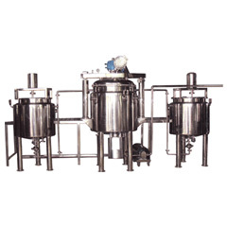
Figure A. (1): Othe model of shaving cream manfucturing plant.

Shaving cream mfg plants are similar to cream mfg plants. Only difference is the speed of the agitators and agitator design in the mfg vessel changes. Best suited mixer for shaving creams is the planetary mixers under vacuum with variable speed drives water and wax vessels, storage vessel, interconnecting pipelines; panel platforms form the accessories of the shaving cream plant.
This type of machine is available with different capacities (5 Kg to Kg/ batch). ^{[12]}

- Description of some equipment that can used in shaving cream plant:

Inline Homogenizer

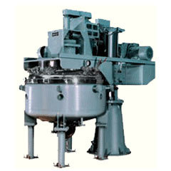
Figure A. (2): Inline Homogenizer.

In Inline agitation system, the possibility of materials –liquid or solid passing through it, without subjected to intense hydraulic and mechanical shear actions is zero. Here suction pipe (inlet pipe) is centrally mounted & outlet is radically mounted, therefore it is physically impossible for any material to pass from inlet to outlet without exposed to agitation.
The stator which surrounds rotor is available with various type of opening i.e. round, square, rectangular & with perforation also so that all the critical demand of mixing, Emulsifying, disintegration & dispersion of solids, suspension can be met out by same equipment.
The machine is versatile & has completely revolutionized the traditional mixing techniques. Here close tolerance of rotor with the stator produces high hydraulic shearing & mechanical action that ensures that material entrapped between rotor & stator is subjected to tremendous shearing actions each minute.
This type of machine is available with different capacities (1 Hp models to 50 Hp). ^{[12]}

Planetary Mixers

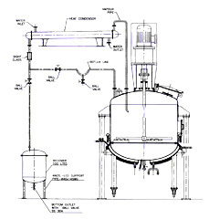
Figure A. (3): Planetary Mixer.

It consists of 2 beater agitators which move in planetary motion hence giving 3 dimensional mixing to the material in the bowl. There is also a scraper blade. There is also a high speed homogenizer through a hollow shaft with an independent drive system. The beater and scraper rotate with help of motor and gear box and the planetary motion is provided by another set of gears fitted in the machine. The bowl is jacketed with either steam or electric jacket. It is provided with suitable locking system which is removable type. Top assembly consists of a top dish with gasket, Gear system coupled with suitable gear box and motor. High speed homogenizer through hollow shaft Suitable hydraulic lifting system is given for top lid lifting and lowering. Mechanical seals provided for both main and homogenizer agitators. Contact parts are of S.S. 316 or S.S. 304 as per clients requirements and non contact parts are gladded with S.S. 304 in case of GMP model and painted in case of NON GMP model.
This type of machine is available with different capacities (5 litter’s models to 2500 litters). ^{[12]}

Tube Filling Machine
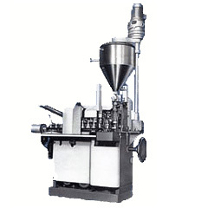
Figure A. (4): Tube filling machine.

Important Special Features:
1) Capability to handle a large range of tube sizes
2) Automatic cap tightening
3) No-tube-no-fill device
4) Automatic tube in feed
5) Adjustable filling pump and several optional attachments.
6) Can handle tube diameters from 10 mm to 40 mm and lengths from 40 mm to 200 mm. ~ Automatic tube in feed with cassette loader.
7) Simultaneous accessibility of many tube holders in case of manual in feed.
8) Tube cleaning device for dust removal (particularly required for pharmaceutical and~ food products}
9) Adjustable filling pump with different volumes.
Specification:
1.Output, tubes per hour depending upon tube size and product.
2. Attendance 1 operator Power consumption 1 KW Floor space occupied 1.2 x 0.7 m.
3.Height, including paste container 1.7 m; (5' - 7").
4. Height, excluding paste container 1.1 m. (3').
5. Net weight 550 kg (1200 Ibs).
6. Gross weight 750 kg (1650 Ibs).
7. Shipping volume 3m³ (100 cu.ft). ^{[12]}

Boiling Kettles
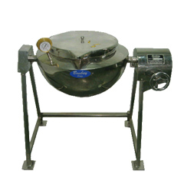
Figure A. (5): Boiling kettles.
“Bombay” Starch Paste Kettle will be made out of S.S. 304 rectangular pipes of 3 mm thick and will be an independent resting type frame work where no foundation will be required. The Kettle will be a hemispherical type bowl with either steam / oil / water heating jacket will be proved. The Kettle will be manufactured from 2.5 mm thick S.S. 304 sheet and the jacket will be of 2.5 mm mild steel (In case of steam jacket the thickness will be 4 mm). There will be oil / water heated fitted at the back bottom side of the Kettle. The Kettle will be having a worm type arrangement for tilting. A temperature controller and a temperature indicator will be provided for temperature control and indication. The Kettle will be insulated with 50 mm thick glass wool insulation and gladded With 16 Swg S.S. 304 sheet. Kettle will be buffed to 150 grit matt finishes externally and internally the Kettle will be buffed to 220 grit mirror finish.
This type of machine is available with different capacities from (10 litters to 2000 litters capacity).
Functions:
Basically this unit is used for preparation of starch paste. Hemispherical shape ensures that the heating of the starch paste is uniform and gets more surface area. The tilting type arrangement ensures ease in unloading the paste into any container or vessel. The starch is put in the Kettle and water is added till desired thickness is achieved. The Kettle is jacketed and is heated till the starch melts and a thick paste is achieved. This paste can be agitated either manually or with the help of an anchor type agitator which will constantly stir the paste so that there will no lumps formation and proper mixing is achieved.
Temperature can be set to desired temp by adjusting the thermostat provided and the temperature can be seen in the dial Thermometer provided. ^{[12]}

Vessels & Tanks

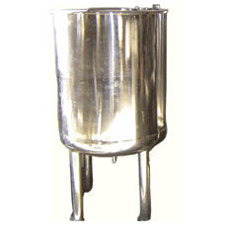
Figure A. (6): Vessels & Tanks.

Vessels and tanks are manufactured as per client's requirements and space available for installations. Tanks and vessels are available in various designs and options such as
• Plain storage tanks with loose top lid & either flat of dished bottom.
• Manufacturing vessels with agitators.
• Reactors.
• Vessels under vacuum / without vacuums.
• Jacketed vessels and tanks.
• Vessels and tanks with limped coils etc.
• Horizontal, capsule shaped, etc tanks available.
Vessels and tanks are available from 50 litters to 100000 litters in any shape and size as per client's requirements. ^{[12]}

Appendix B: Commercially Available Shaving Cream Formulas:
Import products:
- Palmolive
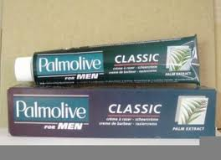

Figure B. (1): Palmolive shaving cream.
Ingredient:

- Aqua, Stearic Acid, Glycerin Acid, Cocos Lucifer Oil, Sodium Silicate, Cocos Nucifera Extract Hydroxysohexyl 3- Cyclohexene Carboxaldehyde.
Marketing information:
Size: 100 ml.
Price: 13 NIS.
Produced by: Colgate_ Palmolive.

- Nivea
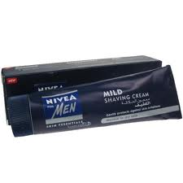
Figure B. (2): Nivea shaving cream.
Ingredients:
- Aqua, Potassium Stearate, Potassium Cocoate, Glycerin, Olea Europaea, Parfume, Dimethicone, Maris sal, Tocopheryl Acetate.,Sodium cocoate, Cetearyl Alcohol, Limonene.

Marketing information:
Size: 100 ml.
Price: 12 NIS.
Produced by: company Beiersdorf_ Nivae.

- ARKO

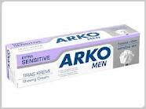
Figure B. (3): ARKO shaving cream.
Ingredients:
- Aqua, Stearic acid, Cocount acid , Potassium hydroxide, Parfume, Propylene glycol, Potassium cocoate , Glycerin, Allantoin , Tocopheryl acetate , Cetearyl alcohol, Sodium hydroxide , Hydroxyl-methylpentylcyclohexenecarboxaldehyde , Linalool, Limonene, Sodium silicate, Sodium borate, Sodium pcA , Potassium chloride, Methylparaben , Butylphenyl mthyl propional , Coumarin, Evernia furucea (treemoss) extract
Marketing Information:
Size: 100g = 94 ml.
Price: 5 NIS.
Produced by: Aviab _Turkey company.

- Gillette
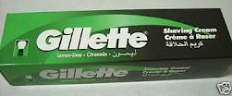
Figure B. (4): Gillette shaving cream.
Ingredients:
- Aqua, Palmitic Acid, Triethanolamine, Isopentane, Glycerylolesta, Stearic Acid, Isobutane, Sorbitol, Parfum, Hydroxyethylcellubse, PTEE, Benzyl salicylate, Limonene, PEG-90M PEG-23M, Propylene glycol, Glycerin, Linalool, Sodium Nitate.
Marketing Information:
Size: 100 ml.
Price: 14 NIS.
Produced by: The Gillette Company.

Palestinian products:
- Ole Man

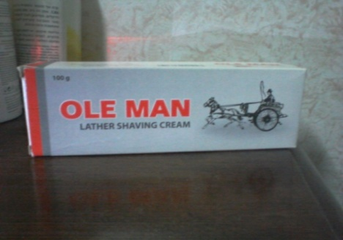

Figure B. (5): Ole Man shaving cream.

Ingredients:

- Stearic acid, Glycerin, Cocount oil, Potassium hydroxide, Blue water, Sodium hydroxide, Cetostearyl alcohol, Sodium trisilicate powder, Boric acid, Purified water.
Marketing information:
Size: 140 ml.
Price: 8 NIS.
Produced by: Jordanian Factory in Bet Jala.

- Man
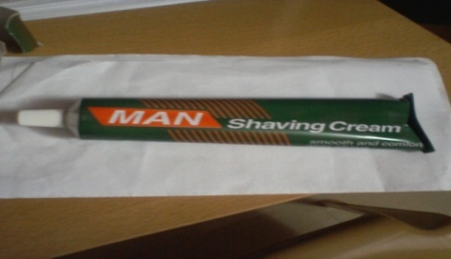
Figure B. (6): Man shaving cream.
Ingredients:
- Aqua, Stearic acid, Cocount fatty acid, Sorbitol, Potassium hydroxide, Glycerine, Sodium laureth sulphate, Fatty alcohol, Ethersulfates, Sodium hydroxide, Perfume, Cetylalcohol, Borax.

Marketing Information:
Size: 120 ml.
Price: 7 NIS.
Produced by: Al-Quads For Medical Product.

- Fresh
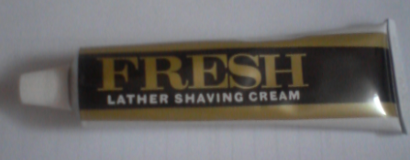
Figure B. (7): fresh shaving cream.
Ingredients:
- Aqua, Stearic acid, Cocount fatty acid, Sorbitol, Potassium hydroxide, Glycerine, Sodium hydroxide, Cetyl alcohol, Perfume, Silicone oil, Boric acid.

Marketing Information:
Size: 100 ml.
Price: 7 NIS.
Produced by: Al-Quads For Medical Product.

Appendix C: Static about the new product Kalo Face:


An –Najah National University
Chemical Engineering Department
استبانه لمشروع تخرج حول معجون حلاقة
Kalo Face
هذه استبانه معده لمعرفة رأي الزبائن بفعالية معجون الحلاقة الجديد بميزة القدرة على شفء الجروح ,يرجى المساعدة في تقييمه بعد تجربة العينة المرفقة,ولكم جزيل الشكر :-
العمر :
16-20 20-30 فوق 30
المستوى التعليمي :
بدون ابتدائي ثانوي جامعي دراسات عليا
الأسئلة :
1.تقوم بحلاقة وجهك كل : يوم يوم بعد يوم اسبوع اسبوعين
2.تشتري معجون الحلاقة المصنع : محليا إسرائيلي أجنبي
3.تستخدم اي نوع من مستحصرات الحلاقة: المعجون الرغوة الجل
4.هل تهتم بالشكل الخارجي للعبوه: نعم لا
5.كم سعر العلبة التي تستخدمها :

المنتج الجديدkalo Face :
1. مظهر معجون الحلاقة : ممتاز جيد مقبول سيء
2. رائحة معجون الحلاقة: ممتازة جيدة مقبولة سيئة
3.رغوة معجون الحلاقة : مناسبة معتدلة غير مناسبة
4.ثبات معجون الحلاقة على الوجه : قوي متوسط ضعيف ضعيف جدا
5. هل يسبب معجون الحلاقة تهيج للبشرة :
نعم لا
6.ملمس البشرة بعد الحلاقة : ناعم خشن
7. شفاء الجروح: ممتاز جيد عادي

ملاحظات تود بإضافتها :

شكرا على تعاونكم

Appendix D: Standard Specification of Shaving Cream:

Table D. (1): Shaving cream specification /standard according to PSI- 2005.
SHAVING CREAM SPECIFICATIONS /STANDARDS WITH TYPICAL VALUES
(As per PIS :MF 632 -6-2005)
Shaving Cream type | Lather
Total Fatty substance, percent by mass (Min) | 40
Water content, percent by mass (Max) | 45
Solid material doesn't dissolved in water, percent by mass (Max) | 0.5
pH number | 5-9
Total Fatty substance doesn’t sponefication, percent by mass (Max) | 7
Free caustic alkali | Nill
Solid material doesn't dissolved in alcohol, percent by mass (Max) | 1
Neutral Oils undissolved, percent by mass (Max) | 3

Appendix E: Shaving Cream Formula & It Manufacture Procedure:
Table E. (1): shaving cream ingredient.
INGREDIENTS | QUANTITY
Stearic acid | 29.5 Grams
Lauric acid | 6 Grams
Myrietic acid | 2 Grams
Oleic acid | 0.5 Gram
50% Potassium Hydorxide(KOH) | 1.5 Gram
Glycerol | 1.5 Gram
70% Sorbitol | 2 Grams
Lanolin | 1 Gram
Triethenol amine | 2 Grams
Methyl paraben | 0.18 Gram
Propyl paraben | 0.02 Gram
Perfume | In Sufficient Quantity
Water | Quantity Sufficient to Make 100 Grams

Table E. (2): shaving cream ingredient.
INGREDIENTS | QUANTITY
Stearic acid | 36.5 Grams
Coconut oil | 8.5 Grams
Potassium hydroxide | 8 Grams
Sodium hydroxide | 1 Grams
70% Sorbitol | 3 Grams
Mineral oil | 2 Grams
Menthol | 0.1 Gram
Sodium suphite | 0.1 Grams
Methyl paraben | 0.18 Grams
Propyl paraben | 0.02 Grams
Perfume | In sufficient quantity
Water | Sufficient to make 100 gms

AEROSOL SHAVE CREAM
Table E. (3): aerosol shaving cream ingredient.
RAW MATERIALS | % By Weight
Concentrate:
Oil Phase:
GLUCAM E-20 Distearate | 5.0
Stripped Coconut Fatty Acids | 2.0
Stearic Acid, xxx | 5.5
AMERLATE LFA | 0.8
Lauramide DEA | 0.5
Water Phase:
Carbomer 941 (3% aqueous) | 3.0
Deionized Water | 79.6
Triethanolamine (99%) | 3.6
Perfume and Preservative | q.s

Procedure:
- Heat oil to 70C.
- Heat water phase minus the triethanolamine to 70C.
- Add water to oil at 70C and immediately add the triethanolamine.
- Cool while mixing to 35C and add the perfume.
- Fill: 97% Concentrate: 3% Propellant A-46

Description:
Highly emollient aerosol shave cream. GLUCAM E-20 Distearate gives excellent spreading properties while imparting slip and lubricity to improve razor glide. The triethanolamine soap of AMERLATE LFA is a powerful emulsifier for the propellants and gives long-term stability to the aerosol pack.
SOURCE: Amerchol Corp.: GLUCAM E-20: Formula T51-114-1A

AEROSOL SHAVE CREAM

Table E. (4): aerosol shaving cream ingredient.
RAW MATERIALS | % By Weight
Concentrate Phase:
GLUCQUAT 1 00 | 2.00
SOLULAN 25 | 1.50
SOLULAN 5 | 0.50
Stearic Acid, xxx | 5.00
Triethanolamine (99%) | 2.62
Deionized water | 88.38
Perfume and preservative | q.s.

Description:

This aerosol shave cream has a rich, lathery foam with good spreadability. GLUCQUAT 100 provides lasting conditioning effects such as emolliency and moisturization. SOLULAN 5 (w/o) and SOLULAN 25 (o/w) help to stabilize the aerosol foam.

SOURCE: Amerchol Corp.: GLUCQUAT 100: Formula T62-166-3.

AEROSOL SHAVE CREAM

Table E. (5): aerosol shaving cream ingredient.
RAW MATERIALS | % By Weight
Phase A:
Pristerene | 4904 6.00
Prifac 5901 | 1 .00
Tween 20 | 1 .00
Estol 152 | 6 1 .00
Phase B:
Deionized Water | 76.40
Pricerine 9083 | 3.00
Witcolate SL-1 | 5.00
Triethanolamine 99% | 4.00
Potassium Hydroxide 85% | 0.50
DERMACRYL-79 | 1 .00
Phase C:
Germaben IIE | 1 .00
Phase D:
Fragrance | 0.10

Procedure:

- In main tank heat water, add TEA, Propylene Glycol, Glycerin ,sorbitol ,heat to 75 $℃$.
- In separate vessel melt Stearic Acid, Coco Fatty Acid, Lano-lin to 70$℃$, add with mixing to main tank.
- Add Mackamide C. Mix 20 minutes cool and at 35 $°$C. add remainder.

SOURCE: McIntyre Group Ltd.: Personal Care Formulary: Formulas Sorbitol, heat to 75 $°$C.

SHAVING CREME #2

Table E. (6): saving cream #2 ingredient.
RAW MATERIALS | By weight%
Stearic Acid | 6.0
Coco Fatty Acid | 0.70
Triethanolamine | 3.82
Propylene Glycol | 1.88
Glycerin | 2.0
MACKAMIDE C | 1.0
Sodium Lauryl Sulfate (30%) | 2.5
Sorbitol 70% | 1.88
Water Q.S. to | 100.0
Fragrance | Q.S
MACKSTAT DM | Q.S.
pH: 8.4-8.6
Fill Ration: Isobutane: 3.47-3.5
Concentrate:. 96 , 5.

Procedures:

1. In main tank heat water, add TEA, Propylene Glycol, Glycerin, Sorbitol, heat to 75 degrees C.
2. In separate vessel melt Stearic Acid, Coco Fatty Acid, Lano-lin to 70 degrees C. Add with mixing to main tank.
3 . Add Mackamide C. Mix 20 minutes cool and at 35 degrees C. add remainder .

SOURCE: McIntyre Group Ltd.: Personal Care Formulary: Formulas

CONDITIONING AFTER SHAVE

Table E. (7): conditioning after shaving ingredient.
INGREDIENTS | % By Weight
Fragrance #573075 | 4.0
Velsan P8-3 | 6.0
SDA-40 Alcohol | 87.0
DM Water | 3.0

Procedure:
1. Mix the above ingredients in the order given, stirring well after each addition. Chill to OC, and filter.
Appearance: Clear pale yellow thin liquid.
In a typical hydroalcoholic system, water & alcohol soluble Velsan P8-3 ester gives a light, soft skin feel.

SOURCE: Sandoz Chemicals Corp.: Formulation CMP-06

AFTER SHAVE EMULSION, VITAMIN CONTENT TYPE O/W

Table (15): after shaving emulsion, vitamin content type O/W raw material.
RAW MATERIALS % By Weight | % By Weight
a) Emulgade F special | 2
Cetiol V | 2
Vitamin (A+D3) Concentrate CLR | 0.2
Mentho 1 | 0.1
Camphor | 0.1
Ethyl alcohol 96 vol. % | 30
Carbopol 934 | 0.3
b) Water, distilled | 57.3
Glycerin | 2
Cremogen Hamamelis Dest. | 5
Boric acid | 0.5
Triethanolamine | 0.5

Manufacture:
a) heat to about 40C and stir until the Carbopol 934 is dispersed
b) heat to about 40C and stir into a).
Perfume, homogenize.
liquid preparation
Model formulations 27.

AFTER SHAVE LOTION, VITAMIN CONTENT
Table E. (8): after shaving lotion, vitamin content raw material.
RAW MATERIALS | Parts By Weight
a) Ethyl alcohol 96% vol. % | 417.0 ml
Camphor | 0.5 g
Menthol | 0.5 g
b) Water, distilled | 583.0 ml
Citric or lactic acid | 3.0 g
c) Vitamin F alcohol-soluble CLR 20.0 g | 417.0 ml

Manufacture:
a) dissolve;
b) dissolve and stir into a);
c) stir in.
Perfume.
aqueous-alcoholic preparation
Model formulations 32

SOURCE: CLR/Chemisches Laboratorium Dr. Kurt Richter GmbH:
Formulas.

AFTER SHAVE GEL
Table E. (9): after shaving raw material.
INGREDIENTS | % By Weight
A Ethylalcohol (96Vol. %) | 50,000
Perfume Oil | 1 , 000
Uvinul D 50 | 0,050
Frescolat, Type ML 620105 | 0,800
Cremophor RH 60 | 1,600
Solulan 98 | 1,000
B Demineralized Water | 0,100
Allantoin | 0,500
C Carbopol 940 | 10,000
D Demineralized Water | 0,900
Neutrol TE | 34,050

Manufacturing Process:
Part A: Dissolve the ingredients in listed order in ethyl alcohol
Part B: Dissolve Allantoin in water and add part B to part A
Part C: Add Carbopol 940 to part A/B slowly under stirring and
Part D: Dissolve Neutrol TE in water and add into the mixture
under stirring.
continue until completely dispersed.
A/B/C for neutralisation. A transparent gel of high
viscosity will be formed.
The final pH-value of the gel should be approx. 7,O-7,5.
SOURCE: Haarman & Reimer GmbH: Formula K 8/7-45720/E.

AFTER SHAVE GEL
Table E. (10): after shaving raw material.
RAW MATERIALS | % By Weight
a) Ethyl alcohol 96 vol. % | 15.0
Water, distilled | 50.0
Carbopol 934 | 1 .o
b) Water, distilled | 21.2
Glycerin | 10.0
Triethanolamine | 0.8
c) Epidermin water-soluble | 2.0

Manufacture:
a) disperse at room temperature with rapid stirring;
b) slowly stir into a);
c) slowly stir in.
Perfume .
Model formulations 13.

AFTER SHAVE SPRAY WITH VITAMINS, QUICK-BREAKING FOAM

Table E. (11): after shaving spray with vitamins, quick-breaking foam.
RAW MATERIALS | % By Weight
a) Lanette 0 | 1 .o
Eumulgin B1 | 0.7
b) Menthol | 0.1
Camphor | 0.1
Ethyl alcohol 96 vol. % | 60.0
Soluvit Richter | 3.0
c) Water, distilled | 0.3
d) Perfume oil | 3 4 . 8

Manufacture:
a) heat to about 50C;
b) and c) dissolve, heat to about 50C and stir into a);
d) stir in.
Fill into aerosol containers immediately after perfuming.
Concentrate:
Product
Propellant 12
Valve :
R-70 micof lex
Actuator:
350-025
90.0%
10.0%
Note: Shake before use.
Model formulations 24

SOURCE: CLR/Chemisches Laboratorium Dr. Kurt Richter GmbH: Formulas

AFTER SHAVE LOTION FOR SENSITIVE SKIN
Table E. (12): after shaving lotion or sensitive skin ingredient.
INGREDIENTS | % By Weight
A Arlatone 983 S | 1,200
Brij 76 | 1,200
Finsolv TN | 4 , 000
Cutina MD | 2 , 500
Neo Heliopan, Type AV 660523 | 2 , 000
Neo Heliopan, Type BB I16210 | 0 , 600
Isopropyl myristate | 1,500
Abil B a839 | 0,800
Solbrol P | 0 , 050
B Demineralized Water | 56 , 700
Solbrol M | 0,150
Glycerin 86% | 2,500
Germall 115 | 0,200
C Demineralized Water | 25,000
Carbopol 941 | 0 , 300
Sodium hydroxide (10% aq. solution) | 1,100
Perfume Oil | 0 , 200

Manufacture process:
Part A: Heat up to 75C.
Part B: Heat up to 85C. Add part B to part A while stirring.
Part C: Disperse the Carbopol in the water using high speed
Cool while stirring to 55C.
agitation. Mix to form a uniform dispersion free from
lumps. Add sodium Manufacturing hydroxide solution while stirring to
form a gel. Add part C to part A/B while stirring. At
40C add the fragrance and cool down while stirring to
room temperature.
The pH of the finished emulsion should be 6.5-7.

SOURCE: Haarman & Reimer GmbH: Formula K 8/7-51378 B/E.

AFTER SHAVE SOOTHER
Table E. (13): after shaving soother ingredient.
RAW MATERIALS | % By Weight
Phase A:
KYTAMER PC | 0.5
Deionized Water | 54.5
Phase B:
GLUCAM P-20 | 5.0
SD Alcohol 40 (Anhydrous) | 40.0
Perfume and Preservative | q.s.

Procedure:
Disperse KYTAMER PC in water at room temperature using
high speed agitation. When completely dispersed begin heating
to 75C with mixing. Mix at 75C until clear. Allow solution
to cool to room temperature. Dissolve GLUCAM P-20, perfume
and preservative in the SD Alcohol 40 at room temperature.
Mix until clear. Slowly add to the KYTAMER PC aqueous
solution at room temperature and mix until clear and uniform.

Description:
After shave soothing hydroalcoholic lotion, KYTAMER PC
imparts a polymeric film on the face leaving the skin feeling
smooth and conditioned. The combination of KYTAMER PC and
GLUCAM P-20 help to reduce facial stinging typical of such
hydroalcoholic systems while also acting as fragrance fixatives.

SOURCE: Amerchol Corp.: KYTAMER PC: Formula T57-271-1.

AFTER SHAVE SOOTHING GEL
Table E. (14): after shaving soothing gel ingrdient.
RAW MATERIALS | % By Weight
Phase A:
Carbomer 941 | 0.25
Water | 63.05
Phase B:
QUATRISOFT Polymer LM-200 | 0.25
Water | 9.75
Phase C:
SD Alcohol 40 | 15.00
Phase D:
Triethanolamine (99%) | 2.50
Water | 9.20
Perfume | q.s.

Procedure:
Prepare phase A and phase B separately with good agitation
at room temperature until clear and uniform. If necessary, heat
phase B after initial dispersing of QUATRISOFT Polymer LM-200.
Cool to room temperature. Add phase B to phase C. Add phase D
to phase A, avoiding air entrapment. Add BC to AD and mix until clear and uniform.

Description:
for use as a soothing after shave skin conditioner. Smooth,
emollient afterfeel.

SOURCE: Amerchol Corp.: QUATRISOFT POLYMER LM-200: T53-154-3
Clear, hydroalcoholic, low viscosity, pourable gel suitable

AFTER SHAVE SOOTHING GEL
Table E. (15): after shave soothing gel ingredient.
RAW MATERIALS | % By Weight
Phase A:
Carbomer 941 | 0.25
Water | 63.05
Phase B:
QUATRISOFT POLYMER LM-200 | 0.25
Water | 9.75
Phase C:
SD Alcohol 40 | 15.00
Phase D:
Triethanolamine (99%) | 2.50
Water | 9.20
Perfume | q.s.

Procedure:
- Prepare phase A and phase B separately with good agitationat room temperature until clear and uniform.
- If necessary,heat phase B after initial dispersing of QUATRISOFT POLYMERLM-200.
- Cool to room temperature. Add phase B to phase C.Add phase D to phase A, avoiding air entrapment.
- Add BC toAD and mix until clear and uniform.
Description:
Clear, hydroalcoholic, low viscosity, pourable gel suitable
for use as a soothing after shave skin conditioner. QUATRISOFT
POLYMER LM-200 serves as a substantive, cationic conditioner
for the face, giving a smooth, emollient afterfeel.

SOURCE: Amerchol Corp.: QUATRISOFT POLYMER LM-200:
Formula T53-154-3.

AFTER-SHAVE-EMULSION
Table E. (16): after shave emulsion ingredient.
RECIPE | % By Weight
A HOSTAPHAT KL 340 N | 3.00
HOSTACERIN DGS | 6.00
Mineral oil, high viscosity | 10.00
Menthol | 0.10
Camphor | 0.10
B HOSTACERIN PN 73* | 0.90
C ALLANTOIN | 0.20
Extrapon Hamamelis | 2.00
Water | 47.40
Preservative | 30.00
D Ethanol | 0.40
Perfume  * Alternative thickeners could also be used. | 10.00

Procedure:
I Melt A at 70C, then add B.
I1 Heat C to 70C.
I11 Stir I1 into I.
IV Stir until cool.
V At 40C the components of D are added to IV.
VI Homogenize if necessary.

SOURCE: Hoechst: Guide Formulations: Formula A VI/1114.

AFTER SHAVE TONER
Table E. (17): after shave toner ingredient.
RAW MATERIALS | % By Weight
1.
Water | 51.00
Carbomer 940 | 0.35
Triethanolamine (99%) | 0.60
11.
Water | 30.05
PHOSPHOLIPID PTS | 1.00
SD3A Alcohol | 15.00
111.
Phenyl Dimethicone (556 Fluid) | 2.00

Manufacture procedure:
Part I:Slowly add Carbomer 940 to water with good agitation.
After carbomer 940 is completely dissolved add triethanolamine.

Part 11:In a separate container, mix water and PHOSPHOLIPID PTS.
Heat to 65C with agitation until PHOSPHOLIPID PTS is completely
dissolved. Cool to 30-35C and add SD3A Alcohol. Add
to Part I and mix until homogeneous.

Part 111:Add Phenyl Dimethicone with agitation. Add Fragrance, col- oring and preservative as required, cool to room temperature

SOURCE: Mona Industries, Inc.: Formula F-393

BRUSHLESS SHAVE CREAM
Table E. (18) : brushless shave cream ingredient.
INGREDIENTS | % By Weight
Phase A:
PEG 400 Diisostearate | 0.5
Dipsal | 3.0
Cetyl Alcohol | 0.5
Stearic Acid (T.P.) | 22.0
Schercemol 3 1 8 | 2.0
Phase B:
Propylene Glycol | 14.0
Water (Deionized) | 56.9
Triethanolamine | 1.0
Methyl Paraben | 0.1
Phase C:
Fragrance | q.s.

Procedure:
1. Heat Phase A to 8OC.
2. Heat Phase B to 8OC.
3 . Add Phase B to Phase A with good agitation.
4. Cool to room temperature.
5. Add Phase C.

SOURCE: Scher Chemicals, Inc.: Formula SO-022

SHAVE CREAM

Table E. (18): shave cream ingredient.
COMPONENTS | % By Weight
A Stearine | 1 8
Beeswax | 2
Shea Butter | 6
B Potassium Hydroxide | 7
Sodium Hydroxide | 1
Water | 10 of the total
C Palmitostearic Acid | 1 5
Glycerin | 1 5
EDTA | 0.30
Water | at 100
Preservative Agents and Perfume | Sufficient quantity

Procedure:

Melt A
Saponify by adding B
Melt palmitostearic acid C
Mix till the end of the reaction
Add water, glycerin and EDTA. Heat at 60C. At 9OC add preservative agents and perfume.

SOURCE: La-Ceresine: Formula
BRUSHLESS SHAVE CREAM
Table E. (19): brushless shaving cream ingredient.
INGREDIENT | %By Weight
VANSEAL NACS-30 | 15
VANSEAL CS | 2.5
Deionized Water | 25.75
Potassium Cocoate | 35
Sorbitol, 70% | 5
PVP-K-30 | 0.75
B AGI Talc | 5
C Stearic Acid | 7
Propylene Glycol Stearate (Cerasynt PA) | 2.5
Cetyl Alcohol | 1.5
D Preservative, Dye, Fragrance | q.s
Preparation:
- Mix A ingredients together and heat to 55C with gentle stirring until clear. Add B to A with adequate agitation.
- Heat C to60C.
- Add C to (A + B),
- mixing until uniform and homogeneous.
- Cool to 30C and add D.
- Consistency: Flowable gel (Viscosity: 2500-3500 cps)
- Suggested Packaging: Plastic bottle or pump.
Features:
cosinate, VANSEAL CS, cocoylsarcosine and potassium cocoate as
high foaming yet mild surfactants. Sorbitol adds humectancy
while PVP and talc provide lubricity. Stearic acid, propylene
glycol stearate, and cetyl alcohol are included as thickeners
and to provide pleasant after-feel.
Mix A ingredients together and heat to 55C with gentle stirr-
This formulation features VANSEAL NACS-30, sodium cocoylsar-
ULTRA AEROSOL SHAVE CREAM FOR SENSITIVE SKIN
Table E. (20): ultra aerosol shaving cream for sensitive skin ingredient.
INGREDIENT | % By Weight
A VEEGUM Ultra 1 .00 | 1
Deionized Water 75.80 | 75.5
B Glycerin 3.00 | 3
Triethanolamine 4.00 | 4
C Stearic Acid XXX 6.00 | 6
Coconut Acid (Emery 622) 1.30 | 1.3
Mineral Oil 2.50 | 2.5
Cetyl Alcohol 1 .oo | 1
VANOX PCX (BHT) 0.20 | 0.2
D VANSEAL NACS-30 5.00 | 5
Methylparaben 0.20 | 0.2
Fragrance q.s. | q.s
Product Characteristics:

Viscosity | 500-700 cps
pH | 8.0+-0.2

Features:
VEEGUM Ultra is used in this emulsion formula to enhance
the stability of the luxurious lather produced by combining
VANSEAL NACS-30 (sodium cocoyl sarcosinate) with stearic and
coconut acid soaps. VANOX PCX acts as an antioxidant in this
formulation.

HYDROALCOHOLIC AFTER SHAVE BALM
Table E. (21): hydro alcoholic after shaving balm ingredient.
RAW MATERIALS | by weight%
Phase A:
Carbomer 934 (3% aqueous sol'n) | 6.6
Deionized Water | 70.4
Phase B:
GLUCAM E-20 Distearate | 2
PROMULGEN D | 2.5
PROPAL | 1.5
Triethanolamine (10% aqueous sol'n) | 2
Phase C:
Specially Denatured Alcohol #40 | 15
Perfume and preservative | q.s.

Procedure:
- Heat phase A to 80C.
- 2-Heat phase B minus the triethanolamineto 80C.
- Add phase A to phase B at 80C.
- 4-Mix while cooling to 50C at which point add the triethanolamine.
5- When uniform add phase C and then the perfume.
6-Stir with cooling to 30C and pour.

Description:
An opaque, soothing, low alcohol aftershave lotion with
medium viscosity. GLUCAM E-20 Distearate, in combination with
PROPAL, leaves a smooth, emollient after feel on the skin. This
pair of emollients protects the skin from the drying effects
of the alcohol. PROMULGEN D enhances the stability and controls
viscosity drift.
SOURCE: Amerchol Corp.: GLUCAM E-20 Distearate: Formula T52-34-1

SHAVE CREAM
Table E. (22): shaving cream ingredient.
RAW MATERIALS | Sequence | % By Weight
Deionized Water | 1 | 74.40
Methylparaben | 1 | 0.25
A1 lantoin | 1 | 0.10
Titanium dioxide, 3328 | 1 | 0.50
Carbowax 400 | 1 | 1 .00
Propylene glycol | 1 | 2.00
Ammonyx 4002 | 2 | 1 .00
Lipopeg 2-L | 2 | 3.25
Liponate GC | 2 | 1 .00
Lip0 GMS-450 | 2 | 5.00
Stearyl alcohol | 2 | 0.20
Cetyl alcohol | 2 | 2.30
Propylparaben | 2 | 0.1 0
Polytex 10 | 2 | 1 .00
Merquat S 3 1.75 | 3 | 0.25
Timiron Supersilver 4 0.40 | 4 | 5.00
4-Bisabolol 5 0.30 | 5 | 74.40
dl-l-tocopherol 6 0.20 | 6 | 0.25
Slippery Elm Bark Extract 5:l 7 | 7 | 0.10
Aloe Vera Gel 7 | 7 | 0.50

Manufacturing Procedure:
1. In main kettle fitted with a homo mixer and a planetary side wiping
Mixer, mix Sequence 1 ingredients using the homo mixer
And heat to 75C.
2. In a side kettle, combine the Sequence 2 ingredients and heat
To 75C under Lightning' mixing.
3. Add Sequence 2 at 75C, sequence 1 at 75C and continue homo
Mixing.
4. Cool to 64C and switch to planetary mixing. Continue cooking.
5. At 45C, add Sequence 3.
6. At 42C, add Sequence 4.
7. At 38C, add Sequence 5 followed by Sequence 6.
8. At 35C, add Sequence 7. Continue mixing and cooling to 28C.
SOURCE: Lip0 Chemicals Inc.: Formula No. 273

SHAVING CREAM-BRUSHLESS
Table E. (23): shaving cream-brushless ingredient.
RAW MATERIALS | % By Weight
EMPILAN GMSISE4O | 6.5
LAUREX CS | 4.5
Liquid paraffin | 2.5
Glycerol | 7.0
Perfume and preservative | qs
Water | to 100
Formula SC1

SHAVING CREAM
Table E. (24): shaving cream ingredient.
RAW MATERIALS | % By Weight
EMPICOL LM45 | 40.0
EMPILAN CME | 2.0
EMPIWAX SK | 1 .o
Stearic acid | 3.5
Sodium hydroxide | 0.5
Glycerol | 1 .o
Lanolin | 0.5
Dye, perfume and preservative | qs
Water | Balance

Suitable for use with a shaving brush.
Formula SC2

SOURCE: Albright & Wilson Americas: Formulas
SHAVING-CREAM
Table E. (25): shaving-cream ingredient.
RECIPE | Parts by Weight
A Stearic acid | 11.20
Myristic acid | 5.60
Coconut fatty acid | 6.40
B Water | 50.84
Potassium hydroxide | 7.52
Sodium hydroxide | 0.39
Triethanolamine | 1.05
PEG 400 | 6.00
C Stearic acid | 11.20
Myristic acid | 5.60
D GENAPOL LRO paste | 3.00
E Menthol | 0.20
Perfume | 1.00
Procedure:
- Melt A at 9oC.
- Heat the solution of B to 9OC.
- slowly stir 11 into I, continue stirring at temperature
- Melt C at 9OC.
- Stir IV into 111.
- Stir until cool (avoid foam formation).
- Stir D into VI at 50C, and at 40C add the solution of E.
- At room temperatures allow to homogenize and one day later homogenize again.
SOURCE: Hoechst: Guide Formulations: Formula A III/100
SHAVING CREME #1
Table E. (26): shaving cream #1 ingredient.
RAW MATERIALS | % By Weigh Concentrate | % By Weight Finished
Deionized Water | 83.80 | 80.99
Natrosol 250 HHR | 0.10 | 0.09
Methyl Paraben | 0.20 | 0.19
Sorbo | 4.00 | 3.864
Sodium Lauryl Sulfate (30%) | 1 .oo | 0.96
Triethanolamine (TEA) | 3.00 | 2.90
MACKAMIDE STD | 0.10 | 0.09
Neofat 18-55 | 6.00 | 5.79
Ceraphyl 424 | 0.20 | 0.19
Mineral Oil | 1 .oo | 0.96
Solulan C-24 | 0.30 | 0.29
Perfume | 0.30 | 0.29
Isobutane | ---- | 3.40

Procedures:
- Clean and dry a stainless steel tank of suitable capacity. Meter #1 into the tank. Start agitation and disperse #2 at room temperature (Do Not Dump! Use Educator). When thoroughly dispersed, begin heating the batch and continue agitation. Add #3, #4, #5, #6 and #7. Continue agitation (Avoid Aeration).
- In a separate container mix #8, #9, and # l o . Start heating this tank to 75C. (167F). Agitate well and add this phase B to phase A. Continue agitation at this temperature, i.e. 167Ffor 45 minutes (AVOID AERATION). Continue agitation and cool the batch to 45C. (113F).
- In a separate container add #11 and heat to 45C. (113F). Add#12 and mix well. Now, add this phase to main batch at 45C.(113F.). Continue slow agitation and cool the batch to room temperature. Withdraw a sample at room temperature and send to Quality Control Lab. Filter through 100 mesh Triclove before filling. (If aerated, do not fill the same day).
Concentrate Specifications:
Appearance: Uniform White Emulsion
Fragrance: To Match Standard
pH @ 25 degrees C.: 8.3+-0.3
Oven Solids, %: 14.3+-0.5
Stearic Acid: 6.0+-0.4
Specific Gravity: 0.94 minimum
SLS (30%): 1.0+-0.2
SOURCE: McIntyre Group Ltd.: Personal Care Formulary: Formula
SHAVING GEL
Table E. (27): shaving gel ingredient.
RAW MATERIALS | % By Weight
Water | 1.25
CELLOSIZE Polymer PCG-10 | 0.10
Water | 3.23
Palmitic Acid | 6.00
Triethanolamine (99%) | 5.00
Glycerin | 2.00
Isopentane | 2.00
Fragrance, Preservative, | 6.00
POLYOX WSR-205 | q.s.
AMEROXOL OE-20 | q.s.
Color

Procedure:

- Add CELLOSIZE Polymer PCG-10 to water at room temperaturewith rapid stirring. When well dispersed heat to 75C.
- Makea 3% solution using 0.1% of POLYOX added to 3.23% water.
- Add to the CELLOSIZE dispersion as it is heating to 75C.
- When batch is 75C and a clear gel has formed, add PalmiticAcid, Triethanolamine,AMEROXOL OE-20, Glycerin and the Preservative system to the batch individually waiting for each ingredient to dissolve before adding the next one.
- When the batch is uniform, cool to room temperature and add Fragrance
- and Color.
- Allow air to escape from the mixture. Cool Isopentaneand shave gel to 15C.
- Add Isopentane slowly to batch with gentle stirring to avoid introducing foam.
- Package in sepro-type aerosolcans with A-40 propellant.

Description:
CELLOSIZE Polymer PCG-10. It contains TEA-Palmitate soap
for foaming and AMEROXOL OE-20 for foam stability. POLYOX
WSR-205 is added to provide lubrication between the skin and
the razor blade.
Add CELLOSIZE Polymer PCG-10 to water at room temperature
This shaving gel is thickened to its gel consistency with

SOURCE: Amerchol Corp.: CELLOSIZE HEC: Formula T55-5-1

TUBE SHAVE CREAM
Table E. (28): tube shaving cream ingredient.
RAW MATERIALS Sequence | Sequence | % By Weight
Stearic Acid | 1 | 17.50
Lipolan R | 1 | 1 .00
Perfecta 239A | 1 | 2.00
Lip0 PGMS | 1 | 3.20
Propylparaben | 1 | 0.10
Liponate IPP | 1 | 0.80
Liponate MM | 1 | 1 .00
DC 200 Fluid (200 cts.) | 1 | 0.25
OP-200 0 | 1 | 1.50
Water | 2 | 45.85
Hamp-ene Na3T | 2 | 0.05
Propylene Glycol | 2 | 4.50
Cellosize QP-3000 | 2 | 0.05
Triethanolamine, 99% | 2 | 0.70
Unicide U-13 | 2 | 0.30
Methylparaben | 3 | 0.25
Sodium Dehydroacetate | 3 | 0.25
Kelgin HV (2% Dispersion) | 2 | 20.00
Propylene Glycol | 2 | 0.50
Menthol | 2 | 0.20
Manufacture procedure:
- In a side kettle, combine Sequence 1 ingredients and heat to 83C with Lightnin' mixing.
- In the main kettle, combine all Sequence 2 ingredients and heat to 80C with Lightnin' mixing.
- Add Sequence 1 to Sequence 2 with continuous Lightnin' mixing.
- Maintain temperature at 80C during the addition.
- Cool with stirring to 72C.
- At 72C begin to cool the batch. Continue agitation. At approximately 58-60C or when the product becomes too thick for Lightnin' mixer, change to variable speed side-wiping agitator. Continue cooling the batch.
- At 45C, add premixed (be sure Menthol is completely dissolved)
- Sequence 3 and disperse thoroughly.
- Continue mixing and cooling to 30C. Package.
SOURCE: Lip0 Chemicals Inc.: Formula No. 291
Appendix F: Cost Estimation:
Table F.1: purchased equipment cost
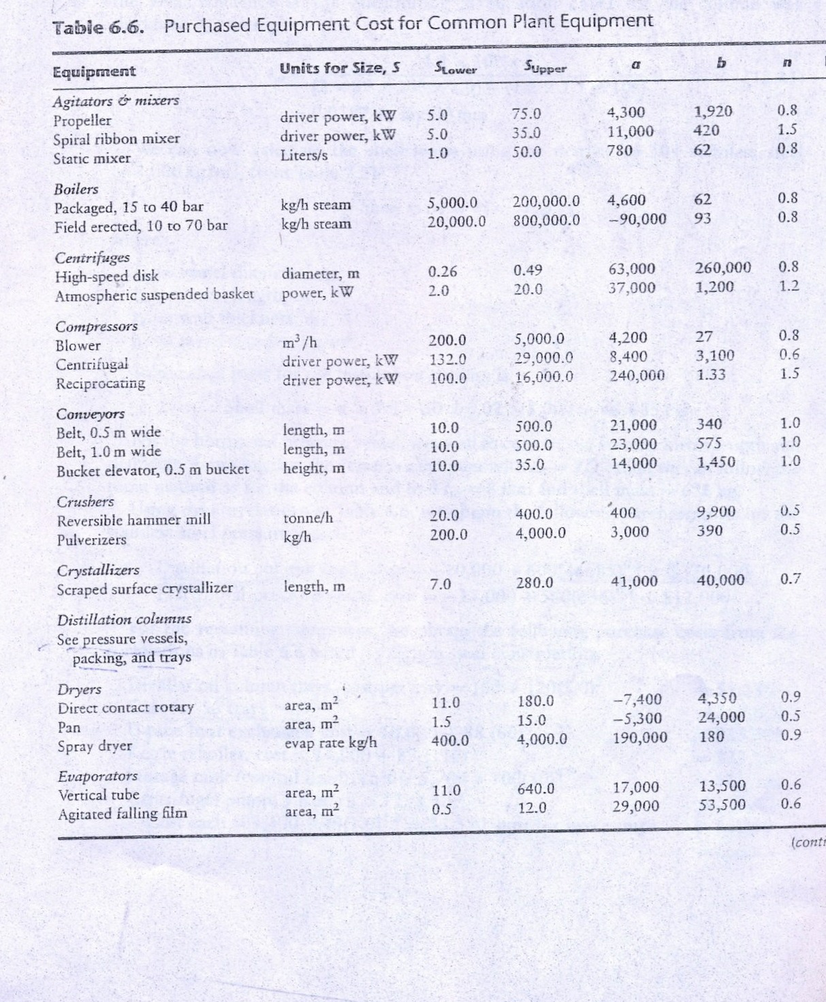

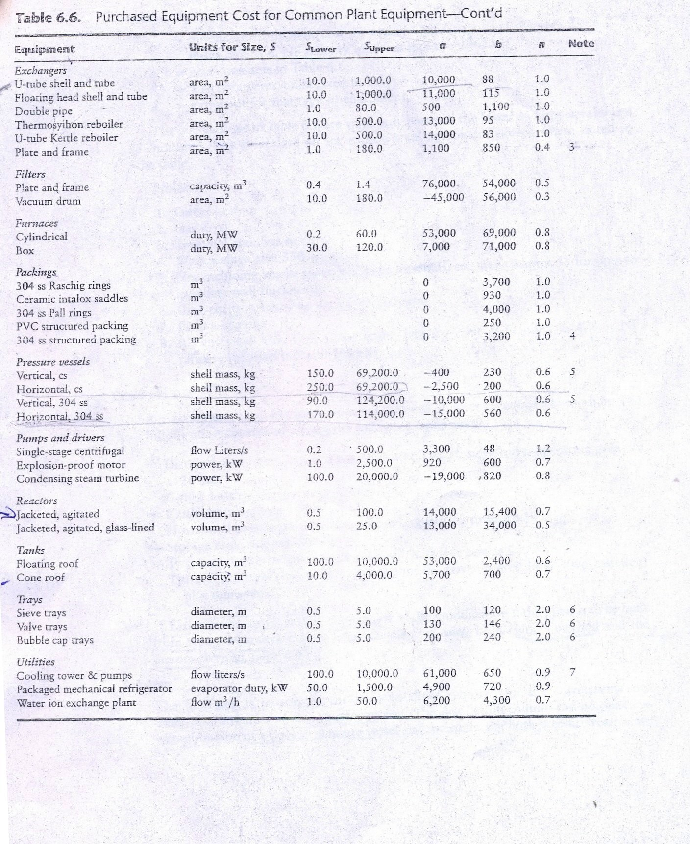

Table F.2 installation factors proposed by hand
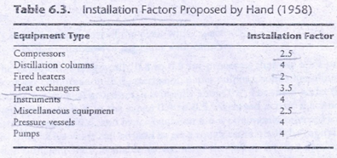
Table F.3: typical labor requirement for process equipment.
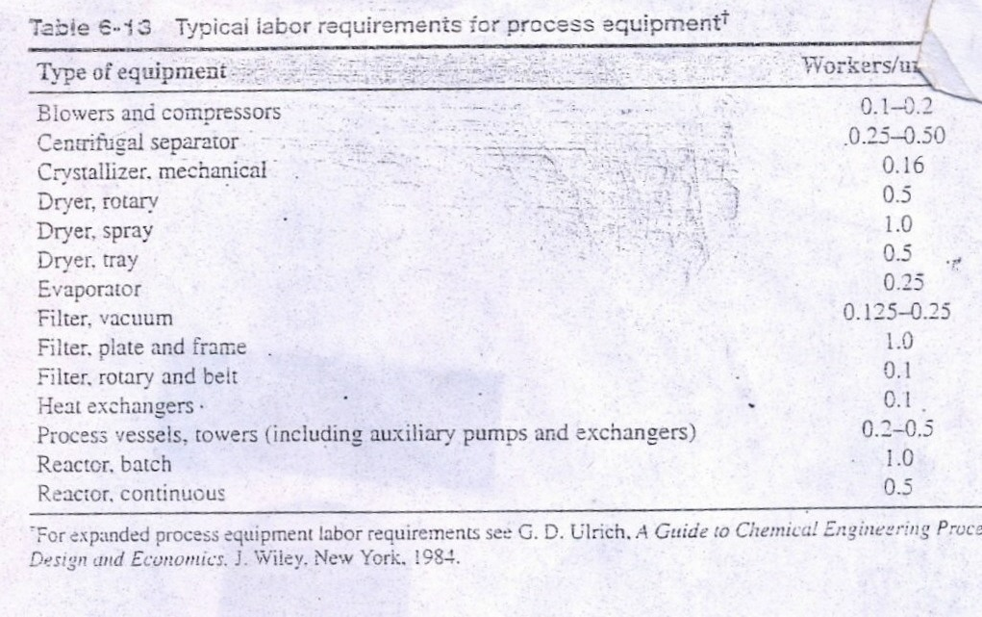

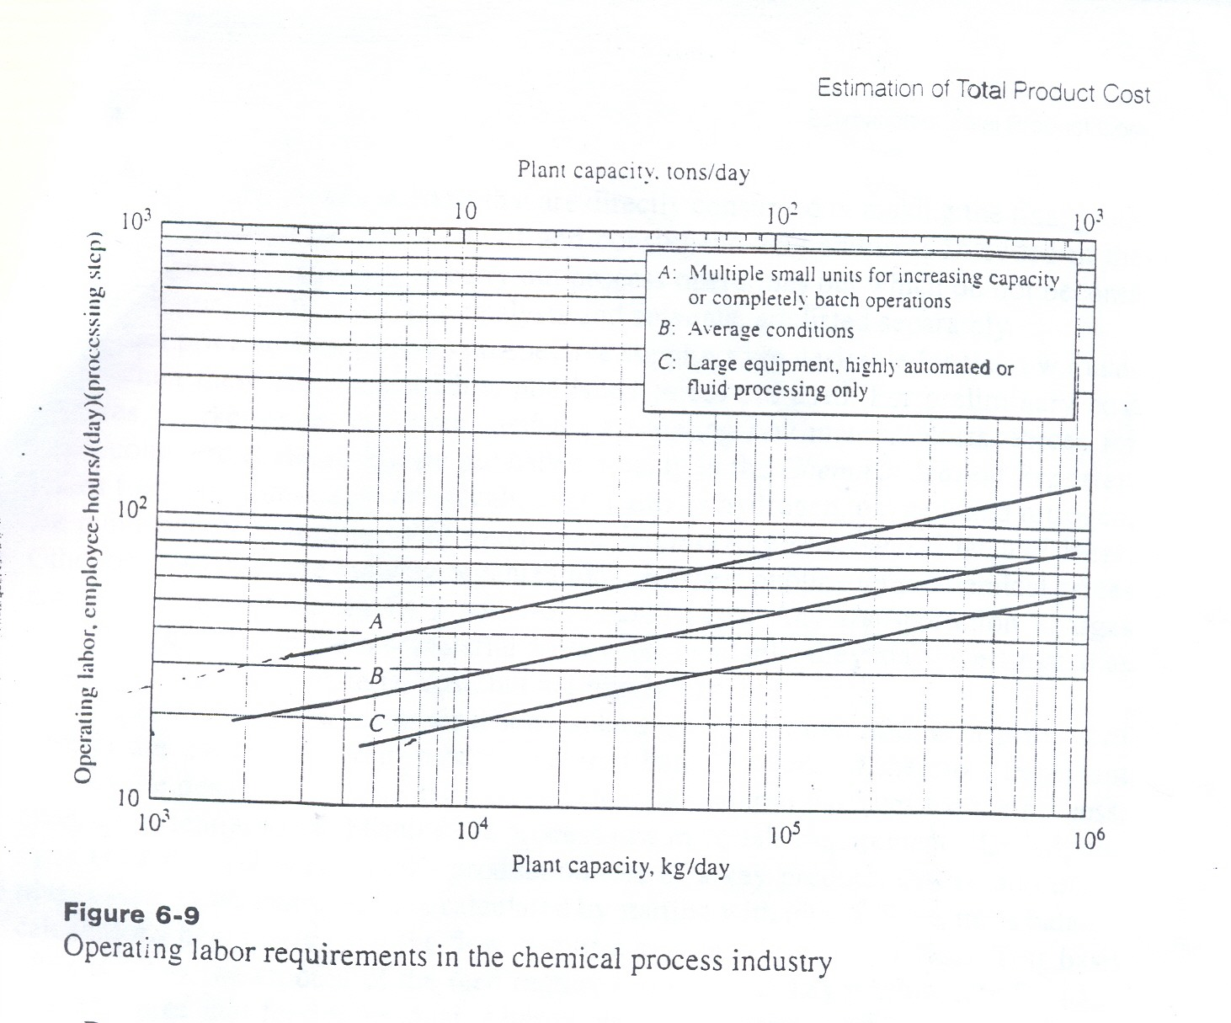
Figure F.4: operating labor requirements in the chemical process industry.
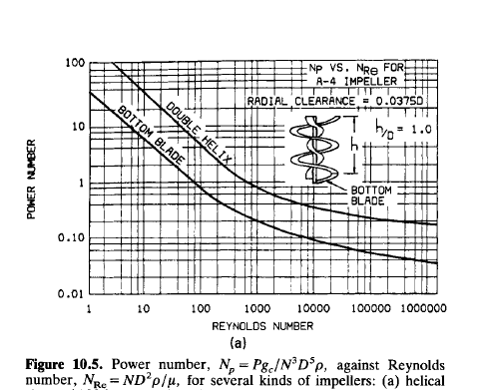
Figure F.5: Power of mixer.

