

Securing Data In The Cloud Through
Data Partitioning And Encryption
Rania Salameh & Shahd Mobarak
Al-Najah National University
Supervised By: D. Adnan Slaman

- Abstract

Cloud computing is quickly evolving moreover being used by various Enterprises, Although there are issues and anxiety concerning the security of the data specially the sensitive data not only during transferring of data through the wires but also during the storage itself since the data will reside there .To ensure the security of the data in the cloud storage not only from hackers moreover from the cloud employees themselves. The proposed cryptography divides the data and stores them in different cloud servers. By this methodology hackers may reach to apart of the data and still will not understand it .

- Introduction

Cloud computing is a type of Internet-based technologies which allow users to share their data and resources among different cloud service providers (CSP) and cloud vendors (CV). The word cloud refers to the Internet, hence Cloud Computing will be a type of computation in which services are delivered through the Internet. Cloud computing has recently witnessed an increasing interest and growth rate, due to the services that cloud offers which fit the needs of users. For example, medical researchers can diagnose challenging disease and cancers through Health informatics. Accurate and fast simulations can be ensured by financial analytics to be available for investors. ”Education as a service improves the quality of education and delivery”. High computing power, scalability, cheap cost of services, high performance, accessibility as well as availability. As people more interested in cloud services the security and privacy aspects become essential to protect the users shared information well against external sources such as the attack of viruses, unauthorized access or threats. However, the security issue caused by the possibility of the cloud employees can reach the data on cloud side still concern the cloud users.

- security issue in the cloud

Privacy and security is the main aspect in cloud. Therefore cloud greatly affected by the threat of security issues. Cloud vendors must make sure that the people using cloud does not face any problem such as data loss or theft of data. There is a chance where a hacker can get into the cloud by impersonating a legitimate user, there by affecting the entire cloud thus affecting many people who are using the infected or affected cloud. Some of the problem which is faced by the Cloud computing are:
I. Data theft
II. Integrity of data
III. Privacy problems
IV. Loss of data
V. Infected Applications
VI. Exact location of data
VII. Vendor level Security
VIII. User level Security

- Previous work

Cloud security issues were discussed and user authenticator scheme is proposed an intelligent cryptography approach named Security Aware Efficient Distributed Storage (SA-EDS).SA-EDS offers high level security protections by encrypt all data and distributive store the data to the different cloud servers without causing big overheads and latency.
Therefore, the proposed approach prevent cloud operators from accessing sensitive data by encrypt the sensitive data, split the package of data into two encrypted data packages then store them into distributed cloud servers as shown in Figure 2. Data retrieval can be obtained by converging two data components from distributed cloud servers.
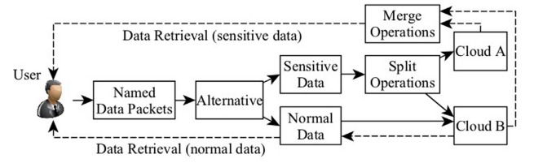Fig. 1. The architecture of the proposed SA-EDS model

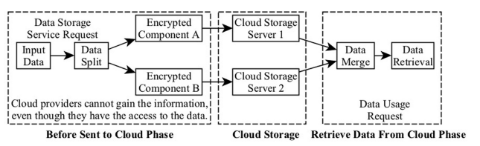
Fig. 2. High level workflow structure of splitting data packets in the Data Distributed Storage Process (D2SP) within SA-EDS model

The paper presents a set of instructions that uses the services of a third party auditor or checker to verify and authenticate the integrity of data stored at servers and in retrieving data back as soon as possible in intact form. The main advantage of this scheme is the use of digital signature to assure the integrity of data. However, the process is quite complex as the keys and data are also encrypted and decrypted respectively

- Our work

We implemented the model above:
Security-Aware Efficient Distributed Storage (SA-EDS) model:
Contain a process of data distributed storage (D2SP) to protect data from cloud employees. This process is done in two phases as follows:
First: Portioning the data into two separate components :
Before sending the data to cloud , the system will generate a random number ( C-component ) that is less than the original data ( D-component) and generate a random key (K ) this key will be stored in a special register at user side, After that we split the data ( D ) by subtracting it with random number ( C ) and put the result into (R-component), And then C-component get XOR by the key. In addition to R-component gets XOR with the key, Finally the result of the first XOR will be stored in a cloud storage server, and the second result of XOR will be stored in different cloud storage.
Second: merge the two component in the first phase and obtain the original data:
Data gets retrieved from the cloud storage servers ,After that they gets (XOR) with the Key (K) , and for the last operation sum the two results and obtain the original data.
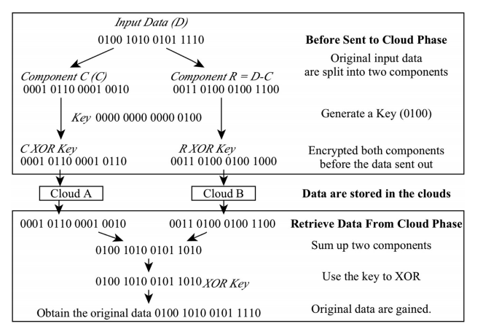
Fig. 3. Motivational example: the main phases of the given example using the proposed scheme.

Sensitive folder:
Adding to the model above we proposed a sensitive folder to check for an update or change inside of it include (ENTRY_CREATE,ENTRY_MODIFY,ENTRY_DELETE) , After that if a modify occurred the system will encrypt the file that has been detected for a change by using the (SA-EDS) model , After that the system upload the separated file into different cloud storage.

- Software used
- C/C++
- JAVA
- Drop Box API with java

- Requirements

  - Functional Requirements

- Should be able to create ,insert, modify and delete files in folder.
- System should update the data in drop box when modify a file .
- Should watch every file add to folder and encrypted it .
- Upload the output of file in different drop box account.

  - Nonfunctional Requirements

- The system should be sensitive for each change.
- The system shall be running at minimum for 24 hours a day.
- The system should respond in less than seconds when do any change in watching directory.
- The user should have an account in drop box.

- System Architecture

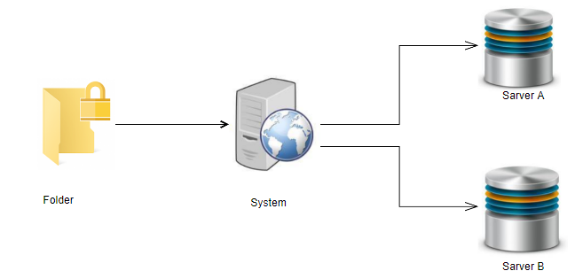

- Result

  - Paper Result
In the paper exposure deferent tried in deferent size , Figure show the result when encryption the data in Setting 1–3: 10 MB, Setting 1–4: 50 MB, and for decryption it used the figure to explain the result use Setting 2–3: 10 MB, Setting 2–4: 50 MB :
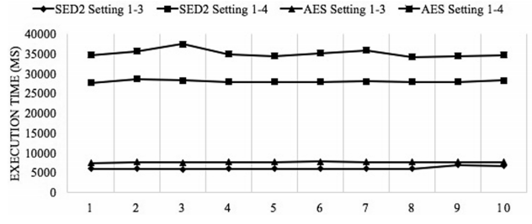
Fig. 4. Comparison on the execution time between EDS and AES under setting 1–3 and 1–4.

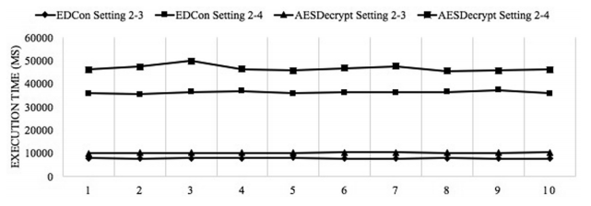
Fig. 5. Comparisons between EDCon and AES decryption under setting 2–3 and 2–4.

Moreover, Fig. 6 represented the encryption execution time differences for both SED2 and AES while the data sizes were varied
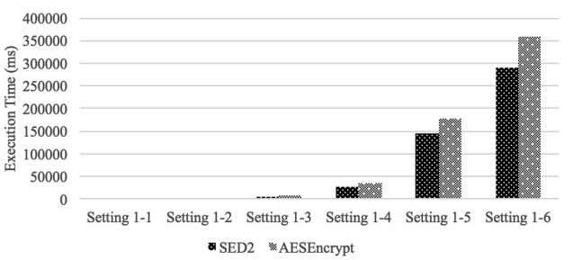
Fig. 6. Comparisons of the encryption execution time between SED2 (before document is sent out) and AES using settings 1-1, 1–2, 1–3, 1–4, 1–5, and 1–6.
In addition, Fig. 7 showed a comparison of the data retrieval processing time while the data sizes were different. The decryption time consumptions had a similar situation to the data encryption.
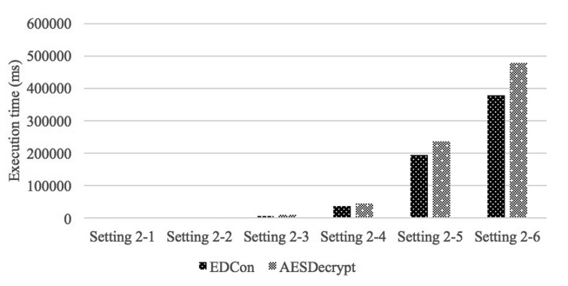

Fig. 7. Comparisons of the data retrieval execution time between EDCon and AES using settings 2-1, 2-2, 2–3, 2–4, 2–5, and 2–6. Document is gained from the cloud server.

  - Our Project Result

After we tried at different size , We have reached that our approach encrypt the data faster than AES , we take the average of valuable after encrypting and decrypting data using SED approach and AES .

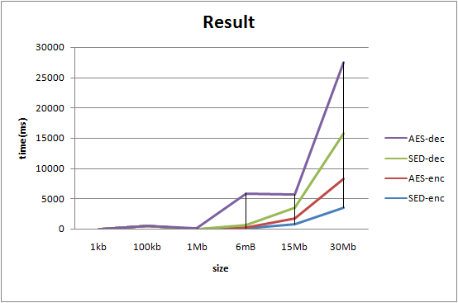
Fig8. The result of our project in encryption and decryption using SED2 and AES .

When we encrypt the data the result we get is as shown bellow in Figure and it display the result and execution time in (ms) that the two algorithm take to finish the encryption.
We simulated the data encryption processes before the data were sent to cloud-side servers. As displayed in the figure, the encryption execution time consumptions were associated with the data sizes. Our work consumed less computation time than AES
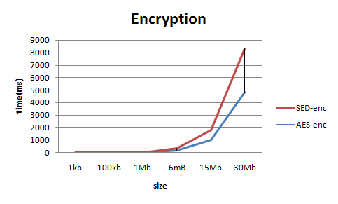
Fig9 . Result of encryption using SED2 and AES

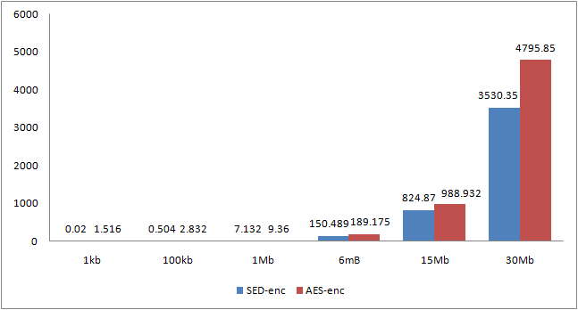
Fig10. The result with the data of encryption

After that we tried to restore the data and we decrypt the file to have the original data, and the two Figure show us the time that take to receive it again, and we have this result : 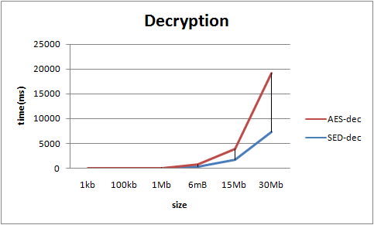

Fig11 . Result of decryption using SED2 and AES

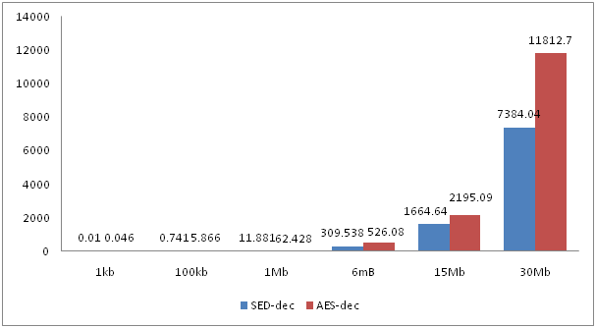
Fig12. The result with the data of decryption

- Conclusions

Cloud environment is widely used in industry and research aspects, therefore security is an important aspect for organizations which use cloud environments. Using proposed approaches, cloud environments can be secured for complex business operations and then no need to worry about sensitive data which will be protected from attacks.
The data processing time had a positive relationship with the data sizes. Our proposed approach needed a shorter processing time than AES when the examined settings were applied.
Meanwhile, we also assessed the calculating performance differences given by encryptions and decryptions. represented execution time differences between the encryption and decryption when the data sizes were varied. The figure showed that the data that needed decryptions were impacted by the data size. The execution time became longer when the data size increased.

