
بسم الله الرحمن الرحيم

An-Najah National University
Faculty of Engineering
Computer Engineering Department
Graduation Project

Online Ordering and GPS Delivery Management System Delivery.PS
Students:
Anas M. N. Khraim
Mahmoud A. M. Sharaf
Supervisors:
Dr. Raed Al-Qadi
Dr. Ashraf Armoosh

Fall 2011
Contents
- Abstract …………………………………………………………………. | 4
- List of tables …………………………………………………………… | 5
- List of figures …………………………………………………………. | 6
- Introduction …………………………………………………………….. | 7
- Chapter 1: Overview of the system …………………..……. | 9
- Chapter 2: Web site implementation ……………………… | 16
- Section 2.1: website requirements……………………………. | 16
- Section 2.1.1: Handling orders requirements …………… | 17
- Section 2.1.2: Advertisements requirements…………….. | 17
- Section 2.1.3: Restaurant organization and management…. | 17
- Section 2.1.4: Delivery management……………………... | 18
- Section 2.1.5: Chief requirements………………………… | 19
- Section 2.1.6: Customer requirements……………………. | 19
- Section 2.2: website interface ………………………….……… | 20
- Section 2.2.1: Restaurant manager interface ……….……. | 20
- Section 2.2.2: Manager Control panel……………………. | 22
- Section 2.2.2.1: Control Orders…………………….. | 22
- Section 2.2.2.2: Control Employees……………….. | 22
- Section 2.2.2.3: Control Meals ……………..…,,…. | 24
- Section 2.2.2.4: Control Services………………….. | 26
- Section 2.2.2.5: Control Customers……………….. | 27
- Section 2.2.2.6: Track deliveries…………………... | 27
- Section 2.2.2.7: Control restaurants……………….. | 28
- Section 2.2.2.8: Control restaurants administrator…. | 29
- Section 2.2.3: customer interface…………….……………. | 30
- Section 2.2.4: Chief interface…………………...…………. | 36
- Section 2.3: implementation & data….……………….………. | 36
- Section 2.3.1: Manager’s pages implementation…....…..… | 37
- Section 2.3.2: Customer’s pages implementation………… | 42
- Section 2.3.3: Chief’s pages logic………………………… | 42
- Chapter 3: Mobile application implementation ….......... | 43
- Section 3.1: Mobile requirements ………………..…………… | 43
- Section 3.1.1: Business requirements …………….............. | 43
- Section 3.1.2: Technical requirements ……….…………… | 44
- Section 3.2: Mobile application implementation …………...… | 45
- Section 3.2.1: Interface …………………………………… | 46
- Section 3.2.2: implementation & Actions ………………… | 50
- Section 3.2.3: Database …………………………….…….. | 52
- Section 3.3: Communication ………………..………..………… | 53
- Chapter 4: Database…………………………………………..…. | 55
- Conclusion ………………………………………..…………………….. | 71
- Thanks ………………………………………………………………….. | 72

.

Abstract
Since there is a huge difficulty in answering the large number of orders simultaneously on telephone for some restaurants or shops, we found that it is much easier for both the restaurant and its clients to have an online system for managing the ordering process.
Our ordering system will provide the menu of each restaurant that joined the system, and it will make the clients able to share their opinions, likes and dislike, reviews, ranking for the content of the menu in comments way.
On the other hand, to make it easier for the client to check his order and to reduce the overhead on the restaurant, we develop a delivery system using the GPS technology to facilitate the tracking of the orders.
So the customers will go over the website and choose the meals and sweets and other from their city’s restaurants the order appears on the manager monitor, after process it will transfer to chef, chef views all current orders to schedule it, when finished it will be taken by delivery man.
Our system provides GPS tracking of the delivery man for the manager to have full control. Moreover, the customer can track the delivery man.
We believe that all these features distinguish our system from the competition, and provide an attractive solution empowering users of our system to conduct business in a modern, advance approach that will enable them to control a large share of the market.

Anas khraim
Mahmoud Sharaf

List of tables
Table 1: application threads and associated works 51
Table 2: serialization 53
Table 3: communication methods 54
Table 4: communication messages 54
Table 5: Areas table 55
Table 6: Cities table 56
Table 7: Contents table 56

List of figures
Figure 1: Use case diagram of the system 10
Figure 2: Sequence diagram of the system 11
Figure 3: Activity diagram for the restaurant manager 12
Figure 4: Activity diagram for the restaurant chief 13
Figure 5: Activity diagram for the delivery man 14
Figure 6: Activity diagram for the customer 15
Figure 7: Shop Admin Page 21
Figure 9: Orders page 22
Figure 10: Show employee’s log 23
Figure 11: Employees page (add new employee) 24
Figure 12: Meals page (add new meal) 25
Figure 13: Meals page (add new meal) 25
Figure 14: Services page (update all the Services in the restaurant) 26
Figure 15: Customers page (Show all the Customers that ordered meals from the restaurant) 27
Figure 16: track delivery page (track all the delivery men from the restaurant) 28
Figure 17: shop info page (Show all the restaurant information and update it) 28
Figure 18: shop admin info page 29
Figure 19: Main page 31
Figure 20: select restaurant page 32
Figure 21: Restaurant page 33
Figure 22: log in page 34
Figure 23: track delivery page 34
Figure 24: sign up page 35
Figure 25: Chief Main page 36
Figure 26: Login Activity 46
Figure 28: orders map view 47
Figure 27: Main Activity 47
Figure 30: Customer details page (coming soon) 48
Figure 29: Context menu options 48
Figure 31: order details (coming soon) 49
Figure 32: application menu 49

Introduction
This documentation is presented to An-Najah National University about our software graduation project, to be discussed in the Committee discussion.
We divided it in chapters and sections to achieve the readability as the following:
In chapter 1, we give an overview of the whole system that is used to handle ordering and delivery of food. This includes a brief description of the subsystems included in our system which are the website and the mobile. We also moved to talk about the centralized database that is used by the system.
In the chapter 2 that talks about website, we described it in 2 layers, the requirements layer that shows how the website satisfies the requirements of the system for the available actors. Since we have multiple actors that have multiple functions to do, the website presents a very power powerful tool for them to handle their requirements and provide them with their needs especially that our website is centralized and all the actors can access it.
The second layer that the website satisfies is the application layer. As a very flexible efficient and powerful tool, the website also is a very suitable application for our system; this is because it is an ordering and delivery system which tended to have a web-based solution. The website interface has a very rich and beautiful interface that satisfy all the actors of the system, and since we are dealing with customers in this system we can benefit from the interface in marketing and advertising, which in return will bring more and more customers to use our system, and make it an international system used by millions.
on the other hand, the logic of the website is very flexible for the actors to fetch the data and insert it to the system, and this is because the website development provide many tools to deal with data and perform the appropriate logic that satisfy all the system’s actors needs.
In chapter 3, we describe the mobile requirements and motivation in order to fit the business behind, and the technical motivation that the mobile fits, then we talk about the Implementation in three points of view; interface which describe and show sketch of the application, logic which describes the synchronization and work concurrency of the application and web server, then data storage in mobile.
Finally talking about the communication module that we used and describe the message passing techniques.

In chapter 4, we talked about the database that is the data center of our application used by both the website and mobile subsystems. We also attached the ER diagram and the UML diagram for the database in order to explain the database tables and their relations.

Anas khraim
Mahmoud sharf
Chapter 1
The project overview
Our system includes a hot area of interaction between the actors on it. And since this interaction is going to be in real time at some scenarios, so we must keep a time management for all the activities happened between the actors. On the other hand, the system encapsulates many subsystems of interactions between the actors, and this includes the website, mobile and of course the centralized server that contains the database.
Our system as food ordering and delivery, it will have main cases that each actor will interact with. According to the actor and the role he’s playing in the system, it will be determined how will the actor interact with each case, and the number of cases he will interact with. In our system we have 4 main actors on it, whom are: “the restaurant manager”, “the restaurant chief”, “the customer”, and “the delivery man”. These actors will interact in many cases in a different ways, and we can summaries the all the cases in the system in 4 cases:” Order food”, “serving food”,” Cook food” and “order Delivery”.
According to the restaurant manager, he will interact with 3 cases: Order food, serving food and order Delivery. He will interact in the Order food case by receiving new orders from customers, and in the case of food serving he will have 2 ways of interaction, either he’ll send the orders to Kitchen, or receive the ready order and package it in order to be delivered. Also, in the case of order Delivery he will assign orders to delivery Man for being delivered.
According to the restaurant chief, he will interact with 2 cases: serving food and order Delivery. He will interact in the food serving case 2 ways, receiving new orders from restaurant manager in order to cook them, and confirm cooking the orders after he finishes cooking them. And in the case of Cook food, the restaurant chief will cook the order assigned to him.

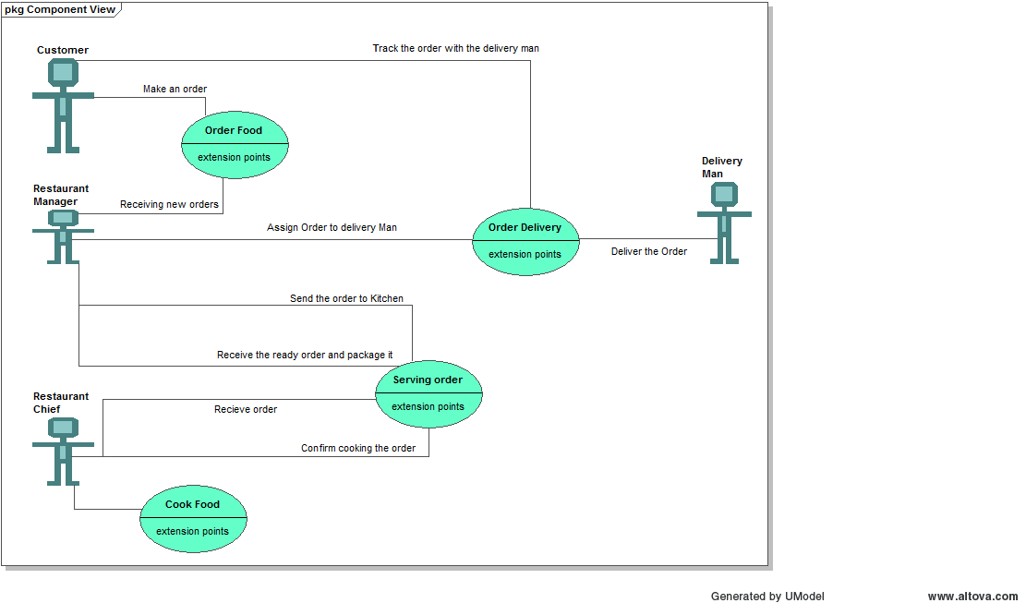
According to the customer, he will interact with 2 cases: Order food and order Delivery. He will interact in the Order food by initially make his order from the restaurant. And in the case of order Delivery he will track the order with the delivery man until it reaches him. Finally, the delivery man will interact with 1 case only which is order Delivery, where he delivers the assigned Orders to him from the restaurant manager. This is all illustrated in the use case diagram, in figure 1.
Figure 1: Use case diagram of the system
As we said before that the interactions of the actors on the system must follow a specific time management, which can be explained as a sequence of interactions. This sequence starts with the customer as he will make an order. It will follow that the restaurant manager will respond to that order and send it to Kitchen in order to be cooked. After that he will wait for the chief to cook it and confirm cooking it.
Then, he will be able to assign the order to a delivery Man to deliver it to the customer. Finally, the delivery man delivers the assigned Orders to him from the restaurant manager, and we should mention that during the order delivery interval, it will be possible to both restaurant manager and customer to track the order. This is all illustrated in the sequence diagram, in figure 2.
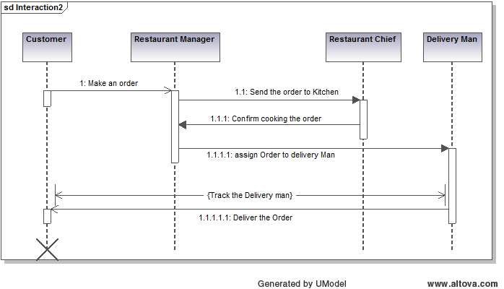
Figure 2: Sequence diagram of the system
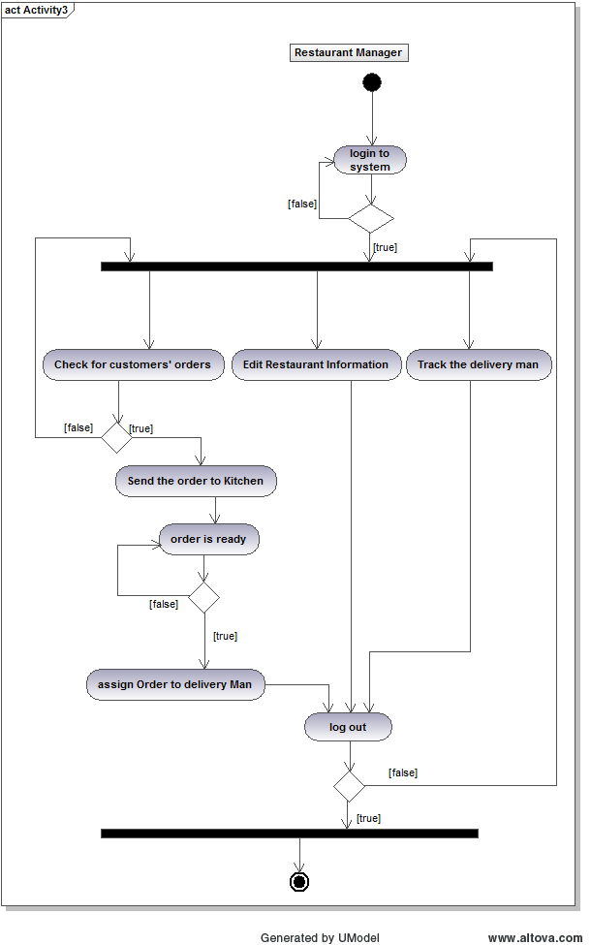
We can describe the activities of each actor on the system in a flow chart called activity diagram. This diagram will show the flow of interactions of each actor with the system from the entry point for him in the system until the exit point. The activity diagram for the restaurant manager is illustrated in figure 3, and the activity diagram for the restaurant chief is illustrated in figure 4, and the activity diagram for the customer is illustrated in figure 5 and finally the activity diagram for the delivery man is illustrated in figure 6,.

Figure 3: Activity diagram for the restaurant manager
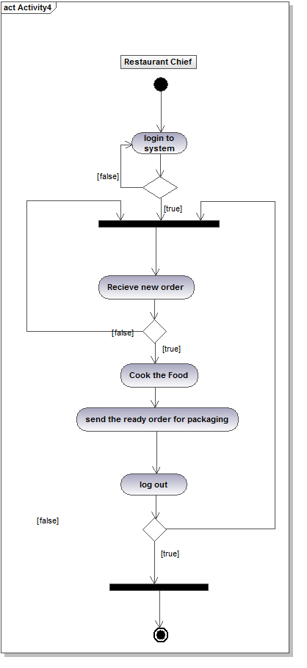

Figure 4: Activity diagram for the restaurant chief
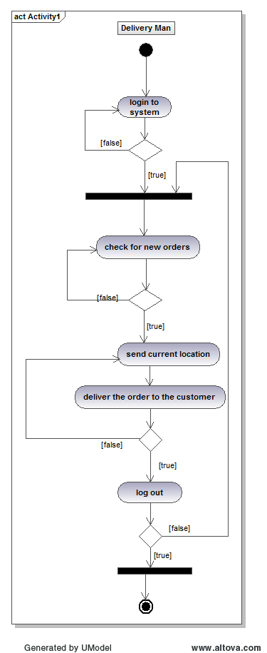
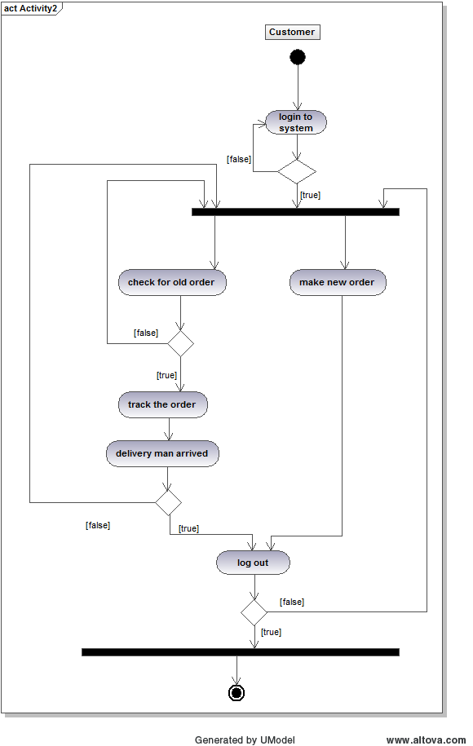
Figure 5: Activity diagram for the delivery man
Figure 6: Activity diagram for the customer
Chapter 2
The Web site

The website we have developed is following a well organized development process that comes to meet the system requirements, and the followed methodology is very useful in studying and analyzing each problem, that allows us to accomplish each task, and guides us to the well known techniques, by applying the best practice in providing the services through our website.

According to the programming languages, we have used Java script and HTML as client side languages, and we choose the ASP.Net C# as the server code behind. The programming methodology was following the standard of object oriented programming, in order to provide a good level in data abstraction, encapsulation, messaging and modularity.

Section 2.1 website Business requirements
The website we have developed come to satisfy many requirements on many sides in real life business issues, and these issues are related to both the business manager and the client. According to the business concept, we have found that there is a serious difficulty in the food ordering system in our country that can decrease the total yearly income for any shop manager if it continues to perform food ordering like in the traditional way.

The food ordering in traditional way using phone does face problems in organizing and receiving a large number of orders in a short time, and so the shop will not be able to answer and serve all its orders, especially that if it has only one phone number or one man responsible for receiving the customers’ orders.

On the other hand, the customer is also having a huge difficulty in ordering if the shop phone still busy for a period of time without the ability to get his order answered. Additionally, it is a big effort on the customer to keep tracking his order by keep calling the restaurant, and waste the time of both the customer himself and the restaurant manager while responding to the redundant customer’s phone calls.

Section 2.1.1 Handling orders
Since the website allows for many interactions and transitions happening at the same time, we offer the restaurant manager a release from the effort of answering large number of orders at the same time, and so serving many orders and getting more income as a result. Not only the restaurant manager will get this benefit, but also the customer will find a better organized faster way to order through the internet with the website application which almost all the people of the world become familiar with.

Section 2.1.2 Advertisements purpose
According to restaurant manager, the website is a very powerful tool to make an advertisement over the internet about his restaurant and what services, categories and meals does it provide, since every one can enter to the website and check out all the meals and offers that are presented from the restaurant while sitting at home. Additionally, the restaurant manager can edit his restaurant menu and services easily and confirm changes that all the website’s visitors can see these new modifications.
Section 2.1.3 Restaurant organization and management
Of course the manager also can change the restaurant-related information like the minimum charge for ordering, open/close time, delivery fees… etc, and all these changes will be directly noticeable to all the customers. Also, he can have a good management to all the employees working in the restaurant, and have a good management to all of their information, especially if he wants some reports about them, in order to establish allowances, bounces and discounts according to the generated reports of their work and social status, and all of this is centralized in our system.

Our system allows the manager to have also a good management for the restaurant’s orders, since all the orders are added to our system, and then it will easily control the ordering process especially that we have developed an algorithm that can help the manager to operate all the ordering processes, and we use a standard sequence in which each order pass through from the moment it is ordered until the moment it is delivered, which are: New Orders, In kitchen Orders, Being Cooked Orders, packaging orders, On delivery orders, delivered orders, not delivered orders.

Each order status is important and has a useful meaning to the actors of the system including the restaurant chief, the order’s delivery man and of course the manager who can see all the stages the order passes through and knows in which status exactly the order is.

One extra benefit the manager can have from our system is to examine all the customers that ordered from its restaurant, and he can add the customers who used to make fake orders into the black list, so that he can be noticed about them next time they order. On the other hand, he can know about the usual customers that always order from its restaurant, and can reward them by making discounts for them in some criteria that is put by the restaurant manager and according to his convenience.
Section 2.1.4 Delivery management
One new fantastic feature in our website system is to track the delivery process. This is important for both the manager and customer as well, and if we want to explain the advantage of this for the manager, we can talk a lot about that. First, the manager can track his delivery men, and knows exactly their places while delivering the orders and this is important to know each step the restaurant’s delivery men go when they move out to deliver the assigned orders.

Second, the manager can make sure about the delivery process that the delivery man is reaching his goal, and this comes in handy when something wrong go with the delivery man, such as the delivery process may break down or something else, and of course this gives the manager the flexibility and the ability to do something in order to make the delivery process continue, like assigning the order to another delivery man or sending someone to help him or calling the customer to tell him that an emergency state happened and the order delivery will be delayed.

Section 2.1.5 Chief requirements
The website also includes a space for the restaurant chief to examine the new orders assigned to him. This is very important for the manager in order to make it pretty easier to assign the orders to the chief for being cooked, and it also doesn’t need an internal desktop system for the restaurant, since all the system is centralized in our server using the internet, and so each chief is just using the website as a client and can enter to his account and start using and receiving the orders with a lot of ease.

Section 2.1.6 Customer requirements
The customer that we want him to have a comfortable ordering process will find our system a valuable new methodology in ordering and delivery. He can just make an account in our system and know about all the restaurants using our system, which will make him to choose what he wants from the menus of the restaurants without having to call their managers and ask them for each food category and meal their restaurants provide, which is an annoying, tiring and boring process for both the customer and the restaurant manager.

Additionally, after the customer logs into the system, he can benefit from the discounts that the restaurant offers, and get updated with every new from each restaurant. Moreover, the customer can review the meals he ordered, which can help the other customers ordering that meal for the first time to know the judgments of the customers who tried it, and they even can interact with each other in a comment-based way. The most important feature that will impress and dazzle the customers is to track their orders online, and see exactly the location of the delivery man who has their orders, instead of keep calling the restaurant manager and checking for the status of the order from the moment it’s ordered until the moment it’s received.

Section 2.2 Web site interface
There will be an interface to satisfy the needs of all the system’s actors, except the delivery man which will deal with the system using the mobile application, especially that he doesn’t need to be in the restaurant while his job is roaming to deliver the orders, and as well the mobile which will be the best suited way for him to interact with the system.

Our website provides interfaces for the restaurant chief, restaurant manager, and the customer. As we didn’t finish putting the last touch on our interface, we will provide you with the initial interface that we use at the moment. We used a library from internet named “EO-Web-Internal” that helps us to make a good interface for the website besides the tools already exist in the Microsoft Visual Studio 2010.
Section 2.2.1 Restaurant manager interface
According to the restaurant manager, the first interface he will use is the main page where he first has to log in as a restaurant manager using the account specified for that (note that he may have another account in the system as a customer), and then he will be moved to the restaurant manager main page, which we named as “Shop Admin”.

This page includes: 5 list boxes and 8 linked labels to move to the other pages related to the restaurant manager, which are: Orders, employees, meals, services, customers, track delivery, edit shop info, edit shop admin info. This is all illustrated in the figure 7.
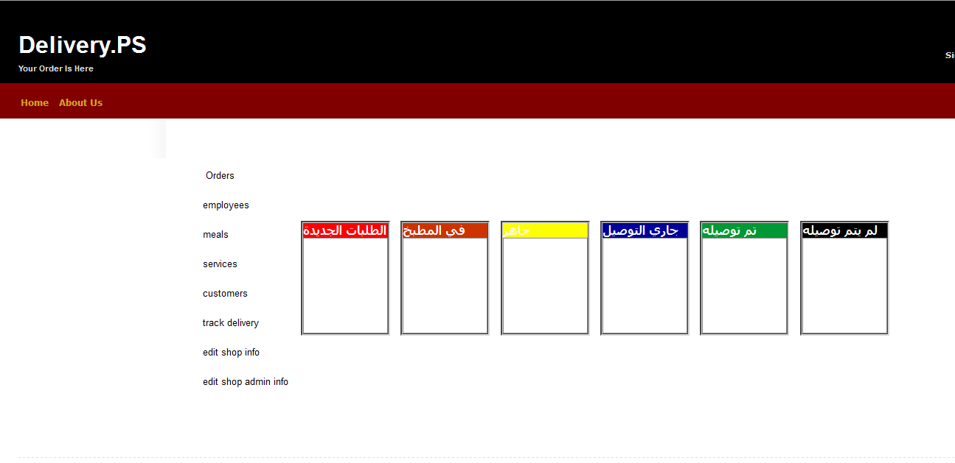
Figure 7: Shop Admin Page
And as you can see in Figure 8, we use the color methodology to inform the restaurant manager about each order status. We used the red color for new orders, orange color for in kitchen orders, yellow color for ready-cooked orders, blue color for on delivery orders, green color for successfully delivered orders (note that non-delivered orders are set in black, and this could happen if we have a fake order or the customer didn’t get the order for some emergency situation).
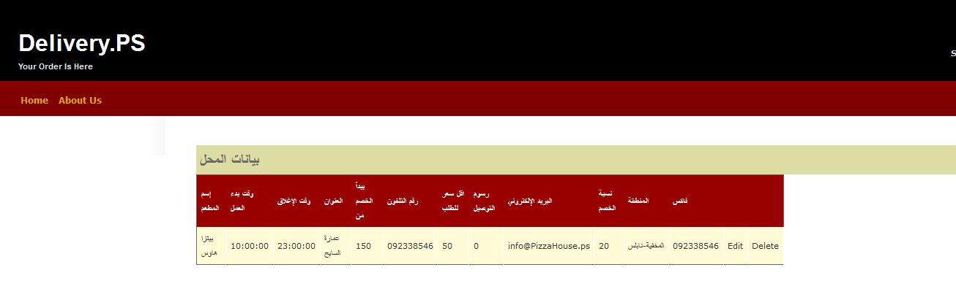figure 8: shop info page.
Section 2.2.2 Manager Control panel

Section 2.2.2 .1 Control Orders
If the restaurant manager pressed on “Orders”, then he will move to the Orders page named “Shop Admin Orders”, where he can see the list of all previous orders of the restaurant.
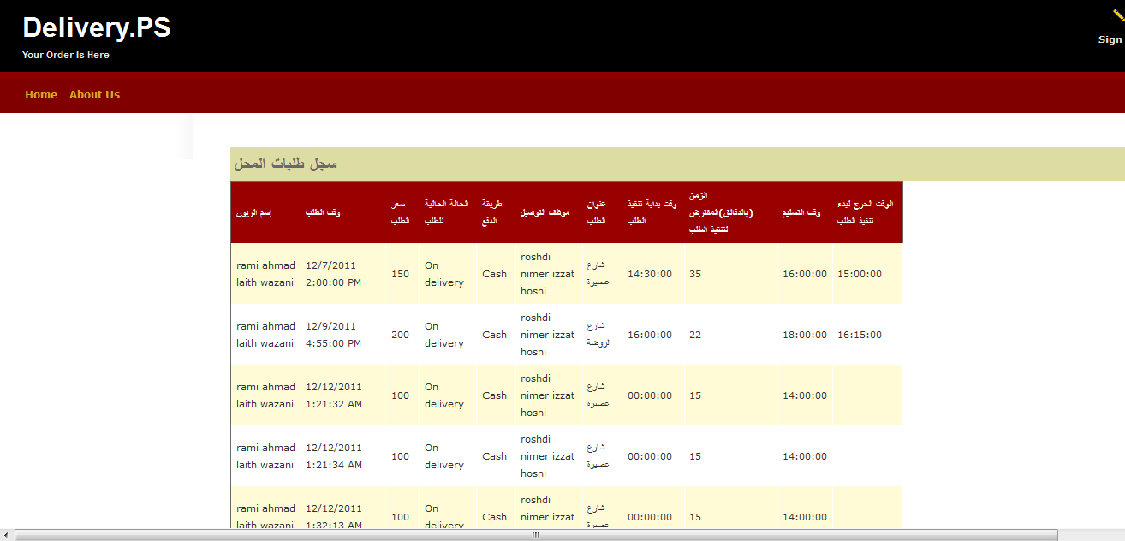
This page includes: Grid View in which each column show a specific data about the restaurants. And the columns are: customer name, ordering time, order total price, order status, payment method, order delivery man, order address, order start preparation time, total preparation time, delivery time, critical time (for more information about each attribute you can see the database chapter). This is all illustrated in the figure 9.
Figure 9: Orders page

Section 2.2.2.2 Control Employees
If the restaurant manager pressed on “Employees”, then he will move to the Employees page named “Employees”, where he can see the list of all the employees of the restaurant until that moment. This page includes: 14 text boxes in order to insert the new employee data, 4 text boxes for the employee name ( first name, second name, third name and last name ), 1 text box for the employee National ID, 1 text box for the employee Phone, 1 text box for the employee Mobile, 1 text box for the employee Address, 1 text box for the employee Email, 1 text box for the employee Age, 1 text box for the employee Social Status, 1 text box for the employee Username and 1 text box for the employee Password.

We also used 1 drop down list for the employee job title (in each restaurant we have 3 job titles: Restaurant manager, Restaurant chief and Delivery Man, and since we first logged in as a manager to move to this page, then we have 2 left job titles to choose from which are Restaurant chief and Delivery Man. Note that the restaurant manager account is added by the system when the account for the restaurant is initially created and added to the system). And we used also 2 radio buttons to select the employee Gender.
Figure 10: Show employee’s log
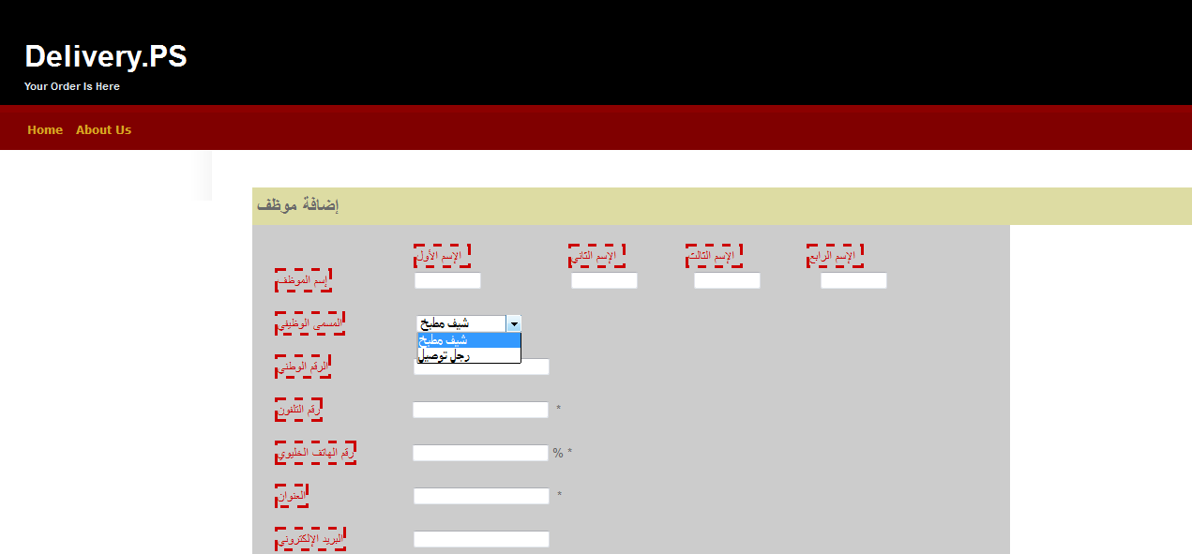

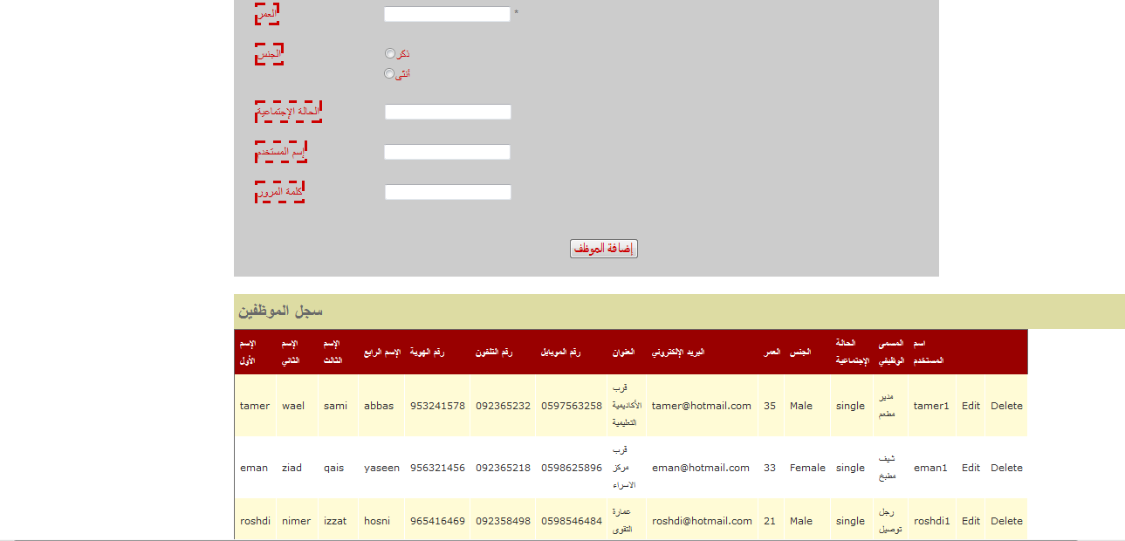
Figure 11: Employees page (add new employee)
This page includes: Grid View in which each column show a specific data about the Employees. And the columns are: employee first name, employee second name, employee third name, employee last name, employee National ID, employee Phone, employee Mobile, employee Address, employee Email, employee Age, employee Social Status, employee Username, employee Gender and finally employee job title (for more information about each attribute you can see the database chapter). This is all illustrated in the figure 3.1 & figure 3.2.

Section 2.2.2.3 Control Meals
If the restaurant manager pressed on “Meals”, then he will move to the Meals page named “Meals”, where he can see the list of all the Meals of the restaurant until that moment. This page includes: 5 text boxes in order to insert the new meal data, 1 text boxes for the meal name, 1 text box for the meal price, 1 text box for the meal discount-value, 1 text box for the meal description, 1 text box for the meal total preparation time. We also used 2 check boxes, 1 to choose the availability of the meal, and the other is to select if the meal is deliverable or not.

We also used 1 drop down list for the meal categorization according to restaurant menu category (in each restaurant we have many menu categories, and this varies from one restaurant to another). And we also used 1 drop down list for the meal categorization according to restaurant food category (in each restaurant we have many food categories, and this varies from one restaurant to another), and it is good to know that customers can use this food category while searching through restaurants about some meal.

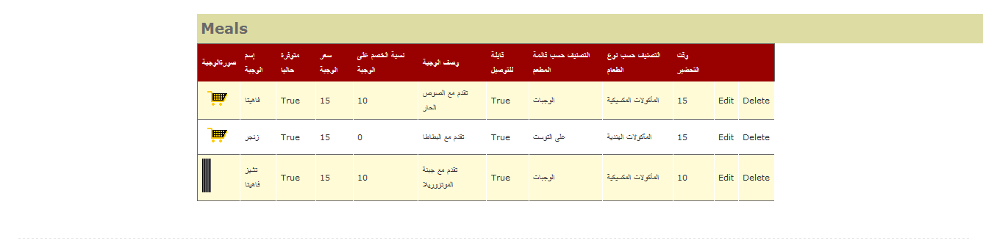
This page includes: Grid View in which each column show a specific data about the Meals. And the columns are: meal name, meal availability, meal Price, meal Discount Value, meal Description, meal Deliverable, meal Preparation Time, meal Menu Category, meal Food Category and finally meal Image (for more information about each attribute you can see the database chapter). This is all illustrated in the figure 12 & figure 13.
Figure 12: Meals page (add new meal)
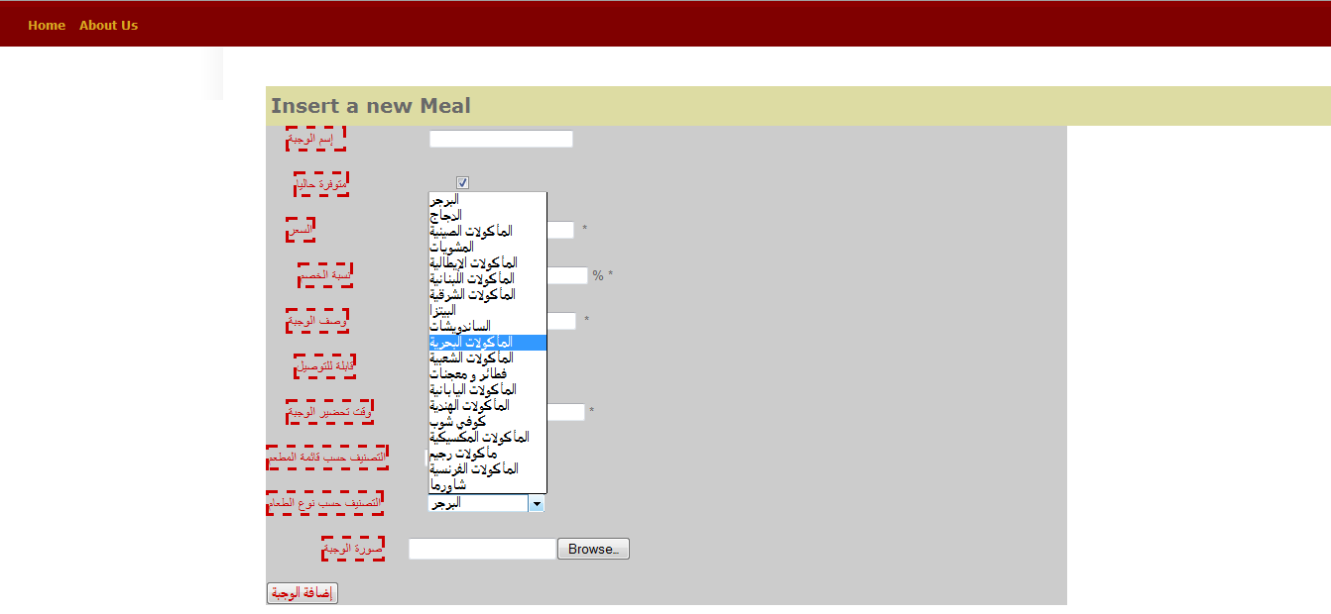
Figure 13: Meals page (add new meal)

Note that the data of each meal must be inserted carefully, especially the meal food category; because it will be used in searching for the restaurant itself, and that’s if the customer wants to choose the restaurant that providing meals with a specific food category.

Section 2.2.2.4 Control Services
If the restaurant manager pressed on “Services”, then he will move to the Services page named “Services”, where he can see the list of all the Services of the restaurant until that moment. This page includes: check box list of all the services that the restaurant provides. We also used image list for all the services images that the restaurant provides in align with each check box service name. This is friendlier to user in order to update the available services in the Restaurant. This is all illustrated in the figure 14.

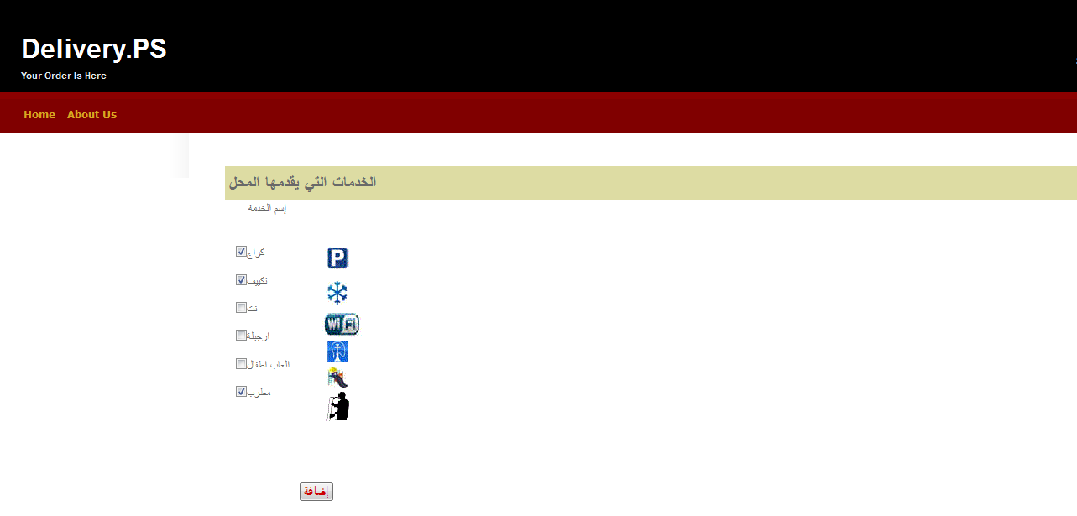
Figure 14: Services page (update all the Services in the restaurant)

Section 2.2.2.5 Control Customers
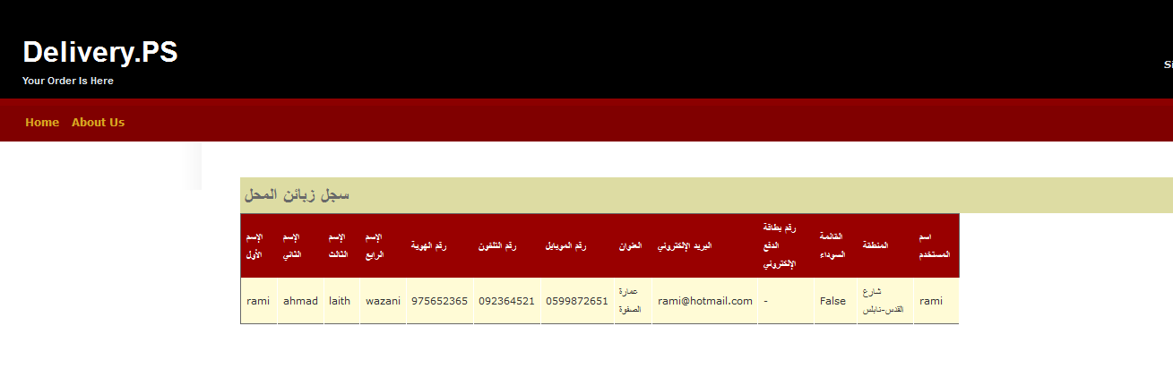
If the restaurant manager pressed on “Customers”, then he will move to the Customers page named “Customers”, where he can see the list of all the Customers that ordered meals from the restaurant until that moment. This page includes: Grid View in which each column show a specific data about the Customers. And the columns are: customer first name, customer second name, customer third name, customer last name, customer National ID, customer Phone, customer Mobile, customer Address, customer credit card, customer area, if the customer is in black list and finally customer Username (for more information about each attribute you can see the database chapter). This is all illustrated in the figure 15.

Section 2.2.2.6 Track deliveries
Figure 15: Customers page (Show all the Customers that ordered meals from the restaurant)
If the restaurant manager pressed on “track delivery”, then he will move to the track delivery page named “track delivery”, where he can see the map of the city in which the restaurant placed. This will be valid after the delivery man has some orders to deliver, and then he can track each delivery man along the way to his order destination at the customer’s address. We used the Bing map to show the tracking process.
This is all illustrated in the figure 16.
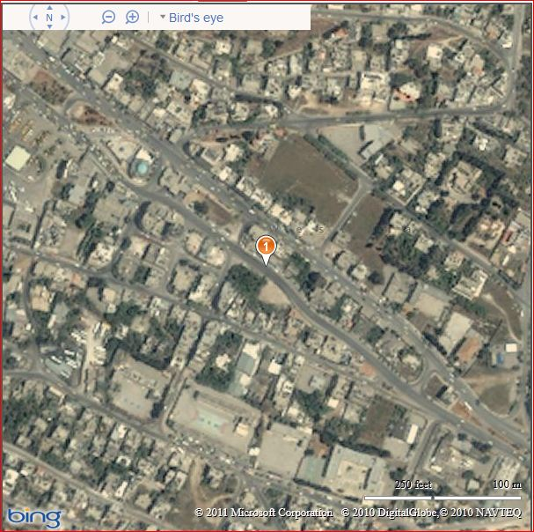
Figure 16: track delivery page (track all the delivery men from the restaurant)

Section 2.2.2.7 Control restaurants
If the restaurant manager pressed on “edit shop info”, then he will move to the shop information page named “shop info”, where he can see the restaurant information until that moment, and can edit and update them. This page includes: Grid View in which each column show a specific data about the shop. And the columns are: shop name, shop open time, shop close time, shop discount-start limit, shop Phone, shop minimum charge, shop Address, shop delivery fees, shop email, shop discount percent, , shop area and shop fax. (For more information about each attribute you can see the database chapter). This is all illustrated in the figure 17.
Figure 17: shop info page (Show all the restaurant information and update it)

Section 2.2.2.8 Control restaurants administrators
If the restaurant manager pressed on “edit shop admin info”, then he will move to the shop administrator information page named “shop admin info”, where he can see his information until that moment, and can edit and update them. This page includes: Grid View in which each column show a specific data about the shop admin. And the columns are: shop admin first name, shop admin second name, shop admin third name, shop admin last name, shop admin National ID, shop admin Phone, shop admin Mobile, shop admin Address, shop admin Email, shop admin Age, shop admin Social Status, shop admin Username, shop admin Gender and finally shop admin password (for more information about each attribute you can see the database chapter). This is all illustrated in the figure 18.

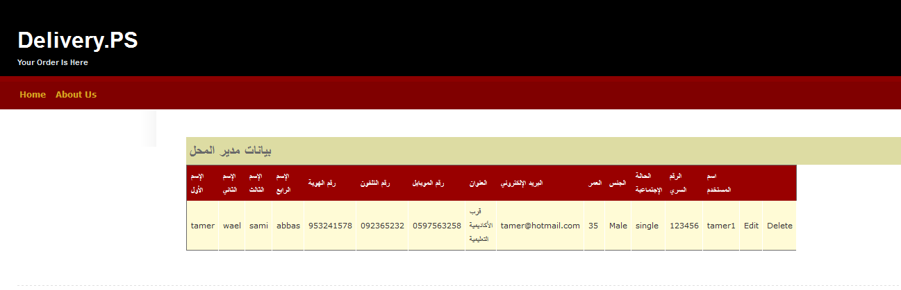
Figure 18: shop admin info page (Show and update the entire restaurant’s manager information)

Section 2.2.3 customer
The customer has an interface that will satisfy his needs, and make him able to choose his order from the list of restaurants available. He can choose the meal he wants from the restaurant he wants, and he can use the search about the meal either by the area in which the restaurant providing that meal placed, or by the food category to which this meal belongs.

After choosing some restaurant, he will move to the restaurant page where he can view the restaurant information like discounts, open/close time, phone …etc. in this page he will see 2 categories: the food categories that the restaurant provide, and the menu category that organize the menu in each restaurant.

When the customer make his decision and choose what meals he wants to order, he can view the information about that meal, like its price, description and the meal image, then he must to specify the quantity of each selected meal. One other amazing thing the customer can do is to review the meals and see the previous reviews as well about any meal (if any). After choosing his order’s meals, he will make a final check out in order to make sure about what meals he ordered and the quantity of each meal. Note that if the customer was new to the system he will then move to log in page where he can make new account and continues his ordering process normally. Additionally, he can track each order from any restaurant in our system from the moment he orders until the moment the delivery man reaches his delivery place. Finally, he can edit his personal information any time and submit the changes as his convenience.
According to customer, the first interface he will use is the “main page” where he first has to log in as a customer using his account if he had an account before, or he can sign up for the first time and starts using our system (note that new customer may enter into our the system and view all the restaurants and meals, but after choosing his order and before finishing the ordering process he will be redirect to make a sign up because the system accept orders only from registered customers). This main page is illustrated in the figure 19.
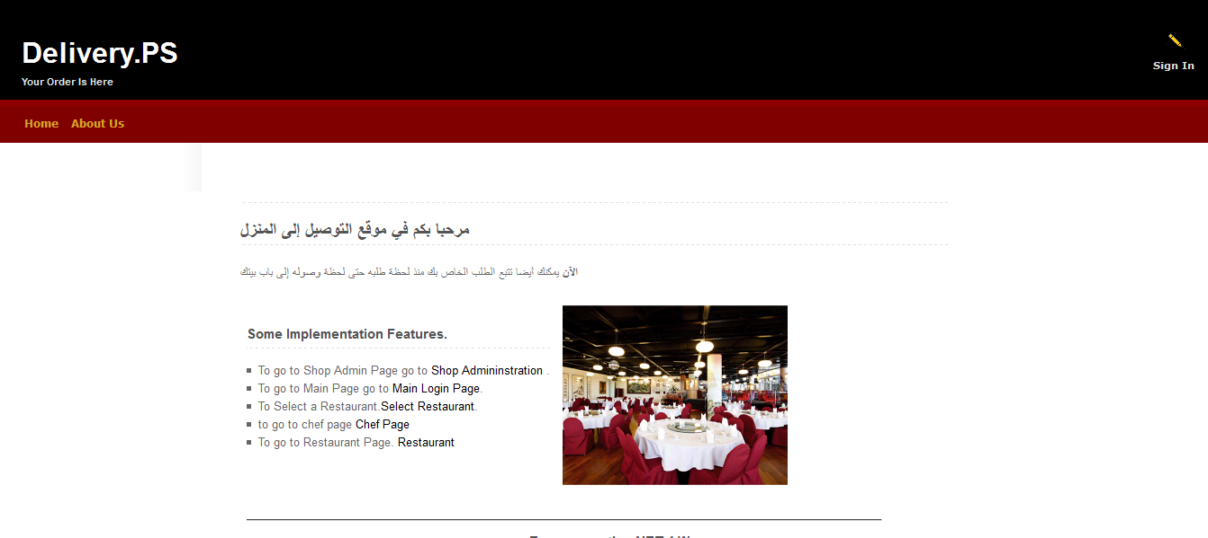
Figure 19: Main page

Then customer will be moved to the “restaurant selection” page, which we named as “select restaurant”. This page includes: 3 drop down lists, 1 to select the city in which the searching about the restaurant will be, 1 to select the area of the selected city in which the searching about the restaurant will be and 1 to select the food category which the restaurant we search for provides. Also, we used 3 buttons, 1 to search according to the area, 1 to search according to the food category and finally one to search according both area and food category. In order to display the result list of the restaurants search, we used a list view with 2 restaurants at each row, which show the name, image and address of each. This is all illustrated in the figure 20.

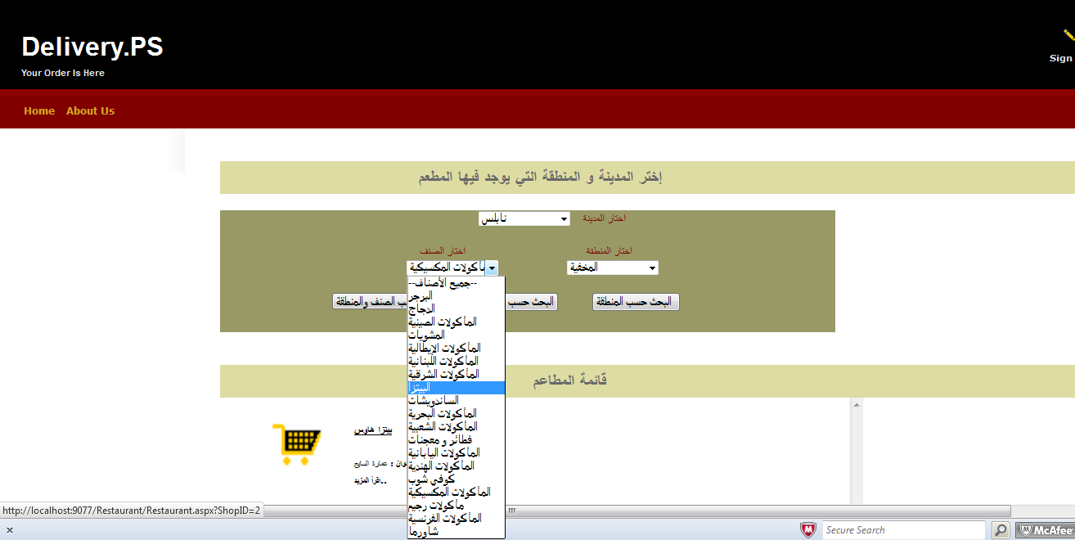
Figure 20: select restaurant page

When the customer chooses a restaurant from the list view, he will be moved to restaurant page, which we named as “Restaurant”. This page includes: 1 image field in which the restaurant image will be placed. And we used 9 labels that show the information about the restaurant like discounts, open/close time, phone …etc. We also used 1 list view to display the food categories founded in the restaurant, and 1 slide menu to show the list of meals according to the menu of the restaurant. Once a customer pick a meal he will see the meal’s information like its price, description and the meal image, then he must to specify the quantity of each selected meal.

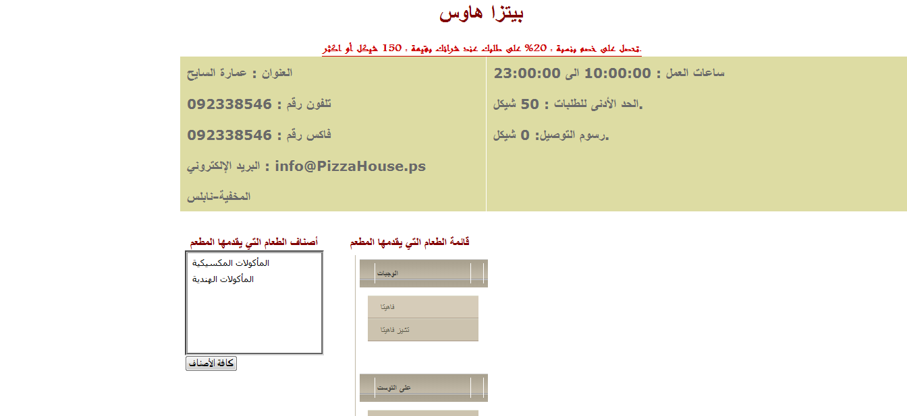
One other amazing thing the customer can do is to review the meals and see the previous reviews as well about any meal (if any), and we used a grid view to show the meal reviews. After choosing his order’s meals, he will make a final check out in order to make sure about what meals he ordered and the quantity of each meal, and this will be displayed using a grid view. This is all illustrated in the figure 21.
Figure 21: Restaurant page

Note that if the customer was new to the system, or he forgot to log in initially, he will then move to “log in” page where he can make new account if new customer or log in with his account if he already registered in the system and continues his ordering process normally, and this makes any one can capable of viewing the restaurant information and meals as an advertisement for it. This is all illustrated in the figure 22.
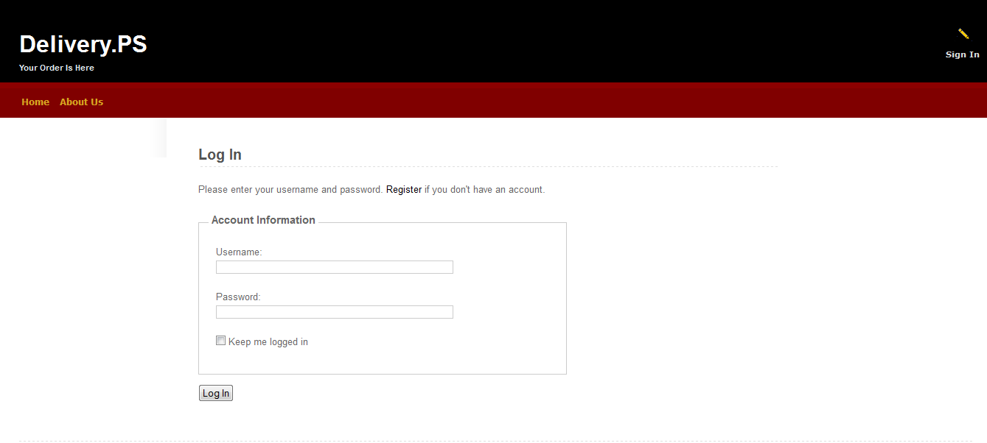
Figure 22: log in page

Additionally, customer can track each order from any restaurant in our system from the moment he orders until the moment the delivery man reaches his delivery place. This is available to customer once he makes an order and the order status become “on delivery”, when the delivery man start moving to deliver the order. This is all illustrated in the figure 23.
Figure 23: track delivery page

Finally, customer can edit his personal information any time and submit the changes as his convenience. On the other hand the new customers can sign up using the sign up page called “sign up”. This page includes: 12 text boxes in order to insert the new customer data, 4 text boxes for the customer name ( first name, second name, third name and last name ), 1 text box for the customer National ID, 1 text box for the customer Phone, 1 text box for the customer Mobile, 1 text box for the customer Address, 1 text box for the customer Email, 1 text box for the customer credit card (if any), 1 text box for the customer Username and 1 text box for the customer password. We also used 2 drop down lists, 1 to select the city in which the customer lives, and the other to select the area in which the customer lives. (For more information about each attribute you can see the database chapter). This is all illustrated in the figure 24.

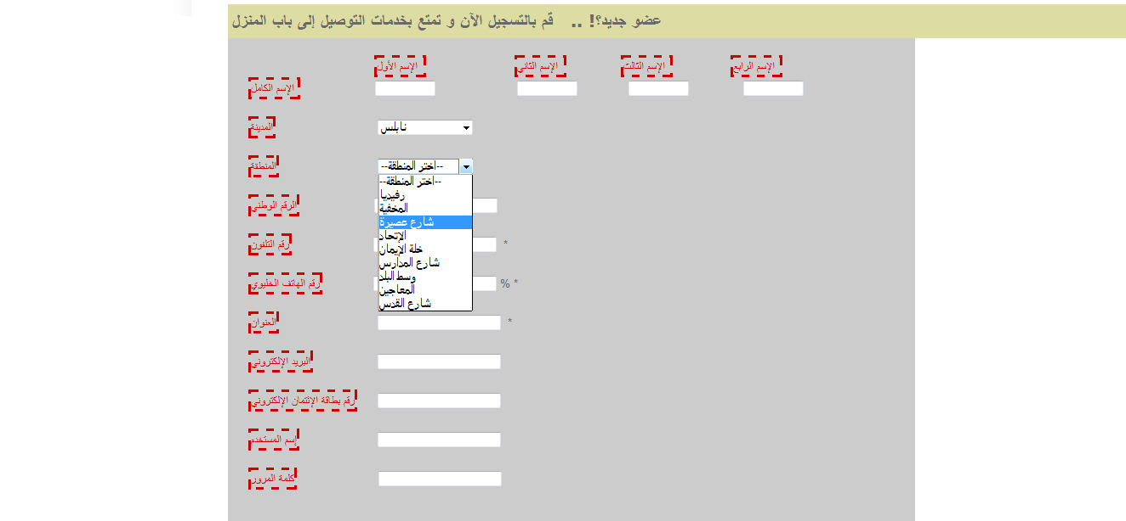
Figure 24: sign up page

Section 2.2.4 Chief
According to Restaurant chief, the interface he will use is the “Chief Main Page” where he first has to log in as an employee using his account (note that his account is created by the restaurant manager). This main page is illustrated in the figure 16.

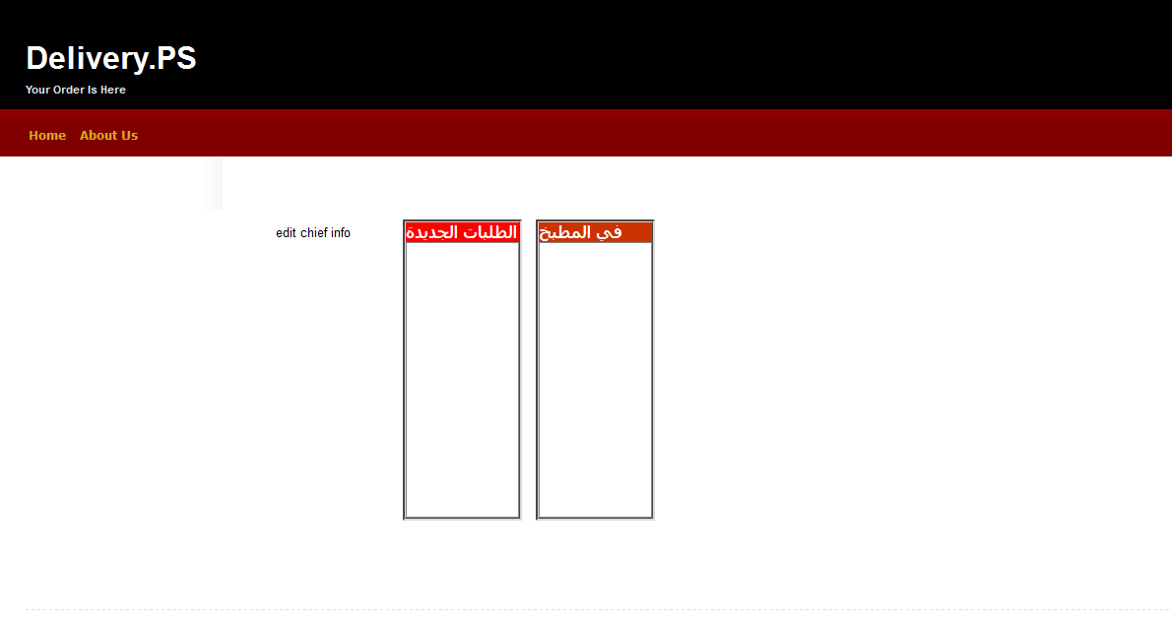
Figure 25: Chief Main page

Section 2.3 implementation & data
The website logic has been developed according to the system’s actors need. There will be in each page a code behind programmed using c# to satisfy the business logic for all the system’s actors, except the delivery man which will deal with the system using the mobile application, especially that he doesn’t need to be in the restaurant while his job is roaming to deliver the orders, and as well the mobile which will be the best suited way for him to interact with the system.
According to the data access layer we used LINQ model (Language-Integrated Query) that extends powerful query capabilities to the language syntax of C# and Visual Basic. LINQ introduces standard easily-learned patterns for querying and updating data, and the technology can be extended to support potentially any kind of data store. Visual Studio includes LINQ provider assemblies that enable the use of LINQ with .NET Framework collections, SQL Server databases, ADO.NET Datasets and XML documents.
We also write our own classes to deal with the database model tables, and this makes us able to flexibly fetch the data, update it and insert it to the database. These classes include: Areas111, Cities111, Customer111, Employees111, Food_Cat111, Job_Cat111, meal in rest, Menu Cat111, not_selected_Services111, Order111, select Area ID, Selected_food_cat111, Selected Job Cat111, Selected menu_cat111, selectShop111, Services111, Shop Admin Info, Shops111.

Section 2.2.3.1 Restaurant Manager’s pages implementation
The restaurant manager page logic includes using “order” table in the LINQ model in order to provide the manager with the available orders and their current status to manage them during serving the order process. We use also AJAX to keep pulling data from the database server to keep the consistency of data. We also developed an algorithm that makes organizing the orders received by each customer very flexible and easy, and we asked a lot of restaurants in order to know how they manage this process of prioritizing & serving the orders. The following pseudo code will explain the algorithm which is divided into 2 scenarios: the first is to “now” orders that are needed to be served as soon as possible, and the other is “at” orders are needed to be served at a specific time specified from the customer himself.

The following illustrates the main rules of the algorithm:

Ordering management algorithm
By default
    - ”at” orders will be added to the order table normally, then it will be “now” order instead of “at” on the critical time (unless we force the “at” order to be in now list).
    - “At” order start time = its critical time.

The following illustrates the “now” part of the algorithm:

// we assign order start time to a value (order start time is important to “now” //orders, but since all “at” orders will finally be “now” orders then it is //important to all orders).

If {“now” list of orders is empty (no orders in the new list)}
Then order start time = ordering time (current time)
End
Else {order start time (for new “now” order) = last order start time in “now” list + its total preparation time
}
End

// before adding new “now” order, we must check “at” orders.
If {“at” list orders is empty}
Then add new “now” order to the “now” list (restaurant manager new orders list) normally
End
Else {
If {[(order start time + new “now” order preparation time)
– critical time (for the order having least critical time from the “at” orders)] > 30 minutes
}
Then
If {(critical time for “at” order
– order start time for “now” order) > 30 minutes
}
Then put them to kitchen as:
Now first
At second (and set its urgent flag to 1)
Order start time “at” = its critical time
End
Else critical time for “at” = order start time for “at” = order start time for “now”
Then put them to kitchen as:
At first
Nowsecond, Order start time for “now” = (critical time + total preparation time) for “at”
End
End
Else if {30 minutes >
[(order start time + preparation time) for “now - (critical time for the order having the least critical time)]
> -30 minutes
}
Then critical time for “at” = order start time for “at”
= (order start time + its preparation time) for “now”
And then put them to kitchen as:
Now first
At second
End
Else {add new “now” order to kitchen normally}
End
}
End

The following illustrates the “At” part of the algorithm:

Count = # of “at” orders; I=1
// I=1…. Count (“at” orders ordered by their critical time ascending)

If {“at” list is empty (count = 0)}
Then if {“now” list (in kitchen orders) is empty}
Then you can order
From (current time + order preparation time + ½ hour)
To (close time – order preparation time for new “at” order)
End
Else {you can order from [last order start time (in “now” list)
+ Its preparation time
+ order preparation time for new “at” order
+ ½ hour]
To [close time – order preparation time
For new “at” order]
}
End
End
Else
If {“now” list (in kitchen orders) is not empty}
Then if {[(critical time for the order having least critical time + ½ hour allowed for delay) – (last order start time + its preparation time) in “now” list]
>= order preparation time for new “at” order
}

Then you can order
From (last order start time
+ Its preparation time
+ order preparation time for new “at” order
+ ½ hour for delivery)
To (critical time for the order having least critical time
+ ½ hour for delivery
+ ½ hour for allowed delay)

End
End
Else {you can order from [current time
+ order preparation time for new “at” order
+ ½ hour to [critical time for the order having least critical time
+ ½ hour for delivery
+ ½ hour for allowed delay]
}
End
If (count > 1)
Then while (I ≠ count)
If {[(critical time for “at” order [I+1] + ½ hour) - (critical time + preparation time for “at” order [I])]
≥ order preparation time for new “at” order
}
Then you can order
From (critical time
+ Preparation time for “at” order [I]
+ Its preparation time
+ order preparation time for new “at” order
+ ½ hour for delivery)
To (critical time for “at” order [I+1]
+ ½ hour for delivery
+ ½ hour for allowed delay)

End
I++;
End
End
If {[close time - (critical time
+ Preparation time for “at” order [I = count])
] > order preparation time for new “at” order
}
Then you can order
From (critical time for “at” order [I = count]
+ Preparation time
+ order preparation time for new “at” order
+ ½ hour for delivery)
To (close time – order preparation time for new “at” order)

End
End

The restaurant manager page logic includes using “employees” table in the LINQ model in order to provide the manager with the available employees and their information to manage them well. Additionally, we used “Meals” table in the LINQ model in order to provide the manager with the available meals and to update and manage them well. Moreover, we used “services” table in the LINQ model in order to provide the manager with the available services and to update and manage them well. In addition to employees table, we used “customers” table in the LINQ model in order to provide the manager with the customers’ information that are used to order from his shop.

Also, we used “order tracking” table in the LINQ model in order to provide the manager with the ability to track his restaurant’s delivery men. The same with “shops” table, where we used the LINQ model in order to provide the manager with the available information of his shop and to update it. Finally, as the manager is an employee in our system, he used the “employees” table in the LINQ model in order to edit his own information.

Section 2.2.3.2 Customer’s pages implementation
The customer’s pages logic includes using “cities” table in the LINQ model in order to provide him with the available cities in the system. Additionally, we used “Meals” table in the LINQ model in order to provide the customer with the available meals and to order from them. Moreover, we used “areas” table in the LINQ model in order to provide the customer with the available areas in each city to facilitate searching for some restaurant. In addition to areas table, we used “customers” table in the LINQ model in order to provide the customer with his information to update it as his convenience. Also, we used “order tracking” table in the LINQ model in order to provide the customer with the ability to track his order and keep an eye of the delivery man carrying it.

The “shops” table also is used by customer’s pages, where we used the LINQ model in order to provide the customer with the available shops in order to pick the one that he wants and make him able to view all the related information about the restaurants. The “reviews” table also is used by customer’s pages, where we used the LINQ model in order to provide the customer with the ability to review each meal. Also, we used “menu category” table in the LINQ model in order to provide the customer with the menu of each restaurant to select his order easily. Finally, as the customer in our system get benefit from the “food category” table in the LINQ model in order to help him search for his own favorite type of food.

Section 2.2.3.3 Chief’s pages implementation
The restaurant chief page logic includes using “order” table in the LINQ model in order to provide the chief with the available orders and their current status to manage them during serving the ordering process. We use also AJAX to keep pulling data from the database server to keep the consistency of data for the newly available orders. We also used the algorithm that we mentioned above to organize the orders received by each customer in a very flexible and easy way, and we asked a lot of restaurants in order to know how they manage this process of prioritizing & serving the orders. Moreover, as the chief is an employee in our system, he used the “employees” table in the LINQ model in order to edit his own information.

Chapter 3
The Smart Mobile Phone

The second part of the delivery system is a smart mobile phone system.
As technology grow rapidly the applications should follow it too, to reduce amount of works that human should consider and to put our business application in a wide area in the competitive market.

Section 3.1 Requirements:
The requirement of the mobile comes from the need of tracking the delivery men and managing and scheduling them by the restaurant manager. And so provides facility for delivery men to know the location of the orders they have to deliver.
The system requirements for mobile are divided into two fields, business requirements and technical requirements defined in the following two sections.

Section 3.1.1 business requirements
The delivery system has employees that travel to deliver the orders for the customers, that requirement must handle by mobile. System needs the mobile device with application is appearing from the following:
- Mobile should authorize the delivery man.
- System should know the location of delivery men to be tracked by the restaurant manager.
- Each customer should track only the delivery man of his order.
- System should guarantee that delivery man can check the orders target location in relative with his location.
- Delivery man should be able to retrieve new orders to deliver every time else if he is logged out from the system.
- Delivery man should see order in list and in map.
- Delivery man should see information of each order and customer information of the order.
- Delivery man doesn’t have web account, so he can show and edit his information.
Using mobile device to handle these requirements will give the project a big chance to occupy the delivery management systems market. So it brings customers to use it not other, and so brings restaurants to take apart from it.

Section 3.1.2 Technical requirements
In order to achieve and implement the business requirement we need:
- GPS sensor.
- Wi-Fi receiver.
- Mobile computer based device (laptop).
- Telephone communication.
We find that if we use these components as tools for each delivery man the system will fail from day number one as the cost is high (for e.g. GPS module costs 50$), so we find that an android based OS smart phone can provide all of these components in a small low power device. So our methodologies become as the following:
- Samsung Galaxy S device.
- Google android operating system.
- Global positioning system (GPS) device implemented in the device.
- Wi-Fi device implemented in the device.
- Programmable phone call services from android.
- Http protocol connection using object oriented programming (java platform).
- Android controls for activities interface.
- Android GPS provider classes from android SDK.
- Google map for viewing locations.
- Android working services.
Mobile application should handle the actions associated with it, there are actions execute on the mobile device and other will execute on the web server so our system is distributed system as following:
- Mobile authorizes the delivery man by checking his access on the datacenter which is on the database on the web server.
- Periodically mobile should send his location to the datacenter.
- Periodically mobile should receive new orders associated with delivery man.
- Mobile must store the orders on its storage to Discriminate between old and new orders.

All of these requirements should be handled using some communication module that uses message passing between the variant operating systems to synchronize the data flow.
Whole application will deploy on the mobile by a file (*.apk) the same for all delivery men in the system.

Section 3.2 Mobile application implementation
We build our mobile application using “Google android SDK” which is on the top of java platform. Specially we use (SDK version 10) which support the application to run on Android operating system version 2.3.3 and lower so full backward compatibility with versions 2.1, 2.2 and 2.3.3.
Developing application by using eclipse (Galileo version) IDE. Developing cycle divided into three stages:
- Interface: application pages and controls.
- Logic: actions handling thread and process synchronization.
- Data: orders storage.
- Communication: protocol and messages.
That we will explain in the following sections:

Section 3.2.1 Interface
We build the mobile interface using XML tags with android to arrange the layout. Our mobile application interfaces. As we didn’t finish putting the last touch on our look and feel interface, we will provide you with the initial interface that we use at the moment.
Login activity:
The first interaction of our application is the login page figure 26 (it’s called “activity” in android SDK terminology) it takes the username and password then using our communication module it checks it in the datacenter and returns the access privilege to the application. So any action on the application it associates with logged in delivery man.
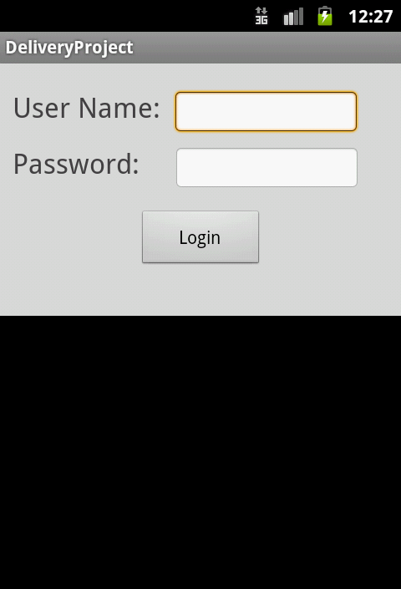

Main activity:
Figure 26: Login Activity
It is the main page that it is open while using the application. It contains two taps as. The first tap is orders in list view (figure 27) which shows the current orders associated with this delivery man each has ID, address and price as an abstract information.
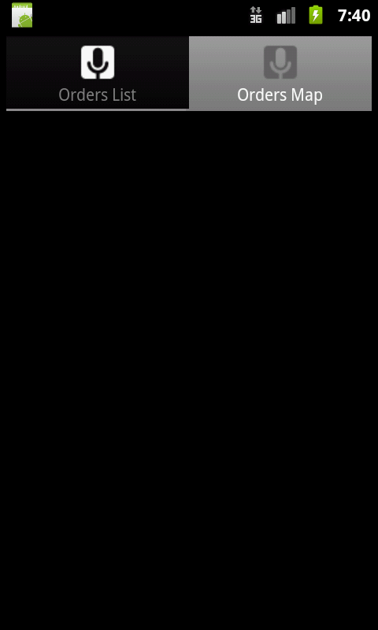
Second tap is orders map view (figure 28) to show all orders location on the map and let delivery man determine the rout of his travel.
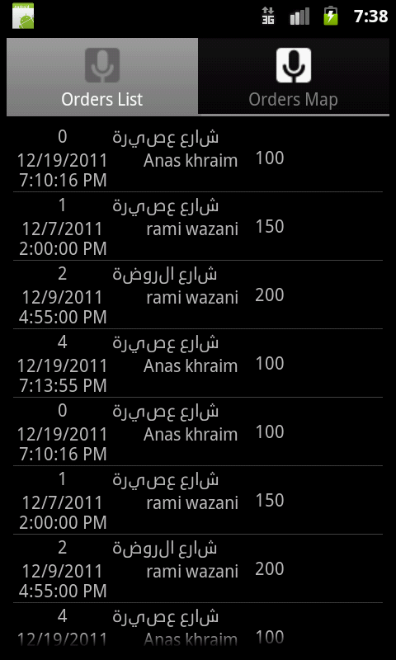
Figure 28: orders map view
Figure 27: Main Activity

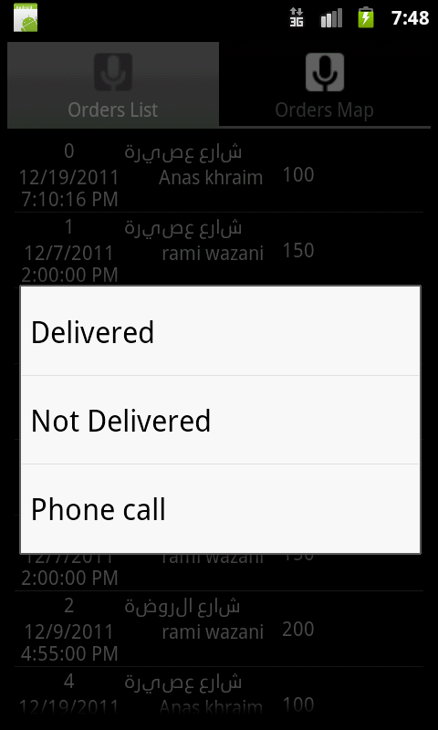
In orders list view when long press is applied on order context menu will appear as in (figure 29) to choose action about that order. Choose delivered when customer takes his order, if not for any reason he should choose call customer to announce him, if not response he should choose not delivered option.
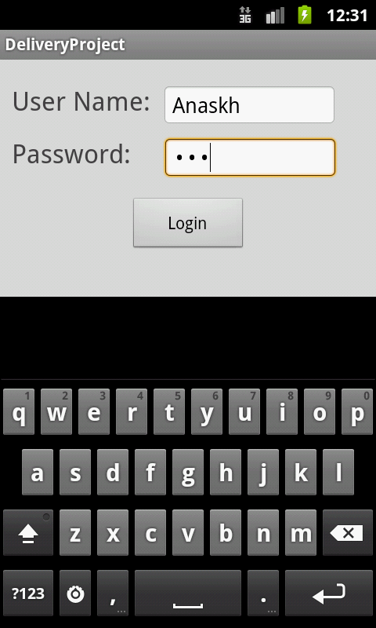
Figure 30: Customer details page (coming soon)
Figure 29: Context menu options

Order details obtained when click on that order so order details page will appear as in (figure 30). Which contains two taps first is to show the information of the customer of that order, second one to show the details information about the order itself as in (figure 31).

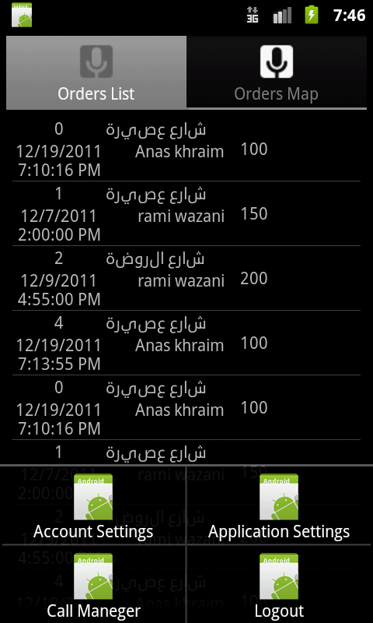
Figure 31: order details (coming soon)
Figure 32: application menu

From main activity delivery man has menu choices as in (figure 32) so he can call his manager, send him a message, view his account information in the system and edit some of his attributes and logout from the system.

Section 3.2.2 Implementation & Actions
It’s the implementation behind the interface and it is considered as the middleware between the interfaces and the communication module.
The Android operating system is a multi-user Linux system in which each application is a different user. Each process has its own virtual machine (VM), so an application's code runs in isolation from other applications.
Every application runs in its own Linux process. Application should do some actions simultaneously; the application should test new orders from database in the web server, should send the device location periodically and should store new orders in order to render it and its information on the application pages.
If we do that in serial single-threaded code the application will blocks many times and it will crash after some blocks so run away from the system. So we divide this big task into small tasks and associate these tasks to threads so scheduling theses threads will put the application in stable behavior without blocks or crashes.
The application considered as multithreaded application and implementation becomes as the following division.

Our implementation:
The application will run half of the work and make a working service that runs independently to keep mobile listening for new orders even the application executing or not, the service will stop only when the delivery man log out from the system.

The following table will show the threads and associated tasks.
Table 1: application threads and associated works
Thread | The work | location | Parent thread
Main thread | Responsible for handling the user’s interactions and creating other threads and the service | Main activity and its Childs | Android OS
UI thread | Responsible for retrieving new order from local database and render it in the list view and map view | Orders list view and map view activities | Main thread
Service thread | Responsible for retrieving the new order notification and notify the delivery man even the application is executing or not | Application service | Main thread
Working thread | Responsible for sending the location of the device periodically to database in web server using communication module | Application Service | Service thread

The actions behind the interfaces is about message passing between two distributed systems using communication model (later on this chapter) it will be as follows:
Send location: use communication module to send the latitude and longitude of the device with id of delivery man and add it in database of the web server.
Retrieve the announcement of new orders: receive on a flag by the communication module if there are new orders it will be true so the service will notify about that and will execute the application if it’s closed.
Retrieve the orders itself: the application will receive the orders from the communication module and add them into local database (SQLite database) .

Send delivered or not: send a flag to communication module assigned with this type of actions true or false.
Call customer & call manager: use the phone number of the customer of that order and give it to telephony system of android (must application request permission to access when the application installed) and call will be performed.
Show orders and customer information: retrieve it from local database and render it in the page.
Edit the delivery man information: update the information then retrieve the information from local database the edit will push the information to the server to be updated.
Show order in map view: use the latitude and longitude of each order in the local database and put point on the map according to that coordinate.

Section 3.2.3 Data
Data storage in the mobile is SQLite database that is associated with each application on the device. We use two tables; orders table and deliveryman table as follows:

Section 3.3 Communication module
As our system is distributed one so there is one web server that has one data centric database and many mobile devices that is coordinated by it, so the communication module we use is message passing to synchronize them with each other.
We use the HTTP protocol to transfer the information by the request to the server and use the response to get the data from the server.
Mobile here is active in the communication as he knows the IP and the port of the server through the domain name (delivery.ps) but server is passive so the mobile is anonymous and he does not know a real IP or port to communicate with.
The key difference between anonymous mobiles here is the delivery man id that is associated with each request.
Each data gram transferred between system end points is serialized through our serializing method:

Table 2: serialization
Data level | Split character
First level | “&”: variable1=value1&variable2=value2…
Second level | “!”: variable3=attribute1:value1!attributew:value2…
Third level | “;”: variable4=attribute1a=value1a;attribute1b=value1b !attribute2a=value2a;attribute2b=value2b…

In the following table we show how mobile can pull from the server and push to it and vice versa:
Table 3: communication methods
Action | Method
Mobile PUSH to sever | Send http request with empty response
Mobile PULL the server | Send empty request and get data in response
Server PUSH to mobile | Send periodically empty request and get in response
Server PULL the mobile | Send periodically request with empty response

To reduce traffic we make as possible as request and response is full data using the response data as piggybacked.
The web server will handle the request with C# coded page we called it server portal that will response the data according to request action and the delivery man id, these two attributes is associated with each message.
Communication messages:
The communication request and response is shown in the following table:
Table 4: communication messages
Action | request | response
Login action | send username and password | accepted or denied and deliver man information when accepted
Send location | Send longitude and latitude | Piggybacked new order announcement
Get new orders | Send the old orders in the mobile | Piggybacked get new orders
Delivered action | Send the order id and flag delivered true | Empty response
Not delivered | Send the order id and flag delivered false | Empty response
Edit deliver man information | Send all information | Edited announcement

Chapter 4
Database

The database we designed is a centralized database at the web server that contains all the required system data. We built our database using Microsoft SQL Server 2008 Express, and then we have used it in Microsoft Visual Studio 2010 ultimate. We use only one database and we named it “Delivery.ps_Data”, and this database consists of 21 tables to satisfy the project needs, and since our project is scalable, the database will be scalable as well. The tables we have used are Areas, Cities, Content, Customer, Employee, Favorite, Food Category, Job Title, Meal, Meal Content, Menu Category, Order, Order meals, Order Status, Order Tracking, Payment Method, Reviews, Services, Shop, Shop Categories and Shop Services.
The following is the description for each table:
Areas table:
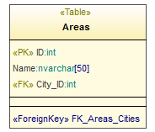
This table stores the information of all areas related to each city for simplicity in searching a specific restaurant in a specific area in a specific city. And this table has 3 columns:
Table 5: Areas table
Column name | description
ID | Assign a unique ID for each area
Name | The name of each area
City ID | The city ID in which this area is located

This table has 1 primary key which is ID and this table has 1 foreign key which is:
FK _ Areas _Cities: This connects each area with its city. The following diagram describes the type of each column:

Cities table:
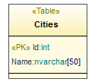
This table stores the information of each city in which there are restaurants that use our system. And this table has 2 columns:
Table 6: Cities table
Column name | description
ID | Assign a unique ID for each city
Name | The name of each city

This table has 1 primary key which is ID

Content table:
This table stores information about the contents of each meal that will be used to help the customer picks his order in a much easier and advanced search. And this table has 2 columns:
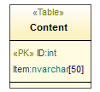
Table 7: Contents table
Column name | description
ID | Assign a unique ID for each item
Item | The name of each item that will be used to specify the characteristics of the meals

This table has 1 primary key which is ID
The following diagram describes the type of each column:
Customer table:
This table stores information about each customer that will use our system in order to facilitate the operation of ordering and delivery of the orders and of course to help paying for orders. Some of the information is necessary for our system and others are not and they are arbitrary for supplying a better service for the customers. And this table has 17 columns:

Column name | description
ID | Assign a unique ID for each customer
First Name | The first name of each customer
Second Name | The second name of each customer
Third Name | The third name of each customer
Last Name | The last name of each customer
Address | The Address of each customer
Email | The email of each customer
Mobile | The mobile of each customer
Phone | The phone of each customer
Area ID | The ID of the area in which each customer is located
credit Card | The credit Card of each customer (if any)
Blacklist | Specify if the customer is in the black list or not
Latitude | The Latitude of the location of each customer
Longitude | The Longitude of the location of each customer
National ID | The National ID of each customer
Username | The Username of each customer (must be unique; because it’s used for logging into the system)
Password | The Password of each customer
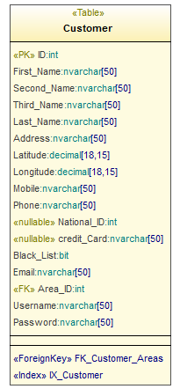
This table has 1 primary key which is ID
And this table has 1 foreign key which is FK _ Customer _Areas, which connects each customer with its area.

Employee Table:
This table stores information about each employee that will be in our system in order to facilitate the operation of managing all the employees in each restaurant. Some of the information is necessary for our system and others are not and they are arbitrary for supplying a better service. And this table has 18 columns:
Column name | description
ID | Assign a unique ID for each employee
First Name | The first name of each employee
Second Name | The second name of each employee
Third Name | The third name of each employee
Last Name | The last name of each employee
Address | The Address of each employee
Email | The email of each employee
Mobile | The mobile of each employee
Phone | The phone of each employee
Shop ID | The ID of the shop in which each employee is working
Job Title ID | The ID of the job title that assigned to each employee
Gender | Specify the gender of each employee
Social Status | The Social Status of each employee
Age | The Age of each employee
National ID | The National ID of each employee
Username | The Username of each employee
Password | The Password of each employee
logged | Specify if the employee who has a deliveryman job title is logged in or not
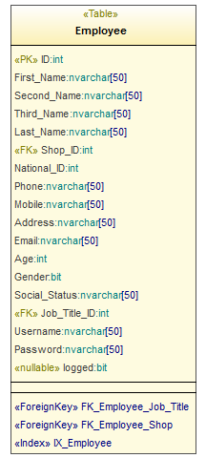
This table has 1 primary key which is ID and this table has 2 foreign keys which are:
FK_ Employee _ Shop: which connects each Employee with its Shop.
FK_ Employee _ Job Title: which connects each Employee with its Job Title.

Favorite Table:
This table stores information about each meal that how many times ordered by each customer in our system in order to facilitate the operation of ordering next time and the system will advice the customers with the most ordered meals in each restaurant. And this table has 3 columns:
Column name | description
Meal ID | The ID of the meal which each customer can order it and increase its rank
Customer ID | The ID of the customer that ordered the meal referred by Meal ID
Ordered count | Specify the count number of which the meal was ordered

This table has 2 combined primary keys which are Meal ID and Customer ID.
And this table has 2 foreign keys which are:
FK_ Favorite _ Customer: which connects each ordered-meal count number with the customer made that orders.
FK_ Favorite _ Meal: which connects each ordered-meal count number with its Meal.
The following diagram describes the type of each column:
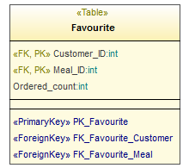
Food Category Table:
This table stores information about the food category of each meal in each restaurant in our system in order to facilitate the operation of ordering meals by its food category and a better categorization for all meals in the system. And this table has 3 columns:
Column name | description
ID | The ID of the food category which some meals belong to
Shop Category ID | The ID of Shop Category to which this food category belongs to
Category | The Name of the food category which some meals belong to
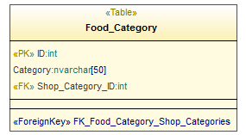
This table has 1 primary key which is ID
And this table has 1 foreign key which is:
FK_ Food Category _ Shop Categories: which connects each food category with the Shop Category to which it belongs.
The following diagram describes the type of each column:

Job Title table:
This table stores information about the job titles assigned to each employee in each restaurant in our system in order to facilitate how to interact with each employee according to his job title and organizing the hierarchy of the employees inside each restaurant. And this table has 3 columns:
Column name | description
ID | The ID of the job title which assigned to some of the employees
Shop Category ID | The ID of Shop Category to which this job title belongs
Category | The Name of the job title which assigned to some of the employees

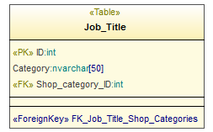
This table has 1 primary key which is ID
And this table has 1 foreign key which is:
FK_ Job Title _ Shop Categories: which connects each Job Title with the Shop Category to which it belongs.
The following diagram describes the type of each column:
Meal table:
This table stores information about each meal that belongs to a specific restaurant in our system, in order to facilitate the operation of managing all the meals in each restaurant. Some of the information is necessary for our system, and others are not and they are arbitrary for supplying a better service. And this table has 14 columns:
Column name | description
ID | Assign a unique ID for each meal
Name | The name of each meal
Availability | The Availability of each meal
Deliverable | Specify if the meal is deliverable or not
Description | The Description of each meal
Discount Value | The Discount Value of each meal
Shop ID | The ID of the shop in which the meal is offered
Food Category ID | The ID of the Food Category to which meal belongs
Price | Specify the Price of each meal
Menu Category ID | The ID of the Menu Category in the restaurant to which meal belongs
Preparation Time | The Preparation Time of each meal
Rank Counter | The Counter that specify the number of customers ranked the meal
Accumulative Rank | The total sum of ranks for the meal from all the customers
Image | The Image of each meal (if any)

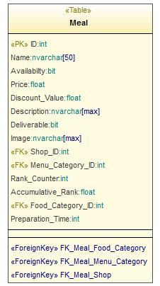
This table has 1 primary key which is ID
And this table has 3 foreign keys which are:
FK_ Meal_ Food Category: that connects each Meal with its Food Category.
FK_ Meal _ Menu Category: which connects each Meal with its Menu Category.
FK_ Meal _ Shop: which connects each Meal with the shop in which the meal is offered.
The following diagram describes the type of each column:

Meal Content table:
This table is a look up table between each meal and its content that will be used to help the customer picks his order in a much easier and advanced search. And this table has 2 columns:
Column name | description
Meal ID | The ID of the meal which each customer can order it and increase its rank
Content ID | The ID of the customer that ordered the meal referred by Meal ID
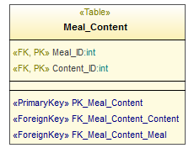
This table has 2 combined primary keys which are Meal ID and Content ID.
And this table has 2 foreign keys which connect each meal with its Content which are:
FK_ Meal Content _ Content, FK_ Meal Content _ Meal
The following diagram describes the type of each column:

Menu Category table:
This table stores information about the Menu categories in which the meals are categorized in each restaurant in our system in order to facilitate the operation of ordering meals by its Menu category and a better categorization for all meals in the system. And this table has 3 columns:
Column name | description
ID | The ID of the Menu category which some meals belong to
Shop Category ID | The ID of Shop Category to which this Menu category belong to
Category | The Name of the Menu category which some meals belong to

This table has 1 primary key which is ID
And this table has 1 foreign key which is:
FK_ Menu Category _ Shop Categories: which connects each Menu category with the Shop Category to which it belongs.
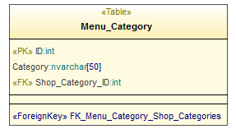
The following diagram describes the type of each column:

Order table:
This table stores information about each order that belongs to a specific restaurant in our system, in order to facilitate the operation of managing all the orders in each restaurant. Some of the information is necessary for our system, and others are not and they are arbitrary for supplying a better service. And this table has 16 columns:

Column name | description
ID | Assign a unique ID for each order
Ordering Time | The ordering Time of each order
Total Price | The total Price of each order
status ID | The status ID of each order that represents its current status
Payment Method ID | The Payment Method ID of each order that represents its Payment Method
Delivered at | The time at which each order is delivered
Now Or at | The ordering type of each order
Address | The Address of each order
Start preparation Time | The time at which the preparation of each order has really started (used in a special algorithm we have developed to prioritize serving the orders)
total preparation time | The total time required for the preparation of each order (used in a special algorithm we have developed to prioritize serving the orders)
Customer ID | The ID of the Customer that ordered this order
critical time | The time at which the preparation of each order should be started (used in a special algorithm we have developed to prioritize serving the orders)
Urgent | Specify that the order is urgent or not (used in a special algorithm we have developed to prioritize serving the orders)
Delivery man ID | The ID of the Delivery man that is responsible for the delivery of this order
Latitude | The Latitude of the location of the customer to whom this order belongs
Longitude | The Longitude of the location of the customer to whom this order belongs

This table has 1 primary key which is ID and this table has 5 foreign keys which are:
FK_ Order _ Customer: that connects each Order with its customer.
FK_ Order _ Employee: which connects each Order with the delivery man responsible for the delivery of this order.
FK_ Order _ Order Status: which connects each Order with its Status.
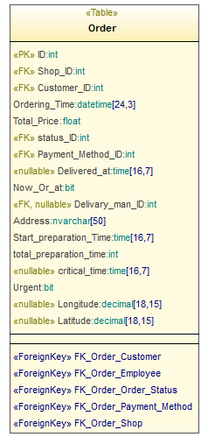
FK_ Order _ Payment Method: which connects each Order with its Payment Method.
FK_ Order _ Shop: which connects each Order with the shop from which it was ordered.
The following diagram describes the type of each column:

Order meals table:
This table stores information about each order that how many meals it contains and the quantity of each meal ordered by each customer in our system in each restaurant. And this table has 3 columns:
Column name | description
Meal ID | The ID of the meal
Order ID | The ID of the order that the meal belongs to
Quantity | Specify the Quantity of each meal in the each order
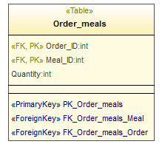
This table has 2 combined primary keys which are Meal ID and Order ID.
And this table has 2 foreign keys which connects each Order with its meals, which are:
FK_ Order meals _ Meal, FK_ Order meals _ Order
Order Status Table:
This table stores information about each order status that shows the process of ordering and delivery of each order ordered by each customer in our system in each restaurant. And this table has 3 columns:
Column name | description
ID | The ID of the status that describes each order
Status | The Name of the status that describes each order
Image | The Image of the status that describes each order
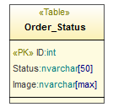
This table has 1 primary key which is ID
The following diagram describes the type of each column:

Order Tracking Table:
This table stores information about each order tracking that shows the process of tracking and delivery of each order ordered by each customer in our system in each restaurant. And this table has 5 columns:
Column name | description
ID | The ID of the order tracking record recorded at some time
Order ID | The ID of the order that the tracking belongs to
Latitude | The Latitude of the current location of the delivery man to whom this order was assigned
Longitude | The Longitude of the current location of the delivery man to whom this order was assigned
Time | The time at which the current location of the delivery man (to whom this order was assigned) was recorded
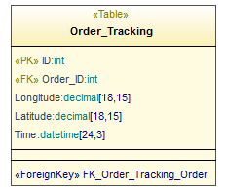
This table has 1 primary key which is ID
And this table has 1 foreign key which is:
FK_ Order tracking _ Order: that connects each Order with its tracking information.

Payment Method Table:
This table stores information about payment method for each order ordered by each customer in our system in each restaurant. And this table has 2 columns:
Column name | description
ID | The ID of the order payment method
payment method | The name of the order payment method
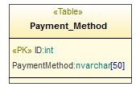
This table has 1 primary key which is ID
The following diagram describes the type of each column:
Reviews Table:
This table stores information about each meal reviews from any customer in our system in each restaurant. And this table has 4 columns:
Column name | description
ID | The ID of the review record related to a specific meal
Meal ID | The ID of the meal that the review belongs to
Customer ID | The ID of the customer that the review belongs to
Review | The review text
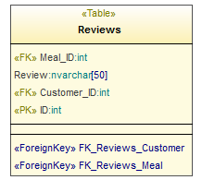
This table has 1 primary key which is ID
And this table has 1 foreign key which is:
And this table has 2 foreign keys which are:
FK_ Reviews _ Customer: that connects each review with the customer to whom this review belongs.
FK_ Reviews _ Meal: which connects each review with the meal to which this review belongs.
The following diagram describes the type of each column:
Services Table:
This table stores information about the services available in each restaurant in our system. And this table has 3 columns:
Column name | description
ID | The ID of the Service that can be available in any restaurant in the system
Service | The Name of the Service that can be available in any restaurant in the system
Image | The Image of the Service that can be available in any restaurant in the system
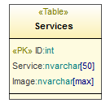
This table has 1 primary key which is ID
The following diagram describes the type of each column:

Shop Table:
This table stores information about each shop that will use our system in order to facilitate the operation of managing, ordering and delivery of the orders. Some of the information is necessary for our system and others are not and they are arbitrary for supplying a better service for the restaurant manager. And this table has 17 columns:
Column name | description
ID | Assign a unique ID for each shop
Name | The name of each shop
Open Time | The open time of each shop
Close Time | The close time of each shop
Minimum Charge | The Minimum Charge to make an order from shop
Address | The Address of each shop
Email | The email of each shop
Image | The Image of each shop
Phone | The phone of each shop
Area ID | The ID of the area in which each shop is located
Delivery Fees | The Delivery Fees on the orders of each shop (if any)
Fax | The Fax of each shop
Latitude | The Latitude of the location of each shop
Longitude | The Longitude of the location of each shop
Category ID | The Category ID to which each shop belongs
Discount Percent | The Discount Percent at every order from each shop
Discount Start Limit | The Limit at which Discount at every order from each shop start
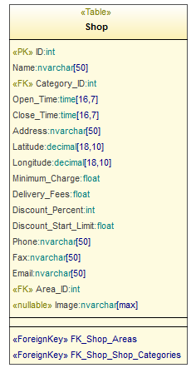
This table has 1 primary key which is ID
And this table has 2 foreign keys which are:
FK_ Shop _ Areas: which connects each Shop with its area.
FK_ Shop _ Shop Categories: which connects each Shop with the Category to which it belongs.
The following diagram describes the type of each column:

Shop Categories Table:
This table stores information about the Shop Categories available in our system (note that we will only use the “Restaurant” shop category in our system, but this system can extend to include sweets shops, flower shops… etc. And this table has 3 columns:
Column name | description
ID | The ID of the Shop Category that can be available in our system
Category | The Name of the Shop Category that can be available in our system
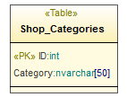
This table has 1 primary key which is ID
The following diagram describes the type of each column:

Shop Services Table:
This table is a look up table between each meal and its Services that will be used to help the Restaurant manager to have many services belong to his restaurant. And this table has 2 columns:
Column name | description
Shop ID | The ID of the Shop which has many services
Service ID | The ID of the Service that can belong to many shops

This table has 2 combined primary keys which are Shop ID and Service ID.
And this table has 2 foreign keys which connect each Shop with its Services which are:
FK_ Shop Services _ Shop, FK_ Shop Services _ Services
The following diagram describes the type of each column:

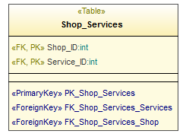

The following is the UML diagram and the ER diagram for the database:

Conclusion
We build the system which consists of web site that deployed on ASP.NET server and mobile application on Android operating system (Linux based), and coordinate the clients and web server and mobile devices in a proper scheduling and synchronization.
We spend 3 months in collecting requirements building database in standard and appropriate way so the data base didn’t changed through development.
The mobile Implementation consumed a lot of time so mobile programming is new field to us, so we got the experience in.

Our system is highly rated to be applied in our community and will take big chance to be in the market (God willing) soon.

Thanks

First, we present our thanks for computer engineering department in AN-Najah National University.
Thanks to our supervisors:
Dr. Raed Al-qadi
Dr. Ashraf Armoosh

Thanks to the Committee discussion members:
Dr. Luai Malhis
Dr. Samer arandi
Dr. Hanal Abu-Zant

Anas khraim
Mahmoud sharaf

