
An-Najah National University
Faculty of Engineering
COMPUTER Engineering Department

Graduating Project #1

Photo Editor Online
Using smart client

Under Supervision :
Dr. Haya Samaaneh
Dr. Ra’ed AlQadi
Dr. Anas Ta’amah
Dr. Lu’ai Malhees

Prepared by:
وفاء حسين النقيب 10507388
دعاء جواد غزال10507438

2009-2010
Photo editor is a offline online service, user can work online or install the application and work offline. And once the user open the offline application it will check for updates automatically . The user can save his files locally .
This application runs on the speed of the client machine not the web’s.

Why smart client ?
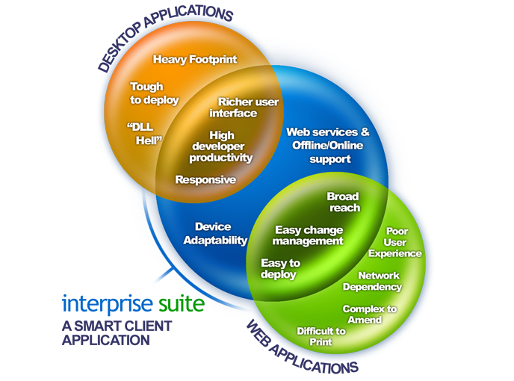

The emergence of the internet and the increased globalisation of business have brought about an ever increasing need to be able to access and process company data from remote locations. Organisations that have needed remote data access capabilities have had to settle for slow click and wait browser based applications, expensive leased lines or hard to setup terminal server applications.
In order to overcome these obstacles Microsoft developed a series of technologies in the .NET framework that allows a desktop applications to connect to data over the internet like a web browser would. By combining the power and flexibility only possible in a desktop application with the ability to transfer data over the internet like a web browser a new, superior type of application is created with the smart client application.
In a typical Client / Server setup a Smart Client application run on Client machines with full access to the computing resource on that machine for example, access cache or data on the client’s memory or hard drive, access printers and other local resources. As Smart Client applications rely on the resources of the client, they greatly increase the scalability of a Client / Server application. As compared to a browser based application, Smart Client applications are substantially faster since they do not have to download HTML, JavaScript, Cascade Style Sheets, Images, etc in order to function.

Advantages of Smart Client
Richer user interface like a desktop client
Faster performance – no html, JavaScript or images to download unlike a web based product
The ability to evolve to allow offline access
The ability to store cached data locally
The ability to consume local resources - i.e. scanners, printers, multiple cpu threads

Photo editor :
Website snap shoot:
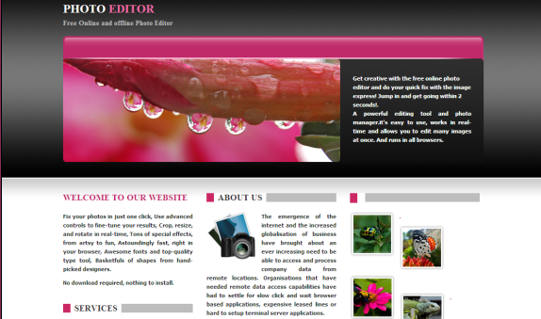

Application snap shoot:
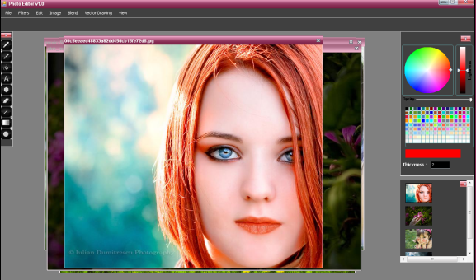

Features :
- Tools:
Pen: free Line tool.
Brush: has many types like star ,circle ,image ..etc.
Bucket tool: fill tool, with some algorithm to fill photos.
Text tool: write text to image.
Eraser tool.
Polygons tool: you can select number of sides of polygon.
Rectangle ,circle , line tools …etc.
- Filters:
More than 40 filter to adjust the photo.
- Capability to open as many image as you can and adjust each one separately.

- Unlimited undo and redo for each image.
- Flip image and mirror it and rotate it.
- Blend images with more than 20 blending types.
Vector drawing:
Draw rectangles ,circles , paths ,Polygon .. etc.
You can move them with the mouse group them and change their layout on a dotted grid .
This application can open Photoshop files(*.Psd). And save as image or .xml file.
Language Used:
For the application: Smart client based on c#.
For the website: Asp.net.
Problems faced us:
Smart client is a new technology , we take time to learn it.

