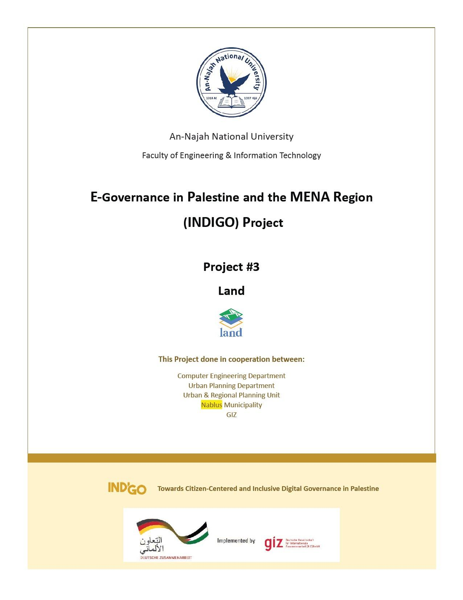
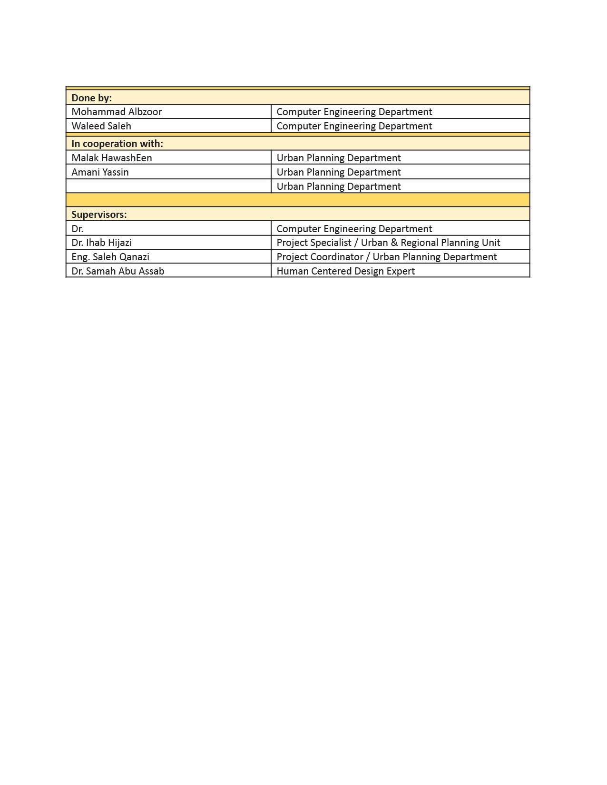

Acknowledgment

To all those who helped in making this project possible, to the municipalities who dedicated some of their time and effort to answer our questions,to our beloved An-Najah National University that supported this project to make the country and the community better and to make us the students make a difference, to the GIZ that gave the resources needed, managed the project and was the communication line between all the parties involved.
To our supervisor Dr.Samer Arandi who although was super busy as the Dean, took a lot of his time for us,he believed that we could do it,he kicked the laziness out of us and even when we had limited progress and no indication to the massive amounts of time spent on the project because of the problems we encountered he kept believing and encouraging us.
To Eng.Saleh Qanazi who was with us almost daily, he kept checking on every step and made the communication with the Urban Planning Team much easier and he was very tolerant of us asking questions and making an insane amount of meetings he was especially tolerant of us forgetting things or being late -which we are very very sorry for-.
To Dr.Ihab Hijazi who pointed us in the right direction when we were clueless, and kept phoning us especially nearing the end. To a teacher from faraway to Dr. Samah Abu Assab who spent her time teaching us Human Centred Design and empathy which and even after all that was done she kept checking on us. To Dr.Emad Natsheh who kept checking on us, encourging us and answering different questions. To many more professors and colleagues who kept us going even in the hardest of times.
To all those mentioned and many more, words can’t describe our thanks so all We could say is thank you very much from the bottom of our hearts

Dedication

We would like to thank everyone who supported us those who this work won’t be done without from friends, family, and those people who made it their life’s journey to write articles that help those who are thirsty for knowledge.

DISCLAIMER

This report was written by student(s) at the Computer Engineering Department, Faculty of Engineering, An-Najah National University. It has not been altered or corrected, other than editorial corrections, as a result of the assessment and it may contain language as well as content errors. The views expressed in it together with any outcomes and recommendations are solely those of the student(s). An-Najah National University accepts no responsibility or liability for the consequences of this report being used for a purpose other than the purpose for which it was commissioned.

Contents

- Introduction 8
  - Background 8
  - Problem Statement 8
  - Significance 8
  - Objectives and Scope 8
  - Report Organization 8
- Constraints and Earlier Coursework 10
  - Constraints 10
    - Immature AR Technology 10
    - Lack of Mobile Devices 10
    - Lack Of iOS Tooling 10
    - Lack Of Domain Knowledge 10
    - Inexperience 10
    - Miscommunication And Late Data Delivery 10
    - Lack Of Time 10
  - Standards/Codes 11
  - Earlier coursework 11
    - Object Oriented Programming 11
    - Database Design 11
    - Distributed Operating Systems 11
    - Software Engineering & Advanced Software Engineering 11
    - Critical Thinking and Research Skills 11
- Literature Review 12
  - Geomolg 12
  - Maps 12
  - What Distinguishes Land-Info From Previous Examples? 13
- Methodology 14
  - Inspiration Phase 14
  - Ideation Phase 14
  - Implementation Phase 14
    - DataBase Design 14
    - System Features and Implementation 16
    - Drawer 19
    - Saves 20
    - Contact Us 20
    - Web Admin 21
    - The logo 23
    - Project Structure 23
- Results And Discussions 25
  - Data and Analysis 25
  - Conclusion 26
- Conclusion 27
  - Summery 27
  - Improvements 27
  - Future Work 27
    - The AR section 27
    - Adding The Data Of Other Cities 27
    - Build The IOS Version 27
    - Web App & Admin Mobile App 27
  - Outcome 27

List of Figures

  - Sign-Up Page 16
  - Sign-In Page 17
  - The map Page 17
  - User Menu. 18
  - Regulation Types 18
  - Report Menu First Section. 18
  - Report Menu Second Section. 19
  - App Drawer. 19
  - Saves Page. 20
  - Contact Us Page 20
  - Email Template 21
  - Complaints Table 21
  - Statistics Page 22
  - Create Admin Page 22
  - The Logo. 23
  - NodeJS and Express Logos 23
  - PostGIS Logo 24
  - React Logo 24
  - Flutter Logo 24
  - MVVM Arch 24
  - Parcels In Jenin. 25
  - Master Plan In Jenin. 26
  - Buildings In Jenin. 26

Abstract

The municipalities Engineering sector gets a lot of questions from citizens who don’t understand the buildings regulations,after some research it was found that Palestine’s buildings regulations and getting in contact with the municipality are troublesome and very confusing for the citizens.An app that solves the problems from the citizens and the engineers perspective was needed,so we tried to take many approaches to solve this problem the first ”Dream” approach was to make an AR app that shows the users a live representation that could be interacted with, but this approach didn’t see the light because of technical issues and the immaturity of the AR tech, so another approach of building an easy to use map application that the user could interact with and use the same app to get in contact with the municipality was the one taken. The app makes the users less likely to contact the engineers for questions so making them do more things with their time, and it also makes the citizens have all the answers to their most common questions easily,reliably and at any time.

Introduction

Background
Knowing the details of the land information and understanding its types and building provisions for each type is one of the basics for building any facility, whether it is a residential or commercial facility, and this matter takes its specialty among the Palestinian people with the diversity of land provisions, so knowledge of its information is essential.

Problem Statement
There are three segments of society, and each segment has its own problems.
- Ordinary citizen: Most citizens face a problem with the difficulty and complexity of formal transactions in order to be able to obtain information related to a specific piece of land, despite the fact that this information is public and available to everyone.
- Women: Due to the fact that the Palestinian society is mostly conservative oriental, women face problems in obtaining information related to the lands that they have inherited.
- The handicapped: The handicapped confront specific challenges in terms of movement and, as a result, going to government departments to enquire, which may result in their rights being revoked or their ability to utilize their property being restricted.

Significance
The collection and preservation of land information is often challenging , so the application we are developing organizes land information and facilitates its preservation and access to all citizens

Objectives and Scope
This application is meant to provide information regarding land in general, and helps to solve the aforementioned problems by providing the following services:
- Locating the user : This feature, which shades the chunk of land on which the user is standing, enables the user to know his current location information.
- Searching for chunks of land by their ID number and being able to save and manage them.
- It enables users to submit complaints regarding the violations they see, and it enables munic- ipalities to view these complaints and display them as desired.
- The service of submitting and viewing warnings, and this service is for building monitors.

Report Organization
Second chapter: In this chapter, we covered the important subjects we learned previously, as well as the external courses and the primary constraints and obstacles we encounter while working on the project.
third chapter: The literature review chapter is a summary of previously published works that are similar to ours in concept. we discuss their qualities and weaknesses, as well as what sets us apart from them.
Fourth chapter (Methodology): We talk about the mentality through which we built the applica- tion, in addition to the mechanism of choosing the idea and the methods used, and then talk about the features that we offer and the technology’s used.
Fifth and final chapter: we talked about the results, as well as the lessons we learned from working on the project and future developments.

Constraints and Earlier Coursework

Constraints

Immature AR Technology
After months of research, planning, and reading thousands of articles, we started working to later find out that AR Technology is nowhere near what is indicated by the articles and the media.
Building an AR application in Flutter was a big challenge as there is no native support for the AR libraries.
There are community-built libraries which after much use were found to be lacking a lot of features.
A switch to native Android code was not much better as after a massive amount of time spent configuring the environment, there was still a lot of instability in the build.

Lack of Mobile Devices
Developing an application requires executing and testing the code which is usually done by using an emulator but an emulator is not feasible in lot situations, in our case we needed a camera that could be moved a lot which required an IOS device in the IOS version and an Android device in the Android version.

Lack Of iOS Tooling
Building a Flutter Application comes with a lot of advantages mainly building for multi-platforms, but when building for an IOS device a MacOS device is needed which is not available.

Lack Of Domain Knowledge
The application required a lot of domain knowledge to be able to communicate, ask questions and understand the requirements.
When writing some functionalities a lot of research and asking professionals who are not readily available was required.

Inexperience
As the first time working with a customer, no matter how much you prepare yourself is a novel experience. Working in a new domain and using new technologies made us take a huge amount of detours and do some things which we later found out were useless.

Miscommunication And Late Data Delivery
The main forms of data representations between the developers and the urban planners are different which resulted in miscommunication when mentioning data which resulted in the data being late.

Lack Of Time
Time is the most important factor in any project. Researching, communicating, testing,developing, understanding the requirements, planning, and the wasted time due to inexperience, all of these things require time which no matter how tiny, quickly adds up.

Standards/Codes
Some of the standards used in building this project are: the REST API standards,the Pales- tinian Coordinate System EPSG:28191, and Global Coordinate Standard used in Google maps EPSG:4326(WGS84).

Earlier coursework

Object Oriented Programming
Is a course that teaches the Object Oriented Programming principles in java although java was not used in this project but the principles are also used in Dart (the programming language used in flutter).

Database Design
As the vast majority of web and mobile applications use databases so database design played a major role in the project, in the system we also used the GIS plugin in the database which extended the possibilities of the database.

Distributed Operating Systems
The back-end in our system was designed using Docker, Docker-Compose and REST APIs , the web front-end (Admin Page) was built using React, all of these technologies and principles were used in the course specifically in the project at the end of the course.

Software Engineering & Advanced Software Engineering
The principles taken in these courses are life long, the code is version controlled using git and written in accordance to the clean code and Client Server architecture and we made sure to make it highly cohesive and lowly coupled.

Critical Thinking and Research Skills
The research and the writing of this report were all taught in this course and it’s one of the few non-technical courses which also is life long.

Literature Review

Land-Info is designed with the motive of providing a convenient application with a good user expe- rience, and of course there was applications that provide similar functionality, and we list them as follows :

Geomolg
Geomolg is a website of the Palestinian Ministry of Local Government that provides geospatial information to users.
What it provides:the municipality of local government, n.d.
- Organization plan
The existing structural plan came from its own aerial photography, and it does not necessarily apply to the aerial photography of the entire West Bank available on the geomulge system. As the permissible percentage of error in the entire aerial photography of the West Bank is about half a meter or more, but the error in aerial photography of a particular country is not allowed to exceed 20 cm.
- Land chunks
Old chunks of land came from pre-1967 papers (currently coming from GNSS instruments which should match the aerial photos). As for the numbering of plots and basins, it should be noted that the amendment to the information on the lands comes based on the requests received to them in this regard, as this information does not come to them from its main source “the Land Department”, and therefore it is modified according to the updates that they receive from the municipalities or users of the geomolg .
- Aerial photo
The goal and the main message of it is to understand the reality, inference and reading only, as the image is not used for the purposes of accurate measurements.
Disadvantages:
- Difficult to use, especially for people who are not familiar with land terminology.
- Failure to provide information about the user’s current location.
- Laggy and hard o use via mobile phone.
- There is no ability to save information about certain land chunk to return to it later
- there is no communication between the users and the municipality.

Maps
We have devoted ourselves to talking about Google Maps in this section, since most of the maps have the same characteristics with minor differences, and this application is the most popular and used.
Google Maps is one of the most sought after innovation in the history of technology. The advent of this feature by the tech-giant Google Inc. Google Map enables people to navigate and find the shortest and most convenient route to their desired destination. According to a recent survey, Google Maps has acquired almost 64 million users. Moreover, it has included new features like street-view, location of hospitals, cafes, police-stations and many more helpful features.Mehta et al., 2019
Advantages:
- Show user current location
- Show a map containing various kinds of helpful services.
- street-view: It is a service that was founded in 2017 that gives interactive panoramas from various locations across the world.
Disadvantages:
- It does not contain information related to land types and building restrictions.
- It is not affiliated with an official body.

What Distinguishes Land-Info From Previous Examples?
MAD has been designed and developed to combine and add to the features of the above examples while avoiding the negatives.
Our application is the only mobile application that takes into account the user and provides him with information in an easy and understandable manner regarding the types of plots of land, and is also able to identify the lands to clarify them.
Providing a land information preservation service that makes it easier for users to return to it when needed, and this service also helps land traders in managing their businesses.

Methodology

This part provides general information about the methods we followed in choosing the idea to designing the logo and information on the application development stages down to the final product.

Inspiration Phase
In this phase, potential users were interviewed, starting with the members of the municipality to know their needs and the most prominent problems they face, where the municipality of Jenin was visited on Saturday, the second of October 2021, the engineering department director Eng. Shereen Abu Wa’er and the general manager Mamdouh Assaf were interviewed to discuss the most major issues, which turned out to be displacement in the settlement basins, and the fact that the structural plan is outdated and does not correspond to reality, in addition to them being concerned about the citizens’ lack of confidence in the services provided by the municipality.
Then, meetings with citizens were held to conclude that the most significant problems faced by citizens include ignorance of laws and provisions, which caused problems for one of the citizens interviewed, as well as poor distribution of health and educational services.
The main problems are as follows:
- Citizens do not trust the municipality’s procedures
- Poor distribution of services
- Citizens do not have easy access to data on planning and building regulations and laws.

# of People  Met | # of Municipality  Members | # of Citizens | # of Women | # of Youth  (20-30)
10 | 4 | 6 | 2 | 2

Ideation Phase
The solution was created by taking into account the most prominent problems as well as the nature and quality of the data available to us that the ordinary citizen can also obtain from the municipali- ties, and it was concluded that the solution should include a platform to display the data in an easy way that enables citizens to interact with it easily and obtain the information they need, in addition to the necessity of providing means that enables citizens to interact with it easily and obtain the information they need. At this point, contact was established with specialists and stakeholders in order to develop a solution and crystallize it in the most appropriate image.

Implementation Phase

DataBase Design
In the quest to develop the features of Land-Info, we need to use SQL, non-SQL and local storage. Relational databases were used to build the main functions inside the application, as it was used to store tables and relations, which are warnings, parcels, buildings, master plan, saves and
complaints.
non-Relational database was used to store the users
the saves table has a many to one relation with the users
the warnings table has a relation many to many with the users the complaints table has a relation many to many with the users
Parcels , Buildings and Master Plan tables are used with GIS plugin for postgres to get the nearest distances to a certain point and to store the shape files into the databases easily.
local storage was used to keep the user logged in.

System Features and Implementation
The app provides many amazing varied features that were designed and structured in a way that enables the user to have the maximum efficiency from the app.
The available features include:

Sign-Up

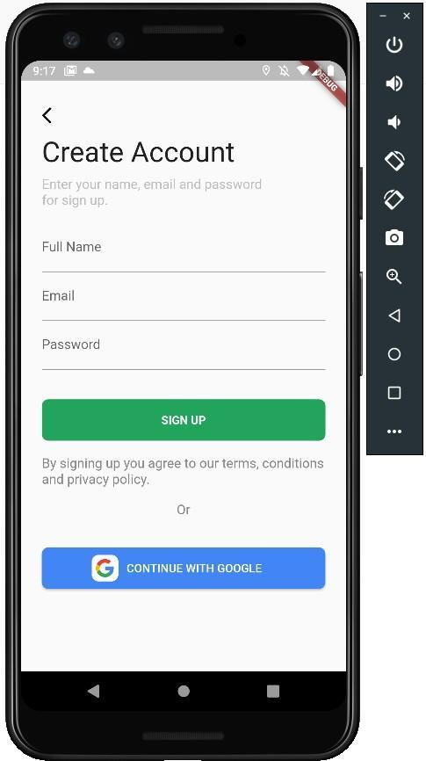

Figure 4.1: Sign-Up Page

Basic information is given by the user in this page 4.1 to create an account in the application to have access to the features provided.
The Firebase authentication feature is used to generate a unique ID that is used to identify the user and to store the info in the Firestore the ID is also used to access the databases that has the data necessery for the operation of the app, the Firebase authentication uses the Google APIs to provide an easy to use Google account login.

Log-in

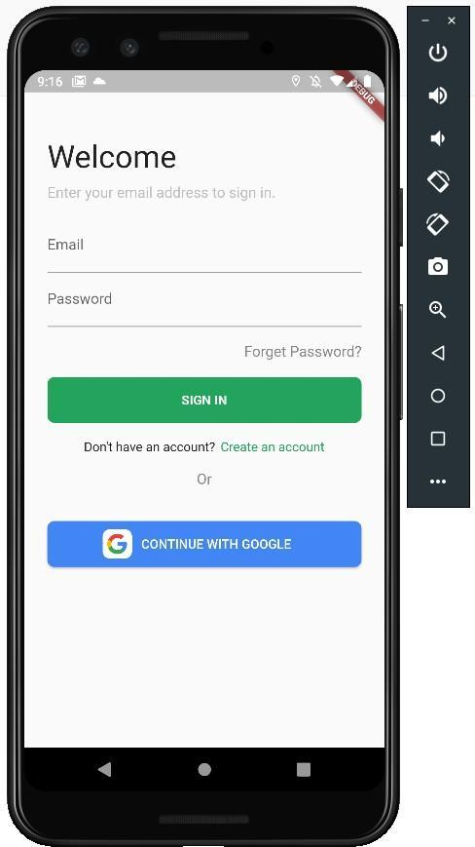

Figure 4.2: Sign-In Page

This page is the entry point of the application, the user enters the username and password that were used to sign up then the user is redirected to the next page of the application.The page also allows users who registered using the Google account to login.

The Map

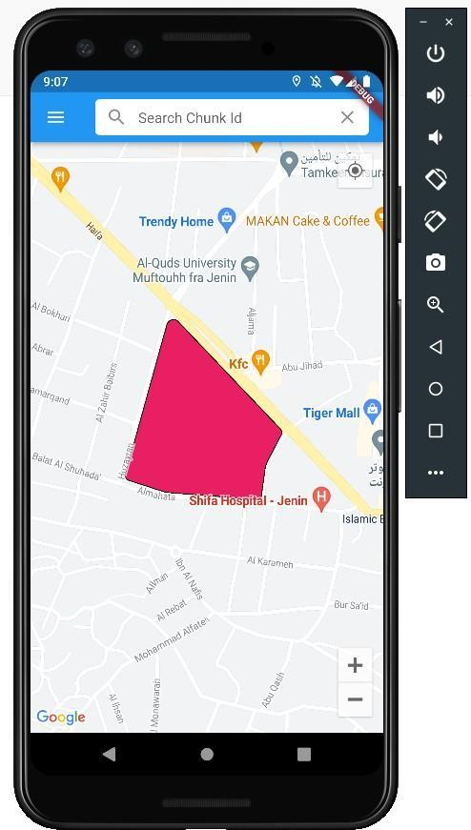

Figure 4.3: The map Page

The figure 4.3 shows a Public building colored. When the user enters the application for the first time a message appears to give the app the permission to access the location,in the case the access was denied the user is automatically redirected to a location in the Center of the city of Jenin, but if the access is given the user is directed to the current location, with the location known the area is highlighted in different colors, the buildings and parcels in the surrounding area are also highlighted, when the user selects a land,it’s type,regulation,area and building type are shown.
This page also allows the user to access the lands wanted by using the Chunk ID which also has the ability to auto complete/suggest the chunk id.
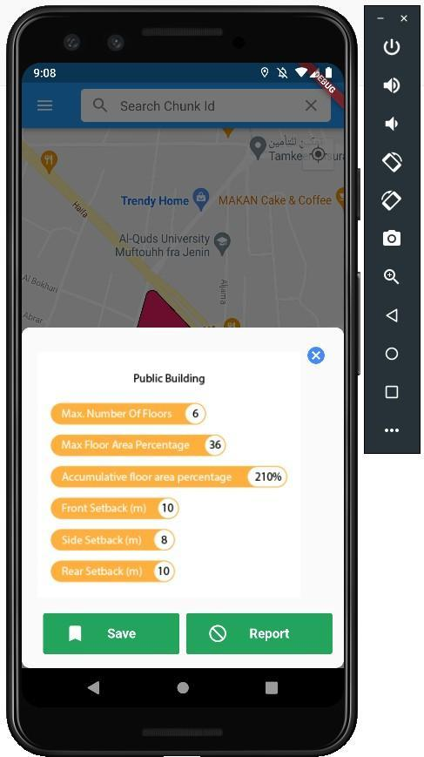

Figure 4.4: User Menu.

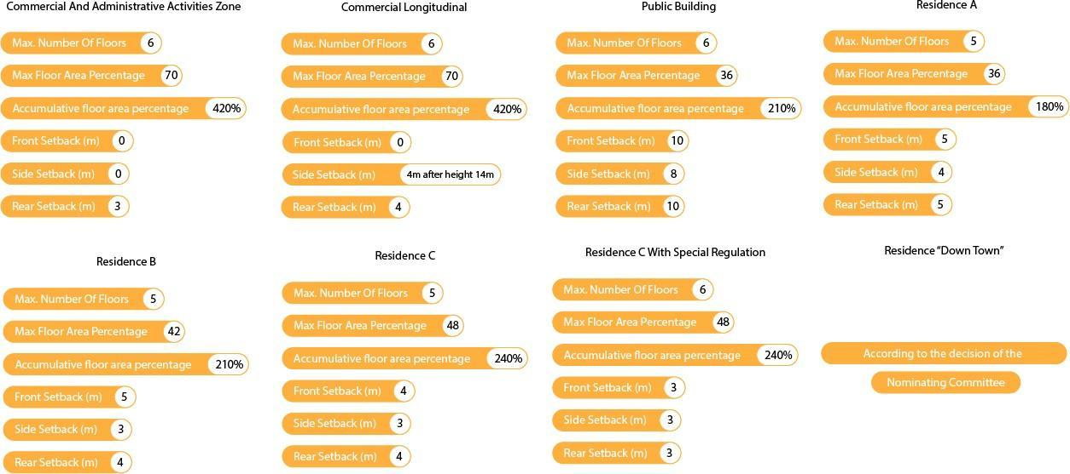

Figure 4.5: Regulation Types.

The user is able add the land to a list of saves by using the save button. The user is also able to file a complaint against a certain plot of land by using the report button that gets the user directed to a page that requests some personal info 4.6 then select the complaint type 4.7.
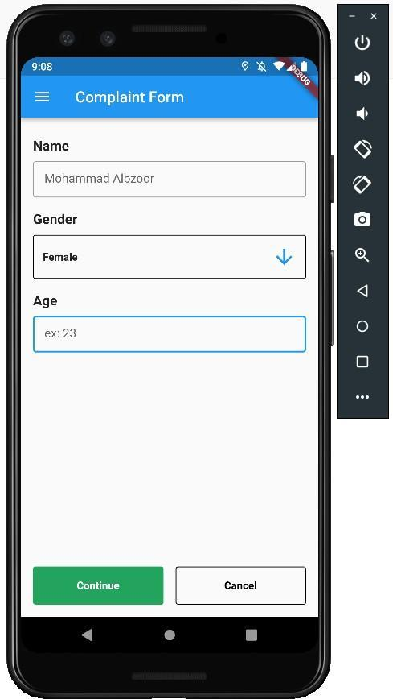

Figure 4.6: Report Menu First Section.
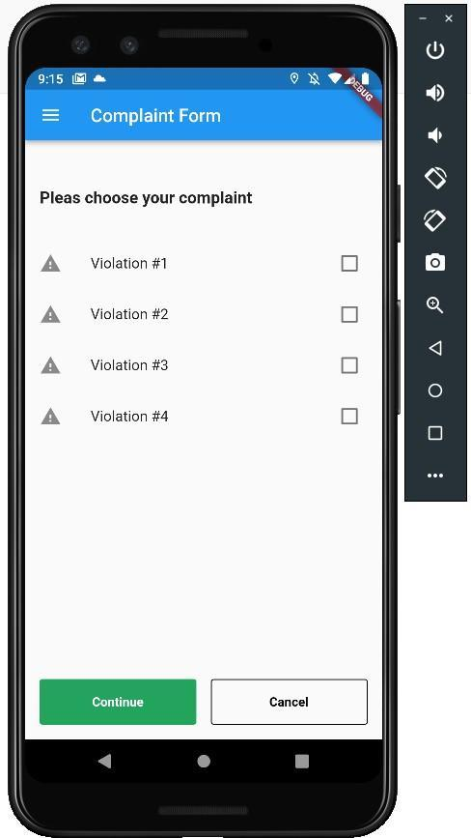

Figure 4.7: Report Menu Second Section.

Drawer

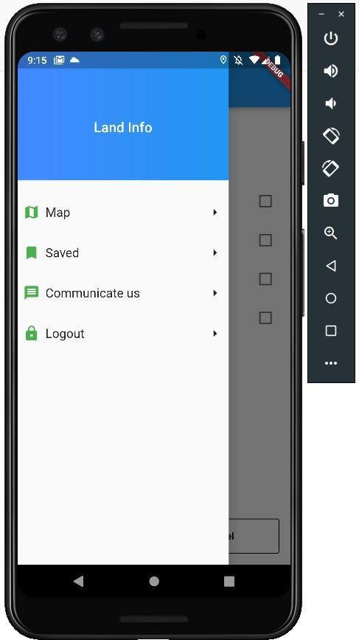

Figure 4.8: App Drawer.

The drawer 4.8 allows the user to quickly navigate to the required page in an easy to use fashion.

Saves

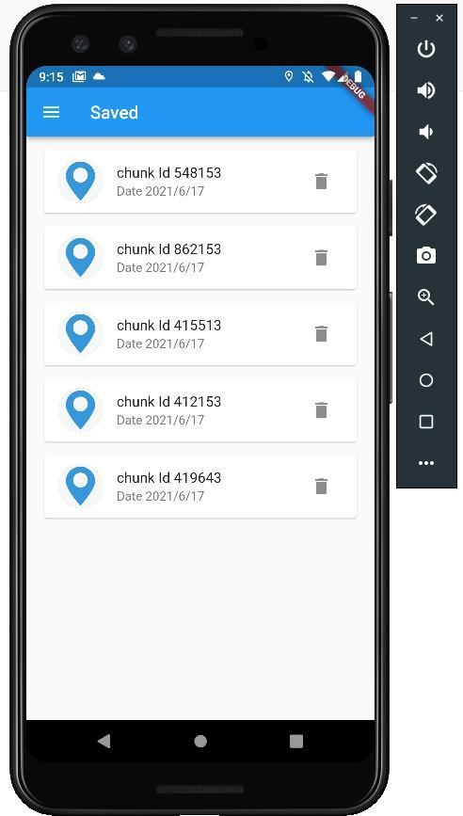

Figure 4.9: Saves Page.

Using this page4.9, the user can access the plots of land that he previously saved and can manage them by deleting them or by clicking on them to access their location on the map in order to be able to see them compared to the lands around them and browse the information related to them

Contact Us

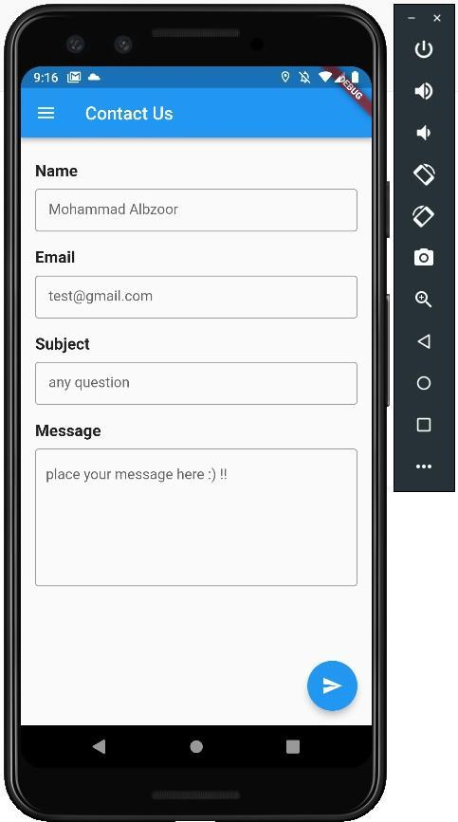

Figure 4.10: Contact Us Page
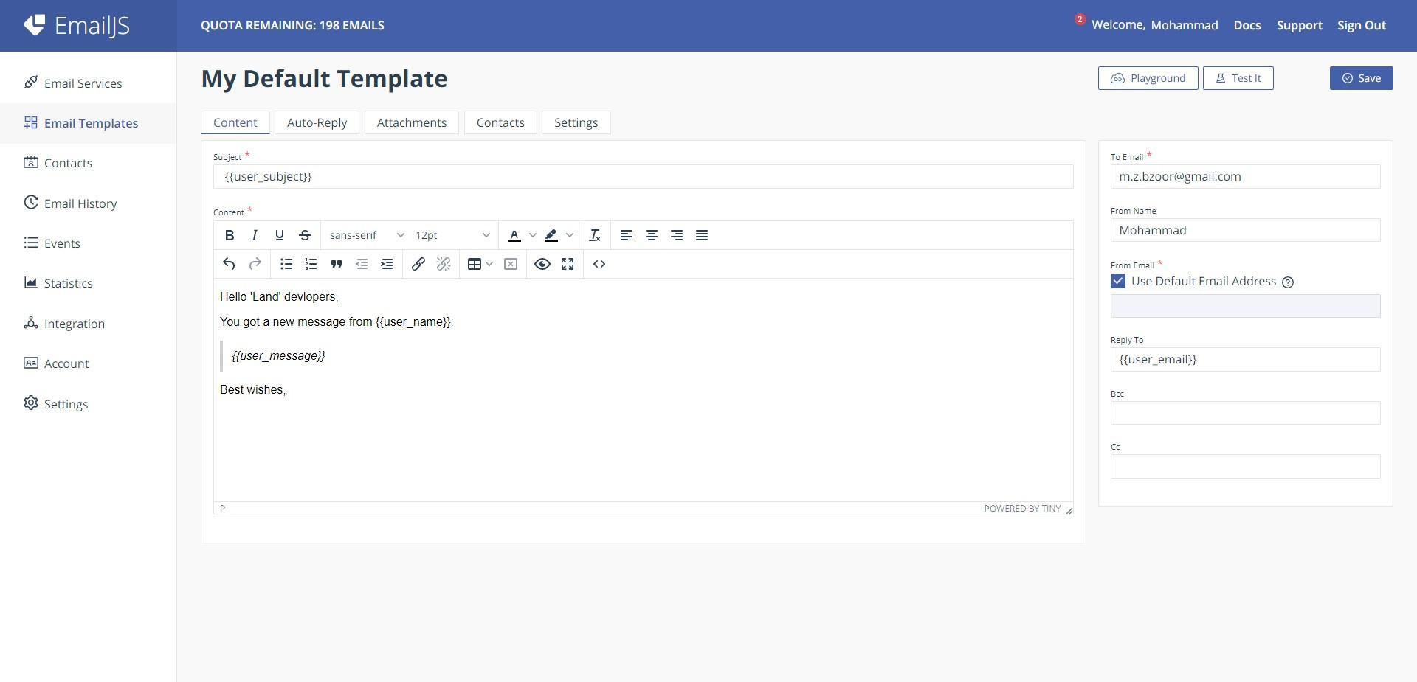

Figure 4.11: Email Template

This interface 4.10 enables the user to communicate with the application developers, whether to provide suggestions for performance improvement, to evaluate work, or to report technical problems.
EmailJS service was used to create a template 4.11for the message.

Web Admin

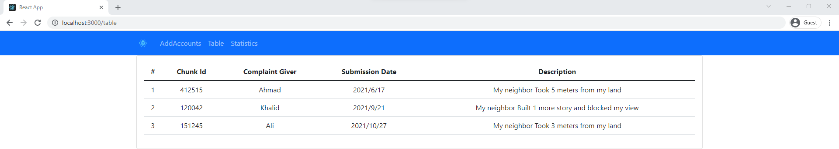

Figure 4.12: Complaints Table

This interface manages the application information, where complaints submitted by users reach it, and they are displayed in a tabular form that is easy to deal with 4.12, in addition to providing statistics in a graphic form 4.13 in order to give the municipalities the flexibility to take the readings related to the complaints
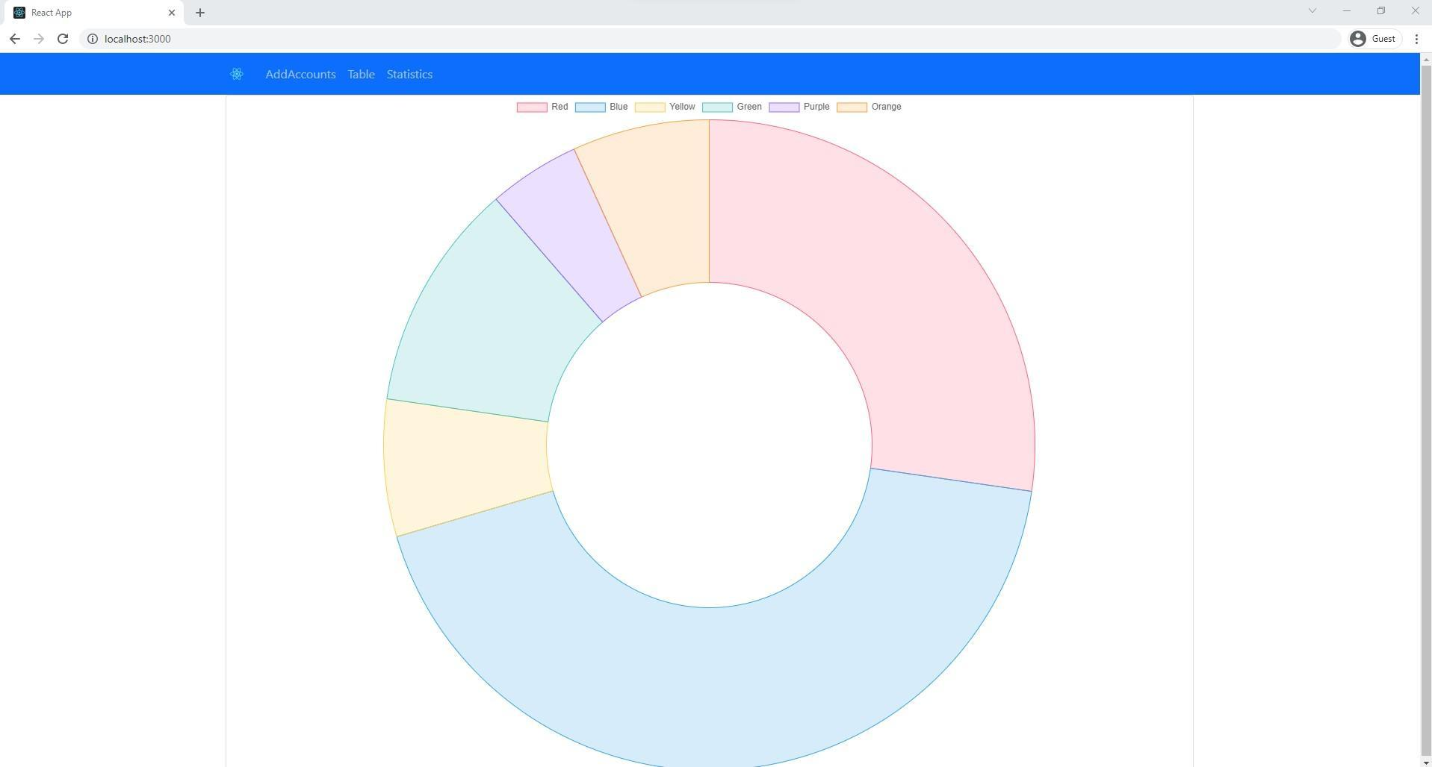

Figure 4.13: Statistics Page

In addition, the web page provides an interface for creating an ”admin” account, which is the account given to building supervisors.
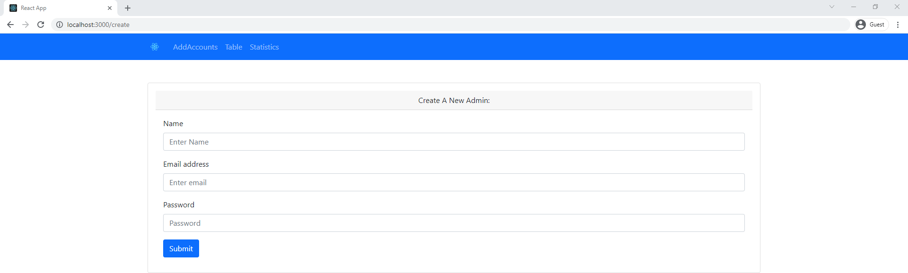

Figure 4.14: Create Admin Page

This account allows the observers to access the feature of issuing and browsing the notifications, so that all notifications are displayed by all the observers in a special notifications page.

Application Structure (Technologies Used In Development)
The methodology used in this study was the subject of this section. A description of qualitative research as a data collection and analysis tool was given. This section covered the measures used during data collection, followed by a section on reporting the findings.

The logo



Figure 4.15: The Logo.

The logo in 4.15 was designed to represent the core and soul of the app as it reflects the idea easily so that the user could get the impression of what the app does just from the logo, the app being a map that the user could manipulate as desired is clearly shown

Logo Elements
The visual part of the logo consists of three layers, the first of which refers to the soil that makes up the land as it is an important factor in determining the building data for a particular land and not others, and for this, it was distinguished in orange, while the second layer expresses water and bodies of water by adding the blue color, and finally, the third layer in its green color, which occupies the largest part of the logo, in order to confirm the basis of the application by adding a map shape, which expresses the visible part of the land in an abstract manner as it appears on the application within the Google map.
As for the written part, a type of font with a clear and easy-to-read character was chosen for the user to give a sense of balance and stability, complementing the visual part of the logo in a streamlined manner.

Project Structure

Back-end
The back-end used in the project is very simple,it consists of Building,Parcels,Master Plan, Warnings and Saves tables using the Postgres with the PostGIS 4.17 plugin and some RestAPIs built using NodeJs and the Express Framework4.16.


Figure 4.16: NodeJS and Express Logos


Figure 4.17: PostGIS Logo

Front-end

Admin Page
The Admin Page is built using the principles taught in the Web Design Course and the ReactJS
4.18 framework was used.


Figure 4.18: React Logo

Mobile App
The mobile app was built using the principles taught in the OOP course using the Dart programming langugage with the Flutter framework.
The MVVM architicture 4.20 was used to build the Flutter app.



Figure 4.19: Flutter Logo

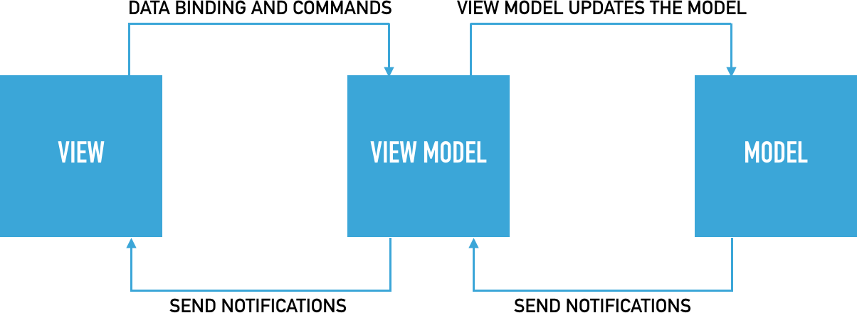

Figure 4.20: MVVM Arch

Results And Discussions

Data and Analysis
This Project needed a lot of data and research but thankfully the data was provided from the Urban Planning Team who got it from the municipality.
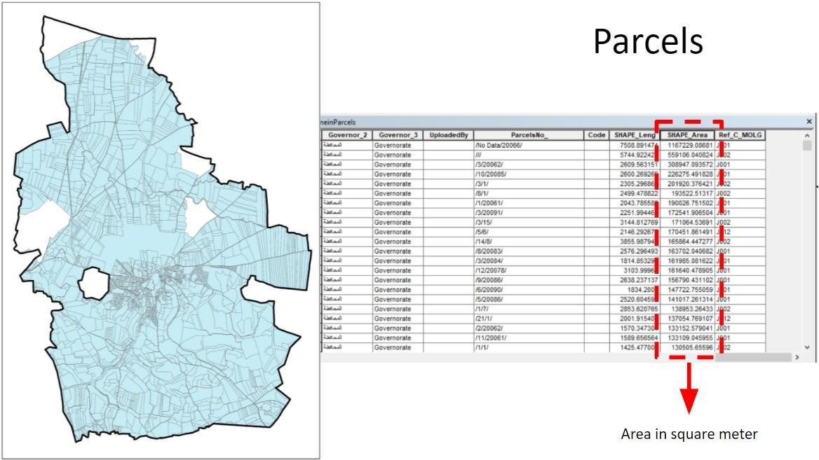

Figure 5.1: Parcels In Jenin.

In 5.1 it shows the different parcels that are in Jenin and the area of each one which is greatly useful for the citizens as they could see their own land and lands that they may buy.
In 5.2 the master plan of Jenin is shown with the different areas shown, the areas as shown are greatly confusing for someone who does not know what the words in the map legend even mean.
In 5.3 it shows the positioning of the building in Jenin,it shows that the buildings are more focused in the center of the city which is completely normal but sadly it also shows that not all buildings are included as Jenin has a lot more buildings, and as this is not easily solved it somewhat limits our application.
After reviewing the data and asking the citizens about their needs, it was found that a lot of citizens rely on an Engineer or someone in the field every time they have a simple enquiry which is troublesome for both sides.
So the first idea was created, create an app that shows texts,shapes and symbols in the real world using the AR technology that the user can interact with, some research was done before embarking with the idea but sadly even after the research it was found that the idea is not feasible with a reasonable amount of time.
So it went to the next best thing which is create a map that the user can interact with and get all the data easily with no domain knowledge to mention.
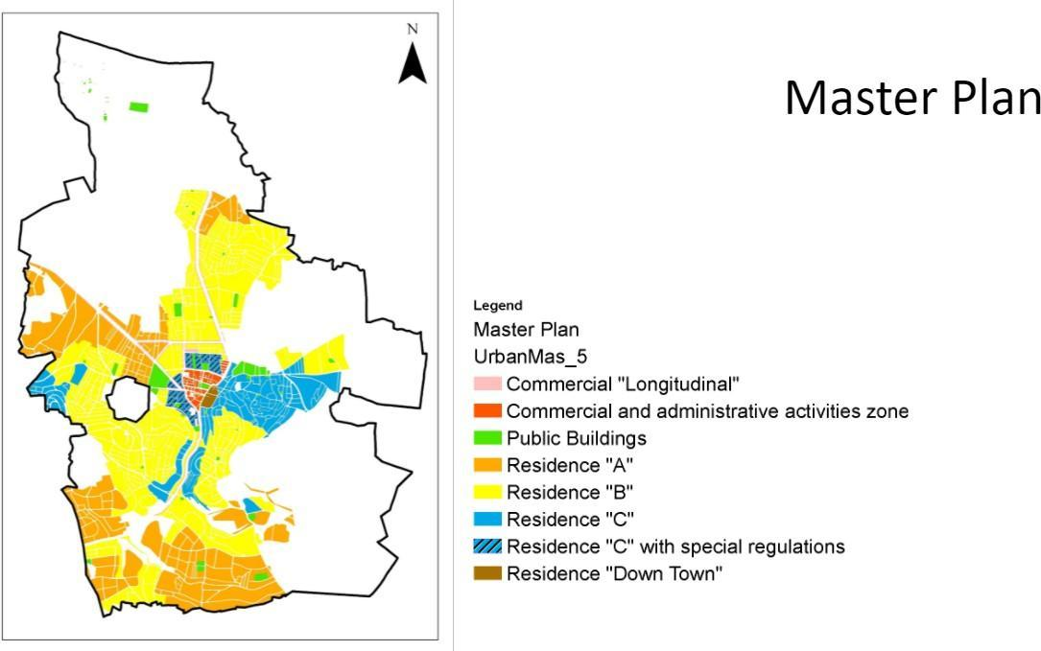

Figure 5.2: Master Plan In Jenin.
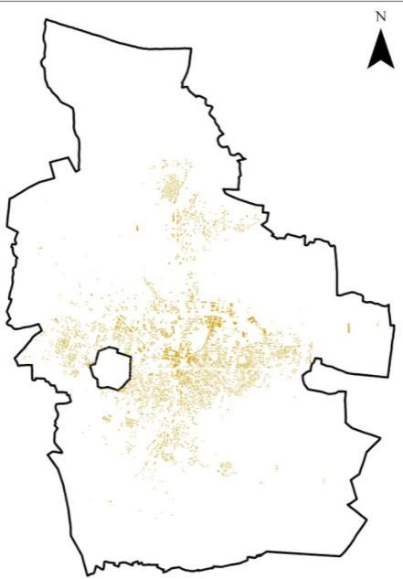

Figure 5.3: Buildings In Jenin.

Conclusion
The app was created and all the initial goals were accomplished except for making an AR app that is a breakthrough for technology and the citizens using it. Some features were added as we listend to the opinions of the users like a warning function and filing a complaint against someone or even directly communicating with the municipality.

Conclusion

Summery
Maps are widely used word-wide from Google Maps and Apple Maps to Geomolg (ArcGIS) but none of them has information local to Palestine in a Mobile App while having an easy to use User Interface.

Improvements
More precise data would make the application better,and more user input and interactions would add more data to be used in the database. More input and management from the municipalities would make it effective and useful for all citizens and would make the effort and resources spent on the project worth it.

Future Work

The AR section
Continue with other ways and more time to implement the AR feature that was the dream goal of this application.

Adding The Data Of Other Cities
Adding the data of other cities would make the application more widely used in all of Palestine and even more.

Build The IOS Version
Making this app accessible in all the mobile platforms which in turn makes it available to more users.

Web App & Admin Mobile App
This would make the application accessible everywhere regardless of the situation.

Outcome
We made a map based application to help citizens and municipalities better communicate and show the citizens all the regulations needed to use their lands.
This project made us realise many things from how to handle clients and the importance of domain knowledge to the conclusion that we were forced to make that the AR technology is not what we hope and think it is.
But all of this was an experience for life and the hope in AR is not gone it is on the contrary more robust, this dream future we will make and Facebook’s Spark AR is an indication of the massive hope that the world has in AR.

Bibliography

Mehta, H., Kanani, P., & Lande, P. (2019). Google maps. Int. J. Comput. Appl, 178, 41–46.
the municipality of local government. (n.d.). Geomolg: Geospacial sit. https://geomolg.ps/L5/index. html?viewer=A3.V1

