An-Najah National University



College of Engineering
ELECRICAL Engineering Department
POWER SAVING AND SECURITY SYSTEM

Supervisor:
M.Sc. Jamal Kharosheh

Submitted by:
Abd Alrazek mohammad hamarsheh

May - 2010

بسم الله الرحمن الرحيم
يرفع الله الذين آمنوا منكم و الذين أوتوا العلم درجات ) )

الاهداء .....
إلى أطهر الخلق و أكرمهم خاتم الأنبياء و المرسلين
سيدنا محمد صلى الله عليه و سلم
إلى الأولى في حياتي و سيدة عمري الفاضلة
إلى من سهرت ليلا لتضمني إلى صدرها و تنفض عني غبار الحياة
إلى من حملتني طوعا ببطنها صغرا و لا زالت تحملني بقلبها إلى يوم الدين
إلى من تعجز كل الكلمات عن وصف عطائها
إلى أمي أهدي هذا العمل المتواضع
إلى روح والدي رحمه الله
إلى الاستاذ المشرف على هذا العمل
الذي كان خير مشرف و خير معطاء
الاستاذ جمال خروشه
إلى كل أحبتي و أصدقائي و كل من ساهم في زرع بذرة أمل بقلبي
أهدي هذا العمل المتواضع
و نسأل الله التوفيق

Acknowledgment
I would like to express my gratitude to all those who gave me the possibility to complete the project.

- The administration of An-najah National University represented by its president Prof. Rami Hamadallah.
- Deanship of faculty of Engineering represented by Dr. Nabeil Dumady.
- The family of Electrical Engineering Department:
Dr. maher khamash.
M.Sc. Jamal Kharosheh
Dr. mazen arrasekh
Dr. samer mialeh
Dr. marwan mahmoud
Dr. naser abu zeid
Dr. raed abu haroun
Sc. Raed hejawi
Sc. Nuha odeh
Dr. Imad break

- My friends

Contents:
Abstract p 6
Chapter one: introduction p 7
1.1 introduction
1.2 application
Chapter two: power saving p 10
2.1 introduction p 11
2.2 power saving through light control p 12
2.3 working principle p 13
2.3 sensor types p 14
2.5 sensor installation p 15
2.6 energy saving p16
Chapter three: security p 17
3.1 introduction p 18
Chapter four: hardware p 19
4.1 introduction p 20
4.2 motion detection circuit p 21
4.3 light intensity measuring circuit p 26
4.4 basic circuit p 27
Chapter five: software p 30
Conclusion p 33

Abstract

This project aims to install a control system based on the presence of a human and amount of light in the room to save energy if it not necessary to switch light on.

For more efficiency and since the presence of a human to be detected this system will be able to activate an alarm if the security is broken by a human if his presence is not allowed.

This system combines many circuits that will operate in the same time to examine the conditions to be tested.

Finally, a microcontroller will combine all the components together to ensure what condition we have.

CHAPTER ONE

INTRODUCTION

1.1 Introduction:
Homes and offices need no high security in day which leads to the fact that light is the main key to home safety and security.
It has been estimated that a single unit of energy saved at the end use point is equal to 2.3 units of energy produced, so using a circuit to measure light intensity during daylight we can achieve a saving in power depending on the amount of light needed for the human eye and the amount entering the room, which is the key in my project for power saving, where if the amount of light is less than necessary and there is a human presence in the room, the lights automatically would be activated, and if not – there is a human presence and the amount of light is sufficient, then the light would remain deactivated.
All previous at the time the human presence is allowed, in other words, while security system is deactivated.
This project aiming to ensure a high secure system and saving in power as much as possible in use of day light.

1.2 Applications:
This project can be applied for house and offices, in offices it would be easier to be applied, because the time of working is limited by the hours of working of this offices. This if we depend on timers to define the time that the presence of a human would be allowed.
We can get the same result through a simple switch connected directly to the PIC, this switch gives high level voltage if the human presence is allowed, and at the time the owner wish to get out the house, simply he turn off this switch, so any presence later would be not allowed until this switch activated again.
This project contain main two ideas:
- Power saving, depending on amount of light and human presence, so to achieve this part we need three main circuits:

- Motion detection circuit.
- Light intensity measuring circuit.
- Basic circuit.

- Security , depending on human presence in the room and if this presence is allowed or not, so we need two circuits to achieve this part:

- Basic circuit
- Motion detection circuit

CHAPTER TWO
Power Saving

  - Introduction:
Lighting controls play a critical role in electric lighting systems, providing the function of Turning the lights on and off using a switch depending on the inputs from the circuits.

  - power Saving through lighting Controls:
Lighting control systems contain three components linked by communication wiring, which is used to transmit control signals, and power wiring, which supplies power.

component | Sensing device | Logic circuit | Power controller
function | Providing information to logic circuit | Decides whether to supply lights | Changes the output of the lighting system

In my project I can therefore view a lighting control system or device as an apparatus that
1) receives information
2) decides what to do with that information.
3) changes the operation of the lighting system.
In other words, we can look at lighting control devices based on inputs and outputs as :
control | Input | Decision making | Output
Occupancy sensor | Detects human  Presence | Decided whether to  Turn on or shut off  lights or to activate  alarm | Sending signal to  Relay which closes  Or opens circuit and  Which relay to use
Light intensity sensor | Its output  Depends on  Amount of light | Decided whether to  Turn on or shut off  lights | Sending signal to  Relay which closes  Or opens circuit

2.3 Working Principle
Occupancy sensors serve three basic functions:
- To automatically turn lights on when a room becomes occupied.
- To keep the lights on without interruption while the controlled space is occupied.
- To turn the lights off within a preset time period after the space has been vacated.
The system consists of a motion detector, an electronic control unit, and a controllable switch (relay).
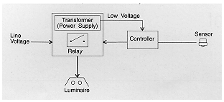
In most occupant sensor systems, the motion detector and controller are housed in one package. The power supply and relay comprise another integral unit. In wall box-type sensors, components are integrated into one compact package, designed to fit into an existing switching box.
Occupant sensors can also be connected to low-voltage relay and building automation systems.

2.4 Sensor Types
There are three types of occupancy sensors are available:
- Passive Infra Red Sensors

Passive infrared sensors (PIR) are triggered by the movement of a heat-emitting body through their field of view. PIR sensors cannot "see" through opaque walls, partitions, or windows so occupants must be in direct line-of-site of the sensor, and this type I use it in my project.

- Ultrasonic sensors

Ultrasonic sensors emit an inaudible sound pattern that is disrupted by any moving object altering the signal returning to the sensor (Doppler shift). They are best suited for spaces where line-of-sight view to the occupant is not always available. This type of sensor detects very minor motion better than most infrared sensors.

- Dual-technology occupancy sensors

Dual technology occupancy sensors use both passive infrared and ultrasonic technologies for less risk of false triggering (lights coming on when the space is unoccupied). Combining the technologies requires a more reliable, yet slightly larger and more expensive device.
We suggest for installation of occupancy sensors in construction villages, the use of PIR sensors is sufficient, as a detection of minor motions only would lead to unnecessarily switching of lights.
Most PIR sensors are sensitive to hand movement up to a distance of about 3m, arm and upper torso movement up to 6m and full body movement up to 12m.

2.5 Sensor Installation
Passive infra-red sensors could be retro-fitted to the existing lights or mounted to the wall.
Wall-box type PIR occupancy sensors are easy to install. These are best suited for small, enclosed spaces where the sensor replaces the light switch on the wall and no extra wiring is required.
Occupancy sensors must be located to ensure that they will not detect movement outside of the desired coverage area, through an open doorway, for example.

2.6 Energy saving:
following energy savings can be realized using occupancy sensors:
Occupancy area | Energy saving
Private Office | 15 – 50 %
Class room | 40 – 50 %
Conference room | 25 – 70 %
Restrooms | 32 – 92 %
Corridors | 32 – 84 %
Storage areas | 50 – 80 %

Using PIR sensors for intermittent occupied areas of the construction village it is estimated that lights are switched off:
At least 80% of the time in toilets, drying room, changing rooms and office kitchen.
At least 65% of the time in canteen and meeting rooms
These estimations take into account the occupancy pattern of the different areas studied at the construction site we have visited.

CHAPTER THREE
SECURITY

3.1 Introduction: Security can be achieved depending on human presence which detected by a motion detection circuit and depending on if the presence is allowed or not.
Placing motion sensor can be helpful to achieve security since it's operating all the time in power saving system.

As the motion detection circuit detection someone presence, it sends a signal which is a voltage to PIC which will decide to use this signal as an input for security or power saving system depending on its software.

CHAPTER FOYR
HARDWARE

4.1 Introduction:
We need several circuits to apply this project, and I need to ensure that each circuit will work properly, and here are the circuit needed
- Motion detection circuit.
- Light intensity measuring circuit.
- Basic circuit.

4.2 Motion Detection Circuit.
Motion sensors are used
- For security, scaring off intruders.
- For convenience, no more fumbling in the dark for switches or using a shoulder to bump the switch when both hands are full of groceries.
- To save electricity, no more forgetting to switch off lights, worrying about forgetting after having left the house, reminding the kids to remember to switch off.

4.2.1 Motion Detector Basics
Motion detectors need to automatically switch lights on and off. Like timer switches, some do not work well with compact fluorescent lamps (CFL). If CFLs are to be used, the motion detector should be stated by the manufacturer as being suitable for CFLs (or electronic ballasts).
Motion detectors can be
- Auto-on, auto-off.
- Manual-on, auto-off. This is good for indoor use, to avoid falsely triggering the light when walking past.
A manual override (both on and off) is also useful.

Detection angles can range from 90 to 360 degrees, depending on the model and expected usage. To avoid false triggering, some sensors have adjustable blinds to reduce the detection angle. Black sticky tape can also be used to cover part of the sensor.
In my project the sensor will focus on the entrance of the room, so a 180 degree will be enough.
Manufacturers claim anything from 30 to 70 feet for maximum detection ranges. Detection ranges or reaction time (switch on time) can get worse if the temperature drops. For cold climates, the minimum operating temperature of the sensor should be checked.
This point is not a problem in my project, since the sensor would be always indoor.

4..2.2 Home Motion Sensor Light Switches
For indoor use, the motion sensor isn't normally built into lamps. Instead motion sensors are built into
- Standard wall switches, hard-wired by the electrician to ceiling or wall lights.
- Standard wall sockets, for plug-in table lamps and night lights.
This is for maximum flexibility, because any existing lights can be used.
Some can be wired as 3-way switches, either with a manual switch (acting as a manual override) or with another sensor. This allows the light to be switched from two locations.

4.2.3The Best Motion Sensor Light
There are a wide variety of motion sensors, suitable for different situations and requirements. Choosing the right sensor and lamp combination involves knowing the usage scenarios and wiring limitations.
Problem areas to look out for include
- Sensors that are too sensitive, switching on when not wanted.
- Sensors that are not sensitive enough, switching on too late.
- Unreliable switches, failing after a few weeks or months.
- Sensors that need to be manually reset after a electrical mains power cut and restoration.
The sensor can detect the human active presence sending an output voltage will be considered in the PIC to determine one of two, light or alarm to be activated automatically and if there is no presence the light will be deactivated automatically.
4.2.4 DETECTION PATTERN
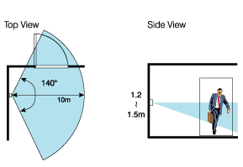

In my project the motion detection circuit ( occupancy detection ) is shown in figure below, the output is in mvolts so I use a non inverting amplifier to amplify the output in order to suite the PIC input.
NON inverting amplifier circuit using 741 Op-Amp :
The Operational Amplifier is probably the most versatile Integrated Circuit available. It is very cheap especially keeping in mind the fact that it contains several hundred components. The most common Op-Amp is the 741 and it is used in many circuits.
The OP AMP is a ‘Linear Amplifier’ with an amazing variety of uses. Its main purpose is to amplify (increase) a weak signal - a little like a Darlington Pair.
The OP-AMP has two inputs, INVERTING ( - ) and NON-INVERTING (+), and one output at pin 6.

In a non-inverting amplifier the voltage enters the 741 chip through leg three and leaves the 741 chip through leg six. This time if it is positive going into the 741 then it is still positive coming out. Polarity remains the same.
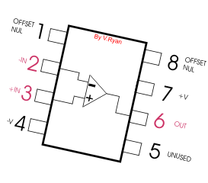
this circuit is used to amplify the motion detector output:
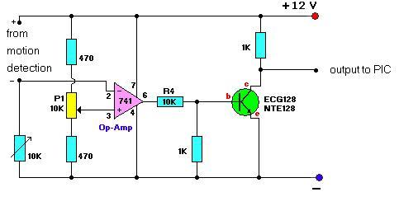

The output of the motion detection circuit is up to 0.4 volt , this circuit will amplify the output in order to suite the PIC input ( 0.4 becomes 5 volts ).
To achieve this I needed a two stages amplifier, so the output of the first circuit is the input of the second one then the output of the second one goes to PIC.

4.3 LIGHT INTENSITY MEASURING CIRCUIT:
The amount of light is one of the main keys in this system, therefore the measurement of the light intensity is thus become one of the important input that cannot be overlooked.
Now During the work hours in offices and if there is a human in the living room, Based on the amount light intensity needed for human eye to work affectively, An estimate of the light intensity in our everyday life is described as below
environment | Luminance
Living room | 45 – 55 lux
office | 400 – 500 lux

The earlier idea was to measure the amount of light on the room then comparing this measured value by a reference one to be stored in the PIC.
In my project for more simplicity instead of using a circuit to measure amount of light I depended on a LDR resistor to detect the changes in luminance in the room, to make this come to surface we must use the LDR resistor as a part in a voltage divider.
Using this simple circuit:
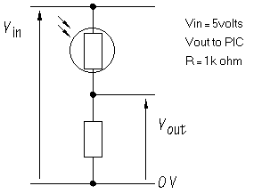
In the living room at a 55 lux the output voltage is 3.5 volt ( logic 1) if the luminance increased this will increase the output voltage. Since the resestance of LDR is decreasing as amount of light increases.

4.4 BASIC CIRCUIT:
A microcontroller is a compact standalone computer, optimized for control applications. Entire processor, memory and the I/O interfaces are located on a single piece of silicon so, it takes less time to read and write to external devices. The PIC16F877 chip has to be powered at all times when its being programmed and running an application.
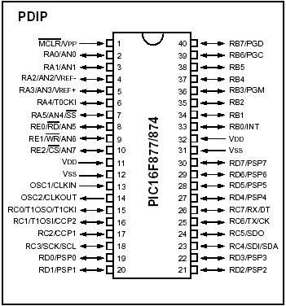
Pin diagram of PIC16F877

The PIC will be used as the data interface between the PC and the PIC16F877 development board. Notice that PIC Flash Development board comes with 2 separate means of serial communications which are marked in Figure
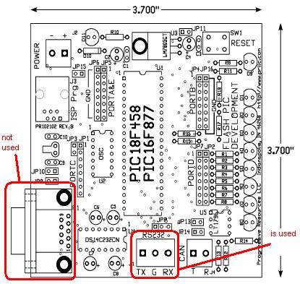

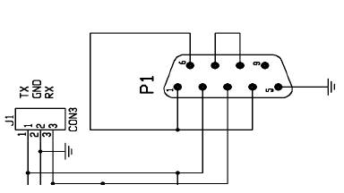

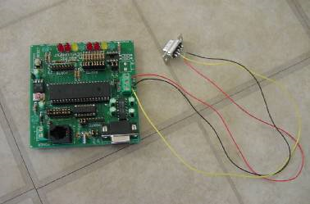

CHAPTER FIVE
SOFTWARE

Consider the following
Output of the motion detection on Pin ao
Output of LDR circuit on Pin a1
Enable presence on a2
Pin B2 to relay of power supply
Pin B3 to relay of alarm

The program:
Int motion, motion2, light
Float motionvolt, motionvolt2, lightvolt
While (1)
{
y:
if ( input_B ( Pin_B0))
{
Set_channel (a0)
Motion = read adc ();
Motionvolt = motion * 5/255 ;
If (motionvolt >= 3.0)
{set_channel (a1)
Light = read_adc ();
Lightvolt = light * 5/255;
If ( lightvolt >= 3.0)
{ go to y
}
Else
{ output_ high ( Pin_B2) }
}
Else
{ go to y ; }
}
Else {
Set_channel (a0)
Motion2 = read_adc ();
Motionvolt2 = motion2 * 5/255 ;
If ( motionvolt2 >= 3.0 )
{out_high (Pin B3)
Else {
Go to y }
}
}

Conclusion:
Human presence and amount of light is the most important features for saving energy.

