USB Oscilloscope &Digital Multimeter

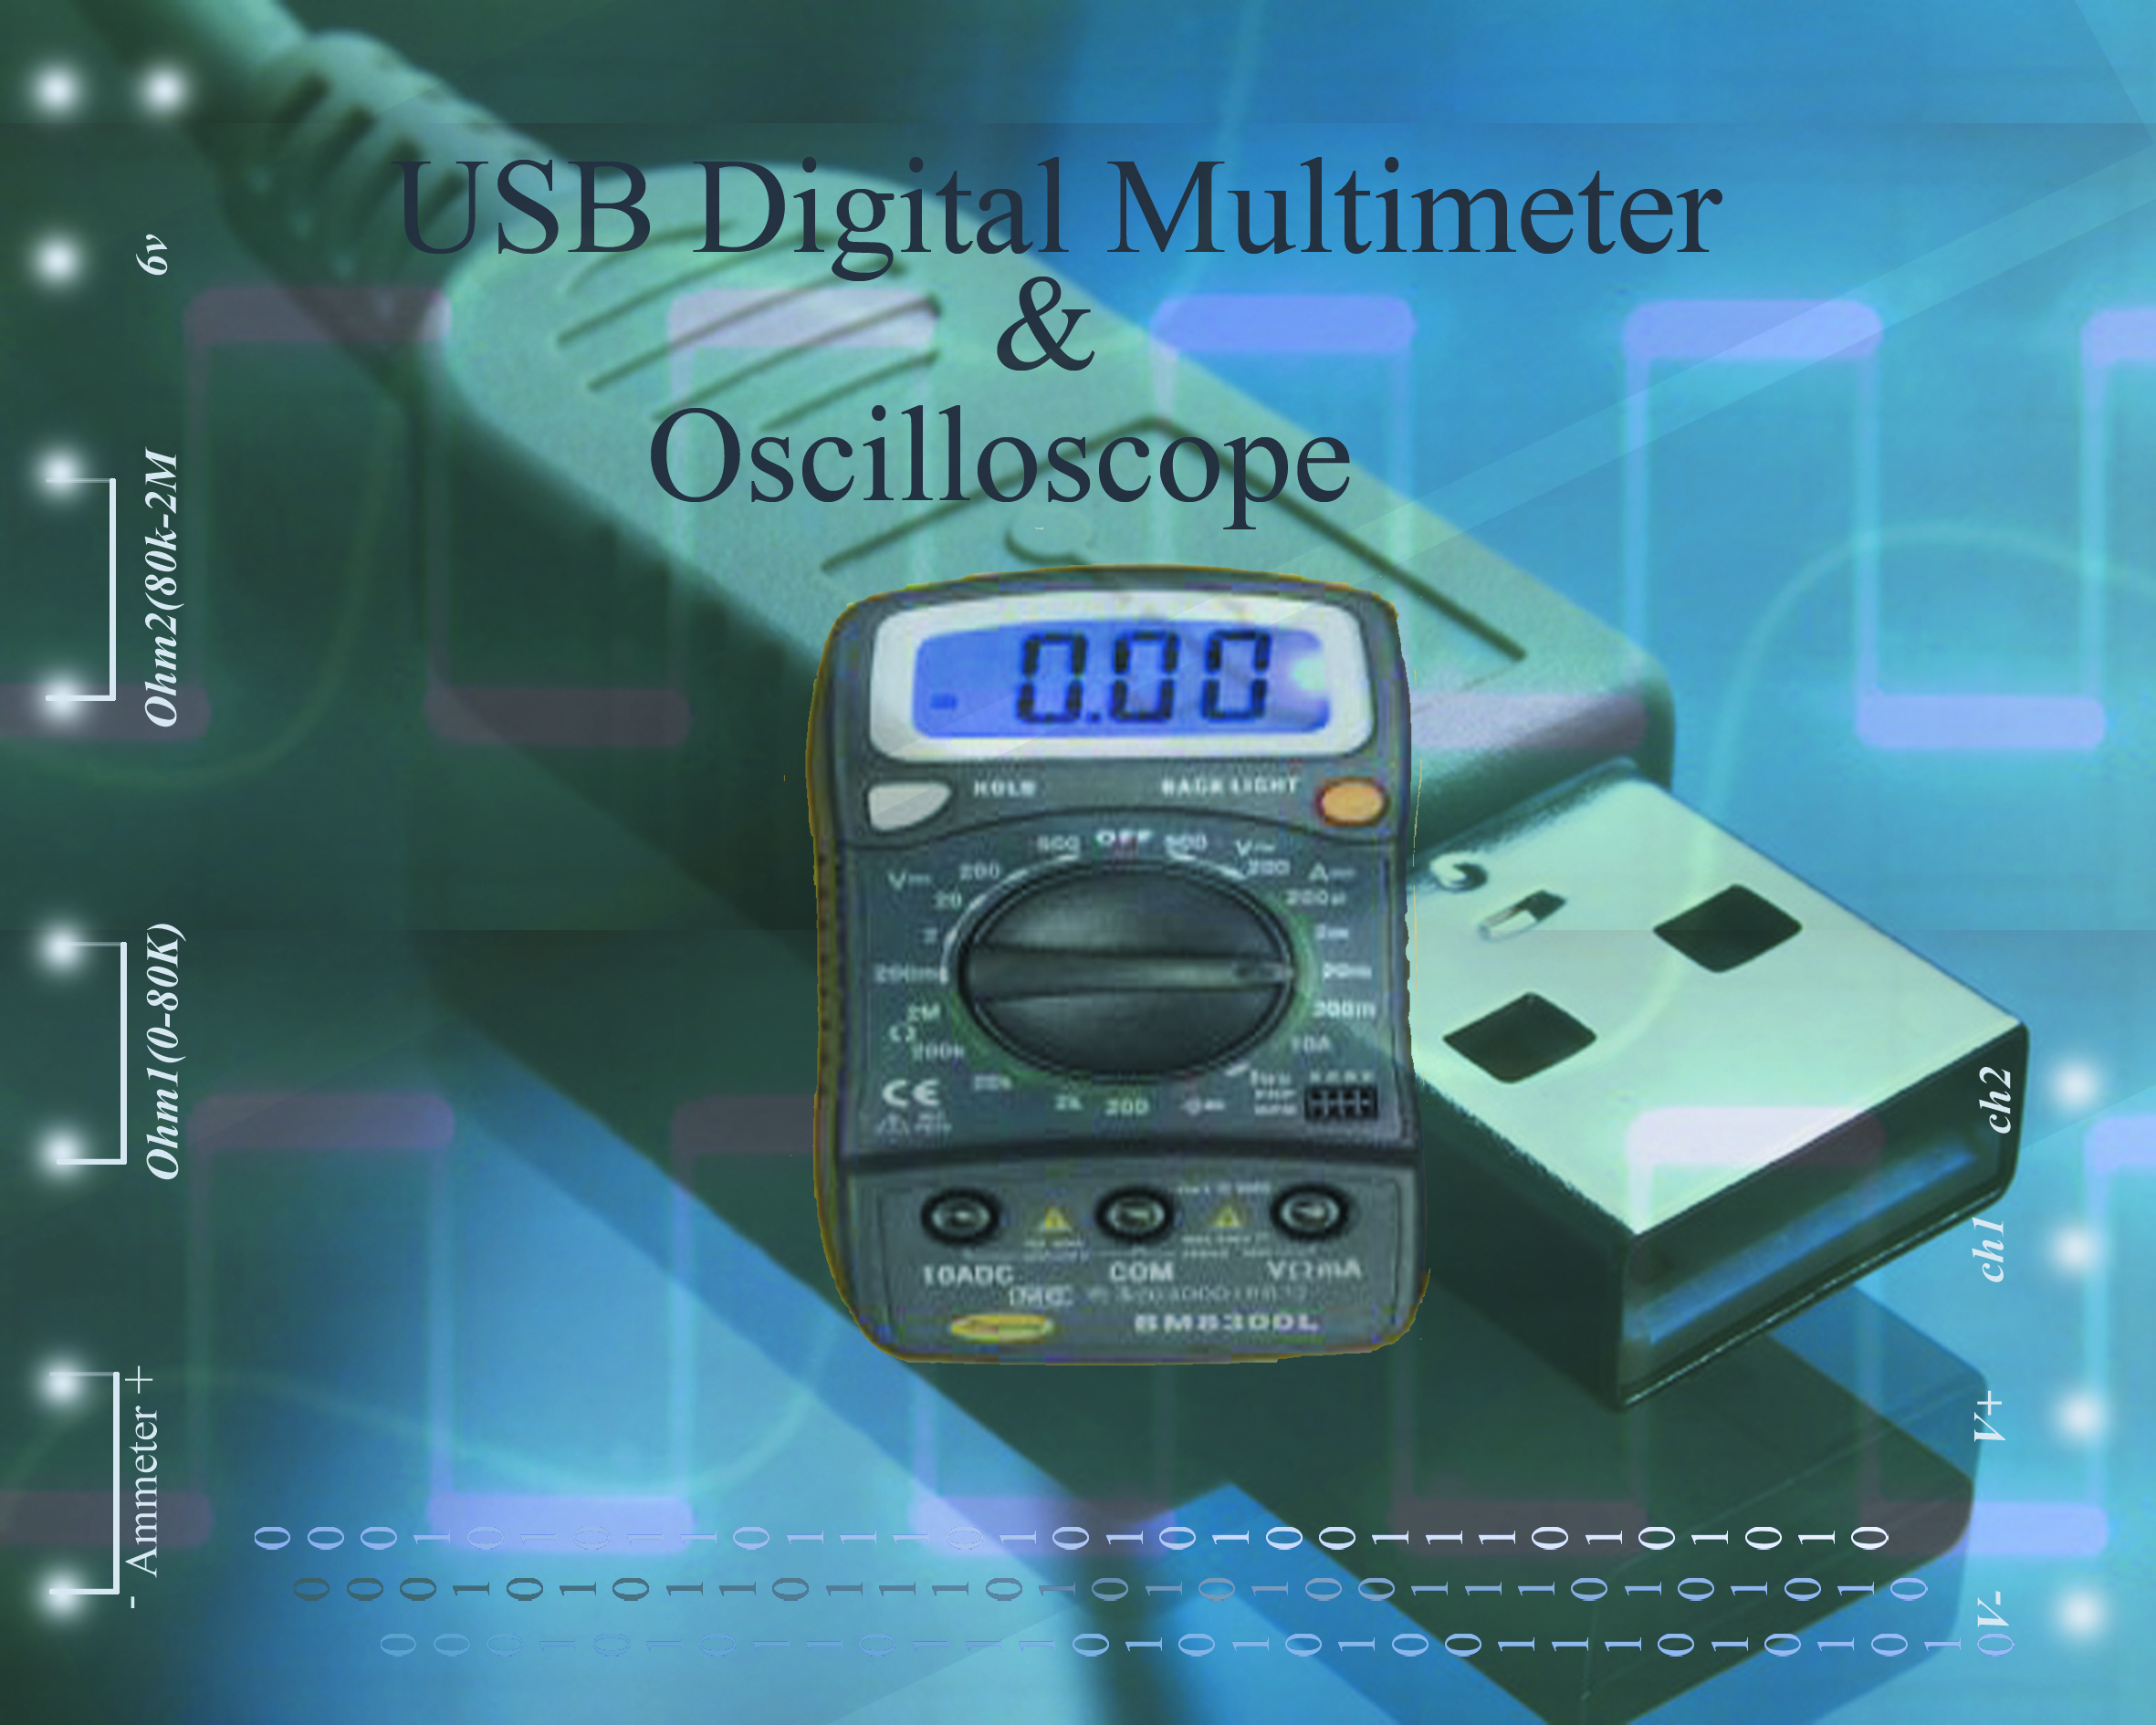

This one's an oscilloscope connected to a computer using the USB bus. This is probably the cheapest oscilloscope on the market, but maybe also the worst... The scope can only record 15479 samples per second.

Screenshots:
The signals in the screenshots have been generated using a Meter International Corp. FG-503 DDS function generator.

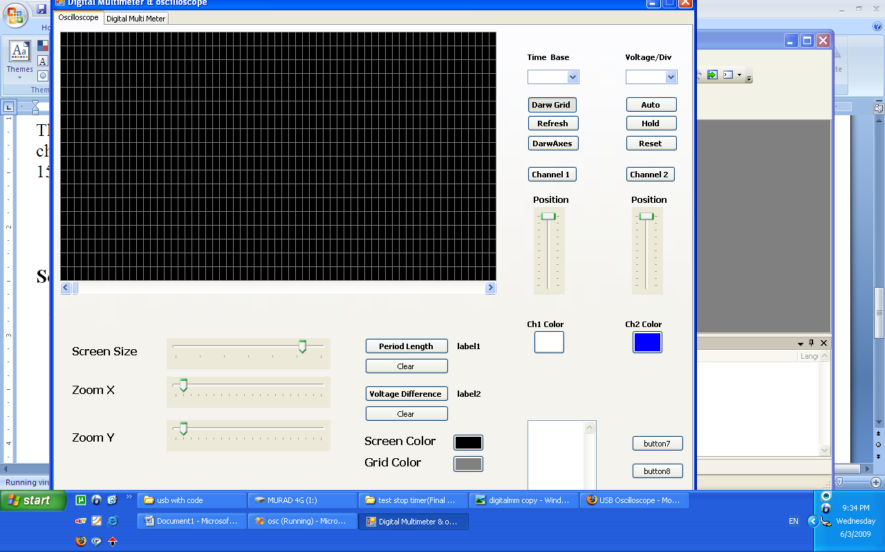

And this is the screen shots for multimeter

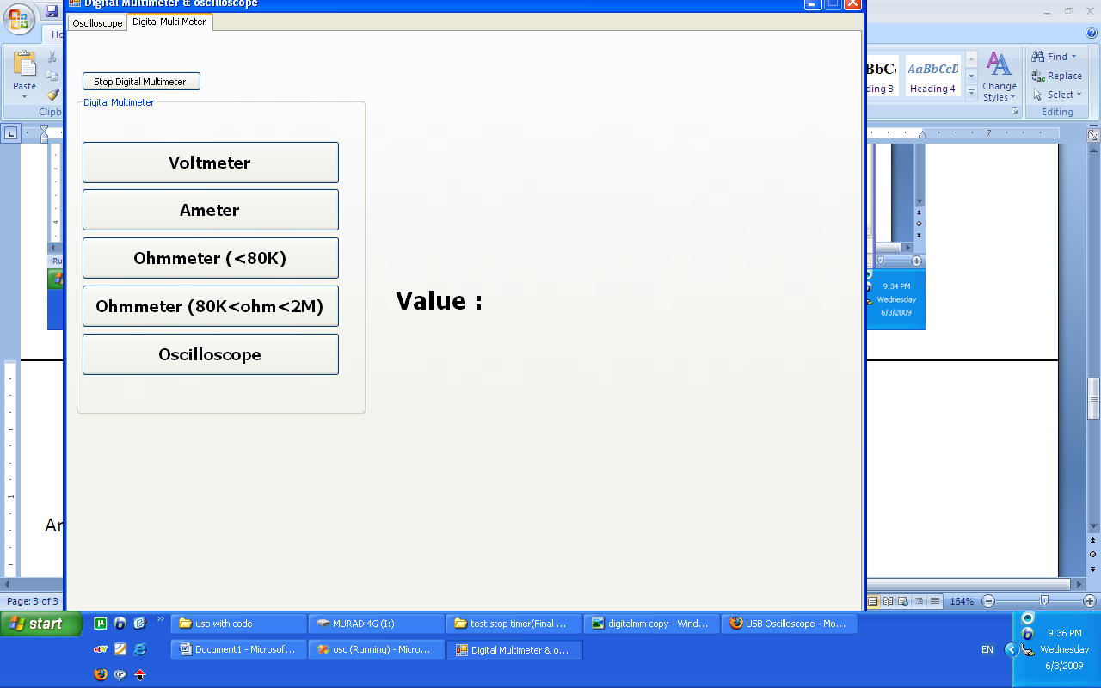

And this c# code for the project

using System;
using System.Collections.Generic;
using System.ComponentModel;
using System.Data;
using System.Drawing;
using System.Text;
using System.Windows.Forms;
using System.IO;
using System.Collections;
using PicWinUSB;
namespace osc
{
public partial class Form1 : Form
{

IntPtr iHandle; // global device handle definition
Color BackColor;
PicWinUSBAPI picwinusbapi = new PicWinUSBAPI();
bool channel1Visible;
bool channel2Visible;
int picWidth = 500;
int picHeight = 250;
int Yshift;
int Xshift;
int Yshift2;
int Xshift2;
Pen grid;
Pen ch1;
Pen ch2;
int Zoom;
Timer t;
Timer t2;
int x=0;
int y;
int prev_x;
int prev_y;
int x2=0;
int y2;
int prev_x2;
int prev_y2;
StreamReader file;
StreamReader file2;
string line;
int counter = 0;
int counter2 = 0;
Graphics g;
string[] coordinates;
ArrayList dataStore;
ArrayList dataStore2;
int lastMinimumValue;
int lastMinimumValue2;
int MinimumValue = 0;
int MaximumValue = 500;
int zoomX, zoomY;
int Mouse1_X;
int Mouse2_X;
int Mouse1_Y;
int Mouse2_Y;
int MouseCount = 0;
bool GridVisiable;
int GridWidth;
int GridHeight;
int DatarecievedCount = 0;
int DatarecievedCount2 = 0;
Timer t3;
public Form1()
{
InitializeComponent();
channel1Visible = false;
channel2Visible = false;
panel1.Width = picWidth;
panel1.Height = picHeight;
hScrollBar1.Maximum = picWidth;
prev_x = 20;
prev_y = picHeight / 4;
prev_x2 = 20;
prev_y2 = 3*picHeight / 4;
zoomX = 1;
zoomY = 1;
GridVisiable = false;
GridWidth = 10;
//comboBox1.SelectedIndex = 0;
GridHeight = 20;
Yshift = picHeight / 4;
Xshift = 0;
Yshift2 =3* picHeight / 4;
Xshift2 = 0;
grid = new Pen(Brushes.Gray, 0.4f);
ch1 = new Pen(Brushes.White, 1f);
ch2 = new Pen(Brushes.Blue, 1f);
Zoom = 0;
dataStore = new ArrayList();
dataStore2 = new ArrayList();
t = new Timer();
t.Interval = 1;
//file = new StreamReader(@"c:\data.txt");
//file2 = new StreamReader(@"c:\data2.txt");
t2= new Timer();
t2.Interval = 10;
zoomX = trackBar2.Value;
zoomY = trackBar3.Value;
button3.BackColor = ch1.Color;
button4.BackColor = ch2.Color;
button5.BackColor = pictureBox1.BackColor;
button6.BackColor = grid.Color;
Guid InterfaceGuid = new Guid("31415926-5358-9793-2384-626433832795"); // .Inf defined Guid
iHandle = picwinusbapi.Init_PicWinUSB(InterfaceGuid);
BackColor = pictureBox1.BackColor;
backPen=new Pen(BackColor,grid.Width);
t3 = new Timer();
t3.Interval = 1000;
}

public void translate_coor(ref int y,ref int x)
{
y = -1 * y * zoomY + Yshift;
x = x*zoomX + 20;
}

public void translate_coor_without_x(ref int y, ref int x)
{
y = -1 * y * zoomY + Yshift;
x = x*zoomX ;
}

public void translate_coor2(ref int y2, ref int x2)
{
y2 = -1 * y2 * zoomY + Yshift2;
x2 = x2 * zoomX + 20;
}

public void translate_coor_without_x2(ref int y2, ref int x2)
{
y2 = -1 * y2 * zoomY + Yshift2;
x2 = x2 * zoomX;
}

public void clear(Graphics g)
{
Pen p=new Pen(Brushes.Yellow,3f);
g.Clear(pictureBox1.BackColor);
if (GridVisiable)
{

DrawGrid(grid, GridWidth, GridHeight);

}
g.DrawLine(p, new Point(20, 0), new Point(20, picHeight));
g.DrawLine(p, new Point(0, picHeight / 2), new Point(picWidth, picHeight / 2));

p = null;

}

public void clearWtihoutX(Graphics g)
{

g.Clear(pictureBox1.BackColor);

if (GridVisiable)
{

DrawGrid(grid, GridWidth, GridHeight);

}
Pen p = new Pen(Brushes.Yellow, 2f);
//g.DrawLine(p, new Point(20, 0), new Point(20, 250));
g.DrawLine(p, new Point(0, picHeight / 2), new Point(picWidth, picHeight / 2));

p = null;
}

private void Form1_Load(object sender, EventArgs e)
{
label12.Text = "";
}

private void button1_Click(object sender, EventArgs e)
{

Graphics g=pictureBox1.CreateGraphics();
Pen p = new Pen(Brushes.Yellow, 3f);
g.DrawLine(p, new Point(20, 0), new Point(20, picHeight));
g.DrawLine(p, new Point(0, picHeight / 2), new Point(picWidth, picHeight / 2));
p = null;
}
int packetlength=1;

void t_Tick(object sender, EventArgs e)
{

t.Stop();

// byte ss = 125;
sdBuffer[0] = 1;
bres = picwinusbapi.Write_PicWinUSB(iHandle, sdBuffer);
if (bres)
{

bres = picwinusbapi.Read_PicWinUSB(iHandle, rdBuffer);
}
//while (packetlength < 64)
//{
if ((rdBuffer[0] == 1))
{

y = Convert.ToInt32((rdBuffer[1]) * 5 / 254)*10;
x = DatarecievedCount;
DatarecievedCount++;

textBox1.AppendText("x= " + DatarecievedCount.ToString() + " y= " + rdBuffer[packetlength].ToString() + "\n");

}

DataClass Dataobject = new DataClass(x, y);
dataStore.Add(Dataobject);
if (x >= hScrollBar1.Minimum && x <= hScrollBar1.Maximum)
{
hScrollBar1.Value = x;
}
translate_coor(ref y, ref x);

if (x == ((counter + 1) * picWidth))
{
hScrollBar1.Maximum = picWidth * (counter + 2);
prev_x = 0;
prev_y = picHeight / 4;
counter++;
clearWtihoutX(g);
}

x = x - (counter * picWidth);
g.DrawLine(ch1, new Point(prev_x, prev_y), new Point(x, y));

prev_x = x;
prev_y = y;

//}

//packetlength = 1;

t.Start();

//}

//else
//{
// prev_x = 20;
// prev_y = picHeight/4;
// file.Close();
// t.Stop();

//}
}

public void Drawline(Pen p ,int x, int y, int prev_x, int prev_y, Graphics g,bool start)
{

if (x % picWidth == 0)
{
prev_x = 0;
}

if (!start)
{

x = x % picWidth;
prev_x = prev_x % picWidth;
translate_coor_without_x(ref prev_y, ref prev_x);
translate_coor_without_x(ref y, ref x);

}

else
{
x = x % picWidth;
prev_x = prev_x % picWidth;
translate_coor(ref prev_y, ref prev_x);
translate_coor(ref y, ref x);

}

g.DrawLine(p, new Point(prev_x, prev_y), new Point(x, y));

}

public void Drawline2(Pen p, int x2, int y2, int prev_x2, int prev_y2, Graphics g, bool start2)
{

if (x2 % picWidth == 0)
{
prev_x2 = 0;
}

if (!start2)
{

x2 = x2% picWidth;
prev_x2 = prev_x2 % picWidth;
translate_coor_without_x2(ref prev_y2, ref prev_x2);
translate_coor_without_x2(ref y2, ref x2);

}

else
{
x2 = x2 % picWidth;
prev_x2 = prev_x2 % picWidth;
translate_coor2(ref prev_y2, ref prev_x2);
translate_coor2(ref y2, ref x2);

}

g.DrawLine(p, new Point(prev_x2, prev_y2), new Point(x2, y2));

}

public void DrawFunction(int minimum,int maximum,Graphics g)
{

int x, y, prev_x=minimum, prev_y=0;
DataClass d;
if (minimum == 0)
{
clear(g);
}

else
{
clearWtihoutX(g);
}

bool start;
try
{

//Pen p = new Pen(Brushes.White, 1f);
for (int i = 0; i < dataStore.Count; i++)
{

d = (DataClass)dataStore[i];

if (d.x == (minimum / zoomX))
{
prev_x = d.x;
prev_y = d.y;

}
if ((d.x >= (minimum / zoomX)) && (d.x <= (maximum / zoomX)))
{
x = d.x;
y = d.y;
if (x * zoomX > picWidth)
start = false;
else
start = true;
Drawline(ch1, x - (minimum / zoomX), y, prev_x - (minimum / zoomX), prev_y, g, start);
prev_x = x;
prev_y = y;
}

}

}
catch (Exception ex)
{
}

}

public void DrawFunction2(int minimum, int maximum, Graphics g)
{

int x2, y2, prev_x2 = minimum, prev_y2 = 0;
DataClass d;
//if (minimum == 0)
//{
// clear(g);
//}

//else
//{
// clearWtihoutX(g);
//}

bool start;
bool start2;
try
{

//Pen p = new Pen(Brushes.White, 1f);
for (int i = 0; i < dataStore2.Count; i++)
{

d = (DataClass)dataStore2[i];

if (d.x == (minimum / zoomX))
{
prev_x2 = d.x;
prev_y2 = d.y;

}
if ((d.x > (minimum / zoomX)) && (d.x <= (maximum / zoomX)))
{
x2 = d.x;
y2 = d.y;
if (x2 * zoomX > picWidth)
start2 = false;
else
start2 = true;
Drawline2(ch2, x2 - (minimum / zoomX), y2, prev_x2 - (minimum / zoomX), prev_y2, g, start2);
prev_x2 = x2;
prev_y2 = y2;
}

}

}
catch (Exception ex)
{
}

}

private void hScrollBar1_Scroll(object sender, ScrollEventArgs e)
{
t.Stop();
t2.Stop();
lastMinimumValue = MinimumValue;
MinimumValue = (hScrollBar1.Value / picWidth)* picWidth;
MaximumValue = ((hScrollBar1.Value / picWidth) + 1) * picWidth;
Graphics g=pictureBox1.CreateGraphics();
if (lastMinimumValue!=MinimumValue)
{
DrawFunction(MinimumValue, MaximumValue,g );
DrawFunction2(MinimumValue, MaximumValue, g);
}

}

public void DrawGrid(Pen grid,int width, int height)
{

Graphics g=pictureBox1.CreateGraphics();

for (int i = 0; i < picWidth; i = i + width)
{
g.DrawLine(grid, new Point(i, 0), new Point(i, picHeight));
}

for (int i = 0; i < picHeight; i = i + height)
{
g.DrawLine(grid, new Point(0, i), new Point(picWidth,i));
}

}

private void button8_Click(object sender, EventArgs e)
{

}

private void button9_Click(object sender, EventArgs e)
{
//Pen grid = new Pen(Brushes.Black, 0.4f);

DrawGrid(grid, GridWidth, GridHeight);
GridHeight = 2 * GridHeight;
GridWidth = 2 * GridWidth;

//grid = new Pen(Brushes.Yellow, 0.4f);
DrawGrid(grid, GridWidth, GridHeight);

}

private void button10_Click(object sender, EventArgs e)
{
//Pen grid = new Pen(Brushes.Black, 0.4f);
DrawGrid(grid, GridWidth, GridHeight);
if (GridWidth > 10)
{
GridWidth = GridWidth/2;
}
if (GridHeight > 10)
{
GridHeight = GridHeight/2;
}

grid = new Pen(Brushes.Yellow, 0.4f);
DrawGrid(grid, GridWidth, GridHeight);
}

private void checkBox1_CheckedChanged(object sender, EventArgs e)
{
if (!checkBox1.Checked)
{
Graphics g = pictureBox1.CreateGraphics();
Pen p = new Pen(pictureBox1.BackColor, 1f);
g.DrawLine(p, new Point(Mouse1_X, Mouse1_Y - (picHeight / 4)), new Point(Mouse1_X, Mouse1_Y + (picHeight / 4)));
g.DrawLine(p, new Point(Mouse2_X, Mouse2_Y - (picHeight / 4)), new Point(Mouse2_X, Mouse2_Y + (picHeight / 4)));
MouseCount = 0;

}
}

private void pictureBox1_MouseHover(object sender, EventArgs e)
{

}

private void pictureBox1_MouseMove(object sender, MouseEventArgs e)
{

}

private void pictureBox1_MouseClick(object sender, MouseEventArgs e)
{
Graphics g = pictureBox1.CreateGraphics();
if (checkBox1.Checked)
{

if (MouseCount < 2)
{
MouseCount++;

if (MouseCount == 1)
{
Mouse1_X = e.X;
Mouse1_Y = e.Y;
Pen p = new Pen(Brushes.Blue, 1f);
g.DrawLine(p, new Point(e.X, Mouse1_Y - (picHeight / 4)), new Point(e.X, Mouse1_Y + (picHeight / 4)));

}
if (MouseCount == 2)
{
Mouse2_X = e.X;
Mouse2_Y = e.Y;
label1.Text = Convert.ToString(Math.Abs(Mouse1_X - Mouse2_X)/zoomX)+" ms";
Pen p = new Pen(Brushes.Blue, 1f);
g.DrawLine(p, new Point(e.X, Mouse2_Y - (picHeight / 4)), new Point(e.X, Mouse2_Y + (picHeight / 4)));
}

}
}

if (checkBox2.Checked)
{

if (MouseCount < 2)
{
MouseCount++;

if (MouseCount == 1)
{
Mouse1_X = e.X;
Mouse1_Y = e.Y;
Pen p = new Pen(Brushes.Blue, 1f);
g.DrawLine(p, new Point(Mouse1_X - picWidth / 4, e.Y), new Point(Mouse1_X + picWidth / 4, e.Y));
}
if (MouseCount == 2)
{
Mouse2_X = e.X;
Mouse2_Y = e.Y;
Pen p = new Pen(Brushes.Blue, 1f);
g.DrawLine(p, new Point(Mouse2_X - picWidth / 4, e.Y), new Point(Mouse2_X + picWidth / 4, e.Y));
label2.Text = Convert.ToString(Math.Abs(Mouse1_Y - Mouse2_Y)/(10*zoomY)) + " V ";
}

}
}
}

private void button11_Click(object sender, EventArgs e)
{

Graphics g = pictureBox1.CreateGraphics();
Pen p = new Pen(pictureBox1.BackColor, 1f);
g.DrawLine(p, new Point(Mouse1_X, Mouse1_Y - picHeight / 4), new Point(Mouse1_X, Mouse1_Y + picHeight / 4));
g.DrawLine(p, new Point(Mouse2_X, Mouse2_Y - picHeight / 4), new Point(Mouse2_X, Mouse2_Y + picHeight / 4));
label1.Text = "";
MouseCount=0;
}

private void button12_Click(object sender, EventArgs e)
{
Graphics g = pictureBox1.CreateGraphics();
Pen p = new Pen(pictureBox1.BackColor, 1f);
g.DrawLine(p, new Point(Mouse1_X - picWidth / 4, Mouse1_Y), new Point(Mouse1_X + picWidth / 4, Mouse1_Y));
g.DrawLine(p, new Point(Mouse2_X - picWidth / 4, Mouse2_Y), new Point(Mouse2_X + picWidth / 4, Mouse2_Y));
label2.Text = "";
MouseCount = 0;
}

private void checkBox2_CheckedChanged(object sender, EventArgs e)
{
if (!checkBox2.Checked)
{
Graphics g = pictureBox1.CreateGraphics();
Pen p = new Pen(pictureBox1.BackColor, 1f);
g.DrawLine(p, new Point(Mouse1_X - picWidth / 4, Mouse1_Y), new Point(Mouse1_X + picWidth / 4,Mouse1_Y));
g.DrawLine(p, new Point(Mouse2_X - picWidth / 4, Mouse2_Y), new Point(Mouse2_X + picWidth / 4,Mouse2_Y));
label2.Text = "";
MouseCount = 0;
}
}

private void button14_Click(object sender, EventArgs e)
{
MinimumValue = (hScrollBar1.Value / picWidth) * picWidth;
MaximumValue = ((hScrollBar1.Value / picWidth) + 1) * picWidth;
Graphics g=pictureBox1.CreateGraphics();
DrawFunction(MinimumValue, MaximumValue, g);
DrawFunction2(MinimumValue, MaximumValue,g);

}

private void comboBox1_SelectedIndexChanged(object sender, EventArgs e)
{
GridVisiable = true;

if (comboBox1.SelectedIndex == 0)
{
// zoomX = 100;
t.Interval = 1;
t2.Interval = 1;
GridWidth = 10;
t.Stop();
lastMinimumValue = MinimumValue;
MinimumValue = (hScrollBar1.Value / picWidth) * picWidth;
MaximumValue = ((hScrollBar1.Value / picWidth) + 1) * picWidth;
hScrollBar1.Maximum = dataStore.Count * zoomX;
DrawFunction(MinimumValue, MaximumValue, pictureBox1.CreateGraphics());
}
else if (comboBox1.SelectedIndex == 1)
{
//zoomX = 10;
t.Interval = 1;
t2.Interval = 1;
GridWidth = 100;
//TimeLabel.Text=Convert.ToString(
t.Stop();
lastMinimumValue = MinimumValue;
MinimumValue = (hScrollBar1.Value / picWidth) * picWidth;
MaximumValue = ((hScrollBar1.Value / picWidth) + 1) * picWidth;
hScrollBar1.Maximum = dataStore.Count * zoomX;
DrawFunction(MinimumValue, MaximumValue, pictureBox1.CreateGraphics());
}
else if (comboBox1.SelectedIndex == 2)
{
// zoomX = 1;
t.Interval = 10;
t2.Interval = 10;
GridWidth = 1000;
t.Stop();
lastMinimumValue = MinimumValue;
MinimumValue = (hScrollBar1.Value / picWidth) * picWidth;
MaximumValue = ((hScrollBar1.Value / picWidth) + 1) * picWidth;
hScrollBar1.Maximum = dataStore.Count * zoomX;
DrawFunction(MinimumValue, MaximumValue, pictureBox1.CreateGraphics());
}
}

private void button15_Click(object sender, EventArgs e)
{
//DatarecievedCount = 0;
//DatarecievedCount2 = 0;

g = pictureBox1.CreateGraphics();
clear(g);

if (channel1Visible)
{
t.Tick += new EventHandler(t_Tick);
t.Start();
}
if (channel2Visible)
{
t2.Tick += new EventHandler(t2_Tick);
t2.Start();
}
}
bool bres;
byte[] sdBuffer=new byte[1]; // Define send DataBuffer size
byte[] rdBuffer = new byte[2];
void t2_Tick(object sender, EventArgs e)
{
//throw new Exception("The method or operation is not implemented.");
//if ((line = file2.ReadLine()) != null)
//{
// coordinates = line.Split('*');
// coordinates[0] = coordinates[0].Trim();
// coordinates[1] = coordinates[1].Trim();
// x2 = Convert.ToInt32(coordinates[0]);
// y2 = Convert.ToInt32(coordinates[1]);
t2.Stop();
bool bres;
// Define recieve DataBuffer size

sdBuffer[0] = 0x02; //Mode

bres = picwinusbapi.Write_PicWinUSB(iHandle, sdBuffer);
bres = picwinusbapi.Read_PicWinUSB(iHandle, rdBuffer);

if (rdBuffer[0] == 2)
{
y2=Convert.ToInt32(rdBuffer[1]*5/254)*10;
x2 = DatarecievedCount2;
DatarecievedCount2++;
}

DataClass Dataobject = new DataClass(x2, y2);
dataStore2.Add(Dataobject);

if (x2 >= hScrollBar1.Minimum && x2 <= hScrollBar1.Maximum)
{
hScrollBar1.Value = x2;
}

translate_coor2(ref y2, ref x2);
if (x2 == ((counter2 + 1) * picWidth))
{
hScrollBar1.Maximum = picWidth * (counter2 + 2);
prev_x2 = 0;
prev_y2 = Yshift2;
counter2++;

clearWtihoutX(g);
}
x2 = x2 - (counter2 * picWidth);
g.DrawLine(ch2, new Point(prev_x2, prev_y2), new Point(x2, y2));

prev_x2 = x2;
prev_y2 = y2;

t2.Start();

}

private void button17_Click(object sender, EventArgs e)
{
t.Stop();
t2.Stop();
}

private void trackBar1_Scroll_1(object sender, EventArgs e)
{
if (channel1Visible)
t.Stop();
if (channel2Visible)
t2.Stop();

if (trackBar1.Value >= Zoom)
{
panel1.Width = panel1.Width + trackBar1.Value-Zoom;
panel1.Height = panel1.Height + trackBar1.Value -Zoom;
Zoom = trackBar1.Value;

}
else
{
panel1.Width = panel1.Width + trackBar1.Value-Zoom;
panel1.Height = panel1.Height + trackBar1.Value - Zoom;
Zoom = trackBar1.Value;
}

pictureBox1.Width = panel1.Width;
pictureBox1.Height = panel1.Height - 20;
pictureBox1.Refresh();
picWidth = panel1.Width;
picHeight = panel1.Height;
hScrollBar1.Maximum = picWidth;

MinimumValue = (hScrollBar1.Value / picWidth) * picWidth;
MaximumValue = ((hScrollBar1.Value / picWidth) + 1) * picWidth;
g = pictureBox1.CreateGraphics();
if (channel1Visible)
DrawFunction(MinimumValue, MaximumValue, g);
if (channel2Visible)
DrawFunction2(MinimumValue, MaximumValue, g);
if (GridVisiable)
DrawGrid(grid, picWidth, picHeight);
}

private void trackBar2_Scroll(object sender, EventArgs e)
{
zoomX = trackBar2.Value ;
GridWidth = trackBar2.Value * GridWidth;

t.Stop();
t2.Stop();
lastMinimumValue = MinimumValue;
MinimumValue = (hScrollBar1.Value / picWidth) * picWidth;
MaximumValue = ((hScrollBar1.Value / picWidth) + 1) * picWidth;
if (dataStore2.Count >= dataStore.Count)
{

hScrollBar1.Maximum = dataStore2.Count * zoomX;
}
else
{
hScrollBar1.Maximum = dataStore.Count * zoomX;
}
g = pictureBox1.CreateGraphics();
if (channel1Visible)
DrawFunction(MinimumValue, MaximumValue, g);
if (channel2Visible)
DrawFunction2(MinimumValue, MaximumValue, g);
}

private void trackBar3_Scroll(object sender, EventArgs e)
{
zoomY = trackBar3.Value ;

if (comboBox2.SelectedIndex == 0)
{
GridHeight = trackBar3.Value * 50;
}

else if (comboBox2.SelectedIndex == 1)
{
GridHeight = trackBar3.Value * 10;
}

t.Stop();
t2.Stop();
lastMinimumValue = MinimumValue;
MinimumValue = (hScrollBar1.Value / picWidth) * picWidth;
MaximumValue = ((hScrollBar1.Value / picWidth) + 1) * picWidth;
g = pictureBox1.CreateGraphics();
if(channel1Visible)
DrawFunction(MinimumValue, MaximumValue, g);
if (channel2Visible)
DrawFunction2(MinimumValue, MaximumValue,g);
}

private void pictureBox1_Click(object sender, EventArgs e)
{

}

private void osc_Click(object sender, EventArgs e)
{

}

private void channel1_CheckedChanged(object sender, EventArgs e)
{

channel1Visible = channel1.Checked;

}

private void channel2_CheckedChanged(object sender, EventArgs e)
{
channel2Visible = channel2.Checked;
}

private void trackBar4_Scroll(object sender, EventArgs e)
{
Yshift = (10-trackBar4.Value) * picHeight / 10;
}

private void trackBar5_Scroll(object sender, EventArgs e)
{
Yshift2 = (10 - trackBar5.Value) * picHeight / 10;
}

private void button2_Click(object sender, EventArgs e)
{
t.Stop();
t2.Stop();
dataStore.Clear();
dataStore2.Clear();
clear(pictureBox1.CreateGraphics());
panel1.Width = picWidth;
panel1.Height = picHeight;
hScrollBar1.Maximum = picWidth;
prev_x = 20;
prev_y = picHeight / 4;
prev_x2 = 20;
prev_y2 = 3 * picHeight / 4;
zoomX = 1;
zoomY = 1;
GridWidth = 10;
GridHeight = 20;
Yshift = picHeight / 4;
Xshift = 0;
Yshift2 = 3 * picHeight / 4;
Xshift2 = 0;
grid = new Pen(Brushes.Yellow, 0.4f);
ch1 = new Pen(Brushes.White, 1f);
ch2 = new Pen(Brushes.Blue, 1f);
Zoom = 0;
dataStore = new ArrayList();
dataStore2 = new ArrayList();
DatarecievedCount = 0;
DatarecievedCount2 = 0;
t = new Timer();
t.Interval = 1;
//file = new StreamReader(@"c:\data.txt");
//file2 = new StreamReader(@"c:\data2.txt");
t2 = new Timer();
t2.Interval = 10;
}

private void button3_Click(object sender, EventArgs e)
{
DialogResult res = colorDialog1.ShowDialog();
if (res == DialogResult.OK)
{
button3.BackColor = colorDialog1.Color;
ch1.Color = button3.BackColor;
button14.Click+=new EventHandler(button14_Click);
}

}

private void button4_Click(object sender, EventArgs e)
{
DialogResult res = colorDialog1.ShowDialog();
if (res == DialogResult.OK)
{
button4.BackColor = colorDialog1.Color;
ch2.Color = button4.BackColor;
}

}

private void button5_Click(object sender, EventArgs e)
{
DialogResult res = colorDialog1.ShowDialog();
if (res == DialogResult.OK)
{
button5.BackColor = colorDialog1.Color;
pictureBox1.BackColor= button5.BackColor;
BackColor = pictureBox1.BackColor;
}
}

private void label11_Click(object sender, EventArgs e)
{

}

private void button6_Click(object sender, EventArgs e)
{
DialogResult res = colorDialog1.ShowDialog();
if (res == DialogResult.OK)
{
button6.BackColor = colorDialog1.Color;
grid.Color = button6.BackColor;
button14_Click(sender, e);
}
}

//private void radioButton5_CheckedChanged(object sender, EventArgs e)
//{
// if (!fun1.Checked)
// {
// bool bres;
// byte[] sdBuffer = new byte[2]; // Define send DataBuffer size

// sdBuffer[0] = 0x06; //Mode
// sdBuffer[1] = 0x01;

// bres = picwinusbapi.Write_PicWinUSB(iHandle, sdBuffer);

// }
//}

private void dmm_Click(object sender, EventArgs e)
{

}

private void radioButton8_CheckedChanged(object sender, EventArgs e)
{
if (radioButton8.Checked)
{
t3.Stop();
tabControl1.SelectedTab = osc;
}
}

private void panel3_Paint(object sender, PaintEventArgs e)
{

}

private void button7_Click(object sender, EventArgs e)
{
bool bres;

sdBuffer[0] = 0x01; //Mode

bres = picwinusbapi.Write_PicWinUSB(iHandle, sdBuffer);
bres = picwinusbapi.Read_PicWinUSB(iHandle, rdBuffer);

if (rdBuffer[0] == 1)
{
y = Convert.ToInt32(rdBuffer[1] * 5 / 254) * 5;
x++;

}

textBox1.AppendText("x= " + x.ToString() + " y= " + y.ToString() + "\n");
}

private void volt_CheckedChanged(object sender, EventArgs e)
{
t3.Tick += new EventHandler(t3_Tick);
t3.Start();

// double sum = 0;
// int count = 0;
//volt:
// if (volt.Checked)
// {
// //MessageBox.Show("mmm");
// bool bres;
// byte[] sdBuffer = new byte[1]; // Define send DataBuffer size
// byte[] rdBuffer = new byte[2]; // Define recieve DataBuffer size

// sdBuffer[0] = 0x03; //Mode

// //while ((count<10))
// //{
// bres = picwinusbapi.Write_PicWinUSB(iHandle, sdBuffer);
// bres = picwinusbapi.Read_PicWinUSB(iHandle, rdBuffer);
// sum += Convert.ToDouble(rdBuffer[1]);
// count++;

// //}
// double volt1 = (sum / count) * 4.9 * 5 / 254;
// //MessageBox.Show(Convert.ToString(sum / count) + " V");
// label12.Text = Convert.ToString(volt1) + " V";
// count = 0;
// sum = 0;
// //goto volt;
// }
}

void t3_Tick(object sender, EventArgs e)
{
//throw new Exception("The method or operation is not implemented.");
double sum = 0;
int count = 0;
byte[] sdBuffer; // Define send DataBuffer size
byte[] rdBuffer ; // Define recieve DataBuffer size

if (volt.Checked)
{
//MessageBox.Show("mmm");
bool bres;
sdBuffer = new byte[1]; // Define send DataBuffer size
rdBuffer = new byte[2]; // Define recieve DataBuffer size

sdBuffer[0] = 0x03; //Mode

//while ((count<10))
//{
bres = picwinusbapi.Write_PicWinUSB(iHandle, sdBuffer);
bres = picwinusbapi.Read_PicWinUSB(iHandle, rdBuffer);
sum += Convert.ToDouble(rdBuffer[1]);
count++;

//}
double volt1 = (sum / count) * 4.9 * 5 / 254;
//MessageBox.Show(Convert.ToString(sum / count) + " V");
volt1 = Math.Round(volt1, 2);
label12.Text = Convert.ToString(volt1) + " V";
count = 0;
sum = 0;

}

else if (Ameter.Checked)
{
bool bres;
sdBuffer = new byte[1]; // Define send DataBuffer size
rdBuffer = new byte[2]; // Define recieve DataBuffer size

sdBuffer[0] = 0x04; //Mode

// while (count<10)
// {
bres = picwinusbapi.Write_PicWinUSB(iHandle, sdBuffer);
bres = picwinusbapi.Read_PicWinUSB(iHandle, rdBuffer);
sum += Convert.ToDouble(rdBuffer[1]);
count++;

//}
double ampere = (sum / count) * 5 / (254 * 5);
//decimal dd = new decimal(ampere);
ampere= Math.Round(ampere, 4);
label12.Text = Convert.ToString(ampere) + " A";
count = 0;
sum = 0;
// goto ameterr;
}

else if (ohm1.Checked)
{
bool bres;
sdBuffer = new byte[1]; // Define send DataBuffer size
rdBuffer = new byte[2]; // Define recieve DataBuffer size

sdBuffer[0] = 0x05; //Mode

//while (count<10)
//{
bres = picwinusbapi.Write_PicWinUSB(iHandle, sdBuffer);
bres = picwinusbapi.Read_PicWinUSB(iHandle, rdBuffer);
sum += Convert.ToDouble(rdBuffer[1]);
count++;

//}

double volt1 =Convert.ToDouble( (sum / count) * 5 / 255);
double current = volt1 / 324;
double resist = (5 - volt1) / current;
resist = Math.Round(resist);
//decimal dd = new decimal(resist);
label12.Text = resist + " Ohm";
count = 0;
sum = 0;
//goto ohm11;
}

else if (ohm2.Checked)
{
bool bres;
sdBuffer = new byte[1]; // Define send DataBuffer size
rdBuffer = new byte[2]; // Define recieve DataBuffer size

sdBuffer[0] = 0x06; //Mode

//while (count<10)
//{
bres = picwinusbapi.Write_PicWinUSB(iHandle, sdBuffer);
bres = picwinusbapi.Read_PicWinUSB(iHandle, rdBuffer);
sum += Convert.ToDouble(rdBuffer[1]);
count++;

//}

double volt1 = (sum / count) * 5 / 254;
double current = volt1 / 370000;
double resist = (5 - volt1) / current;

//decimal dd = new decimal(resist);
resist = Math.Round(resist / 1000);
label12.Text = Convert.ToString(resist) + " K Ohm";
count = 0;
sum = 0;
// goto ohm22;
}

}

private void Ameter_CheckedChanged(object sender, EventArgs e)
{

t3.Tick += new EventHandler(t3_Tick);
t3.Start();

// double sum = 0;
// int count = 0;
//ameterr:
// if (Ameter.Checked)
// {
// bool bres;
// byte[] sdBuffer = new byte[1]; // Define send DataBuffer size
// byte[] rdBuffer = new byte[2]; // Define recieve DataBuffer size

// sdBuffer[0] = 0x04; //Mode

// // while (count<10)
// // {
// bres = picwinusbapi.Write_PicWinUSB(iHandle, sdBuffer);
// bres = picwinusbapi.Read_PicWinUSB(iHandle, rdBuffer);
// sum += Convert.ToDouble(rdBuffer[1]);
// count++;

// //}
// double ampere = (sum / count) * 5*2 / (254 * 5);
// label12.Text = Convert.ToString(ampere) + " A";
// count = 0;
// sum = 0;
// // goto ameterr;
// }
}

private void ohm1_CheckedChanged(object sender, EventArgs e)
{

t3.Tick += new EventHandler(t3_Tick);
t3.Start();
// double sum = 0;
// int count = 0;
//ohm11:
// if (ohm1.Checked)
// {
// bool bres;
// byte[] sdBuffer = new byte[1]; // Define send DataBuffer size
// byte[] rdBuffer = new byte[2]; // Define recieve DataBuffer size

// sdBuffer[0] = 0x05; //Mode

// //while (count<10)
// //{
// bres = picwinusbapi.Write_PicWinUSB(iHandle, sdBuffer);
// bres = picwinusbapi.Read_PicWinUSB(iHandle, rdBuffer);
// sum += Convert.ToDouble(rdBuffer[1]);
// count++;

// //}

// double volt = (sum/count) * 5 / 255;
// double current = volt / 324;
// double resist = (5 - volt) / current;

// decimal dd = new decimal(resist);

// label12.Text = Convert.ToString(dd.ToString("0.##")) + " Ohm";
// count = 0;
// sum = 0;
// //goto ohm11;
// }
}

private void ohm2_CheckedChanged(object sender, EventArgs e)
{

t3.Tick += new EventHandler(t3_Tick);
t3.Start();

// double sum = 0;
// int count = 0;
//ohm22:
// if (ohm2.Checked)
// {
// bool bres;
// byte[] sdBuffer = new byte[1]; // Define send DataBuffer size
// byte[] rdBuffer = new byte[2]; // Define recieve DataBuffer size

// sdBuffer[0] = 0x06; //Mode

// //while (count<10)
// //{
// bres = picwinusbapi.Write_PicWinUSB(iHandle, sdBuffer);
// bres = picwinusbapi.Read_PicWinUSB(iHandle, rdBuffer);
// sum += Convert.ToDouble(rdBuffer[1]);
// count++;

// //}

// double volt = (sum / count) * 5 / 254;
// double current = volt / 100000;
// double resist = (5 - volt) / current;

// label12.Text = Convert.ToString(resist) + " Ohm";
// count = 0;
// sum = 0;
// // goto ohm22;
// }
}

private void fun2_CheckedChanged(object sender, EventArgs e)
{
//if (fun2.Checked)
//{
// MessageBox.Show("gfhfhf");
// bool bres;
// byte[] sdBuffer = new byte[2]; // Define send DataBuffer size

// sdBuffer[0] = 0x07; //Mode
// sdBuffer[1] = 0x01;

// bres = picwinusbapi.Write_PicWinUSB(iHandle, sdBuffer);

//}
}
Pen backPen;
private void comboBox2_SelectedIndexChanged(object sender, EventArgs e)
{

backPen=new Pen(BackColor,grid.Width);
if (comboBox2.SelectedIndex == 0)
{
DrawGrid(backPen, GridWidth, GridHeight);
GridHeight = 50;
DrawGrid(grid, GridWidth, GridHeight);

}

else if (comboBox2.SelectedIndex == 1)
{

DrawGrid(backPen, GridWidth, GridHeight);
GridHeight = 10;
DrawGrid(grid, GridWidth, GridHeight);

}

if (!GridVisiable)
{
//Pen grid = new Pen(Brushes.Yellow, 0.4f);
DrawGrid(backPen, GridWidth, GridHeight);

}

else
{
//Pen grid = new Pen(Brushes.Black, 0.4f);
DrawGrid(grid, GridWidth, GridHeight);

}

//GridVisiable = !GridVisiable;

}

private void checkBox3_CheckedChanged(object sender, EventArgs e)
{
if (checkBox3.Checked)
GridVisiable = true;
else GridVisiable = false;
if (!GridVisiable)
{
//Pen grid = new Pen(Brushes.Yellow, 0.4f);
DrawGrid(backPen, GridWidth, GridHeight);

}

else
{
//Pen grid = new Pen(Brushes.Black, 0.4f);
DrawGrid(grid, GridWidth, GridHeight);

}

}
Timer t4;
private void button7_Click_1(object sender, EventArgs e)
{
bool bres;

sdBuffer[0] = 0x01; //Mode
// bres = picwinusbapi.Write_PicWinUSB(iHandle, sdBuffer);
t4 = new Timer();
t4.Interval = 1;
t4.Tick += new EventHandler(t4_Tick);
t4.Start();
//while(packetlength<=10)
//{

}

void t4_Tick(object sender, EventArgs e)
{
//throw new Exception("The method or operation is not implemented.");

bres = picwinusbapi.Write_PicWinUSB(iHandle, sdBuffer);
if (bres)
{

bres = picwinusbapi.Read_PicWinUSB(iHandle, rdBuffer);
}
//while (packetlength < 64)
//{
if ((rdBuffer[0] == 1)||(rdBuffer[0] == 1))
{

if (rdBuffer[0] == 1)
{
y = Convert.ToInt32((rdBuffer[1]+127) * 5 / 254);
x = DatarecievedCount;
DatarecievedCount++;
}

else
{
y = Convert.ToInt32(rdBuffer[1] * 5 / 254);
x = DatarecievedCount;
DatarecievedCount++;

}

textBox1.AppendText("x= " + DatarecievedCount.ToString() + " y= " + rdBuffer[packetlength].ToString() + "\n");
}
// packetlength++;

//}
//packetlength = 1;
}

private void button8_Click_1(object sender, EventArgs e)
{
t4.Stop();
}

private void button9_Click_1(object sender, EventArgs e)
{
t3.Stop();
}

private void label15_Click(object sender, EventArgs e)
{

}
}
}

using System;
using System.Collections.Generic;
using System.Text;

namespace osc
{

class DataClass
{
public int x;
public int y;
public DataClass()
{
x = 0;
y = 0;

}

public DataClass(int x1,int y1)
{
x = x1;
y = y1;

}

}
}

using System;
using System.Runtime.InteropServices;
using System.IO;
using Microsoft.Win32.SafeHandles;

namespace PicWinUSB
{
class DeviceInterfaceImports
{
public const int DIGCF_PRESENT = 0x00000002;
public const int DIGCF_DEVICEINTERFACE = 0x00000010;

public const int FILE_ATTRIBUTE_NORMAL = 0x00000080;
public const int FILE_FLAG_OVERLAPPED = 0x40000000;

[StructLayout(LayoutKind.Sequential)]
public struct SP_DEVICE_INTERFACE_DATA
{
public int cbSize;
public Guid InterfaceClassGuid;
public int Flags;
public IntPtr Reserved;
}

[StructLayout(LayoutKind.Sequential)]
public struct SP_DEVICE_INTERFACE_DETAIL_DATA
{
public int cbSize;
[MarshalAs(UnmanagedType.ByValTStr, SizeConst = 256)]
public string DevicePath;
}

[DllImport(@"setupapi.dll", CharSet = CharSet.Auto, SetLastError = true)]
public static extern IntPtr SetupDiGetClassDevs(
ref Guid ClassGuid,
[MarshalAs(UnmanagedType.LPTStr)] string Enumerator,
IntPtr hwndParent,
UInt32 Flags);

[DllImport(@"setupapi.dll", CharSet = CharSet.Auto, SetLastError = true)]
public static extern Boolean SetupDiEnumDeviceInterfaces(
IntPtr hDevInfo,
IntPtr devInfo,
ref Guid interfaceClassGuid,
UInt32 memberIndex,
ref SP_DEVICE_INTERFACE_DATA deviceInterfaceData);

[DllImport(@"setupapi.dll", SetLastError = true)]
public static extern Boolean SetupDiGetDeviceInterfaceDetail(
IntPtr hDevInfo,
ref SP_DEVICE_INTERFACE_DATA deviceInterfaceData,
IntPtr deviceInterfaceDetailData,
UInt32 deviceInterfaceDetailDataSize,
out UInt32 requiredSize,
IntPtr deviceInfoData);

[DllImport(@"setupapi.dll", SetLastError = true)]
public static extern Boolean SetupDiGetDeviceInterfaceDetail(
IntPtr hDevInfo,
ref SP_DEVICE_INTERFACE_DATA deviceInterfaceData,
ref SP_DEVICE_INTERFACE_DETAIL_DATA deviceInterfaceDetailData,
UInt32 deviceInterfaceDetailDataSize,
out UInt32 requiredSize,
IntPtr deviceInfoData);

[DllImport(@"setupapi.dll", CharSet = CharSet.Auto, SetLastError = true)]
public static extern UInt16 SetupDiDestroyDeviceInfoList(
IntPtr hDevInfo);

[DllImport("kernel32.dll")]
public static extern IntPtr CreateFile(
string fileName,
FileAccess fileAccess,
FileShare fileShare,
IntPtr securityAttributes,
FileMode creationDisposition,
UInt32 flags,
IntPtr template);

[DllImport("kernel32.dll")]
public static extern bool CloseHandle(
IntPtr hObject);
}
}

using System;
using System.Diagnostics;
using System.IO;
using System.Windows.Forms;
using Microsoft.Win32.SafeHandles;
using System.Runtime.InteropServices;

namespace PicWinUSB
{
unsafe public class PicWinUSBAPI
{
#region Imported functions from winusb.dll ... some functions has not been checked yet.
[DllImport("winusb.dll")]
private static extern bool WinUsb_AbortPipe(IntPtr InterfaceHandle, byte PipeID);
//[DllImport("winusb.dll")]
//private static extern bool WinUsb_ControlTransfer(IntPtr InterfaceHandle, WINUSB_SETUP_PACKET SetupPacket, byte* Buffer, ulong BufferLength, out ulong* LengthTransferred); // retocar
[DllImport("winusb.dll")]
private static extern bool WinUsb_FlushPipe(IntPtr InterfaceHandle, byte PipeID);
[DllImport("winusb.dll")]
private static extern bool WinUsb_Free(IntPtr InterfaceHandle);
[DllImport("winusb.dll")]
private static extern bool WinUsb_GetAssociatedInterface(IntPtr InterfaceHandle, byte AssociatedInterfaceIndex, out IntPtr AssociatedInterfaceHandle);
[DllImport("winusb.dll")]
private static extern bool WinUsb_GetCurrentAlternateSetting(IntPtr InterfaceHandle, out byte* AlternateSetting);
[DllImport("winusb.dll")]
private static extern bool WinUsb_GetDescriptor(IntPtr InterfaceHandle, byte DescriptorType, byte Index, ushort LanguageID, out byte* Buffer, ulong BufferLength, out ulong* LengthTransferred);
[DllImport("winusb.dll")]
private static extern bool WinUsb_GetInterfacePowerPolicy(IntPtr InterfaceHandle, ulong PolicyType, out ulong* ValueLength, out void* Value); // raro
[DllImport("winusb.dll")]
private static extern bool WinUsb_GetPipePolicy(IntPtr DeviceHandle, byte PipeID, ulong PolicyType, out ulong* ValueLength, out void* Value); // raroo
[DllImport("winusb.dll")]
private static extern bool WinUsb_Initialize(IntPtr DeviceHandle, out IntPtr InterfaceHandle); // out inter
[DllImport("winusb.dll")]
private static extern bool WinUsb_QueryDeviceInformation(IntPtr DeviceHandle, ulong InformationType, out ulong BufferLength, out ulong Buffer); // raro
[DllImport("winusb.dll")]
private static extern bool WinUsb_QueryInterfaceSettings(IntPtr InterfaceHandle, byte AlternateSettingNumber, IntPtr UsbAltInterfaceDescriptor); // falta lo ultimo
//[DllImport("winusb.dll")]
//private static extern bool WinUsb_QueryPipe(IntPtr InterfaceHandle, byte AlternateInterfaceNumber, byte PipeIndex, out WINUSB_PIPE_INFORMATION PipeInformation);
[DllImport("winusb.dll")]
private static extern bool WinUsb_ReadPipe(IntPtr InterfaceHandle, byte PipeID, byte[] Buffer, int BufferLength, out uint LengthTransferred, IntPtr Overlapped);
[DllImport("winusb.dll")]
private static extern bool WinUsb_ResetPipe(IntPtr InterfaceHandle, byte PipeID);
[DllImport("winusb.dll")]
private static extern bool WinUsb_SetCurrentAlternateSetting(IntPtr InterfaceHandle, byte AlternateSetting);
[DllImport("winusb.dll")]
private static extern bool WinUsb_SetInterfacePowerPolicy(IntPtr InterfaceHandle, ulong PolicyType, ulong ValueLength, void* Value); // creo q mal
[DllImport("winusb.dll")]
private static extern bool WinUsb_SetPipePolicy(IntPtr InterfaceHandle, byte PipeID, ulong PolicyType, ulong ValueLength, void* Value);
[DllImport("winusb.dll")]
private static extern bool WinUsb_WritePipe(IntPtr InterfaceHandle, byte PipeID, byte[] Buffer, int BufferLength, out uint LengthTransferred, IntPtr Overlapped);
#endregion

public IntPtr Init_PicWinUSB(Guid InterfaceGuid)
{
bool bResult = false;
UInt32 requiredLength = 0;
UInt32 Instance = 0; // Instance > 0 if various PicWinUSB are attached
IntPtr iHandle;
IntPtr hDev;

// [1] Get a handle to the device information set by passing the device interface GUID that you defined in the INF to SetupDiGetClassDevs.
IntPtr deviceInfo = DeviceInterfaceImports.SetupDiGetClassDevs(ref InterfaceGuid, null, IntPtr.Zero, (DeviceInterfaceImports.DIGCF_PRESENT | DeviceInterfaceImports.DIGCF_DEVICEINTERFACE));

// [2] Call SetupDiEnumDeviceInterfaces to enumerate the system’s device interfaces and obtain information on your device interface
DeviceInterfaceImports.SP_DEVICE_INTERFACE_DATA interfaceData = new DeviceInterfaceImports.SP_DEVICE_INTERFACE_DATA();
interfaceData.cbSize = Marshal.SizeOf(interfaceData);

bResult = DeviceInterfaceImports.SetupDiEnumDeviceInterfaces(deviceInfo, IntPtr.Zero, ref InterfaceGuid, Instance, ref interfaceData);

// [3] Call SetupDiGetDeviceInterfaceDetail to get detailed data for the device interface.
DeviceInterfaceImports.SetupDiGetDeviceInterfaceDetail(deviceInfo, ref interfaceData, IntPtr.Zero, 0, out requiredLength, IntPtr.Zero);

DeviceInterfaceImports.SP_DEVICE_INTERFACE_DETAIL_DATA detailData = new DeviceInterfaceImports.SP_DEVICE_INTERFACE_DETAIL_DATA();

if (IntPtr.Size == 8) detailData.cbSize = 8;// x64 OS
else detailData.cbSize = 5; // x86 OS

bResult = DeviceInterfaceImports.SetupDiGetDeviceInterfaceDetail(deviceInfo, ref interfaceData, ref detailData, requiredLength, out requiredLength, IntPtr.Zero);

// [4] Destroy non used anymore info
DeviceInterfaceImports.SetupDiDestroyDeviceInfoList(deviceInfo);

// [5] Pass the device path to CreateFile to obtain a file handle for the device.
hDev = DeviceInterfaceImports.CreateFile(detailData.DevicePath, FileAccess.ReadWrite, FileShare.ReadWrite, IntPtr.Zero, FileMode.Open, (DeviceInterfaceImports.FILE_ATTRIBUTE_NORMAL | DeviceInterfaceImports.FILE_FLAG_OVERLAPPED), IntPtr.Zero);
Debug.WriteLine(detailData.DevicePath);

// [6] Call WinUsb_Initialize to obtain the WinUSB handle for the device.
bResult = WinUsb_Initialize(hDev, out iHandle);
//if(bResult)Debug.WriteLine("PicWinUSB found!!!!!");

return iHandle;
}

public bool Write_PicWinUSB(IntPtr iHandle, byte[] dBuffer)
{
byte PipeID = 0x01; // send pipe
int szBuffer = dBuffer.GetLength(0);
uint bytesWritten;
bool bResult;

bResult = WinUsb_WritePipe(iHandle, PipeID, dBuffer, szBuffer, out bytesWritten, IntPtr.Zero);
//Debug.WriteLine(bytesWritten);

return bResult;
}

public bool Read_PicWinUSB(IntPtr iHandle, byte[] dBuffer)
{
byte PipeID = 0x81; // recieve pipe
int szBuffer = dBuffer.GetLength(0);
uint bytesRead;
bool bResult;

bResult = WinUsb_ReadPipe(iHandle, PipeID, dBuffer, szBuffer, out bytesRead, IntPtr.Zero);
//Debug.WriteLine(bytesRead);

return bResult;
}
}
}

And this the code for pic using PICC

#include "C:\Documents and Settings\Administrator\My Documents\test\test.h"
#include <LCD.C>

#define LCD_TYPE 1
//#include <lcd.c>
void main()
{
// lcd_init();

setup_adc_ports(NO_ANALOGS|VSS_VDD);
setup_adc(ADC_OFF|ADC_TAD_MUL_0);
setup_psp(PSP_DISABLED);
setup_spi(FALSE);
setup_wdt(WDT_OFF);
setup_timer_0(RTCC_INTERNAL);
setup_timer_1(T1_DISABLED);
setup_timer_2(T2_DISABLED,0,1);
setup_timer_3(T3_DISABLED|T3_DIV_BY_1);
setup_comparator(NC_NC_NC_NC);
setup_vref(FALSE);
lcd_init();
setup_oscillator(False);

printf(lcd_putc,"'fkhkh\n");
// TODO: USER CODE!!
while (1) {
restart_wdt();
}
}

The layout and schematics in attachments file with the CD

