An najah university
Faculty of Information Technology
Department of computer since

May - 2019
Shippex
By
Hiba Kharouf 11523568
Lamees Nazzal 11524766
Maryam Adili 11525708

Supervised by
Dr. Hussam A.Halim

ABSTRACT
We will design and program our project which serves many companies and offices import, export and transfer goods from one country to another or in the same country.
Our program is handled and communicated by sending an official request via e-mail to log in and fill in the requested data, specifying the country, the city, the consignee, the addressee, the number and the type of goods to be dealt with if they are sensitive.
As well as phone number to inform users of the location of their goods and when deliver to be received by a recipient.
In order to obtain the service, the customer must ensure that the goods are not in violation, such as weapons and dangerous materials, to be returned with all responsibility and damage. Also do not let us damage the goods beyond our control.

DEDICATION
We dedicate this research to our beloved homeland Palestine.
To who lighted the way for us and gave us unlimited support, our families.
To who encouraged us and waited our success, our friends.
With our love & respect to them

ACKNOWLEDGEMENTS
First of all, we would like to express our deepest gratitude to Dr. Hossam Abdel Halim for giving our the opportunity to work on such an interesting project. It would not have been possible to complete this work without his excellent guidance, unswerving encouragement, and support.
I would like to thank to those who paved the way for us the way of science and knowledge. In university life with our distinguished doctors. To those who planted optimism in our path and provided us with assistance, facilities, ideas and information. With our love & respect to them.

ABSTRACT ......................................................................................................
DEDICATION...................................................................................................
ACKNOWLEDGEMENTS...............................................................................

CHAPTER 1. INTRODUCTION ................................................................ 1
Purpose of the requirements document............................................... 1.1
Why chose this project............................................................................ 1.2
Explained.................................................................................................... 1.3

CHAPTER 2. - Initiation..........................................................................2.1
Proposed scope and enhancement.........................................................2.2
Scope............................................................................................................2.3
Development of Project Objectives 2.4

CHAPTER 3. MATERIALS AND EXPERIMENTAL PROCEDURES.....
3.1 Domain Analysis ......................................................................................
User Requirements.................................................................................... 3.2
User Requirements.....................................................................................3.3
System Requirements................................................................................3.4
Functional Requirements..........................................................................3.5
Nonfunctional Requirements .................................................................3.6
Gantt Chart...................................................................................................3.7

Chapter 4 - Analysis and Design..............................................................
Use Case Diagram.......................................................................................4.1
Activity Diagram.........................................................................................4.2
Class Diagram..............................................................................................4.3
Sequence Diagram......................................................................................4.4
State Diagram...............................................................................................4.5
Acritical Diagram.......................................................................................4.6
ER Diagram.................................................................………………..........4.7

Future Work.................................................................………………..............
REFERENCES.................................................................……………….........

Chapter 1 – Introduction

1.0 Introduction
E-shopping is experiencing an increase in demand among people, there are many applications and species, and enough companies are available to reach these requests at lightning speed. This service helps reduce congestion, helps us get what we want without leaving the house, and funds shorten distances and meet requirements.
Shipping companies have become one of the best places to make money and succeed, especially in the age of Internet and speed, and trade is no longer confined to the rich and wealthy who flourished in this region among Mediterranean businessmen. Freight is the transport of goods from one place to another and from one country to another either by sea shipping via ports by ships or air freight through airports by aircraft or road freight by trucks and trains.
There are many local and international freight forwarding companies. These companies differ in terms of service, quality, customer service and delivery speed. The two most important features in the delivery company you choose are the speed of delivery and good customer service.

1.2 Why chose this project
We chose this project because the majority of people at this time need to have delivery companies to transport their goods and there are a lot of delivery companies, but after the delivery of goods to the company does not know the customer where the goods arrived because they do not provide the tracking feature of the shipment, This is what distinguishes our company ,that when the delivery of goods to one of the company's branches A message arrives on the sender's and the recipient's phone, containing a code used to track the shipment by entering the code in a dedicated place on our company's website, showing the location of its goods or where it was directed, Messages are also sent to the sender's phone each time the status of his goods occurs, containing the location of the goods, A message arrives when the recipient receives his goods.

1.3 Explained
Our company acts as an intermediary between the sender and the receiver to transport goods, when the sender wants to send goods through our company, he opens the company's website to submit a request and fill out the page with which he receives the necessary information about him and the person sent to him, such as: name, ID number, e-mail, telephone number, country, city and postal code.
He also fills out a form of information about the goods to be sent
Like: number of packages, weight, ship date, price,
It selects who will pay the amount of the sender or receiver and who will pay the customs, and is described the characteristics of the goods sent.
When the request arrives for the admin appears as he clicks on a show, the information sent by the sender appears and if the information contains a mistake or the goods is a violation, the admin clicks on the rejection, if the administrator approves the request, clicks the Accept button.
After we accept the customer's request, we send the full cost of the shipment consisting of the original price and the customs price and the additional cost on the urgent charges and shipping cost then provide it with the date of shipment and the date of arrival of the goods.
If the data sent is satisfactory to the customer, he shall have the right to approve and confirm the request and then send the parcel to the office on the date recorded
When the package is delivered to us, the ID picture and the customer are supplied with a card containing the barcode and password created specifically for this package, based on the identity number of the parties and sent to the recipient's email.
This is done when the user enters the site and enters the barcode and password is able to monitor the status of his goods.
Because the company has more than one branch in different countries, all the goods arrive at a branch of the company. The location of the branch that received the goods is stored and a message is sent to the sender containing the location where the goods arrived, and when the goods reach the address sent to him arrive message to the person The receiver on his phone number to go to the company to receive the goods.
When the future reaches the company, the barcode and password to the company are given and received the goods and received the amount from him if he agreed that the future will pay the amount, and sign the future receipt, the company sends a message to the sender that the goods were delivered to the person sent him.

Chapter 2- Initiation

2.1 Current/ Existing System
The idea of the system is similar to the Wasel and Aramex system, but the most prominent feature of our system is the tracking by messages so that the user knows where the goods place.

2.2 Proposed scope and enhancement
Statistics: We would like to have more accurate statistics.
It is also possible to develop the Android application so that it is easy to use the user, who provide many shipments through the site.

2.3 Scope
Our system uses people who want to send packages or companies send their goods or online delivery.
Users will benefit from our system, which will make it easier for them to send their shipments easily and safely with the possibility of tracking their shipments by telling them the message of arrival to any branch or transfer to the next branch.
The user will feel comfortable finding out where they ship.

2.4 Development of Project Objectives
The main objective of the project is to add a message tracking feature using a special code for each consignment so that the sender and recipient parties can determine the location of the shipment.
From the moment it is accepted by the sending office, the system automatically sends a message of acceptance and waiting for the user to deliver. When delivery of the shipment to the office, the office will confirm the delivery of the shipment and then the tracking begins. The office will send the shipment to another office. The sender and recipient will receive a message that the shipment is on its way to the office. Its arrival will be confirmed by the office and sent to another office if not in the required place yet. In order for the shipment to arrive at the required location, the text of the shipment will arrive at the delivery of the shipment to the required location and awaiting receipt. The shipment will be confirmed by a letter and a form will be attached to the sender, recipient, shipment and costs.

Track code:
The track code is a special number for the shipment used by the sender and the receiver to track its shipment.

schedule
Each office will update its shipments and prepare a shipment. It will have to enter the time, date and name of the receiving office. This data will appear at the offices
The benefit of the schedule is mostly for external shipments so that if an office with an external shipment will notify the neighboring offices of the shipment and the offices that have external shipments in the same place will send it to this office to be sent together.
Cost:
There is a special page showing prices and special offers.
The cost is calculated by weight and the type of transport is internal or external in the following way:
If (weight >= 7 )
Cost = 7 dollars
Else
Cost = weight dollars

CHAPTER 3. MATERIALS AND EXPERIMENTAL PROCEDURES.....

3.1 Domain Analysis
Stakeholders
People who want to deliver goods or parcels from one place to another
Processes
Users can add multiple people to the Recipients list.
So they can send the parcel to them through the Shipments and choose the desired person
Ability to modify Recipients data or delete them from the list.
Also shipments can be modified or deleted before they are accepted by the system.

3.2 User Requirements
Login Interface:
In case the user is not registered yet, he can enter the details and register.
Which asks the user to type his username and password
If the user entered either his username or password incorrectly. then an error message occur.

3.3 System Requirements
3.3.1 Hardware Interfaces:
Only the recommended configuration (basic requirements of a computer system ) no other specific hardware is required to run the software.

3.3.2 Software Interfaces:
Browser to load and view the web pages.-
-Operating System.

3.4 Functional Requirements

When a user adds a person, that person's data will be added to the database and kept for that user until modified or deleted.
When adding a shipment, it will require that you enter the data in addition to the message, which is added to the list of recipients.
This will show the sender (user) data of the server and the smoker in the office located in the place sent to him as well..
The sender's office verifies the validity of the data and approves or rejects them. The system automatically sends a letter of acceptance or rejection.
Then the sender's office selects the next message will arrive to the user that the shipment on the road X and upon arrival to the office will be the other office ordered the delivery of goods then the system will send again a message on its arrival.
The office will send it to the following office if it is not in the required place or the arrival order where the recipient looks to take it and deliver it to the shipping form.

3.5 Nonfunctional Requirements
Ease of use
Any user who wants to use our site can find out how to use it easily as it is arranged and all steps are clear.

Speed
- Processed transaction should not be longer.
- Response time for user request should be 0.5 second .
- Screen refresh time once new tab open in the browser.

3.6 Gantt Chart
Users Location:
-main admin.
-Offices.
-the customer.

The customer:
When the user opens the company's website, if he has a previous account, he chooses to log in and enter his email address and password. If he does not have an account, he chooses to register to create a new account, he has an interface asking him to enter both Name, E-Mail Address , Phone number, city, state, zip, address, Password, Confirm When it enters the correct data it has an account concluded in our website.
After you sign in or create an account, to send a shipping request at the beginning, you must add the recipients if they are not already added. When the Recipient icon is selected, a dialog box appears containing the previously added recipients and a recipient add icon to add a new recipient, When pressed, the following data is required.
Full name, phone, email, city, state, address, zip.
When you enter the required correct statements, the new recipient is added to the list of existing recipients.
Then select the shipment icon to add a shipment showing the interface of the previously added shipments, and if you want to add a new shipment choose either local order or international order according to the place sent to him, and request the addition of the following information.
From-( Place sent from it).
.(Place of consignee)To-
Package type , package number, weigh.
select recipient -(Choose the person to send the package to from the people we added)
In addition to the name of the sending country if it is an international order.
It is expected to be approved by the sending office.
When the Office approves the shipment request, a message arrives at the sender's phone, your shipment is approved and you waiting you to deliver the packages to (The name of the office sent by him).
When the office receives the package, a message arrives on the sender's phone your package delivered to (The name of the office sent by him) your track code.
Also, whenever the shipment moves or arrives at the office addressed to him, a message arrives on the sender's phone containing the location to which the shipment arrived. In this case, the shipment is followed by messages that reach his phone number or take the code sent in the first message and enter it into the tracking box On the site of our company and show him where the shipment went and where directed, and when it reaches the country sent to him a message on the recipient's phone that the goods sent to him arrived and waiting to receive, when received a message arrives on the sender's phone that the person who sent him received the goods.

Main admin:
Admin creates e-mails and passwords for each office, from the icon to add an office of its choice. The interface asks for the following data entry:
Name, E-Mail Address, Phone number, city, state, zip
address, Password, Confirm Password.
Enter valid data You create a special account for each office, used by the office to enter the company's site, to do its work.
Displays all shipments from all customers and offices, and contains statistics for these shipments including the sending office, the receiving office, the customer name, the total number of shipments of this office, and the shipments that are connected and cannot be seen by anyone else.

Offices:
In each office, its shipments show only the consignments sent to it and sent from it, when it reaches a shipment request from a customer or from another office showing a notice of a message, if shipment request from customers , the office displaying the shipment, appear for it information about the sender ,recipient and shipment then When delivered the package to the office, the office presses the icon name ( received the package)Then sender and recipient receive a message containing the code to use for the tracking.
There is a schedule for each office, insert on it the place where the shipment will be directed it , the date of shipment and time, so he accepts a shipment from a customer and The shipment schedule is inspected ,if determine the shipment directed to area defined by the customer (who send shipment) or to an area next to this area by other office the shipment is directed to this office by current office.
If they shipment request violate the conditions and policies, the offices reject them.
If the notice of message from another office ,Displays the shipment information(sender , recipient , shipment data) sent by the customer to the previous office , but cannot be approved or rejected because the sender office (former office) approved and was directed to the current office because it is in the area where the customer wants to send his parcel to it or in the vicinity of the desired area and directed by the current office to the other's office according to the schedule of their shipments , When a goods arrives at the office and the situation occurs, it is received or addressed to another office. A message arrives to the sender containing the location of the goods or the place addressed to him.
When the office receives the goods, the receiving status occurs as it received to customer , a message arrives to the sender and receiver that the goods have been delivered to the recipient.
It prints a receipt containing information about the sender, receiver, shipping, price and method of payment. The recipient signs the receipt and takes a copy and keeps a copy to company.

Chapter 4 - Analysis and Design
4.1 Use Case Diagram
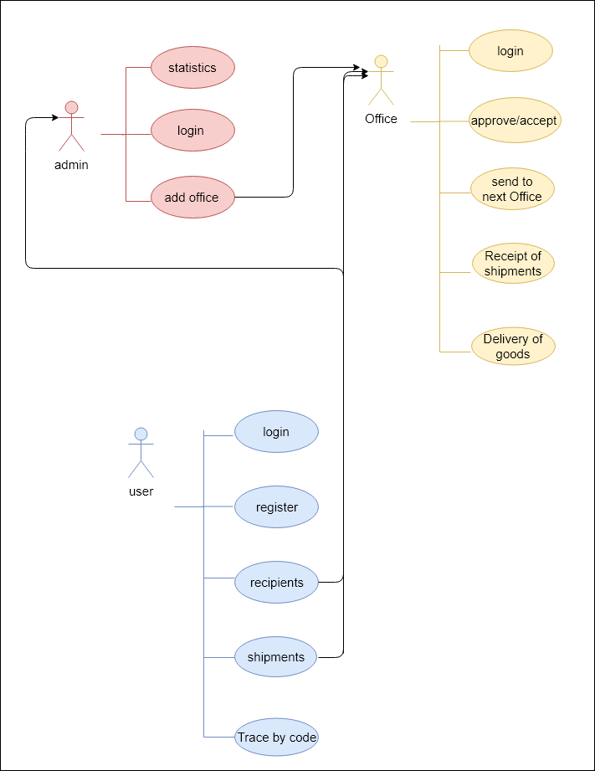

4.2 Activity Diagram

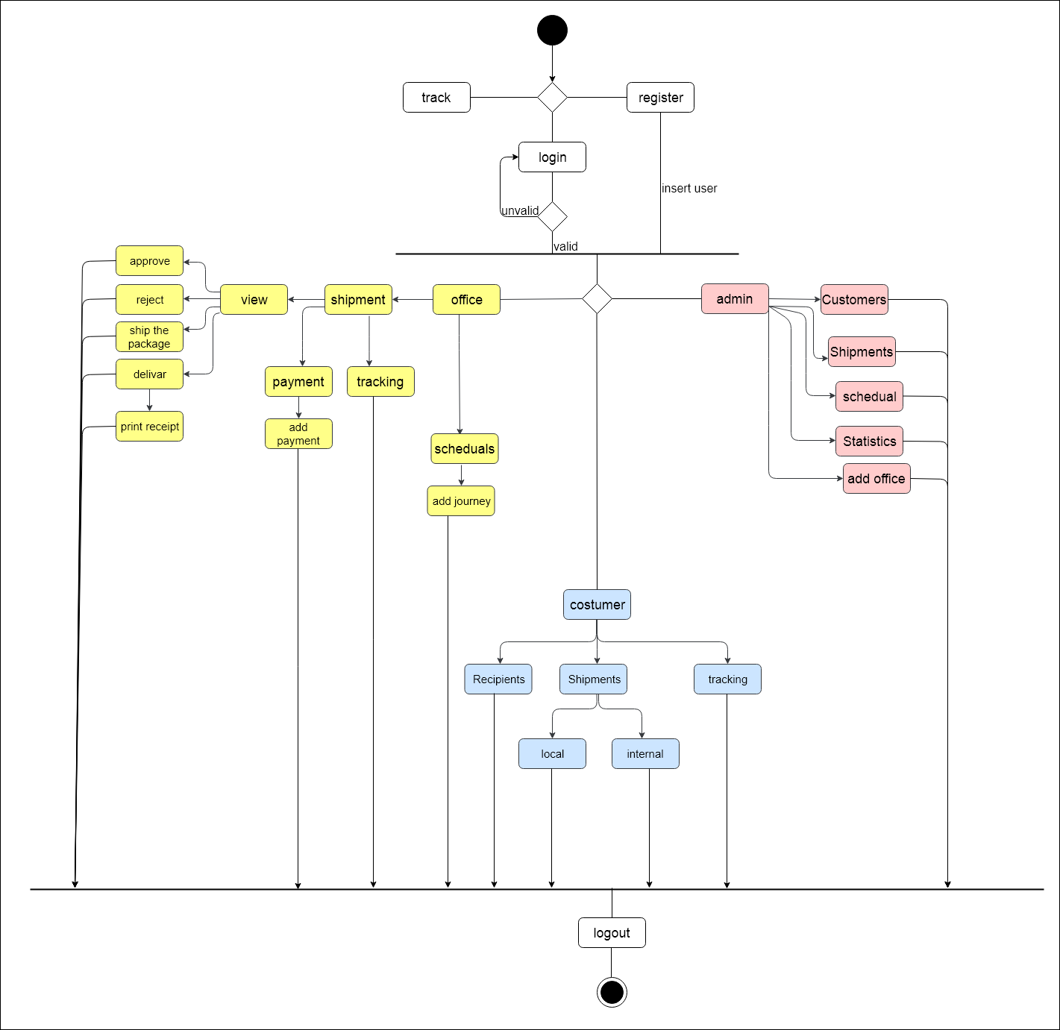

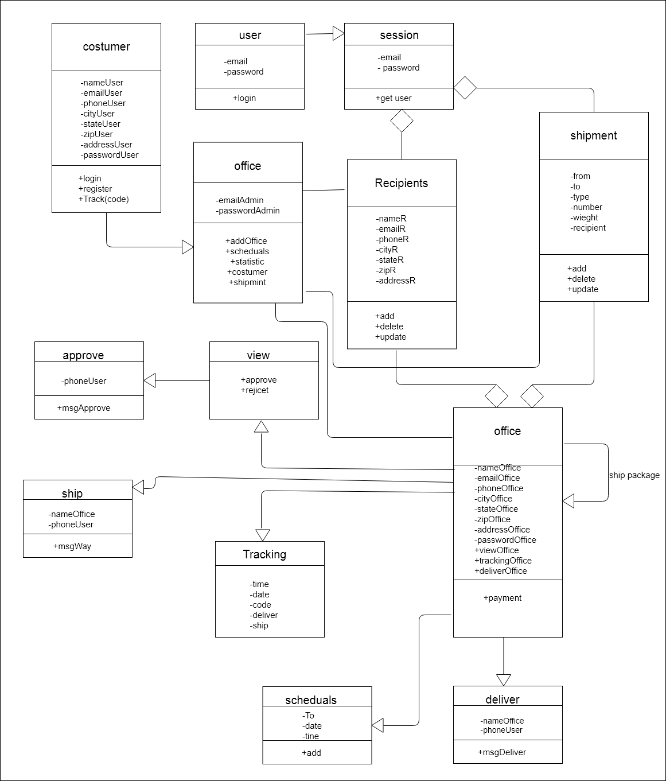
4.3 Class Diagram

4.4 Sequence Diagram
For user
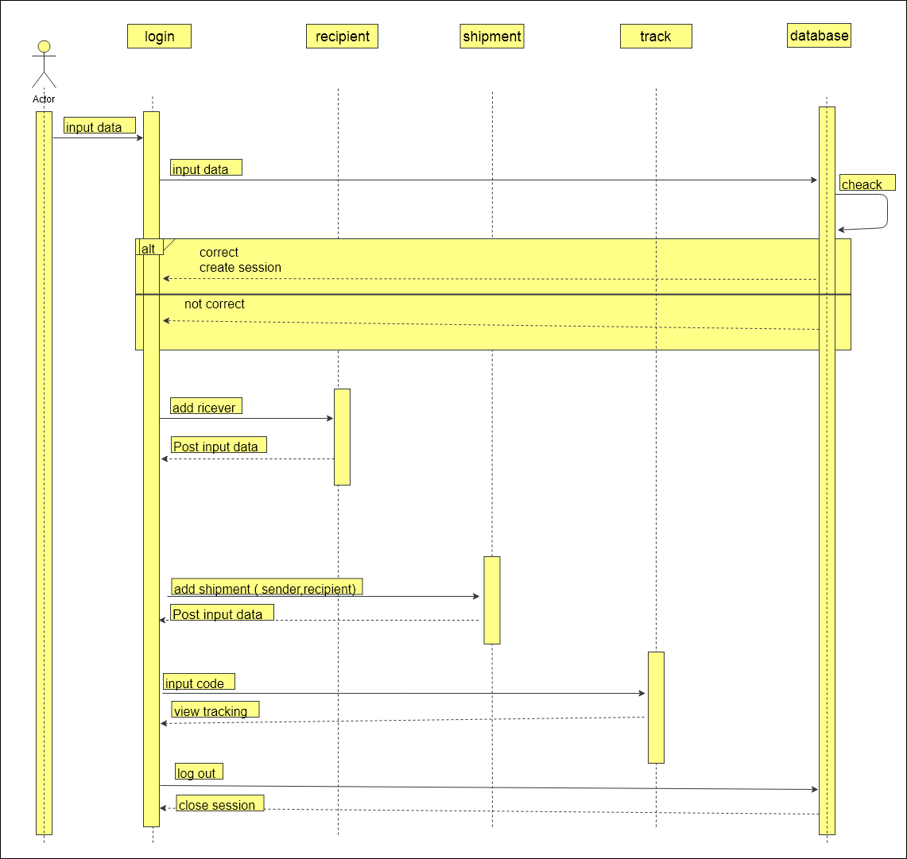

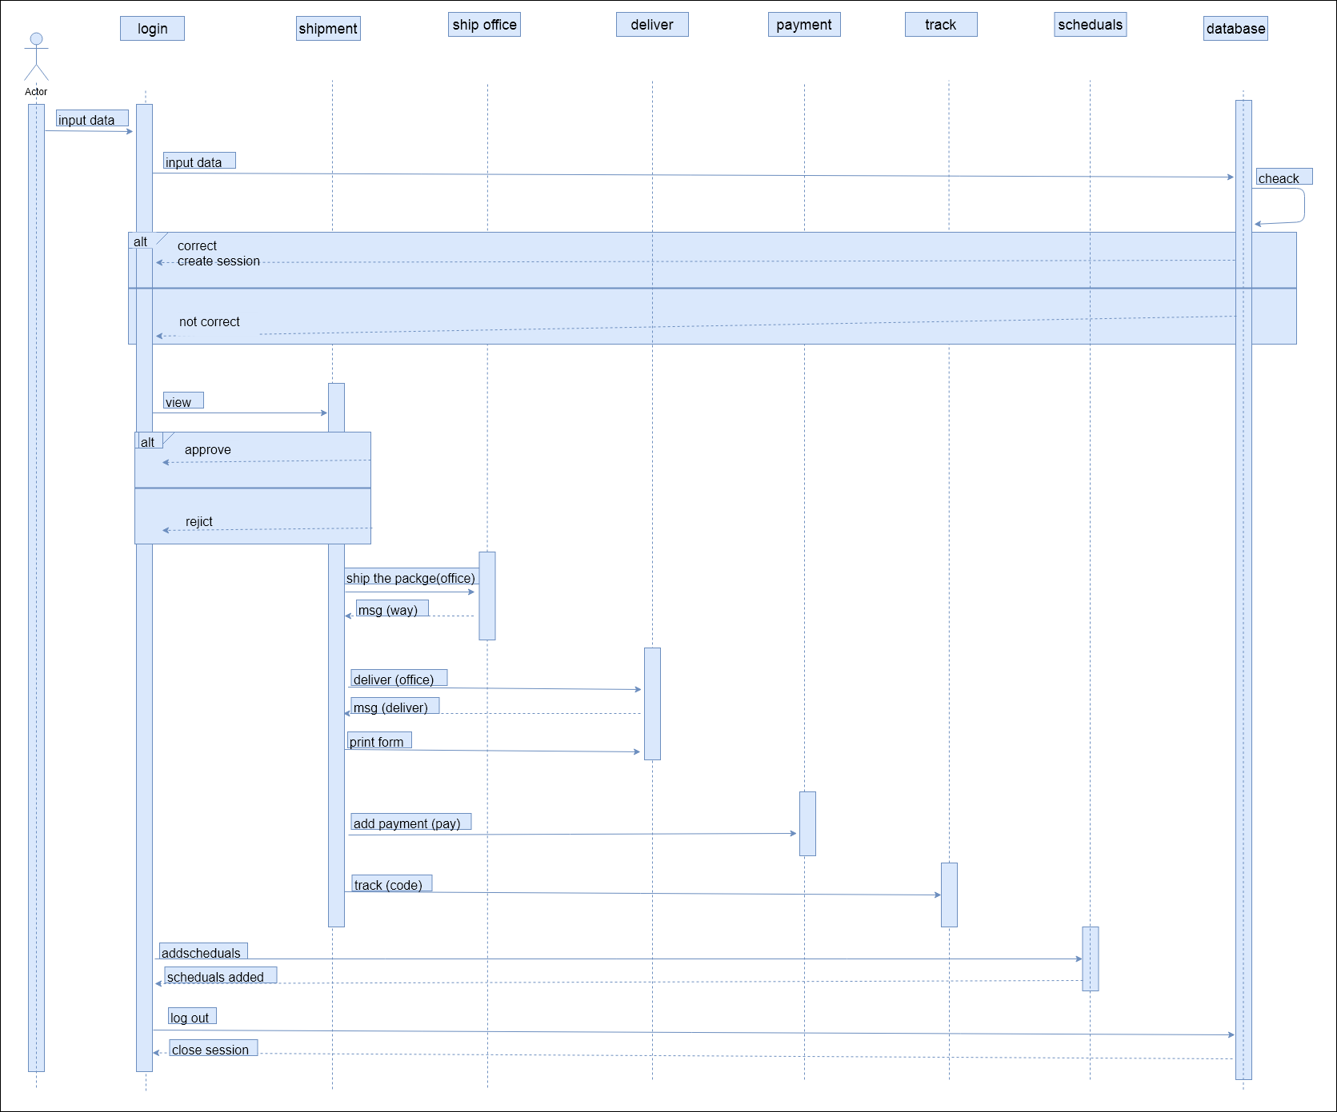
For office

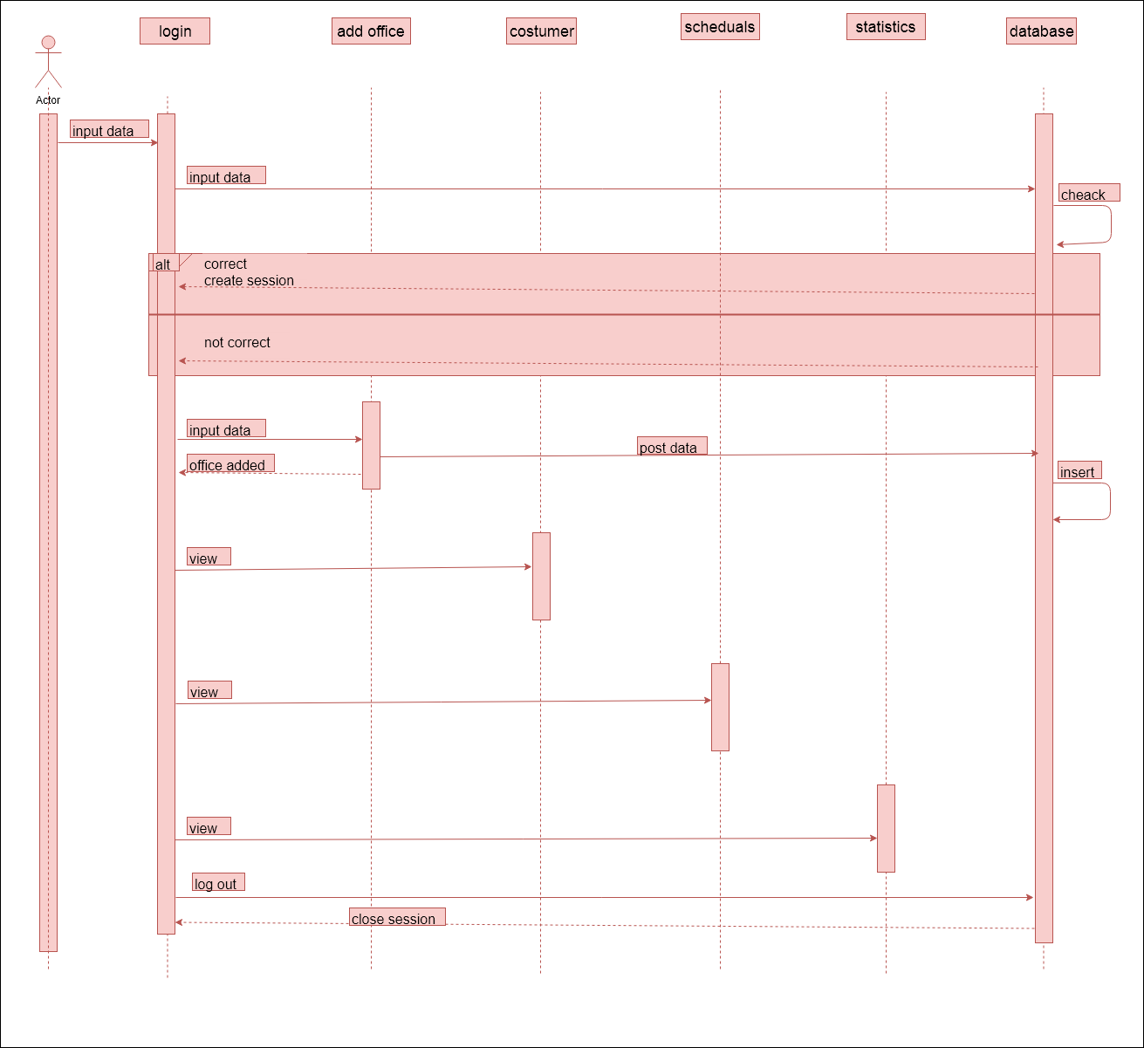
For admin

4.5 State Diagram
For user
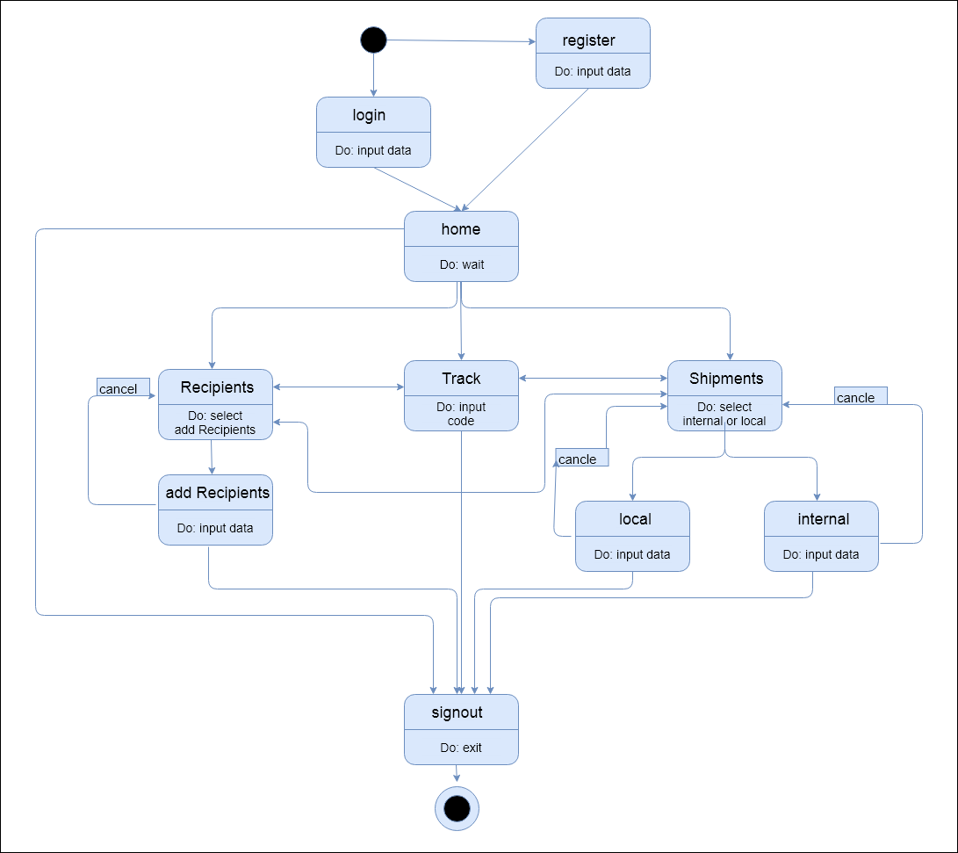

For office
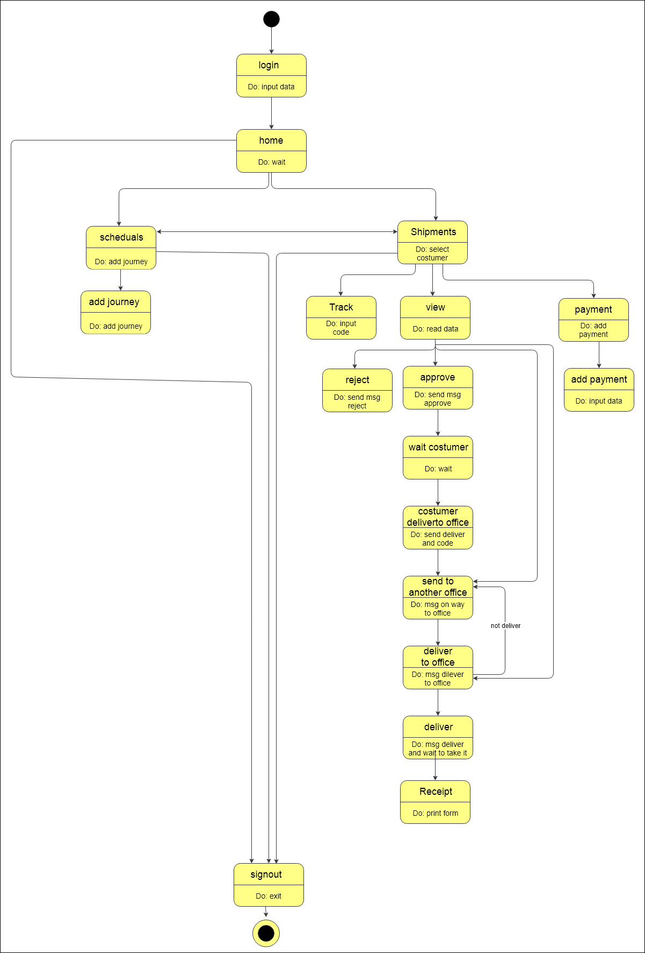

For admin
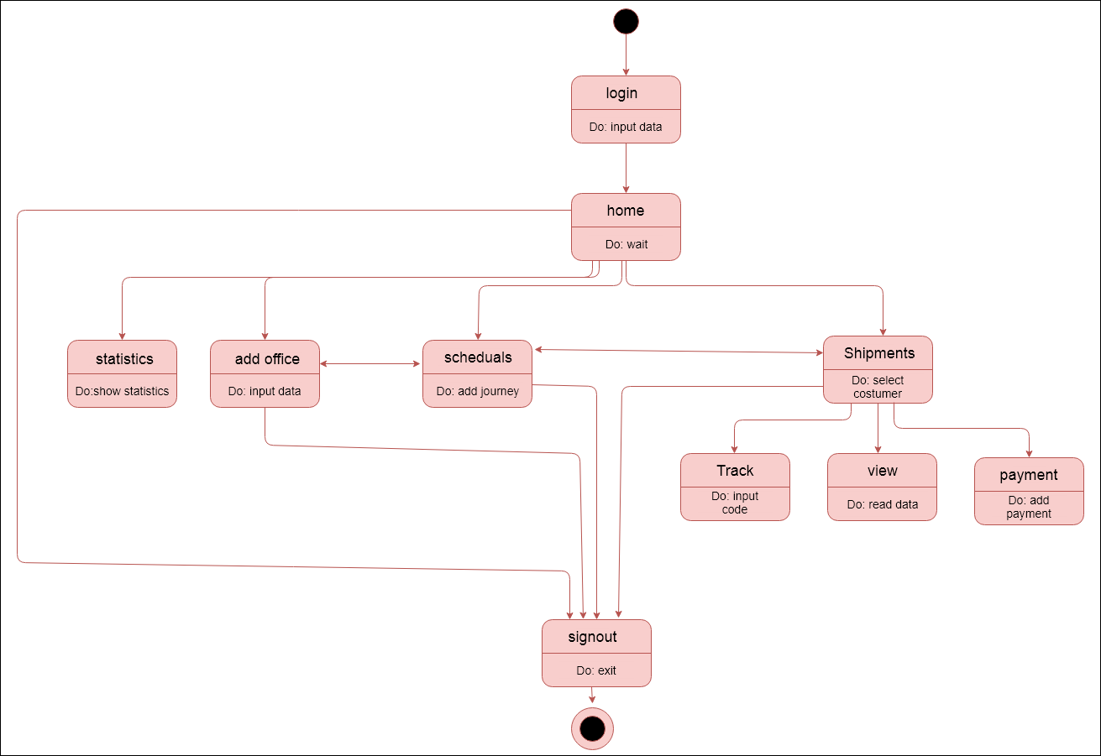

4.6 context Diagram
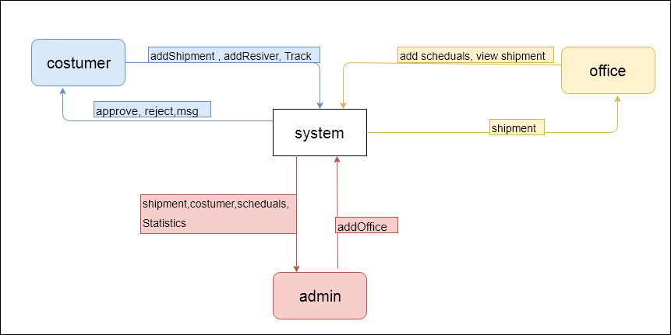

4.7 Acritical Diagram
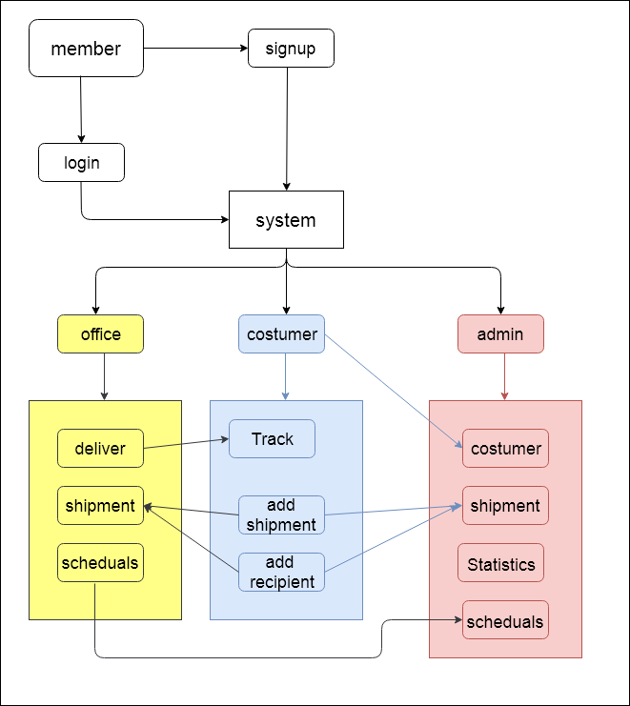

4.8 ER Diagram
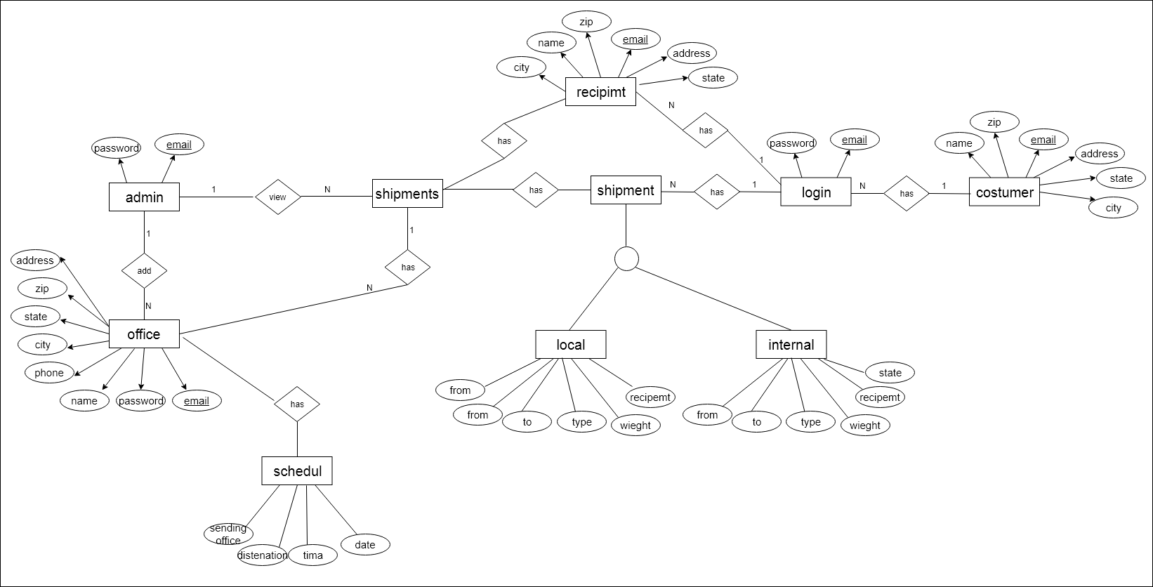

Future Work
We have many features that can be added to our project but due to limitation in time we did not include them in this version. Some of these features are:
1) Build an archive file.
2) Android application.
3) Specify the shortest time for the shipment automatically instead of checking the schedule by the office so that the path is automatically determined.

REFERENCES
Laracast : https://laracasts.com/ .. Reference-> laravel
Stackoverflow : https://stackoverflow.com/
W3school: https://www.w3schools.com/ .. Reference-> bootstrap
Ian Sommerville Software Engineering, 9th Addison-Wesley Company , USA ,2010
Cover picture : https://www.pexels.com/search/cargo/

