

Graduation project
Data mining for community service course

Project supervisor
Dr. Najwan Aldelq

By students:

Ruba Shahwan Raghad Dalab Mais Aljabi

Graduation Year:
2018-2019
An-Najah National University
IT. collage - Management Information System
Contents:
Introduction………………………………………………………….
Data mining definition…………………………………………………………………………….
Flowchart for Data mining process………………………………………………………….
About the project…………………………………………………
Idea of the project……………………………………………………………………
Problems that faces community service course……………………….
Goals of the project………………………………………………
Solve those problems above…………………………………………………….
Make suggestions to improve some process…………………………….
Project implementation plan………………………………..
Data that we took from Community service course before cleaning……
ETL process(Extract, Transform, Load)…………………………………………………
Data after cleaning in excel……………………………………………………………….
Fields are using in Rapidminer process after cleaning data……………….
Load data by Rapidminer…………………………………………………………………
Tool used in the project……………………………………………………………………
Results…………………………………………………………………
Problems we faces in the project………………………...
Recommendations…………………………………………………

DATA MINING:
The process of sorting through large data set to identify patterns and establish relationships to solve problems through data analysis. Data mining tools allow enterprises to predict future trends, Data mining is an interdisciplinary subfield of computer science with an overall goal to extract information (with intelligent methods) from a data set and transform the information into a comprehensible structure for further use .

Data Mining process :

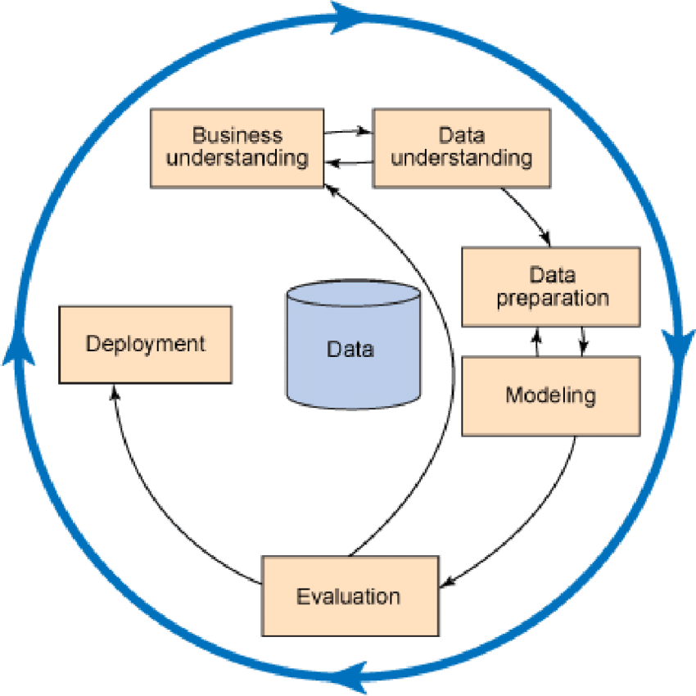
Flow chart for the project :
Start

Import data on excel

Import data in RM

Clean data with RM
Implement basket market analysis process

End
Prediction and forecasting for the results
Draw decision tree in RM
Extract the results on excel file

About community service center :

Business understanding step -
The community service center located at An-Najah National University cares about the community service course. The center works on organizing effective programs that serve the community. Cooperation is a key factor in the center and contributes to solving problems through implementing a number of community programs in cooperation with institutions and volunteers .

Project idea:
The idea of the project came through studying the course of community service and volunteering in the center and knowing that there is a problem facing the center then we went to the center to know the most important work in it, analyzing the way the center works , how the center collect the data and then the problem of the center was identified after get the approval to take the data to extract the required information that helps and facilitates In community service work.

: Objectives
- To explore frequency for groups for activates together.
- Predicting the number of notebooks in the next semester.
- Students' similarities
- Solving the problem of lack of statistical drawings that show students' data and attitudes.

Tools that used in project :
-

Rapidminer tool : is a data science software platform developed by the company of the same name that provides an integrated environment for data preparation, machine learning, deep learning, text mining, and predictive analytics. It is used for business and commercial applications as well as for research, education, training, rapid prototyping, and application development and supports all steps of the machine learning process including data preparation, results visualization, model validation and optimization.

-


Microsoft Excel is a spreadsheet developed by Microsoft for Windows, macOS, Android and iOS It features calculation, graphing tools, pivot tables, and a macro programming language called Visual Basic for Applications.



Merge two worksheets in Excel: Combine tables by matching columns , the Merge Tables Wizard can combine data from two sheets based on any number of common columns that you select. You can choose to update data in the main table, add new columns from the lookup table, pull non-matching rows and additional matches.

Cleaning data :
Data understanding and preparation step -
Data preparation aimed to outfit data to use for modeling step and get result for it , it starts with row data ,do processes that modify the data to fit it with goals set .

Example of row data

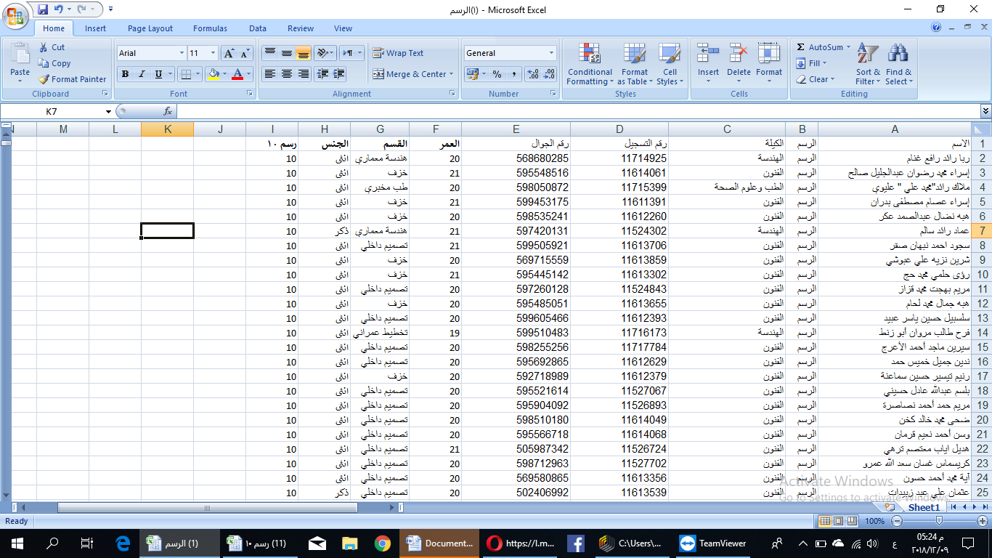

Data file which is 12 files of activities in service community are separated , contains some unuseful columns, so Rapidminer help to delete these columns using attribute process , then use filter process to ignore the missing value from useful columns and remove duplicate process using registration number as ID .
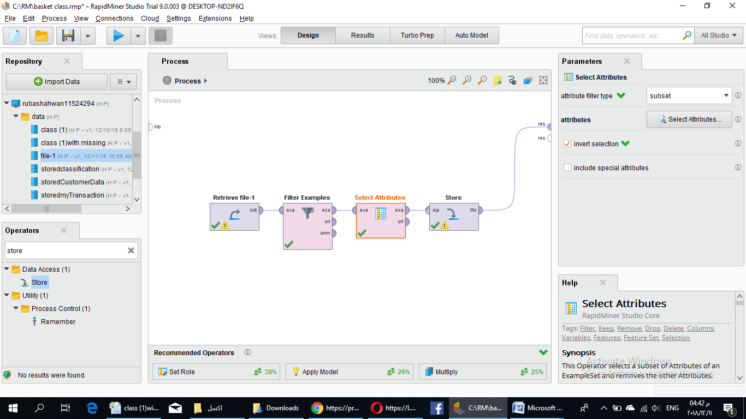
The results from rapidminer

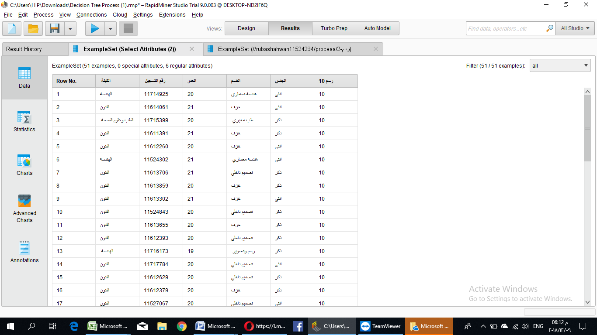

Convert data into English language by RM using replace prosess .
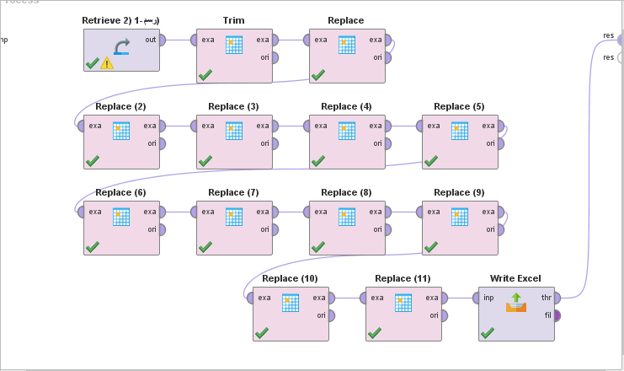

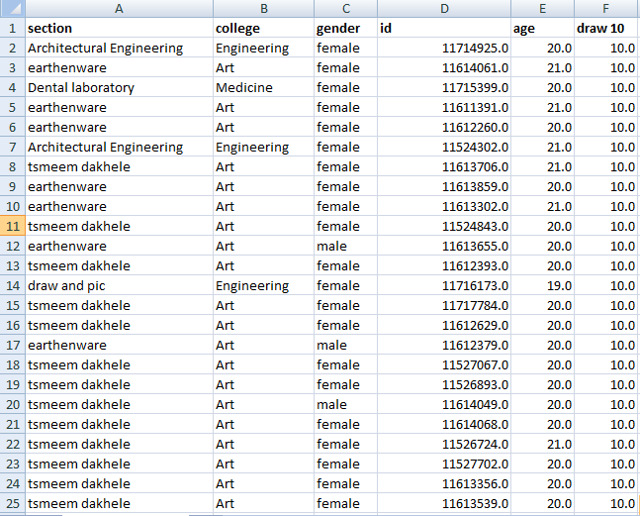
-Data integration
Then we merge each file of activities to one file has all activities , put 0 if not take the activity ,10 if take it and number of hours is 10, 20 for 20 hours by using “Merge two worksheet by excel tool “ following these steps

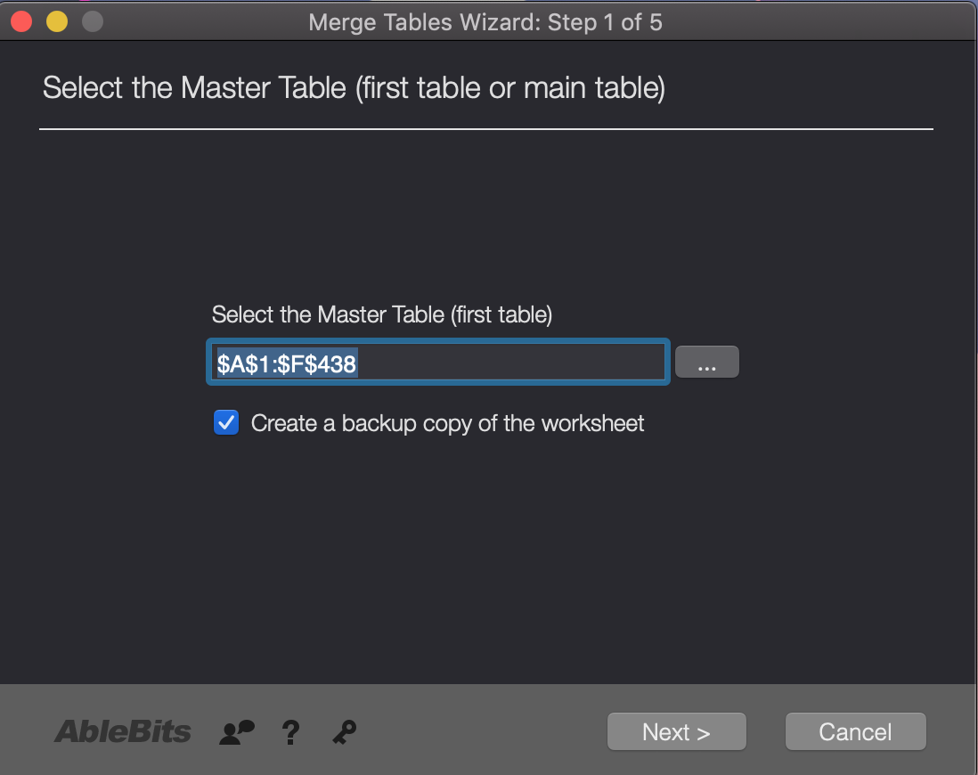

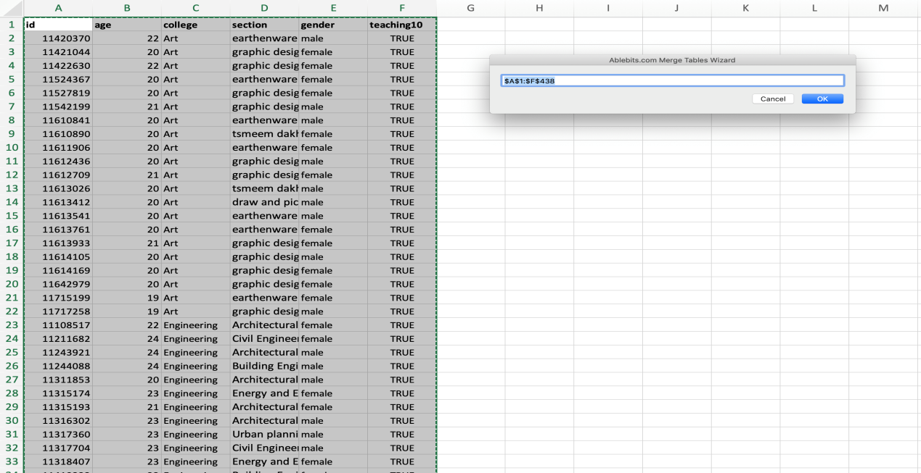

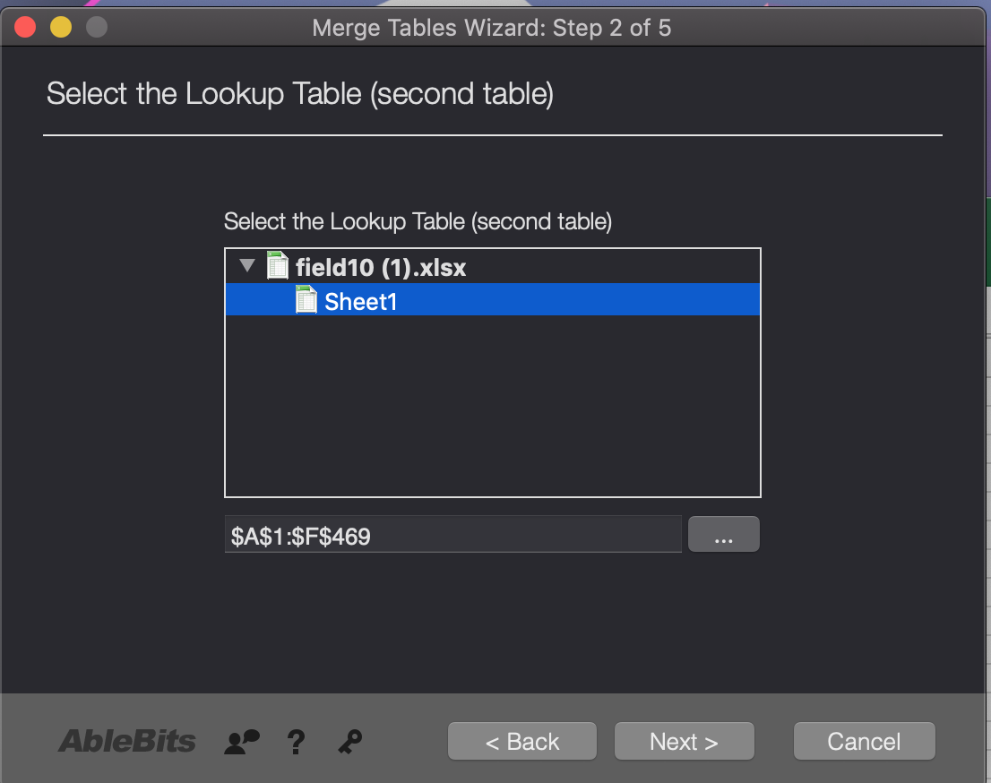

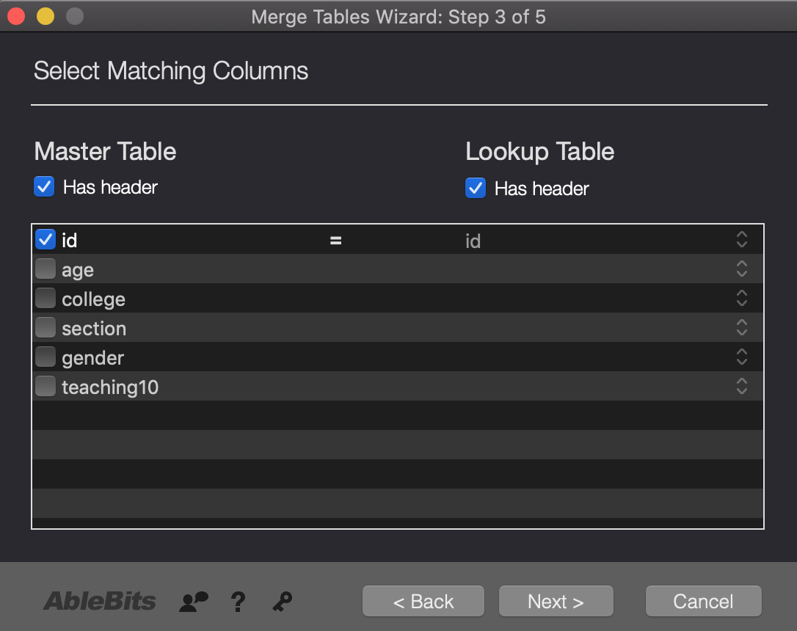

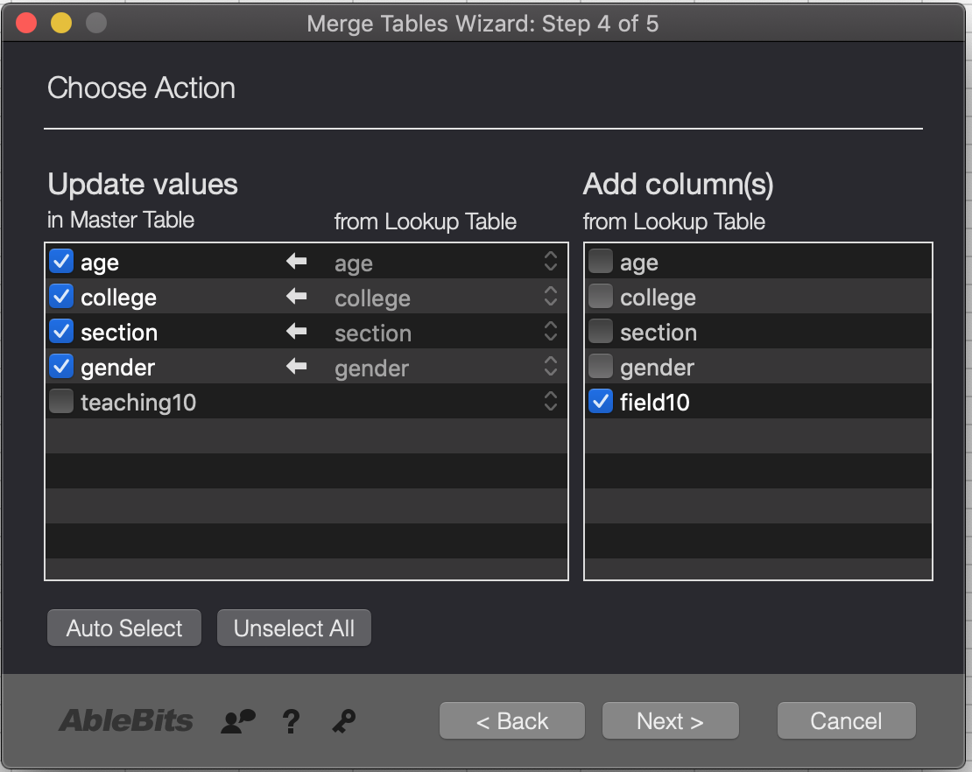

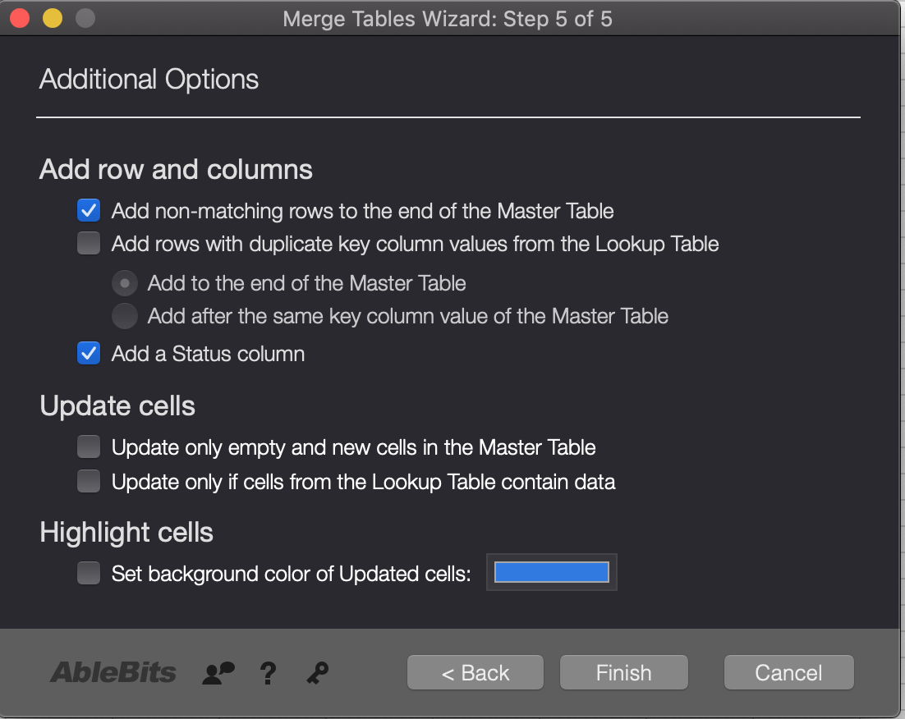

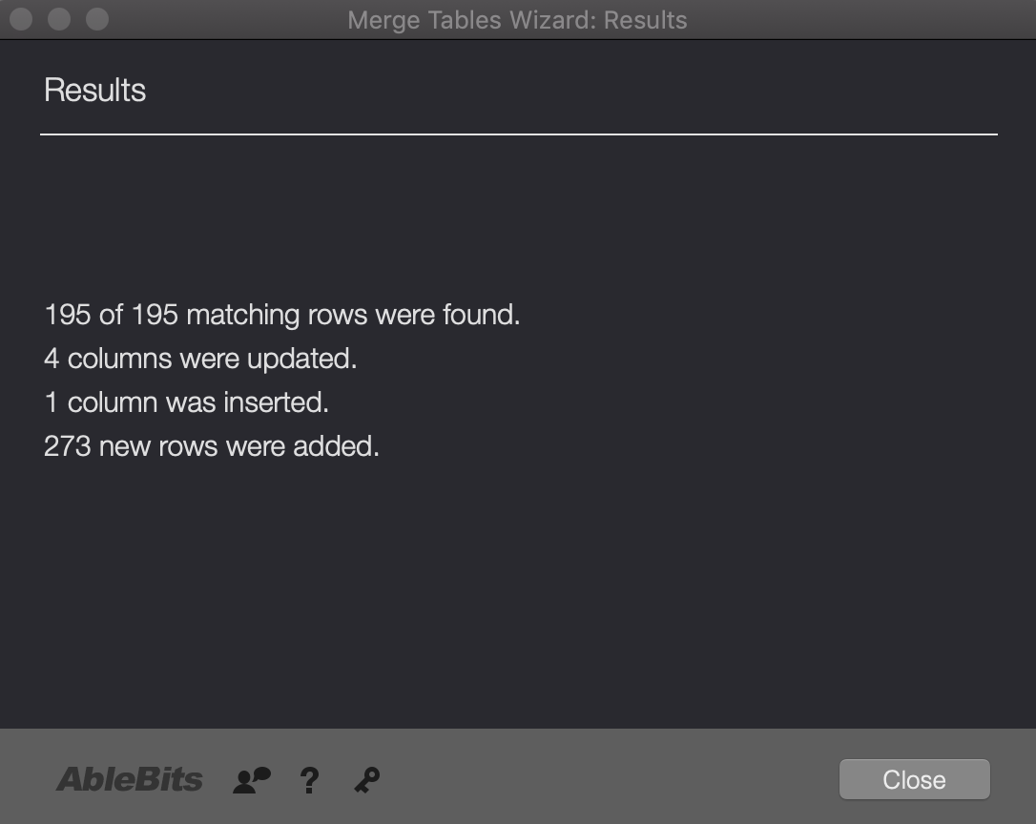

The final result of merging two files is
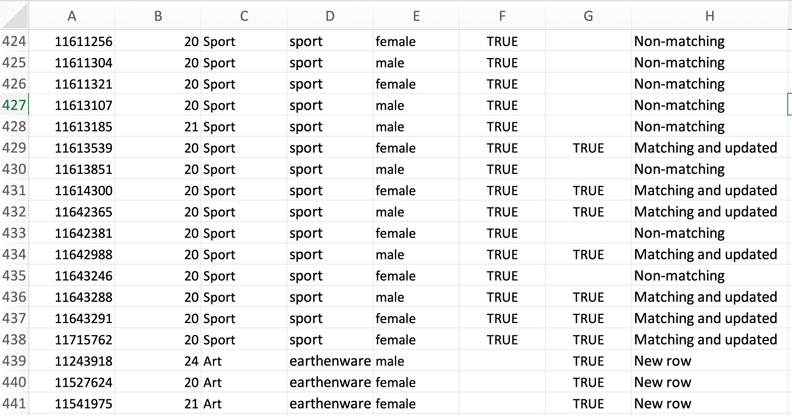
The final data after merging all files together
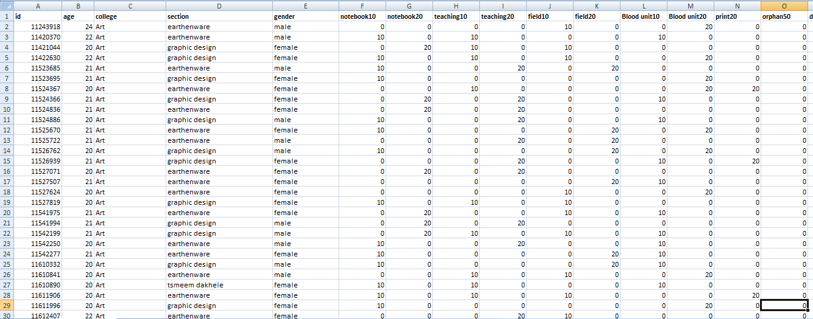
Her we… turn the data from numerical to nominal “TRUE & FALSE” via process numerical to binomial

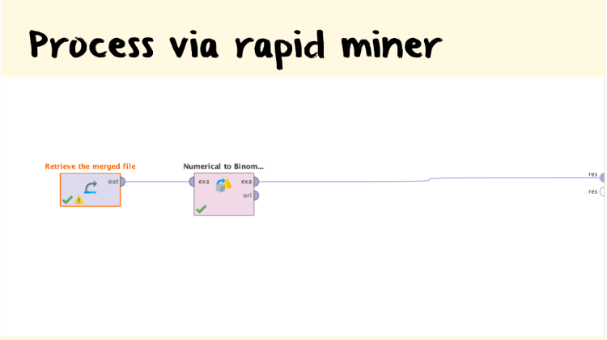

Result of replacing to TRUE & FALSE

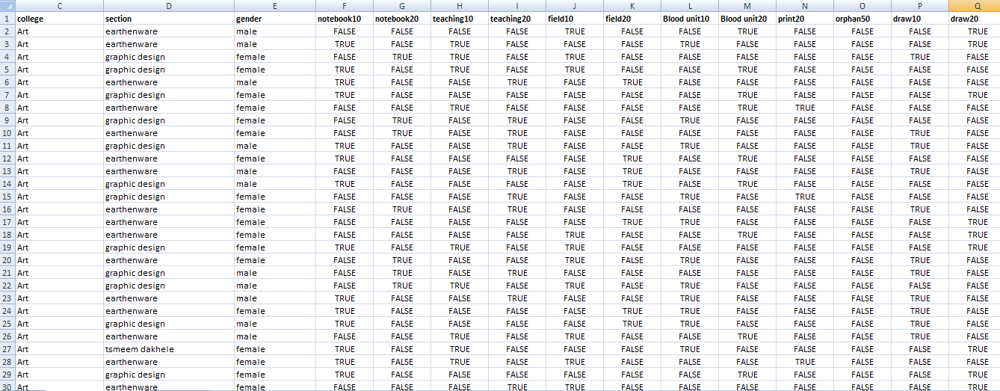
After that we decide to convert the data to classes which needs in Decision tree process so we use if statement to classify groups of activities as classes.

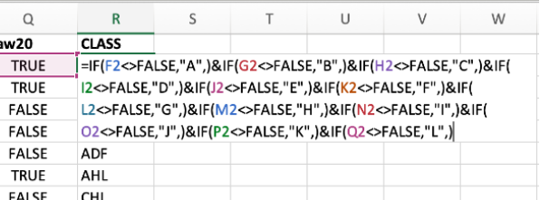
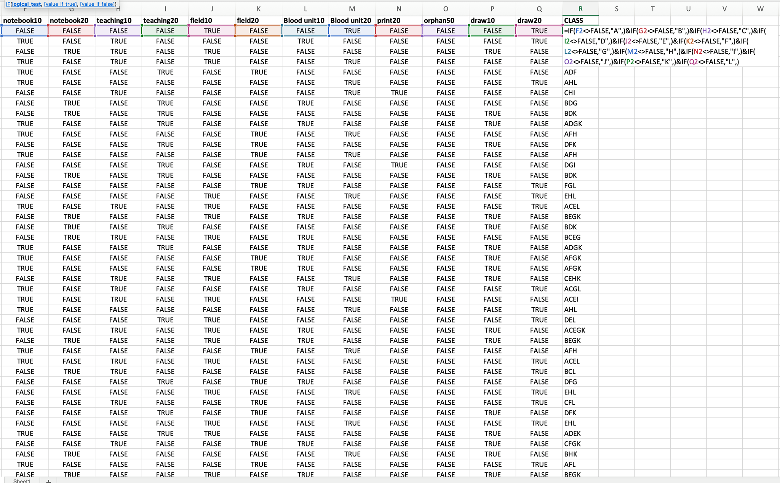
this is the result after if statement .
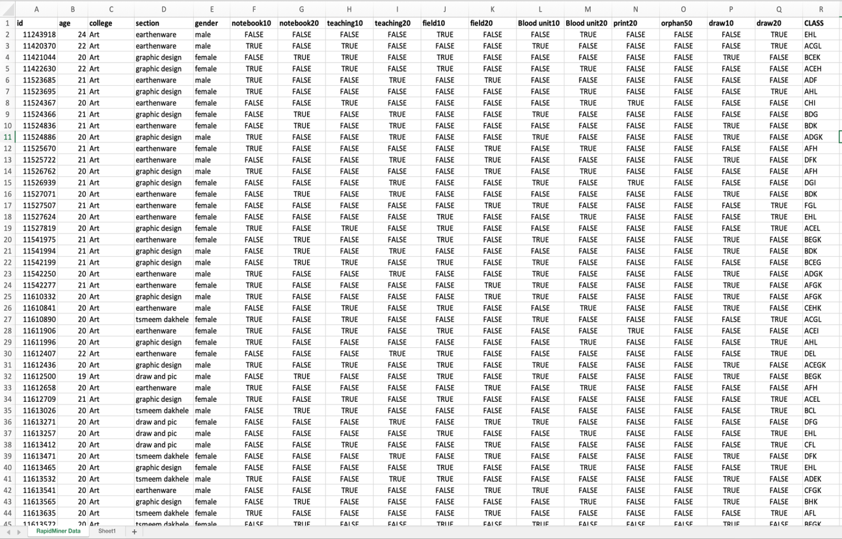

Her we delete the true and false.
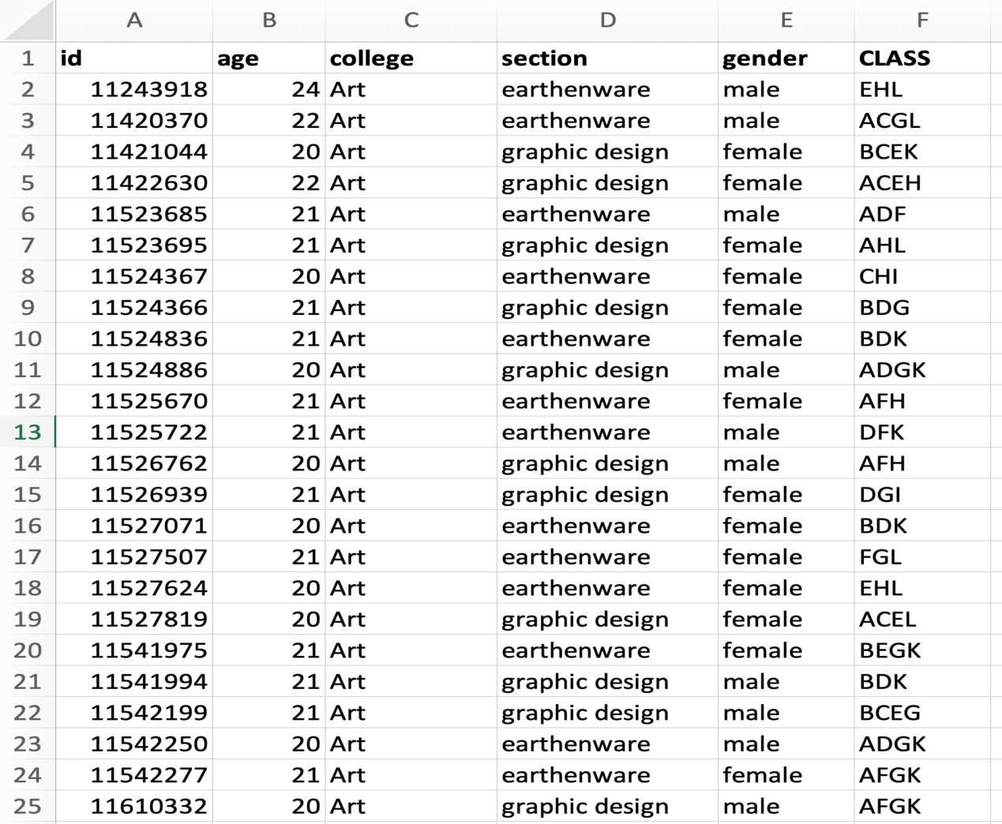

After that , for another result of classes to compare and take the accurate one, we take the highest 11 rows support from “association rule “ and its groups then removes duplicate so 7 rows remain to get to processes convert to classes .

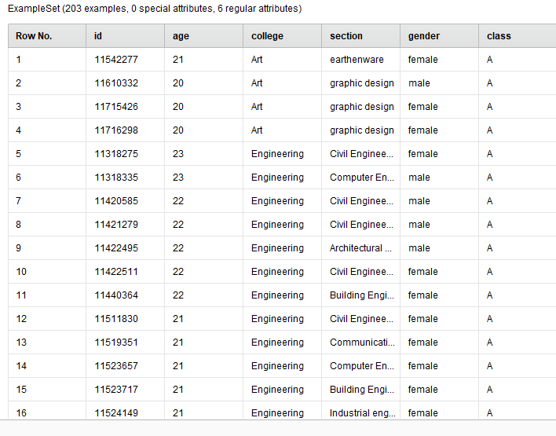
The process :
- Modeling step
is now arrived , import prepared data to Rapidminer and build “basket market analysis model”
With “ true and false “ data file .

Basket Market Analysis :
is a modeling technique based upon the theory that if you take a certain group of items, you are more (or less) likely to take another group of items.
MBA uses information to
■ Identify who customers are (not by name)
■ Understand why they make certain activities
■ Gain insight about its services
■ activities which are take together
■ Products which might benefit from promotion
■ Take action
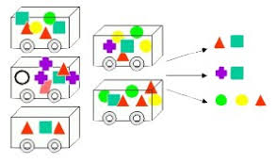

Association rule mining (using market basket analysis) :
discovering interesting relations between variables in large databases. It is intended to identify strong rules discovered in databases using some measures of interestingness. This rule-based approach also generates new rules as it analyzes more data.
Process of BMA (basket market analysis):

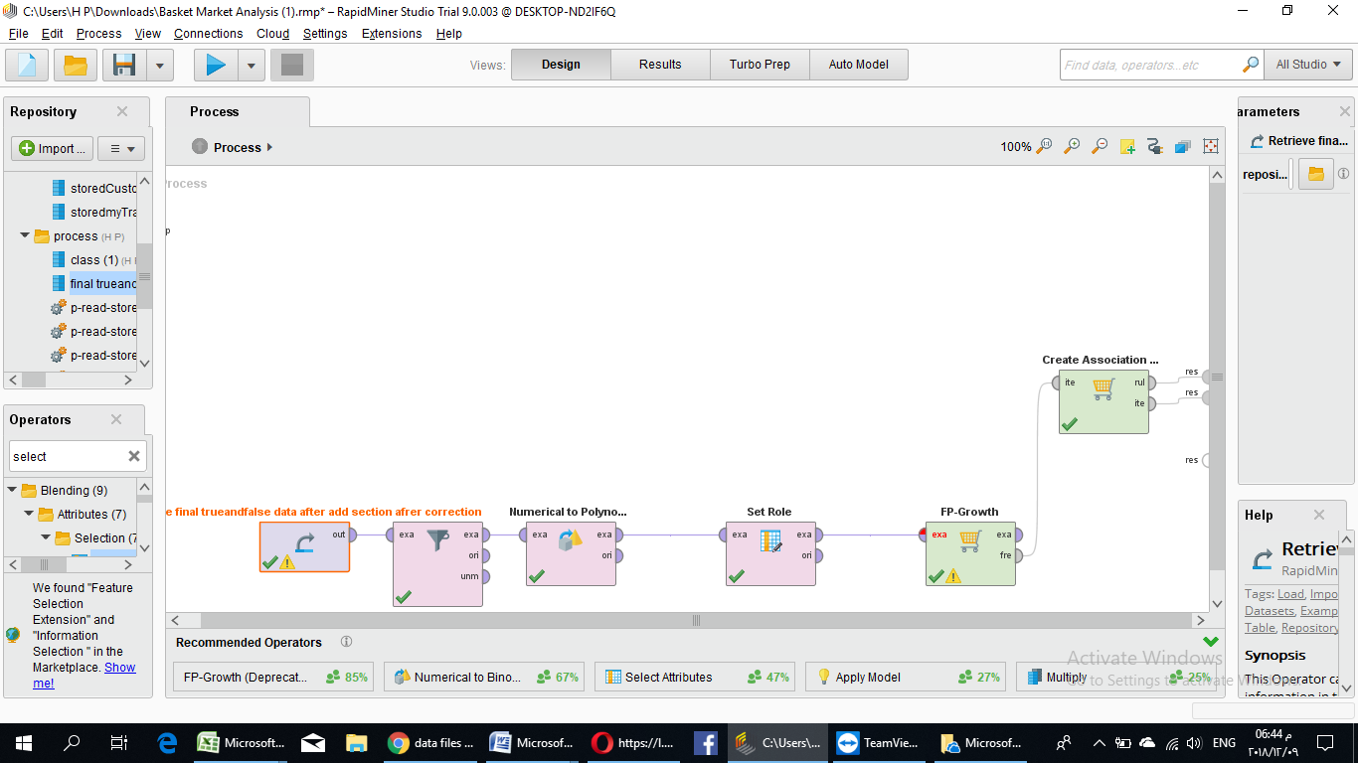

Use these processes for : to determine frequent item sets. A frequent item sets denotes that the items in the set have been taken together frequently, in a certain ratio of transactions. This ratio is given by the support of the item set

Create association rules which can be used for activities recommendations depending on the confidences of the rules .

Various model
Using auto model in Rapidminer for file classes to make comparison between different models
In rapidminer and decide which model take.

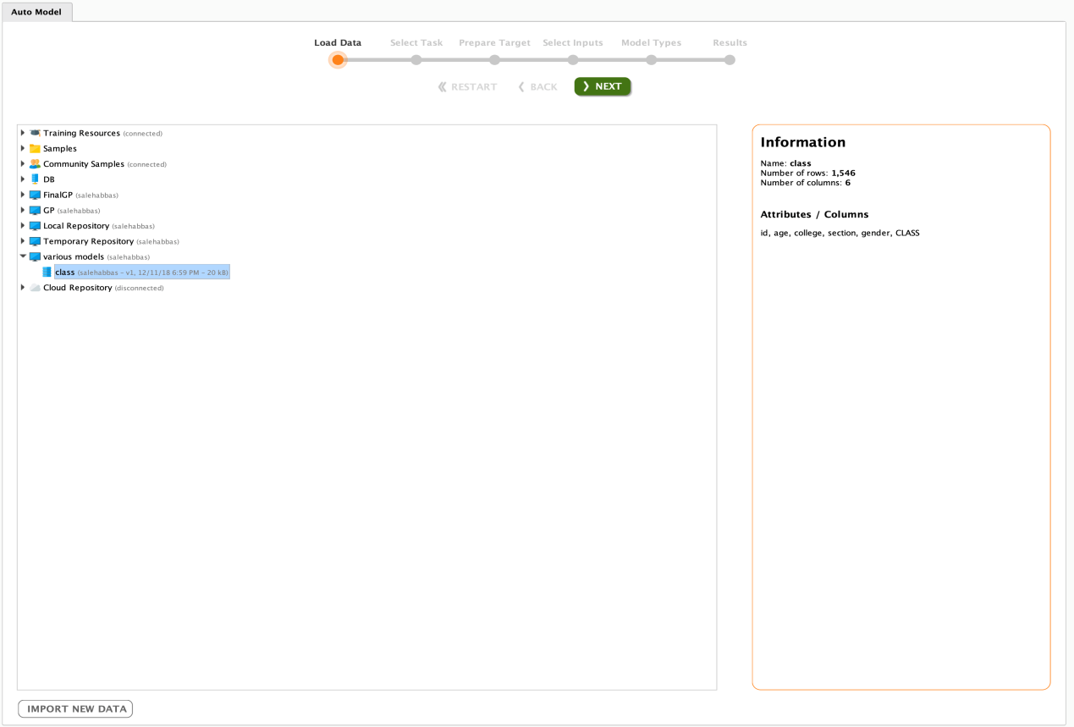

Then select attribute class as label
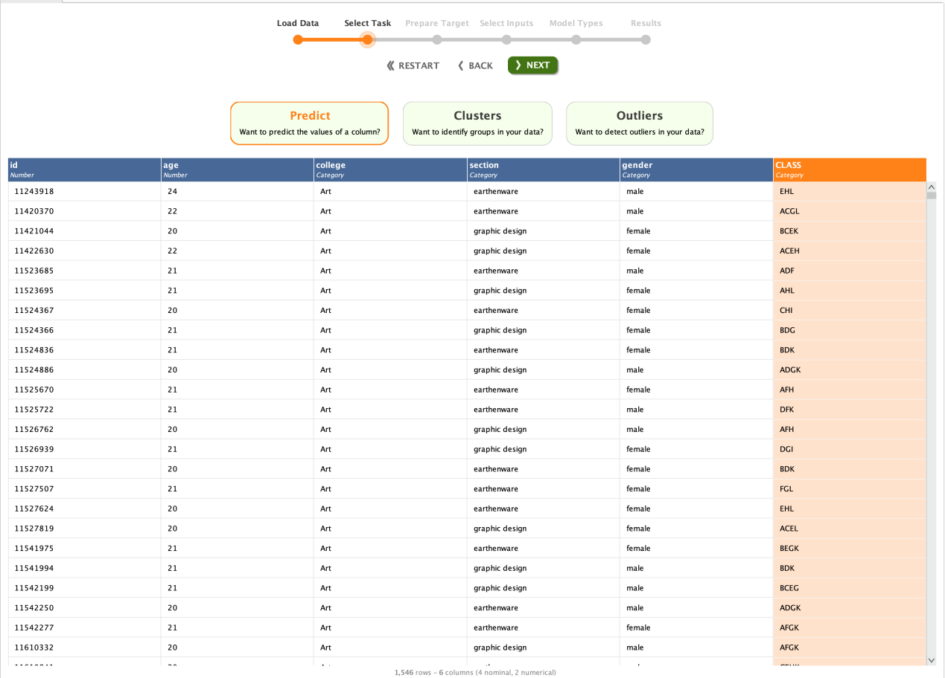
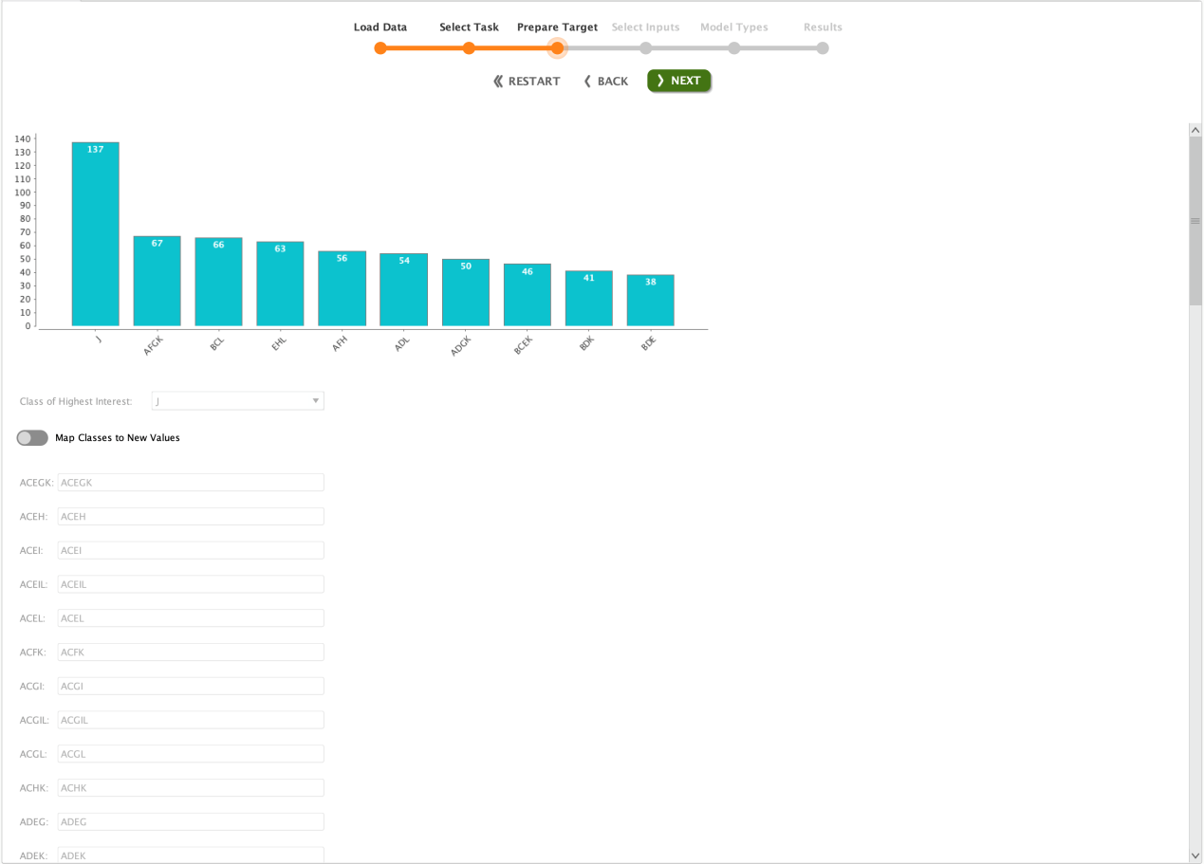

Then select attributes that we need to use
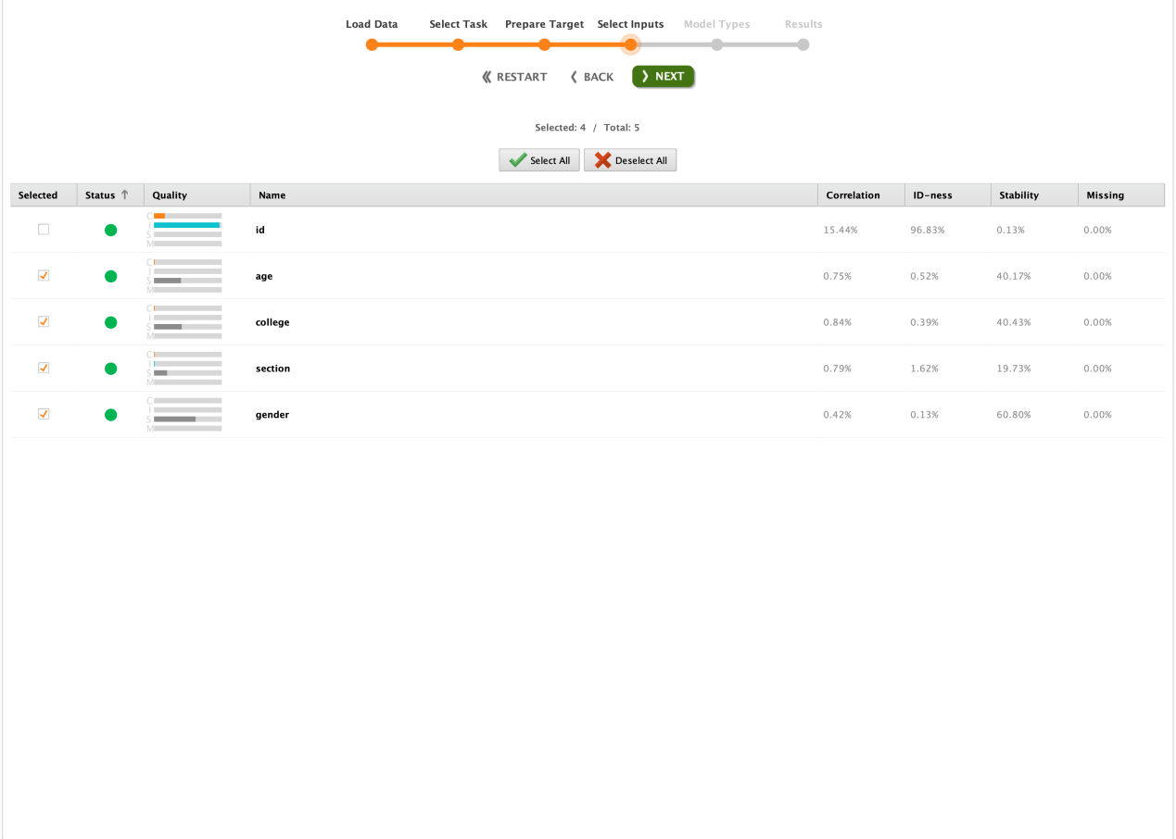
Choose models
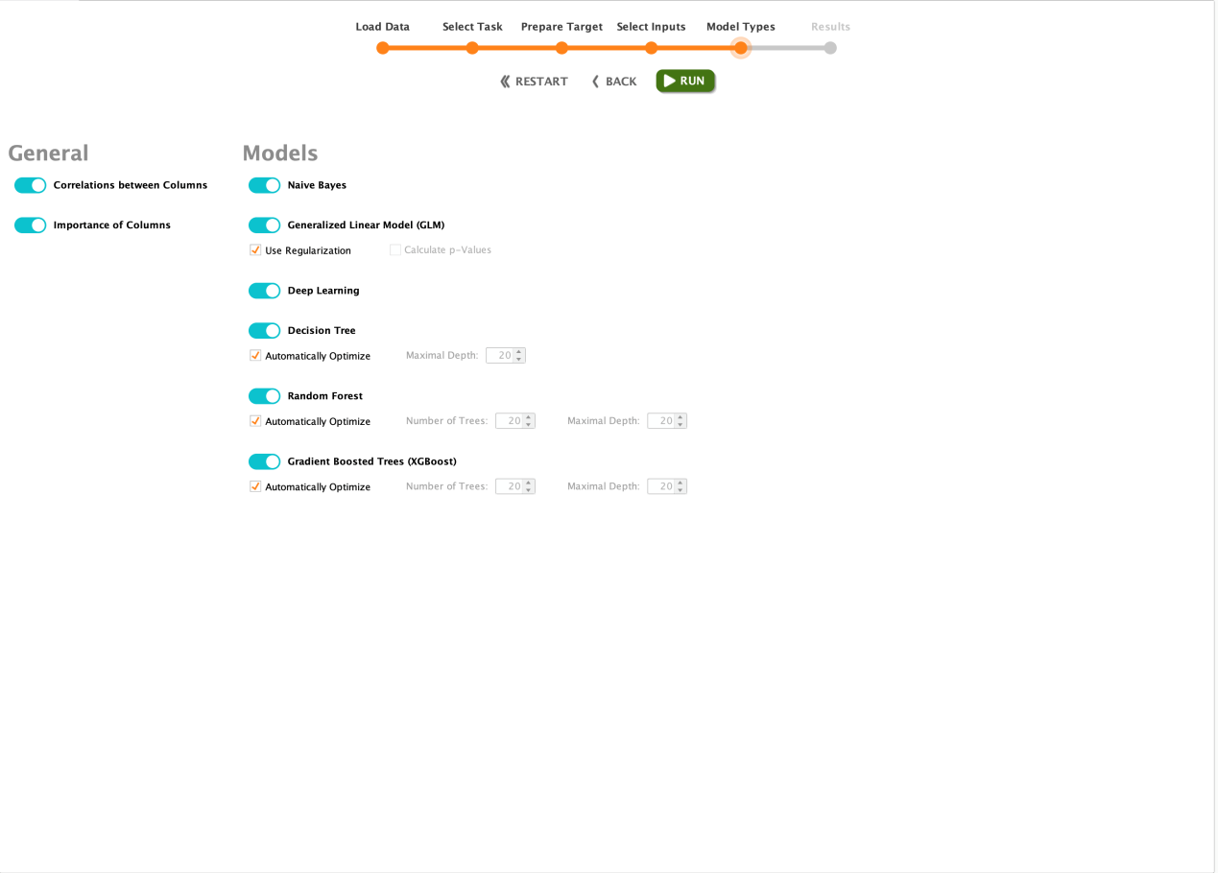
Decision tree :
Decision tree is a decision support tool that uses a tree-like model of decisions and their possible consequences, including chance event outcomes, resource costs, and utility. It is one way to display an algorithm that only contains conditional control .
Decision tree by using files of 7 classes.

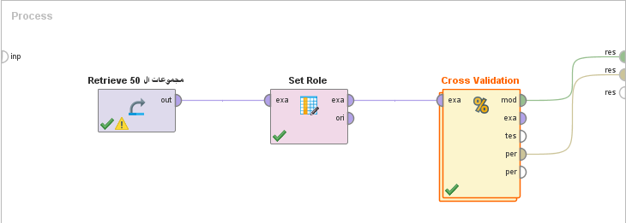
+

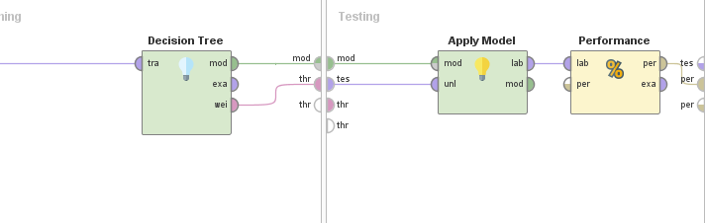

We use decision tree to follow the features of the student and create the pattern which the student get it ,and to make the model learns from the data it has to predict a particular label .

Results
- The evaluation step
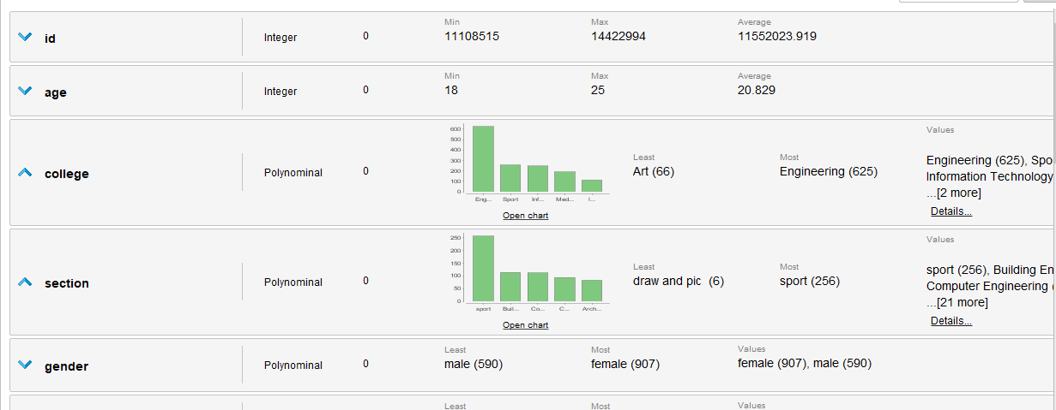

From this priority result we can be sure that the data have no missing vales and some details like Engineering is the most college take service community course in semesters
“ the statistic bie chart for colleges “

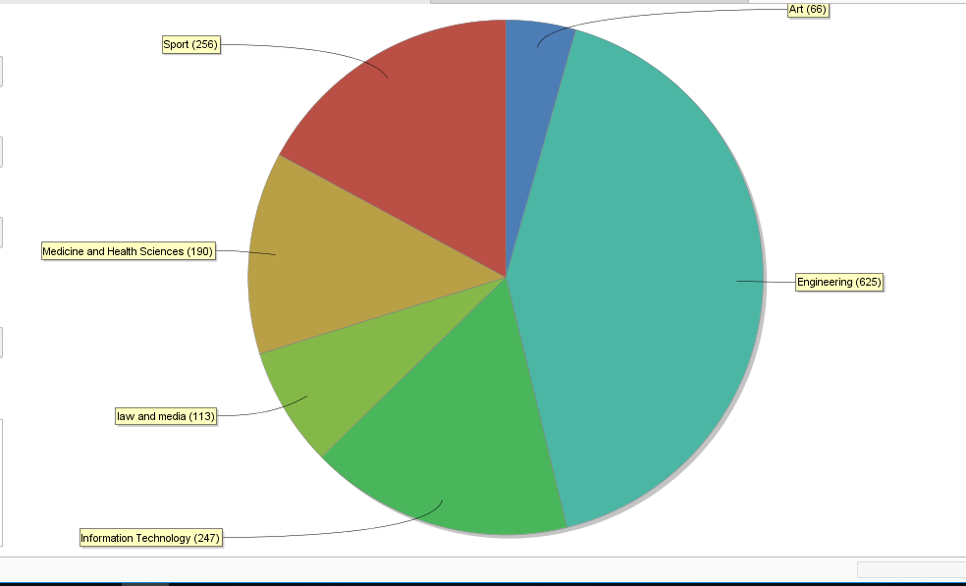

Basket Market analysis results
Here BMA get the groups of activities which may take together “Frequently set “from on activity “ 10 hours” to all activity “50 hours” and its support measure .

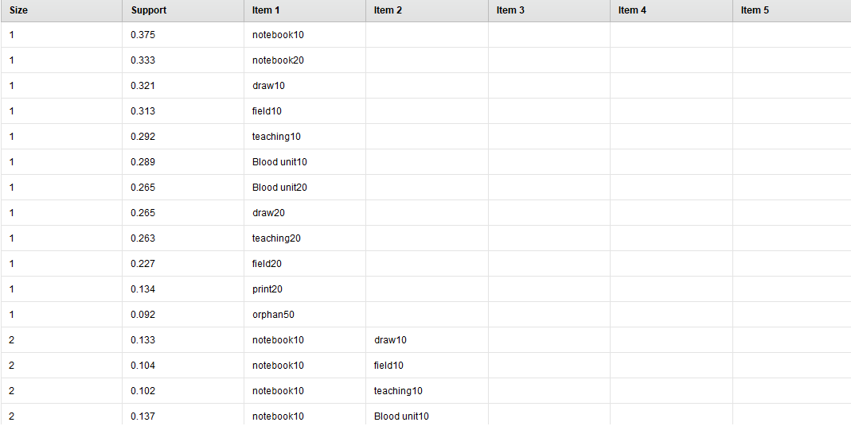

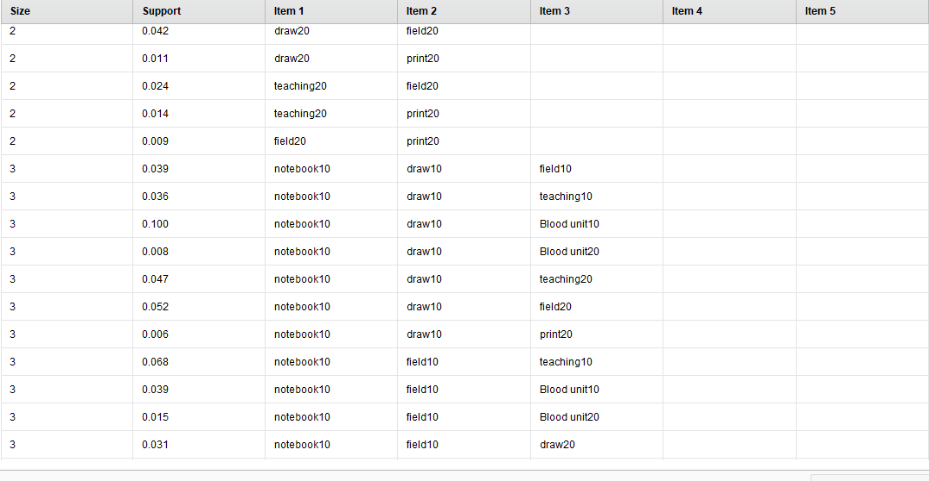
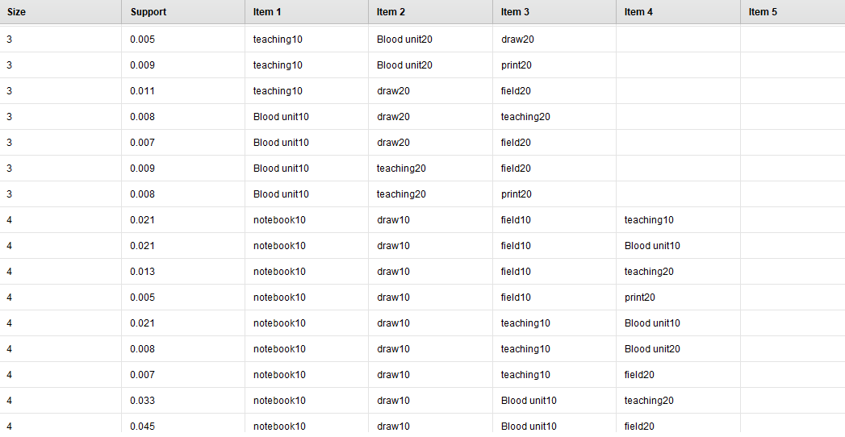

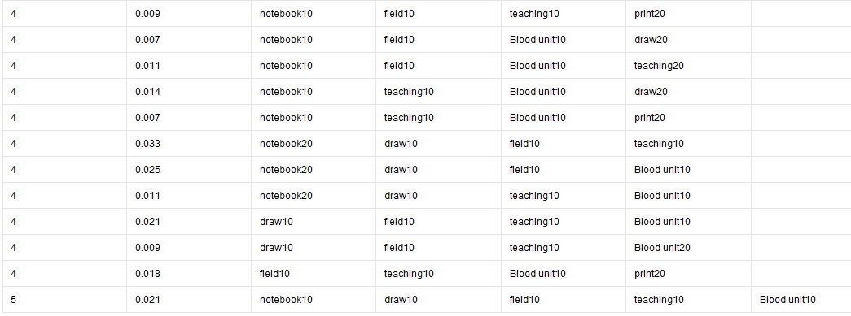

And then MBA get results It is intended to identify strong rules discovered between activities using some measures

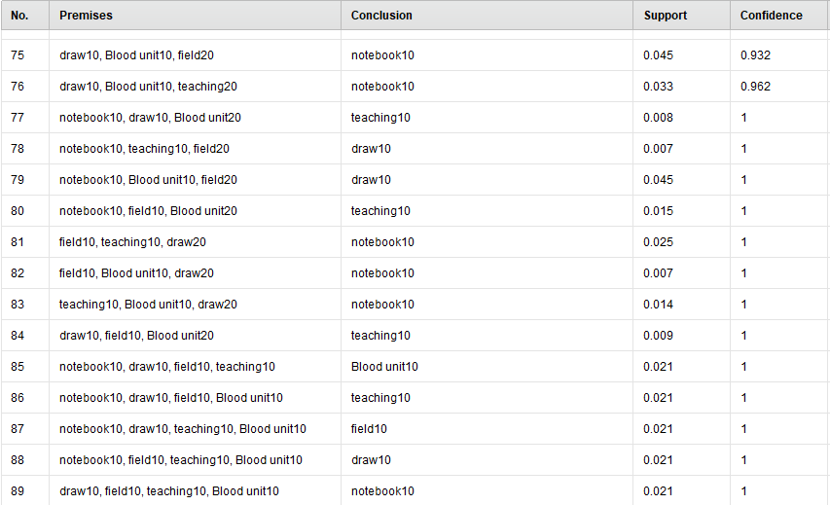

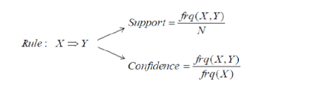

Association Rules find all sets of items (item sets) that have support greater than the minimum support and then using the large item sets to generate the desired rules that have confidence greater than the minimum confidence.

Auto models result
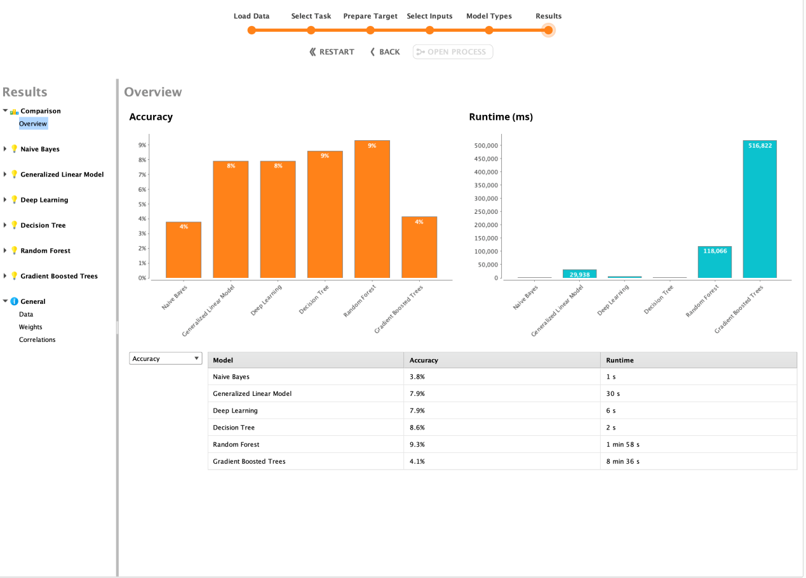
This results shows that decision tree is the highest accuracy , so we decide to take decision tree model for modeling data .
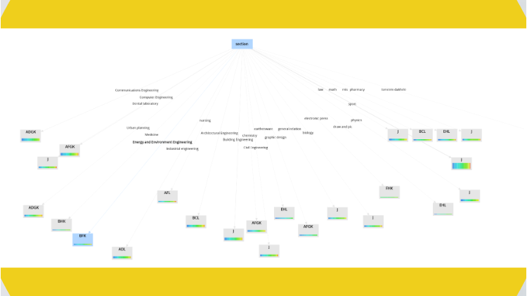
Confusion matrix for performance of the tree



Decision tree result
We have presented a method to search a linear decision tree for the most relevant tests, in order to help the end-user to understand the prediction of the tree for a new case .

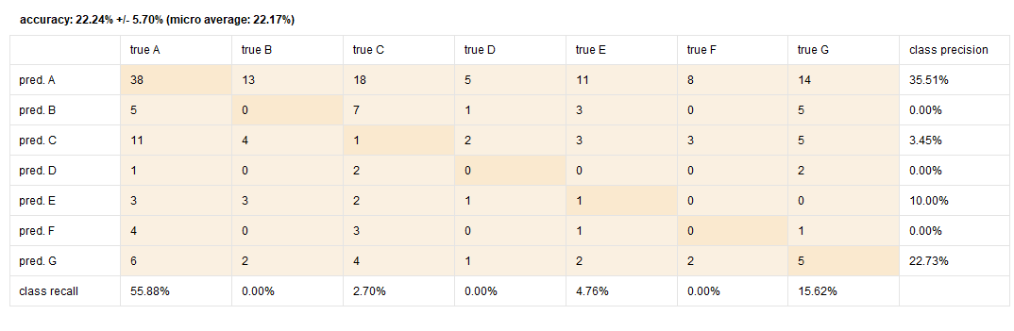

This is sub of whole tree collage engineering

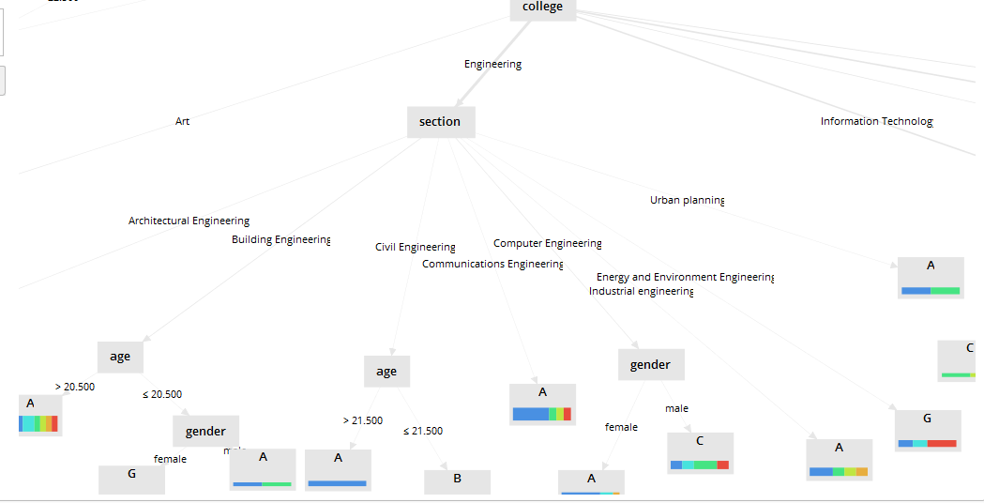
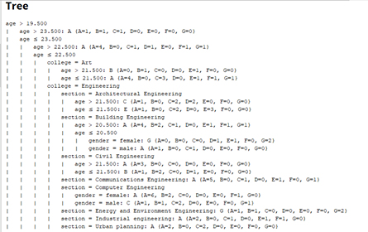

Forecasting for notebook activity in next semester

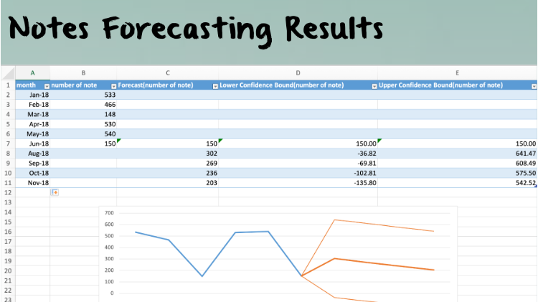

-Deployment step

the last step require monitoring the result and maintaining errors or rework to get accurate result
the produce the final report .

for BMA model at first we try to put all colleges with each other in BMA process
the result was like this

Then we try to select just one college “for each college respectively” the result was

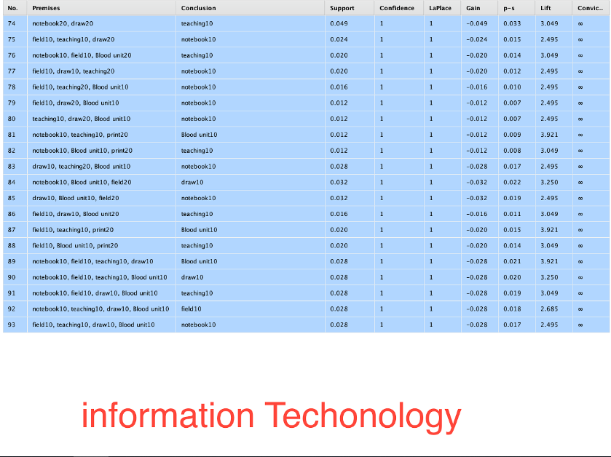
In general we can decide to take BMA for each single college better than BMA for all colleges together
Because of the basic measures “support and confidence” is higher and take more options of “50 hours” activities for the college .

Problems we faced :
1-Difficulties in gathering the data , many organizations refused to give us their computerized data .
2- problem in the size of the data , its very small so the accuracy is not good .
3- to get tool that merge data .
4-the tool which we used is not fully support help in occurred errors .

Recommendation and solutions :
1- Your idea must be clear to the data resources to make the process of gathering data easier .
2- Improve the process of storing the students data to have more clean and clear data .
3- Storing data in a merged files “that data must be already enter in a merge method”
4- There must be a database for the center of community service integrated with zajel database .



