

An-Najah National University
Faculty of Graduate Studies

Assessment and Risk Management for Constructed Urban Roads
Case Study: Municipalities of South Nablus

By
Odai jamal Mustafa odeh

Supervisors
Dr. Amjad Issa
Dr. Jamal Dabbeek

This Thesis is Submitted in Partial Fulfillment of the Requirements for the Degree of Master in Highway & Transport Engineering, Faculty of Graduate Studies,
An-Najah National University, Nablus - Palestine.
Spring | 2025-2026
Assessment and Risk Management for Constructed Urban Roads-
Case Study: Municipalities of South Nablus

By
Odai Odeh

This Thesis was Defended Successfully on 00/00/0000 and approved by:

Insert Name  Supervisor | Signature
Insert Name  Co-Supervisor | Signature
Insert Name  External Examiner | Signature
Insert Name  Internal Examiner | Signature

Dedication
All praise is to Allah… who made this journey possible, eased its hardships, and brought it to completion.
This work is the result of years of effort, patience, and prayer, and I dedicate it with love:
To myself, for not giving up, even when the road felt long.
To my parents, my mother and father, whose prayers never stopped and whose sacrifices carried me further than I could ever repay.
To my daughters, my heart’s joy and my greatest motivation. Your presence gives me strength and meaning.
To my wife, my partner in every detail of this journey. You stood beside me in tired moments and encouraged me when I needed it most. Thank you for everything.
To all who supported me… thank you for your kindness, patience, and belief in me. May Allah accept this effort, bless it, and make it a reason for benefit and continued success.
All praise is due to Allah, Lord of the worlds.

Acknowledgements
I would like to thank the municipalities of Huwara, Beita, Qabalan, Jammaein, and Aqraba for their cooperation and support in conducting the survey. Their help was essential to the success of this study.
I am truly grateful to everyone who supported me throughout the writing of this thesis. This experience was not always easy, but it was meaningful and rewarding, and I deeply appreciate the encouragement I received.
I want to especially thank my supervisors, Dr. Amjad Issa and Dr. Jamal Dabbeek, for their guidance, patience, and valuable feedback. Their mentorship made a real difference and helped me strengthen this work.
To my friends and colleagues, thank you for your encouragement and for standing by me during this journey. Your support mattered more than I can express.
Lastly, to everyone who helped in any way, directly or behind the scenes, thank you. Your contribution is appreciated, and it helped bring this thesis to completion.

Declaration
I, the undersigned, declare that I have submitted the thesis entitled:
Assessment and Risk Management for Constructed Urban Roads- Case Study: Municipalities of South Nablus
TITLE OF THESIS AS APPROVED BY THE FACULTY OF GRADUATE STUDIES
I declare that the work provided in this thesis, unless otherwise referenced, is the researcher’s own work and has not been submitted elsewhere for any other degree or qualification.

_Odai Odeh___ | Student's Name:
_____________________________________ | Signature:
_____________________________________ | Date:

Table of Contents
Dedication III
Acknowledgements IV
Declaration V
List of Tables VIII
List of Figures IX
List of Abbreviations X
Abstract XI
1. Introduction 1
1.1 Background 1
1.2 Risk Management Tools 4
1.3 Road Life Cycle 7
1.4 Problem Statement 9
1.5 Significance of the Study 12
1.6 Thesis Objectives 15
1.7 Study Area 16
1.8 Research Question 21
1.9 Hypotheses of the Study 21
1.10 Thesis Outline 22
2. Literature Review 24
2.1 Risk and Uncertainty 24
2.2 Sources of Risk 27
2.3 Risk Response 28
2.4 Risk Characteristics 29
2.5 Typical Risk in a Construction Project 30
2.6 Relevant Studies in Palestine 31
2.7 Relevant Studies in Developing Countries and developed countries 32
2.8 Relevant Studies in Rural area 38
2.9 Number of questioner for the most important global studies 40
3. Research Methodology 42
3.1 Research Methodology 43
3.1.1 Analytical Hierarchy Process (AHP) Method 45
3.1.2 Average Weighted Method (AWM) Method 45
3.1.3 Key components of Risk Assessment 45
3.2 Sources of information collected 45
3.2.1 Survey 47
3.3 Data Collection 47
3.4 Sample Size 50
3.5 Identification of Risks 51
3.6 Risk Assessment and Analysis 53
3.6.1 What AHP 53
3.6.2 How AHP work 54
3.6.3 Why AHP Is Used in Road Construction Risk Management- ---------------55
3.7 Calculating a Risk Index 58
4. Results and Analysis 63
4.1 Introduction 63
4.2 Statistical analysis and dusscisson ------------- -------------------------------64
4.3 Risk Index Calculation Resulting Using AHP 72
4.4 Risk Index Calculation Resulting Using WAM 84
4.5 Studing the influnce of indicators factors on RI 93
4.6 Studing the influnce of Weight on RI 93
4.7 Analysis 102
4.8 Risk Mapping result 107
4.8.1 Risk Model for Huwara 113
4.8.2 Risk Model for Beita 114
4.8 .3 Risk Model for Jammain 115
4.8.4 Risk Model for Aqraba 116
4.8.5 Risk Model for Qablan 117
5. Discussion of Results 118
5.1 Discussion 118
5.2 Continuous Improvement 121
6. Conclusions and Recommendations 123
6.1 Conclusion 123
6.2 Recommendations 126
6.3 Research Limitation 129
References 131
Appendices 137
Appendix A 137
Appendix B 163
Appendix C 205
Appendix D -------------------------------------------------------------------------------------207
Appendix E -------------------------------------------------------------------------------------207
الملخص ب‌

List of Tables
Table 1: The lengths and types of the road network in the five targeted municipalities. 20
Table 2: The most important recent studies in the subject of risk and uncertainitys . 26
Table 3: The most important recent studies in the subject source of risk 27
Table 4: The most important recent studies in the subject of risk charactarestic 28
Table 5: The most important recent studies in the subject of typical risk in construction project 30
Table 6: The most important global,local,and regional studies 31
Table 7: The information gatherd and sources 33
Table 8: the most recent ,global,local,and reginal studies and their finding 38
Table 9: Number of questionnaires for the most relevant global studies related to the assessment and risk management for constructed urban roads--------------------- 41
Table 10: Sample of collected data sourcing 46
Table 11: number of target group and nature of their work during the distribution questionnaires 51
Table 12: The number of people interviewed by targeted LGUs 51
Table 13: The values and what meaning using the Saaty s 1-9 scale 54
Table 14: The values of RI depend on the size of matrix 54
Table 15: Assigning scores to each factor 60
Table 16: Calculation Risk level 61
Table 17: Calculation Cronbach's Alpha for Survey for the town of Huwara town 65
Table 18: Calculation Cronbach's Alpha for Survey for the town of Qablan town 66
Table 19: Calculation Cronbach's Alpha for Survey for the town of Aqraba town 67
Table 20: Calculation Cronbach's Alpha for Survey for the town of Beita town 68
Table 21 Calculation Cronbach's Alpha for Survey for the town of Jammain town 69
Table 22: Validation of RI Results 72
Table 23: Calculation of RI for Huwara town By AHP 75
Table 24: Calculation of RI for Beita town By AHP 76
Table 25: Calculation of RI for Aqraba town By AHP 77
Table 26: Calculation of RI for Qablan town By AHP 78
Table 27: Calculation of RI for jammain town By AHP 79
Table 28: Calculation of RI for Huwara town By WAM 85
Table 29: Calculation of RI for Beita town By WAM 86
Table 30: Calculation of RI for Aqraba town By WAM 87
Table 31: Calculation of RI for Qablan town By WAM 88
Table 32: Calculation of RI for Jammain town By WAM 89
Table 33: Pairwise comparison 90
Table 34: Pairwise comparison for Huwara town 92

List of Figures
Figure (1): Representation of the risk management process according to ISO 31000 6
Figure (2): Aerial photo of Huwara town from the GeoMOLG website 16
Figure (3): Aerial photo of Jammaein town from the GeoMOLG website 17
Figure (4): Aerial photo of Qabalan town from the GeoMOLG website 18
Figure (5): Aerial photo of Aqraba town from the GeoMOLG website 19
Figure (6): Aerial photo of Beita town from the GeoMOLG website 19
Figure (7): Risk characteristics 29
Figure (8): Road Risk Map 34
Figure (9): Research methodology flow chart 43
Figure (10): Research methodology flow chart using AHP 43
Figure (11): Steps of Analytic Hierarchy Process 44
Figure (12): Research Methodology and Analysis 57
Figure (13): The European matrix for calculated weight 63

Figure (14): Influence of the weight and average weight on the first road in Huwwara by AHP ------------------------------------------------------------- 80
Figure (15): Influence of the weight and average weight on the first road in Beita by AHP 80
Figure (16): Influence of the weight and average weight on the first road in Aqraba by AHP 81
Figure (17): Influence of the weight and average weight on the first road in Qablan by AHP 81
Figure (18): Influence of the weight and average weight on the first road in Jammain by AHP 81
Figure (19): Influence of factor on RI for Beita 93
Figure (20): Influence of factor on RI for Aqraba 94
Figure (21): Influence of factor on RI for Qabalan 95
Figure (22): Influence of factor on RI for Jammaein 96
Figure (23): Influence of factor on RI for Huwara 97
Figure (24): Influence of weight on RI for Huwara. 100
Figure (25): Influence of weight on RI for Beita 100
Figure (26): Influence of weight on RI for Jammain 101
Figure (27): Influence of weight on RI for Qablan 101
Figure (28): Influence of weight on RI for Aqraba 102
Figure (29): Average risk index for the five municipalities 104
Figure (30): A map showing the five municipalities and the geographical distribution between these municipalities and communities 107
Figure (31): Risk model for for targeted studies Huwara 113
Figure (32): Risk model for for targeted studies Beita 114
Figure (33): Risk model for for targeted studies Jammaein 115
Figure (34): Risk model for for targeted studies Aqraba 116
Figure (35): Risk model for for targeted studies Qabalan 117

List of Abbreviations
Abbreviation | Meaning
CD | Civil Defense
DC | Drainage Condition
EP | Emergency Plan (emergency planning)
EQ | Seismic Zone
FZ | Flood-Prone
H | Human
HV/S | Horizontal and Vertical Sight Distance
LSG | Lighting and Signage
MF | Maintenance Frequency
N | Natural
P | Political
PCI | Pavement Condition Index
PD | Population Density
RSC | Surface Condition
RD | Road Design
RI | Risk Index
RM | Rate of Motor-Vehicle Emissions
TV | Traffic Volume
W | Weight
RI | Random Index
CR | Consistency Ratio
CI | Consistency Index
AW | Average Weighted
AHP Analytic Hierarchy Process
D Design

Assessment and Risk Management for Constructed Urban Roads-
Case Study: Municipalities of South Nablus
By
Odai Odeh
Master Thesis/Highway and Transportation Engineering
Supervisors
Dr. Amjad Issa
Dr. Jamal Dabbeek

Abstract
Background: Road construction projects carry a significant amount of risk due to their spread over a wide geographical area and their exposure to underground conditions. Risk can be defined as an event characterized by uncertainty, and this uncertainty is measured in terms of its probability of occurrence.

Understanding risks in early project stages enables project managers to mitigate impacts and enhance efficiency through effective risk management. This involves identifying, analyzing, and implementing methods to minimize risks while appropriately allocating them to contracting parties, including owners, consultants, and contractors.
,
Aims: The main objectives of the research are to identify and analyze risk factors, their severity, and their allocation from the perspectives of public general road users and stakeholders.; to propose risk prevention and mitigation measures; and to strengthen the resilience of roads in the targeted municipalities.
Methodology: The research methodology includes five municipalities in southern Nablus, utilizing data from ten streets in each area based on relevant factors. Structured interviews with a questionnaire gathered detailed information, which was analyzed using the Analytic Hierarchy Process (AHP) and Average Weighted methods (AWE) to create a comprehensive risk index.
Main results: The main results include evaluating the current situation in risk management, identifying the most common risks after the implementation period, and examining major models used in risk assessment and Probabilistic Risk Assessment (PRA).
Conclusions of the study: The findings suggest several recommendations for evaluating the status of road projects post-implementation, based on a survey of drivers and road users. Risk factors for municipalities were assessed on a 5-point scale, revealing Aqraba as the least risky (1.94), followed by Qablan (1.96), Huwara (2.53), Beita (2.70), and Jammaein (2.97).
Keywords: West Bank road network; Israeli mobility restrictions; transport risk factors; emergency transport planning.

Chapter One

Introduction

1.1 Background
After an urban road project is achieved, the priority no longer lies in construction activities, but in managing the risks that appear once the road is in daily use. Even though the construction phase usually involves detailed planning, close supervision, and strict quality control, the road continues to face a range of changing risks after it opens to the public. These risks can develop from traffic behavior, gradual infrastructure deterioration, environmental and climatic changes, and unexpected incidents that may affect the road’s long-term safety and performance.
Urban road networks are fundamental components of municipal infrastructure, serving as critical links for transportation, economic development, public services, and social interaction. The quality, safety, and sustainability of urban roads directly influence the mobility of residents, accessibility to essential facilities, and the overall urban development of municipalities. As urban populations continue to grow and traffic demands increase, municipalities face significant challenges in maintaining road infrastructure and ensuring its long-term performance.
Constructed urban roads are exposed to various risks throughout their service life, including structural deterioration, traffic overloads, inadequate drainage systems, environmental factors, construction defects, and limited maintenance resources. These risks can reduce road functionality, increase maintenance costs, compromise user safety, and negatively affect local economic activities. Therefore, systematic assessment and effective risk management have become essential tools for municipalities seeking to improve infrastructure performance and optimize resource allocation.
Risk management in urban road infrastructure involves identifying potential hazards, evaluating their likelihood and consequences, and implementing strategies to mitigate their impacts. Through comprehensive assessment methods, municipalities can prioritize maintenance interventions, enhance road safety, and improve the resilience of transportation networks against both natural and human-induced risks.
The municipalities of South Nablus represent an important case study due to their diverse urban characteristics, varying levels of infrastructure development, and the challenges associated with population growth, financial constraints, and environmental conditions. Many roads within these municipalities have undergone construction or rehabilitation in recent years, making it necessary to evaluate their current condition and identify factors that may threaten their performance and sustainability.
This study aims to assess the condition of constructed urban roads within the municipalities of South Nablus and to analyze the risks affecting their operational efficiency and durability. By applying risk assessment and management principles, the research seeks to identify critical infrastructure vulnerabilities, evaluate existing management practices, and propose recommendations that support sustainable road maintenance and improved municipal decision-making. The findings are expected to contribute to enhancing road infrastructure management and promoting safer, more reliable urban transportation systems in the South of Nablus governorate. Consequently, post-construction risk management highlights on the ongoing discovery of possible threats, evaluating their chances of occurrences, their potential effects, and strategies employed to manage or diminish their impact. However, the construction stage, where the main concern involves worker safety, site situations, and possible delays, post construction efforts, primarily aims to guarantee that the road stays safe, operational and sustainable throughout its lifespan (Hayat, 2014).
It is important to recognize that the risk evaluations made during the construction stage often fail to completely reflect how risks change and build up over the year once the road is in use. Without a solid and ongoing system to track, assess, and address these risks. Urban roads may encounter unexpected hindrances and challenges which could endanger public safety, raise unnecessary maintenance costs, disrupt traffic flow, diminish quality of life, and adversely affect the economic productivity of nearby areas (Hayat, 2014).

Urban roads are important since they act as the basis for current cities allowing the movement of people, products, and services each day. They continue to grow and have increasing populations, hence there is an ever-increasing demand for road systems that can provide safety, efficiency, and sustainability as they are built and put into use. After they are implemented and utilized, they will be subject to a wide variety of risks that could hinder their function, safety, and long-term sustainability.
Natural disasters, environmental degradation, excessive amounts of vehicular traffic, poor design, and inadequate maintenance practices are all factors that can put urban roads at risk. In order to assess the condition of the urban road infrastructure and manage associated risk factors effectively, obtaining a thorough understanding (through an assessment process) of how the roads are currently constructed (both physically as well as operationally) is one part of the risk management process.
There are many methods available to conduct assessments of roads, including pavement condition assessments, vehicle counts, and structural checks. Each of these methods will help determine what types of "wear" and/or potential failures are currently present on the roadway before they develop into larger problems. On a different track, risk management identifies potential sources of risk, assesses their level of probability and impact, and then develops mitigation strategies to mitigate the risk that those risks pose to the performance, safety and/or economic viability of the roadway.
A combination of assessing roads and the associated risk will be needed to maintain or improve the performance of urban roads. An evaluation is a systematic, data-driven way to assess and evaluate specific attributes of a roadway, such as structural integrity, pavement quality, drainage capability, traffic load, and compliance with environmental standards. If done consistently, this process allows engineers and planners to identify emerging issues, address safety concerns, and develop appropriate responses to operational problems.
Nevertheless, exclusively using assessments is insufficient, particularly considering the fast-paced and complex nature of urban environments. As a result, it is imperative to have robust risk management processes to predict and resolve existing and future threats. Existing and future threats can arise through natural disasters (e.g., flooding or earthquakes), human behavior (e.g., excessive loads) or poorly constructed structures, or as a result of climate change, or through lack of maintenance. A good risk management strategy includes identifying risks, analyzing risks, establishing a priority order, and implementing preventive or corrective actions.
As a result of combining comprehensive assessment with proactive risk management, urban roads offer an increased potential for safety, reliability and longevity over time when both are combined. Evidence-based decisions provide better allocation of resources for sustainable development of urban infrastructure. Therefore, the purpose of this thesis is to examine the methods used to evaluate urban roads post-construction, identify key risk factors that affect the performance of urban roads, and make recommendations for effective methods for managing and reducing these risks in the overall context of urban road infrastructures (Hayat, 2014).

1.2 Risk Management Tools
Risk management tools play a vital role in the assessment and management of risks associated with constructed urban roads in the municipalities of South Nablus. These tools provide a structured approach for identifying potential hazards, evaluating their impacts, and prioritizing corrective actions to improve road performance and safety. In this study, risk management tools include risk assessment matrices, statistical analysis techniques, risk indices, and the Analytic Hierarchy Process (AHP) for weighting and ranking risk factors according to their relative importance. Factors such as pavement deterioration, inadequate drainage systems, traffic congestion, construction quality, maintenance deficiencies, and road safety conditions can be evaluated using these tools to determine their contribution to overall road risk. The application of quantitative and qualitative risk management techniques enables municipalities to prioritize maintenance and rehabilitation projects, allocate resources more efficiently, and support evidence-based decision-making. Consequently, the use of risk management tools enhances the effectiveness of urban road management strategies, contributes to safer transportation networks, and promotes the long-term sustainability of road infrastructure in South Nablus municipalities (Project Management Institute, 2021).
In assessing constructed roads in urban settings, this study reviews multiple principal methods and applications for assessing roads to manage risks that materialize following their construction. It discusses the recurring stresses of climate change, increasing urban congestion, and deterioration due to old age impacting road infrastructure and offers ideas on how to help mitigate these types of risks (PIARC, 2019).
Risk management tools play a vital role in the assessment and management of constructed urban roads by enabling municipalities to identify, analyze, and mitigate factors that may compromise road performance, safety, and sustainability. In the municipalities of South Nablus, these tools support informed decision-making by providing systematic methods for evaluating infrastructure conditions and prioritizing maintenance activities. Commonly used tools include field inspections, pavement condition assessments, risk matrices, Geographic Information Systems (GIS), and traffic analysis techniques. These methods help municipal authorities identify areas vulnerable to deterioration, drainage failures, excessive traffic loads, and other operational risks. Furthermore, risk management tools facilitate the efficient allocation of limited financial and technical resources by ranking risks according to their likelihood and potential impact. Through continuous monitoring and evaluation, municipalities can implement preventive maintenance strategies, reduce infrastructure failures, improve road safety, and enhance the overall resilience of urban transportation networks. Consequently, the application of risk management tools is essential for ensuring the long-term functionality and sustainability of urban roads in the South Nablus municipalities.
Following the construction and opening of urban roads to the public, performance and safety of those urban roads are not going to be static over time. Instead, performance and safety will be evolving over time and will continue to do so, due to a variety of interacting factors which can include variation in traffic loading; change in environmental conditions; utility-related roadway excavations; and additional stress created due to ongoing urban development.
Therefore, all these factors will combine together to affect the changing condition of urban road tort liability, and will necessitate that urban roads be continuously evaluated/assessed for purposes of risk management throughout the entire service life of the urban roads, as illustrated in Figure (1).
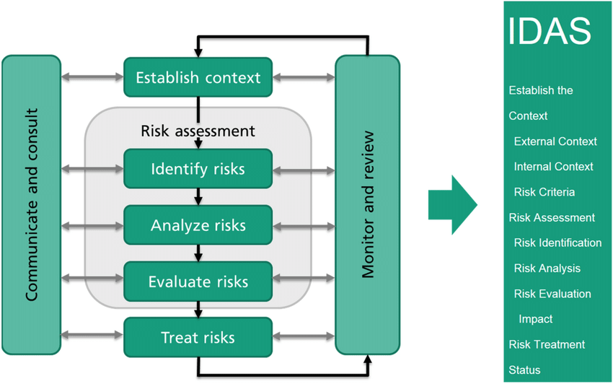

Figure (1): Representation of the risk management process according to ISO 31000 in the web application IDAS, as applied to the urban domain (Finger et al., 2021).
After an urban road has been completed and is in use, it is extremely important to continue measuring its overall safety, function, and cost-effectiveness over time; therefore, roads must be inspected, risk managed, or monitored periodically to ensure that they are still safe and functional in the future. At the same time, these inspections provide an opportunity to complete post-implementation assessments of the highway's structural integrity, surface condition, drainage capacity, and alignment with the original design.
The post-implementation assessment process will help in identifying damage to the road, deterioration of the road, or structural instability at an early stage (identified as premature) before it can be repaired. This will assist both highway authorities and their site's contractors to assess whether the highway meets acceptable operating conditions as established by both the user and operator.
In the post-implementation phase of risk management for an asset (such as a road) involves determining what potential risks exist that could further degrade the physical condition of that asset after the successful implementation (operational) period; this determination will be made through a systematic process of identifying, analyzing and developing strategies to mitigate these identified risks (i.e., traffic volumes increasing, lack of maintenance, extreme weather conditions, accidents, etc.).
Risk management will provide the ability for agencies to effectively prioritize maintenance; allocate maintenance resources more efficiently; and take forward-looking proactive actions to avoid or minimize interruptions and the expense incurred in repairing or rebuilding the subject asset at a later date.
Thus, this study shows the importance of the proactive, data-based approach to measuring and managing risks to constructed urban roads during the post-implementation (operational) period. Best practices, tools and techniques will be reviewed that may be utilized by urban planners, engineers and policymakers to prolong the lifespan of urban transport and infrastructure assets, while providing safe transportation; providing economic efficiency; and improving the resiliency of the environment.

Risk Mitigation Management for Road Infrastructure Projects is a fundamental part of achieving successful road infrastructure projects is through risk management; they are complex in nature; require a significant investment of money; and have high consequences to the public in regard to safety. Because these projects are essential to fostering economic growth and growth in social activity through moving people and goods from one place to another, they regularly experience problems that can negatively impact their intended objectives. Budget overruns, delays in schedule, and inefficiencies are frequent occurrences and can contribute to making the infrastructure efforts less effective (Khatleli, 2020; Lee et al., 2023).

1.3 Road Life Cycle
A road infrastructure project's life cycle consists of several phases, from the design phase through the planning phase and into construction and operations. Each phase comes with its own uncertainty, be it financially based (for example, increases in construction material costs) or operationally based (for example, obstacles to accessing a construction site due to adverse weather conditions or unknown site conditions).
The road life cycle is a fundamental concept in the assessment and risk management of constructed urban roads, as it encompasses all stages of a road's existence, from planning and design to construction, operation, maintenance, rehabilitation, and eventual reconstruction. Each stage presents specific risks that can affect the road's performance, safety, and durability. In the municipalities of South Nablus, effective management of the road life cycle is essential due to increasing urbanization, growing traffic demands, and limited municipal resources. During the design and construction phases, risks may arise from inadequate engineering practices, poor material quality, or insufficient drainage systems. As roads enter the operational phase, factors such as traffic loading, environmental conditions, and routine wear and tear contribute to gradual deterioration. Continuous assessment throughout the life cycle enables municipalities to detect defects early, implement timely maintenance interventions, and prevent costly failures. By adopting a life-cycle approach to road management, municipal authorities can optimize infrastructure investments, extend pavement service life, improve road safety, and ensure the long-term sustainability of urban transportation networks in South Nablus.
It has been shown that effective implementation of risk assessments throughout the life cycle of a project reduces levels of accidents, overall financial stability of projects and enhances quality of decision-making (Greenan et al., 2016; Pešić et al., 2022; Senić et al., 2024; Simić et al., 2023; Trifunović et al., 2024).
This narrow perspective fails to provide adequate visibility of cumulative risk, which may lead to underestimation and to reactionary behaviors rather than to proactive planning. These issues highlight the requirement for methodologies to assess risk to be broader in scope, more adaptable in practice, and provide better representation of the interdependencies inherent in the uncertain nature of modern road infrastructure projects (Buffarini et al., 2022; Li & Chen, 2018; Rusim et al., 2019).

The method described in this research provides a clearer picture of the risks being faced today, and can also provide an estimate of how likely these risks are to occur in future projects, unlike many conventional methods that would ignore the complexity of inter-relationships and uncertainty between various risk elements. As such, the method provides greater support for proactive risk management than the other conventional methods, as well as greater opportunities for reducing costs, delays and ultimate failure than with the various other methods discussed in this article.

1.4 Problem Statement
Urban roads are regularly experiencing issues with maintenance due to the realities of the roads. After they have been constructed and placed into service, many of the city's and/or infrastructure managers are experiencing ongoing challenges in maintaining their intended long-term performance and safety, as well as the structural integrity of the roads, which were developed during the construction phase. It involves identifying the problems that roads face after implementation, whether they are natural, political, or related to design factors.
Road infrastructure is considered one of the fundamental components of social and economic development in rural and urban communities. Constructed roads play a significant role in improving mobility, accessibility to services, economic activities, and regional connectivity. In the municipalities south of Nablus, road networks represent essential infrastructure that supports daily transportation, agricultural movement, commercial activities, and access to education and healthcare services.
Despite the continuous implementation of road construction and rehabilitation projects in these municipalities, many roads experience operational and structural problems after implementation. These problems include pavement deterioration, drainage deficiencies, surface cracking, potholes, erosion, traffic safety hazards, and inadequate maintenance practices. Such issues negatively affect road performance, increase maintenance costs, reduce road lifespan, and create safety and environmental risks for road users and surrounding communities.
One of the major challenges facing municipalities south of Nablus is the absence of integrated systems for post-implementation assessment and risk management of constructed roads. In many cases, municipal interventions are reactive rather than preventive, occurring only after severe road deterioration or infrastructure failure has already developed. Additionally, limited financial resources, weak technical monitoring systems, lack of updated infrastructure databases, and insufficient coordination between municipal departments further complicate effective road management.
Although several studies have addressed road construction management and traffic safety, limited research has focused on post-implementation assessment and operational risk management for existing roads in rural municipalities, particularly within the Palestinian context. Most previous studies focus on large urban centers or highways and pay limited attention to the unique environmental, financial, and administrative challenges affecting rural municipal roads.
Therefore, there is a need for a comprehensive framework that supports municipalities in assessing the condition and operational risks of constructed roads after implementation. Such a framework should integrate technical, environmental, safety, and maintenance indicators to assist municipal engineers and decision-makers in identifying high-risk road segments, prioritizing maintenance interventions, and improving infrastructure sustainability.
This study seeks to address this gap by evaluating the current status of constructed roads in municipalities south of Nablus and developing an assessment and risk-management approach that can support sustainable municipal road management and long-term infrastructure performance.
The roads were designed and built according to widely accepted engineering principles; however, the real-world application of these design principles has resulted in the road experiencing many different pressures over the lifetime of the roadway, such as increases in the amount of traffic on the roadway, lack of appropriate drainage, and changes in climate and/or environmental conditions.
Without a systematic method for post-implementation evaluation and risk management, roadway issues often go undetected until they are severely deteriorated, leading to inadequate maintenance budgets, unforeseen failures, and unsafe conditions, which impose additional financial burdens on city or infrastructure managers.
Additionally, many of our urban areas do not have the technical expertise, financial resources, or tools to continue the monitoring of roads for potential risk mitigation. The result has been that in many cases, the service life of the roadway is shorter than originally intended, the cost of repairs to the roadway is greater than originally anticipated, and there has been an interruption of transportation services to the community.
The existence of these issues highlights the need for effective strategies for ongoing assessment and risk management of constructed urban roads. To support this effort requires identifying key risk factors, conducting routine evaluations of pavements and structures' conditions, and using an evidence-based approach to inform maintenance and intervention prioritization decisions. Without these processes in place, urban road facilities will continue to experience progressive functional degradation, which negatively impacts public safety, hinders the movement of people within cities, and results in reduced productivity throughout the economy.
Related to traffic load growth, changing environmental conditions, utility installations, and the effects of ongoing urbanization are many stresses affecting urban roads after they have been placed into public use. Although roads are designed and constructed in accordance with established technical standards, many roads will start to experience functional and/or structural deterioration within a short period after being built; this is largely due to the fact that post-implementation evaluation (and risk management) systems are commonly not implemented.

In the absence of a strong assessment and risk management framework for urban roads, those roads are at risk for long term failures of service resulting in a negative impact on transportation efficiency, economic activity and public safety. Filling this gap requires the implementation of rigorous methodologies to enable continuous monitoring of the condition of the roads, as well as identifying, prioritizing and mitigating risks in a timely manner. These practices are critical if urban roads are going to continue to operate effectively, safely and sustainably through their entire life cycle.
Despite the growing importance of urban road infrastructure in supporting mobility, economic development, and public safety, there remains a lack of comprehensive studies that systematically assess and manage the risks associated with constructed urban roads in the municipalities of South Nablus. Existing practices often rely on reactive maintenance approaches and limited evaluation criteria, which may not adequately address the diverse technical, environmental, traffic, and safety-related risks affecting road performance. Therefore, this study seeks to develop a structured framework for the assessment and risk management of constructed urban roads by identifying key risk factors, evaluating their relative significance, and establishing a risk-based decision-making approach that can assist municipalities in prioritizing interventions, optimizing resource allocation, and enhancing the sustainability and safety of road networks.

1.5 Significance of the Study
Urban roads are essential components of contemporary infrastructure. They facilitate transportation of humans, products, and services throughout the rapidly developing metropolitan regions. However, once built, urban roads are also immediately subjected to significant levels of external pressure (e.g., structural deterioration; as the result of increased vehicle loads, environmental stresses, and climate-related threats such as flooding and extreme heat).
This study represents a major advancement in infrastructure management because it's filling an important gap in the area of evaluating and mitigating risks after construction. Specifically, by examining how current practices, tool availability, and assessment methods (for example; road condition assessment, safety monitoring, and resilience planning) typically evaluate urban roads, this study will provide a holistic assessment of how these roads can be maintained in a safe (and effective) manner over an extended period of time. Lastly, the study identifies the benefit of using sustainability and resilience principles as part of ongoing infrastructure management.
Long-term performance and safety of urban built roads are critical to sustaining efficient transportation systems, supporting economic productivity, and safeguarding public safety. Unfortunately, very few urban built road projects are adequately maintained after construction is completed. This can lead to significant delays in maintaining the roads and to gradual uncontrolled deterioration of the road structure, increasing risk to users of the road as well as to surrounding infrastructure. Thus, assessment and risk management are required to ensure the functionality, safety, and resilience of urban built roads over time and through the end of their intended service life.
The methodology of the study reflects existing monitoring and management practices for constructed urban built roads at the implementation phase, and uses performance metrics and risk assessment techniques to develop a more comprehensive understanding of how to effectively monitor and manage constructed urban built roads following implementation. For example, use of pavement condition indices, safe roadway audits, and deterioration modeling can aid in evaluating the condition of the road prior to any maintenance action and determining the appropriate time for the maintenance to be performed. In addition, the use of GIS-based risk mapping may assist in expediting maintenance decisions, which may help prevent structural or operational failure.
Finally, the study contributes to the response of developing problems that are becoming more prominent in contributing to the vulnerability of road infrastructure, specifically climate change, extreme weather events, and urbanization trends. By proposing more integrated, data-based solutions to current limitations, the study aims to enable the application of more proactive infrastructure management practices.
Therefore, the results are beneficial to civil engineers, city planners, infrastructure managers, and policy makers hoping to improve the sustainability, resilience, and safety of city transportation infrastructure. The significance of the research can be summarized in the following points:
1. Ensuring public safety
Pedestrian, cyclist, and driver safety are largely influenced by urban road conditions. Increased crash likelihood is linked to damaged road surfaces, inadequate infrastructure, and poor traffic management. This research proposes a safety framework for assessing construction projects, tracking risk management from evaluation to completion. It aims to pinpoint high-risk locations for tailored safety improvements, emphasizing ongoing monitoring and targeted interventions in these areas.
2. Prolonging road lifespan and reducing maintenance costs
.
The implementation of a systematic risk management framework allows organizations to detect issues early and make informed maintenance decisions aligned with scheduled activities. This approach facilitates longer road maintenance duration while reducing ongoing costs, which is critical for cities with financial limitations and infrastructure needs.
3. Adapting to urban growth and changing traffic patterns
The study examines how urban expansion alters road usage patterns, driven by land-use changes, population growth, and new businesses, leading to increased traffic and shifting risk patterns in the transportation system. It highlights the need for effective risk management to identify future pressure points. New developments will require greater capacity and safety measures. Additionally, evolving public transport usage reflects community priorities for safer pedestrian paths, improved cycling facilities, and enhanced multimodal transportation links.
4. Mitigating environmental risks
Urban road management systems are increasingly challenged by environmental stressors such as floodwaters, landslides, and extreme weather. Organizations lacking robust risk management face higher costs by responding to hazards post-incident. This study explores how environmental factors affect road systems and proposes mitigation strategies, including improved drainage and flood defenses, and materials that withstand extreme temperatures. Strengthening these elements enhances resilience amid changing climate patterns and intensified environmental impacts.
5. Ensuring regulatory compliance and best practices
The post-construction risk management process must adhere to evolving compliance requirements, including safety and environmental standards. Effective risk management ensures that design, maintenance, and operational procedures align with best practices and applicable laws. Maintaining compliance enhances the trustworthiness of the road management system, facilitating transparent decision-making regarding performance and safety outcomes.
6. Facilitating data-driven decision-making
Risk management relies on thorough data collection, rejecting assumption-derived data. Continuous monitoring is essential, requiring road data, traffic patterns, and accident statistics for analysis. This study illustrates that real-time data access enhances evidence-based decision-making by supplying current information. Improved data quality allows authorities to allocate resources strategically and identify high-risk areas, facilitating effective interventions and funding initiatives to reduce risks.
1.6 Thesis Objectives
This research aims to achieve the following objectives:
- To identify and analyze key risk factors, along with their severity and allocation, by considering the perspectives of road users, pedestrians, drivers, owners, contractors, and municipalities.
- To develop risk maps and risk matrices that support the identification of risks and the forecasting of potential future risks.
- To develop a risk index for each road and use the assigned risk value to establish a priority-based ranking.
- Propose risk prevention and mitigation measures that address the identified risks in an effective and practical manner.

1.7 Study Area
The study area contains five municipalities located in the southern part of Nablus. These municipalities are Huwara, Beita, Jammaein, Aqraba, and Qabalan. Figures 2-6 presents a map illustrating the geographic location of the targeted municipalities. Several reasons justify the selection of these municipalities for the study:
• They share similar geopolitical conditions.
• They experience comparable socio-economic challenges.
• There is notable diversity in contextual factors, such as the types of hazards and risks, across these municipalities.
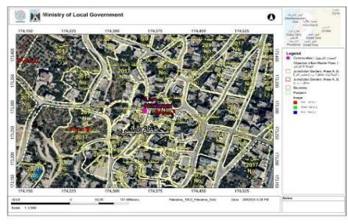
The first municipality in the study area is Huwara, a Palestinian town in the West Bank, part of the Nablus Governorate. It is located 9 km south of Nablus on the Nablus, Jerusalem Road. It is administered by a municipal council. Huwara's current population is approximately 6,659, all of whom are Muslims, according to the census conducted by the Palestinian Central Bureau of Statistics (Palestinian Central Bureau of Statistics, 2021)

Figure (2): Aerial photo of Huwara town from the GeoMOLG website.
The second municipality in the study area is Jammaein, a town located 16 kilometers southwest of Nablus in the West Bank. It is bordered to the west by the villages of Qira and Zeita Jamma'in, to the north by 'Urif, Madama, and Asira al-Qibliya, to the east by Einabus, and to the south by Marda. The village's current land area is approximately 21,000 dunams, with a built-up area of 2,912 dunams. (Palestinian Central Bureau of Statistics, 2021)
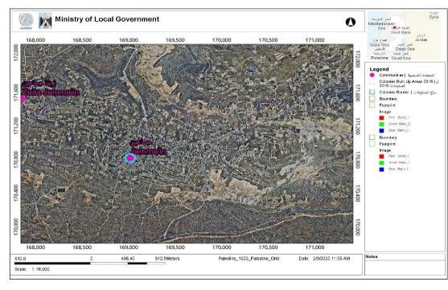

Figure (3): Aerial photo of Jammaein town from the GeoMOLG website
The third municipality in the study area is Qabalan, which is located east of the Nablus Governorate, approximately 19–20 kilometers southeast of Nablus city. The town of Qabalan, located in the Nablus Governorate in the West Bank, has a population of approximately 8,195 people, according to the 2024 statistics from the Palestinian Central Bureau of Statistics. The village's total area is approximately 10,546 dunams. (Palestinian Central Bureau of Statistics, 2021)
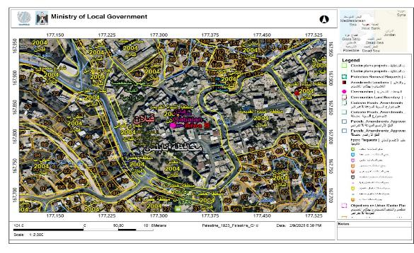
Figure (4): Aerial photo of Qabalan town from the GeoMOLG website
The fourth municipality in the study area is Aqraba, a Palestinian town in the Nablus Governorate in the northern West Bank, approximately 19–20 kilometers southeast of Nablus city. The population of Aqraba is approximately 10,024 people according to the 2024 census Its area is about 144 thousand dunams. (Palestinian Central Bureau of Statistics, 2021)

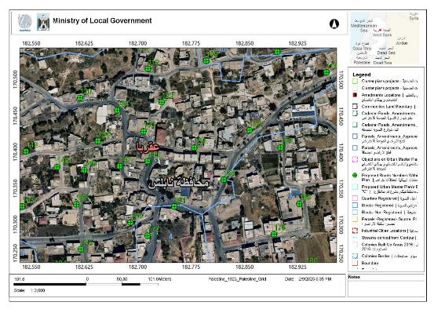
Figure (5): Aerial photo of Aqraba town from the Geo MOLG website.
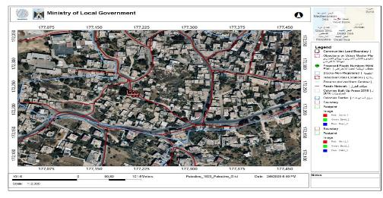
The fifth municipality in the study area is Beita, a Palestinian town in Nablus. It is located 13 km southeast of Nablus and east of the Nablus, Ramallah Road. It is bordered to the south by Qabalan and Yatma, to the east by Osrin and Aqraba, to the west by the Nablus Ramallah Road and Huwara, and to the north by Awarta. (Palestinian Central Bureau of Statistics, 2021)

\
Figure (6): Aerial photo of Beita town from the GeoMOLG website.
From each of the five towns, ten roads/streets were selected to enable balanced and comparable representation across the study areas. This sampling technique enables the representation of different functional road types, different geometric characteristics, grades, land use, and diverse pavement conditions within each town. The equal division ensures fairness in inter-town comparison and cuts down selection bias. Also, the sample size was considered adequate for the purpose of descriptive and comparative analyses within the practical limitations of time, resources and field accessibility.
The sample of roads selected for this study is drawn from various functional classifications, as presented in Table 1 below. This table details the total length of roads within the targeted municipalities in the southern Nablus Governorate, categorized according to their functional classification.
Table 1: The lengths and types of the road network in the five targeted municipalities (Palestinian Central Bureau of Statistics, 2024)

Municipality | Local roads (KM) | Collector roads (KM) | Arterial roads (KM) | Total lengths of roads | Percentage of road lengths
Huwara | 25 km | 8 km | 4 km | 37 Km | 32%
Bieta | 35 km | 12 km | 10 km | 47 km | 38%
Jammaein | 31 km | 10 km | 11 km | 51 km | 42%
Aqraba | 45 km | 17 km | 14 km | 66 km | 44%
Qabalan | 44 km | 13 km | 12 km | 69 km | 49%
Ten roads were selected from each country for the purpose of standardization, although they originally differed in length, width, and use. The table shows the lengths of the road network and the proportion of selected samples from each country.
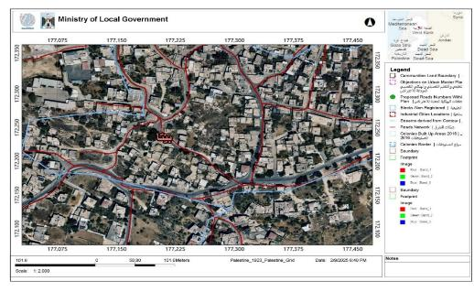
The selection of these municipalities is purposeful: the risks examined in this research are expected to manifest on roads in these areas during the post-implementation period. In parallel, the study takes into account the financial obligations and ongoing maintenance costs that may follow from these risks. It is also important to emphasize that the risks are not confined to engineering and design considerations alone. They are shaped as well by the wider political context, which influences the country as a whole and the targeted area in particular.
The selection of "south of Nablus" as a research location stems from its main communities which share similar political problems and infrastructural development challenges with their nearby regions. The area experiences three main problems which include road erosion and mobility restrictions and road closures. The existing conditions lead to traffic being redirected to use only a small number of available routes which results in increased traffic loads on specific road sections.
The continued use of a road results in concentrated traffic which leads to faster road degradation and causes defects to the asphalt surface. The region serves as an ideal research area because its municipalities share an interrelated road system, which allows researchers to study and control post-implementation danger assessment throughout the entire research process using a common tracking method. A risk assessment process requires each municipality to conduct road evaluations which will determine all road risks across different risk categories through standardized risk assessment procedures.

1.8 Research Questions
This research aims to answer two main research questions:
- What are the main post –construction risk factors affecting urban roads in the targeted municipalities ?How can AHP be used to prioritize post –construction risks in urban roads?
- What are the relative risk levels of the studied municipalities based on the developed risk index?

1.9 Hypothesis of the study
The following hypotheses are proposed in the study:
Hypothesis 1: Impact of post-implementation assessment
Assessment of road performance
• Null Hypothesis (H₀₁):
Post-implementation assessment has no significant impact on the performance and durability of constructed urban roads.
• Alternative Hypothesis (H₁₁):
Post-implementation assessment has a significant positive impact on the performance and durability of constructed urban roads.
Hypothesis 2: Effectiveness of risk management in reducing road failures
• Null Hypothesis (H₀₂):
Risk management practices do not significantly reduce the frequency or severity of failures in constructed urban roads after implementation.
•Alternative Hypothesis (H₁₂):
Risk management practices significantly reduce the frequency and severity of failures in constructed urban roads after implementation.

1.10 Thesis Outline
The study's design aims to present research findings through a methodical and logical approach. The introduction starts with an explanation of risk management's significance to road infrastructure projects, which establishes the study's context within existing research. The following chapter delivers a comprehensive examination of relevant research studies, which includes earlier research and methods that assess risk through advanced analytic techniques.
The methodology chapter then sets out the research framework in detail, with particular focus on the data-driven techniques used in the study and how they are implemented. The results chapter provides output results from all methods used in the study, which evaluate their ability to predict seven different risk groups. The discussion chapter uses these findings to compare different methods used in this research, while it also assesses how well the developed models match findings from previous research.
The conclusion summarizes the main findings while showing their impact on managing infrastructure projects.

Chapter Two

Literature Review

2.1 Risk and Uncertainty
Risks are those uncertainties or conditions which, when they occur, have both positive and negative impacts on the deliverables of the project. Risk is generally expressed in terms of occurrence probability and its consequences, or impact on the output of the project. For any event to be taken as a potential risk factor, it must have a probability of occurrence between 0 and 1, which indicates the likelihood that the risk event will occur. Hence, the impact of risk factors can be stated when details are related to the possibility of occurrence and a series of probable outcomes with their likelihood of occurring (Smith et al., 2014). Uncertainty is that event for which the probability of occurrence is unknown, i.e., uncertainty is that event about which little is known in relation to the extent or likelihood of its occurrence, with only the possibility that it might occur. Uncertainty is said to exist when an event results in multiple possible outcomes, yet the probability of those outcomes is unknown (Smith et al., 2014).
Urban roads face many different problems mainly because of the complexity of the infrastructure itself, the fact that traffic volumes are always high, and the combined effect of risks coming from both the environment and people. In this case, risk management is understood as a methodical way by which risks that may endanger the safety of roads, their functionality, and resistance are first recognized, then analyzed, and finally reduced (Smith et al., 2014).
This literature review brings together key research, frameworks, and methodologies on risk management for urban roads. It highlights work focused on risk identification, assessment models, and mitigation strategies, while also emphasizing the role of adaptive management in responding to changing conditions over time.
Risk management has become an essential requirement for construction projects. The risk management process includes risk identification, risk assessment, and risk control. Qualitative methods and quantitative methods are utilized to assess risk. The adoption of risk management is necessary to maximize the significance of positive factors and diminish the significance of contrary factors in project goals. The adoption of risk management is crucial since it is an efficient practice for identifying, assessing, and mitigating project risk (Abd El-Karim et al., 2015).
Project risk is an uncertain occurrence or circumstance that, if it occurs, may have a beneficial or destructive influence on a project’s goals. Risk analysis mechanisms examine the possibility of an event, the likelihood of its occurrence, and the impact of that occurrence. Risk management includes a six-step method, namely, risk management planning, risk identification, qualitative risk analysis, quantitative risk analysis, risk response planning, and risk monitoring and control. The suggested steps act as a guideline to manage risk in any project. However, many authors have simplified the six steps to risk identification, risk assessment, risk response, and risk monitoring (Project Management Institute, 2000).
Most construction projects are economically risky, especially projects in developing countries. Although construction practitioners are aware of the possible risks and their outcomes, not all organizations are adequately prepared to establish risk management in their construction projects. Moreover, numerous studies have shown that highway construction projects have higher risks compared to other construction projects due to the geographic area and threats related to underground conditions. Also, the risk related to highway and road construction projects has a significant impact on issues related to cost, time, and quality of project delivery. It is known that road construction projects require huge investment, and to prevent costly project failures and other risks from occurring, systematic risk management needs to be established (Chapman & Ward, 2003).
Implementation of risk management in the construction industry has a potential effect on project success. Proper risk management should be well established and agreed upon by all parties before implementation. Divergent understandings during the early stages of the risk management process among stakeholders, such as those observed in road projects in Sri Lanka, have negatively affected the implementation of risk management. Three elements that are important in the risk management process are time, cost, and quality. Furthermore, cost overrun, delays, and reduction of quality can be prevented by applying risk management to construction projects. Besides, previous studies have also shown that there are several highway projects that exceeded their budget and time due to what have been called unforeseen events. Therefore, these studies provide evidence regarding the involvement of public infrastructure projects, particularly in road networks, in the implementation of risk management (Akinrinade, 2018; Ehsan et al., 2010; Giang & Sui Pheng, 2011; Naidu, 2008; Yusuwan et al., 2008)as presented in Table 2.
Table 2: The most recent relevant studies related to risk and uncertainty.
No. | Study | Focus / Method | Uncertainty / Risk Approach | Key Findings
 | Interval-valued Fermatean Fuzzy AHP for seismic vulnerability of urban roads (2024) Ahmet Kaan Yıldırım, Bahar Yalçın Kavuş, Tolga Kudret Karaca, | Fuzzy AHP multi-criteria decision making for seismic vulnerability | Fuzzy logic handles ambiguity in expert criteria and weighting | Identifies & quantifies vulnerability in road network under seismic hazard; helps prioritize mitigation needs.
 | Hybrid Fuzzy-CNN Framework for Urban Traffic Risk & Sustainability (2025)  Zhong, Z., & Ren, Z. | Fuzzy Delphi to weight criteria + CNN risk prediction | Designed to reduce subjective weight uncertainty & data imbalance | High predictive performance + GIS risk maps; identifies risk hot spots in constructed road segments
 | CNN-based Risk Assessment for Urban Road Collapse (2023)  Jiang et al. | Deep learning risk model for collapse risk |  | CNN model (accuracy≈0.97) identifies key factors (construction proximity/size) for road collapse risk and maps high-risk segments.
  collapse risk
  Implicitly handles complex indicator relationships

2.2 Sources of Risk
Risk can be categorized into project-specific risk and non-project-specific risk. Risk related to both categories needs to be considered during the identification of risk factors within a project. The project team, during analysis of the risk event, needs to define the boundaries within which the risk is to be considered and break down the risk event into independent risk elements. This facilitates understanding of the risk events and helps in better selection of the risk response strategy. The general checklist for breaking down sources of risk includes commercial, financial, legal, political, environmental, communication, geographical, construction, technological, operational, and management risks (Chitkara, 2011)as presented in Table 3.
Table 3: The most recent relevant studies in the subject of source or risk.
No. | Study (Year & Source) | Area Covered / Case | Sources of Risk Identified | Main Outputs / Findings
 | Urban Road Risk Assessment … CNN framework (2025)  Zhong, Z., & Ren, Z. | Urban road network risk (Foshan, China) | Anthropogenic & environmental factors: construction proximity/size, pipelines, geology, soil type | Developed CNN risk model for collapse risk; top contributors were anthropogenic construction and environmental geology factors; maps risk hotspots.
 | A Systematic Risk Assessment Approach for Urban Roadside Infrastructure (2024)  Apak et al. | Field data in urban roadside assets | Roadside infrastructure vulnerabilities, traffic hazards, geometric irregularities | Identified risk parameters (traffic, infrastructure, roadside assets) and developed risk groupings; human/vehicle interaction and infrastructure state were key sources.
 | Data-Driven Probabilistic Bayes Framework for Urban Risks (2025)  Rohith Kumar et al. | Cross-domain urban systems | Cascading risk interdependencies (weather, infrastructure, utilities) | Established probabilistic identification of interlinked risk sources across domains relevant to road infrastructure resilience.

2.3 Risk Response
In order to enhance opportunities and reduce threats to the project’s objectives, risk response is an effective procedure to adopt in the risk management process. Risk response ensures that identified risks are appropriately mitigated. As suggested by the Project Management Institute, there are four techniques for risk response, which are risk avoidance, risk transference, risk mitigation, and risk acceptance. Trangkanont and Charoenngam (2014) recorded several earlier studies and proposed a framework for risk response strategy for public–private partnership (PPP) projects. Tserng et al. (2009) suggested an Ontology-Based Risk Management (ORM) framework, which includes risk identification, risk analysis, and risk response, in order to enhance risk management performance by improving workflow and knowledge reuse. Meanwhile, Dziadosz and Rejment (2015) suggested a risk response plan for generic construction projects based on the designed risk with a scale of low, medium, and high levels as presented in Table 4.
Table 4: The most t recent relevant studies in the subject of risk response.
No. | Study (Year) | Region / Case | Method Used | Main Outputs / Risk Response Focus
 | Enhancing Urban Resilience: Managing Flood-Induced Disruptions in Road Networks (2025)  Salvo, G., Karakikes, I., Papaioannou, G., Polydoropoulou, | Palermo, Italy | Dynamic microsimulation (Dynasim) + real-time traffic data | Proposes comprehensive emergency mobility plans using adaptive signals and rerouting strategies to manage traffic during flood events; contributes to operational response planning for extreme weather.
 | Prioritization of Preventive Measures: A Multi-Criteria Approach to Risk Mitigation in Road Infrastructure Projects (2025)  Senić et al. | General (methodological, Europe / broader context) | Delphi + multi-criteria Decision-Making | Offers a systematic methodology to rank and prioritize preventive and mitigation measures for road infrastructure, aiding risk response planning.

2.4 Risk Characteristics
Risk characteristics can be defined in a number of ways. Wideman (1992) provides one example that has transcended risk management in a number of technical fields: “knowns, known-unknowns, and unknown-unknowns.” This classification has been used to describe project costs and contingency in Figure 7. A known is an item or situation containing no uncertainty. Unknowns are items or situations that are recognized, but their effects are not fully understood. A known-unknown is an identifiable uncertainty. An unknown-unknown is simply an item or situation whose existence has yet to be encountered or imagined (Wideman, 1992; Slovic, 2000). The most important recent studies in the subject of risk characteristics are shown in Table 5.
RISK CHARACTERISTICS
Knowns, known-unknowns, and unknown-unknowns
Risk triggers
Risk versus opportunity events
Figure (7): Risk characteristics
Table 5: The most recent relevant studies in the subject of risk characteristics.
No. | Study (Year) | Region / Scope | Method Used | Main Outputs / Risk Characteristics Identified
 | Uncertainty Quantification in Road-Level Traffic Risk (2023)  Gao et al. | Lambeth borough, London, UK | STZINB-GNN graph neural network with uncertainty quantification | Reveals traffic risk characteristics (temporal/spatial risk levels) with explicit model uncertainty — demonstrating spatio-temporal risk distributions across road segments.
 | Driving risk identification on urban roads (2024)  Yan et al. | Urban arterial/collector roads (unspecified area) | Multi-scale vehicle/road data + entropy weight-TOPSIS + logit models | Distinct risk profiles for arterial vs collector roads; identifies how driver, vehicle, road geometry, and environment factors vary by road type.

2.5 Typical Risk in a Construction Project
Typical risks in a construction project include (Zou et al., 2007):
• Accidents on site resulting in physical injury.
• Failure to complete the project as per the planned design.
• Unable to accomplish the project within the estimated time duration.
• Failure to obtain the approval documents as per local authorities’ and legal requirements.
• Delay in the project due to unforeseen site conditions.
• Price fluctuation and market uncertainty related to construction material and labor.
• Possibility of the budget exceeding the upper boundary limit as per the client’s expectation.
• Force majeure conditions.
• Failure to maintain project progress within the estimated cost.
• Loss to the contractor due to unaccounted events.
• Unable to make timely decisions related to variations and uncertainties.
• Unable to achieve the required quality standards or comply with Safety, Health, and Environment (SHE) regulations. (Flanagan & Norman, 1993)as presented in Table 6.
Table 6: The most recent relevant studies in the subject of typical risk in construction projects.
No | Study (Year) | Region / Case | Method Used | Main Outputs / Typical Risks Identified
 | Risk Analysis of Road Construction Projects: Case of Erbil (2025)  Darwish et al. | Erbil, Iraq | Probability-impact matrix + Monte Carlo simulation | Identified 46 out of 67 typical risk factors; technical risks were most significant for cost impact; quantified risk probability for project performance variation.
 | Strategic Risk Management in Urban Road Construction Project Nepal (2020)  Adhikari & Mishra | Siddharthanagar, Nepal | Questionnaire survey + scenario analysis | Identified potential risks from contractor & client perspective; main risk handling included contingency planning, supervision, alternative methods; emphasized risk register and frequent review (not strictly urban but directly road construction focused).

2.6 Relevant Studies in Palestine
Two studies were cited related to the subject. Aqel E. (2019) noted that transportation infrastructure is becoming increasingly vulnerable to natural hazards. Such hazards can interrupt critical services and hinder emergency operations, particularly in areas where alternative routes are limited. In Palestine, surface transportation networks play a central role in evacuation and disaster response, which makes resilience a key requirement. Focusing on Nablus City, the study identified several major natural hazards, earthquakes, flooding caused by heavy rainfall, landslides, and snow, and showed that these hazards differ in both their probability and their potential impact. Through the use of historical data and the development of hazard scenarios, the study clarified how each hazard could affect the transportation network. The findings were presented with the aim of helping decision-makers design effective emergency plans and prioritize infrastructure improvement strategies (Aqel, 2019).

Nour El-Din Maari (2014), focused on the architectural styles of buildings exceeding five stories in Nablus, and the impact of these styles on the seismic vulnerability of these buildings and their behavior during earthquakes. It also highlighted the mechanism for rapid seismic assessment of existing buildings based on several criteria that determine their behavior during earthquakes. The study further discusses the evacuation of residents and the provision of alternative housing. This study employed a descriptive and quantitative methodology, utilizing several scientific research tools, most notably observations, field surveys, and interviews with officials and residents. The results revealed high levels of vulnerability in many buildings, particularly those built in mountainous areas. These buildings often exhibit architectural and structural styles that do not meet the minimum requirements for earthquake-resistant buildings. The results also indicated the absence of any seismic design considerations in most high-rise buildings in Nablus, and the lack of consideration for seismic studies in the planning and land-use designation processes. Furthermore, the research identified areas that may be completely or partially blocked, thus preventing rescue teams from accessing them. In addition, thesis pointed to the poor condition of hospitals in terms of the roads leading to them. The study recommended several measures, most importantly the need to implement urban planning styles that do not take seismic aspects into account, as well as working to improve narrow roads that may be closed according to the seismic scenario presented in this study. The author also recommended the need to conduct more detailed studies of soft floor structures and multi-story buildings, which were found to be highly vulnerable in this study, in addition to public facilities, schools, and hospitals.

2.7 Relevant Studies in Developing and developed Countries
Key Studies on Assessment & Risk Management for Constructed Urban Roads are presented in Table 7. Moreover, the road risk map is presented in Fig 8.
Table 7: The most relevant global, local, and regional studies and their main findings.
No. | Study | Country | Focus / Topic | Methods / Outputs | Key Contribution
1- | Rezvani et al. (2024): Urban Resilience Index for Road Networks | Europe (Lisbon), Global framework | Scenario-based resilience and disaster risk reduction | Four-stage resilience methodology + Geo-AI simulation; cost–benefit analysis | Proactive resilience planning improved network performance by ~7.6% compared to reactive strategies; benchmarks for decision-making.
2- | Ahmet Kaan Yildirim  Seismic Vulnerability Assessment of Urban Roads (2024) | Turkey — Regional/seismic | Risk from earthquakes to urban roads | Interval-valued Fermatean fuzzy AHP for vulnerability scoring | Identified high-risk road sections in Istanbul; integrated built environment and disaster response factors.
3- | Hemant Gain, Anjay Kumar Mishra, and P. S. Aithal.  Risk Management Practices in Road Construction Projects (2022) | Nairobi, Kenya (regional example) | Survey of risk management practices in urban road construction (risk transfer, prevention, control). |  | Risk transfer, prevention and control positively affect project performance; highlights planning and material quality risks.
4- | Jiting Tang  Resilience Assessment of Urban Road Transportation in Rainfall (2024) | Shenzhen & China (regional) |  | Improved Resilience Triangle with traffic & meteorological data | Quantitative assessment of resilience under rainfall; found road density and rainfall intensity as key drivers of resilience variations; useful for climate-risk planning.
5- | Francesca Demasi, Giuseppe Loprencipe, and Laura Moretti  Road Safety Analysis of Urban Roads — Italian Case Study (2018) | Italy (local urban roads) | Urban road safety risk methods | Systematic review (PRISMA-based) | - Identified 10 proactive urban road safety assessment methodologies  - Emphasizes proactive over reactive (crash-based) methods  - Highlights focus on safety of vulnerable users

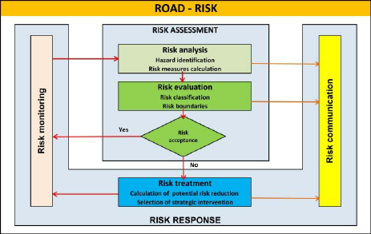
Figure (8): Road Risk Map (Abd El-Karim et al., 2015)
While most previous research focuses on buildings, this study concentrates on existing urban roads and the challenges facing our region. This research calculates the risk index factor and links it to natural, economic, and political factors. A key feature of this study is its focus on existing urban roads in five municipalities south of Nablus city. Models were created for each municipality using structural plans and Geographic Information Systems (GIS) software. Streets were presented and classified according to their risk factor.
Limited previous studies evaluated the risks in urban roads in Palestine. However, this research evaluated the risks in 10 urban roads in each of the five municipalities and proposed a risk matrix for identifying the impact and probability for each criterion. Moreover, the thesis ranking the priority of each factor in each criterion using AHP method.
Risk assessment of existing urban roads is unique because it deals with real, limited, and constantly changing systems, not entirely new designs. These urban agglomerations often had their roads designed some time ago without considering traffic volume, speeds, vehicle numbers, and weights. Now, they must accommodate traffic congestion, mixed traffic, and heavier loads. This creates risks that were not anticipated in the original design. Furthermore, there is limited flexibility for physical changes because existing urban roads cannot be widened due to the presence of older buildings. Therefore, risk management focuses on low-cost, high-impact interventions (signal timing, signage, markings, and traffic calming) rather than complete redesigns.
For existing roads, risk management is rarely a "one-off fix." The process requires continuous observation and testing of temporary road solutions which include temporary cycle lanes and tactical urban planning. The process exists as an adaptable system which allows for continuous changes between different states. The social and political aspects of urban road changes influence how daily activities and business operations and property access are affected by these modifications.
The risk management process needs to balance technical safety goals with public acceptance and equitable treatment and political viability which becomes less significant during new road development projects. The organization needs to concentrate its efforts on assessing risks which should take precedence over their complete removal. Organizations need to establish risk thresholds which enable them to achieve acceptable outcomes instead of creating environments which protect against all potential risks.
Previous studies in the West Bank have focused on the impact of earthquakes on building patterns and alternative roads in the event of natural disasters such as floods. However, this research evaluates existing urban roads and the most prominent challenges that face in the southern Nablus region, the study employed interviews and quantitative and qualitative descriptive methods, focusing on linking these challenges to natural factors, factors caused by the occupation, and human-related factors. A large number of streets were surveyed, and two research methodologies were adopted. These findings will serve as a reference for southern municipalities after road construction and the solutions we will adopt to address the problems facing these communities, as well as to develop emergency and maintenance plans.
Although previous studies on this topic have focused on the impact of earthquakes on building designs and have used an Analytic hierarchy process calculation method, this study will help in understanding post-construction problems and finding appropriate solutions for municipalities. A matrix of risks facing roads after construction will be created for each municipality and incorporated into future emergency and maintenance plans to mitigate these risks.
The contribution of the research is that it is the first study in Palestine which evaluated the risk associated with urban road in post construction phase by developing Risk index. Four criteria were used to identify the weights of the indicators through using Analytic Hierarchy Process (AHP) and Average weight method (AWM). The study Targeted the 5 big municipalities in the south of the Nablus city which share similar socio–economic and geopolitical condition.
Expected Contribution of the Thesis is presented by a proposed a structured framework for evaluating urban roads after construction and operation, include (pavement condition assessment, drainage performance, traffic efficiency, pedestrian safety, maintenance status, and infrastructure durability.) The contribution is important because many municipalities lack standardized post-construction evaluation systems, integration of Risk Management into Municipal Road Operations. Most municipalities focus on construction completion rather than long-term operational risks. introduce a system that helps municipalities (identify risks early, classify risks by severity, prioritize interventions, allocate maintenance budgets efficiently, and reduce infrastructure deterioration, This shifts municipalities from reactive maintenance to preventive risk management, development of decision-making tools for municipalities a major practical contribution would be creating tools municipalities can use for infrastructure management, such as (risk matrices, condition-rating GIS-based road assessment models, maintenance prioritization frameworks, or KPI-based evaluation systems). Identification of operational deficiencies after road implementation (poor drainage performance, pavement deterioration, traffic congestion, weak maintenance planning, utility trench damage, inadequate pedestrian infrastructure, or safety hazards). Documenting these issues creates evidence-based recommendations for future municipal projects, bridging the gap between construction and long-term municipal management. One of the strongest academic contributions is addressing the gap between: project completion, and long-term municipal performance monitoring. that successful road construction does not necessarily guarantee successful operational performance.
Existing literature on road infrastructure assessment and risk management has primarily focused on: major urban centers, highways, and road construction phases. Most previous studies emphasize: traffic safety, accident analysis, or engineering design standards,
While limited attention has been given to the post-implementation operational performance of existing roads in rural municipalities. In the context of the West Bank, and particularly municipalities south of Nablus, there is a significant lack of integrated studies that evaluate and construct roads after implementation from both technical and municipal management perspectives. Rural municipalities in this region face unique challenges including: limited financial resources, weak maintenance systems, difficult topography, population expansion, infrastructure deterioration, and environmental impacts such as storm water runoff and erosion. Despite the importance of rural roads for economic development, agricultural transportation, healthcare access, and social connectivity, no comprehensive framework currently exists for assessing operational risks and infrastructure performance of existing municipal roads after implementation in these areas. Furthermore, most available studies address road safety independently, without integrating: pavement condition assessment, maintenance management, environmental risks, drainage performance, operational efficiency, and municipal decision-making systems Within one comprehensive risk-management framework.
Gap addressed by the thesis is presented by developing an integrated framework for post-implementation assessment and risk management of existing municipal roads in rural areas south of Nablus. Evaluating roads from multiple dimensions including: technical condition, safety performance, maintenance efficiency, environmental impacts, and operational sustainability. Providing localized empirical data for rural municipalities in the West Bank, where infrastructure management studies remain limited. Supporting municipalities with practical decision-making tools for: maintenance prioritization, infrastructure monitoring, and risk reduction strategies. Bridging the gap between engineering assessment and municipal infrastructure management within rural Palestinian communities.
The thesis contributes scientifically by proposing a context-specific model for assessing and managing risks associated with existing roads after implementation in rural municipalities. It also contributes practical recommendations that can improve sustainability, municipal planning, and long-term road performance in developing rural environments.
The findings of this study may assist municipalities south of Nablus in: improving preventive maintenance systems, reducing infrastructure deterioration, enhancing road safety, optimizing limited budget municipalities, and supporting sustainable rural development.

2.8 Relevant Studies in Rural area
Key Studies on Assessment & Risk Management for Constructed Urban Roads are presented in Table 8.
Table 8: The most relevant global, local, and regional studies and their main findings.
No | Study | Country | Focus / Topic | Methods / Outputs | Key Contribution
1- | A Road Safety Risk Prediction Methodology for Low Volume Rural Roads (2016)  Harris, D., | Rural roads in New Zealand | Predict high-risk rural road sections independent of crash-history records | Four-stage resilience methodology + Geo-AI simulation; cost–benefit analysis | Developed a geospatial risk-prediction model to identify dangerous curves and high-risk road sections on rural roads.
2- | Identifying High Crash Risk Segments in Rural Roads Using Ensemble Decision Tree-Based Models (2022)  Iranmanesh, M., | Rural roads in Iran | Develop crash-risk prediction models for operational rural roads | Interval-valued Fermatean fuzzy AHP for vulnerability scoring | Produced spatial-temporal crash-risk maps using traffic, weather, and geometric road data to prioritize dangerous rural road sections.
3- | In-built Network-Wide Road Safety Assessment Methodologies for Rural Roads (2024)  Elvis Chia Ngwah | International rural road networks | Review and compare methodologies for rural road safety assessment |  | Identified 14 network-wide rural road assessment methodologies and compared risk indicators, data collection methods, and infrastructure parameters

Road infrastructure plays a critical role in supporting economic development, accessibility, and social integration in rural areas. Constructed roads in rural municipalities contribute significantly to agricultural activities, transportation services, healthcare access, and regional connectivity. However, many rural roads experience operational and structural problems after implementation due to insufficient maintenance systems, environmental exposure, limited municipal resources, and inadequate post-construction monitoring. Therefore, post-implementation assessment and risk management have become essential components of sustainable rural road infrastructure management.

2.9 Number of questionnaires for the most important global studies related to the assessment and risk management for constructed urban roads
In most AHP (Analytic Hierarchy Process) studies related to construction risk management, infrastructure assessment, and urban roads, 100 questionnaires are generally considered more than sufficient, especially if the respondents are qualified experts or stakeholders. In fact, many internationally published AHP studies use much smaller samples because AHP focuses on expert judgment quality and consistency, not only large statistical populations. Therefore, in my study, 100 questionnaires were sufficient and comprehensive compared to several international studies that used the hierarchical method. This table shows the most important of these studies and the number of questionnaires as presented in Table 9
Table 9: Number of questionnaires for the most relevant global studies related to the assessment and risk management for constructed urban roads
No | Study (Year & Source) | Topic | AHP Type | Number of Questionnaires / Experts | Importance
 | Assessing Risk and Uncertainty Inherent in Chinese Highway Projects Using AHP  Zayed, T., Amer, M., & Pan, J. (2008). | Highway project risk management | Classical AHP | Case-study expert evaluation (well below 100 participants) | One of the foundational highway risk-management AHP studies internationally.
 | The Weighting of Risk Factors for Road Infrastructure Accidents Using AHP Method  International Journal on Advanced Science, Engineering and Information Technology, Vol. 9, No. 4, 2019. | Urban road accident risk factors | AHP weighting | 40 respondents | Frequently referenced for road infrastructure safety risk weighting.
 | Risk Assessment of Public Road Construction Projects Using AHP  Putri Aifa Syuhaida, Shabuddin (2019) | Public road construction risk management | AHP pairwise comparison | Small expert-based survey (<100) | Focused on prioritizing construction and post-construction risks.

Chapter Three

Research Methodology

3.1 Research Methodology
A whole comprehensive research methodology is required to assess and manage the risks that urban roads face after construction with sufficient accuracy. In the post-construction stage, road performance is shaped by real operating conditions, and risks can develop gradually or emerge suddenly. For that reason, the methodology needs to follow a systematic sequence of steps and apply appropriate methods to identify risks, evaluate their likelihood and impact, and propose mitigation actions (International Organization for Standardization, 2018).
Several factors were not used in the study because they do not affect the risk factor and because they are rare in our regions.
Therefore, two methodologies were chosen in the research, Analytic Hierarchy Process (AHP) and Average Weighted Method (AWM). The structural approach provides protection to urban road infrastructure through its three benefits of safety, extended lifespan, and operational efficiency. The proposed research methodology will synthesize post-construction risk assessment and risk management procedures for urban roads. The AWM method used AHP as its first methodology to calculate weights for all its elements. The general research methodology flow chart is illustrated in Figure 9, whereas the specific methodology using AHP method is presented in Figure 10.
- Comparing on previous study theoretically

DISCUSSION
- Risk Index
- View maps

RESULTS
DATA ANALYSIS
Analytical Hierarchy Process:
- Aggregating Individual Judgement
- Calculation of Geometric mean
- Pair-wise matrix
- NormalizedprincipalEigentopriorityvector(PV)
- Consistency Checking
DATA COLLECTION
Methods:
- Average weighted method
- Analytical Hierarchy Process (AHP)
Samples:
- Construction Project Team
- Literature searching of risks associated to road construction project
- Interview with road

Figure (9): Research methodology flowchart
Calculation Average weighted
m
Calculation weight
m
Calculation λmax
m
AHP

Calculation Consistency Index (CI) & Consistency Ratio (CR)
The weights that were calculated were used in the Average weighted method.

Figure (10): Research methodology flowchart using AHP

3.1.1 Analytic Hierarchy Process (AHP) Method
The Analytical Hierarchy Process (AHP) was chosen as it represents a systematic and transparent methodology for determining the relative importance of evaluation criteria based on pairwise comparisons. The method allows the inclusion of expert opinion, converts the subjective judgment into numerical weights and assesses the consistency of decision makers’ judgment. The features make AHP very suitable for prioritization of risk factors and performance indicators in urban road construction and post-implementation assessment studies.
Risk management criteria for constructing urban roads in the municipalities of South Nablus. A panel of experts is selected to ensure that the judgments reflect practical experience and technical knowledge. The panel typically consists of 5–10 experts representing the main stakeholders, including municipal engineers, transportation and highway engineers, pavement specialists, urban experts, and academics with expertise in road infrastructure and risk assessment. Each expert compares every criterion with every other criterion using Saaty's 1–9 fundamental scale, expressing how much more important one criterion is than another. These judgments are organized into square pairwise comparison matrices, where the diagonal elements are equal to one, the upper triangular elements contain the assigned comparison values, and the lower triangular elements are their reciprocals. If multiple experts participate, their judgments are combined using the geometric mean to produce a single consensus comparison matrix. The final weights of the criteria are then extracted by calculating the normalized principal eigenvector of the comparison matrix, which represents the relative priority of each criterion.
To ensure the reliability of the judgments, the consistency of the matrix is ​​evaluated using the Consistency Index (CI) and the Consistency Ratio (CR), with a CR value of less than 0.10 indicating an acceptable level of consistency. These resulting weights are subsequently used to prioritize the factors influencing the assessment and risk management of constructed urban roads in the municipalities of south Nablus. The comparisons and matrix construction were carried out by 25 municipal engineers from the municipalities of southern Nablus, the Ministry of Transport and Communications, the Ministry of Local Government, and the Ministry of Public Works and Housing.
Relative importance of the twelve factors affecting the assessment and risk management of constructed urban roads in the municipalities of south Nablus. The matrix was constructed by placing the same twelve factors in both the rows and columns, allowing each factor to be compared directly with every other factor. Pairwise comparisons were performed according to the Analytic Hierarchy Process (AHP) using Saaty's 1–9 fundamental scale, where a value of 1 indicates equal importance between two factors, while values ​​of 3, 5, 7, and 9 represent moderate, strong, very strong, and extreme importance, respectively; the values ​​2, 4, 6, and 8 were used for intermediate judgments. The diagonal elements of the matrix were assigned a value of 1, reflecting that each factor is equally important when compared with itself, while reciprocal values ​​were assigned to the corresponding lower triangular elements to maintain matrix consistency. Since the matrix contains twelve factors, a total of 66 independent pairwise comparisons ([n (n-1) / 2 = 12(11)/2 = 66]) were required from the expert panel. The completed comparison matrix was then normalized, and the principal eigenvector was calculated to determine the relative weight of each factor.
Finally, the consistency of the experts' judgments was evaluated using the Consistency Ratio (CR), with values ​​less than 0.10 considered acceptable, ensuring that the derived weights were reliable for prioritizing the factors influencing urban road assessment and risk management in the municipalities of south Nablus.
The AHP method is used in the research to identify the priorities and weights among selected indicators, The AHP is a structured decision-making method developed by Thomas L. Saaty in the 1970s. It is used to solve complex problems involving multiple criteria by converting subjective judgments into measurable weights. (Saaty, 1980). AHP breaks a decision problem into a hierarchical structure consisting of:
- Goal – The main objective
- Criteria – Factors influencing the decision
- Sub-criteria (optional)
- Alternatives – Options to choose from.
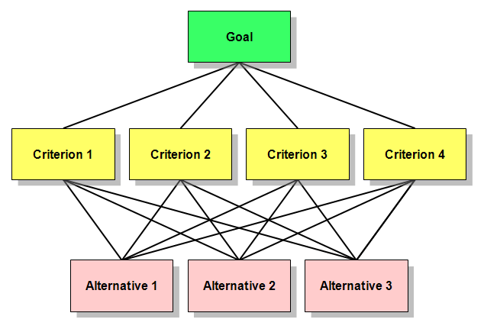
Figure 11 illustrates the steps of AHP method.
Figure (11): Steps of Analytic Hierarchy Process (Saaty, 1980).

3.1.2 Average Weighted Method (AWM)
The weighted average method is selected because it is simple, efficient and can consider the relative importance of evaluation criteria. The approach allows for the combination of the opinions of experts and stakeholders into a single numerical score, which serves as a basis for ranking and prioritizing the factors affecting urban road construction projects. Moreover, it is particularly appropriate for survey-based studies with a high number of respondents and evaluation criteria.
The Average Weighted Method (AWM) is often used to calculate a Risk Index (RI) in construction or infrastructure studies by combining probability (likelihood) and impact (severity) with assigned weights. The weights were calculated using (AHP) and adopted in the Method (Saaty, 1980).
3.1.3 Key Components of Risk Assessment
A. Likelihood (Probability)
It means how likely is the risk to occur again or continue post-implementation?
B. Severity
It measures how serious the consequences of a risk event are.
3.2 Sources of information that were collected
Information was collected from five municipalities in southern Nablus. One hundred questionnaires, each containing 40 questions, were distributed. The questions were categorized according to the nature of the factors, with each category containing a set of questions. The questions were distributed according to the factors, natural, political, and man-made. This data was collected from municipal engineers in the five municipalities (Huwara, Qabalan, Beita, Jamma'in, and Aqrabah), as well as engineers from the Ministry of Local Government, the Ministry of Public Works, and the Municipal Development and Lending Fund. Questionnaires were also distributed to road users (drivers and pedestrians), and field interviews were conducted with them. The questions focused on the efficiency of drainage systems, lighting, and the proximity of health and civil defense centers to the municipalities. Design standards were also addressed, specifically whether all design procedures were considered. The impact of Israeli closures on certain streets was discussed, along with their effect on traffic volume, which increases vehicle counts on some streets compared to others. The survey addressed pre-implementation inspections, whether they are conducted, periodic maintenance, contractor compliance, technical specifications, and physical properties of roads. Recommendations were provided by the municipalities at the end of the survey.
Purpose:
- To gather existing knowledge on risk management for urban roads after construction, identifying trends, challenges, and best practices.
Methods:
- Review of academic papers and books, field interviews
- Analyze case studies and examples of urban road risk management practices in different geographical regions and climates.
Review international standards and guidelines (e.g., ISO 31000 for risk management, AASHTO guidelines) for managing risks in roads.
Table 10: Sample of collected data sourcing.
Data | Source of data | Comment
Internal streets in the town of Huwara and Jammain (weights of factors and their importance) | Hawara Municipality, Jammain municipality, road users and pedestrians, GeoMOLG. | These streets have physical characteristics that differ from one another.
Internal streets in the town of Bieta, Aqraba and Qabalan (weights of factors and their importance) | Bieta Municipality, Aqraba municipality, Qabalan municipality, road users and pedestrians, GeoMOLG. | These streets have physical characteristics that differ from one another.
Road classifications, lengths, and widths | Five Municipalities | GeoMOLG and the structural plans of the municipalities.
Risk factor and their weight | Five Municipalities | GeoMOLG and the structural plans of the municipalities.

3.2.1 Survey
The survey was divided into three sections based on existing factors, with questions for each section focusing as follows: The first section, related to natural factors, included questions about the efficiency of rainwater drainage, the availability of sufficient drainage inlets, the nature of the area and soil, and whether regular maintenance of the inlets is carried out. The second section, related to political factors and their consequences, included questions about whether road closures affect some streets more than others, the level of lighting, the presence or absence of warning signs, and the availability of sidewalks and traffic islands. The third section, focusing on human factors, included questions about the proximity of a civil defense center and health centers, the presence of sensors that provide alerts, when necessary, the implementation of the maintenance plan, and whether contractors adhere to maintenance and warranty procedures. A copy of the survey is included in the Appendix B.

3.3 Data Collection
The data collection process is an important step in any comprehensive risk management study. The collected data usually include an assessment of several road conditions, such as roughness (ride), surface distress (condition), surface skid characteristics, and structure (pavement strength and deflection) for the existing road. In addition to different types of data such as traffic, geopolitical, geography, environmental, socio-economic, as well as stakeholders’ perspectives and observations.
Data collection represents a critical component of the assessment and risk management process for constructed urban roads, as it provides the foundation for identifying road conditions, evaluating potential hazards, and developing appropriate mitigation strategies. In the municipalities of South Nablus, data collection involves both primary and secondary sources. Primary data are obtained through field inspections, road condition surveys, direct observations, and interviews with municipal engineers and local stakeholders. These activities focus on documenting pavement deterioration, drainage system performance, traffic congestion, road safety features, and environmental conditions affecting road infrastructure. Secondary data are gathered from municipal archives, engineering reports, maintenance records, traffic statistics, and accident databases. Geographic Information Systems (GIS) and Global Positioning System (GPS) technologies can also be utilized to map road networks and identify high-risk locations. The collected data are systematically analyzed to assess the probability and severity of risks associated with urban roads, enabling municipalities to prioritize maintenance activities, allocate resources efficiently, and enhance the safety, functionality, and long-term sustainability of the urban transportation network.
The data for analyzing the situation of the case studies were collected through various sources, primarily through online research and data extraction, specifically from the website of the Ministry of Local Government's Geographic Information System (GeoMOLG) and the geographic information website of the municipalities. In addition, additional information was obtained from the municipalities. Moreover, a series of interviews and discussions were held with key stakeholders across the three study sites and the (MoLG), including municipal representatives, planners, and engineers. Engaging these groups helped capture a fuller picture of the local context and provided practical insights from individuals who are directly involved in or impact by, urban development in the targeted municipalities.
Questionnaires were distributed to road users and interviews were conducted. One hundred questionnaires were prepared and distributed, covering municipalities and ministries and road users. The category included municipal and ministry engineers. Evaluating existing urban roads requires a mix of physical, operational, safety, and contextual data. The following provides breakdown of the most important information and data categories by evaluation goals (e.g., performance, safety, planning, equity, resilience).
- Physical Characteristics
These describe the built environment of the road such as:
• Road width (lane width, shoulder width, sidewalk width).
• Number of lanes
• Pavement condition (cracking, rutting, surface roughness, often measured by PCI or IRI).
• Right-of-way dimensions.
• Street furniture and utilities (lighting, signage, street trees, drainage , grades).
- Multimodal Usage and Accessibility
Urban roads serve more than just motor vehicles such as:
• Pedestrian counts and crossings.
• Bicycle infrastructure presence and usage.
- Safety Data
To evaluate risk and prioritize improvements such as:
• Crash data (location, severity, type – vehicle, pedestrian, cyclist).
• Speed-related incidents.
- Environmental and Contextual Factors
To understand broader impacts and integration:
• Land use patterns (residential, commercial, industrial).
• Surrounding population density.
• Storm water runoff and flooding risk.
- Equity and Community Feedback
For inclusive and responsive planning such as :
• Demographics (income, age, race/ethnicity distributions in adjacent areas).
• Community surveys or complaints.
- Political Factors
These factors include:
• Continuous closures and road diversions.
• Street bulldozing.

3.4 Sample Size
The sample size was selected from five municipalities in southern Nablus, the Ministry of Public Works and Housing, the Ministry of Local Government, the Ministry of Transport, and the Municipal Development Lending Fund (MDLF). Ten streets with different functional classifications and geometric characteristics were selected from each municipality: namely Huwara, Beita, Jammaein, Aqraba, and Qabala. The risk index was calculated using two methods based in AHP and AWM.
A questionnaire was administered, consisting of 40 factors, to identify the most prominent challenges facing the road sector after implementation, differing in terms of physical and geometric characteristics, and were classified according to road type. The sample included a variety of questions and included municipal engineers, the ministry and various institutions, and road users. Once an urban road construction project has been completed, post-implementation data collection becomes crucial for:
• Evaluating actual performance vs. planned outcomes.
• Identifying residual risks or failures.
• Improving future project planning and risk mitigation.
• Ensuring public safety and infrastructure sustainability.
We calculate the sample size:
$n= \frac{z^{2}}{e^{2}} p(1-p)$---------------equ 4 (Cochran, 1977) n = required sample size
z= z-score for your confidence level (1.96 for 95% confidence)
p = expected proportion (0.5)
e= margin of error (10%)
$$n= \frac{{1.96}^{2}}{{0.1}^{2}} 0.5(1-0.5)$$
n = 96.04
This research used 100 questionnaires, and that is sufficient. Table 11 presents the targeted groups in the study and Table 12 shows the number of interviewed people in each LGU.
Table 11: Number of target groups and nature of their work during the distribution of questionnaires.
NO | Number of questionnaires | Nature of work
 | 50 | Municipal and Ministry Engineers
 | 50 | Road users and drivers

Table 12: The number of people interviewed in the targeted LGUs.
Interviewed groups | Group 1 (Huwara) | Group 2  (Bieta) | Group 3  (Aqraba) | Group 4  (Jammain) | Group 5  (Aqraba)
Municipal engineers, ministries, and institutions | 10 | 10 | 8 | 12 | 10
Road users and drivers | 10 | 14 | 12 | 9 | 5

3.5 Identification of Risks
Identification of risks is the process of systematically recognizing potential events or conditions that could negatively affect a project, organization, or activity. It is a key step in risk management and helps decision-makers prepare for uncertainties before they occur.
Risk identification is a key step in the assessment and risk management of constructed urban roads, as it enables municipalities to recognize factors that may negatively affect road performance, safety, and serviceability. In the municipalities of South Nablus, the process involves identifying both existing and potential risks through field inspections, analysis of historical records, and consultation with engineers, municipal officials, and road users. Common risks include pavement deterioration, potholes, surface cracking, inadequate drainage systems, traffic congestion, road accidents, poor signage, and infrastructure damage caused by weather conditions or excessive vehicle loads. Additional risks may arise from rapid urban expansion, utility works, insufficient maintenance budgets, and non-compliance with engineering standards during construction. By systematically identifying these risks, municipalities can better understand the vulnerabilities of their road networks and establish a foundation for subsequent risk analysis, prioritization, and the development of effective mitigation measures to improve road safety, reliability, and sustainability.
Purpose:
- To identify and classify the risks that urban roads face in the post-construction phase.

Methods:
- Field surveys and observations: Conduct site visits to urban roads to observe and document existing risks such as potholes, cracks, number of accidents, and flooding.
- Stakeholder interviews: The team gathers qualitative information about perceived dangers through their interactions with local officials and road maintenance workers and city planners and traffic engineers and local residents. The distribution of the matrix led to the creation of questions which resulted in the classification of risks into three categories: high, medium and low. The post-implementation questions required identification of the most critical implementation risks based on road project execution which included political issues stemming from road closures and conflicts.
- Expected outcome:
- A comprehensive list of risks categorized by type.
- Preliminary data on the impact and frequency of these risks.

  - Risk Assessment and Analysis
Risk assessment and analysis constitute a crucial phase in the management of constructed urban roads, as they enable decision-makers to evaluate the likelihood and potential consequences of identified risks. In the municipalities of South Nablus, this process involves systematically examining risks such as pavement deterioration, drainage failures, traffic accidents, structural deficiencies, and the impacts of increasing traffic loads. The assessment is conducted using data collected from field surveys, maintenance records, traffic statistics, and stakeholder consultations. Each risk is evaluated based on its probability of occurrence and its severity in terms of safety, operational efficiency, maintenance costs, and public accessibility. Qualitative and quantitative assessment techniques, including risk matrices and prioritization models, can be employed to classify risks according to their level of significance. The results of the analysis help municipal authorities identify critical areas requiring immediate intervention, allocate resources more effectively, and develop targeted maintenance and rehabilitation strategies to enhance the safety, durability, and sustainability of the urban road network.
    - What AHP Is
AHP stands for Analytic Hierarchy Process, a widely used multi-criteria decision-making (MCDM) method in risk assessment and management. The following explanation provides urban road construction and risk management professionals with a comprehensive overview of their work.
Definition: AHP is a structured technique for organizing and analyzing complex decisions, based on mathematics and psychology (Saaty, 1980).
Purpose: It helps prioritize risks, alternatives, or strategies by breaking down a problem into a hierarchy of goal → criteria → sub criteria → alternatives.

How AHP Works
- Define the Goal: Select the most critical risks to address in an urban road construction project.”
- Identify Criteria and Sub-Criteria: Criteria might include: financial risk, technical risk, safety risk, environmental risk, schedule risk.
- List Alternatives / Risk Factors: Delayed payments, poor contractor performance, utility relocation, weather impacts.
- Pairwise Comparison of Criteria /Alternatives: Experts compare each pair on a scale (1–9) according to relative importance.
For example, is financial risk more important than schedule risk? By how much?
Each criterion is compared with every other criterion using Saaty’s 1–9 scale:
Table 13 shows pair wise comparison using 1-9 scale. Moreover, Table 14 presents the values of random index (RI) based on the size of matrix.
Table 13: The values ​​and what they mean using the Saaty’s 1–9 scale
Value | Meaning
1 | Equal importance
3 | Moderate importance
5 | Strong importance
7 | Very strong importance
9 | Extreme importance
2,4,6,8 | Intermediate values

Table 14: The values ​​of RI depending on the size of matrix
Size Of Matrix (n) | Random Consistency Index (RI)
1 | 0
2 | 0
3 | 0.52
4 | 0.89
5 | 1.11
6 | 1.25
7 | 1.35
8 | 1.40
9 | 1.45
10 | 1.49
11 | 1.51
12 | 1.54
13 | 1.56
- Compute Weights and Consistency
AHP calculates normalized weights for each criterion and alternative.
Consistency ratio (CR) ensures expert judgments are logically consistent (CR < 0.1 is generally acceptable).
CR=CI/ RI ---- (CI: Consistency Index).
- Rank Alternatives
Combine weights to prioritize risks or select mitigation measures.
    - Why AHP Is Used in Road Construction Risk Management

The method enables organized decision-making through its process of dividing difficult construction tasks into separate risk elements which help researchers to study each element. The system enables users to prioritize risks through its method of converting expert opinions into numeric values which assist in creating risk rankings. The system enables users to work with both expert judgments (Saaty, 1980).
The quantitative data-driven which provides flexibility through its dual input system. The system allows risk assessment to become more precise and dependable through its ability to combine with fuzzy logic and Monte Carlo simulation and GIS technologies. The procedure begins with the identification of urban road risks which must be followed by risk assessment and analysis as the subsequent crucial step. The process evaluates risk probability while assessing potential outcomes to determine risk priority which supports the selection of suitable protective measures.
Purpose: To assess the severity and likelihood of each identified risk and prioritize them based on their potential impact on the urban road network.
Methods:
- Qualitative assessment: semi qualitative through using expert judgment, interviews, and workshops to assess risks based on qualitative criteria (e.g., severity, occurrence frequency). This approach depends on questionnaire responses and interview findings, and the results will be represented using one of the selected risk assessment models.
- Quantitative assessment:
Risk matrix: assign numerical values to the likelihood and severity of each risk, plotting them on a matrix to prioritize risks. This method also relies on questionnaire and interview data, and the outcomes will be expressed using one of the risk evaluation models.
Expected outcome:
A prioritized list of risks with identified likelihood, severity, and potential impact.

Developing of Risk Index
Quantitative (Questionnaire)
Qualitative (interviews)
Existing relevant studies
Developing risk matrix

Define Objective and Key Risks
Literature Review
Data Collection
Risk Identification
Risk Analysis
Risk Evaluation
Risk Mitigation Strategies

Conclusions and Recommendation

Figure (12): Research Methodology and Analysis.
Develop risk matrix
Conclusion and recommendation

Calculating Risk Index
Calculating the risk index is an essential step in the assessment and risk management of constructed urban roads, as it provides a quantitative measure for comparing and prioritizing identified risks. In the municipalities of South Nablus, the risk index can be determined by evaluating each risk according to two main criteria: the likelihood of occurrence and the severity of its consequences. These criteria are typically assigned numerical ratings based on field observations, engineering assessments, historical data, and expert judgment. The risk index is then calculated by multiplying the probability score by the impact score, resulting in a value that reflects the overall significance of the risk. Higher risk index values indicate issues that require immediate attention, while lower values represent risks that can be monitored or addressed through routine maintenance. This approach enables municipal authorities to rank risks systematically, identify critical sections of the road network, and allocate financial and technical resources more efficiently. By using a risk index, decision-makers can support evidence-based planning and implement effective mitigation measures to improve the safety, performance, and long-term sustainability of urban roads in South Nablus municipalities.
A Risk Index is a numerical way to represent how risky a situation, project, or decision is. It helps people compare risks and prioritize actions or a simple numerical tool used to measure and compare the level of risk in a given situation. It is widely used in fields like Risk Management, engineering, healthcare, and business to support better decision-making.
The following step-by-step framework can be used to calculate a risk index for constructed urban roads:
Step 1: Define the Purpose
Are you assessing risk for:
• Traffic accidents?
• Flood damage?
• Structural failure?
• Accessibility and maintenance?
For this study, it is assumed that the focus is on the overall safety risk of constructed urban roads, including structural, environmental, and traffic-related risks.
Step 2: Identify Key Risk Factors
- Hazard factors
• Flood zone presence (FZ)
• Earthquake/seismic zone (EQ)
• Landslide hazard (LS)
• Traffic volume (TV)
- Exposure factors
• Population density near the road (PD)
• Critical infrastructure nearby (CI)
- Vulnerability factors
• Road surface condition (RSC)
• Drainage condition (DC)
• Lighting and signage (LSG)
• Maintenance frequency (MF)
• Road design (RD)
• Civil defense (CD)
• Emergency plan (EP)
• Horizontal and vertical sight distance (HV/S)
• Rate of emissions (RM)
Step 3: Assign Scores to Each Factor
The relevant factors and the used scale is present the Table 15.

Factor | Description | Scale
FZ | Flood-prone | 1 = Yes (1–5)
TV | Traffic Volume | 1–5 (Low to High)
PD | Population Density | 1–5 (Low to High)
RSC | Surface Condition | 1 = Excellent, 5 = Poor
DC | Drainage | 1 = Good, 5 = Poor
MF | Maintenance | 1 = Frequent, 5 = Rare
LSG | Lighting/Signage | 1 = Adequate, 5 = Poor
RD | Road design | 1 = Good, 5 = Poor
CD | Civil defense | 1 = Good, 5 = Poor
EP | Emergency plan | 1 = Good, 5 = Poor
HV/S | horizontal and vertical sight | 1 = Good, 5 = Poor
RM | Rate of emissions | 1= Good, 5 = Poor
Table 15: Assigning scores to each factor

Step 4: Create a Risk Index Formula
The risk index formula using average weighted method is :
Risk Index (RI)=w1⋅FZ + w2⋅TV + w3⋅PD + w4⋅RSC + w5⋅DC + w6⋅MF + w7⋅LSG + w8⋅RD + w9⋅CD + w 10⋅EP + w11⋅ HV/S + w12⋅ RM
Where w1w_1w1​ to w12w_12w12 ​ are weights representing the importance of each factor.
Step 5: Compute the Risk Index
Solved Example:
Risk Index (RI)=w1​⋅FZ+w2​⋅EQ+w3​⋅TV+w4​⋅PD+w5​⋅RSC+w6​⋅DC+w7​⋅MF+w8​⋅LSG
Factor | Value | Weight | Weighted value
FZ | 1 | 0.1 | 0.1
EQ | 3 | 0.1 | 0.3
TV | 4 | 0.15 | 0.6
PD | 3 | 0.1 | 0.3
RSC | 2 | 0.2 | 0.4
DC | 4 | 0.15 | 0.6
MF | 3 | 0.1 | 0.3
LSG | 2 | 0.1 | 0.2

RI=0.1+0.3+0.6+0.3+0.4+0.6+0.3+0.2=2.8
Step 6: Classify the Risk
The classification of the Risk level is based on categories presented in Table 16.
Table 16: Calculation Risk level (National Institute of Standards and Technology. (2012).
RI Score | Risk Level
0–1.5 | Low
1.6–2.5 | Moderate
2.6–3.5 | High
3.6–5 | Very High

In the example above, Risk Index = 2.8, which corresponds to a high risk.
The Risk Index (RI) was calculated using two methods, the first is a weighted average, as shown on the previous page; the second is the Analytic Hierarchy Process, a multi-criteria decision-making method widely used in the literature. This method is expected to give accurate results. The AHP equations and methodology are presented here after.
The equations of this methodology are presented hereafter:
AW= λmax​W ---------- Equation (3) i=1∑n​wi​=1 (Saaty, 1980)
A = pairwise comparison matrix.
w = priority weight vector.
Lambda λmax​ = largest value of A

Step 1: Consistency Index (CI)
CI= λmax- n / n-1 ----------- Equation (4) (Thomas L. Saaty)

Step 2: Consistency Ratio (CR)
CR=CI/ RI --------------- Equation (5) (Thomas L. Saaty)
• RI = Random Index (depends on n) --- n : size of matrix
• CR < 0.10 → acceptable consistency.

Chapter Four

Results and Analysis

4.1 Introduction
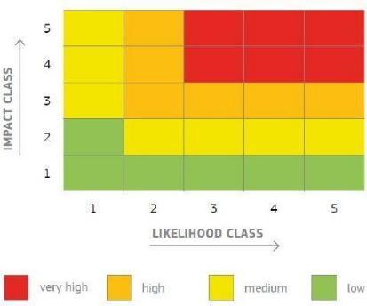
The Risk Index (RI) is calculated by multiplying the probability (or likelihood) of a risk occurring by its consequence (or impact). This produces a numerical risk score, which can be used to prioritize risks, with higher scores indicating greater risk levels that require more urgent attention and mitigation efforts. Various specific formulas and methods exist for calculating a risk index, depending on the context, as presented in Figure 13.

Figure (13): Risk Matrix Proposed by the European Commission (Source: European Commission. (2017). Risk management framework: Guide for decision-making. Directorate-General for Mobility and Transport. Publications Office of the European Union.
Basic risk formula: Risk Score = Probability × Impact -----(Equation 6)
To calculate a risk index for constructed urban roads, it is necessary to define the context, data, and methodology. Risk indices typically combine multiple factors (hazards, exposure, vulnerability) into a single score or classification. The following presents a general step-by-step guide, with an example formula at the end.
Moreover, the calculation of the risk index for constructed urban roads involves quantifying various risk factors and combining them into a single index that helps in prioritizing maintenance, rehabilitation, or safety interventions.
4.2 Statistical Analysis and Discussion
4.2.1 Reliability Testing:
Reliability testing is a fundamental component of statistical analysis in assessing risk management practices for constructing urban roads within the municipalities of South Nablus. It is used to determine the consistency and stability of the data collection instrument, ensuring that the results accurately reflect the perceptions and experiences of respondents. In this study, reliability was evaluated using the Cronbach's Alpha coefficient, which measures the internal consistency among questionnaire items related to road assessment and risk management factors. A Cronbach's Alpha value of 0.70 or higher is generally considered acceptable, indicating that the survey items reliably measure the intended constructs. Conducting reliability testing enhances the credibility of the research findings by reducing measurement errors and ensuring that the collected data can be confidently used for subsequent statistical analyses, including risk identification, infrastructure assessment, and evaluation of road safety management practices in the municipalities of South Nablus.
To calculate Cronbach's alpha (α),
$α= \frac{k}{k-1}(1- \frac{\sum_{i=1}^{k}{σ_{i}^{2}}}{σ_{T}^{2}} )$--------------- Equation 7
α ≥ 0.90: Excellent
α between 0.80–0.89: Good
α between 0.70–0.79: Acceptable
illustrates the results of determining Cronbach's Alpha values ​​for the five municipalities.
Calculation Cronbach's Alpha for Survey for the town of Huwara town as presented in appendix C.

Calculation Cronbach's Alpha for Survey for the town of Qablan town as presented in appendix C

Calculation Cronbach's Alpha for Survey for the town of Aqraba town as presented in appendix C

Calculation Cronbach's Alpha for Survey for the town of Bieta town as presented in appendix C

Calculation Cronbach's Alpha for Survey for the town of Jammain town as presented in appendix C

Calculation of RI:
Sample calculations of equations for the first street in each city, by AHP equation.
- For the Road #1 in Huwara:
λmax = 13.36 + 15.17 + 15.77 + 15.21 +13.74 +14.76 + 11.10 + 12.35 + 11.79 + 14.29 + 13.35 + 14.28 / 12 = 13.08
CI = λmax – n / n-1
= 13.08 -12 / 12 -1
= 0.09
RI = 1.54 ------- From Table 12
CR = 0.09 / 1.54 = 0.06 (Consistent)

- For the Road #1 in Beita:
λmax = 12.59 + 13.25 + 12.18 + 12.03 +12.44 +12.18 + 12.03 + 12.27 + 12.18 + 12.18 + 12.03 + 12.15 / 12 = 12.29
CI = λmax – n / n-1
= 12.29 -12 / 12 -1
= 0.02
RI = 1.54 ------- From Table 12
CR = 0.02 / 1.54 = 0.01 (Consistent)

- For the Road #1 in Aqraba:
λmax = 12.20 + 12.86 + 13.52 + 12.80 +13.06 +13.10 + 11.88 + 12.77 + 13.52 + 14.58 + 14.51 + 13.74 / 12 = 13.21
CI = λmax – n / n-1
= 13.21 -12 / 12 -1
= 0.11
RI = 1.54 ------- From Table 12
CR = 0.11 / 1.54 = 0.07 (Consistent)

- For the Road #1 in Qablan:
λmax = 13.45 + 13.48 + 13.43 + 13.25 +13.11 +13.03 + 12.69 + 12.92 + 12.55 + 13.24 + 11.27 + 12.55 / 12 = 12.91
CI = λmax – n / n-1
= 12.91 -12 / 12 -1
= 0.08
RI = 1.54 ------- From Table 12
CR = 0.08 / 1.54 = 0.05 (Consistent)

- For the Road #1 in Jammain:
λmax = 12.86 + 13.86 + 12.77 + 13.45 +14.51 +13.66 + 13.31 + 13.65 + 13.85 + 13.58 + 14.22 + 11.11 / 12 = 12.74
CI = λmax – n / n-1
= 12.74 -12 / 12 -1
= 0.06
RI = 1.54 ------- From Table 12
CR = 0.06 / 1.54 = 0.04 (Consistent)
The results are summarized as:
The following table summarizes previous studies that applied hierarchical risk assessment methods (AHP/FAHP) for road infrastructure and safety evaluation. The table is structured to compare their risk factors and results with the proposed thesis framework The selected factors in the research include: flood zone, traffic operation, population density, maintenance, lighting/signage, road design, civil defense, emergency plan, surface condition, and drainage, with two additional factors to complete the 12-factor hierarchy.

Table 22: Validation of RI results
Study | Methodology | Objective | Risk Factors Considered | Results / Findings | Relevance to r the research
Putri Aifa Syuhaida & Shabuddin (2019), Risk Assessment of Public Road Construction Projects Using Analytical Hierarchy Process (AHP), Universiti Malaysia Pahang | Analytic Hierarchy Process (AHP) using expert-based pairwise comparison matrices | To identify, evaluate, and prioritize the major risks affecting public road construction projects in Malaysia. | The study developed a hierarchical risk structure consisting of nine main risk categories: natural and maintenance risk, technical risk, organizational risk, contractual risk, natural hazard risk, socio-political risk, and resource risk. sub-factors included flood risk, inflation, surfaces condition, drainage, population density, road design changes in laws and regulations, lack of coordination among stakeholders, and funding problems. | The AHP results ranked economic and financial risk as the most significant factor (0.267), followed by technical risk (0.165), organizational risk (0.148), contractual risk (0.130), natural hazard risk (0.125), socio-political risk (0.086), and resource risk (0.079). Among the sub-factors, flood risk (0.633) was identified as the highest-priority risk, followed by inflation risk, changes in government regulations, lack of coordination, and funding risk. | The thesis supports the application of AHP for road infrastructure risk prioritization. The identification of flood risk, technical issues, and resource-related problems is consistent with the present study factors, particularly flood zone, road design, drainage, maintenance, and emergency planning. however, the south Nablus study expands the assessment framework by focusing on constructed urban roads and incorporating operational and safety-related factors such as traffic operation, population density, lighting/signage, surface condition, civil defense, and emergency plan.

The aforementioned table was created by comparing the findings of a prior study on the risk factor with those of municipalities located south of Nablus. At least twenty-five engineers and experts participated in the study, which employed a hierarchical analysis method. The findings demonstrated that natural elements were more influential than other influences as FZ, TV, and PD.

4.3 Risk Index Calculation Results Using AHP Method.
- Huwara
The RI was calculated for the ten streets using AHP method as presented in appendix D
- Beita
The RI was calculated for the ten-street using AHP method as presented in appendix D
3. Aqraba
The RI was calculated for the ten streets using AHP method as presented appendix D
4. Qabalan
The RI was calculated for the ten streets using AHP method as presented in appendix D
5. Jammaein
The RI was calculated for the ten streets using AHP method as presented in appendix D.
In this study, the Analytic Hierarchy Process (AHP) was employed to determine the relative importance (weights) of the twelve factors affecting the assessment and risk management of constructed urban roads in the municipalities of South Nablus. The calculated weight of each factor represents its relative contribution to the overall risk assessment, while the average weight provides a benchmark for comparing the importance of all factors within the decision-making framework. Factors with weights exceeding the average weight are considered high-priority risk indicators because they have a greater influence on pavement performance, road safety, maintenance requirements, and infrastructure sustainability. These factors require immediate attention in planning, monitoring, and maintenance programs. Conversely, factors with weights below the average weight remain important but exert a comparatively smaller influence on the overall assessment and may be addressed through routine management strategies or long-term improvement plans. The comparison between individual factor weights and the average weight enables decision-makers to distinguish critical risks from secondary issues, ensuring that limited municipal resources are allocated efficiently. Furthermore, the weighting process enhances the objectivity of the assessment by transforming expert judgments into quantitative values ​​through pairwise comparisons and consistency, thereby reducing subjective bias in prioritizing road verification management actions. The average weight also serves as a useful reference for evaluating the balance of the decision model, indicating whether the importance of the factors is evenly distributed or concentrated among a few dominant variables. In the context of the municipalities of South Nablus, this approach supports evidence-based infrastructure management by identifying the most influential factors affecting urban road performance, optimizing maintenance scheduling, minimizing financial and operational risks, and improving the long-term sustainability and resilience of the urban road network. Therefore, the integration of individual weights and average weights within the AHP framework provides a scientifically robust basis for ranking the twelve evaluation factors, prioritizing interventions, and developing effective risk management strategies for constructed urban road.

Factors with weights above the average are considered critical because they exert a greater influence on road safety, infrastructure performance, maintenance requirements, and long-term sustainability, whereas factors with weights below the average remain relevant but have a comparatively lower impact on the overall risk assessment. Within this framework, road surface condition is generally expected to receive one of the highest weights because it directly affects vehicle safety, ride quality, structural performance, and maintenance needs. Traffic volume is another highly influential factor, as increasing traffic loads accelerate pavement deterioration, increase congestion, and raise accident risk. Drainage condition is also a major factor because inadequate drainage promotes water infiltration, weakens pavement layers, and accelerates structural failure. Flood zone is assigned a substantial weight in areas susceptible to seasonal rainfall and flash flooding, as repeated inundation can damage pavement materials, and interrupt transportation services. Road design, including geometric characteristics and pavement structure, strongly influences operational efficiency and safety, making it a key criterion in the AHP hierarchy. Horizontal and vertical sight distance significantly affects driver visibility and reaction time, thereby influencing accident probability, especially on curved roads, steep grades, and urban intersections. Lighting and signage improve driver awareness, reduce nighttime crashes, and enhance traffic control, while deficiencies in these elements increase operational risk. Maintenance frequency reflects the effectiveness of municipal asset management; roads that receive timely inspections and preventive maintenance generally exhibit lower deterioration rates and lower life-cycle costs. The availability and readiness of civil defense services strengthen emergency response capabilities by reducing the consequences of traffic accidents, fires, floods, and other incidents affecting the road network. Likewise, the presence of a comprehensive emergency plan improves preparedness, coordination among municipal agencies, and the speed of recovery following hazardous events. Finally, the rate of emissions represents the environmental dimension of road assessment, reflecting the influence of congestion, pavement condition, and traffic operations on air quality and environmental sustainability. Although its direct effect on structural pavement performance may be less than that of engineering factors, it remains an important criterion for sustainable urban transportation planning. By comparing the weight of each factor with the average weight, decision-makers can distinguish high-priority risks from lower-priority concerns, allowing municipalities in South Nablus to allocate financial resources more effectively, prioritize maintenance and rehabilitation projects, strengthen preventive risk management measures, and improve the safety, resilience, and sustainability of the urban road network. The AHP methodology therefore provides a transparent and scientifically rigorous framework for transforming expert judgment into quantitative priorities, enabling municipal authorities to make evidence-based decisions that optimize infrastructure performance under limited financial and technical resources as represented in figures 14-18.

These figures for the first road in each municipality illustrate the relationship between the factor with weight and average weight.

Figure (14): Influence of the weight and average weight on the first road in Huwara by AHP

Figure (15): Influence of the weight and average weight on the first road in Beita by AHP

Figure (16): Influence of the weight and average weight on the first road in Aqraba by AHP

Figure (17): Influence of the weight and average weight on the first road in Qablan by AHP

Figure (18): Influence of the weight and average weight on the first road in Jammain by AHP

4.4 Risk Index Calculation Resulting Using WAM.
1. Huwara
Ten streets in Huwara town were selected, and the risk index (RI) was calculated for each street, as represented in Appendix E.
2. Beita
Ten streets in Beita town were selected, and the RI was calculated for each street as represented in Appendix E.
3. Aqraba
Ten streets in Aqraba town were selected, and the RI was calculated for each street, as presented in Appendix E.
4. Qabalan
Ten streets in Qablan town were selected, and the RI was calculated for each street, as presented in Appendix E.
5. Jammaein
Ten streets in Jammaein town were selected, and the RI was calculated for each street, as presented in Appendix E.

Table 33: Pairwise comparison
# | Factor | FZ | TV | PD | RSC | DC | MF | LSG | RD | CD | EP | HV/S | RM
1 | FZ | 1 | 3 | 4 | 5 | 6 | 6 | 7 | 7 | 8 | 8 | 9 | 9
2 | TV | 0.33 | 1 | 2 | 3 | 4 | 4 | 5 | 2 | 2 | 3 | 3 | 4
3 | PD | 0.25 | 0.5 | 1 | 2 | 3 | 3 | 4 | 4 | 5 | 5 | 6 | 7
4 | RSC | 0.2 | 0.33 | 0.5 | 1 | 2 | 4 | 5 | 5 | 6 | 6 | 7 | 8
5 | DC | 0.16 | 0.25 | 0.33 | 0.5 | 1 | 2 | 2 | 2 | 3 | 3 | 4 | 5
6 | MF | 0.16 | 0.25 | 0.33 | 0.25 | 0.5 | 1 | 2 | 2 | 3 | 3 | 4 | 4
7 | LSG | 0.14 | 0.2 | 0.25 | 0.2 | 0.5 | 0.5 | 1 | 2 | 2 | 3 | 3 | 4
8 | RD | 0.12 | 0.5 | 0.25 | 0.2 | 0.5 | 0.5 | 0.5 | 1 | 2 | 2 | 3 | 3
9 | CD | 0.12 | 0.5 | 0.2 | 0.16 | 0.33 | 0.33 | 0.5 | 0.5 | 1 | 2 | 2 | 3
10 | EP | 0.11 | 0.33 | 0.2 | 0.16 | 0.33 | 0.333 | 0.33 | 0.5 | 0.5 | 1 | 2 | 2
11 | HV/S | 0.11 | 0.33 | 0.16 | 0.14 | 0.25 | 0.25 | 0.33 | 0.333 | 0.5 | 0.5 | 1 | 2
12 | RM | 0.11 | 0.25 | 0.14 | 0.12 | 0.2 | 0.25 | 0.25 | 0.33 | 0.33 | 0.5 | 0.5 | 1
 | Sum | 2.84 | 7.45 | 9.37 | 12.75 | 18.61 | 22.16 | 27.91 | 26.66 | 33.33 | 37 | 44.5 | 52
 | FZ | 0.35 | 0.47 | 0.42 | 0.36 | 0.32 | 0.29 | 0.27 | 0.25 | 0.22 | 0.21 | 0.19 | 0.16
 | TV | 0.11 | 0.15 | 0.21 | 0.22 | 0.21 | 0.19 | 0.19 | 0.07 | 0.05 | 0.07 | 0.06 | 0.07
 | PD | 0.08 | 0.078 | 0.10 | 0.14 | 0.16 | 0.14 | 0.15 | 0.14 | 0.14 | 0.13 | 0.12 | 0.12
 | RSC | 0.07 | 0.05 | 0.05 | 0.07 | 0.10 | 0.19 | 0.19 | 0.18 | 0.16 | 0.15 | 0.15 | 0.14
 | DC | 0.05 | 0.03 | 0.03 | 0.03 | 0.05 | 0.09 | 0.07 | 0.07 | 0.08 | 0.07 | 0.08 | 0.09
 | MF | 0.05 | 0.03 | 0.03 | 0.01 | 0.02 | 0.04 | 0.07 | 0.07 | 0.08 | 0.07 | 0.08 | 0.07
 | LSG | 0.05 | 0.03 | 0.02 | 0.01 | 0.02 | 0.02 | 0.03 | 0.07 | 0.05 | 0.07 | 0.06 | 0.07
 | RD | 0.04 | 0.07 | 0.02 | 0.01 | 0.02 | 0.02 | 0.01 | 0.03 | 0.05 | 0.05 | 0.06 | 0.05
 | CD | 0.04 | 0.07 | 0.02 | 0.01 | 0.01 | 0.01 | 0.01 | 0.01 | 0.02 | 0.05 | 0.04 | 0.05
 | EP | 0.03 | 0.05 | 0.02 | 0.01 | 0.01 | 0.01 | 0.01 | 0.01 | 0.01 | 0.02 | 0.04 | 0.03
 | HV/S | 0.03 | 0.05 | 0.01 | 0.01 | 0.01 | 0.01 | 0.01 | 0.01 | 0.01 | 0.01 | 0.02 | 0.03
 | RM | 0.03 | 0.03 | 0.01 | 0.01 | 0.01 | 0.01 | 0.01 | 0.01 | 0.01 | 0.01 | 0.01 | 0.01
 | W | 0.29 | 0.13 | 0.13 | 0.12 | 0.06 | 0.05 | 0.04 | 0.04 | 0.03 | 0.02 | 0.02 | 0.01
 | AW | 4.08 | 1.98 | 1.81 | 1.75 | 0.90 | 0.76 | 0.59 | 0.52 | 0.41 | 0.32 | 0.26 | 0.20
 | λmax | 13.74 | 14.33 | 13.90 | 13.53 | 13.28 | 13.0 | 12.82 | 12.63 | 12.32 | 12.50 | 12.39 | 12.48

W=0.35 +0.11+0.08+0.07+0.05+0.05+0.05+0.04+0.04+0.03+0.03+0.03/12= 0.29
AW= 1*0.29 + 3*0.13 + 4*0.13 + 5*0.12 + 6*0.06 + 6*0.05 + 7*0.04 + 7*0.04 + 8*0.03 +8*0.02 + 9*0.02 +9*0.01 = 4.08
λmax = 13.74 + 14.33 +13.90 +13.53 +13.28 +13 +12.82 +12.63 +12.32+12.50 +12.39 +12.48 /12 = 13.08

FZ is 3× more important than TV. | TV is 1/3 × more important than FZ. | PD is 3× more important than TV.
FZ is 4× more important than BD. | TV is 2× more important than PD. | PD is 4× more important than BD.
FZ is 5× more important than RSC. | TV is 3× more important than RSC. | PD is 5× more important than RSC.
FZ is 6× more important than DC. | TV is 4× more important than DC. | PD is 6× more important than DC.
FZ is 6× more important than DC. | TV is 4× more important than MF. | PD is 6× more important than DC.
FZ is 9× more important than RM. | TV is 5× more important than LSG. | PD is 9× more important than RM.
FZ is 9× more important than HV/S. | TV is 2× more important than CD. | PD is 9× more important than HV/S.
FZ is 7× more important than RD. | TV is 2× more important than RD. | PD is 7× more important than RD.
FZ is 7× more important than LSG. | TV is 3× more important than HV/S. | PD is 7× more important than LSG.
FZ is 8× more important than EP. | TV is 3× more important than EP. | PD is 8× more important than EP.
FZ is 8× more important than CD. | TV is 4× more important than RM. | PD is 8× more important than CD.
FZ is 3× more important than TV. | TV is 1× more important than TV. | PD is 3× more important than TV.
Table 34 : In the Analytic Hierarchy Process (AHP), pairwise comparison is the core technique used to determine the relative importance of criteria (and alternatives), The first road in Howwara

RSC is 1/5× more important than FZ. | DC is 1/6 × more important than FZ. | MF is 1/6× more important than FZ.
RSC is 1/3× more important than TV. | DC is 1/4× more important than TV. | MF is 1/4× more important than TV.
RSC is 1/2× more important than PD. | DC is 1/3× more important than PD. | MF is 1/3× more important than PD.
RSC is 1× more important than RSC. | DC is 1/2× more important than RSC. | MF is 1/4× more important than RSC.
RSC is 2× more important than DC. | DC is 1× more important than DC. | MF is 1/2× more important than DC.
RSC is 4× more important than MF. | DC is 2× more important than MF. | MF is 1× more important than MF.
RSC is 5× more important than LSG. | DC is 2× more important than LSG. | MF is 2× more important than LSG
RSC is 5× more important than RD. | DC is 2× more important than RD. | MF is 2× more important than RD.
RSC is 6× more important than CD. | DC is 3× more important than CD. | MF is 3× more important than CD.
RSC is 6× more important than EP. | DC is 3× more important than EP. | MF is 3× more important than EP.
RSC is 7× more important than HV/S. | DC is 4× more important than HV/S. | MF is 4× more important than HV/S.
RSC is 8× more important than RM. | DC is 5× more important than RM. | MF is 4× more important than RM.
LSG is 1/7× more important than FZ. | RD is 1/8 × more important than FZ. | CD is 11/8× more important than FZ.
LSG is 1/5× more important than TV. | RD is 1/2× more important than TV. | CD is 1/2× more important than TV.
LSG is 1/4× more important than PD. | RD is 1/4× more important than PD. | CD is 1/5× more important than PD.
LSG is 1/5× more important than RSC. | RD is 1/5× more important than RSC. | CD is 1/6× more important than RSC.
LSG is 1/2× more important than DC. | RD is 1/2× more important than DC. | CD is 1/3× more important than DC.
LSG is 1/2× more important than MF. | RD is 1/2× more important than MF. | CD is 1/3× more important than MF.
LSG is 1× more important than LSG. | RD is 1/2× more important than LSGD. | CD is 1/2× more important than LSG.
LSG is 2× more important than RD. | RD is 1× more important than RD. | CD is 1/2× more important than RD.
LSG is 2× more important than CD. | RD is 2× more important than CD. | CD is 1× more important than CD.
LSG is 3× more important than EP. | RD is 2× more important than EP. | CD is 2× more important than EP.
LSG is 3× more important than HV/S. | RD is 3× more important than HV/S. | CD is 2× more important than HV/S.
LSG is 4× more important than RM. | RD is 3× more important than RM. | CD is 3× more important than RM.
EP is 1/9× more important than FZ. | HV/S is 1/9 × more important than FZ. | RM is 1/9× more important than FZ.
EP is 1/3× more important than TV. | HV/S is 1/3× more important than TVD. | RM is 1/4× more important than TV.
EP is 1/5× more important than PD. | HV/S is 1/6× more important than PD. | RM is 1/7× more important than PD.
EP is 1/6× more important than RSC. | HV/S is 1/7× more important than RSC. | RM is 1/8× more important than RSC.
EP is 1/3× more important than DC. | HV/S is 1/7× more important than DC. | RM is 1/5× more important than DC.
EP is 1/3× more important than MF. | HV/S is 1/4× more important than MF. | RM is 1/4× more important than MF.
EP is 1/3× more important than LSG. | HV/S is 1/3× more important than LSG. | RM is 1/4× more important than LSG.
EP is 1/2× more important than RD. | HV/S is 1/3× more important than RD. | RM is 1/3× more important than RD.
EP is 1/2× more important than CD. | HV/S is 1/2× more important than CD. | RM is 1/3× more important than CD.
EP is 1× more important than EP. | HV/S is 1/2× more important than EP. | RM is 1/2× more important than EP.
EP is 2× more important than HV/S. | HV/S is 1× more important than HV/S. | RM is 1/2× more important than HV/S.
EP is 2× more important than RM. | HV/S is 1/2× more important than RM. | RM is 1× more important than RM.

4.5 Studying the influence of indicator factors on risk Index.
Figure 19 illustrates the relationship between each factor and its weighted value for the ten streets and shows the variation in the influencing factors for each factor and the relevant streets in the town of Beita. Whereas in the town of Beita, the strongest influences were TV, FZ, and CD. The strongest impact is associated with the nature of the land and the floods resulting from inefficient manholes, as well as the distance of the Civil Defense station, which affects the ability to respond to accidents and carry out road repairs.

Figure (19): Influence of factors on RI for Beita.
Figure 20 illustrates the relationship between the factor type and the weighted value which shows the variation in the influencing factors in the town of Aqraba for the ten streets.
Whereas in the town of Aqraba the strongest influence was represented by TV, FZ and CD. The strongest impact is related to the nature of the land and the floods resulting from inefficient manholes, as well as the distance of the Civil Defense services, which affects the response to accidents and road repairs.
Contractors' failure to perform the necessary maintenance during the warranty period directly affects the roads and accelerates their deterioration. According to those interviewed about maintenance, many contractors do not adhere to warranty terms and do not perform maintenance after the first year. It is also noted that the impact of other factors is lower, such as the presence of adequate lighting, as well as the lack of consideration of emergency plans in the design.

Figure (20): Influence of factors on RI for Aqraba.
Figure 21 illustrates the relationship between factor type and weighted value, showing variation in the influencing factors in the town of Qablan for the ten streets. Whereas in the town of Qabalan the strongest influence was represented by TV, CD, and MF, the strongest impact is associated with the nature of the land and floods resulting from inefficient manholes, as well as the distance of the Civil Defense services, which affects the response to accidents and road maintenance.

Figure (21): Influence of factors on RI for Qabalan.
Figure 22 illustrates the relationship between the factor type and the weighted value which shows the variation in the influencing factors in the town of Jammaein for the ten streets. Whereas in the town of Jammaein, the strongest influence was represented by FZ, CD, TV, and MF, the strongest impact is associated with the nature of the land and floods resulting from inefficient manholes, as well as the distance of the Civil Defense services, which affects the response to accidents and road repairs. Moreover, Contractors' failure to perform the necessary maintenance during the warranty period directly affects the roads and accelerates their deterioration. It is also noted that the impact of other factors is lower, such as the presence of adequate lighting, as well as the lack of consideration of emergency plans in the design.

Figure (22): Influence of factors on RI for Jammaein.
Figure 23 illustrates the relationship between the factor and the weighted value and shows the variation in the influencing factors in the town of Huwara for the ten streets. The collection of information and questionnaire data made it clear that the town of Huwara has suffered from several problems since the implementation of projects. The most prominent of which are the low level of lighting, political factors, continuous closures, and the increase in the volume of vehicle traffic on the streets within the town. In addition, the distance between the Civil Defense and the hospital contributes to delays in responding to accidents, particularly during continuous closures and due to its location linking the north and the south. Moreover, after the implementation of the bypass road to Huwara, economic activities decreased, and the lack of sign installation on the roads and the inefficiency of manholes accelerated road deterioration.

Figure (23): Influence of factors on RI for Huwara.

Studying the influence of weight on risk index
The Analytic Hierarchy Process (AHP) was employed to quantify the relative importance of the twelve risk factors affecting urban roads in the municipalities of South Nablus and to evaluate their influence on the overall risk index. In AHP, each factor is assigned a normalized weight that reflects its relative contribution to road risk based on expert pairwise comparisons. These weights are then integrated with the corresponding performance or condition scores of each road segment to calculate a composite risk index. Consequently, the influence of each factor on the final risk index is directly proportional to its assigned weight; Factors with higher weights have a greater impact on the calculated risk level, while factors with lower weights contribute less to the overall assessment. This weighting approach ensures that critical engineering, operational, environmental, and emergency management factors receive appropriate emphasis during the evaluation process.

The analysis indicates that factors such as road surface condition, traffic volume, drainage condition, and road design generally exert the strongest influence on the risk index because they directly affect pavement performance, traffic safety, structural durability, and serviceability. Deteriorated pavement surfaces increase the likelihood of accidents and vehicle damage, while high traffic volumes accelerate pavement deterioration and increase operational risks. Likewise, poor drainage conditions promote water infiltration into pavement layers, weakening the subgrade and accelerating structural failure. Inadequate road design, including geometric deficiencies, insufficient lane width, or improper intersection layouts, further increases accident probability and reduces overall network efficiency. Because these factors typically receive relatively high AHP weights, even modest deterioration in their condition can substantially increase the overall risk index.

Other factors, including flood zone, lighting and signal, maintenance frequency, horizontal and vertical sight distance, civil defense, emergency plan, and rate of emissions, also influence the risk index, although their impact depends on their assigned weights and local conditions. Roads located within flood-prone areas are exposed to greater structural damage and service disruption during severe rainfall events, while inadequate lighting, poor signage, and limited sight distance increase accident risk, particularly during nighttime or adverse weather conditions. Maintenance frequency influences the progression of pavement deterioration by determining how quickly defects are identified and repaired. The availability of civil defense resources and effective emergency response plans reduces the consequences of accidents and natural hazards, thereby lowering overall operational risk. Although the rate of emissions has a smaller direct effect on pavement performance, it is an important indicator of environmental sustainability and traffic efficiency and therefore contributes to the comprehensive risk assessment.

The overall risk index is calculated by combining the normalized weight of each factor with its corresponding field assessment score. As a result, improvements in highly weighted factors produce a greater reduction in the risk index than equivalent improvements in lower-weighted factors. This characteristic enables municipal authorities to identify priority intervention areas and allocate maintenance budgets more efficiently. For the municipalities of South Nablus, the application of AHP demonstrates that prioritizing factors with the highest weights can significantly improve road safety, extend pavement service life, reduce maintenance costs, and enhance the resilience and sustainability of the urban road network. Therefore, the weighting process not only establishes the relative importance of each criterion but also provides a scientifically sound basis for strategic decision-making, risk prioritization, and sustainable infrastructure management as represented in figure 24-28.

Figure (24): Influence of weight on RI for Huwara.

Figure (25): Influence of weight on RI for Beita.

Figure (26): Influence of weight on RI for Jammain.

Figure (27): Influence of weight on RI for Qablan.

Figure (28): Influence of weight on RI for Aqraba.

4.7 Analysis
Two methods were used to calculate the Risk Index (RI): The Analytic Hierarchy Process and the Average Weighted Method. The results were very close. After collecting the data, analyzing it, and calculating the risk index for the targeted roads in the five municipalities in the southern part of Nablus city, namely Huwara, Aqraba, Qablan, Beita, and Jammaein, the results indicated that common problems emerged after implementation. The most prominent of which were the inefficiency and inadequacy of manholes, which cause damage to the streets, as well as the low level of lighting and lack of consideration of safety issues, curves, and the permitted speed in the design. There were also factors related to the Israeli occupation, such as closures and the erection of barriers between the towns, which hinder the timely arrival of rescue teams and the rapid handling of accidents.
The town of Huwara had highest number of accidents due to insufficient signs and poor lighting. Whereas the town of Jammaein was ranked second in the risk analysis, this was due to insufficient consideration of design issues, failure to repair faults during the maintenance period due to contractors' lack of responsiveness, and inefficiency of the storm water drainage system. Furthermore, the town of Beita ranked in the third place, mainly due to shortcomings in design considerations, poor rainwater drainage, closures, the absence of nearby Civil Defense services, delayed response to accidents, and the lack of an emergency plan. Moreover, Qablan town ranked fourth, where the most prominent factors were inadequate lighting, the nature of the terrain in the area, closures, the lack of nearby Civil Defense services, and the absence of an emergency plan. Finally, the town of Aqraba ranked last, with the main factor being inefficient rainwater drainage.
After calculating the risk index, the town of Aqrabah has the lowest RI value (1.94) according to the standards, placing it first by a slight margin over the town of Qabalan. This is attributed to the speed of response to maintenance, adherence to applicable design standards, the presence of a civil defense center, the effectiveness of drainage systems, and the availability of adequate lighting on all roads. The town of Qabalan followed closely in the second place with a value of (1.96), due to the presence of adequate and effective drainage systems, the proximity of the civil defense center, the rapid response time in case of accidents, and the prompt implementation of the maintenance plan. The town of Huwara came in the third place with a value of (2.53), with a high-risk factor attributed to the continued closures, inefficient drainage systems, poor lighting, and increased traffic volume on some streets compared to others due to closures and occupation measures. The town of Beita followed in the fourth place with a value of (2.70), with a high-risk factor attributed to the lack of necessary inspections during construction, the inefficiency and inadequacy of drainage systems, the occupation's closure measures, and the distance of the civil defense center. The town of Jamma'in came in last place value (2.97), with a high-risk factor attributed to the absence of drainage systems. There is no civil defense or emergency center, design standards are not taken into account, inspections are not carried out during implementation, there is no road maintenance plan, and no repairs are being made.
The implementation of an entire assessment system together with risk management for urban road construction projects will enable better infrastructure performance and public safety and improved operational efficiency. The approach identifies physical and environmental and operational risks through systematic identification which enables urban road networks to achieve better resilience and reliability. Figure 29 displays the average RI values which apply to all.

Figure (29): Average risk index for the five municipalities
By comparing the research results with local or global studies, such that the study Farhan and Fwa (2009) demonstrated that the Analytic Hierarchy Process (AHP) is an effective tool for pavement maintenance prioritization. By comparing three AHP variants with direct expert assessments, the study concluded that the Absolute AHP approach provides the most accurate representation of engineering judgment. The results showed that AHP-based prioritization methods are superior to traditional empirical indices because they incorporate multiple evaluation criteria and expert knowledge in a structured manner. Consequently, the study recommended the use of Absolute AHP for large-scale pavement management and infrastructure decision-making
In their study, the researchers focused on using a hierarchical process and selecting factors that influence roads after implementation, such as storm water drainage systems, traffic volume, flooding, and the nature of the area. The researchers compared the rankings generated by these AHP methods with a direct assessment method, which was used as a benchmark because it reflected the judgments of experienced engineers. The major finding was that the Absolute AHP method produced results that most closely matched expert evaluations, making it the most reliable and practical approach for pavement maintenance prioritization (Farhan & Fwa, 2009).
The results of the assessment indicate significant variations in the condition and risk levels of urban roads among the municipalities located south of Nablus. Roads situated within densely populated municipal centers generally experience higher levels of deterioration due to increased traffic loads, frequent utility excavations, and limited maintenance resources. In contrast, roads located in less densely developed areas showed relatively better structural conditions but remained vulnerable to environmental factors such as surface runoff, erosion, and slope instability. The analysis revealed that inadequate drainage systems, pavement distress, and insufficient road safety features were among the most common risk factors affecting road performance. Municipalities with higher population densities and greater traffic volumes recorded elevated risk indices, highlighting the strong relationship between urban growth and road infrastructure degradation.
Furthermore, the spatial distribution of risks demonstrated that road sections located along major transportation corridors and at critical intersections require priority attention due to their strategic importance and higher probability of service disruption. These findings emphasize the need for a proactive risk management approach that integrates regular condition assessments, preventive maintenance programs, improved drainage infrastructure, and targeted investments to enhance the resilience, safety, and long-term sustainability of the urban road network in the southern Nablus municipalities.
The application of the 12-factor risk assessment matrix to the urban roads of the municipalities south of Nablus revealed varying levels of infrastructure vulnerability across the study area. The evaluated factors included pavement condition, traffic volume, drainage efficiency, road geometry, maintenance frequency, road age, construction quality, slope stability, accident history, population density, utility service interference, and environmental exposure. The results showed that pavement deterioration, inadequate drainage systems, and insufficient maintenance were among the highest-risk factors, contributing significantly to the overall risk scores of several municipalities. Roads located in densely populated areas exhibited increased risk due to heavy traffic loads and frequent infrastructure interventions, while roads traversing hilly terrain were more affected by slope instability and surface runoff.
Factors related to road geometry and accident history also demonstrated moderate to high risk levels in locations characterized by narrow carriageways and limited visibility. In contrast, construction quality and road age showed lower relative influence in municipalities where recent rehabilitation projects had been implemented. The overall matrix results indicate that risk is not driven by a single factor but rather by the interaction of structural, environmental, and operational conditions. Therefore, priority interventions should focus on improving drainage systems, implementing preventive maintenance programs, enhancing road safety measures, and monitoring high-traffic corridors to reduce the cumulative risk affecting the urban road network in the municipalities of southern Nablus
The spatial presentation of the five municipalities is presented in Figure 30. The map shows the urban road network and the distribution of risk factors affecting road performance and sustainability. Through the application of a 12-factor risk assessment matrix, the map enables the identification of areas where road infrastructure is exposed to varying levels of risk and vulnerability. The matrix combines engineering, environmental, traffic, and socio-economic indicators to evaluate the overall condition of constructed urban roads within the study area.

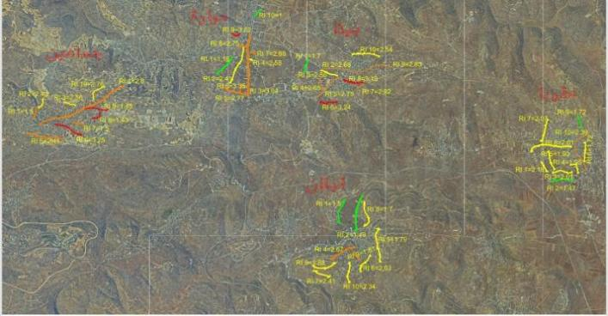
4.8 Risk Mapping Results
Figure (30): A map showing the five municipalities and the geographical distribution between these municipalities and communities.

The analysis of the risk assessment matrix demonstrates that the presence of flood-prone zones has a significant impact on the overall risk index of constructed urban roads in the municipalities south of Nablus. Road segments located within or near natural drainage paths, wadis, and low-lying areas are more exposed to surface water accumulation during heavy rainfall events. This exposure increases the likelihood of pavement deterioration, subgrade weakening, erosion, and partial or complete road failure, which consequently elevates the risk scores for these locations. Flood-prone road sections also experience frequent disruptions to traffic flow, reduced accessibility, and increased safety hazards for both vehicles and pedestrians, particularly during winter storm events.
The assessment shows that inadequate drainage infrastructure and insufficient stormwater management further intensify the vulnerability of roads situated in flood zones. In contrast, road segments located on higher ground or areas with effective drainage systems tend to exhibit lower risk levels. Therefore, integrating flood risk mapping into road planning, improving drainage capacity, constructing protective culverts and channels, and implementing regular maintenance of storm water systems are essential measures to reduce flood-related impacts and lower the overall road risk index in the municipalities of southern Nablus.
The second factor, traffic volume, measures the intensity of vehicle movement on urban roads. Roads connecting major municipalities generally experience heavier traffic loads, accelerating pavement degradation and increasing accident risks, The results of the risk assessment matrix show that traffic volume is one of the most influential factors affecting the overall risk index of constructed urban roads in the municipalities south of Nablus. Roads with higher traffic volumes, particularly those serving as main connectors between municipalities and commercial centers, tend to exhibit increased risk levels due to accelerated pavement deterioration and higher exposure to traffic conflicts. Heavy and continuous vehicle flow contributes to the rapid development of structural distresses such as rutting, cracking, and surface wear, which reduces road service life and safety performance.
In addition, high traffic density increases the probability of congestion, delays, and road accidents, especially in areas with inadequate lane width or poor intersection design. The analysis also indicates that roads experiencing mixed traffic conditions, including passenger vehicles, public transport, and heavy trucks, are more vulnerable to operational stress and therefore receive higher risk scores. Conversely, low-volume roads in residential or peripheral areas generally show lower risk values due to reduced mechanical loading and fewer conflict points. These findings highlight the need for traffic management strategies, capacity improvements, and periodic maintenance scheduling to mitigate the impact of traffic volume on road deterioration and to reduce the overall risk index in the southern Nablus municipalities.

The third factor, population density, reflects the level of urbanization surrounding road corridors. Densely populated municipal centers generally experience greater transportation demand, resulting in increased pressure on road infrastructure. The fourth factor, pavement condition, reflects the physical state of road surfaces and highlights locations suffering from cracking, rutting, potholes, and surface deterioration. Areas with poor pavement conditions appear as high-risk zones because they directly affect road safety and serviceability.

The fifth factor drainage efficiency, evaluates the ability of road drainage systems to manage storm water runoff. The map identifies several areas where inadequate drainage contributes to water accumulation, pavement weakening, and accelerated infrastructure deterioration. The sixth factor, maintenance frequency, examines the effectiveness of routine and periodic maintenance activities. Areas receiving insufficient maintenance tend to show increasing levels of deterioration and risk.
The seventh factor, Lighting/Signage the results of the risk assessment matrix show that lighting and signage are important factors influencing the overall risk index of constructed urban roads in the municipalities south of Nablus. Road sections with inadequate street lighting and insufficient or poorly maintained traffic signs generally exhibited higher risk values due to their direct impact on road safety and driver awareness. Poor lighting conditions reduce visibility during nighttime and adverse weather conditions, increasing the likelihood of traffic accidents, pedestrian conflicts, and delayed driver reactions. Similarly, missing, damaged, or unclear traffic signs can lead to driver confusion, improper lane use, speeding, and failure to recognize hazards or intersections.
The spatial analysis indicated that roads located on the outskirts of municipalities and in less developed areas were more likely to suffer from deficiencies in lighting and signage, resulting in elevated risk scores compared to well-equipped urban centers. Therefore, improving the quality, coverage, and maintenance of street lighting and traffic signage can significantly reduce road safety risks and contribute to lowering the overall risk index. These findings highlight the importance of incorporating lighting and signage improvements into municipal road management and risk mitigation strategies to enhance the safety and operational efficiency of the urban road network.
The eighth factor, road design and road geometry, includes road width, curvature, gradients, intersection design, and sight distance. The map reveals that roads with narrow cross-sections or sharp curves often correspond to higher-risk locations due to reduced operational safety.

The ninth factor and ten factors indicate that the availability and effectiveness of emergency plans and civil defense services have a significant influence on the overall risk index of constructed urban roads in the municipalities south of Nablus. Municipalities with well-developed emergency response plans, clear evacuation procedures, and rapid access to civil defense services generally exhibited lower risk levels because they are better equipped to respond to road-related incidents, natural hazards, and infrastructure failures. Effective emergency planning reduces the consequences of accidents, road blockages, flooding events, and other emergencies by ensuring timely intervention, traffic management, and public safety measures.
In contrast, areas with limited emergency preparedness or longer response times showed higher risk scores, as delays in addressing incidents can increase the severity of damages, disrupt transportation services, and endanger road users. The analysis also demonstrated that proximity to civil defense centers and the availability of emergency equipment contribute positively to road network resilience. Therefore, strengthening coordination between municipalities and civil defense authorities, improving emergency response capabilities, and regularly updating emergency management plans are essential measures for reducing road-related risks and enhancing the overall safety and resilience of the urban transportation system in southern Nablus.

The eleventh factor, horizontal and vertical sight, the analysis of the risk assessment matrix revealed that horizontal and vertical sight distance is a critical factor affecting the risk index of constructed urban roads in the municipalities south of Nablus. Adequate sight distance enables drivers to detect obstacles, pedestrians, intersections, and changes in road conditions in sufficient time to react safely. However, roads characterized by sharp horizontal curves, steep gradients, restricted visibility due to terrain, roadside structures, or vegetation tend to exhibit higher risk levels. The mountainous topography common in many southern Nablus municipalities can significantly limit both horizontal and vertical sight distances, increasing the probability of traffic conflicts and accidents.
The assessment showed that road segments with poor visibility generally received higher risk scores because drivers have less time to make safe decisions, particularly under high traffic volumes or adverse weather conditions. Conversely, roads with clear and unobstructed sight distances demonstrated lower risk levels and better operational safety. These findings highlight the importance of incorporating visibility standards into road design, maintenance, and rehabilitation programs, including curve improvements, vegetation management, and appropriate warning signage, as effective measures for reducing the overall road risk index and enhancing transportation safety.
The twelfth factor results indicate that the rate of emissions is an important environmental factor influencing the overall risk index of constructed urban roads in the municipalities south of Nablus. Road segments experiencing high traffic volumes, frequent congestion, and a large proportion of heavy vehicles generally produce higher levels of vehicle emissions, including carbon dioxide (CO₂), nitrogen oxides (NOₓ), particulate matter (PM), and other air pollutants. Elevated emission rates are often associated with reduced environmental quality, adverse public health impacts, and decreased sustainability of the transportation network. In the assessment, roads with higher emission levels received increased risk scores because they indicate inefficient traffic flow and greater environmental pressure on surrounding urban areas.
The analysis further showed that densely populated municipal centers and major transportation corridors were more vulnerable to emission-related risks due to the concentration of traffic activities. Consequently, reducing traffic congestion, improving road conditions, enhancing traffic management systems, and promoting sustainable transportation alternatives can contribute to lowering emission rates and reducing the overall risk index. These measures support not only safer and more efficient road networks but also improved environmental and public health outcomes in the municipalities of southern Nablus. environmental exposure, evaluates the influence of climatic and natural conditions, including rainfall, temperature fluctuations, runoff, and soil erosion, on road performance.
The integrated analysis of these twelve factors within the map demonstrates that risk levels are not uniformly distributed across the municipalities. Instead, they are concentrated in locations where several risk factors overlap. Roads exposed to heavy traffic, poor drainage, inadequate maintenance, and challenging topographic conditions generally exhibit the highest risk scores. Conversely, roads with good construction quality, effective maintenance programs, and favorable environmental conditions show lower risk levels. Therefore, the map serves as an essential decision-support tool for municipal authorities by identifying priority areas for intervention, guiding maintenance planning, optimizing resource allocation, and supporting sustainable urban road management throughout the southern Nablus municipalities.

4.8.1 Risk Mapping for Huwara
Figure 31 illustrates the relationship between the factor and the average weighted value across the selected streets in Huwara town showing the selected streets and their risk levels.
Street No. 1 has a low risk factor due to effective drainage, adequate lighting, and regular maintenance. Street No. 5, on the other hand, has a high-risk factor due to increased traffic, a lack of directional signs, and insufficient maintenance, resulting in a high-risk factor. There is also no drainage system. According to the risk model map, the risk index varies, with the highest proportion after analysis falling between medium and high. This is due to natural factors such as inefficient rainwater drainage, lack of necessary periodic maintenance, poor lighting in these areas, and road closures resulting from political circumstances, which lead to an increase in the number of vehicles (ADT) on these streets.
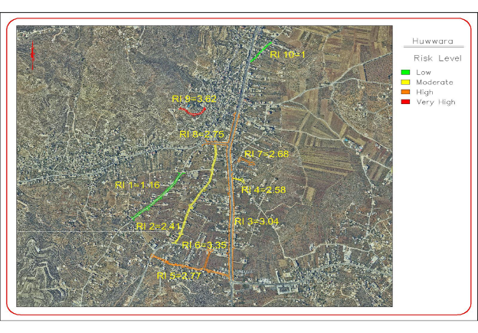
Figure (31): Risk model for targeted streets Huwara.
4.8.2 Risk Mapping for Beita
Figure 32 illustrates the relationship between the factor and the average weighted value across the selected streets in Beita town showing the selected streets and their risk levels. Street No. 1 has a low risk factor due to effective drainage, adequate lighting, and regular maintenance as required. It is an internal street. Street No. 6, on the other hand, has a high-risk factor due to the lack of a drainage system and the absence of pre-construction testing. Furthermore, it is located in a flat area, meaning the soil classification is high, which has led to a high-risk factor for this street.
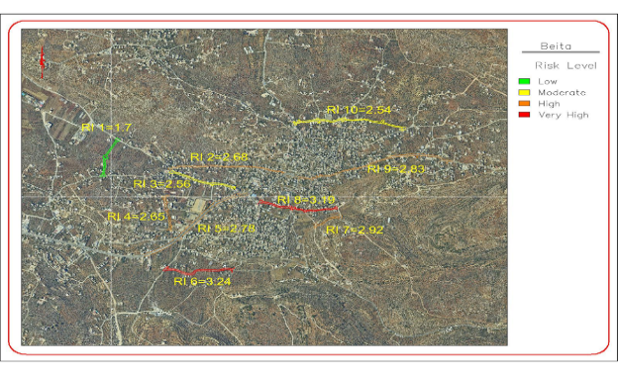
By referring to the risk model map, there is a clear variation in the risk index. After analysis, it became evident that the risk index falls within the low to medium range. This is due to the efficiency of rainwater drainage, the implementation of necessary periodic maintenance, adequate lighting in these areas, and the consideration of safety measures during the design process
Figure (32): Risk model for targeted streets Beita.

4.8.3 Risk Mapping for Jammaein
Figure 33 illustrates the relationship between the factor and the average weighted value across the selected streets in Jammaein town showing the selected streets and their risk levels. Street No. 6 and Street No. 8 have a very high-risk factor due to the lack of effective drainage, the absence of regular maintenance, the contractors' failure to honor maintenance warranties, the disregard for required design factors, and the lack of soil testing.
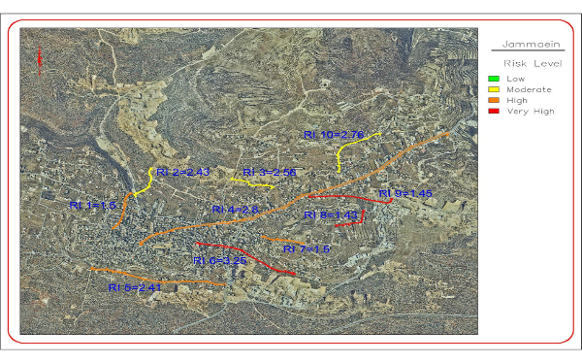
According to the map, there is a variation in the risk index. After analysis, it became clear that the risk index ranges from high to very high. This is due to several factors, most notably the failure to consider proper design procedures during the planning process, the lack of drainage, the continuous closures by the Israeli occupation, the contractors' failure to adhere to necessary maintenance procedures, inadequate lighting, the absence of safety signs, and the lack of clear standards during the preparation of the plans.
Figure (33): Distribution of risk index for selected roads in Jammaein.

4.8.4 Risk Mapping for Aqraba
Figure 34 illustrates the relationship between the factor and the average weighted value across the selected streets in Aqraba town showing the selected streets and their risk levels., Street No. 8 and Street No. 9 have a low risk factor due to contractors' commitment to maintenance guarantees, the existence of an emergency plan in case of incidents, the presence of a Civil Defense center in the town of Aqrabah, and the presence of monitoring systems and cameras on these streets to detect accidents and violations. These factors contribute to the low risk factor.
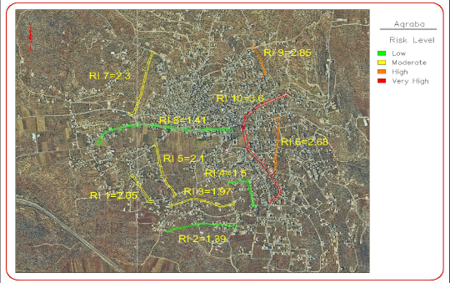
By referring to the risk model map, there is a clear variation in the risk index. After analysis, it became evident that the risk index falls within the low to medium range. This is due to the efficiency of rainwater drainage, the implementation of necessary periodic maintenance, adequate lighting in these areas, and the consideration of safety measures during the design process.
Figure (34): Risk model for targeted streets Aqraba.

4.8.5 Risk Mapping for Qablan
Figure 35 illustrates the relationship between the factor and the average weighted value across the selected streets in Qablan town showing the selected streets and their risk levels. Street No. 1 has a low risk factor due to contractors' commitment to maintenance guarantees, the existence of an emergency plan and regular maintenance, the presence of a Civil Defense center nearby, the presence of monitoring systems and cameras on these streets to detect accidents and violations, and the high level of lighting. Additionally, the necessary inspections were conducted before implementation. Street No. 9, on the other hand, has a medium risk factor due to the inefficiency of the drainage systems, drivers' failure to obey traffic signals, and the presence of gatherings on the street's right-of-way.
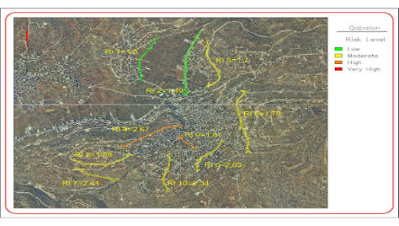
By referring to the risk model map, there is a clear variation in the risk index. After analysis, it became evident that the risk index low. This is due to the efficiency of rainwater drainage, the implementation of necessary periodic maintenance, adequate lighting in these areas, and the consideration of safety measures during the design process

Figure (35): Risk model for targeted streets Qabalan.

Chapter Five

Discussion of Results

5.1 Discussion
The assessment of urban constructed roads shows that road conditions depend on more than the work of engineers. The design and material selection together with the operational environment of the road and its social and economic impacts determine how roads perform. The study found that deterioration occurs because of material properties and design parameters together with actual conditions that include traffic loading (Traffic loading refers to the number of vehicles using a road, bridge, or transportation system) and drainage effectiveness and maintenance activities. Road asset management implementation of risk management frameworks moves the focus from failure response to proactive identification of potential issues through early problem detection and damage assessment and mitigation application before it becomes expensive to address.
The research identifies common weaknesses which cities face because of their high population density. Inadequate drainage stands out as a persistent trigger for deterioration, particularly when water is allowed to accumulate or flow in unintended ways. The combination of utility cuts which damage road surfaces and the lack of coordination between urban development and transportation planning leads to different types of road risks which cause streets to become used in ways that differ from their design.
The Risk Index was calculated using two different methods, AHP and AWM, with results that were close to each other. The AHP provides slightly better results than the alternative method because all relevant factors were taken into consideration.
However, whether AHP actually gives better results depends on the problem, the quality of the input judgments, and what the "alternative method" is. For example, AHP may outperform simple ranking or scoring methods because it captures relative importance more accurately, but the improvement is often described as slight because both methods may reach similar conclusions.
The hierarchical method involves creating a matrix which includes all factors and their weights before dividing it into multiple stages to calculate the weights and consistency coefficient. The two methods produced results that were almost identical with just minor discrepancies between them.
The process of implementation encounters multiple obstacles. The researchers found that risk management activities experience delays and weaknesses because organizations lack sufficient data and their institutional capacity restrictions and their budget constraints. Stakeholder engagement and ongoing monitoring represent two vital elements which maintain urban road networks' capacity to endure and remain operational for extended periods.
After analyzing the results, the most influential factors affecting the municipalities south of Nablus were (FZ, TV, RSC, MF, DC,). These factors were as similar as possible across all municipalities, including the impact of floods, inefficient storm water drainage, political factors, road closures, and increased traffic on internal roads compared to other roads. External roads were less affected in terms of risk severity due to adherence to design standards, the availability of adequate lighting and warning signs, and better drainage efficiency compared to internal roads, which lack drainage systems due to their age, failure to consider good design standards, and the lack of necessary tests before asphalt work and preparation.
After calculating the risk factor for the five towns it became clear that some factors were more influential than others. Aqraba had the lowest risk factor, attributed to the consideration of new design standards, effective drainage, and high-efficiency lighting. It also benefits from its proximity to the Civil Defense center, emergency plans for road closures and construction, and the presence of warning and speed limit signs. Following Qablan in the second place, which also benefited from consideration of design standards, emergency plans, and regular maintenance and prevention procedures. Despite having lower traffic volume and better lighting than Qabalan, Aqrabah still ranked second. Hawara ranked third, due to ineffective storm water drainage, poor lighting, and high traffic volume as compared to the other towns. Its distance from the Civil Defense center, coupled with its low-lying location, makes it prone to flooding, as it serves as a catchment area for all surrounding regions. Beita suffered from a high-risk factor due to inefficient drainage and the absence insufficient lighting, coupled with a high risk of flooding due to its proximity to the new bypass road, the lack of emergency plans, the absence of a nearby civil defense unit, and frequent road closures, all contributed to a high-risk level. Finally, the town of Jamma'in ranked last, with an extremely high-risk level due to the lack of drainage systems, emergency plans, a civil defense presence, and maintenance plans. All of these factors resulted in a very high-risk level.
Similarly, internal roads were more vulnerable than external roads in terms of the severity of factors and risks, as the external roads that connect towns had a lower risk factor due to the presence of rainwater drainage systems, consideration of design factors, and the presence of adequate and appropriate warning signs and lighting.
The results indicate that the most significant risks affecting the performance and sustainability of constructed urban roads in the municipalities of South Nablus are associated with inadequate drainage systems, insufficient maintenance practices, funding constraints, and rapid urban expansion. The assessment revealed variations in risk levels among municipalities, reflecting differences in infrastructure quality, technical capacity, and resource availability. Roads located in densely populated and rapidly developing areas exhibited higher vulnerability to pavement deterioration, traffic congestion, and environmental impacts. These findings are consistent with previous studies emphasizing that proactive risk management, regular condition monitoring, and integrated infrastructure planning are critical for extending road service life and reducing long-term rehabilitation costs.
Furthermore, the results suggest that prioritizing preventive maintenance and incorporating risk-based decision-making into municipal road management strategies can significantly improve road safety, serviceability, and resilience against future urban and environmental challenges.
Commenting on the study's findings, particularly regarding the five residential areas, it was found that internal roads are more prone to problems after implementation due to frequent closures, increased traffic volume, inadequate drainage systems, poor lighting, and the absence of traffic signs and road markings. The second phase involved external roads between these towns, which are less problematic due to their higher construction standards than internal roads.
The AHP analysis provided a systematic framework for prioritizing the twelve risk factors affecting constructed urban roads in the municipalities of South Nablus. The results demonstrated that the highest-ranked factors have a greater influence on road performance, safety, and long-term sustainability than lower-ranked factors, indicating the need for targeted risk mitigation measures. The variation in factor weights highlights the complex nature of urban road management, where technical, financial, environmental, and administrative issues interact to influence project outcomes. Factors receiving the highest priority should be addressed during the planning, design, and maintenance stages, as their impact on road deterioration and service quality is more substantial.
Conversely, lower-ranked factors, although less critical, should not be neglected because their cumulative effects may contribute to infrastructure failure over time. The consistency ratio obtained from the AHP analysis confirmed the reliability of expert judgments and supports the validity of the prioritization process. These findings suggest that municipalities can improve the effectiveness of road asset management by allocating resources according to the relative importance of identified risks and adopting a risk-based decision-making approach for future urban road projects.

5.2 Continuous Improvements
The evaluation shows how urban road maintenance needs adaptive management combined with continual improvement efforts. Authorities use actual road performance data to compare with design specifications in order to select better materials and create effective drainage systems and develop construction guidelines. The adoption of a risk-based maintenance strategy enables maintenance to transition from emergency repairs toward scheduled maintenance activities which results in lower maintenance expenses while enhancing road durability for growing cities that face climate-related challenges.
The constant development of assessment and risk management processes for built urban road systems requires a methodical approach that uses data to track road performance throughout its entire operational period. Urban roads undergo ongoing assessment processes which start after construction ends to check their structural strength and traffic performance and safety standards and their effects on the environment. The author uses regular condition assessments which include pavement inspections, roughness measurements, drainage evaluations, and traffic flow analyses to detect early signs of road damage (i.e., cracking, rutting, and potholes) traffic jams, and flooding risks.

Chapter Six

Conclusions and Recommendations

6.1 Conclusions
This study examined the current practices of assessment and risk management for constructed urban roads within the municipalities of South Nablus, focusing on the challenges affecting road quality, sustainability, safety, and service efficiency. The findings demonstrate that urban road projects in the study area face multiple risks during planning, construction, and post-construction phases, including inadequate maintenance planning, limited financial resources, weak coordination among stakeholders, technical deficiencies, environmental impacts, and rapid urban expansion.

The research highlighted that risk assessment is not consistently integrated into municipal road management processes, resulting in recurring structural failures, traffic safety concerns, drainage problems, and increased long-term maintenance costs. In many municipalities, decision-making remains largely reactive rather than preventive, which reduces the effectiveness of infrastructure investments and negatively affects public satisfaction and urban mobility.

The study further revealed that adopting systematic risk management approaches can significantly improve the performance and durability of urban roads. Effective assessment methods, regular inspections, data-driven planning, and prioritization of maintenance activities contribute to reducing infrastructure deterioration and minimizing economic and social losses. In addition, strengthening institutional capacity, improving technical expertise, and enhancing inter-agency coordination are essential for achieving sustainable urban road management.

Another important conclusion is that municipalities in South Nablus require modernized infrastructure management systems supported by geographic information systems (GIS), standardized engineering procedures, and comprehensive risk evaluation frameworks. Such tools can assist municipalities in identifying vulnerable road sections, forecasting potential failures, and allocating resources more efficiently.

The study concludes that successful risk management for constructed urban roads depends on integrating engineering, environmental, financial, and administrative considerations into a unified framework. Municipal authorities should therefore shift toward proactive maintenance strategies, enforce engineering standards, improve project monitoring mechanisms, and encourage community participation in reporting road-related issues.

Finally, this case study emphasizes that improving urban road assessment and risk management practices in the municipalities of South Nablus is essential not only for infrastructure sustainability but also for enhancing public safety, supporting local economic development, and improving the overall quality of urban life. The recommendations presented in this research may serve as a practical foundation for policymakers, municipal engineers, and urban planners seeking to develop more resilient and sustainable road infrastructure systems in Palestine.
This study assessed and prioritized the risks affecting constructed urban roads in the municipalities of South Nablus through a comprehensive risk management approach, with particular emphasis on identifying the factors that most significantly influence road performance, safety, durability, and sustainability. Using the Analytic Hierarchy Process (AHP), twelve key risk factors were evaluated and ranked according to their relative importance based on expert judgments and local conditions. The findings demonstrated that urban road infrastructure is exposed to a combination of technical, financial, environmental, operational, and administrative risks that collectively affect the quality and service life of road networks. The analysis revealed that certain factors exert a greater influence on road deterioration and project success, highlighting the need for municipalities to adopt a systematic and proactive approach to risk management rather than relying solely on corrective maintenance practices.
The results further indicated that inadequate planning, insufficient maintenance resources, construction-related deficiencies, increasing traffic loads, drainage problems, and institutional challenges are among the critical issues that contribute to reduced road performance and increased lifecycle costs. The application of AHP provided a reliable framework for prioritizing these risks and supporting decision-makers in allocating limited resources more effectively. Based on the findings, it can be concluded that integrating risk assessment into all stages of road development, from planning and design to construction, operation, and maintenance, is essential for improving the resilience and sustainability of urban transportation infrastructure in South Nablus. Municipal authorities should focus on the highest-priority risks identified by the analysis, strengthen technical and managerial capacities, enhance coordination among stakeholders, and implement preventive maintenance programs to reduce future failures and rehabilitation expenses.
Furthermore, the adoption of risk-based decision-making practices can contribute to improved road safety, better service quality, and more efficient use of public funds. Overall, this study provides a practical framework for evaluating and managing risks associated with urban roads and offers valuable guidance for municipal planners, engineers, and policymakers seeking to enhance the performance and longevity of road infrastructure in South Nablus and other municipalities facing similar urban development challenges.

The post-implementation phase demonstrates that urban roads can achieve longer service periods with reduced costs and enhanced quality of life through the combination of proactive risk management and modern assessment techniques and sustainable practices. The outcomes reveal that three essential elements continuous monitoring, stakeholder engagement, and adaptive planning serve as essential elements needed to maintain urban transportation systems for safe operation and future resilience. The key results show better road conditions, reduced accident rates, improved drainage performance, and optimized maintenance scheduling. The combination of data-driven tools with stakeholder feedback has enabled decision-making to achieve greater transparency and accountability and responsiveness to stakeholder needs.

6.2 Recommendations

1. Establish Periodic Road Assessment Programs
Municipal engineers should implement regular field inspections and technical evaluations for existing roads to identify deterioration and operational risks at an early stage. Periodic assessments should include:
- Pavement condition evaluation,
- Drainage performance inspection,
- Roadside safety assessment, and
- Traffic flow monitoring.
Routine assessment programs can support preventive maintenance and reduce long-term rehabilitation costs.

2. Develop an Integrated Road Risk Management Framework
Municipalities should adopt an integrated framework that combines:
- Technical assessment,
- Safety evaluation,
- Environmental monitoring, and
- Maintenance planning.
The framework should include risk identification, risk classification, and prioritization procedures to support decision-making and efficient allocation of municipal resources.

3. Prioritize Preventive Maintenance Strategies
Many municipalities rely primarily on reactive maintenance after severe road deterioration occurs. Municipal engineers are encouraged to adopt preventive maintenance strategies such as:
- Crack sealing,
- Pothole repair,
- Drainage cleaning, and
- Shoulder stabilization.
Preventive maintenance can significantly extend road service life and reduce future repair costs.

4. Improve Drainage Systems and Stormwater Management
Poor drainage is one of the major causes of pavement deterioration in rural municipalities. Engineers should ensure:
- Regular cleaning of drainage channels,
- Inspection of culverts and stormwater systems, and
- Proper management of surface runoff.
Special attention should be given to roads located in sloped or flood-prone areas south of Nablus.

5. Utilize Geographic Information Systems (GIS)
Municipalities should adopt GIS technologies for road inventory and infrastructure monitoring. GIS-based systems can help engineers:
- Identify high-risk road segments,
- Document maintenance history,
- Monitor infrastructure conditions, and
- Support maintenance prioritization.
GIS tools also improve data management and long-term municipal planning.

6. Strengthen Road Safety Measures
Municipal engineers should improve road safety conditions through:
- Installation of warning signs,
- Maintenance of road markings,
- Roadside protection barriers,
- Speed-control measures, and
- Pedestrian safety improvements near schools and populated areas.
Road safety audits should be conducted periodically to identify hazardous locations.

7. Develop Road Condition Databases
Municipalities should establish centralized databases containing:
- Pavement condition records,
- Maintenance activities,
- Accident reports,
- Drainage problems, and
- Infrastructure deficiencies.
Accurate databases support evidence-based decision-making and improve maintenance efficiency.

8. Enhance Coordination Between Municipal Departments
Effective risk management requires coordination among:
- Engineering departments,
- Public works units,
- Utility providers, and
- Emergency services.
Improved coordination can reduce infrastructure conflicts, particularly those related to utility excavations and unplanned road damage.

9. Increase Training and Technical Capacity
Municipal engineers and technical staff should receive continuous training in:
- Road condition assessment,
- Infrastructure risk management,
- GIS applications,
- Safety auditing, and
- Sustainable maintenance practices.
Capacity-building programs can improve municipal technical performance and infrastructure management quality.

10. Incorporate Environmental and Climate Considerations
Municipal road management strategies should account for environmental risks such as:
- Erosion,
- Flooding,
- Landslides, and
- Climate-related pavement damage.
Climate-resilient design and maintenance approaches should be integrated into future rehabilitation and improvement projects.

11. Allocate Dedicated Budgets for Road Maintenance
Municipalities should allocate sufficient and dedicated financial resources for routine road maintenance and risk mitigation activities. Delayed maintenance often increases infrastructure deterioration and rehabilitation costs.

12. Encourage Community Participation
Municipalities should establish communication mechanisms that allow residents to report:
- Road damage,
- Drainage problems,
- Safety hazards, and
- Infrastructure failures.
Community participation can improve monitoring efficiency and support faster municipal response.

6.3 Research Limitations
The main limitations of the study are summarized as follows:
- Limited Availability of Reliable Data
The assessment needs complete and up-to-date information which includes accurate traffic volume data, complete accident record details, pavement condition and maintenance records.
- Time Constraints:
The study period may not be long enough to capture long-term pavement behavior seasonal effects or gradual deterioration processes that become visible through extended operating periods.
- Limited Geographic Coverage
Results that depict road conditions at only selected sites rather than the network as a whole might not lend themselves well to generalization.

- Dependence on Visual Inspection Methods
Visual inspection is useful but not sufficient on its own. Surface observation cannot detect hidden defects which include subgrade failures and internal pavement damage.
- Human and Technical Bias
Inspections and risk ranking need judgment that depends on the application of standardized criteria because assessments require judgment. The process will create different results because evaluators may assess things differently.

References

Abd El-Karim, M., Mosa El Nawawy, O., & Abdel-Alim, A. M. (2015). Identification and Assessment of Risk Factors Affecting Construction Projects. Housing and Building National Research Center Journal, 13(2), 202–216. https://doi.org/10.1016/j.hbrcj.2015.05.001
Adhikari, R., & Mishra, A. (2020). Strategic risk management practice in urban road construction project of Nepal. Zenodo. https://doi.org/10.5281/zenodo.7347076
Ahmed, R., Osman, R., & Amer, M. (2024). Navigating urban congestion: A comprehensive strategy based on an efficient smart IoT wireless communication for PV powered smart traffic management system. PLOS ONE, 19(10). https://doi.org/10.1371/journal.pone.0310002
Akinrinade, M. (2018). Managing Risk in Construction Projects: A quantitative study. Northcentral University.
Alam, S., Yin, Z., & Ali, A., Ali, S., Noor, A., & Jan, N. (2019). A comprehensive study of project risks in road transportation networks under CPEC. International Journal of Financial Studies, 7(3), 41. https://doi.org/10.3390/ijfs7030041
Alsubaie, A., Alutaibi, K., & Martí, J. (2015). Resilience assessment of interdependent critical infrastructure. In A. M. Kosta, C. Lambrinoudakis, S. Gritzalis, & J.
Amran Hamid, R., & Djakman, C. (2024). Identification of Risk Management. Atestasi : Jurnal Ilmiah Akuntansi, 7(2), 907 -916. https://doi.org/10.57178/atestasi.v7i2.891
Aqel, E. (2019). Towards more resilient transportation network against natural hazards in Nablus City, Palestine. (Unpublisahed thesis). An-Najah National University.
Barbu, A., & Postăvaru, N. (2022). Risk analysis in road infrastructure construction projects using the FMEA method – Failure modes and effects analysis. Revista Şcolii Doctorale de Urbanism, 11, 5-16.
Buffarini, G., Clemente, P., Giovinazzi, S., Ormando, C., Pollino, M, & Rosato, V. (2022). Preventing and managing risks induced by natural hazards to critical infrastructures. Infrastructures, 7, 76. https://doi.org/10.3390/infrastructures7060076
Chapman, C., & Ward, S. (2003). Project Risk Management: Processes, Techniques and Insights. Wiley.
Chitkara, K. (2011). Construction Project Management. Tata McGraw-Hill.
Cochran, W. (1977). Sampling techniques (3 ed.). John Wiley & Sons.
Dingus, T., Jahns, S., & Horowitz, A. D., & Knipling, R. (2014). Human factors design issues for crash avoidance systems. In Human factors in intelligent transportation systems (pp. 55–93). Psychology Press.
Dziadosz, A., & Rejment, M. (2015). Risk analysis in construction projects: Chosen methods. Procedia Engineering, 122, 258–265. https://doi.org/10.1016/j.proeng.2015.10.034
Eckelman, M. (2013). Life cycle assessment in support of sustainable transportation. Environmental Research Letters, 8(2). https://doi.org/10.1088/1748-9326/8/2/021004
Ehsan, N., Mirza, E., & Alam, M., & Ishaque, A. (2010). Risk Management in Construction Industry. In Proceedings of the 2010 3rd IEEE International Conference on Computer Science and Information Technology (pp. 16-22). IEEE. https://doi.org/10.1109/ICCSIT.2010.5564663
Elvi, R., Høye, A., & Vaa, T., & Sørensen, M. (2009). The Handbook of Road Safety. Emerald Group Publishing. https://doi.org/10.1108/9781848552517
European Commission. (2017). Risk management framework: Guide for decision-making. Directorate-General for Mobility and Transport. Publications Office of the European Union.
Farhan, J., & Fwa, T. (2009). Pavement maintenance prioritization using analytic hierarchy process. . Transportation Research Record: Journal of the Transportation Research Board, 2093(1), 12-34. https://doi.org/10.3141/2093-02
Finger, J., Ross, K., & Häring, I., Restayn, E.-M., Siebold, U. (2021). Open chance and risk management process supported by a software tool for improving urban security. European Journal for Security Research, 6, 39–71. https://doi.org/10.1007/s
Flanagan, R., & Norman, G. (1993). Risk management and construction. Blackwell Scientific.
Furtado, M. (2015). Measuring the resilience of transportation networks subject to seismic risk. (Master’s thesis, University of Massachusetts Amherst). ScholarWorks@UMass Amherst. https://doi.org/10.7275/6463860
Geurts, K., Thomas, I., & Wets, G. (2005). Understanding spatial concentrations of road accidents using frequent item sets. Accident Analysis & Prevention, 37(4), 787 -799. https://doi.org/10.1016/j.aap.2005.03.014
Giang, D., & Sui Pheng, L. (2011). Role of construction in economic development: Review of key concepts in the past 40 years. Habitat International, 35, 118–125. https://doi.org/10.1016/j.habitatint.2010.06.003
Greenan, M., Toussaint, M., & Peek-Asa, C., Rohlman, D., & Ramirez, M. R. (2016). The effects of roadway characteristics on farm equipment crashes: A geographic information systems approach. Injury Epidemiology, 3, 31. https://doi.org/10.1186/s40621-016-0096-1
Gupta, A., Singh, S., Wajih, S. A., Mani, N, & Singh, A. K. (2017). Urban resilience and sustainability through peri-urban ecosystems: Integrating climate change adaptation and disaster risk reduction. Gorakhpur Environmental Action Group.
Hayat, E. (2014). Evaluation of local governments' capacity in the maintenance of post- disaster road reconstruction assets. University of Salford.
International Organization for Standardization. (2018). ISO 31000:2018: Risk management—Guidelines. International Organization for Standardization. https://www.iso.org/standard/65694.html
Ivanenko, O. (2020). Implementation of risk assessment for critical infrastructure protection with the use of risk matrix. ScienceRise, 2(67), 26–38. https://doi.org/10.21303/2313-8416.2020.001340
Khatleli, N. (2020). Risk management in construction projects. IntechOpen. https://doi.org/10.5772/intechopen.80628
Kim, J., Lee, J., & Kang, J. (2023). Smart cities and disaster risk reduction in South Korea by 2022: The case of Daegu. Heliyon, 9(8). https://doi.org/10.1016/j.heliyon.2023.e18794
Lee, J., Jung, D., & Baek, C., & An, D. (2023). An Analytical Study Predicting Future. Sustainability, 15(24), 16680. https://doi.org/10.3390/su152416680
Li, H., Liang, M., Li, F, & Zuo, J., Zhang, C., & Ma, Y. (2022). Operational safety risk assessment of water diversion infrastructure based on FMEA with fuzzy inference system. Water Supply, 22(10), 7513–7531. https://doi.org/10.2166/ws.2022.322
Li, Y., & Chen, Y. (2018). A new method based on field strength for road infrastructure risk assessment. Journal of Advanced Transportation, 6379146. https://doi.org/10.1155/2018/6379146
Lopez, A. (Ed.). (2015). Critical information infrastructures security. 0th international conference, CRITIS 2015, Berlin, Germany, October 5–7, 2015, revised selected papers ( 43 -55). Springer. https://doi.org/10.1007/978-3-319-26567-4_4
Maari, N.-D. (2014). Rapid seismic assessment of multi-story buildings in Nablus and disaster response plans. Unpublished M.Sc. thesis, An-Najah National University, Palestinian territories.
Mhetre, K., Konnurb, B., & Landage, A. (2016). Risk management in construction industry. International Journal of Engineering Research (IJER), 5(1), 153–155. https://doi.org/10.17950/ijer/v5i1/035
Mishra, A., & Mallik, K. (2017). Factors and Impact of Risk Management Practice on success of Construction Projects of Housing Developers, Kathmandu, Nepal. International Journal of Sciences: Basic and Applied Research (IJSBAR), 36(7), 206- 232. https://www.gssrr.org/JournalOfBasicAndApplied/article/view/8499
Munier, N. (2014). Risk management for engineering projects. Springer. https://doi.org/10.1007/978-3-319-05251-9
Naidu, G. (2008). Infrastructure development in Malaysia. In International Infrastructure Development in East Asia – Towards balanced regional development and integration (ERIA Research Project Report 204–27). IDE -JETRO.
Palestinian Central Bureau of Statistics. (2021). Localities in Nablus governorate: Population, housing and establishment census 2017. Palestinian Central Bureau of Statistics.
Palestinian Central Bureau of Statistics. (2024). Road network length in the West Bank by governorate and road type. https://www.pcbs.gov.ps.
Park, J., Seager, T., Rao, P. S. C, & Convertino, M., & Linkov, I. (2013). Integrating risk and resilience approaches to catastrophe management in engineering systems. Risk Analysis, 33(3), 356–367. https://doi.org/10.1111/j.1539-6924.2012.01885.x
Perera, B., Dhanasinghe, I., & Rameezdeen, R. (2009). Risk management in road construction: The case of Sri Lanka. International Journal of Strategic Property Management, 13(1), 87–102. https://doi.org/10.3846/1648-715X.2009.13.87-102
Pešić, A., Stephens, A., Newnam, S., Čičević, S., Pešić, D, & Trifunović, A. (2022). Youth perceptions and attitudes towards road safety in Serbia. Systems, 10, 191. https://doi.org/10.3390/systems10050191
PIARC. (2019). Road Asset Management Manual. PIARC.
Project Management Institute. (2000). A Guide to the Project Management Body of Knowledge (PMBOK® guide) (2000 ed.). Project Management Institute.
Project Management Institute. (2021). A Guide to the Project Management Body of Knowledge (PMBOK® Guide) (7 ed.). PMI.
Raz, T., & Michael, E. (2001). Use and benefits of tools for project risk management. International Journal of Project Management, 19(1), 9-17. https://doi.org/10.1016/S0263-7863(99)00036-8
Renuka, S., Umarani, C., & Kamal, S. (2014). A review on critical risk factors in the life cycle of construction projects. Journal of Civil Engineering Research, 4(2A), 31–36. https://doi.org/10.5923/c.jce.201401.07
Rusim, D., Parung, H., & Latief, R. U., & Tjaronge, W. (2019). Risk analysis of time on road infrastructure development (Case study: Construction industry in Papua). IOP Conference Series: Earth and Environmental Science, 235, p. 012077. https://doi.org/10.1088/1755-1315/235/1/012077
Sa’dl Issa Alkhawaja, A., & Varouqa, I. (2023). Risks management of infrastructure line services and their impact on the financial costs of road projects in Jordan. Measurement: Sensors, 25, 100647. https://doi.org/10.1016/j.measen.2022.100647
Saaty, T. (1980). The analytic hierarchy process: Planning, priority setting, resource allocation (7 ed.). NY: McGraw-Hill.
Sareen, S., Remme, D., & Haarstad, H. (2021). E-scooter regulation: The micro-politics of market-making for micro-mobility in Bergen. Environmental Innovation and Societal Transitions, 40, 461–473. https://doi.org/10.1016/j.eist.2021.10.009
Senić, A., Dobrodolac, M., & Stojadinović, Z. (2024). Predicting extension of time and increasing contract price in road infrastructure projects using a Sugeno fuzzy logic model. Mathematics, 12, 2852. https://doi.org/10.3390/math12182852
Simić, N., Ivanišević, N., Nedeljković, Đ., Senić, A., Stojadinović, Z, & Ivanović, M. (2023). Early highway construction cost estimation: Selection of key cost drivers. Sustainability, 15, 55-84. https://doi.org/10.3390/su15065584
Slovic, P. (2000). The perception of risk. London: Earthscan.
Smith, N., Merna, T., & Jobling, P. (2014). Managing risk in construction projects (3 ed.). Wiley Blackwell.
Snowdon, D. (2011). Risk and resilience [Video]. YouTube. https://www.youtube.com/watch?v=2Hhu0ihG3kY
Trangkanont, S., & Charoenngam, C. (2014). Private Partner’s Risk Response in PPP Low Cost Housing Projects. Property Management, 32(1), 67–94. https://doi.org/10.1108/PM-02-2013-0008
Trifunović, A., Senić, A., Čičević, S., Ivanišević, T., Vukšić, V, & Simović, S. (2024). Evaluating the road environment through the lens of professional drivers: A traffic safety perspective. Mechatronics and Intelligent Transportation Systems, 3, 31–38. https://doi.org/10.56578/mits030103
Tserng, H.-P., Yin, S.-L., Dzeng, R.-J., Wou, B., Tsai, M. D, & Chen, W. Y. (2009). A Study of Ontology-Based Risk Management Framework of Construction Projects Through Project Life Cycle. Automation in Construction, 18(7), 994 -1008. https://doi.org/10.1016/j.autcon.2009.05.005
Wideman, R. (1992). Project and program risk management: A guide to managing project risks and opportunities. Project Management Institute.
Williams, T. (2019). Community participation in road safety policy development and strategy planning. Journal of the Australasian College of Road Safety, 30(4), 60–66. https://doi.org/10.33492/JACRS-D-19-00179
Yusuwan, N., Adnan, H., & Omar, A. F. (2008). Clients’ perspectives of risk management practice in Malaysian construction industry. Journal of Politics and Law, 1, 121-130. https://doi.org/10.5539/jpl.v1n3p121
Zou, P., Zhang, G., & Wang, J. (2007). Understanding the key risks in construction projects in China. International Journal of Project Management, 25(6), 601–614.
Zubieta, I., Brown, G., & Cohen, R., & Medina, E. (2013). Cananea copper mine: An international effort to improve hazardous working conditions in Mexico. International Journal of Occupational and Environmental Health, 15(1), 14–20. https://doi.org/10.1179/1077352513Z.0000000006

Appendices

Appendix A
1. Calculation of the Risk Index Using the Risk Matrix – Huwara Municipality
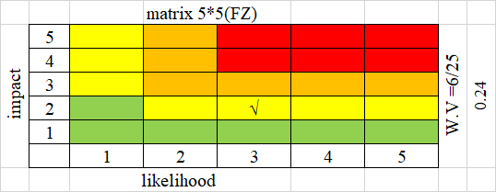
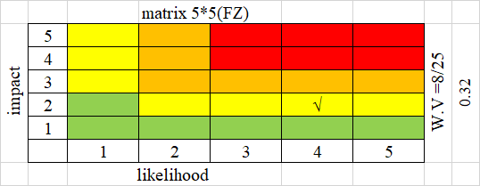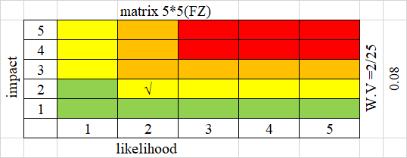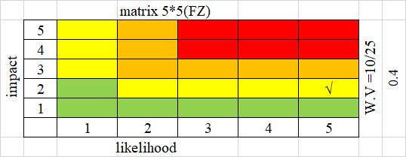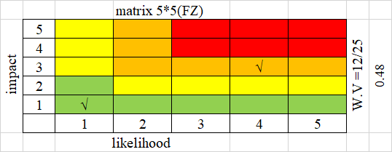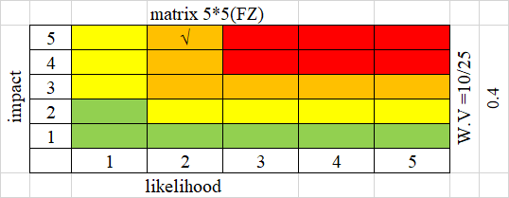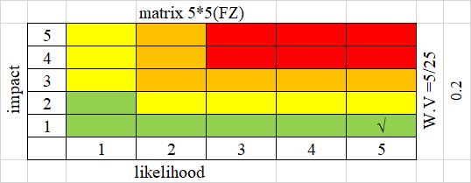
2. Calculation of the Risk Index Using the Risk Matrix – Beita Municipality

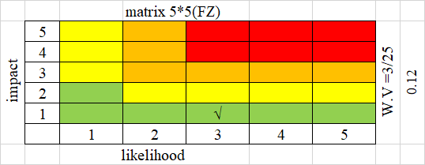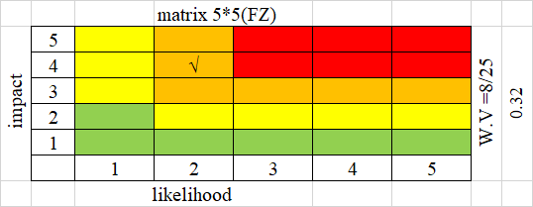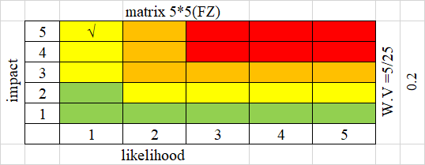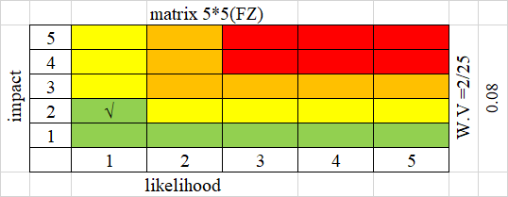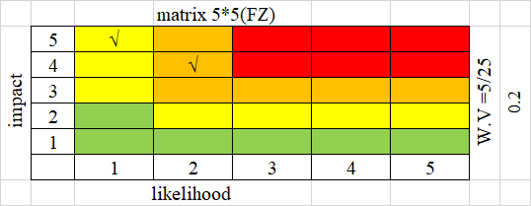gg
3. Calculation of the Risk Index Using the Risk Matrix – Jammaein Municipality

4. Calculation of the Risk Index Using the Risk Matrix – Qabalan Municipality

5. Calculation of the Risk Index Using the Risk Matrix – Aqraban Municipality

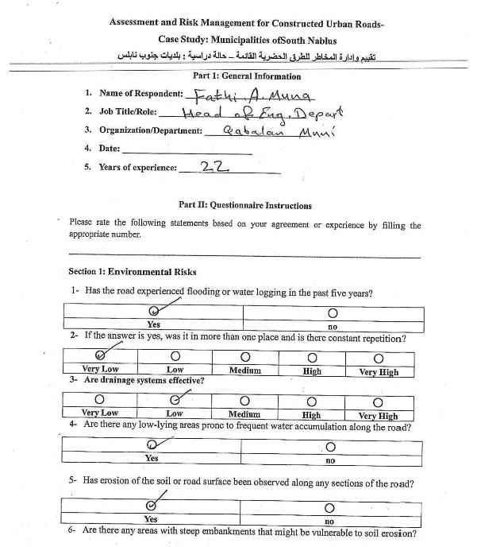
Appendix B
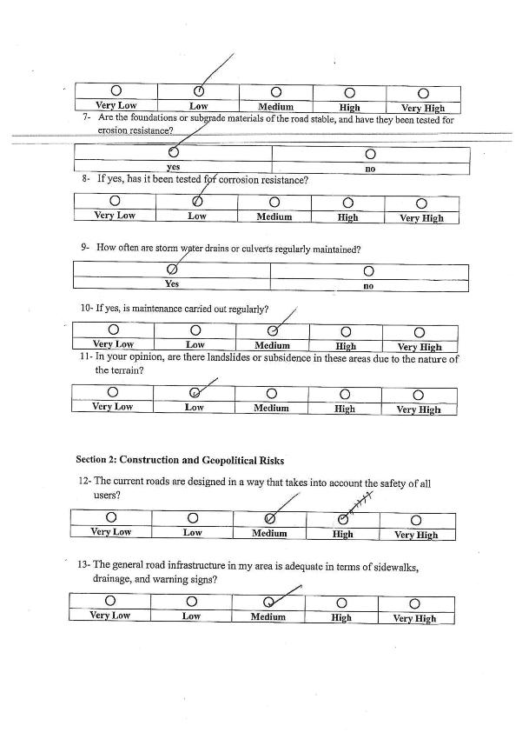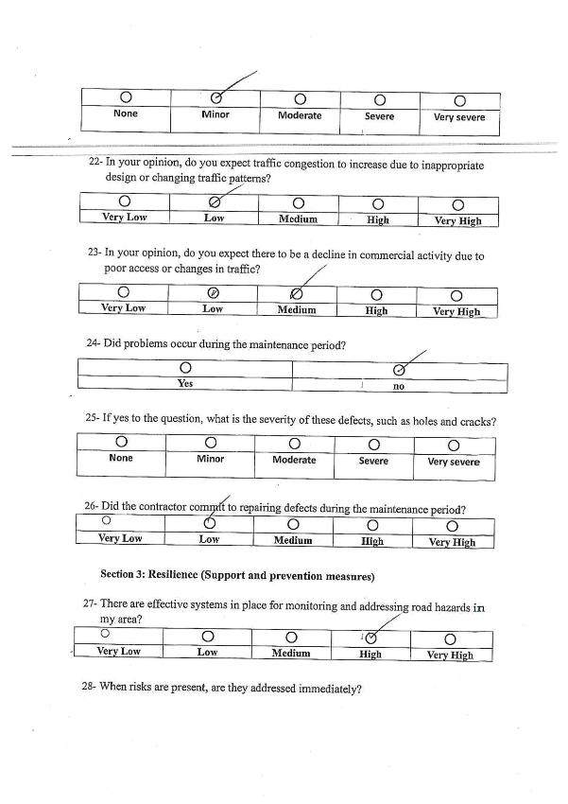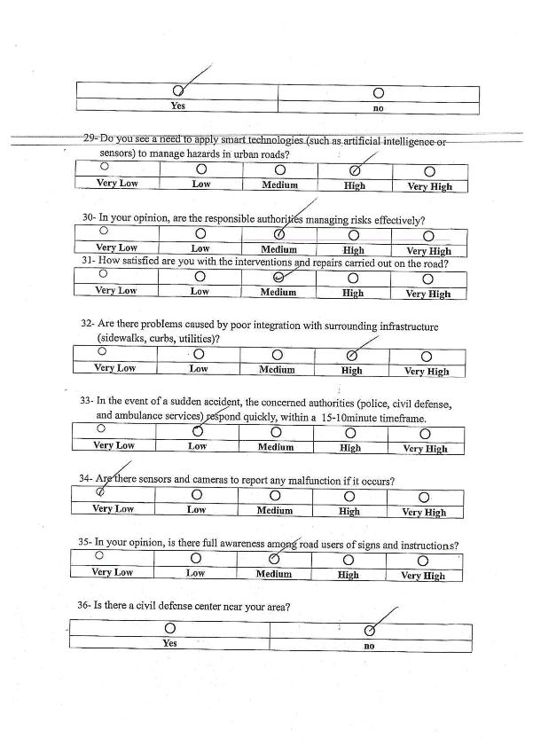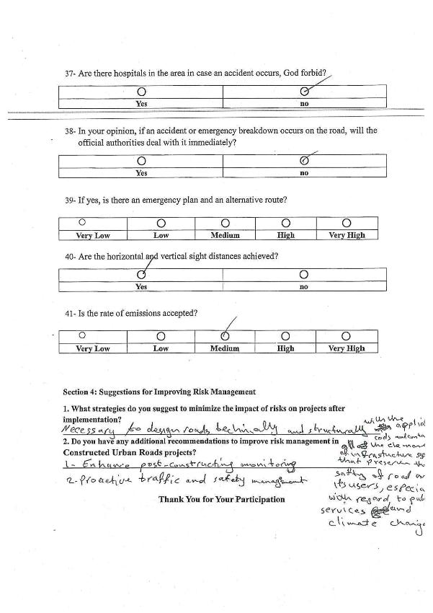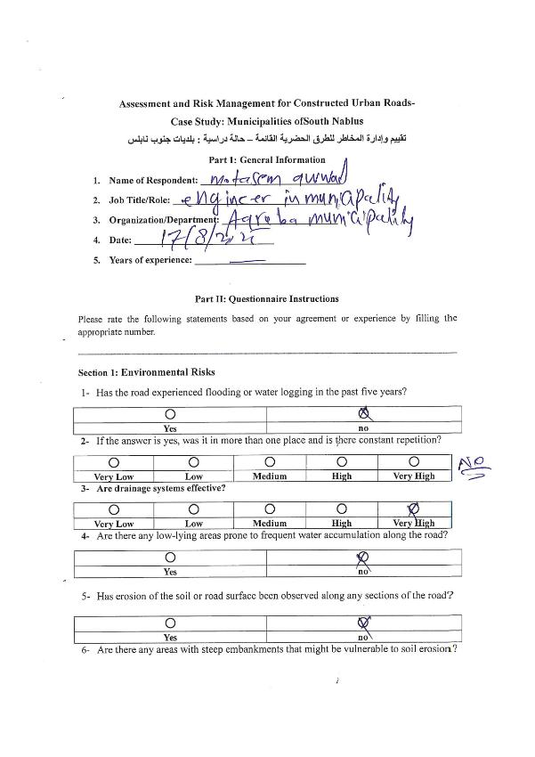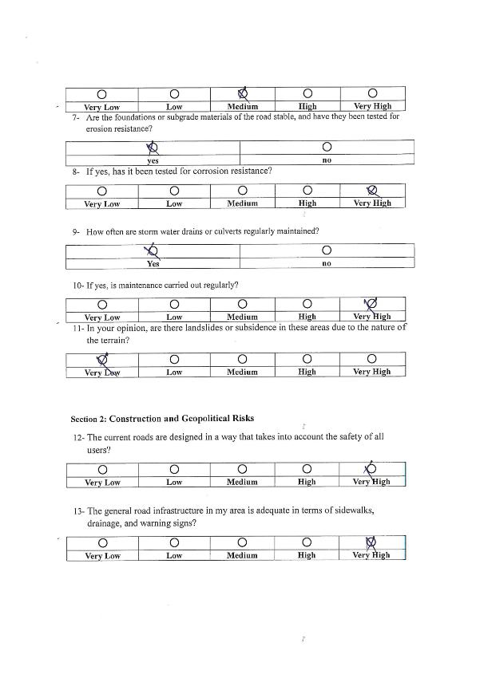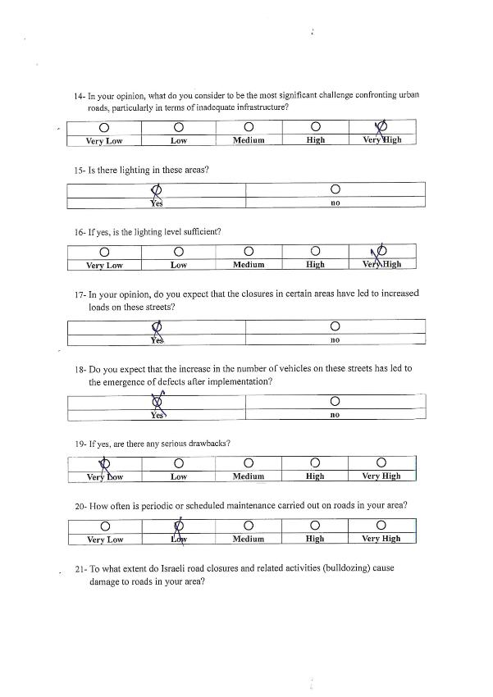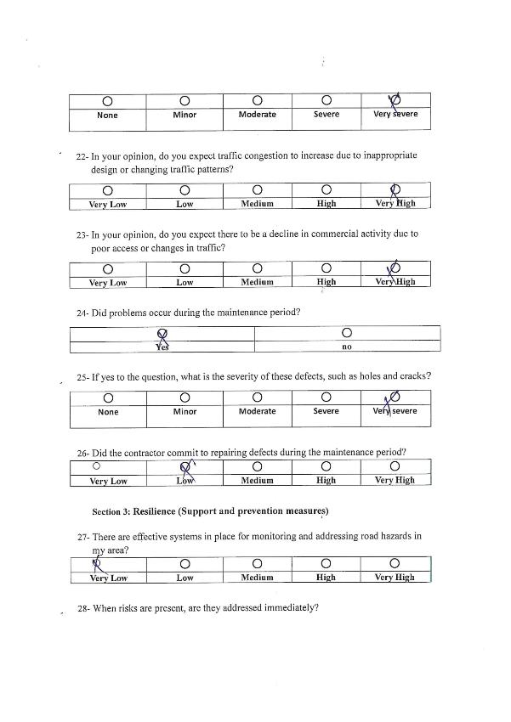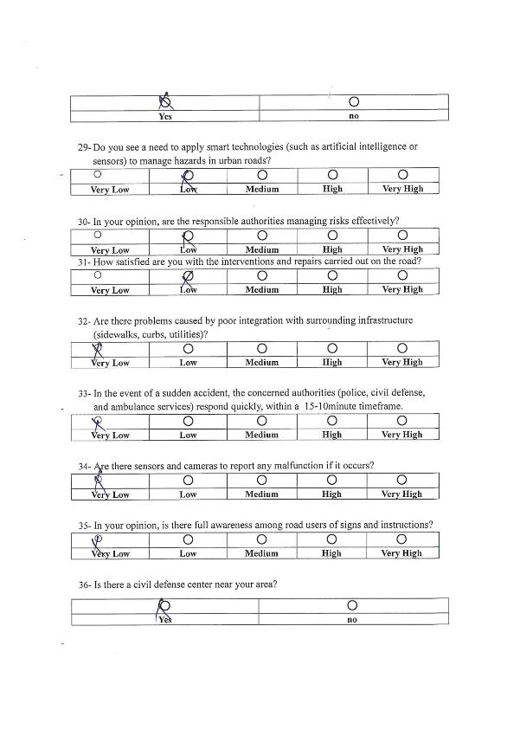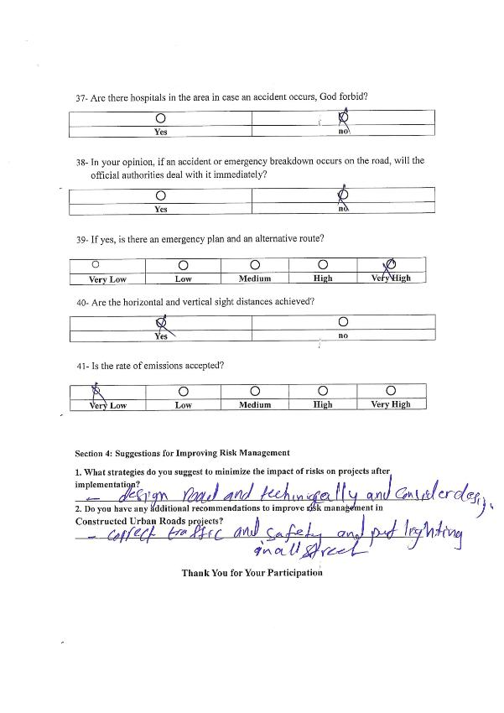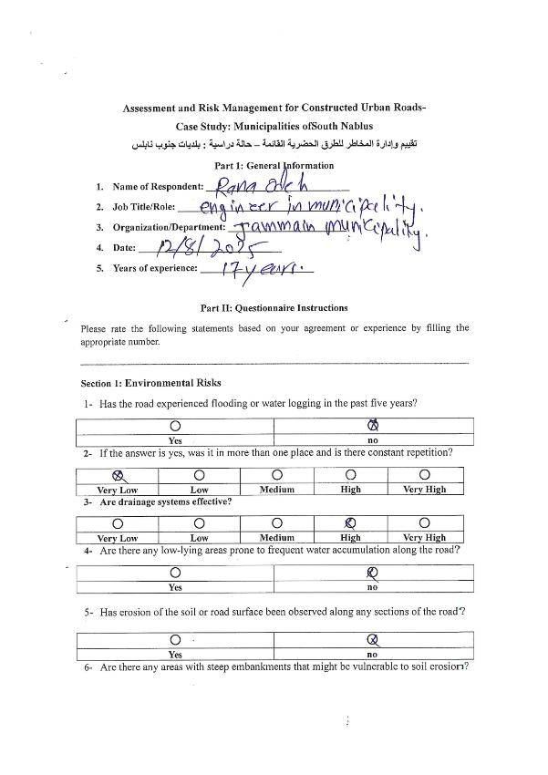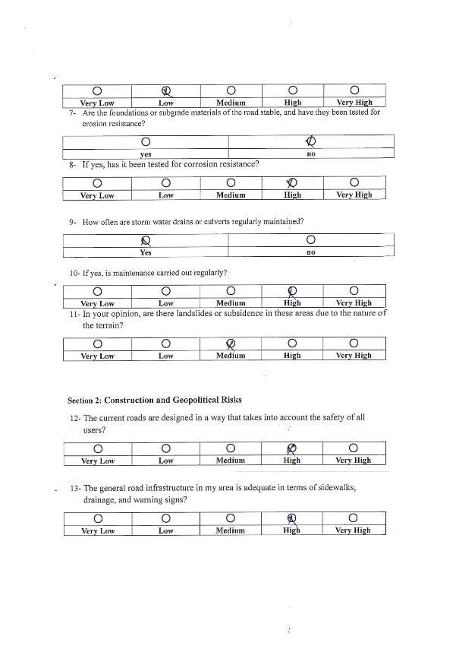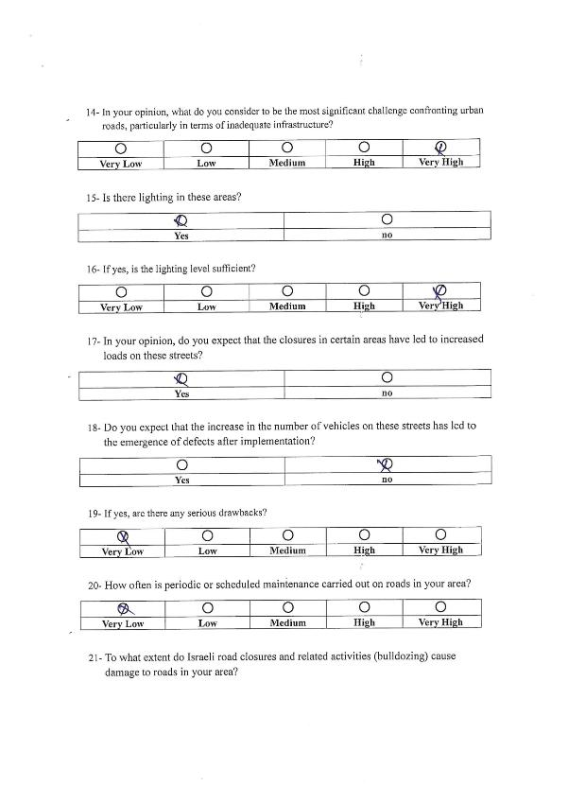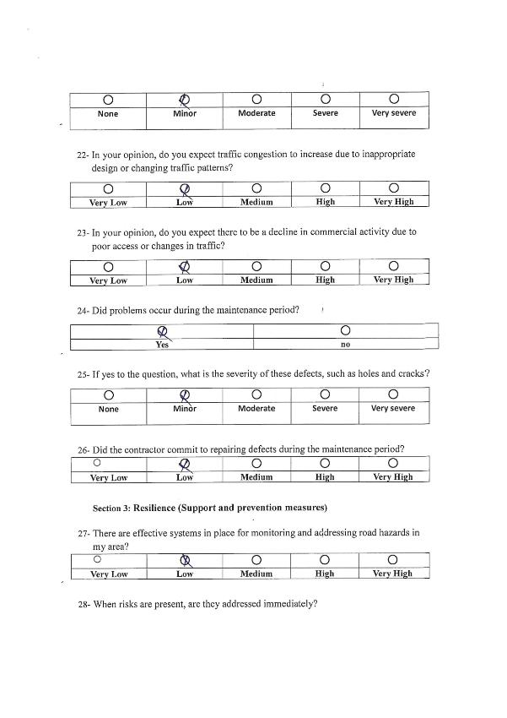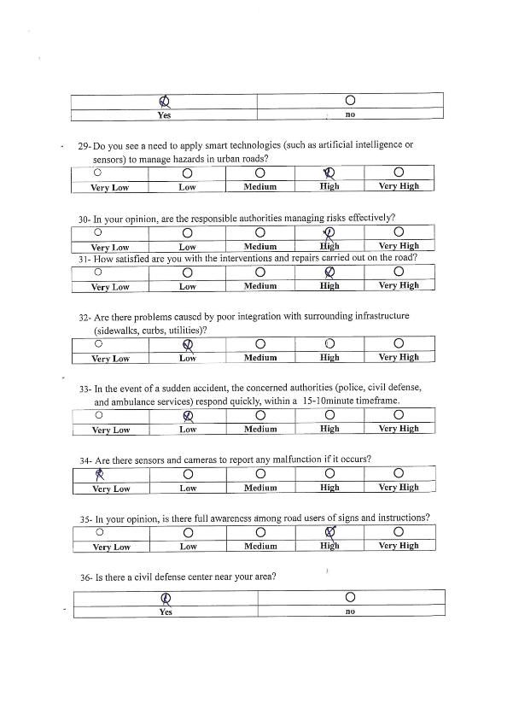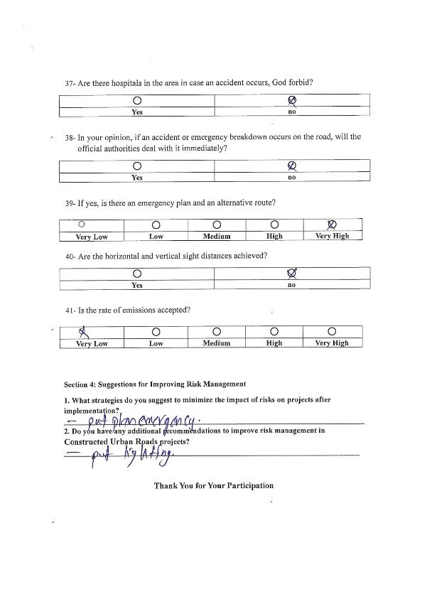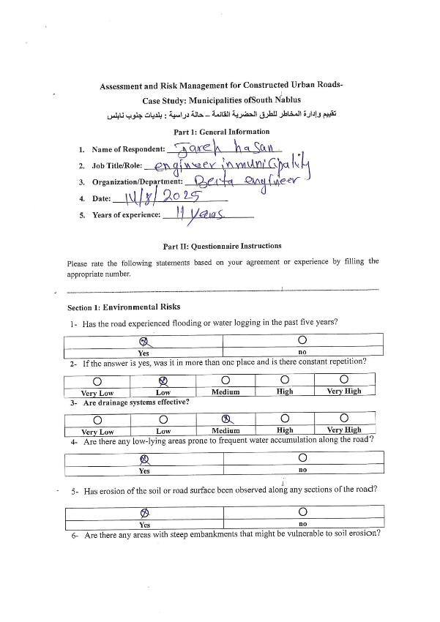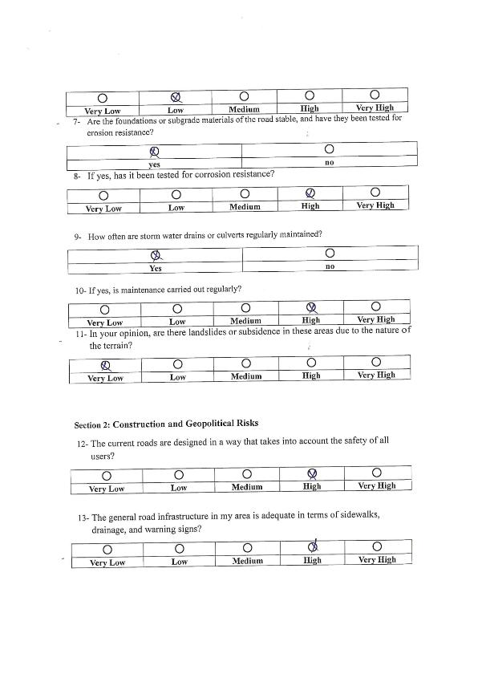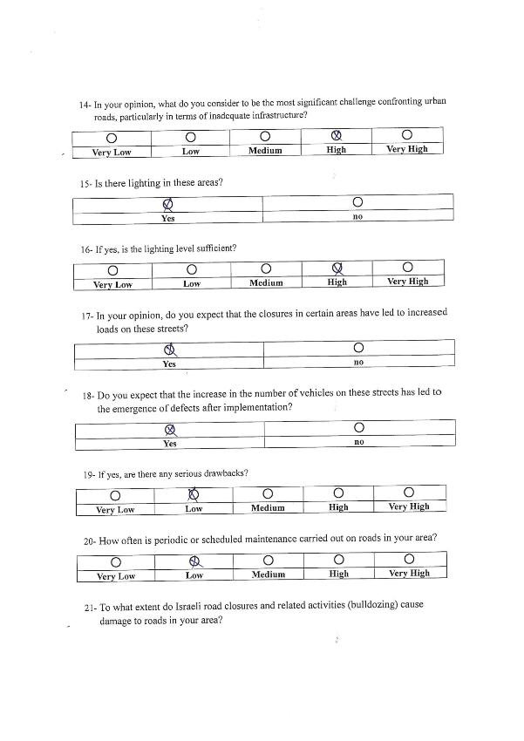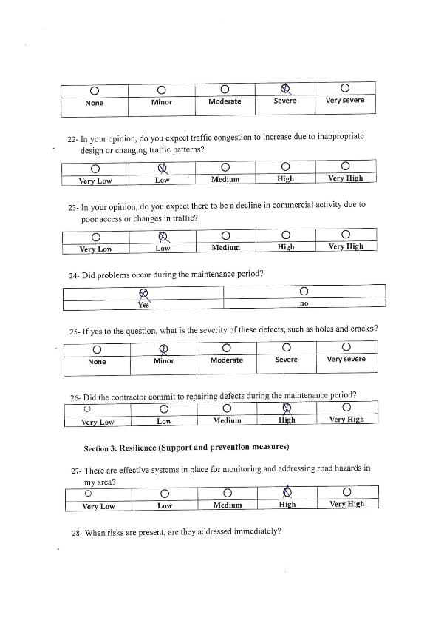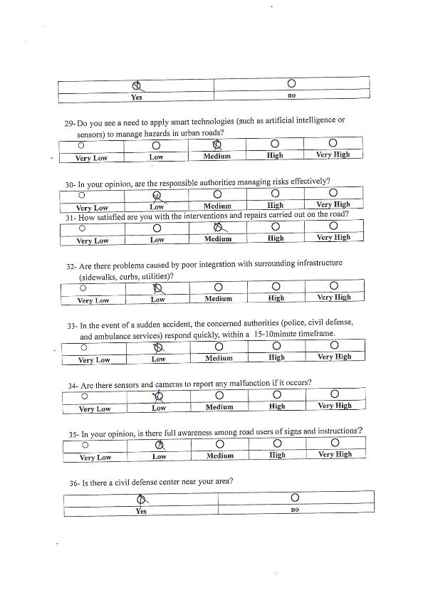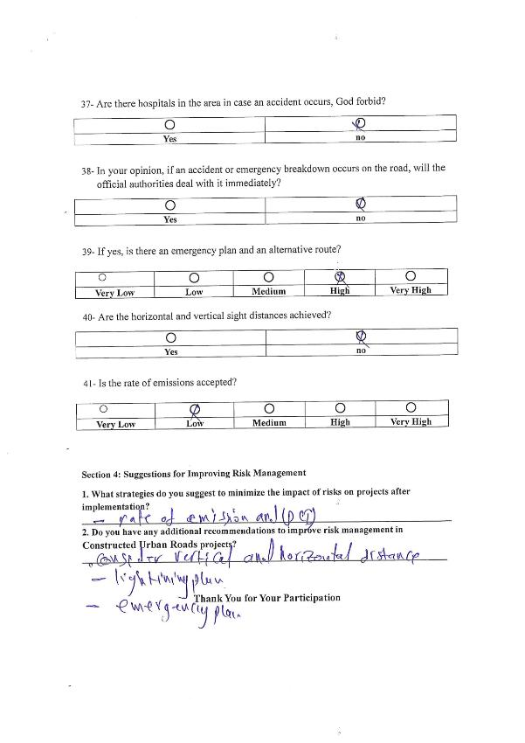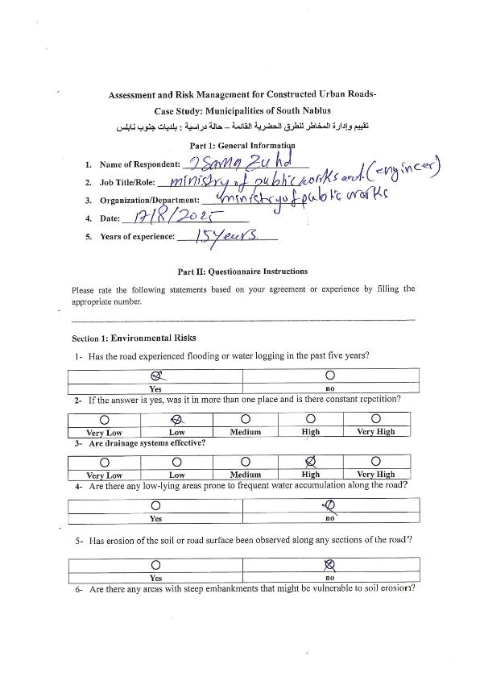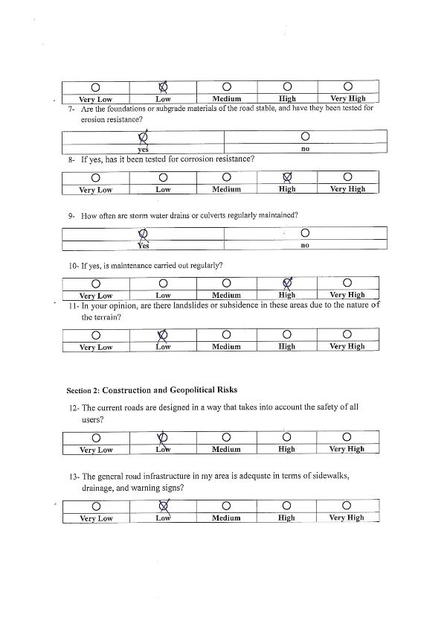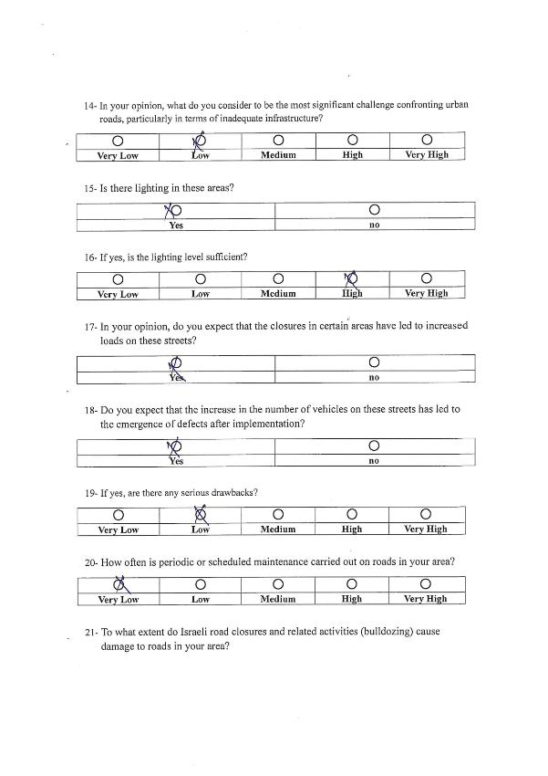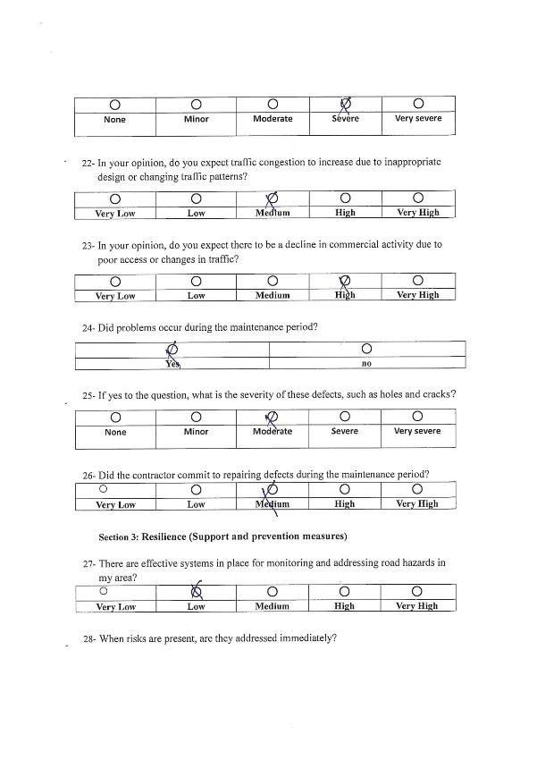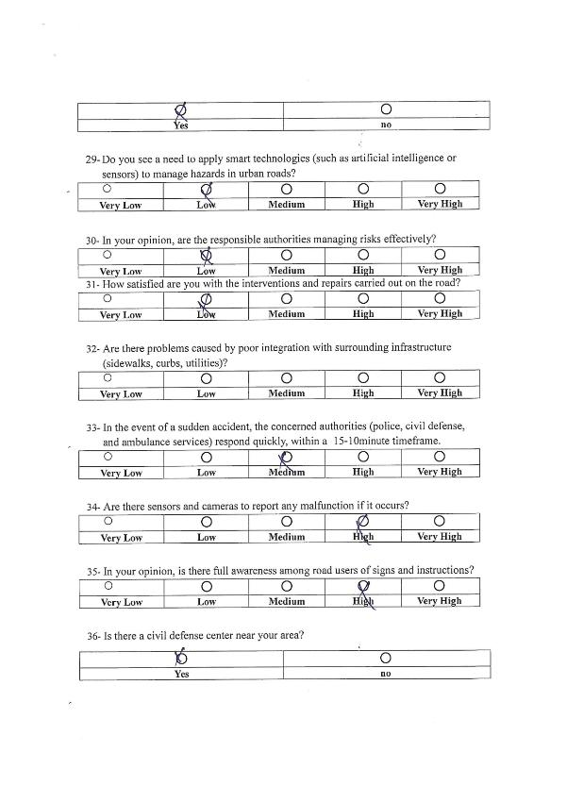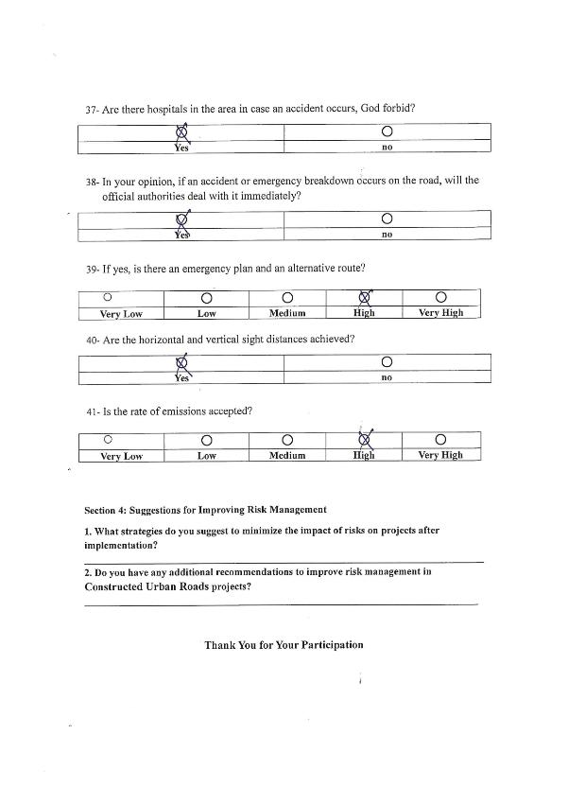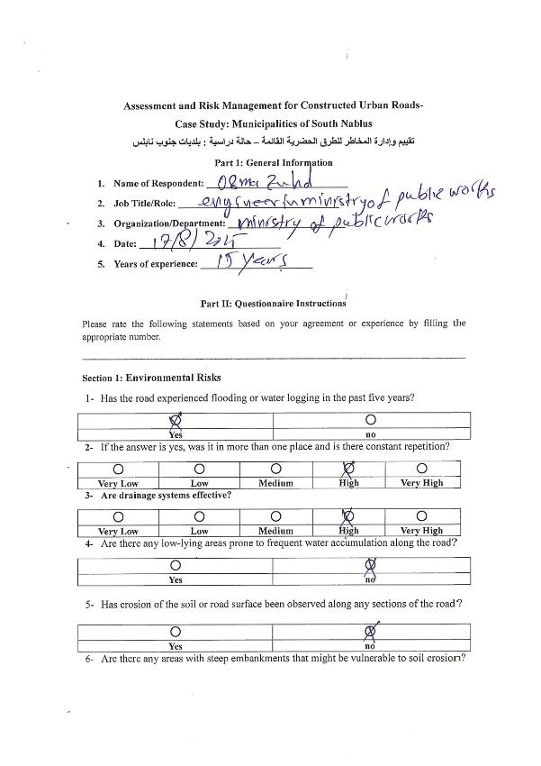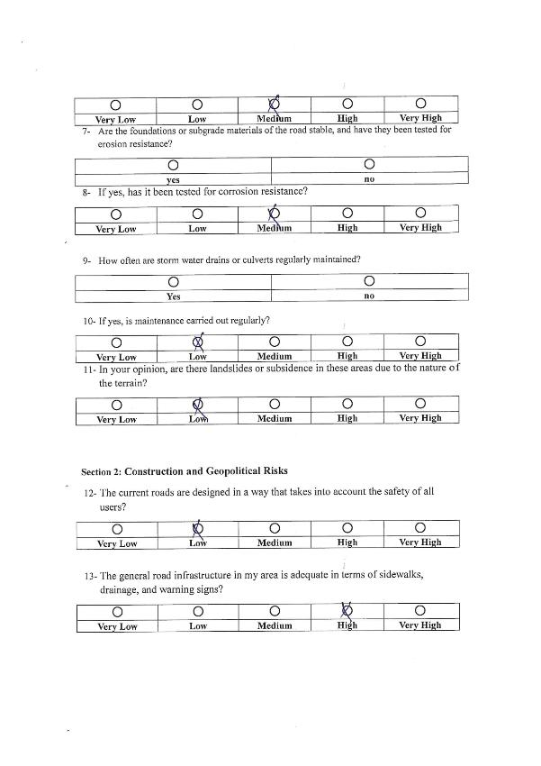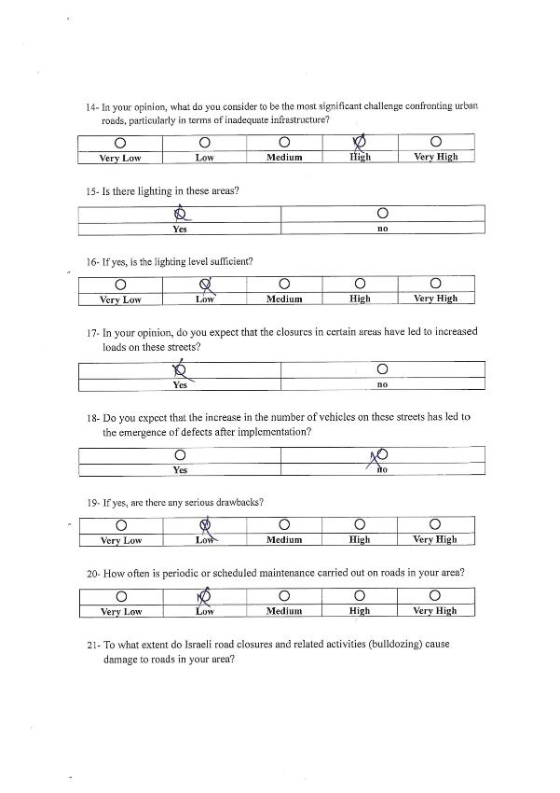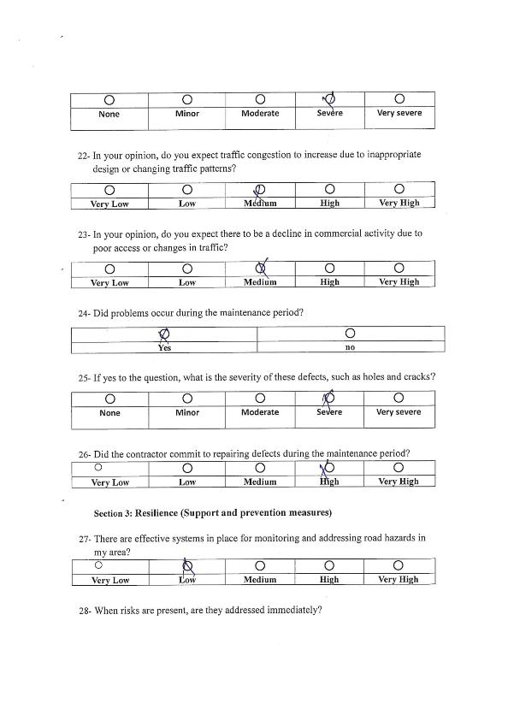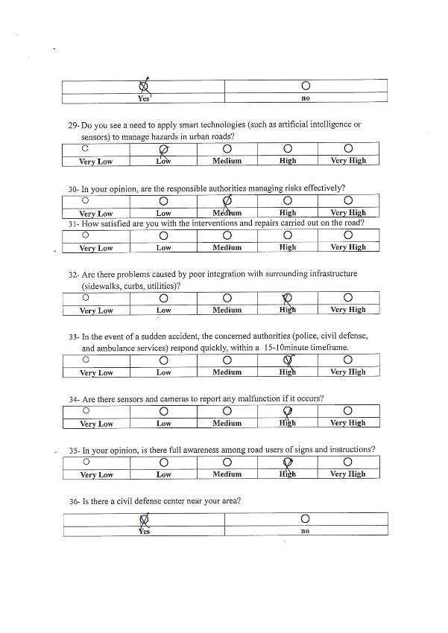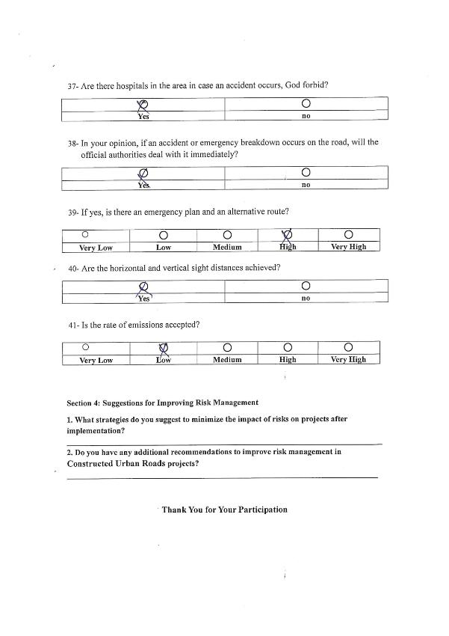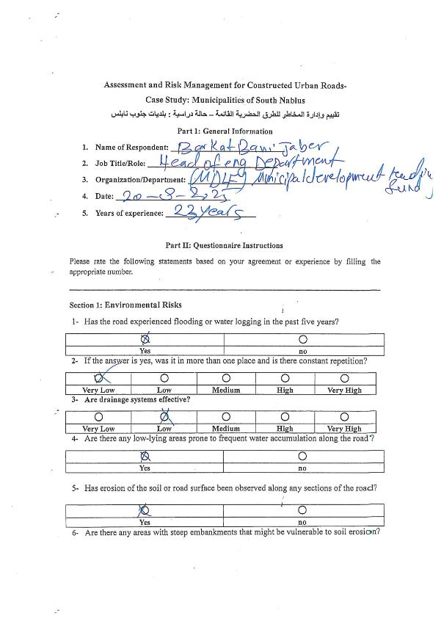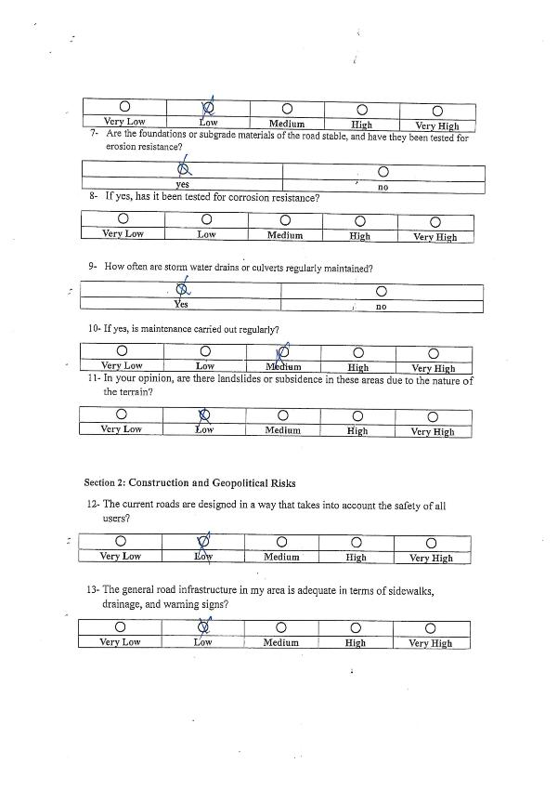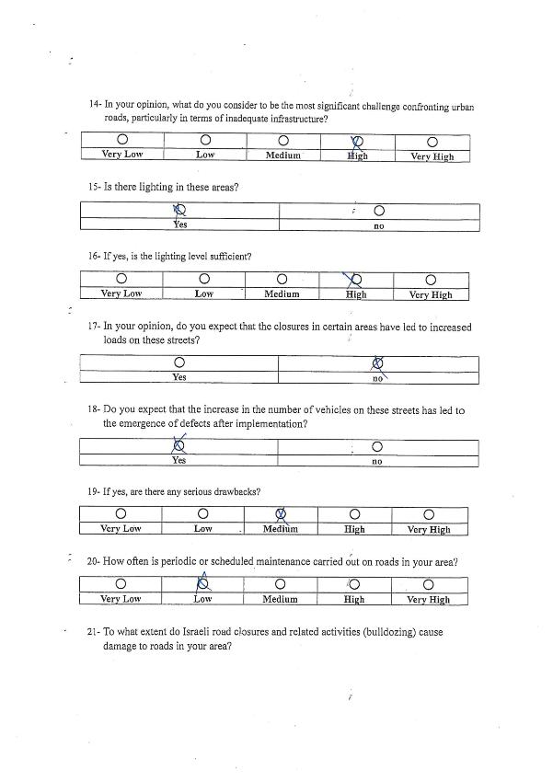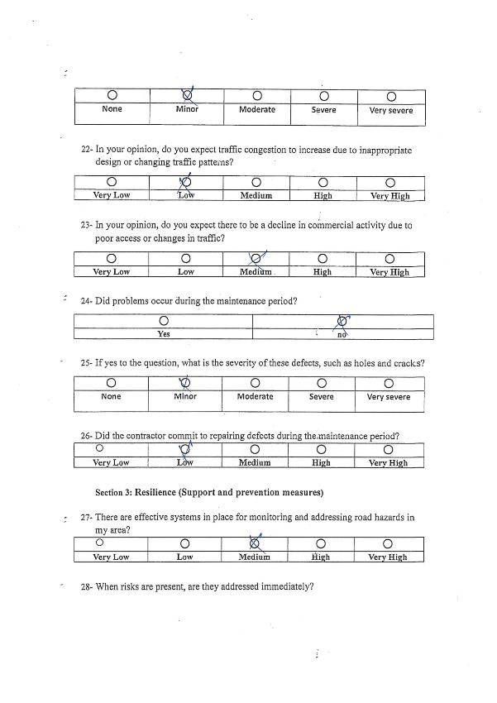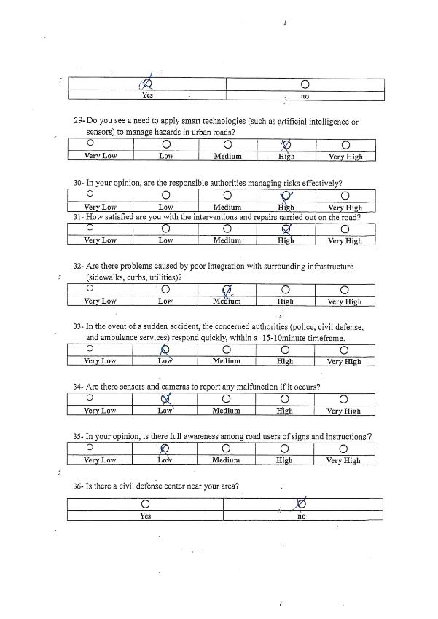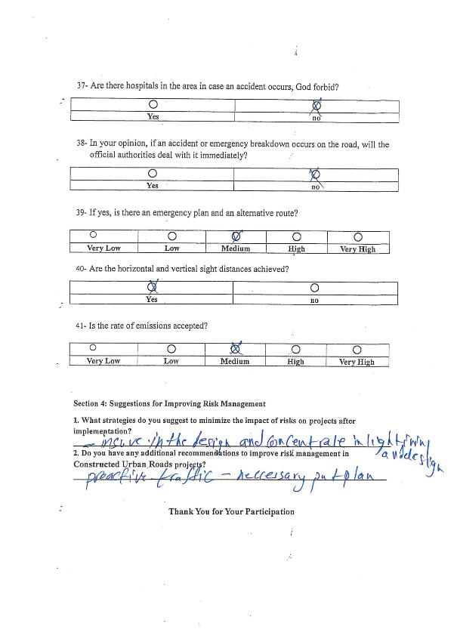

Appendix C

Statistical Analysis and Discussion
Anova: Single Factor
SUMMARY
Groups | Count | Sum | Average | Variance
group 1 | 2 | 20 | 10 | 0
group 2 | 2 | 20 | 10 | 32
group 3 | 2 | 20 | 10 | 8
group 4 | 2 | 20 | 10 | 2
group 5 | 2 | 10 | 5 | 0
ANOVA
Source of Variation | SS | Df | MS | F | P-value | F crit
Between Groups | 40 | 4 | 10 | 1.190476 | 0.416722 | 5.192168
Within Groups | 42 | 5 | 8.4
Total | 82 | 9

Anova: Single Factor
SUMMARY
Groups | Count | Sum | Average | Variance
# | 10 | 55 | 5.5 | 9.166667
Group 1 | 10 | 19.76 | 1.976 | 0.09916
Group 2 | 10 | 19.72 | 1.972 | 0.095573
Group 3 | 10 | 28.67 | 2.867 | 0.124423
Group 4 | 10 | 25.32 | 2.532 | 0.149729
Group 5 | 10 | 27.02 | 2.702 | 0.116107
ANOVA
Source of Variation | SS | df | MS | F | P-value | F crit
Between Groups | 86.46977 | 5 | 17.29395 | 10.64062 | 3.79E-07 | 2.38607
Within Groups | 87.76493 | 54 | 1.625276
Total | 174.2347 | 59

  - Huwara
summary :
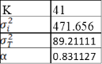

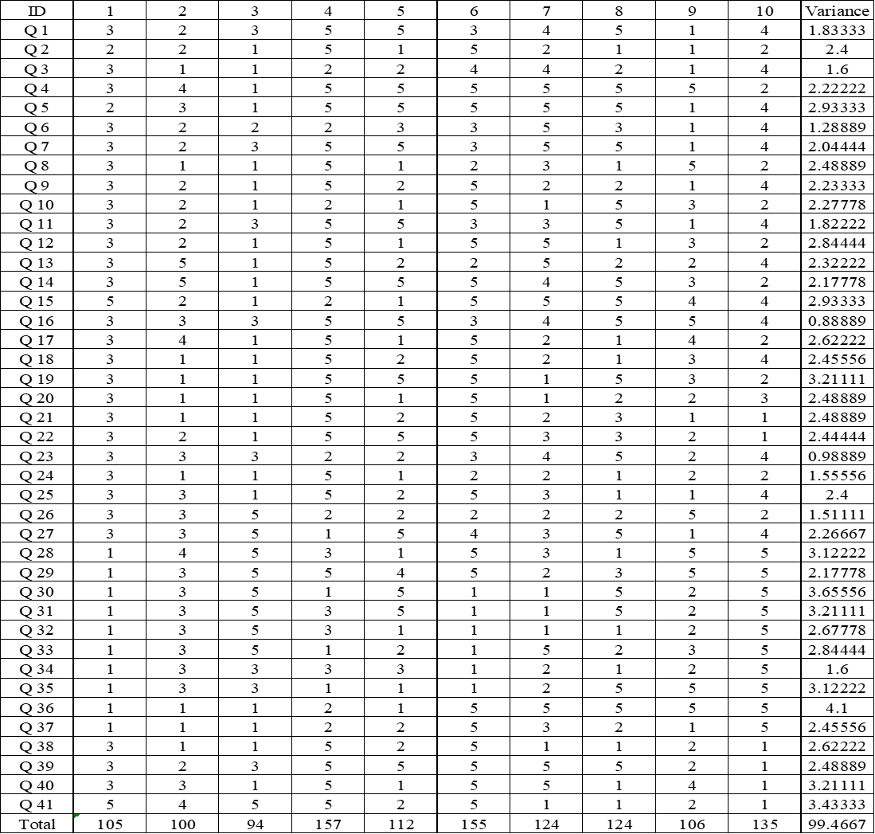
  - Qablan
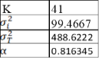
summary :

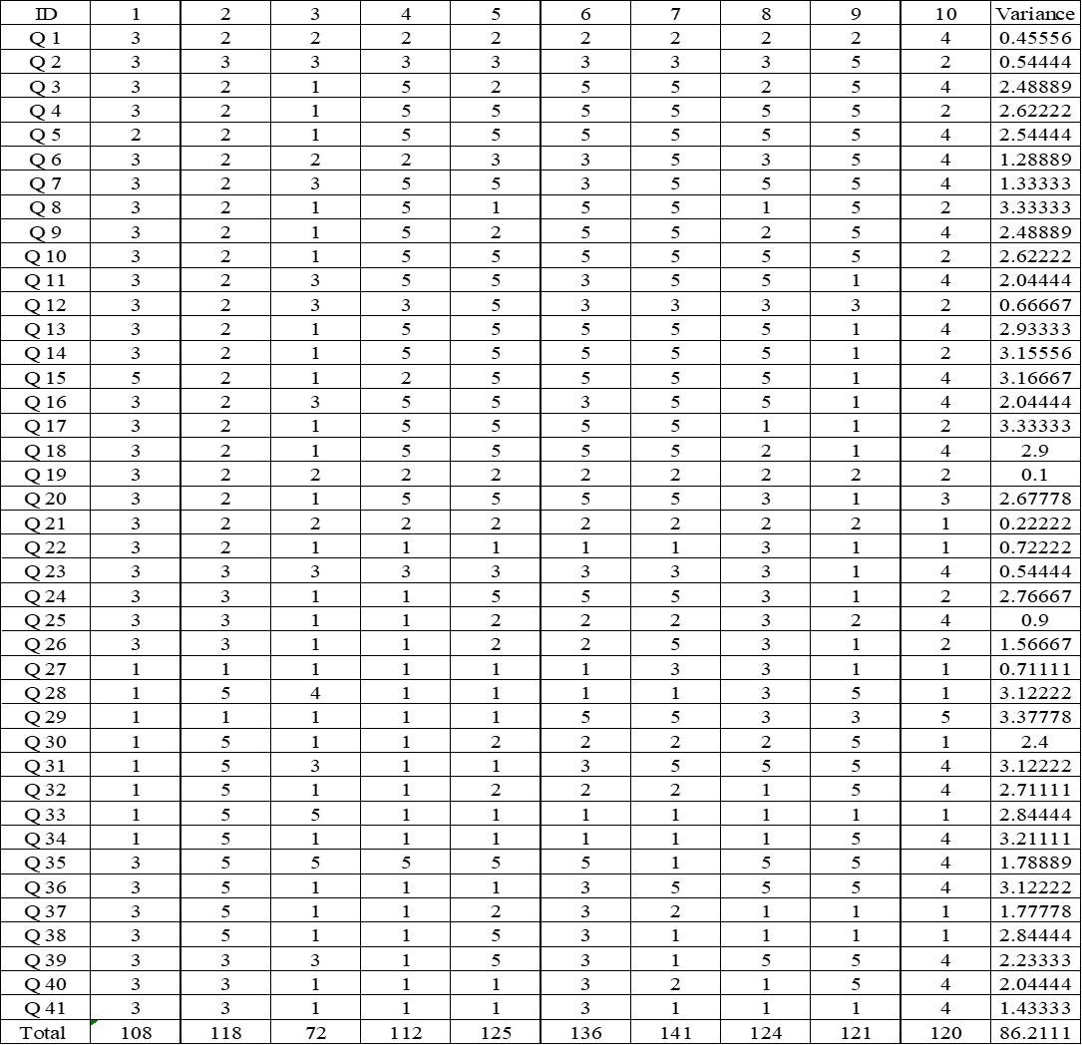
  - Aqraba
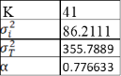
summary:

  - Beita
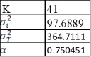
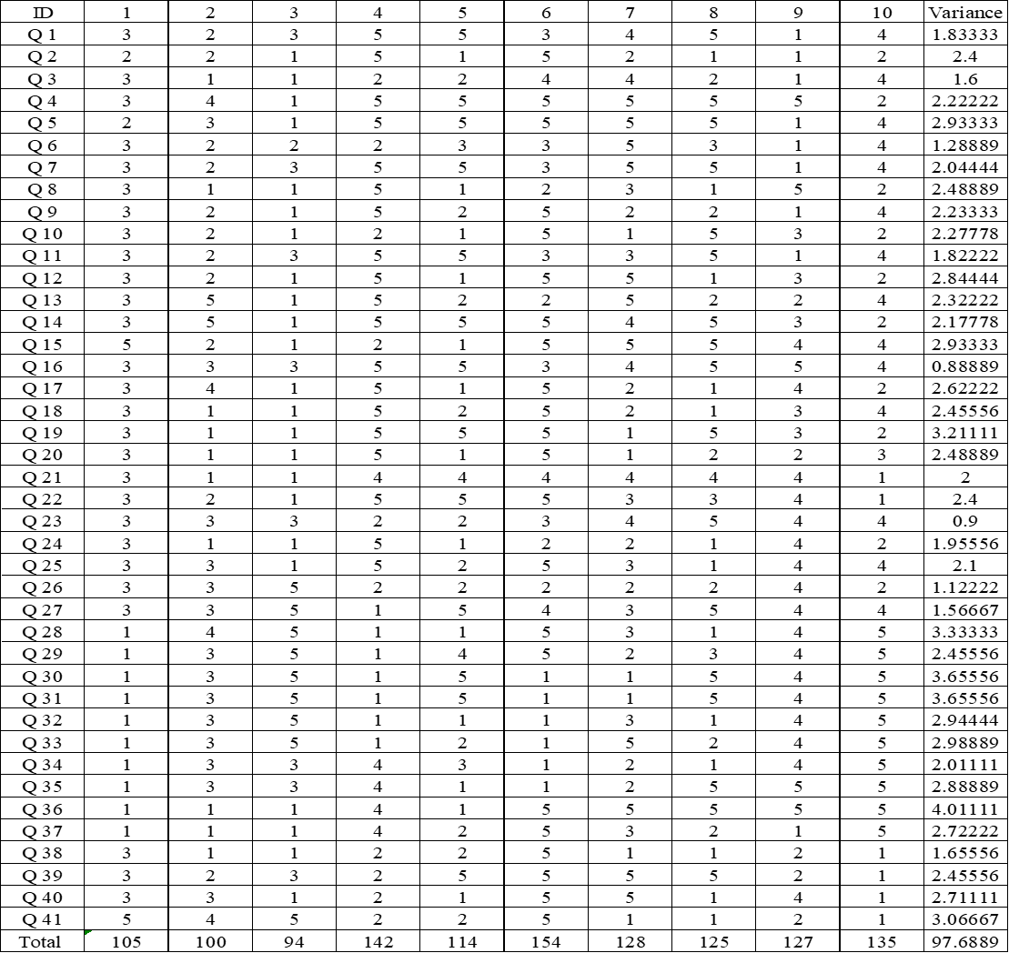
summary :

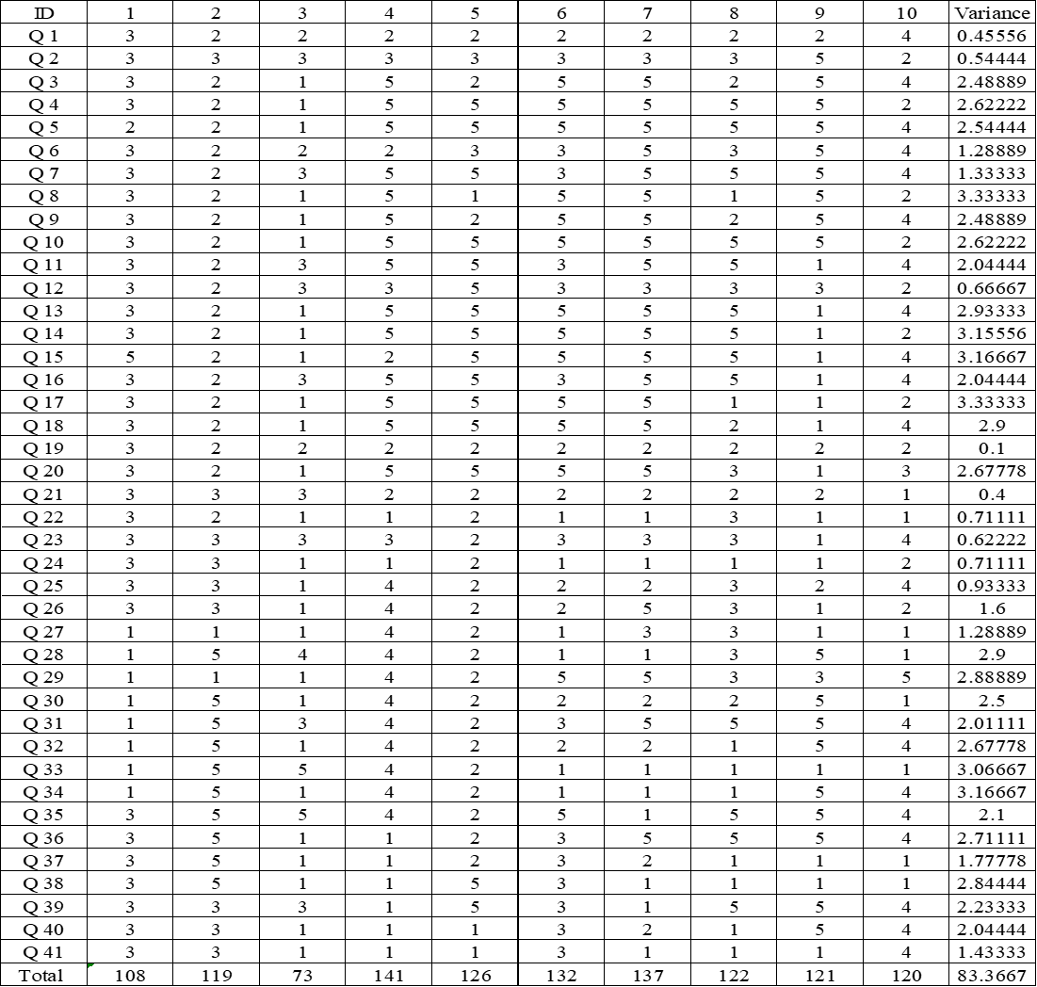
  - jammain
summary :
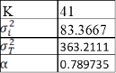

Appendix D

Risk Index Calculation Resulting Using AHP method.
- Huwwara
Summary:

λmax | 13.08
CI | 0.09
RI | 1.54
CR | 0.06
CR<0.1 | Accepted
∑ Weight | 1.00

Summary:
λmax | 13.67
CI | 0.15
RI | 1.54
CR | 0.09
CR<0.1 | Accepted
∑ Weight | 1.00

Summary:
λmax | 12.66
CI | 0.06
RI | 1.54
CR | 0.03
CR<0.1 | Accepted
∑ Weight | 1.00

Summary:
λmax | 13.30
CI | 0.11
RI | 1.54
CR | 0.07
CR<0.1 | Accepted
∑ Weight | 1.00

Summary:
λmax | 13.88
CI | 0.17
RI | 1.54
CR | 0.09
CR<0.1 | Accepted
∑ Weight | 1.00

Summary:
λmax | 13.29
CI | 0.11
RI | 1.54
CR | 0.07
CR<0.1 | Accepted
∑ Weight | 1.00

Summary :
λmax | 13.46
CI | 0.13
RI | 1.54
CR | 0.08
CR<0.1 | Accepted
∑ Weight | 1.00

Summary:
λmax | 13.76
CI | 0.16
RI | 1.54
CR | 0.09
CR<0.1 | Accepted
∑ Weight | 1.00

Summary:
λmax | 13.68
CI | 0.15
RI | 1.54
CR | 0.09
CR<0.1 | Accepted
∑ Weight | 1.00

Summary:
λmax | 13.37
CI | 0.12
RI | 1.54
CR | 0.08
CR<0.1 | Accepted
∑ Weight | 1.00

- Beita

Summary:
λmax | 12.29
CI | 0.02
RI | 1.54
CR | 0.01
CR<0.1 | Accepted
∑ Weight | 1.00

Summary:
λmax | 12.76
CI | 0.06
RI | 1.54
CR | 0.04
CR<0.1 | Accepted
∑ Weight | 1.00

Summary:
λmax | 13.14
CI | 0.10
RI | 1.54
CR | 0.06
CR<0.1 | Accepted
∑ Weight | 1.00

Summary:
λmax | 14.71
CI | 0.24
RI | 1.54
CR | 0.08
CR<0.1 | Accepted
∑ Weight | 1.00
Summary:
λmax | 13.71
CI | 0.15
RI | 1.54
CR | 0.10
CR<0.1 | Accepted
∑ Weight | 1.00

Summary:
λmax | 14.01
CI | 0.18
RI | 1.54
CR | 0.09
CR<0.1 | Accepted
∑ Weight | 1.00

Summary:
λmax | 13.91
CI | 0.17
RI | 1.54
CR | 0..09
CR<0.1 | Accepted
∑ Weight | 1.00

Summary:
λmax | 13.64
CI | 0.14
RI | 1.54
CR | 0.09
CR<0.1 | Accepted
∑ Weight | 1.00
Summary:
λmax | 12.89
CI | 0.08
RI | 1.54
CR | 0.05
CR<0.1 | Accepted
∑ Weight | 1.00

Summary:
λmax | 14.05
CI | 0.18
RI | 1.54
CR | 0.08
CR<0.1 | Accepted
∑ Weight | 1.00

- Aqraba
Summary:

λmax | 13.21
CI | 0.11
RI | 1.54
CR | 0.07
CR<0.1 | Accepted
∑ Weight | 1.00

Summary:
λmax | 12.62
CI | 0.05
RI | 1.54
CR | 0.03
CR<0.1 | Accepted
∑ Weight | 1.00

Summary:
λmax | 12.89
CI | 0.08
RI | 1.54
CR | 0.05
CR<0.1 | Accepted
∑ Weight | 1.00

Summary:
λmax | 13.87
CI | 0.17
RI | 1.54
CR | 0.09
CR<0.1 | Accepted
∑ Weight | 1.00

Summary:
λmax | 12.69
CI | 0.06
RI | 1.54
CR | 0.04
CR<0.1 | Accepted
∑ Weight | 1.00

Summary:
λmax | 13.04
CI | 0.09
RI | 1.54
CR | 0.06
CR<0.1 | Accepted
∑ Weight | 1.00

Summary:
λmax | 13.77
CI | 0.16
RI | 1.54
CR | 0.10
CR<0.1 | Accepted
∑ Weight | 1.00

Summary:
λmax | 14.45
CI | 0.22
RI | 1.54
CR | 0.14
CR<0.1 | Accepted
∑ Weight | 1.00

Summary:
λmax | 14.64
CI | 0.24
RI | 1.54
CR | 0.09
CR<0.1 | Accepted
∑ Weight | 1.00

Summary:
λmax | 15.43
CI | 0.31
RI | 1.54
CR | 0.09
CR<0.1 | Accepted
∑ Weight | 1.00

- Qabalan

Summary:
λmax | 12.91
CI | 0.08
RI | 1.54
CR | 0.05
CR<0.1 | Accepted
∑ Weight | 1.00

Summary:
λmax | 15.37
CI | 0.30
RI | 1.54
CR | 0.07
CR<0.1 | Accepted
∑ Weight | 1.00

Summary:
λmax | 14.75
CI | 0.25
RI | 1.54
CR | 0.08
CR<0.1 | Accepted
∑ Weight | 1.00

Summary:
λmax | 13.85
CI | 0.16
RI | 1.54
CR | 0.10
CR<0.1 | Accepted
∑ Weight | 1.00

Summary:
λmax | 14.25
CI | 0.20
RI | 1.54
CR | 0.08
CR<0.1 | Accepted
∑ Weight | 1.00

Summary:
λmax | 14.42
CI | 0.22
RI | 1.54
CR | 0.09
CR<0.1 | Accepted
∑ Weight | 1.00
Summary:
λmax | 15.28
CI | 0.29
RI | 1.54
CR | 0.08
CR<0.1 | Accepted
∑ Weight | 1.00
Summary:
λmax | 15.07
CI | 0.27
RI | 1.54
CR | 0.06
CR<0.1 | Accepted
∑ Weight | 1.00

Summary:
λmax | 14.09
CI | 0.190
RI | 1.54
CR | 0.09
CR<0.1 | Accepted
∑ Weight | 1.00

Summary:
λmax | 13.85
CI | 0.16
RI | 1.54
CR | 0.10
CR<0.1 | Accepted
∑ Weight | 1.00

- Jammaein

Summary:
λmax | 12.74
CI | 0.06
RI | 1.54
CR | 0.04
CR<0.1 | Accepted
∑ Weight | 1.00

Summary:
λmax | 12.93
CI | 0.08
RI | 1.54
CR | 0.05
CR<0.1 | Accepted
∑ Weight | 1.00

Summary:
λmax | 12.27
CI | 0.02
RI | 1.54
CR | 0.01
CR<0.1 | Accepted
∑ Weight | 1.00

Summary:
λmax | 12.76
CI | 0.06
RI | 1.54
CR | 0.04
CR<0.1 | Accepted
∑ Weight | 1.00

Summary:
λmax | 13.82
CI | 0.16
RI | 1.54
CR | 0.09
CR<0.1 | Accepted
∑ Weight | 1.00

Summary:
λmax | 13.55
CI | 0.14
RI | 1.54
CR | 0.09
CR<0.1 | Accepted
∑ Weight | 1.00

Summary:
λmax | 13.88
CI | 0.17
RI | 1.54
CR | 0.09
CR<0.1 | Accepted
∑ Weight | 1.00

Summary:
λmax | 13.74
CI | 0.15
RI | 1.54
CR | 0.10
CR<0.1 | Accepted
∑ Weight | 1.00
Summary:
λmax | 13.31
CI | 0.11
RI | 1.54
CR | 0.07
CR<0.1 | Accepted
∑ Weight | 1.00

Summary:
λmax | 13.35
CI | 0.12
RI | 1.54
CR | 0.08
CR<0.1 | Accepted
∑ Weight | 1.00

Appendix E

Risk Index Calculation Resulting Using AWM method.

Huwwara

- Beita

- Aqraba

- Qablan

- Jammain

جــــامعــــــــة النجاح الوطنية
كليـــــة الدراســــــــات العليــــــا
تقييم وإدارة المخاطر للطرق الحضرية القائمة – حالة دراسية: بلديات جنوب نابلس

إِعداد
عدي جمال مصطفى عودة

إشراف
د. أمجد عيسى
د. جمال الدبيك
قدمت هذه الرسالة استكمالاً لمتطلبات الحصول على درجة الماجستير في برنامج هندسة الطرق والمواصلات، من كلية الدراسات العليا، في جامعة النجاح الوطنية، نابلس- فلسطين.
2025\2026

تقييم وادارة المخاطر للطرق الحضرية القائمة

حالة دراسية : بلديات جنوب نابلس
اعداد
عدي عودة
المشرفيين
د.امجد عيسى
د. جمال دبيك

الملخص
خلفية: تنطوي مشاريع إنشاء الطرق على قدر كبير من المخاطر نظرًا لانتشارها على مساحة جغرافية واسعة وتعرضها لظروف تحت الأرض. يُمكن تعريف المخاطر بأنها حدث يتسم بعدم اليقين، ويُقاس هذا عدم اليقين باحتمالية حدوثه. يُمكن أن تؤثر المخاطر بشكل كبير على أي جانب من جوانب المشروع، لا سيما تكلفته أو مدته أو نطاقه. يُساعد فهم المخاطر في المراحل المبكرة من المشروع مديري المشاريع على تقليل آثارها وإنجاز المشروع بكفاءة أكبر. يُمكن تحقيق ذلك من خلال إدارة المخاطر بشكل سليم. تشمل عملية إدارة المخاطر تحديد المخاطر وتحليلها وتطبيق أساليب للحد منها..
الأهداف: الهدف الرئيسي من البحث هو تقييم وإدارة المخاطر للطرق الحضرية القائمة بعد التنفيذ وما يترتب من دور للاحتلال الإسرائيلي المتعلقة بقطاع الطرق والمواصلات في جنوب نابلس، وخصوصًا بلدات حوارة وبيتا وقبلان وجماعين وعقربا و تتمثل الأهداف الرئيسية للبحث في تحديد وتحليل عوامل الخطر، وشدتها، وتوزيعها من وجهات نظر مستخدمي الطرق والمشاة والسائقين والمالكين والمقاولين والبلديات؛ واقتراح تدابير الوقاية من المخاطر والتخفيف من آثارها؛ وتعزيز مرونة الطرق في البلديات المستهدفة.
المنهجية: استُخدمت في هذا البحث المنهجية الكمية والنوعية، وتمت مراجعة الأدبيات. كما تم إجراء مقابلات مع عدد من ممثلي البلديات والمؤسسات والوزارات، وتم إجراء تحليل وعمل نماذج باستخدام أنظمة المعلومات الجغرافية، وتحليل فني عن طريق المصفوفة وقياس شدة معامل الخطر.
النتائج الرئيسية: تُظهر النتائج أن العوامل السياسية والإغلاقات وزيادة حركة المرور على طرق دون أخرى، وعدم وجود تصريف مياه بشكل كافٍ، وكذلك عدم مراعاة أمور التصميم بالشكل السليم، وكذلك عدم اجراء الصيانة الدوريه تؤثر على شبكة الطرق. وتؤكد النتائج أن البلدات التي تتبع معايير التصميم بالشكل السليم وتتابع إجراءات الصيانة يكون معامل الخطر فيها متدنياً مقارنةً بالبلديات الأخرى.
الاستنتاجات من الدراسة: تشير النتائج إلى أنه بعد إجراء الاستطلاع وأخذ آراء الجمهور، ولا سيما السائقين ومستخدمي الطرق في الاعتبار، تم اقتراح عدة توصيات لتقييم الوضع الحالي لمشاريع الطرق بعد تنفيذها. وبعد حساب عامل المخاطرة للبلديات بطرية التحليل الهرمي ، تبين أن بلدية عقربا هي الأقل خطورة (1.94)، تليها بلدية قبلان في المرتبة الثانية (1.96)، ثم بلدية حوارة في المرتبة الثالثة (2.53)، ثم بلدية بيتا في المرتبة الرابعة (2.70)، وأخيراً بلدية جماعين في المرتبة الخامسة (2.97).
الكلمات المفتاحية : شبكة الطرق في الضفة الغربية، القيود المفروضة على التنقل في إسرائيل، عوامل الخطر في النقل، التخطيط لحالات النقل الطارئة.

