CHAPTER ONE
Introduction
  - Overview
This chapter introduces an overview about our system; it reveals the importance of using our system for doctors and patients, gives a background on how to use it and then it shows the UML diagram of our database.

  - Background

Location-aware medical alarm mobile system consists of three main parts:

Part 1: Backend System: includes a database for all patients, store about each patient his important information like blood, his illnesses, important drugs, allergies.....

Part 2: Web interface for Management (can be used by the doctor or the hospital): the doctor is the only one who can edit patient's data.

Part 3: Mobile Application for Patients:
- Main Features :
- The mobile application will have an icon that the patient can click on it when he feels bad, this icon is a part of our program, and it will take the GPS location and send it to the doctor's web interface as an ALERT.
- The most important, it'll show the patients data, so that if any emergency happens, the ambulance or surrounding people will know how they will treat him. In other words his mobile will act as a medical information card.
- Accessories :
- A medication reminder (prescription service) to get his medicine on time. It is a fully customizable reminder application that allows your doctor to specify what drugs the patient take and reminds him when to take them on time.
- Booking an appointment through his mobile. This service ideally suited to doctors who run with daily appointments. With the ability to limit bookings to a specific block of dates. Doctor can cancel any date and automatically send SMS message to patient’s phone telling him about cancelling his date.
- Send two copies of SMS messages one for doctor and the other for patient’s friend in case of requesting emergency.

According to our website, we bought a real domain so you can visit it any time by just clicking on the link www.healthyallthetime.com . This website helps doctors to add new patients, update their medical information, drug information and their appointments. Critical information about patient must be saved on database such as Allergies, Previous Surgery, Blood Type and Chronic Diseases. This data will be send to the phone application as medical history. Also, it will be shown on the website in a flipping book designed in a wonderful and user friendly way.

  - When to use our application
- What if you need immediate assistance but for some reason you cannot talk?
- What if you had an accident but you're not able to clearly explain where you are?
- In an emergency, you may not be able to speak and give vital information to alert others about your special health needs. Medical providers must sometimes treat emergency patients without any way to contact someone who could provide vital information about that patient.

  - Backend system of our project
Backend system includes a database for all patients, this database consist of 6 tables:
- Patient info table :
Includes Patient name, Age, Identity number, Allergies, Blood type, chronic diseases and user name.
- Doctor info table :
Includes his name, Specialization, Age and Password to get access to his website.
- Drug info table
Includes Patient id, Drug name, Prescription, Start time, period, Number of times.
- Login table
Includes User name, Password, and Mobile number.
- Booking date table
Includes Patient id, date, and time of booking.
- GPS info table
Includes Longitude, Latitude, and User name of patient.
Figure 1.1 shows the tables in MySQL database.
This database is used as intermediate between the website and our mobile application. The mobile will get access to this database to send and retrieve information needed, also the website will use it to show ,update or delete data according to doctor’s vision .
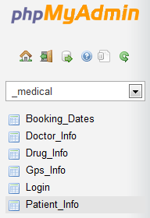
Figure 1.1

  - UML Diagram.
Figure 1.2 shows the UML diagram for Logging in.
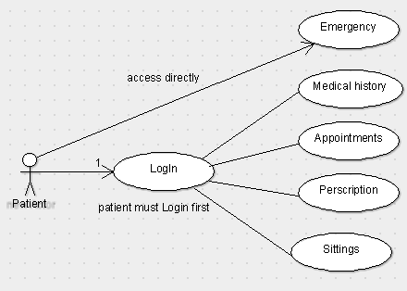
Figure 1.2

Figure 1.3 shows the UML diagram for HTTP connection.
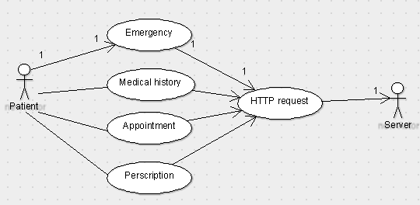
Figure 1.3

  - Summery
This chapter introduced a general view of whole project, starting from our project parts and a brief description of each part. Then it described when to use our application and discussed in details the backend system of our project and finally it shows the UML Diagram for logging in and HTTP connection between mobile and the web server.

CHAPTER TWO
Mobile Application Part

  - Overview
This chapter introduces a detailed description of mobile application side, its features and services which help patient in his life. Furthermore, it shows the implementation of each service and describes the benefit of each one.

  - Login to application
In simple terms, data security is the practice of keeping data protected from corruption and unauthorized access. The focus behind data security is to ensure privacy while protecting personal or corporate data. In our application, once logged in, you have various given privileges until logging out. However, to improve the security and increase authentication patient must logged in using his/her user name and password then he/she will be able to access medical history, appointments, and prescription services except emergency service which you can access it directly without requiring a user name and password. Figure 2.1 shows login page of our application.

.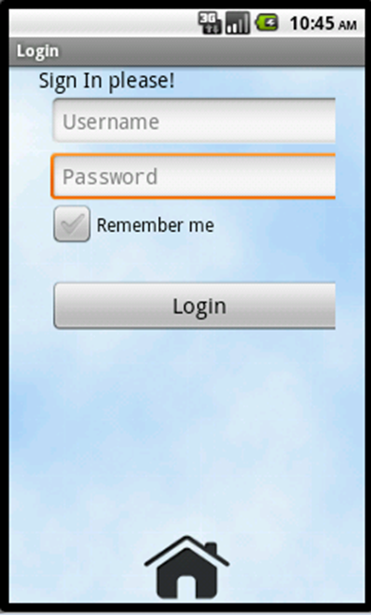
Figure 2.1

By clicking on login button after entering user name and password will send http request to the server. We used JSON to encode the data and send it from mobile to the server which will decode data and check it.
Let us take an example; Huda is a patient want to see her medical info. All that is required is to touch medical history button, then a login activity will appear asking her to enter her user name and password as shown in Figure 2.2.

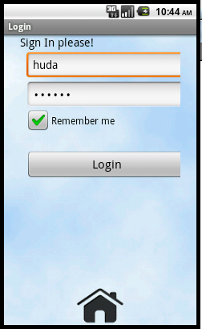
Figure 2.2

When the patient click on login button, the first thing we must make sure that user name and password are not set to null! The next step is to make HTTP request in order to communicate between the web server and our mobile application.

The next steps are on server side; a PHP page must receive the request and connect to MySQL database to return the response.

After confirming the user name and password for Huda, she will get access to her medical history easily and return to home page of the application as shown in figure 2.3

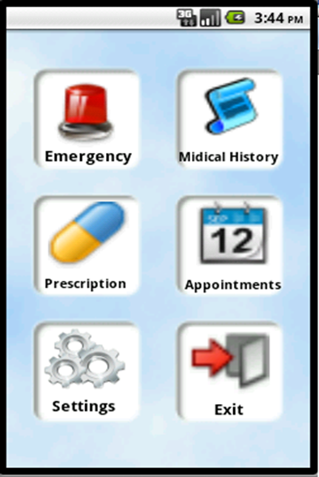
Figure 2.3

Figure 2.4 shows the HTTP connection between mobile client and the web server

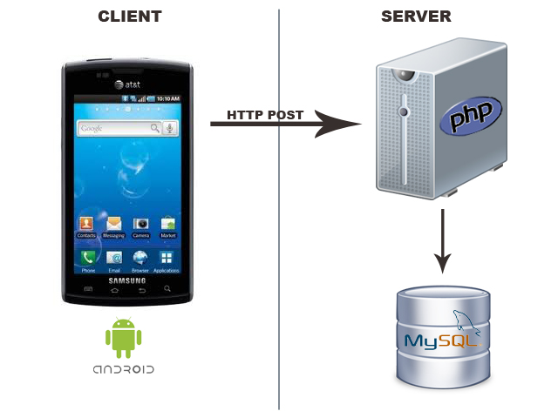
Figure 2.4

Problems come out of our hands:
In order to login, the application should send HTTP request on the server side, so internet connection is essential in this step and if there is no internet access then this step will not complete and patient will not access his medical history, Appointment and emergency services.

  - Emergency service
Patient can use emergency service whenever he needs medical assistance, had an accident or for some reason he cannot talk or cannot able to clearly explain where he is.
Figure 2.5 shows how to get access to this service.

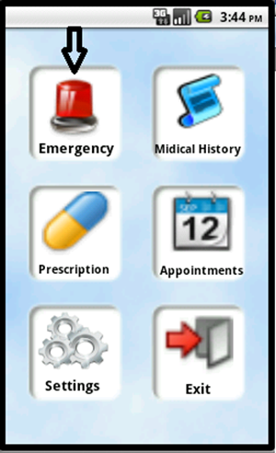
Figure 2.5
In case of any emergency accident, this service helps the patient to notify his doctor that he needs help and sending his location to doctor’s website. The patient can access this service in an easy way, it does not require him to sign in with a user name and password, instead of this, his name is stored on his mobile via shared preferences in settings feature. What the patient has to do is just touch this button, then the button will handle an event that do the following:

• Mobile side:

We had implemented a class called emergency.java which does the following:
1- A text message will be send to the doctor’s mobile telling him that this patient needs help.
2- Another text message will be send to another mobile number such as the patient’s friend or his closest person, this mobile number is specified and saved in settings feature so that it allows patient to change the number easily.

Figure 2.6 shows the message sent from patient’s mobile to doctor’s mobile.

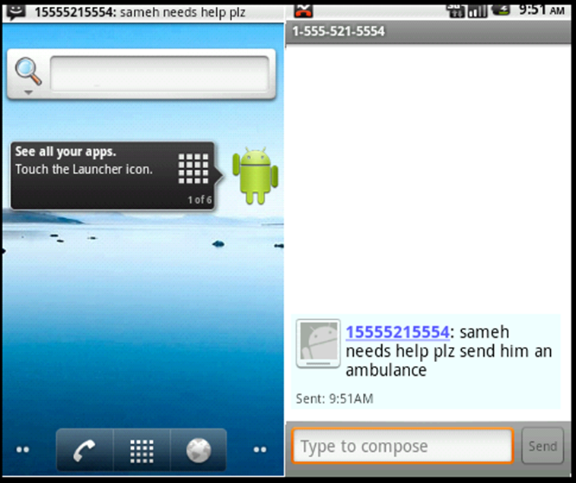
Figure 2.6

- Also this button will send the GPS coordinates (Longitude and Latitude) to web server via http request.

This is done by embedding these values in URL like this
request.setURI (new URI (http://healthyallthetime.com/GoogleMap.php? Longitude= +Longitude+"&Latitude="+Latitude+"&username='"+str_user+"'"
));
Then sending the data via http get method.

- server side :

We wrote a PHP code in server side to receive the coordinates and store them in MySQL database. In GoogleMap.php we wrote a java script code to map these coordinates with Google maps, we used the map in this website http://www.openstreetmap.org.

In order to embed Google maps in our web pages we signed up for Google Maps API and we got a key that allows us to use these maps.
The map which holds the patient’s location will appear in a div on each page on our website each time a button is pressed. We used Ajax to listen to MySQL database and alert the pages of our website if new values of coordinates added in the database and request the map on real time in a div associated with the patient’s name and the time the button is pressed as shown in figure 2.7. Also, a sound alert is embedded in the website to play at the same time the emergency button is pressed.

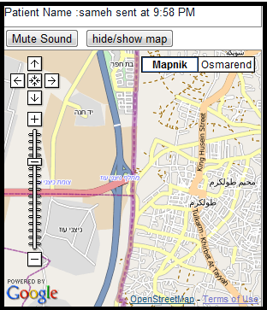

Figure 2.7

Also our website takes in consideration a case if more than one patient press the button at the same time so it can shows the maps of maximum 4 patients requesting help at the same time as shown in figure 2.8.
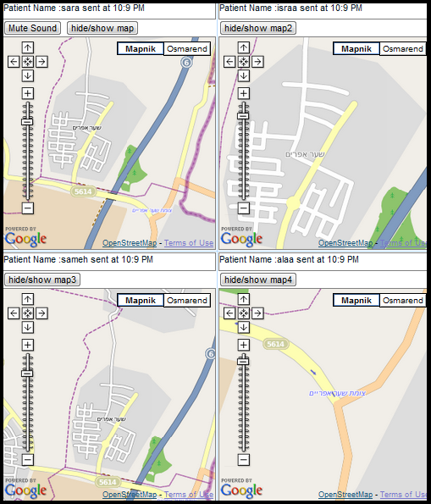
Figure 2.8

Note:
- Patient name will be send with his location to the web server; this name is stored in the mobile via shared preferences after the patient signed in.
- The maps will appear automatically on any page on the website without refreshing that page; it will automatically scroll down to show the map.

Problems and solutions:

- There is no clear maps for Palestine on Google maps, so we are restricted with these maps which are not accurate to show the exactly location of the patient, it only shows the street name. We thought to build our own maps of Palestine but doing this took much time and it is very difficult! So we stayed on using Google maps.

- First we wrote a code which gets the current location and send it to MySQL database but we faces a problem that Mobile does not support GPS inside home or some places .we got over this problem by changing the code which tracks the GPS location and take the last value of GPS coordinates stored in the device. In this case, no worry about the location of the patient if he is inside a building.

  - Medical history card service
In the event of an emergency or travelling, having information such as medical conditions, medications, allergies, and medical tests easily available avoids delays in treatment and costly mistakes.

This feature allows medical history to be available at the patient’s fingertips whenever he needs it.
We take in consideration the security issues concerned with patient, because his medical information is sensitive and critical, no one can access it without his permission. To make sure this kind of security, a user name and password are required when he press on medical history button. After confirming the user name and password the patient will get access to his information in an easily way. See figure 2.9

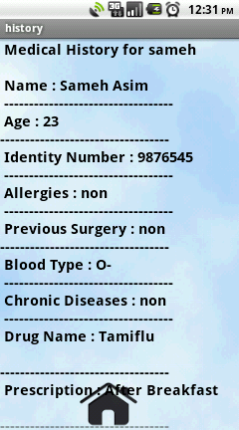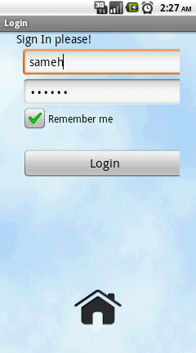
Figure 2.9

Note: confirming user name and password is done by sending them to web server database after pressing on login button. If they are correct and match the data stored in the database, a confirmation will be send from website to mobile allowing the user to get his information.

- Mobile side :

In this side we used threads which request all the medical data from a PHP page. In order to communicate between the web server and our application we used http post request. Once a user name and password entered in login page a communication between web server and mobile starts, then the application will redirect the user to a page showing his medical history.

We used 2 classes:

- RequestThread.java class
In this class we wrote a code to retrieve data from web server using HTTP Post method also we used JSON object which sends username and password to web server and verifies if they are accurate then return the result to mobile.

- History.java class.
Here we define a thread to request data, this thread is an instance of RequestThread class, we use this method instead of HTTP Post method because it is faster for retrieving large data.

- Server side :

We wrote a PHP code in medical_history.php page to send all data concerned with patient. These data is requested according to user name and password entered in login page on his mobile.

  - Prescription service
One of the more frustrating aspects of patient care is when patients do not follow medication instructions once they leave the hospital or clinic. Research shows that as many as 50 percent of patients fail to follow the treatment prescribed by their doctors, which can undermine treatment already given.
By using this service, the patient will never forget to take his drugs and he will not need any body to remind him about all these.
Our application allows pharmacists and physicians to send medication reminders to patients over their mobile phones.

Figure 2.10 shows a captured image after pressing on Prescription button.

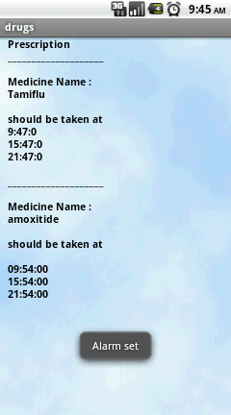
Figure 2.10

• Mobile side:
We implemented this button using 3 classes:
1. Alarm.java class
This class creates a media player object and impedes a sound alert that start when the time of medicine begin, also it contains an alert dialog which holds a notification of medicine time.

2. Drug.java class
This class does many things. First, it brings the data from web server such as medicine name, period, start time and the number of times the medicine should be taken.
Also it contains functions to set alarm at a specific time depends at appropriate intervals prescribed by the doctor, this function uses alarm manager class which provides access to the system alarm services.

3. Alarm Receiver.java class
The role of this class is to broadcast the alarm when it goes off and allows the alarm to work in the background even if the application is closed.

4. DbAdapter.java class

This class uses SQLite database in order to store the values of the data received from web server, and updates them if the doctor updates these data .it provides methods to open, query, update and close the database. Also, it provides insert, update and delete methods.

When the time of drug came in, an alert will appear saying that you should take your medicine at that time and the application will directly open and redirect to reminder tap to show his drugs and the time to take each one as shown in Figure 2.11

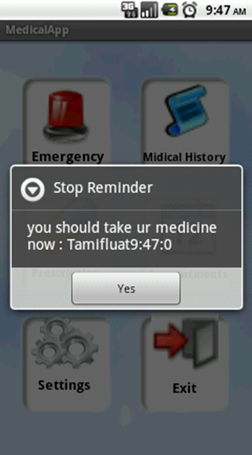
Figure 2.11

• Server side
In this side we wrote a php code in Alarm.php page which sends the Drug name , number of times , start time and period to mobile in order to use them for reminding .

Problems:
We face a problem in this part that if the time occurs in the past the alarm will be triggered immediately. We solved this problem by adding a piece of code that allows the alarm to set only at the time specified by the doctor.

  - Appointments service
Another important feature of our phone application is booking system. Our booking system can be accessed from anywhere through our application, Booking a visit to a doctor through the Internet means that patient have greater access to doctor schedules. Booking Application can show the patient a range of scheduling options that would be difficult to obtain over the phone call. Patient can see exactly when each appointment start and end.
More people use phone applications to make appointments. Let us explain the simple steps to make an appointment using our application. Figure 2.12 shows a view of appointment service.

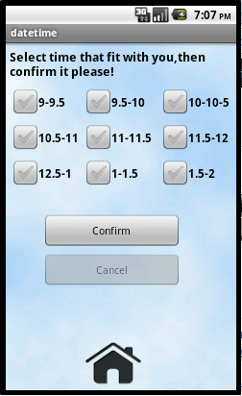
Figure 2.12

In the figure 2.12, you can see that all checkboxes are enabled which means that all times are available to the patient, any patient can choose any time of these choices and confirm it by clicking on confirm button, by this step an Http request will be sent to the server side in order to save patient’s username, time and date of the day.
In the figure 2.13 the patient can’t book appointment from 11-11.5, the check box is disabled which means that another patient book this appointment, we can guarantee that no more one patient can book the same time.
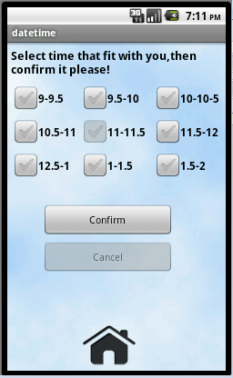
Figure 2.12
Each time patient opens the Appointments an http request will be send to the server side asks it which time is booked by others - checkbox will be disabled- and which time is free, so patient can book the time that is free only. Patient can book one appointment only. After confirming the appointments the cancel button becomes enabled, which gives the patient ability to cancel the appointment if he couldn’t make it.
In figure 2.13, you can see the steps of booking a date.
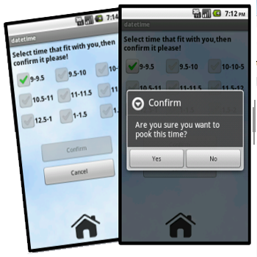
Figure 2.13
Figure 2.14 shows a view after confirming the appointment .for more flexibility patient can cancel his appointments so other patients can book it!
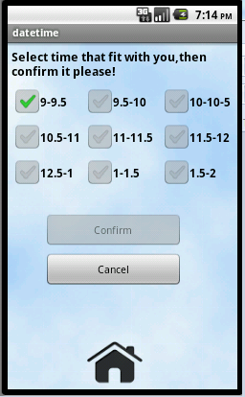
Figure 2.14

  - Settings and Exit feature
    - Settings Feature
As we said if patient needs some help he will use our app to click on the emergency button in order to send his GPS location to the server side so they could send him a help, also we said that emergency button must be accessed directly, no need to login first. But how server side will recognize that patient? We need a way to send patient’s name to the server side in case of emergency situation.
We created Settings activity; when patient sends his GPS location, extra info will be send such as patient’s username. Patient must save his user name and the doctor’s phone number in addition to family phone number in his mobile, so the two phone numbers will receive SMS messages from the patient in emergency situations. See figure 2.15

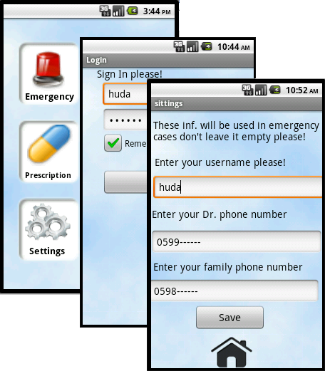
Figure 2.15
Username and phone numbers will be saved in the device data base, user should save them once and he could update them any time he wants. We used Shared Preferences to save the data in the device’s database. The Shared Preferences class provides a general framework that allows us to save and retrieve persistent key-value pairs of primitive data types. We can use Shared Preferences to save any primitive data: Booleans, floats, integers, longs, and strings. This data will persist across user sessions (even if our application is killed).

    - Exit
Figure 2.16 shows the Exit button which will exit the application, in sign out in websites, to increase protection level we create this button to prevent an unauthorized access to the application. Because medical information is very sensitive we must protect it from being accessed by others.

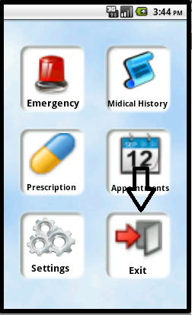
Figure 2.16

  - Summery
In this chapter we discussed in details the mobile application side, its features and services, problems and solutions for some of them and it gave instructions on how to use each service and in what situations. Moreover, it discussed the implementation of each service.

CHAPTER THREE
Web Server Part

- Overview
This chapter introduces a detailed description of our medical website for doctors, and how the doctor will get benefit from this website specially in managing his patient’s data. Also, it describes the implementation of the website.

- Website Management
Our online website www.healthyallthetime.com manages patient’s data in a flexible and user friendly way. Figure3.1 shows the interface of home page of this site.
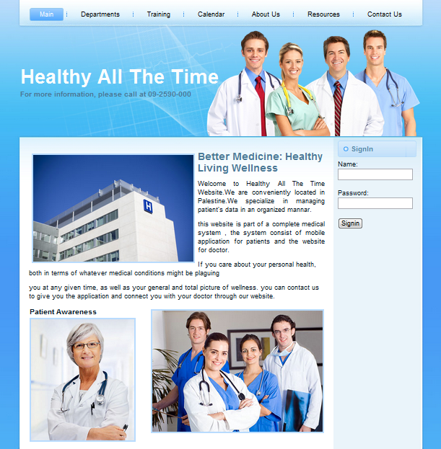
Figure 3.1

As you can see from figure 3.1, the doctor must login to be able to access patient’s data. This is done to ensure privacy and security for the doctor and his patients.
After checking and verifying doctor user name and password, the website will redirect to home page as you see in figure 3.2.

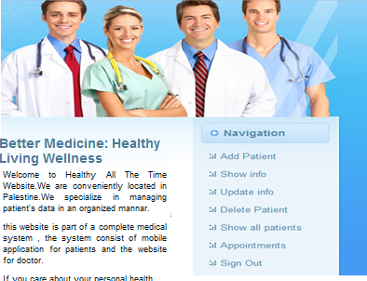
Figure 3.2

From figure 3.2, you can see that the doctor can manage patient’s data in many ways. For example, he can add new patient, update patient’s info, delete a patient, show all patients and their info in a flipping book, and show booking dates and appointments. The next sections describe each one in details.

- 1 Add new patient
In this part doctor can add new patient with new personal information such as patient’s name, identity number and Age, medical information such as Blood type, Allergies, previous surgery and chronic disease, Drug info such as drug name, prescription, time and period. And info for the mobile application such as phone number, username and password. Figure 3.3 shows a view of this page.
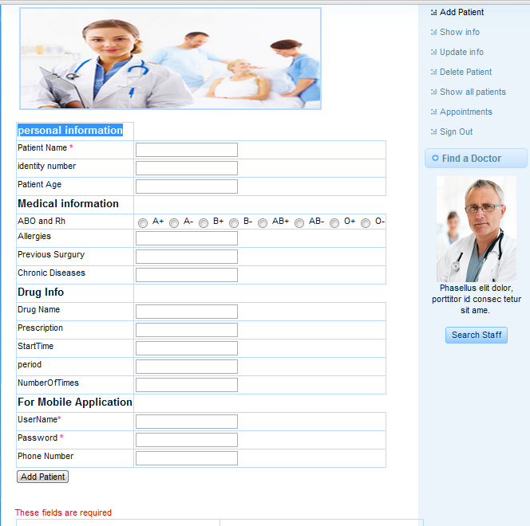
Figure 3.3

    - Delete patient
Simply the doctor can delete patient’s info by entering his user name and id as shown in figure 3.4. In this case, the patient could not use his mobile application to get his medical history, appointments or prescription.

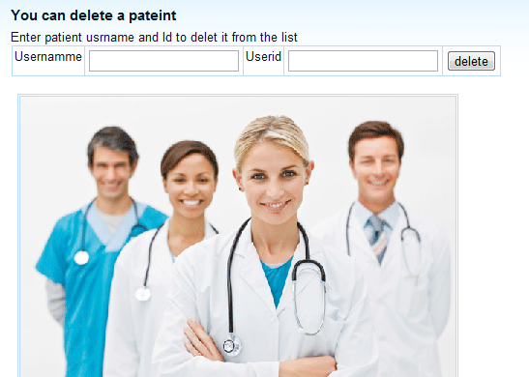
Figure 3.4

    - Update patient’s info
If a doctor want to update patient’s info he will do that easily, all what he needs to do is to enter the user name of patient then all his information will appear in text boxes, so doctor could update them.
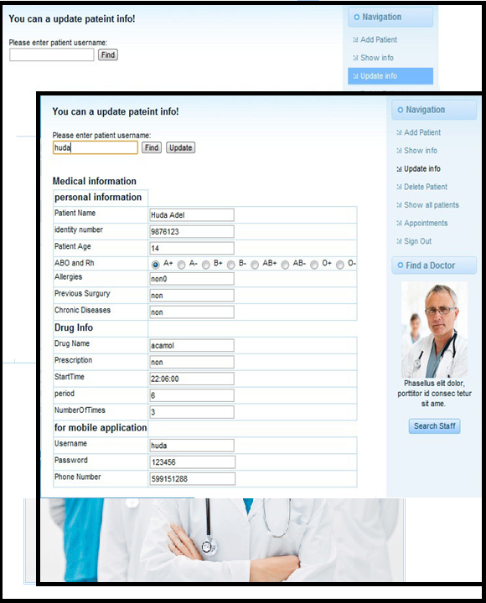
Figure 3.5

    - Appointments
Another important part in the website is the Appointments .In the mobile app a patient can book a date, here the doctor can check out all the appointments, add a new booking date, or cancel it and alert the patient using SMS service. Using this part of our website is very easy; you can see a view in figure 3.6.

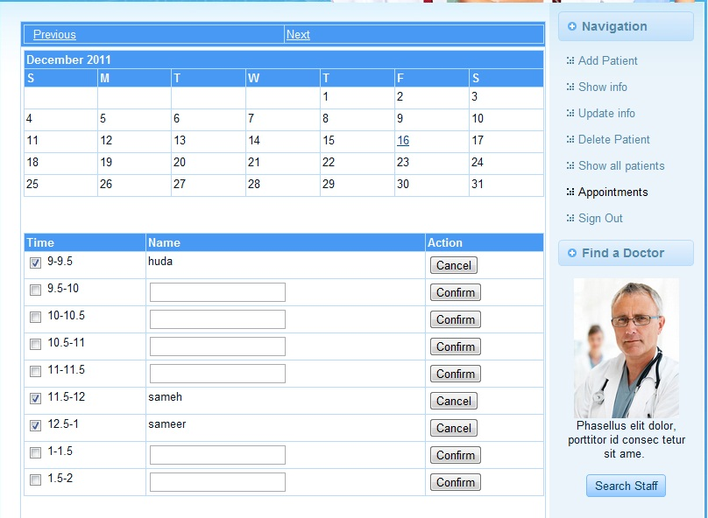
Figure 3.6

One of our website features is sending an SMS message to the patient’s phone if the doctor cancels his date, telling patient that his appointment was canceled for some reasons.
    - Show all patients
This page displays a table of all patients registered in doctor’s web server.

    - Show patient’s info in a flipping book
In our website the patient’s medical history appear in a flipping book which lets the doctor to review the patient’s data in a wonderful and easy way by just clicking on the next button to flip the page and view the next one. See figure 3.7.

Each page of this book provides detailed information about the patient such as his name, age, sensitive information, booking dates, drugs taken … etc.

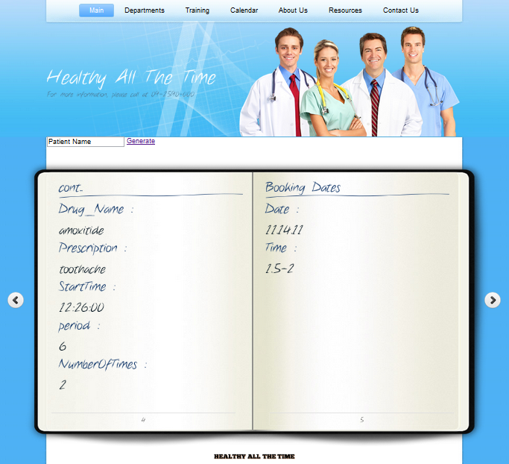
Figure 3.7

We built the book using Jquery tool and JavaScript files to configure the book interface , book pages and the contents .

Why did we use a flipping book?
Using a flipping book gives a good user interface and allows doctor to access patient’s data quickly and in an organized manner. The doctor just enter patient’s name in a text field then the medical history will be generated on this book automatically after clicking on Generate link.

- Summery
In this chapter, we have discussed the web server side. Then we introduced each part of website in details and explained how doctor can use it.

CHAPTER FOUR
Used Tools and Programming Languages

  - Overview
This chapter discusses the programming languages used to build our project and the used tools. Also, it introduces reasons of why do we choose these languages over other ones.

  - Programming languages
Here is a list of programming languages we used for our project:
- JavaScript
- PHP
- JQuery
- Java for Android
- HTML
- AJAX
- JSON
- CSS

  - Platform for mobile
We used Android 2.2 Platform.

- Why did we choose android platform?
Android OS is already available on many devices such as HTC, Motorola, and Samsung, while Apple only has one shape of Apple iPhone.
On the other hand, almost all carriers have android devices on their line ups. However, Apple iPhone is generally available with limited number of carriers.

- Why did we choose PHP language?
- PHP is a flexible language. Use OOP or not. Use naming conventions or not.
- It runs on many different operating systems.
- It can be optimized, even compiled for performance closer to that of more established compiled languages.
.

  - Used Tools
- MySQL Database

We used MySQL over Oracle for many reasons:
- MySQL is characterized as a free, fast, reliable open source relational database. However, oracle is costly and expensive compared with MySQL.
- MySQL is available on virtually all hosting companies. Oracle are only limited to large corporations due to licensing costs.

- Eclipse IDE for Java Developers
- Adobe Dreamweaver CS5.
- Android emulator platform 2.2

CHAPTER FIVE
Conclusion and Future Work

Mobiles have managed to become an inseparable part of everybody’s day to day life. Mobile phones offer us many things within its small attire that the technologies have almost touched every single need of human beings. This is an era of high-end smart phones, carrying an array of applications to make life easier. We are very proud to implement such application that aimed to increase health care in our country in effective way.

  - Conclusion
Millions of people in the world use the currently existing medical alert systems. The healthcare industry, today, is growing at unprecedented rates. In many countries in the world health care expenditures are projected to be many trillions a year. Our project offers services which cut down on the cost of having a nurse at home for elderly patients. Being a complete system which takes into consideration the patient's community of interest, our project offers a very fast alert system.

  - Motivation and Future Work
Our project is suitable for one doctor or one hospital, but what about connecting more than one hospital? In the next future we aim to connect all hospitals in our country together. So that if patient X treated in Nablus and he needs a help while he is in Al-Khalil then the nearest hospital must offer the help also information of the patients must be able to transfer from one hospital to another to guarantee maximum health care for patients, the next goal is making a center medical system in all Palestine.

