Outline
- Introduction
- Methodology
- Data analysis
- Identifying the responsibility of causes of claims perception of contractors
- Rate of Importance perception of owners
- Identifying the responsibility of causes of claims perception of owners
- Rate of Importance perception of contractors
- Recommendations
- Case study

Introduction
The aim of this research is to detect and analyze the factors that frequently cause claim in Nablus and Ramallah during the construction stage and allocation of causes for issuing construction claims

Methodology
The study will employ a questionnaire survey method. The data will be analyzed to identify the most important claims factors and identify the responsibility of causes of claims from the perspectives of the owners and contractors. Then recommendations about how to manage the will be suggested.

Data analysis
Sample size:
SS = n'/ (1+ n'/N), n' = S² / V² = (0.5)² / (0.05)² = 100.
In Nablus:
SS. contractors = 100/(1+100/22) =18. SS. owner is assumed.
In Ramallah:
S. contractors = 100/ (1+100/24) =19. S SS. owner is assumed.

We fill out questionnaires through 37 buildings companies classified first class in Ramallah and Nablus (18 in Nablus and 19 in Ramallah)

Causes of construction claims and identifying the responsible it is of each cause perception of contractors.
The owner is responsible for occurring the claims are
- Late payments
- Differing site condition
- Design changes and Change in specifications based on the owner request
- Political reasons "wars" and force majeure

The contractor is responsible for occurring the claims are
- Failure to provide access to the site
- Poor management
- Insufficient qualified labor
- Delay
- Poor understanding term of contract by the contractor,
- Variation of brands
- Schedule error prepared by the contractor,
- Extra work in the site
And the others causes are responsible for designer:
- Late approval for drawings and samples from the supervisor engineer
- Direct changes in the planned method of construction
- Delay in answering field questions and variances
- Design error or inconsistence (unclear) drawings
- Error in estimating the cost of the project, error in estimating the duration of the project

Rate of Importance perception of contractors

RII= $\sum_{i=0}^{i=4 }{ Wi}$ *100%
A*N

Weight of importance
Scale | weight
4 | Extremely important
3 | Very important
2 | Important
1 | Somewhat important
0 | Not important

Top ten causes of claims perception of owners
Rank | Cause | Weight from 4
1 | Extra work in site | 3.89
2 | Municipalities regulation for example forbidden entry of trucks Downtown from 8:00 am to 3:00pm. | 3.82
3 | Differing site condition. | 3.80
4 | Variation of brands (type is not available in market). | 3.76
5 | Delay in construction because of weather conditions. | 3.72
6 | Schedule error prepared by the contractor. | 3.70
7 | Currency change. | 3.68
8 | The difficulty of implementing the project, as a result of implementing the project for the first time. | 3.57
9 | Delay in answering field questions and variances. | 3.52
10 | Poor management of site conditions. | 3.46

Causes of construction claims and identifying the responsible it is of each cause perception of owners
The owner is responsible for occurring the claims are
- Late payments of agreed date
- Design changes and change in specification based on the owner request
- Variation of brands (type is not available in market)
- Force majeure
The contractor is responsible for occurring the claims are
- Failure to provide access to the site
- Poor management of site conditions
- Insufficient qualified labor in the site
- Delay
- Poor understanding term of contract by the contractor
- Differing site condition
- Poor performance in construction,
- Extra work in the site

And the others causes are because of the designer,
- late approval for drawings and samples from the supervisor engineer
- Delay in answering field questions
- Design error or (unclear) drawings,
- Error in estimating the cost and the duration of the project
- Variation of brands

Rate of Importance perception of owners
Top ten causes of claims perception of owners.
Rank | Cause | Weight from 4
1 | Late payment of agreed date, extra work in site. | 3.78
2 | Extra work in site. | 3.75
3 | Delay in construction because of weather conditions. | 3.69
4 | Differing site condition. | 3.65
5 | Delay in construction and completion of the work. | 3.60
6 | Poor management of site condition. | 3.52
7 | Failure to provide access to the site. | 3.48
8 | Planning error in the planning. | 3.44
9 | Poor performance in construction. | 3.41
10 | Interference with the contractor during construction. | 3.32

Recommendation:
- The Consultant more detailed drawings, bill of quantities, specifications.
- The Consultant make sure the specification of materials that needed are clear.
- The owner and consultant chose the best contractor.
- The owner make sure that the tender is ready for execution .
- The owner make sure permits, licenses or approvals required, sufficient detailed drawings, make sure that there is an enough budget and choose a supervisor staff.
- Employing qualified engineers, and contractors to make a true decision when changes are needed.
- Supervisor engineers to approve the drawings and samples, to avoid delay.
- Make sure that the fund is available to pay all what the project needs without any delay.
- Prepare a schedule with real and reasonable durations to avoid delay.
- Check the state of building and street that surrounding.
- Check the state of the groundwater.

Case study
- Project name: Nablus - Beit Iba- Deir Sharaf road.
- Funded by: USAID.
- Construction management: BLACK&VETCH.
- Contractor: APCO/ARCON.
- Sub contractor: Brothers construction Company.

- The project is surfacing 2600 m from station 3000 m to 5600 m that is located on Nablus Deir Sharaf road
- For surfacing the street; Brothers Company concluded agreement with Qandeel Company
- Marshall test was examined in the lab, and the results were positive
- but after heavy rain on the street its color has became light nearby white, and there was crashing in the street as following:
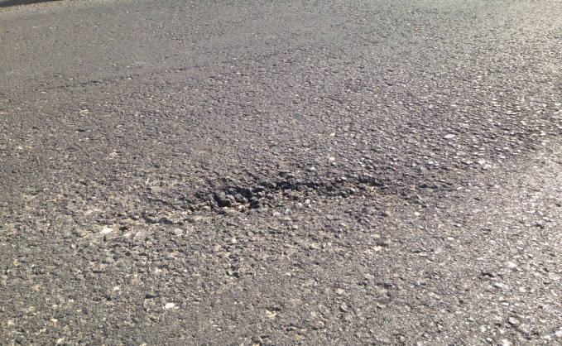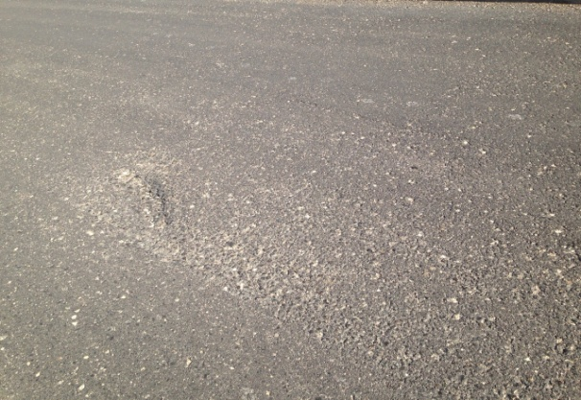
Pictures from Nablus Deir Sharaf Street
- The lab was called again to examine the street, and took a sample 7*40*40 cm, the results of the test were as following:
- Stiffness ratio= 470 mm/kg; and the minimum in the specification is 500 mm/kg.
- There in the middle of the street section contains 300 m in good condition, but the lab recommended to remove it; because it will affect on the street.
- Initially Qandeel rejected the recommendations. But After this; the disputes were resolved by negotiate.
- But a new problem emerged; the section that contains 300 m which is good. Who bears the responsibility? Who bears the cost? The problem still exists so far.
Briefly; in this case the claim was changes in the specifications that have been agreed, that the contractor is responsible for occurring, and the claim was resolved by negotiation.

