An-Najah National University
Graduation Project
Renewable energy
Submitted to:
Dr.Emad Braik
Presented by:
Doha Mohammed Mansour

Table of figure
Figure 1 Growth of renewable energy 6
Figure 2 Global wind energy 8
Figure 3 Photovoltaic cell 10
Figure 4 Global photovoltaic 14
Figure 5 Photovoltaic system 16
Figure 6 Equivalent circuit 19
Figure 7 Voltage current curve 21
Figure 8 Efficiency curve 25
Figure 9 Crystalline silicon cell 28
Figure 10 series connection 29
Figure 11 parallel connection 30
Figure 12 stand alone photovoltaic system 31
Figure 13 grid connected photovoltaic system 32
Figure 14 hybrid system 33

Table of table
Table 1 photovoltaic power……………………………………………………………………………………………………………13
Table 2 Global photovoltaic…………………………………………………………………………………………………………..14
Table 3 Photovoltaic efficiency……………………………………………………………………………………………………18
Table 4 efficiency of photovoltaic……………………………………………………………………………………………..26
Table 5 photovoltaic material……………………………………………………………………………………………….………26

Contents
Energy Resources 5
Nonrenewable Energy 5
Renewable Energy 5
Sunlight, or solar energy 7
Wind energy 8
Tidal energy 9
Definition 10
What are Photovoltaic Cells 11
The main components of the PV system are: 12
The goals of PV cells 12
harmful chemicals involved in crystalline PV cell manufacture are 15
What is the environmental impact of photovoltaic 16
How Does A Cell Become A Module? 17
PV Panel 17
PV Array 18
Current-Voltage curve for a solar cell 21
Matlab code 23
Efficiency values 26
Series connection 29
Parallel connection 29
Stand alone connected 31
Grid connected 31
Hybrid system 33
Battery storage 35
PV with Battery Storage 35
How It Works 35

Introduction

Energy Resources
It can be classified into two categories:

Nonrenewable Energy
- Conventional and fossil fuel
- Their supplies are limited and we cannot produce as much fossil fuel in a short time as we like
- Most of our electricity is generated based on nonrenewable energy resources
- Fossil fuel are: coal, petroleum, natural gas

Renewable Energy
- Alternative Energy
- It can called sustainable energy
- It include: biomass, geothermal energy, hydro power, solar energy, ocean energy, and wind energy
- They are called renewable because they are replenished or regenerated in a short time
- We use renewable energy sources mainly to make electricity and provide thermal heat for applications
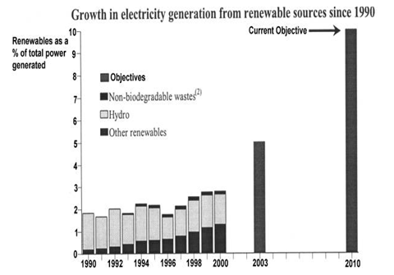
Figure 1 Growth of renewable energy

Advantages of renewable energy
- It should not ever deplete
- The fact that they are renewable. We will never run out of sources of renewable energy
- Photovoltaic system are flexible, highly reliable and last long

Importance of Photovoltaic system
- They operate cost effectively in remote areas where it would be expensive or impossible to rum power
- Produce no pollution
- Reduce a growing dependency brought in energy and electricity.
- Decrease the cost of complying with existing and upcoming ecological regulations.
- Conserve nature for future generations
- Improve the stability of energy supplies
- Protects our environment and public health by preventing or decreasing pollutants

Earth resources:
- Water called hydro energy
- Air called wind energy
- Earth called geothermal energy

Types of Renewable Energy

Sunlight, or solar energy
- Most renewable energy comes from the sun
- Solar energy is an energy source that involves tapping the radiant light energy that is emitted by the sun and converting it into electricity.
- Homes that are powered by solar energy have been installed with batteries that have a capability of storing power that can operate electrical appliances such as TV, Radio, computers and refrigerators

Wind energy
- It is captured with wind turbines
- Wind power is the conversion of wind energy into a useful form of energy, such as using wind turbines to make electrical power
- Large wind farms consist of hundreds of individual wind turbines which are connected to the electric power transmission network

Global Wind Power in this figure
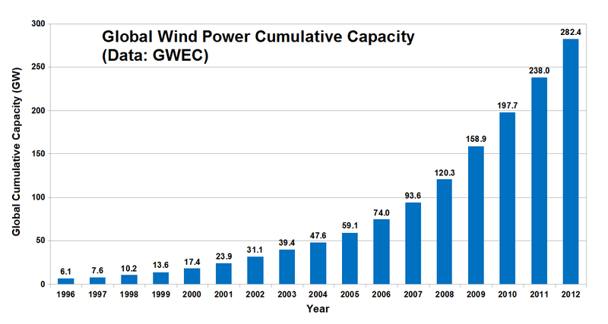
Figure 2 Global wind energy

Tidal energy
The energy of the ocean's waves
Tidal energy is produced by the ocean water during the rise and fall of tides.
Tidal energy is a renewable source of energy.
The world's first tidal power station was constructed in 2007 at Strangford Lough in Northern Ireland

Photovoltaic cell
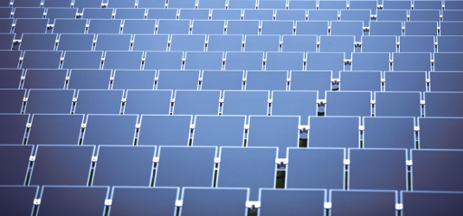
Figure 3 Photovoltaic cell

Definition
- The term "photovoltaic" comes from the Greek meaning "light", and from "Volt"
- It is an electrical device that converts the energy of light directly into electricity by the photovoltaic effect
- Is a method of generating electrical power by converting solar radiation into direct current electricity using semiconductors
- Photovoltaic power generation employs solar panels composed of a number of solar cells containing a photovoltaic material
- Due to the increased demand for renewable energy sources, the manufacturing of solar cells and photovoltaic arrays has advanced considerably in recent years.
- Materials presently used for photovoltaics include monocrystalline silicon, polycrystalline silicon, amorphous silicon, cadmium telluride, and copper indium gallium selenide/sulfide
- Solar photovoltaic is a sustainable energy source
- Solar photovoltaics is now, after hydro and wind power, the third most important renewable energy source in terms of globally installed capacity.
- More than 100 countries use solar PV

What are Photovoltaic Cells
- PV Cells use solar power to create energy
- PV Cells are use in calculators, on satellites and to power our own homes
- PV cells have very high potential to be a primary source of energy
- It creates jobs and strengthens the economy since it is a brand new industry
- PV cells are very reliable and costs little to build and operate

Building block of a solar panel
- Photovoltaic cells are used to make solar modules which generate electrical power from sunlight.
- Multiple cells in an integrated group, all oriented in one plane, constitute a solar photovoltaic panel or "solar photovoltaic module" as distinguished from a "solar thermal module" or "solar hot water panel."
- The electrical energy generated from solar modules, referred to as solar power, is an example of solar energy.
- A group of connected solar modules (such as prior to installation on a pole-mounted tracker system) is called an "PV array"

The main components of the PV system are:
- Photovoltaic Cell
- Photovoltaic Module
- Photovoltaic Array
- Charger Controller
- Battery Storage
- Inverter
- DC Loads and AC Loads

The goals of PV cells
- The main goal of PV cells is to replace fossil fuels as the main source of energy
- To use the sunlight as an alternative due to its endless amounts

How it works
- Solar cells directly convert sunlight into energy has been dominated by solid-state junction devices, often made of semiconductor or silicon
- A magnetic field is created that forces electrons to move and that is what we consider electricity
- Output of PV cells depends on weather and the time of day

The operation of a photovoltaic cell
- The absorption of light, generating either electron-hole pairs or excitons
- The separation of charge carriers of opposite types.
- The separate extraction of those carriers to an external circuit

Photovoltaic power
Table 1 photovoltaic power giga watt
Photovoltaic power worldwide
2005 | 5.4
2006 | 6.9
2007 | 9.5
2008 | 16.2
2009 | 23.6
2010 | 40.7
2011 | 71.1
2012 | 102.2

Global photovoltaic market
Table 2 Global photovoltaic
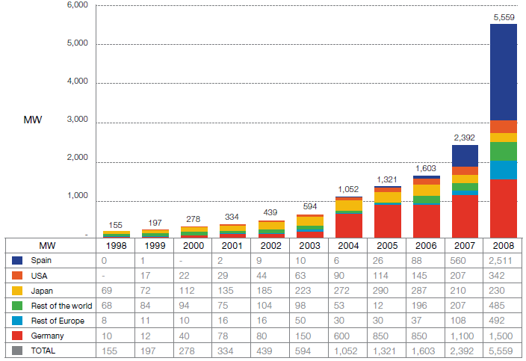
Figure 4 Global photovoltaic

Solar Cell
- Photo voltaic are convert light to electricity
- 1839: Discovery of the photoelectric effect by Bequerel
- 1873: Discovery of the photoelectric effect of Selen (change of electrical resistance)
- 1954: First Silicon Solar Cell as a result of the upcoming semiconductor technology (η = 5 %)

What is the environmental impact of photovoltaic
The main areas of potential concern are:
- The energy required to produce them, particularly the photovoltaic cells
- What happens to them at the end of their lifetime
- Toxic and other potentially harmful materials used or created in the production of PV panels/cells

harmful chemicals involved in crystalline PV cell manufacture are
- crystalline silicon is made using silane gas, the production of which results in waste silicon tetrachloride which is toxic. It can be recycled into more silane gas but has the potential to cause harm
- Sulphur Hexafluoride is used to clean the reactor used in silicon production. If it escaped it would be a very potent greenhouse gas. It can also react with silicon to create a range of other compounds.
- a range of other chemicals used for cleaning the silicon and cells
There is also lead and small amounts of aluminium and silver in the electronics.

What is the environmental impact of photovoltaic
The main areas of potential concern are:
- The energy required to produce them, particularly the photovoltaic cells
- What happens to them at the end of their lifetime
- Toxic and other potentially harmful materials used or created in the production of PV panels/cells

PV-System
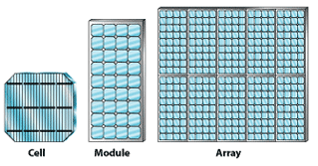
Figure 5 Photovoltaic system
- The basic photovoltaic or solar cell typically produces only a small amount of power. To produce more power, cells can be interconnected to form modules, which can in turn be connected into arrays to produce yet more power. Because of this modularity, PV systems can be designed to meet any electrical requirement, no matter how large or how small.

How Does A Cell Become A Module?
- Cell: The basic photovoltaic device that is the building block for PV modules
- One silicon solar cell produces 0.5 volt
- 72-cell modules are the new standard for grid- connected systems having a nominal voltage of 24-Volts and operating at about 30 Volts.
- Module is the basic building block of systems
- Can connect modules together to get any power configuration
- PV Module
- Module: A group of PV cells connected in series and or parallel and encapsulated in an environmentally protective laminate
- Polycrystalline silicon module and monocrystalline silicon module

PV Panel
- Panel: A structural group of modules that is the basic building block of a PV array

PV Array
- Array: A group of panels that comprises the complete direct current PV generating unit

PV materials and technologies produce different efficiencies
Table 3 Photovoltaic efficiency
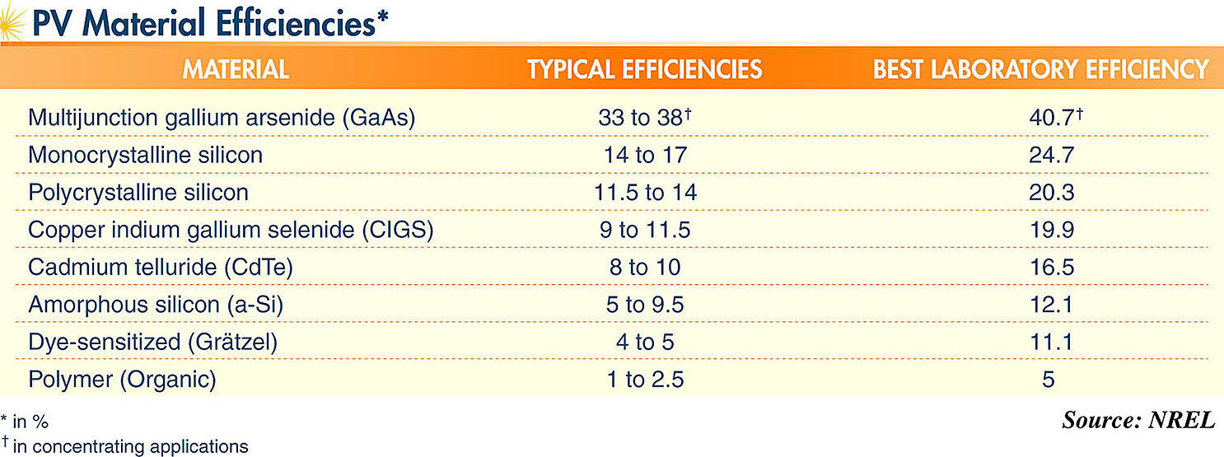

PV Cell Equivalent Circuit
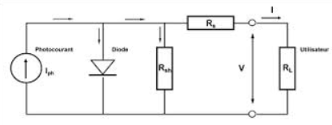
Figure 6 Equivalent circuit
I_{PH:} photocurrent of the solar-cell
I_{D} /U_{D}:current and voltage of the internal p-n diode
R_{shunt}:shunt resistor due to inhomogeneity of the surface and loss-current at the solar-cell edges
R_{S}:serial resistor due to resistance of the silicon-bulk and contact material
V: Solar-cell current and voltage
R_{L}/I_{L}/U_{L}: Load-Resistance, current and voltage
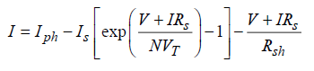
load current in Amperes
voltage across the shunt branches
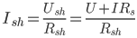 current through the shunt resistor
- How to calculate the annual solar energy output of a photovoltaic system
E = A * r * H * PR
E = Energy (kWh)
A = Total solar panel Area (m²)
r = solar panel yield (%)
H = Annual average solar radiation on tilted panels (shadings not included)
PR = Performance ratio to evaluate the quality of a photovoltaic, coefficient
for losses (range between 0.5 and 0.9, default value = 0.75)

Photovoltaic cell characteristic curve

Current-Voltage curve for a solar cell

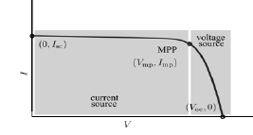
Figure 7 Voltage current curve
- Short circuit current :I_{sc}=I_{L} it is the greatest value of the current generated by a cell . V=0
- Open circuit voltage correspond to the voltage drop across the diode (p-n junction), when it is transverse by the photocurrent I_{ph} , when the generated current is I=0. It reflects the voltage of the cell in the night and it can be mathematically expressed as:
- V_{OC} = nkt ln ( IL/Io) /q = Vt ln(IL/Io)
- Where Vt = mkTc / e
- Maximum power point is the operating point (Vmax, Imax) at which the power dissipated in the resistive load is maximum
- Pmax= Vmax*Imax
- The fill factor (FF) of a solar-cell is the relation of electrical power generated (P_{MPP}) and the product of short current Isc and open-circuit voltage Voc
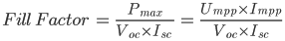
- The efficiency η is the relation of the electrical power generated (P_{max})and the light irradiance (AG₀) of input power P_{inp} impinging on the solar-cell
- Maximum efficiency is the
- ηmax = P_{Max} / AG₀ = Imax Vmax / AGo
- η = PP / AG₀ *100%

Matlab code

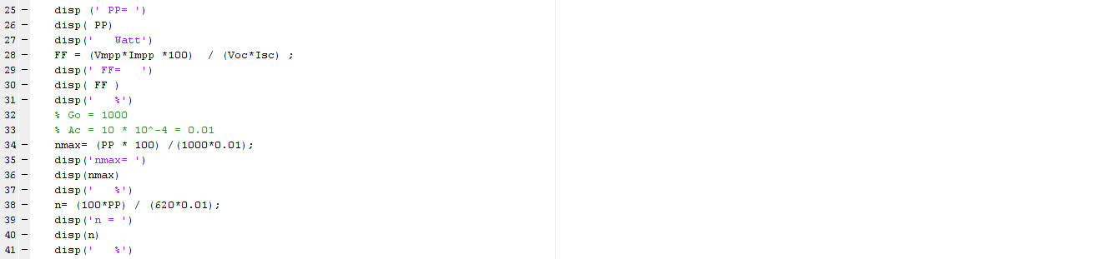
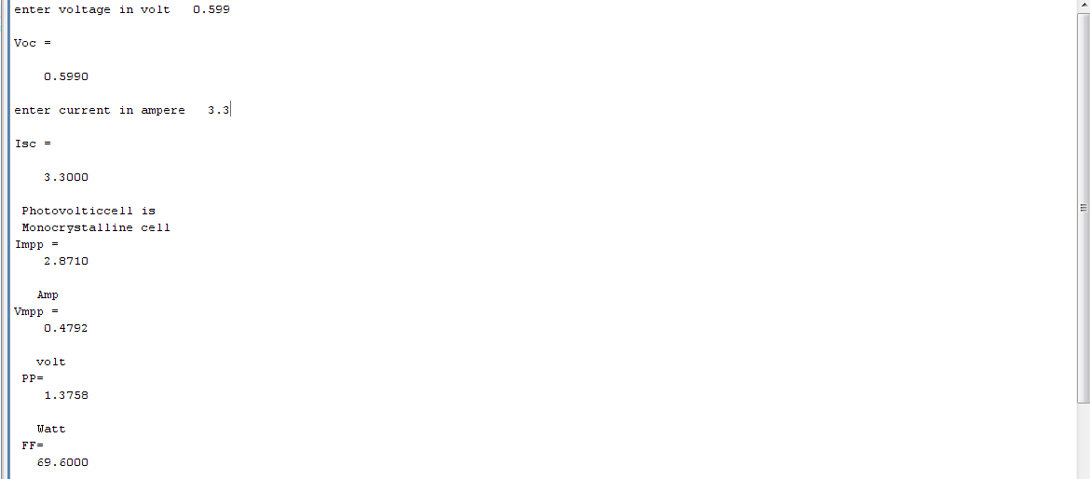
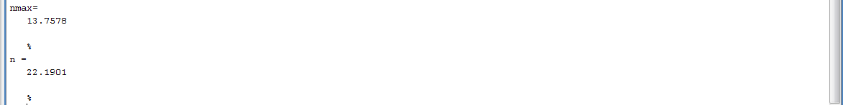
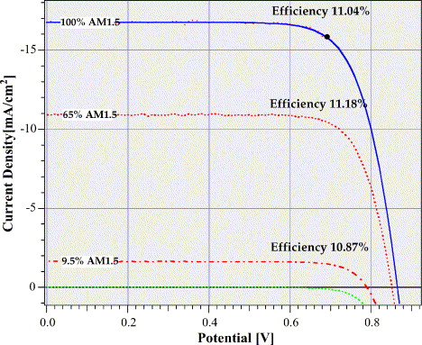
Figure 8 Efficiency curve

Pv modules
- Monocrystalline Cell
- Polycrystalline cell
- Amorphas silicon Cell

Efficiency values

Table 4 efficiency of photovoltaic
Material | η (laboratory) | η (produktion)
Monocrystalline | 24,7 | 14,0 – 18,0
Polycrystalline | 19,8 | 13,0 – 15,5
Amorphous | 13,0 | 8,0

Table 5 photovoltaic material
Material | Crystalline order | Thickness | Wafer
Monocrystalline | One ideal lattice | 50μm - 300μm | One single crystall
Polycrystalline | Many small crystalls | 50μm - 300μm | grain (0,1mm – Xcm)
Amorphous | No crystalline order;  Groups of some regularly bound atoms | < 1μm | No wafer

Efficiency of photovoltaic
- Efficiency is a major driver in reducing costs and meeting energy requirements in limited areas
- Further efficiency improvements are possible with all PV technologies

Application on Photovoltaic
- Water Pumping: PV powered pumping systems are excellent ,simple ,reliable – life 20 yrs
- Commercial Lighting: PV powered lighting systems are reliable and low cost alternative. Security, billboard sign, area, and outdoor lighting are all viable applications for PV
- Consumer electronics: Solar powered watches, calculators, and cameras are all everyday applications for PV technologies.
- Telecommunications
- Residential Power: A residence located more than a mile from the electric grid can install a PV system more inexpensively than extending the electric grid
- (Over 500,000 homes worldwide use PV power as their only source of electricity)

- Construction of crystalline silicon cell
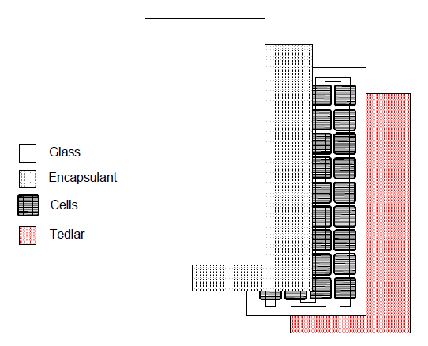
Figure 9 Crystalline silicon cell

Connection of group cell

Series connection
- The figure shows the connection of three individual cells in series.
- The output current is equal to current for one cell
- The output voltage is increase
- V output is equal to summation to the cells
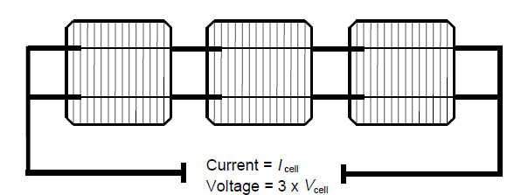
Figure 10 series connection

Parallel connection
- The figure shows parallel connection of three cells
- Total current is equal to the total current
- Itotal = 3I
- Total voltage is equal to voltage for one cell
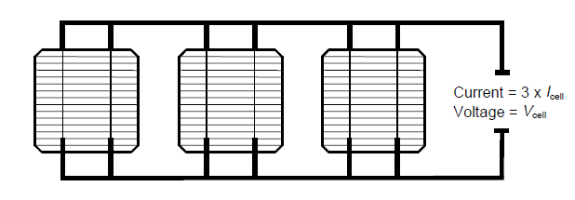
Figure 11 parallel connection

The photovoltaic system
- The PV systems consist of number of interconnected components designed to accomplish a task.
- It may feed electricity into the main distribution grid to pump water from a well, to power a calculator
- The design of the system depend on the task perform

There are three configurations

Stand alone connected
Stand alone PV system operates independently
Of other power supply
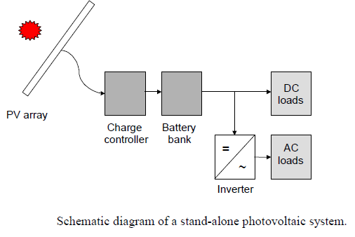
Figure 12 stand alone photovoltaic system

Grid connected
It is independent of other power source
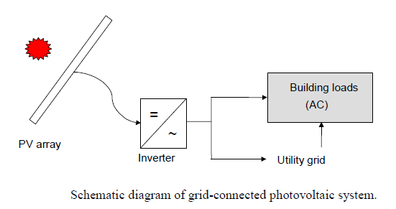
Figure 13 grid connected photovoltaic system

Hybrid system
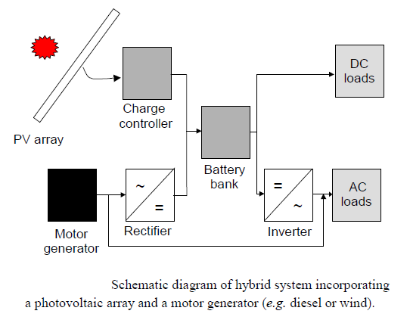
Figure 14 hybrid system

Photovoltaic Controller
A controller will need to prolong the battery life of Pv System.
The most basic function of a controller is to prevent battery overcharging. If batteries are allowed to routinely overcharge, their life expectancy will be dramatically reduced. A controller will sense the battery voltage, and reduce or stop the charging current when the voltage gets high enough. This is especially important will sealed batteries where we can’t replace the water that is lost during overcharging.
Unlike Wind or Hydro System controllers, PV controllers can open the circuit when the batteries are full without any harm to the modules.
Most PV controllers simply open or restrict the circuit between the battery and PV array when the voltage rises to a set point. Then, as the battery absorbs the excess electrons and voltage begins dropping, the controller will turn back on.
Some controllers have these voltage points factory-present and non adjustable, other controllers can be adjustable.
Reverse current flow is the tiny amount of electricity that can flow backwards through PV modules at night, discharging the battery, but the loss of power is insignificant. Only with larger PV systems is this significant but almost all charge controllers deal with it automatically.

Energy Storage

Battery storage
- What is battery?
Battery is an energy device that converts the chemical energy it stored directly into electric energy via an electrochemical process that involves oxidation and reduction reactions
- The battary’s capacity for holding energy is rated in amp hour:
1amp delivered for 1hour= 1amp hour battery capacity is listed in amp hour at a given voltage
- Manufacturing typically rate storage battries at 20 hour rate
- 220 amp hour battery will deliver 11 amps for 20 hour

PV with Battery Storage
- Storing electrical energy makes PV systems a reliable source of electric power day and night, rain or shine.
- PV systems with battery storage are being used all over the world to power lights, sensors, recording equipment, switches, appliances, telephones, televisions, and even power tools.

How It Works
- During the daylight hours the pv module charge the battery
- The battery supplies power to the load
whenever needed

Conclusion
We define two types of energy renewable and nonrenewable .Then we talk about photovoltaic components and goal and we define the connection series and parallel .And current voltage characteristic .Then we talk how to store energy by using a battery .The importance of renewable energy. The types of renewable energy

Reference
- http://www.ewp.rpi.edu/hartford/~ernesto/Su2011/EP/MaterialsforStudents/Rasmussen/Pearsall2001_chap15.pdf
- http://www.azom.com/article.aspx?ArticleID=1157
- http://www.google.ps/url?sa=t&rct=j&q=&esrc=s&frm=1&source=web&cd=6&ved=0CDoQFjAF&url=http%3A%2F%2Fwww.sln.org.uk%2Fgeography%2FDocuments%2FGeograpevine%2FN%2520Staffs%2520GA%2Frenewables%2520lecture%2520-%2520garth.ppt&ei=AdKZUs2zH4Xy7AaUxYHoDQ&usg=AFQjCNGYurmGnNazDhXouGl8zoBNt1oV-A
- http://www.omicspublishinggroup.net/renewable-energy-its-importances/
- http://www.renewableenergyworld.com/rea/tech/home
- http://education.nationalgeographic.com/education/encyclopedia/tidal-energy/?ar_a=1
- http://en.wikipedia.org/wiki/Wind_power
- http://www.ask.com/question/what-is-the-definition-of-solar-energy
- http://search.tb.ask.com/search/GGmain.jhtml?searchfor=renewable+energy+ppt&ptb=63533C30-6E77-494D-A7F1-8DE834D3E93B&n=77fda534&tpr=hpsb&ts=1386657459624&p2=%5EZ7%5Exdm032%5ES07480%5Eps&si=CKjCjvf30boCFbLJtAodCzwAwQ&st=hp

