8 Designs of Stairs:
In this section we took apart of stairs to be designed as a sample for all stairs in this project, started by estimating the dead load and live load for this stairs , then performed and analyzed by SAP program and took the deflection ,shear and moment on

8. 1 Stairs Details:
Total height=13m, Inner Radius=2m, Outer Radius=4.5m
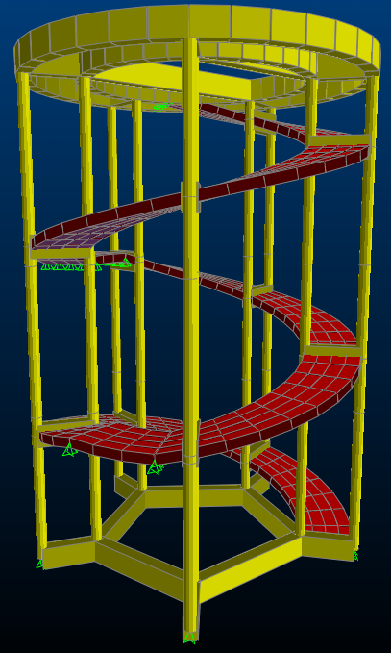
Fig (8-1) plan section of stairs
8. 2 Thickness of slab:
t=$\frac{L}{24}$ One end continuous
t=$\frac{L}{28}$ One end continuous
=$\frac{2π*R/l}{24}$
= (2$π$*4.5/5)/24 =0.236 m
Take t=25cm.
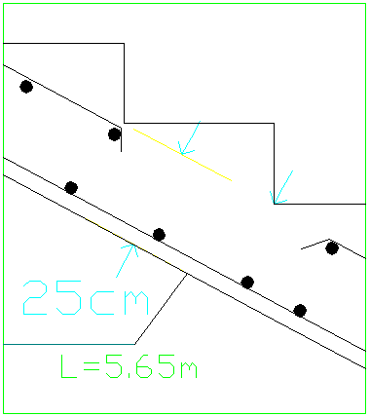
Fig (8-2) Dimension of stairs

8. 3 Stairs Load:
Ultimate load=1.2D+1.6L
Where:
D: dead load.
L: live load due to included use and occupancy.
𝔀u=1.2DL+1.6LL
DL=Super imposed load +Own weight
DL=0.3 ton/m², LL=0.4 ton/m²
0.68 m for each1m horizontal
Length=1.2m
Own weight=volume*Ɣ=1.2*0.25*1.5*2.5=1.125 ton/ m²
𝔀u=1.2*(0.3+1.125) +1.6*0.4
=2.35 ton/ m²

8.4 Slab design:
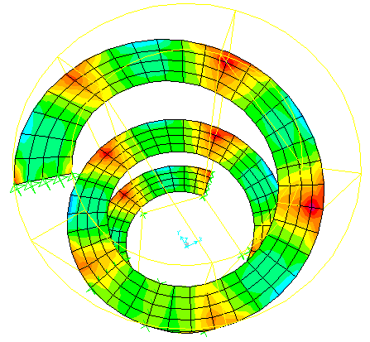
Fig (8-3) 𝓜 22 stairs
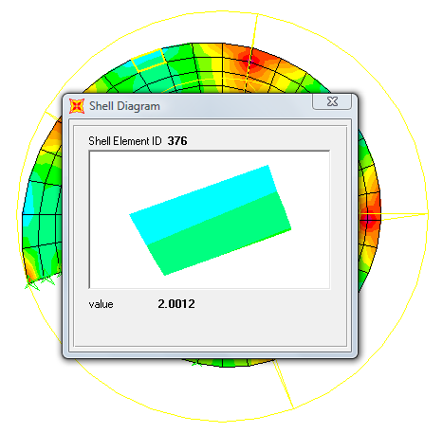
Fig (8-4) 𝓜_{+ve} stairs
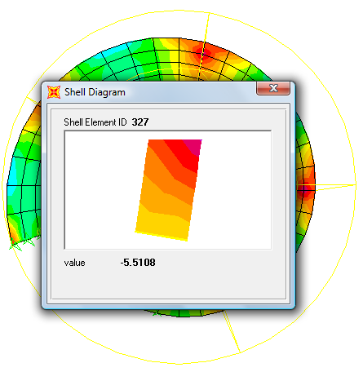
Fig (8-5) 𝓜_{-ve} on stairs

Design for:
𝓜_{-ve}=5.5 ton.m
$$ρ=0.85\frac{f_{c}}{f_{y}}\left(1-\sqrt{\left(1-\frac{{2.35M}_{u}}{{∅bd}^{2}f_{c}}\right)}\right)$$
𝜌=.85*240/4200(1-√ (1-2.35*5.5*10⁵/.9*22²*100*240)
𝜌 =0.0031
𝜌min=0.0018*ℎ/d=0.0018*25/22=2.05*10⁻³
𝜌> 𝜌min=3.1*10⁻³
As= 𝜌*b*h
=3.1*10⁻³*150*22=10.23cm²
(ф12) As= (10ф12) S=15 cm)

𝓜_{+ve}=2 ton.m
$$ρ=0.85\frac{f_{c}}{f_{y}}\left(1-\sqrt{\left(1-\frac{{2.35M}_{u}}{{∅bd}^{2}f_{c}}\right)}\right)$$
𝜌=.85*240/4200(1-√ (1-2.35*2*10⁵/.9*22²*100*240)
𝜌=0.001
𝜌min=0.0018*ℎ/d=0.0018*25/22=2.05*10⁻³
𝜌< 𝜌min=2.05*10⁻³
As= 𝜌min*b*h.
=2.05*10⁻³*150*22=6.77cm²
(ф12) As= (6ф12) S=25 cm)

Shrinkage reinforcement:
A_{sh}=0.0018*b*h
=0.0018*100*25=4.5 cm²
(4 ф12) , S=25 cm.
Spacing < 45 cm & 5h

Shear reinforcement:
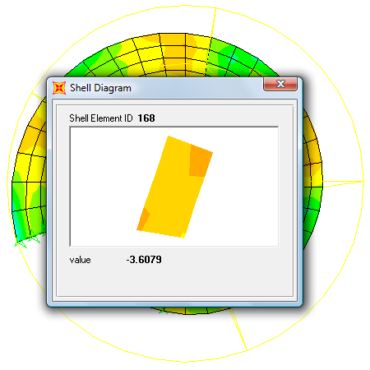
Fig (8-6): Shear force in stairs
Vu=3.6 ton
ФVc=ф*0.53*√ 𝒇c* b*d
фVc =0.75*0.53*√240*100*22*10⁻³
=13.55ton
Vu< фVc no need for shear reinforcement

Checks:
1) b_{min}:
b_{min} =2*c+2*ds+n*db+(n-1)*S+1.
de=ℎ-ys.
ys =c+ds+0.5*db. For one layer
b_{min} = 2*3+2+2*1.2+1*3+1=14.4<15cm
d=ℎ-ys
ys=3+1+.5*1.2=4.6cm
d_{e} =25.4cm
2) DR& ф
ℎf>a=4200*6.77/.85*240*100=1.4cm
C=a/.85=1.4/.85=1.65
ℰt = (d-c/c)*0.003
ℰt= (25.4-1.65/1.65)*.003
.073>.004 no Double Rein & ф=0.9 ok
3) 𝓜d =0.9*6.77*4200*(25.4-(1.4/2))/10⁵
𝓜d =6.32ton.m>5.5ton.m ok

8.5 Check computability of structure
As shown in figures deformed shape for modal indicates that the structure moves as one unit so that the compatibility is satisfied. And show the fundamental period of structure.
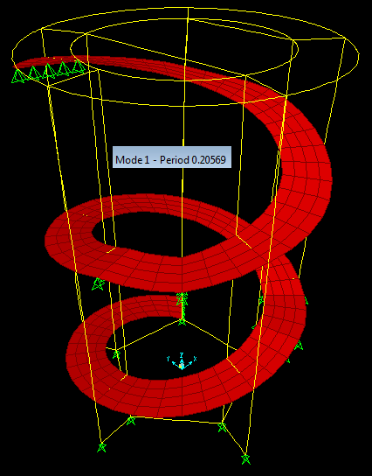
Fig (8-7): Deformed shape for modal

8.6 Displacements:
- the maximum deflection occurs on the slab for Stairs due to live load equal to 0.14 cm as shown in figures :
For block (A):
$$\frac{L }{Δ}≥360$$
𝓛=5.56m $→$
=1.57 >0.02 cm OK
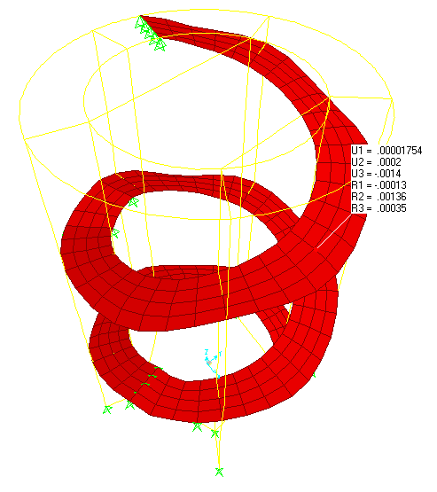
Fig (8-8): max deflection due to live load

