

Graduation Project (2)
Production of Powder Grease for Wire drawing
Prepared by:
Ameera Hassan
RenadShanaa
Sandy Alawna
TasneemSarhan

Submitted to:
Eng: Shadi Sawalha

Submitted in Partial Fulfillment of the Requirement of BSC Degree in Chemical Engineering
Chemical Engineering Department
Al-Najah National University

May 3, 2015
Abstract:
Wire drawing is a metal working process used to reduce the cross section of wire by pulling the wire through single or series of drawing dies. This process needs aid to ease drawing and minimize the friction between produced product and machine die, that can be achieved by using dry grease powder and the most common type is calcium soap (calcium stearate).
This product is required by many companies work in this field like Al- Shark Electrode company which is specialist in wire drawing for many applications, the powder grease used by them is not manufactured in Palestine and is imported from foreign countries at high cost, for that this project aims to produce the powder by different economical and efficient techniques.
In this project calcium stearate was prepared by different methods either direct reaction of lime with fatty acid or converting sodium stearate to calcium stearate.
For both methods the calcium carbonate was supplied from two sources, local market and a waste from stone cutting plants (stone cutting waste).
By direct method, six samples were prepared, two of them were succeeded and the others were failed.
On the other hand, eleven samples were prepared by indirect method, eight of them have succeeded technically but the others were failed.
Some tests like PH, solubility, ash content, DSC test, and the appearance were applied on the success samples from each method.
According to the results of these tests, one sample has been chosen which was (ID7), because it has good properties, it’s a hard powder, insoluble in water, with melting temp 129.87ᵒC and softening temp 73.92ᵒC, the ash content was 21% and with a PH equal 6.5.
Also it has the lowest raw materials cost between all samples, which is 1.95NIS/Kg. This price is competitive compared to the price of the imported calcium grease.
The total consumption of this powder in Palestine was 100 ton/year with a selling price of 4,800 NIS/ton. The feasibility study for a plant producing powder grease carried out based on the above information, the capital investment was 15900NIS, and net profit was 85,945.24NIS/year, cash flow of 91,845.24NIS/year and payback period equal 9.5 years. The growth of production with a rate of 5% for the next 3 years was assumed.
Table of contents:
Chapter 1: Introduction | 6
1.1 Introduction | 7
1.2 Wire Drawing Definition | 8
1.3 Definition of lubricant and its types | 8
1.4 Calcium stearate:- | 9
1.5 Additives of lubricants | 11
Chapter 2: Experimental Work | 13
2.1 Materials and Chemicals | 14
2.2 Sample preparation | 14
2.2.1 First Indirect Method | 14
2.2.2 Second Direct Method | 18
2.3 Tests | 20
Chapter 3: Result and Dissection | 21
3.1 Result | 22
3.2 Discussion of Results | 23
Chapter 4: Market Study | 26
4.1 Feasibility Study | 27
4.1.1 Market Analysis | 27
4.1.2 Technical study | 27
Conclusion | 33
References | 34
Appendix | 35

List of Tables:
Table (1): calcium stearate properties | 10
Table (2): Preparation Method for Indirect Sample using Commercial CaCO₃ | 16
Table (3): Preparation Method for Indirect Sample using Waste CaCO₃ | 17
Table (4): Preparation Method for Direct Sample using Commercial Ca(OH)₂ | 18
Table (5): Preparation Method for Direct Sample using Waste CaCO₃ | 19
Table (6): Result of Indirect Method | 22
Table (7): Result of Direct Method | 22
Table (8): Installation, Maintenance And Depreciation Costs | 28
Table (9): Raw Materials, Prices and Amounts Kg/year | 29
Table (10): Statement of Income and Expenses | 32

List of Figures:

Fig (1): Saponification equation | 14
Fig (2): PFD of Producing Calcium Stearate by Direct and Indirect Methods | 19
Fig (3) : The relation between concentration HCl wt % and ash content | 23
Fig (4) : DSC curve for sample prepared from calcuim carbonate | 24
Fig (5) : DSC curve for sample prepared from stone cutting waste | 24
Fig (6): Approved method for powder grease preparation | 27
Fig (7): Standard properties | 35

Chapter One
Introduction

1.1 Introduction

In wire drawing process, a wire is pulled through a series of dies reducing its size and extending its length, and the reduction in size is known as draft and is expressed in percentage of original wire size. Various materials are utilized as lubricants to produce different finishes on the surface of the wire and to minimize die wear. In dry drawing the coating frequently is an organic compound baked on the surface of cleaned wire and drawn through dry lubricants of various types in the die box. Lubrication is used mainly to reduce the resistance to sliding between the work piece (the wire) and the tool (the die). The reduction in resistance manifests itself in several ways, among which are the following:

- Reduced drawing force due to reduced values of the coefficient of friction.
- Reduced wear on the die.
- Reduced surface temperature on the die and on the wire.
- Altered appearance of the wire surface.
- Improved draw ability, deterred wire tearing, etc.(Dhaher,2009, P 1)

Each one of these factors can be measured and serve as a criterion for the evaluation of lubricants, and for the comparison among lubricants. By any criterion there is no ideal lubricant or single lubricant that is superior to all applications. Lubricant performance evaluation must be performed under conditions that are as close to the actual production conditions as possible. There are good reasons for evaluating lubricants on production equipment, during production runs. The selection of the lubricant depends on other factors such as price, toxicity, safety and residual film advantages and shortcomings. (Dhaher, 2009, P 1).

In this project, calcium stearate (calcium soap) was prepared as a main component of powder grease, this product was made by two methods; first: directly by reacting lime with fatty acid, the used lime was supplied from local market or produced from calcium carbonate available in stonecutting waste; secondly by converting sodium soap into calcium one by reaction with suitable chemicals. The produced samples from different methods were tested and used on the machines of Al-Shark Electrode Company to examine their capability to facilitate the process of wire drawing.

1.2 Wire Drawing Definition
Wire drawing is a process of pulling wires through tapered dies resulting in the reduction of it is cross-section and increase in its length. The diameter of a Wire may range from .025 mm – 15mm. Drawing is normally a cold working process in which good tolerances and surface finish can be obtained.
Larger reduction may be obtained by passing the wire through a series of dies, the maximum reduction in one pass being limited to about .45. For most wire drawing operations, the drawing speed (the speed of wire at the exit of the die) ranges from 10m/min to 3000 m/ min.

1.3 Definition of lubricant and its types:

A lubricant is a substance introduced to reduce friction between surfaces in mutual contact, which ultimately reduces the heat generated when the surfaces move. It may also have the function of transmitting forces, transporting foreign particles, or heating or cooling the surfaces. The property of reducing friction is known as lubricity (or slipperiness).
The main functions of a lubricant are:
- Friction and wear reduction.
- Heat removal and contaminant suspension.
There are a lot of applications on lubricants: internal combustion engines, vehicles and wire drawing.
Lubricants are classified into two major groups: Automotive lubricants and Industrial lubricants.
Automotive lubricants have to perform in different types of vehicles both petrol and diesel under a variety of operating conditions. Modern vehicles are fuel efficient and comfortable with high levels of performance. They are required to meet stringent emission norms.
Industrial lubricants can be subdivided into industrial oils and industrial specialties. Specialties in this case are principally greases, metal working lubricants and solid lubricant films. (Kumar, 2008, P80).

Modern equipment must be lubricated in order to extend its lifetime. A lubricant performs a number of critical functions. These include lubrication, cooling, cleaning and suspending, and protecting metal surfaces against corrosive damage. Lubricant comprises a base fluid and an additive package. The primary function of the base fluid is to lubricate and act as a carrier of additives. The function of additives is either to enhance an already existing property of the base fluid or to add a new property. The examples of already existing properties include viscosity, viscosity index, pour point, and oxidation resistance. The examples of new properties include cleaning and suspending ability, anti-wear performance, and corrosion control. (Kumar, 2008, P80).

Wire drawing lubricants:-

First type is that lubricant carriers :- it is function not only prevent adhesive metal to die but also pich up and carry lubricants through the die. Frequently, lime metallic material (copper, tin, lead), borax, polymer coating may be used in avariety of metals.
Second type is that of soap:- soap is reaction between fatty acid and alkyl group and properities depend on type of fatty acid and alkyl group, most of soaps used in wire drawing lubraicants based upon stearate , the most comnly used stearate in wire drawing is calcium, sodium , potasium, alluminum based stearates.
Third type:- is that of graphit and molybednum disulphid, there is solid lubricant processing used as boundary lubricants, graphit mixed with aluminum powder and added to steric acid as being recommended for cold drawing.
Fourth type:- include drawing paste, grease , oil and emulsion. This type is a wet drawing lubricant are expected to provide a boundary lubricant film and extract heat from the die and the workpiece. In this type are found straight soap solutions of about 15% by weight concentration. (Kumar, 2008, P83).
1.4 Calcium stearate:-
One of the main types of powder grease is the calcium stearate base. The dry drawing lubricants are usually called lubricating powder, drawing powder, there are two kinds: Sodium soap and lime soap. Sodium soap is derived from fatty acids and alkali saponification reaction, calcium soap only by the fatty acids (fats) and white ash derived saponification
Customer can choose the different drawing powder according to the different drawing process. The price of the drawing lubricant is mainly influenced by the oil in the wire drawing powder. And powdered wire drawing lubricants can classify by their solubility in water. Insoluble lubricants are usually calcium based (e.g. calcium stearate).Table (1) summarized the properties of calcium stearate. (Leslie, 2003, P 254).

Table (1): calcium stearate properties ^{[W1]}
Molecular formula | [CH₃(CH₂)₁₆CO₂]₂Ca
Molecular weight | 606
Specific gravity | 1.1
Moisture content | 3.0% max
Calcium | 8.5 + 0.8% max
Free Fatty Acid | 1.0% max
Apparent density | 0.13 + 0.03g/ml
Melting point | 147C -160C
Classification | carboxylic acid salt
physical state | White solid
solubility in water | Insoluble
Stability | stable under ordinary conditions

1.5 Additives of lubricants

Additives are chemical compounds added to lubricating oils to enhance specific properties to the finished oils. Some additives enhance new and useful properties to the lubricant; some enhance properties already present, while some act to reduce the rate at which undesirable changes take place in the product during its service life. Additives, in improving the performance characteristics of lubricating oils, have aided significantly in the development of improved prime movers and industrial machinery.
The function of additives can be summarized as follows:
- Protect metal surfaces (rings, bearings, gears etc.).
- Extend the range of lubricant applicability.
- Extend lubricants' life. (Rizvi, 2009, P 100) and (Ludema, 1996, P 124)

There are many types of additives such as:
- Friction modifiers (FM): These are additives that usually reduce friction.

- Anti-wear agent (A.W.) and extreme pressure additives (E.P.): Anti wear (AW) agents have a lower activation temperature than the extreme-pressure (EP) agents. The latter are also referred to as anti-seize and anti-scuffing additives.

- Antioxidant additives (AO): One of the most important aspects of lubricating oils is that the oxidation stability be maximized. Exposure of hydrocarbons to oxygen and heat will accelerate the oxidation process.

- Anti-foam agent (A.F): The foaming of lubricants, is a very undesirable effect that can cause enhanced oxidation by the intensive mixture with air, cavitations damage as well as insufficient oil transport in circulation systems that can even lead to lack of lubrication.

- Rust and corrosion inhibitors: are usually compounds having a high polar attraction toward metal surfaces. By physical or chemical interaction at the metal surface, they form a tenacious, continuous film that prevents water from reaching the metal surface.
- Viscosity index improvers: Probably the most important single property of lubricating oil is its viscosity.

- Pour point depressants (PP):The pour point PP of a lubricating oil is the lowest temperature at which it will pour or flow when it is chilled without disturbance under prescribed conditions.

(Rizvi, 2009, P 100), (Ludema, 1996, P 124), and (Leslie, 2003, P 254).

- Detergent and dispersant additives. (D/D): Modern equipment must be lubricated in order to prolong its lifetime. One of the most critical properties of the automotive lubricants, especially engine oils, is their ability to suspend undesirable products from thermal and oxidative degradation of the lubricant. (Alun, 2010, P 244).

Chapter Two
Experimental Work

2.1 Materials and Chemicals:
The chemicals used in this project were:
- Sodium soap which was prepared by using used corn oil and caustic soda.
- Commercial Hydrochloric acid with 38 wt% supplied from local market.
- Calcium carbonate from two sources: market and cutting stone waste.

2.2 Sample preparation:
In this project calcium stearate was prepared by two methods: direct reaction of lime with fatty acid or indirect by converting sodium stearate into calcium stearate.
2.2.1 Indirect Method:
In this method; sodium soap was converted to calcium stearate. Preparation of sodium soap was as followed:
139g caustic soda dissolved in 300 ml water, the resulting solution added to 1 kg of oil, the mixture was stirred until becoming homogenous, and the saponification finished. The mixture poured in mold and left for 3 days.
Used cooking oil was used to prepare soap by cold method; it was chosen to reduce cost of preparation compared to hot one. The saponification equation is shown in Figure (1):
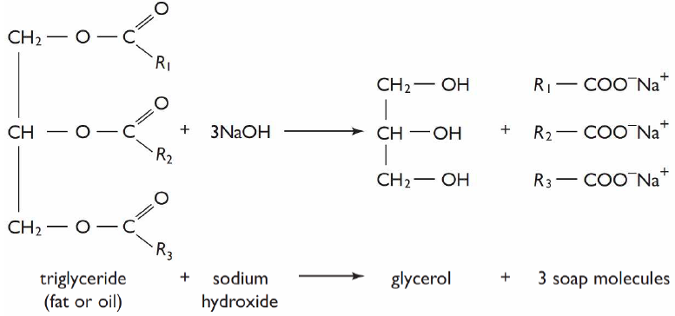
Figure (1): saponification equation

Calcium stearate preparation:
500 gm soap were dissolved in 2 liters of water and heated to 60°C, during this time the mixture of calcium carbonate and hydrochloric acid prepared. When the desired temperature reached, the mixture added slowly with continuous stirring until a white product appeared.
The calcium carbonate used for preparation calcium stearate by this method was supplied from two sources: local market and the other one from stone cutting waste.
Calcium Carbonate and Hydrochloric Acid reacted according to these equations:

CaCO_{3(s)} + 2HCl _{(L)} |  | CaCl_{2(L)} + CO₂(g) + H₂O | 1
Soap_{(L)} + CaCl_{2(L)} |  | Calcium Stearate_{(S)} | 2

In this method the quantity of each of the hydrochloric acid, soap, and calcium carbonate has been fixed, and the variable parameter was acid concentration.
Samples prepared by indirect method using CaCO₃ from local market are summarized in Table (2):

Table (2): Preparation Method for Indirect Sample using Commercial CaCO₃
Indirect (CaCO3) from Market | Sample | Material and chemical(gm) | Preparation method
Indirect (CaCO3) from Market | ID(1) | HCl: 6%.  Sodium soap:500  CaCO₃: 151.5. | - 0.5 kg soap dissolved in 2L water and heated to 60C  - Dissolved 151.5 CaCO3 in 333.5 HCl (6%)  - The two solutions added to each other.
Indirect (CaCO3) from Market | ID(2) | HCl: 15%  Sodium soap:500  CaCO_{3 :}166.5 | - 0.5 kg soap dissolved in 2L water and heated to 60C  - Dissolved 166.5 CaCO3 in 333.5 HCl (15%)  - The two solutions added to each other.
Indirect (CaCO3) from Market | ID(3) | HCl: 25%  Sodium soap:500  CaCO₃:166.5 | - 0.5 kg soap dissolved in 2L water and heated to 60C  - Dissolved 166.5 CaCO3 in 333.5 HCl (25%)  - The two solutions added to each other.
Indirect (CaCO3) from Market | ID(4) | HCl: 33%  Sodium soap:500  CaCO₃:166.5 | - 0.5 kg soap dissolved in 2L water and heated to 60C  - Dissolved 166.5 CaCO3 in 333.5 HCl (33%)  - The two solutions added to each other.

The second part of this method was using stone cutting waste instead of calcium carbonate; these samples are shown in Table (3):

Table (3): Preparation Method for Indirect Sample using Waste CaCO₃
Indirect (CaCO₃) from cutting stone waste | Sample | Material and Chemical (gm) | Preparation Method
Indirect (CaCO₃) from cutting stone waste | ID(5) | HCl: 6%  Sodium soap:500  CaCO₃:151.5 | - 0.5 kg soap dissolved in 2L water and heated to 60C  - Dissolved 151.5 CaCO3 in 333.5 ml HCl (6%)  - Add the two solutions to each other.
Indirect (CaCO₃) from cutting stone waste | ID(6) | HCl: 15%  Sodium soap:500  CaCO₃ : 166.5 | - 0.5 kg soap dissolved in 2L water and heated to 60C  - Dissolved 166.5 CaCO3 in 333.5 ml HCl (15%)  - Add the two solutions to each other.
Indirect (CaCO₃) from cutting stone waste | ID(7) | HCl: 15%  Sodium soap:500  CaCO_{3:}250 | - 0.5 Kg soap dissolved in 1L water and heated to 60C.  - Dissolved 250g CaCO3 in 333.5ml HCl (15%).  - Add the two solutions to each other.
Indirect (CaCO₃) from cutting stone waste | ID(8) | HCl: 15%  Sodium soap:500  CaCO₃: 333 | - 0.5 Kg soap dissolved in 1L water and heated to 60C  - Dissolved 333gm CaCO3 in 333.5 HCl (15%)  - Add the two solutions to each other.
Indirect (CaCO₃) from cutting stone waste | ID(9) | HCl: 25%  Sodium soap:500  CaCO₃ : 166.5 | - 0.5 kg soap dissolved in 2L water and heated to 60C  - Dissolved 166.5 CaCO3 in 333.5 HCl (25%)  - Add the two solutions to each other.
Indirect (CaCO₃) from cutting stone waste | ID(10) | HCl: 33%  Sodium soap:500  CaCO₃: 166.5 | - 0.5 kg soap dissolved in 1L water and heated to 70C  - Dissolved 166.5 CaCO3 in 333.5 HCl (33%)  - Add the two solutions to each other.
Indirect (CaCO₃) from cutting stone waste | ID(11) | HCl: 6%  Sodium soap:500 CaCO₃: 166.5 | - 0.5 kg soap dissolved in 1L water and heated to 70C  - Dissolved 166.5 CaCO3 in 333.5ml HCl (6%).  - Add the two solutions to each other.

2.2.2 Direct Method:
This method is a direct reaction between the oil and calcium hydroxide, the calcium hydroxide used in this method supplied from two sources: local market and the other one prepared by the reaction between CaCO3, HCl and NaOH according to these equations:
CaCO_{3(s)} + 2HCl _{(L)} CaCl_{2(L)} + CO₂(g) + H₂O | 3
CaCl_{2(L)} + 2NaOH_{(L)} 2NaCl + Ca(OH)₂ | 4

In this method 200g oil Heated to 60C, then Ca (OH) ₂added to the oil, the resulting mixture heated to 150ºC.
Oil _{(L)} + Ca(OH)_{2(s)} 60ºC-150ºC Calcium Stearate_{(S)} | 5

In this method, the amount of oil has been fixed, and the variable parameter was the amount of calcium hydroxide, as shown in table (4)
Table (4): Preparation Method for Direct Sample using Commercial Ca(OH)₂
Direct Ca(OH)₂ from market | Sample | Material and Chemical (gm) | Preparation Method
Direct Ca(OH)₂ from market | D(1) | Oil:200g  Ca(OH)₂:166.5 | - Heat 200g oil to 60ºC.  - Added 166.5 g Ca(OH)₂and heat to 150ºC
Direct Ca(OH)₂ from market | D(2) | Oil:200g  Ca(OH)₂:222 | - Heat 200.18g oil to 60ºC.  - Added 222 g Ca(OH)₂and heat to 150ºC
Direct Ca(OH)₂ from market | D(3) | Oil:200g  Ca(OH)₂:333g | - Heat 200g oil to 60ºC.  - Added 333 g Ca(OH)₂and heat to 150ºC

Table (5) shows preparation of samples by direct method using Ca(OH)₂ prepared from stone cutting waste according to equations:(3), (4) and (5)

Table (5): Preparation Method for Direct Sample using Waste CaCO₃
Direct Ca(OH)₂ prepared from CaCO₃ | Sample | Material and Chemical (gm) | Preparation Method
Direct Ca(OH)₂ prepared from CaCO₃ | D(4) | Oil:200g  Ca(OH)₂:166.5 | - Heat 200g oil to 60ºC.  - Added 166.5 g Ca(OH)₂and heat to 150ºC
Direct Ca(OH)₂ prepared from CaCO₃ | D(5) | Oil:200g  Ca(OH)₂:233  cutting stone waste | - Heat 200.18g oil to 60ºC.  - Added 333 g Ca(OH)₂and heat to 150ºC
Direct Ca(OH)₂ prepared from CaCO₃ | D(6) | Oil:200g  Ca(OH)₂:233g CaCO3 market | - Heat 200g oil to 60ºC.  - Added 333 g Ca(OH)₂and heat to 150ºC

The two methods can be summarized in Figure (2):
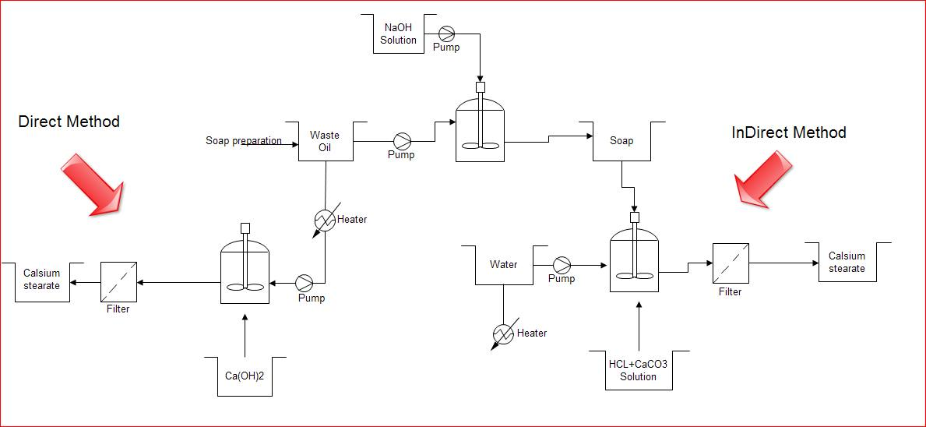
Figure (2): PFD of Producing Calcium Stearate by Direct and Indirect

2.3 Tests:
The following tests were done to find the properties of calcium stearate that is considered the main component of the powder grease:
- DSC test: Differential Scanning Calorimetry is a thermal analysis used to test the behavior of the product under heating and cooling in addition to find melting and softening temperatures.
- Solubility in water.
- Physical properties like: PH, Appearance and Density.
- Ash content: this test is used to determine the amount of material that does not burn in the sample, and it carried out by measuring 2 grams of the sample and putting it in the oven at a temperature of 750ºCfor a half-hour.

Chapter Three
Result and discussion:

3.1 Result:
The sample that were prepared previously were tested according to the PH value, ash content, water solubility, and the appearance to decide if they are accepted or not. Tables (6) and (7) show the results of samples prepared by indirect and direct methods respectively:
Table (6): Result of Indirect Method
Sample | Appearance | Weight (gm) | PH | Ash content% | Water Solubility | Decision
ID(1) | The sample was sticky and 80% of its weight still in beaker | 88 | 8.6 | 37 | Insoluble | Rejected
ID(2) | Hard powder | 379.24 | 7.6 | 23 | Insoluble | Accepted
ID(3) | Hard powder but sticky on hand | 393.55 | 6.6 | 10.5 | Insoluble | Accepted
ID(4) | One solid piece but sticky to hand | 467.5 | 7 | 9.5 | Insoluble | Accepted
ID(5) | The sample was sticky and 60% of its weight still in beaker | 200.68 | 8.4 | 23.8 | Insoluble | Rejected
ID(6) | Soft and moist powder | 708 | 6.78 | 7 | Insoluble | Rejected
ID(7) | Hard powder | 515 | 6.5 | 21 | Insoluble | Accepted
ID(8) | Soft and moist powder | 756 | 6 | 25.5 | Insoluble | Rejected

Table (7): Result of Direct Method
Sample | Appearance | Weight(gm) | PH | Ash content% | Water Solubility | Decision
D(1) | Creamy liquid | ------ | ------ | ------ | ------ | Failed
D(2) | Creamy liquid | ------ | ------ | ------ | ------ | Failed
D(3) | Creamy liquid | ------ | ------ | ------ | ------ | Failed
D(4) | Creamy liquid | ------ | ------ | ------ | ------ | Failed
D(5) | Hard powder | 250 | 12.5 | 42% | Insoluble | Success
D(6) | Hard powder | 200 | 11 | 42.5% | Insoluble | Success

3.2 Discussion of Results:-
According to our procedure we have 2 methods of preparing calcium stearate, direct and indirect.
Eleven samples were prepared by Indirect method (ID1 to ID11); these samples were tested and compared with the reference (a powder grease supplied by an Italian company) regarding some physical properties such as; appearance, melting point, ash content, pH and solubility in water. Therefore, four samples were accepted (ID2, ID3, ID4, ID7).
The accepted samples have values of ash content ranging from 9.5 to 23.8%, while the ash contents for pure calcium stearate and reference sample are 9.5-12.5% and 48% respectively. That means the produced calcium stearate needs other additives to meet the required ash content which could be achieved by adding CaCO₃ or other suitable high ash content where they serve also as cost reducers.
The difference in ash content is related to both the concentration of HCl and the initial amount of calcium carbonate or cutting stone waste. In this project the concentration of HCl was varied from 6 to 33 wt% for calcium carbonate and its effect on ash content was observed, Figure (3) shows the effect of acid concentration on the ash content.

Figure (3): the relation between concentration HCl wt % and ash content
It is obvious from Figure (3) that ash content decreases with increasing concentration of hydrochloric acid. This behavior can be related to the amount of excess HCl needed to complete the reaction.

One of the important properties needed for calcium stearate is softening and melting temperature. In this project these temperatures were examined by DSC for two samples prepared by reacting 15 % HCl with calcium carbonate and stone cutting waste. DSC curves are shown in figure (4) and figure (5).

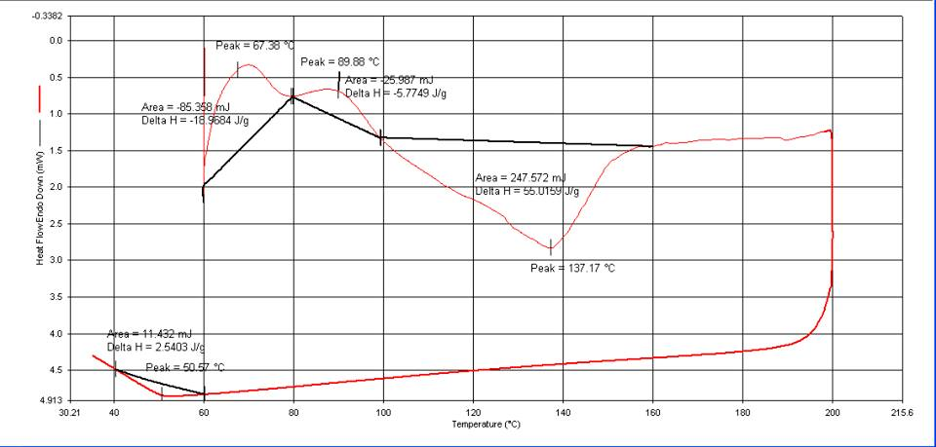
Figure (4): DSC curve for sample prepared from calcuim carbonate
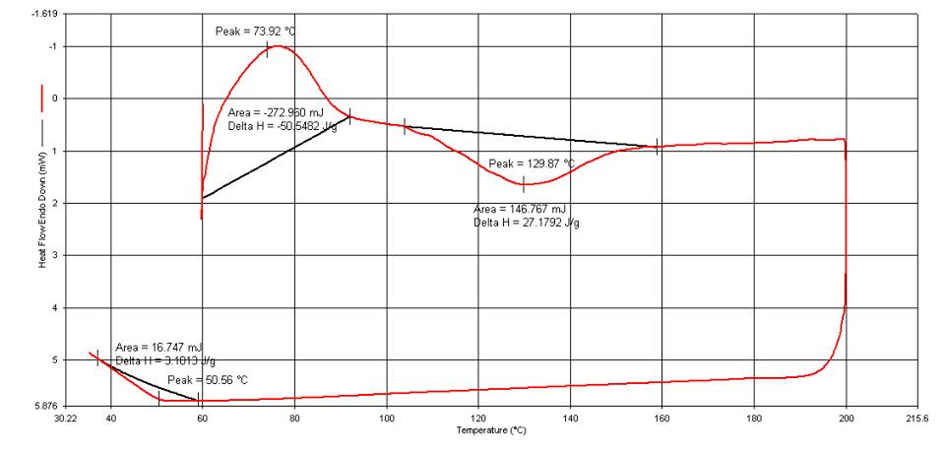
Fig (5): DSC curve for sample prepared from stone cutting waste

It is clear from figures above that the melting temperatures were (137.17 ºC),(129.87 ºC) for sample prepared from calcium carbonate and stone cutting waste respectively.
These values are near the melting temperature of the reference sample which was (147 to 160 ºC). The softening temperature for our samples were about (67.38 to 89.99 ºC),(73.92 ºC) respectively, at this temp the grease (calcium stearate) transferred from solid hard state into leathery state where it is helpful in lubricating the drawn wire.
The raw materials cost of the accepted sample were calculated to select the lowest one for economical and competition purposes of the powder grease which will be sold in Palestine market with accepted price at good quality.
The cheapest sample was ID7 which prepared from 15 % HCl and calcium carbonate from stone cutting waste the price was 1.95 NIS.

By direct method 6 samples were prepared (D1 toD6) but only two samples were accepted because they have nearly similar properties of the standard sample. But unfortunately there raw materials cost were high than the sample prepared by indirect method.

Chapter Four
Market Study

4.1 Feasibility Study:-
This study is conducted to decide about the economic feasibility of constructing a powder grease plant in Palestine.
4.1.1 Market Analysis:
Powder grease is not produced in Palestine and mainly imported from Italy to be used in wire drawing for producing of pins, electrodes and other drawn metals, several Palestinian factories use this product in their activity and their annual consumption is nearly about 100,000 Kg, on another hand this product is not produced in Israel and middle east markets, therefore a plan for increasing the sales could be built to reach these markets by assuming 5% growth for proceeding 3years, the selling price of the current competitor (Italian source ) is about 4800 NIS/ ton. In this study it will be assumed that one ton will be sold with about 4400 NIS.
4.1.2 Technical Study:-
The method for producing powder grease will be the indirect using cooking used oil (mixture of different vegetables oil) and an abundant source of CaCO₃ (the stone cutting waste) as shown in Figure (6)

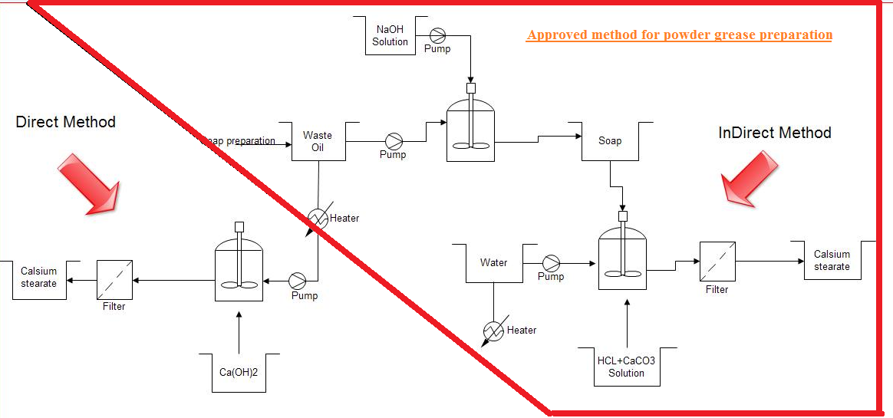
Figure (6): Approved method for powder grease preparation
Equipment’s:-
The main equipment’s used to prepare calcium stearate are listed in table (8), it includes equipment’s installed cost, maintenance and depreciation costs based on the following assumptions.
- Maintenance equals 2% of equipment price.
- Depreciation equals 10% of equipment price.

Table (8): Installation, Maintenance and Depreciation Costs
Equipments | Number | Power(hp) | Installed Cost (NIS) | Depreciation | Maintenance
Oil storage tank | 1 | 0 | 1000 | 100 | 20
Jacketed reactor | 1 | 3 | 10000 | 1000 | 200
Water tanks | 1 | 0 | 1000 | 100 | 20
Mixers | 2 | 1 | 20000 | 2000 | 400
Pumps | 3 | 1 | 4500 | 450 | 90
Reactor | 1 | 1 | 7500 | 750 | 150
Conveyer (Filter) | 1 | 0.5 | 7000 | 700 | 140
Dryer | 1 | 0.5 | 8000 | 800 | 160
Cars and Vehicles | 1 | --- | 100,000 | 10,000 | 2000
Total Cost |  | 7 | 159000 | 15900 | 3180

Total Capital Investment = 159,000 NIS
Revenue:
The selling price of one ton of calcium stearate was assumed in section (4.1.1) 4400NIS
Price of 1 Kg of calcium stearate = 4.4 NIS
Revenue = production rate × selling price
Revenue = 100,000Kg/year × 4.4 NIS =440,000 NIS/year

Raw Materials:-
The following raw materials are needed to produce powder grease (calcium grease) by considered preparing method:
- used corn oil
- Caustic soda
- Hydrochloric acid
- Calcium carbonate; this compound may be available from two sources the first source from market and the other from cutting stone waste. Table (9) shows the amounts of raw materials and their prices required to produce 100 tons annually.
Table (9): Raw Materials, Prices and Amounts kg/year
Raw Material | Amount kg/kg | Amount kg /100 ton | Cost of Raw Material kg/NIS | Cost of Raw Material/100 ton  NIS
HCl | 0.667 | 66700 | 0.4669 | 46690
CaCO3 | 0.5 | 50000 | 0.15 | 7500
Soap | 1 | 100000 | 1.4865 | 148650
Total Cost |  | 216700 | 2.0284 | 202,840

Cost of raw material = 202,840 NIS/year

Utilities:-
Assume that:
The plant operates 200 days/year, with 8 hours per day.
The Electricity cost = 0.61NIS/kW
$$Elecricity Cost\frac{NIS}{year}=power consumption×price of Kw×200day/yr$$
$$Elecricity Cost / year=7hp×\frac{0.61nis}{kw}×200day×8hour×\frac{745 hp }{1000}$$
$$Elecricity Cost/ year=\frac{5,089.84Nis}{year}$$

Labor:
Assume daily production 500Kg, these needs 3 labors with 8 hours working
Salaries of workers= $\frac{100,000Kg/year}{500Kg/day}$ * 8hr * 10NIS * 3 labor= 48,000 NIS/year

Maintenance:
Maintenance = 3,180 NIS/year see table (8) for maintenance

Depreciation:
Depreciation= 15,900NIS/year see table (8) for maintenance

General and Administration cost (G&A):
Because the size of the plant produced powder grease is small, the General and administration cost assumed to be 8% from revenue.
G&A = 440,000 * 8% = 35,200 NIS/year

Land Rent:
The area of this plant was assumed to be 500 m², and the rent rate of 1m² is 80 NIS/yr, so the total expense for the land will be 40,000 NIS/yr.

Income and Expenses statement:
The following table shows the income and expenses statement for the supposed plant, with 100 ton production for the first year and growth percent 5% for the next 3 years (2017-2019).
Table (10): Income and Expenses statement
Income and Expenses | 2016 | 2017 | 2018 | 2019
Revenue | 440,000 | 462000 | 485100 | 509355
Raw Material | 202840 | 205107 | 215362.35 | 226130
Electricity | 5089.84 | 5344.332 | 5611.548 | 5892.126
Labor | 48,000 | 50400 | 52920 | 55566
Depreciation | 15,900 | 15,900 | 15,900 | 15,900
Maintenance | 3180 | 3180 | 3180 | 3180
Gross Margin | 124990.16 | 14268.668 | 152126.1 | 162686.4
G&A | 35200 | 36960 | 38808 | 40748.4
EBIT | 89790.16 | 105108.668 | 113318.1 | 121938
Taxes | 44000 | 46200 | 48510 | 50935.5
Net Profit | 45790.16 | 58908.668 | 64808.1014 | 71002.50647
Cash flow | 61690.16 | 136498.668 | 217206.7614 | 304109.2665
Payback period | This project needs a 1.5 years to payback the capital investment

Conclusion:
The results of this project were as follows: -
- The best sample was (ID7); prepared by indirect method from stone cutting waste with HCl concentration 15% and 50% additives
- Appearance: hard powder
- Solubility: insoluble in water
- Melting Temp = 129.87ᵒC
- Softening Temp = 73.92ᵒC
- Ash content: was 21%
- PH = 6.5
- Gross Margin = 124990.16NIS with percentage 28.4%
- G&A cost = 35,200 NIS
- EBIT= 89790.16 NIS with Percentage = 31.5%
- Net Income = 45790 NIS/yr
- Cash flow = 61690.16 NIS/yr
- Payback period = 1.5 years
- After this study the project will be profitable.

References:

Alun L., Ken B.T., Randy C.B., and Joseph V.M. (2010). Large-scale dispersant leaching andeffectiveness experiments with oils on calm water; Marine Pollution Bulletin pp, 60, & 244–254.

Leslie R.R., Lubricant Additives (2003). “Chemistry and Applications”, Marcel Dekker, Inc. P 293-254.

Ludema K.C. (1996); Friction, Wear, Lubrication, A Textbook in Tribology, CRC Press L.L.C., P124-134.

Rizvi, S.Q.A. (2009)."A comprehensive review of lubricant chemistry, technology, selection, and design, ASTM International", West Conshohocken, PA., P100-112.

Saadi M. Dhaher (2009). "Preparation of Dry Solid Lubricant for Drawing of Welding Steel Wires from Local Iraqi Materials", Vol. 20, P.28-34.

Surender Kumar (2008)." Technology of Metal forming process", p. 80-83.

[W1]: (Unilox Industrial Corporation), http://unilox.com/files/CaST961.pdf, asset on 30/4/2015.

Appendix:
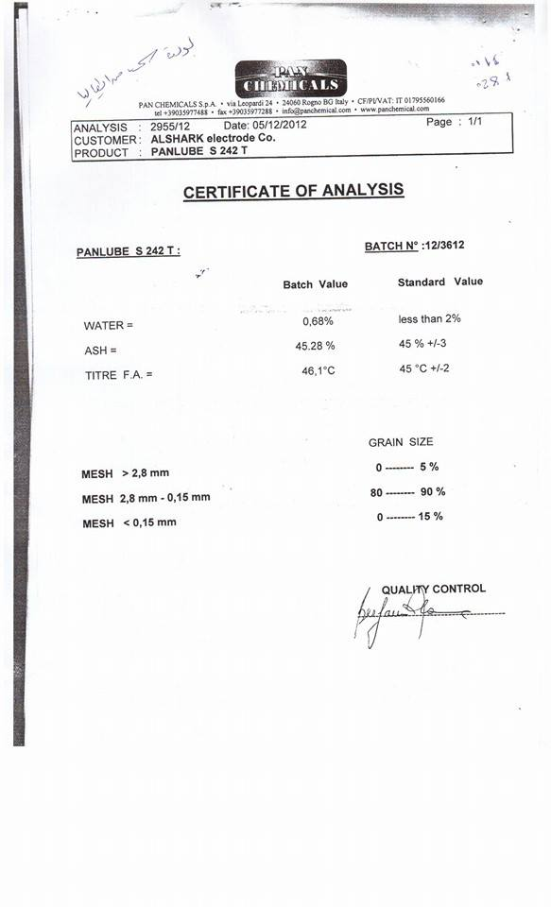
Fig (7): standard properties

