Project title: Braille Printer Academic Year: 2022/2023
Project Type: Hardware Department Name: Computer Engineering Department
Supervisor Name: Dr. Samer Arandi

Group Members: 1- Momen Odeh 2- Noor Aldeen AbuShehadeh
Project’s Abstract:
People with visual disabilities suffer from the problem of unavailability of books and references in Braille, which restricts their access to them. Therefore, there is a need for printing Braille. However, they face several challenges, including the high cost of printers and their scarcity in the market.
A Braille printer provides a valuable means for visual disabilities people to access printed knowledge and materials by converting plain texts into Braille patterns. This significantly enhances the learning and personal development of individuals with visual impairments.
We will implement a Braille Printer that contains a paper feeder which will scroll paper from the paper container to the printing area. the paper feeder consists of a DC motor to scroll the paper. printing mechanism contains a solenoid to knock on the paper that is pinned at the XY coordinate, controlled using 2 stepper motors. To control the movement of the paper from the paper container to the printing area and then out of the printer, we need 2 motors. The challenge in this project is to build a fully functioning braille printer that really works.
Features of this printer:
- build a simple web portal to allow users to submit text to be printed.
- the printer will connect to a webserver to receive the text to print.
- Check if there is a paper in the paper container using a sensor.
- Paper feeder takes paper from paper container.
- Scroll the paper into the printing area.
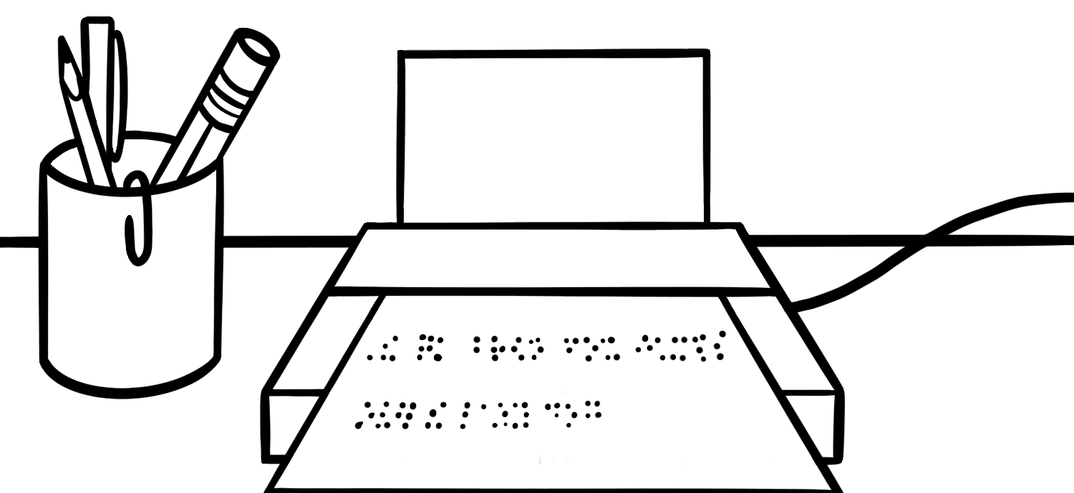
- Printing on the paper by determining the correct place and knocking by solenoid.
- Show the printing status on the LCD.
- Provide audio feedback to indicate status of the printing
process (e.g. make a buzzing sound when printing is
finished or when there is an error, etc).

