

Graduation project

Assist the management of Tulkarem municipality in electricity of prepaid bills

Prepared by : Supervised by :
Jowana Nasrallah Dr.Maher AbuBaker
Neveen Moqadeh
Index:

Goals ……………………………………………………3 _ 4
Gathering data …………………………………….5 _6
Tools…………………………………………………….7
Coding………………………………………………….8 _ 9
Data preparation………………………………….10 _12
Data mapping……………………………………….13 _ 17
Data grouping……………………………………….18 _ 21
Data visualization………………………………….22 _ 53
Data visualization for data grouping….22 _ 37
Data visualization for data…………………38 _ 53
Data mining……………………………………………53 _ 63

The main Goal
Help them to draw their policies in various areas planning and management.

Municipality Questions(problems) :

- Split the subscribers according to the charging quantity into three classes
Class 1: 0 _160
Class 2: 161 _400
Class 3: 400_ above
- the amount of electricity consumption by region to help them make decisions in the locations of electricity charging centers
- The increase in electricity charging (subscriber consumption) during the months
- Number of subscribers classified by classes per months
- solve the discrepancy the quantity of charging electricity and the employees there serve customers
Other questions:
- What are the Numbers of clients each class in each area?
- What is the Numbers of clients in each class for each month?
- What is the count bills per month?
- What is the count bills in each area?
- What is the count of bills according to per month?
- What is the electricity quantity consumed per month?
- What is the electricity quantity consumed per Area?
- What is the count of bills per day of the week?
- What is the count of bills per hour throw-out the day?
- What is the count of bills per day of the month?
- What is the count of bills per hour of each day of the week?
- What is electricity quantity the per hour of each day of the week?
- What is the electricity quantity per tariff?
- What is the count per tariff of each day of the week?
- What is the electricity quantity per tariff each month?
- What is the count of bills per tariff?
- What is the mean of electricity quantity per month?

Gathering data
We have tried to obtain data from many companies such as Bravo, Paltel, and institutions such as the municipality of Tulkarem.
When we went to the private companies, which was paltel and Bravo , they refused to give us the data because they considered it as a secret data , so we went to the municipality of Tulkarem and provided us with the data containing the electricity of prepaid Bills of Tulkarm city and its suburbs for a period of seven months from 6th of 2018 to 12th of 2018.
The Excel files contained the following data:

Filename: (clients.xlsx):
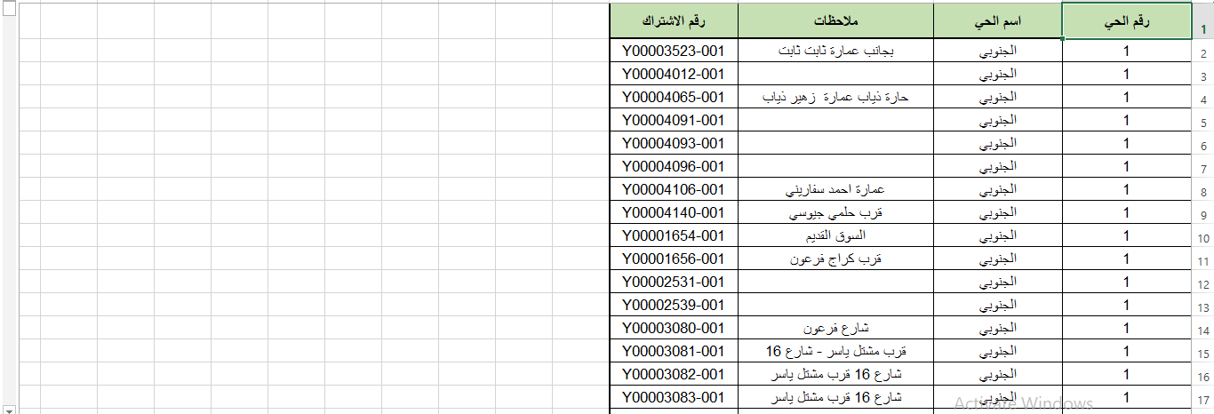

Filename:( tarif.xlsx):
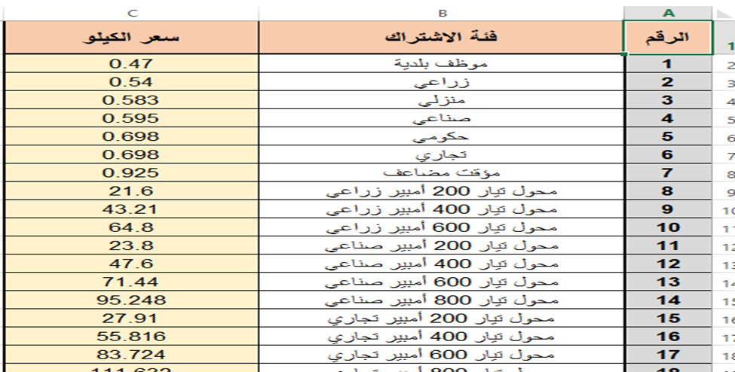
Filename: (bills_data.xlsx)

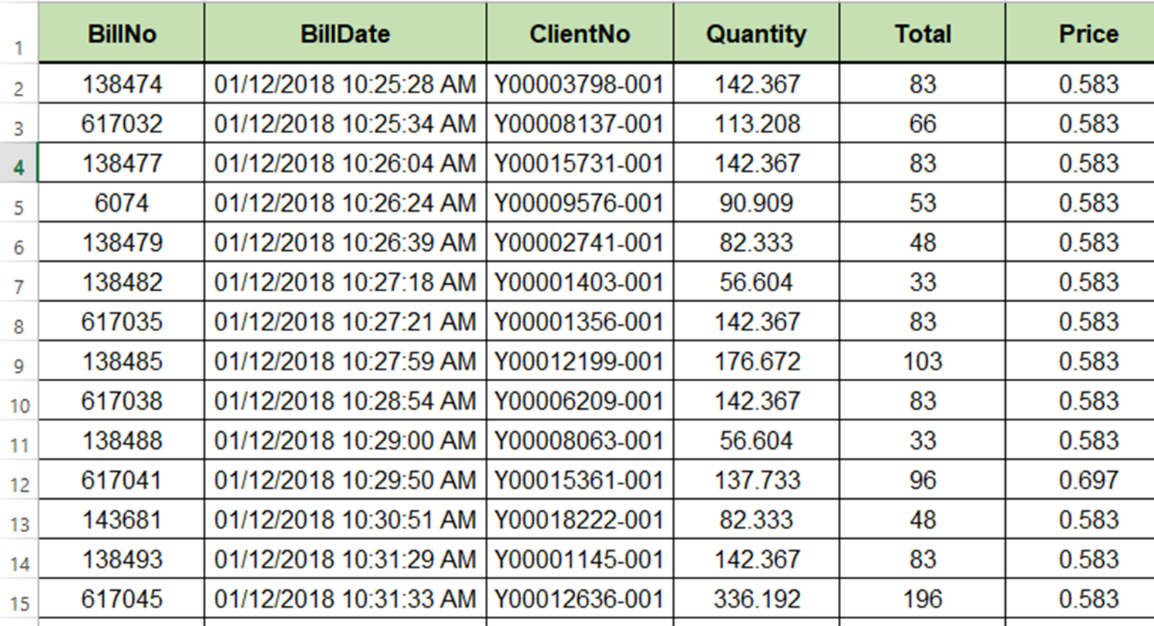

Tools
We searched for a tool to analyze the data we had obtained. The first option was Rapid Miner, we tried to load the data on it but it didn’t understand the amount of the large data that we have obtained which was 250 000 Record so it is a commercial tool that we must pay money to work on it and also because it can’t accommodate more than 100 records for Free.
The second option was the use of Pandas (Jupyter) –Python language, knowing that we did not know it previously and we have learned it by the assistant of the project supervisor and searching on Google.
Since this is one of the strongest tools to analyze the data in 2018 and it is free to be adapted to work on it.

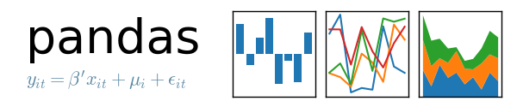

Coding
أسماء الاحياء وارقامهم:
الجنوبي | 1
الغربي | 4
وسط البلد | 5
الجنوبي الغربي | 6
الشرقي | 8
الشرقي الشمالي | 9
الشمالي | 10
الصوانة | 11
عزبة ناصر | 12
عزبة الجراد | 13
عزبة شوفة | 14
كفا | 15
محيط شويكة | 18
شويكة الشرقي | 19
شويكة الغربي | 21
ارتاح | 24
ارتاح الجديدة | 25
ارتاح وسط البلد | 26
ذنابة الشمالية | 27
ذنابة | 29
حارة السلام | 31
مخيم طولكرم | 32
البنوك | 39
عزبة الطياح | 43
ظهرة الشرفا | 44
ظهرة اكبارية | 45
شويكة | 46
طولكرم | 47
ضاحية الرشيد | 48
نور شمس | 49
جبل السيد | 50

أنواع التعرفة وارقامها:
1 | موظف بلدية
2 | زراعي
3 | منزلي
4 | صناعي
5 | حكومي
6 | تجاري
7 | مؤقت مضاعف
8 | محول تيار 200 أمبير زراعي
9 | محول تيار 400 أمبير زراعي
10 | محول تيار 600 أمبير زراعي
11 | محول تيار 200 أمبير صناعي
12 | محول تيار 400 أمبير صناعي
13 | محول تيار 600 أمبير صناعي
14 | محول تيار 800 أمبير صناعي
15 | محول تيار 200 أمبير تجاري
16 | محول تيار 400 أمبير تجاري
17 | محول تيار 600 أمبير تجاري
18 | محول تيار 800 أمبير تجاري
19 | منشار حجر 600 أمبير
20 | منشار حجر 800 أمبير
أيام الأسبوع:

الاثنين | 0
الثلاثاء | 1
الأربعاء | 2
الخميس | 3
الجمعة | 4
السبت | 5
الاحد | 6

Data preparation
We have called the necessary modules for data preparation then uploaded the file(bills_data.xlsx):

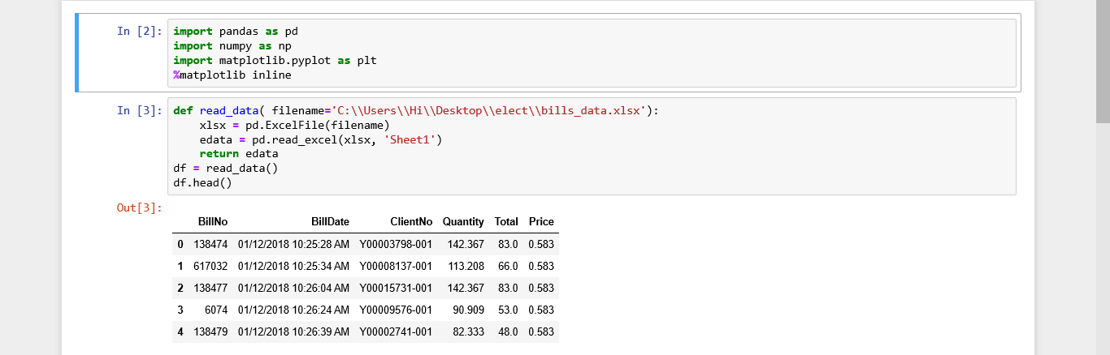

We converted the column (BillDate )from string to date form then added a new column (hour)that describe the time of client arrived and make an invoice and take the values of it from (BillDate) .
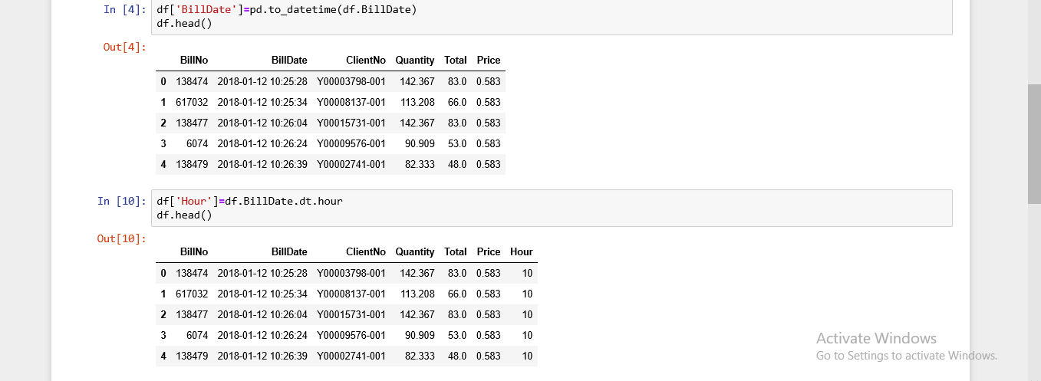

We converted BillDate to (D/MM/YYYY) form, then we save in BillDate Column, then we created a new column (Dayofweek) then we took its values
from BillDate.
We created new two columns(Month),(Day), then we took its values from
BillDate.
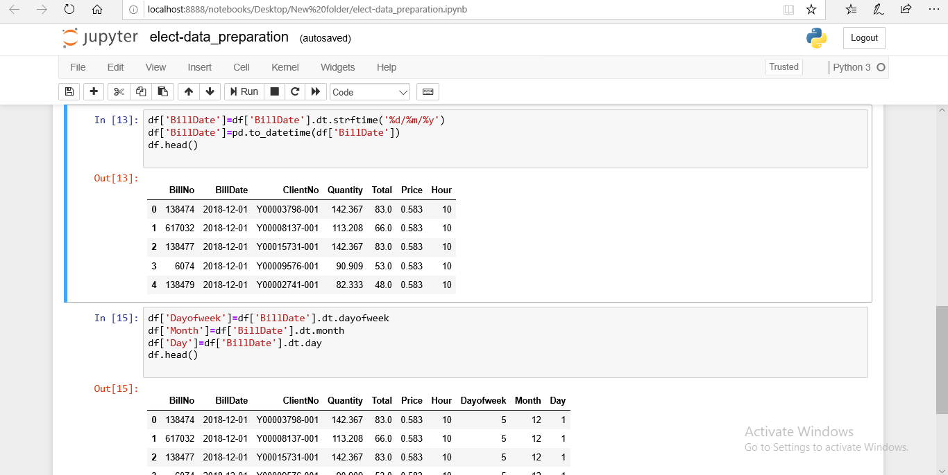

We saved this data in a file in Excel.CSV form , named elect_data__phase1.CSV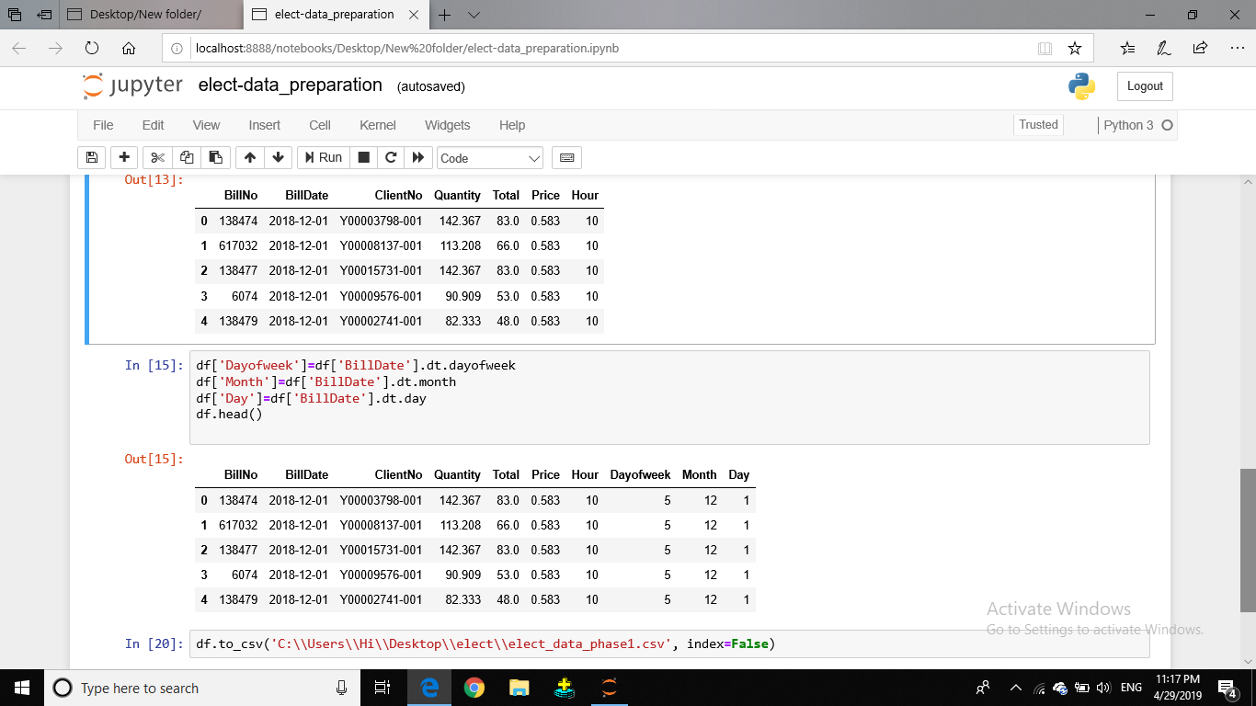

File name: ( elect_data__phase1.CSV)
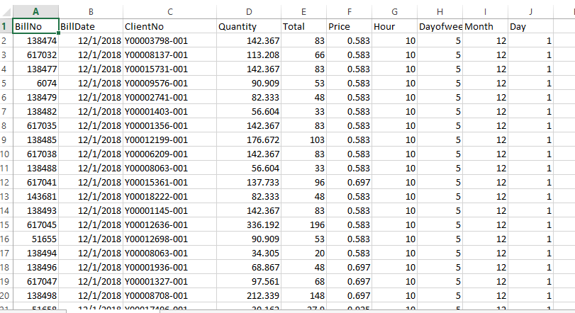

Data mapping
We called necessary modules for data mapping, and upload three files
1-clients.xlsx 2-Tarif.xlsx 3- elect_data_phase1.csv
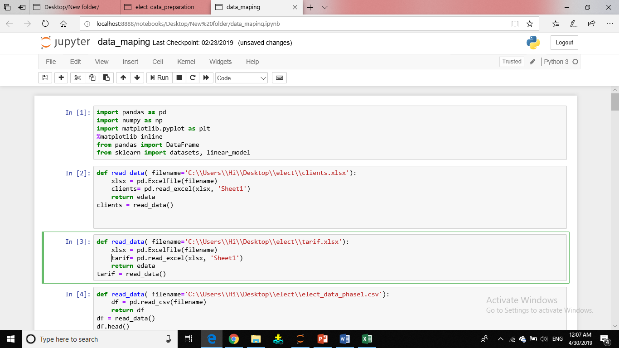

We created two columns (Tarifa),(AreaNo)
And give them 0 value.

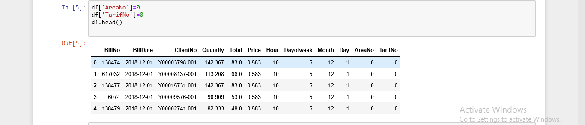

We create Array (price_to_Tarif) that contain the value of the Tarif and its number
Then we did the mapping between (price_to_Tarif )array and (price) column.
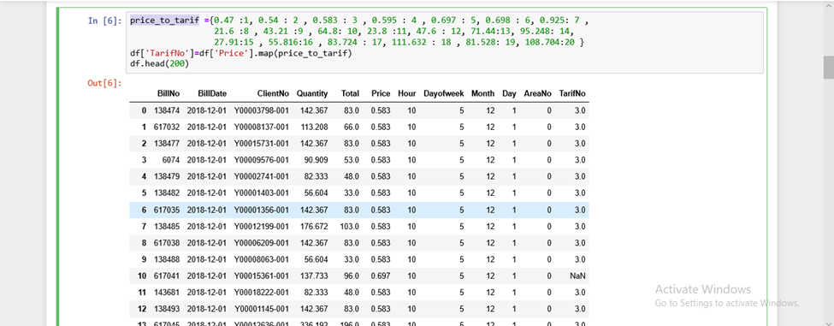

We faced a problem that is there is some records have a value of Tarifno NONApplicaple-NAN
Because the municipality changed the tariff price through the month from 0. 697-0.698

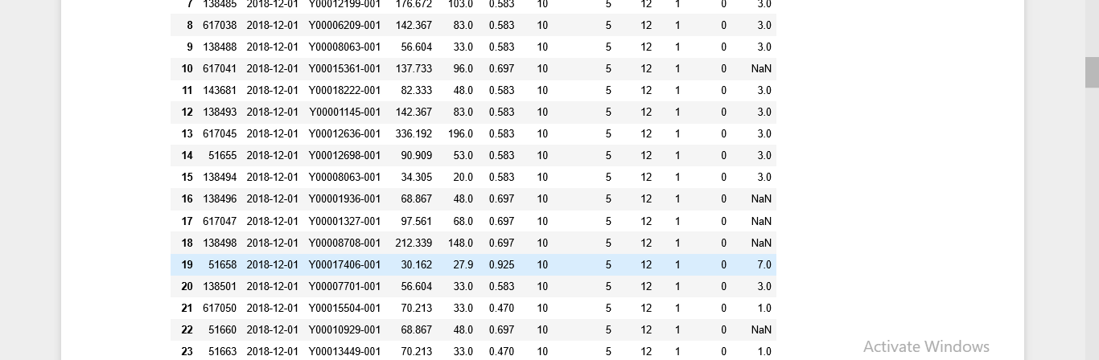

We solved this problem by putting the right number for this tariff price.
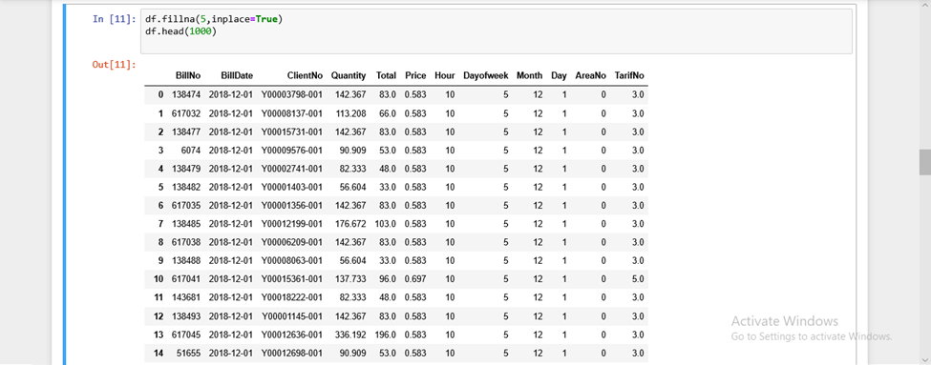

We divide the records into five parts that each part have 50,000 records, then we put them in for-loop
to do the mapping between it and file (clients.xlsx).
Then we saved it in a file (finel_data.csv).

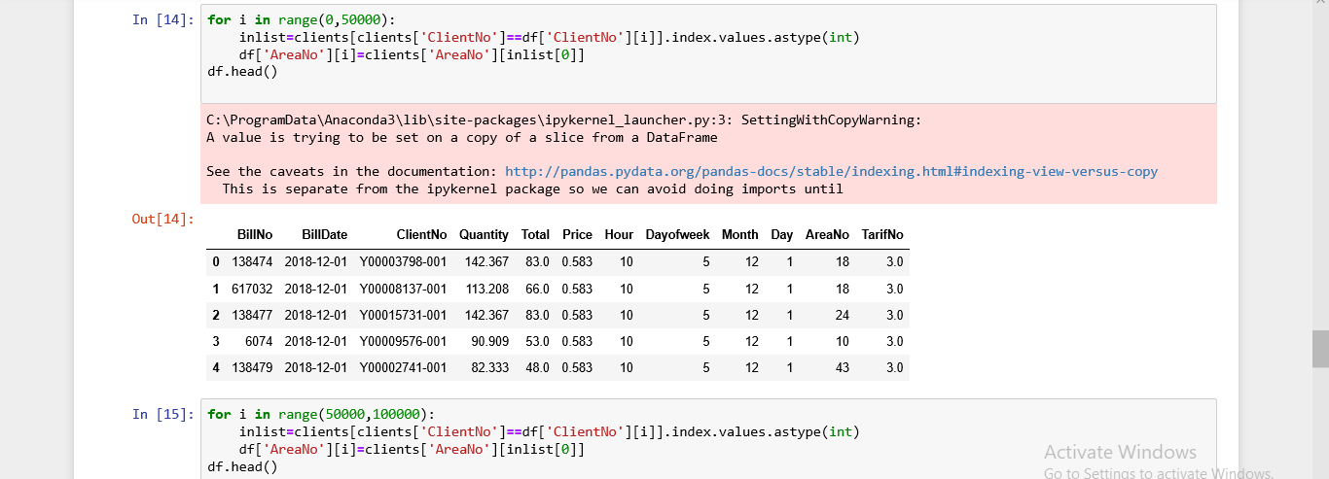

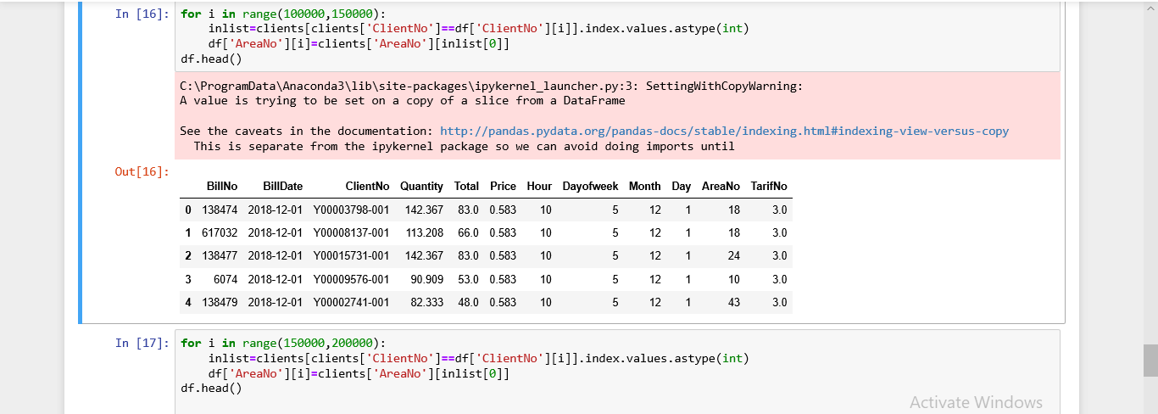

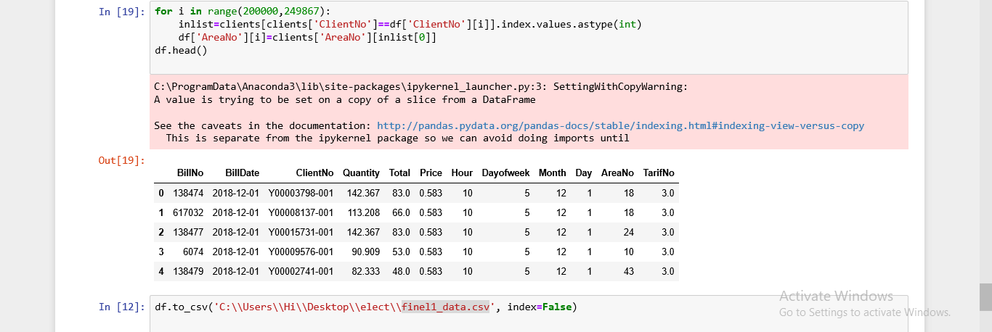

File name:( finel_data.csv)

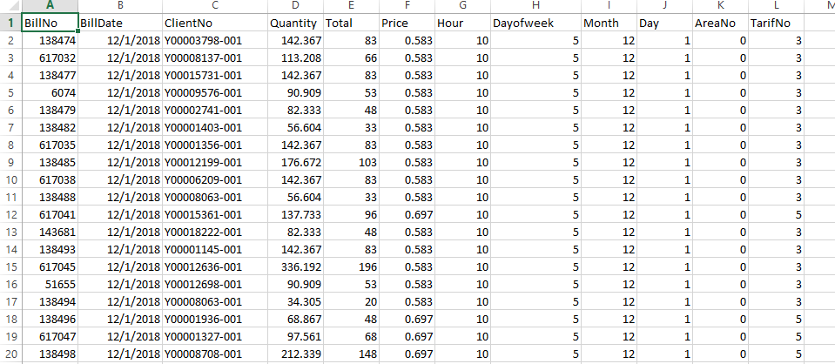

Data grouping
Split the subscribers according to the charging quantity into three classes
Class 1: 0 _160
Class 2: 161 _400
Class 3: 400_ above
We called necessary modules for data grouping then upload the file (finel_data.csv) 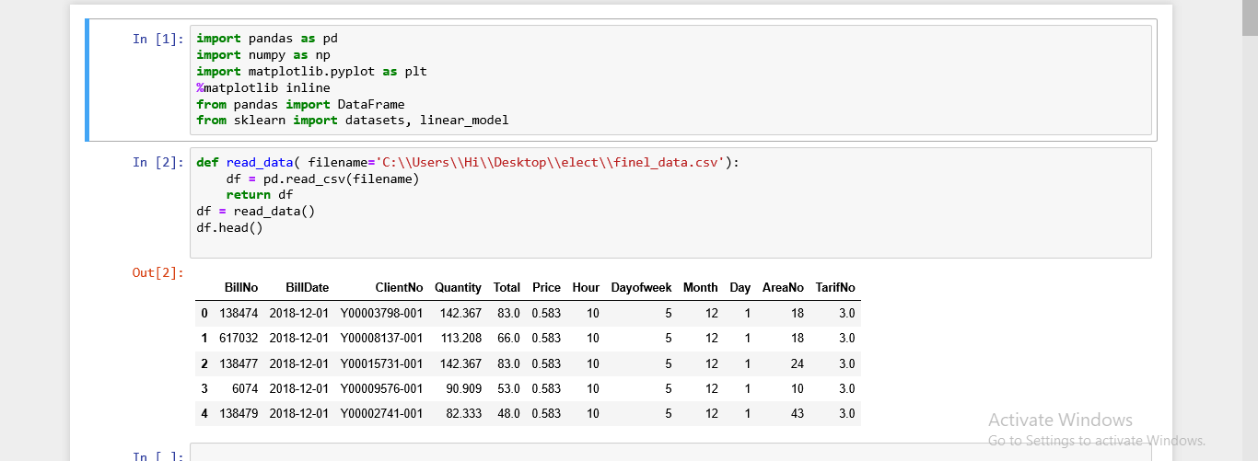
We made a group by for ( Month, ClientNo, AreaNo, TarifNo), that some electricity quantity for the client through each month and the number of Bills for each month.
Then we created new columns (ClassNo) and give it 0 value

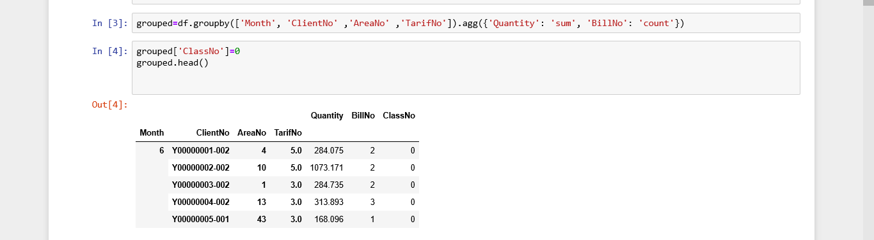

We divide clients that consumed from 0-160 and give them the value of ClassNo=1.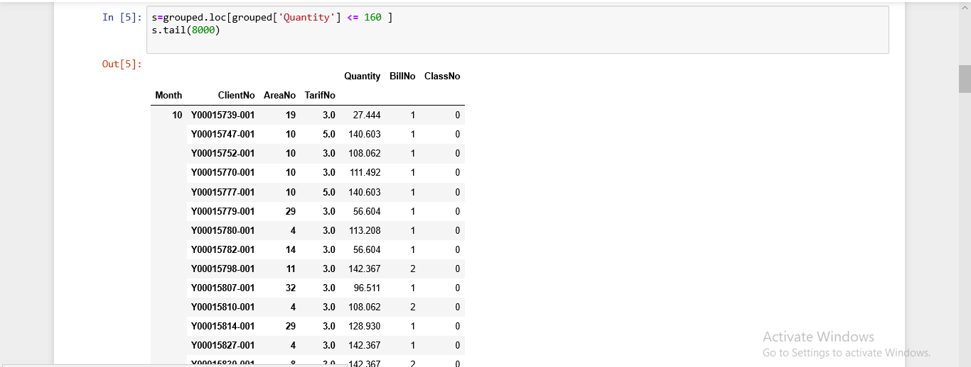
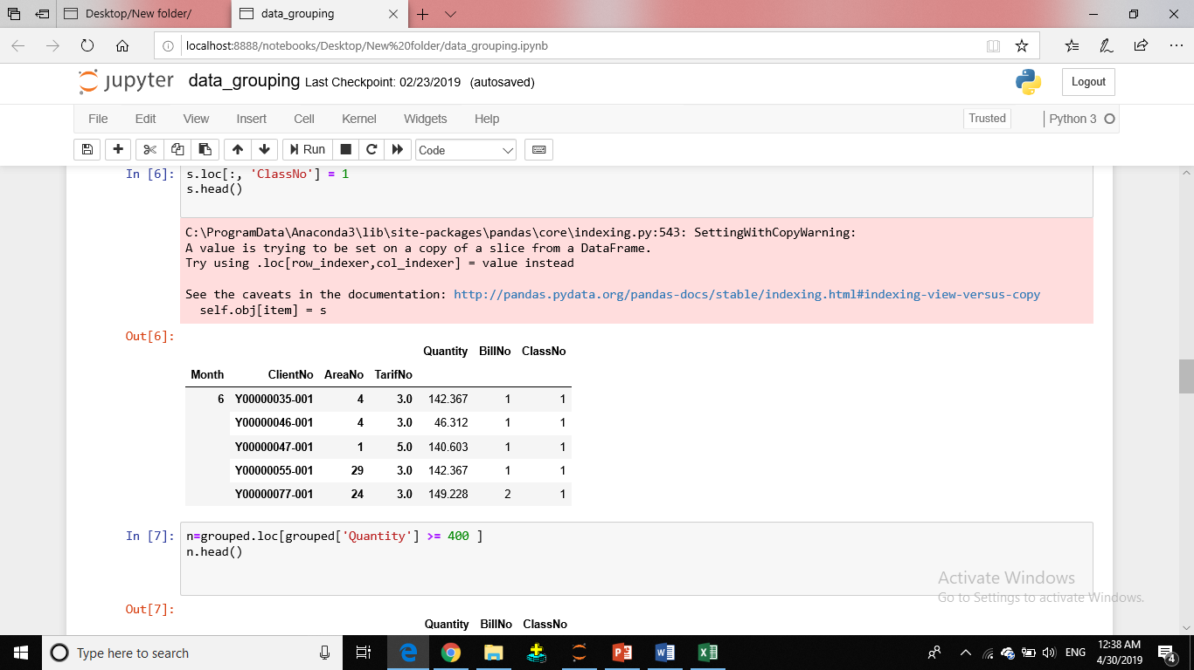
We divide clients that consumed from 160-400 and give them the value of ClassNo=2.

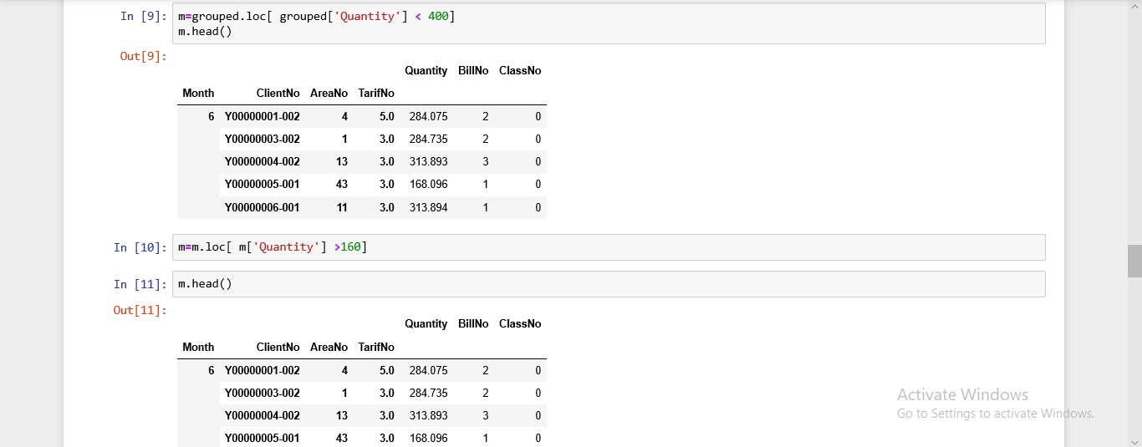
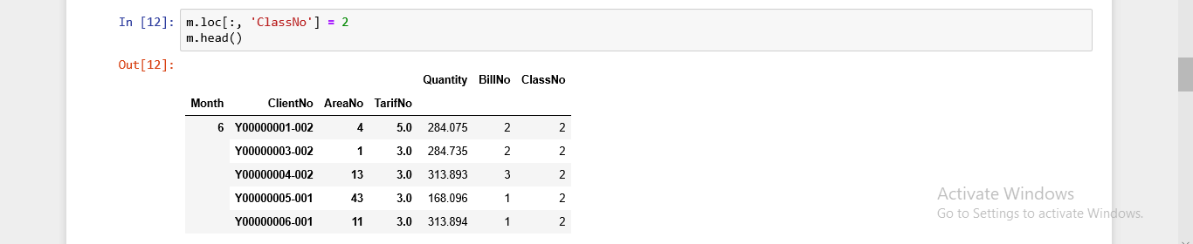
We divide clients that consumed from 400_above and give them the value of ClassNo=3.
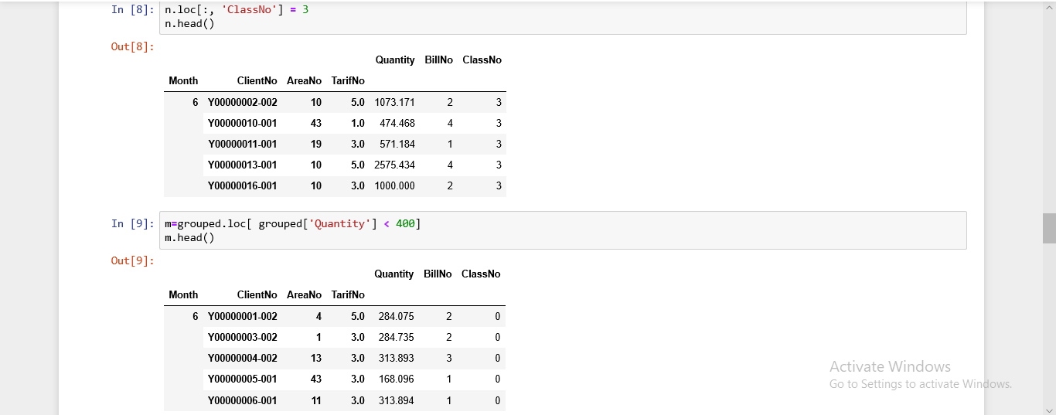
Collect all parts(Class 1,Class2,Class3) together.
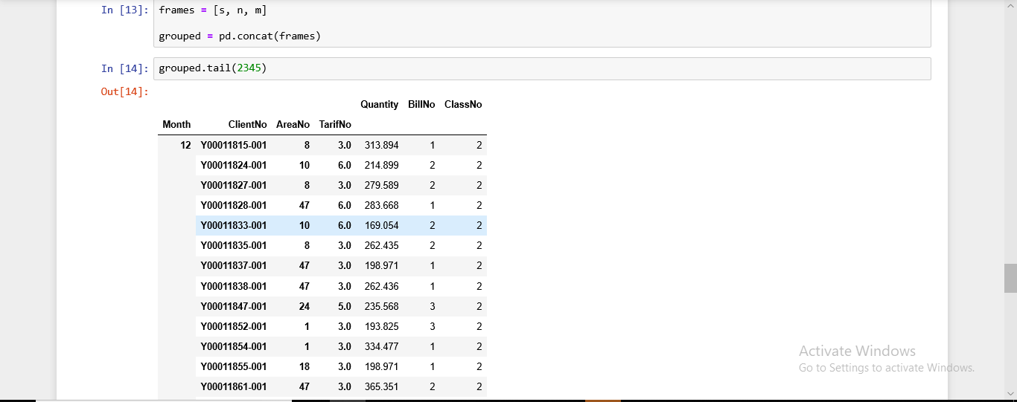

Then save this data in(group_data.csv).

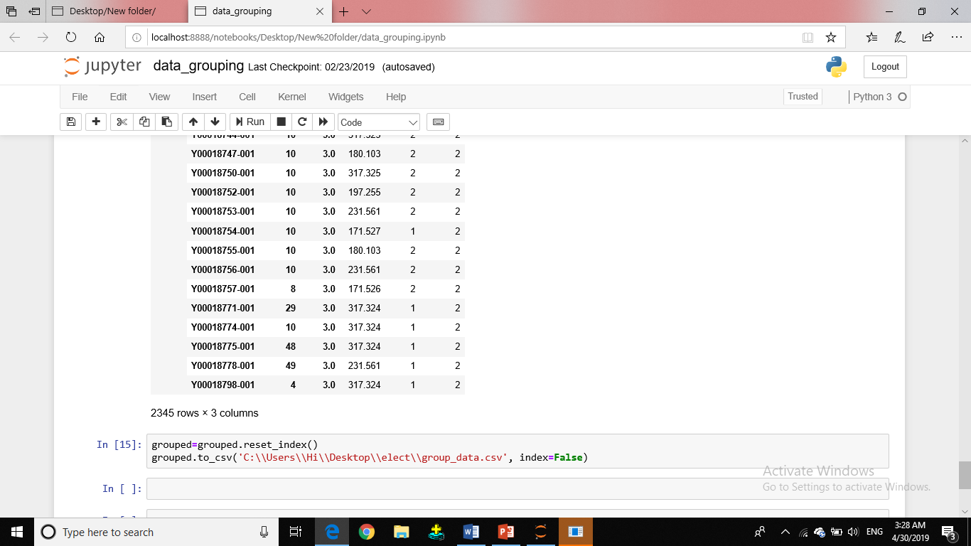
File name: (group_data.csv)
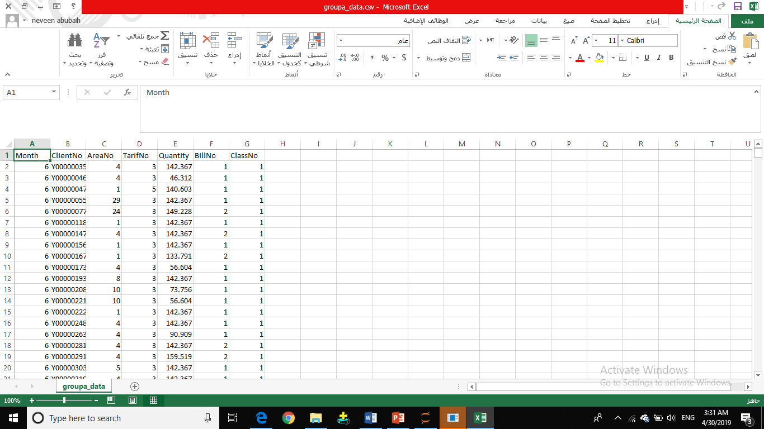

Data visualization
1-Data visualization for data grouping
We called necessary modules for data visualization then upload the file (group_data.csv).
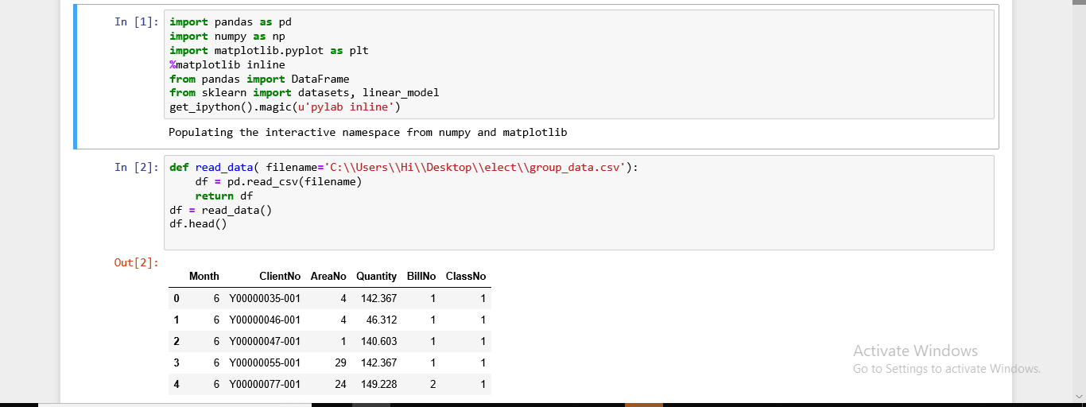

we prepared data for data visualization .
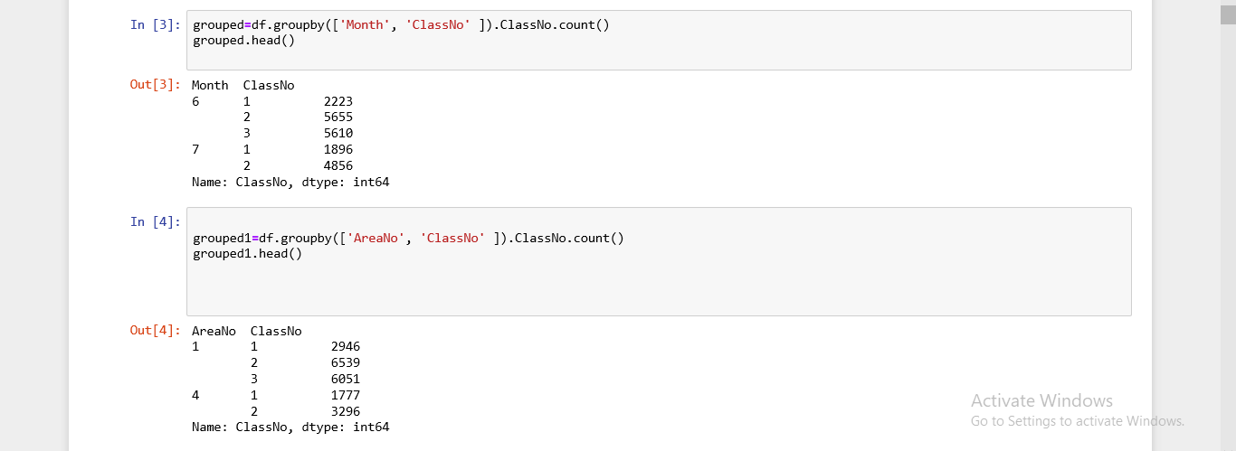

we made a group by (Month, AreaNo, ClassNo), that count the classes by ClassNo.
then we divide clients according to class numbers.
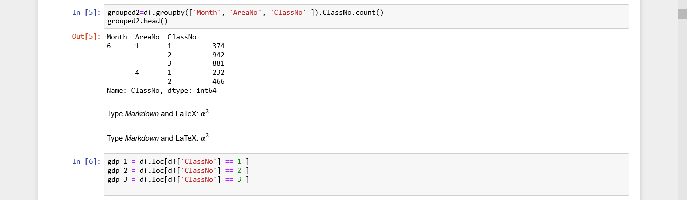

We took the numbers of clients in class 1 per area.
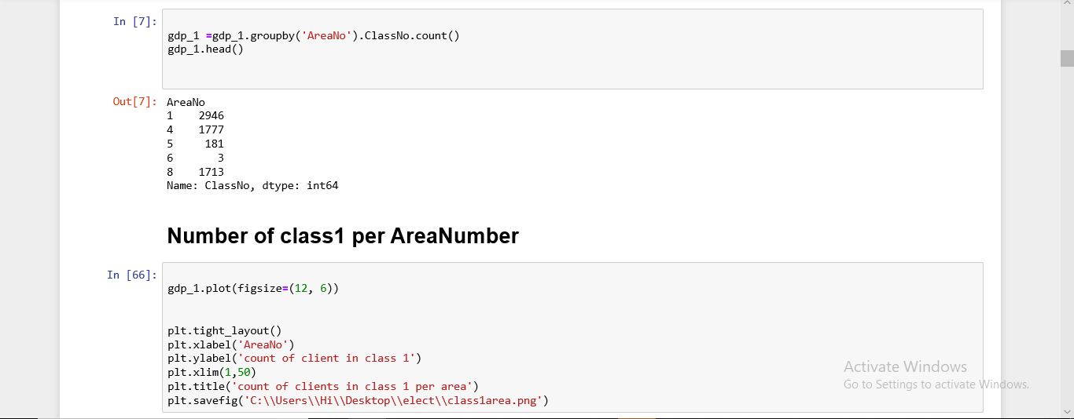

What is Numbers of clients in class 1 in each area?
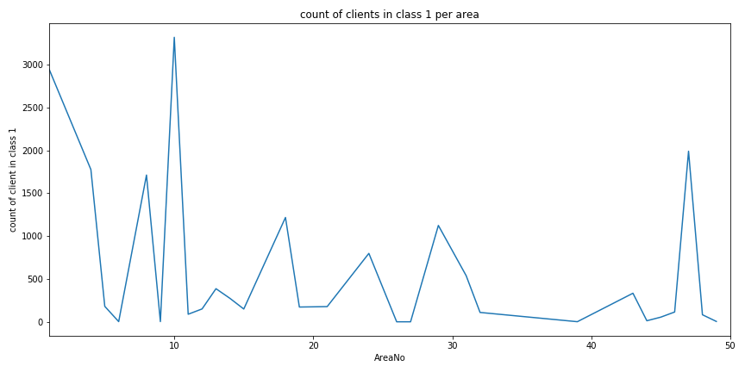
Then Numbers of clients in class 2 per area
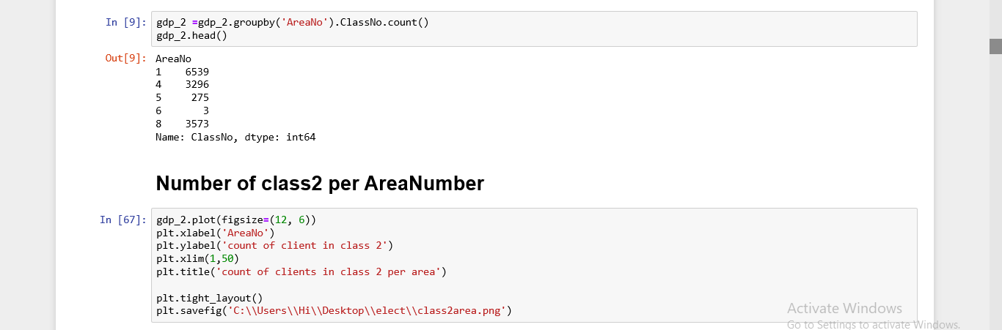

What are the numbers of clients in class 2 in each area?

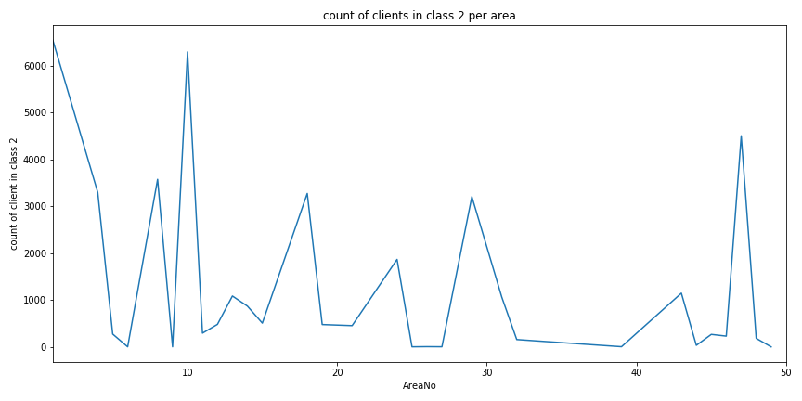
Numbers of clients in class 3 per area

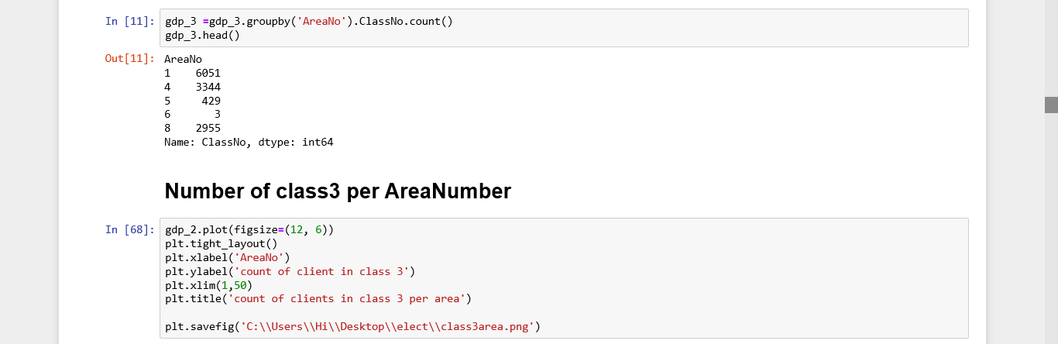

What are the numbers of clients in class 3 in each area?
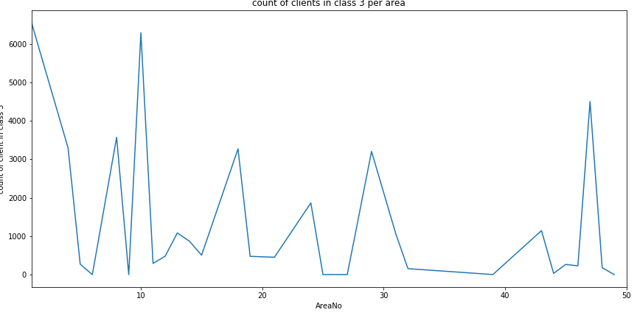
Counts of clients for each class per area number
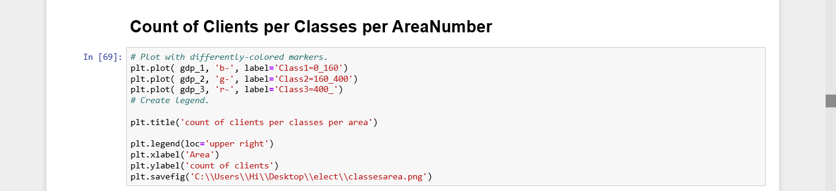

What are the numbers of clients in each class in each area?

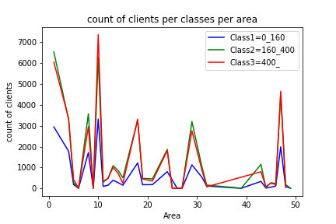
we divide client according to classes numbers then took numbers of clients in class 1 per month.
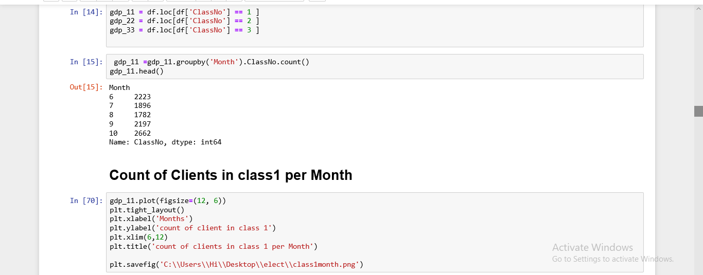

What is the Numbers of clients in class 1 for each month?
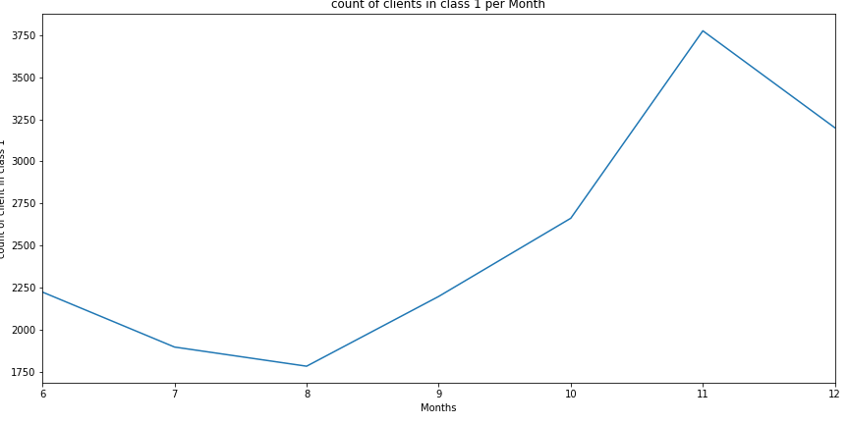
We took the numbers of clients in class 2 per month.

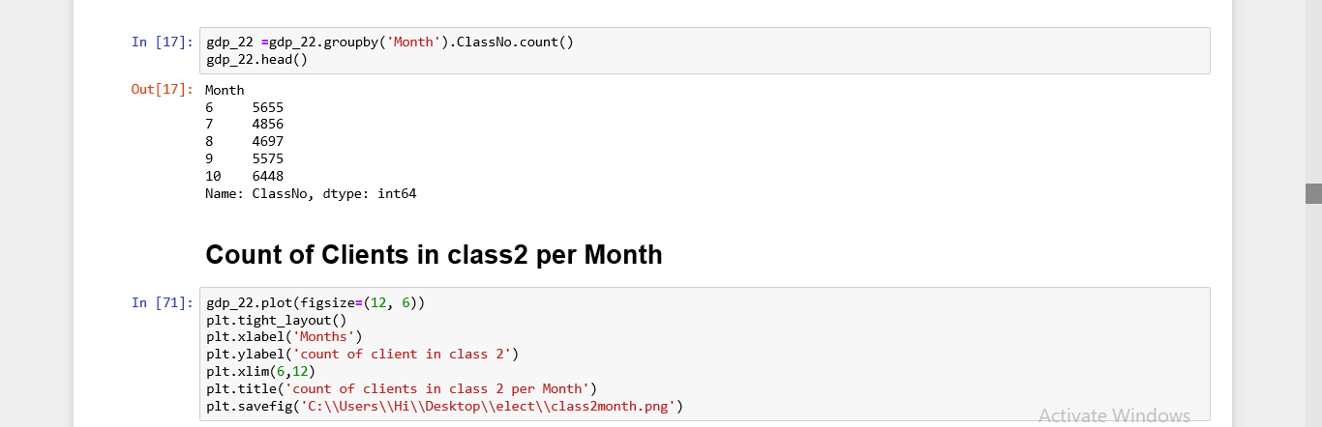

What is the numbers of clients in class 2 for each month?

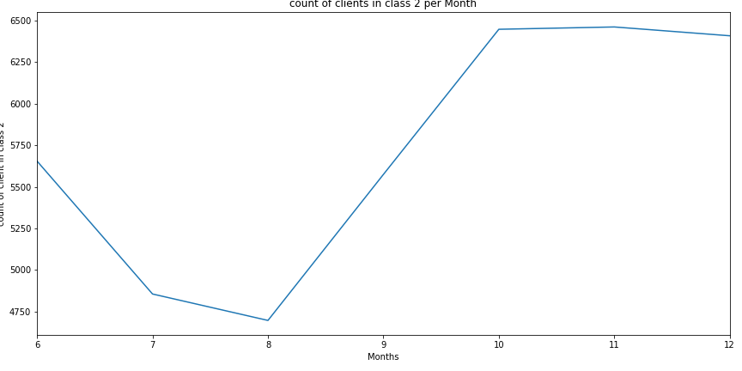

We took the numbers of clients in class 3 per month.

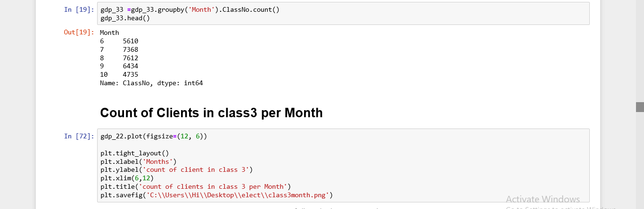

What is the Numbers of clients in class 2 for each month?

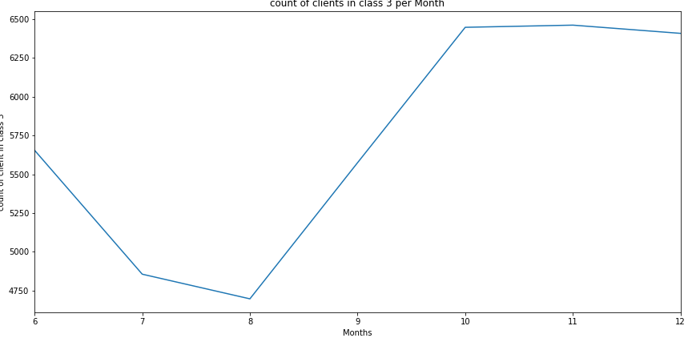
Draw count of clients in each class per month
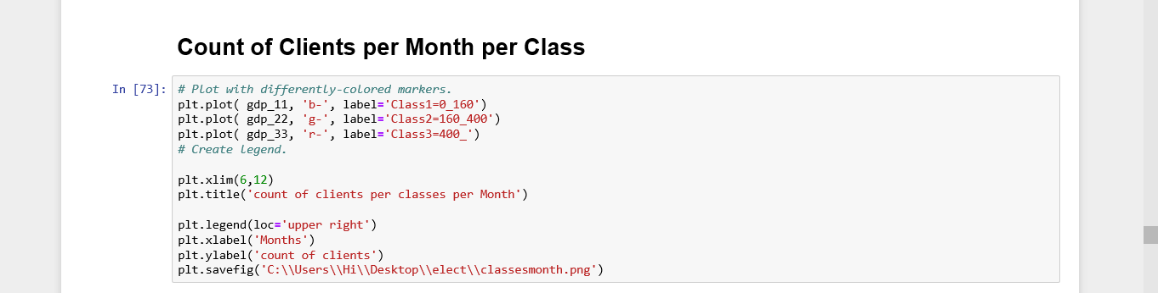

What is Numbers of clients in each class for each month?
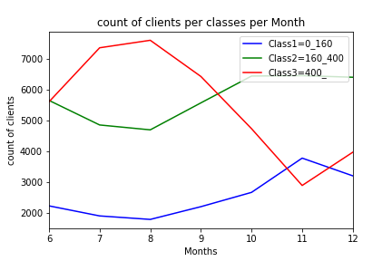
Divide classes according their numbers, and then find the numbers of clients in each classes per month.

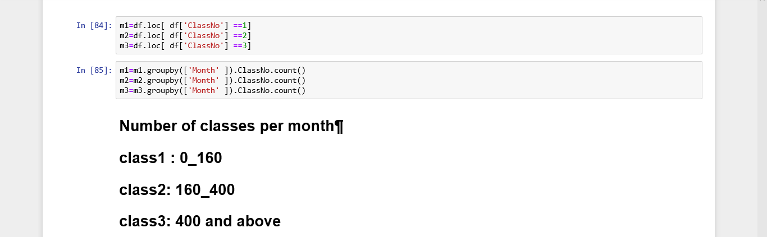

Draw the count of clients in each class per month.

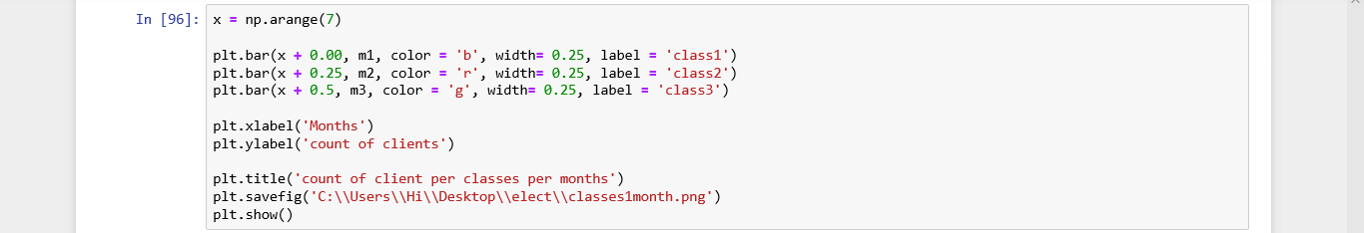

What is the count of clients in each class for each month?
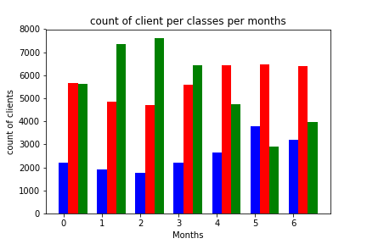

Find the count of bills per month then draw it
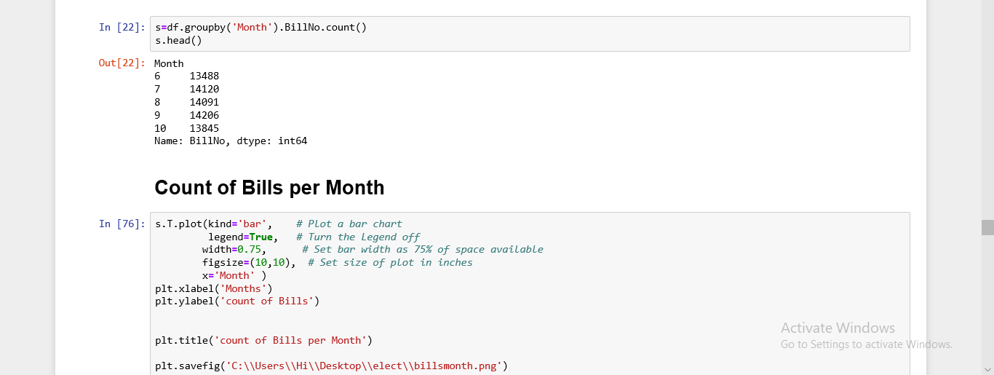

What is the count bills per month?
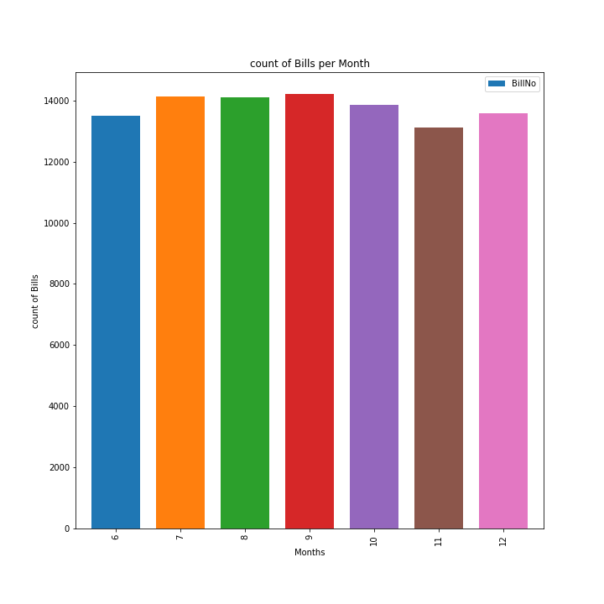

Find a count of bills per area and then draw it
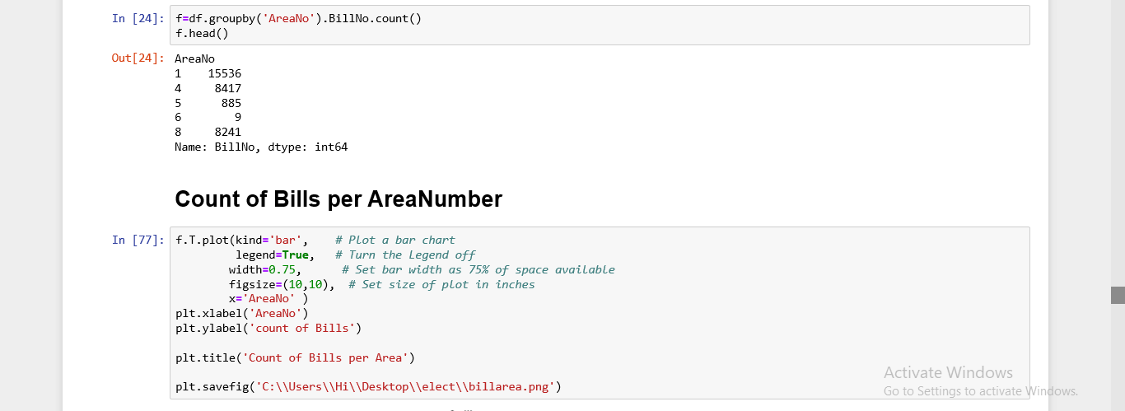
What is the count bills in each area? 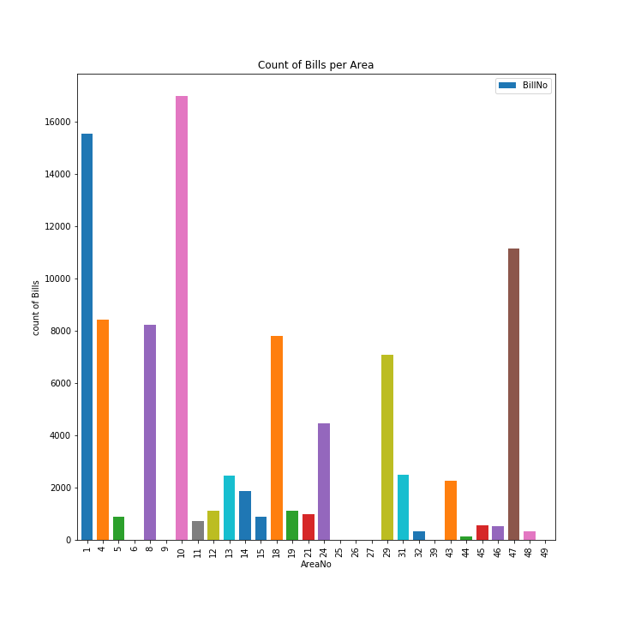

We divide records according to month, then find the count of bills for each number of the bill, then draw it.
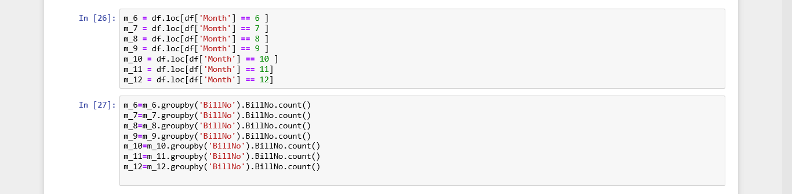
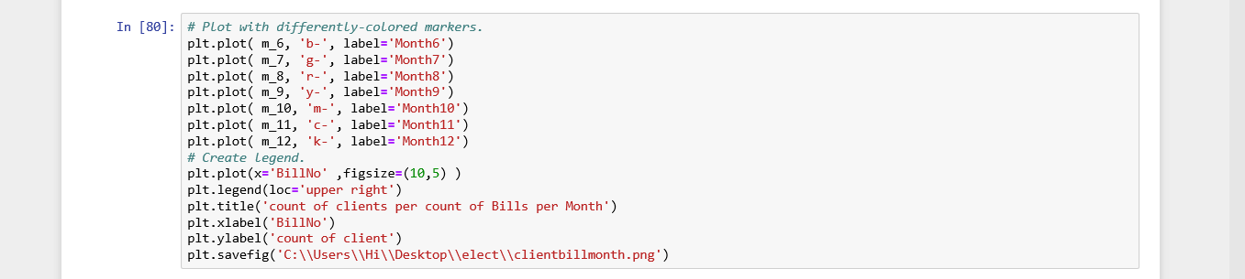
What is the count of bills according to per month?
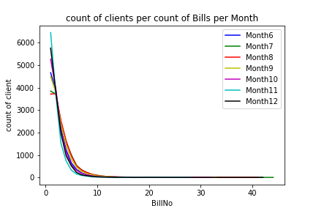

2-Data visualization for data
We called necessary modules for data visualization then upload the file (finel_data.csv).
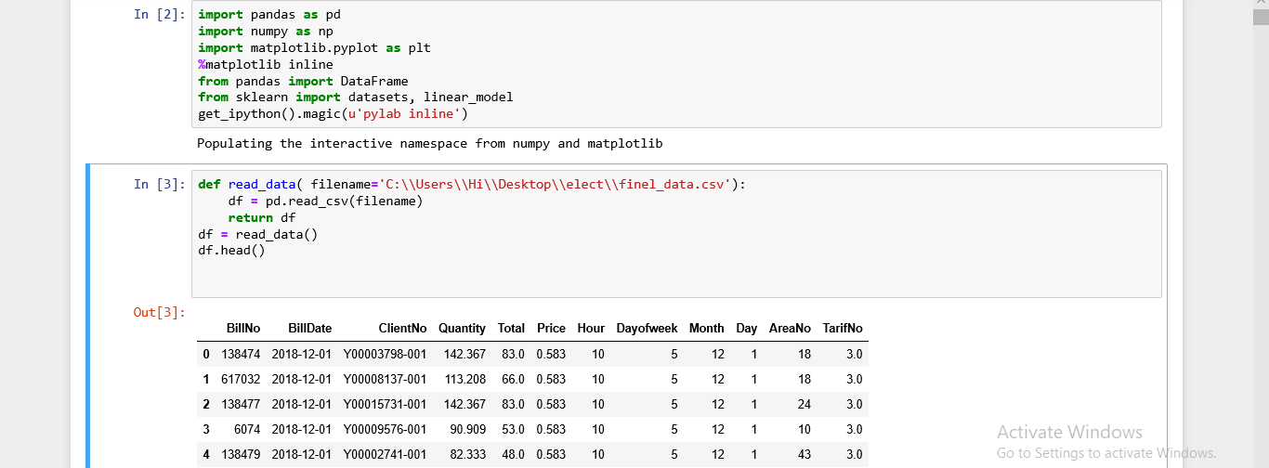
find the summation of electricity quantity for each month, draw it.

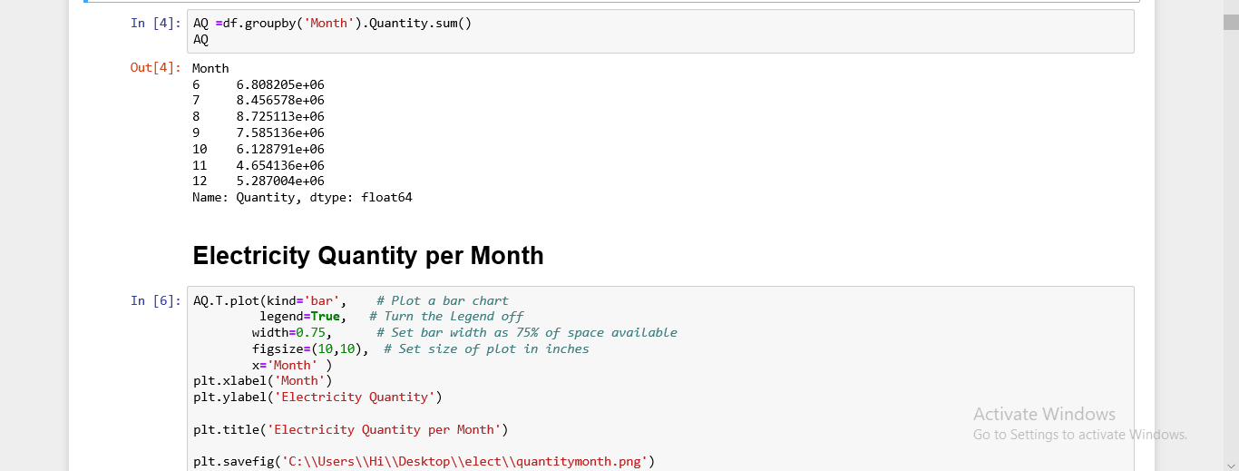

What is the electricity quantity consumed per month?
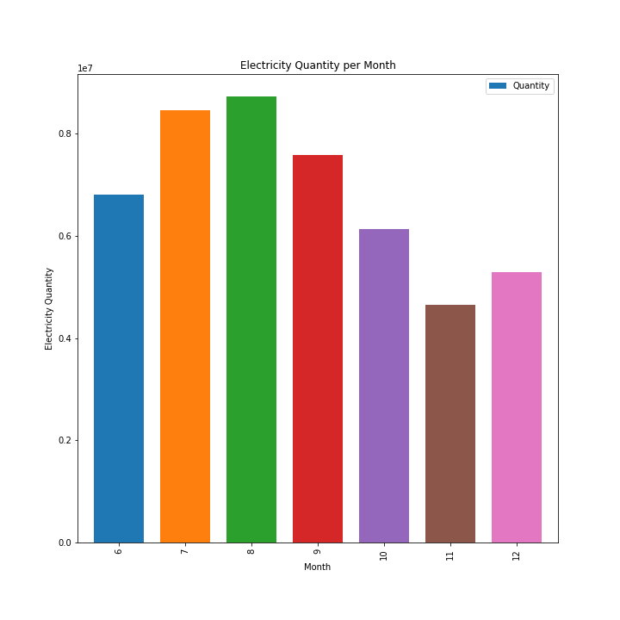

find the summation of electricity quantity for each month, draw it.

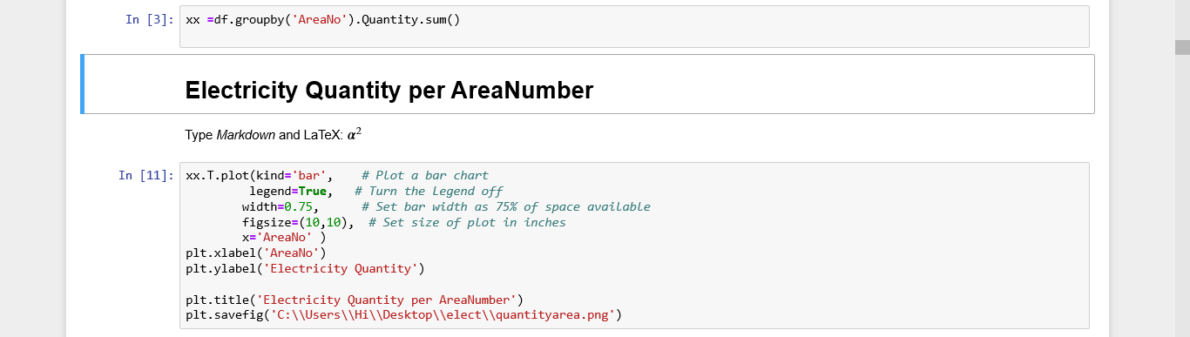

What is the electricity quantity consumed per Area?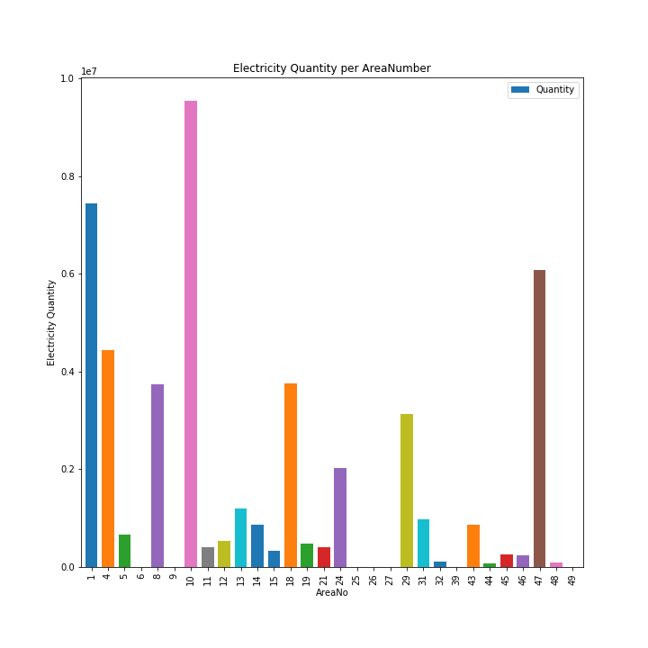

Find the count of bills per day of the week, draw it.
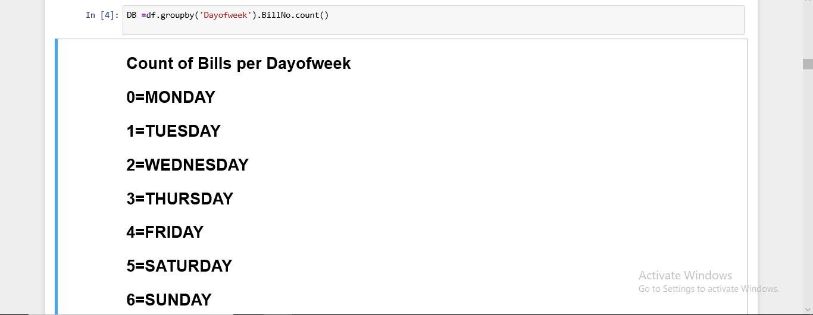
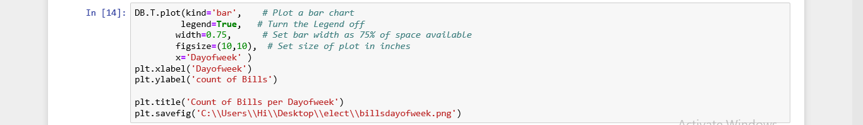
What is the count of bills per day of the week?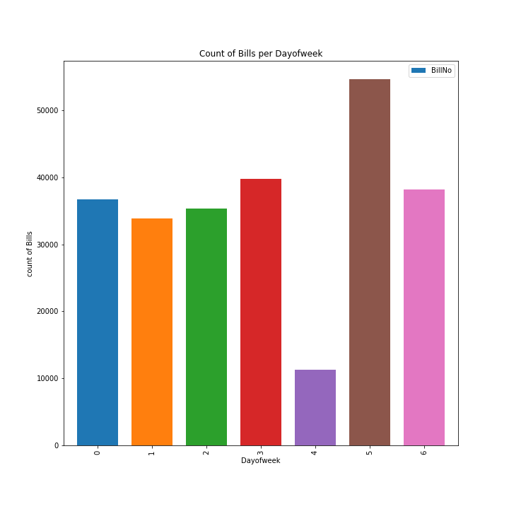

Find the count of bills per hour, then draw it.
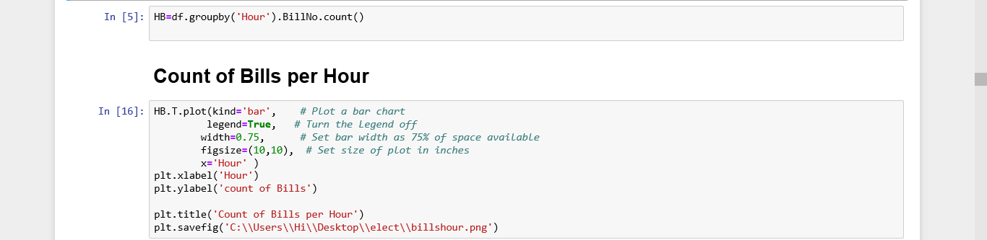
What is the count of bills per hour throw-out the day?
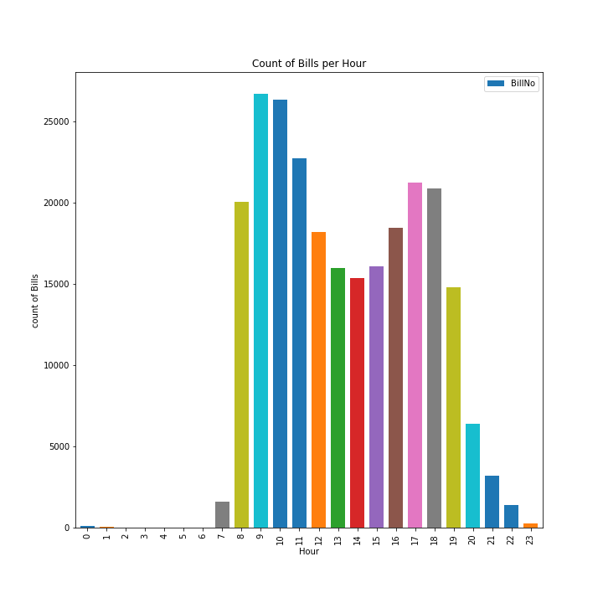
Find the count of bills per day of the month, then draw it

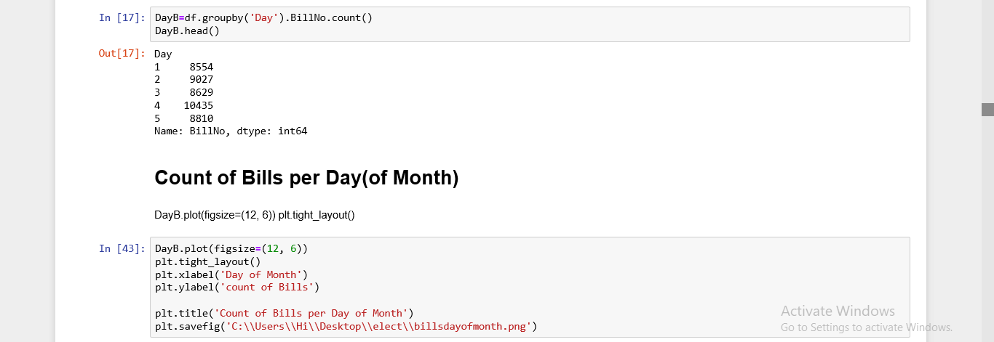
What is the count of bills per day of the month?

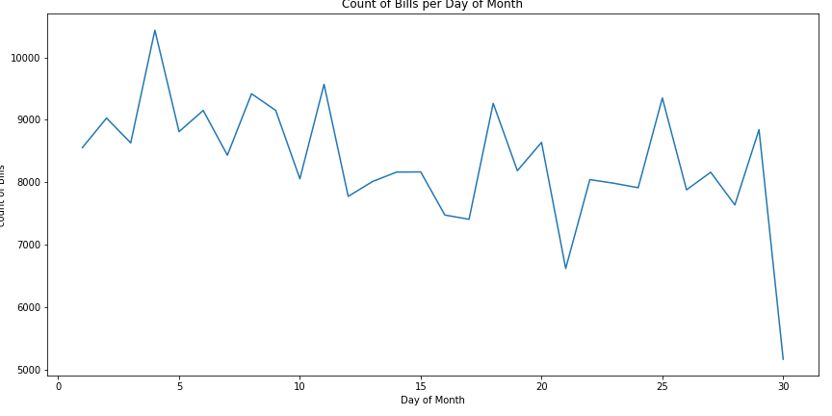

Find the count of bills per hour in each day of the week and draw it
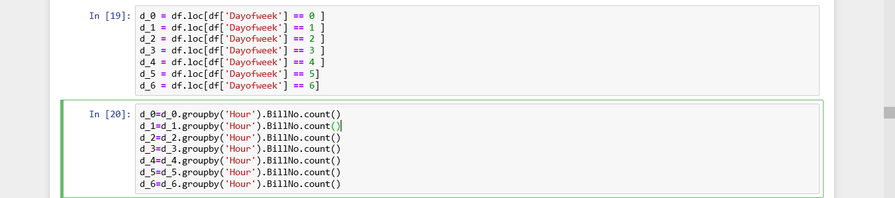
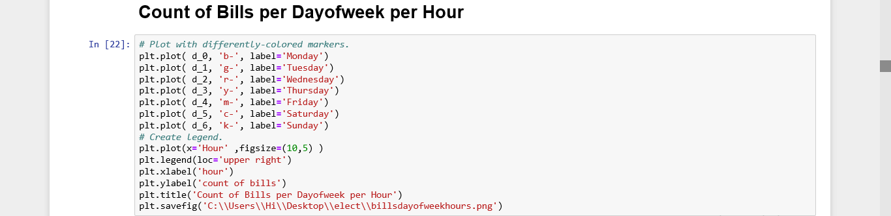
What is the count of bills per hour of each day of the week?

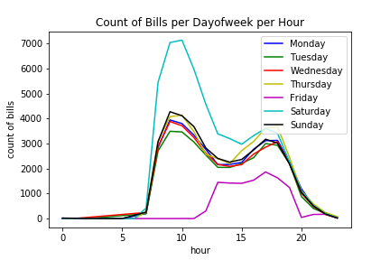

Find the electricity quantity per hour in each day of the week and draw it
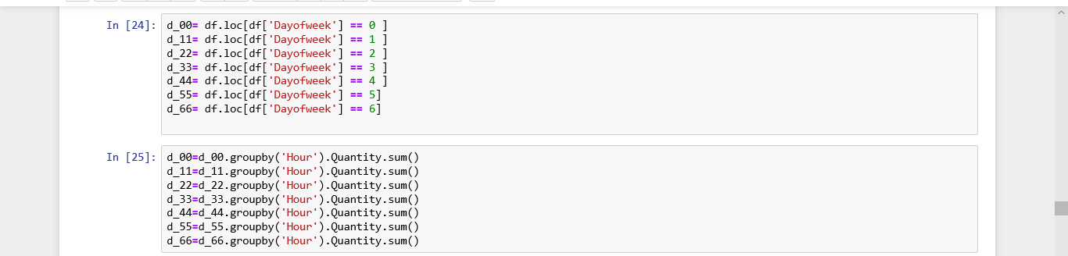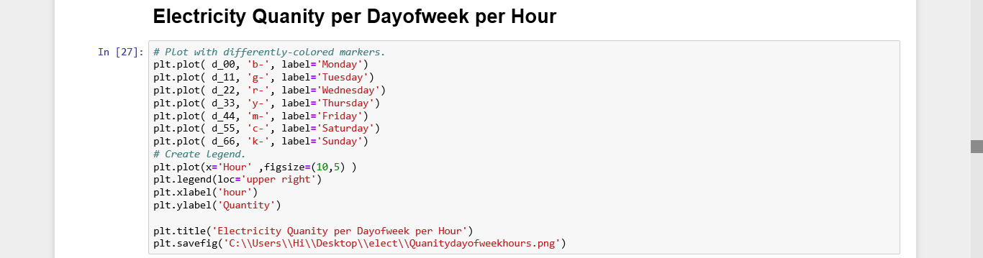
What is electricity quantity the per hour of each day of the week?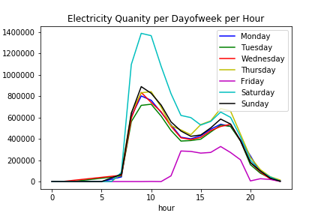

Find the electricity quantity per tariff number and draw it
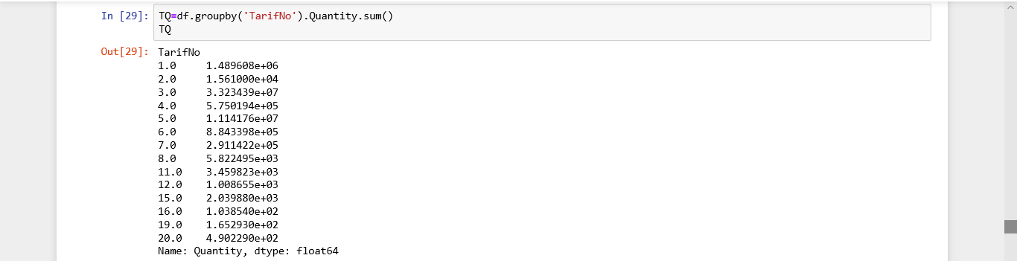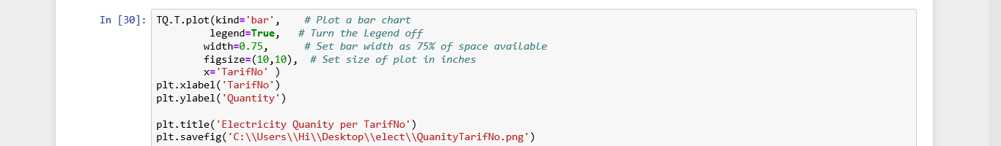
What is the electricity quantity per tariff?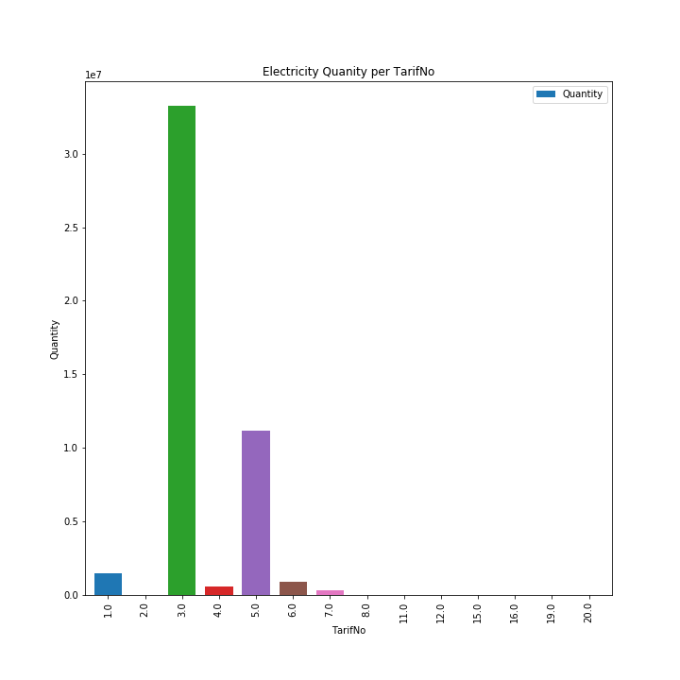

Find the count of bills per tariff of each day of the week, then draw it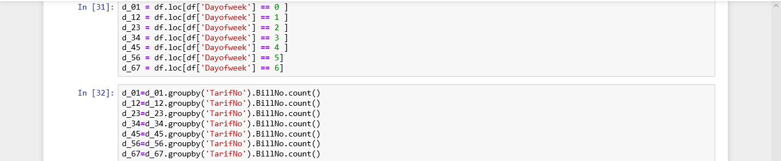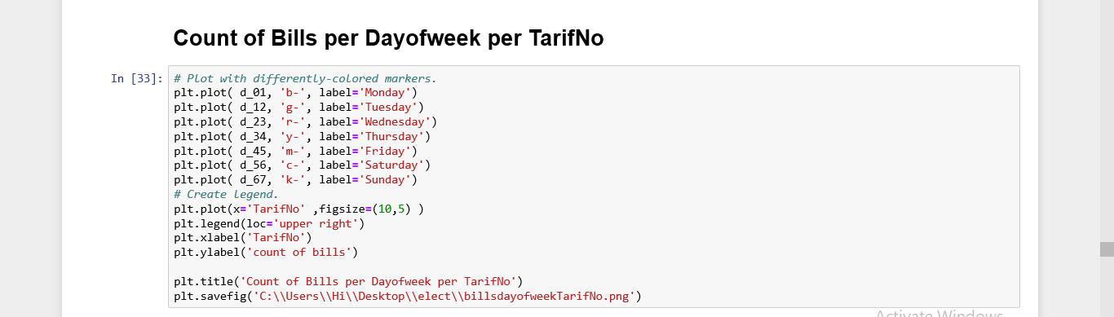
What is the count per tariff of each day of the week?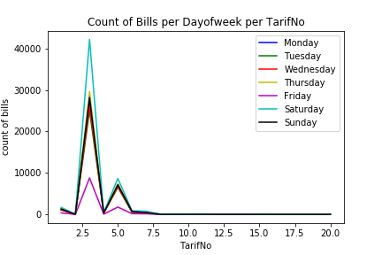

Find the electricity quantity per tariff of each month, then draw it
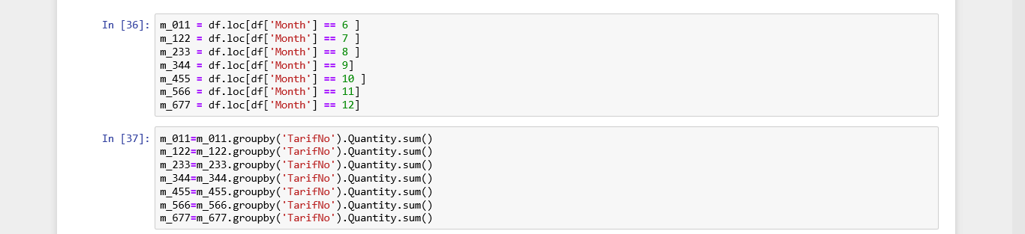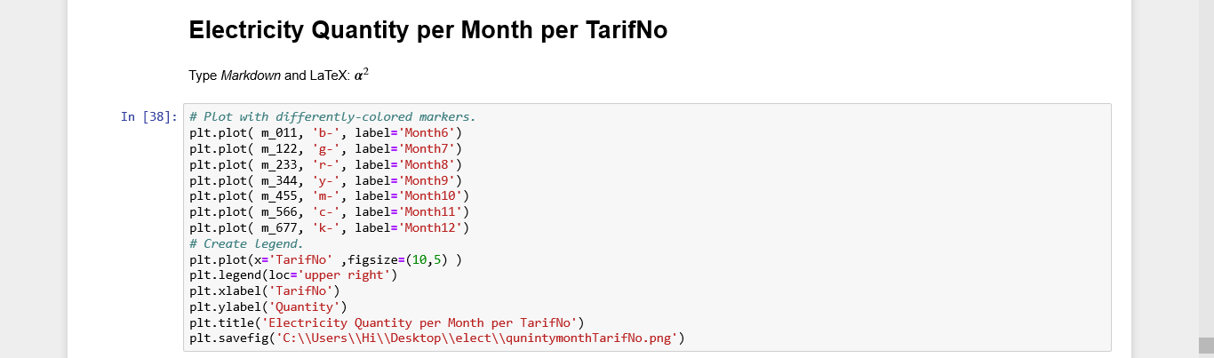
What is the electricity quantity per tariff each month?
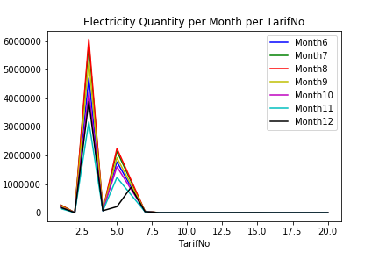

Find the count of bills per tariff, then draw it
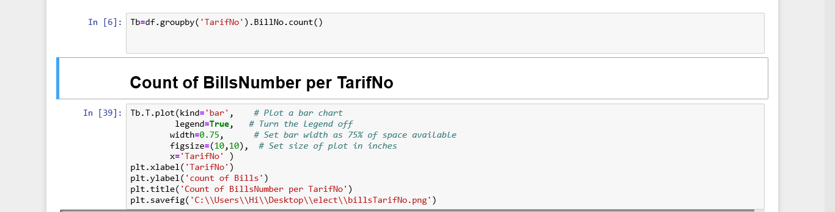
What is the count of bills per tariff?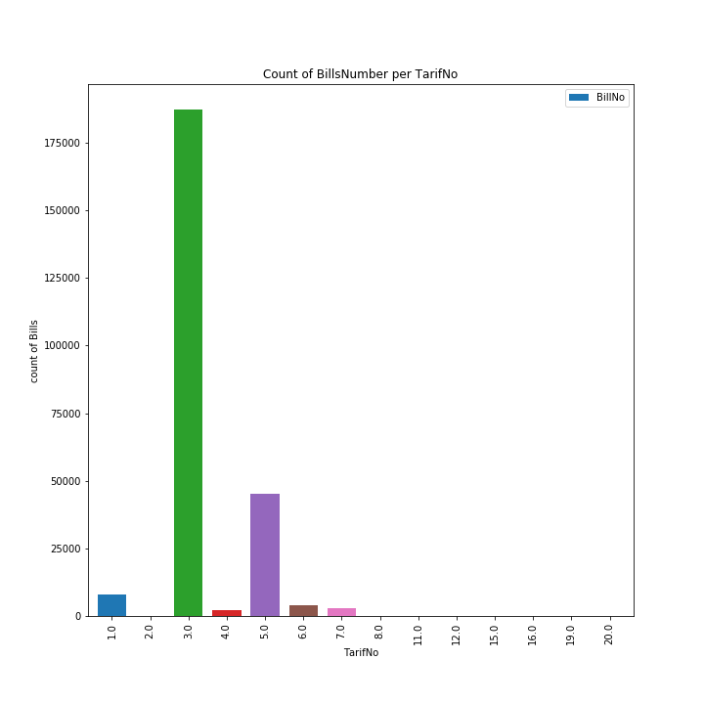
Find the mean of electricity quantity per month, then draw it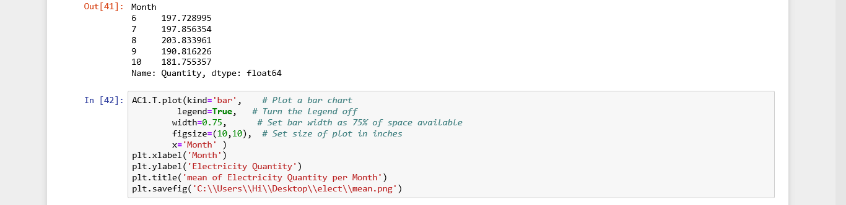
What is the mean of electricity quantity per month?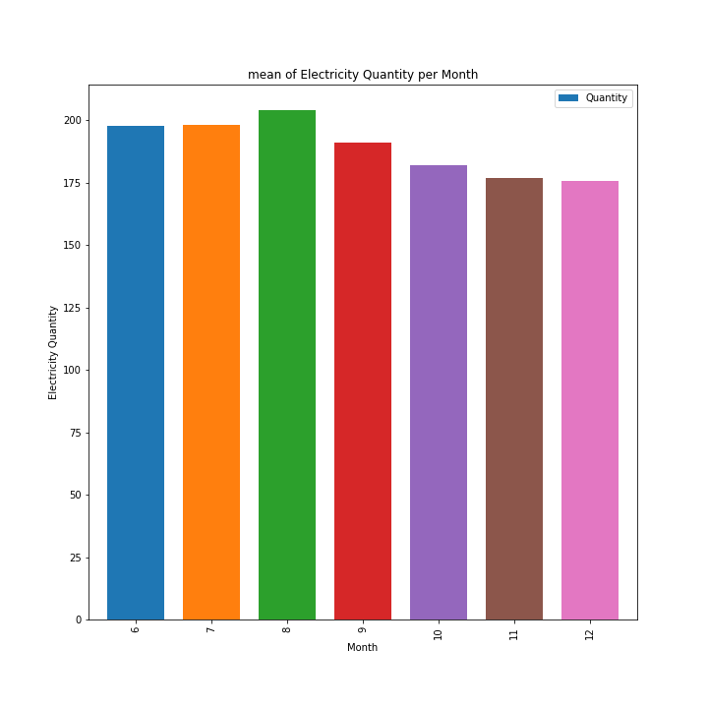
Data mining
We called necessary modules for data mapping, and upload three files
(finel_data.csv)
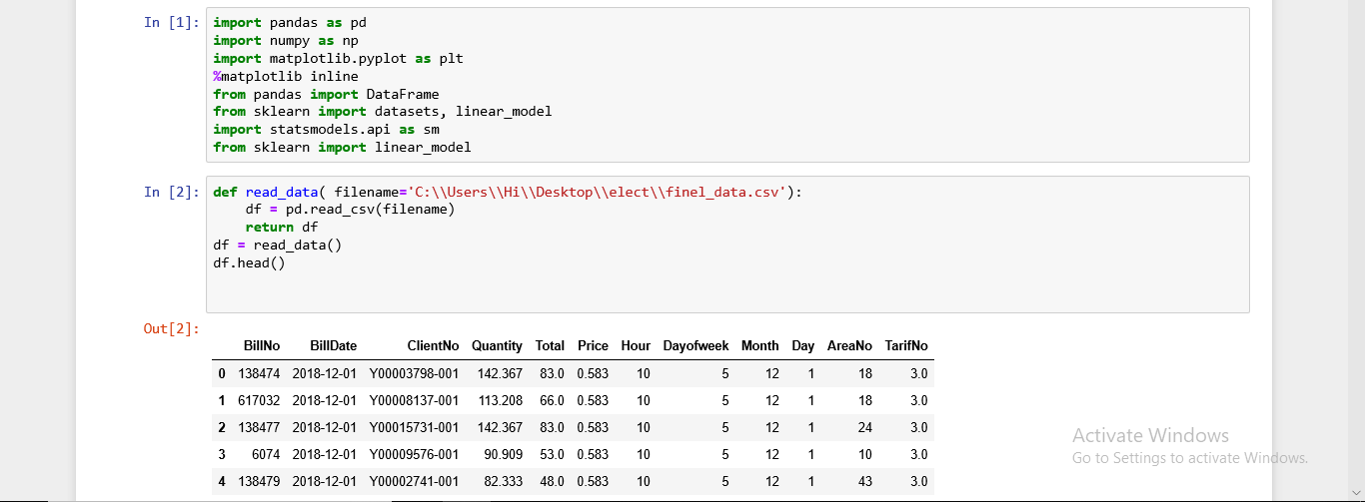
Calculate the correlation between columns, we observe that the correlation between columns(especially between quantity and other column )is low (>0.5), for this reason, we can not make regression for electricity quantity.
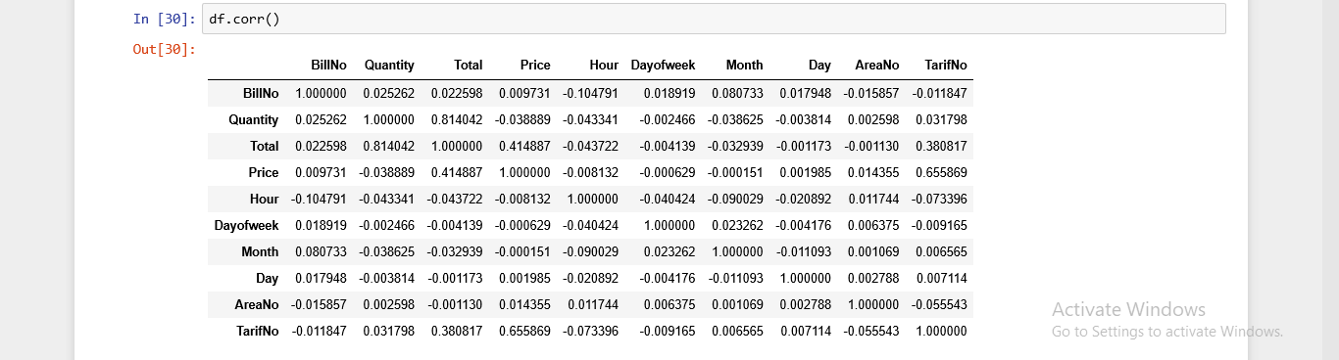

We upload another file (group_data.csv),and took this columns (Month,AreaNo,TarifNo,ClassNo)
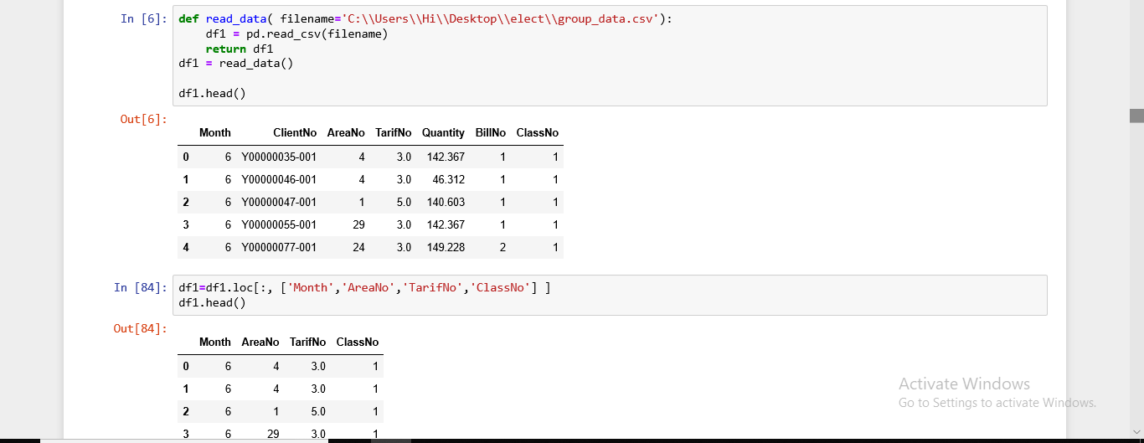
We identify the X = the group of attributes (columns ) (Month,AreaNo,TarifNo)that we uses to classification the label attribute (ClassNo)
Y= label attribute (ClassNo)
And we split data into 2 groups 1-train to build the model 2-test to test the model and find the accuracy

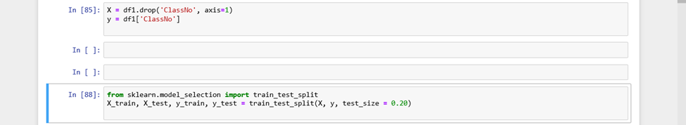
We use support vector classification to build a model by(x_train,y_train) then predict the (x_test) and save the values of prediction in y_pred
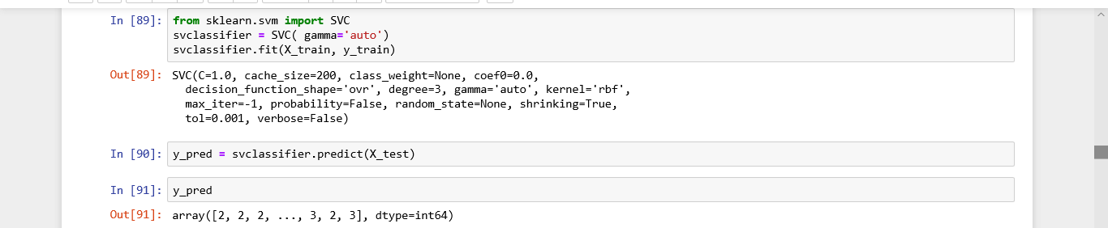

Then we find the confusion matrix and classification report of this model and then presented
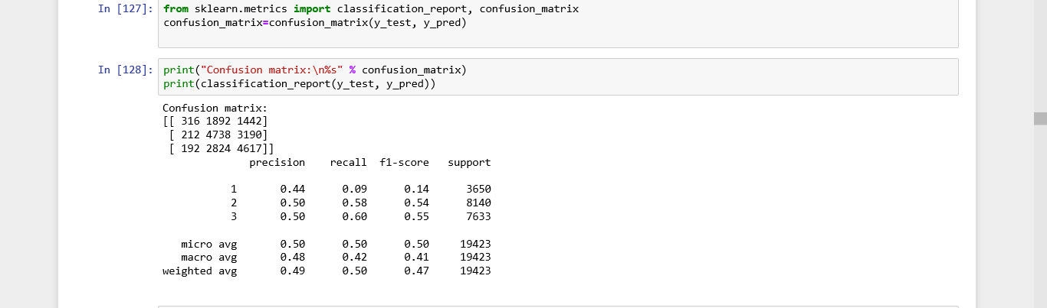
Then draw the confusion matrix

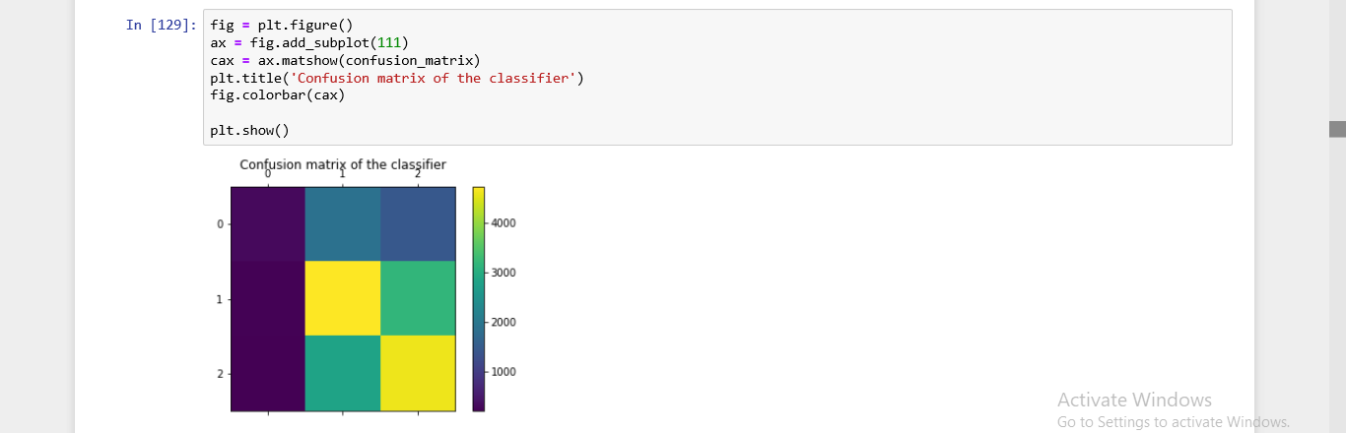
then we find the accuracy of this model and the count of records that the model prediction correctly from the total records
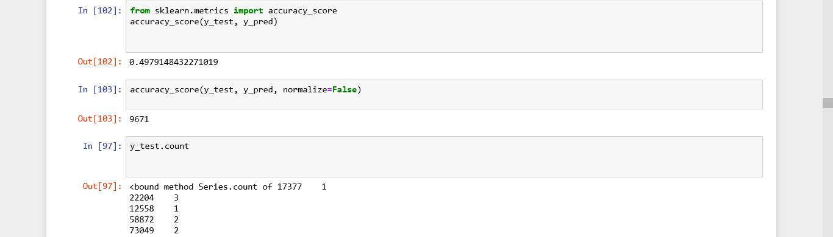

We use naive_bayes classification to build a model by(x_train,y_train) then predict the (x_test) and save the values of prediction in y_pred
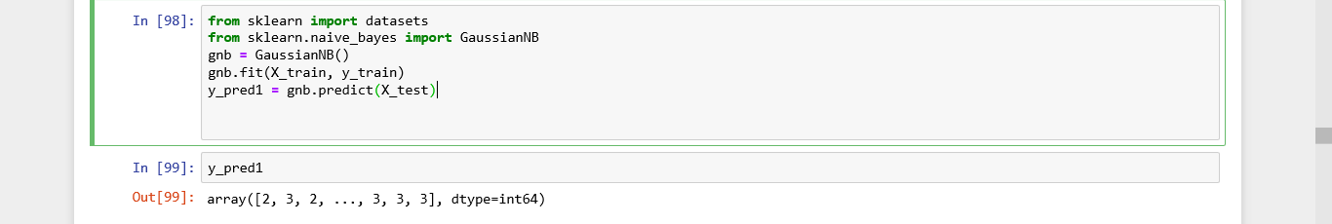
Then we find the confusion matrix and classification report of this model and then presented
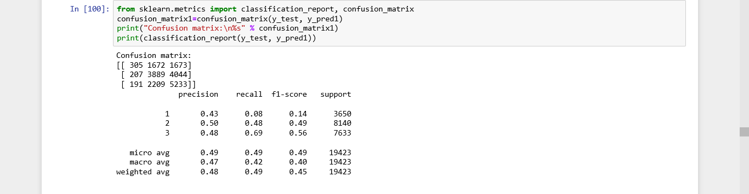
Then draw the confusion matrix
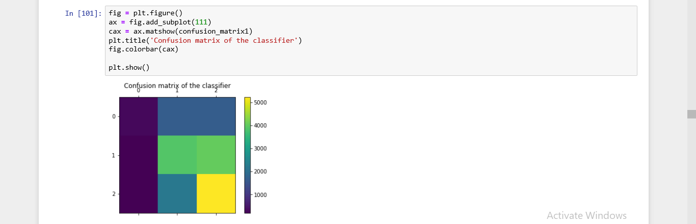
then we find the accuracy of this model and the count of records that the model prediction correctly from the total records
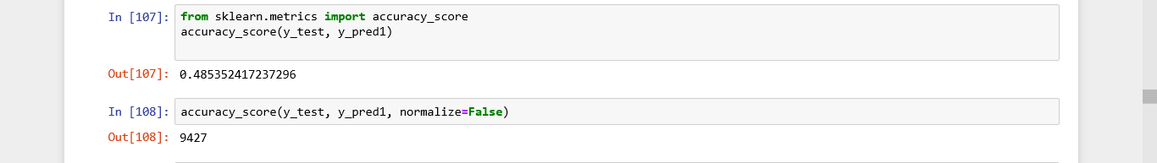

We use decision tree classification to build a model by(x_train,y_train) then predict the (x_test) and save the values of prediction in y_pred
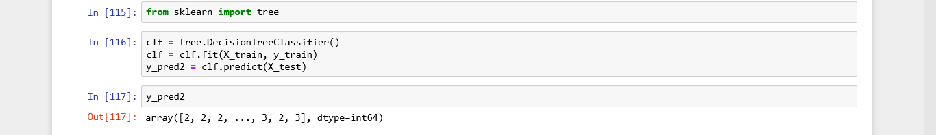
Then we find the confusion matrix and classification report of this model and then presented
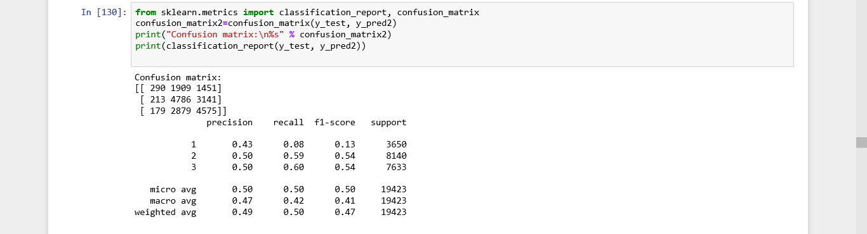
Then draw the confusion matrix
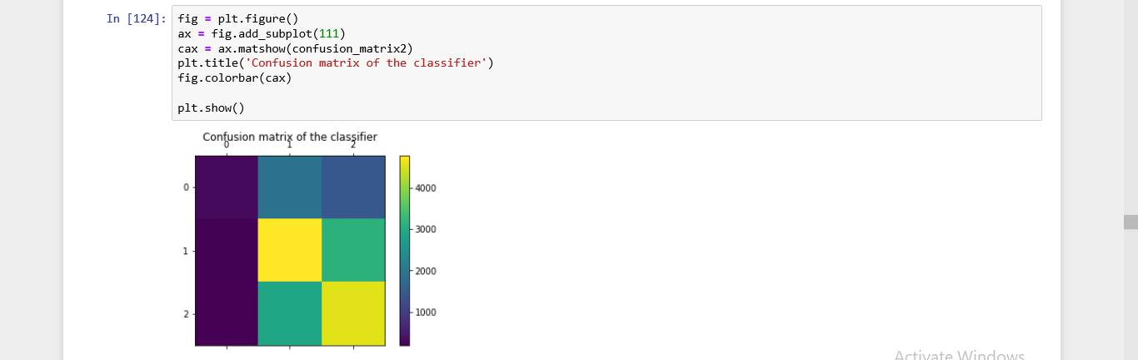
then we find the accuracy of this model and the count of records that the model prediction correctly from the total records
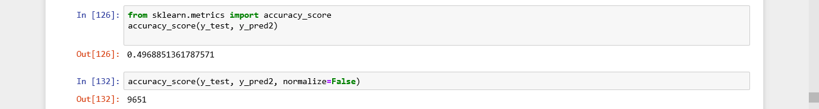

We use k-nearest neighbors classification to build a model by(x_train,y_train) then predict the (x_test) and save the values of prediction in y_pred
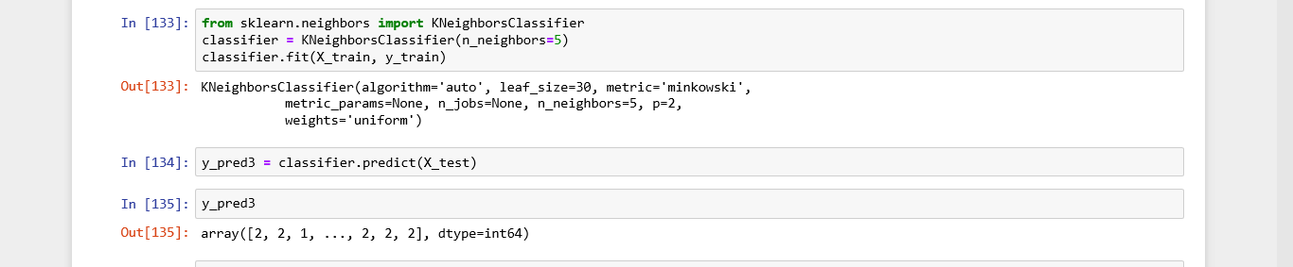
Then we find the confusion matrix and classification report of this model and then presented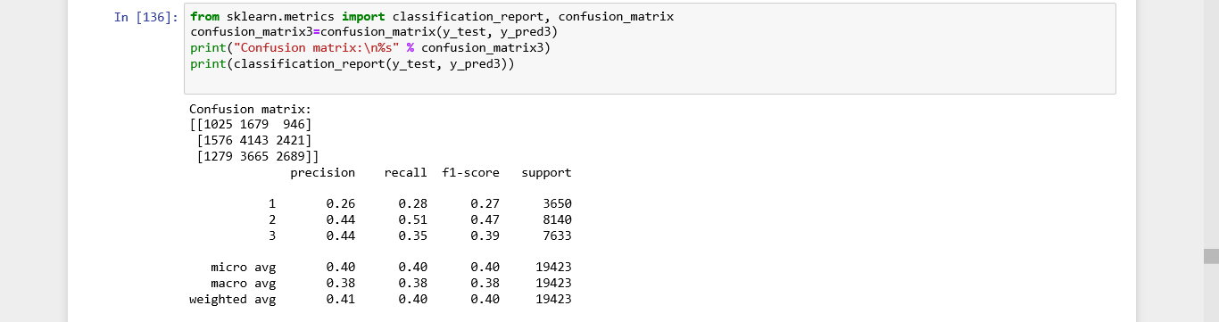
Then draw the confusion matrix
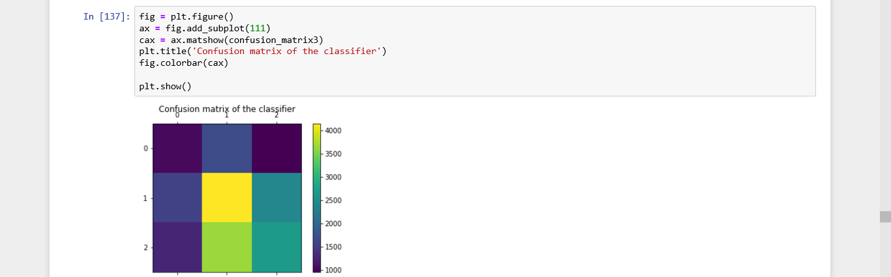
then we find the accuracy of this model and the count of records that the model prediction correctly from the total records
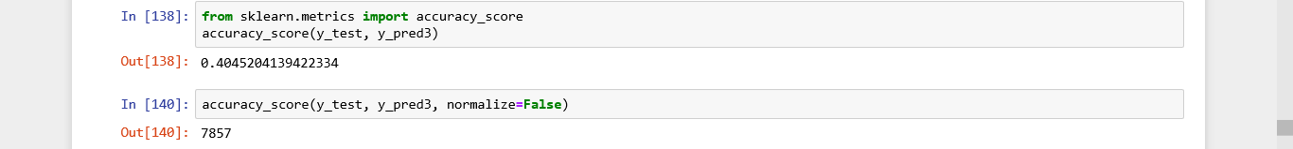

We use a neural network to build a model by(x_train,y_train) then predict the (x_test) and save the values of prediction in y_pred

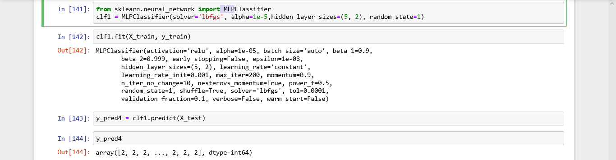
Then we find the confusion matrix and classification report of this model and then presented
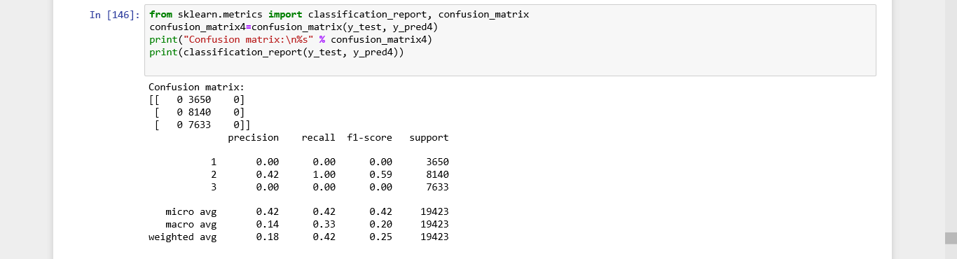
Then draw the confusion matrix
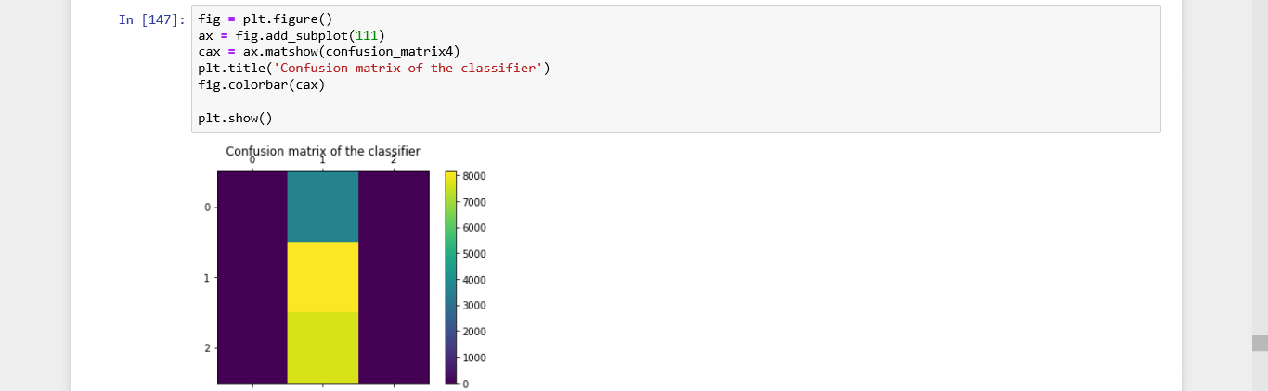
then we find the accuracy of this model and the count of records that the model prediction correctly from the total records
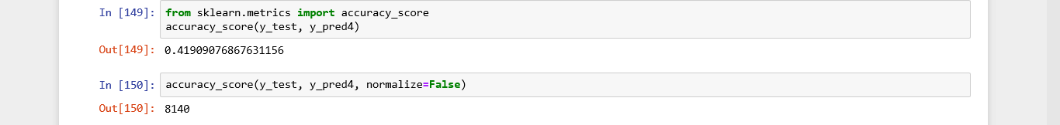
We use linear discriminant analysis to build a model by(x_train,y_train) then predict the (x_test) and save the values of prediction in y_pred
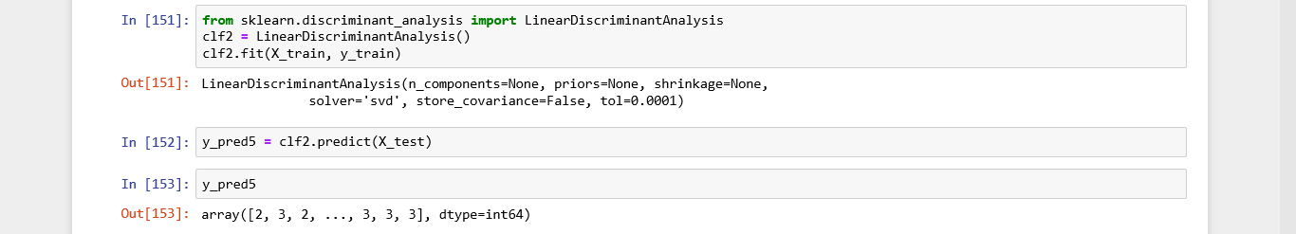
Then we find the confusion matrix and classification report of this model and then presented
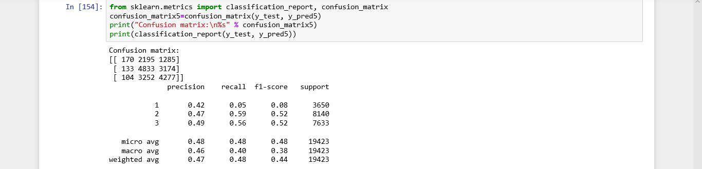
Then draw the confusion matrix
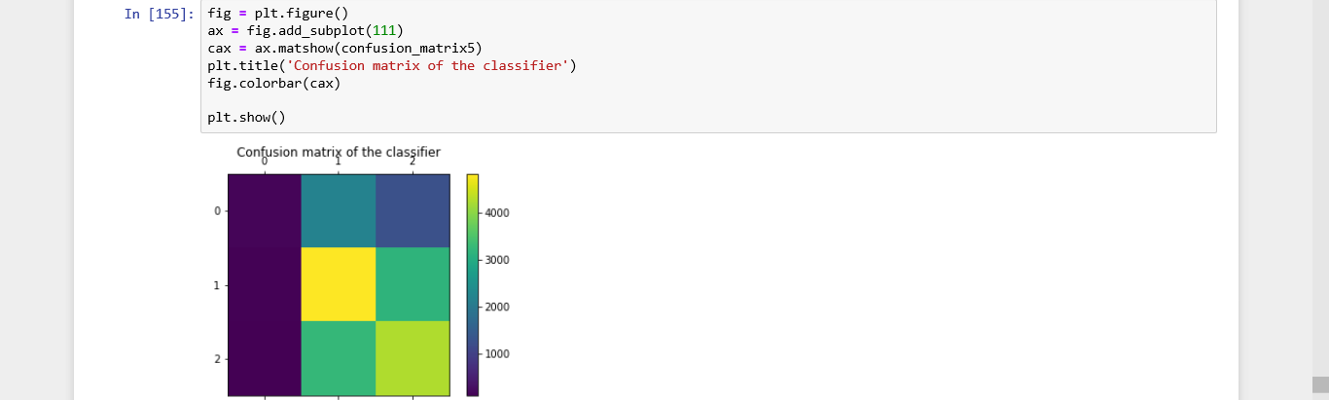
then we find the accuracy of this model and the count of records that the model prediction correctly from the total records
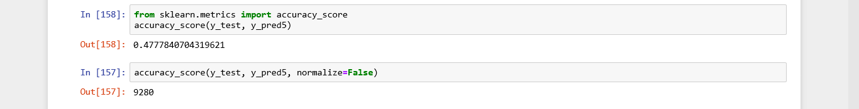

We use logistic regression to build a model by(x_train,y_train) then predict the (x_test) and save the values of prediction in y_pred
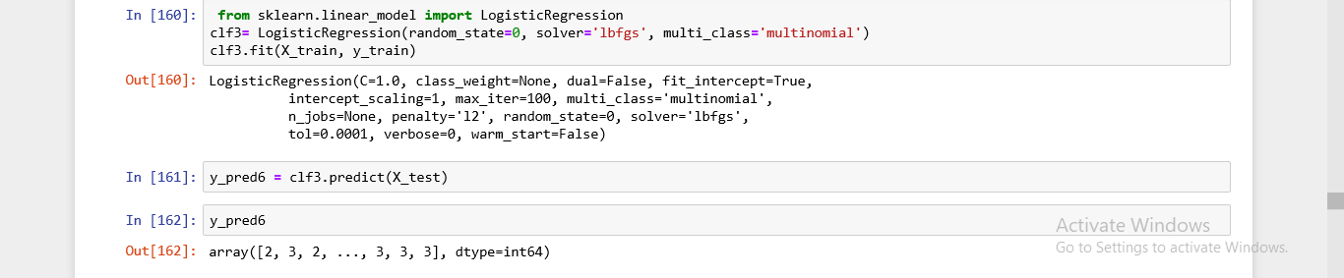
Then we find the confusion matrix and classification report of this model and then presented
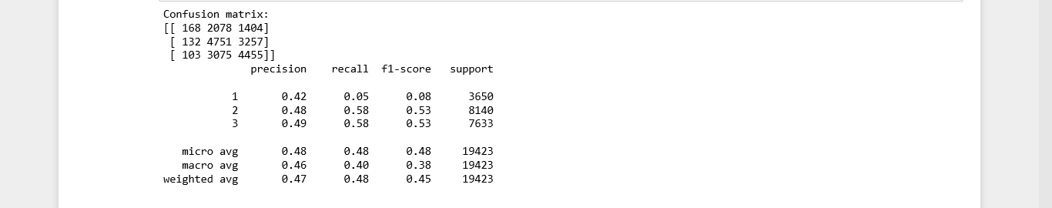
Then draw the confusion matrix
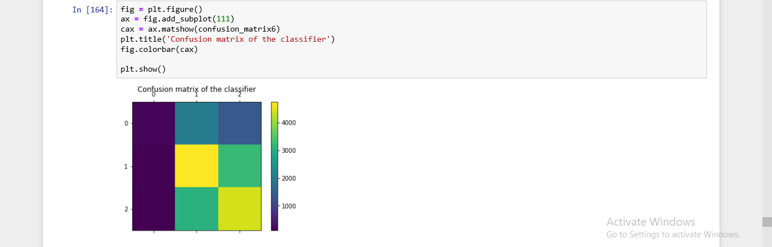
then we find the accuracy of this model and the count of records that the model prediction correctly from the total records
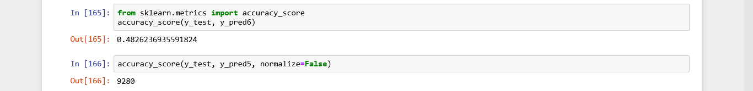

The simple victor machine id give us the large accuracy personage
0.4979148432271019
In simple split
And we calculate the accuracy percentage in k_ford methods but the accuracy
It has not changed dramatically
.49517312395417684

