c



An-Najah National University

FACULTY OF ENGINEERING AND INFORMATION TECHNOLOGY
Computer Engineering Department

Software Graduation Project

FOOD2GO

Students: Supervisor:
Shareef Nader Salahat Dr.Mohanad Jabi
Firas 'Ahed Aghbar

June ,27, 2024
Acknowledgment

To our Computer Engineering Department Doctors we say thank you so much for all the great work each of you have done in the computer engineering department Your wisdom, knowledge and dedication have all contributed to our academic journey.
A special thanks to our supervisor Dr. Muhannad Jabi Your dedication to our project, your guidance and constant encouragement have been amazing. Your guidance has not only helped us academic life but also pushed us to be the best in everything we do.
To those who helped us without asking for anything in return we say thank you for being with us all the way. The collaboration, encouragement and shared enthusiasm from all of you have added to the fun and the sense of achievement.
Finally, but not least we thank you all our parents. Their trust, support, encouragement, patience and faith in us have given us the strength and courage to complete our academic journey.
This project is a team work and we are thankful to all who contributed to it. Thank you for being part of our academic and personal life.
Abstract

FOOD2GO is a comprehensive and easy-to-use web and mobile application designed to revolutionize the food delivery industry by creating an effective link between customers and restaurants. This platform is equipped with a wide range of features that greatly enhance the food ordering experience. Customers can browse several restaurants, explore detailed menus, and place orders effortlessly. For restaurants,FOOD2GO provides tools to easily create, modify and manage menus and orders, thereby presenting their culinary offerings to a wide and targeted audience. The primary goal of FOOD2GO is to simplify the food delivery market, making transactions more efficient, transparent and accessible to a diverse user base. In the current market, finding the right restaurant or meal can be difficult due to the lack of a unified platform that combines all the available options. Customers often have to navigate multiple websites and applications, which complicates their search for the desired meals. On the other hand, restaurants struggle to reach the target audience effectively, which hinders their ability to promote their offers and efficiently manage their operations. FOOD2GO addresses these challenges by providing a single integrated platform where users can easily search for their favorite meals and restaurants. The app integrates a variety of dining options, including fast food outlets, fine dining establishments and local restaurants, into one accessible interface. This comprehensive approach ensures that users can find what they are looking for quickly and easily.

The app's recommendation system offers personalized meal suggestions tailored to individual preferences, enhancing the user experience. Moreover, FOOD2GO features a powerful in-app chat and messaging system that facilitates seamless communication between restaurants managers and the app administrator. User account management features allow customers to save their favorite restaurants, track order history and participate in fruitful discussions with restaurant staff. Integration with Google Maps enriches the user experience by providing their accurate location information. In addition, user-submitted reviews and ratings enhance transparency and help other users make informed decisions. The food2go app is strictly optimized for mobile platforms for customers and the web for restaurant managers and site admin, ensuring a smooth experience regardless of the device used. This optimization ensures that all features are easily accessible and run smoothly, providing users with a hassle-free food ordering and delivery experience.
Table of content

Acknowledgment ...........................................................................................................................2
Abstract ..................................................................................................................................................2
Table of content.....................................................................................................................................4
Introduction ............................................................................................................................................4
motivation ......................................................................................................................................6
Aim and Objective .........................................................................................................................6
Scope of work ................................................................................................................................6
Constrains ....................................................................................................................................................7
Literature Review........................................................................................................................................8
Methodology ...............................................................................................................................................9
Result ..........................................................................................................................................................15
Result “ User App ” ................................................................................................................................16
Result “Admin Dashboard” ....... .................................................................................................................38
Result “Resturant Dashboard” .............................................................................................................50
Conclusion ...........................................................................................................................................56

Introduction

Motivation

The motivation behind the development of FOOD2GO stems from the need to enhance the efficiency, transparency, and accessibility of the food delivery market. In today's fast-paced world, customers face significant challenges in finding and ordering their desired meals due to the fragmented nature of existing food delivery platforms. Customers often have to navigate through multiple websites and apps to find suitable dining options, which can be time-consuming and frustrating

Restaurants also face difficulties in reaching abroad and targeted audience, which limits their ability to promote their offerings and manage their operations effectively. The lack of a unified platform hinders restaurants' efforts to streamline their menu management, order processing, and customer interaction, leading to inefficiencies and missed opportunities for growth

Aims and Objectives

- Aims:

The primary aim of FOOD2GO is to transform the food delivery market by creating a seamless, efficient, and user-friendly platform that effectively connects customers with a wide range of restaurants. By integrating advanced technological features, the platform seeks to enhance the overall food ordering and delivery experience, making it more accessible, transparent, and efficient for all users involved.

- Objectives:

Simplify the Food Ordering Process:

Develop an intuitive user interface for both web and mobile platforms to facilitate easy browsing, selection, and ordering of meals from various restaurants.
Implement advanced search and filtering functionalities to help users quickly locate their preferred dishes and restaurants based on criteria such as cuisine, price, rating, and location.
Enhance Customer Experience:

Integrate a simple recommendation system that provides personalized meal suggestions based on individual user preferences and past order history.

Facilitate Efficient Communication:

Establish a robust in-app chat and messaging system to allow direct communication between restaurant managers and admin of app, ensuring prompt responses and personalized service.

Provide tools for restaurants to easily create, edit, and manage their menus and orders, thereby improving operational efficiency.

Promote Transparency and Informed Decision-Making:
Allow users to submit reviews and ratings for restaurants and dishes, fostering a transparent environment that helps customers make informed choices.
Display user-submitted reviews and ratings prominently to guide other users in their dining decisions.
Ensure Accessibility and Convenience:

Leverage Advanced Technologies:

Integrate with Google Maps to provide accurate location information and enhance the user experience during the search and delivery processes.
Utilize data analytics to continuously improve the recommendation system and overall platform performance based on user behavior and feedback.

By achieving these objectives, FOOD2GO aims to set a new benchmark in the food delivery industry, offering a comprehensive and innovative solution that benefits both customers and restaurants, ultimately driving growth and enhancing the overall dining experience.

1.3 Scope of work

FOOD2GO aims to address the issues mentioned of restaurant managing orders, and customers making more effort to find their favorite meal, by creating an integrated platform that brings together a wide variety of restaurants and dining options in one place. By consolidating the food delivery market, FOOD2GO simplifies the process for customers to find and order their preferred meals while providing restaurants with the tools they need to manage their operations efficiently.

Constraints

- Lack of knowledge:
choosing the techniques to implement was challenging, because there are carious ways and technologies that can be used to develop either web apps or mobile apps, so we took sometime to decide and search about different techniques, and so we chose React JS for the web app, and Dart for our mobile app. We had to be proficient in these technologies and languages, that we didn’t even know how to write a single program on smartphone app or in building websites.

Meeting these challenges required us to lay a strong foundation and comprehend the fundamentals of such technologies. The first blow came when

Additionally, huge software installations needed during development impeded deployment on devices. Besides academic schedules, proper planning is important to ensure enough time is set aside for the project.

Another hurdle is difficulty in searching and selecting suitable training courses, that requires more effort and time in reviewing a program or solution. We decided to consult experts experienced in this field who can provide effective guidance through technical complexities and overcome several obstacles.

So as to ease these problems, therefore, we specifically sought help from professionals, and the supervisor Dr.Muhannad Jabi who have vast knowledge about the technologies being applied and try to find ways out of them.

Literature Review

The emergence of technology has appreciably converted the meals offering enterprise, main to the development of revolutionary applications designed to simplify ordering processes and enhance user reviews. The proposed FOOD2GO project embodies the idea of a comprehensive food offering utility, responding to the increasing demand for platforms that streamline the food ordering system for each customers and restaurants. Existing research highlights the demanding situations people face in navigating a fragmented meals delivery marketplace, specially in terms of restaurant discovery, order placement, and effective verbal exchange.

Studies indicate that conventional techniques of ordering meals, which frequently depend on multiple, scattered programs and platforms, result in a demanding and time-consuming experience for capability clients. The FOOD2GO utility addresses this trouble by integrating various eating places into a single platform that meets the various needs of users searching for to order food.

Moreover, studies emphasizes the importance of user-friendly interfaces and superior functionalities in food transport programs. The FOOD2GO assignment aligns with this fashion by using advanced queries for filtering mechanisms, and a sturdy in-app chat and messaging system. These factors no longer best decorate the consumer enjoy but additionally make a contribution to the performance of food ordering methods, as suggested with the aid of studies focused on the impact of generation at the meals provider industry.

Transparency and credibility are routine topics in meals transport research, with an emphasis on the importance of informed selection-making. The FOOD2GO application addresses this thing by way of introducing user-submitted evaluations and ratings, in addition to reviews. The inclusion of such capabilities aligns with studies advocating for transparency in meals delivery approaches to build consider among users.

In end, the FOOD2GO venture stands at the forefront of modern-day meals offering applications, addressing important challenges recognized through widespread research. By integrating superior features and prioritizing transparency, the platform offers a promising way to streamline meals ordering methods. Moreover, its responsiveness on each cell (for customers) and internet platforms (for directors) ensures an unbroken consumer revel in, catering to the diverse desires of today's market.

Methodology

Non-Functional Requirements

• Screen Adaptation:
It is viable to dynamically exchange the interface of the software for distinct sizes of monitors. It has built-in functions that automate the procedure of changing fonts, sizes, and photographs for choicest rendering on diverse gadgets.
• Security:
Chat capability is secured from internal threats and unauthorized outdoor get entry to which guarantees confidentiality and integrity of person interactions.

• Ease-of-Use:
The utility is designed with a person-friendly approach, providing pages geared up with a fixed of icons and hyperlinks for streamlined navigation among extraordinary sections. This design permits customers to effortlessly go back to the preceding web page, enhancing normal user experience.

• Usability:
The software is designed to be self- descriptive and clean in use which permits users without difficulty recognize how it works without requiring professional help or support. The interface is designed for easy comprehension, lowering the studying curve of users working with the device.

Design
Effective design making plans holds substantial importance. Prioritizing simplicity and efficiency, the graphical person interface performs a pivotal function in comprehending the intended capability of the software program. When starting up the design phase for any software, important issues come into play. These involve analyzing similar apps within the app save, formulating a layout that resonates with the furnished services and target audience, and innovating an extraordinary layout that distinguishes this app within its class.

Registration and Log In
When a user registers, he can access the mobile app as soon after he created his account, but for the restaurant registration, after all the information are entered, he has to wait for the admins approval for his registration request, and he can login and access his dashboard as soon as the admin approves his registration request.
We used the JWT (jason web token) for our authentication and authorization methods. So that when a user logs in, a token is generated, having the user Id and his role in the app inside the toke, to view pages and resources that he is authenticated to see based on the information decoded from the token.

Forgot Password

Users can reset their password by pressing the "Forgot Password?" link at the login web page, which takes the user to a page to enter his registered email and click "Send email." An email is sent to the user containing a link to a ‘reset password’ page where he enters his new password twice for confirmation, and the user id is decoded from the token sent with the link in the received email, so the user with that id will have his own new password.

Map and guidelines

Google Maps offers a clear advantage, especially when taking advantage of the initial ability to determine your location on the map.

Real time chat
A Real -time, -manner conversation channel is implemented using Firebase among eating place managers and admins inside the FOOD2GO application. Here's the way it works:

- Restaurants-Side:

- Sending Messages: The app sends the messages out to a Firebase database whenever the administrator or the of a restaurant owner types any message.
- Receiving Messages: Firebase will inform this application every time a message is sent by another user to it.
- Displaying Messages: A new incoming message is updated on the chat interface by the application so that the user can see it.

- Admin - Side:

- Listen for Connections: Firebase listens for connection requests from client browsers.
- Receive Messages: When a restaurant owner or administrator composes and sends out messages, Firebase picks them up and stores them in database.
- Send Messages: The Firebase real-time database, or Firestore, takes care of sending those messages back to all users who are currently connected in real-time after receiving a message.
By imposing this real-time chat feature, FOOD2GO helps with communication between eating place proprietors and admins, enhancing coordination and ensuring prompt decision of any issues or inquiries.

Notifications

Admin :

The Admin receives notifications from chat when having a new message from a restaurant, and from the new registered restaurants.

-Restaurant:

The restaurant receives notifications from other restaurants or from the admin in the chat app, and whenever there were a new placed order.

Payment
• Client-aspect: Customers browse eating place menu, pick objects, and upload them to their cart.
• Checkout Process: Customers evaluation order details and proceed to the checkout page.
• Payment Options: Multiple payment options are to be had, which includes credit/debit playing cards, virtual wallets, and neighborhood payment techniques.
• Processing Payment: Payment information is securely transmitted to the charge gateway.
• Order Confirmation: Customers obtain an order affirmation and an electronic receipt.
• Server-aspect: Order Verification: The server verifies order information and calculates general value.
• Payment Gateway Integration: The server communicates with a relied on price gateway to procedure the payment.
• Transaction Confirmation: The payment gateway sends a confirmation returned to the server.
• Order Notification: The server sends a notification to the eating place and the consumer.
• Secure Data Handling: Payment-associated statistics is handled securely and compliance with fee security standards is maintained

Recommendation System

The FOOD2GO application uses a simple recommendation system to improve user experience by offering personalized meals suggestions. The system tracks user interactions, generates personalized suggestions by connecting with the SQL database and execute queries to get more relevant meals that fits the user by tracking back his last orders. The server collects and stores data on user interactions. The recommendation system processes data in real-time to ensure relevance and timely recommendations. The benefits of this system include enhanced user experience, increased order volume, and data-driven insights for restaurants. Overall, FOOD2GO ensures users receive relevant and personalized suggestions, enhancing their dining experience and fostering deeper engagement with the application.

Statistics

FOOD2GO uses statistics to understand user behavior, app performance, and market trends. It collects and analyzes user interaction metrics, order statistics, user demographics, and registration and login data. Server-side statistics include response time, error rates, engagement metrics, and transactional metrics. Analytical tools include data visualization, predictive analytics, The benefits of statistics include improved user experience, informed decision-making, performance optimization, and better understanding of the market. By leveraging comprehensive statistics, FOOD2GO can refine its offerings and deliver a superior user experience.

Implementation

Key Library

4.3.1.1 Server Side

Nodejs:

For the server side, we have chosen to work with express and Node JS as our backend server, mainly because it is similar to the react frontend javascript, and allows the usage of multiple libraries like: ‘multer’ for image upload handling, ‘bcrypt’ to store hashed passwords, and to retrieve hashed passwords from the database. ‘JWT’ for token generation and handling and decoding for verification and authentication. And other more libraries that served multiple the use of the backend.

SQL:

We have selected SQL as our database, due to its reliability and performance in managing dependent data. The use of SQL ensures data integrity and helps complex queries, which helped up in our recommendation system, making it suitable for the dynamic requirements of our venture. By leveraging SQL, we will efficiently manage statistics associated with orders, users, restaurants, and different important aspects of the FOOD2GO utility. The database is seamlessly incorporated with our software to make sure efficient facts exchange.

4.3.1.2 Client Side

Flutter and Dart (Mobile):

For the cellular front-quit, we applied Flutter, an open-supply UI software program improvement toolkit created with the aid of Google, which makes use of the Dart programming language. Flutter lets in us to build natively compiled applications for cellular from a single codebase, providing visually attractive and high-performance user interfaces. Leveraging Dart’s skills alongside the Flutter framework, we acquire code reusability and create UI additives that adapt seamlessly throughout diverse cell systems. Flutter’s standardized set of APIs simplifies the improvement system, fostering the advent of intuitive and responsive person interfaces, and ensuring a regular and tasty consumer revel in throughout one-of-a-kind gadgets.

React JS (Web):

For the web front-quit, we hired React JS, a famous JavaScript library for building user interfaces. React JS is thought for its performance and flexibility, making it a tremendous preference for developing dynamic and responsive web programs. By using React JS, we can create reusable UI components that provide an unbroken person experience. The library’s virtual DOM feature optimizes rendering overall performance, ensuring rapid and efficient updates to the consumer interface. React JS’s issue-based structure allows for smooth upkeep and scalability, supporting the complicated and evolving necessities of the FOOD2GO web application.

Tools

Android Studio:

Choosing Android Studio for integrating the emulator become a sport-changer, making sure our cell app performed at its exceptional. The integrated emulator in Android Studio now not best mimicked the Android device setup correctly but also came loaded with versatile features for trying out and debugging. Its functionality to copy numerous Android tool configurations allowed us to thoroughly take a look at how our app behaved
across one of a kind systems. The real-time remarks and overall performance tracking features of the emulator in Android Studio have been instrumental in tweaking the user enjoy and catching ability problems early on in development. Opting for Android Studio as our emulator hub appreciably contributed to the overall success of our undertaking, imparting a dependable and green trying out environment for our Android
software.

Visual Studio:

For the backend development and different components of our task, Visual Studio emerged as a key player. Developed through Microsoft, Visual Studio supplied a versatile and strong IDE catering to various
programming languages and frameworks. Its integrated equipment for coding, debugging, and testing proved

worthwhile in the development of backend functionalities. The support for a huge variety of programming languages and frameworks, coupled with its collaboration capabilities, made Visual Studio an high-quality
preference for making sure the reliability and efficiency of our task's backend additives. The seamless integration with Azure offerings similarly facilitated deployment and management elements, contributing to the overall achievement of our mission.

Results
The FOOD2GO project pursuits to gain the network by way of streamlining meals offering methods. The venture has generated activity introduction, economic growth, and superior person revel in. The software simplifies meals ordering, offers efficient communique, secures payments, and promotes transparency. Restaurant proprietors benefit from streamlining operations, improved visibility, and elevated income. Technological advancements consist of cross-platform accessibility and real-time statistics processing. FOOD2GO helps neighborhood restaurants and provides comfort for customers..

User App

Welcoming Pages
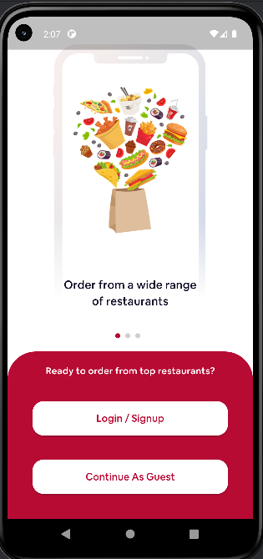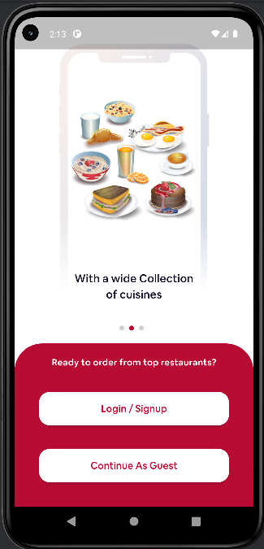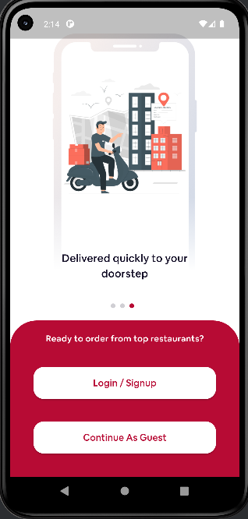
Figure 1: Welcoming Pages

The Welcoming Page is the application's initial screen, introducing its purpose and offering
two buttons: "Register" for new users and "Login" for existing users to create an account.

Sign up page
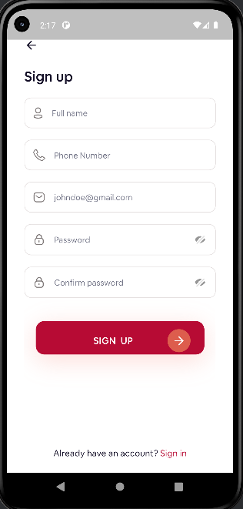

Figure 3: Sign Up Page (English)

Sign-Up web page gives customers a sincere method to establish an account. Input vital details together with Full Name , email, cellphone, and create a secure password. Upon completion, click on the "Sign Up" button to finalize the registration. For people with current accounts, a committed button directs customers to the login web page, ensuring a continuing transition for returning customers

Login Page

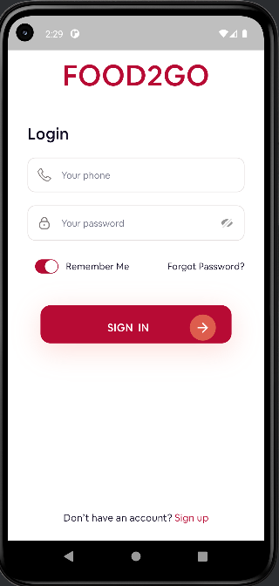
Figure 6: Login Page

Login Page serves as the steady gateway for users to get right of entry to their Account by means of coming into their registered electronic mail and password. To provoke the process, customers are caused to input their login credentials and proceed with the aid of clicking the "Login" button. Additionally, for those without an current account, a designated button is to be had to seamlessly redirect them to the Sign-Up display, facilitating the account creation procedure. This consumer-friendly approach ambitions to beautify the general user experience, ensuring accessibility and simplicity of navigation within the platform

Current location

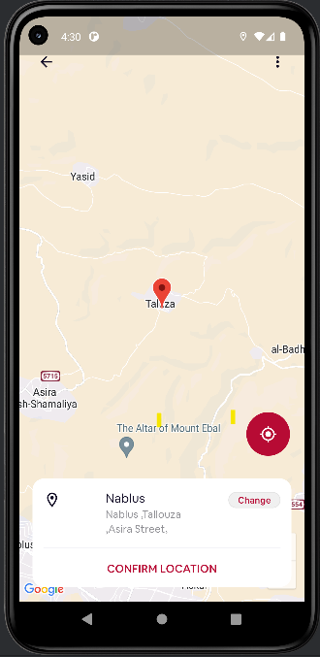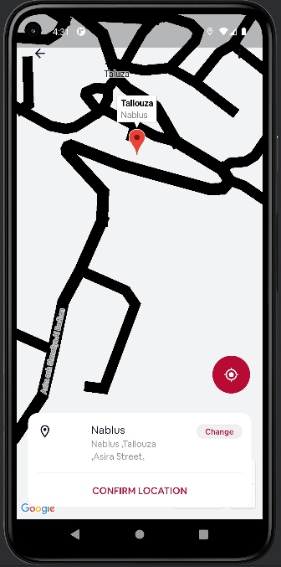

When logged in, the user is allowed to specify his exact location, as it is saved inside the application to facilitate the delivery process

Bottom Bar

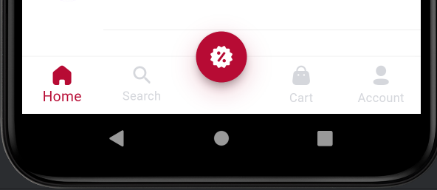
Figure 9: Bottom Bar

The Bottom Bar functions as a central navigation tool, ensuring smooth movement between five core screens: Home Page, Search Page, Featured Offers Page, Cart Page, and Account Page. This streamlined design enhances user experience by providing quick access to essential features, fostering intuitive navigation throughout the application.

Home Page

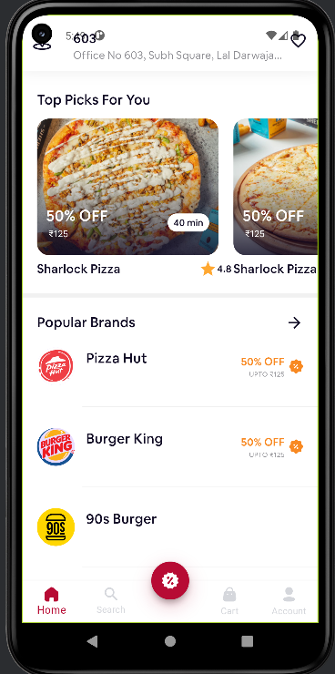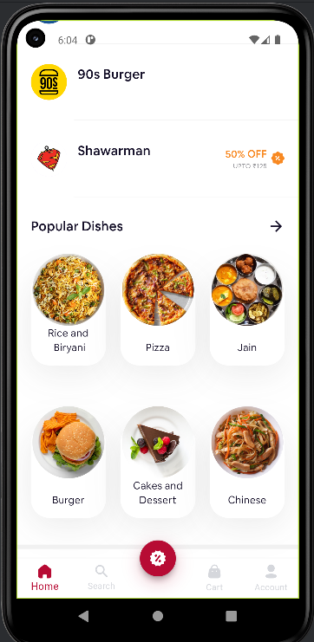

Figure 10: Home Page

Welcome to the homepage, a curated space offering customized assets recommendations tailored to your possibilities. In the first phase, you'll discover traits from our recommendation gadget"Top PIcks For You", presented in a visually dynamic layout. Users have the choice to scroll horizontally through the displayed menus or select a comprehensive assessment by using clicking at the offer or restaurant name to explore all the recommended functions of our state-of-the-art advice system.
The 2nd phase, entitled "Popular Brands" offers more than a few famous and maximum requested eating places at the site, whilst the 1/3 phase entitled " Pobular Dishes" Displays the maximum popular and famous objects on the site

All Restaurants Nearby

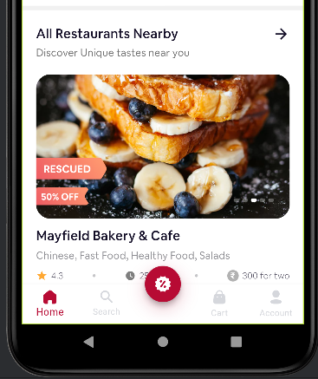

The "all Restaurants Nearby" feature in the FOOD 2 GO application allows users to easily discover and explore a comprehensive list of restaurants located near their current location. This functionality enhances the user experience by providing quick access to dining options within a convenient distance.
      - Search Page

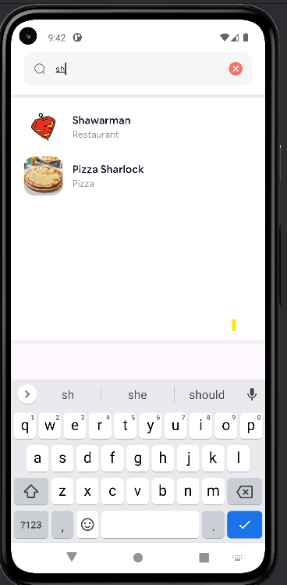

The "Search Page" in the FOOD2GO application is a powerful and user-friendly feature that allows users to search for restaurants and specific food items quickly and efficiently. This functionality enhances the user experience by providing comprehensive search capabilities tailored to individual preferences.
5.1.6.3 Cart Page

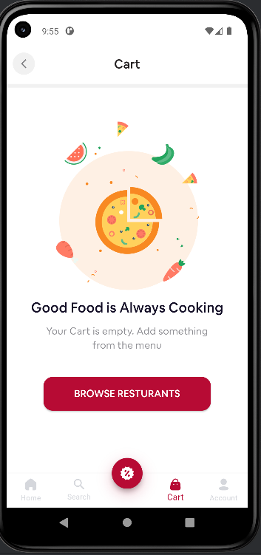

The "Cart Page" inside the FOOD2GO application gives customers with an outline in their selected meals objects earlier than putting an order. This function guarantees a clean and handy checkout process, enhancing the overall user enjoy.
5.1.6.4 Account Page

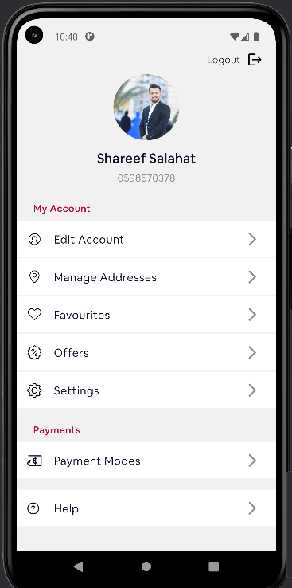

The FOOD2GO application's "Account Page" offers users a centralized location for managing personal information, settings, and preferences. It features a profile section with a login button, allows users to edit their account, manage delivery addresses, display favorite restaurants, view promotions and discounts, manage settings, and manage payment methods. The page also provides assistance with common issues and customer support options. The user-friendly design ensures quick navigation and easy access to information. Overall, the "Account Page" enhances the user experience by providing complete control over their personal information and preferences.
5.1.6.4 Edit Account Page
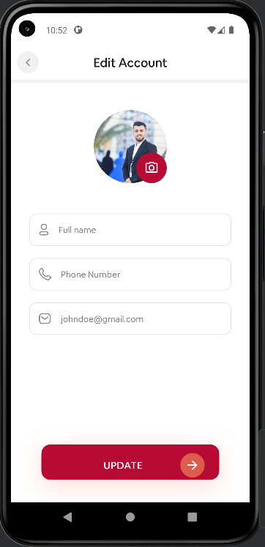

FOOD2GO's "Edit Account Page" is a user-friendly feature that allows users to update their personal information, enhancing communication and order accuracy. The page features a profile picture, personal information fields, an update button, and navigation. Users can enter or update their full name, phone number, and email address. The page also has a prominent "Update" button at the bottom, allowing users to save their changes. The user-friendly design ensures a clean layout, well-spaced fields, and a prominent update button. This user-friendly feature enhances the overall user experience and ensures accurate communication for orders and notifications.

5.1.6.4 Edit Account Page

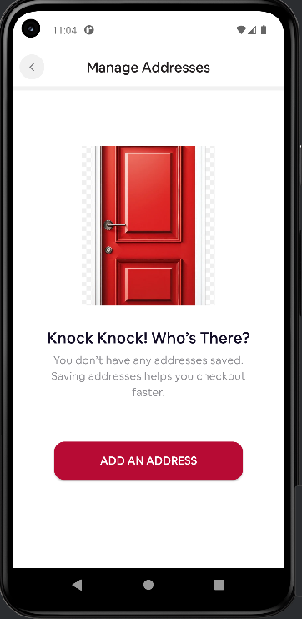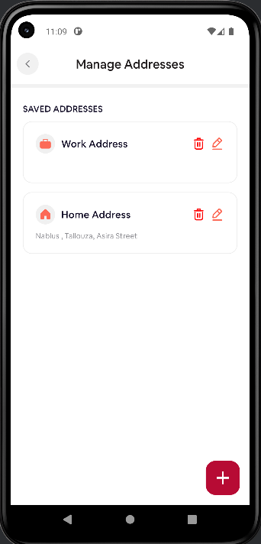
FOOD2GO's "Manage Addresses Page" is a user-friendly characteristic that allows users to feature, edit, and manipulate their delivery addresses. This function complements the ordering procedure by using permitting customers to enter their current locations fast and as it should be. an interactive "Add an Address" button, a stored address list, and icons for enhancing and deleting addresses. Users can add new addresses with the aid of clicking on the "Add an Address" button or the FAB, and edit existing addresses via clicking at the edit icon next to a saved deal with. The delete icon gets rid of an cope with from the stored list after confirmation. The web page's functionality consists of adding a new deal with, enhancing an current address, and coping with a couple of addresses. The blessings of dealing with addresses encompass efficiency, accuracy, and comfort, contributing to a streamlined and hassle-free ordering enjoy..
5.1.6.5 Favourites Page

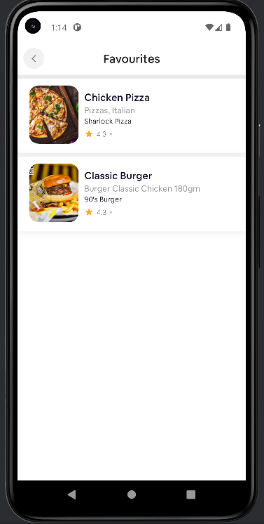

The "Favourites Page" in the FOOD2GO application permits customers to keep and quickly get entry to their desired restaurants and menu items. This characteristic enhances the person enjoy by presenting a personalized and convenient manner to reorder favorite meals and discover desired dining options.

5.1.6.6 Offers Page

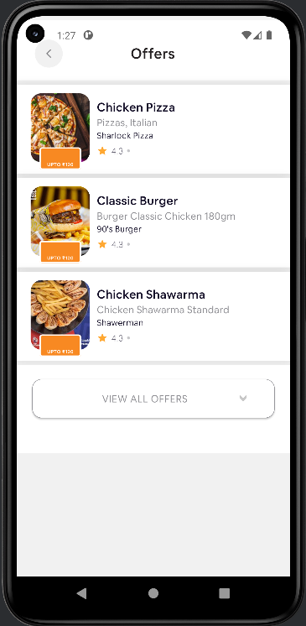

The "Offers Page" inside the FOOD2GO software offers customers with smooth access to contemporary promotions, reductions, and special deals to be had from diverse restaurants. This characteristic complements the consumer experience via helping users store cash and discover new eating options.

5.1.6.7 Payment Modes Page

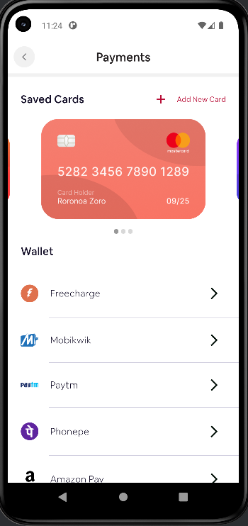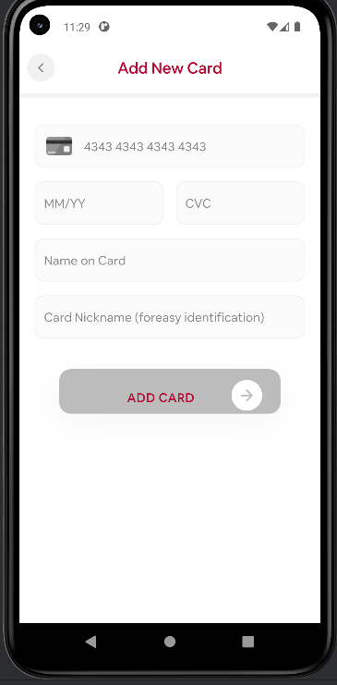

The FOOD2GO utility's "Payment Modes Page" offers users the capability to manipulate and pick out their desired fee strategies for seamless transactions. The page shows stored cards and lists diverse digital wallets for customers to link and use for payments. Users can upload new cards, hyperlink wallets, and select charge methods at some point of checkout. This characteristic complements the consumer enjoy through providing multiple payment options, security, and flexibility, making sure a secure and efficient payment process.

“This Example of CARDS”

    - Purchase Process

- Go To Restaurant Page && View the existing items

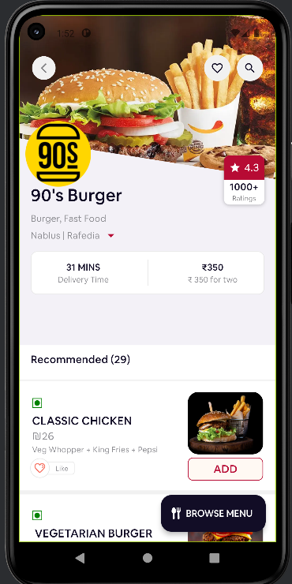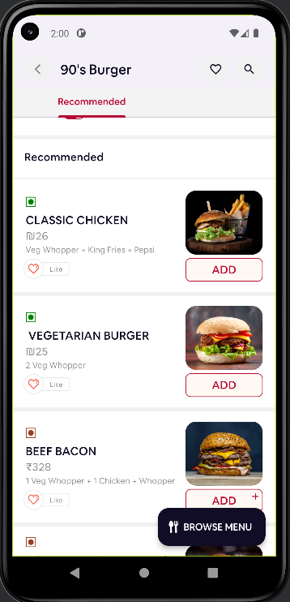

- Press on ADD Button

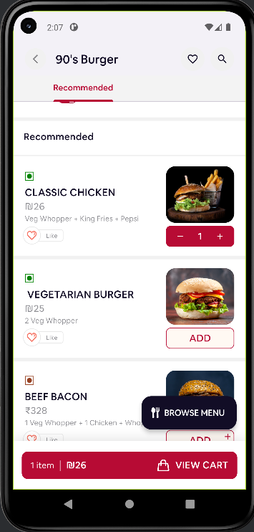

- Go TO View Cart

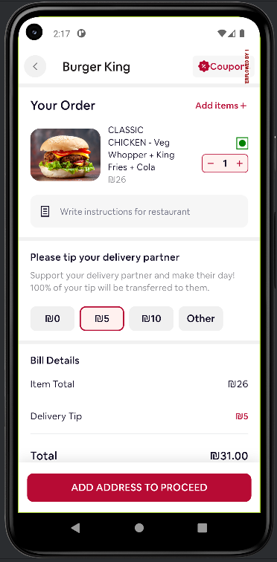

- Enter Address Detils
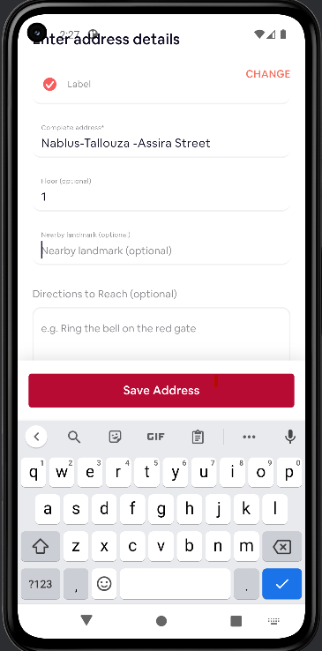

- Make Payment Screen
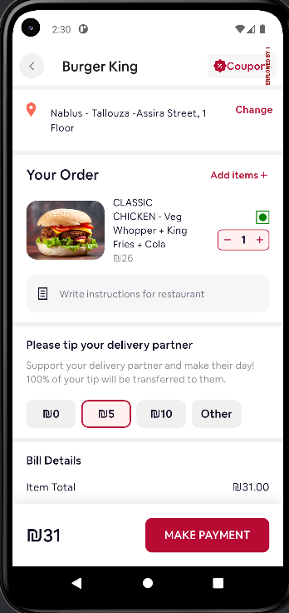

- Choosing a payment method

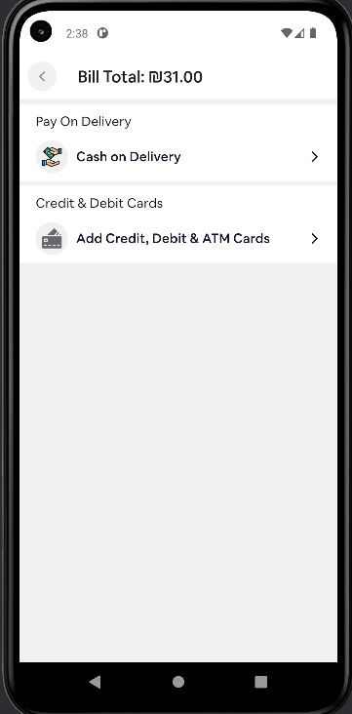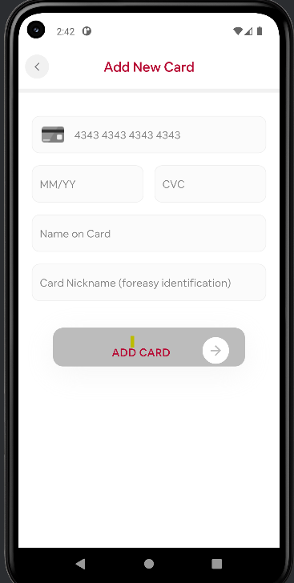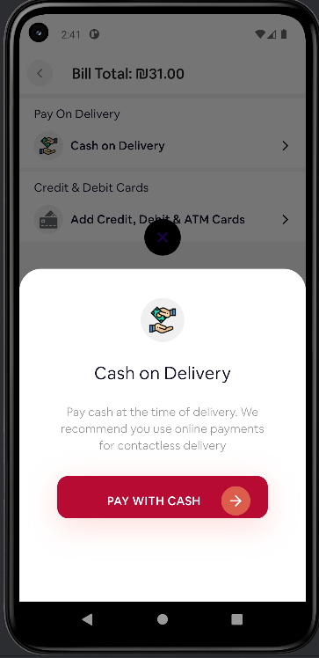

- The purchase process is completed

\
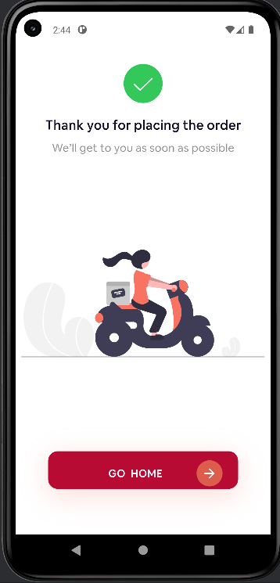

Admin Dashboard Website

5.2.1 Home Page

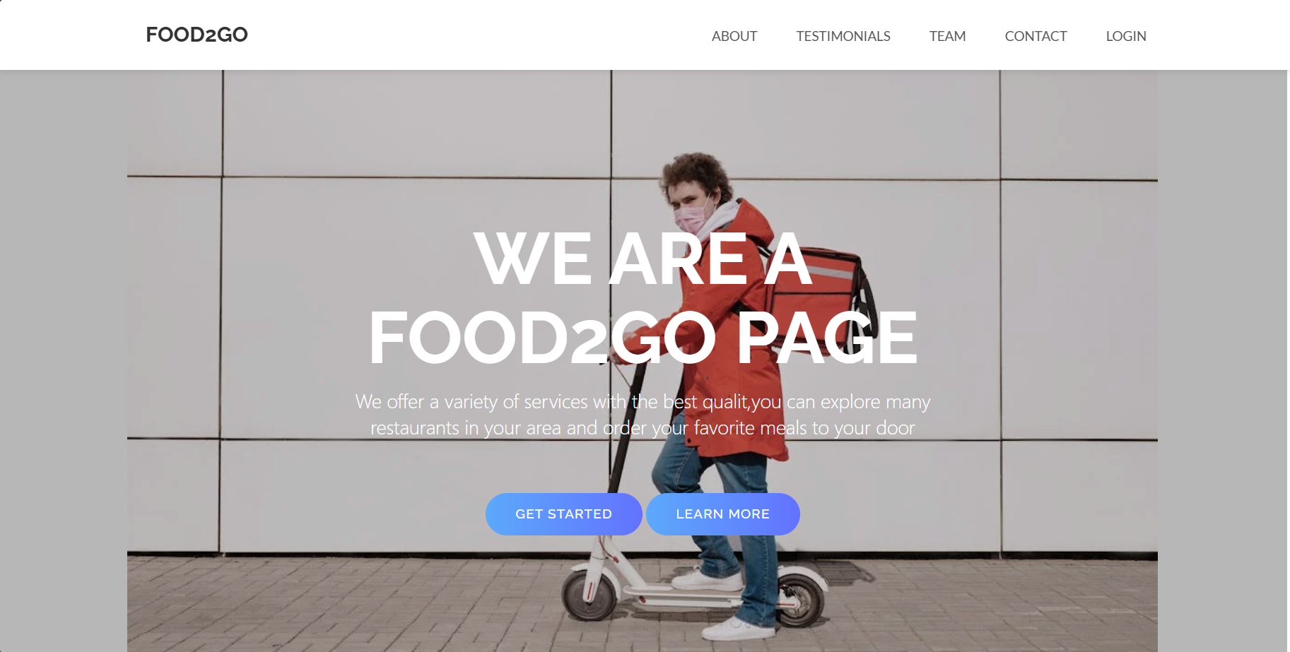

5.2.2 About Us Page
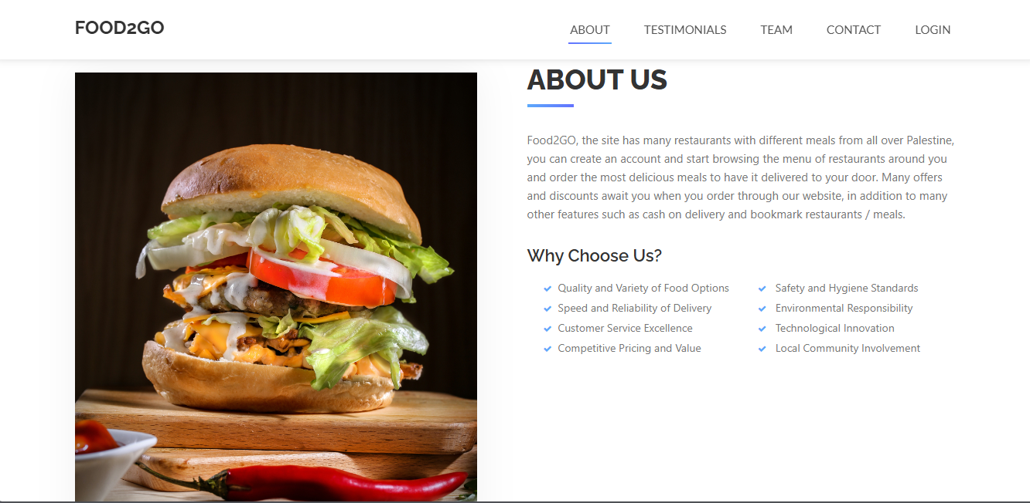

5.2.3 Team Page
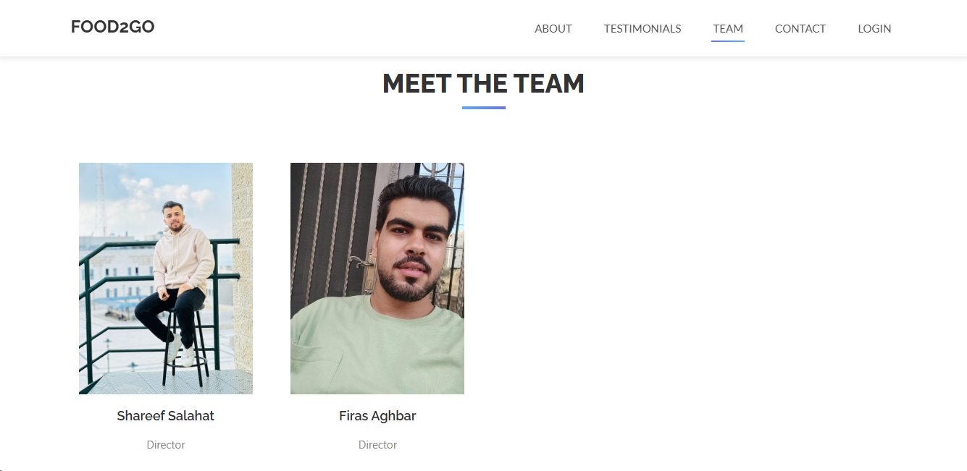

5.2.4 Contact Page

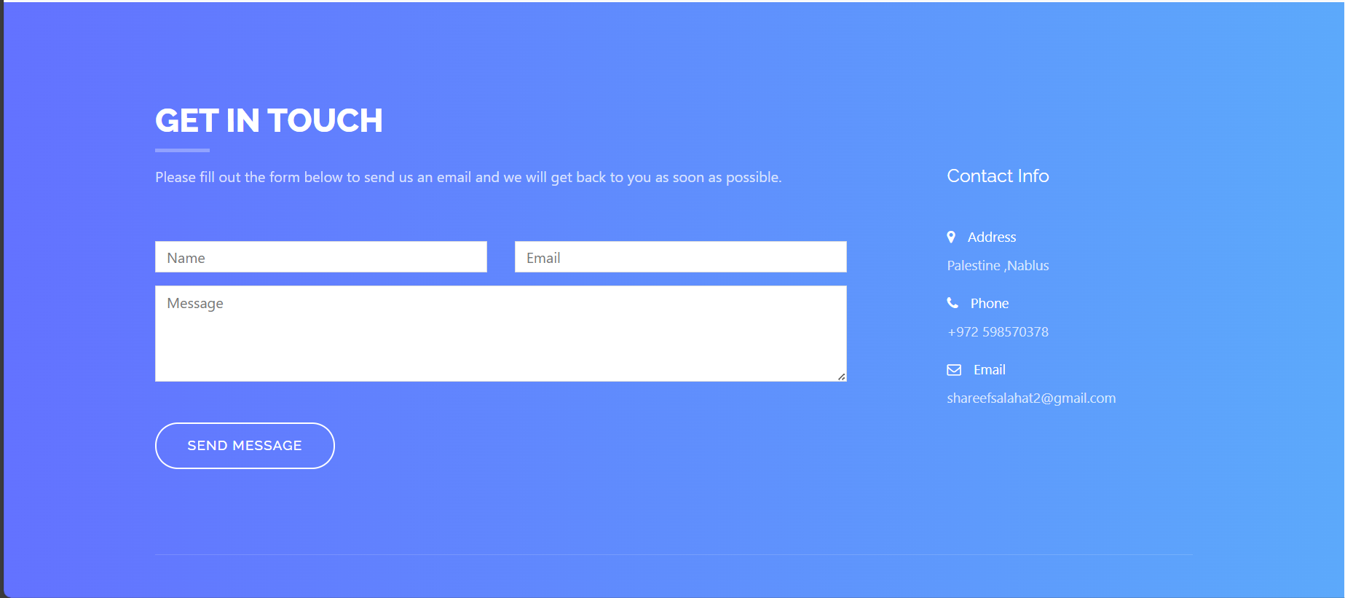

This is the received email:

5.2.5 Login Page

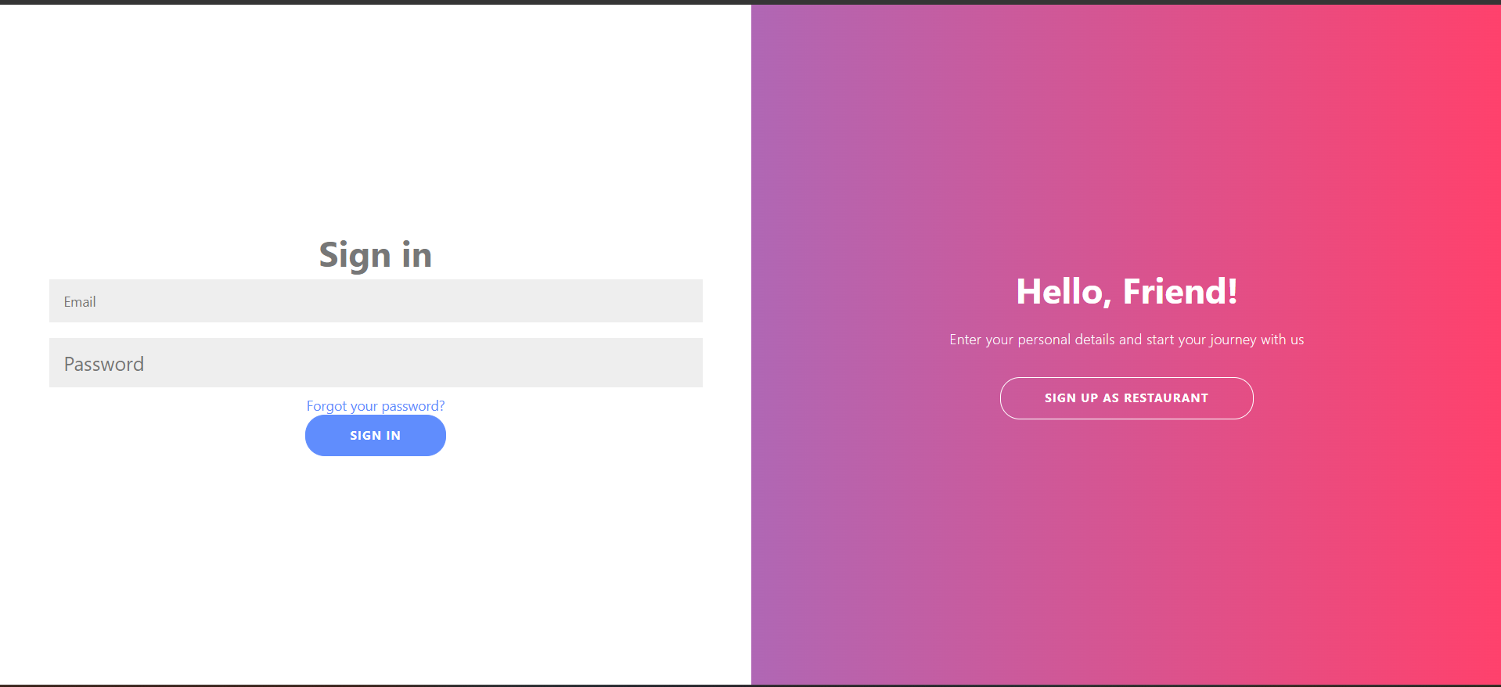

5.2.5.1 Forget Password

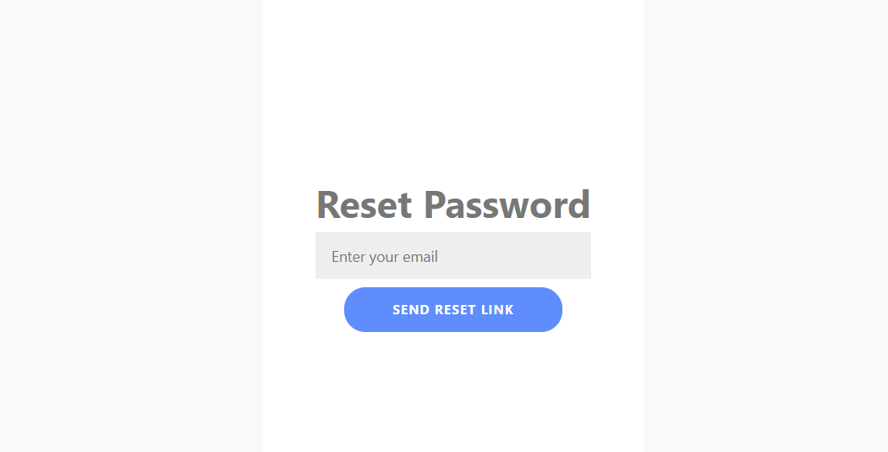

5.2.5.2 Forget Password

Email received:
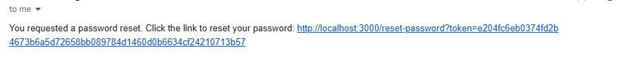

5.2.5.3 New Password

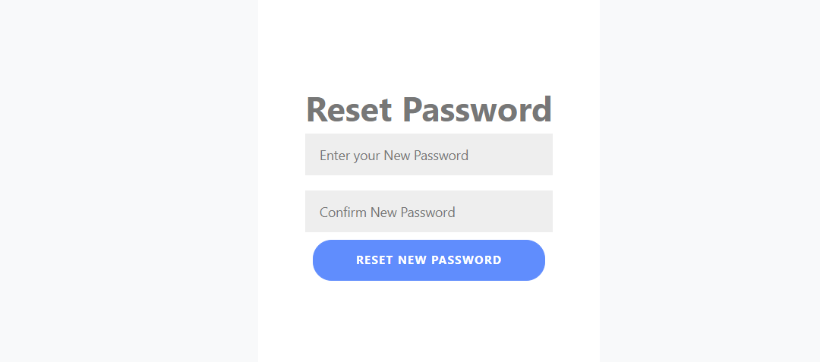

5.2.4 Admin Dashboard Page
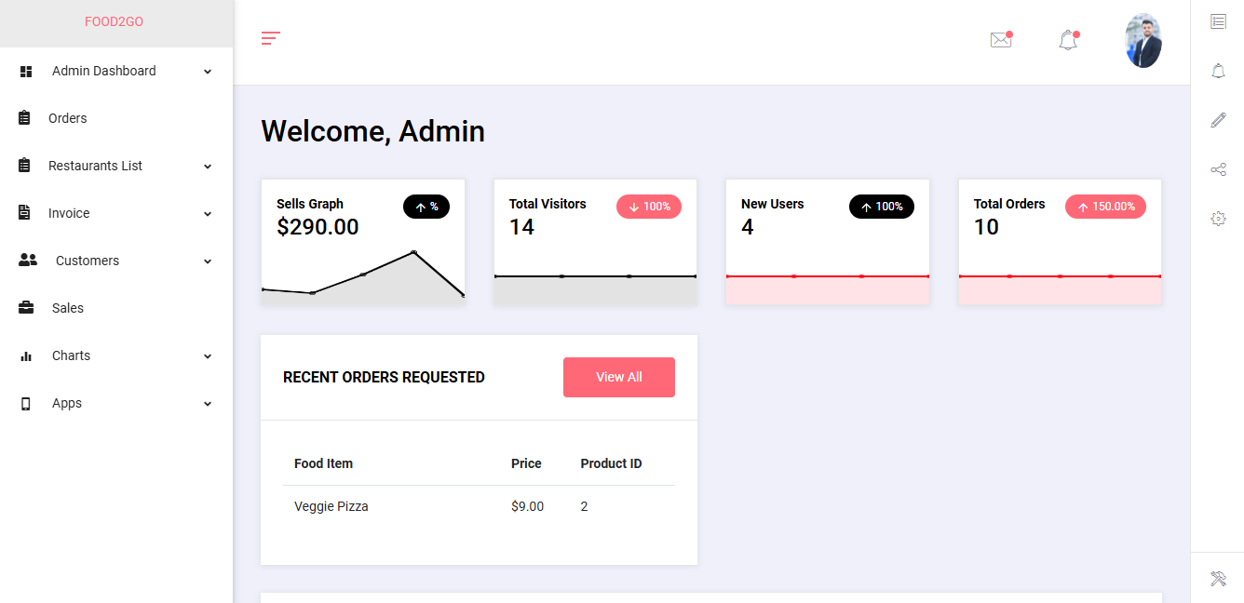

5.2.5 New Restaurant List

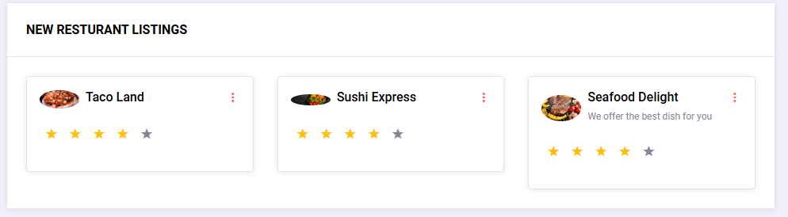
This show the few recent restaurants .

5.2.6 Statistics and Trending orders:
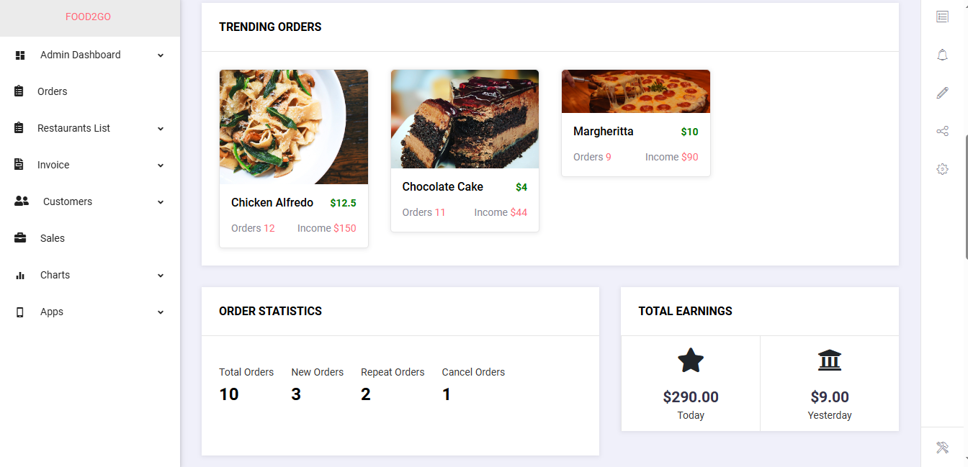

5.2.8 Orders List

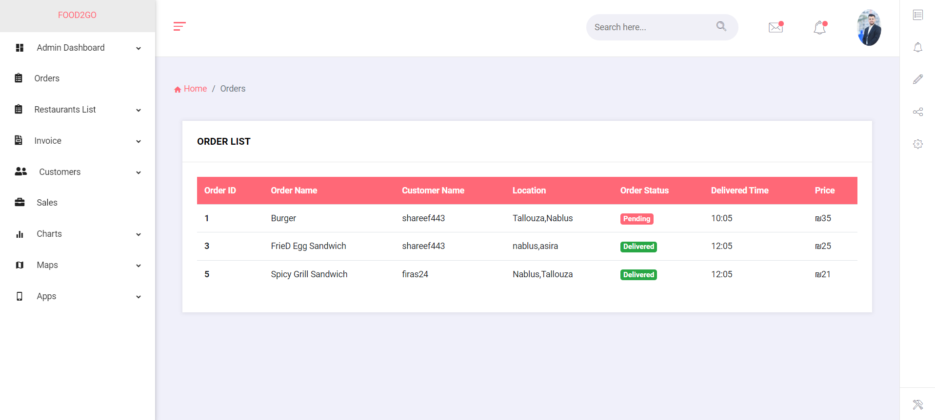

5.2.11 Restaurant Request
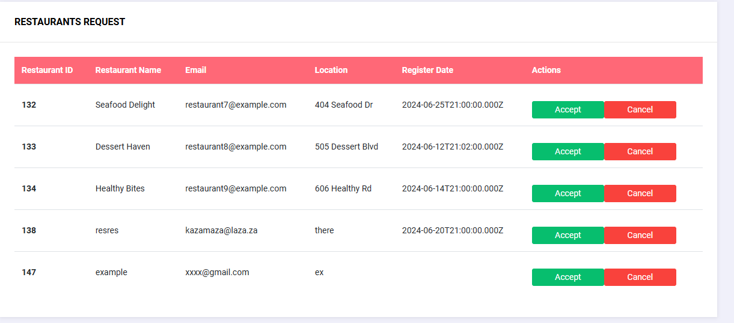

5.2.12 Restaurant List

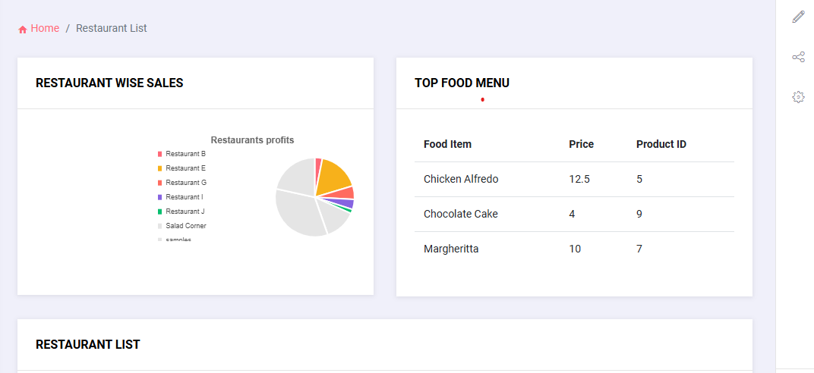
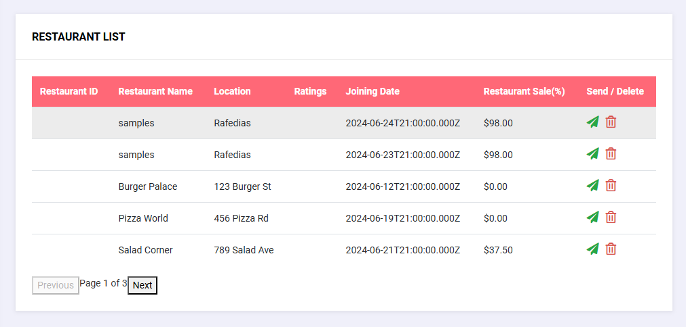

5.2.13 Invoice Details

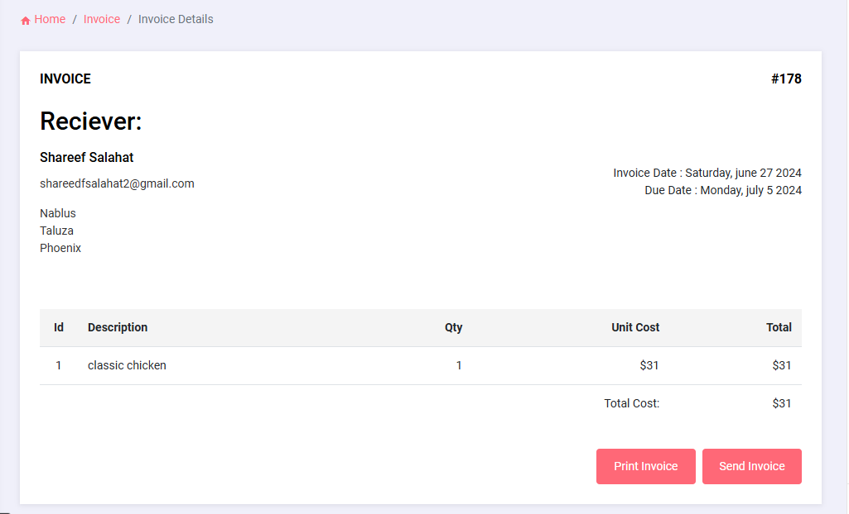

5.2.14 Invoice LIST
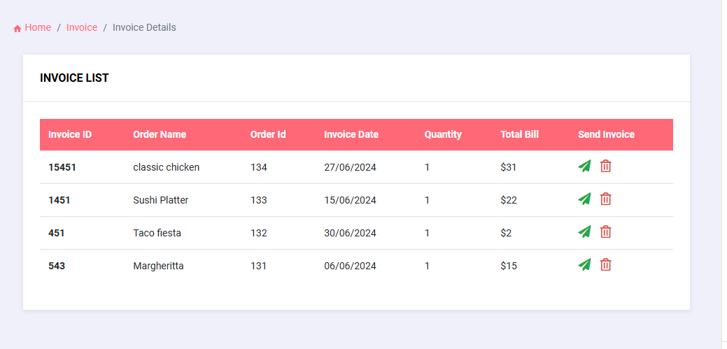

5.2.15 Customers Review
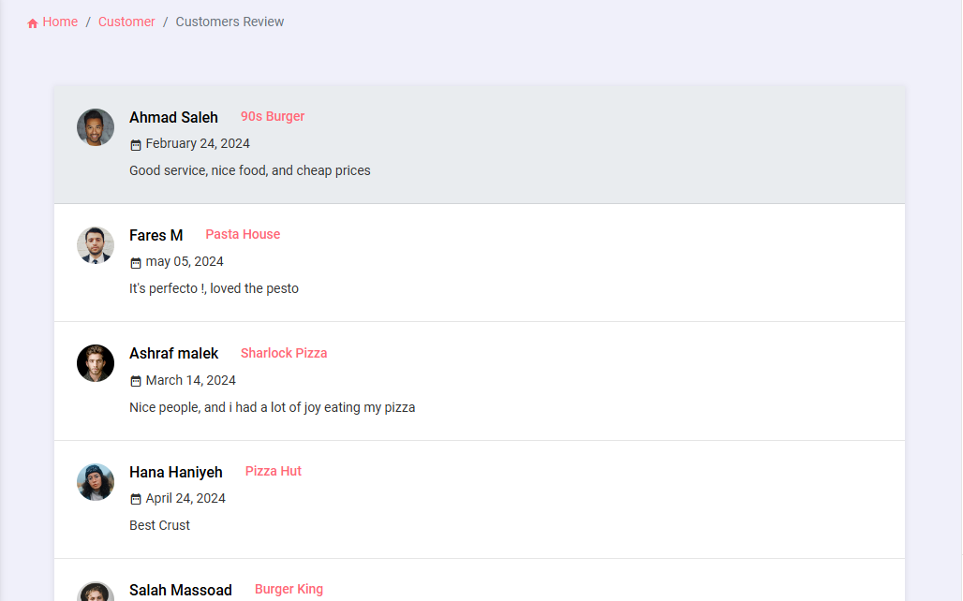

5.2.16 Customers List
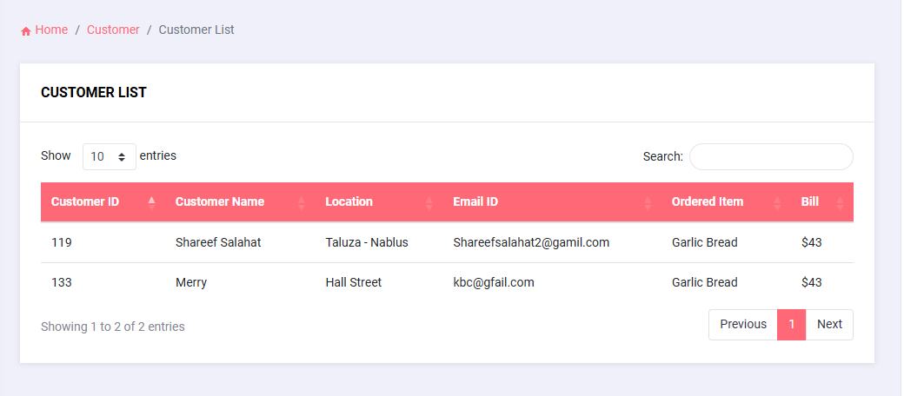

5.2.17 Chart JS

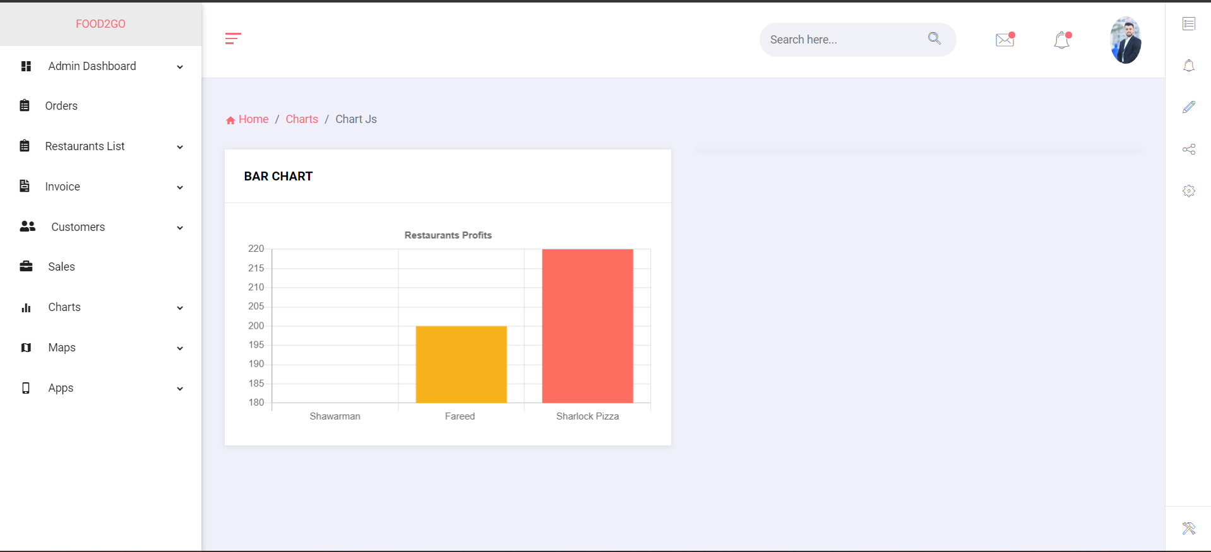

5.2.18 Chat System

Restaurant side:
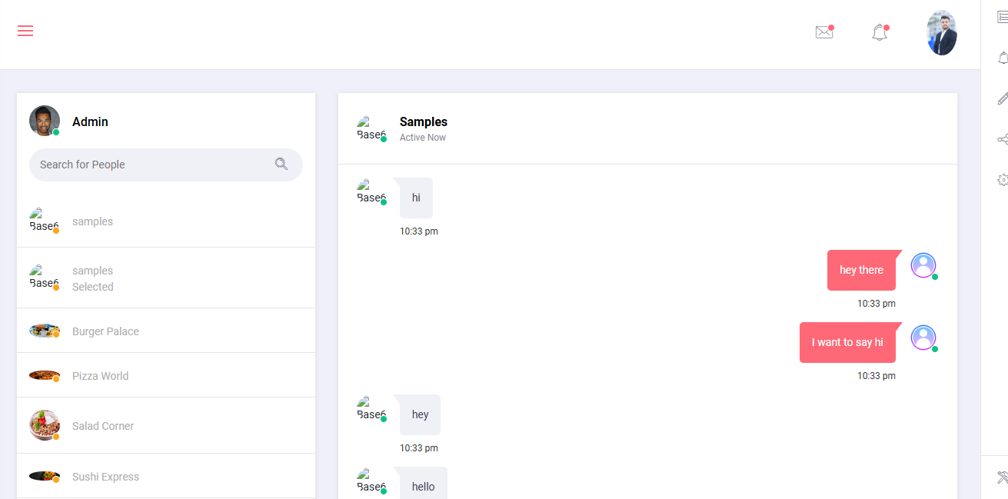

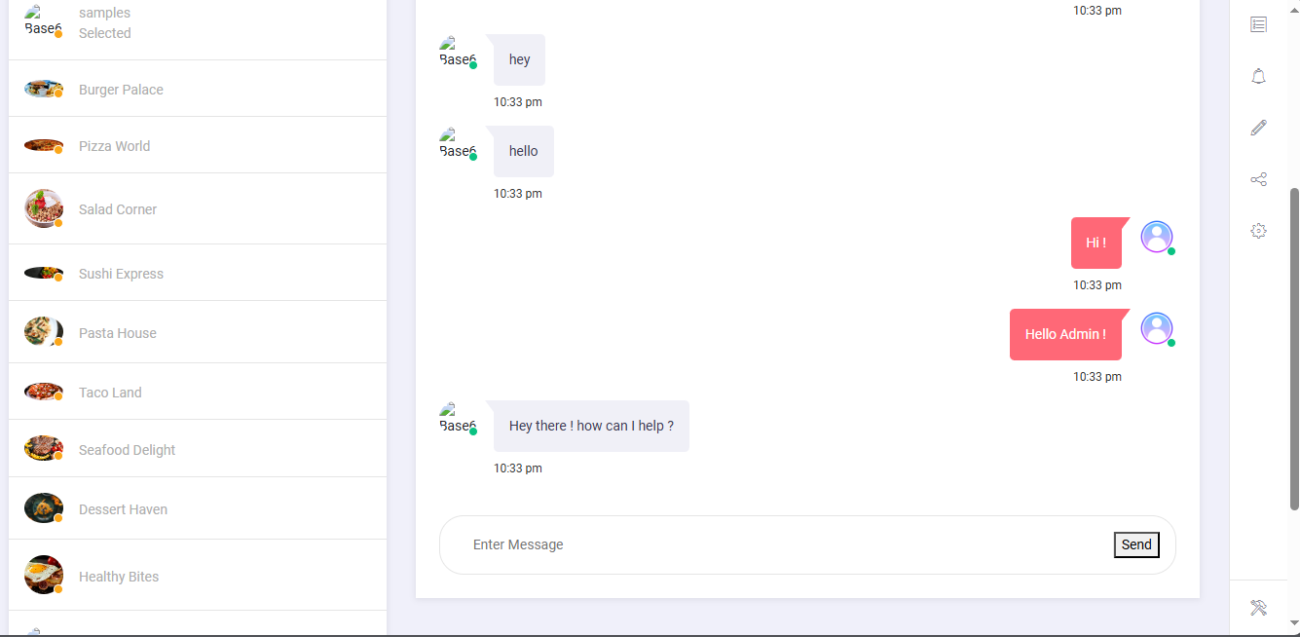
Admin side:

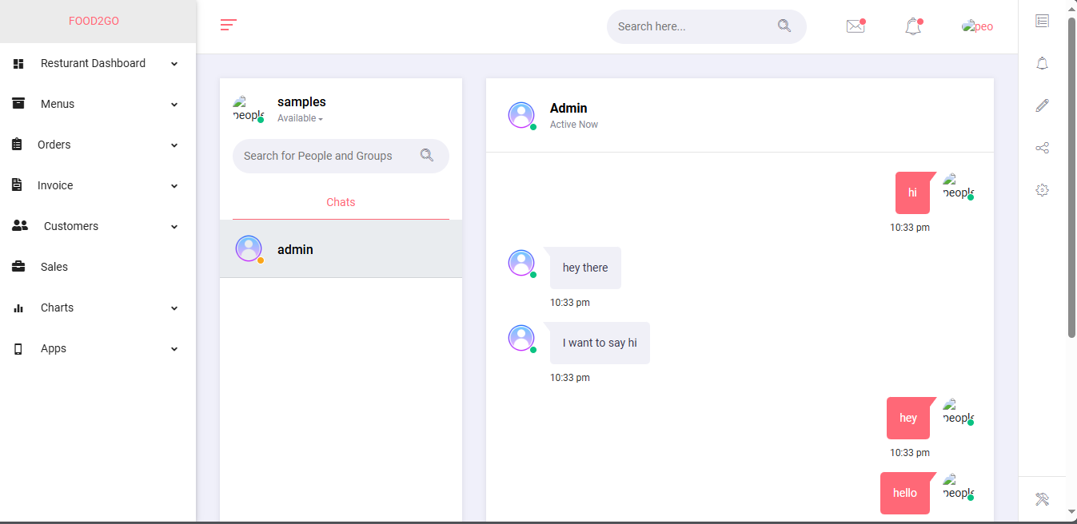
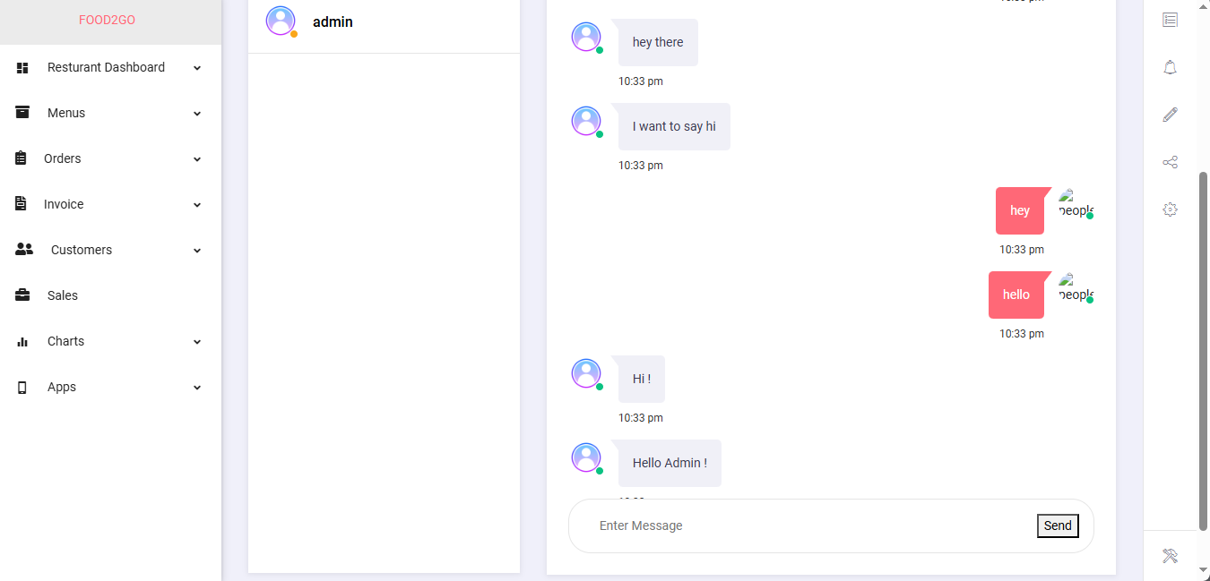

5.2.19 To do List

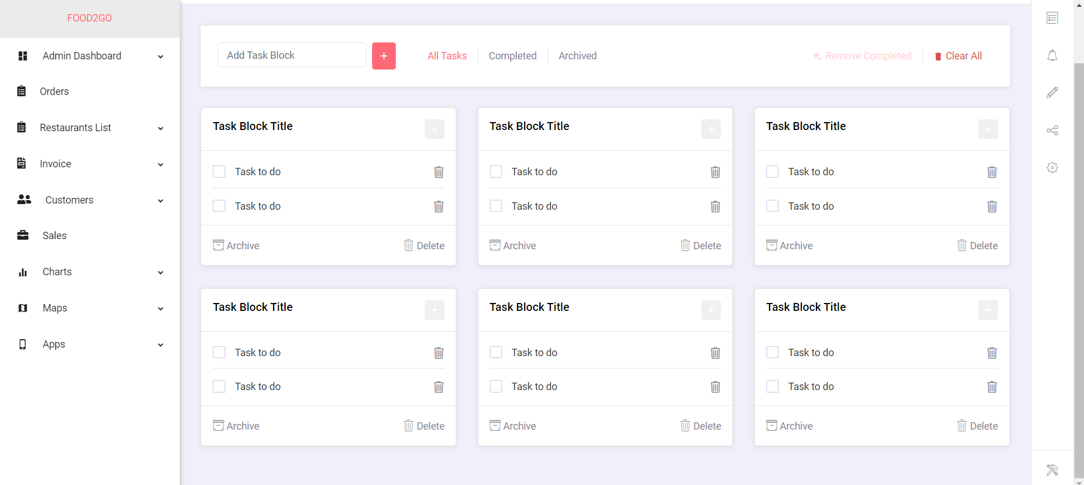

5.2.20 Admin Profile

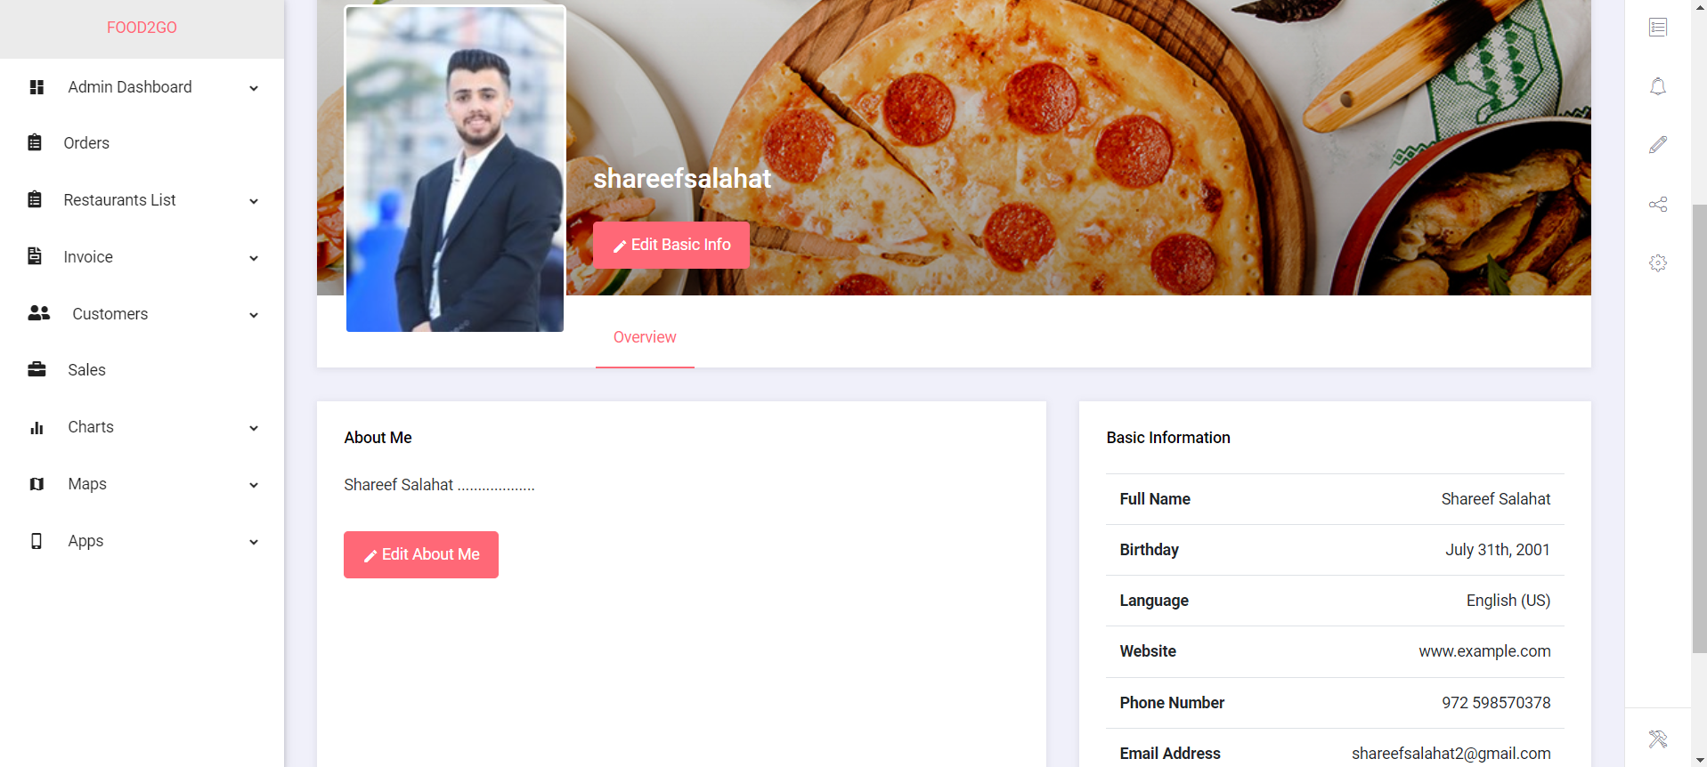

5.2.21 Dark Mode

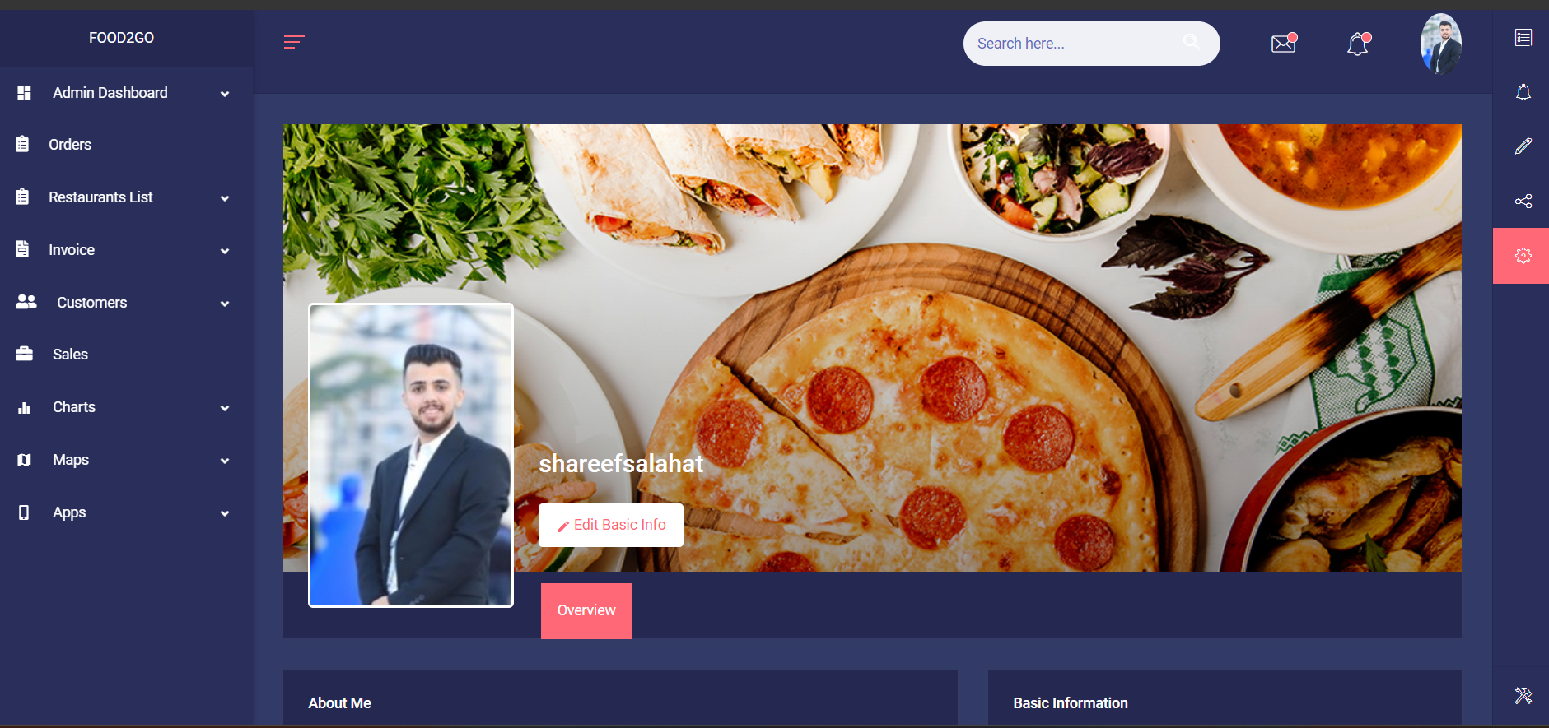

6. Restaurant Dashboard

6.1 Home Page

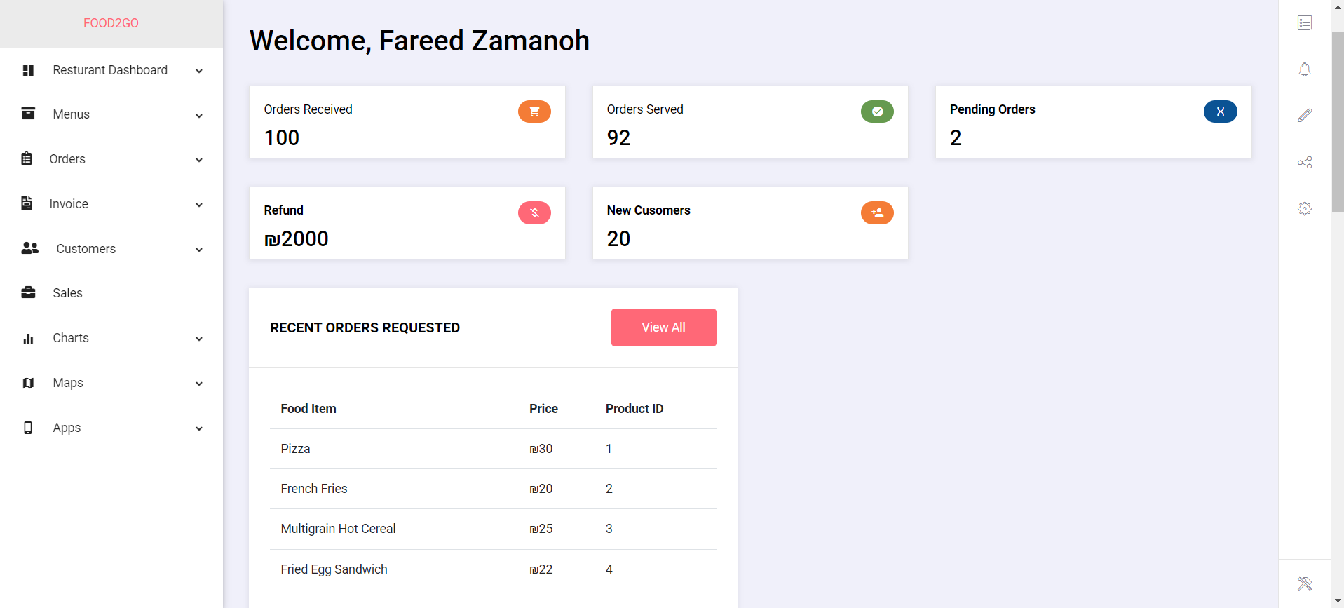

6.2 Trending Orders

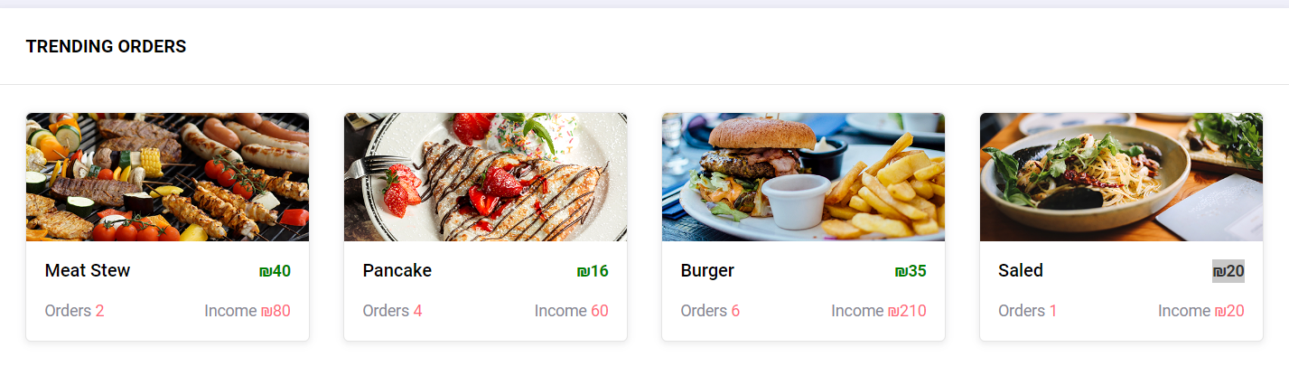

6.3 Order Timing Chart

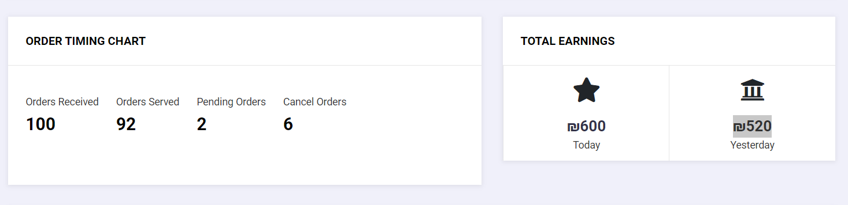

6.4 Order List

6.5 Menu Catalogue

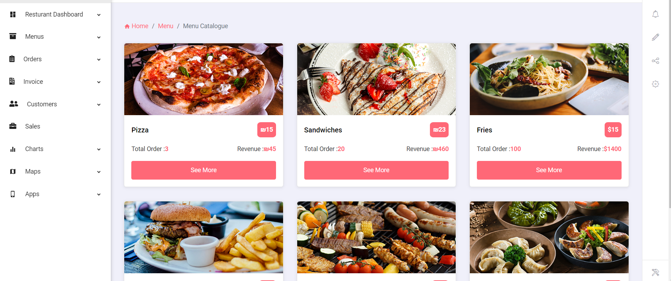

6.6 Menu list

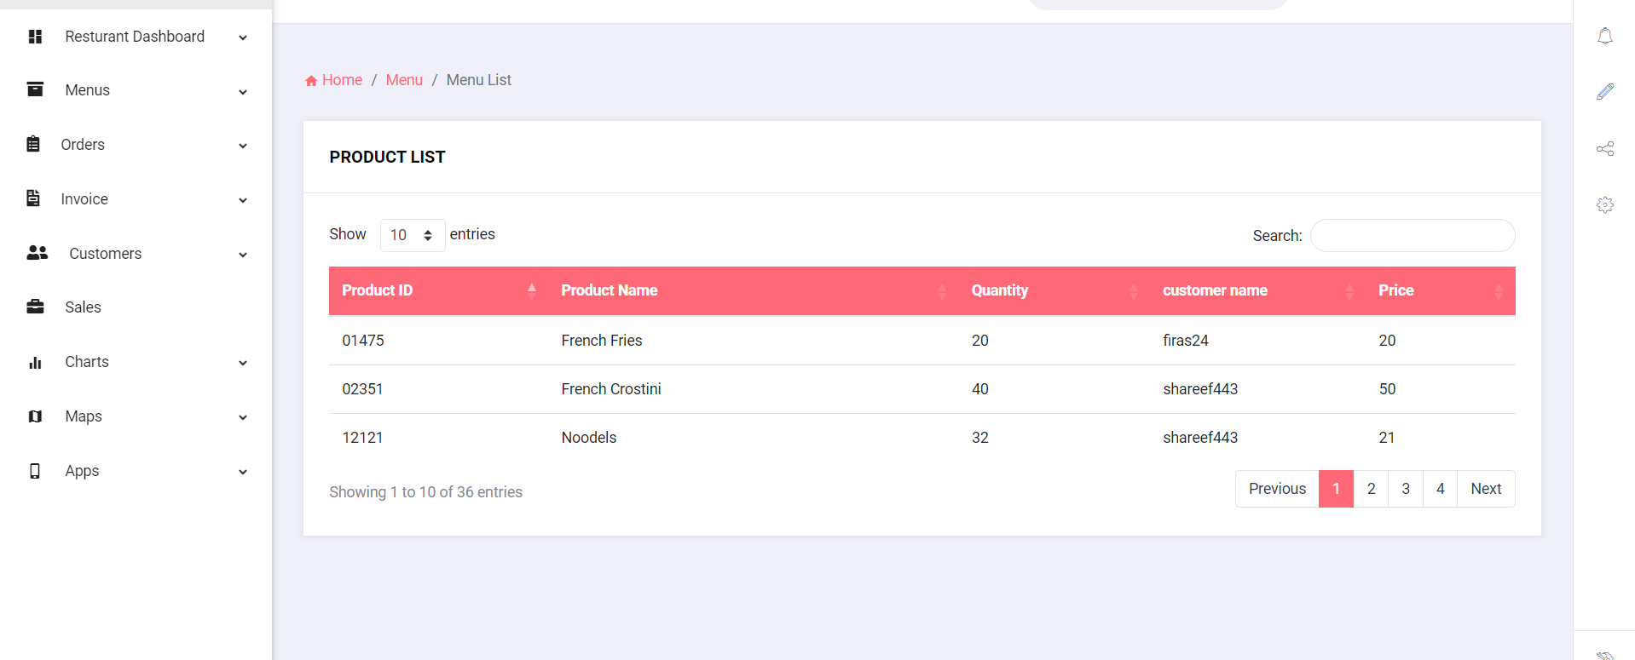

6.7 Menu Gird

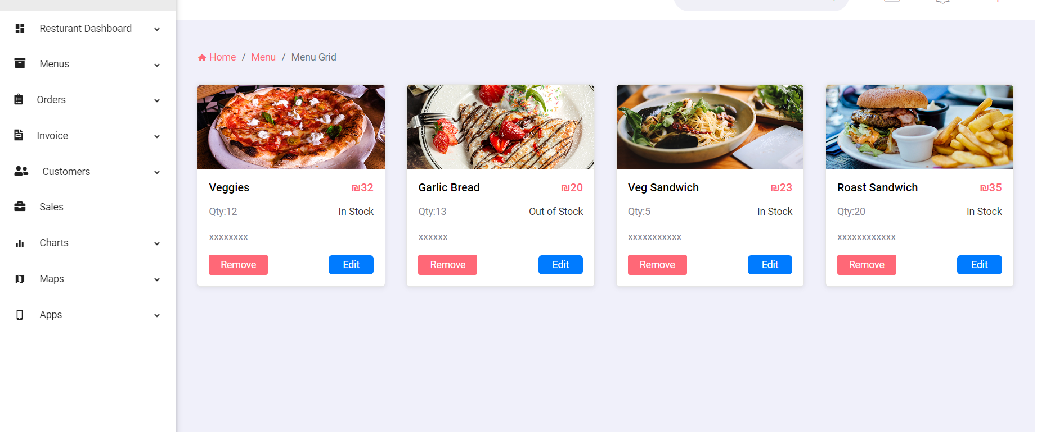

6.8 Add Product Form

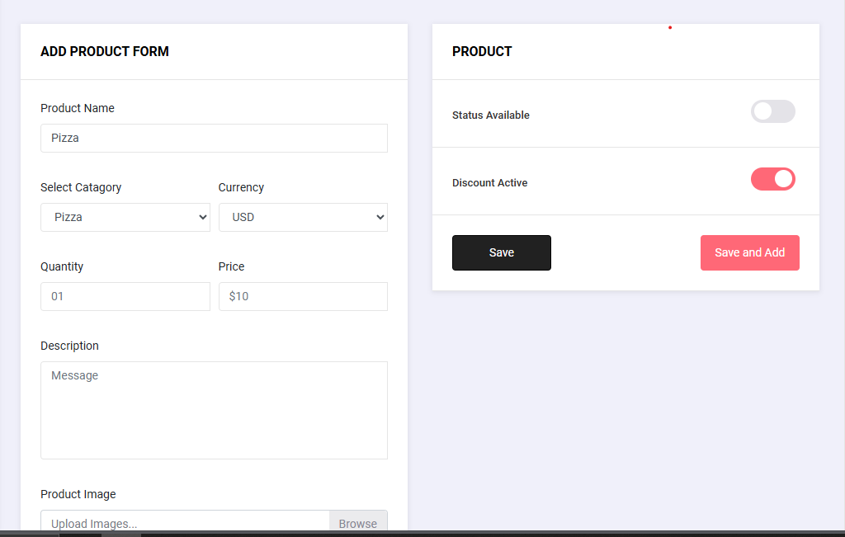

6.9 Product Details
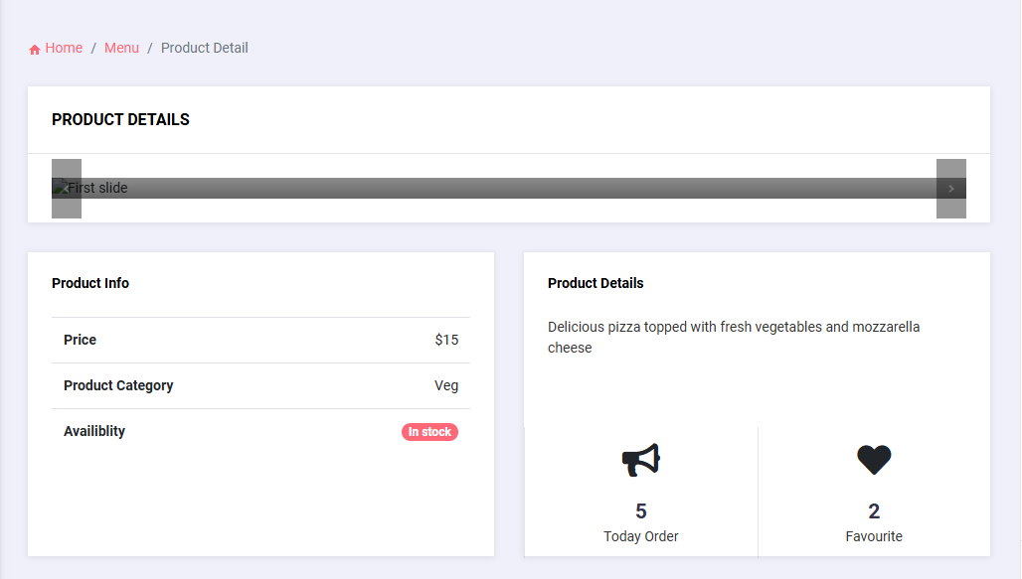

6.10 Order Request

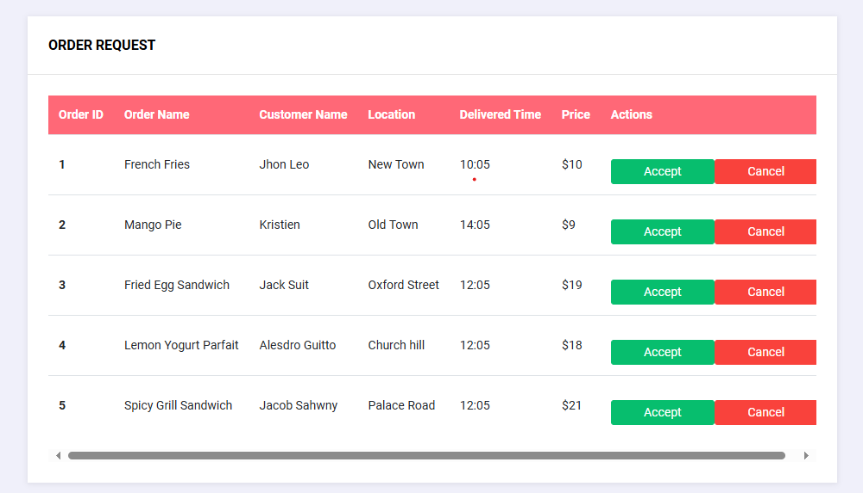

Order Request when click Button Accept or Cancel

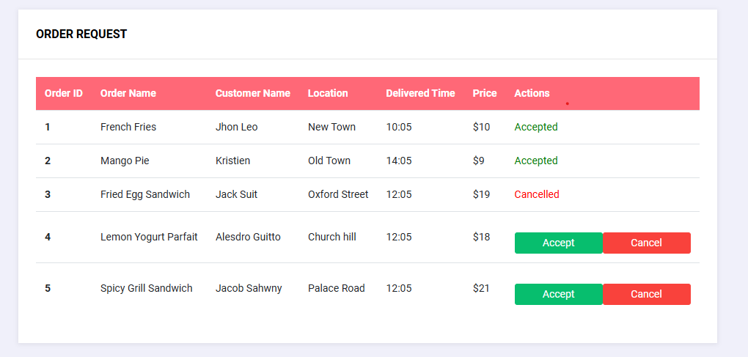

6.11 Resturant Profile

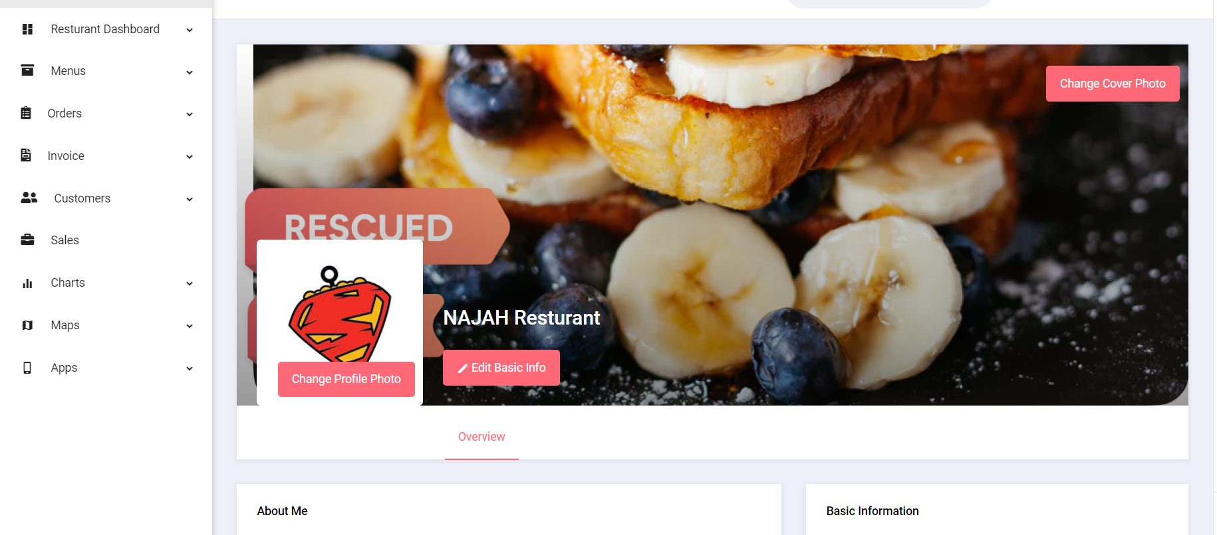

Results and discussion

The FOOD2GO project is geared towards enhancing customers and restaurants experience in delivering food by giving them a user-friendly platform with advanced functionalities. With high satisfaction rates and reviews, the project attracted a wide range of users.

This app has made the ordering process easier, facilitated real-time communication, and enhanced customer service delivery. The project addressed issues such as unified platform, easiness of using it and ordering efficiently for customers. Technological integration, restaurant partnerships and economic/cultural impact on community have helped this technology’s development (successful).

Future work
We will concentrate on improving the recommendation system, or making some alterations in payment options like expanding them as well as refining user interface. In addition to this FOOD2GO can look into expanding its services so as to offer a variety of food choices and implementing sustainable practices. And finally adding a dashboard for a driver which will deliver the meals.

Conclusions

The FOOD2GO project has completely changed the food delivery experience by improving user experience, restaurant operational efficiencies. Key accomplishments involve an easy to use design, better search, personalized suggestions, real time conversation tools, and secure payment system. The app has also given powerful features for managing menus, orders as well as customer interactions leading to increased productivity and customer satisfaction. FOOD2GO has helped the local economy grow through job creation as well as support of local enterprises thus contributing to growth of food service sector.

FOOD2GO has remained a top player in the food delivery industry due to its technological advancements such as real-time communication using Firebase, amazing recommendation systems or even safe payment gateways. Lessons learned include designing for users, being flexible and adaptable as well as partnership and collaboration. Things like expanding services; implementing sustainable practices; increasing personalization among others are some of the future directions.

In summary, FOOD2GO successfully met its objectives by enhancing food delivery services, supporting local businesses and employing modern technologies. To continue innovating and responding to user

