ABSTRACT
Deregulation, freer customer choice and open market competition are occurring in the energy supply market. These changes necessitate the automating of kilowatt-hour reading for most energy suppliers.
This project describes an automating meter reading system using the existing telephone lines, which gives fast communication and more accurate meter readings.
The project module consists of two parts customer part and employee part. The integration of these components was studied and this semester

Chapter one
The KWH meter
An electric meter or energy meter is a device that measures the amount of electrical energy supplied to or produced by a residence, business or machine.
The most common type is more properly known as a kilowatt-hour meter or a joule meter. When used in electricity retailing, the utilities record the values measured by these meters to generate an invoice for the electricity.
They may also record other variables including the time when the electricity was used.
The most common unit of measurement on the electricity meter is the kilowatt-hour, which is equal to the amount of energy used by a load of one kilowatt over a period of one hour, or 3,600,000 joules. Some electricity companies use the SI mega joule instead.
Some meters measured only the length of time for which current flowed, with no measurement of the magnitude of voltage or current being made. These were only suited for constant load applications.

Modern electricity meters operate by continuously measuring the instantaneous voltage (volts) and current (amperes) and finding the product of these to give instantaneous electrical power (watts) which is then integrated against time to give energy used (joules, kilowatt-hours etc). The meters fall into two basic categories, electromechanical and electronic.

Electromechanical meters
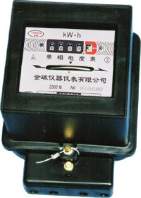
The most common type of electricity meter is the Thomson or electromechanical induction watt-hour meter, invented by Elihu Thomson in 1888.

Technology
The electromechanical induction meter operates by counting the revolutions of an aluminium disc which is made to rotate at a speed proportional to the power. The number of revolutions is thus proportional to the energy usage. It consumes a small amount of power, typically around 2 watts.
The metallic disc is acted upon by two coils. One coil is connected in such a way that it produces a magnetic flux in proportion to the voltage and the other produces a magnetic flux in proportion to the current. The field of the voltage coil is delayed by 90 degrees using a lag coil.This produces eddy currents in the disc and the effect is such that a force is exerted on the disc in proportion to the product of the instantaneous current and voltage. A permanent magnet exerts an opposing force proportional to the speed of rotation of the disc – this acts as a brake which causes the disc to stop spinning when power stops being drawn rather than allowing it to spin faster and faster. This causes the disc to rotate at a speed proportional to the power being used.

Reading
Most domestic electricity meters must be read manually, whether by a representative of the power company or by the customer. The reading may be supplied to the power company by an employee.

Prepayment meters
The standard business model of electricity retailing involves the electricity company billing the customer for the amount of energy used in the previous month or quarter.
In some countries, if the retailer believes that the customer may not pay the bill, a prepayment meter may be installed. This requires the customer to make advance payment before electricity can be used. If the available credit is exhausted then the supply of electricity is cut off by a relay.
In our country almost people used electro-mechanical KWH meter previuosly and this means that there are a large number of meter readings to be captured on a regular basis.
Currently these meter readings are captured by an employee capturing the meter reading manually. The main drawbacks of this system are human errors and excessive time taken to capture the meter reading.
Now they use Prepayment meters but we conclude that No one in Palestine companies and municipalities knows the software of the prepayment meter, and they can’t do any improvement or correction by themselves on these meters.

The idea in our project talk about to eliminate the need for the meter reader to enter the home and the use of prepayment meter by making some improvements on traditional meters, this improvement is adding anew piece in KWH meter to send data (energy consumption ) automatically.
The metering module consists of IR transmitter – receiver , a micro-controller and a modem .
We use telephone lines to collect data from energy metering devices and transfer that data to a central database for billing and analyzing .

To transfer data (energy consumption ) we must change it from analag to digital, then we use micro-controller for collecting data to transfer it via modem. These data will be received by another modem which connects with computer for reading and analyzing using C# program.

Chapter two
IR transmitter /receiver
The principle of measuring energy consumption depends on the output pulses from the receiver circuit , which is the input of PIC .

Infrared light:
Infrared light lies between the visible and microwave portions of the electromagnetic spectrum. Infrared light has a range of wavelengths, just like visible light has wavelengths that range from red light to violet.
"Near infrared" light is closest in wavelength to visible light and "far infrared" is closer to the microwave region of the electromagnetic spectrum. The longer, far infrared wavelengths are about the size of a pin head and the shorter, near infrared ones are the size of cells, or are microscopic.
IR circuits:
This circuit has two stages: a transmitter unit and a receiver unit.
The transmitter unit consists of an infrared LED and its associated circuitry.
The receiver unit consists of a sensor and its associated circuitry.

IR transmitter:

The transmitter circuit consists of the following components:

IC 555

Resistors
- Capacitors
- IR LED

The IR LED emitting infrared light is put on in the transmitting unit. To generate IR signal, 555 IC is used and Infrared LED is driven through transistor BC 548.
IC 555 is used to construct a stable multivibrator which has two stable states. It generates a square wave of frequency 38kHz and amplitude 5Volts. It is required to switch ‘ON’ the IR LED.

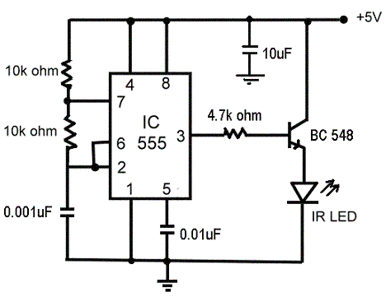

IR RECEIVER:
The receiver circuit consists of the following components:

- TSOP1738 (sensor)
- IC 555
- Resistors
- Capacitors

In receiver section, the first part is a sensor, which detects IR pulses transmitted by IR-LED. Whenever a disk crosses the sensor, the output of IR sensor transits through a low state. As a result the monostable is triggered and a short pulse is applied to the external interrupt of the microcontroller.

The IR receiver circuit is shown in the figure below.
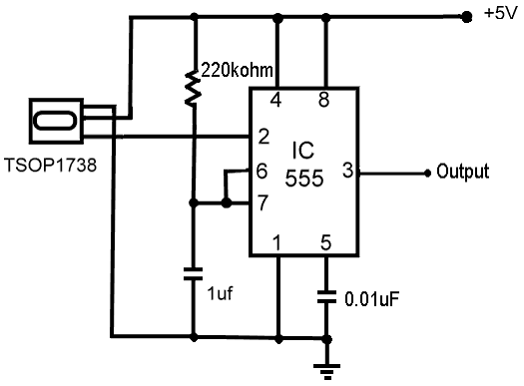

We make a small hole in the metallic disc in KWH meter and Putting IR transmitter/receiver circuits above and below the metallic disc.
The output pulses from receiver circuit are produced at the moment the hole becomes between the transmitter and receiver circuit, during the rotation of the disc.
The micro-controller received pulses for calculating the energy consumption.
We notice that we use IR transmitter and receiver circuits to change the transferd data from analog to digital, this method is very cheap and simple, but there are different method to change signal from analog to digital by using current transformer and voltage transformer, this method is expensive and complex.

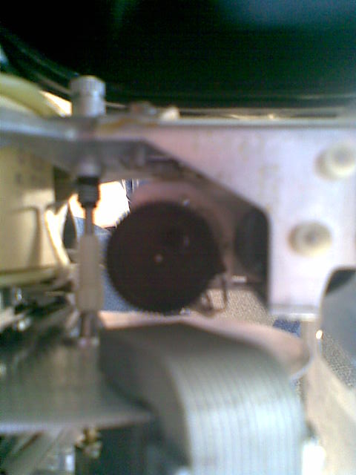

Micro-controller basic circuit
We are using in our project the PIC16F877A micro-controller from microchip .
The 16F877A is one of the most popular PIC microcontrollers and it's easy to see why - it comes in a 40 pin DIP pinout and it has many internal peripherals.
The 40 pins make it easier to use the peripherals as the functions are spread out over the pins. This makes it easier to decide what external devices to attach without worrying too much if there enough pins to do the job.
One of the main advantages is that each pin is only shared between two or three functions so its easier to decide what the pin function (other devices have up to 5 functions for a pin).
Note: A disadvantage of the device is that it has no internal oscillator so you will need an external crystal of other clock source.

Basic circuit
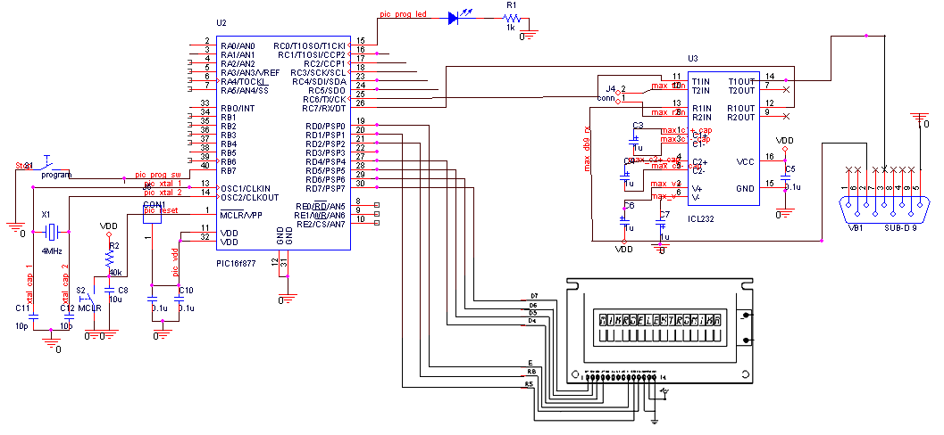

Algorithm
off
on
send
This is our algorithm to program the pic. The output from the IR-receiver was the input of the external interrupt. The pulses will be count up with counter and stored in the EPROM of the pic every day. When the management system sends to the pic through telephone lines any order it will execute it according to that order.
When it receives
“send” it will send the data
“on” it will return the service
“off” it will send the data then cut the service

pic basic circuit

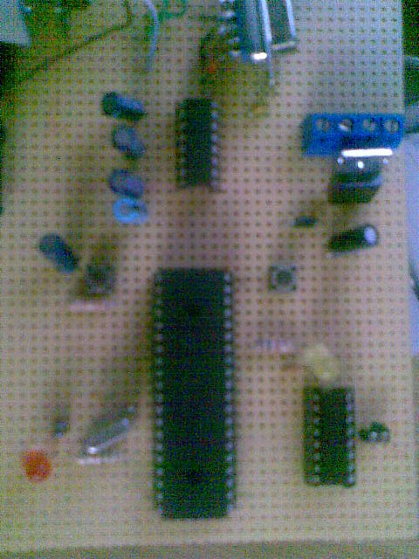
Uln IC
Notes:
- We choose to store in the EPROM in order to keep the data and not lose it if the pic was restarted.
- We use the uln2003 IC to connect the conductor in order to make sure that the pic is in safe from over voltage.

Chapter three
Modem
Modem (from modulator-demodulator) is a device that modulates an analog carrier signal to encode digital information, and also demodulates such a carrier signal to decode the transmitted information. The goal is to produce a signal that can be transmitted easily and decoded to reproduce the original digital data. Modems can be used over any means of transmitting analog signals, from driven diodes to radio.
Command and Data modes refer to the two modes in which a computer modem may operate. These modes are defined in the Hayes command set, which is the de-facto standard for all modems. These modes exist because there is only one channel of communication between the modem and the computer, which must carry both the computer's commands to the modem, as well as the data that the modem is enlisted to transmit to the remote party over the telephone line.
When a modem is in command mode, any characters sent to it are interpreted as commands for the modem to execute, per the Hayes command set. A command is preceded by the letters 'AT', which stand for 'Attention'. For example, if a modem receives 'ATDT5551212' while in the command mode, it interprets that as an instruction to dial the numbers 5551212 on the telephone, using touch-tone dialing.

While in command mode, the modem may send responses back to the computer indicating the outcome of the command. For example, the modem may respond with the word "BUSY" in response to the ATDT command, if it hears a busy signal after dialing and is configured to listen for busy signals.
Any communication in command mode (in both directions) is terminated by a carriage return.
When a modem is in data mode, any characters sent to the modem are intended to be transmitted to the remote party. The modem enters data mode immediately after it makes a connection. For example, if ATDT5551212 resulted in a phone call that was answered by another computer modem, the modem would report the word "CONNECT" and then switch to data mode. Any further characters received over the serial link are deemed to be from the remote party, and any characters sent are transmitted to the remote party.
When a voice-capable modem is in "voice data" mode, any data sent to the modem is interpreted as audio data to be played over the phone line, rather than character bytes to be transmitted digitally to the other party.
Almost all of the Hayes modem commands start with the two letter sequence AT - for getting the modem's attention. Because of this, modem commands are often called AT Commands
Hayes Microcomputer Products, Inc. was a modem manufacturer from the beginning of the 1980s until the end of the 1990s . Hayes developed the Hayes Smart modem.
This was a unique product at the time, because this modem was no longer simply a "dumb" device blindly converting serial data to and from audio tones, but contained some "intelligence". It was possible to send commands to the modem to configure it, to execute certain operations (such as dialing a number, quieting the speaker, hanging up, etc.), and to read the current status of the connection. Hayes developed and published a command set to control the modem over a serial line. This command set became popular among consumer modem manufacturers, and was cloned a thousand times. Known as both the "Hayes command set" and the "AT command set", it has long been the de-facto standard for controlling consumer modems and also many professional modems

