ti
An – Najah National University
Faculty of Engineering Electrical Engineering Department

Power supply with regulated adjustable output

Graduation Project
Supervisor : Prof.Dr.Marwan Mahmoud
Students:
Qamar Hazeem(10716189)
Farida Odeh(10718807)
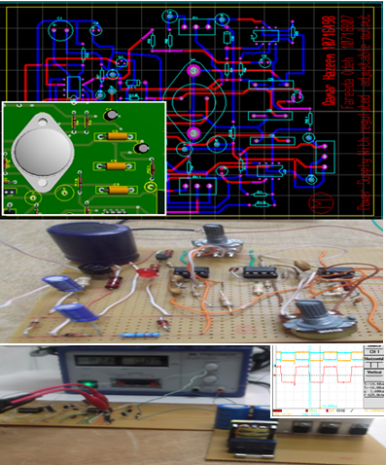

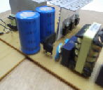

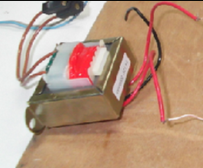

2012

Contents
Abstract 4
Introduction 5
1-Chapter one: 6
1.1-Linear power supply 6
2.2-Switch mode power supply 7
2-Chapter two: 8
2.1-Linear power supply 8
2.1.1-General Description about the linear power supply circuit : 8
2.1.2-Technical Specifications: 9
2.1.3-Features: 9
2.2-How the circuit Works: 10
2.2.1-Transformer: 10
2.2.2-Rectifier 11
2.2.3-Rippel smoothing circuit : 12
2.3-Voltage regulator: 13
2.4-current regulator: 16
2.5-(PCB – Connections): 19
3-Chapter three: 21
3.1-Switched mode power supply 21
3.2-First stage: 23
3.2.1- Pulse width modulation (PWM) control circuit(TL494 IC): 24
3.2.2- Drivers switch & coil isolation: 25
3.3-Second stage: 29
3.3.1-AC Harmonic Filter 29
3.3.2-Bridge rectifier 31
3.3.3-Rippel smoothing circuit: 32
3.3.4-Power switch (BJT transistor): 32

Abstract
A power supply is a buffer circuit that provides power with the characteristics required by the load from a primary power source with characteristics incompatible with the load. It makes the load compatible with its power source.
Power Supply A device for the conversion of available power of one set of characteristics to another set of characteristics to meet specified requirements. Typical application of power supplies include to convert raw input power to a controlled or stabilized voltage and/or current for the operation of electronic equipment.
We designed the various circuits constituting the power supply.
we built two type of DC power supply first type is linear DC power supply that contains appropriate transformer ,the rectifier ,the ripple smoothing circuit, operational amplifier, various type of transistor , linear pontesiometer to adjust the voltage and the current.
The another type is switch mode power supply that contains smoothing current circuit ,the rectifier, the transistors work as a switch, Puls with modulation control circuit by using TL494 IC, and finally DC stage that gives more than level.

Introduction
A regulated power supply is one that controls the output voltage or current to a specific value; the controlled value is held nearly constant despite variations in either load current or the voltage supplied by the power supply's energy source.
DC power is a laboratory equipment necessary to provide DC loads with DC voltage and DC current directly from the AC gride.
The output voltage and DC current have to be adjustable to fit with the voltage and power demands of different laboratory equipment.
A power supply converting AC line voltage to DC power must perform the following functions at high efficiency and at low cost:

1. Rectification: Convert the incoming AC line voltage to DC voltage.
2. Voltage transformation: Supply the correct DC voltage level(s).
3. Filtering: Smooth the ripple of the rectified voltage.
4. Regulation: Control the output voltage level to a constant value irrespective of line, load and temperature changes.
5. Isolation: Separate electrically the output from the input voltage source.
6. Protection: Prevent damaging voltage surges from reaching the output; provide back-up power or shut down during a brown-out.

Types of Power Supply:
  - Battery power supply
  - Unregulated power supply
  - Linear regulated power supply
  - Switched-mode power supply
  - Programmable power supply
  - Uninterruptible power supply

1-Chapter one
We have mentioned previously we built two type of power supply :

1.1-Linear power supply
1-linear power supply with the following block diagram:

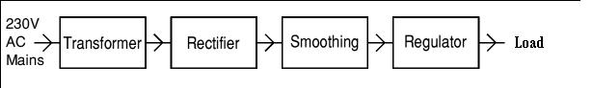
We choose the following circuit to build it , but we have a problem in availability the component (high power transistor Q5,Q6)
So we choose another circuit that make voltage ,current regulator with limit ( 0-30 Vdc,.002-3 A). 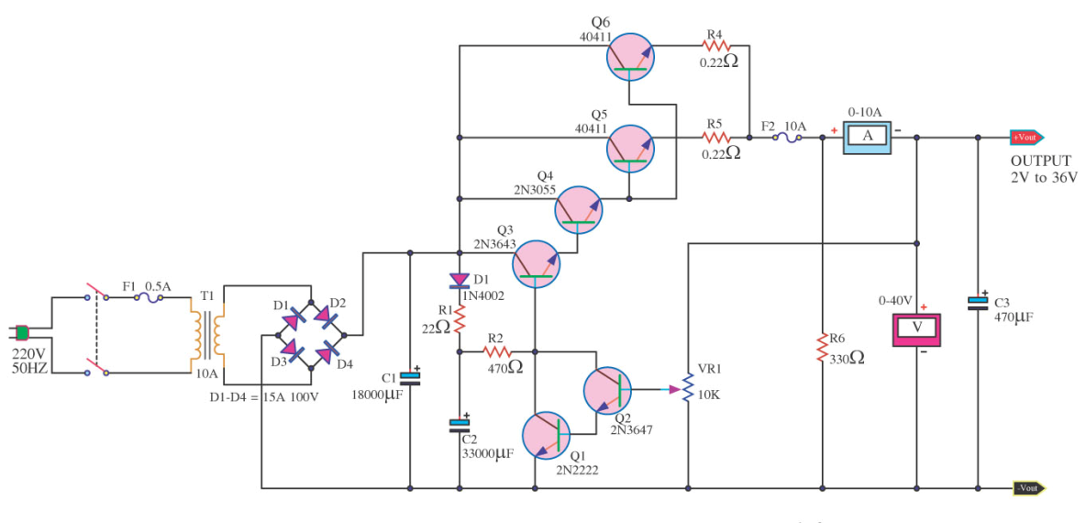
Figure -1
We will explain about it in the chapter two, here we have summary about what we completion in this semester.

2.2-Switch mode power supply

2-Switch mode power supply with the following block diagram:

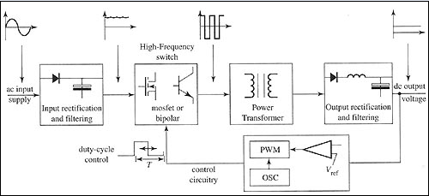
Figure -2

We built the following circuit for switch mode power supply :

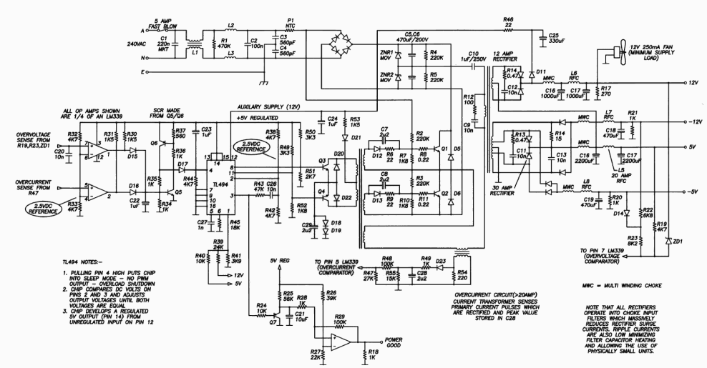
Figure-3

2-Chapter two

2.1-Linear power supply

0-30 VDC STABILIZED POWER SUPPLY WITH CURRENT CONTROL 0.002-3 A

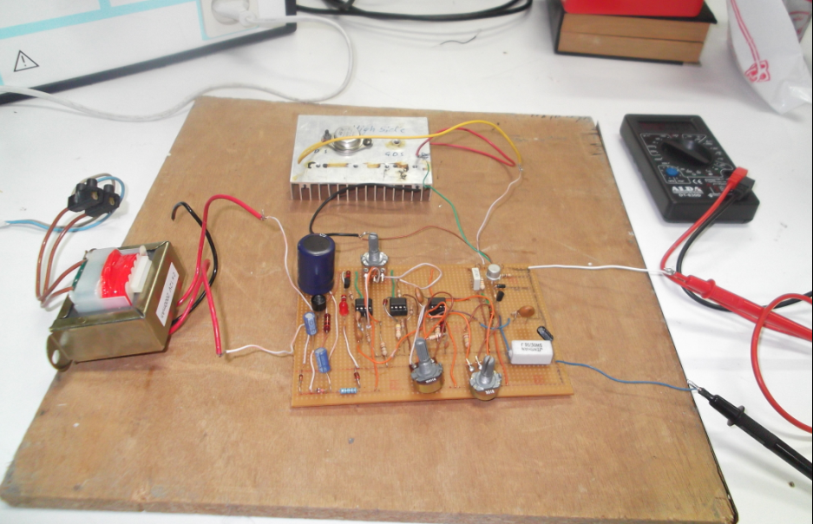

Figure-4

2.1.1-General Description about the linear power supply circuit :
This is a high quality power supply with a continuously variable tabilized output adjustable at any value between 0 and 30VDC. The circuit also incorporates an electronic output current limiter that effectively controls the output current from a few milliamperes (2 mA) to the maximum output of three amperes that the circuit can deliver.
This feature makes this power supply indispensable in the experimenters laboratory as it is possible to limit the current to the typical maximum that a circuit under test may require, and power it up then, without any fear that it may be damaged if something goes wrong.

2.1.2-Technical Specifications:
Input Voltage: .…............ 24 VAC
Input Current: .…............ 3 A (max)
Output Voltage: .…......... 0-30 V adjustable
Output Current: .…......... 2 mA-3 A adjustable
Output Voltage Ripple: .… 0.01 % maximum

2.1.3-Features:
- Reduced dimensions, easy construction, simple operation.
- Output voltage easily adjustable.
- Output current limiting with visual indication.
- Complete protection of the supplied device against over loads and malfunction.

In the following Schematic diagram for the circuit:
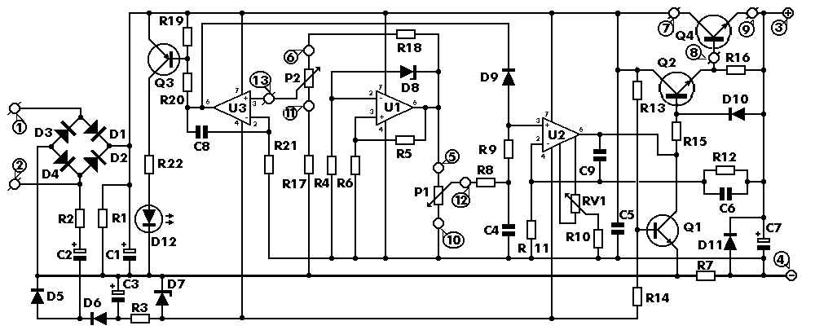
Figure-5

2.2-How the circuit Works:

2.2.1-Transformer:
A transformer is a device that transfers electrical energy from one circuit to another through inductively coupled conductors—the transformer's coils. varying current in the first or primary winding creates a varying magnetic flux in the transformer's core and thus a varying magnetic field through the secondary winding. This varying magnetic field induces a varying electromotive force (EMF), or "voltage", in the secondary winding. This effect is called inductive coupling.
If a load is connected to the secondary, current will flow in the secondary winding and electrical energy will be transferred from the primary circuit through the transformer to the load. In an ideal transformer, the induced voltage in the secondary winding (V_{s}) is in proportion to the primary voltage (V_{p}), and is given by the ratio of the number of turns in the secondary (N_{s}) to the number of turns in the primary (N_{p}) as follows:

In our project:

There is a step-down mains transformer with a secondary winding rated at 24 V/3 A, which is connected across the input points of the circuit at pins 1 & 2, (the quality of the supplies output will be directly proportional to the quality of the transformer).
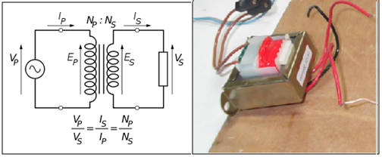
Figure-6

2.2.2-Rectifier:

A rectifier is an electrical device that converts alternating current (AC), which periodically reverses direction, to direct current (DC), which flows in only one direction. The process is known as rectification.
A full-wave rectifier converts the whole of the input waveform to one of constant polarity (positive or negative) at its output. Full-wave rectification converts both polarities of the input waveform to DC (direct current), and is more efficient. However, in a circuit with a non-center tapped transformer, four diodes are required instead of the one needed for half-wave rectification .Four diodes arranged this way are called a diode bridge or bridge rectifier.

Calculation for full wave rectifier:

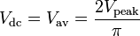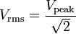

In our project:

The AC voltage of the transformers secondary winding is rectified by the bridge formed by the four diodes D1-D4.
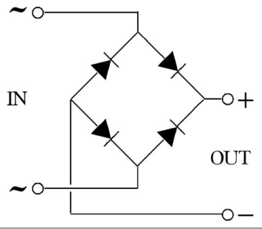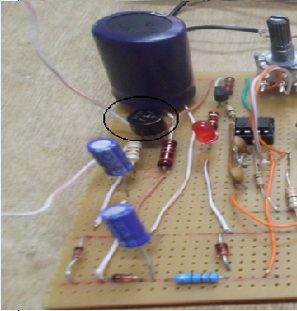
Figure-7 Figure-8

2.2.3-Rippel smoothing circuit :

The most common meaning of ripple in electrical science is the small unwanted residual periodic variation of the direct current (dc) output of a power supply which has been derived from an alternating current (ac) source, While half-wave and full-wave rectification suffice to deliver a form of DC output, neither produces constant-voltage DC.

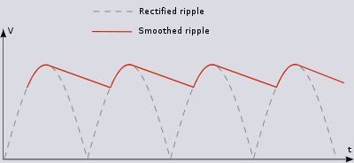
Figure-9
Now,we will use this equation to calculate the size of capacitor:

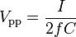
where
- V_{pp} is the peak-to-peak ripple voltage ,got from OSC
- I is the current in the circuit ,load current.
- f is the frequency of the ac power
- C is the capacitance
The DC voltage taken across the output of the bridge is smoothed by the filter formed by the reservoir capacitor C1 and the resistor R1.
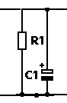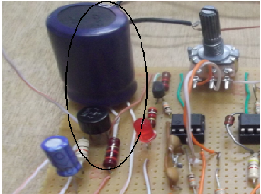
Figure-10 figure-11

2.3-Voltage regulator:

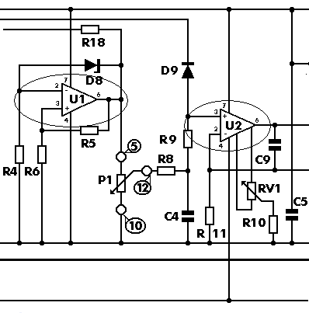
Figure-12
4-Instead of using a variable feedback arrangement to control the output voltage, our circuit uses a constant gain amplifier to provide the reference voltage necessary for its stable operation. The reference voltage is generated at the output of U1.
5-The diode D8 is a 5.6 V zener, The voltage in the output of U1 gradually increases till the diode D8 is turned on, When this happens the circuit stabilises and the Zener reference voltage (5.6 V) appears across the resistor R5, The current which flows through the non inverting input of the op-amp is negligible, therefore the same current flows through R5 and R6, and as the two resistors have the same value the voltage across the two of them in series will be exactly twice the voltage across each one. Thus the voltage present at the output of the op-amp (pin 6 of U1) is 11.2 V, twice the zeners reference voltage, fig-1 illustrate what happened exactly.
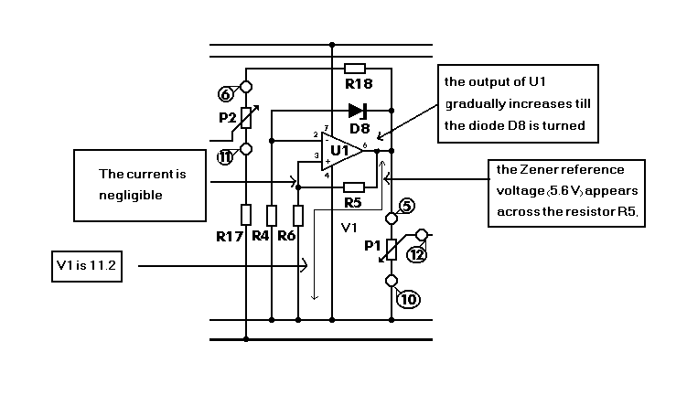
Figure-13

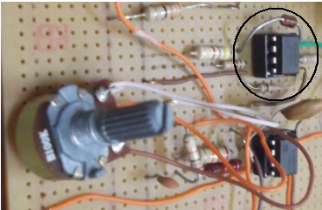
Figure-14
6-The integrated circuit U2 has a constant amplification factor of approximately 3 times, according to the formula A=(R11+R12)/R11, and raises the 11.2 V reference voltage to approximately 33 V, The trimmer RV1 and the resistor R10 are used for the adjustment of the output voltages limits so that it can be reduced to 0 V.
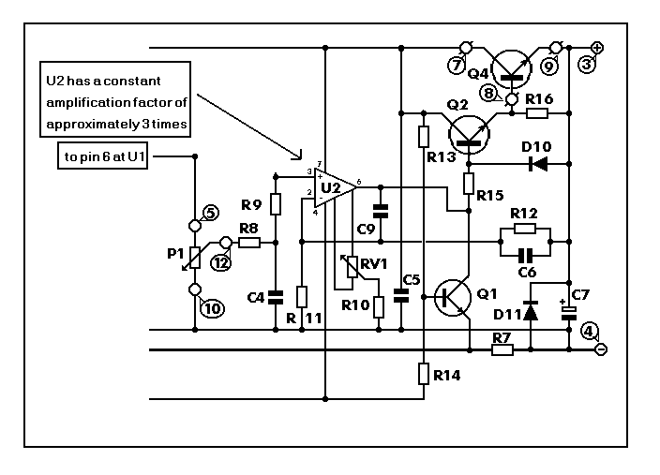
Figure-15
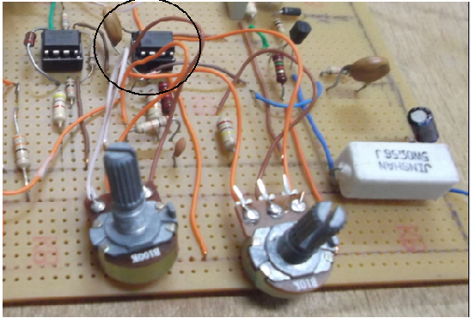Figure-16

The following reading got from the circuit:
Voltage | Current | load

2.4-current regulator:
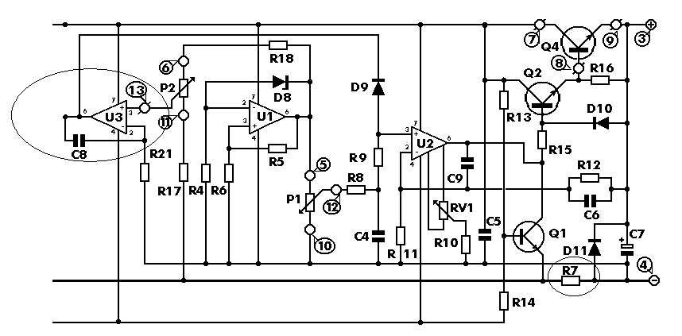
Figure-17
Another very important feature of the circuit, is the possibility to preset the maximum output current which can be drawn from the p.s.u., effectively converting it from a constant voltage source to a constant current one. To make this possible the circuit detects the voltage drop across a resistor (R7) which is connected in series with the load. The IC responsible for this function of the circuit is U3. The inverting input of U3 is biased at 0 V via R21. At the same time the non inverting input of the same IC can be adjusted to any voltage by means of P2.
1-Let us assume that for a given output of several volts, P2 is set so that the input of the IC is kept at 1 V.
2-If the load is increased so that the voltage drop across R7 is greater than 1 V, IC3 is forced into action work as comparator, compare the voltage at inverting input with non inverting input that adjust to any voltage by means of P2 assume 1V .
3-The output of U3 is low and coupled to the non inverting input of U2 by D9 , U2 is responsible for the voltage control and as U3 is coupled to its input the latter can effectively override its function, and the voltage decrease at the output of U2 ,so decreasing the voltage at the base of Q2 ,this is causing decrease the current sinking from emitter to the load, so the voltage drop across R7 decreasing because the current decreasing
The following component make current regulator:
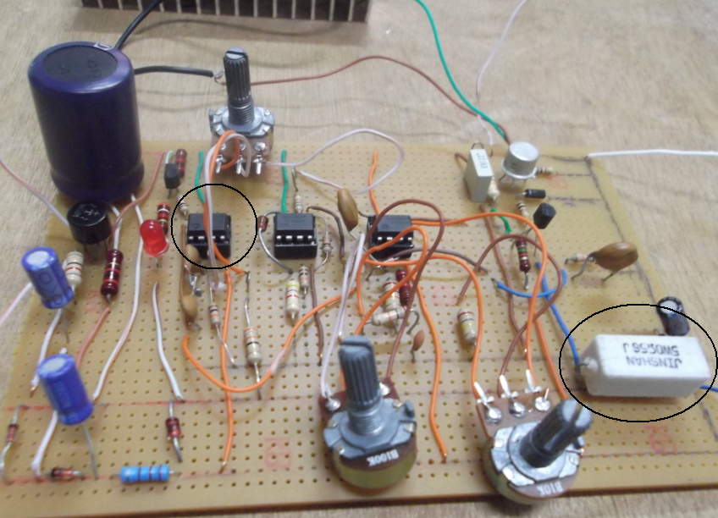
Figure-18

After we built this circuit we decide Implementation as printed board (PCB),so we Implement it in PROTEUS PROGRAM .
The following circuit implement in this program : 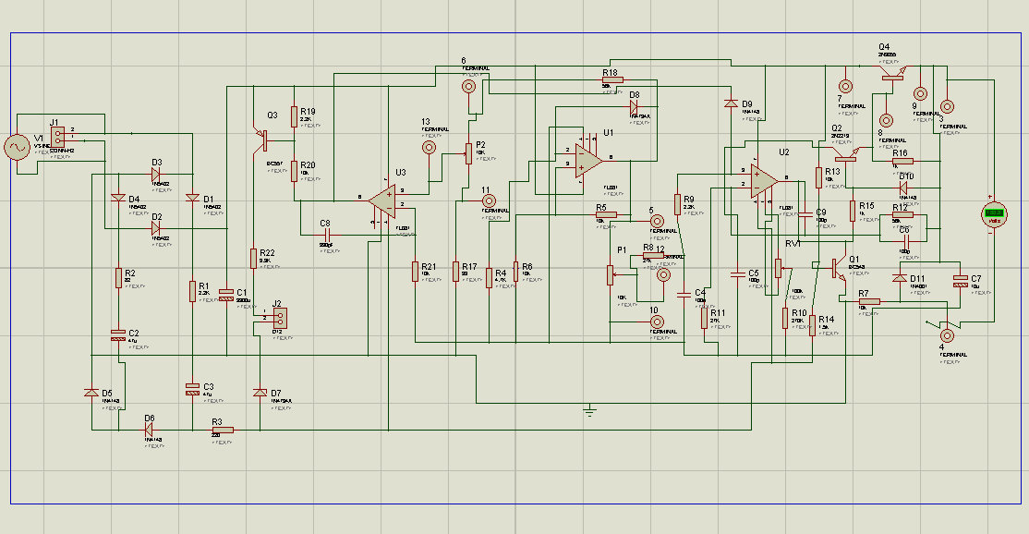
Figure-19
2.5-(PCB – Connections):
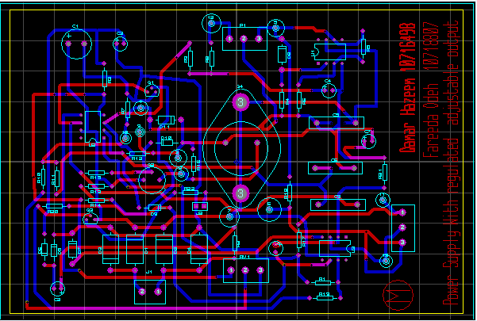
Figure-20
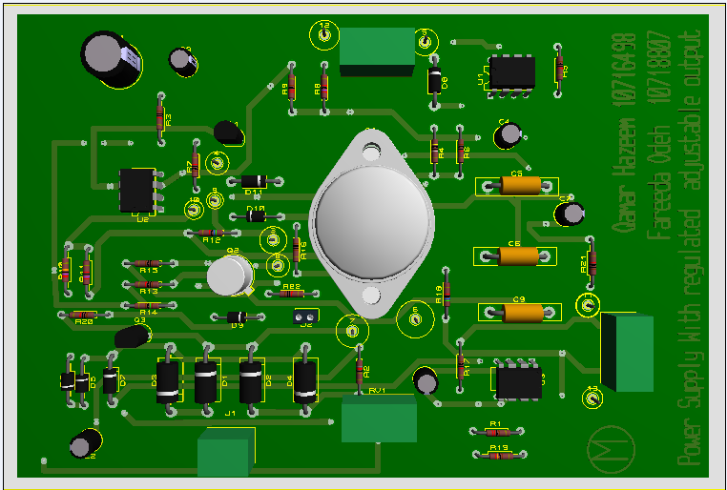
Figure-21
The following picture represent printed board circu

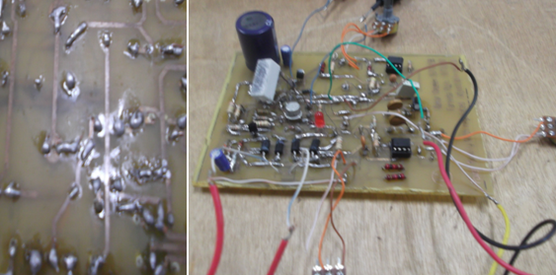

The complete package for the linear power supply show in the following picture:

3-Chapter three

3.1-Switched mode power supply
A switched-mode power supply (switching-mode power supply, SMPS, or switcher) is an electronic power supply that incorporates a switching regulator to convert electrical power efficiently. Like other power supplies, an SMPS transfers power from a source, like mains power, to a load, such as a personal computer, while converting voltage and current characteristics. An SMPS is usually employed to efficiently provide a regulated output voltage, typically at a level different from the input voltage.
Unlike a linear power supply, the pass transistor of a switching-mode supply continually switches between low-dissipation, full-on and full-off states, and spends very little time in the high dissipation transitions (which minimizes wasted energy). Ideally, a switched-mode power supply dissipates no power. Voltage regulation is achieved by varying the ratio of on-to-off time. In contrast, a linear power supply regulates the output voltage by continually dissipating power in the pass transistor. This higher power conversion efficiency is an important advantage of a switched-mode power supply. Switched-mode power supplies may also be substantially smaller and lighter than a linear supply due to the smaller transformer size and weight.
Switching regulators are used as replacements for the linear regulators when higher efficiency, smaller size or lighter weight are required. They are, however, more complicated, their switching currents can cause electrical noise problems if not carefully suppressed, and simple designs may have a poor power factor.
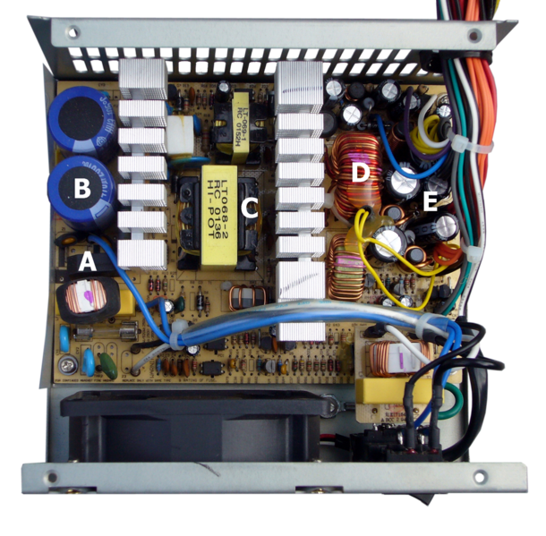
Figure -23
SMPS will divide in two part :
1-The primary side:
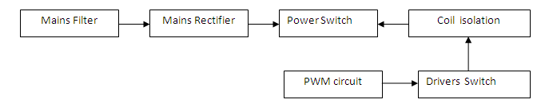
2- The secondary side:
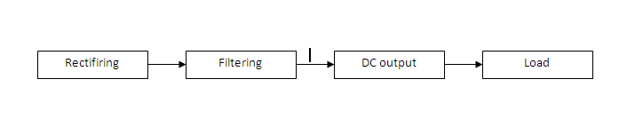

In my gradution project We built the following circuit for switch mode power supply :

Figure-24
This is a 230W switching power supply outputing two dual polarity voltage (+12) / (-12) and (+5) / (-5).
Note that all rectifiers operate into choke input filters which massively reduced rectifier surge currents are also low minimizing filter capacitor heating and allowing the use of phisically small unit.

These circuit can be divided into three stage:

Dc stage
Control circuit
High power circuit

3.2-First stage:
We built the control circuit to give us Pulse width modulation (PWM) by using IC component which is called (TL 494 IC).
**Theory:

3.2.1- Pulse width modulation (PWM) control circuit(TL494 IC):

DESCRIPTION:
The TL494 incorporates all the functions required in the construction of a pulse-width-modulation (PWM) control circuit on a single chip. Designed primarily for power-supply control, this device offers the flexibility to tailor the power-supply control circuitry to a specific application.

The TL494 contains :

1- Two error amplifiers.
2- An on-chip adjustable oscillator.
3- A dead-time control (DTC) comparator.
4-A pulse-steering control flip-flop, a 5-V
5- 5%-precision regulator.
6- Output-control circuits.

1-The error amplifiers exhibit a common-mode voltage range from –0.3 V to VCC – 2 V.
2-The dead-time control comparator has a fixed offset that provides approximately 5% dead time.
3-The on-chip oscillator can be by passed by terminating RT to the reference output and providing a sawtooth input to CT, or it can drive the common circuits in synchronous multiple-rail power supplies.

In our project:

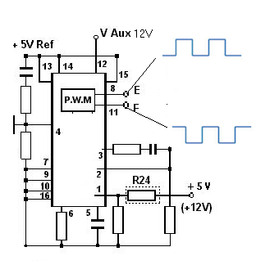

Figure-25

*The above diagram inside the regulator IC. In the top left hand corner there is an oscillator whose frequency is determined by the resistor and capacitor combination connected to pins 5 and 6.

*Pin 8 and Pin 11 will give pulses with shift reach to nanosecond which is make you in safe side that two driver transistor do not work at the same time.

*Pulling Pin 4 high put chip into sleep mode –No PWM output –over load shutdown, this happened when current over 20 amper.

3.2.2- Drivers switch & coil isolation:
driver is an electrical circuit or other electronic component used to control another circuit or other component, such as a high-power transistor. They are usually used to regulate current flowing through a circuit or is used to control the other factors such as other components, some devices in the circuit.
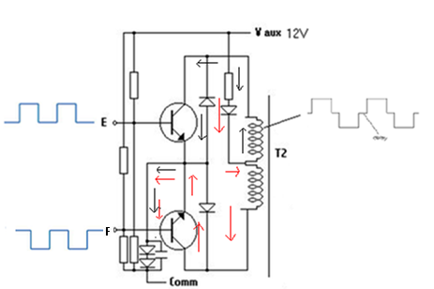
Figure-26
Now ,
*We use two diver transistor as shown in above circuit .
*The direction of current in coil will give alternating voltage .
*The transformer (T2) will make the isolation.
*E &F will take the pulses from PWM control circuit IC

In our project:

We connect the following circuit:

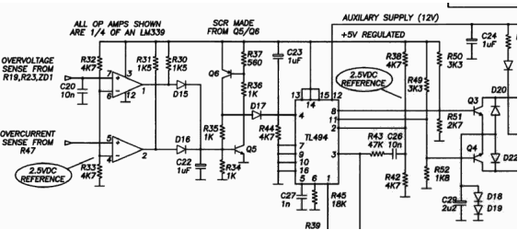

Figure-27
: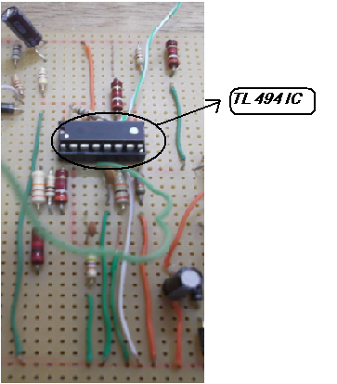
Figure-28

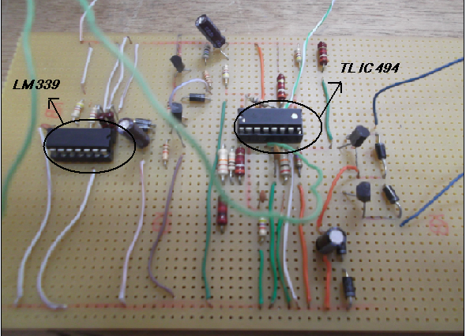

Figure-29
The result from these circuit as pulses on oscilloscope:

Note:

We manipulate on our circuit to give us correct pulses by connecting (pin 3) with (pin 4)

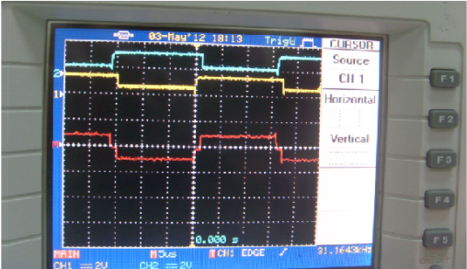
Figure-30

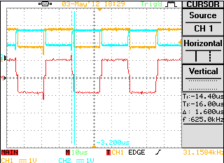
Figure-31

The complete control circuit in the following picture :

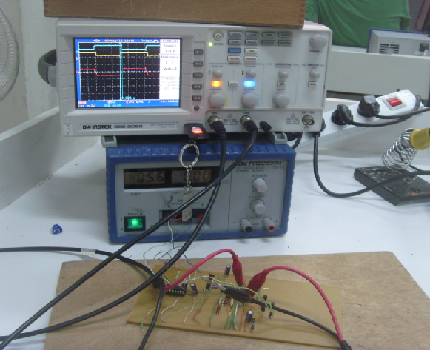
Figure-32

3.3-Second stage:
We built the high power circiut:

**Thoery:

3.3.1-AC Harmonic Filter

*A harmonic filter is used to eliminate the harmonic distortion caused by appliances.
* Harmonics are currents and voltages that are continuous multiples of the fundamental frequency of 60 Hz such as 120 Hz (2nd harmonic) and 300 Hz (5th harmonic).
*Harmonic currents provide power that cannot be used and also takes up electrical system capacity.
*Large quantities of harmonics can lead to malfunctioning of the system that results in downtime and increase in operating costs.
*The harmonic filter is built using an array of capacitors, inductors, and resistors that deflect harmonic currents to the ground.
*Each harmonic filter could contain many such elements, each of which is used to deflect harmonics of a specific frequency.
The Cause
Harmonic distortion is caused by equipment that are non-linear loads. These loads use current in a pulsing manner and at times feed harmonic currents back into the wiring. In non-linear loads, the current waveform is different from the applied voltage waveform.
The effect:
- Voltage distortions
- Excessive currents on neutral wires
- Overheating of motors
- Microprocessor control problems
Examples of non-linear, harmonic-causing loads are:
- Electronic equipment such as personal computers
- Battery chargers
- Lighting dimmer controls
- Fluorescent lights
- Welders
- Electronic ballasts
- Printers
- Photocopiers
- Fax machines
In our project:

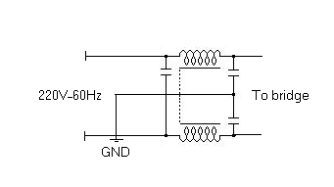
Figure-33
*Input 220V,60 Hz to the AC filter as shown in the previous diagram consist L,C.
*The reason for using this filter that our project is a SMPS for personal computers,Which is a non linear load,so we need a harmonic filter.

3.3.2-Bridge rectifier :

As we explaine in the linear DC power supply ,this bridge will convert from AC to DC, but in SMPS the bridge should have the the high limit of voltage and current than the linear which is reach to 300V ,15 A because the 220V AC from the gride will connect directly to the bridge without using step down transformer.
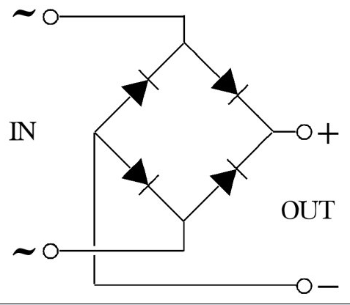
Figure-34

3.3.3-Rippel smoothing circuit:

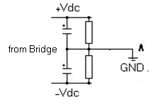
Figure-35
In our project ,we will use the capacitor with value 470 micro F/200 V as shown in the Figure,and connected in way to give( +Vdc, -Vdc) and at the middle gives common.

3.3.4-Power switch (BJT transistor):

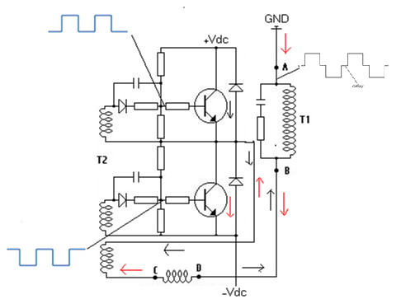
Figure-36
In the above circuit :
*The important thing that you should take into account ,two transistor must not work at the same time, if this happened it will distortion system.
*It is work as inverter, converts direct voltage ( DC) to to alternating voltage(AC).
*The direction of current in the coil will produce the alternating voltage (AC).
*The pulses at the base of two transistor will take from the Pulse width modulation (PWM) control circuit which is called TL494 IC.
*This two pulses have shift by small time to ensure that two transistor doesn’t
Work at the same time.
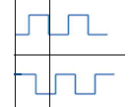
*We will take into account that we should use drive circuit to make isolation between the power switch circuit(it is high-power transistor) and the PWM control circuit to avoid make distortion in system if suddenly happened short circuit.
In our project:

We connect the following circuit:

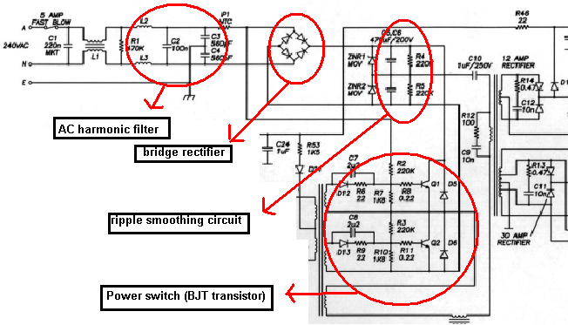
Figure-37

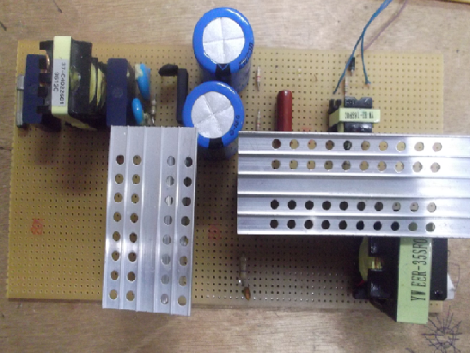
Figure-38

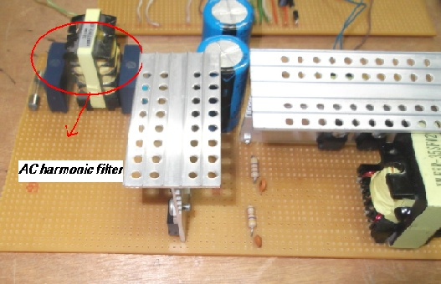

Figure-39

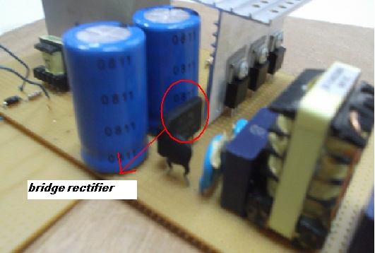

Figure -40
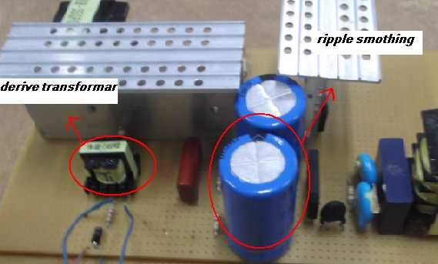
Figure-41

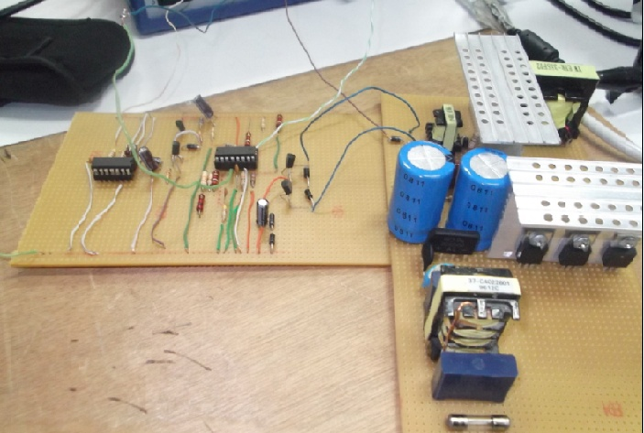

Figure-42

Note:
1-Unfortunately we could not get the correct result from this circuit(the result is pulses distorted and not accurate.),because we have a high noise on a derive transformer.
2-We have tried to replace this transformer by another type, but we did not take a good result .

3-For this reason, we can not get the four stage voltage.

Conclusion:
In our project, we choosing the new circuit diagram for the linear power supply after we miss some component in the old circuit and we don’t find it , then we studying each block in this circuit ,learn about the operational amplifier because our circuit dependent mainly in regulating for voltage and current in operational amplifier.
We learning a lot of skills through the implementation of the project such as how to troubleshooting , estimating, Sense engineering, and accuracy skills in welding .
We build the switch mode power supply which is have three stages ,
Control stage ,high power stage and finally DC stage ,we get a good result from control circuit in the form of shifted pulses.

References:

  - http://www.supertex.com/pdf/app_notes/AN-D25.pdf
  - http://en.wikipedia.org/wiki/Switched-mode_power_supply
  - http://www.smps.us/smpsdesign.html
  - http://bigbro.biophys.cornell.edu/documents/Temperature_Control/Duesing/tc2.html

