

An-Najah National University

Faculty Of Engineering And Information Technology

Computer Engineering

Athar

Student Names : Hadeel Jumaa & Zaina Abusamra

Supervisor : Dr. Manar Qamhieh

Presented in partial fulfillment of the requirements for Bachelor degree in (Computer Engineering).

”Software Graduation Project” June 2024

Acknowledgment

In the name of Allah, the Most Gracious, the Most Merciful,

We commence by expressing our gratitude to Allah for His unyielding guidance and blessings, which have been pivotal in successfully completing my graduation project. This accomplishment marks a significant milestone in my academic journey, and without His benevolence, it would not have been possible.

A special acknowledgment is owed to our dedicated supervisor, Dr. Manar Qamhieh, whose constant encouragement and unwavering support played a crucial role in shaping and ensuring the success of our project.

Our sincerely thank our friends and families for their enduring motivation, support, and understanding throughout this challenging journey. Their presence has been a source of strength and encouragement.

With heartfelt gratitude, Hadeel&Zaina

Disclaimer

The contents of this document represent the outcomes of the research and analysis conducted by Hadeel Jumaa and Zaina Abusamra. The information and opinions expressed herein are solely those of the authors and do not necessarily reflect the perspectives of the university.

While we have exerted every effort to ensure the accuracy and completeness of the information presented, we cannot guarantee the accuracy, complete- ness, or usefulness of any information within this documentation. Readers are strongly advised to exercise their own discretion and judgment when interpreting and applying the information contained in this document, and to seek professional advice when necessary.

The author disclaims responsibility and liability for any damages, losses, or liabilities arising from the use or reliance upon any information provided in this documentation.

Contents
Introduction 6
Problem 6
Objectives 7
Scope 8
Importance 8
Report Organization 8
Limitations and Earlier work 9
Limitations 9
Earlier work 10
Literature Review 11
Methodology 12
Technical choices 12
Methods and Techniques 13
Mobile pages 13
Web pages 31
Conclusion and Results 43
Future work 43

Abstract

Athar Platform is a charitable platform that aims to promote and organize charitable work through an application that facilitates the process of publishing needy humanitarian cases, assisting in collecting donations for them, and meeting their needs.

The platform aims to enhance transparency and efficiency in charitable work, in addition to expanding the donor base by facilitating the donation process and making it accessible to everyone.

This platform enables admins to publish donation cases after verifying their authenticity, in addition to organizing the donation collection process and generating reports on completed donations to increase the platform's credibility.

In conclusion, this platform aims to facilitate the donation process and reach the largest possible segment of society.

Introduction

Problem
In the past, the donation process lacked transparency, making it difficult for donors to ensure that their donations reached the intended recipients. Athar Platform provides a transparent system for collecting and distributing donations, where donors can track the progress of their donations and see the projects they support. In addition, it was difficult for donors to reach those in need and identify reliable charities. The platform "Athar" offers many services. Firstly, it allows the main admin to manage employees by adding or deleting them and assigning specific permissions. There are three types of permissions: employees responsible for approving needy cases after verifying the validity of the documents, employees accountable for adding needy cases for review and publication on the platform, and the last employee who creates reports after completing the procedures and removing the case from the platform's pages. Additionally, this platform enables users to submit requests to publish their humanitarian cases or to enter as donors to review humanitarian cases.

Objectives
Athar platform seeks to achieve many noble goals that serve charitable work and strengthen social solidarity. These main goals include the following:
  - Enhancing Transparency and Efficiency in Charitable Work:
- Transparent Donation Collection and Distribution System: Athar ensures that aid reaches its rightful recipients efficiently and effectively through its transparent donation collection and distribution system.
- Donation Impact Tracking: Donors can track the progress of their donations and see the projects they support, which enhances trust in the platform and encourages informed giving.
- Detailed Reports: The platform provides detailed reports on how donations are used, allowing donors to assess the impact of their contributions on the community.
  - Expanding the Donor Base and Supporting Community Participation:
- Diversity of Donation Fields: The platform allows donations to be made to various charitable fields, including education, health, relief, and social development, meeting the diverse needs of donors.
- Spreading the Culture of Giving: Athar contributes to spreading the culture of giving and philanthropy in Saudi society, encouraging social solidarity and supporting the needy.
  - Ensuring Information Security and Protecting Donor Privacy

Scope

The Athar platform's scope encompasses a comprehensive system for supporting charitable projects, including effectively and transparently connecting donors with charities and those in need. It also provides a secure environment for collecting donations, managing charitable projects, and ensuring that those in need benefit effectively and securely.

Importance
Emerges as a pioneering initiative in the field of supporting individuals and communities in various aspects of life.
The platform works to promote social solidarity and enhance goodness and giving among individuals. Athar Charity seeks to improve the quality of life for the needy and provide the necessary support in the health, education, and social fields. The Athar platform is distinguished by its transparency and credibility in managing resources and donations, making it a reliable choice for individuals and organizations seeking to make a positive difference in society.

Report Organization
This report is systematically published to comprehensively highlight the development, implementation, and impact of Athar. In the introductory chapter, we present the context and rationale behind Athar, detailing the problem statement, objectives, scope, significance, and organizational details of this report. The following chapter explores the constraints encountered during development, emphasizing the challenges and limitations that influenced design decisions. The literature review section delves into current research relevant to charitable platforms for fundraising and humanitarian case dissemination, outlining ideas that informed Athar's development. Subsequently, the methodology chapter provides a detailed description of the approach taken, covering the technologies used, design considerations, and comprehensive development methodology. The results and discussion section presents Athar's outcomes, including user feedback, system performance, and discussions on notable impacts. Finally, the conclusion chapter summarizes the key findings, draws conclusions based on the results, and explores potential future improvements for Athar. This organized approach offers readers a cohesive journey through the creation, implementation, and outcomes of this innovative application supporting charitable projects.

Limitations and Earlier work

Limitations
While Athar represents a pioneering effort in the realm of charitable initiatives, it is essential to acknowledge certain limitations and build upon prior work. One significant challenge lies in ensuring sustained and widespread community engagement, as the success of the platform hinges on active participation from both donors and beneficiaries. Additionally, the reliance on reliable funding sources for optimal functionality may pose barriers in regions with limited financial resources. The platform's effectiveness also depends on the transparency and accountability of the organizations and individuals involved, which can vary.
In terms of earlier efforts, existing charitable platforms have paved the way for community-centered approaches, yet Athar distinguishes itself by prioritizing ethical standards and impact transparency. Drawing inspiration from prior initiatives, the development team meticulously addressed donor trust, beneficiary empowerment, and streamlined donation processes to enhance the overall user experience.
As Athar builds upon earlier innovations, ongoing research and stakeholder feedback will be crucial in refining the platform and overcoming these identified challenges. Throughout the development of Athar, we encountered notable limitations that provided valuable insights into the complexities of crafting a robust charitable platform. One significant challenge we faced was our initial ambition to integrate a comprehensive monitoring system, utilizing advanced technology to enhance the platform's ability to offer real-time impact assessments and donor feedback. Unfortunately, this vision encountered a substantial roadblock—the unavailability of sufficient infrastructure and expert resources. Despite concerted efforts to secure the necessary expertise, implementing a fully integrated monitoring system proved to be a formidable task. The intricate nature of impact assessment demands nuanced understanding and technological support, which requires ongoing development and collaboration with experts in the field. Consequently, the integration of the monitoring system had to be adjusted and phased in gradually.
While this limitation underscored the challenges inherent in realizing our initial vision, it also highlighted the importance of collaborative partnerships and expert involvement in the development of effective charitable initiatives. Through continuous improvement and strategic partnerships, Athar remains committed to advancing its mission of promoting sustainable development and positive social change within communities in Palestine.

Earlier work
Athar embodies the culmination of lessons learned from previous endeavors that have significantly shaped the landscape of supporting individuals and communities across diverse facets of life. Inspired by projects such as the "Humanitarian Good Initiative" and "Technological Innovations in Social Aid," our commitment to a beneficiary-centric approach and continuous improvement has been reinforced.For instance, the "Humanitarian Good Initiative" highlighted the importance of transparency and accountability in resource management, influencing our approach to enhancing delivery and distribution processes. Meanwhile, "Technological Innovations in Social Aid" contributed valuable insights, guiding the development of services and programs that foster community engagement and well-being. These pioneering projects have paved the way for innovative solutions and best practices, impacting our approach to crafting a platform that not only addresses traditional challenges in the social aid domain but also strives to set new standards in this field.Building upon the successes and experiences gained from previous undertakings, Athar Charity aspires to be at the forefront of technological advancements in support of Athar and humanitarian work.

Literature Review

In examining existing literature on mental health applications with features similar to Athar, several noteworthy platforms have contributed significantly to the landscape of psychological well-being support. These platforms serve as valuable references in understanding user expectations and refining the design and functionality of Athar:

- Ehsan: A pioneering charitable platform that provides comprehensive mental health support through various accessible channels, emphasizing community engagement and user-centric care [1].

- Jood: Another prominent charitable organization offering mental health support and community services, focusing on holistic well-being and support systems [2].

- International Humanitarian Aid Organization: Known for its global humanitarian efforts including mental health initiatives, promoting sustainable solutions, and community resilience [3].

- Ufandao: An innovative platform facilitating charity and donations with a focus on community welfare and mental health support across diverse regions [4].

Synthesizing insights from these diverse platforms, Athar aims to build upon successful models while introducing innovative features that address specific limitations and challenges in the realm of mental health support. The lessons learned from these platforms contribute to the ongoing evolution of Athar, ensuring its leadership in user-centered, technology-driven mental health applications.

Methodology

Technical choices

    - Flutter: In the development of Athar, the decision to employ Flutter as the cross-platform framework was driven by its versatility and efficiency. Flutter’s single-codebase approach allowed for simultaneous development on both iOS and Android platforms, ensuring a consistent user experience. The rich set of pre-designed widgets and the hot reload feature facilitated rapid prototyping and iteration, streamlining the development process. Flutter’s expressive UI capabilities contributed to the creation of an engaging and visually appealing user interface, aligning with our goal of providing a seamless and intuitive user experience

    - Node.js: Node.js emerged as the backend runtime environment for Athar, offering a non-blocking, event-driven architecture that proved instrumental in handling concurrent connections efficiently. Its scalability and ease of integration with other technologies made it well-suited for building a robust backend infrastructure. Leveraging the Node.js ecosystem, we implemented RESTful APIs to facilitate seamless communication between the frontend and backend components. The asynchronous nature of Node.js ensured optimal performance, enhancing the responsiveness of the application and contributing to a smooth user experience.

    - Firebase: Firebase was pivotal in enhancing Athar's real-time capabilities and user engagement features. By leveraging Firebase's suite of tools such as Firebase Authentication, Firestore for scalable NoSQL cloud database, Cloud Functions for serverless backend logic, and Cloud Messaging for push notifications, we enriched Athar with seamless user authentication, dynamic data syncing, and responsive communication channels. Firebase's robust analytics and crash reporting further empowered us to monitor app performance and optimize user experiences effectively. Integrating Firebase into our Flutter-based application accelerated development timelines while ensuring scalability and reliability in delivering a cohesive cross-platform solution for iOS and Android users.

- GitHub:GitHub served as the cornerstone of our version control and collaborative development efforts throughout the Athar project. Its distributed version control system allowed for seamless collabo- ration among team members, enabling parallel development on different features. The branching and merging capabilities of Git, coupled with GitHub’s user-friendly interface, facilitated efficient code management and streamlined collaboration. Continuous integration workflows, code reviews, and issue tracking were seamlessly integrated into our development pipeline through GitHub, ensuring code quality and project transparency.

- Postman: Postman played a critical role in the development and testing phases of Athar. Utilizing Postman's intuitive interface and comprehensive API testing capabilities, we ensured seamless communication between Athar's frontend and backend components. Postman's collection runner facilitated automated testing of RESTful APIs implemented with Node.js, validating endpoints and data integrity across various scenarios. Its ability to mock APIs during development expedited frontend progress, enabling parallel workstreams and ensuring API reliability. Postman's collaboration features enhanced team efficiency, allowing for centralized API documentation and shared testing workflows. By integrating Postman into our development process, we optimized API performance, minimized deployment risks, and maintained robust backend functionality essential for Athar's success.

Methods and Techniques

Mobile pages

      - Home page: The homepage displays general information and excerpts about the platform, showcasing donation areas and opportunities. Additionally, it presents overall statistics on donations. At the bottom of the page, a navbar allows us to navigate to other pages within the application.

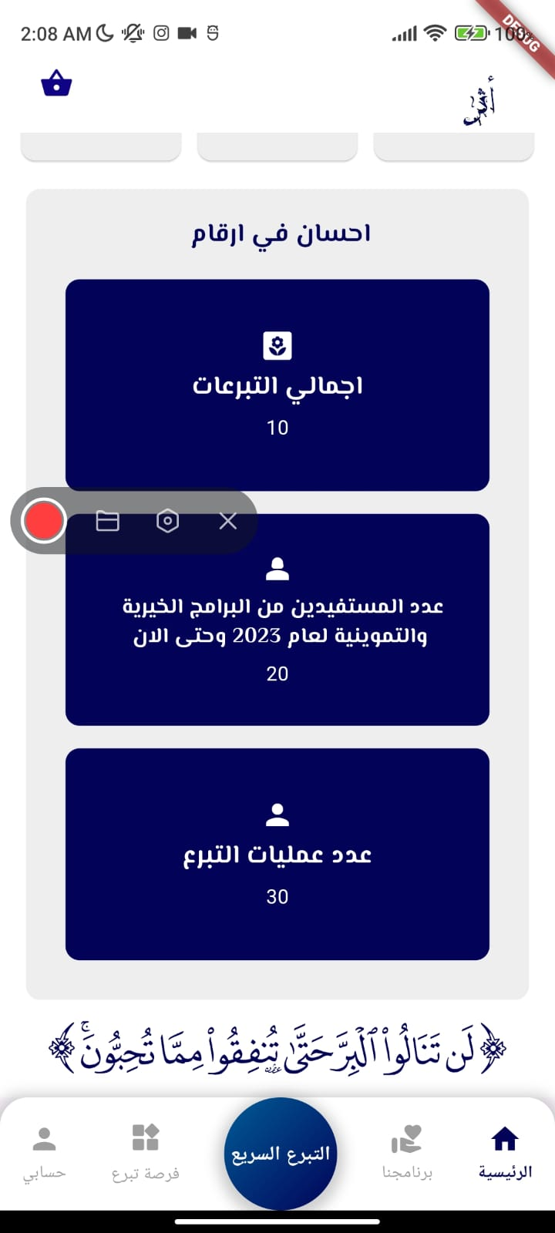
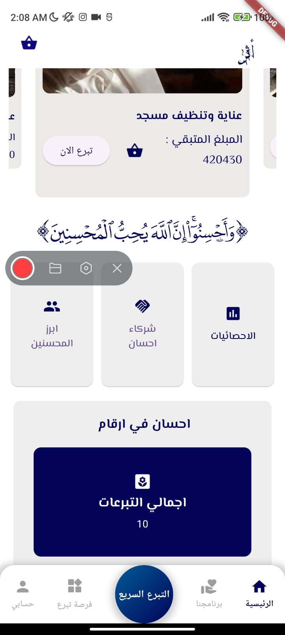
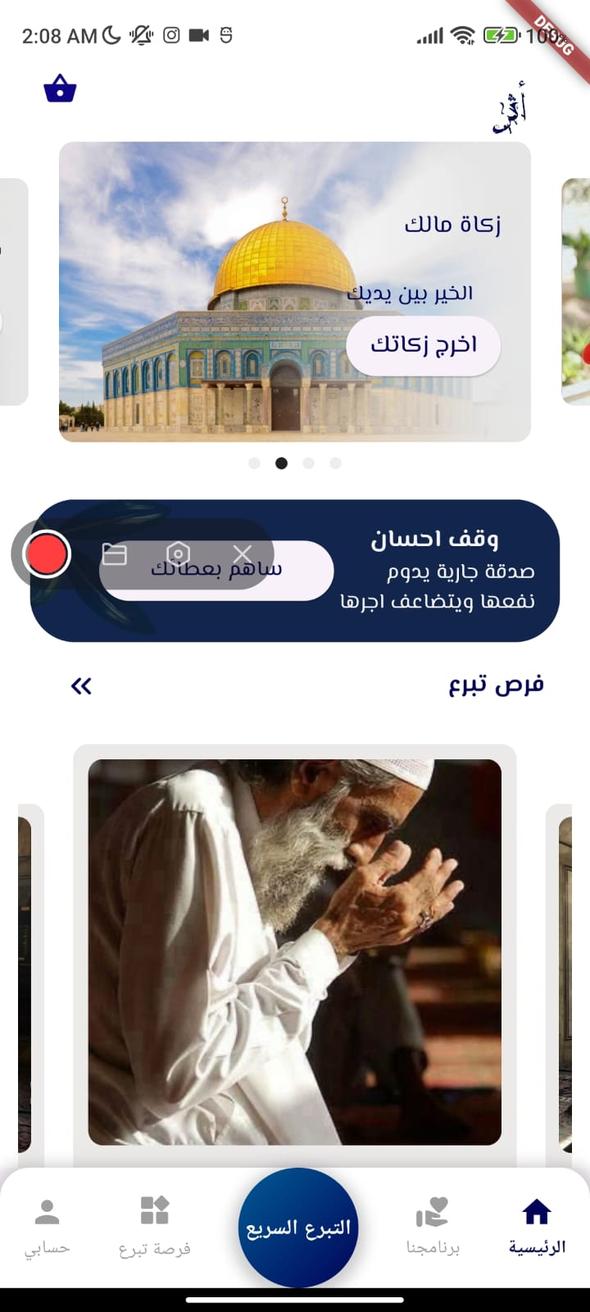

Figure1:Home Page for mobile application

      - Donation Opportunities Page: This page displays projects and cases that have been approved by supervisors responsible for adding projects. It includes several sections such as:

      - General Projects Section: Shows various types of projects.
      - University Installments Section: Displays cases of needy students.
      - Courts Section: Includes legal assistance cases.
      - Bills Section: Supports individuals needing help with bill payments.
      - The content on this page is managed by the employee responsible for adding and approving projects based on documentation.

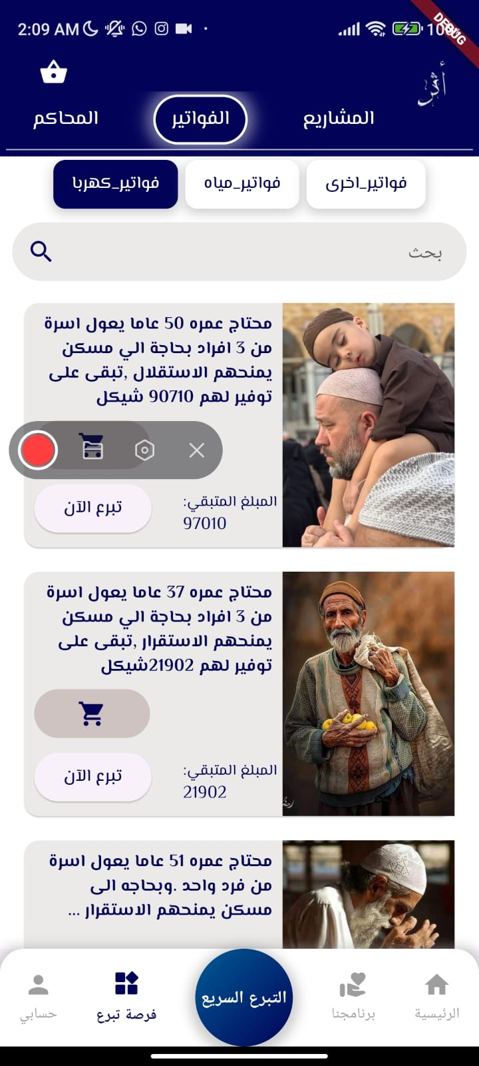

Figer2: Donation Opportunities Page

      - Sign-in Page: This page allows users to log into the platform as a donor, beneficiary, or administrator. Through this page, you will be able to access the platform if you already have an account. After verifying your username and email, you will be able to review your profile on the application.

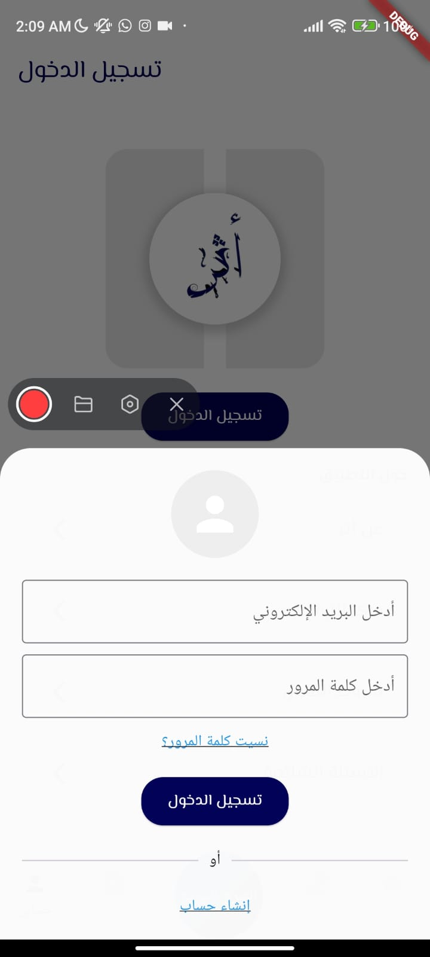
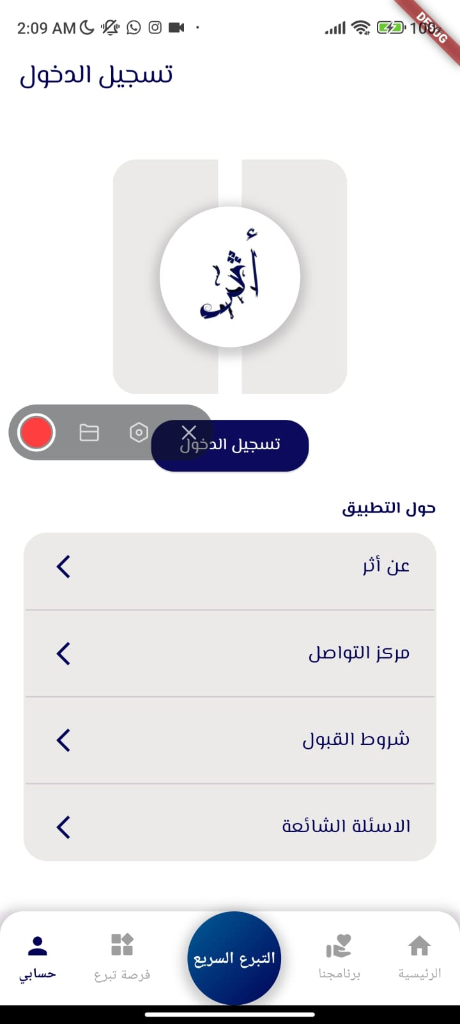

Figure3:Sign in Pages

If you do not already have an account, you can create a new one using this page. It allows you to create an account as a donor or a beneficiary. As a donor, you can create your account by entering your name, email, password, age, phone number, and selecting the donor option. Once entered, your account will be created.
If you choose to register as a beneficiary, additional information about your situation will be requested, along with documents proving your need. After submitting the account creation request, it will be reviewed by the admin for the accuracy of the information provided. The account creation will then be either accepted or declined based on the verification of the information.

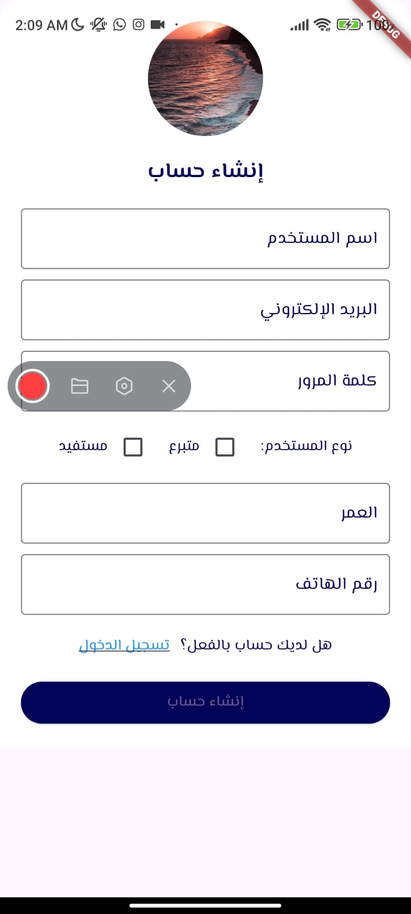
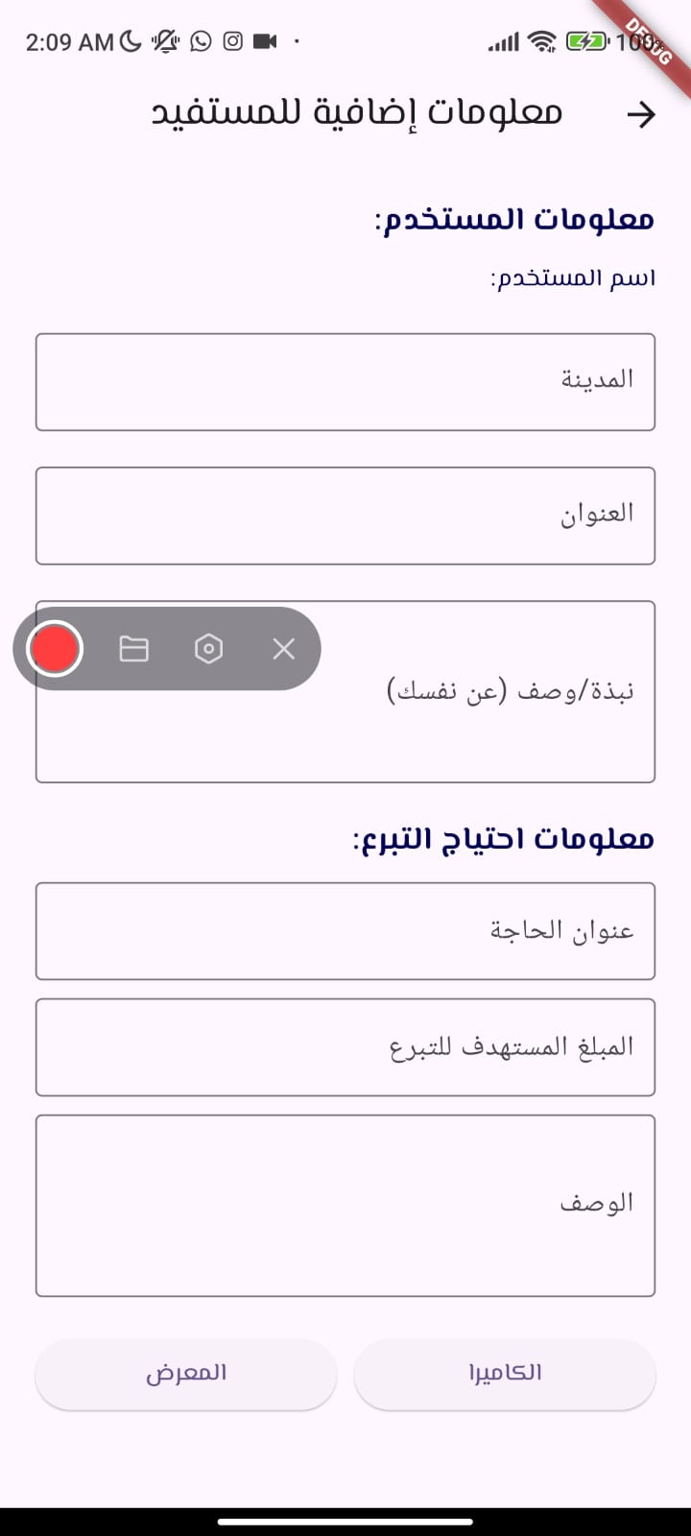

Figure4: Create Account Page

      - Main Admin Page: This page displays information about the main admin, allowing them to change and update this information. The page grants the main admin permissions to review employees, add new employees, assign specific permissions, delete employees, and revoke their permissions as needed.

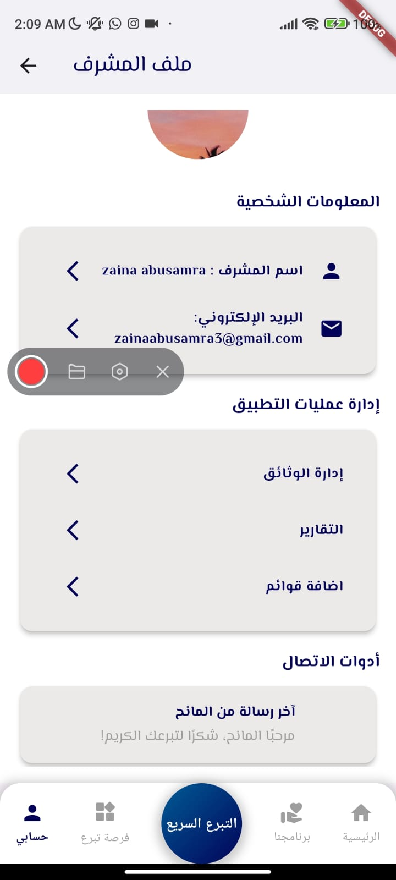

Figure5: Main Admin Page

When clicking on "Document Management," employees responsible for document management will be displayed. Clicking on "Reports" will show employees responsible for creating reports. Clicking on "Add Lists" will display employees responsible for adding lists to the Donation Opportunities page. From these pages, new employees can be added or previous employees can be removed.

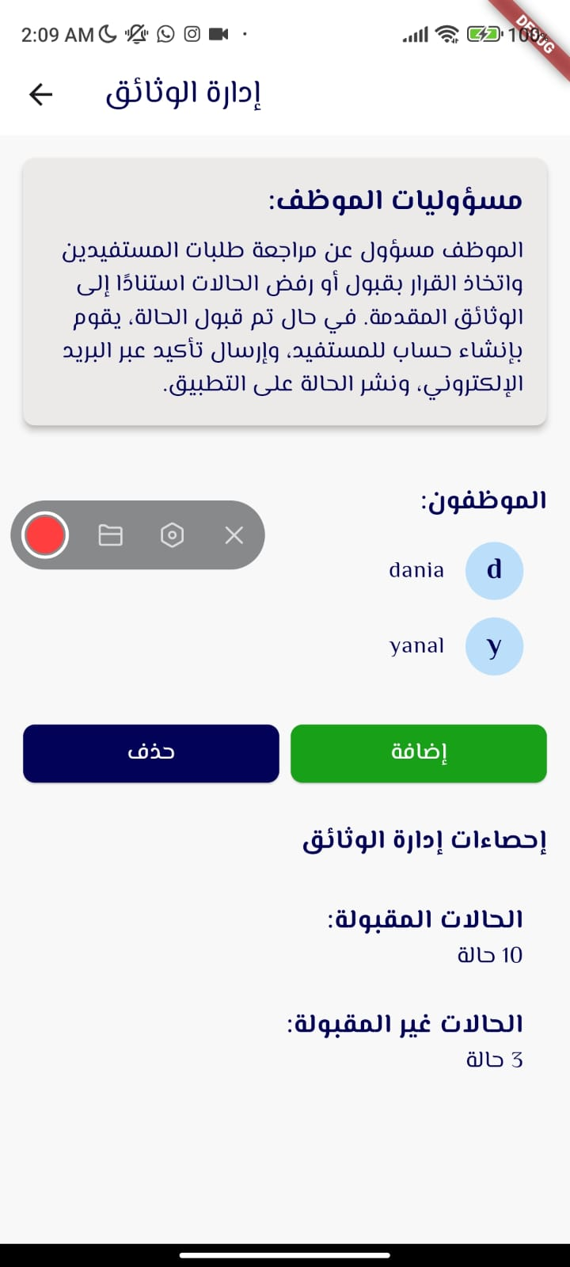

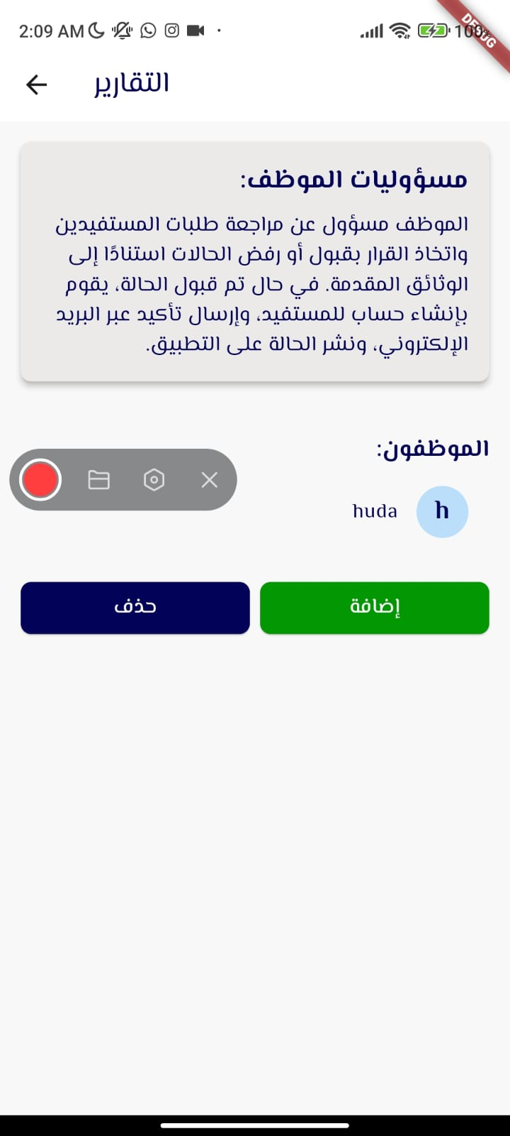
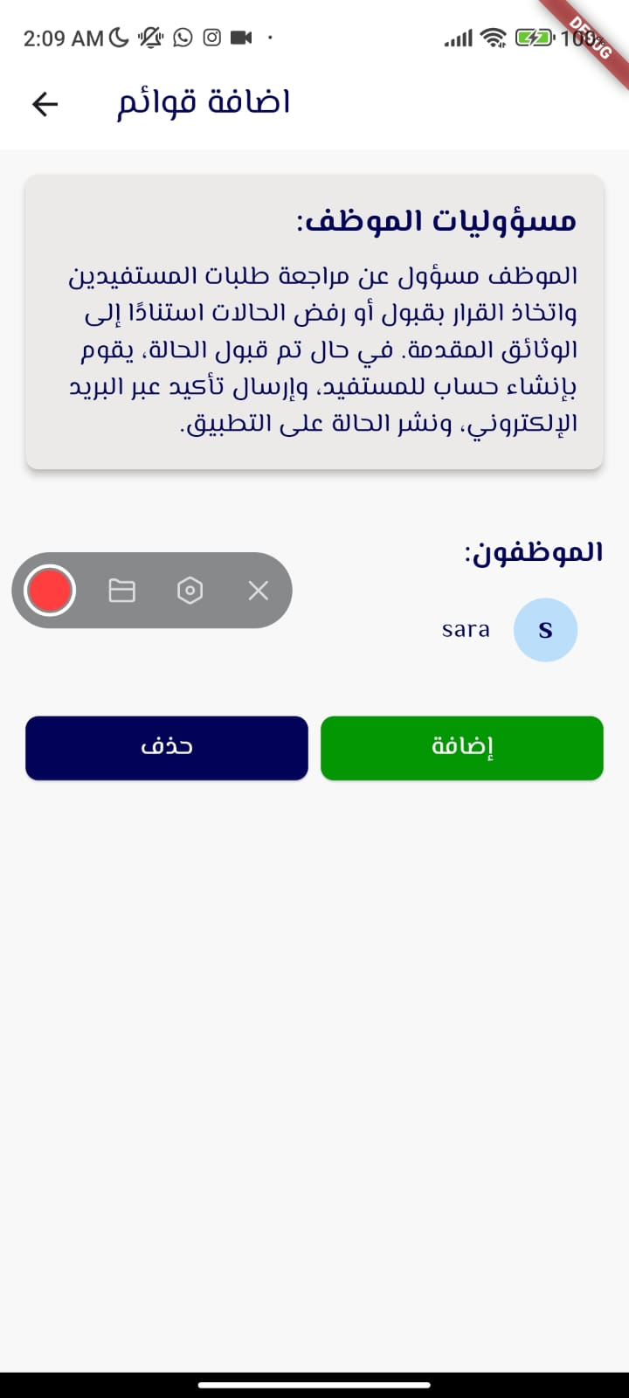

Figure6: Employee Review Pages

      - Add New Employee Page: This page enables the admin to create an account for a new employee and define the permissions they can exercise. The admin can choose from three permissions: creating reports, adding lists, and managing documents.

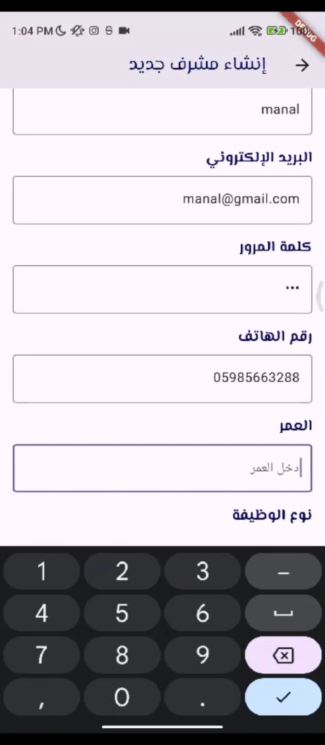
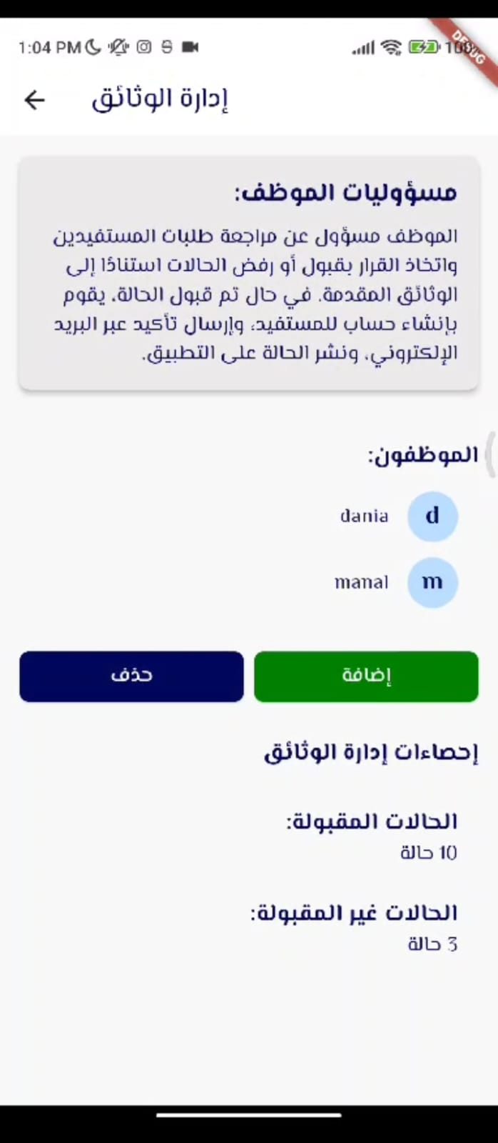

Figure7: Add New Employee Pages

      - Document Management Employee Page: This page displays requests submitted by beneficiaries. Requests are categorized into three sections: pending requests awaiting review, approved requests, and rejected requests.

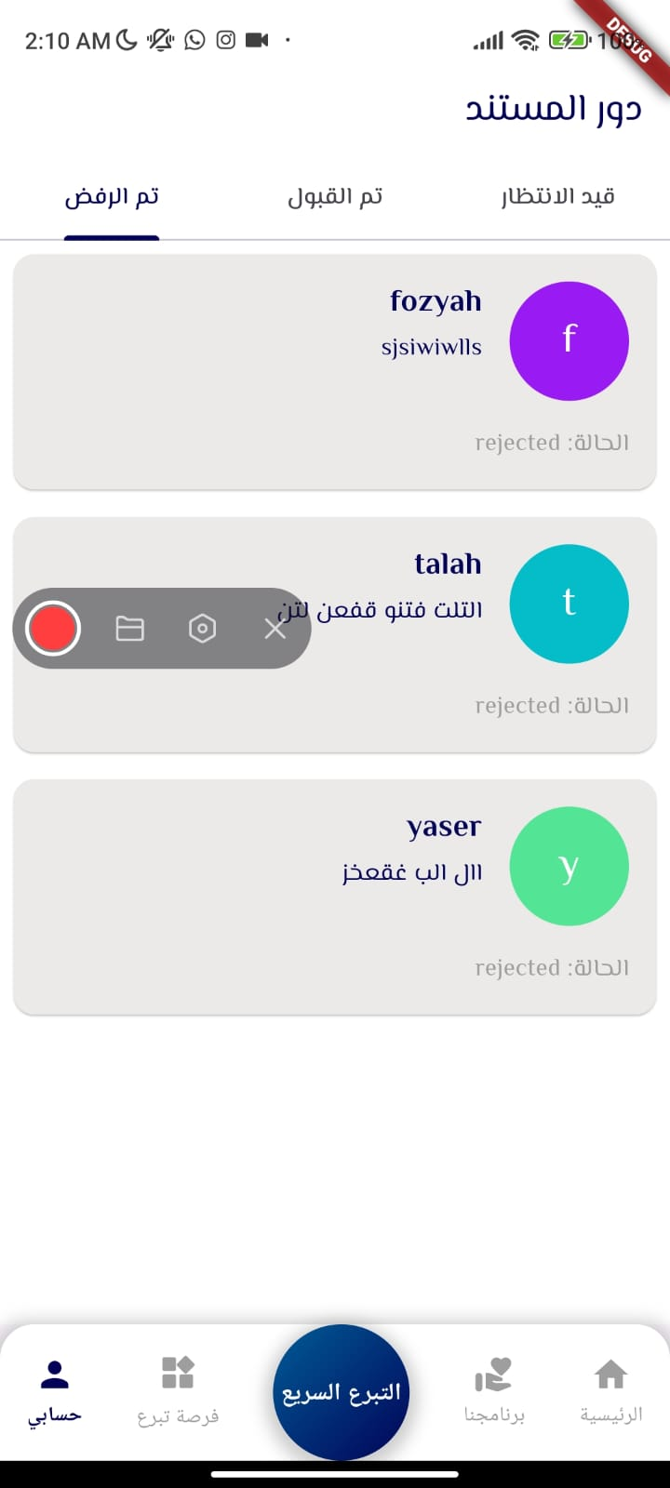
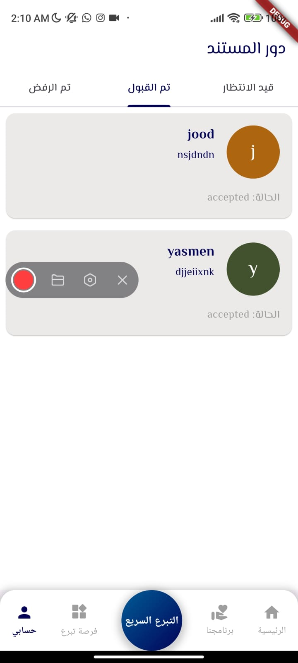
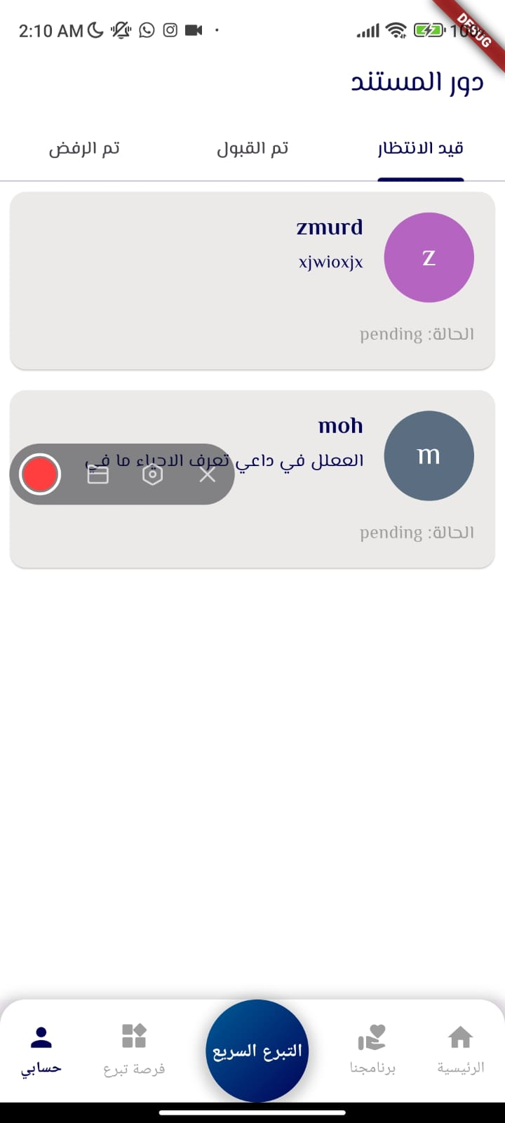

Figure8: Document Management Employee Page

      - Request Details Page: This page is shown to the employee responsible for reviewing cases. It displays the details of the request submitted by the beneficiary, including the documents provided. The employee can either accept or reject the request. Additionally, the employee can send a message to the beneficiary requesting additional documents or confirming acceptance of the request.

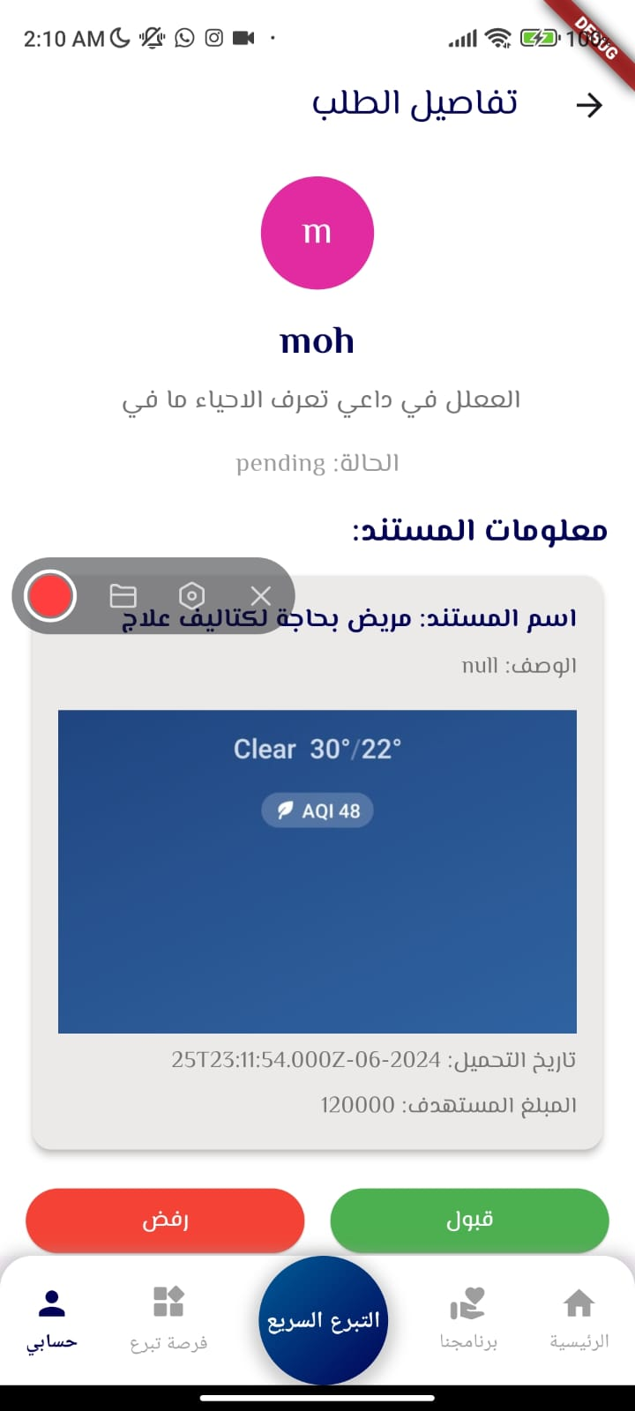
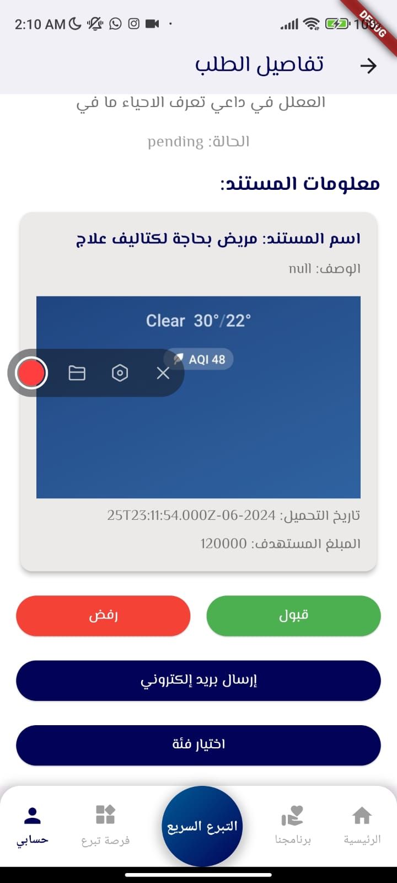
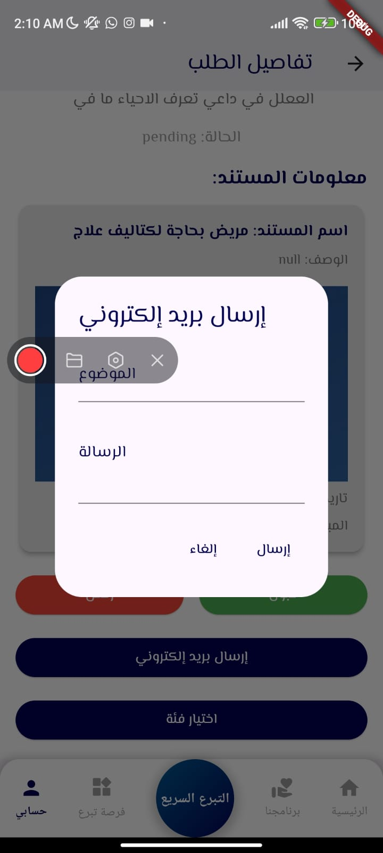

Figure9: Request Details Page

When clicking on the category selection to publish the case, the pages responsible for describing the case will appear. This allows for modifying certain details and adding additional photos. Upon confirming the request acceptance, it will be published on the public projects page.
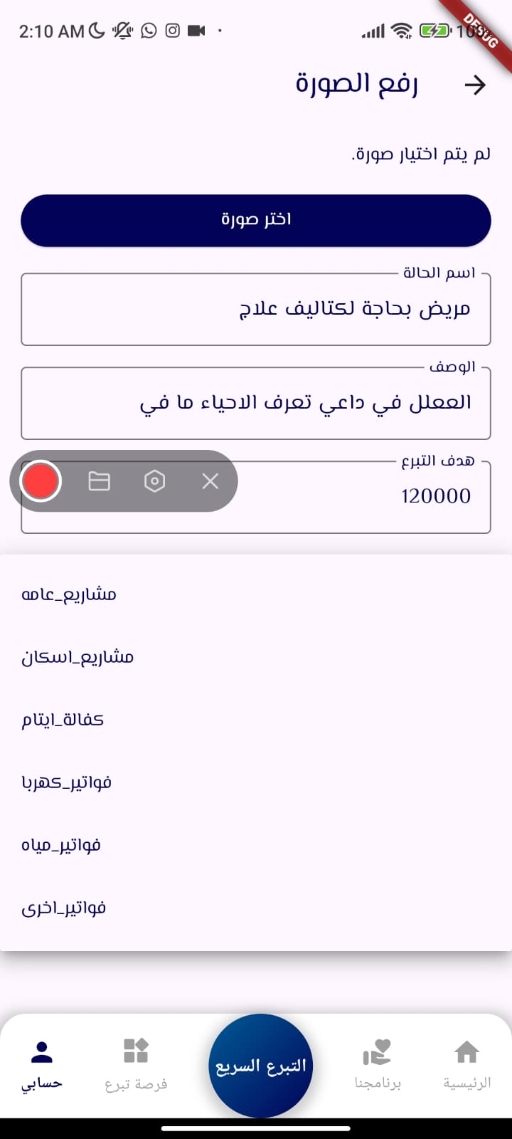
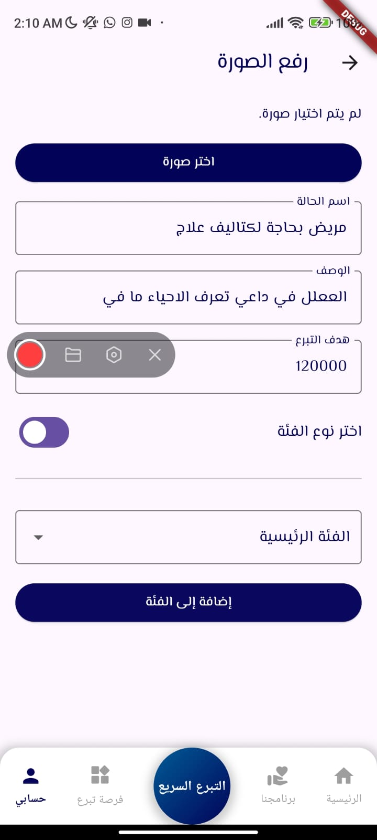

Figure10: Request Details Page (confirm the order)

      - Page of Employee Responsible for Adding Lists: Through this page, the employee responsible for adding lists will be able to organize and add new lists to the Donation Opportunities page.
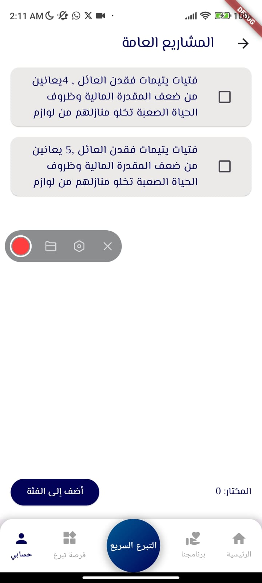
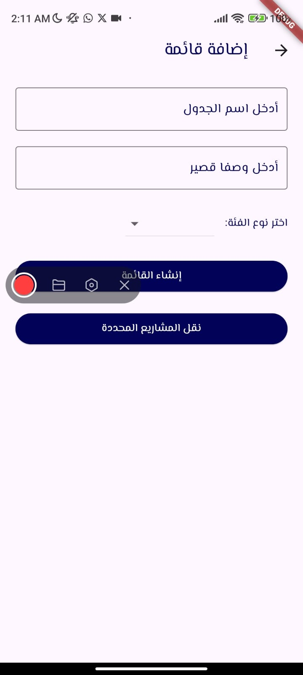
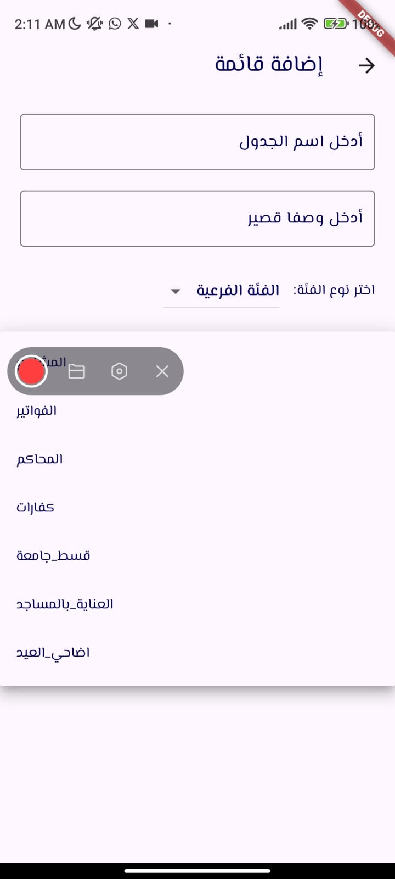

Figure11: Pages of Employee Responsible for Adding Lists

      - Reports Creation Administrator Page: Through this page, projects that have received donations will be displayed. It presents three sections:
- Projects not yet verified, where beneficiaries have not yet submitted documents.
- Pending projects awaiting report creation.
- Completed projects with available reports.
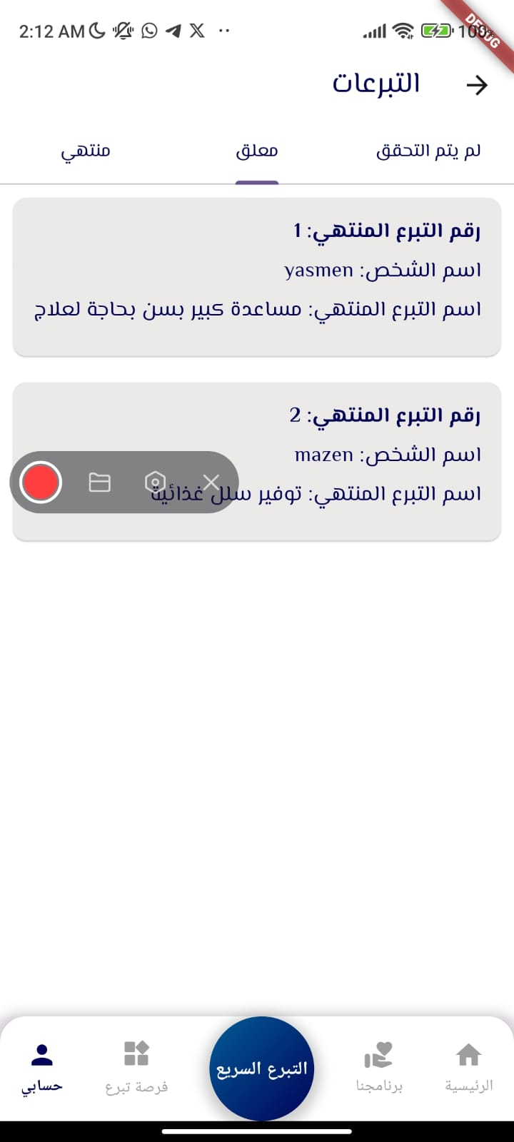
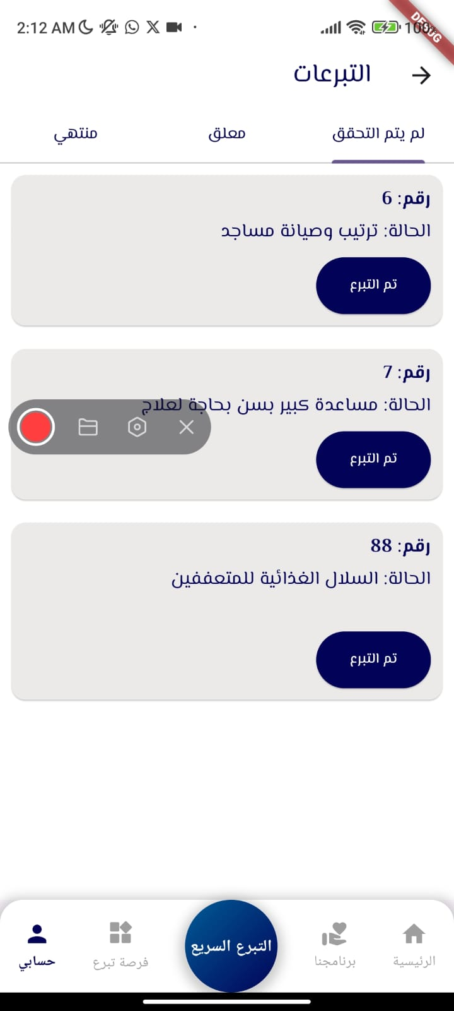
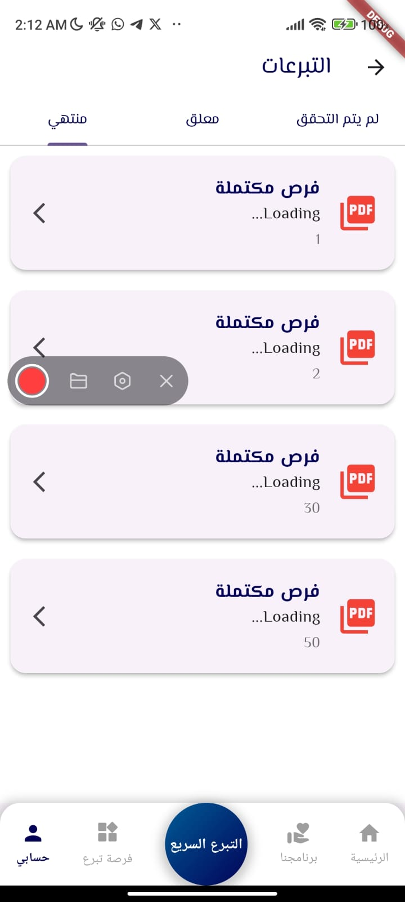

Figure12: Reports Creation Administrator Pages

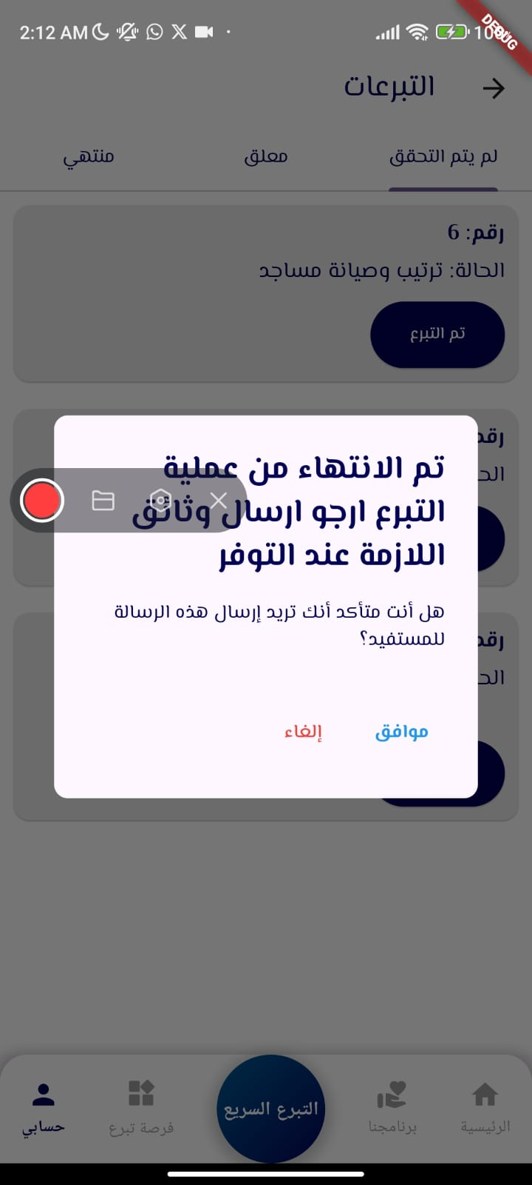
By clicking on Donated to Projects Not Verified Yet, we can send a request to the beneficiary to attach documents proving their benefit from the donation, so that a report can be created for this case.

Figure12: Send a message to the beneficiary page

      - Report Creation Page: Through this page, information about the case that received the donation will be reviewed, along with documents submitted by the beneficiary. Upon clicking "Create Report," a report will be generated for this case.
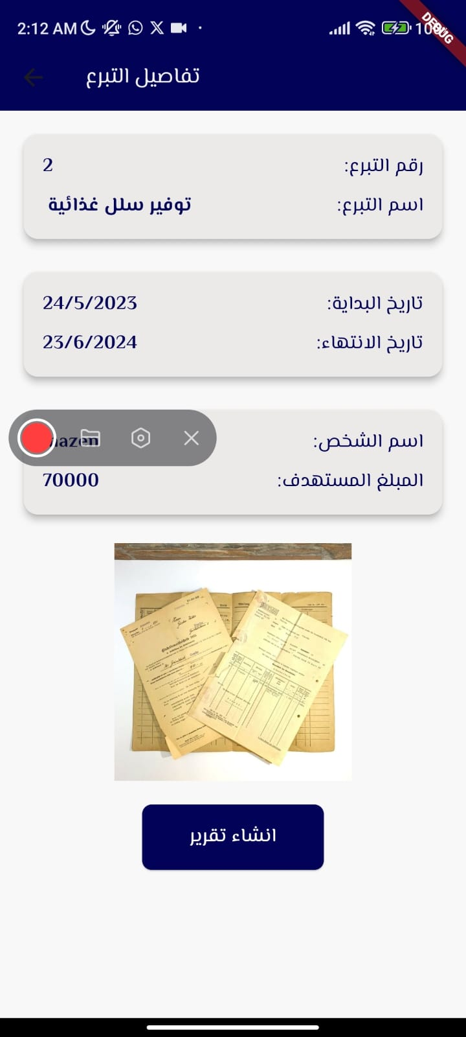

Figure13: Report Creation Page

      - Report Display Page: After creating the report, it will be added to the list under the "Completed" section. Clicking on the report will display its content describing the case.

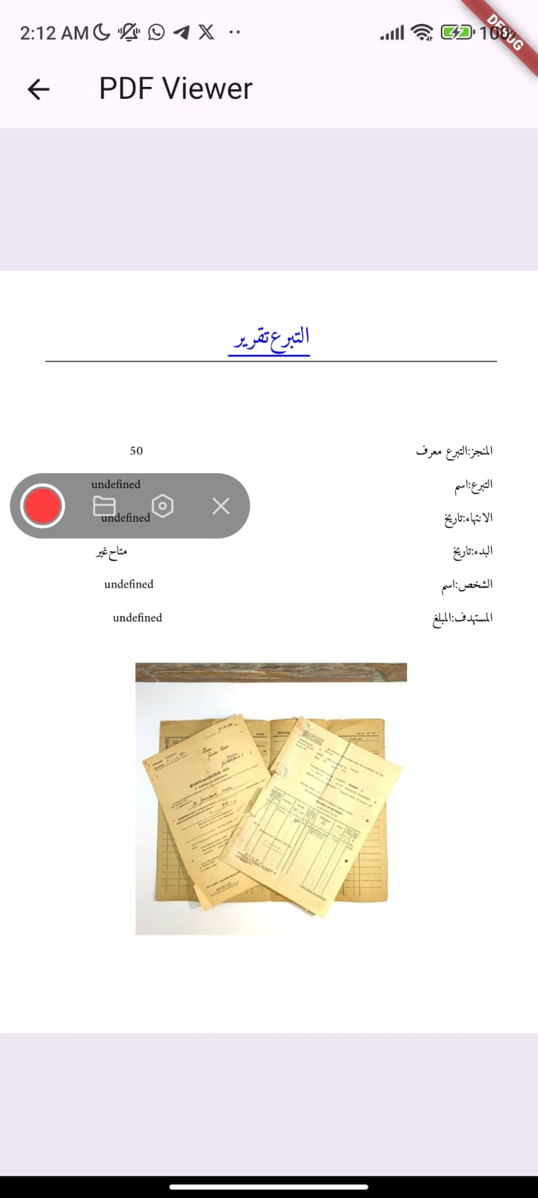

Figure14: Report Display Pages

      - Beneficiary Profile Page: There are two statuses for the beneficiary:

- If the donation has been received and the full amount has been collected, a button to download documents will appear upon request by the employee responsible for creating reports.
- If the full amount has not been collected, information about the status will be displayed along with the amount that has been collected.
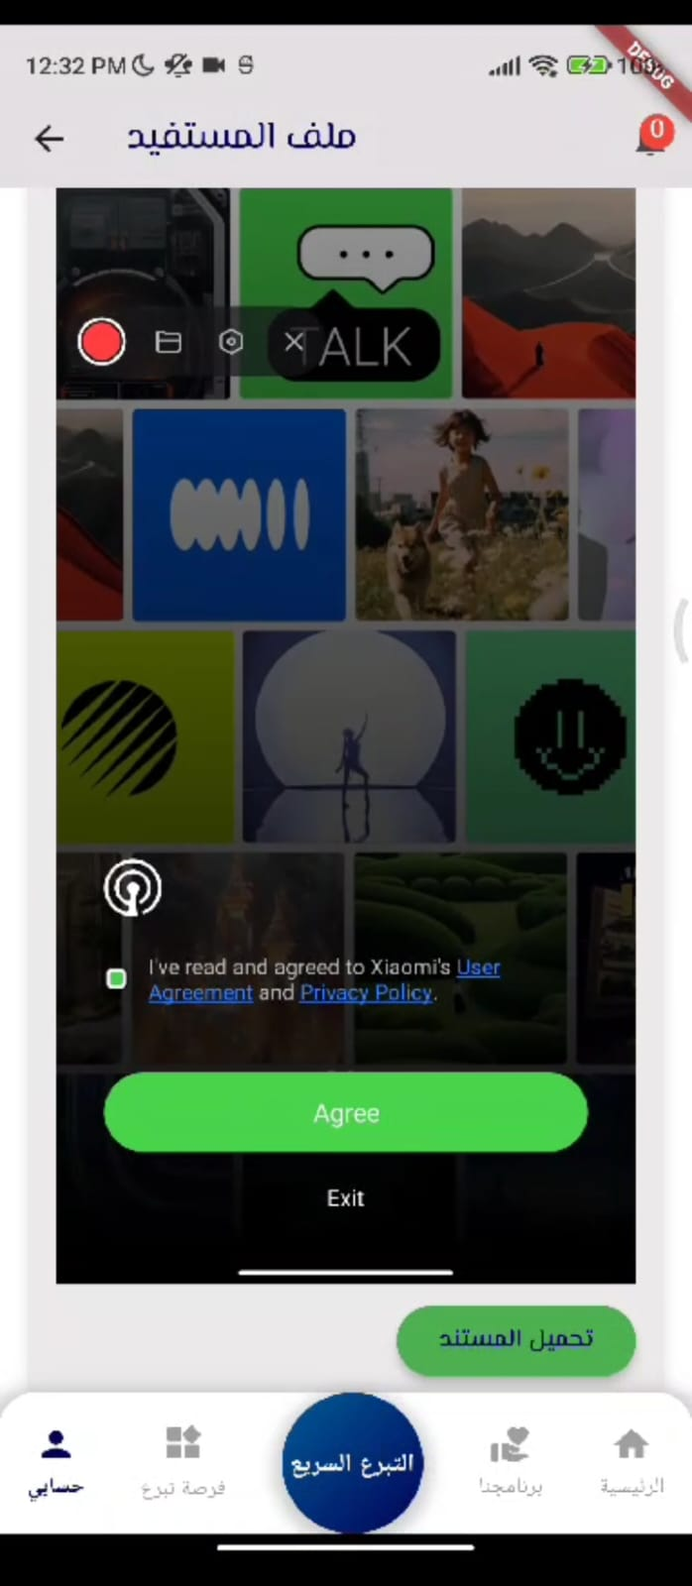
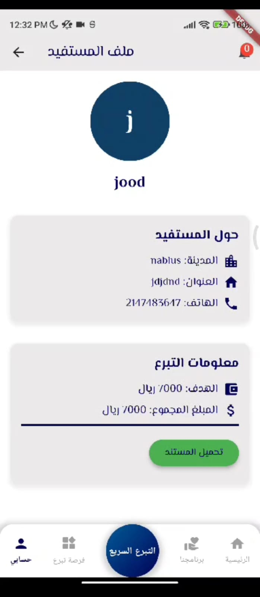

Figure15: Beneficiary Profile Page (DONE)

And Figure 16 shows the profile of a beneficiary where the required amount has not yet been fully collected.

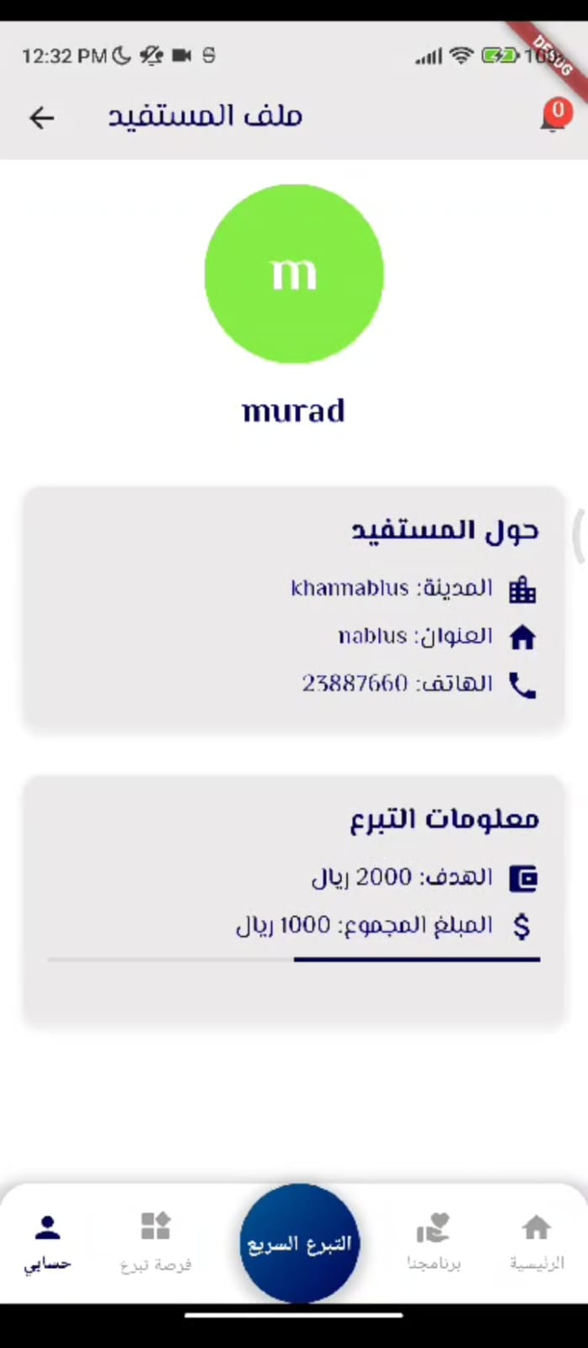

Figure16: Beneficiary Profile Page

      - Donor Page: This page displays the donor's personal information along with the projects they have donated to and the amount contributed. Donors can also review cases based on the donation year or month.

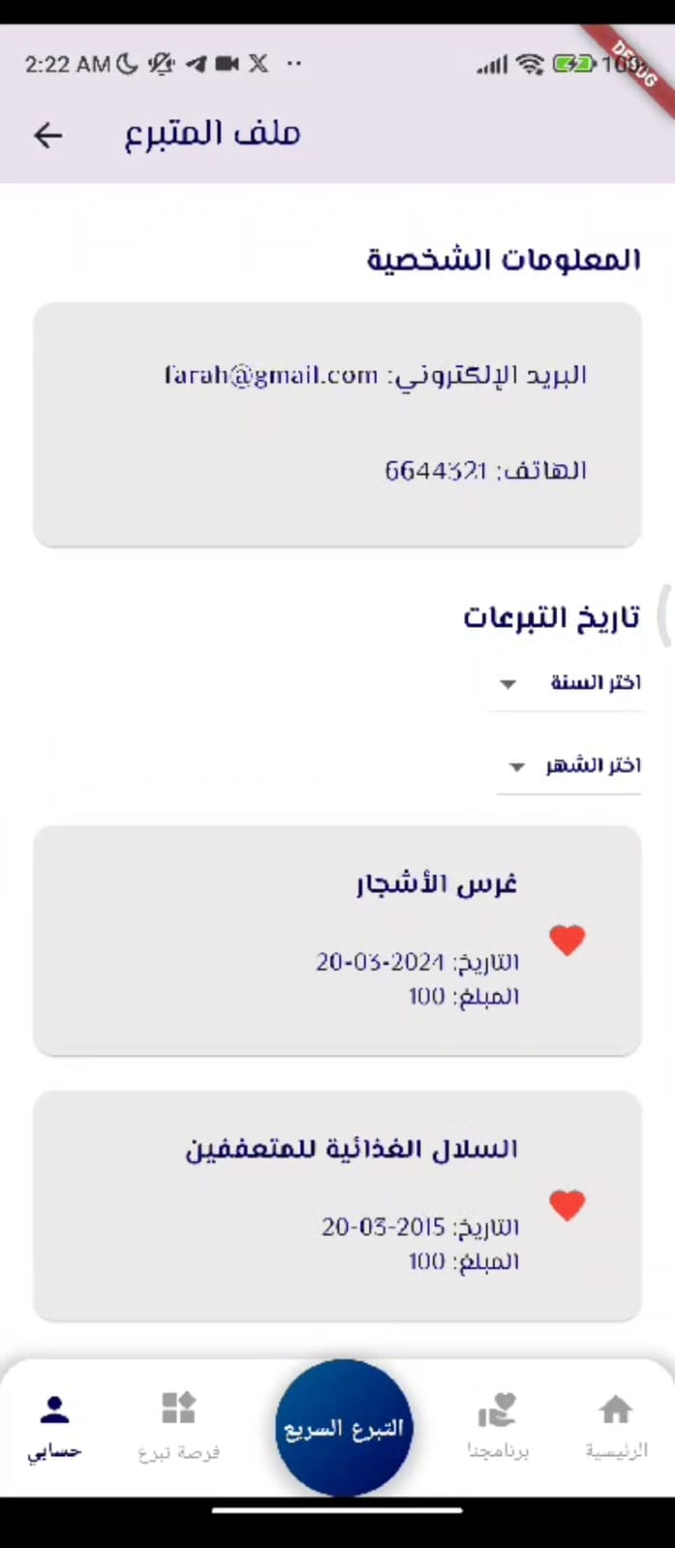

Figure17: Donor profile Page

Web pages

      - Home page: The homepage displays general information and excerpts about the platform, showcasing donation areas and opportunities. Additionally, it presents overall statistics on donations. At the bottom of the page, a navbar allows us to navigate to other pages within the application.
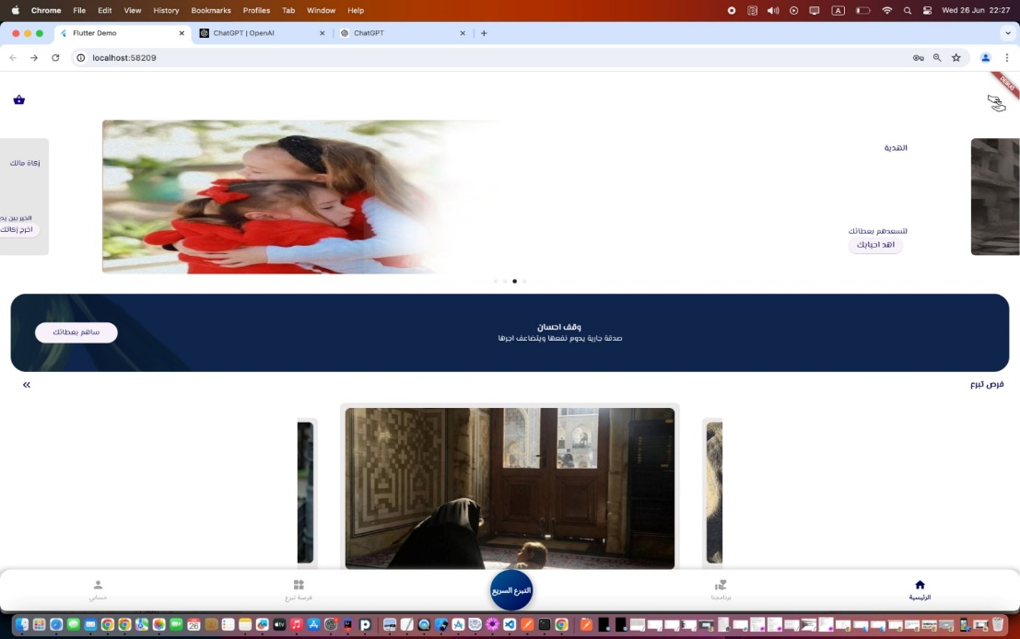

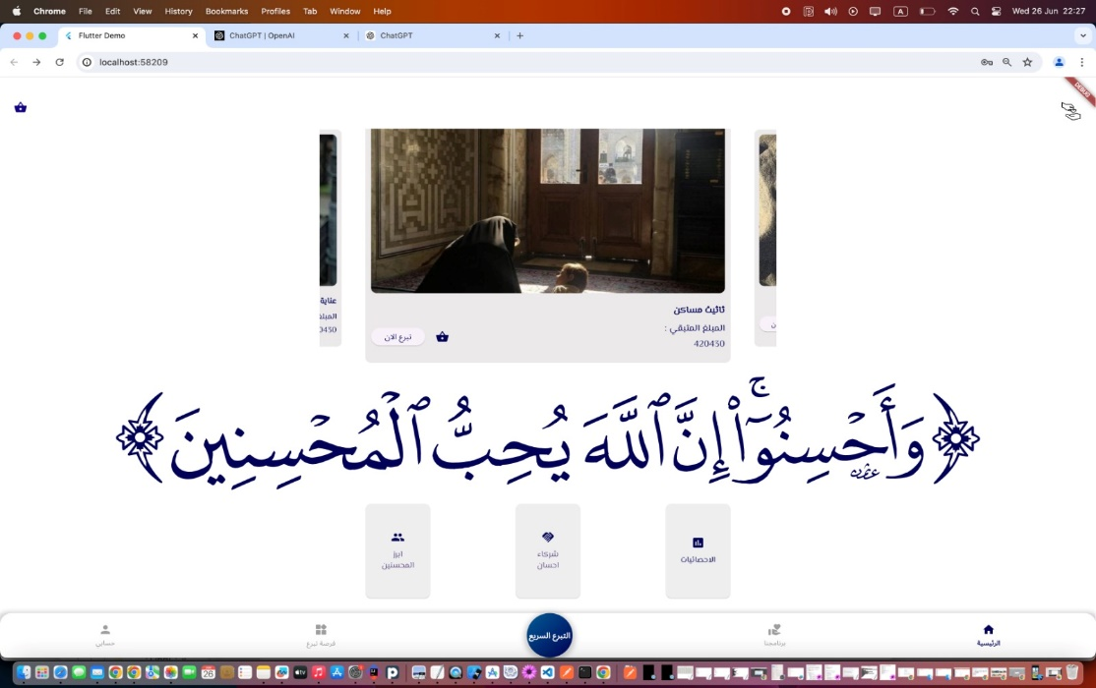

Figure 18: Home Page for Web

      - Donation Opportunities Page: This page exhibits projects and cases that have been sanctioned by supervisors responsible for adding projects. It comprises several sections including:
- General Projects Section: Displays various types of projects.
- University Installments Section: Exhibits cases of students in need.
- Courts Section: Includes cases requiring legal assistance.
- Bills Section: Provides support for individuals needing help with bill payments.
The content on this page is overseen by the employee responsible for adding and authorizing projects based on documentation.
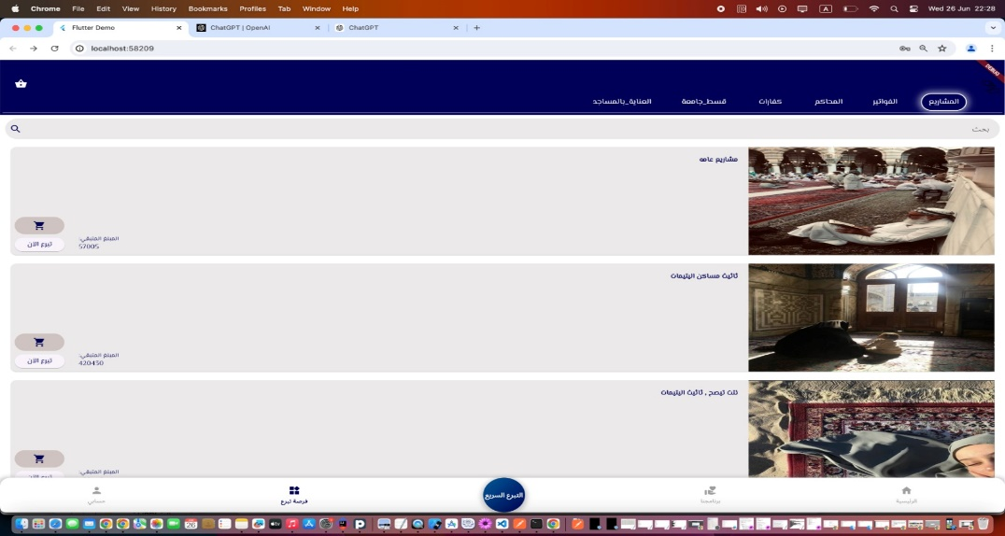

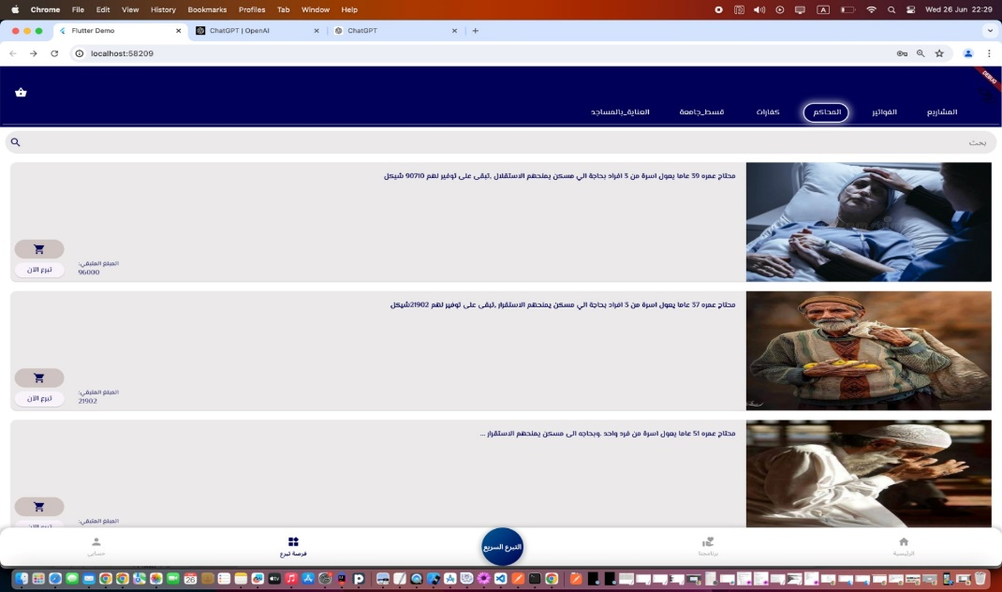

Figure 19: Donation Opportunities Page for Web

      - Sign-in Page: This page provides access for users to log into the platform as a donor, beneficiary, or administrator. You can access the platform if you already have an account by verifying your username and email. Once verified, you will be able to review your profile on the application
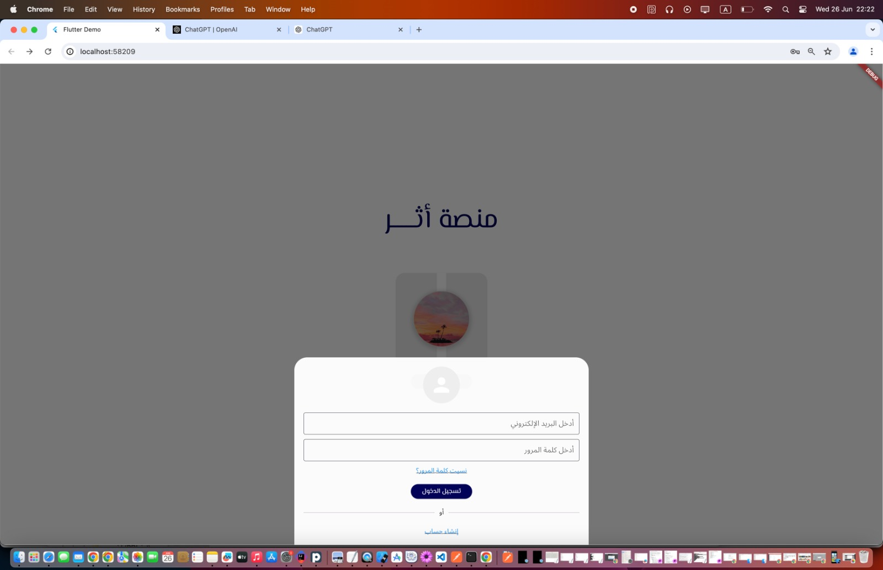

Figure20:Sign in Page for web

If you don't have an account yet, you can create one using this page. You can choose to create an account as either a donor or a beneficiary. As a donor, you need to provide your name, email, password, age, and phone number, and select the donor option. Once you've entered this information, your account will be created. If you want to register as a beneficiary, you will need to provide additional information about your situation and submit documents proving your need. After you submit the account creation request, it will be reviewed by the admin to ensure the accuracy of the information provided. Based on this verification, the account creation will either be accepted or declined.

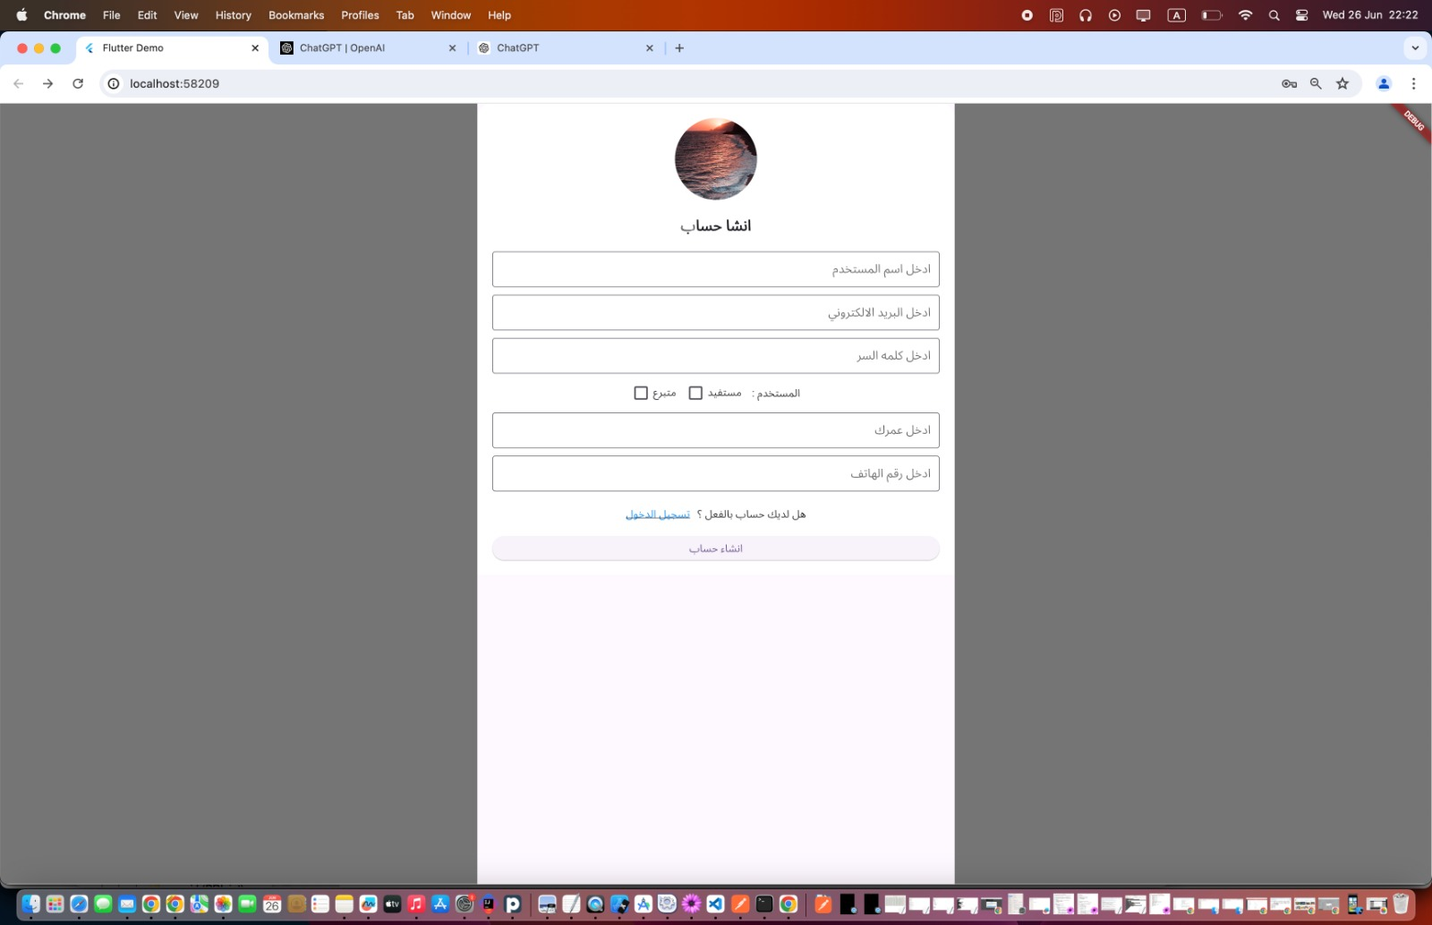

Figure21: Create an Account Page for web

      - Main Admin Page: This page provides information about the main admin and enables them to update their details. It also gives the main admin the ability to review employees, add new employees, assign specific permissions, delete employees, and revoke permissions as necessary.

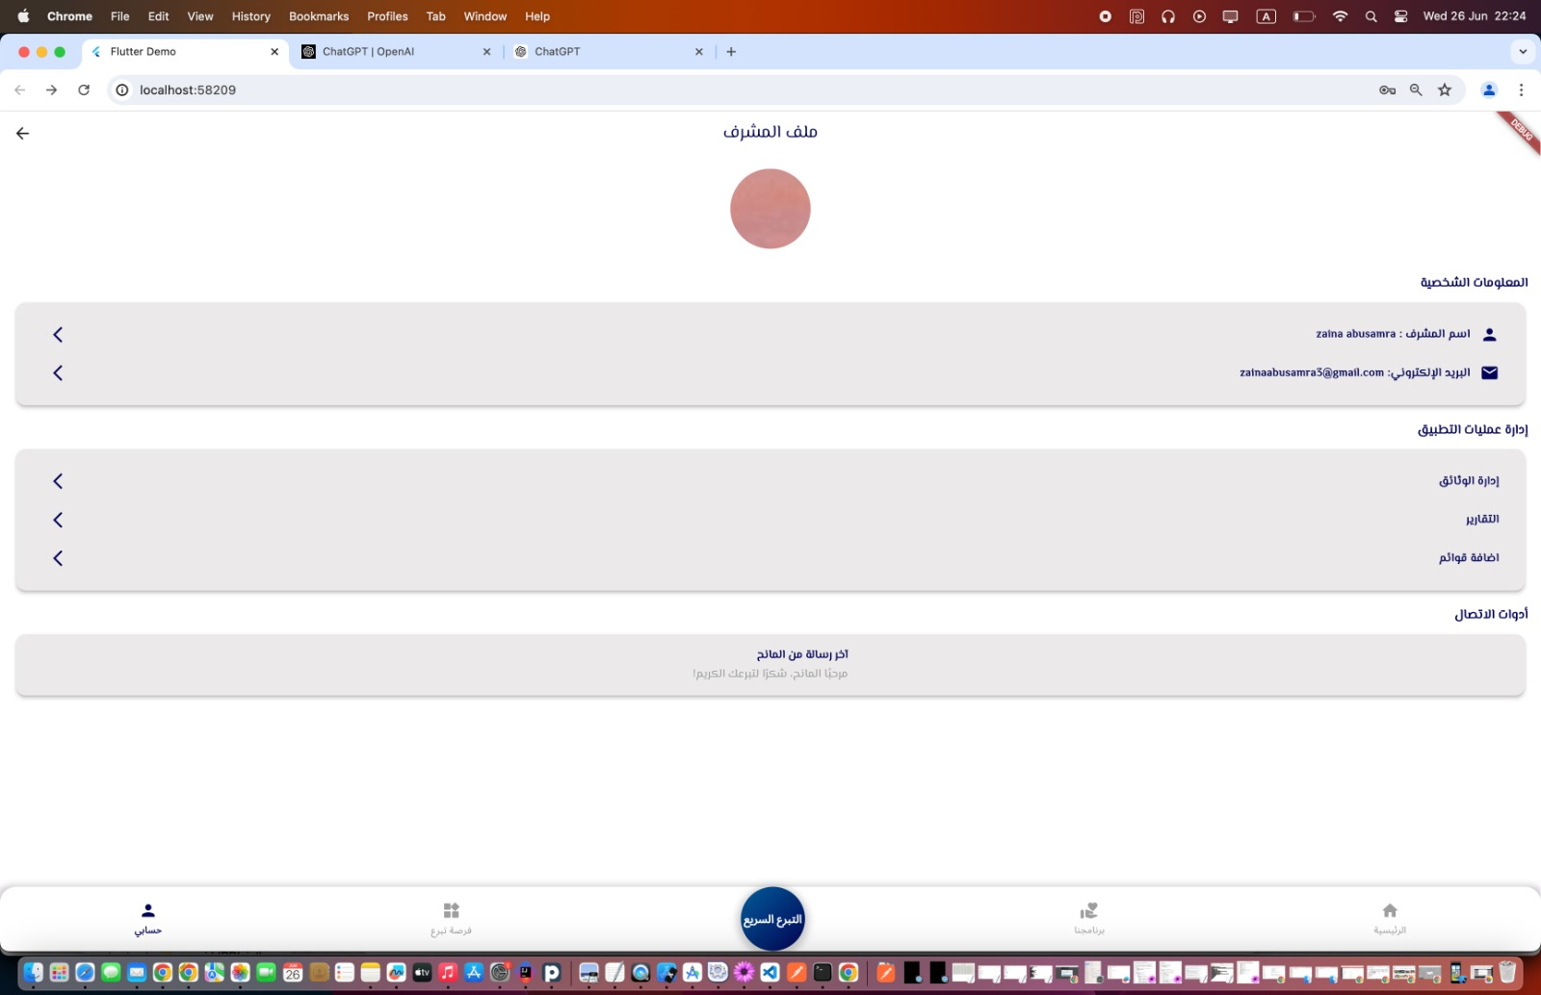

Figure22: Main Admin Page for web

When clicking on "Document Management," employees responsible for document management will be displayed. Clicking on "Reports" will show employees responsible for creating reports. Clicking on "Add Lists" will display employees responsible for adding lists to the Donation Opportunities page. From these pages, new employees can be added or previous employees can be removed.
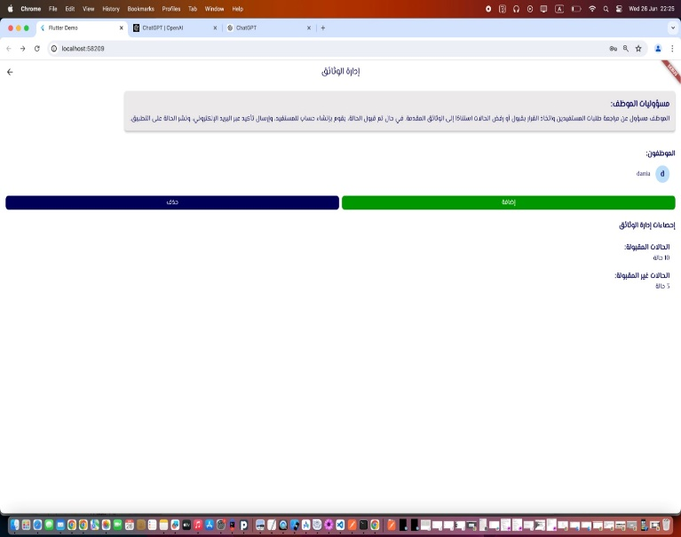
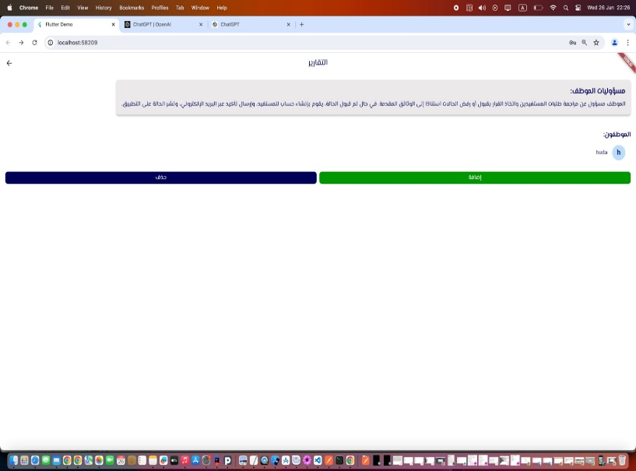

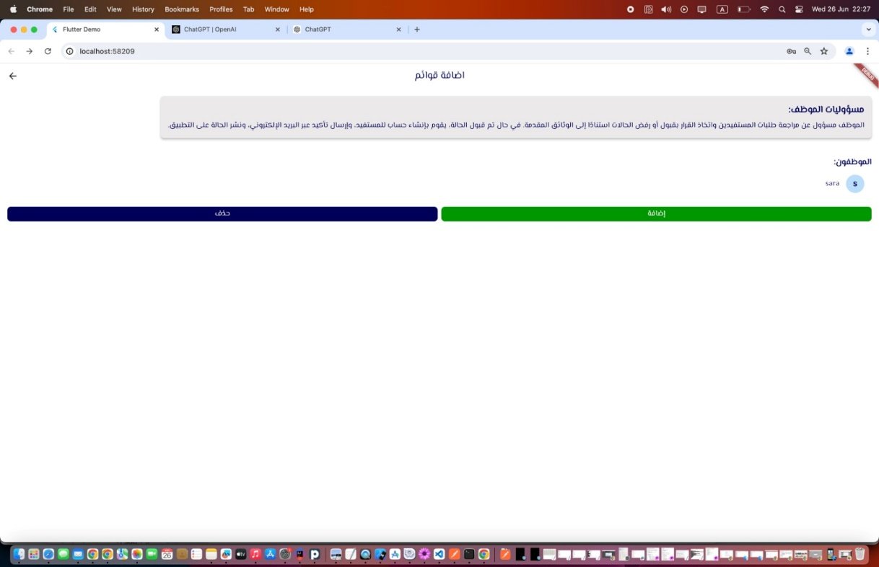

Figure23: Employee Review Pages for web

      - Add New Employee Page: This page allows the administrator to create an account for a new employee and define the permissions they can have. The administrator can choose from three permissions: creating reports, adding lists, and managing documents.

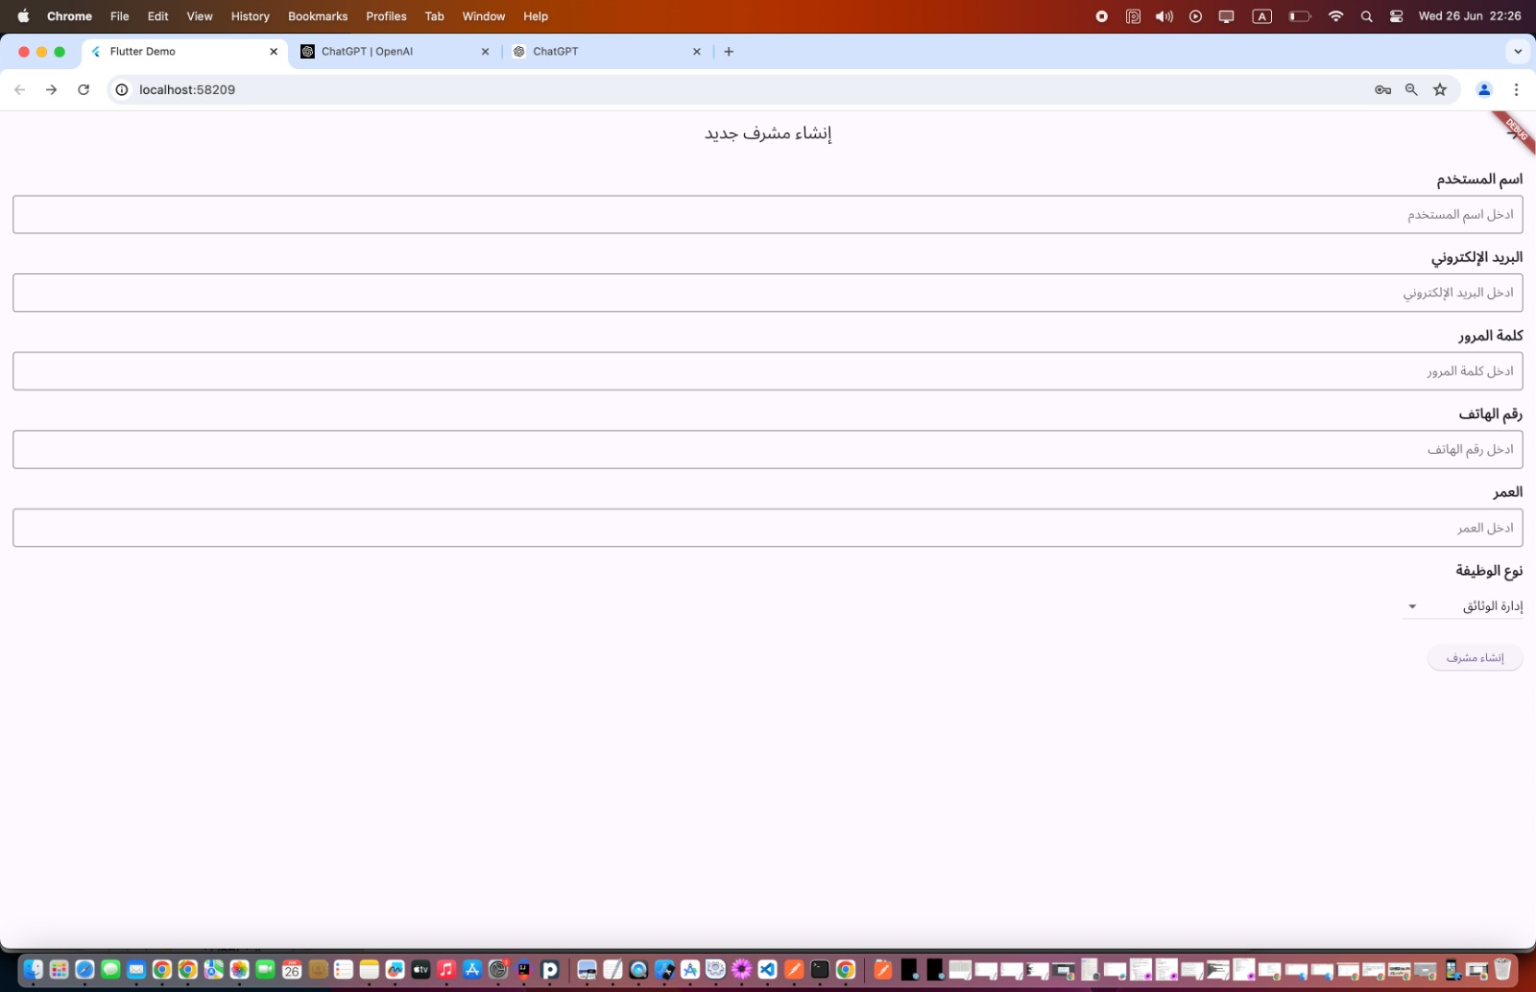

Figure24: Add New Employee Pages

      - Document Management Employee Page: This page presents requests submitted by beneficiaries, categorized into three sections: pending requests awaiting review, approved requests, and rejected requests.

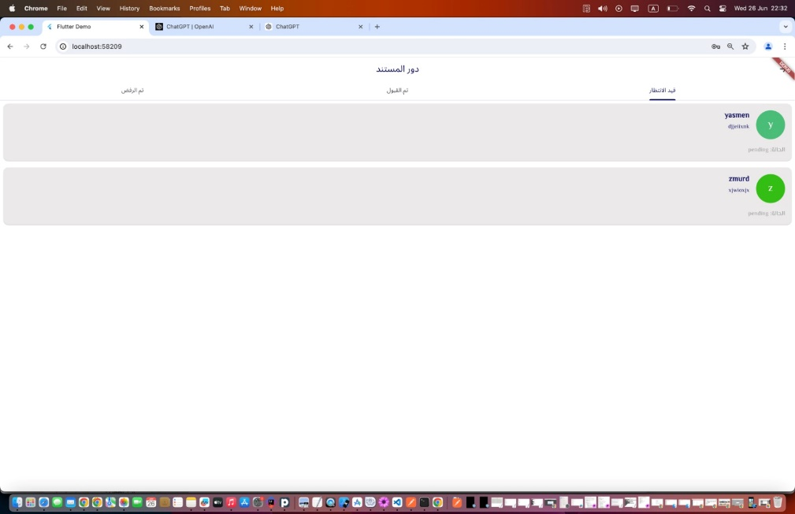

Figure25: Document Management Employee Page for web
      - Page of Employee Responsible for Adding Lists: Through this page, the employee responsible for adding lists can organize and add new lists to the Donation Opportunities page.

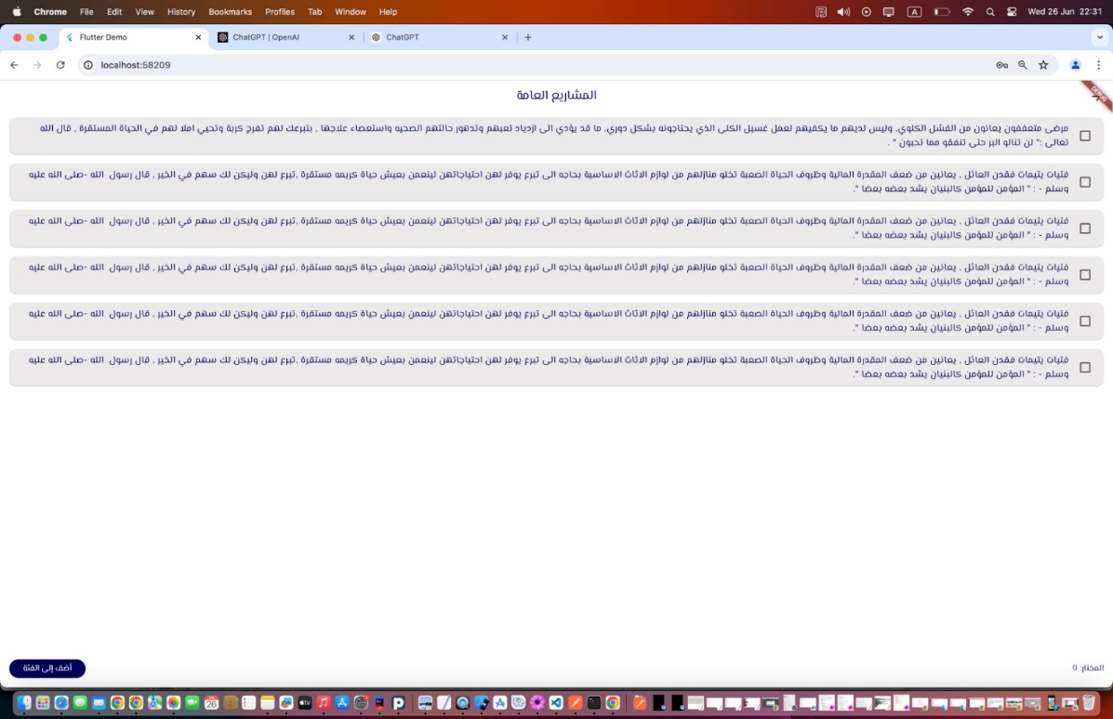

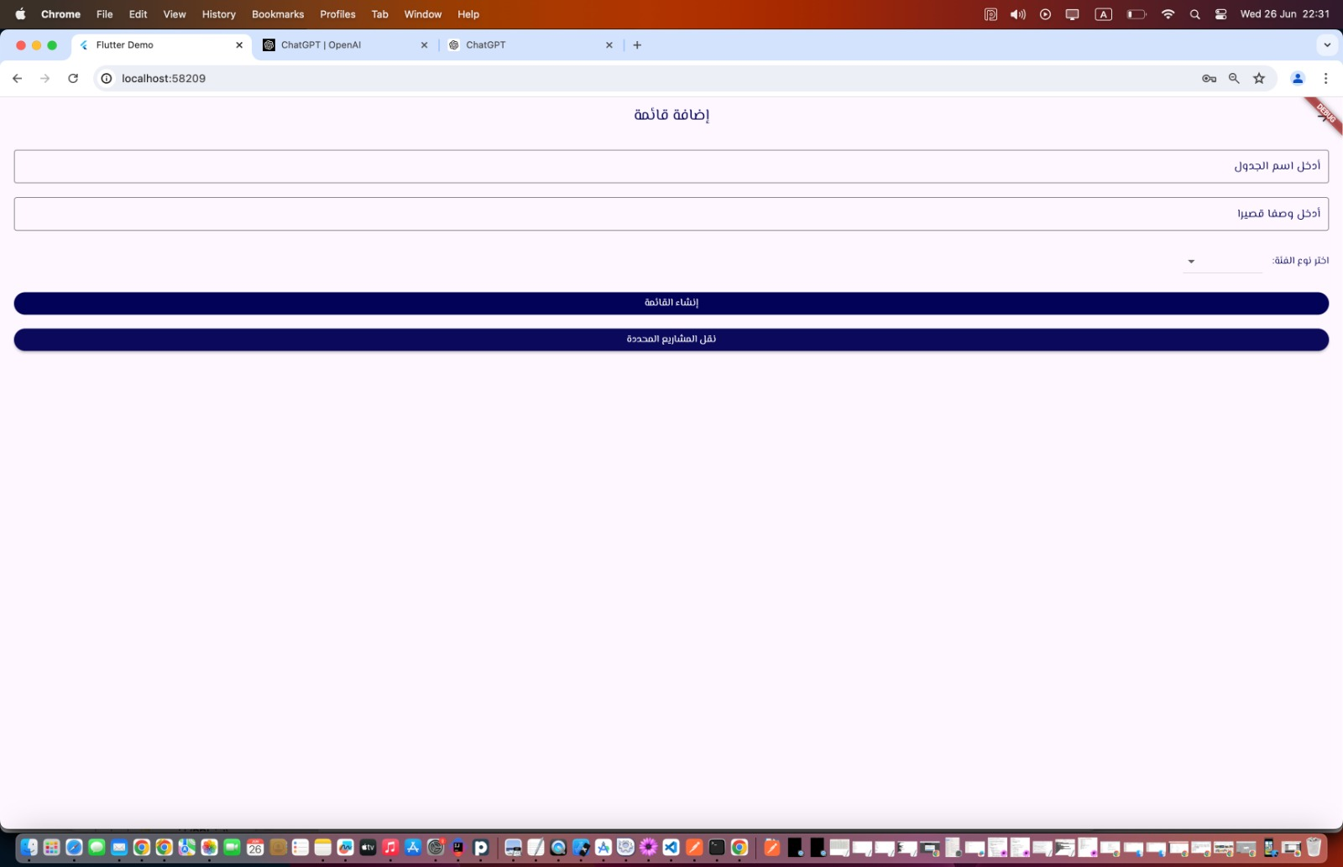

Figure26: Pages of Employee Responsible for Adding Lists for web

      - Reports Creation Administrator Page: Through this page, projects that have received donations will be displayed.

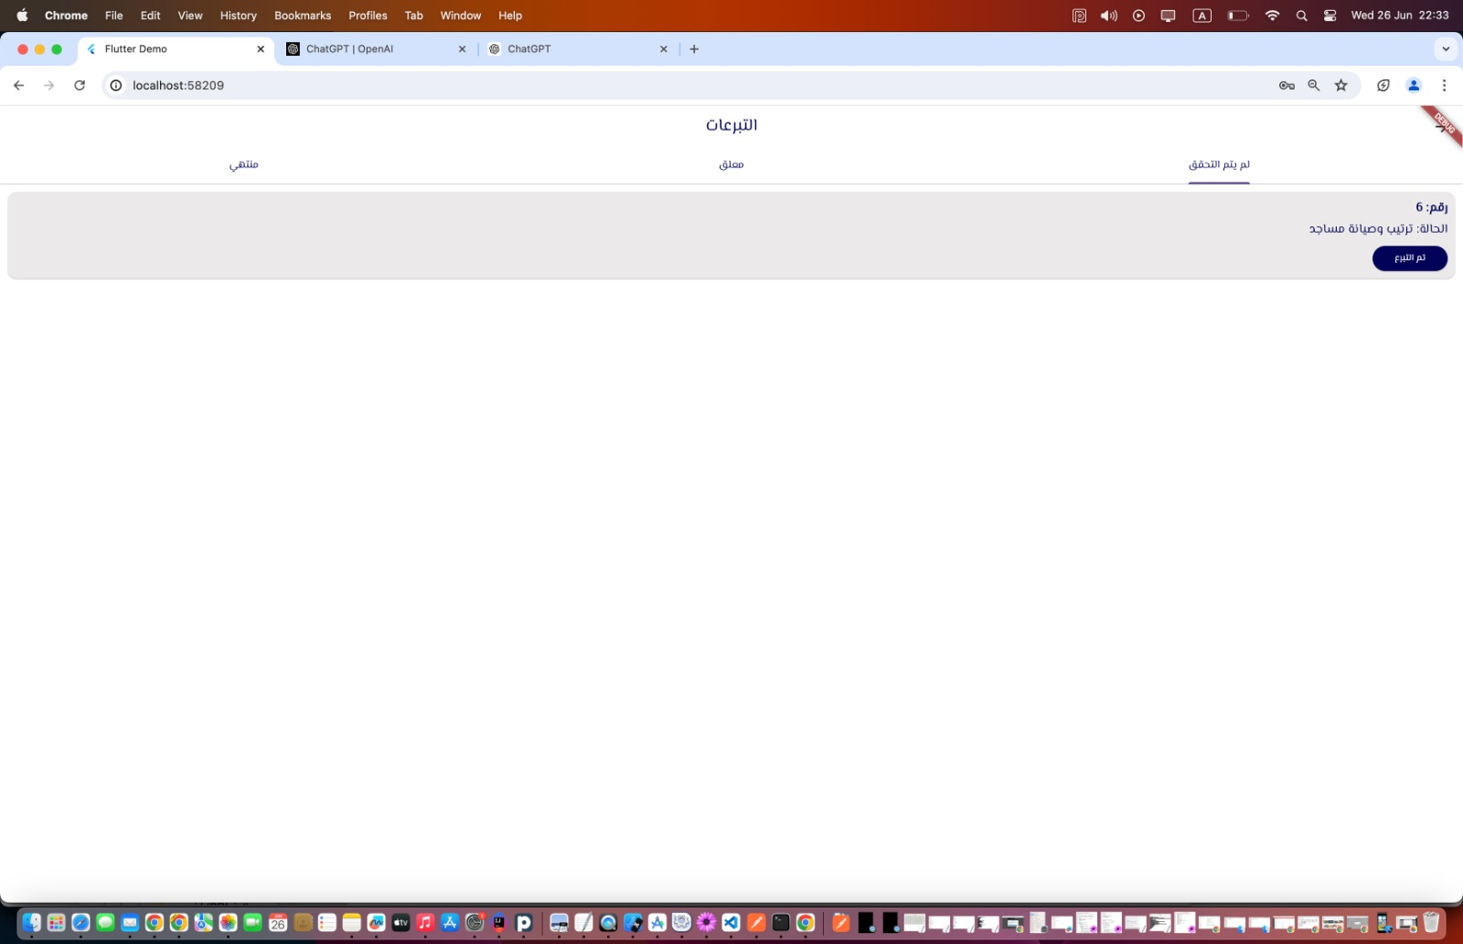

Figure27: Reports Creation Administrator Page for web

      - Beneficiary Profile Page: There are two statuses for the beneficiary:

- If the donation has been received and the full amount has been collected, a button to download documents will appear upon request by the employee responsible for creating reports.
- If the full amount has not been collected, information about the status will be displayed along with the amount that has been collected.

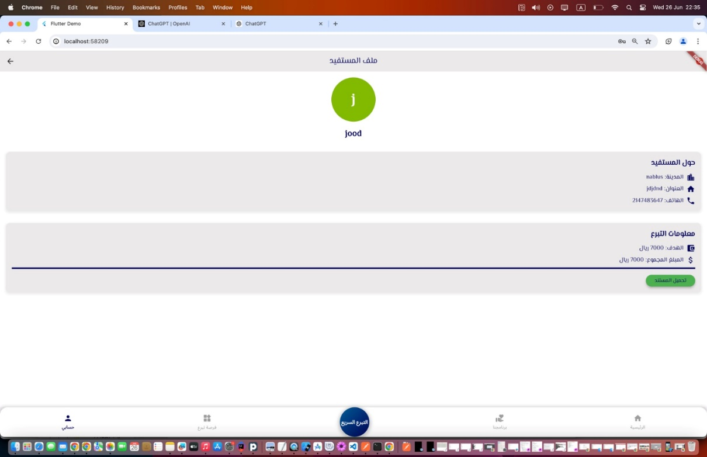

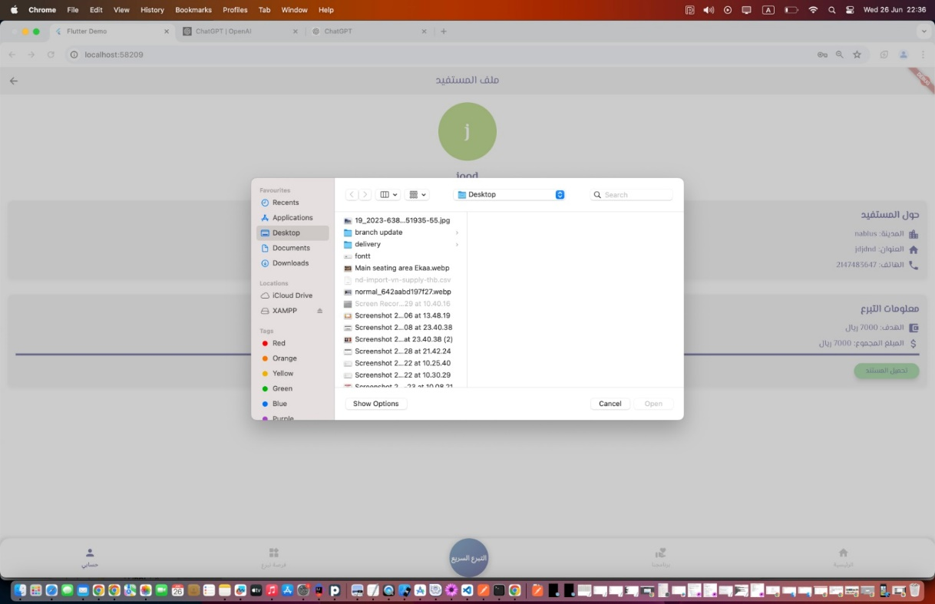

Figure28: Beneficiary Profile Page (DONE)
      - Donor Page: This page presents the donor's personal information, the projects they have contributed to, and the amount donated. Donors can also filter cases by donation year or month.

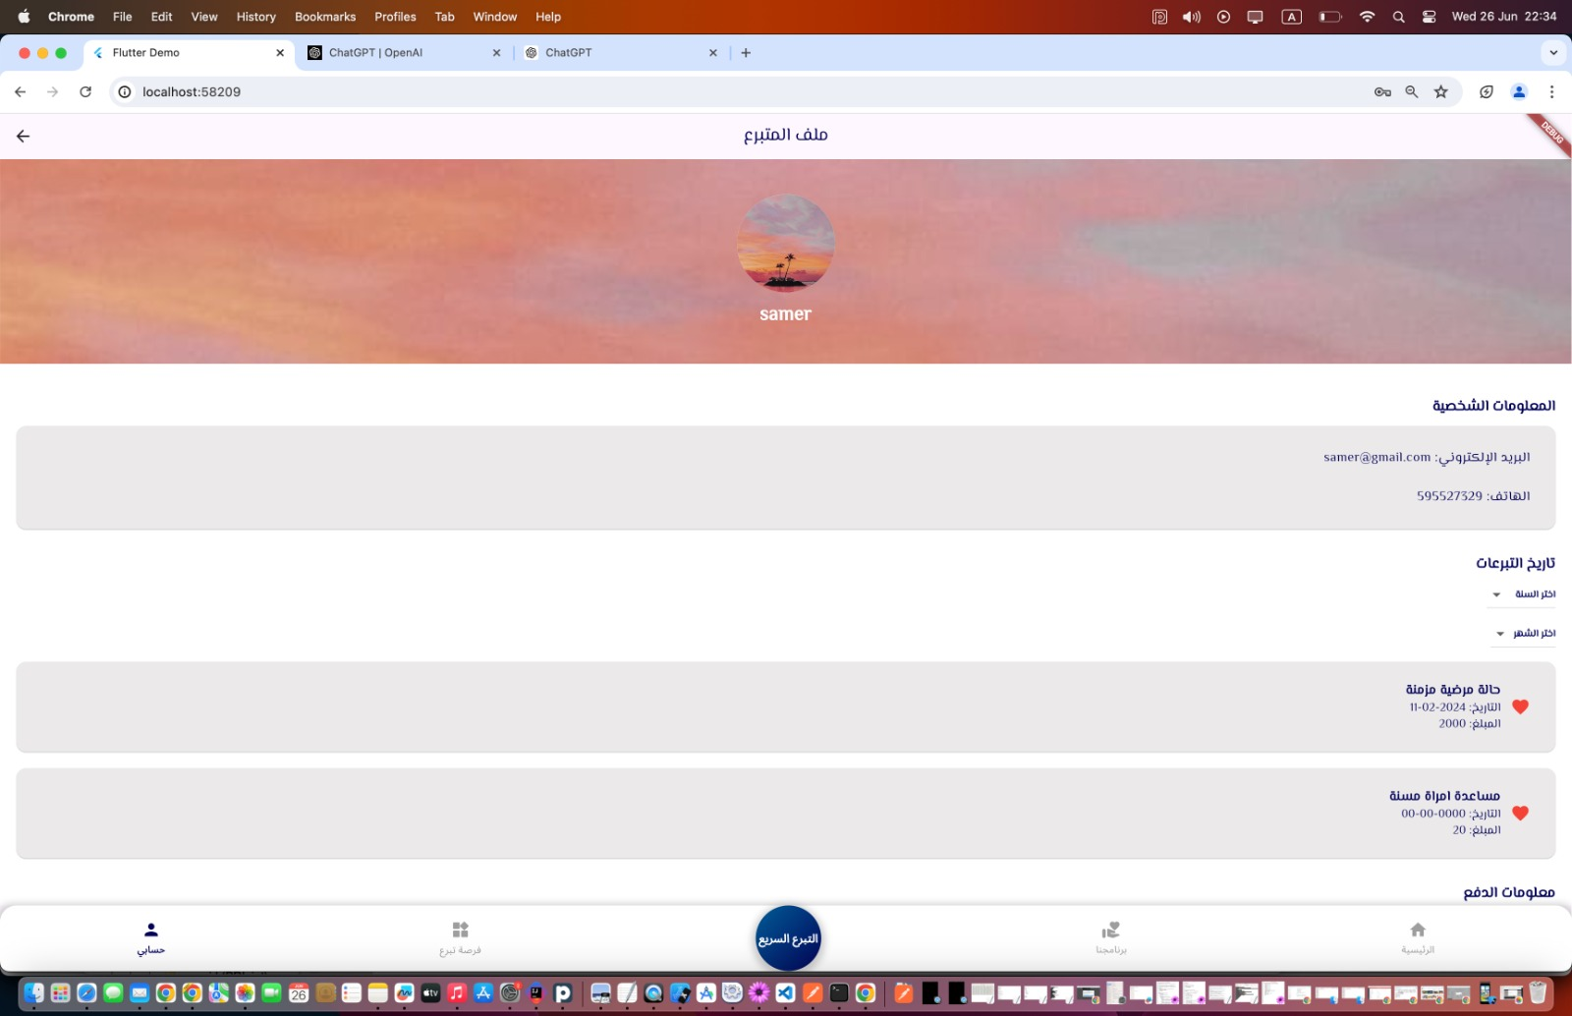

Figure29: Donor profile Page

Conclusion and Results
In conclusion, the development and implementation of Athar represent a transformative advancement in the field of charitable platforms dedicated to enhancing community welfare. By prioritizing a meticulous and user-centered approach, Athar has effectively addressed critical challenges in traditional charitable initiatives, offering a comprehensive platform that empowers individuals on their journey toward holistic well-being. The integration of personalized support services, versatile donation methods, and a nurturing community environment has resulted in a user-friendly and innovative charitable solution.
Built upon foundational technologies and best practices from platforms like Flutter, Node.js, GitHub, and Firebase, Athar stands at the forefront of technological innovation in charitable endeavors, setting benchmarks for personalized support and community engagement. Looking ahead, Athar serves as a catalyst for ongoing enhancements and collaborations, exemplifying the intersection of technology and social welfare to foster enduring positive outcomes and improved community well-being.

Future work

For future development, Athar presents exciting opportunities to expand and enrich its capabilities, aiming to provide a more comprehensive array of charitable support services. One pivotal direction involves integrating an advanced system that facilitates personalized assistance and tailored solutions. This system could utilize sophisticated algorithms to conduct thorough user assessments, analyze feedback, and generate personalized recommendations based on established charitable principles. By incorporating such a system, Athar can significantly enhance its ability to offer bespoke support, thereby fostering deeper engagement and more impactful outcomes for beneficiaries.

Furthermore, recognizing the significance of personalized care pathways, Athar envisions implementing location-based services as a crucial enhancement. This feature aims to assist beneficiaries in easily locating nearby charitable organizations and services, streamlining access to essential resources and support. By integrating location-based functionalities, Athar seeks to empower beneficiaries to seamlessly connect with charitable initiatives in their local communities, thereby enhancing accessibility and facilitating a seamless transition between online and on-site charitable services. This enhancement aligns with Athar commitment to providing a holistic charitable support system that meets the diverse needs of beneficiaries across various contexts.These prospective developments hold promise in elevating Athar impact and solidifying its role as a pivotal resource for individuals seeking comprehensive charitable support. By continually innovating and expanding its capabilities, Athar aims to enrich the lives of beneficiaries and strengthen community welfare initiatives, exemplifying its dedication to advancing charitable causes and promoting sustainable social impact.

References

- Ehsan.sa. (n.d.). Retrieved Feb 27, 2024
- Jood. (n.d.). Retrieved June 27, 2024
- International Islamic Charitable Organization. (n.d.). Retrieved June 27, 2024
- Ufandao. (n.d.). Retrieved June 27, 2024,

