AN-NAJAH NATIONAL UNIVERSITY
FACULTY OF ENGINEERING
TELECOMMUNICATION ENGINEERING DEPARTMENT

Project Report On
Millimeter Wave Massive MIMO for Next Generation Wireless Communication
Submitted
In Partial Fulfillment
Of The Requirements For
Bachelor Degree
In Telecommunication Engineering
Supervisor: Prepared By:
Dr. Yousef Dama Asma’a Halbouni
Asma’a Yaish

April 22, 2018

Acknowledgements

Thanks to Allah for reconciling us to complete this project. Also, we would like to thank our supervisor Dr. Yousef Dama for his effort in Supervising and direct us to complete this great work. And we want to thank him for supplying us with a great and valuable amount of information.
A lot of thanks to our families for their great support in each step. And finally we would like to thank our university for embraced us during the five years of studying.

Abstract

Due to the huge technology evolution nowadays, the world is moving towards implementing new advanced networks aimed to provide better services. 5G will need to meet very challenging requirements and cover a wide range of scenarios and services. Utilizing unused mmWave spectrum is one key enabling solution for meeting the extreme data demand growth. While mmWave spectrum offers a great opportunity to increase capacity, little is known about the propagation channel characteristics. So in our project we will focus on studying 5G propagation channel.
For the second part of this project, we started our project with testing Flat fading channel and real channel for a MIMO system, based on coding technique and based on changing number of transmitted antennas. Our testing was on Matlab, where we use a code to implement MIMO system for a real and flat fading channel, and we attach the result we got.
Then we moved to beamforming with its two architecture, analog and digital beamforming. We tested MIMO channel with beamforming, and saw how adding beamforming will enhance performance. Then, we saw how full duplex can be achieved using hybrid transformer connected to single pole balancing circuit, and it was tested on Matlab Simulink, and we attach the result that we got.

Contents
Acknowledgements 2
Abstract 3
Table of Figures 6
Chapter One: Introduction 7
1.1 Introduction 7
1.2 Methodology 8
1.3 The structure of report 8
Chapter Two: Standard and Constraint 9
2.1 Standard 9
2.2 Constraints 9
Chapter Three: Massive MIMO 10
3.1 Introduction 10
3.2 Literature Review of MIMO 10
3.3 Alamouti and Space Time Block Coding 11
3.3.1 Space Time Block Coding 11
3.3.2 Alamouti code 2*1 MIMO 11
3.4 Orthogonal Space Time Block Coding 14
3.5 Quasi-Orthogonal Space Time Block Coding 14
3.5.1 A new Approach for O-STBC and QO-STBC which based on idea of original Encoding matrix 14
3.6 Channel Model Supported by NYUSIM 27
3.7 Massive MIMO Matlab Results 31
Chapter Four: Beamforming 45
4.1 Introduction 45
4.2 mmWave Beamforming 45
4.3 mmWave Beamforming Architectures 46
4.3.1 Analog Beamforming 46
4.3.2 Digital Beamforming 48
4.4 Beamforming Matlab Results 50
Chapter Five: Duplexing 59
5.1 Introduction 59
5.2 Flexible Duplexing 60
5.3 Enabling Technologies 61
5.4 Electrical Balance Duplexing 62
5.5 Duplexing Matlab Simulink 66
Chapter Six: Conclusion and Future Work 68
6.1: Conclusion 68
6.2: Future Work 69
Reference 70

Table of Figures
Figure 3.1: MIMO Block Diagram 10
Figure 3.2: Alamouti Space Time Diversity 12
Figure 3.3: Encoding and transmission sequence for the Alamouti two transmit antennas 12
Figure 3.4: Atmospheric Attenuation vs. Frequency. 28
Figure 3.5: T-R separation Vs. Path Loss 29
Figure 3.6: Power Received 30
Figure 3.7: Conventional, Hadamard and Proposed QO-STBC 32
Figure 3.8: Hadamard and Proposed QO-STBC Based on No. Of Tx 33
Figure 3.9: Changing order of Modulation for Flat fading Channel using Proposed QO-STBC. 34
Figure 3.10: Changing order of Modulation for Flat fading Channel using Proposed Hadamard. 34
Figure 3.11: Comparison on No. of TX using 32QAM for Flat Fading Channel. 35
Figure 3.12: Comparison on No. of TX using 64QAM for Flat Fading Channel. 36
Figure 3.13: Changing number of receiver and coding technique for Flat Fading channel, for 128 QAM. 37
Figure 3.14: Changing number of receiver and coding technique for Flat Fading channel, for 128 QAM. 39
Figure 3.15: Real channel using Proposed Hadamard and Proposed QO-STBC. 40
Figure 3.16: Changing order of Modulation for Real Channel using Proposed Hadamard. 41
Figure 3.17: Changing order of Modulation for Real Channel using Proposed QO-STBC. 42
Figure 3.18: Comparison on No. of TX using 64QAM on Real Channel. 42
Figure 3.19: Changing number of receiver and coding technique for Real channel, for 128 QAM. 43

Figure 4.1: Analogue Beamforming system with single RF chain used at the transmitter and another at the receiver . 47
Figure 4.2: Digital beamforming architecture. Full complexity system with an RF chain connected to each antenna in the array . 49
Figure 4.3: Comparison between MIMO, MIMO Analog BF, and MIMO Digital BF on flat fading channel 51
Figure 4.4: Comparison between Analog and Digital beamforming on flat fading channel. 52
Figure 4.5: Comparison between Proposed Hadamard and Proposed QO-STBC on Flat Fading channel. 53
Figure 4.6: Changing number of transmitter for analog beamforming for Flat fading channel. 54
Figure 4.7: Changing order of modulation for analog beamforming for Flat fading channel. 55
Figure 4.8: Comparison between MIMO, MIMO Analog BF, and MIMO Digital BF on Real channel. 56
Figure 4.9: Real channel using Proposed Hadamard and Proposed QO-STBC with beamforming MIMO. 57
Figure 4.10: Changing number of transmitter for analog beamforming for real channel. 58

Figure 5.1: Hybrid transformer providing TX-RX isolation using electrical balance . 63
Figure 5.2: Balancing network topologies. (a) Single pole parallel RC circuit balancing. (b) triple-π network balancing . 64
Figure 5.3: Hybrid Transformer and Balancing circuit on Matlab Simulink. 66
Figure 5.4: Results from Simulink: LNA Output, and Antenna output. 67

Chapter One: Introduction

1.1 Introduction
The development and growth of wireless technologies in the past decade has led to the rapid adoption of smart phones and tablets, and emerging wearable devices for health and fitness. Consumers are expecting every device they have to be connected to the network to record, transfer, view, or monitor data. With these new technologies comes the demand for more data, video, and content access. While the growth in wireless devices and technologies has sky-rocketed, the spectrum available for these devices has not kept pace. Carriers and other fixed or mobile service providers are reaching the upper bounds of channel capacity, and the reality of a spectrum shortfall is now becoming increasingly clear. The wireless spectrum below 6 GHz will not be enough to meet future needs, as the current global allocation of cellular and unlicensed wireless local area network (WLAN) spectrum is quite small when compared to the vast spectrum available between 6 and 300 GHz.
Utilizing unused raw mmWave spectrum (30 GHz to 300 GHz) is one key enabling solution for meeting the extreme data demand growth. While mmWave spectrum offers a great opportunity to increase capacity, little is known about the channel propagation characteristics for mobile access networks in various environments at these carrier frequencies [1].
There have been intensive investigations on mmWave propagation characteristics and channel modeling in various environments, which is paving the way for 5G mmWave system design and deployment.
The construction and implementation of channel models are becoming increasingly important for wireless communication system design, and computer-aided design tools such as channel simulators are essential for performance evaluation of communications systems and for simulating network deployments, before moving forward with new technologies. There are several channel simulators that have been developed and used by previous researchers for indoor and outdoor propagation channels such as NYUSIM [2].
One of 5G technologies that is used to compact effect of high propagation loss due to high frequencies is beamforming. Beamforming is a key technique that is used to improve the signal-to-noise ratio of received signals, eliminate undesirable interference sources, and focus transmitted signals on a specific location. Beamforming is at the heart of modern wireless communications systems.
The ever increasing needs of higher data rates and massively increasing device populations are creating constant push towards developing new methods and technologies to increase the capacity of wireless communication networks. As the date rates and network capacity are strongly connected to the amount of the available radio spectrum, which is generally a very scarce resource, finding ways to increase the efficiency and flexibility of the spectrum utilization is one of the most essential targets and ingredients towards the 5G full duplexing radio networks.

1.2 Methodology
The basic idea in our project was to study propagation channel models of 5G. To accomplish this, we studied an analytical model which has a new approach for QO-STBC based on encoding matrix and virtual channel matrix, and by using a Matlab code we make a comparison between SNR and BER, also a statistical model such as SV model, which also used a Matlab code to simulate the channel, we used open source tool NYUSIM to extract channel coefficients to test a real channel. And finally we used beamforming matrix to test MIMO beamforming system.

1.3 The structure of report
The structure of this report is divided into six chapters. Chapter one introduce introduction and methodology used for the project. Chapter two introduces the standard for 5G, and the constraint for implementing 5G. Chapter three introduce massive MIMO system and its Matlab results.
For chapter four, third technology of 5G were introduced, beamforming with its two architecture and its Matlab results. Then in chapter five, concept of full duplex is discussed, and its Simulink results. In the final chapter a conclusion and future work is introduced.

Chapter Two: Standard and Constraint

2.1 Standard
Until now there is no standard for 5G network, so the definition is still very fluid. It is assumed that 5G networks will not become commercially available until the 2020 timeframe. The International Telecommunications Union (ITU) will be the standards body that releases the final standard, which is also being referred to as International Mobile Telecommunications (IMT)-2020.
The vision of 5G is becoming clearer as we move closer to 2020. Most experts say 5G will feature network speeds that are blazingly fast at 20 Gbps or higher and have a latency that is more milliseconds. Not only will people be connected to each other but so will machines, automobiles, city infrastructure, public safety and more.
5G networks are also expected to have always-on capabilities and be energy efficient, all of which will likely require new protocols and access technologies.
Due to undefined standard until now, we assume that the range of frequencies higher than 1Gbps, the data rate higher than 10 Gbps, with latency less than 1 millisecond, power equal to 47 dB, with high reliability 10^⁻⁹ BER and in term of modulation scheme assume using SC-OFDM for uplink frequency, where OFDM is using in the downlink frequency.

2.2 Constraints
mmWave due to its high frequency it suffer from small wavelength, which means small distance can be reached by using mmWave so we will have small cells, which means more base stations we need to cover a certain area, which will increase cost.
Also, we cannot implement 5G in our situation because our country suffer from lack of the frequency and spectrum.

Chapter Three: Massive MIMO

3.1 Introduction
A unique characteristic in a wireless channel (mobile radio channel) is a multipath fading environment. The signal at the receiver end contains not only the transmitted radio wave, it also includes a large number of reflected radio waves arrived at different times. Delay in the received signal is the result of reflections from the obstacles such as buildings, mountains, vehicles, hills or trees. These reflected delayed waves interfere with direct waves and cause Inter Symbol Interference (ISI) which causes significant degradation of network performance and that was in the past [3].

3.2 Literature Review of MIMO
MIMO as shown in Figure 3.1 is a wireless antenna technology that uses multiple antennas on transmitter side and multiple antennas on receiver side has attracted attention in wireless communications, because of better data throughput and link range without additional in bandwidth or transmit power due to ability of transferring more data at the same time. Between transmitter and receiver, the signal can take many paths, additionally by moving the antennas even a small distance the paths used will change. The variety of paths available occurs as a result of the number of objects that appear to the side or even in the direct path between the transmitter and receiver. Previously these multiple paths only served to introduce interference (ISI). By using MIMO, these additional paths can be used to advantage. They can be used to provide additional robustness to the radio link by improving the bit error rate, or by increasing the link data capacity [4].
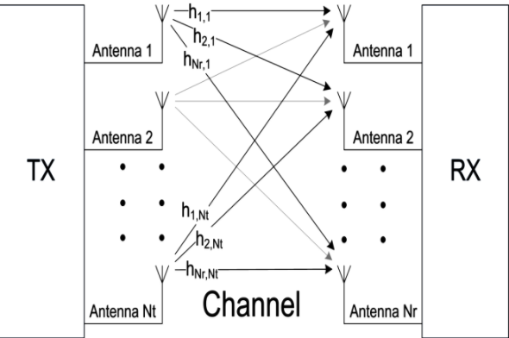 Figure 3.1: MIMO Block Diagram

3.3 Alamouti and Space Time Block Coding

3.3.1 Space Time Block Coding
Space Time Block coding is a technique used in wireless communications to transmit multiple copies of a data stream across a number of antennas and to exploit the various received versions of the data to improve the reliability of data-transfer. In other words, if we compare with SISO, we have more than one channel between Transmitters and Receivers so, there are diversity, and due to diversity, data and its copies is send on several channels and the Bit-Error-Rate is less than SISO system. So that, space time coding combines all the copies of the received signal in an optimal way to extract as much information from each copy as possible.
Space-time coding involves the transmission of multiple copies of the data. This helps to compensate for the channel problems such as fading and thermal noise. Although there is redundancy in the data some copies may arrive less corrupted at the receiver.
In the case of STBC in particular, the data stream to be transmitted is encoded in blocks, which are distributed among spaced antennas and across time. While it is necessary to have multiple transmit antennas, it is not necessary to have multiple receive antennas, although to do so improves performance.
An STBC is usually represented by a matrix. Each row represents a time slot and each column represents one antenna's transmissions over time.

3.3.2 Alamouti code 2*1 MIMO
Alamouti which is a special case of STBC as shown in Figure 3.2 is a basis complex space-time diversity technique that can be used in 2x1 MISO mode or in a 2x2 MIMO mode. It is the only STBC that can achieve its full diversity gain without needing to sacrifice its data rate. This property usually gives Alamouti code a significant advantage over the higher-order STBCs even though they achieve a better error-rate performance.
The mathematical explanation of the scheme with two transmitting and one receiving antennas is explained next. At the transmitter side, a block of two symbols is taken from the source data and sent to the modulator. After that, Alamouti space-time encoder takes the two modulated symbols, it called S₁ and S₂ creates encoding matrix S where the symbols S₁ and S₂ are mapped to two transmit antennas in two transmit time slots.
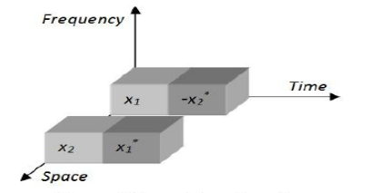 Figure 3.2: Alamouti Space Time Diversity [3]
The information to be transmitted is modulated and fed to the space time encoder. The space time encoder consists of two transmit antennas as part of the multiple input multiple output technology. So here the information is transmitted through two separate antennas. Each transmitting and the receiving antenna pair has a channel, represented by different channel coefficients. These channel coefficients play a major role in the design of the system. As the number of antennas increases at both the ends of the channel, the complexity of the system also increases [3].
The encoding and transmission sequence for the two transmit antennas in the Alamouti scheme is shown in Figure 3.3.
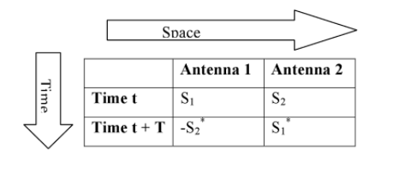 Figure 3.3: Encoding and transmission sequence for the Alamouti two transmit antennas
At time t, S₁ and S₂ are transmitted simultaneously by antennas 1 and 2 respectively. In the next time slot, t+T where T is the symbol duration, -S*₂ and –S*₁ are transmitted simultaneously by antennas 1 and 2 respectively, where * denotes complex conjugation.
The channel coefficients remain constant over two consecutive symbols periods, the signals at the two receiver antennas are given by a set of linear equations as follows [4]:
At time slot t1 Y₁ = S₁h₁ + S₂h₂ + n₁ (3.1)
At time slot t2 Y₂ = -S*₂h₁ + -S*₁h₂ + n₂ (3.2)
Where n₁ and n₂ are AWGN, Y₁ and Y₂ are received vectors
In the matrix form,
$\left[\begin{aligned}Y1 \\ Y2\end{aligned}\right]$ = $\left[\begin{matrix}S1 & S2 \\ -S2* & -S1*\end{matrix}\right]$ *$\left[\begin{aligned}h1 \\ h2\end{aligned}\right]$ + $\left[\begin{aligned}n1 \\ n2\end{aligned}\right]$ (3.3)
Y = hS + n, where Y is the received signal.
In order to get rid of conjugates of transmitted data at the receiver, we take conjugate of Y₂
Y₁ = S₁h₁ + S₂h₂ + n₁ (3.4)
Y*₂ = -S₂h*₁ + -S₁h*₂ + n*₂ (3.5)
The matrix will be $\left[\begin{aligned}Y1 \\ Y2*\end{aligned}\right]$ = $\left[\begin{matrix}h1 & h2 \\ -h2* & -h1*\end{matrix}\right]$ *$\left[\begin{aligned}S1 \\ S2\end{aligned}\right]$ + $\left[\begin{aligned}n1 \\ n2*\end{aligned}\right]$ (3.6)
Let’s define channel H = $\left[\begin{matrix}h1 & h2 \\ -h2* & -h1*\end{matrix}\right]$ and inverse of H is equal to H⁻¹
At receiver side, equalization will be performed in order to recover original transmitted symbols with noise and channel effect, which done by multiplying received signal Y by H⁻¹.
So, the estimated symbols will be
S₁' = S₁ + (h₁*n₁ + h₂*n₂)/(|h₁|₂ + |h₂|₂) (3.7)
S₂' = S₂ + (h₂n*₂ - h₁n*₁)/(|h₁|₂ + |h₂|₂) (3.8)

3.4 Orthogonal Space Time Block Coding
The pioneering work of Alamouti has been the basis to create orthogonal space time block coding systems (OSTBCs) for more than two transmit antennas. OSTBC have received considerable attention in recent open-loop multiple-input-multiple-output (MIMO) wireless communication literature because they allow low complexity maximum-likelihood decoding and guarantee full diversity [5].
The drawback of O-STBCs is that full-rate code words do not exist for more than two transmit antennas. For the case of four transmit antennas, the rate limitation of O-STBCs was overcome by quasi-orthogonal (QO) STBCs at the expense of diversity loss [6].

3.5 Quasi-Orthogonal Space Time Block Coding
It has been proved that a complex orthogonal design of STBCs that provides full diversity and full transmission rate is not possible for more than two transmit antennas. To achieve full-rate transmission while maintaining much of the orthogonality benefits of OSTBC, Quasi Orthogonal Space Time Block Code (QO-STBC) has been proposed. A QOSTBC can achieve full rate but interference terms will appear from the neighboring signals during the signal detection which will increase the detection complexity and decrease the gain performance [7].
In quasi-orthogonal coding, the columns of the transmission matrix are divided into groups. Columns within each group are not orthogonal to each other but those from different groups are mutually orthogonal. Pairs of transmitted symbols can be decoded independently, but there is some loss of diversity in QOSTBC due to coupling terms between the estimated symbols [8].

3.5.1 A new Approach for O-STBC and QO-STBC which based on idea of original Encoding matrix

A. Conventional QO-STBC
In Quasi-orthogonal code structure, the columns of the transmission matrix are divided into groups. The columns within each group are not orthogonal to each other but those from different groups are orthogonal to each other. By using quasi-orthogonal design, pairs of transmitted symbols can be decoded independently, the loss of diversity in QO-STBC is due to some coupling terms between the estimated symbols.
- For two transmitter, we transmit only two symbols ( x1, and x2), the encoding matrix X12 is:
$X12=\left[\begin{matrix}x_{1} & x_{2} \\ {-x}_{2}^{*} & x_{1}^{*}\end{matrix}\right]$ 2x2 Matrix (3.9)

- For four transmitter, if we assume transmit only four symbols 𝑥1, 𝑥2, 𝑥3, and x4, the original matrix XA is formed from two (2 × 2) Alamouti code matrices X12 and X34:
$X12=\left[\begin{matrix}x_{1} & x_{2} \\ {-x}_{2}^{*} & x_{1}^{*}\end{matrix}\right]$ (3.10) and $X34= \left[\begin{matrix}x_{3} & x_{4} \\ {-x}_{4}^{*} & x_{3}^{*}\end{matrix}\right]$ (3.11)
And so, $XA=\left[\begin{matrix}X12 & X34 \\ X34 & X12\end{matrix}\right]$= $\left[\begin{matrix}x_{1} & x_{2} & x_{3} & x_{4} \\ {-x}_{2}^{*} & x_{1}^{*} & {-x}_{4}^{*} & x_{3}^{*} \\ x_{3} & x_{4} & x_{1} & x_{2} \\ -x_{4}^{*} & x_{3}^{*} & -x_{2}^{*} & x_{1}^{*} \end{matrix}\right]$4x4 Matrix (3.12)

- For eight transmitter, we transmit only eight symbols 𝑥1, 𝑥2, 𝑥3, x4, x5, x6, x7, and x8, the encoding matrix X8 is formed from two (2 × 2) Alamouti code matrices XA and X58:
$X56=\left[\begin{matrix}x_{5} & x_{6} \\ {-x}_{6}^{*} & x_{5}^{*}\end{matrix}\right]$ (3.13) and $X78= \left[\begin{matrix}x_{7} & x_{8} \\ {-x}_{8}^{*} & x_{7}^{*}\end{matrix}\right]$ (3.14)
$X58=\left[ \begin{matrix}X56 & X78 \\ X78 & X56\end{matrix}\right]$ = $\left[\begin{matrix}x_{5} & x_{6} & x_{7} & x_{8} \\ {-x}_{6}^{*} & x_{5}^{*} & {-x}_{8}^{*} & x_{7}^{*} \\ x_{7} & x_{8} & x_{5} & x_{6} \\ -x_{8}^{*} & x_{7}^{*} & -x_{6}^{*} & x_{5}^{*} \end{matrix}\right]$ 4x4 Matrix (3.15)
So, the encoding matrix of eight symbols is:
$X8=\left[\begin{matrix}XA & X58 \\ X58 & XA\end{matrix} \right]$ =$\left[\begin{matrix}x_{1} & x_{2} & x_{3} & x_{4} & x_{5} & x_{6} & x_{7} & x_{8} \\ {-x}_{2}^{*} & x_{1}^{*} & {-x}_{4}^{*} & x_{3}^{*} & {-x}_{6}^{*} & x_{5}^{*} & {-x}_{8}^{*} & {-x}_{7}^{*} \\ x_{3} & x_{4} & x_{1} & x_{2} & x_{7} & x_{8} & x_{5} & x_{6} \\ {-x}_{4}^{*} & x_{3}^{*} & {-x}_{2}^{*} & x_{1}^{*} & {-x}_{8}^{*} & x_{7}^{*} & {-x}_{6}^{*} & x_{5}^{*} \\ x_{5} & x_{6} & x_{7} & x_{8} & x_{1} & x_{2} & x_{3} & x_{4} \\ {-x}_{6}^{*} & x_{5}^{*} & {-x}_{8}^{*} & x_{7}^{*} & {-x}_{2}^{*} & x_{1}^{*} & {-x}_{4}^{*} & x_{3}^{*} \\ x_{7} & x_{8} & x_{5} & x_{6} & x_{3} & x_{4} & x_{1} & x_{2} \\ {-x}_{8}^{*} & x_{7}^{*} & {-x}_{6}^{*} & x_{5}^{*} & {-x}_{4}^{*} & x_{3}^{*} & {-x}_{2}^{*} & x_{1}^{*}\end{matrix}\right]$ 8x8 matrix (3.16)
- For sixteen transmitters, we transmit only sixteen symbols, the encoding matrix X16 is formed from this code matrices: From point 3 we take X8 and the next matrices.
$X_{9-10}= \left[\begin{matrix}x_{9} & x_{10} \\ {-x}_{10}^{*} & x_{9}^{*}\end{matrix}\right]$ (3.17) and $X_{11-12}\left[\begin{matrix}x_{11} & x_{12} \\ {-x}_{12}^{*} & x_{11}^{*}\end{matrix}\right]$ (3.18)
$X_{13-14}=\left[\begin{matrix}x_{13} & x_{14} \\ {-x}_{14}^{*} & x_{13}^{*}\end{matrix}\right]$ (3.19) and $X_{15-16}=\left[\begin{matrix}x_{15} & x_{16} \\ {-x}_{16}^{*} & x_{15}^{*}\end{matrix}\right]$ (3.20)
$X_{9-12}=\left[\begin{matrix}X_{9-10} & X_{11-12} \\ X_{11-12} & X_{9-10}\end{matrix}\right]$ 4x4 matrix (3.21)
$X_{13-16}=\left[\begin{matrix}X_{13-14} & X_{15-16} \\ X_{15-16} & X_{13-14}\end{matrix}\right]$ 4x4 Matrix (3.22)
$X9=\left[\begin{matrix}X_{9-12} & X_{13-16} \\ X_{13-16} & X_{9-12}\end{matrix}\right]$ 8x8 Matrix (3.23)
So, the encoding matrix of sixteen symbols is:
$X16=\left[\begin{matrix}X8 & X9 \\ X9 & X8\end{matrix} \right]$ 16x16 Matrix (3.24)

- For thirty two transmitter, if we assume transmit only thirty two symbols, The original matrix X32 for thirty two transmitter antennas can be generated as follows:
From the point 4, we take X16.
$X_{17-20}=\left[\begin{matrix}x_{17} & x_{18} & x_{19} & x_{20} \\ {-x}_{18}^{*} & x_{17}^{*} & {-x}_{20}^{*} & x_{19}^{*} \\ x_{19} & x_{20} & x_{17} & x_{18} \\ -x_{20}^{*} & x_{19}^{*} & -x_{18}^{*} & x_{17}^{*} \end{matrix}\right]$ 4x4 Matrix (3.25)
$X_{21-24}=\left[\begin{matrix}x_{21} & x_{22} & x_{23} & x_{24} \\ {-x}_{22}^{*} & x_{21}^{*} & {-x}_{24}^{*} & x_{23}^{*} \\ x_{23} & x_{24} & x_{21} & x_{22} \\ -x_{24}^{*} & x_{23}^{*} & -x_{22}^{*} & x_{21}^{*} \end{matrix}\right]$ 4x4 Matrix (3.26)
$X_{25-28}=\left[\begin{matrix}x_{25} & x_{26} & x_{27} & x_{28} \\ {-x}_{26}^{*} & x_{25}^{*} & {-x}_{28}^{*} & x_{27}^{*} \\ x_{27} & x_{28} & x_{25} & x_{26} \\ -x_{28}^{*} & x_{27}^{*} & -x_{26}^{*} & x_{25}^{*} \end{matrix}\right]$ 4x4 Matrix (3.27)
$X_{29-32}=\left[\begin{matrix}x_{29} & x_{30} & x_{31} & x_{32} \\ {-x}_{30}^{*} & x_{29}^{*} & {-x}_{32}^{*} & x_{31}^{*} \\ x_{31} & x_{32} & x_{29} & x_{30} \\ -x_{32}^{*} & x_{31}^{*} & -x_{30}^{*} & x_{29}^{*} \end{matrix}\right]$ 4x4 Matrix (3.28)
And so, $X_{17-24}=\left[\begin{matrix}X_{17-20} & X_{21-24} \\ X_{21-24} & X_{17-20}\end{matrix}\right]$ 8x8 Matrix (3.29)
And $X_{25-32}=\left[ \begin{matrix}X_{25-28} & X_{29-32} \\ X_{29-32} & X_{25-28} \end{matrix}\right]$ 8x8 Matrix (3.30)
$X15=\left[ \begin{matrix}X_{17-24} & X_{25-32} \\ X_{25-32} & X_{17-24}\end{matrix}\right]$ 16x16 Matrix (3.31)
So, the encoding matrix of thirty two symbols is:
$X32=\left[ \begin{matrix}X16 & X15 \\ X15 & X16\end{matrix}\right]$ (3.32)

- For sixty four transmitter, we transmit only sixty four symbols, the encoding matrix X64 is formed from this code matrices: from point 5, we take X32 matrix and the next matrix.
$X_{33-36}=\left[\begin{matrix}x_{33} & x_{34} & x_{35} & x_{36} \\ {-x}_{34}^{*} & x_{33}^{*} & {-x}_{36}^{*} & x_{35}^{*} \\ x_{35} & x_{36} & x_{33} & x_{34} \\ -x_{36}^{*} & x_{35}^{*} & -x_{34}^{*} & x_{33}^{*} \end{matrix}\right]$(3.33),$X_{37-40}=\left[\begin{matrix}x_{37} & x_{38} & x_{39} & x_{40} \\ {-x}_{38}^{*} & x_{37}^{*} & {-x}_{40}^{*} & x_{39}^{*} \\ x_{39} & x_{40} & x_{37} & x_{38} \\ -x_{40}^{*} & x_{39}^{*} & -x_{38}^{*} & x_{37}^{*} \end{matrix}\right]$(3.34) $X_{41-44}=\left[\begin{matrix}x_{41} & x_{42} & x_{43} & x_{44} \\ {-x}_{42}^{*} & x_{41}^{*} & {-x}_{44}^{*} & x_{43}^{*} \\ x_{43} & x_{44} & x_{41} & x_{42} \\ -x_{44}^{*} & x_{43}^{*} & -x_{42}^{*} & x_{41}^{*} \end{matrix}\right]$(3.35),$X_{45-48}=\left[\begin{matrix}x_{45} & x_{46} & x_{47} & x_{48} \\ {-x}_{46}^{*} & x_{45}^{*} & {-x}_{48}^{*} & x_{47}^{*} \\ x_{47} & x_{48} & x_{45} & x_{46} \\ -x_{48}^{*} & x_{47}^{*} & -x_{46}^{*} & x_{45}^{*} \end{matrix}\right]$(3.36) $X_{49-52}=\left[\begin{matrix}x_{49} & x_{50} & x_{51} & x_{52} \\ {-x}_{50}^{*} & x_{49}^{*} & {-x}_{52}^{*} & x_{51}^{*} \\ x_{51} & x_{52} & x_{49} & x_{50} \\ -x_{52}^{*} & x_{51}^{*} & -x_{50}^{*} & x_{49}^{*} \end{matrix}\right]$(3.37),$X_{53-56}=\left[\begin{matrix}x_{53} & x_{54} & x_{55} & x_{56} \\ {-x}_{54}^{*} & x_{53}^{*} & {-x}_{56}^{*} & x_{55}^{*} \\ x_{55} & x_{56} & x_{53} & x_{54} \\ -x_{56}^{*} & x_{55}^{*} & -x_{54}^{*} & x_{53}^{*} \end{matrix}\right]$(3.38) $X_{57-60}=\left[\begin{matrix}x_{57} & x_{58} & x_{59} & x_{60} \\ {-x}_{58}^{*} & x_{57}^{*} & {-x}_{60}^{*} & x_{59}^{*} \\ x_{59} & x_{60} & x_{57} & x_{58} \\ -x_{60}^{*} & x_{59}^{*} & -x_{58}^{*} & x_{57}^{*} \end{matrix}\right]$(3.39), $X_{61-64}=\left[\begin{matrix}x_{61} & x_{62} & x_{63} & x_{64} \\ {-x}_{62}^{*} & x_{61}^{*} & {-x}_{64}^{*} & x_{63}^{*} \\ x_{63} & x_{64} & x_{61} & x_{62} \\ -x_{64}^{*} & x_{63}^{*} & -x_{62}^{*} & x_{61}^{*} \end{matrix}\right]$(3.40)
And so, $X_{33-40}=\left[\begin{matrix}X_{33-36} & X_{37-40} \\ X_{37-40} & X_{33-36}\end{matrix}\right]$ 8x8 Matrix (3.41)
And $X_{41-48}=\left[ \begin{matrix}X_{41-44} & X_{45-48} \\ X_{45-48} & X_{41-44}\end{matrix}\right]$ 8x8 Matrix (3.42)
$XD=\left[ \begin{matrix}X_{33-40} & X_{41-48} \\ X_{41-48} & X_{33-40} \end{matrix}\right]$ 16x16 Matrix (3.43)
And so, $X_{49-56}=\left[\begin{matrix}X_{49-52} & X_{53-56} \\ X_{53-56} & X_{49-52}\end{matrix}\right]$ 8x8 Matrix (3.44)
$X_{57-64}=\left[ \begin{matrix}X_{57-60} & X_{60-64} \\ X_{60-64} & X_{57-60}\end{matrix}\right]$ 8x8 Matrix (3.45)
$XC=\left[ \begin{matrix}X_{49-56} & X_{57-64} \\ X_{57-64} & X_{49-56}\end{matrix}\right]$ 16x16 Matrix (3.46)
$X33=\left[ \begin{matrix}XD & XC \\ XC & XD\end{matrix}\right]$ 32x32 Matrix (3.47)
So, the encoding matrix of sixty four symbols is:
$X64=\left[ \begin{matrix}X32 & X33 \\ X33 & X32\end{matrix}\right]$ 64*64 matrix (3.48)

B. Proposed QO-STBC
In this methodology detection matrix D_{n} used to produce eigenvalues and eigenvectors. The solution of the eigenvalues problem of matrix D_{n} can be shown as:
D_{n.} V – V.D = 0 (3.49)
Where D = λI, λ is the eigenvalues operator, and V is eigenvectors.
- For 2 transmitters, we have two symbols (x1, x2) to transmit for each time slot.
By using (3.9), the detection matrix D2 we get is $D2=\left[\begin{matrix}α & 0 \\ 0 & α\end{matrix}\right]$ (3.50)
Then, from D2 we will find eigenvalues and eigenvectors; to obtain a new encoding matrix using eigenvectors V. This D2 shows that there is no interference for 2 transmitters, because they are orthogonal to each other, and α represents gain.
$V_{2}=\left[\begin{matrix}1 & 0 \\ 0 & 1\end{matrix}\right]$ (3.51)
Then New Encoding Matrix will be A₂= V2* equation (3.9)
$A_{2}= \left[\begin{matrix}x1 & x2 \\ {x2}^{*} & {-x1}^{*}\end{matrix}\right]$ (3.52)
At receiver side, Y will be received this A2 coefficients (2*2) multiplied by channel coefficients Ch, added to them AWGN.
$Y=A_{2 \left( new EncodingMatrix\right)}* Ch+AWGN$ (3.53)

- For 4 transmitters, we have four symbols (x1, x2, x3, and x4) to transmit for each time slot.
Due to 4 signals; we will have interference, QO-STBC will be introduced, and Detection matrix by using equation XA (3.12) will be used to eliminate interference from neighboring signals, because signals are not orthogonal to each other’s, they are Quasi-Orthogonal.
By multiplying XA with ${XA}^{H}$ (${XA}^{H}$ is the Hermitian of XA), we obtain detection matrix D4.
So, Detection matrix for 4 Transmitters will be ${D4}_{4-Tx}=\left[\begin{matrix}α & 0 & β & 0 \\ 0 & α & 0 & β \\ β & 0 & α & 0 \\ 0 & β & 0 & α\end{matrix}\right]$ (3.54)
Eigenvector from D4_{4-Tx} is ${EigenVector}_{4QO-STBC}=\left[\begin{matrix}1 & 0 & -1 & 0 \\ 0 & 1 & 0 & -1 \\ 1 & 0 & 1 & 0 \\ 0 & 1 & 0 & 1\end{matrix}\right]$ (3.55)
Then new encoding matrix will be:
$A_{4QO-STBC}encoding matrix= \left[\begin{matrix}x_{1}+x_{3} & x_{2}+x_{4} & x_{3}-x_{1} & x_{4}-x_{2} \\ x_{2}^{*}+x_{4}^{*} & {-x}_{1}^{*}-x_{3}^{*} & x_{4}^{*}-x_{2}^{*} & x_{1}^{*}-x_{3}^{*} \\ x_{1}+x_{3} & x_{2}+x_{4} & x_{1}-x_{3} & x_{2}-x_{4} \\ x_{2}^{*}+x_{4}^{*} & {-x}_{1}^{*}-x_{3}^{*} & x_{2}^{*}-x_{4}^{*} & x_{3}^{*}-x_{1}^{*}\end{matrix}\right]$ (3.56)
On Receiver side: $Y=A_{4QO-STBC \left(EncodingMatrix\right)}* Ch+AWGN$ (3.57)

- For 8 transmitters, eight symbols to transmit (x1, x2, x3, x4, x5, x6, x7, and x8) for each time slot. As we did previously, we will find Detection matrix from equation X8 (3.16) multiplied with its Hermitian matrix. And from D8 we obtain eigenvectors, then we will obtain the new encoding matrix.
The eigenvalues matrix 𝐷8 𝑄𝑂−𝑆𝑇𝐵𝐶 and the corresponding eigenvectors 𝑉8 𝑄𝑂−𝑆𝑇𝐵𝐶 for eight transmitter antennas are given by equations
So, D8_{8-Tx} for 8 Transmitters (3.58): ${D8}_{8Tx}=\left[\begin{matrix}β+α-σ-γ & 0 & 0 & 0 & 0 & 0 & 0 & 0 \\ 0 & β+α-σ-γ & 0 & 0 & 0 & 0 & 0 & 0 \\ 0 & 0 & -β-α+σ+γ & 0 & 0 & 0 & 0 & 0 \\ 0 & 0 & 0 & -β-α+σ+γ & 0 & 0 & 0 & 0 \\ 0 & 0 & 0 & 0 & -β+α+σ-γ & 0 & 0 & 0 \\ 0 & 0 & 0 & 0 & 0 & -β+α+σ-γ & 0 & 0 \\ 0 & 0 & 0 & 0 & 0 & 0 & β+α+σ+γ & 0 \\ 0 & 0 & 0 & 0 & 0 & 0 & 0 & β+α+σ+γ\end{matrix}\right]$
$V_{8QO-STBC}=\left[\begin{matrix}-1 & 0 & -1 & 0 & 1 & 0 & 1 & 0 \\ 0 & -1 & 0 & -1 & 0 & -1 & 0 & 1 \\ -1 & 0 & 1 & 0 & -1 & 0 & 1 & 0 \\ 0 & -1 & 0 & 1 & 0 & 1 & 0 & 1 \\ 1 & 0 & -1 & 0 & -1 & 0 & 1 & 0 \\ 0 & 1 & 0 & -1 & 0 & 1 & 0 & 1 \\ 1 & 0 & 1 & 0 & 1 & 0 & 1 & 0 \\ 0 & 1 & 0 & 1 & 0 & -1 & 0 & 1\end{matrix}\right]$ (3.59)
Then, New Encoding Matrix A8 QO-STBC will be next: (3.60: a (First 4 column), and b (Second 4 column)):
On Receiver side: $Y=A_{8QO-STBC \left(EncodingMatrix\right)}* Ch+AWGN$ (3.61)
On the same way for 16, 32, and 64 transmitters, where detection matrix of the original encoding matrix is used to find to eigenvectors matrix; to form the new Encoding matrix, which will be original encoding matrix multiplied by eigenvectors.

$$\left[\begin{matrix}x_{5}-x_{3}-x_{1}+x_{7} & x_{6}-x_{4}-x_{2}+x_{8} & x_{3}-x_{1}-x_{5}+x_{7} & x_{4}-x_{2}-x_{6}+x_{8} \\ x_{6}^{*}-x_{4}^{*}-x_{2}^{*}+x_{8}^{*} & x_{1}^{*}+x_{3}^{*}-x_{5}^{*}-x_{7}^{*} & x_{4}^{*}-x_{2}^{*}-x_{6}^{*}+x_{8}^{*} & x_{1}^{*}-x_{3}^{*}+x_{5}^{*}-x_{7}^{*} \\ x_{5}-x_{3}-x_{1}+x_{7} & x_{6}-x_{4}-x_{2}+x_{8} & x_{1}-x_{3}+x_{5}-x_{7} & x_{2}-x_{4}+x_{6}-x_{8} \\ x_{6}^{*}-x_{4}^{*}-x_{2}^{*}+x_{8}^{*} & x_{1}^{*}+x_{3}^{*}-x_{5}^{*}-x_{7}^{*} & x_{2}^{*}-x_{4}^{*}+x_{6}^{*}-x_{8}^{*} & x_{3}^{*}-x_{1}^{*}-x_{5}^{*}+x_{7}^{*} \\ x_{1}+x_{3}-x_{5}-x_{7} & x_{2}+x_{4}-x_{6}-x_{8} & x_{3}-x_{1}-x_{5}+x_{7} & x_{4}-x_{2}-x_{6}+x_{8} \\ x_{2}^{*}+x_{4}^{*}-x_{6}^{*}-x_{8}^{*} & x_{5}^{*}-x_{3}^{*}-x_{1}^{*}+x_{7}^{*} & x_{4}^{*}-x_{2}^{*}-x_{6}^{*}+x_{8}^{*} & x_{1}^{*}-x_{3}^{*}+x_{5}^{*}-x_{7}^{*} \\ x_{1}+x_{3}-x_{5}-x_{7} & x_{2}+x_{4}-x_{6}-x_{8} & x_{1}-x_{3}+x_{5}-x_{7} & x_{2}-x_{4}+x_{6}-x_{8} \\ x_{2}^{*}+x_{4}^{*}-x_{6}^{*}-x_{8}^{*} & x_{5}^{*}-x_{3}^{*}-x_{1}^{*}+x_{7}^{*} & x_{2}^{*}-x_{4}^{*}+x_{6}^{*}-x_{8}^{*} & x_{3}^{*}-x_{1}^{*}-x_{5}^{*}+x_{7}^{*}\end{matrix}\right]$$  $$b$$  (3.60) | $$\left[\begin{matrix}x_{1}-x_{3}-x_{5}+x_{7} & x_{4}-x_{2}+x_{6}-x_{8} & x_{1}+x_{3}+x_{5}+x_{7} & x_{2}+x_{4}+x_{6}+x_{8} \\ x_{2}^{*}-x_{4}^{*}-x_{6}^{*}+x_{8}^{*} & x_{1}^{*}-x_{3}^{*}-x_{5}^{*}+x_{7}^{*} & x_{2}^{*}+x_{4}^{*}+x_{6}^{*}+x_{8}^{*} & -x_{1}^{*}-x_{3}^{*}-x_{5}^{*}-x_{7}^{*} \\ x_{3}-x_{1}+x_{5}-x_{7} & x_{2}-x_{4}-x_{6}+x_{8} & x_{1}+x_{3}+x_{5}+x_{7} & x_{4}+x_{2}+x_{6}+x_{8} \\ x_{4}^{*}-x_{2}^{*}+x_{6}^{*}-x_{8}^{*} & x_{3}^{*}-x_{1}^{*}+x_{5}^{*}-x_{7}^{*} & x_{2}^{*}+x_{4}^{*}+x_{6}^{*}+x_{8}^{*} & -x_{1}^{*}-x_{3}^{*}-x_{5}^{*}-x_{7}^{*} \\ x_{3}-x_{1}+x_{5}-x_{7} & x_{2}-x_{4}-x_{6}+x_{8} & x_{1}+x_{3}+x_{5}+x_{7} & x_{4}+x_{2}+x_{6}+x_{8} \\ x_{4}^{*}-x_{2}^{*}+x_{6}^{*}-x_{8}^{*} & x_{3}^{*}-x_{1}^{*}+x_{5}^{*}-x_{7}^{*} & x_{2}^{*}+x_{4}^{*}+x_{6}^{*}+x_{8}^{*} & -x_{1}^{*}-x_{3}^{*}-x_{5}^{*}-x_{7}^{*} \\ x_{1}-x_{3}-x_{5}+x_{7} & x_{4}-x_{2}+x_{6}-x_{8} & x_{1}+x_{3}+x_{5}+x_{7} & x_{4}+x_{2}+x_{6}+x_{8} \\ x_{2}^{*}-x_{4}^{*}-x_{6}^{*}+x_{8}^{*} & x_{1}^{*}-x_{3}^{*}-x_{5}^{*}+x_{7}^{*} & x_{2}^{*}+x_{4}^{*}+x_{6}^{*}+x_{8}^{*} & -x_{1}^{*}-x_{3}^{*}-x_{5}^{*}-x_{7}^{*}\end{matrix}\right]$$  $$a$$

C. Proposed Space Time Block Code from Diagonalized Hadamard Matrix (DHSTBC)
The generated codes provide full rate and full diversity when the numbers of the receiver antennas are at least equal to the number of transmitter antennas. The code matrices for DHSTBC are Hadamard matrices of size N = 2^{n} where n ≥ 1.

- For two transmitter, we transmit only two symbols( x1, x2), these two symbols are sorted to form the cyclic matrix X12 as follows, the new encoding matrix X12 _{new} derived based on DHSTBC method is:
$X_{12}=\left[\begin{matrix}x_{1} & x_{2} \\ x_{2} & x_{1}\end{matrix}\right]$ Cyclic Matrix for 2 symbols (3.62)
$H_{2}= \left[\begin{matrix}1 & 1 \\ 1 & -1\end{matrix}\right]$ Hadamard matrix for two transmitters (3.63)
The resultant matrix ${X12}_{new}$is a DHSTBC and hence, the overall expression is given by:
$${{ X12}_{new}=H}_{2}*X12$$

${X12}_{new}=\left[\begin{matrix}x_{1}-x_{2}^{*} & x_{2}+x_{1}^{*} \\ {x_{1}+x}_{2}^{*} & x_{2}-x_{1}^{*}\end{matrix}\right]$ New Encoding 2*2 Matrix (3.64)

- For four transmitter, we transmit only four symbols 𝑥1, 𝑥2, 𝑥3 𝑎𝑛𝑑 𝑥4, the new encoding matrix ${XA}_{new}$ in equation (3.68) will be derived based on DHSTBC method is as shown next:
Let 𝑥1, 𝑥2, 𝑥3 𝑎𝑛𝑑 𝑥4 be the transmitted symbols. These symbols are sorted to form the cyclic matrix $X_{12}$ and $X_{34}$ as in equations follows:
$X_{12}=\left[\begin{matrix}x_{1} & x_{2} \\ x_{2} & x_{1}\end{matrix}\right]$ (3.62) and $X_{34}=\left[\begin{matrix}x_{3} & x_{4} \\ x_{4} & x_{3}\end{matrix}\right]$ (3.65)

The matrix to be transmitted is:
$XA=\left[\begin{matrix}X_{12} & X_{34} \\ X_{34} & X_{12}\end{matrix}\right]$ = $\left[\begin{matrix}x_{1} & x_{2} & x_{3} & x_{4} \\ x_{2} & x_{1} & x_{4} & x_{3} \\ x_{3} & x_{4} & x_{1} & x_{2} \\ x_{4} & x_{3} & x_{2} & x_{1} \end{matrix}\right]$ 4x4 Matrix (3.66)

The Hadamard matrix of order four is given as:
$H_{4}=\left[\begin{matrix}1 & 1 & 1 & 1 \\ 1 & -1 & 1 & -1 \\ 1 & 1 & -1 & -1 \\ 1 & -1 & -1 & 1 \end{matrix}\right]$ Hadamard matrix for four transmitter (3.67)
So, the resultant matrix ${XA}_{new }$is a DHSTBC and hence, the overall expression is given by:
${XA}_{new}=H_{4}*XA$ The New Encoding Matrix is:
${XA}_{new =} \left[\begin{matrix}x_{1}+x_{2}+x_{3}+x_{4} & x_{1}+x_{2}+x_{3}+x_{4} & x_{1}+x_{2}+x_{3}+x_{4} & x_{1}+x_{2}+x_{3}+x_{4} \\ x_{1}-x_{2}+x_{3}-x_{4} & x_{2}-x_{1}+x_{4}-x_{3} & x_{1}-x_{2}+x_{3}-x_{4} & {x_{2}-x}_{1}+x_{4}-x_{3} \\ x_{1}+x_{2}-x_{3}-x_{4} & x_{1}+x_{2}-x_{3}-x_{4} & x_{3}+x_{4}-x_{1}-x_{2} & x_{3}+x_{4}-x_{1}-x_{2} \\ x_{1}-x_{2}-x_{3}+x_{4} & {x_{2}-x}_{1}-x_{4}+x_{3} & {x_{2}-x}_{1}-x_{4}+x_{3} & {x_{1}-x}_{2}-x_{3}+x_{4} \end{matrix}\right]$ (3.68)

- For eight transmitter, we transmit only eight symbols 𝑥1, 𝑥2, 𝑥3, x4, x5, x6, x7, and x8, the new encoding matrix ${X8}_{new}$ will be derived based on DHSTBC method is formed as shown next:
Let 𝑥1, 𝑥2, 𝑥3, x4, x5, x6, x7, and x8, be the transmitted symbols. These symbols are sorted to form the cyclic matrix $X_{8}$ as in equations follows:
By using equation (3.64), (3.65), in addition to the next matrixes:
$X_{56}=\left[\begin{matrix}x_{5} & x_{6} \\ x_{6} & x_{5}\end{matrix}\right]$ (3.69) and $X_{78}=\left[\begin{matrix}x_{7} & x_{8} \\ x_{8} & x_{7}\end{matrix}\right]$ (3.70)
$X_{4}=\left[\begin{matrix}X_{12} & X_{34} \\ X_{34} & X_{12}\end{matrix}\right]$ 4x4matrix (3.71) and $X_{5}=\left[\begin{matrix}X_{56} & X_{78} \\ X_{78} & X_{56}\end{matrix}\right]$ 4x4matrix (3.72)
$X_{8}=$ $\left[\begin{matrix}X_{4} & X_{5} \\ X_{5} & X_{4}\end{matrix}\right]$ 8x8 matrix (3.73)
The Hadamard matrix of order eight is given as next:
$H_{8}=\left[\begin{matrix}1 & 1 & 1 & 1 & 1 & 1 & 1 & 1 \\ 1 & -1 & 1 & -1 & 1 & -1 & 1 & -1 \\ 1 & 1 & -1 & -1 & 1 & 1 & -1 & -1 \\ 1 & -1 & -1 & 1 & 1 & -1 & -1 & 1 \\ 1 & 1 & 1 & 1 & -1 & -1 & -1 & -1 \\ 1 & -1 & 1 & -1 & -1 & 1 & -1 & 1 \\ 1 & 1 & -1 & -1 & -1 & -1 & 1 & 1 \\ 1 & -1 & -1 & 1 & -1 & 1 & 1 & -1\end{matrix}\right]$ (3.74)

So, the resultant matrix ${X8}_{new}$is a DHSTBC and hence, the overall expression is given by:
$${X8}_{new}=H_{8}*X8$$
We estimate XX (3.75 a (First 2 column), b (Second 2 column)), XB (3.76 a (First 2 column), b (Second 2 column)), and XM (3.77 a (First 2 column), b (Second 2 column)) matrices from multiplying original matrix for eight transmitters by Hadamard matrix of order 8:
And so, the new encoding matrix is:
${X8}_{new}=\left[\begin{matrix}XX & XX \\ XB & XM\end{matrix}\right]$ New Encoding 8*8 Matrix (3.78)
On the same way for 16, 32, and 64 transmitters, we generate a cyclic matrix and Hadamard matrix then the new encoding matrix which will be cyclic matrix multiplied by Hadamard matrix.

$$\left[\begin{matrix}x_{1}+x_{2}+x_{3}+x_{4}-x_{5}{-x}_{6}-x_{7}-x_{8} & x_{1}+x_{2}+x_{3}+x_{4}-x_{5}-x_{6}-x_{7}-x_{8} \\ x_{1}-x_{2}+x_{3}-x_{4}-x_{5}+x_{6}-x_{7}+x_{8} & x_{2}-x_{1}-x_{3}+x_{4}+x_{5}-x_{6}+x_{7}-x_{8} \\ x_{1}+x_{2}-x_{3}-x_{4}-x_{5}{-x}_{6}+x_{7}+x_{8} & x_{2}+x_{2}-x_{3}-x_{4}-x_{5}{-x}_{6}+x_{7}+x_{8} \\ x_{1}-x_{2}-x_{3}+x_{4}-x_{5}{+x}_{6}+x_{7}-x_{8} & x_{2}-x_{1}+x_{3}-x_{4}+x_{5}-x_{6}-x_{7}+x_{8} \end{matrix}\right]$$  $$a$$  $$\left[\begin{matrix}x_{1}+x_{2}+x_{3}+x_{4}-x_{5}{-x}_{6}-x_{7}-x_{8} & x_{1}+x_{2}+x_{3}+x_{4}-x_{5}-x_{6}-x_{7}-x_{8} \\ x_{1}-x_{2}+x_{3}-x_{4}-x_{5}+x_{6}-x_{7}+x_{8} & x_{2}-x_{1}-x_{3}+x_{4}+x_{5}-x_{6}+x_{7}-x_{8} \\ x_{3}-x_{2}-x_{1}+x_{4}+x_{5}+x_{6}-x_{7}-x_{8} & x_{3}-x_{2}-x_{1}+x_{4}+x_{5}{+x}_{6}-x_{7}-x_{8} \\ x_{2}-x_{1}+x_{3}-x_{4}+x_{5}{-x}_{6}{-x}_{7}+x_{8} & x_{1}-x_{2}-x_{3}+x_{4}-x_{5}{+x}_{6}+x_{7}-x_{8}\end{matrix}\right]$$  $$b$$  (3.76) | $$\left[\begin{matrix}x_{1}+x_{2}+x_{3}+x_{4}+x_{5}{+x}_{6}+x_{7}+x_{8} & x_{1}+x_{2}+x_{3}+x_{4}+x_{5}{+x}_{6}+x_{7}+x_{8} \\ x_{1}-x_{2}+x_{3}-x_{4}+x_{5}-x_{6}+x_{7}-x_{8} & x_{2}-x_{1}-x_{3}+x_{4}-x_{5}+x_{6}-x_{7}+x_{8} \\ x_{1}+x_{2}-x_{3}-x_{4}+x_{5}+x_{6}-x_{7}-x_{8} & x_{1}+x_{2}-x_{3}-x_{4}+x_{5}+x_{6}-x_{7}-x_{8} \\ x_{1}-x_{2}- x_{3}+x_{4}+x_{5}-x_{6}-x_{7}+x_{8} & x_{2}-x_{1}+x_{3}-x_{4}-x_{5}+x_{6}+x_{7}-x_{8} \end{matrix}\right]$$  a  $$\left[\begin{matrix}x_{1}+x_{2}+x_{3}+x_{4}+x_{5}{+x}_{6}+x_{7}+x_{8} & x_{1}+x_{2}+x_{3}+x_{4}+x_{5}{+x}_{6}+x_{7}+x_{8} \\ x_{1}-x_{2}+x_{3}-x_{4}+x_{5}{-x}_{6}+x_{7}-x_{8} & x_{2}-x_{1}-x_{3}+x_{4}-x_{5}+x_{6}-x_{7}+x_{8} \\ x_{3}-x_{2}-x_{1}+x_{4}-x_{5}-x_{6}+x_{7}+x_{8} & x_{3}-x_{2}-x_{1}+x_{4}-x_{5}-x_{6}+x_{7}+x_{8} \\ x_{2}-x_{1}+x_{3}-x_{4}-x_{5}+x_{6}+x_{7}-x_{8} & x_{1}-x_{2}-x_{3}+x_{4}+x_{5}{-x}_{6}-x_{7}+x_{8}\end{matrix}\right]$$  $$b$$  (3.75)

$$\left[\begin{matrix}x_{5}-x_{2}-x_{3}-x_{4}-x_{1}{+x}_{6}+x_{7}+x_{8} & x_{5}-x_{2}-x_{3}-x_{4}-x_{1}{+x}_{6}+x_{7}+x_{8} \\ x_{2}-x_{1}-x_{3}+x_{4}+x_{5}-x_{6}+x_{7}-x_{8} & x_{1}-x_{2}+x_{3}-x_{4}-x_{5}{+x}_{6}-x_{7}+x_{8} \\ x_{3}-x_{2}-x_{1}+x_{4}+x_{5}+x_{6}-x_{7}-x_{8} & x_{3}-x_{2}-x_{1}+x_{4}+x_{5}+x_{6}-x_{7}-x_{8} \\ x_{2}-x_{1}+x_{3}-x_{4}+x_{5}{-x}_{6}-x_{7}+x_{8} & x_{1}-x_{2}-x_{3}+x_{4}-x_{5}+x_{6}+x_{7}-x_{8}\end{matrix}\right]$$
a

$$\left[\begin{matrix}x_{5}-x_{2}-x_{3}-x_{4}-x_{1}{+x}_{6}+x_{7}+x_{8} & x_{5}-x_{2}-x_{3}-x_{4}-x_{1}{+x}_{6}+x_{7}+x_{8} \\ x_{2}-x_{1}-x_{3}+x_{4}+x_{5}-x_{6}+x_{7}-x_{8} & x_{1}-x_{2}+x_{3}-x_{4}-x_{5}+x_{6}-x_{7}+x_{8} \\ x_{1}+x_{2}-x_{3}-x_{4}-x_{5}{-x}_{6}+x_{7}+x_{8} & x_{1}+x_{2}-x_{3}-x_{4}-x_{5}{-x}_{6}+x_{7}+x_{8} \\ x_{1}-x_{2}-x_{3}+x_{4}-x_{5}+x_{6}+x_{7}-x_{8} & x_{2}-x_{1}+x_{3}-x_{4}+x_{5}{-x}_{6}-x_{7}+x_{8}\end{matrix}\right]$$
b
$$(3.77)$$

3.6 Channel Model Supported by NYUSIM
Researchers have focused on abundant mmWave spectrum as a potential candidate for 5G cellular systems, but only a few channel measurement campaigns have been conducted to understand this frequency regime. To generate reliable models for future mmWave system design, path loss models must be built for link budget and signal strength prediction, with the inclusion of directional and beamforming antenna arrays. NYU WIRELESS researchers have performed extensive propagation measurements in both New York City and Austin, and they developed the broadband statistical spatial channel model (SSCM) which is used in NYUSIM.
Path Loss Model:
The linear path loss of a channel is defined as the ratio of transmitted power to received power $PL=\frac{P_{T}}{P_{R}}$ , but there are several models of channel path loss are found.
The channel path loss model used in NYUSIM is the Close-In Free Space Reference Distance Path Loss Model. This model is used with 1 m anchor point, with an additional attenuation term due to many atmospheric attenuation factors. Close In can be expressed as:
${PL}^{CI}\left(f,d\right)\left[dB\right]=FSPL\left(f,1 m\right)\left[dB\right]+10n\log_{10}\left(\frac{d}{do}\right) + AT\left[dB\right]+ x_{σ}^{CI}$ (3.79)
Where f is the carrier frequency in GHz, d is the 3D T-R separation distance, n represents the path loss exponent (PLE), do denotes the free space reference distance in meters, which is set to 1 m in the NYUSIM channel mode. $x_{σ}^{CI}$ is a zero-mean Gaussian random variable with a standard deviation σ in dB.
$FSPL\left(f,1 m\right)\left[dB\right]= 20\log_{10}{(\frac{4πf*{10}^{9 }}{C}})=32.4\left[dB\right]+ 20\log_{10}{(f)}$ (3.80) Where c is the speed of light, and f is in GHz.
And AT is the attenuation term induced by the atmosphere, which is characterized by:
$AT\left[dB\right]= α\left[\frac{dB}{m}\right]* d[m]$ (3.81) where α is the attenuation factor in dB/m for the frequency range of 1 GHz to 100 GHz, which includes the collective attenuation effects of dry air (including oxygen),water vapor, rain, and haze.
While millimeter waves traveling through the atmosphere it will be absorbed by molecules of oxygen, water vapor and other gaseous atmospheric constituents. Figure 3.4 next where we have the frequencies above 10 GHz versus attenuation due to atmospheric gaseous, shows several peaks that occur due to absorption of the radio signal by water vapor (H2O) and oxygen (O2), coinciding with the mechanical resonant frequencies of the gas molecules.
At these frequencies, absorption results in high attenuation of the radio signal and, therefore short propagation distance. It should also be mentioned that absorption at any frequency is a function of temperature, pressure, relative humidity (RH) and elevation angle.
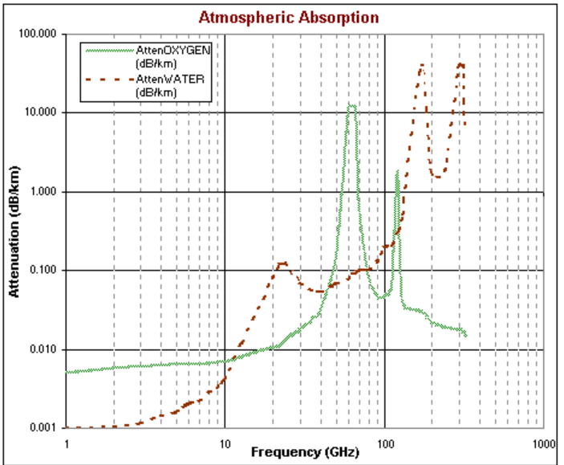
Figure 3.4: Atmospheric Attenuation vs. Frequency.

In the project we focused on the attenuation due to Rain and water vapor; because frequencies that will be used by 5G are the same as mechanical resonant frequencies of the gas molecules.
The formula for Rain attenuation: $α_{Rain}=aR^{b}$
where a and b are functions of operating frequency and rain temperature, the value of R [mm·h⁻¹] is for an exceedance of 0.01% of the time for point rainfall rates with an integration time of one minute.
The CI model inherently has an intrinsic frequency dependency of path loss already embedded within the FSPL term. A useful property of (3.79) is that 10n describes path loss in dB in terms of decades of distances beginning at 1 m.
The CI path loss model is based on fundamental principles of wireless propagation, dating back to Friis and Bullington, where the PLE parameter offers insight into path loss based on the environment, having a PLE value of 2 in free space (by Friis) and a value of 4 for the asymptotic two ray ground bounce propagation model (by Bullington). Standardizing to a reference distance of 1 m makes comparisons of measurements and models simple, and provides a standard definition for the PLE, while enabling intuition and rapid computation of path loss.
So that, the channel coefficients that we got from NYUSIM depends on CI path loss value and other values.
For example, some of the result we got after running the software, where frequency was 28 GHz, 800 MHz Bandwidth, 4 Transmitters and One Receiver, 50% Humidity, 30 dBm Power to transmit and 20 Celsius temperature over LOS environment was as follow:
Figure 3.5 shows how path loss values increase as T-R separation is increased, which is true because as distance increase, the signal will be more attenuated due to increase of obstacles and due to inverse relation between distance and power received.
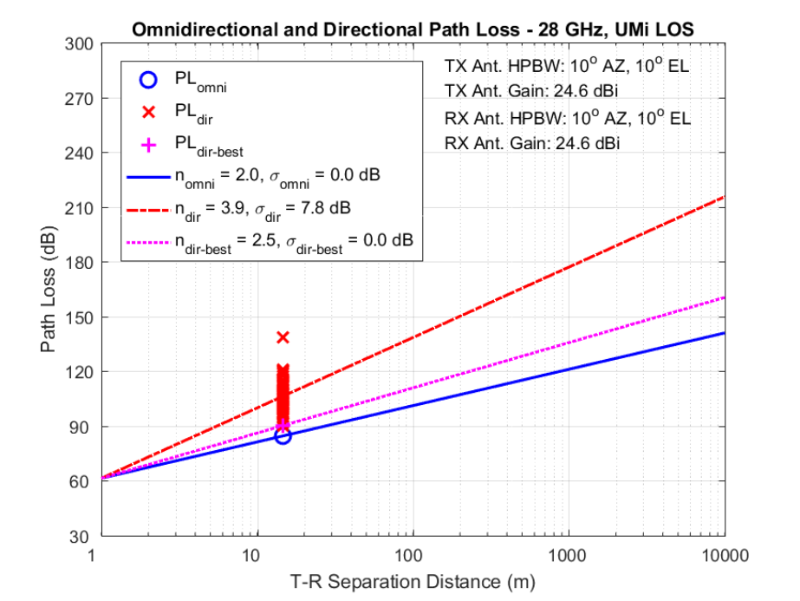
Figure 3.5: T-R separation Vs. Path Loss
Figure 3.6 next shows multiple values including Frequency, Time Delay, Power Received, Path Loss, Gain, and Azimuth and Elevation angles. From this figure we can see that$P_{R}= P_{T}-PL$, knowing that the P_{T} is 30 dBm.

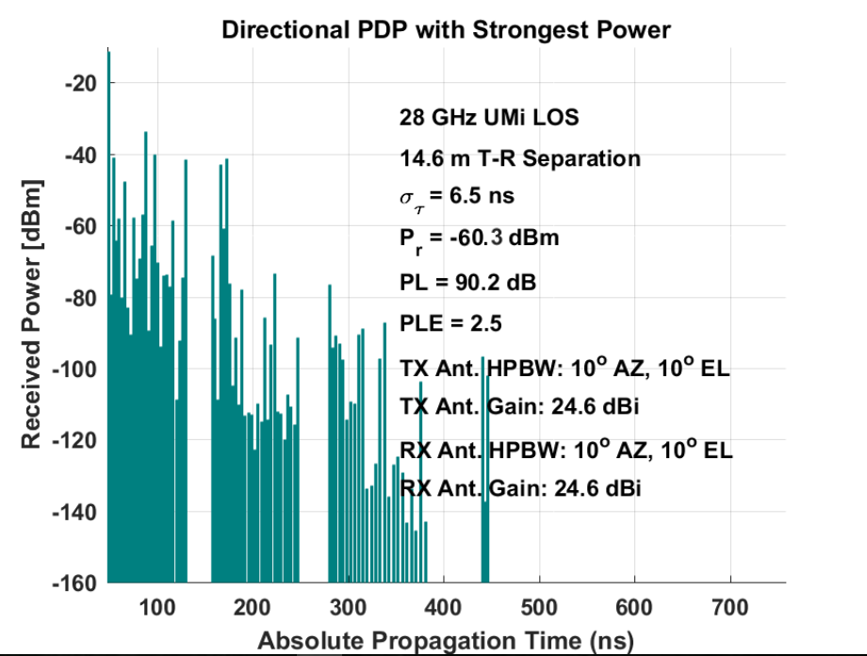
Figure 3.6: Power Received
After applying a Matlab code based on Path Loss values, Time Delay, Power Received, Phase, And Azimuth angle for both AOA and AOD, we will have the channel coefficients, where the number of channel coefficients depend on the number of transmitter and receiver. For example, the channel coefficients that we got for 4 Transmitter and 1 Receiver were 4 coefficients as follows:
Channel coefficients =10⁻³*[0.193 - 0.43i 0.465 - 0.402i 0.399 - 0.257i 0.218 + 0.111i], then we will apply these channel coefficients to be in the form of the equivalent virtual channel matrix EVCM where these 4 coefficients will be repeated to form a 4*4 channel matrix.
Equivalent Virtual Channel Matrix {CH} = $\left[\begin{matrix}0.193-0.43i & 0.465-0.402i & 0.399-0.257i & 0.218+0.111i \\ 0.465-0.402i & -0.193-0.43i & 0.218-0.111i & -0.399-0.257i \\ 0.399-0.257i & 0.218+0.111i & 0.193-0.43i & 0.465-0.402i \\ 0.218-0.111i & -0.399-0.257i & 0.465-0.402i & -0.193-0.43i\end{matrix}\right]$

After we got these channel coefficients in 4*4 matrix, these coefficients will be multiplied by Hadamard matrix H4 of order 4 (because we have 4 transmitters); to generate new Equivalent Virtual Channel Matrix.
$$H4=\left[\begin{matrix}1 & 1 & 1 & 1 \\ 1 & -1 & 1 & 1 \\ 1 & 1 & -1 & -1 \\ 1 & -1 & -1 & 1\end{matrix}\right]$$
Then, new Equivalent Virtual Channel Matrix will be:
$HH=H4 *CH$.
$$new EVCM=\left[\begin{matrix}1.93-4.3i & 4.65-4.02i & 3.93-2.57i & 2.18+1.11i \\ 4.65+4.02i & -1.93-4.3i & 2.18-1.11i & -3.99-2.57i \\ 3.93-2.57i & 2.18+1.11i & 1.93-4.3i & 4.65-4.02i \\ 2.18-1.11i & -3.93-2.57i & 4.65+4.02i & -1.93-4.3i\end{matrix}\right]$$
At receiver side, it will be received this channel coefficients (4*4) multiplied by original data added to them AWGN.
$$Y=new EVCM*AWGN$$

3.7 Massive MIMO Matlab Results
In this section, we will talk about the results that we got from Matlab by modeling Equivalent Virtual Channel Matrix (EVCM) [which is almost the same as Encoding Matrix, where in encoding matrix original symbols will be repeated, but in virtual matrix, channel coefficients will be repeated, which will result in a simple decoding techniques at receiver side]. The EVCM was tested using three coding techniques. At first, Conventional QO-STBC was used with no any modifications was added to improve quality. Then, Proposed QO-STBC was used, where Detection matrix was used to extract eigenvector, to generate a new virtual channel to improve performance. Finally, Proposed Hadamard which gave us the best performance.
The first type of the channel we worked on was Flat Fading channel, and by using a Matlab code, a comparison between three methods was made.
By comparing these techniques (Conventional, Hadamard and Proposed QO-STBC) in Figure 3.7, we can note that to achieve 10⁻² BER in case Conventional QO-STBC we need 7dB SNR, for Proposed Hadamard gives -7 dB SNR, and for Proposed QO-STBC gives -1 dB SNR, which means that the noise in Hadamard is higher than in Proposed QO-STBC and Conventional, but at the time it gives the same value of BER, which means Hadamard can handle more noise and give the same performance as the others.
Figure 3.7: Conventional, Hadamard and Proposed QO-STBC
Because Hadamard and Proposed QO-STBC give better performance than Conventional, another comparison was made to see performance between these two methods as in Figure 3.8:
Figure 3.8: Hadamard and Proposed QO-STBC Based on No. Of Tx
Figure 3.8 shows that if we increase the number of transmitter, Hadamard will also give a better performance. For example, at 10⁻² BER:
For 16*1 >> Hadamard gives 1.04 dB and QO-STBC gives 12.9 dB.
For 32*1 >> Hadamard gives -5.6 dB and QO-STBC gives 9.2 dB.
From the these previous results, and as we got before from Figure 3.7, Hadamard gives a better performance and can bear more noise and gives the same value of BER if also the number of transmitter is increased.
Then the type of modulation used was changed as shown next in Figure 3.9 and Figure 3.10, to see if Proposed Hadamard will give a better performance than Proposed QO-STBC for 64 Tx and 4 Rx.
Figure 3.9 shows that to achieve 10⁻² BER for Proposed QO-STBC:
Using 64QAM we need 13.4 dB SNR, for 32QAM gives 7.6 dB SNR, for QPSK gives -2.27 dB SNR, and for BPSK gives -9.96 dB SNR. This results show that when increasing order of modulation at the same value of BER, SNR will increase, which means that the power will increase with respect to noise, in other words using high order modulation require high power or a certain level of noise. Also, high SNR where power received is high, means that the distance between transmitter and receiver is small.
Figure 3.9: Changing order of Modulation for Flat fading Channel using Proposed QO-STBC.
Figure 3.10 next shows that to achieve 10⁻² BER for Proposed Hadamard:
Figure 3.10: Changing order of Modulation for Flat fading Channel using Proposed Hadamard.
As shown in Figure 3.10, to achieve 10⁻² BER for Proposed Hadamard:
Using 64QAM we need -8.3 dB SNR, for 32QAM gives -13.7 dB SNR, for QPSK gives -24.4 dB SNR, and for BPSK gives -29.26 dB SNR. This results show that when increasing order of modulation at the same value of BER, SNR will increase.
Comparing Figure 3.9 and Figure 3.10 in terms of coding techniques used, it can be shown that when using Proposed Hadamard coding technique performance will be better in terms of SNR. The previous two Figure shows that Proposed Hadamard will give a lower value of SNR at the same value of BER, in other words Proposed Hadamard can handle more noise, reach a longer distance between transmitter and receiver, and give the same performance as Proposed QO-STBC.
Since Proposed Hadamard gives a better performance in handling more noise, Figure 3.11 shows the relation between SNR and BER at 32QAM, where the number of transmitters is changed on flat fading channel.
Figure 3.11: Comparison on No. of TX using 32QAM for Flat Fading Channel.

As shown in Figure 3.11, we can note that to achieve 10⁻² BER:
Using 4Tx gives 8 dB SNR, for 16Tx gives -1.9 dB SNR, for 32Tx gives -10.17 dB SNR, for 64Tx gives -12.4 dB SNR, and for 128Tx gives -19.6 dB SNR. This results means that when increasing number of transmitters at the same BER, the value of SNR will decrease. If we want to compare based on worst case scenario, where is achieving better BER at lower SNR is required. Looking at these results the best performance is when using higher order of antenna. So, we use 128Tx antenna because it gives the lower SNR.
It can be observed clearly that when using higher order of antenna , it saves more SNR than when using lower order of antenna. We note that when using 128 antenna at transmitter, we will save 27.6 dB than using 4 transmitters.
Figure 3.12 show also the relation between SNR and BER but at 64QAM when the number of transmitters is changed on flat fading channel using Proposed Hadamard coding technique.
Figure 3.12: Comparison on No. of TX using 64QAM for Flat Fading Channel.
As shown in Figure 3.12, we note that to achieve 10⁻² BER:
Using 4Tx we need 13 dB SNR, for 16Tx gives 0.69 dB SNR, for 32Tx gives -4.5 dB SNR, for 64Tx gives -7.2 dB SNR, and for 128Tx gives -14.27 dB SNR. This results means that when increasing number of transmitters at the same BER, the value of SNR will decrease. If we want to compare based on worst case scenario, where is achieving better BER at lower SNR is required. Looking at these results the best performance is when using higher order of antenna. So, we use 128Tx antenna because it gives the lower SNR.
Comparing Figure 3.10 and Figure 3.11 in terms of order of modulation, when increase order of modulation, the value of SNR for each order of antenna will increase as was shown in Figure 3.9. So, as SNR increasing, we can use higher order modulation .From the previous two figures at 10⁻² BER, for 4 transmitters, and the same results for the other number of transmitters:
At 32QAM, the value of SNR = 8 dB, and at 64 QAM, the value of SNR = 13 dB
So, using 64QAM (high order modulation) in instead of 32QAM, the value of SNR will be higher, which mean small separation between Tx and Rx.
In Figure 3.13 next, SNR with BER comparison was made using 128 QAM, for 128 transmitters, and for one and two receivers:
Figure 3.13: Changing number of receiver and coding technique for Flat Fading channel, for 128 QAM.
As shown in Figure 3.13, we make a comparison based on number of receiver and on coding technique. For the number of received antenna, we note that to achieve 10⁻⁴ BER using Proposed Hadamard, using 128x2 gives -9.3 dB SNR, and for 128x1 gives -4.9 dB SNR, the results was as expected when increasing number of receivers at the same BER using the same use coding technique, the value of SNR will decrease. So, Based on this result using 128x2 better because it achieve the same BER at lower SNR.
Also we can compare based on the coding techniques used (Conventional, Proposed Hadamard and Proposed QO-STBC). We note that -10 dB SNR using 128x2: for Proposed Hadamard gives 0.00019 BER, for Proposed QO-STBC gives 0.64 BER, and for conventional gives 0.75 BER, these results mean that Proposed Hadamard achieves the lowest BER. So, it gives the best performance and it is the best coding technique to use.
In the end we will compare between three Figures (Figure 3.11, Figure 3.12 and Figure 3.13). The curve 128x2 at 32QAM, 64QAM, and 128QAM, we will observe that:
For 128x2 Proposed Hadamard at 32QAM → BER=10⁻² → SNR= -19.6 dB
For 128x2 Proposed Hadamard at 64QAM → BER=10⁻² → SNR= -15 dB
For 128x2 Proposed Hadamard at 128QAM → BER=10⁻² → SNR= - 14 dB
Noted that increase order of modulation, SNR will be increased at the same value of BER.
For Figure 3.14 next, SNR with BER comparison was made using 128 QAM, with 256 transmitters, and for one and two receivers:
Figure 3.14: Changing number of receiver and coding technique for Flat Fading channel, for 128 QAM.
As shown above in Figure 3.14, achieving 10⁻⁴ BER for 128 QAM using Proposed Hadamard require: for 2561*1 > -12.48 dB, and for 256*2 > -16.8 dB , so increasing number of receiver to 2 receivers for 256 transmitters, will enhance performance of system of roughly 4.32 dB. Comparing between 128 transmitter and 256 transmitter, if number of antenna transmitting is two receivers, then system to gain roughly 7.5 dB.
If we want to compare based on BER increasing number of transmitter and receiver, BER will be much lower and it will nearly perform as wireline channel (No fading).
After flat fading channel, NYUSIM which is based on real data measurements was used to get actual channel coefficient, to modeling this real channel Proposed Hadamard was used.
The same code used for Flat Fading will be used here for real channel, but the type of channel changed. In Flat fading we used random values to get channel coefficients, but NYUSIM tool give us a real channel coefficients.
After running code, the value of BER did not changed over range of SNR used, where the range of SNR used was from -20 to 30 dB, which indicate a high value of noise and low power received. In other words, and as known from PL equation used in this tool, low power received meaning that distance is too high, due to inverse proportional relation between distance and power received.
So that, we changed the range of SNR used to become from 20 to 80 dB and we got a result as will be shown next. The results we got indicates that at low SNR (high distance), we won’t receive any signal, which seek to prove the idea that mmWave which is based on high frequencies will not work on large distances, or in other words, it proves that mmWave will work on small cells.
The first comparison in Figure 3.15 was between the two coding technique; to make sure that if Proposed Hadamard in real channel will give as in flat fading channel a better performance.
Figure 3.15: Real channel using Proposed Hadamard and Proposed QO-STBC.
Figure 3.15 shows the same result as in Figure 3.7, where performance of Proposed Hadamard is better than Proposed QO-STBC, at the same value of BER, Hadamard will give a lower value of SNR than QO-STBC.
By using also the real channel coefficients, we made another comparison in Figure 3.16 between different order of modulation for 64 transmitters and 4 receivers, and by using Proposed Hadamard.
Figure 3.16: Changing order of Modulation for Real Channel using Proposed Hadamard.
Figure 3.16 shows that increasing the order of modulation, the value of SNR will be increased at a certain value of BER. In other words high order modulation need high value of SNR, which means small distance (Small cells). Also Figure 3.16 shows that BPSK works in the worst scenario, where high distance is required, and also it can handle more noise with respect to other higher order modulation.
We made also the same comparison as the previous, but we used Proposed QO-STBC as shown next in Figure 3.17:
Based on Eigenvectors of Proposed QO-STBC, the same result we got also when increasing order of modulation, where at a certain BER; increasing order of modulation will increase SNR, in other words received power increased and distance decreased.

Figure 3.17: Changing order of Modulation for Real Channel using Proposed QO-STBC.

Because Proposed Hadamard coding technique gives a better performance even on a Real Channel; in Figure 3.18 next, shows the relation between SNR and BER at 64QAM when the number of transmitters is changed on Real channel using Proposed Hadamard coding technique.
Figure 3.18: Comparison on No. of TX using 64QAM on Real Channel.
As shown next in Figure 3.18, where range of SNR is changed to indicates that 5G network will work on a small distance. The result we got for using real channel, was as the previous results when increasing number of transmitter.
For example: at 10⁻² BER:
For 4*2 >> SNR= 79.12 dB,,, For 16*2 >> SNR= 74.5 dB,,, For 32*2 >> SNR= 73.7 dB,,,
For 64*2 >> SNR= 59dB.
For 64 *2 gives the best behavior, because it achieves the same BER at the lowest SNR, and the system we want to work at; need to achieve better BER at lower SNR. And by using 64 transmitter we will obtain a gain of 20.12 dB compared when using 4 transmitters.
Figure 3.19 next the last result in this chapter will show the relation between SNR and BER as number of receiver is increased for real channel:
Figure 3.19: Changing number of receiver and coding technique for Real channel, for 128 QAM.
It is obvious from Figure 3.19 above that Proposed Hadamard will give the lowest of SNR at a certain value of BER, which gives Hadamard the best coding technique, as it can handle additional amount of noise and give the same behavior. Also, looking at these result at 10⁻³ BER, we obtain that implementing 128*2 that gives 61.88 dB will improve performance of system of about 8.92 dB than implementing 128*1 that gives 70.8.

Chapter Four: Beamforming

4.1 Introduction
Fifth generation networks are envisioned to ease the burden on the current infrastructure by offering significantly higher data rates through increased channel bandwidths. Considering the shortage of available frequencies traditionally used for mobile communications, mmWave bands became a suitable alternative. The large bandwidth available at these frequencies helps to offer data rates that satisfy 5G demands [9].
5G mmWave will suffer from high propagation losses that greatly vary depending on the environment. However, with these propagation losses introduced at the mmWave frequencies, an additional gain needs to be added to the system in order to be suitable for adopting at the next generation wireless communications. One important approach is to utilize the privilege introduced by the small size of the antenna elements at the mmWave frequencies to increase the directivity gain. So that, beamforming antenna arrays will play an important role in 5G implementations [10].

4.2 mmWave Beamforming
To achieve directional gain; either a large physical aperture or a phased array antenna must be employed. A large physical aperture is not possible due to a very costly installation and the expected maintenance costs related to wind loading and other misalignments. Thanks to the small wavelength of mmWave frequencies that facilitate the use of a large number of antenna elements in a compact form factor to synthesize highly directional beams corresponding to large array gains, while at the same time keeping individual antenna elements small and cheap.
The fundamental principle of mmWave beamforming; is to transmit identical information on each element of the array while varying the amplitude and/or the phase of the signal at each antenna. Or in other words, an appropriate beamforming scheme to focus the transmitted and/or received signal in a desired direction in order to overcome the unfavorable path loss in cellular communications at mmWave frequency bands [11]. The direction and shape of the array’s effective beam are controlled by the change of the phases and amplitudes of the individual antennas in the array [10].
So that, the small wavelength of mmWave frequency facilitates a support of beamforming using a number of antennas to form directive beams with large array gain, which makes it possible to combat the large propagation loss. Furthermore, while compensating the large path loss of the mmWave bands with use of an array beamforming technique (RF beamforming or analog beamforming), use of multiple chains and digital domain processing which support of MIMO techniques (baseband (BB) precoder) towards enhancing performance even further.
The application of beamforming in massive MIMO systems has the following advantages:
- Enhanced energy efficiency.
- Improved spectral efficiency.
- Increased system security.
- Applicability for mmWave bands.

4.3 mmWave Beamforming Architectures
The limited use of this mmWave band is a result of adverse propagation effects in particular due to obstacles in the NLOS. Several transceiver architectures have been developed to compensate these issues by focusing the received or transmitted beams in a desired direction. All these solutions make use of smaller antenna element sizes due to higher carrier frequencies that enable the construction of larger antenna arrays.
Two variables are used for beamforming: Amplitude and phase. The combination of these two factors is used to improve side lobe suppression or steering nulls. Phase and amplitude for each antenna elements are combined in a complex weight. The complex weight is then applied to the signal that is fed to the corresponding antenna [9].

4.3.1 Analog Beamforming
Analog beamforming or RF beamforming, one of the simplest approaches to improve the directivity gain in mmWave systems, where a single RF chain with only a single analog-to digital converter (ADC) and digital-to-analog converter (DAC) is used. A network of phase shifters is used to control the phase of the signal fed to the antenna array [10].
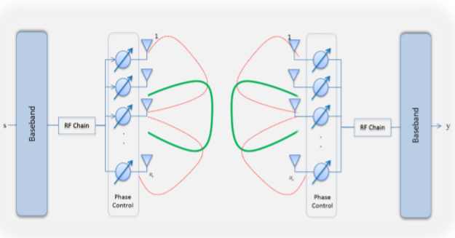 Figure 4.1: Analogue Beamforming system with single RF chain used at the transmitter and another at the receiver [10].

Consider the mmWave MIMO system shown in Figure 4.1 in which a base station with Ntx antennas transmits Ns data streams to a user with Nrx antennas. The transmitter is equipped with one RF chain. On the other hand, the receiver is assumed to support also one RF chain. The transmitter applies an Ntx ×$N_{c}^{t}$ ($N_{c}^{t}$: Number of RF chain at transmitter) RF beamformer weight matrix. Here, the RF beamformer weight could be implemented using VGAs and phase shifters that are connected with the antennas.
The RF beamforming gain obtained by controlling phase and magnitude of input signal to each antenna in such a way that the transmit/receive output signals from/to the antennas constructively form a directive beam(s) to a particular direction(s). However, the RF beamforming gain acquired by array antenna structure entails trade-off between array gain and beamwidth. That is, for a linear array, the larger array gain we can achieve to a particular direction with the larger number of antennas while the narrower the beamwidth of the directive beam becomes.
An analog beamforming pattern is generated by a digitally controlled RF phase shifter with q bits per element, meaning that each antenna’s phase takes one value $φ_{m}$ among a size 2 ^{q} set of quantized phases given by:
$φ_{m}∈\left\{0, 2π\left(\frac{1}{2^{q}}\right),2π\left(\frac{2}{2^{q}}\right), …, 2π\left(\frac{2^{q}-1}{2^{q}}\right) \right\}$ (4.1)
To further demonstrate the principle of analog beamforming, consider a MIMO communication system with transmit beamforming vector f and a receive beamforming vector, also known as the combining vector w. Using s as the information to be transmitted, the system input-output relationship can be written as:
$y=w^{*}Hfs+w^{*}n$ (4.2)
H is the mmWave channel, and n is the noise, and f implemented using phase shifters and is defined with the quantized phases $φ_{m}$ and written as:
$f= \frac{1}{\sqrt{M}}{\left[1 e^{-j2π(d/λ)sin⁡(φ1)} …e^{-j(M-1)2π(d/λ)sin⁡(φ1)} \right]}^{T}$ (4.3)
Where M: number of array elements, which is equal to Ntx, d is the distance between elements and is equal to$λ/2$ , $λ$ is wavelength, and T is the number of paths. The performance of the analog beamforming in this case is limited by the use of quantized phase shifts and the resulted phase quantization error can be found. This makes it more challenging to finely tune the beams and steer nulls.
The accurate selection of the beamforming and combining vectors results in an increased channel gain |w ∗ Hf|, with the maximum gain is achieved by setting f to the dominant left singular vector of H and w to the right singular vector [10].

4.3.2 Digital Beamforming
Digital Beamforming DBF or Baseband precoder, plays an important role in the field of wireless communication. It provides all the benefits of digital domain. Bulky and costly phase shifters and amplifiers used in Analog Domain are replaced by simple multiplication in Digital Domain, which can be performed by a simple computer. Digital Beamforming is performed where each antenna element is connected to a separate RF chain.
Consider the mmWave MIMO system shown in Figure 4.2 in which a base station with Ntx antennas transmits Ns data streams to a user with Nrx antennas.
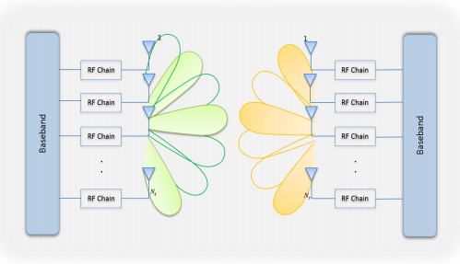 Figure 4.2: Digital beamforming architecture. Full complexity system with an RF chain connected to each antenna in the array [10].
The transmitter is equipped with $N_{c}^{t}$ chains. On the other hand, the receiver is assumed to support $N_{c}^{r}$ chains. The transmitter applies a $N_{c}^{t}$× Ns baseband (BB) precoder matrix. Where this BB precoder weights are processed in the digital domain.
The DBF transmitter has three main stages [12]: the CWM stage, the Digital-Up Converter (DUC) stage, and the RF Modulation Stage. The RF Modulation is not part of the Digital Beamformer, but it is important in the implementation of the Phased Array Antenna.
Complex Weight Multiplier (CWM) stage controls the amplitude of the in-phase and quadrature signals prior to the Digital-Up Conversion. Then DUC receives two baseband signals (in-phase and quadrature signals) and modulates these signals into a single real band pass signal [12].
For an orthogonal frequency-division multiplexing (OFDM) system, digital beamforming is carried out on a subcarrier basis before the inverse fast Fourier transform (IFFT) operation at the transmitter and after the FFT operation at the receiver, whereas analog beamforming is performed in the time domain after the IFFT operation at the transmitter and before the FFT operation at the receiver.
In general, digital beamforming provides a higher degree of freedom and offers better performance at the expense of increased complexity and cost due to the fact that separate FFT/IFFT blocks (for OFDM systems), digital-to-analog converters (DACs), and analog-to-digital converters (ADCs) are required per each RF chain. Analog beamforming, on the other hand, is a simple and effective method of generating high beamforming gains from a large number of antennas but less flexible than digital beamforming [11]. It is this trade-off between flexibility/performance and simplicity that drives an advanced hybrid beamforming algorithm, exploiting both analog and digital domain beamforming, which not only offers sharp beamforming to cope with the propagation loss but also allows advanced digital domain processing such as multi-beam MIMO with manageable complexity.

4.4 Beamforming Matlab Results
In this chapter, we will talk about the results that we got from Matlab by modeling a MIMO system with beamforming. In order to do so, the same things that we did for testing MIMO system will be used here in addition to vectors that represent beamforming.
Looking at equation (4.2), where received signal $y=w^{*}Hfs+w^{*}n$
From this equation we need to find f, H, and w. H will be the same as for MIMO system, where EVCM will be used (channel coefficients will be repeated not original data symbols).
For beamforming vectors or weight vectors f will be generated at transmitter side and multiplied with original data before transmitting signal.
Beamforming vectors consist of beamforming vector multiplied by array factor vector, where array factor depicts the spatial response of antenna array in space. The number of weight vectors will be generated based on the number of array elements and number of RF chain, each element will have its own vector (in other words its own amplitude and phase). And based on equation (4.3), weight vector for each antenna element will be: $f= \frac{1}{\sqrt{M}}{\left[1 e^{-j2π(d/λ)sin⁡(φ)} …e^{-j(M-1)2π(d/λ)sin⁡(φ)} \right]}^{T}$
$φ$ That used for each vector is a value from the equation (5.1), and we work on q = 3 bits.
And array factor vector will be $AF= \left[1 e^{j[kd\cos\left(φ\right)+ β]} …e^{j(M-1)[kd\cos\left(φ\right)+ β]} \right]$
Array factor vector coefficients is k, d, $φ$ and β.
Where, $k=\frac{2π}{λ}$, $d=\frac{λ}{2}$, and $β=-kd\cos\left(φ\right)$
So that, array factor will be multiplied with weight vector, and the result will be multiplied with original data. At receiver side, we will receive$Hfs+n$, in order to extract original data, the received signal will be multiplied by combining vector w. w must equal to f in order to find original data, so received signal will be multiplied with $w^{*}$ which is equal to f.
First of all, at flat fading channel we compare between MIMO system without BF, MIMO with analog BF, and MIMO with Digital BF, as shown in Figure 4.3 next:
Figure 4.3: Comparison between MIMO, MIMO Analog BF, and MIMO Digital BF on flat fading channel.
The result that we got from the previous Figure 4.3 shows that implementing beamforming to MIMO system will enhance performance of system, will make MIMO system even more robust against errors than without using beamforming.
From Figure 4.3: for a 10⁻³ BER, SNR for a MIMO system is about 7.98 dB, for MIMO analog BF is -2.6 dB, and for MIMO DBF is -12.27 dB. We benefit from these values, implementing an analog BF will obtain a gain in the system of almost 10.58 dB, and implementing digital BF will gain almost 20.25 dB compared to MIMO system. So that, implementing either an analog BF or digital BF will make system more reliable, more robust, and will also allow system to transmit to a higher distance compared to MIMO system only as values of SNR is decreased when using beamforming.
Then, we compared between analog BF and digital BF, as shown next in Figure 4.4:
Figure 4.4: Comparison between Analog and Digital beamforming on flat fading channel.

Figure 4.4 shows that digital beamforming will allow system to handle more noise compared to analog beamforming when compared at specific value. For 10⁻³ BER, digital BF will obtain a gain of almost 11 dB in compare with analog BF.
As we did for MIMO system in the previous chapter, we will use MIMO analog beamforming to compare between Proposed Hadamard and Proposed QO-STBC coding technique, as will be shown in the next Figure 4.5:
Figure 4.5: Comparison between Proposed Hadamard and Proposed QO-STBC on Flat Fading channel.

From Figure 4.5, we can see that using Proposed Hadamard will obtain a gain of 6.6 dB than using Proposed QO-STBC for 10⁻³ BER, and that Hadamard can handle more noise and give the same performance.
Also, when comparing this Figure 4.5 with Figure 3.7, at 10⁻³ BER: by using Hadamard we obtain a gain of 8.5 dB, and by using QO-STBC we obtain also a gain of 5 dB. These results mean that Hadamard even when applying beamforming to MIMO system will give a better performance.
Then, in Figure 4.6 we increase number of transmitters for this flat fading channel with analog beamforming and based on Proposed Hadamard.
As we can see from Figure 4.6, increasing number of transmitter will enhance performance of system. For 10⁻² BER, 32 transmitters will give the best behavior, will give the lowest SNR at the same value of BER, which means it will handle more noise and give the same performance as the other lower order of transmitters. For 32 transmitters we will get almost 10.5 dB gain with respect to 4 transmitters.
Figure 4.6: Changing number of transmitter for analog beamforming for Flat fading channel.
We can compare also this Figure 4.6 with Figure 3.11, we can see that MIMO analog beamforming will give better performance when compared to a pure MIMO system. For 10⁻² BER, we will gain 2.83 dB when adding beamforming for 32 transmitters, 9.1 dB gain will be obtained when using 16 transmitters, and 10.5 dB gain will be added to MIMO system when performing beamforming to 4 transmitters.
In Figure 4.7 next, changing order of modulation for MIMO analog beamforming system:
As we can see from Figure 4.7 where order of modulation changed, increasing order of modulation at certain value of BER will increase value of SNR. Which means that high order of modulation work on small cells due to required high value of SNR, or in other words, it cannot handle too much amount of noise.
Figure 4.7: Changing order of modulation for analog beamforming for Flat fading channel.
When comparing this Figure 4.7, with Figure 3.11 and Figure 3.12; the result of comparison shows how implementing beamforming to MIMO will enhance system even more. For 32QAM, and at 10⁻² BER, beamforming will make MIMO system to gain roughly16 dB, and for 64QAM, and at 10⁻² BER, a gain of roughly 19 dB when implementing beamforming to MIMO system.
After flat fading channel, NYUSIM which is based on real data measurements was used to get actual channel coefficient, we model this real MIMO channel with beamforming and by using Hadamard coding technique.
The same code used for Flat Fading above was used here, but the type of channel changed. In Flat fading we used random values to get channel coefficients, but NYUSIM tool give us a real channel coefficients.
After running code, the value of BER did not changed over range of SNR used, where the range of SNR used was from -20 to 10 dB, which indicate a high value of noise and low power received. In other words, and as known from PL equation used in this tool, low power received meaning that distance is high, due to inverse proportional relation between distance and power received.
So that, we changed the range of SNR used to become from 20 to 80 dB and we got a result as will be shown next. The results we got indicates that at low SNR (high distance) we won’t receive any signal, which seek to prove the idea that mmWave which is based on high frequencies will not work on large distances, or in other words, it proves that mmWave will work on small cells.
The same comparison between MIMO system, MIMO analog beamforming, and MIMO digital beamforming was made but here on a real channel as shown next in Figure 4.8:
Figure 4.8: Comparison between MIMO, MIMO Analog BF, and MIMO Digital BF on Real channel.

Also for a real channel, analog and digital beamforming will give a better performance in compare with a pure MIMO system. Digital beamforming will give a gain of almost 20 dB with respect to MIMO system, and in analog beamforming will obtain a gain of almost 10 dB with respect to MIMO. This figure also proves that implementing MIMO with beamforming will give the best performance of system.
In Figure 4.9 next, we compare between Two coding technique Proposed Hadamard and Proposed QO-STBC on real MIMO channel with beamforming, and the result was as follows:
Figure 4.9: Real channel using Proposed Hadamard and Proposed QO-STBC with beamforming MIMO.
The previous Figure 4.9 shows that Proposed Hadamard will give a better performance when compared to Proposed QO-STBC. For 10⁻² BER, Proposed Hadamard gives 45.04 dB SNR, and Proposed QO-STBC gives 51.25 dB SNR. So that, Hadamard will handle more noise, reach a longer distance and gives the same performance as QO-STBC for the same value of BER.
Looking at Figure 3.15, form these two figures we notice that implementing beamforming to MIMO system will give a better performance. For 10⁻² BER, implementing beamforming using Hadamard will enhance system by 10.96 dB, and by using QO-STBC, will enhance by 9.75 dB.
Figure 4.10 next shows increasing number of transmitter on real channel:
As in flat fading channel, in real channel modeling we found that increasing the number of transmitters will make MIMO beamforming system more robust against errors. By using higher order antennas, we can achieve a very good BER, while in contrast distance between transmitter and receiver will be reduced.

Figure 4.10: Changing number of transmitter for analog beamforming for real channel.

For 10⁻² BER, 16 transmitters give 54.84 dB, 8 transmitters give almost 62.44 dB, and 4 transmitters give 64.41 dB. So that, 16 transmitter will obtain a gain of 9.57 dB in compare to 4 transmitters.
This Figure 4.10 can be compared with Figure 3.18 at 10⁻² BER, and we realize that: using 16 transmitter with beamforming will allow MIMO system to gain 19.66 dB, and using 4 transmitters will allow MIMO system to gain 14.71 dB.

Chapter Five: Duplexing

5.1 Introduction
Next generation wireless communication networks are required to provide a signiﬁcant increase in the achieved data rates. Accordingly, deploying different techniques that help give the necessary performance boost is essential [13].
Wireless communication systems are fundamentally limited by the availability of the electromagnetic spectrum in which they must operate. Consequently, increasing spectral efﬁciency has been a major focus of research over recent decades, and given the exponential growth in demand for radio services, spectral efﬁciency will continue as a key research driver for years to come. Radio signals attenuate quickly with distance, and therefore in radio systems the transmit signal powers are typically much higher than receive signal powers [15].
Nowadays spectrum resources are divided between transmit and receive channels either in time, using Time Division Duplexing (TDD), or frequency, using Frequency Division Duplexing (FDD). However, since the 1980s, and particularly in recent years, research has challenged this paradigm, proposing new system architectures utilizing various techniques to provide high levels of transmit to receive isolation, thus allowing simultaneous transmission and reception at the same frequency. This division free duplexing, often referred to simply as full duplex wireless [15].
Full-duplex wireless communication, in which transmission and reception occur at the same time and in the same frequency band, has the potential to as much as double the spectral efﬁciency or capacity of TDD or FDD systems without increasing bandwidth [16].
However, the main hurdle that limits the capacity gain is the high self-interference (SI) caused by a node’s transmit signal generates high-powered interference to its own receiver and by avoiding this problem, full duplex technique can be achieved. Recently, the evolution in the SI cancellation has revived the attention to full duplex communication. To achieve in-band full duplex communication, the self-interference must be reduced to an acceptable level at the receiver. Any residual self-interference will effectively increase the receiver noise ﬂoor, reducing the capacity of the receive channel. To achieve the theoretical two-fold capacity increase, inﬁnite isolation would be required. Inﬁnite transmitter-receiver (TX-RX) isolation is not practically feasible; however, provided the isolation is high enough such that the residual self-interference is at least some 5 dB or so below the receiver noise ﬂoor, then the impact on the receive performance will be negligible. [15].

5.2 Flexible Duplexing
Recent interest in full-duplex radio has produced novel transceiver architectures which provide high transmit to receive (Tx-Rx) isolation, promising to double link capacity by allowing simultaneous transmit and receive on the same frequency. However, techniques for isolating the transmitter and receiver are not only applicable to full duplex communication, but should be considered in the wider context of ﬂexible duplexing. A ﬂexible duplexer would prevent self-interference and allow simultaneous transmission and reception at any combination of transmit and receive frequencies. Flexible duplexing could bring a range of beneﬁts to future communications systems, including [14]:
- In-band Full-duplex communication: If self-interference can be sufﬁciently suppressed, then division free duplexing is possible, requiring just half the spectral resources as compared to Time Division Duplexing (TDD) or Frequency Division Duplexing (FDD). This can theoretically double link capacity.

- Multipurpose spectrum usage: In-band Full-duplex operation could enable base-stations to provide simultaneous access and backhaul in the same band. This could, for example, be highly beneﬁcial for the mmWave mesh networks being studied as a possible 5G backhaul solution.

- FDD transceiver cost reduction: Radio architectures in today’s mobile handsets commonly use multiple off chip components for duplexing and ampliﬁcation in multiple bands. Due to the limited tunability of acoustic resonator duplexing ﬁlters, and limited Power Ampliﬁer (PA) bandwidth, multiband FDD operation is currently achieved by duplicating these components for each operating band, and using RF switches for band selection. A fully ﬂexible duplexing architecture could replace all of these components, reducing the bill of materials cost, and providing an economy of scale beneﬁt by enabling the manufacture of a single device for the global market.

- Enhanced roaming capabilities: The increased size and cost associated with current multiband architectures means that present day 4G handsets typically support only a subset of FDD bands. Different devices are manufactured, supporting different band combinations as required in different global regions, thus limiting roaming capabilities. A fully ﬂexible duplexer would eliminate this problem.

5.3 Enabling Technologies
To achieve the high levels of isolation required for full duplex operation, analogue cancellation and digital cancellation are important enabling technologies. However, duplex isolation can also be provided by the antenna system and/or antenna coupling network. Antenna based isolation methods are highly applicable to ﬂexible duplexing, as sufﬁcient isolation achieved through antenna based methods would render cancellation unnecessary for FDD operation [14].
Antenna based suppression methods can provide signiﬁcant isolation, however these designs require additional antennas which is a disadvantage in applications where device size and form factor are important considerations. Antenna separation, uses separate transmit and receive antennas and is a simple and effective method of achieving TX-RX isolation. Shielding, radiation pattern, and polarization can be exploited to improve isolation, however the achievable isolation is fundamentally limited by the physical separation of the antennas. Antenna cancellation, involves positioning transmit antennas such that their radiated signals interfere destructively at the receive antenna(s), but the isolation offered by this technique is signiﬁcantly reduced in multipath environments. The multi-antenna techniques mentioned above are well suited to applications such as cellular base stations, however the increase in device cost and size due to the additional antennas make these techniques less attractive for smaller devices such as smartphones and tablet computers.
Single antenna duplexing architectures based on circulators have been tested. However, circulators are typically bulky, expensive, and have limited bandwidth and tunability, and therefore are not well suited to a small form factor ﬂexible duplexing architecture. Recent advances in electronic circulator technology promise to mitigate these problems, and although currently only a proof of concept, this may be an important enabling technology in years to come.
An alternative single antenna duplexing technique is Electrical Balance (EB) duplexing, which can provide high Tx-Rx isolation, is tunable over wide frequency ranges, and can be implemented on-chip, making it well suited to ﬂexible duplexing in small form factor devices [14].

5.4 Electrical Balance Duplexing
Transformer based isolation methods were ﬁrst developed in the early 20th century for use in wired telephony systems. In an analog telephone, the microphone and earpiece must both be connected to the telephone line, but the microphone signal must be isolated from the earpiece to prevent the users own speech deafening them to the much weaker audio signal being received. This early application is entirely analogous to the requirements of single antenna full duplex wireless transceivers, where the Tx and Rx must both be coupled to the same antenna, but high Tx-Rx isolation is required [13].
Recent research has investigated using electrical balance in hybrids for implementing wireless FDD. The multiple off-chip required for FDD operation could potentially replace with multiband cellular handsets, thus reducing their cost and size. This technique, sometimes referred to as electrical balance isolation (EBI) is, however, equally applicable to the full duplex wireless systems, although for full duplex operation the isolation requirements are much higher than for FDD.
EB duplexing exploits electrical balance in a hybrid junction to achieve high Tx-Rx isolation. A number of transformer conﬁgurations can be used, including auto-transformers, 90 or 180 hybrid couplers, and hybrid transformers. In our report, we will talk about four port hybrid transformer.
Figure 5.1 depicts a hybrid transformer based EB duplexer and deﬁnes the Differential Mode (DM), and Common Mode (CM) signals at the receiver input. EB duplexers must not only provide high DM isolation in order to reduce self-interference, but must also protect the receiver from CM signals, which can cause Low Noise Ampliﬁer (LNA) device breakdown due to the large voltage swing at the LNA input. The operation of the EB duplexer depicted in figure 1 is, The Tx current supplied by the Power Ampliﬁer (PA) enters the hybrid at the center tap of the primary winding and is split between two paths ﬂowing in opposite directions, with one component ﬂowing to the antenna (and being transmitted), and the other to the balancing network.
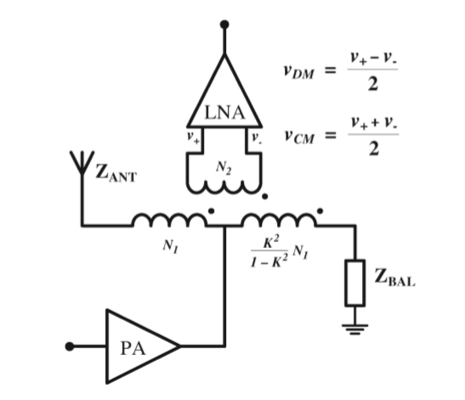
Figure 5.1: Hybrid transformer providing TX-RX isolation using electrical balance [15].
The relative magnitudes of these currents is determined by the coupling coefﬁcient, K. The balancing impedance is adjusted such that these two currents create equal but opposite magnetic ﬂuxes that cancel, and therefore zero current is induced in the secondary winding and the receiver is completely isolated from the transmitter. Conversely, a signal received by the antenna causes current to ﬂow through the primary winding in one direction, thereby coupling it to the receiver winding. There is, of course, some loss associated with the duplexer. Some Tx power is dissipated by the balancing network, instead of being transmitted, and not all of the Rx power is coupled to the LNA.
DM TX-RX power gain of an ideal EB duplexer is:
$G_{TX_RX}=L{|Γ_{BAL}-Γ_{ANT}|}^{2}$ (5.1)
Where Γ_{BAL} and Γ_{ANT} are the complex reﬂection coefﬁcients of the balancing network and antenna respectively, and where L is a constant scaling factor which depends on the coupling coefﬁcient such that$L= K^{2}(1-K^{2})$.
From equation 5.1, we can see that isolation depends on how closely Γ_{BAL} can match Γ_{ANT}, and therefor how closely the balancing impedance can match the antenna impedance. However, due to moving objects in the local environment, Γ_{ANT} may be time variant and therefore, the system must be adaptive.
In order to obtain high isolation, the balancing impedance must be as close as possible to the antenna impedance. For purely resistive loads, high isolation can be achieved over wide bandwidths, however, in practice the antenna impedance seen by the hybrid transformer is frequency dependent.
- Balancing Topologies
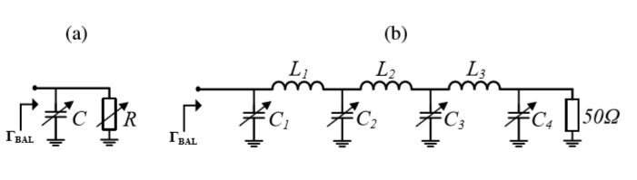
Figure 5.2: Balancing network topologies. (a) Single pole parallel RC circuit balancing. (b) triple-π network balancing [14].
In Figure 5.2, we can see two types of possible balancing topologies. The first part is Single pole RC circuits, where impedance of this circuit cannot be simultaneously controlled at more than one frequency, and therefore the duplexer can typically be balanced at one frequency point only. A triple-π balancing network topology allows the balancing impedance to be simultaneously controlled at two frequency points.
- Single Pole Balancing calculations
In our project we will study single pole, where balancing can be obtained at a single carrier frequency or across a band.
- Balancing at Carrier frequency
If antenna reﬂection coefﬁcient is a frequency dependent Γ_{ANT} (ω), and Γ_{BAL} is frequency invariant, the frequency dependent TX-RX power gain of the duplexer is given by
$G_{TX_RX}=L{|Γ_{BAL}-Γ_{ANT}(wc)|}^{2}$ (5.2)
In order to determine the balancing impedance is to set it to be equal to the antenna impedance at the carrier frequency $Γ_{BAL} = Γ_{ANT}(wc)$ (5.3)
Although this provides very high isolation at the carrier frequency, variation in the antenna impedance with frequency drastically reduces the isolation as we move away from this frequency. Since the self-interference power is spread across the transmit bandwidth, setting the balancing impedance to obtain high isolation at a single frequency point is not necessarily useful if this results in poor isolation at other frequencies in the transmit band. Instead, we wish to maximize the SNR at the receiver, and therefore we wish to ﬁnd the optimum balancing impedance which minimizes the total self-interference power across the entire band [15].

- Optimum Balancing Impedance
To minimize the self-interference power at the LNA, we must minimize the mean of the Tx-Rx gain across the band. Minimum Mean Square Error (MMSE) is used to find optimum impedance.
${G_{Tx_Rx}}_{MMSE} =\min_{Γ_{BAL}}\overline{\left\{L|{Γ_{BAL}-Γ_{ANT}(w)|}^{2}\right\}}$ w1 < w < w2 (5.4)
${G_{Tx_Rx}}_{MMSE} =L \min_{Γ_{BAL}}\left\{\frac{1}{w2-w1}\int_{w1}^{w2}{{|Γ_{BAL}-Γ_{ANT}(w)|}^{2}} dw\right\}$ (5.5)
Where ω2 and ω1 are the upper and lower band limits respectively. It can be shown that the minimizer,${Γ_{BAL}}_{MMSE}$ is given by:
${Γ_{BAL}}_{MMSE}= \frac{1}{w2-w1}\int_{w1}^{w2}{Γ_{ANT}(w)} dw$ (5.6)
Then, for a purely resistive antenna ${Γ_{BAL}}_{MMSE} = \overline{Γ_{ANT}(w)}$ w1<w<w2 (5.7)
In the case of complex impedance ${Z_{BAL}}_{MMSE} =Zo\frac{1+ \overline{Γ_{ANT}(w)}}{1- \overline{Γ_{ANT}(w)}}$ w1 < w < w2 (5.8)
Then, at this optimum point, Tx-Rx isolation is maximized and given by:
${G_{Tx-Rx}}_{MMSE}(w)=L{|{Γ_{BAL}}_{MMSE}-Γ_{ANT}(w)|}^{2}$ (5.9)
Then the balancing impedance can be realized using a series RC or RL circuit, depending on the sign of the imaginary part of the balance impedance as in figure 5.2(a) [15].

5.5 Duplexing Matlab Simulink
By using Matlab Simulink, a simulation was made by using three winding transformer representing Hybrid transformer, and the same circuit as shown in Figure 5.1,was build.
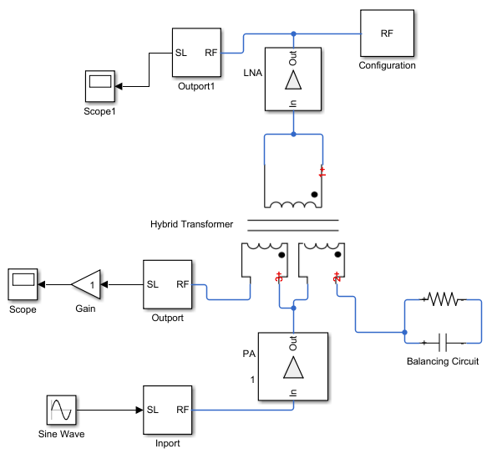
Figure 5.3: Simulink Hybrid Transformer and Balancing circuit.
As we can see from Figure 5.3 previously, data will go through power amplifier (PA), divided into two equal opposite fluxes current. Coupling factor = 0.84, L1 = 15.3nH, L3 = 2.24nH, and L3=L1*(K²/1- K²) in order to generate two equal current magnitude. And the value of RC circuit which depends on antenna impedance, will be adjusted such that these two currents create equal but opposite magnetic ﬂuxes that cancel, and therefore zero current is induced in the secondary winding and the receiver is completely isolated from the transmitter.
As we can see from Figure 5.4, the first part represent LNA output, where output is zero which means there is no signal reached Rx side, so that LNA (representing Rx side) will be isolated from transmitted signal. And the second part represent amplified signal that will be transmitted.
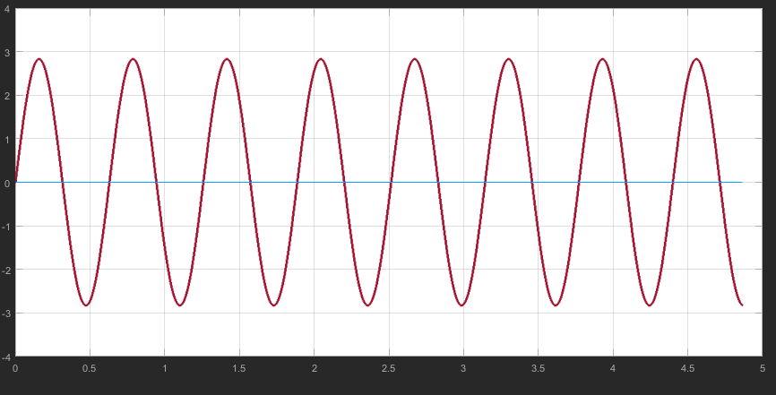
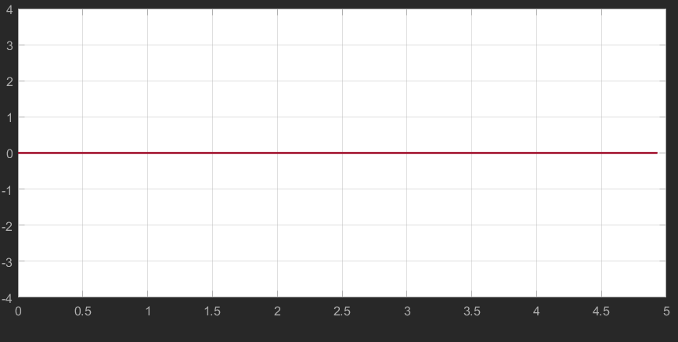
Figure 5.4: Results from Simulink: LNA Output, and Antenna output.

Chapter Six: Conclusion and Future Work

6.1: Conclusion
Fifth generation consist of 5 technologies. In our graduation project we studied 4 technologies, which are mmWave, massive MIMO, beamforming, and full duplexing, and mainly we focused on studying propagation channel characteristic under these technologies.
For the first semester, we saw that mmWave spectrum (3-300 GHz) is one key enabling solution due to abundant amounts of unused spectrum. For massive MIMO we started with Alamouti code (STBC) which was the first technique that came with idea of transmitting multiple copies of data across a number of antennas in order to make use of various received versions of the data to improve the reliability of data transfer. Then we moved to QO-STBC, because 5G network will use massive MIMO, where number of antenna will be 64 and more, and increasing number of antennas to more than two antennas will make matrix that will represents channel quasi-orthogonal. In order for us to test MIMO propagation channel, analytical model which has a new approach for QO-STBC was tested using Matlab to find EVCM, also a statistical model such as SV model was tested, and we used an open source tool called NYUSIM which take real measurements to see effect of path loss compare to humidity, rain rate, number of transmitter and receiver (we see effect of rain rate and humidity because 5G frequencies are the same as the resonant frequency for these two attenuator).
In this semester, we continued our testing on 5G propagation channel. We tested a flat fading channel and a real channel (channel coefficients taken from NYUSIM). For both channels, first we compare between coding techniques and concluded that Hadamard will give the best behaviour when comparing between SNR and BER. Then we increased number of transmitted antennas to 256 antenna for flat fading channel and for real channel, and we realized that at specific value of BER, as number of antenna increased, the value of SNR will be reduced, which means that increasing number of antenna will enhance performance of system, will make system more robust against errors, also we saw from real channel results that there will be a signal only at high values of SNR and high SNR means that power received is high and the separation between transmitter and receiver is small, which proves idea of that 5G will work on small cells. Also we changed the order of modulation, we concluded that to obtain high SNR or small cells, we need high order of modulation.
Then we moved to beamforming, where each element in MIMO system will have its own amplitude and phase to generate a directional gain. There are two architecture for beamforming, analog and digital beamforming. We tested propagation channel based on these two architecture. We realized that adding beamforming to a MIMO system will give the ultimate system, because it will enhance performance of system of almost 20 dB when using digital beamforming, and by 9.5 dB when using analog beamforming. Beamforming was also tested for a flat fading and real channel, also increasing number of antennas will improves system even more, and we also reached that increasing order of modulation will be available only at high SNR, in other words in small cells.

The last thing we did, was to see if full duplex can be achieved, and how can we implement it. Through our research we reached that full duplex can be achieved. In our project we studied how to implement full duplex on a single antenna which will be by using a Hybrid transformer, connected to a single pole balancing circuit.

6.2: Future Work
A lot of things that can be done to complete our project. Such as testing real channel for larger number of antennas more than we did (we reached 128 transmitters), also test Hybrid architecture beamforming. Also seeking other techniques to implement full duplexing, also spatial modulation would be an interesting subject to investigate.

Reference

[1] T. S. Rappaport, G. R. MacCartney, M. K. Samimi, and S. Sun, Wideband Millimeter-Wave Propagation Measurements and Channel Models for Future Wireless Communication System Design.
[2] S. Sun, G.R. MacCartney, T. S. Rappaport, A Novel Millimeter-Wave Channel Simulator and Applications for 5G Wireless Communications.
[3] Ramanagoud Biradar, Dr.G.Sadashivappa, Study and Analysis of 2x2 MIMO Systems for Different Modulation Techniques using MATLAB.
[4] Study Paper on Multiple-Input Multiple-Output (MIMO) Technology
[5] Weifeng Su, S. N. Batalama, D. A. Pados, On Orthogonal Space-Time Block Codes and Transceiver Signal Linearization.
[6] R. Grover, Weifeng Su, D. A. Pados, An 8×8 Quasi-Orthogonal STBC Form for Transmissions over Eight or Four Antennas.
[7] Y.A.S. Dama, R.A. Abd-Alhameed, T.S. Ghazaany, S. Zhu, A New Approach for OSTBC and QOSTBC.
[8] Y.A.S Dama, H. Migdad, W. Shuaieb, E. Elkazmi, Eshtiwi A. Abdulmula, R.A. Abd-Alhameed, W. Hammoudeh, and A. Masri, A new approach for implementing QO-STBC over OFDM.
[9] Rohde & Schwarz Millimeter-Wave Beamforming: Antenna Array Design Choices & Characterization.
[10] Hatem H. Abbas, Beamforming Techniques for Millimeter Wave Relay Networks.
[11] W. Roh, J. Seol, J. Park, B. Lee, Jaekon Lee, Y. Kim, Jaeweon Cho, and K. Cheun, Millimeter-Wave Beamforming as an Enabling Technology for 5G Cellular Communications: Theoretical Feasibility and Prototype Results.
[12] Sanjeet Kumar Gupta, Rakesh Sharma, Anish Kumar, Digital Beamforming for Simultaneous Power and Information Transmission in Wireless Systems.
[13] Leo Laughlin, Mark A. Beach, Kevin A. Morris, and John L. Haine, Optimum Single Antenna Full Duplex Using Hybrid Junctions.
[14] Radwa Sultan, Lingyang Song, Karim G. Seddik, and Zhu Han, Full Duplex in Massive MIMO Systems: Analysis and Feasibility.
[15] Leo Laughlin, Mark A. Beach, Kevin A. Morris, and John Hain, Electrical Balance Isolation for Flexible Duplexing in 5G Mobile Devices.
[16] Evan Everett, Clayton Shepard, Lin Zhong, and Ashutosh Sabharwal, SoftNull: Many-Antenna Full-Duplex Wireless via Digital Beamforming.

