الإهداء
الحمد لله كما ينبغي لجلاله.. الحمد لله حمداً كثيراً مباركاً ملء السموات و ملء الأرض , و ملء ما شئت يا ربنا من شيء بعد. و الصلاة والسلام على عبده الذي أسرى إلى المسجد الأقصى, وعرج به إلى السموات العلى..
لأنها فاسطين الأنياء, فلسطين عمر و صلاح الدين و القسام والشهداء.. فلسطين الجريحة النازفة التي من جرحها و دمائها و معاناة شعبها انبثق مشروعنا..
و رغم الصعوبات الجمة, و الظروف القاسية إلا أننا اخترناه متسلحين بالصبر و المثابرة..
وإلى فلسطين الأبية نقدم ثمرة جهدنا المتواضع, و إلى جامعتنا حماها الله التي وضعنا اسمها " النجاح" نصب أعيننا, إلى من رعانا و مهد لنا سبل النجاح أساتذتنا المخلصين حفظهم الله و رعاهم.. و نخص بالذكر الدكتور سامر ميالة وكما نشكر دكاترتنا في قسم الهندسة الكهربائية الذي دائما ما كانوا حرصين على ان نصل الى هذا المرحله من العلم ونشكرهم جميعا على جهودهم .
,إلى الوالدين العزيزين ....
والى أخواني الذين دعمونا معنوياٌ .
وإلى أخواني وأخواتي الاتي لم تلدهم أمي, رفقاء دربي أرجو أن يجمعنا الله بهم على منابر من نور ...
إلى كل هؤلاء نهدي مشروعنا.. اللهم ما كان من توفيق ونجاح فمن عندك.. و ما كان من تقصير و أخطاء فمن أنفسنا.. نسأل الله التوفيق و الإخلاص في العمل..

أبي وتيسير
Contents
1.Abstract : 4
1. Introduction 5
3. Background: 7
3.1 System Existence: 7
3.2 System applications: 8
3.3 The Output of Our project : 8
4 . Project Implementation: 9
4.1 Block diagram of the project: 9
4.2 How the system works? 10
4.3 The Anatomy of our project . 11
4.3.1 The induction loop : 12
4.3.1.2 Implementation 13
4.3.2 The Microcontroller ( Arduino ) : 18
4.3.3 Mobile (python programing language ) : 23
4.3.4 Bluetooth module : 31
4.3.4 Anti Violation Program (Image processing by Matlab ): 34
4.3.4.2 Image processing 35
4.3.4.3 GUI pf the project ……………………………………………………………………………………………. ……..35
4.3.5 FTP SERVER : 46
5.0 Conclusion: 47
6.References : 48
7. Cost : 49
8.Appendix: 50

Table of figures :
Figure 1 the reality of our project 7
Figure 2 Block diagram of the project 9
Figure 3flow char of arduino 10
Figure 4 loop after burring in the street 13
Figure 5n schematic diagram of induction loop circuit 14
Figure 6 induction loop 15
Figure 7 schematic diagram of 555 timer 16
Figure 8Figure 7 signals of the induction loop before the effect 17
Figure 9 signals of the induction loop after the effect 17
Figure 10 features of the mobile 25
Figure 11 Phone menu. 26
Figure 12 Python running on a phone 27
Figure 13 Our script running on the phone 27
Figure 14 flow chart of python program 28
Figure 15 python code edited by notepad part 1 29
Figure 16 python code edited by notepad part 2 29
Figure 17 Bluetooth module 31
Figure 18 Bluetooth with microcontroller circuit 32
Figure 19 block diagram of microcontroller with Bluetooth 33
Figure 20 Ftp Server 35

1.Abstract :

The idea of our project comes from reality in which we live where there is a lot of accidents that occur on the roads as a result of crossing the red signal in addition to traffic jams, which our city suffering from it . Also to provide security and reduce the effort of many people and these problems claim the lives of many human and material losses. From here came the idea of our project comes from.
This project based on different subsystems contains induction loop connected with microcontroller cheek the violation and mobile connected with microcontroller via Bluetooth to take picture from the violator and send it to the server and program on PC to edit this traffic violation ,during this process we use mobile network to upload pictures from mobile and download pictures from the server to the PC .
This program can be used in police stations to identify the traffic violation without the need for a policeman at this junction and uncover the reasons for the accidents that occur on the roads and find out the reasons the writing or performing of this offense based on the existence of data specific to each driver, such as car number and the name of the violator after this process. Where they can write of the offense and sent to the person without the need for a violator or police officer. And also use this system in the municipalities to handle traffic problems and avoid traffic jams.

Introduction

Running red light is one of the vehicle violation actions occurring in all big cities most frequently and the following troubles of traffic safety are becoming more and more serious. It is impossible to monitor all the roads and all the intersections by point policeman artificially throughout the entire 24 hours of the day. Recently, various monitoring systems for the vehicle violation actions of running red light are presented by experts. These systems have many disadvantages such as complex structure and necessity of transmission line that are too much to tolerance. There is no doubt that it is pressing to develop a new type of monitoring system for the vehicle violation of running red light. In this project a wireless monitoring system of the vehicle violation of running red light based on GPRS is developed with the combined usage of communication, Internet, image processing and other advanced Technologies. The new system employs microcontroller connected with mobile to edit this violation and the mobile programmed by python language . The data transfer is implemented by way of GPRS, which has the advantages of wide coverage area, high reliability, low cost and etc. During the development of the new system, several key problems, such as the vehicle violation judgment of running red light , number plate intellectualized recognition, wireless transmission of the violation information, data combined usage of communication , and etc. , have been solved. The monitoring system not only can provide the more scientific and more effectual supports for traffic management but also will inevitably be applied as an important subsystem of ITS (Intelligent Transportation Systems). The new monitoring system of running red light stands for a certain trend in the future.

Background:

In this chapter we want to introduce the history of our project and the existence of this project and what the benefits that we gain from this project and what the challenges when we are building this project .

System Existence:

Red-light cameras have been around for more than 40 years, but they've only gained widespread popularity in the past decade. Police forces all over the world claim that these systems are a great addition to their communities. They serve as a deterrent against traffic violations, and they help police keep track of the worst offenders. Additionally, they are a good source of government revenue. It doesn't cost much to maintain the system once it's installed, and it works 24 hours a day, seven days a week, systematically catching violators and sending out revenue-generating traffic tickets that are really hard to contest.
This system simulates the reality and can be implemented because of the existence of the hardware.

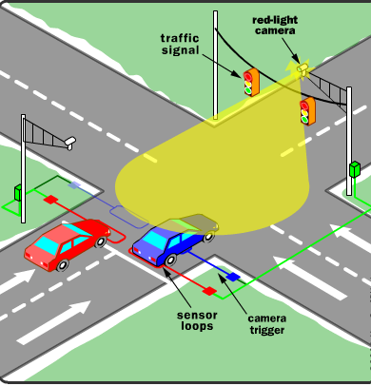
Figure 1 the reality of our project

System applications:

Traffic light Anti Violation .
Our project .
- Parking Management system .
The idea of the project is to manage parking sites .

- Managing traffic jams during rush hours
The idea of the project is that to connect all the traffic joints together via communication to solve traffic jams .

- Medical application .
The idea of the project is to keep doctors in touch with
. patient all the time, and the status of his case according to
his disease

The Output of Our project :

- Time of the violation.
- Date of the violation.
- The position of the violation.
- Violation ticket for the violator.
- Picture of driver who violates the traffic.

4 . Project Implementation:
We want to introduce the Steps of implementing our project, during this process we talk about different systems briefly:

4.1 Block diagram of the project:
Intelligent System for traffic Violations monitoring

Figure 2 Block diagram of the project

4.2 How the system works?
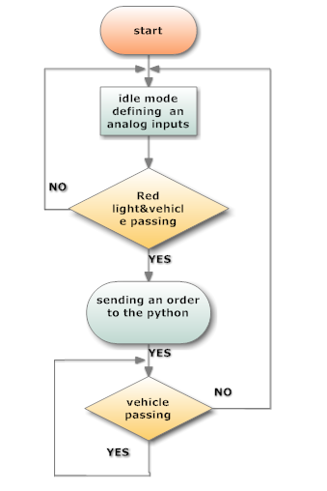
Figure 3flow char of arduino

Where our project can be summarized in a set of small systems to complement our whole picture of the project, where there is a loop placed in front of the line where the people is allowed to pass on the street and the loop buried in the street , this loop work from the principle of the magnetic field influenced by metal of the offending car . This change in the magnetic field affect the current of the coil and change it , according to this change there is electronic circuit simulates this change . In that event the signal is sent to the microcontroller .And then, after the arrival of the signal to the microcontroller which in turn examines the red light signal .
If verify these two conditions there is program placed in the mobile which is written with python programming language , this command received by the mobile through Bluetooth because it is the only channel that the python understand , this python program waits all the time this command from the microcontroller .
This mobile placed in a high place to shoot the car offense, and then store this image in Mobile with time and date of this violation ,then this picture sent to the server through the telephone network local by GPRS and stored in a particular place, we selected on this server , and then download this image after arriving at the server through a special program designed for this server to transfer data from this server as soon as the picture arrive to the server it will be download to the computer .
then there is program that we designed it installed in the computer of the company will edit the ticket of this violation with time and date of this violation .

4.3 The Anatomy of our project

4.3.1 The induction loop :

4.3.1.1 What is induction loop :

When we talk about induction loop we describe an electromagnetic communication and detection system , relies on the the fact that moving the electromagnetic field will induce electrical current in the near wire .
This induction loop with its electronic circuit is used to receive and transmit signals when it detects the metal of the car and presence of the vehicle . it is applied to metal detectors, where a large coil , which consist around 4 turns, and resonant circuit, which can easily tuned . The detected object may be metallic
The loop is a continuous run of copper wires that enters and exits from the same point. The two ends of the loop wire are connected to the loop extension cable, which in turn connects to the vehicle detector. The detector powers the loop causing a magnetic field in the loop area. The loop resonates at a constant frequency and reaches resonance state . A base frequency is established when there is no vehicle over the loop. When a large metal object, such as a vehicle, moves over the loop, the resonate frequency changes . This change in frequency is sensed and, depending on the design of the detector , and if the car is closer to the ground the effect is increase and the frequency is increased too. and Pulse giving to the camera, take a snapshot of the violator .
Vehicle detection loops are used to count vehicles passing or arriving at a certain point, for instance approaching a traffic light, and in motorway traffic management. An insulated, electrically conducting loop

4.3.1.2 Implementation:

This loop is buried in front of the line of infantry (people passes) on the street where it is hidden completely so are not affected by surrounding small things but be affected metal of car.
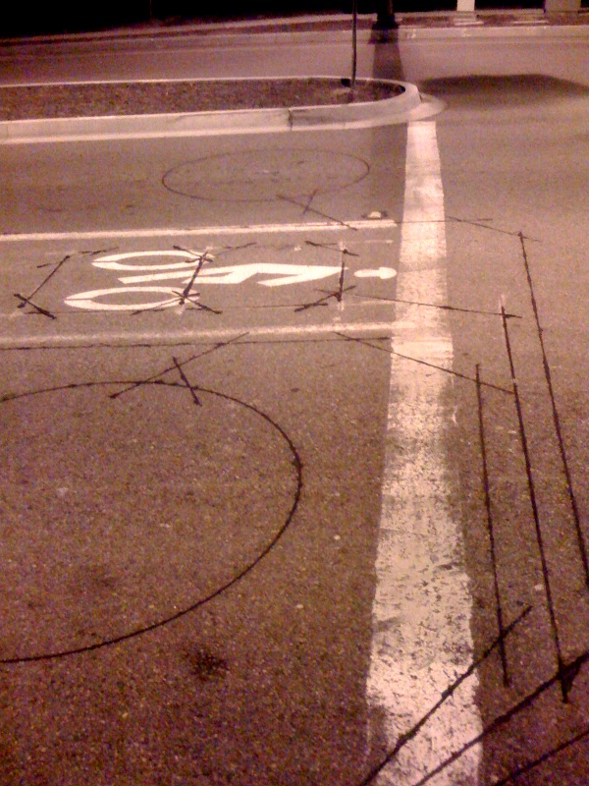
Figure 4 loop after burring in the street
It works Loop when the signal is red as it works to detect car
Offense during the red signal and is connected with the circuit will assume operating to detect this violation and send a signal to microcontroller to perform a command a according to this violation and take the snapshot from the violator .

4.3.1.3 Modern day applications:

- vehicle detection (e.g. at traffic lights) .
- car park Parking Guidance and Information systems .
- metal detectors .
- audio induction loops .

4.3.1.4 The schematic diagram :

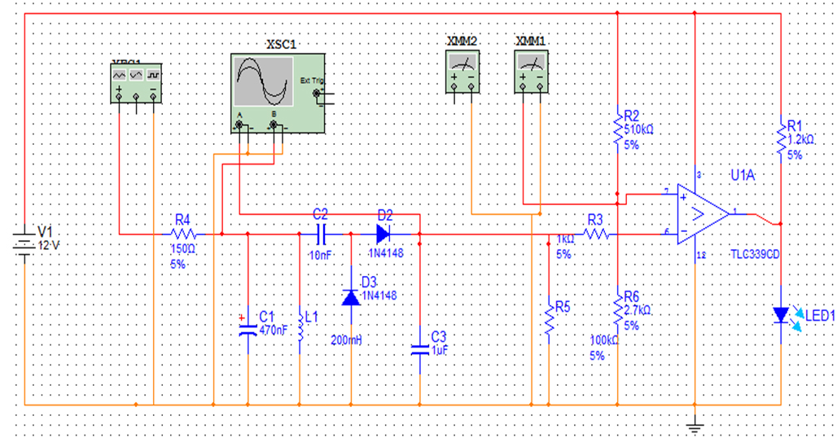
Figure 5n schematic diagram of induction loop circuit

We will talk about the components of the ciruit :

4.3.1.4.1 Conductor (copper loop ) :

Consists of four rolls of copper turn in the form of a rectangle
a bout the size of the car is working on establishing a magnetic
field influenced by the offending car iron .
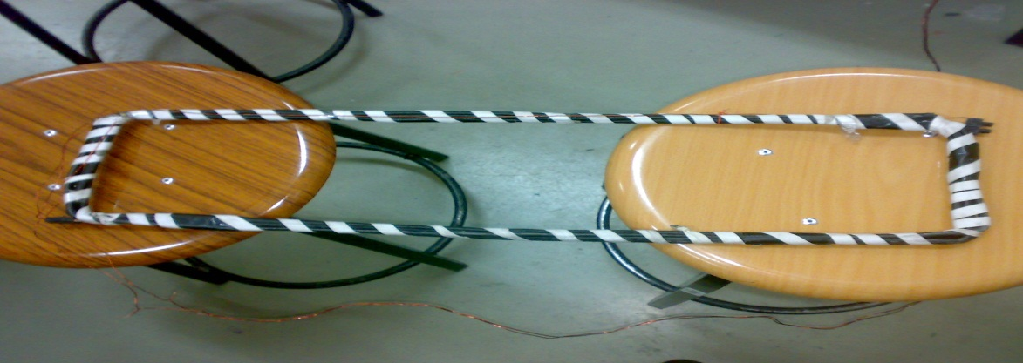
Figure 6 induction loop

The inductance of the loop is about 0.25uH , and we use 0.47 uF to reach resonance according to this equation :
$$F˳=\frac{1}{2π\sqrt{LC}}$$
f˳=resonance frequency= 47kHz.
L=inductance of the loop =0.25 uH
C=capacitor =0.47uF

We can calculate ,In mathematics the inductance L :
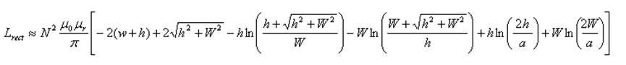
N=number of turns
H=height of the rectangle
W=width of the rectangle
A=wire radius
µr=relative permeability of the medium

4.3.1.4.2 555 timer :
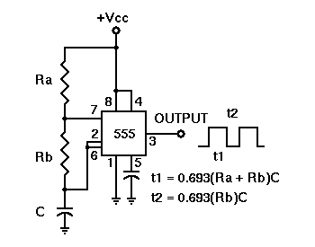
Figure 7 schematic diagram of 555 timer

555 timer components :
Ra is variable resistor =100k
Rb is fixed resistor =15k
C= 470 pf

To generate resonance frequency , the 555 timer generate a train of pulses with frequency about 47kHz with 75 % duty cycle ,then enters the RLC circuit that resonates at the same frequency , generates sinusoidal signal
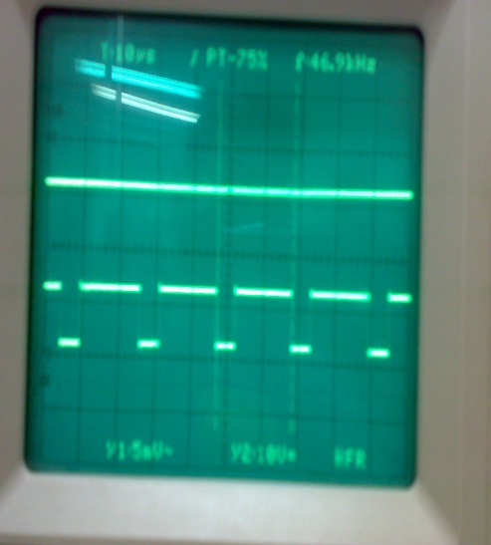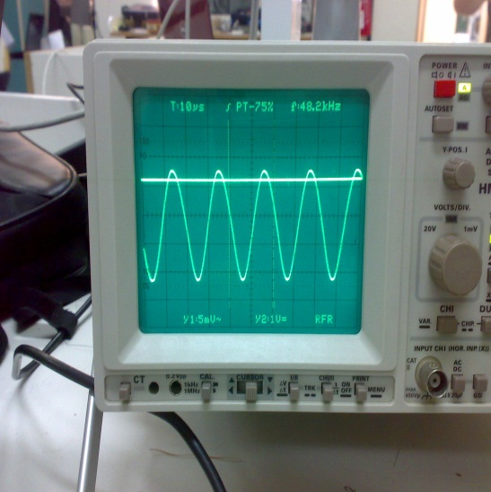
Figure 8Figure 7 signals of the induction loop before the effect
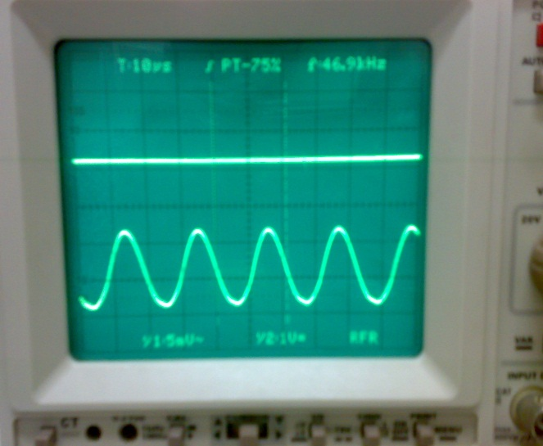
Figure 9 signals of the induction loop after the effect

This sinusoidal signal enters the half wave rectifier circuit to get the dc signal .That will give us 3.5 V dc in the output at the resonance . then this signal compare it with reference voltage depend on the responce of the circuit (we use potentiometer to vary the reference voltage ) .then we get the pulse in the output of the comparator when there is violation and send it to the microcontroller to perform command according to this violation .

4.3.2 The Microcontroller ( Arduino ) :
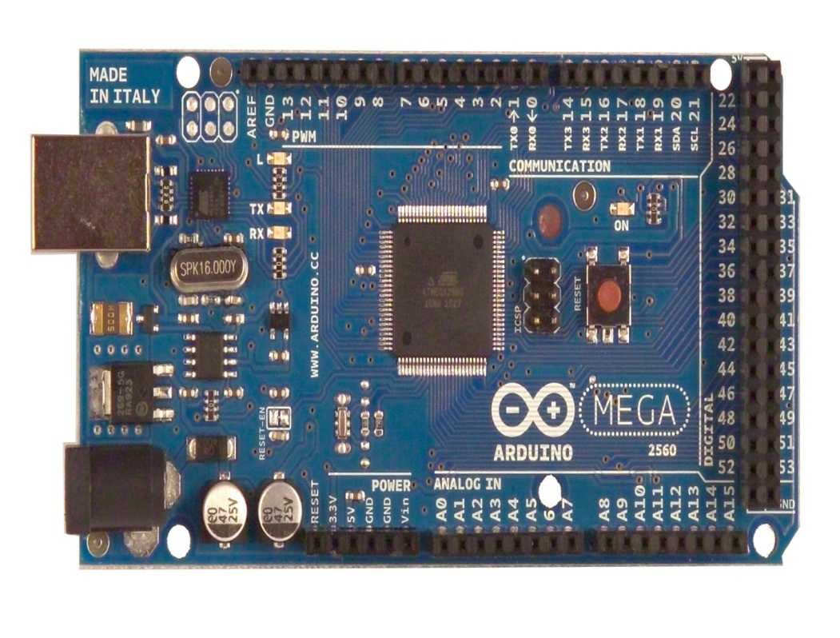

4.3.2.1Arduino- mega2560 :
The Arduino Mega 2560 is a microcontroller board based on the ATmega2560 . It has 54 digital input/output pins (of which 14 can be used as PWM outputs), 16 analog inputs, 4 UARTs (hardware serial ports), a 16 MHz crystal oscillator, a USB connection, a power jack, an ICSP header, and a reset button. It contains everything needed to support the microcontroller; simply connect it to a computer with a USB cable or power it with a AC-to-DC adapter or battery to get started. The Mega is compatible with most shields designed for the Arduino Duemilanove or Diecimila.

4.3.1.1Some features :

Microcontroller | ATmega2560
Operating Voltage | 5V
Input Voltage (recommended) | 7-12V
Input Voltage (limits) | 6-20V
Digital I/O Pins | 54 (of which 14 provide PWM output)
Analog Input Pins | 16
DC Current per I/O Pin | 40 mA
DC Current for 3.3V Pin | 50 mA
Flash Memory | 256 KB of which 8 KB used by bootloader
SRAM | 8 KB
EEPROM | 4 KB
Clock Speed | 16 MHz

4.3.3 Programming :
- Get an arduino board and USB cable .
You also need a standard USB cable (A plug to B plug): the kind you would connect to a USB printer, for example. (For the Arduino Mega 2560 you 'll need an A to Mini-B plug show image below )
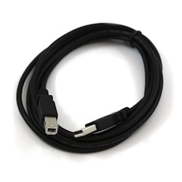
- Download the arduino program :
We download the lastest version of this program (arduio-0022) for windows 7
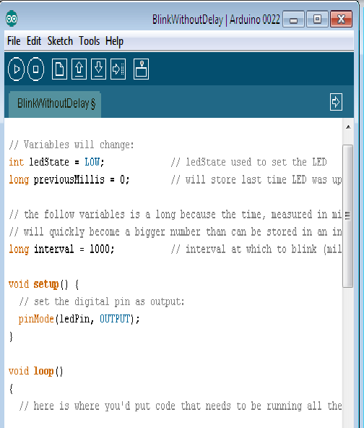

- Configuration of the code :
- The first space define variables and define the number of each pin and install the drivers that you want to use it in the program (note -every pin has number printed in the board )
For example :
Int ledpin =13 ;
- void setup : is to initialize the pins as input or output and initialize the serial port .
for example :

eg .digitalPin (13,output );

- void loop : this is where you can write the function or code to perform your program .
if (i==1) {
digitalWrite(13 ,HIGH)
}
- selecting the board that you want to use it
You'll need to select the entry in the Tools > Board menu that corresponds to your Arduino.

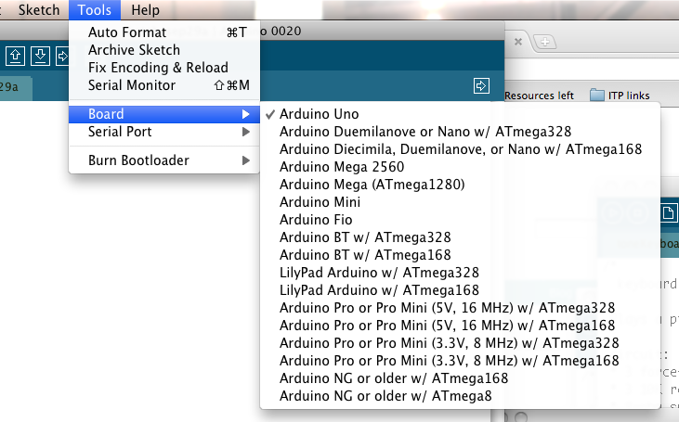

- select the serial port :
Select the serial device of the Arduino board from the Tools >Serial Port menu. This is likely to be COM3 or higher (COM1 and COM2 are usually reserved for hardware serial ports). To find out, you can disconnect your Arduino board and re-open the menu; the entry that disappears should be the Arduino board. Reconnect the board and select that serial port.
- Upload the program
Now, simply click the "Upload" button in the environment. Wait a few seconds - you should see the RX and TX leds on the board flashing. If the upload is successful, the message "Done uploading." will appear in the status bar. (Note: If you have an Arduino Mini, NG, or other board, you'll need to physically present the reset button on the board immediately before pressing the upload button.)
Then your code will be transferred to your board .

4.3.3 Mobile (python programing language ) :

4.2.3.1 What is python?

why we chose this language " python"?
Python is a high-level programming language which can execute on symbian OS which is an operating system designed by Symbian for mobile devices; all current Nokia high-end mobile phone models are based on Symbian OS.
Beside the programming capabilities of the mobile phone, there is even more flexibility on the phone. As given in the figure below a mobile device has many different capabilities and functionalities.
We have grouped those of a mobile (smart) phone into three classes, namely user interfaces, communication interfaces, and built-in resources. The user interfaces comprise typically the speaker, microphone, camera, display, built-in sensors, and keyboard capabilities.In our project we used the camera to take a snapshot ,display to show the status of the programWhile executing and the keyboard capabilities to run the program.
The built-in terminal resources include the battery, the central processing unit, and the data storage, we used the central processing unit to treat our data and storage the photo in the mobile memory temporary . The third part is communication interfaces which is very important part that in our project we used the short–range communication to communicate the microcontroller via Bluetooth to receive the interrupt signal due to vehicle's passing , and the long –range communication to send these photos via GSM network through the GPRS to our FTB server in the internet.

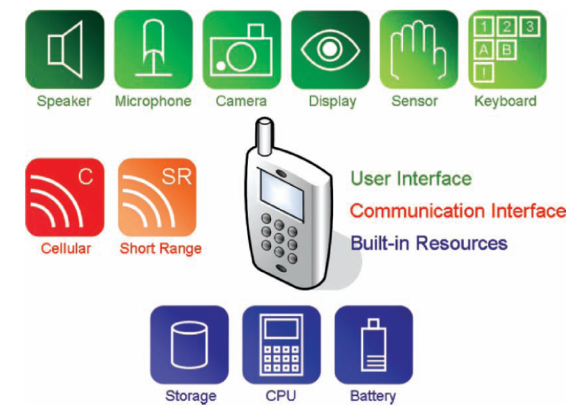
Figure 10 features of the mobile

4.3.3.2 Software Installation on the Phone:

- Download the Python for S60 interpreter software to your computer from the Source Forge's PyS60 project website: http://sourceforge.net/projects/pys60 . It is available for free as a Symbian install file (.SIS). Note, you need to choose the correct Python for S60 interpreter software file based on your phone model (e.g., whether your model is based on the 2nd or 3rd edition of the S60 developer platform). In our case we worked on nokia- n73 -3rd edition and we chose the suitable one.
- Install the Python for S60 interpreter software to your phone via Bluetooth ,USB cable, or Nokia PC Suite. After this, your phone is ready to run Python scripts. The Python icon should be visible oyour phone's desktop or inside one of its subfolders

Figure 11 Phone menu.

Now the mobile phone is ready to execute the python scripts.

4.3.3.3How Python Runs Programs:

The Python interpreter reads the program you have written and carries out the code statements it contains. The simplest form of a Python program is just a text file containing Python statements which are executed. Such a text file is in our case the Python script that we are writing.

Before we will take about our python program ,we will give an example about printing" hello world!" on the screen:
We Wrote the following line in the text editor:
print "Hello world!"

Test a Python Script

Start the PyS60 interpreter by clicking on the Python icon (Figure 2.1) on
the desktop or inside the appropriate folder on your phone. Once the
PyS60 interpreter has started up, select "Options" (Figure 2.4(a)) and "Run script" (Figure 2.4(b)). Choose your script name, e:hello.py, from the list and select "OK". Your script should now start up and you should see a green line stating Hello world! (Figure 2.5).

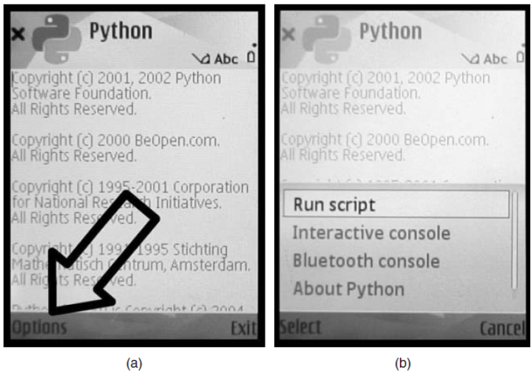
Figure 12 Python running on a phone

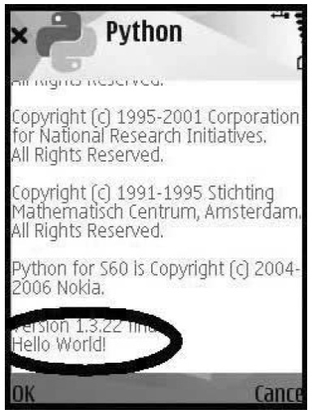
Figure 13 Our script running on the phone

4.4.3.4 why we write this code ?

- Communicate with the microcontroller via Bluetooth to receive the interrupt signal due to vehicle's passing .
- Taking a photo immediately after vehicle's passing.
- The time of image capture with image file attached.
- Saving this photo in the mobile's memory (optional).
- Send these photos via GSM network through the GPRS to our FTB server in the internet .

4.2.3.5The Flowchart:

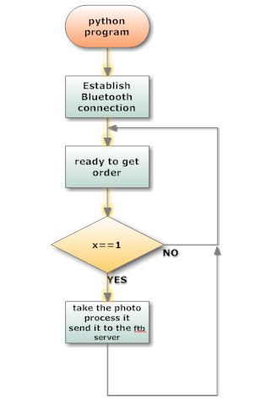
Figure 14 flow chart of python program

4.2.3.4 To explain our code let us divide it into parts:

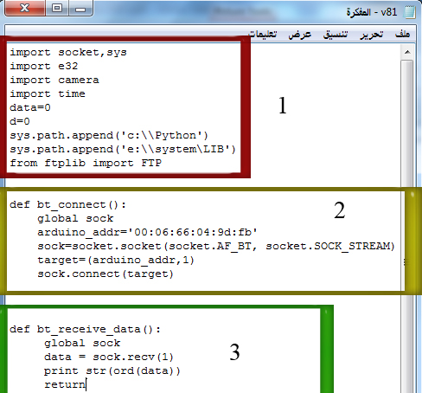
Figure 15 python code edited by notepad part 1
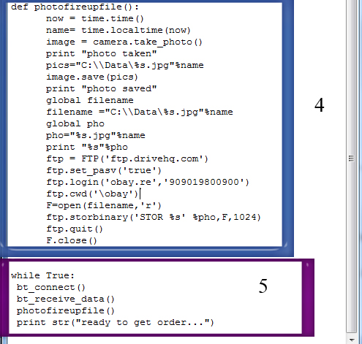
Figure 16 python code edited by notepad part 2
- we imported the all modules that we need in our program
from pys60 that we imported
- e32 : Utilities related to Symbian OS that are not related to the user interface.
- Camera: Taking of photographs and starting and closing of the viewfinder.
- Time: Time and date functions, we used it to give the pic the current date and time when it taken.
- Sys: we used it to add ftp library in the program.
- Socket: TCP/IP networking, Bluetooth, setting the default access point, we used it to open the Bluetooth channel to communicate with the micro controller.
- Ftb: this library helped us to connect with our ftb (file transfer protocol) server that we transmit the data through it.
The module is a file that contains a collection of related functions and data grouped together. PyS60 comes with a rich set of modules, for example messaging to handle SMS functionalities, camera for taking photos, and appuifw, which provides ready-to-use user interface elements.
- Bluetooth connection code: as you see in this code we connected the python(mobile) with the Bluetooth piece which has a unique MAC address.
- Receiving the interruption order from the microcontroller code: this code wait any interrupt will come from the MC due to vehicle passing and printing the received data on the screen.
- Taking and sending the photo code: the big code do many things:
- Taking the snapshot immediately after getting order.
- Saving it temporary in the mobile memory.
- Renaming it with the current date and time.
- Preparing the photo to transmitting through the GSM network.
- Opening the server channel, contacting with the specific server and send the username and the password.
- Sending the photo during GPRS service.
- "while" statement: this statement make the program execute as an infinite loop ,that we called all function we prepared inside it.

4.3.4 Bluetooth module :
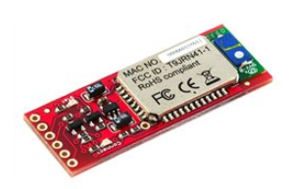
Figure 17 Bluetooth module
The serial channel between the microcontroller and the mobile phone we chose it because it's one of the channel that the python program can read the data from it .
And this wireless channel more practical than wires ,that you can connect any mobile phone without thinking of type or shape of the serial cable.
Features:
- This Bluetooth module designed to work directly with the microcontroller (TTL) .
- Operates in harsh RF environments like WiFi, 802.11g, and Zigbee.
- Encrypted connection and has an unique MAC address that you just can connect to it with this address ,which make it more secure.
- It works on the Frequency range 2.4~2.524 GHz which is free.
- Serial communications rate from 2400-115200bps in our project we used 115200 bps.
- Built-in antenna and transmission distance up to 100m.
Our work:
We connected the Bluetooth piece with our MC as show in the figure below :
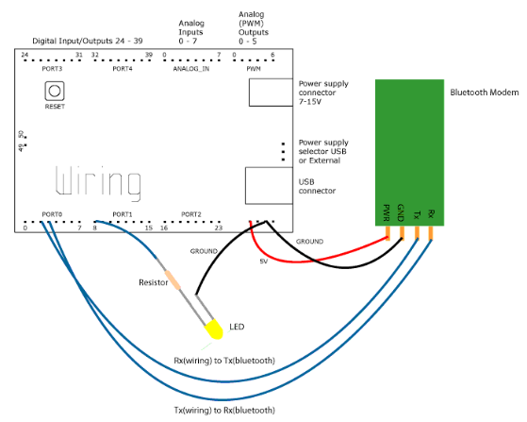
Figure 18 Bluetooth with microcontroller circuit

After that we wrote a program to identify it inside the microcontroller as follow:
- We gave it a name in this order (Serial.println("SET BT NAME BT_Arduino"))
- We configured the data rate to be 115200 ( Serial.println("SET CONTROL BAUD 115200")).
- We configured the authority and many other configurations, you can see the complete code in the appendix.
In the other side (in the mobile side) we configured it in the python code
that we identified :
- The Bluetooth MAC(Media Access Control) address (arduino_addr='00:06:66:04:9d:fb'), this address is a unique address which make the comm. channel is more secure.
- We wrote other commands to connect the mobile with the Bluetooth
to make the socket open to transmit and receive the command between the mobile and the microcontroller.
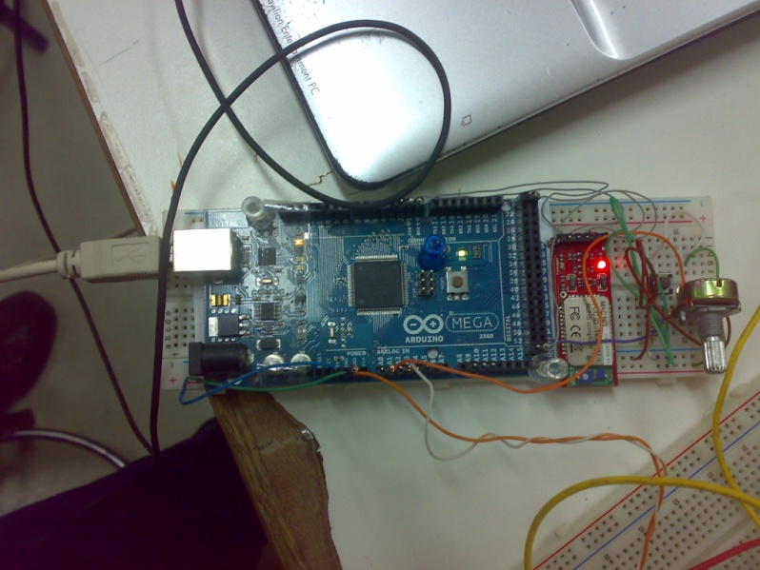
Figure 19 block diagram of microcontroller with Bluetooth

This photo shows the Bluetooth piece connecting with the MC.

4.3.4 Anti Violation Program (Image processing by Matlab ):

This program installed in the computer constructed by matlab with its language and use to recognize the plate number of the car , from the image that we took it by camera and it to the server after the mobile uploaded it , then recognize the number of the car with time and date of this violation , then can notice this violation .
We want to explain the algorithm that we use it :

4.3.4.1 Download pictures from FTP server :

in this program ,there is two ways to download the pictures from the server , to complete the process of recognition :
- By matlab code designed to download picture pictures from server.
- By synchronization between matlab file and the file transfer program For the ftp server ,any file received in the server will be downloaded at the matlab file (or matlab directory ) .
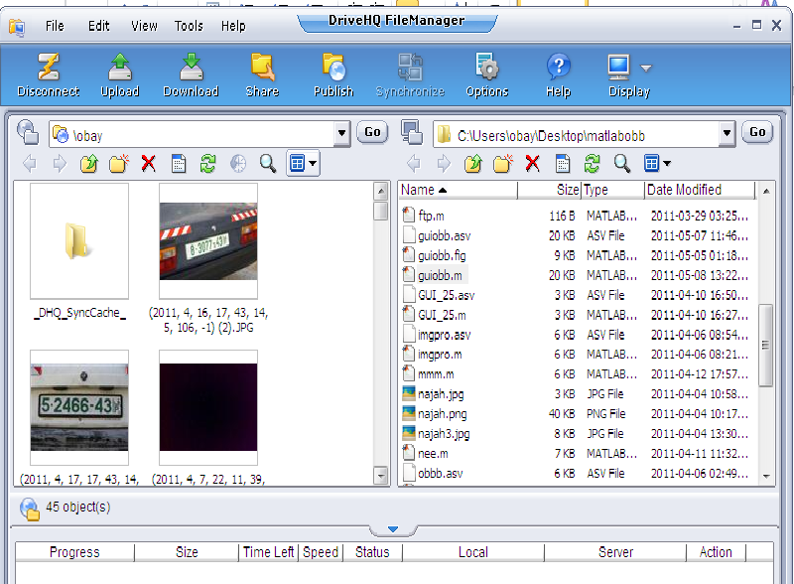
Figure 20 Ftp Server
- …….first window for the server files.
- …….second window for the matlab files.

4.3.4.2 Image processing
In electrical engineering and computer science, image processing is any form of signal processing for which the input is an image, such as a photograph or video frame; the output of image processing may be either an image or, a set of characteristics or parameters related to the image. Most image-processing techniques involve treating the image as a two-dimensional signal and applying standard signal-processing techniques to it.
Image processing usually refers to digital image processing, but optical and analog image processing also are possible. This article is about general techniques that apply to all of them. The acquisition of images (producing the input image in the first place) is referred to as imaging.

4.3.4.2.1 Plate number recognition

- Read and resize the image:
The first step is to red the image, Then we take information about its height and its width to resize the image in suitable ratio, we choose width = 400 and the height = 400 * width/height.
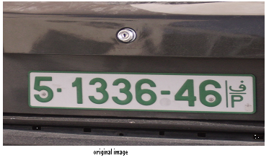
- convert the image to gray:

After that we convert the image to gray scale, this conversion is important because we will take the edge which needs this form of image. Then we enhance the image, this step gets good results in some cases and approximately gets the same results in other cases.
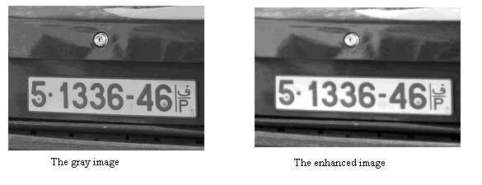

- take the complement of the image:
In this step we take the complement and we enhance it and we take canny method to find the edge, The Canny method finds edges by looking for local maxima of the gradient of the image. The gradient is calculated using the derivative of a Gaussian filter. The method uses two thresholds, to detect strong and weak edges, and includes the weak edges in the output only if they are connected to strong edges. This method take sigma as the standard deviation of the Gaussian filter, this factor control the amount of details of image, if sigma increases the details will decrease.
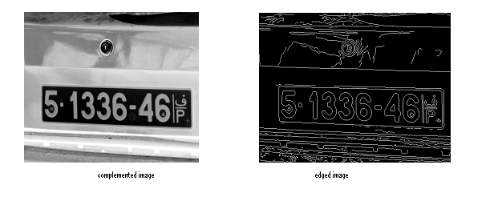

We choose segma = .95, but if the process can not get the plate we change it until we reached to correct result.

- Filter the image from small objects:

Then we convert the image to double class because the functions that we use need this class. and then we filter the image from any object less than 280 pixels and we close the image:
- label the image to objects:
Now we have an image consists of objects, to decide the correct plate from these objects we label them and we find the characters of each object

- separate every object:
Then we separate, fill and rotate every object to give them specific characteristics that help us to know the plate like below pictures:
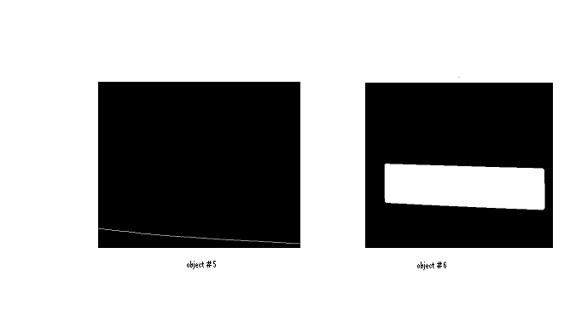
- Recognize the plate:
Now we have an image consists of objects, to decide the correct plate from these objects we label them and we find the characters of each object
By trial and error we specify the suitable description Solidity, the ratio between the height and width, convex area and bounding box.
The last step is to display the plate by multiplying the plate object with the original image:

4.3.4.3.2 Number recognition

In this section we have image consist of the plate found and the numbers inside it, the next step is to recognize the numbers.
The algorithm:

- Convert the image to black and white:
We need this process to use functions that segment the objects:
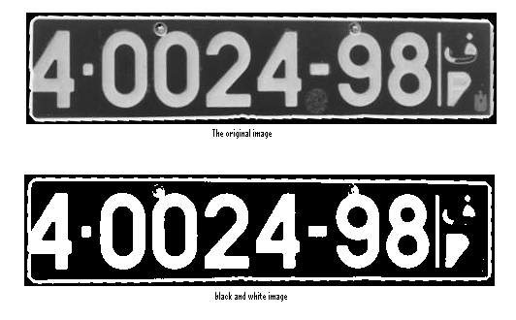
- Remove the frame:

- Filter the image from objects:
We do this step to remove objects which have area less than 100 pixels, this area can be change depending on the resolution of camera and the distance taken from the camera and the car:

- Remove connected objects:
In this step we remove unwanted objects that connected to the numbers by taking the projection of columns and removing the values of amplitude less than .15 .
The image after this process is:

we do the same process for the rows to remove connected objects.

- Segment the numbers by taking the boundary box:
Now we have image consist of only the numbers that we want. Then we segment the number by taking boundary box for every one as shown below:
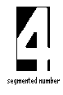
This process doen for every number
- Take the horizontal and vertical projections for each number
And then we take the horizontal and vertical projection(number of pixels versus its position) for each number to identify it . and we take every number after we fill it to increase the proparities to describe any number.

4.3.4.4 Comparison with database of the police office :
The next step is to connect the programm with database of the police office , our program test the number that we idintify, to the owmer of this car then edit this violation with the name of the violater according to his database in the police office with time and date of violation .
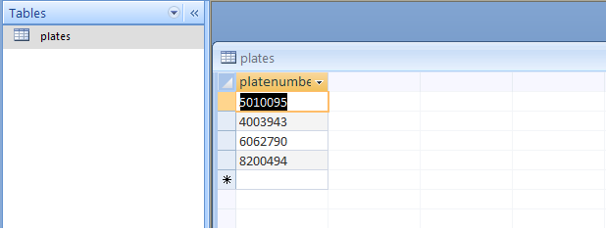

4.3.4.5 The GUI of the program:

This is where we designed our program ,in matlab.
that we can construct our program easily ,this GUI contains push buttons , edit text , static text ,axes to show pictures…. Etc .

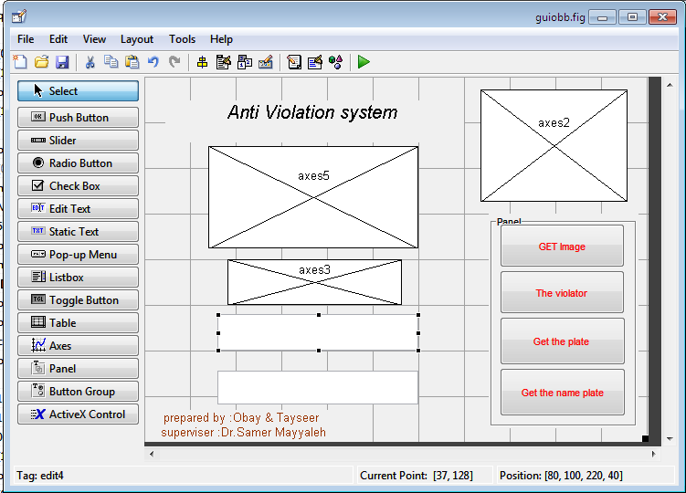

The first GUI is choose the picture from the server after we download it
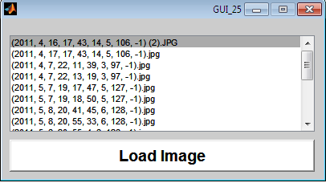
The complete GUI our program like that and ready to use :
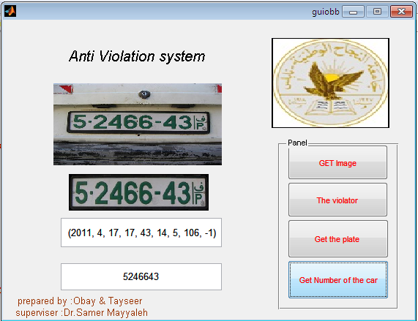

4.3.5 FTP SERVER :

We use Drive HQ server to upload our pictures .this FTP server give us year trial to transfer the data .
The port of FTP server is 23 and we need authenticating we want to connect with this server .and we use file Drive HQ file transfer manager 5.0 to edit our data .
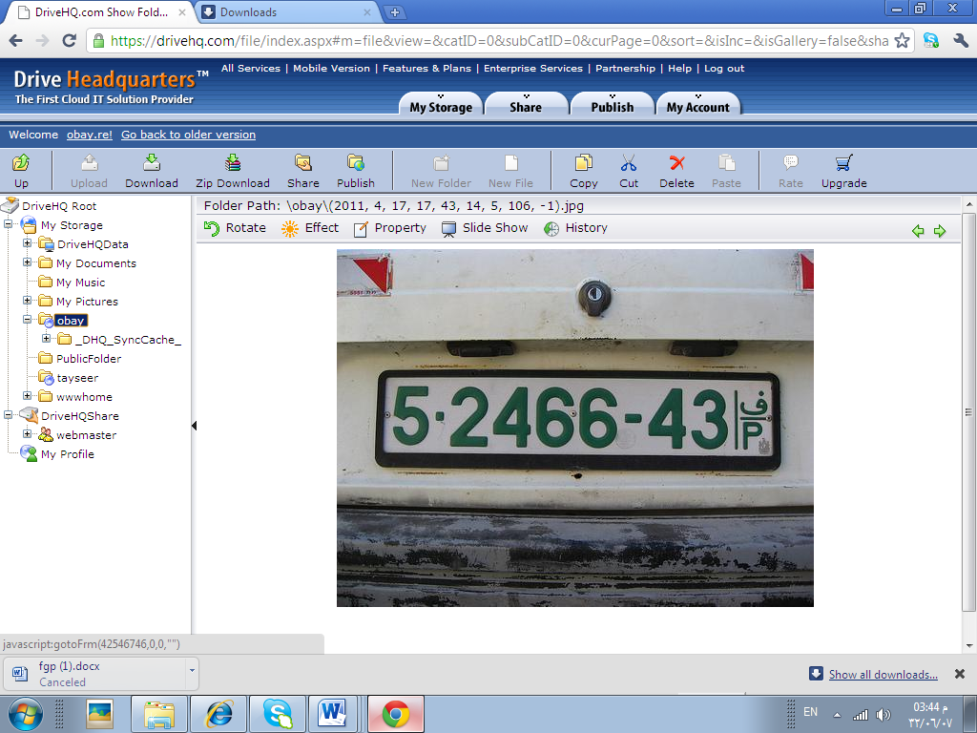
This is the picture we take it from the server after upload the violation car picture .

5.0 Conclusion:

In the summary, our project combined control engineering, electronics and communications to get the project , aimed to integrate the solution's problem found in the ground and to save time and effort to many of our institution and the addition of technology in our reality.
Our complete project has much application that can help the humanity, from commercial to medical application, that the "traffic light anti violation system" is one of these applications.
Our goal in the future is to make an inelegant traffic system that all traffic nodes are joint together and with our induction loop
That will give us the current traffic status in the city that make the micro controller to make the right decide to solve the traffic jams during rush hours and avoid accidents .

6.References :

1- text book .’’ Springer.Mobile.Phone.Programming.Aug.2007’’ red
2- Heath, C. (2006) Symbian OS Platform Security: Software Development
Using the Symbian OS Security Architecture. Chichester: John Wiley
& Sons
3- Lutz, M. (2001) Python Pocket Reference. O’Reilly
Lutz, M. and Ascher, D. (2003) Learning Python. O’Reilly
Scheible, J. and Ojala, T. (2005) ‘MobiLenin – Combining a multi-track
music video, personal mobile phones and a public display into multiuser
interactive entertainment.’ at www.leninsgodson.com/mobilenin
Von Hippel, E. (2005) Democratizing Innovation. MIT Press
3- text book ‘’ Practical programming by python’’
4-Image Processing in C" (Copyright 1994, ISBN 0-13-104548-2) was published byR & D Publications
1601 West 23rd Street, Suite 200
Lawrence, Kansas 66046-0127

4- red light camera ‘’ www.mathworks .com’’

Cost :

Parts | Price (NIS) | quantity | Total cost estimate(NIS)
Induction loop circuit | 100 | 1 | 100
Arduino mega2560 | 350 | 1 | 350
Bluetooth module | 250 | 1 | 250
Mobile (N73) | 300 | 2 | 300
Server account 1 year | free |  | 0
Total cost |  |  | 1000

8.Appendix:
Appendix A ( Arduino code ) :
const int redPin = 51;
const int analogPin = 53;
const int ledPin = 13;
int redState1 = 0;
int loopState2 = 0;
int val=0 ;

void setup() {
pinMode(ledPin, OUTPUT);
pinMode(redPin, INPUT)
pinMode(analogPin, INPUT);
Serial.begin(9600);
void loop(){
redState1 = digitalRead(redPin);
val=digitalRead( analogPin );
if (val == HIGH) {
if (redState1 ==HIGH){
digitalWrite(ledPin, HIGH);
}
}
else

digitalWrite(ledPin, LOW);
}
Appendix B (python code ) :
import sys
sys.path.append('c:\\Python')
sys.path.append('e:\\system\LIB')
import appuifw

from ftp import FTP
picselection = 'c:\\Data\Image2.jpg'
def fireupfile():
global picselection
ftp = FTP('www.drivehq.com') # connect to host
ftp.set_pasv('true')
ftp.login('tayseer','halawa') # login anonymous
ftp.cwd('public_html/examplefolder') # change directory where to store the image
F=open(picselection,'r')
ftp.storbinary('STOR image.jpg',F,1024) # store the image
ftp.quit()
F.close()
if appuifw.query(u"fire up image?","query") == True:
fireupfile()

Appendix C (matlab code ) :

function varargout = guiobb(varargin)
% GUIOBB M-file for guiobb.fig
% GUIOBB, by itself, creates a new GUIOBB or raises the existing
% singleton*.
%
% H = GUIOBB returns the handle to a new GUIOBB or the handle to
% the existing singleton*.
%
% GUIOBB('CALLBACK',hObject,eventData,handles,...) calls the local
% function named CALLBACK in GUIOBB.M with the given input arguments.
%
% GUIOBB('Property','Value',...) creates a new GUIOBB or raises the
% existing singleton*. Starting from the left, property value pairs are
% applied to the GUI before guiobb_OpeningFcn gets called. An
% unrecognized property name or invalid value makes property application
% stop. All inputs are passed to guiobb_OpeningFcn via varargin.%
%%
% *See GUI Options on GUIDE's Tools menu. Choose "GUI allows only one
% instance to run (singleton)".
%
% See also: GUIDE, GUIDATA, GUIHANDLES

% Edit the above text to modify the response to help guiobb

% Last Modified by GUIDE v2.5 09-May-2011 12:04:50

% Begin initialization code - DO NOT EDIT
gui_Singleton = 1;
gui_State = struct('gui_Name', mfilename, ...
'gui_Singleton', gui_Singleton, ...
'gui_OpeningFcn', @guiobb_OpeningFcn, ...
'gui_OutputFcn', @guiobb_OutputFcn, ...
'gui_LayoutFcn', [] , ...
'gui_Callback', []);
if nargin && ischar(varargin{1})
gui_State.gui_Callback = str2func(varargin{1});
end

if nargout
[varargout{1:nargout}] = gui_mainfcn(gui_State, varargin{:});
else
gui_mainfcn(gui_State, varargin{:});
end
% End initialization code - DO NOT EDIT

% --- Executes just before guiobb is made visible.
function guiobb_OpeningFcn(hObject, ~, handles, varargin)
% This function has no output args, see OutputFcn.
% hObject handle to figure
% eventdata reserved - to be defined in a future version of MATLAB
% handles structure with handles and user data (see GUIDATA)
% varargin command line arguments to guiobb (see VARARGIN)

% Choose default command line output for guiobb
handles.output = hObject;

% Update handles structure
guidata(hObject, handles);

% UIWAIT makes guiobb wait for user response (see UIRESUME)
% uiwait(handles.figure1);

guidata(hObject, handles);
axes(handles.axes2);
image(imread('najah3.jpg'));
axis off;

%to display in another

% --- Outputs from this function are returned to the command line.
function varargout = guiobb_OutputFcn(hObject, eventdata, handles)
% varargout cell array for returning output args (see VARARGOUT);
% hObject handle to figure
% eventdata reserved - to be defined in a future version of MATLAB
% handles structure with handles and user data (see GUIDATA)

% Get default command line output from handles structure
varargout{1} = handles.output;

% --- Executes on button press in ftp.
function ftp_Callback(hObject, eventdata, handles)
% hObject handle to ftp (see GCBO)
% eventdata reserved - to be defined in a future version of MATLAB
% handles structure with handles and user data (see GUIDATA)

% hObject handle to pushbutton2 (see GCBO)
% eventdata reserved - to be defined in a future version of MATLAB
% handles structure with handles and user data (see GUIDATA)
guidata(hObject, handles);
axes(handles.axes5);
image(imread('4000.jpg'));
axis off;

%xlswrite('car-plate.xls', [o;c])

% --- Executes on button press in plate.
function plate_Callback(hObject, eventdata, handles)
% hObject handle to plate (see GCBO)
% eventdata reserved - to be defined in a future version of MATLAB
% handles structure with handles and user data (see GUIDATA)

counter = 1;
segma = .95;
index = -1;
ex= '.jpg';
%for(uu =2:39)
uu=4000;
str = int2str(uu);
ww = strcat(str,ex);
i = imread(ww);
info = imfinfo(ww);
width = 400;
height = ceil(width * (info. Width/info.Height));

i = imresize(i,[width height],'bilinear');
%figure,imshow(i);
g = rgb2gray(i);
%figure,imshow(g);
ag = imadjust(g);
%figure,imshow(ag);

IM2 = imcomplement(ag);
%figure,imshow(IM2);

IM2ag = imadjust(IM2,[0.01 .99],[]);

%figure,imshow(IM2ag);

%level = graythresh(IM2ag);
while(index==-1)
counter;
eo = edge(IM2ag,'canny',[],segma);

%figure,imshow(eo);

bw= double(eo);

filtered = bwareaopen(bw,280,8);

se = strel('disk',1);

bw = imclose(filtered,se);
%figure,imshow(bw)
[L,NUM] = bwlabel(bw,8);

%figure,imshow(label2rgb(L, @jet, [.5 .5 .5])),title(uu)

a = regionprops(L,'all');

objects = zeros(size(i,1),size(i,2),NUM);
isr = zeros([NUM 1]);
ra = zeros([NUM 1]);
ara = zeros([NUM 1]);
torf = zeros([NUM 1]);
area1 = zeros([NUM 1]);
for(j=1:NUM)
objects(:,:,j) = L(:,:) & (j==(L(:,:)));
objects1(:,:,j) = imfill( objects(:,:,j),'holes');
%figure,imshow(objects1(:,:,j)),title(j)

x_width=0;
y_width = 0;
x = floor(a(j).BoundingBox(1));
y = floor(a(j).BoundingBox(2));
x_width = ceil(a(j).BoundingBox(3))+(a(j).BoundingBox(1)>x);
y_width = ceil(a(j).BoundingBox(4))+(a(j).BoundingBox(2)>y);
if(y==0)
y=1;
y_width = y_width-1;
end
if(x==0)
x=1;
x_width = x_width-1;
end

if(x_width+x >= height)
x_width = x_width -1;
end
if(y_width+y >= width)
y_width = y_width -1;
end
subimage = zeros([width height]);

subimage(1:y_width+1,1:x_width+1) = objects1(y:y+y_width,x:x+x_width,j);
% figure, imshow(subimage(:,:));
y = subimage(:,:);

gf = imrotate(y,-1*a(j).Orientation);
% figure,imshow(gf),title(j)
b = regionprops(gf,'all');

ara(j) = b.MajorAxisLength/b.MinorAxisLength;

ar(j) = b.BoundingBox(3)/b.BoundingBox(4);

ca(j) = b.ConvexArea/(b.BoundingBox(3)*b.BoundingBox(4));

s(j) = b.Solidity;
area1(j) = b.Area;
end

for(j=1:NUM)
if(((ara(j)>2.5)&(ara(j)<7))&((ar(j)>2.5)&(ar(j)<7))&(ca(j)>.77)&((s(j)>.85)|(s(j)<.2))&(area1(j)>400))
index = j;
torf(j)=1;
end
end

coun = sum(torf);
%for(j=1:NUM)
% if( torf(j)==1)
% figure,imshow(objects1(:,:,j)),title(j)
%

% end
% end

segma = segma+1;
counter = counter +1;
end
%figure,imshow(objects1(:,:,index)),title(index)
se = strel('disk',9);
objects1(:,:,index) = imdilate(objects1(:,:,index),se);
%figure,imshow(objects1(:,:,index)),title(index)
objects1(:,:,index) = imfill(objects1(:,:,index));
%figure,imshow(objects1(:,:,index)),title(index)
reg = regionprops(objects1(:,:,index),'all');

if(reg.Solidity<.70)

reg = regionprops(objects1(:,:,index),'all');
x_width=0;
y_width = 0;
x = floor(reg.BoundingBox(1));
y = floor(reg.BoundingBox(2));
x_width = ceil(reg.BoundingBox(3))+(reg.BoundingBox(1)>x);
y_width = ceil(reg.BoundingBox(4))+(reg.BoundingBox(2)>y);
if(y==0)
y=1;
y_width = y_width-1;
end
if(x==0)
x=1;
x_width = x_width-1;
end

if(x_width+x >= height)
x_width = x_width -1;
end
if(y_width+y >= width)
y_width = y_width -1;
end

object1= objects1(y:y+y_width,x:x+x_width,index);
%figure,imshow(object1),title('obj1')

%%%%%%%%%%%%%
[La,num] = bwlabel(object1,8);
reg1 = regionprops(La,'all');

x_width1=0;
y_width1 = 0;
x1 = floor(reg1.BoundingBox(1));
y1 = floor(reg1.BoundingBox(2));
x_width1 = ceil(reg1.BoundingBox(3))+(reg1.BoundingBox(1)>x1);
y_width1 = ceil(reg1.BoundingBox(4))+(reg1.BoundingBox(2)>y1);
if(y1==0)
y1=1;
y_width1 = y_width1-1;
end
if(x1==0)
x1=1;
x_width1 = x_width1-1;
end

if(x_width1+x1 >= height)
x_width1 = x_width1 -1;
end
if(y_width1+y1 >= width)
y_width1 = y_width1 -1;
end
%%%%%%%%%%%%%

object(y1:y1+y_width1,x1:x1+x_width1) = 1;

object = imrotate(object(y1:y1+y_width1,x1:x1+x_width1),reg1.Orientation,'bicubic');
%figure,imshow(object),title('objr')
object= imresize(object,[size(object1,1) size(object1,2)],'bicubic');
%figure,imshow(object),title('objre')
object1 = or(object,object1);
%figure,imshow(object1),title('or')

objects1(y:y+y_width,x:x+x_width,index) = object1(:,:);

%figure,imshow(objects1(:,:,index)),title(index)
objects1(:,:,index) = imfill(objects1(:,:,index));
end

plate = uint8(zeros([size(i,1) size(i,2)]));
plate = IM2ag(:,:).*uint8(objects1(:,:,index));
%figure,imshow(plate)
colorplate(:,:,1) = i(:,:,1).*uint8(objects1(:,:,index));
colorplate(:,:,2) = i(:,:,2).*uint8(objects1(:,:,index));
colorplate(:,:,3) = i(:,:,3).*uint8(objects1(:,:,index));

reg = regionprops(objects1(:,:,index),'all');

x_width=0;
y_width = 0;
x = floor(reg(1).BoundingBox(1));
y = floor(reg(1).BoundingBox(2));
x_width = floor(reg(1).BoundingBox(3))+(reg(1).BoundingBox(1)>x);
y_width = floor(reg(1).BoundingBox(4))+(reg(1).BoundingBox(2)>y);
if(y==0)
y=1;

end
if(x==0)
x=1;

end

if(x_width+x >= size(plate,2))
x_width = size(plate,2)-x;
end
if(y_width+y >=size(plate,1))
y_width = size(plate,1)-y;

end

last_plate= plate(y:y+y_width,x:x+x_width);
last_plate_color = colorplate(y:y+y_width,x:x+x_width,:);
%figure,imshow(last_plate)
last_plate = imrotate(last_plate,-1*reg(1).Orientation,'bicubic');
last_plate_color = imrotate(last_plate_color,-1*reg(1).Orientation,'bicubic');
% figure,imshow(last_plate)

c = imrotate(objects1(y:y+y_width,x:x+x_width,index),-1*reg(1).Orientation,'bicubic');
c= bwlabel(c);
reg = regionprops(c,'all');

x_width=0;
y_width = 0;
x = floor(reg(1).BoundingBox(1));
y = floor(reg(1).BoundingBox(2));
x_width = floor(reg(1).BoundingBox(3))+(reg(1).BoundingBox(1)>x);
y_width = floor(reg(1).BoundingBox(4))+(reg(1).BoundingBox(2)>y);
if(y==0)
y=1;

end
if(x==0)
x=1;

end
if(x_width+x >= size(last_plate,2))
x_width = size(last_plate,2)-x;
end
if(y_width+y >=size(last_plate,1))
y_width = size(last_plate,1)-y;

end
newone= last_plate(y:y+y_width,x:x+x_width);
new_color_one = last_plate_color(y:y+y_width,x:x+x_width,:);
%figure,imshow(newone)

str = int2str(uu+39);
ww = strcat(str,ex);
imwrite(newone,ww);
str = int2str(uu+(39*2));
ww = strcat(str,ex);
imwrite(new_color_one,ww);

guidata(hObject, handles);
axes(handles.axes3);
image(imread('4078.jpg'));

axis off;

% --- Executes on button press in num.
function num_Callback(hObject, eventdata, handles)
% hObject handle to num (see GCBO)
% eventdata reserved - to be defined in a future version of MATLAB
% handles structure with handles and user data (see GUIDATA)

original = imread('4039.jpg');
[n m] = size(original);
%figure,imshow(original)

level = graythresh(original);

J = imadjust(original);
bw = im2bw(J);
%figure,imshow(bw)
[x y ] = size(original);

for(i=1:y)
yyy(i) = (sum(original(:,i)));
end
for(i=1:x)
xxx(i) = (sum(original(i,:)));
end
maxy = max(max(yyy(:)));
maxx = max(max(xxx(:)));
%figure,plot([1:y],yyy(:));
%figure,plot([1:x],xxx(:));
bw(:, 1:ceil(y*.015))=0;
bw(1:ceil(x*.08),:)=0;
bw(floor(x*.9):x,:)=0;
bw(:,floor(y*.95):y)=0;
for(i=1:ceil(y*.05))
if(yyy(i)/maxy>.8)
bw(:,i)=0;
end
end
for(i=1:ceil(x*.2))
if(xxx(i)/maxx>.5)
bw(i,:)=0;
end
end
%figure,imshow(bw)
filtered2 = bwareaopen(bw,100,4);
% figure,imshow(filtered2)
% hold on
[L NUM] = bwlabeln(filtered2);
%title(NUM)

reg2 = regionprops(L,'all');

for(i=1:NUM)
areaa(i) = reg2(i).Area;
widtha(i) = reg2(i).BoundingBox(3);

heighta(i) = reg2(i).BoundingBox(4);
end
area1 = sort(areaa);
height1 = sort(heighta);
width1=sort(widtha);
LL = zeros([size(L,1) size(L,2) ]);
mw = median(width1);
mh = median(height1);
ma = median(area1);
for(i=1:NUM)
max1y = max(widtha(i),mw);
max1x = max(widtha(i),mw);
min1y = min(widtha(i),mh);
min1x = min(heighta(i),mh);
max1a = max(areaa(i),ma);
min1a = min(areaa(i),ma);
if((min1y/max1y>.5)&(min1x/max1x>.9)&(min1a/max1a>.5))
LL(:,:) = LL(:,:)|(L(:,:)&L(:,:)==i);
end
end
for(i=1:size(LL,1))
projhhh(i) = sum(sum(LL(i,:)));
end
maxd = max(projhhh);
projhhh = projhhh./maxd;
for(i=1:size(LL,1))
if(projhhh(i)<.15)
LL(i,:) = 0;
end
end
%figure,plot(projhhh,[1:size(LL,1)])
[LL NUM] = bwlabeln(LL);
projection = zeros([m 1]);

%figure,imshow(LL)
hold on
for(i=1:NUM)
LLL(:,:,i) = LL(:,:) & LL(:,:) == i;

end

LLL = double(LLL);
proj2222 = zeros([m 1]);

LL(:,:) = LL(:,:) &LL(:,:)>0;
for(i=1:m)
proj2222(i) = (sum(LL(:,i)));
end

%figure,plot([1:m],proj2222(1:m))
rec(1:NUM) = 'u';

for(i=1:NUM)

regdig = regionprops(LLL(:,:,i),'all');
wx = floor(regdig.BoundingBox(2));
wl = floor(regdig.BoundingBox(2))+floor(regdig.BoundingBox(4));

hx = floor(regdig.BoundingBox(1));
hl = floor(regdig.BoundingBox(1))+floor(regdig.BoundingBox(3));
digit = zeros([wl hl]);
digit = LLL(wx:wl,hx:hl,i);
% figure,imshow(digit)
projhdigit = zeros([size(digit,1) 1]);
projwdigit = zeros([size(digit,2) 1]);
for(j=1:size(digit,1))
projhdigit(j) = sum(sum(digit(j,:)));
end
maxdh = max(projhdigit);

projhdigit = projhdigit./maxdh;
%figure,subplot(2,2,1),plot([1:size(digit,1)],projhdigit)
for(j=1:size(digit,2))
projwdigit(j) = sum(sum(digit(:,j)));
end
maxdw = max(projwdigit);
projwdigit = projwdigit./maxdw;
%subplot(2,2,2),plot([1:size(digit,2)],projwdigit)

digit1 = zeros([wl hl]);
digit1 = imfill(digit);
% figure,imshow(digit1)
projhdigit1 = zeros([size(digit1,1) 1]);
projwdigit1 = zeros([size(digit1,2) 1]);
for(j=1:size(digit1,1))
projhdigit1(j) = sum(sum(digit1(j,:)));
end
maxdh1 = max(projhdigit1);

projhdigit1 = projhdigit1./maxdh1;
%subplot(2,2,3),plot([1:size(digit1,1)],projhdigit1)
for(j=1:size(digit1,2))
projwdigit1(j) = sum(sum(digit1(:,j)));
end
maxdw1 = max(projwdigit1);
projwdigit1 = projwdigit1./maxdw1;
%subplot(2,2,4),plot([1:size(digit1,2)],projwdigit1)

wl = size(digit,2);

hl = size(digit,1);
[max1 ind1m] = max(projhdigit(1:(floor(.5*hl))));
[max2 ind2m] = max(projhdigit(hl:-1:ceil(.5*hl)));
[min1 indmin1] = min(projhdigit1(ceil(.3*hl):floor(.8*hl)));
max11 = max(max1,max2);
max21 = min(max1,max2);
%%%%%%%%%%%%%%%TWOOOOOOOOOOOOOOOO%%%%%%%%%%%%%%%%%%%%%%
if((max21/max11>.8)&(max2>.95)&(projhdigit(ceil(.4*hl):floor(.8*hl))<.5)&(max1>.8))
if((projwdigit(ceil(.3*wl):floor(.8*wl))>.5))
rec(i)='2';
end
end

[max1_5 ind1m_5] = max(projhdigit(1:(floor(.33*hl))));
[max2_5 ind2m_5] = max(projhdigit((ceil(.33*hl)):floor(.66*hl)));
[max3_5 ind3m_5] = max(projhdigit(floor(.66*hl):hl));

%%%%%%%%%%%%%%%%SIXXXXXXXXXXXXX%%%%%%%%%%%%%%%%
if((max1_5>.8)&(max2_5>.8)&(max3_5>.8))
if((projhdigit1(ceil(.5*hl):floor(.7*hl))>.8)&(indmin1<floor(.5*hl)))
rec(i)='6';
end
%%%%%%%%%%%%%%%%NINEEEEEEEEEEEEEEEE%%%%%%%%%%%%%%%%%%%%%%
if((projhdigit1(ceil(.3*hl):floor(.5*hl))>.8)&(indmin1>floor(.2*hl)))
rec(i)='9';
end
%%%%%%%%%%%%%%%%%EIGHTTTTTTT%%%%%%%%%%%%%%%%%%%
if((projhdigit1(ceil(.3*hl):floor(.8*hl))>.6))
rec(i)='8';
end
%%%%%%%%%%%FIVEEEEEEEEEEEEEEEEE%%%%%%%%%%%%%%%%%
if( rec(i)=='u')
if(projwdigit(ceil(.2*wl):floor(.8*wl))>.4)
rec(i)='5';
end
end
end
max_3 = max(max1_5,max3_5);
min_3 = min(max1_5,max3_5);
[mmax3 indmmax3] = max(projwdigit1(ceil(.3*wl):floor(.8*wl)));
%%%%%%%%%%%%%%%%%%%%%%%%%%%%%%%%%%%%%%%THREEEEEEEEEEEEEEEEEEEE%%%%%%%%%%%%%

if( rec(i)=='u')
if(((min_3/max_3)>.8)&(max2_5/max1_5<.8)&(max2_5/max3_5<.8)&(indmmax3>(floor(.3*wl))))
rec(i)='3';
end
end
%%%%%%%%%%%%%%%%%%ZEROOOOOOOOOOOOOOOOOOOOOoo%%%%%%%%%%%%%%%%%%%
if( rec(i)=='u')
if((projhdigit1(ceil(.3*hl):floor(.7*hl))>.7))
if((projwdigit1(ceil(.3*wl):floor(.7*wl))>.7))
rec(i)='0';
end
end
end
%%%%%%%%%%%%%%%%%%ONEEEEEEEEEEEEEEEEEEE%%%%%%%%%%%%%%%%%%%%%

if(rec(i)=='u')
if((mmax3>.90)&(indmmax3>(floor(.3*wl)))&(max1>.90)&(ind1m<(ceil(.3*hl))))
if(projwdigit1(ceil(.1*wl):floor(.4*wl))<.5)
rec(i)='1';
end
end
end
%%%%%%%%%%%%%%%%%%%%SEVEEEEEEEEEEEEEEN%%%%%%%%%%%%%%%%%%
if(rec(i)=='u')
if((max1>.90)&(ind1m<(ceil(.3*hl))))
if(projwdigit1(ceil(.3*wl):floor(.7*wl))>.6)
rec(i)='7';
end
end
end
%%%%%%%%%%%%%%%%%%%%%%%FOUR%%%%%%%%%%%%%%%%%%%%%%%%%%
[max4 ind4] = max(projhdigit(ceil(.1*hl):hl));
[min4 indmin4] = min(projhdigit(ceil(.1*hl):hl));
[max42 ind42]= max(projwdigit(ceil(.1*wl):wl));
if(rec(i)=='u')
if((ind4>floor(.5*hl))&(indmin4>floor(.5*hl))&(max4>.9))
rec(i)='4';
end
end
if(rec(i)=='u')
if((ind4>floor(.5*hl))&(max4>.9)&(max42>.9)&(ind42<floor(.5*wl)))
rec(i)='4';
end
end
end
s = sscanf(rec,'%s') ;
set(handles.edit3,'String',s);

function pushbutton6_Callback(hObject, eventdata, handles)
D = dir('*.jpg');
S.NAM = {D(:).name};
S.fh = figure('units','pixels',...
'position',[450 450 400 200],...
'menubar','none',...
'name','Verify Password.',...
'resize','off',...
'numbertitle','off',...
'name','GUI_25');

S.ls = uicontrol('style','list',...
'units','pix',...
'position',[10 60 380 120],...
'backgroundcolor','w',...
'string',S.NAM,...
'HorizontalAlign','left');
S.pb = uicontrol('style','push',...
'units','pix',...
'position',[10 10 380 40],...
'backgroundcolor','w',...
'HorizontalAlign','left',...
'string','Load Image',...
'fontsize',14,'fontweight','bold',...
'callback',{@pb_call,S});
function [] = pb_call(varargin)

S = varargin{3};
L = get(S.ls,{'string';'value'});
try

L = L{1}{L{2}} ;

X=imread(L);
imwrite(X,'4000.jpg')

end

function edit3_Callback(hObject, eventdata, handles)
% hObject handle to edit3 (see GCBO)
% eventdata reserved - to be defined in a future version of MATLAB
% handles structure with handles and user data (see GUIDATA)

% Hints: get(hObject,'String') returns contents of edit3 as text
% str2double(get(hObject,'String')) returns contents of edit3 as a double

function edit3_CreateFcn(hObject, eventdata, handles)
% hObject handle to edit3 (see GCBO)
% eventdata reserved - to be defined in a future version of MATLAB
% handles empty - handles not created until after all CreateFcns called

% Hint: edit controls usually have a white background on Windows.
% See ISPC and COMPUTER.
if ispc && isequal(get(hObject,'BackgroundColor'), get(0,'defaultUicontrolBackgroundColor'))
set(hObject,'BackgroundColor','white');

end

function edit4_Callback(hObject, eventdata, handles)
% hObject handle to edit4 (see GCBO)
% eventdata reserved - to be defined in a future version of MATLAB
% handles structure with handles and user data (see GUIDATA)

% Hints: get(hObject,'String') returns contents of edit4 as text
% str2double(get(hObject,'String')) returns contents of edit4 as a
% double

% --- Executes during object creation, after setting all properties.
function edit4_CreateFcn(hObject, eventdata, handles)
% hObject handle to edit4 (see GCBO)
% eventdata reserved - to be defined in a future version of MATLAB
% handles empty - handles not created until after all CreateFcns called

% Hint: edit controls usually have a white background on Windows.
% See ISPC and COMPUTER.
if ispc && isequal(get(hObject,'BackgroundColor'), get(0,'defaultUicontrolBackgroundColor'))
set(hObject,'BackgroundColor','white');
end

% --- Executes on button press in pushbutton12.
function pushbutton12_Callback(hObject, eventdata, handles)
% hObject handle to pushbutton12 (see GCBO)
% eventdata reserved - to be defined in a future version of MATLAB
% handles structure with handles and user data (see GUIDATA)

guidata(hObject, handles);
axes(handles.axes5);
image(imread('4000.jpg'));
axis off;

