An- Najah National University
Engineering Faculty
Building Engineering Department

The effect of Environmental Design
on Construction Direct and operation Cost

Prepared by :
Hamad Ibrahim Hamad Jaroun
Saleh Ali Hasan Daoud
Mohammad Najeeb Ahmed Abdullah
Graduation Project Submitted in Partial Fulfillment of the Requirements for the Degree of B.Sc in building Engineering.
Supervised by :
Ins. Luay Dwaikat

Chapter one: Introduction

1.1 Problem definition

In our project we will check the impact of environmental design on construction project total direct & operational cost on HIGH SCHOOL .

1.2 Why this project is important

lack of knowledge of the owners of buildings, designers and contractors to influence environmental design to direct & operation construction cost .

1.3 Applications

Provide recommendation for designers about the costly environmental design elements and provide recommendations about the high school operating cost reduction.

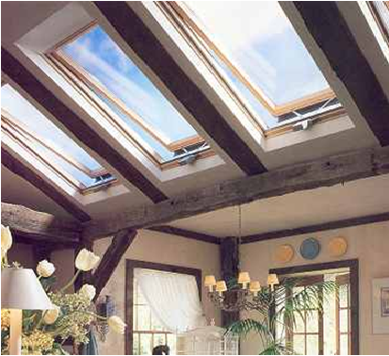

Chapter two : Methodology
2.1 work methodology

1. Evaluate a high school project already designed and constructed .
2. Analysis the direct cost and estimate the operating cost .
3. look about correct methods for the design and how do that .
4. look about environmental aspects that can affect on our high school project.
5. Redesign of the school With the application of environmental aspects and also the correct methods for the design .
6. Recalculate the direct cost analysis estimate the operational cost .
7. Compare the results with previous results for the design and recording .
8. look for payback period .

2.2 Design criteria

For the programs we used, we follow these values for the design
1. Reflection percent
Floor = 30 %
Ceiling = 80 %
Wall = 60 %
2. Recommended Illuminance values
Corridor = 150 Lux
Stair = 150 Lux
Classroom = 500 Lux
Laboratory = 500 Lux
Kitchen = 150 Lux
Library = 500 Lux
Bathroom = 100 Lux
Head master room = 500 Lux
Secretary room = 500 Lux
Social assistant room = 500 Lux
3. Temperature
In Summer T in = 24 cº
In Winter T in = 22 cº
The reference region for the design is Jerusalem
4. Humidity ratio = 50 %
5. Number of students in each class = 30 student

