1.1 Backend Side

1.1.1 XAMPP
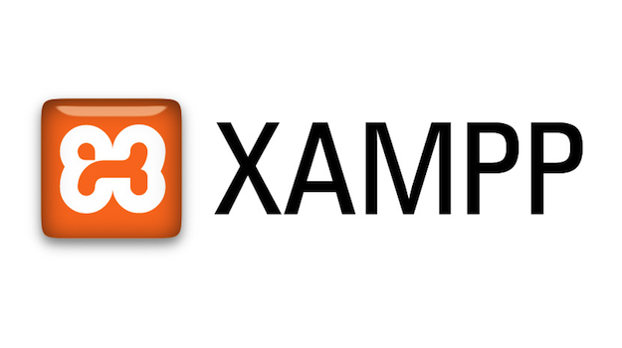
XAMPP is an open-source software developed by Apache Friends. XAMPP software package contains Apache distributions for Apache server, and PHP. And it is basically a local host or a local server. This local server works on your own desktop or laptop computer. This XAMPP server software gives you a suitable environment for testing MYSQL, PHP and Apache projects on the local computer. We used XAMPP in the first stages of the project and on testing.

1.1.2 000WEBHOST

000webhost is a free website hosting solution that provides an array of valuable features, including a website builder, WordPress support, and no ads. Users can upgrade to a paid plan to get even more features. 000webhost is the best free web hosting solution for those who are truly on a tight budget. We used 000webhost on the production phase so our backend can be reached from any location in the world.

4.3 Database Side

4.3.1 MySQL
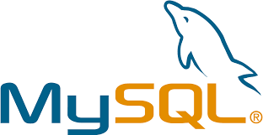
MySQL, the most popular Open Source SQL database management system, is developed, distributed, and supported by Oracle Corporation.
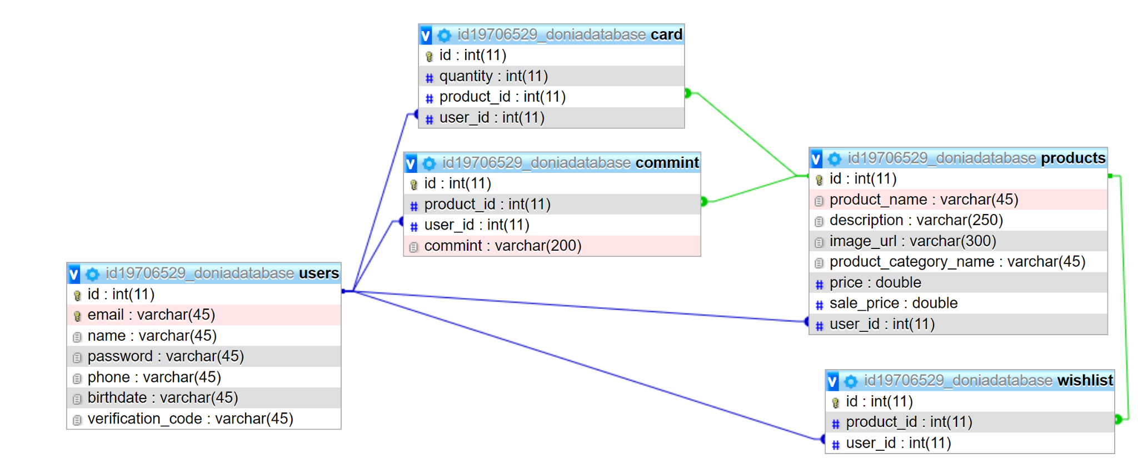
We used MySQL to build our database because we have a good knowledge about how it works and how to operate it on our servers. Our system database structure is described in the image below.

