
Traffic Accident Emergency Notifications System(TAENS)

Noor Jamleh 11524425
Mohammad Amereh 11526657
mohamad sobuh 11525675
Traffic Accident Emergency Notifications Traffic Accident Emergency Notifications System. Traffic Accident Emergency NoSystem.
Supervisor:
Dr. Othman Othman

Acknowledgment

We are heartily thankful to our supervisor Dr. Othman Othman for his guidance and support from the initial to the final level which enabled us to complete this part of project.
Also, we give all our regards and wishes to all the academic supervisors and the employees at An-Najah National University whom encouraged and supported us throughout our study.

Table of Contents:

List of Figures 3
List of Tables 4
ABSTRACT 6
Chapter 1: Introduction 6
1.1 statement of the problem 6
1.2 Objectives of the work. 6
1.3 Scope of the work. 7
1.4 Importance of the work 7
1.5 Organization of the Report 7
Chapter Two: Literature Review 7
2.1 The main reasons to choose this project 7
2.2 Our System 8
2.2.1 Detection of accident 8
Chapter Three: System analysis and design 9
3.1 User requirement: 11
3.1.1 Functional requirement: 11
3.1.2 Non Functional requirement: 12
3.2 System requirements: 13
3.2.1 Functional Requirements: 13
3.2.2 Nonfunctional Requirements: 14
3.3 Architectural design: 15
Chapter four: overview design 16
4.1 Input & output interface : 16
4.1.1 INPUTS: 18
4.1.2 OUTPUT: 37
Chapter five:System scenario 42
5.1 General Scenario : 42
5.2 Login Scenario: 43
5.3 Control Panel Scenario: 50
5.3.1 Administrator Scenario: 50
5.3.2 Ambulance scenario: 57
5.3.3 police scenario: 65
5.3.4 notification System scenario 71
Chapter six: DATABASE 74
6.1 ER DIAGRAM: 75
6.2 APPENDIX: 75
Chapter Seven: Evaluation: 76
Chapter Eight : Constrains, Standards/Codes 77
8.1 Constraints: 77
2.2 Standards/Codes : 78
Chapter Nine: Methodology 81
9.1 Block Diagram 81
9.2Circuits 82
9.3 Project Description 83
9.4 The Used Technology 84
9.4.1 GPS 84
9.4.2 IEEE 802.11 protocol 85
9.5 Project Components: 86
9.5.1 ARDUINO UNO 86
9.5.2Universal Serial Bus (USB) 87
9.5.3 ESP8266 Wi-Fi Module 88
9.5.4 GPS Receiver Module 88
9.5.5 Vibration Sensor Switch. 89
9.5.6 Resistors 90
9.5.7 5V Buzzer 90
Chapter Ten: Conclusion and recommendations 91
10.1 Future work 91
References 92
Appendix 1 94
Appendix 2 99

List of Tables

Table 1 ARDUINOUNO (ATmega328P). 68

Table 2 WiFi module parameter 69
Table 3 GPS Module specification 69
Table 4 Electrical characteristic of vibration sensor switch 70
Table5 causes and consequences of accidents and traffic violations in the West Bank 70
Table6 versions of IEEE802.11 71
Table 7 Wi-Fi standards with different in data rate and coverage area 71

ABSTRACT

The Rapid growth of technology has made our life easier. This advancement in technology also increased the traffic hazards. Hence the ratio of road accidents which take place frequently increases causing immense loss of life due to poor emergency facilities. Our project provides a solution for accident in order to make the human life safety. It enables intelligent detection of an accident at any place and reports about the accident if it's happen. Our project of GPS [15] module, Wi-Fi module and web site for reporting issue.

The system depend on accident so that when a vehicle face an accident, immediately a vibration sensor will detect that an accident happen and send a signal message to the Microcontroller, Due to this signal, an alert message will be send through Wi-Fi module including coordination for the location of accident and MAC address of the Wi-Fi module which set in the car to online website specifically for emergency centers, due to this information they can detect the location of accident immediately from MapQuest and the number ,type and size of vehicle , then they can add any notes about accident .

Chapter 1: Introduction

1.1 statement of the problem

The development of a transportation system has been the generative power for human beings to have the highest civilization above creature in the earth .Despite many efforts taken by different organization all around the world by various programs to warn against careless driving ,accidents, have taken place every day .However many lives could have been saved if the car is supported with a sufficient intelligent circuits like shock sensor, GPS module and Wi-Fi module that will notify the emergency service to get the crash information from an online web site and provide a proper help at suitable time .

1.2 Objectives of the work.
- To develop a system with all the useful utilities, this will help owners, Police, Rescue Squad and other authorities do their work more efficient and effective.
- To utilize the capability of a GPSreceiver to detect an accident and send the location of the accident by the Wi-Fi module by using the 3G network or Wireless LAN network to Alert Service Centre.

1.3 Scope of the work.
Our project is about making cars more intelligent and interactive which notify or resist user under unacceptable conditions. It provide critical information of real time situation to rescue victims of accident.

1.4 Importance of the work
Nowadays due to increasing in the deadly Vehicles accident, number of victims and injuries are also increasing. Speed is one of the basic reasons for vehicle accident. Many lives could have been saved if the emergency service could get accident information and reach in time which is supported by our project.

1.5 Organization of the Report
Chapter 1 of this report serves to provide an overview of the basic concepts and objective. Chapter 2 literature review provides the main reason of choose that project and compare with our system is similar .chapter 3 System analysis and the internal design . Chapter 4 is for interface and the outside design . Chapter 5 System scenario . Chapter 6 DataBase that have the datagram and the appendix . Chapter 7 is for Evaluation of that project ,chapter 8,9 is for the hardware part and work ,as well as the conclusion with suggestions for further improvements in the work.

Chapter Two: Literature Review

2.1 The main reasons to choose this project

The Rapid growth of technology has made our life easier. This advancement in technology also increased the traffic hazards. Hence the ratio of road accidents which take place frequently increases causing immense loss of life due to poor emergency facilities. Main causes behind these road accidents include: lack of training institutes, unskilled drivers, poor road conditions, use of cell phone during driving, over loading and poor governmental plans in this regard. According to Statistics released by the Palestinian Ministry of Transportation we take a clear vision about the causes and consequences of accidents and traffic violations in the West Bank as show below [5]:
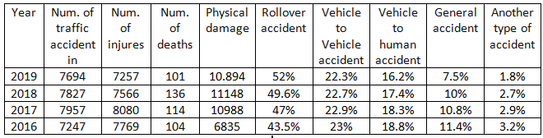

At present criteria, we cannot detect where the accident has occurred and hence no information related to it, leading to the death of an individual. The research work is going on for tracking the position of the vehicle. In this project GPSis used for tracking the position of the vehicle

There are certain technologies that already exists in the area of obstacle detection and warning. Each of them deals with the obstacle in a similar way the only differentiation is the sensor and its technique in recognizing the obstacle and actions initiated after sensing the obstacle. The following are the different approaches that were implemented in previous attempts of solving the obstacle problem: Enhancing riding safety and comfort, it is necessary to monitor the automobile's status[14]. A Safety System for Intelligent portable Hybrid Electric Bicycle IEEE paper published in 2011 attempted to develop a safety system for intelligent portable hybrid electric bicycle. The safety system includes two functions: Anti-crash warning system, balanced tire pressure monitoring system. Those are combined with ultrasonic[2] ranging technology and sensor technology for electric bicycles. Accident detection and reporting system using GPS, GPRS and GSM technology IEEE paper published in 2012 This paper proposes to utilize the capability of a GPSreceiver to monitor speed of a vehicle and detect accident basing on monitored speed and send accident location to an Alert Service Center. The GPSwill monitor speed of a vehicle and compare with the previous speed in every second through a Microcontroller Unit. Whenever the speed will be below the specified speed, it will assume that an accident has occurred. The system will then send the accident location acquired from the GPSalong with the time and the speed by utilizing the network. This will help to reach the rescue service in time and save the valuable human life.

2.2 Our System

2.2.1 Detection of accident
In the case that the vehicle gets a hit and an accident happened. Then we use an accident detection unit which be fitted in the front and other sides of the car .This accident detection unit consists of vibration sensors which work as a switch. Inside is a stiff spring coiled around a long metal pin. When the switch is moved, the spring touches the center pole to make contact. So, when there's motion, the two pins will act like a closed switch. When everything is still, the switch is open [13]. In case of accident, if the car is hit to some other vehicle or others object, then the spring of the switch will be compressed and make a short circuit. Due to this a signal will be sent to Arduino. Once Arduino gets signal from sensor, then it will immediately turn on the buzzer and will get the coordinates from the GPS modem. GPS module connected with the Wi-Fi module to Arduino board. GPSmodule is always connected to satellite and the vehicle position always can be detect ,when the accident happens the last position of the car send to the Arduino as a longitude and latitude then the Arduino transfer this information to Wi-Fi module which connected to 3G network or Wireless LAN network in order to send this information to online web site specifically for emergency centers .the position appear on the website after 30 second of accident happened as a notification, then the position of vehicle appear on mapquest with exact position .

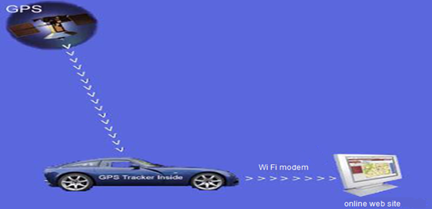
Figure 1: description for all system.

Chapter Three: System analysis and design

User types:

- Administrator.
- Police.
- Ambulance.
- notification system.

- Administrator: gets all the administration authority.

2.Police : view the location of the accident , write or edit the police report.

3.Ambulance: view the location of the accident , write or edit the Ambulance report.

4.notification system: send notification to police and Ambulance when the accident is occurred.

Users characteristics:

Admin and users can access this software; they are supposed to have basic knowledge on how to use this system. But admin just access the control panel.

User Authority:

Admin has all the control on the web application, and ambulance user has the ability to access the ambulance page only, and the police user have the ability to access the police page only.

Administrator:
- Access to all parts of the web.
- View police and ambulance reports.
- Add and delete a user from the system.

Police:
- Access to the private page in the police only.
- view the location of the accident , write or edit the police report.
- Change his password account .

Ambulance:
- Access to the private page in the ambulance only.
- view the location of the accident , write or edit the ambulance report.
- Change his password account.

notification system:
The system sends a notification about the accident to the police and ambulance , which contains the location of the accident .

3.1 User requirement:

3.1.1 Functional requirement:
- Application startup:
- Each user in the system has his own login information to be able to access his page.
2.Managing the account of the users:
- The administrator has the ability to add and delete users and access their information accounts from the system and has the ability to change his password.

- The police user only has access to the police account and has the ability to change his password.

- The ambulance user has the authority to access the ambulance account only and has the ability to change his password.
3. Organizing all activities and action on data :
Administrator:
- Watch the accident report of the ambulance and the police.

- Access to all statistics in the system.

- Access to vehicles registered with the system with the ability to edit, delete ,add and Search for a specific vehicle.

- Access to users registered with the system with the ability to edit, delete ,add and Search for a specific user.

- search for a specific accident.

- Change his password.

Police:
- Enter the police report.
- access the location accident.
- access all police reports.
- search for a specific accident.
- Change his password.
Ambulance:
- Enter the Ambulance report.
- access the location accident.
- access all police reports.
- search for a specific accident.
- Change his password.

3.1.2 Non Functional requirement:

- Easy to use: the website is designed in Arabic language and with a simple design to facilitate dealing with it by all users.

- Secure store data to each user: User data will be stored in the private database on the website and users will not be able to access other users information.

- Provide privacy: The admin can access all the pages of the site, while the ambulance can access the ambulance page only, and the police can access the police page only.
- Reliability: The website gives the same repeated result under the same conditions.

- Easy to learn : the user don’t take longer time to learn the concept and components of the application .

3.2 System requirements:

3.2.1 Functional Requirements:
- notification system:
- The system sends a notification about the accident to the police, which contains the location of the accident .

- The system sends a notification about the accident to the ambulance that contains the location of the accident.
- data entry system:
This section depends on Administrator and Police and Ambulance:
- Admin: inserts users and vehicles information into the system.
- Police: insert the police report that includes the date of the accident, the name of the driver, the car number, governorate, and the location of the accident.
- Ambulance: insert the ambulance report, which contains the number of deaths, the number of injuries and the location of the accident.

- Statistics system: Depends on police and ambulance reports.
The following statistics can be viewed from admin:
- Distribution of vehicles by type.
- Distribution of vehicles by size.
- Distribution of vehicles by city.
- Distribution of vehicles by type and city.
- Distribution of accidents by type.
- Distribution of accidents by size.
- Distribution of accidents by city.
- Distribution of accidents by drivers.
- Distribution of accidents according to the injured.
- Distribution of accidents by type of accident.

3.2.2 Nonfunctional Requirements:
- Performance: The response time of all procces take 4 sec that’s make the application quickly and this is our goal.

- Scalability: The system can be expanded according to user requirements.

- Usability: the website is designed in Arabic language and with a simple design to facilitate dealing with it by all users.

- Data Integrity: Each part of the system completes another part in order to collect data in the required way.

3.3 Architectural design:
: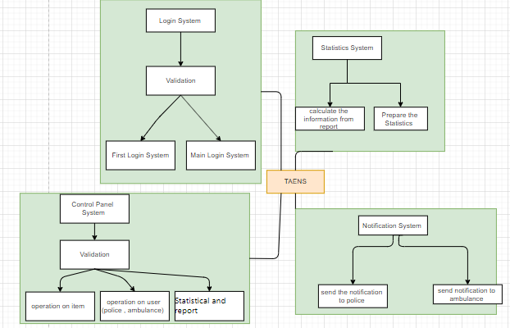
Figure 2:Architectural design

The sub system and compose for TAENS system:
- Control Panel System:
Sub system is used to control all system functionality.
1.1 Operation on cars: Control all process on vehicle adds, search, and update vehicles .
1.2 Operation on user(police , ambulance): Control all process on user add, delete, search, update, users.
1.3 statistical and report: process to view the ambulance or police report and statistical.

- Login System:
Sub system that use to login by users and admin to system.
2.1 First Login: this component is for admin first login must change password and create user.
  - Main Login: this component goal to reach to control panel.
3. Notification System:
Sub System that is used for sending notification to user (ambulance and police) .
3.1 send the notification to police : whenever an accident happen a notification sent to the police account that contains the car location.
3.2 send the notification to ambulance :whenever an accident happen a notification sent to the ambulance account that contains the car location.

4. Statistical System :
Sub System that use to create the Statistical.
4.1 collect the information from report: gathering information from two resources: reports that written by police and ambulance, and database.
4.2 prepare the statistical: create the statistical automatically and send it to administrator.

Chapter four: overview design

4.1 Input & output interface :

In this chapter we will display the data that will inserted to online website , and we will show the result .
- Overall design from inside.
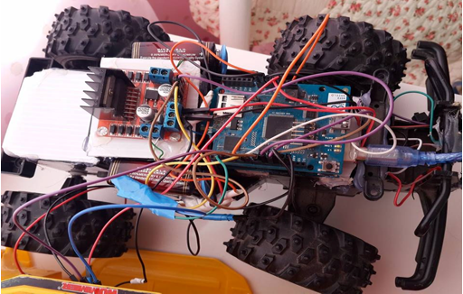
Figure 3:Car design from inside.

- Overall design from outside
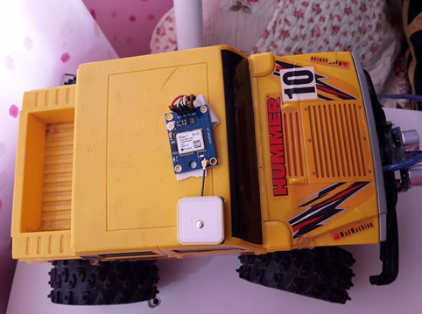
Figure 4 :Car design from outside
- Home page for online website.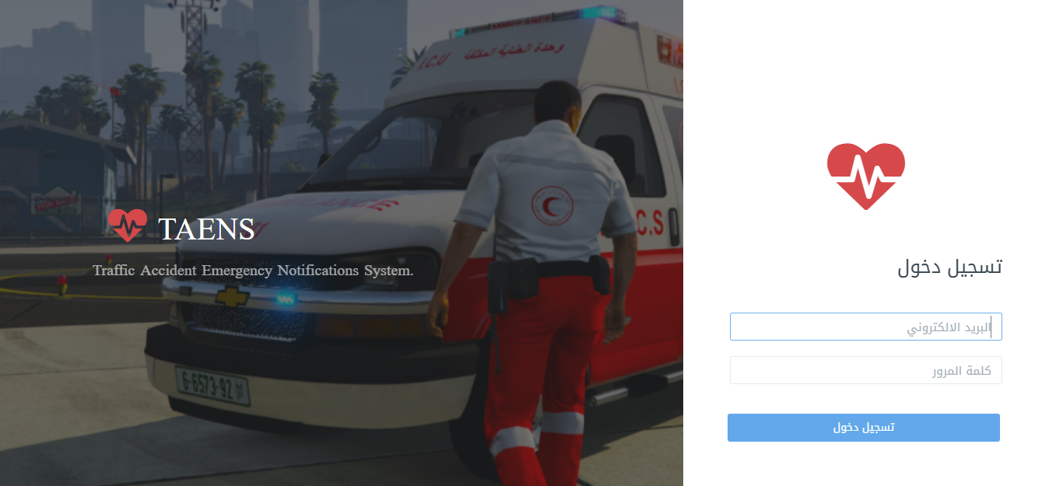
Figure 5: Home page.
from this page we can login to three domain, admin user by admin email , police user for by police email , ambulance user and hospitals by ambulance email.

4.1.1 INPUTS:
This section talks about the data that will be included in every part of the website

- Admin domine

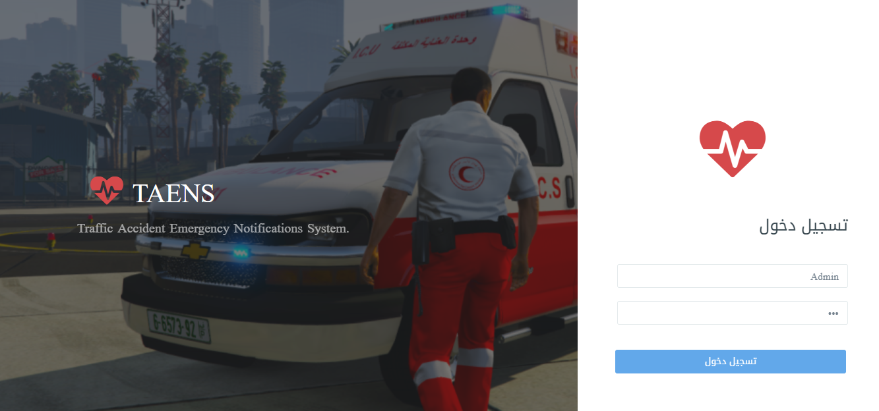
Figure 6:Admin login.
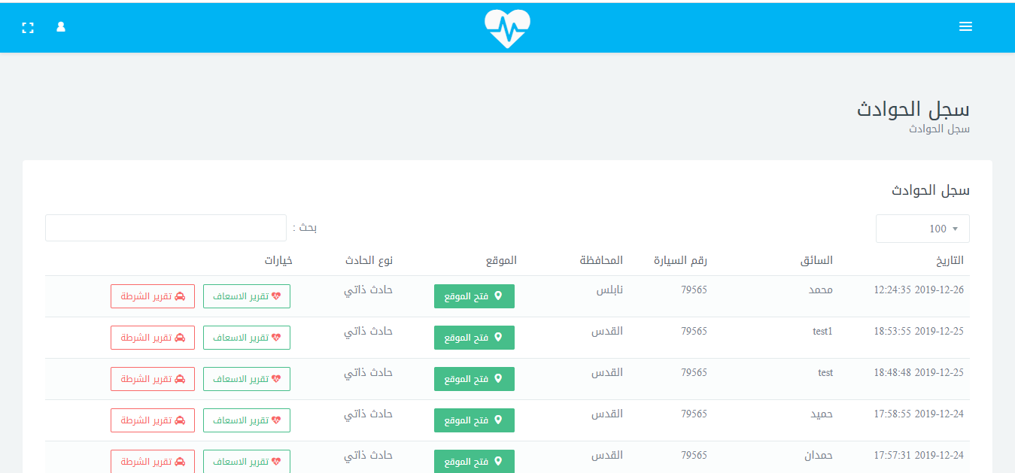
Figure 7:Admin page.
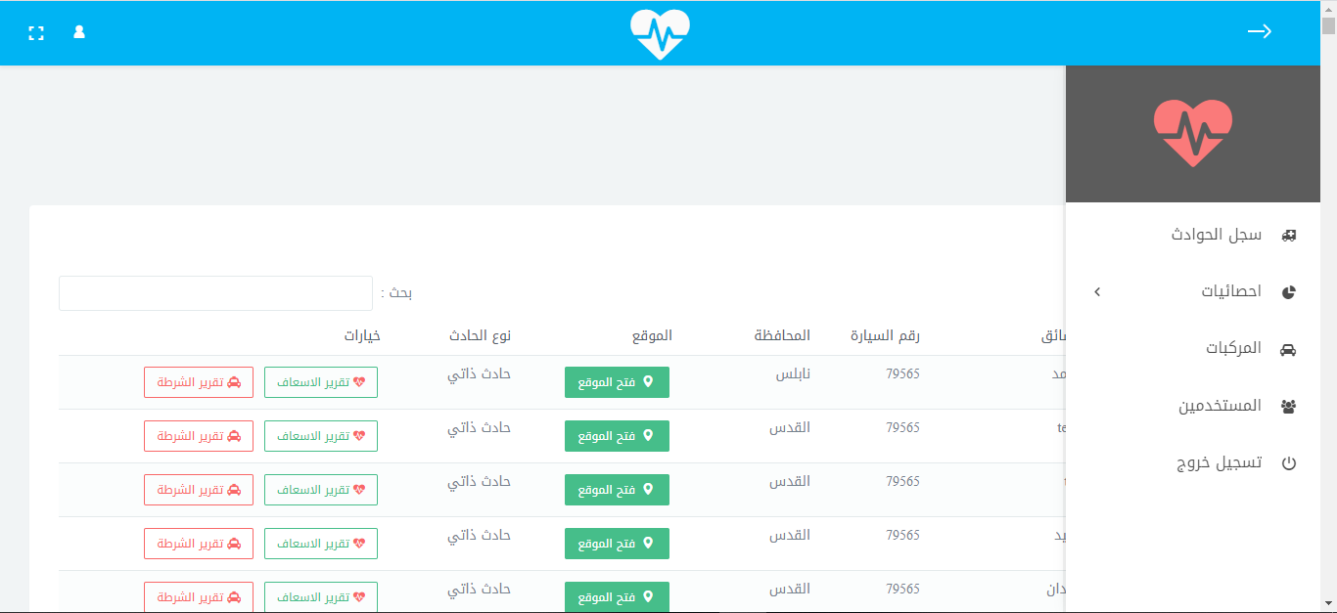
Figure 8:Admin dashboards.

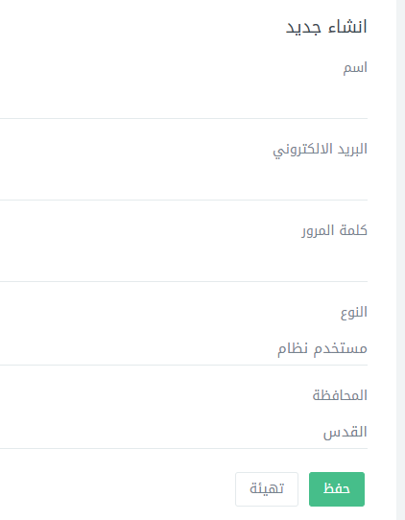
Figure 9: Add a new user.

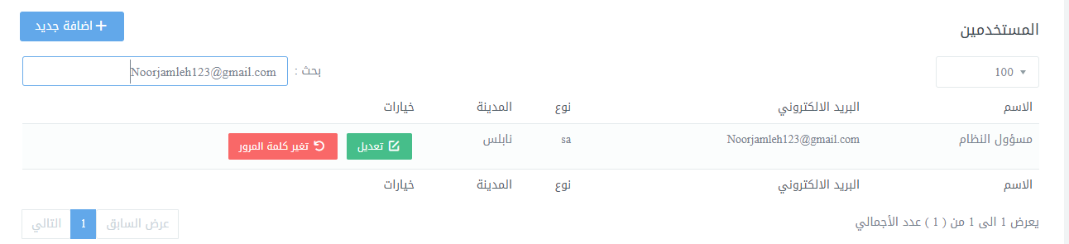
Figure 10: Search for a specific user.

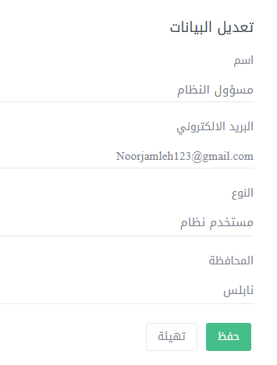

Figure 11 : Modify the data of a specific user.

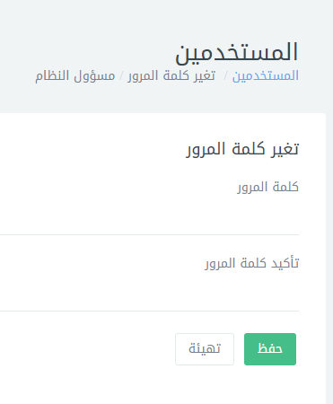
Figure 12: change password for Admin.

Figure 13: Determine the number of results to return.
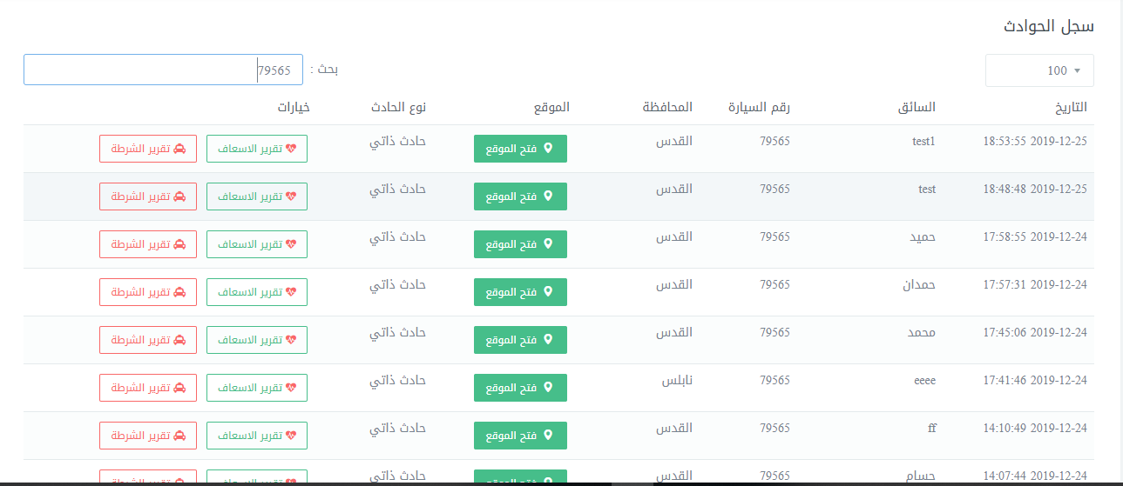
Figure 14: search a specific accident by admin.

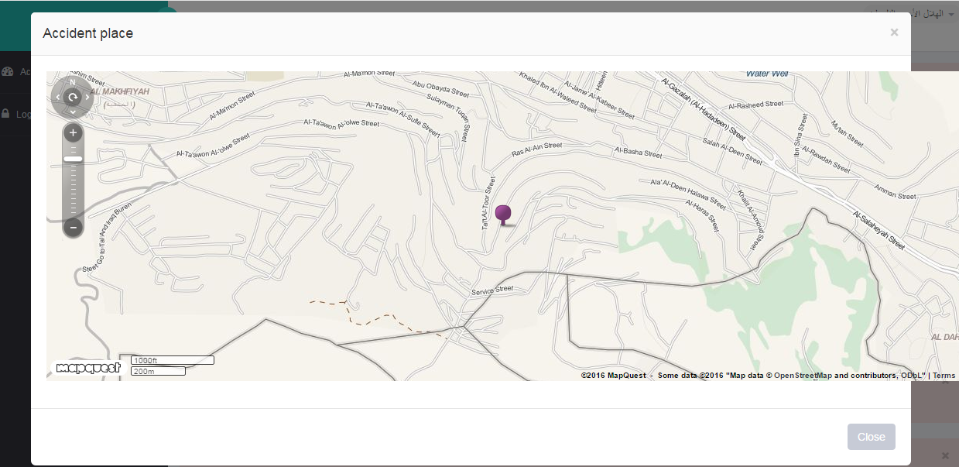
Figure15: Accident Location on mapquest seen by admin domain.


Figure 16: Access to the ambulance report by admin.

Figure 17: Access to the police report by admin.
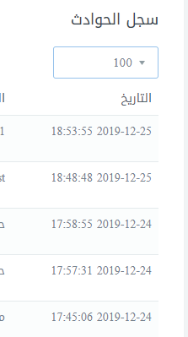
Figure 18: Determine the number of results to return.
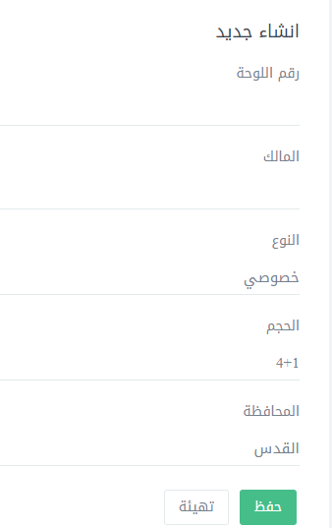
Figure 19: Add a new vehicle.
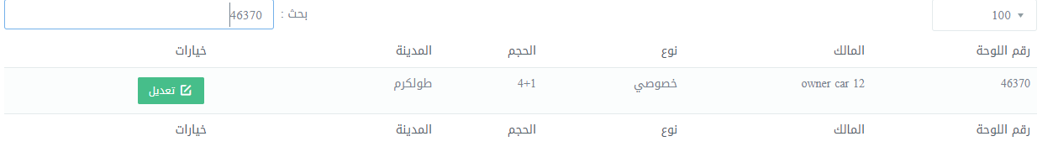
Figure 20: Search for a specific vehicle.

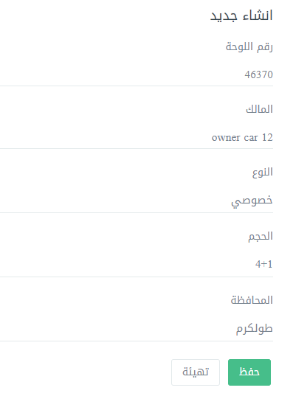
Figure 21: Edit the vehicles information.
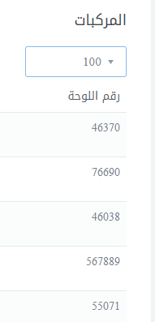
Figure 22: Determine the number of results to return.

- Ambulance User domine

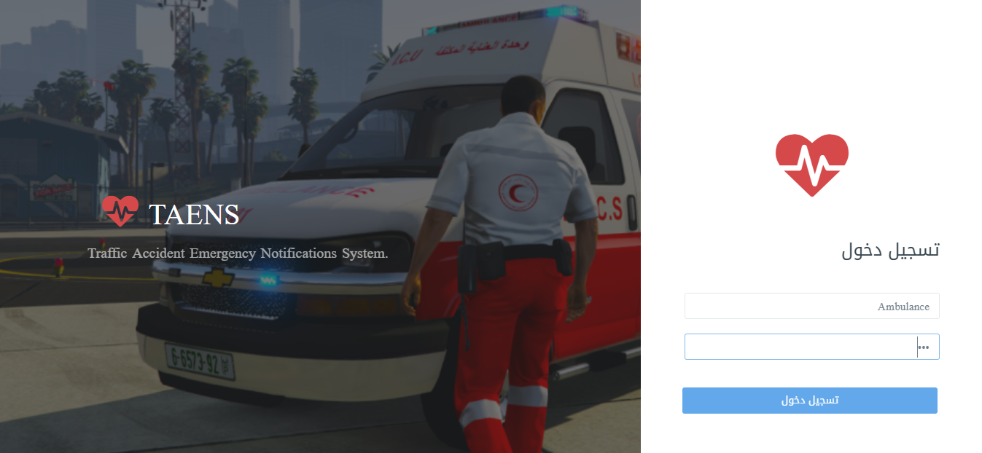
Figure 23: Ambulance login.
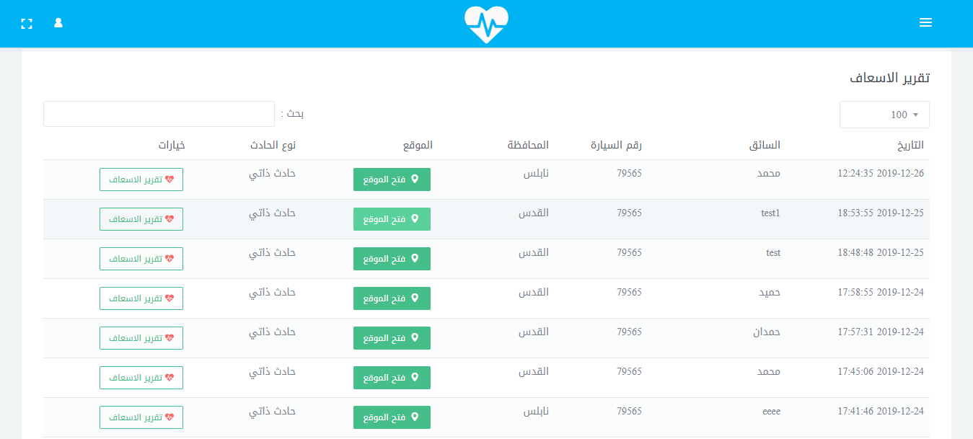
Figure 24: Ambulance page.

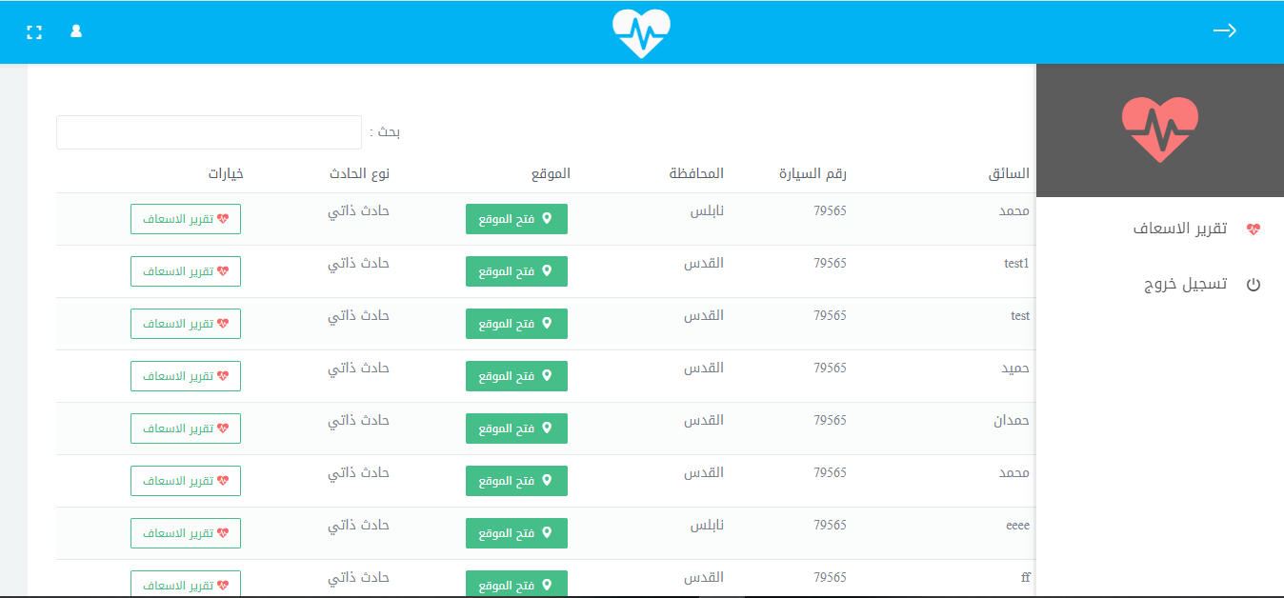
Figure 25: Ambulance options.
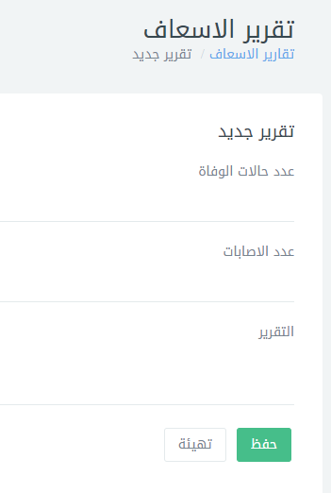
Figure 26: Ambulance report template.

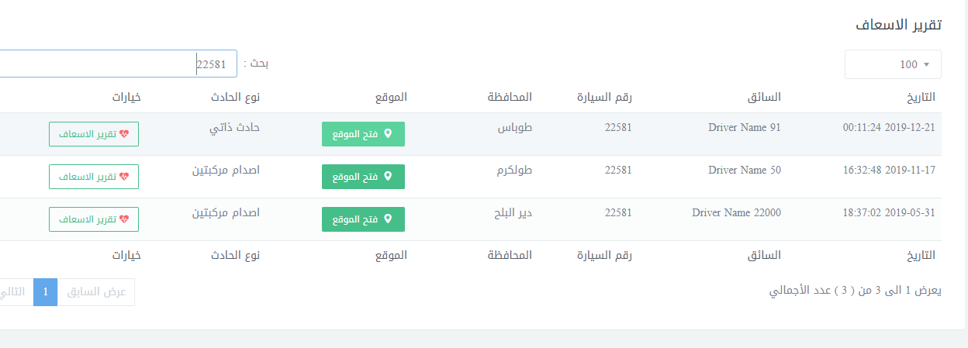
Figure 27: search a specific accident by Ambulance user.
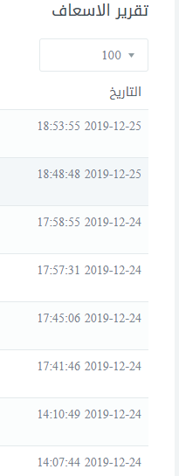
Figure 28: Determine the number of results to return.
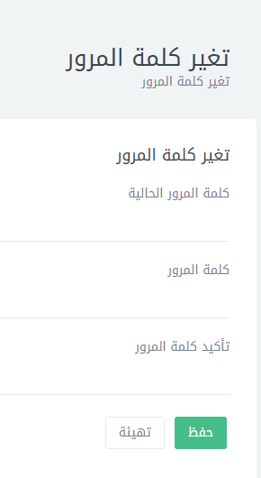
Figure 29: Change the password for ambulance user.
- Police User domine

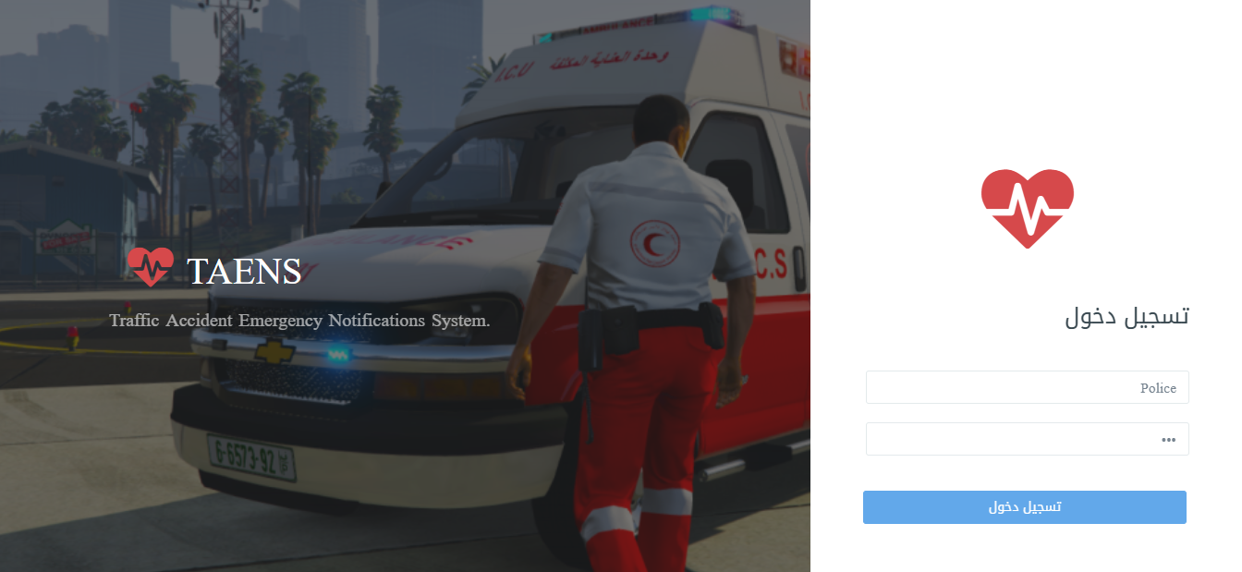
Figure 30:police login.
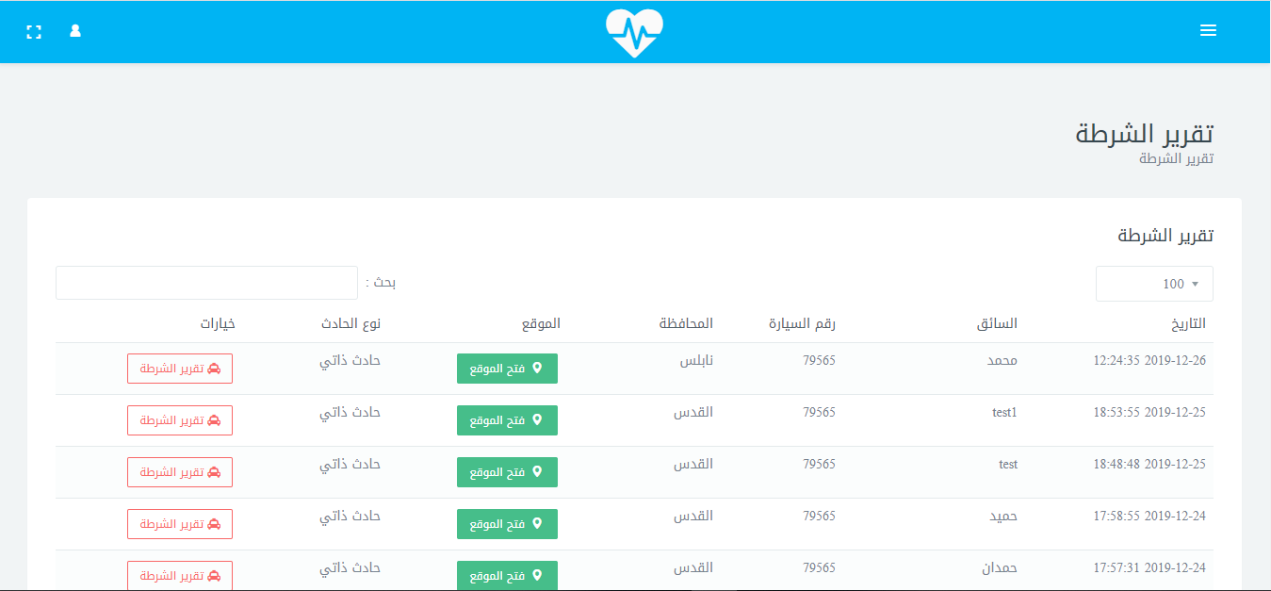
Figure 31:police page.

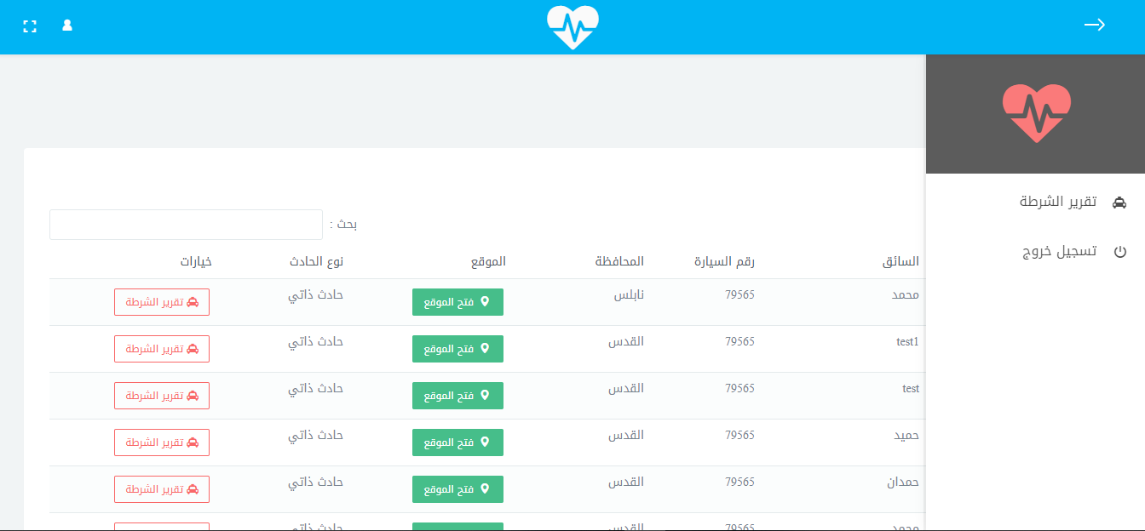
Figure 32: Police options.

Figure 33: police report template.
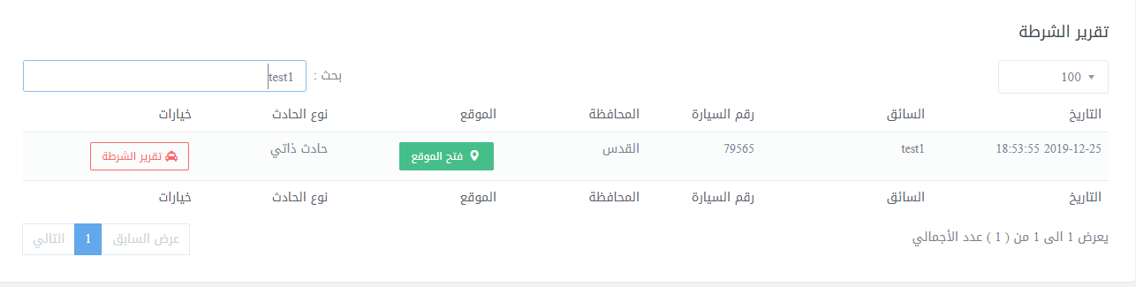
Figure 34: search a specific accident by police user.
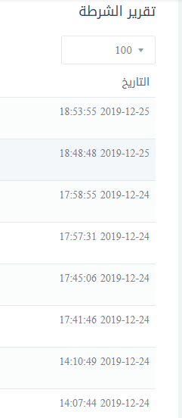
Figure 35: Determine the number of results to return.
Figure 36: Change the password for police user.

4.1.2 OUTPUT:
This section talks about the result , the results will be in the form of statistics, and only the admin can see them

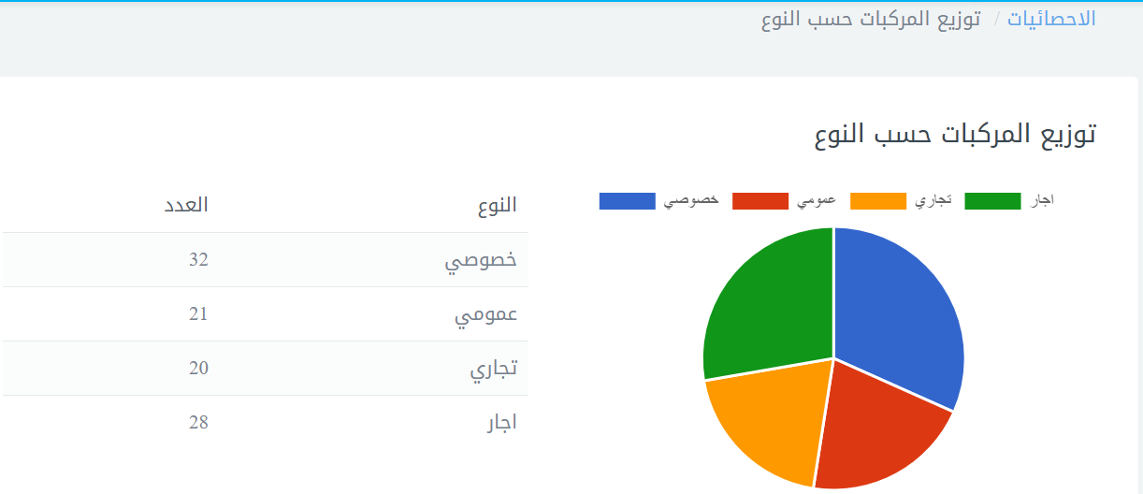

Figure 37: Distribution of vehicles by type.
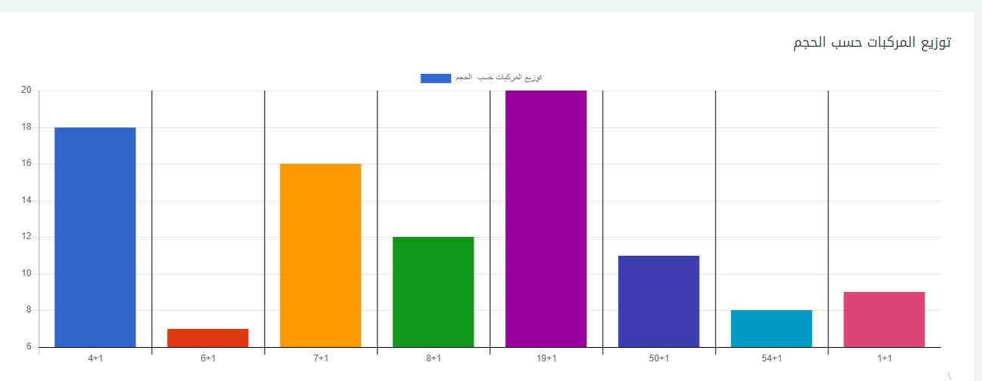
Figure 38: Distribution of vehicles by size.
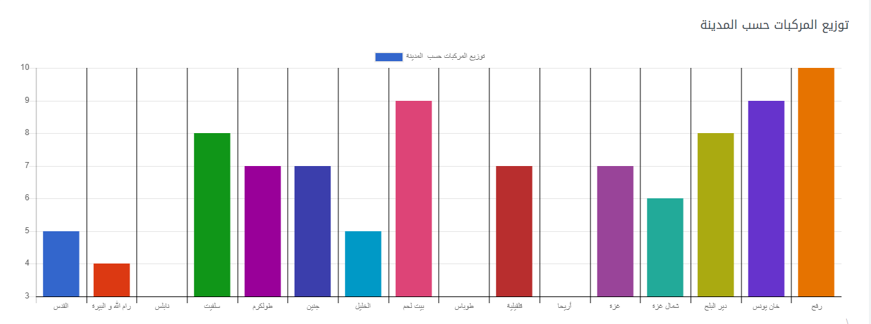
Figure 39: Distribution of vehicles by city.
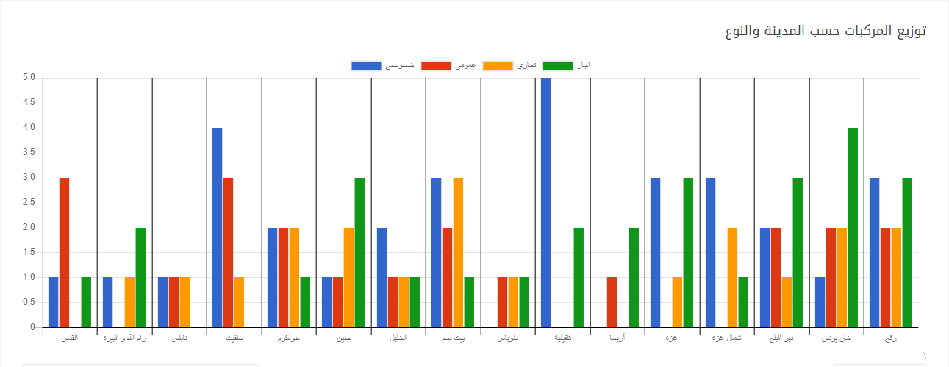
Figure 40: Distribution of vehicles by type and city.

Figure 41: Distribution of accidents by type.
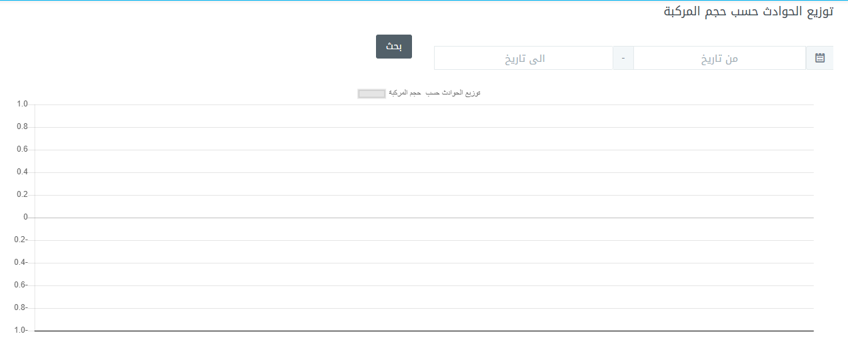
Figure 42: Distribution of accidents by size.
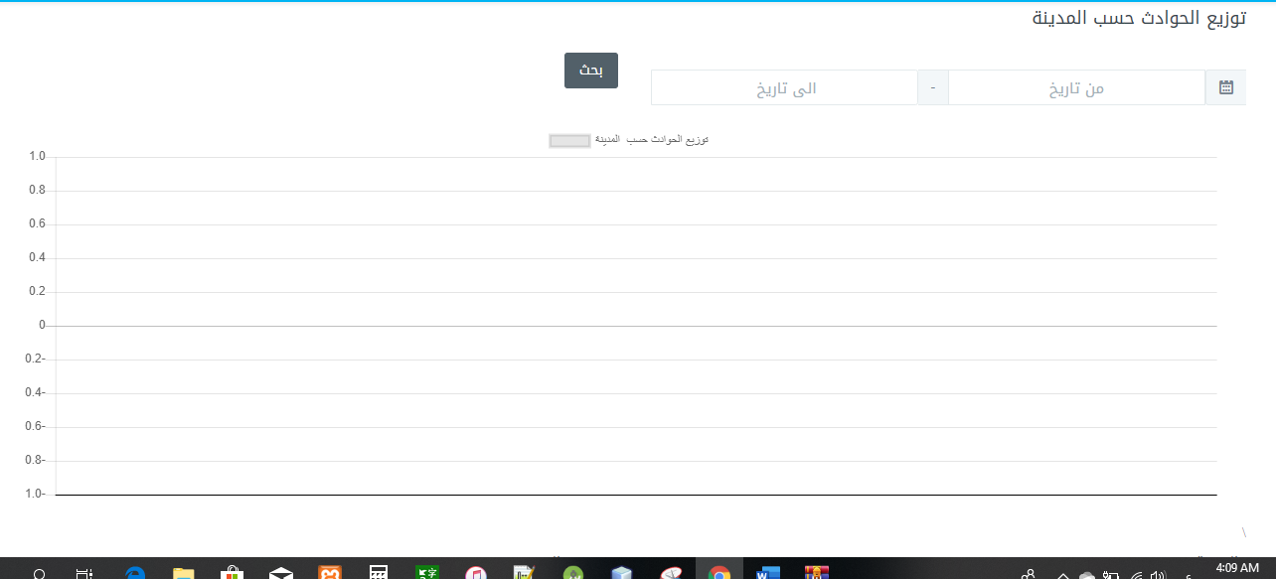
Figure 43: Distribution of accidents by city.
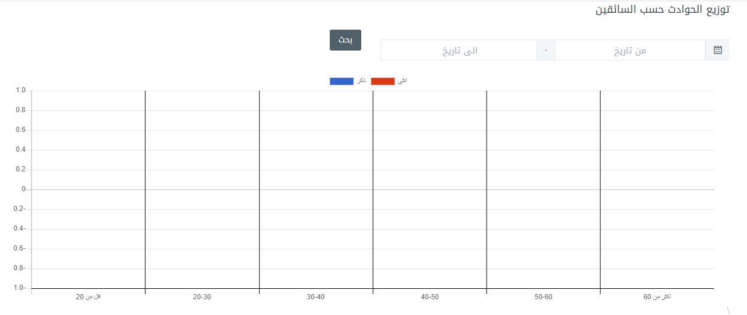
Figure 44: Distribution of accidents by drivers.
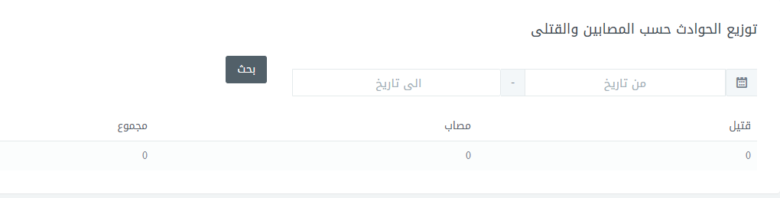
Figure 45: Distribution of accidents according to the injured.

Figure 46: Distribution of accidents by type of accident.
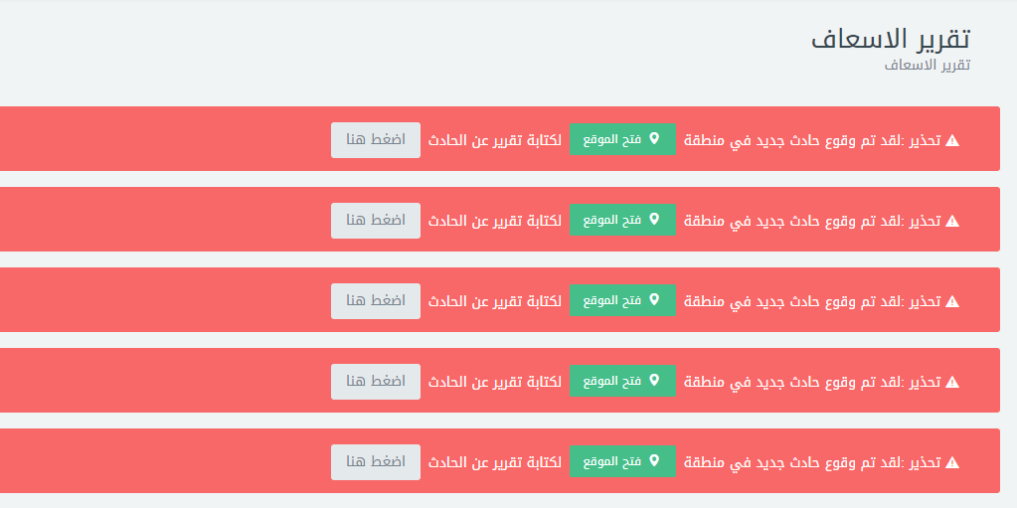
Figure 47: Ambulance notification.
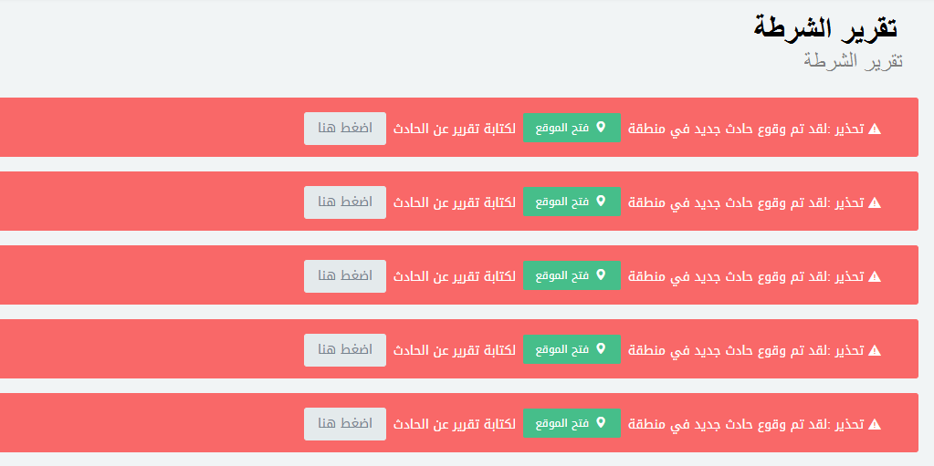
Figure 48: police notification.

Chapter five:System scenario

5.1 General Scenario :
Initially assumption:
The administrator adds two users POLICE_USER and AMBULANCE_USER, now these users can access the application.

Rolls and Responsibly :
Adminstrator_USER: Control with all system components, after admin enter his username and password the system display the control panel screen which is contain every action and activity, he can add user (Ambulance or Police) and vehicle , delete, update and search, and he can view the statistical report , he can view the report that written by Police or Ambulance ,user can be different type Ambulance or Police user.
Police_USER: This user has the responsibility to enter police report and edit it, and he can view all his reports and can change the password of his account.
Ambulance_USER:This user has the responsibility to enter ambulance report and edit it, and he can view all his reports and can change the password of his account.

5.2 Login Scenario:
1. Administrator Login:
Initially assumption:
The Administrator _USER wants to login his account.
Normally:
1) Enter his username and password to login into system.
2) The System welcomes the administrator after logging in to his account and displays the system control panel screen.
What can be wrong?
The administrator enter his ID (username) OR password wrongly. In this case, an error massage shown to the admin telling him about the error.
Use case:
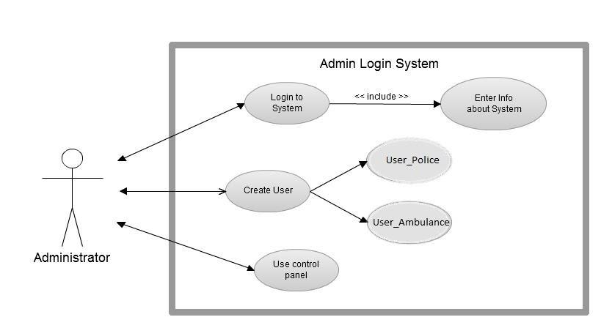
Figure 49:Use case to admin login system.
Activity Diagram: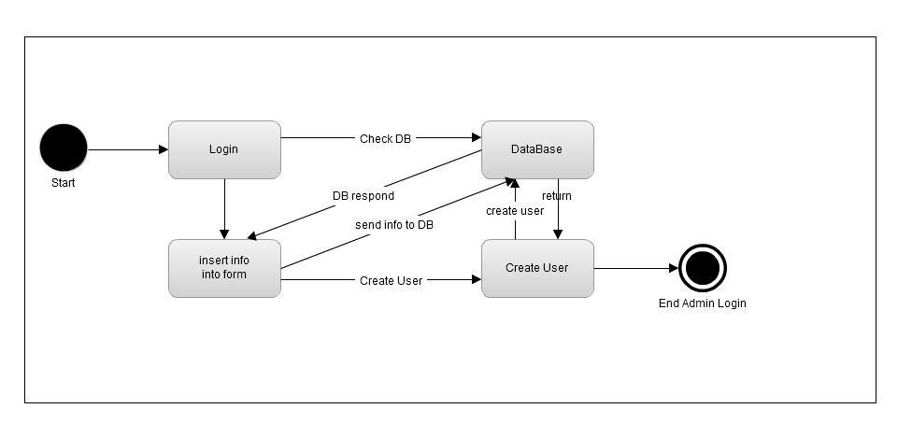
Figure 50:Activity Diagram to admin login system.
Sequence Diagram:
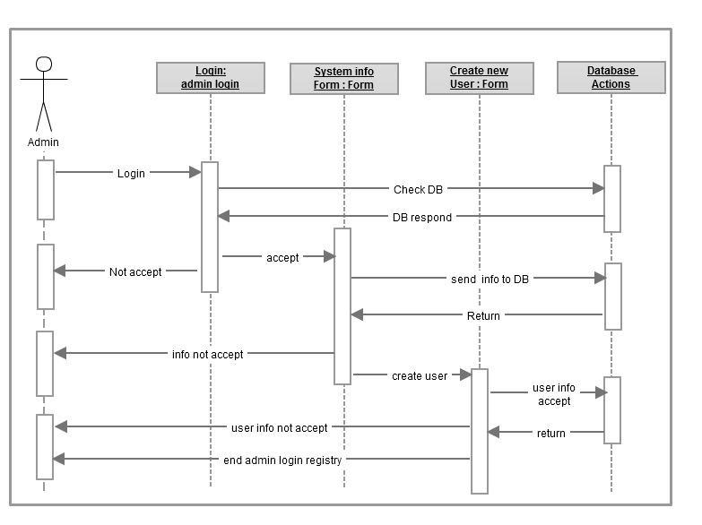
Figure 51:Sequence Diagram to admin login system.

police -User Login:
Initially assumption:
The police user has created by administrator and he wants to login to system for the first time.
Normally:
1) User enters his ID (Username) and his password and login to the system.
2) After he moves to his control panel screen.

What can be wrong?
1)User enters his ID or password wrongly. In this case, the system shows an error massage and prompts him to inter the information again.
2) User is not active and he cannot login .

Use case:
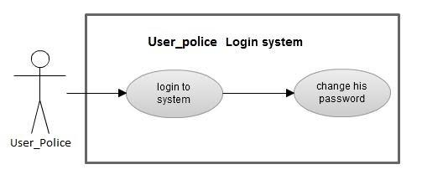
Figure 52:Use case Diagram to user police login system.

Activity Diagram:
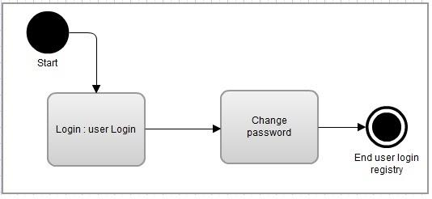
Figure 53:Activity Diagram to user police login system.

Sequence Diagram:
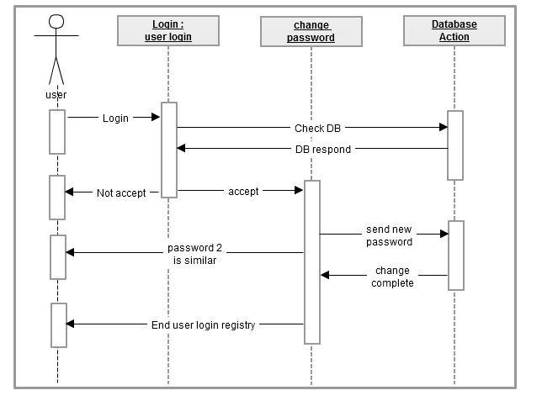
Figure 54:Sequence Diagram to user police login system.

3.Ambulance_ User Login:
Initially assumption:
The Ambulance _USER has created by administrator and he wants to login to system for the first time.
Normally:
1) User enters his ID (Username) and his password and login to the system.
2) After he moves to his control panel screen.

What can be wrong?
- User enters his ID or password wrongly. In this case, the system shows an error massage and prompts him to inter the information again.
2) User is not active and he cannot login
Use case:
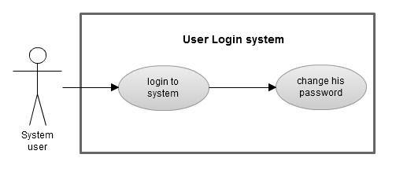
Figure 55:Use case Diagram to user Ambulance login system.

Activity Diagram:
Figure 56:Activity Diagram to user Ambulance login system.
Sequence Diagram:

Figure 57:Sequence Diagram to user Ambulance login system.

5.3 Control Panel Scenario:

5.3.1 Administrator Scenario:
1.users:
a) Add user:
Initially assumption:
The admin finishes registry login and now he gets into his control panel and intends to add user.
Normally:
1) The admin clicks the "add new user" button in control panel.
2) The new user form will be shown.
3) After he finishes filling the form for a new user, he clicks submit and finishes.
What can be wrong?
Some missing or invalid data fields in the "add user" Form. In this case, the system will show an error message.
b) Search user:
Initially assumption:
The admin finishes registry login and now he gets into his control panel and searches for user.
Normally:
1) The admin click the "search user" button in control panel after choose users from menu.
2) The screen search will be shown.
3) Admin searches by email of user only and click the search button.
4) The result will be listed and displayed on the search screen.
What can be wrong?
Search does not find the user. In this case, the system will show a message “There is no information entered”.
c) update user:
Initially assumption:
The admin finishes adding user and wants to update user.
Normally:
1) The admin clicks to search user button in control panel after choose users from menu (similar to search user in administrator scenario).
2) Then he clicks to user, and then the user form will be shown.
3) After he finishes he clicks done.
What can be wrong?
1) Search does not find the user. In this case, the system will show a message” There is no information entered”.
2) Some fields in the form are left empty.

2.Statics:
Initially assumption:
The admin finishes registry login and now he gets into his control panel and intends to see the statistical report
Normally:
1) The admin clicks the "statics" button in control panel.
2) The screen will show all the statics
What can be wrong?
No internet connection then can’t show the statistical.
3.vehicle :
a) add vehicle:
Initially assumption:
The admin add vehicle after choose the vehicle from menu .
Normally:
1) The admin clicks the "add new vehicle" button in control panel.
2) Entering the vehicle information
3) After he finishes filling the form for a new vehicle, he clicks submit and finishes and The information is saved in a database and the vehicle is inserted.

What can be wrong?
Some missing fields in the "add vehicle" Form. In this case, the system will show an error message ”there is a required field”.
b)search vehicle:
Initially assumption:
The admin finishes go to vehicle and now he gets into his control panel in vehicle and searches for it .

Normally:
1) The admin click the "search vehicle" button in control panel.
2) The screen search will be shown.
3) Admin searches by name or by Plate Number and click the search button.
4) The result will be listed and displayed on the search screen.
What can be wrong?
Search does not find the vehicle. In this case, the system will show a message error” There is no information entered”.
c) update vehicle:
Initially assumption:
The admin finishes show vehicle and wants to update it .
Normally:
1) The admin clicks to search vehicle button in control panel (similar to search user in administrator scenario).
2) Then he clicks to vehicle, and then the vehicle form will be shown.
3) After he finishes he clicks done.
What can be wrong?
1) Search does not find the vehicle. In this case, the system will show a message error.
2) Some fields in the form are left empty.
4.Accidents
a)View accident log:
Initial assumption:
The administrator ends the login ,now accesses its dashboard, and intends to view the accident log.
The administrator can choose a specific number for the most recent accidents.
Normally:
The Admin clicks the "View accident log" button in the control panel after choose accident log from menu.
What can be wrong?
No access to Database. In this case, the system will show an error message.
B)search accident:
Initially assumption:
The admin finishes go to accident log and now he gets into his control panel in accident and searches for it .
Normally:
1) The admin click the "Search'' accident button in control panel.
2) The screen search will be shown.
3) Admin searches by the car driver's name and click the search button.
4) The result will be listed and displayed on the search screen.
What can be wrong?
Search does not find the accident. In this case, the system will show a message error.

Use case:

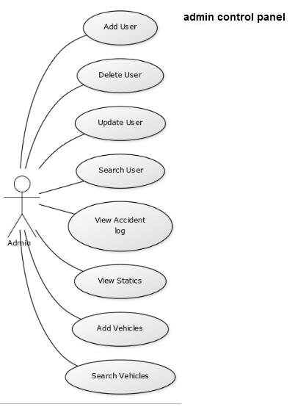
Figure 58:Use case Diagram to admin control panel.

Activity Diagram:
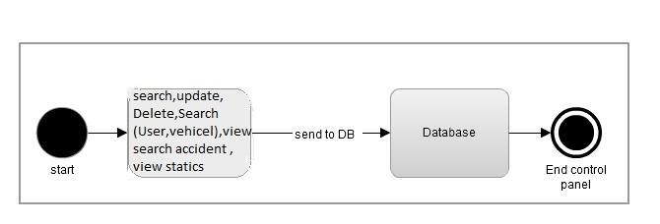
Figure 59:Activity Diagram to admin control panel.

Sequence Diagram:
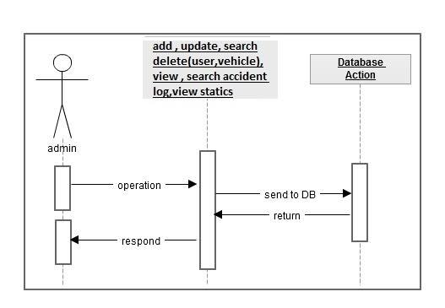
Figure 60:Sequence Diagram to admin control panel.

5.3.2 Ambulance scenario:
a)View Ambulance reports:
Initial assumption:
The Ambulance_ user ends the login ,now accesses its dashboard, and intends to view the accident reports
The Ambulance _user can choose a specific number for the most recent accidents.
Normally:
The Ambulance_ user clicks the "View Ambulance report" button in the control panel.
What can be wrong?
There is no match between the search and the information stored in database, In this case, the system will show not found massage.
Use case diagram :

Figure 61:Use case Diagram to View Ambulance reports.
Activity diagram:
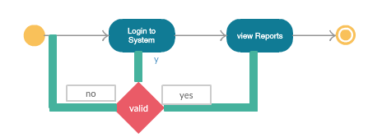
Figure 62:Activity diagram Diagram to View Ambulance reports.

Sequence diagram:

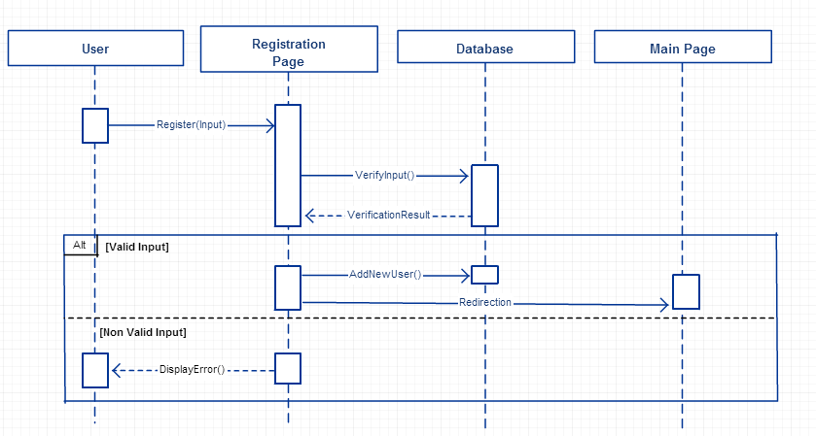
Figure 63:Sequence diagram Diagram to View Ambulance reports.
b)Writing reports about the accident:
Initial assumption:
The Ambulance_ user ends the log in ,now accesses its dashboard, when notification received ,user click to write the accident reports.
Normally:
The Ambulance_ user clicks the "write report " button in the control panel.
What can be wrong?
Some missing fields in the "write report" Form. In this case, the system will show an error message “This field is required”.

Use case diagram :
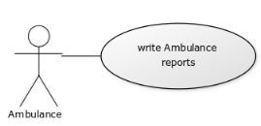
Figure 64:Use case diagram to Writing Ambulance reports.

Activity diagram:
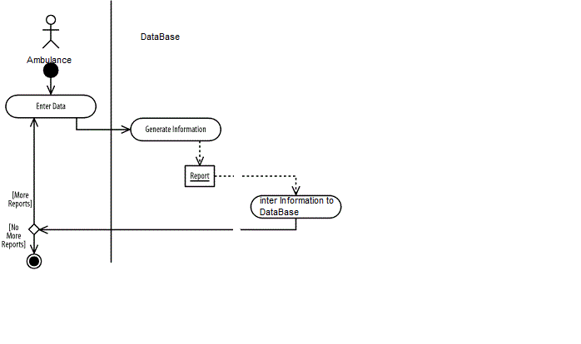
Figure 65:Activity diagram to Writing Ambulance reports.

Sequence diagram:
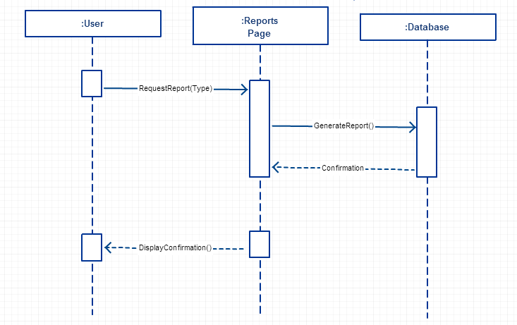
Figure 66:Sequence diagram to Writing Ambulance reports.
c)Search reports about the accident:
Initially assumption:
The admin finishes go to view ambulance reports and now he gets into his control panel in accident and searches for it .
Normally:
1) The Ambulance_ user click the "Search'' accident button in control panel.
2) The screen search will be shown.
3) Ambulance_ user searches by the Driver name or plate number and click the search button.
4) The result will be listed and displayed on the search screen.
What can be wrong?
Search does not find the report. In this case, the system will show a message” There is no reports .

Use case diagram :
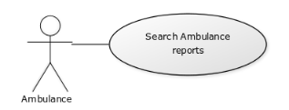
Figure 67:Use case diagram to search Ambulance reports.

Activity diagram:
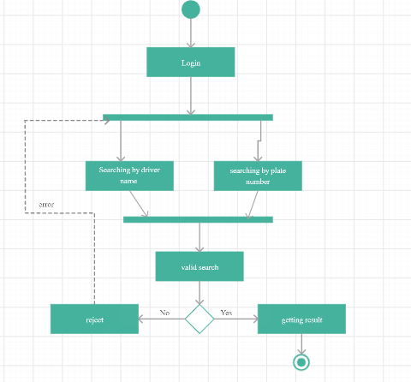
Figure 68:Activity diagram to search Ambulance reports.

Sequence diagram:
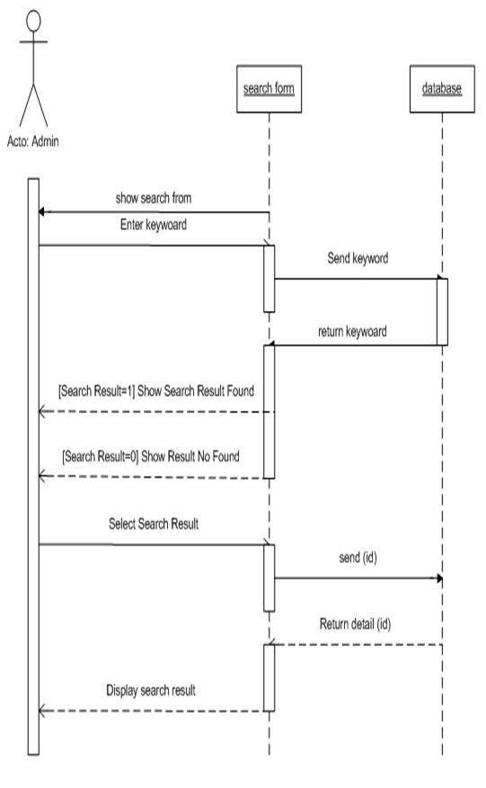
Figure 69:Sequence diagram to search Ambulance reports.

5.3.3 police scenario:

a)View police reports:
Initial assumption:
The police user ends the login ,now accesses its dashboard, and intends to view the accident reports
The police user can choose a specific number for the most recent accidents.
Normally:
The police user clicks the "View police report" button in the control panel.
What can be wrong?
There is no match between the search and the information stored, In this case, the system will show not found
Use case diagram:

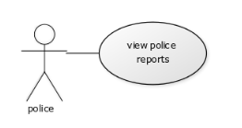
Figure 70:Use case diagram to View police report.

Activity diagram :
Figure 71:Activity diagram to View police report.
Sequence diagram:
Figure 72:Sequence diagram to View police report.
b)Writing reports about the accident:
Initial assumption:
The police_ user ends the log in ,now accesses its dashboard, when notification received ,user click to write the accident reports.
Normally:
The police_ user clicks the "write report " button in the control panel.
What can be wrong?
Some missing fields in the "write report" Form. In this case, the system will show an error message.
Use case diagram:
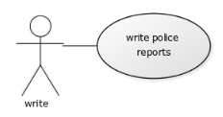
figure 73:Use case diagram to Writing Police reports.

Activity diagram:
figure 74:Activity digram to Writing police reports.

Sequence diagram:
figure 75:Sequence digram to Writing police reports.

c)Search reports about the accident:
Initially assumption:
The police_ user finishes go to view police reports and now he gets into his control panel in accident and searches for it .
Normally:
1) The police_ user click the "Search'' accident button in control panel.
2) The screen search will be shown.
3) police_ user searches by the Driver name or plate number and click the search button.
4) The result will be listed and displayed on the search screen.
What can be wrong?
Search does not find the report. In this case, the system will show a message (not found ).
Use Case diagram :
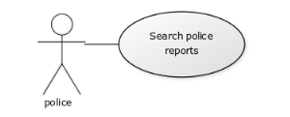
figure 76:Use case digram to search police reports.

Activity diagram:
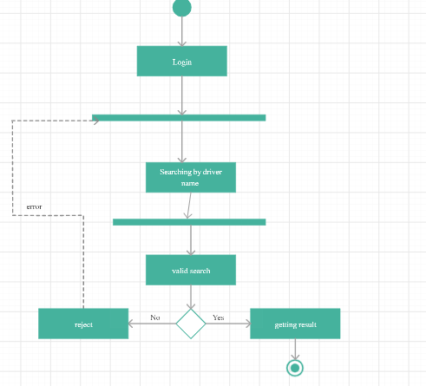
figure 77:Activity digram to search police reports.

Sequence diagram:
figure 78:Sequence digram to search police reports.

5.3.4 notification System scenario
Send notification to user:
Initial assumption:
when the accident occurred , the Notification System send a Notification to Police User and Ambulance User
Normally:
1.the Accident is occurred.
2.The Notification System send a notification to Ambulance User and Police User the notification contains the car number and location
3.The Ambulance User click on location from notification to see it , and click the “fill the report ”
4.The Police User click on location from notification to see it , and click the “fill the report ”
What can be wrong?
if the notification system doesn’t have the connection to internet , the notification won’t be sent.

Use Case diagram :
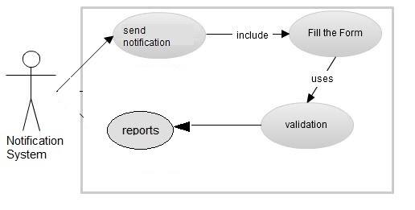

figure 79:Use case digram to send notification.

Activity Diagram :
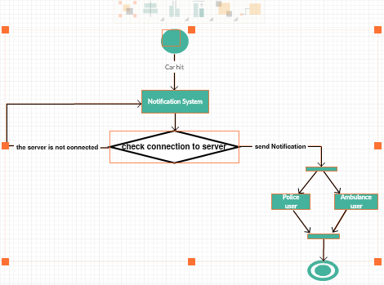
figure 80:Activity digram to send notification.

Sequence diagram:
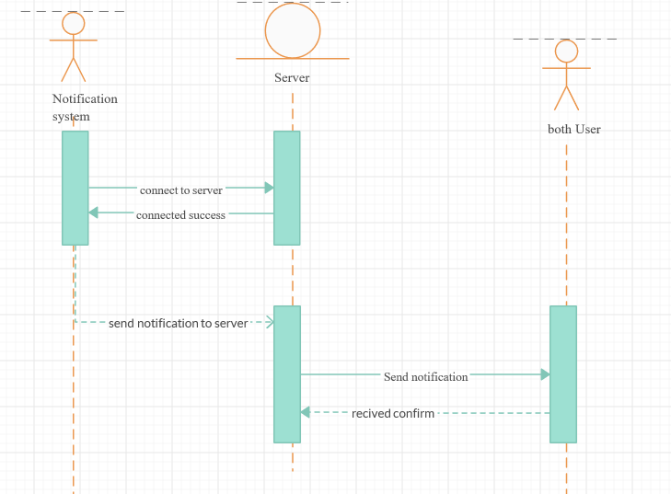
figure 81:Sequence digram to send notification.

Chapter six: DATABASE

6.1 ER DIAGRAM:

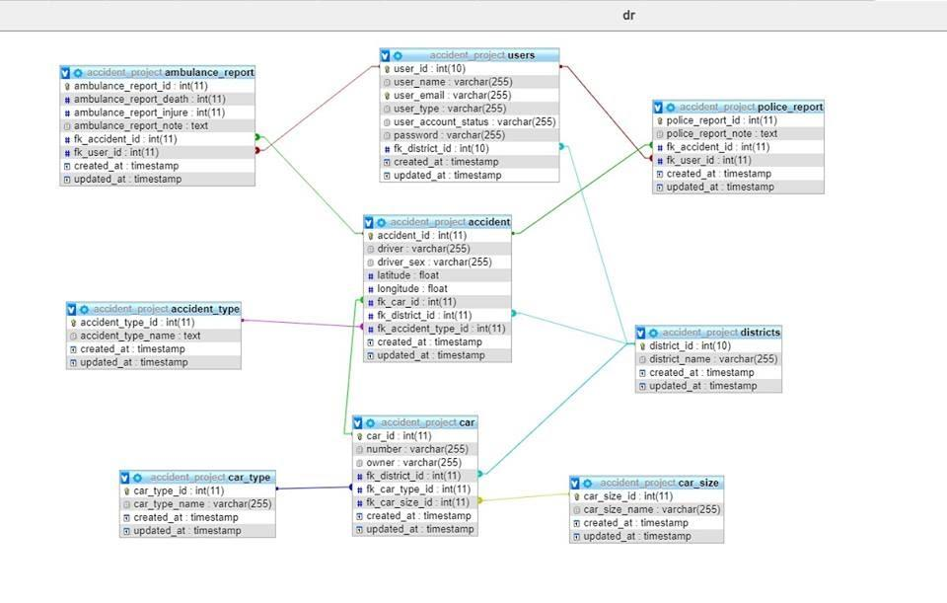
figure 82: Database Digram

6.2 APPENDIX:
To see the database code you can go to the page 101 in that documentation its from page 101 to 108.

Chapter Seven: Evaluation:
At the end of the project we have succeeded in designing a reporting system based on vibration sensor, buzzer alarm, GPS module, Wi-Fi module. The project focused on reporting an accident when a vehicle face an accident, immediately a vibration sensor will detect that an accident happen and send a signal message to the Microcontroller, Due to this signal, an alert message will be send through Wi-Fi module including coordination for the location of accident and MAC address of the Wi-Fi module which set in the car to online website specifically for emergency centers, due to this information they can detect the location of accident immediately from mapquest and the number ,type and size of vehicle , then they can add any notes about accident . So ,for this purpose we design an online website "www.abusaied.com/sos " for emergency and police centers by using PHP language to get the information from Wi-Fi module and display notifications on website.
For this purpose we design an online website " www.abusaied.com/sos "for emergency centers by using PHP language to get the information from Wi-Fi module and display notifications on website. First of all, it contains only one list , it's home list, from this list we can login to three domain, admin user for designers, police user for police centers, ambulance user for ambulance centers and hospitals. Just police and ambulance centers can see the notifications and add notes and information about accident for statistical issue.
The end of home page there's contact with our team (Get in touch) to contact with us, in order to solve any problem faces the users during the using of website.

So, if we login to first domain (admin user) by using a user name and password for security issue we will have many choices, the first choice is Accident log and that used to search and view accident reports, the second choice is statisticals,thats for prepared the statistics thats used by the government and statistics center,the third choice is vehicle, use for adding information (Vehicle number ,Vehicle class, vehicle owner ,Vehicle MAC ,Vehicle size , vehicle type (private or taxi) and the city ),the fourth choice is accounts using to change user name and password , in vehicle the mac number used for vehicle registered in Ministry of transportation .This is important because when a website get a notification, it will check if the vehicle registered or not by using MAC address, in other word check if the notification fake or not, this is use to add more security to system and more reliability .in the case that notification is real and car is registered, the system will give all information available about vehicle and this will help centers to know more about owner ,size, class and number of vehicle .The last choice is logout.
In second domain we have Police User, police login to this domain by using username and password for security issue. If an accident happens anew notification will be appear on the screen with a keyword (click here),if we click on this key word we will get the exact position of accident on mapquest, and by default when a notification arrive, the information about accident position date and time will be fill in a Table. Table contain date, time, injure ,dead ,Ambulance note , Police note. Police center just can edit police note domain and make a search to know number of accidents and there information during a specific period detected by them
Third domain is Ambulance User. Ambulance centers can login using username and password for security issue .they also have the same ability to see arrive notifications and detect the location when they click on click here keyword or on check place keyword, and they also have same table which fill by default but they can edit another domains in table such like Injure ,Dead and Ambulance note .

Chapter Eight : Constrains, Standards/Codes

8.1 Constrains:

The main problems appeared in the project are:
· How to deal with ARDUINO .
· The sensitivity of the vibration sensor .
· GPSrequire clear view of sky to lock satellite.
Most GPStracking devices require satellite line-of-sight to function properly. This means that, if the view of the satellites (the sky essentially) is blocked by a significant natural or man-made obstruction, the device won’t be able to “read” the satellites and thus won’t be able to determine its global positioning.
Overcome: This problem will be solving by placing an external antenna on the roof of the vehicle (or putting the GPSin roof of the vehicle) and this will eliminate most signal interference caused by the vehicle.

2.2 Standards/Codes :
· ARDUINOUNO (ATmega328P)
MICROCONTROLLER | ATmega328P
Operating voltage | 5V
Input voltage (recommended) | 7-12V
Input voltage (limit) | 6-10V
Digital I/O Pins | 14(which 6 provide PWM output)
PWM Digital I/O Pins | 6
Analog Input Pins | 6
DC current per I/O Pin | 20mA
DC Current for 3.3V Pin | 50mA
Flash Memory | 32KB(ATmega328P) of which .5 KB used by bootloader
SRAM | 2KB (ATmega328P)
EEPROM | 1KB(ATmega328P)
Clock Speed | 16MHZ
Table1: ARDUINOUNO (ATmega328P)

· Wi-Fi module
Range | 50-100 meter
Network Topology | Point to hub
Operating Frequency | 2.4 and 5 GHz
Complexity | High
Power Consumption(Battery option and life | High
Security | WEP, WPA/WPA2 (AES and TKIP - Personal) Security Modes
Typical Application | Wireless LAN connectivity ,broadband ,Internet access
connection | Connection is open at all
Supply Voltage | 4.5V - 12V
Table4: Wi-Fi module parameter

· GPS module.
Input Supply Voltage | 3.3V-6V
I/O Maximum Logic Level | 3.6V
first fix (TTFF) for hot starts | <1 second
first fix (TTFF) for cold starts | 27 seconds
max update rate | 5Hz
configuration storage | External EEPROM
Position Accuracy | 2 m
Velocity Accuracy | 0.1 m/s
Maximum Velocity | 500 m/s
Heading Accuracy | 0.5 degrees while moving
Hotstart sensitivity | -156dBm
Dimensions of GPSGPSModule | 36mm (1.42in) x 25.8mm (1.02in) x 4mm (0.16in)
Dimensions of Antenna | 25.5mm (1in) x 25.5mm (1in) x 8.8mm (0.35in)
Table5: GPS Module specification
· Vibration sensor switch.
Maximum Voltage | 12V
Contact Resistance | <10 ohm
Contact Time | 2 ms
Maximum Current | 20mA
Insulation Resistance | >10M ohm
Temperature Range | -40 to 80ºC
Table6: Electrical characteristic of vibration sensor switch

Chapter Nine: Methodology

9.1 Block Diagram
Figure 4-1 is a block diagram describing the main sections of the device.

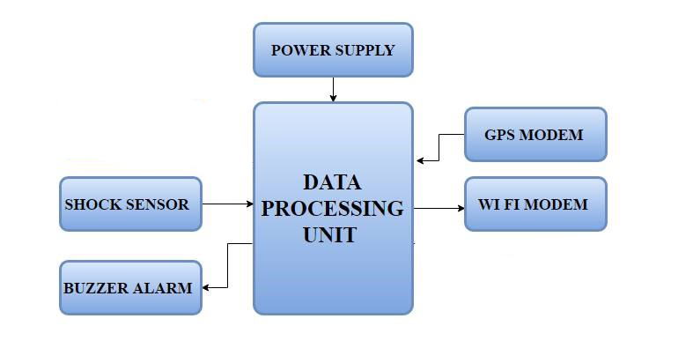
Figure83: Block Diagram
Block Descriptions:

- Data processing unit: it is an Arduino Uno microcontroller which takes input from shocks sensors over all sides of vehicle. This data is used to make a decision whither the self-control system for speed start or not and transmitted a signal to DC motor or to decide if the accident happen in order to receive information from GPS modem and send it to Wi-Fi module.

- GPS Unit: To determine the coordination for the accident place and transmitting it to microcontroller.

- Wi-Fi Module: it use to Receive coordination from microcontroller and send them to online web site, also send MAC address owned by module to the same site.

- Vibration Sensor Switch : Transmit signal to the microcontroller when the accident happened.

- Buzzer Alarm : receive information from microcontroller when an accident happened.

- Power Supply: (1 battery – 9 Volt) that feed the component with power

9.2Circuits
The Vcc pin of the wifi module is connected to the 3.3V pin on the board and the GND pin is connected to the GND pin on the board , and the Rx pin is connected to digital pin 4 on the board, and Tx pin is connected to digital pin 5.
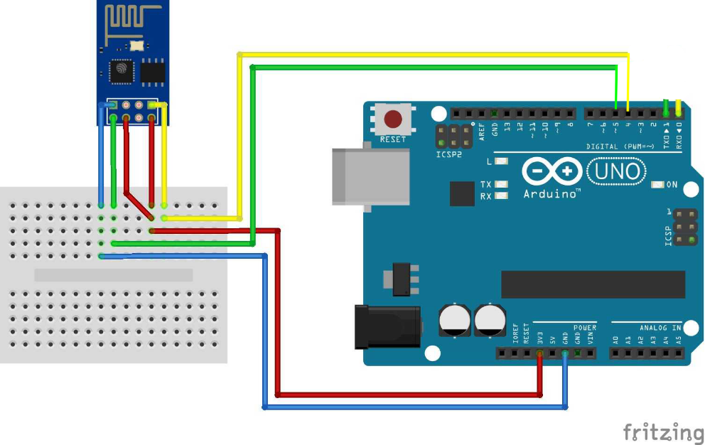
Figure84: ESP8266 -Arduino connection

For shock sensor and buzzer, the GND pin is connected to the GND pin on the board, input pin from shock connected to pin 7 on arduino and output pin from buzzer connected to pin 9 on Arduino.
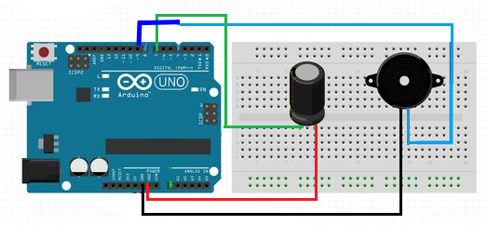
Figure85: Shock sensor, buzzer –Arduino connection
In GPS module connection, we connected GPS ground with Arduino ground, Tx pin in GPS with Pin 3, 5 V for GPS with 5V of Arduino, Rx pin in GPS with 4.7K ohm and 10K
oh resistor , then 10K ohm resistor connected to pin 2 in Arduino .
. 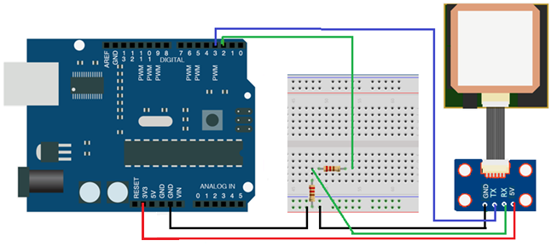
Figure86: GSP-Arduino connection

9.3 Project Description

If the car hit to some other vehicle or others object then a vibration sensor sends a signal message to the Arduino. Once Arduino gets signal from sensor, then it will immediately turn on the buzzer and get the coordination from the GPS modem, where GPS module reading position of the car continuously and at each iteration it sends the longitude and latitude to the Arduino. When the accident detects, the last reading for GPS module send to the Wi-Fi module as a string in a post request. We set a Wi-Fi module as a WIFI client and set the server as www.abusaied.com/sos The connection with wireless LAN network must be done. Then it's transfer information to online website as HTTP connection to the server, if there is a successful connection (HTTP) then HTTP post request will be sent to the web host and close the connection.

9.4 The Used Technology

9.4.1 GPS
Global Positioning System was developed by the United States' Department of Defense. It uses between 24 and 32 Medium Earth Orbit satellites that transmit precise microwave signals. This enables GPS receivers to determine their current location, time and velocity. The GPS satellites are maintained by the United States Air Force.

How it works
- 21 satellites and three spare satellites are in orbit at 10,600 miles above the Earth. The satellites are spaced, so that from any point on Earth four satellites will be above the horizon.
- Each satellite contains a computer, an atomic clock, and a radio. With an understanding of its own orbit and the clock, it continually broadcasts its changing position and time. (Once a day, each satellite checks its own sense of time and position with a ground station and makes any minor correction.)
- On the ground, any GPS receiver contains a computer that "triangulates" its own position by getting bearings from three of the four satellites. The result is provided in the form of a geographic position - longitude and latitude - to, for most receivers within 100 meters. If a fourth satellite can be received, the receiver/computer can figure out the altitude as well as the geographic position
- If you are moving, your receiver may also be able to calculate your speed and direction of travel and give you estimated times of arrival to specified destinations.

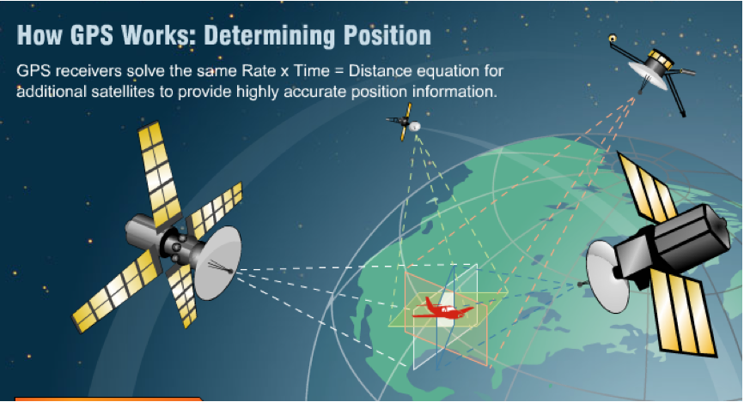

Figure87: describe how GPS works

9.4.2 IEEE 802.11 protocol

Wi-Fi is a short name for Wireless Fidelity. Generally, Wi-Fi refers to any type of IEEE 802.11 Wireless Local Area Network (WLAN). More specifically, Wi-Fi is the industry standard for products as defined by the Wi-Fi alliance and conforming to IEEE802.11. WLANs extend the reach of Local Area Networks (LANs) by providing wireless connectivity. It designed originally for cable replacement in corporate environments; WLANs have become very popular in providing IP connectivity in residential, small office and campus environments. With Wi-Fi , it is possible to create high-speed wireless local area networks, provided that the computer to be connected is not too far from the access point. In practice, Wi-Fi can be used to provide high-speed connections (11 Mbps or greater) and here are three versions of IEEE802.11 :

Name of standard | Name | Description.
802.11a | Wi-Fi 5 | The 802.11a standard (called Wi-Fi 5) allows higher bandwidth (54 Mbps maximum throughput, 30 Mbps in practice). The 802.11a standard provides 8 radio channels in the 5 GHz frequency band
802.11b | Wi-Fi | The 802.11b standard is currently the most widely used one. It offers a maximum throughput of 11 Mbps (6 Mbps in practice) and a reach of up to 300 meters in an open environment. It uses the 2.4 GHz frequency range, with 3 radio channels available
802.11g |  | The 802.11g standard offers high bandwidth (54 Mbps  maximum throughput, 30 Mbps in practice) on the 2.4 GHz  frequency range. The 802.11g standard is backwards-compatible with the 802.11b standard, meaning that devices that support the 802.11g standard can also work with 802.11b.
Table8: versions of IEEE802.11
Nowadays there are many devices support all these standards together, as you can see above in the table, These type of Wi-Fi standards are different in data rate and coverage area, so in our project we don’t need high bit rate because we don’t need to transfer huge data. The data that we will transfer is just a coordination for the place of accident , on the other hand we need wide coverage area to cover all parts of our home so the best choice will be 802.11b.

Hypothetical speed | Range (indoors) | Range (outdoors)
11 Mbit/s | 50 m | 200m
5.5 Mbit/s | 75m | 300m
2 Mbit/s | 100m | 400m
1 Mbit/s | 150m | 500m
Table 9: Wi-Fi standards with different in data rate and coverage area

9.5 Project Components:

9.5.1 ARDUINO UNO
The ARDUINO Uno is a microcontroller board based on the ATmega328, which presented in the picture bellow .It has 14 digital input/output pins (of which 6 can be used as PWM outputs), 6 analog inputs, a 16 MHz quartz crystal, a USB connection, a power jack, an ICSP header and a reset button. It contains everything needed to support the microcontroller; simply connect it to a computer with a USB cable.
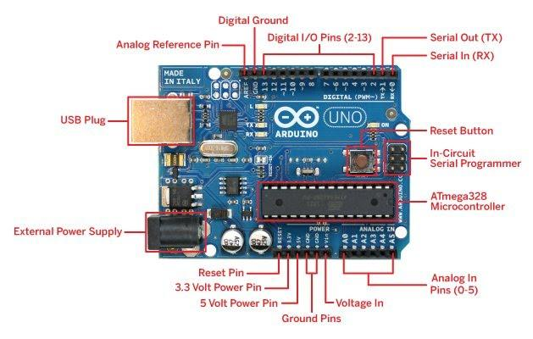
Figure89 :ARDUINO UNO (ATmega328P)
Differences with other boards
The Uno differs from all preceding boards in that it does not use the FTDI USB-to-serial driver chip.
Power
The Uno board can be powered via the USB connection or with an external power supply. The power source is selected automatically. External (non-USB) power can come either from an AC-to-DC adapter (wall-wart) or battery .

9.5.2Universal Serial Bus (USB)
Cable Used for communication between the Arduino board and a computer or other devices.
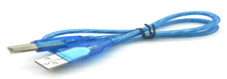
Figure90: USB

9.5.3 ESP8266 Wi-Fi Module
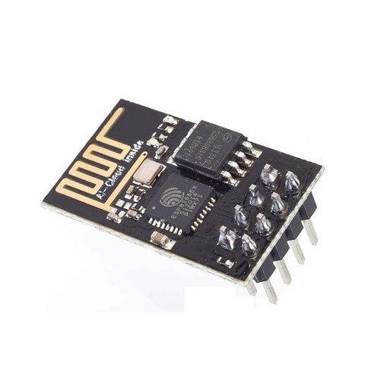
Figure91: ESP8266 (Wi-Fi module)

Description
The ESP8266 WIFI Module is a self-contained SOC with integrated TCP/IP protocol stack that can give any microcontroller access to your WIFI network. The ESP8266 is capable of either hosting an application or offloading all Wi-Fi networking functions from another application processor. Each ESP8266 module comes pre-programmed with an AT command set firmware, meaning, you can simply hook this up to your Arduino device and get about as much WIFI-ability as a WIFI Module offers. The ESP8266 module is an extremely cost effective board with a huge, and ever growing, community.

This module has a powerful enough on-board processing and storage capability that allows it to be integrated with the sensors and other application specific devices through its GPIOs with minimal development up-front and minimal loading during runtime. Its high degree of on-chip integration allows for minimal external circuitry, including the front-end module, is designed to occupy minimal PCB area. The ESP8266 supports APSD for VoIP applications and Bluetooth coexistence interfaces, it contains a self-calibrated RF allowing it to work under all operating conditions, and requires no external RF parts.

9.5.4 GPS Receiver Module

This GPS is a very capable GPS for the size. Compatible with UART capable devices including Arduino, Raspberry pi and MSP430. GPS receiver uses NMEA protocol as defined by the National Marine Electronics Association (NMEA). It gives output messages as follows. So, we get 7-8 different messages.
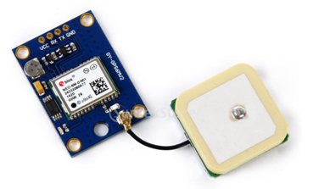
Figure92: GPS Module
Specification [10]
- Satellites: 22 tracking, 66 searching
- Update rate: 5Hz max.
- Position Accuracy: 2 meters
- Velocity Accuracy: 0.1 meters/s
- first fix (TTFF)for hot starts: <1 second
- first fix (TTFF)for cold starts: 27 seconds
- heading accuracy: 0.5 degree while moving.
- Maximum Altitude: 18,000 meters
- Maximum Velocity: 500m/s
- Operating voltage: 3.3V-6V
- Operating current: 11 mA current draw during navigation
- Output: 50 channel NMEA receive
- UART :9600 baud by default but it configured from 4800 to 115200
- WAAS (Wide Area Augmentation system) supported
- Weight: 17.6 grams
- Dimensions of GPSGPSModule:36mm (1.42in) x 25.8mm (1.02in) x 4mm (0.16in)
- Dimensions of Antenna :25.5mm (1in) x 25.5mm (1in) x 8.8mm (0.35in)

9.5.5 Vibration Sensor Switch.
These spring-vibration switches are high sensitivity non-directional vibration induced trigger switches. Inside is a very soft spring coiled around a long metal pin. When the switch is moved, the spring touches the center pole to make contact. So, when there's motion, the two pins will act like a closed switch. When everything is still, the switch is open.
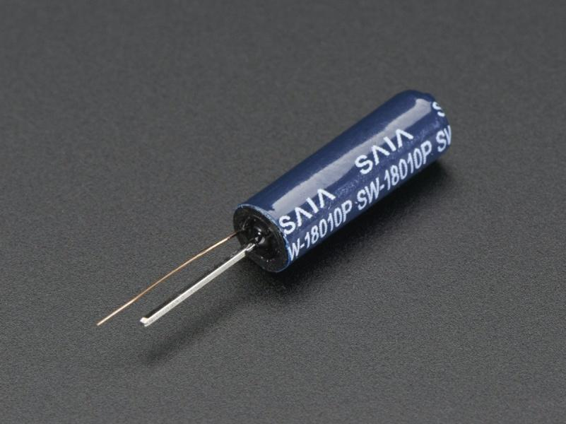
Figure93: Vibration sensor

9.5.6 Resistors
Resistor is an electrical component that reduces the electric current.
The resistor's ability to reduce the current is called resistance and is measured in units of ohms (symbol: Ω). In our design we used 1 resistor of 10K ohm.
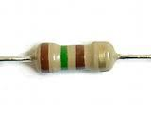
Figure95: 150 Ohm Resistor

9.5.7 5V Buzzer
The buzzer is an electromagnetic type audio signaling device, consist of number of switches or sensors connected to a control unit.


Figure96: 5V Buzzer

Chapter Ten: Conclusion and recommendations

With the advancement of technology in every walk of life, the importance of safety of vehicle has increased and the high priority is given to lives of people. The project gives the design which has advantages of little cost, portability, and small size. The platform of this system is Arduino Uno microcontroller along with vibration sensor, GPS module, Wi-Fi module. The automatic detection of accident location will provide a feasible solution for traffic and accident hazards and also gives security to the vehicle as well as reduces loss of valuable lives and property.

10.1 Future work
For the future work, we can send a notification to other cars driving on the road where the accident has happened, we also can send a list of alternatives roads or the name of the shortest way for the car to avoid the accident road.
In the future, this program will become a complete system to protect the car before the accident occurs, and it will stay away from danger or collision with something, and this is done on the basis of a set of sensors installed on the car to avoid danger
The user will also be given a suggested route if he finds an accident on his way.

References
[1] Arduino.cc,UnoATmega328P,Arduino Board Uno.[Online]Available from https://www.arduino.cc/en/Main/ArduinoBoardUno [Last Access: $1^{st}$, May, 2015].

[2]cypress, Ultrasonic sensor data sheet, [Online] Available from :
http://www.cypress.com/file/55476/download [Last Access: $1^{st}$, May, 2015].

[3]electosome, ultrasonic sensor distance. [Online] Available from :
https://electrosome.com/ultrasonic-sensors-distance-proximity/ [Last Access: $1^{st}$, May, 2015].

[4]sensorsmag, ultrasonic sensor distance. [Online] Available from :
http://www.sensorsmag.com/sensors/acoustic-ultrasound/choosing-ultrasonic-sensor-proximity-or-distance-measurement-825 [Last Access: $1^{st}$, May, 2015].

[5] Palestinian National Information Center-WAFA INFO. [Online] Available from :
http://www.wafainfo.ps/atemplate.aspx?id=8209 [Last Access: $1^{st}$, May, 2015].

[6]teachengineering , Measuring Distance with Sound Waves. [Online] Available from :
https://www.teachengineering.org/view_activity.php?url=collection/nyu_/activities/nyu_soundwaves/nyu_soundwaves_activity1.xml [Last Access: $1^{st}$, May, 2015].

[7]Arduino.cc, Arduino Wi-Fi module. [Online] Available from :
https://www.Arduino.cc/en/Main/ArduinoWiFiModule [Last Access: $1^{st}$, May, 2015].

[8]Arduino sensors, Arduino ultrasonic distance sensor. [Online] Available from :
http://Arduinosensors.com/index.php/Arduino-ultrasonic-distance-sensor/ [Last Access: $1^{st}$, May, 2015].

[9]scholar.lib.vt.edu, Vehicle detectors. [Online] Available from :
http://scholar.lib.vt.edu/theses/available/etd-43098-201311/unrestricted/APPENDIX-B2.PDF
[Last Access: $1^{st}$, May, 2015].
[10] Addicore , NEO-6M GPSModule with EEPROM. [Online] Available from : http://www.addicore.com/NEO-6M-GPSGPS-p/231.htm [Last Access: $1^{st}$, May, 2015].

[11] developershom, introduction to AT command. [Online] Available from :
http://www.developershome.com/sms/atCommandsIntro.asp [Last Access: $1^{st}$, May, 2015].
[12] IEEE.org, Wireless Fidelity-Wi-Fi . [Online] Available from :
https://www.ieee.org/about/technologies/emerging/wifi.pdf [Last Access: $1^{st}$, May, 2015].
[13]adafruit ,Fast vibration sensor switch. [Online] Available from : https://www.adafruit.com/products/1766 [Last Access: $1^{st}$, May, 2015].
[14] Suryavanshi S. , Vaingankar S. ,Patil S.,Kor S. ,Automobile Accident Prevention Using Ultrasonic, International Journal of Advanced Research in computer Science and Software Engineering;2015, 5, Issue 3,
[15] GPS search mobile computing .tech target, Global Position System. [Online] Available from :
http://searchmobilecomputing.techtarget.com/definition/Global-Positioning-System [Last Access: $1^{st}$, May, 2015].

Appendix 1
The code for our project:
#include <SoftwareSerial.h>
#include <SPI.h>
#include <TinyGPS++.h>
#define Beeb 9
const int BUTTON_PIN = 12; // the number of the pushbutton pin
int RXPin = 2;
int TXPin = 3;
int shok=0;
int car_id=202;
float lat, lng;
SoftwareSerial gpsSerial(RXPin, TXPin);
TinyGPSPlus gps;
//------------------WIFI VALUES------------------------
SoftwareSerial esp8266(4, 5); // 4 = RX, 5 = TX
String ssid ="wiwi";
String password ="wiwi12345678";
String server ="www.abusaied.com"; //ip address of localhost
String uri = "/sos/sos.php?latitude=";
String Latitude;
String Longitude;
//------------------WIFI VALUES END--------------------

void resetWifi() {
esp8266.begin(9600);
delay (2000);
esp8266.println("AT+RST");
delay(2000);
if(esp8266.find("OK") )
Serial.println("Module Reset");
}
void connectWifi() {
delay(2000);
esp8266.println("AT+CWMODE=1");
esp8266.println("AT+CIPMODE=0");
esp8266.println("AT+CIPMUX=1");
esp8266.println("AT+CWQAP");
String cmd ="AT+CWJAP=\""+ssid+"\",\""+password+"\"";
esp8266.println(cmd);
Serial.println(cmd);
delay(2000);
if(esp8266.find("OK")){
Serial.println("Connected!");
delay(1000);
}
else {
Serial.println("Not connected!");
httppost();
}
}
void setup() {
pinMode(13, OUTPUT); // on-board LED, usually pin 13
pinMode(11,INPUT);
Serial.begin(9600);
gpsSerial.begin(9600);
Serial.println("Waiting GPS signal");}
void httppost() {
esp8266.println("AT+CIPSTART=\"TCP\",\"" + server + "\",80");//start a TCP connection.
delay(3000);
if( esp8266.find("OK")) {
Serial.println("TCP connection ready");
}
String postRequest =
"GET " + uri +yourLatitude+ "&longitude=" +yourLongitude+ "&car_id=" +car_id+" HTTP/1.1\r\n" +
"Host: " + server + "\r\n" +
"Connection: close\r\n\r\n";
String sendCmd = "AT+CIPSEND=";//determine the number of caracters to be sent.
esp8266.print(sendCmd);
esp8266.println(postRequest.length());
delay(3000);
if(esp8266.find(">")) {
Serial.println("Sending..");
esp8266.print(postRequest);
if(esp8266.find("OK")) {
Serial.println("Packet sent");
Serial.print(postRequest);
esp8266.println("AT+CIPCLOSE");
delay (2000);
esp8266.end();
} }}

void gpsFCN (){
delay (5000);
shok=digitalRead(7);
delay (1000);
Serial.println("TEST");
if (shok==HIGH) {
Serial.println("ON");
analogWrite(Beeb,250);
delay(3000);
analogWrite(Beeb,0);
delay (10000);
if (gps.location.isValid()){
yourLatitude=String(gps.location.lat(), 6);
yourLongitude=String(gps.location.lng(), 6);
Serial.print("GET /sos/sos.php?longitude=");
Serial.println(yourLongitude);
Serial.println("&latitude=");
Serial.println(yourLatitude);
delay (2000);
gpsSerial.end();
delay (2000);
resetWifi();
connectWifi();
}
else
{delay(5000);
Serial.println("Location: Not Available");
}}
else {
delay(1000);
Serial.println("OFF");}
}
void loop()
{
while (gpsSerial.available() > 0)
if (gps.encode(gpsSerial.read()))
gpsFCN ();
if (millis() > 5000 && gps.charsProcessed() < 10)
{
Serial.println("No GPS detected");
while(true);
}
}

Appendix 2
Database: `accident_project`
-- --------------------------------------------------------
CREATE TABLE `accident` (
`accident_id` int(11) NOT NULL,
`driver` varchar(255) COLLATE utf8mb4_unicode_ci DEFAULT NULL,
`driver_sex` varchar(255) COLLATE utf8mb4_unicode_ci DEFAULT 'male',
`driver_Age` int(11) DEFAULT NULL,
`latitude` varchar(255) COLLATE utf8mb4_unicode_ci DEFAULT NULL,
`longitude` varchar(255) COLLATE utf8mb4_unicode_ci DEFAULT NULL,
`fk_car_id` int(11) DEFAULT NULL,
`fk_district_id` int(11) DEFAULT NULL,
`fk_accident_type_id` int(11) DEFAULT NULL,
`created_at` timestamp NULL DEFAULT NULL,
`updated_at` timestamp NULL DEFAULT NULL
) ENGINE=InnoDB DEFAULT CHARSET=utf8mb4 COLLATE=utf8mb4_unicode_ci;
-- --------------------------------------------------------
CREATE TABLE `accident_type` (
`accident_type_id` int(11) NOT NULL,
`accident_type_name` text COLLATE utf8mb4_unicode_ci DEFAULT NULL,
`created_at` timestamp NULL DEFAULT NULL,
`updated_at` timestamp NULL DEFAULT NULL
) ENGINE=InnoDB DEFAULT CHARSET=utf8mb4 COLLATE=utf8mb4_unicode_ci;
-- --------------------------------------------------------
CREATE TABLE `ambulance_report` (
`ambulance_report_id` int(11) NOT NULL,
`ambulance_report_death` int(11) DEFAULT 0,
`ambulance_report_injure` int(11) DEFAULT 0,
`ambulance_report_note` text COLLATE utf8mb4_unicode_ci DEFAULT NULL,
`fk_accident_id` int(11) DEFAULT NULL,
`fk_user_id` int(11) DEFAULT NULL,
`created_at` timestamp NULL DEFAULT NULL,
`updated_at` timestamp NULL DEFAULT NULL
) ENGINE=InnoDB DEFAULT CHARSET=utf8mb4 COLLATE=utf8mb4_unicode_ci;
-- --------------------------------------------------------
CREATE TABLE `car` (
`car_id` int(11) NOT NULL,
`number` varchar(255) COLLATE utf8mb4_unicode_ci DEFAULT NULL,
`owner` varchar(255) COLLATE utf8mb4_unicode_ci DEFAULT NULL,
`fk_district_id` int(11) DEFAULT NULL,
`fk_car_type_id` int(11) DEFAULT NULL,
`fk_car_size_id` int(11) DEFAULT NULL,
`created_at` timestamp NULL DEFAULT NULL,
`updated_at` timestamp NULL DEFAULT NULL
) ENGINE=InnoDB DEFAULT CHARSET=utf8mb4 COLLATE=utf8mb4_unicode_ci;
-- --------------------------------------------------------
CREATE TABLE `car_size` (
`car_size_id` int(11) NOT NULL,
`car_size_name` varchar(255) COLLATE utf8mb4_unicode_ci DEFAULT NULL,
`created_at` timestamp NULL DEFAULT NULL,
`updated_at` timestamp NULL DEFAULT NULL
) ENGINE=InnoDB DEFAULT CHARSET=utf8mb4 COLLATE=utf8mb4_unicode_ci;
-- --------------------------------------------------------
CREATE TABLE `car_type` (
`car_type_id` int(11) NOT NULL,
`car_type_name` varchar(255) COLLATE utf8mb4_unicode_ci DEFAULT NULL,
`created_at` timestamp NULL DEFAULT NULL,
`updated_at` timestamp NULL DEFAULT NULL
) ENGINE=InnoDB DEFAULT CHARSET=utf8mb4 COLLATE=utf8mb4_unicode_ci;
-- --------------------------------------------------------
CREATE TABLE `districts` (
`district_id` int(10) NOT NULL,
`district_name` varchar(255) NOT NULL,
`created_at` timestamp NULL DEFAULT NULL,
`updated_at` timestamp NULL DEFAULT NULL
) ENGINE=InnoDB DEFAULT CHARSET=utf8;
-- --------------------------------------------------------
CREATE TABLE `police_report` (
`police_report_id` int(11) NOT NULL,
`police_report_note` text COLLATE utf8mb4_unicode_ci DEFAULT NULL,
`fk_accident_id` int(11) DEFAULT NULL,
`fk_user_id` int(11) DEFAULT NULL,
`created_at` timestamp NULL DEFAULT NULL,
`updated_at` timestamp NULL DEFAULT NULL
) ENGINE=InnoDB DEFAULT CHARSET=utf8mb4 COLLATE=utf8mb4_unicode_ci;
-- --------------------------------------------------------
CREATE TABLE `users` (
`user_id` int(10) NOT NULL,
`user_name` varchar(255) CHARACTER SET utf8 NOT NULL,
`user_email` varchar(255) COLLATE utf8mb4_unicode_ci NOT NULL,
`user_type` varchar(255) COLLATE utf8mb4_unicode_ci NOT NULL,
`user_account_status` varchar(255) COLLATE utf8mb4_unicode_ci NOT NULL DEFAULT 'active',
`password` varchar(255) COLLATE utf8mb4_unicode_ci NOT NULL,
`fk_district_id` int(10) DEFAULT NULL,
`created_at` timestamp NULL DEFAULT current_timestamp(),
`updated_at` timestamp NULL DEFAULT current_timestamp()
) ENGINE=InnoDB DEFAULT CHARSET=utf8mb4 COLLATE=utf8mb4_unicode_ci;

ALTER TABLE `accident`
ADD PRIMARY KEY (`accident_id`),
ADD KEY `fk_car_id` (`fk_car_id`),
ADD KEY `fk_district_id` (`fk_district_id`),
ADD KEY `fk_accident_type_id` (`fk_accident_type_id`);

ALTER TABLE `ambulance_report`
ADD PRIMARY KEY (`ambulance_report_id`),
ADD KEY `fk_user_id` (`fk_user_id`),
ADD KEY `fk_accident_id` (`fk_accident_id`);

ALTER TABLE `car`
ADD PRIMARY KEY (`car_id`),
ADD KEY `fk_district_id` (`fk_district_id`),
ADD KEY `fk_car_type_id` (`fk_car_type_id`),
ADD KEY `fk_car_size_id` (`fk_car_size_id`);

ALTER TABLE `car_size`
ADD PRIMARY KEY (`car_size_id`);

ALTER TABLE `car_type`
ADD PRIMARY KEY (`car_type_id`);

ALTER TABLE `districts`
ADD PRIMARY KEY (`district_id`);

ALTER TABLE `police_report`
ADD PRIMARY KEY (`police_report_id`),
ADD KEY `fk_user_id` (`fk_user_id`),
ADD KEY `fk_accident_id` (`fk_accident_id`);

ALTER TABLE `users`
ADD PRIMARY KEY (`user_id`),
ADD UNIQUE KEY `users_user_email_unique` (`user_email`),
ADD KEY `users_fk_district_id_foreign` (`fk_district_id`);

ALTER TABLE `accident`
MODIFY `accident_id` int(11) NOT NULL AUTO_INCREMENT;

ALTER TABLE `accident_type`
MODIFY `accident_type_id` int(11) NOT NULL AUTO_INCREMENT;

ALTER TABLE `ambulance_report`
MODIFY `ambulance_report_id` int(11) NOT NULL AUTO_INCREMENT;

ALTER TABLE `car`
MODIFY `car_id` int(11) NOT NULL AUTO_INCREMENT;

ALTER TABLE `car_size`
MODIFY `car_size_id` int(11) NOT NULL AUTO_INCREMENT;

ALTER TABLE `car_type`
MODIFY `car_type_id` int(11) NOT NULL AUTO_INCREMENT;

ALTER TABLE `districts`
MODIFY `district_id` int(10) NOT NULL AUTO_INCREMENT;

ALTER TABLE `police_report`
MODIFY `police_report_id` int(11) NOT NULL AUTO_INCREMENT;

ALTER TABLE `users`
MODIFY `user_id` int(10) NOT NULL AUTO_INCREMENT;

ALTER TABLE `accident`
ADD CONSTRAINT `accident_ibfk_1` FOREIGN KEY (`fk_car_id`) REFERENCES `car` (`car_id`) ON DELETE CASCADE ON UPDATE CASCADE,
ADD CONSTRAINT `accident_ibfk_2` FOREIGN KEY (`fk_accident_type_id`) REFERENCES `accident_type` (`accident_type_id`) ON DELETE CASCADE ON UPDATE CASCADE,
ADD CONSTRAINT `accident_ibfk_3` FOREIGN KEY (`fk_district_id`) REFERENCES `districts` (`district_id`) ON DELETE CASCADE ON UPDATE CASCADE;

ALTER TABLE `ambulance_report`
ADD CONSTRAINT `ambulance_report_ibfk_1` FOREIGN KEY (`fk_user_id`) REFERENCES `users` (`user_id`) ON DELETE CASCADE ON UPDATE CASCADE,
ADD CONSTRAINT `ambulance_report_ibfk_2` FOREIGN KEY (`fk_accident_id`) REFERENCES `accident` (`accident_id`);

ALTER TABLE `car`
ADD CONSTRAINT `car_ibfk_1` FOREIGN KEY (`fk_car_type_id`) REFERENCES `car_type` (`car_type_id`) ON DELETE CASCADE ON UPDATE CASCADE,
ADD CONSTRAINT `car_ibfk_2` FOREIGN KEY (`fk_car_size_id`) REFERENCES `car_size` (`car_size_id`) ON DELETE CASCADE ON UPDATE CASCADE,
ADD CONSTRAINT `car_ibfk_3` FOREIGN KEY (`fk_district_id`) REFERENCES `districts` (`district_id`) ON DELETE CASCADE ON UPDATE CASCADE;

ALTER TABLE `police_report`
ADD CONSTRAINT `police_report_ibfk_1` FOREIGN KEY (`fk_user_id`) REFERENCES `users` (`user_id`) ON DELETE CASCADE ON UPDATE CASCADE,
ADD CONSTRAINT `police_report_ibfk_2` FOREIGN KEY (`fk_accident_id`) REFERENCES `accident` (`accident_id`) ON DELETE CASCADE ON UPDATE CASCADE;

ALTER TABLE `users`
ADD CONSTRAINT `users_ibfk_1` FOREIGN KEY (`fk_district_id`) REFERENCES `districts` (`district_id`) ON DELETE CASCADE ON UPDATE CASCADE;
COMMIT;

