

Faculty of Engineering & Information Technology
Computer Engineering Department
Graduation Project – I (10636581)

Student Space

Submitted By:

Mohammad Hara
Laith Atari
Supervisor:
Dr. Hanal Abuzant

second Semester 2023/2024

Presented in partial fulfilment of the requirements for Bachelor degree in Computer Engineering

Acknowledgement

We would like to thank our dear supervisor, Dr. Hanal Abu Zant, for his support and guidance for us and his effort with us in order to carry out this project.
We would also like to thank the professors of An-Najah University in general and the professors of the Computer Engineering Department in particular, from whom we learned and benefited from their experiences throughout our years of study. We would not have been able to complete this project without them.
We would like to thank our families who, without their effort, motivation and support, whether financially or morally, would have been lost
Why were we able to do this project.

Disclaimer

Students Laith Atari and Mohammad hara from the Department of Computer Engineering in the College of Engineering at An-Najah National University wrote the attached report, It is important to point out that the students alone own the ideas contained in the report, and it is worth noting that An-Najah National University disclaims responsibility for any word contained in this report.

Table of Contents
Figure 1 : database implementation(ER)...................................................................11
Figure 2 : sign up...............................................................................13
Figure 3 : sign in...............................................................................................14
Figure 4: home page...............................................................................................15
Figure 5 : side bar..............................................................................................16
Figure 6 : profile.............................................................................................17
Figure 7 : send a friend request ...............................................................................................18
Figure 8 : accept or decline friend ...............................................................................................19
Figure 9: show friend list.............................................................................................20
Figure 10: change password...............................................................................................21
Figure 11: notification list...............................................................................................22
Figure 12: donation ...............................................................................................23
Figure 13: chatting..............................................................................................24
Figure 14: chatting...............................................................................................25
Figure 15: calling...............................................................................................26
Figure 16: trade...............................................................................................27
Figure 17: add item to cart ...............................................................................................28
Figure 18: checkout information...............................................................................................29
Figure 19: checkout done...............................................................................30
Figure 20: my order ...............................................................................................31
Figure 21: on the way order...............................................................................................32
Figure 22: on the way order...................................................................33
Figure 23: finish order...............................................................................34
Figure 24: finish order...............................................................................................35
Figure 25: filter of trade...............................................................................................36
Figure 26: teach course..............................................................................................37
Figure 27: teach course.............................................................................................38
Figure 28: teach request...............................................................................................39
Figure 29: teach request ...............................................................................................40
Figure 30: approved session.............................................................................................41
Figure 31: time of session...............................................................................................42
Figure 32: teach session...............................................................................................43
Figure 33: filter and search friends...............................................................................................44
Figure 34: web Sign up..............................................................................................45
Figure 35: web Sign up...............................................................................................45
Figure 36: web Sign in...............................................................................................46
Figure 37: Home page...............................................................................................46
Figure 38: admin sign in...............................................................................................47
Figure 39: Statistics...............................................................................................48
Figure 40: users...............................................................................49
Figure 41: Cities...............................................................................................50
Figure 42: Universities ..............................................................................................51
Figure 43: Faculties...............................................................................................52
Figure 44: Majors...............................................................................................53
Figure 45: Courses..............................................................................................54
Figure 46: Categories...............................................................................................55
Figure 46: Donations...............................................................................................56

Table of Figures
Figure 1 : database implementation(ER)...................................................................11
Figure 2 : sign up...............................................................................13
Figure 3 : sign in...............................................................................................14
Figure 4: home page...............................................................................................15
Figure 5 : side bar..............................................................................................16
Figure 6 : profile.............................................................................................17
Figure 7 : send a friend request ...............................................................................................18
Figure 8 : accept or decline friend ...............................................................................................19
Figure 9: show friend list.............................................................................................20
Figure 10: change password...............................................................................................21
Figure 11: notification list...............................................................................................22
Figure 12: donation ...............................................................................................23
Figure 13: chatting..............................................................................................24
Figure 14: chatting...............................................................................................25
Figure 15: calling...............................................................................................26
Figure 16: trade...............................................................................................27
Figure 17: add item to cart ...............................................................................................28
Figure 18: checkout information...............................................................................................29
Figure 19: checkout done...............................................................................30
Figure 20: my order ...............................................................................................31
Figure 21: on the way order...............................................................................................32
Figure 22: on the way order...................................................................33
Figure 23: finish order...............................................................................34
Figure 24: finish order...............................................................................................35
Figure 25: filter of trade...............................................................................................36
Figure 26: teach course..............................................................................................37
Figure 27: teach course.............................................................................................38
Figure 28: teach request...............................................................................................39
Figure 29: teach request ...............................................................................................40
Figure 30: approved session.............................................................................................41
Figure 31: time of session...............................................................................................42
Figure 32: filter and search friends...............................................................................................43
Figure 34: web Sign up..............................................................................................45
Figure 35: web Sign up...............................................................................................45
Figure 33: web Sign in...............................................................................................46
Figure 36: Home page...............................................................................................46
Figure 37: admin sign in...............................................................................................47
Figure 38: Statistics...............................................................................................48
Figure 39: users...............................................................................................49
Figure 40: Cities...............................................................................50
Figure 41: Universities ...............................................................................................51
Figure 42: Faculties..............................................................................................52
Figure 43: Majors...............................................................................................53
Figure 44: Courses...............................................................................................54
Figure 45: Categories..............................................................................................55
Figure 46: Donations...............................................................................................56

Abstract

Since we are students at the end of their academic studies as a result of the accumulation of experiences and expertise, and we are about to finish our academic career at the university, we noticed the difficulties that students face related to teaching subjects and laboratories, so we tried to find those difficulties.

Sometimes, one of the students has books, references, and study summaries that he does not need, and it may be electronic parts, etc., and on the other side there is a student who needs the same things, but they often may exhaust him financially if he tries to buy them. Therefore, we tried to bridge the distances between the two parties, in addition to that in light of what We are exposed to the war of genocide against the Palestinian people by global Zionism (the Israeli occupation in particular) and the fight against Palestinian content as a form of media misinformation. We have combined two important features. Each idea had previously been worked on in a separate project, but in our project we tried to combine both in our application. They are the exchange of supplies and experiences between students, in addition to a social platform that brings together people through which we can publish in order to allow us (as Palestinians) to communicate the image. As it is, without deletion, evasion or deception

in addition This project will be developed by adding additional features and modifying the existing features in the project, based on the evaluation and opinions of students while they use this project, as there will be a feature of adding comments from students and based on them, the application will be modified continuously,The financial return for the application will be through a link for those who want to donate after benefiting from the application’s services and making it easier for them in many matters

Chapter One: Introduction

In the recent period, we have begun to notice that after completing graduation projects, engineering drawing tools, textbooks, etc., we have begun to notice that we need a place to organize the publications that students publish on the pages in order to display these things, or other students who want to obtain these things. In addition to the need to have a website on which we can publish what we want without restriction or racism.

  - Objectives
This project aims to create an environment that helps university students exchange things among themselves, which saves them time searching for things, such as electronic parts, and also saves them money because they can obtain them either for free, or at a cost lower than their original cost, in addition to a social platform that brings together People through it to allow us (as Palestinians) to convey the image. As it is without omission, evasion or deception

  - Significance
The importance of this project lies in saving time and effort for the university student, in providing the things he needs with the best quality and lowest prices than those available in the market, or instead of getting rid of the things he does not need, he can display them on the site and have another student take advantage of them and By publishing this on a platform that does not fight Palestinian content and is not racist, also after benefiting from the application there is a link through which a person can support the application

1.3 Organization of the Report
Chapter 1: Introduction: General description of the project
Chapter 2: An overview of student space and the history of its development
Chapter 3: Give sufficient details about the and methods you used and the challenges you faced
Chapter 4: After building the project, we achieved several results and goals
Chapter 5: Explains what solutions and benefits the student space has contributed to
Chapter 6: Summary of the project and what we offer suggestions based on experience and future improvements
Chapter 7: References

Chapter Two: Theoretical Background and Previous Work

Applications for exchanging goods between people and social networking applications have developed significantly over the past decade due to people’s preference and reliance on technology as a way of life because it makes their lives easier. There are many exchange applications such as Depop, Facebook Marketplace, OfferUp, and Letgo.
Therefore, we tried to exploit this idea in a way that is relevant and appropriate for university students because of the difficulties they face in exchanging objects, books, and even teaching, and they do not find a platform that provides them with that. We have combined two ideas, the first and basic of which is to provide them with a place where they can display the study supplies they need and others can take them, so that The second idea is to provide an alternative social media platform to Facebook and others because of their suppression of freedoms and falsification of facts

Chapter Three: Methodology

3.1 Used Technologies
- Visual Studio Code: Served as the primary Integrated Development Environment (IDE) for coding, editing, and debugging purposes .
- Android Studio: Utilized as an emulator to simulate and test the mobile application across various virtual environments .
- Firebase: Chosen for its robust and scalable 'NoSQL' real-time database, Firebase supported real-time chatting and notifications. Additionally, Firebase storage was used to securely manage and store images in the cloud, ensuring efficient accessibility of image data across the platform.
- Postman: Employed for API testing to ensure application reliability, enabling the execution of various HTTP requests and responses .
- PayPal Developer: Used for secure and efficient payment transactions, offering a comprehensive suite of development tools such as APIs, SDKs, and Sandbox testing environments, which were crucial for integrating reliable payment solutions into the application.
- Flutter(dart): We have used it in front-end development of mobile and web applications
- Spring boot: We use it in the backend of the application because it is good for small applications
- React js: we used this technology to develop a simple web page that displays to the admin what is happening in the application in addition to statistics, and through which he can control the application

3.1.1 database implementation(ER)
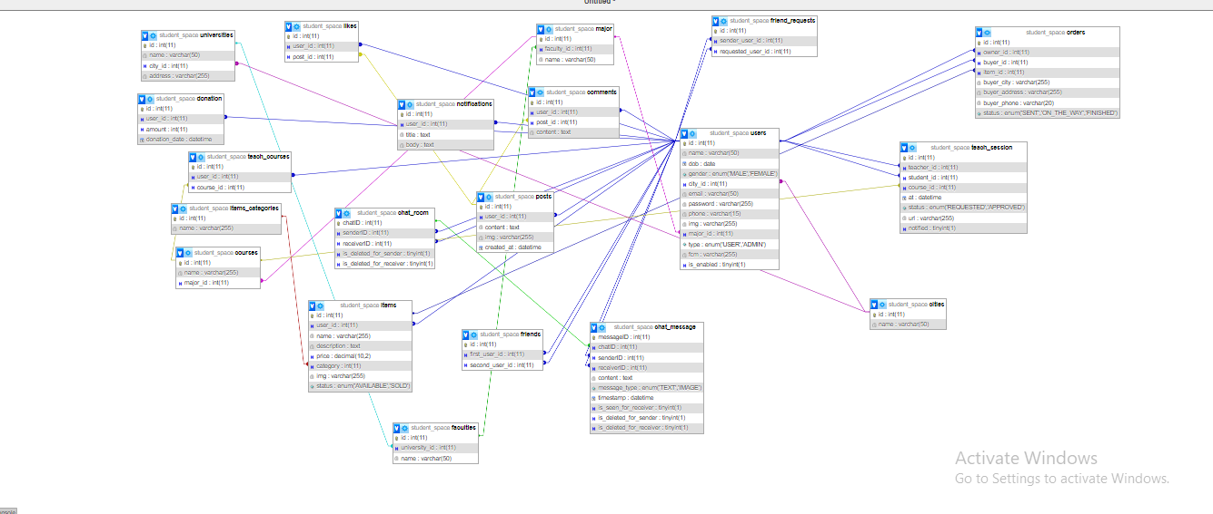
Figure 1 : database implementation(ER)

3.2 Constraints
1. We encountered some difficulties in designing the website in terms of UI design , since we do not have sufficient background in it.
2. We faced some difficulties with the chat feature due to some complexities and details

system Features and Implementation

    - Signup
Through this application, registration for university students, specifically Palestinian universities

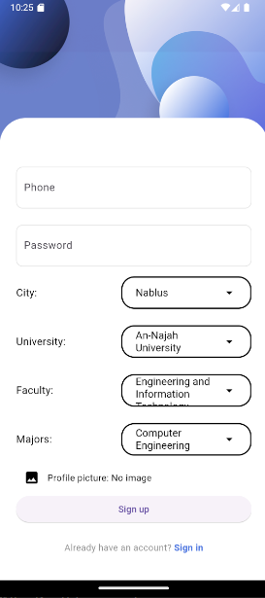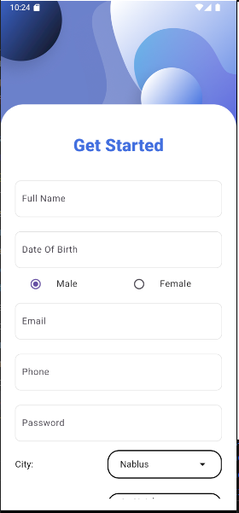

Figure 2 : sign up
3.3.2 sign in
A student who has previously registered in the application can log into his account, in addition to changing the password if he forgets it
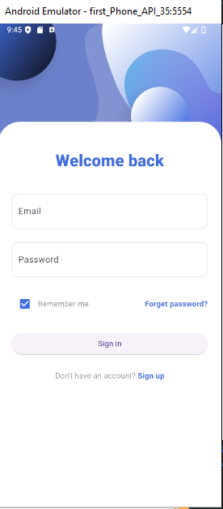
Figure 3 : sign in

3.3.3 home page

On the home page, posts are displayed for friends and the person’s posts are displayed and people in the same specialty. We worked on this in order to provide a platform for students to express their opinions freely

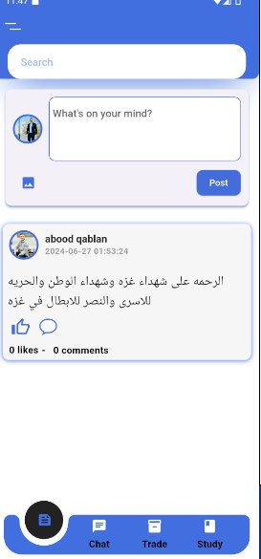
Figure 4: home page

3.3.4 side bar

The Side Bar is the control interface for Leos. It displays his affairs, trade, studying appointments, and friends. In addition, he can donate to the application as a form of thanks, and he can also change the password through it.

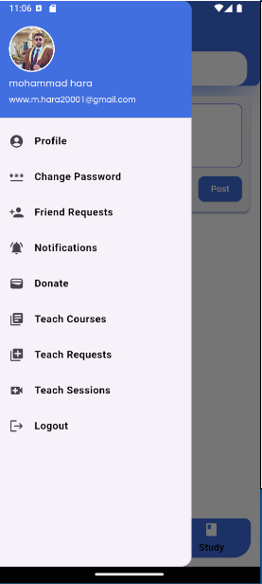
Figure 5 : side bar

3.3.5 profile

On the profile page, the user's information is displayed, in addition to that he can modify his personal information and view his posts

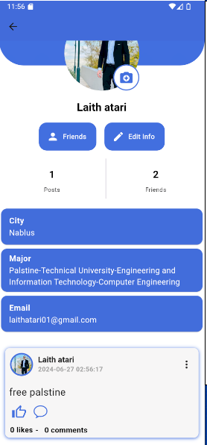
Figure 6 : profile

3.3.6 .1 send a friend request

The user can add friends through the application to exchange knowledge with them and meet new people. When a friend is added, a notification appears and he has the choice to accept or cancel.
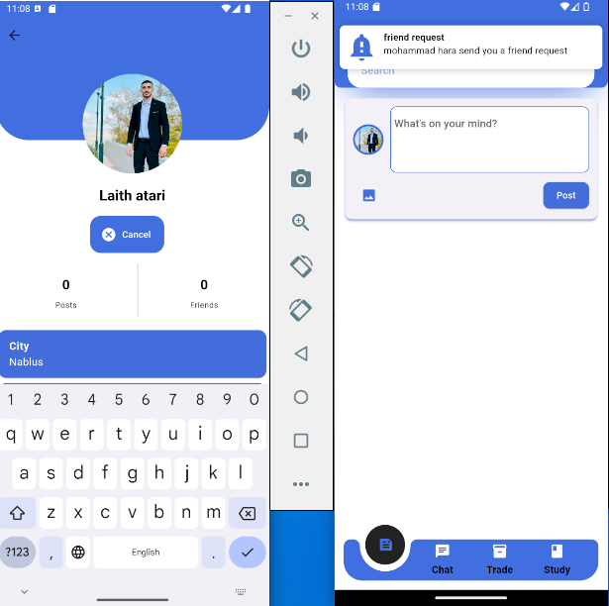
Figure 7 : send a friend request

3.3.6.2 accept or decline friend


Figure 8 : accept or decline friend

3.3.8 show friend list

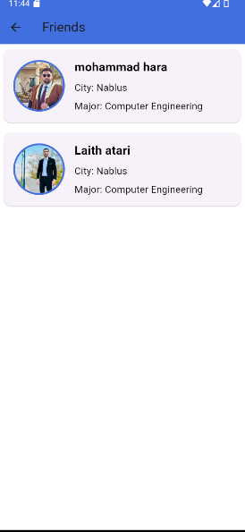
Figure 9: show friend list

3.3.9 change password
On this page, the password is reset by the user in the event that it is leaked or his device has been hacked.
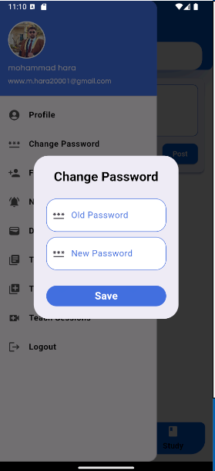

Figure 10: change password

3.3.10 notification list
The notifications page shows message notifications, friend request notifications, and trade and study notifications. In short, it shows all the notifications for all the features in the application.

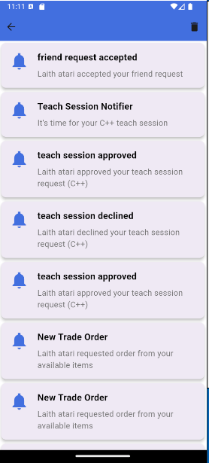
Figure 11: notification list

3.3.11 donation
Donate This section is the profit margin for the application because there is no source of income for the application. We used the PayPal Developer Tool to create a simulation for that.
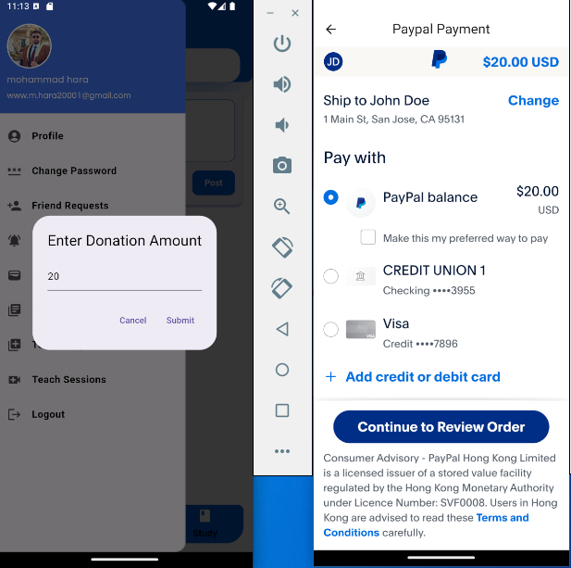

Figure 12: donation

3.3.12 chatting
Chat through the application is a very important feature, as it helps users communicate better, as we have provided written conversation and the “Seen” feature, which makes the second party aware that the first party has read the message and can reach him through calls

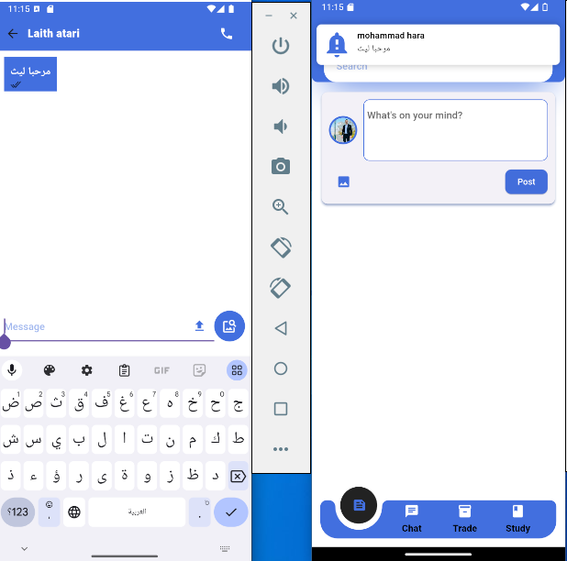
Figure 13: chatting

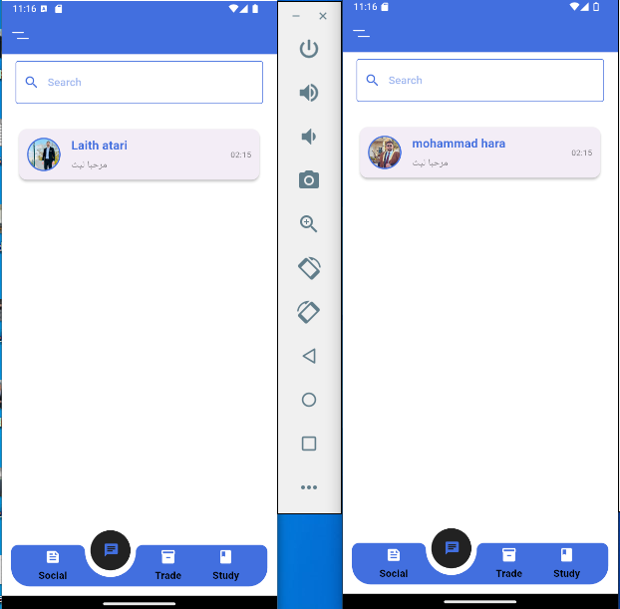
Figure 14: chatting

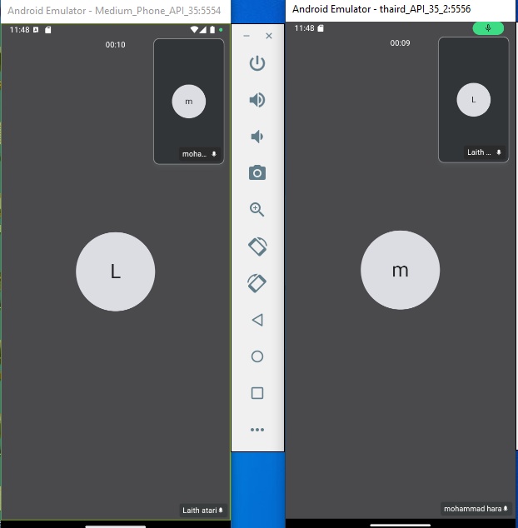
Figure 15: calling

3.3.13 trade
Trade is the feature that the application revolves around, as it takes place in several stages, as we will explain in the following images

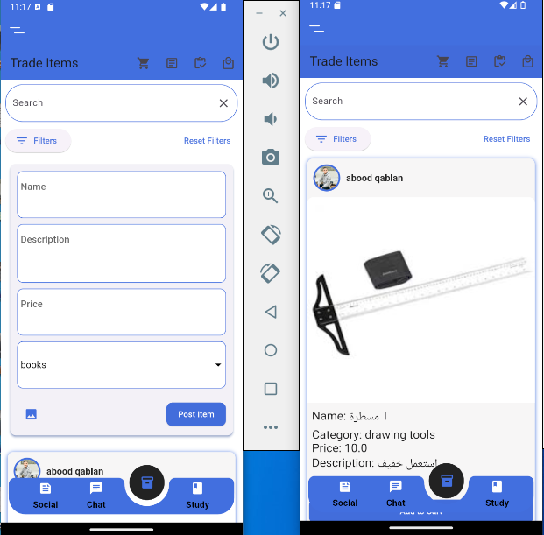
Figure 16: trade

3.3.14 add item to cart
In the first stage, the student who wants to buy enters the Trade section, where there is a filter on the search and limits on the price he wants to pay. If he finds what he wants, he adds it to the cart.

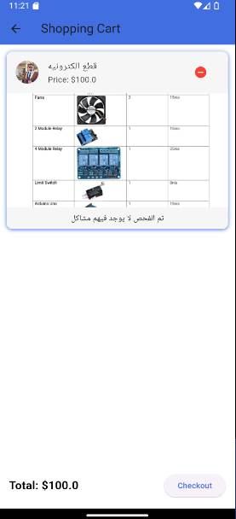
Figure 17: add item to cart

3.3.15 checkout information
Then, in the cart stage, if the customer wants to confirm the purchase order, he clicks on Checkout and enters his information so that the delivery company can deliver it to him, and then a notification reaches the product owner of the order.
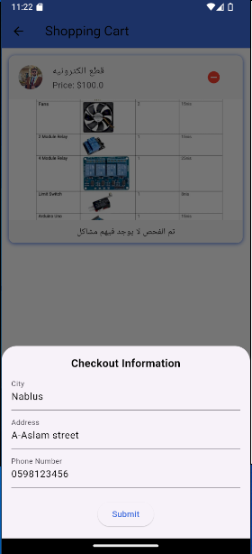
Figure 18: checkout information

3.3.16 checkout done

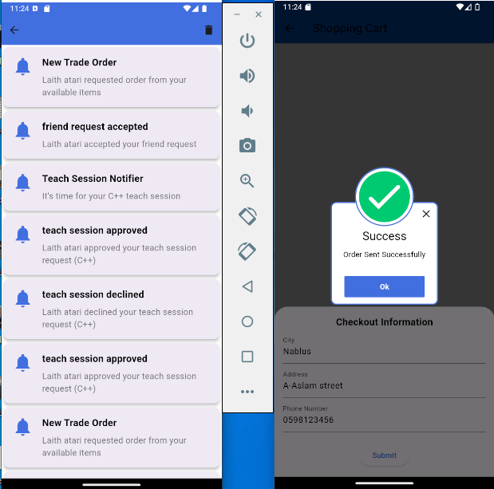
Figure 19: checkout done

3.3.17 my order
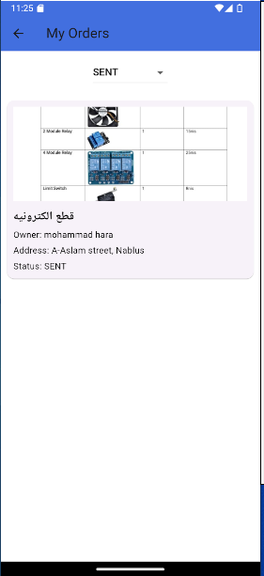

Figure 20: my order

3.3.18 on the way order
At this stage, the product owner delivers the product to the delivery company, which in turn delivers the product and places the product in an on-the-way state.

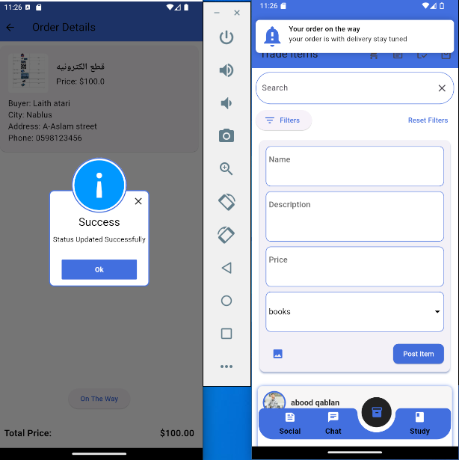
Figure 21: on the way order

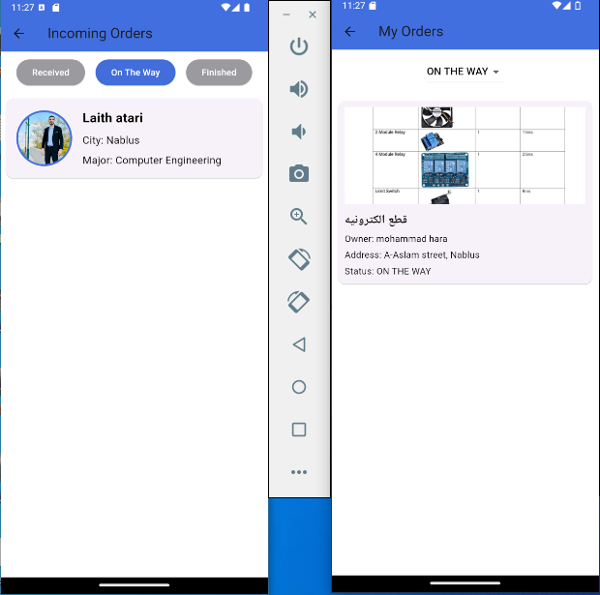
Figure 22: on the way order

3.3.19 finish order
In the last stage, when the owner receives the money from the delivery company after it has delivered the product to the customer and received its price, he puts it in the Finish stage.

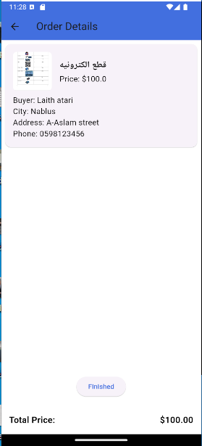
Figure 23: finish order

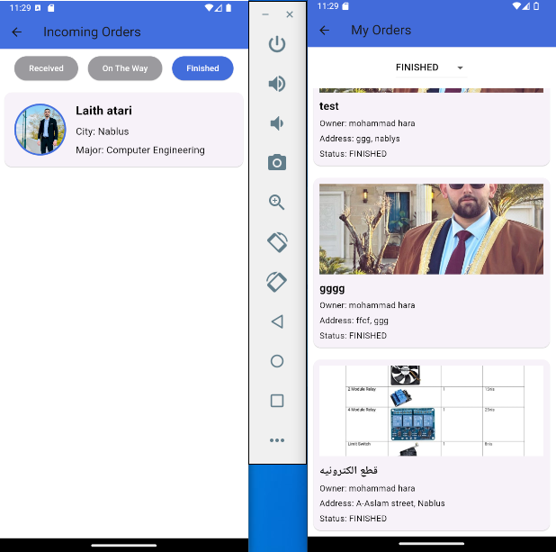

Figure 24: finish order

3.3.20 filter of trade

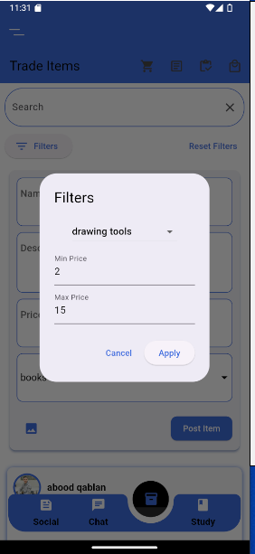
Figure 25: filter of trade

3.3.21 teach course
This feature is based on teaching, where the student searches for someone to teach him in a specific subject, through the user entering the courses he is studying through the Tech Courses section in the Side Bar, and the student who wants someone to teach him searches and finds him, then click request , and a notification about the student teacher appears. After he chooses the time

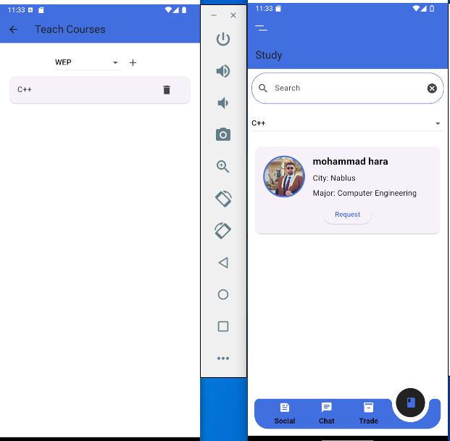
Figure 26: teach course

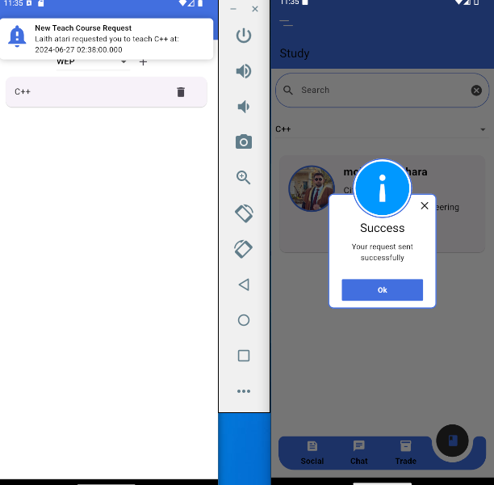
Figure 27: teach course

3.3.22 teach request
Teaching requests for the student who wants to teach appear under the TechRequest section in the Side Bar, then he accepts or rejects. If he accepts, he must enter his Zoom link or a similar platform like Times. We tried to find a meeting directly through the application, but this feature requires a paid subscription.

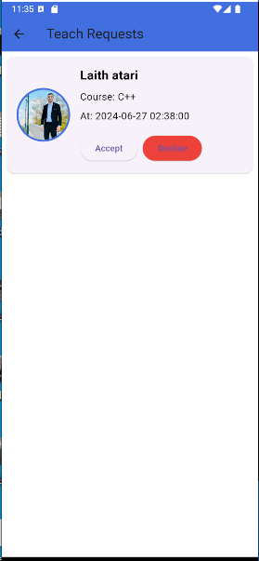
Figure 28: teach request

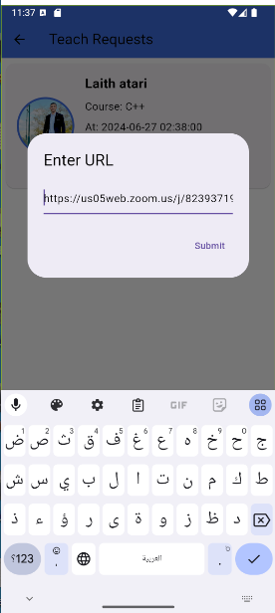
Figure 29: teach request

3.3.23 approved session
If the student-teacher accepts the request, it will appear immediately upon notification that the teacher has accepted the meeting

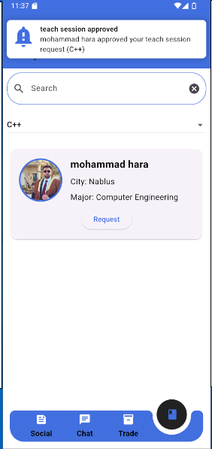
Figure 30: approved session

3.3.24 time of session
Here we have entered a date after two minutes so that our notifications will appear quickly. Therefore, when the meeting time comes, a notification will be sent as a reminder.

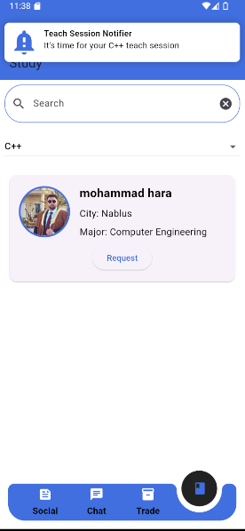
Figure 31: time of session

3.3.25 teach session

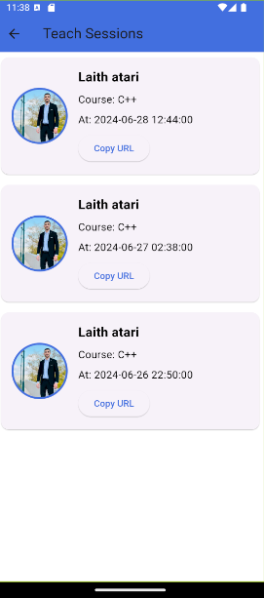
Figure 32: teach session

3.3.26 filter and search friends

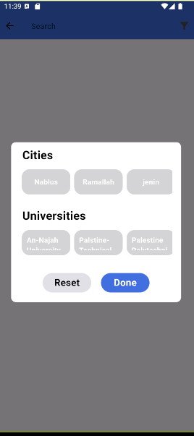
Figure 33: filter and search friends

3.3.26 web application
Here is a simple overview of the web application, as it has the same details and features as the mobile application
Sign up
From here, the user can enter his information to create his own account
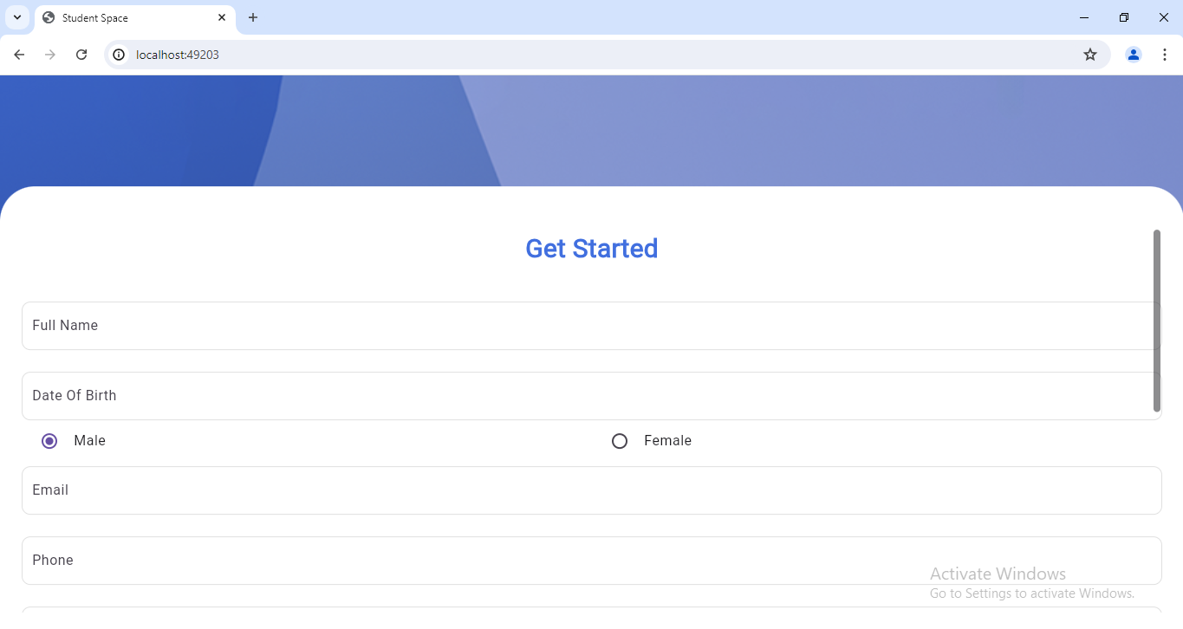
Figure 34: web Sign up
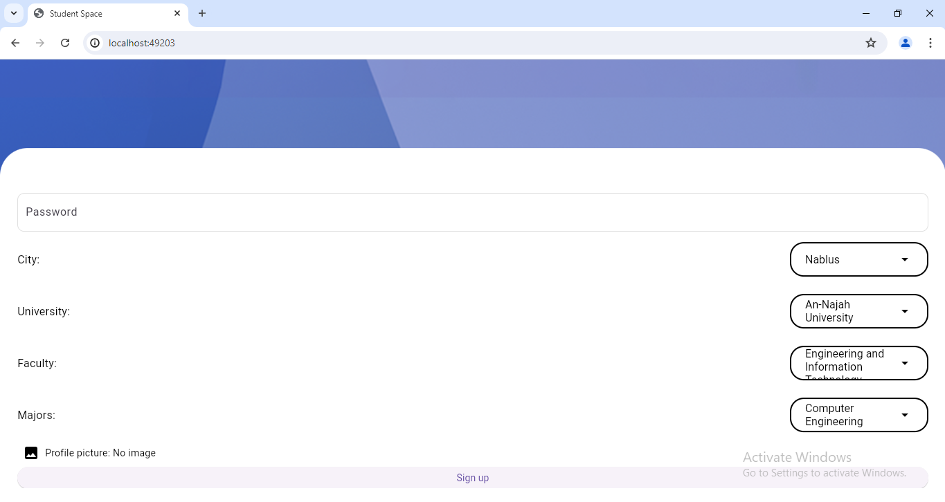
Figure 35: web Sign up
Sign in
After sign up , the user can log into his account from here, and he can also change the password if he forgets it.
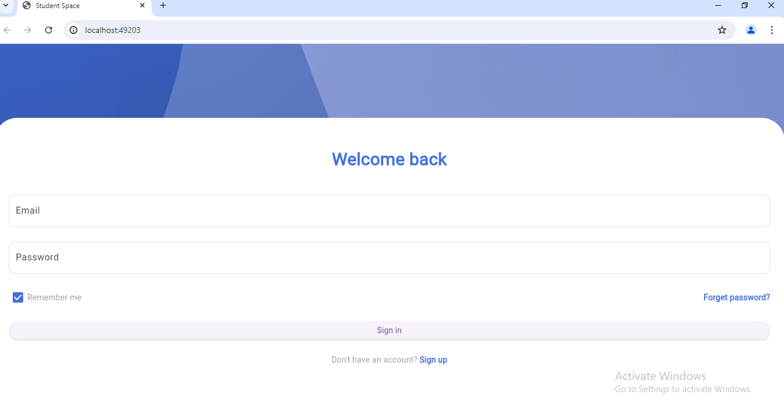
Figure 36: web Sign in
Home page
Here the main page of the application appears
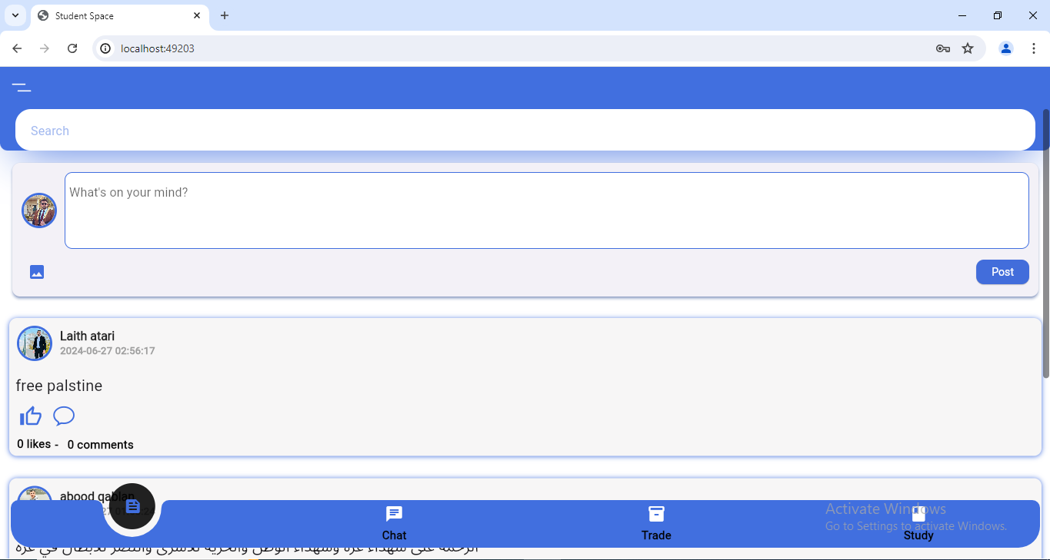
Figure 37: Home page
3.3.27 admin page

3.3.27.1 sign in

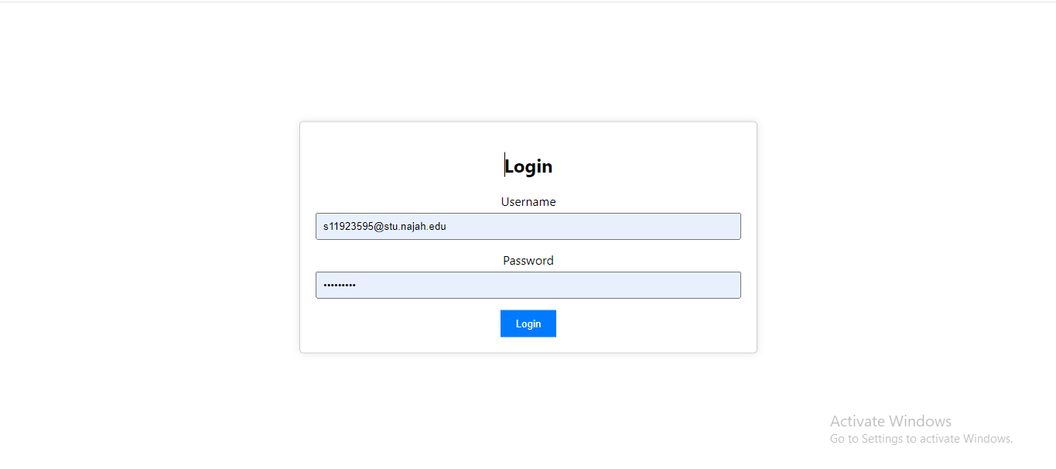
Figure 38: admin sign in

3.3.27.2 Statistics
Here the admin shows general statistics about the application

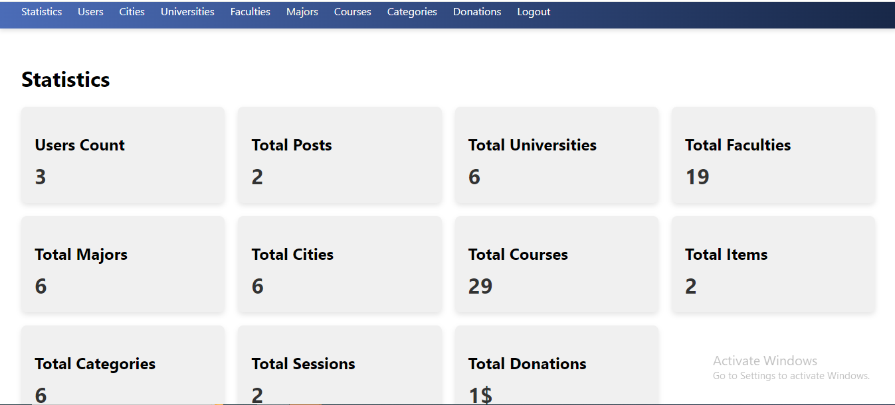
Figure 39: Statistics

3.3.27.3 users
Here the admin shows the users of the application and their information, and he can disable any account he chooses

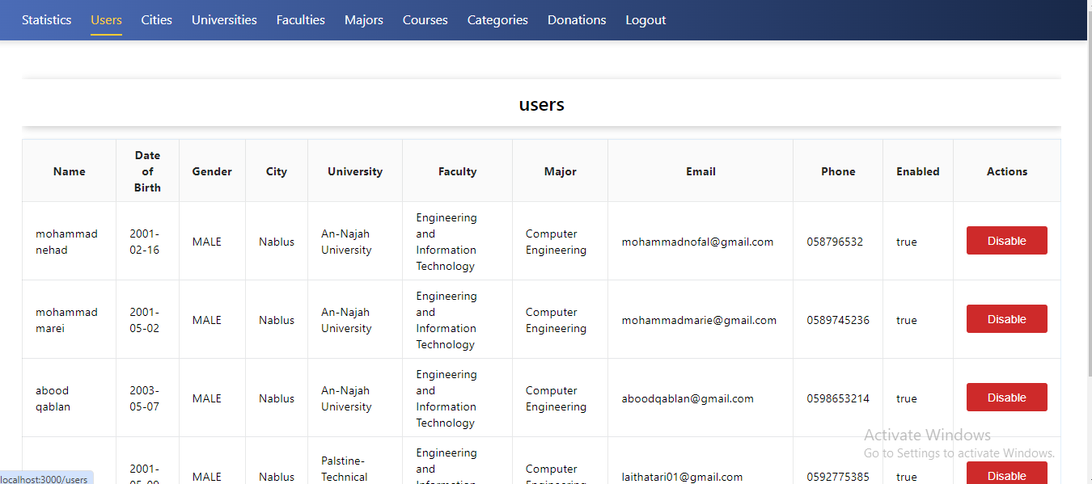
Figure 40: users

3.3.27.4 Cities
Here the admin shows the cities and he can add any city he chooses

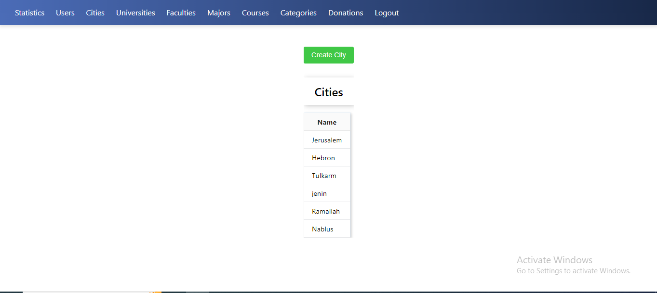
Figure 41: Cities

3.3.27.5 Universities
Here the admin shows the name of the university, in which city, and its location, and he can add any university he chooses.

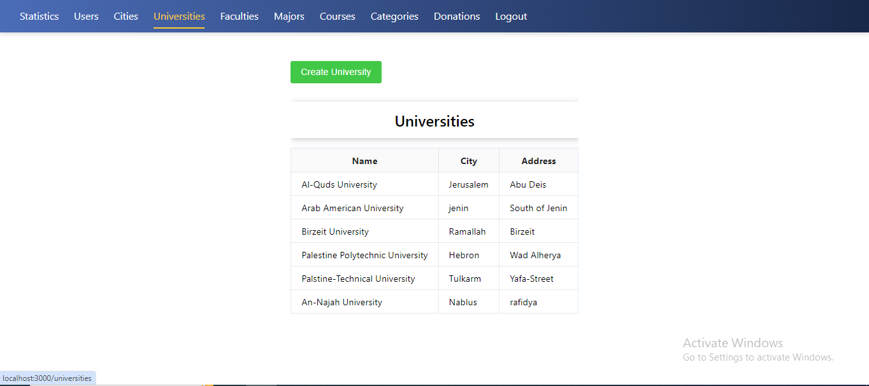
Figure 42: Universities

3.3.27.6 Faculties

Here the admin shows the Faculties and universities associated with it, and he can add any
college he chooses
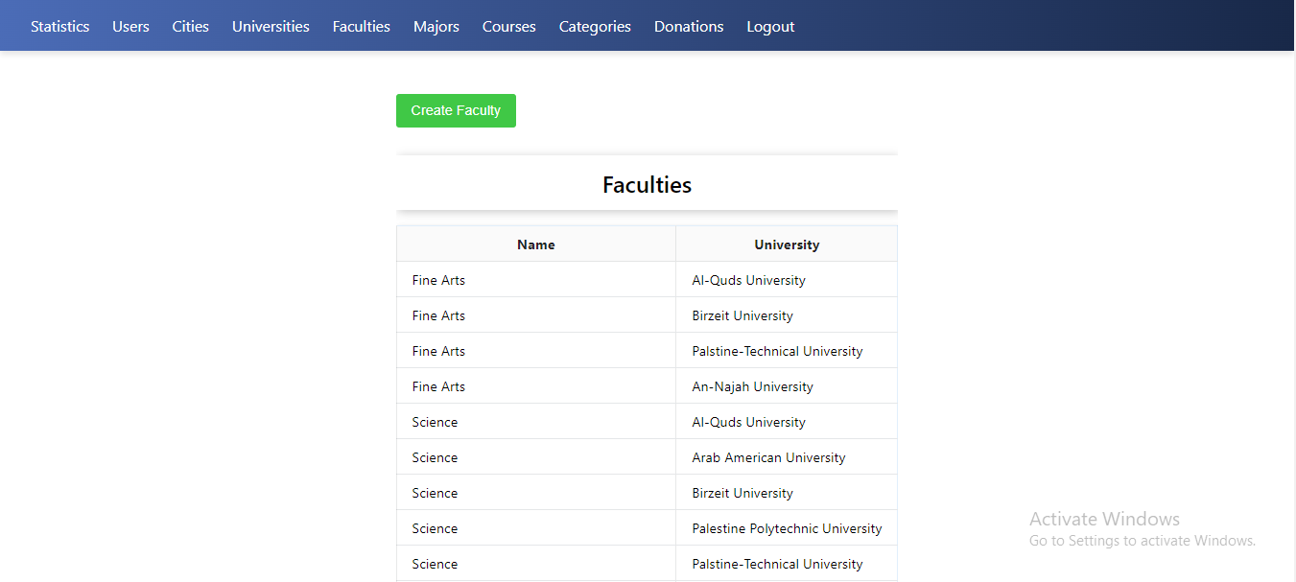
Figure 43: Faculties

3.3.27.7 Majors
Here the admin displays the details and the name of the Majors associated with it, and he can add any college he chooses

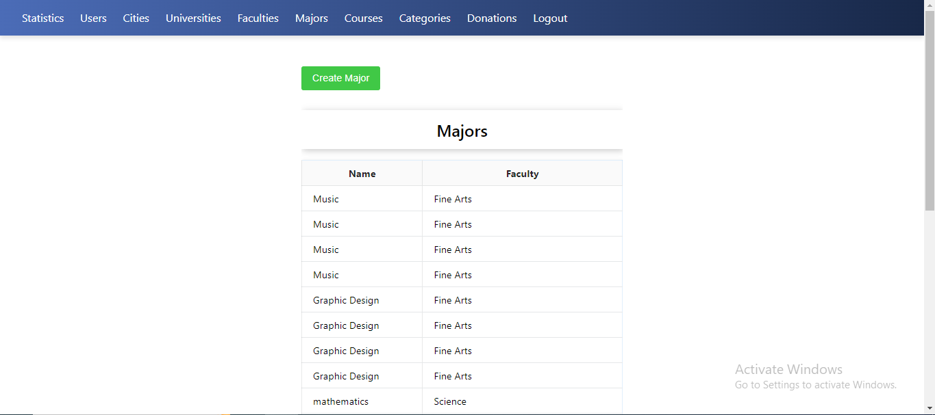
Figure 44: Majors

3.3.27.8 Courses
Here the admin displays the courses and Majors associated with them, and he can add any
course he chooses

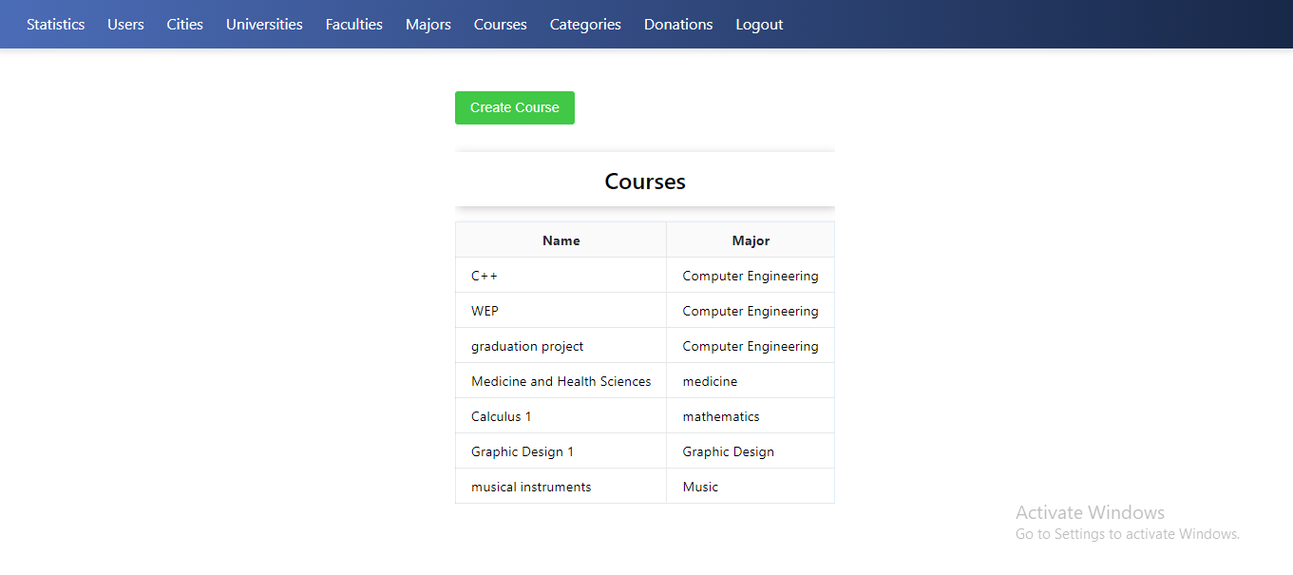
Figure 45: Courses

3.3.27.9 Categories
Here the categories that students may need appear

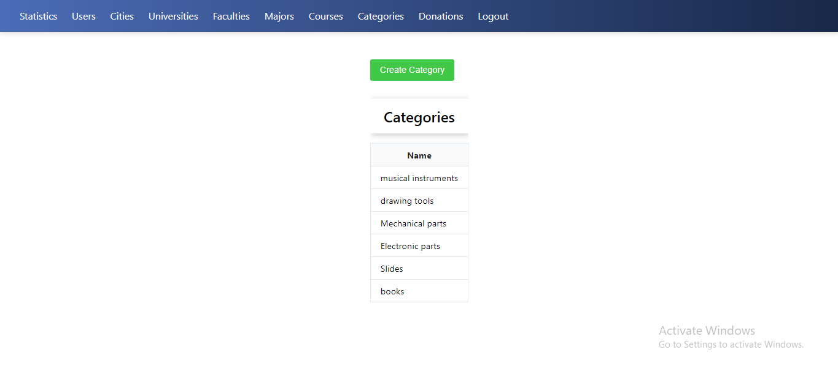
Figure 46: Categories

3.3.27.10 Donations
Here the details appear when someone donates to the site

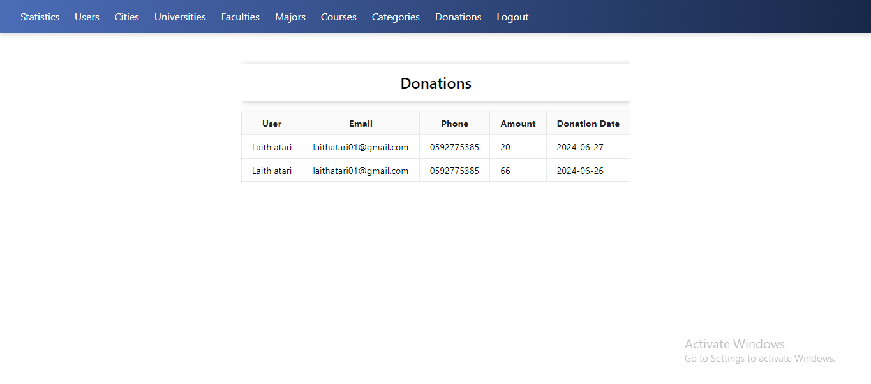
Figure 47: Donations

Chapter Four: Results
At the end of this project, we succeeded in achieving the goals that we set, as we created a website and a phone application, which university students will benefit from among themselves and save them time and effort in accessing what they need, all of this in an easy-to-use, clear and simple application that guarantees the user a useful and wonderful experience.
It allows students to browse the site to get what they need or view things they do not need, as students correspond with each other and accomplish the task, in addition to that the administrator supervises all aspects of the application.

Chapter Five: Discussion
In this project, we focused on making life easier for the student by providing services in which he faces difficulty in his university life. The idea of ​​our application is that it is a non-profit idea so that we do not burden the student with additional fees. The profit is through donating to the application, and in the future, this method can be added or replaced with another method of profit. It displays advertisements for restaurants and others

Chapter Six: Conclusion and Recommendations

6.1 Conclusion
In conclusion, our project aims to facilitate the lives of students and help them through the project that we have undertaken, as it saves them time and effort, in obtaining what they need and communicating with each other, in an easy-to-use and simple application, and solves the problem of applications that restrict and control content, and under the supervision of the person in charge of Application

6.2 Recommendations
We recommend our colleagues to choose their project idea well, and to learn the necessary programming languages for the project, such as , during their university years so that they are proficient in them while undertaking the project, and to organize their ideas well before undertaking the graduation project, so that they are fully aware of what they are doing. While doing the project, choose the appropriate partner also a good time before doing the graduation project so that they can understand and agree with each other to complete the project in the best possible way.

6.3 Future Work
In the future, we may provide the ability to open a meeting through the application itself without using an external platform such as Zoom
In addition, a source of profit must be opened for the application, and this can be done by adding advertisements for restaurants, offices, and university housing, or by taking a small commission.
Keeping up with the developments taking place in the field of artificial intelligence, which can be employed in the application in order to provide the best nominations to users that suit them

Chapter seven :References

1. https://dart.dev/guides

2. https://docs.spring.io/spring-boot/index.html

3. https://developer.paypal.com/api/rest/

4. https://docs.flutter.dev/ pdf

